# Controlled Conversation

## General info

This extension works for MS Edge. Sometimes administrators in corporate environment force some setting on users’ browsers. One of such settings is a home page open when you start a new tab. This setting cannot be changed by a user, as it is managed by the administrator. This extension will not disable that setting, but when you open a new tab it will quickly load a www.google.com page. You should not see the ugly, slow loading company home page, instead a google page will be displayed. You can change the home page in the background.js file slightly modifying the file, as described below.

## How to install and configure

Go to “Settings” >> “Extensions”:

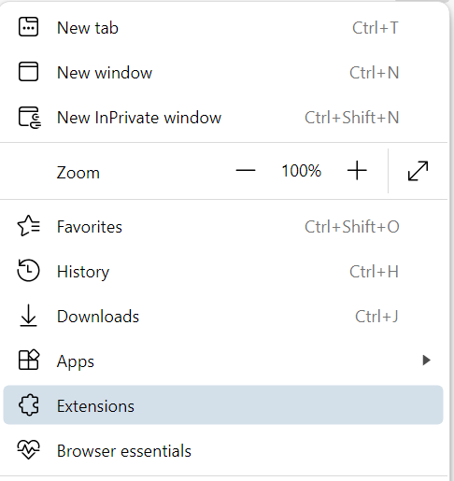

Click “Manage extensions”:

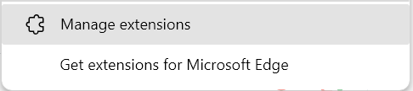

Click “Developer mode” and next “Load Unpacked”:

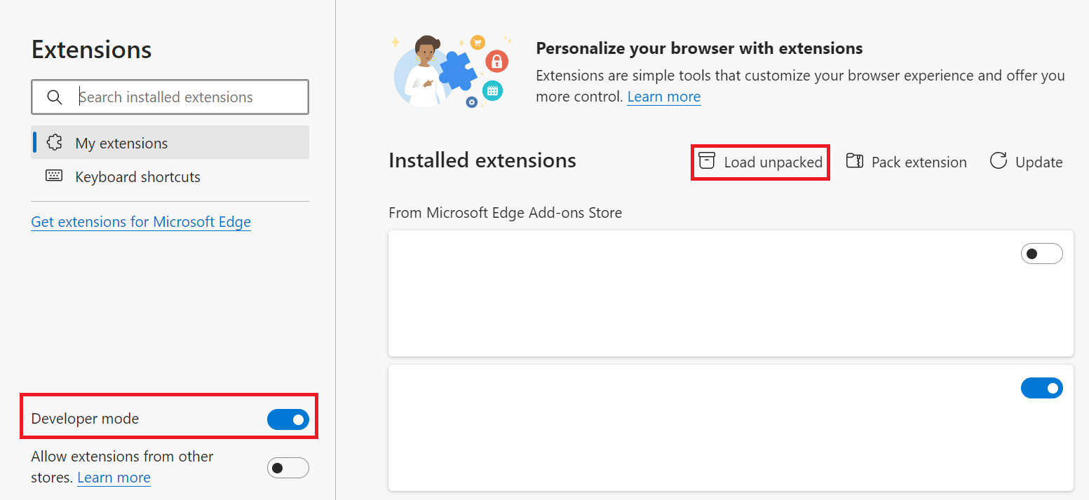

Point to directory where you unpacked the extension:

Make sure that the new extension is enabled:

Open a new tab – it should start loading the forced by admin web page, but will automatically reload the google.com or another page (you can change it by modifying the background.js file – see instructions below). Do you like it? Buy me a coffee 😉 <https://paypal.me/controlconversation>

Should another page be loaded by Controlled-Conversations instead of google.com, modify the background.js file:

After such modifications, reload the extension using the reload button:

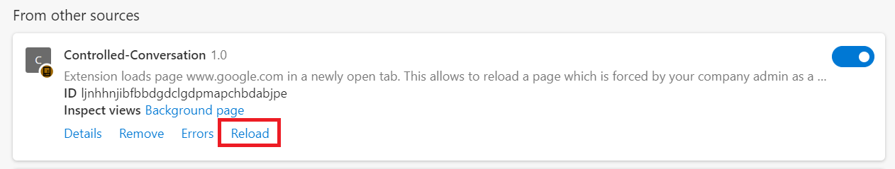

Enjoy your freedom!