This is the after login user page. Contains all the topics that the user is registered to like Computer Science, Physics and etc.
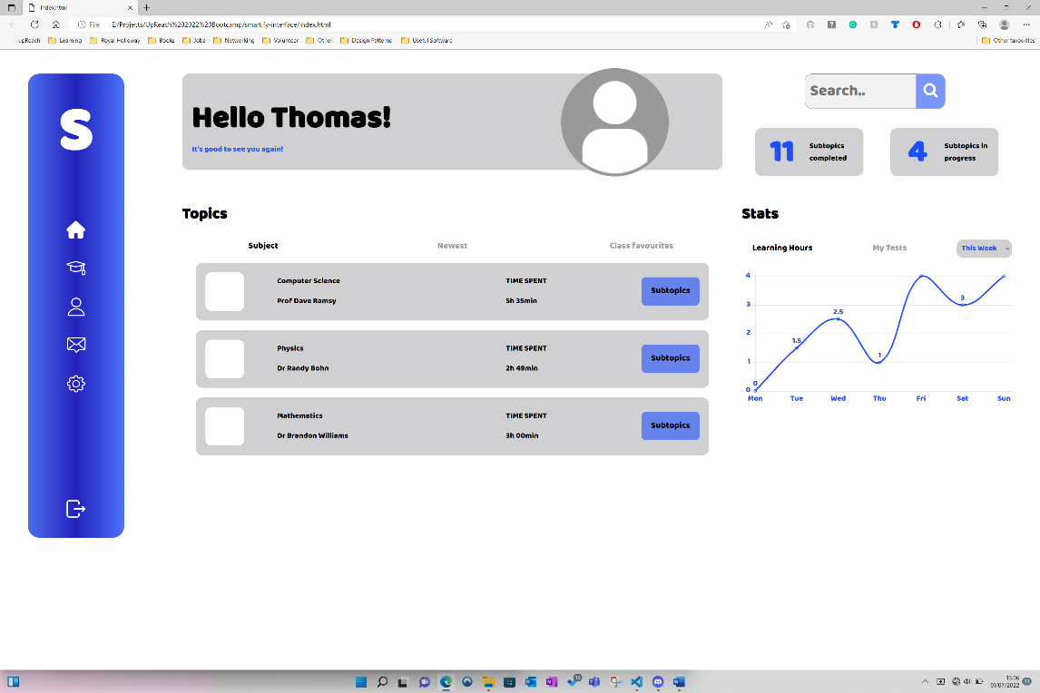

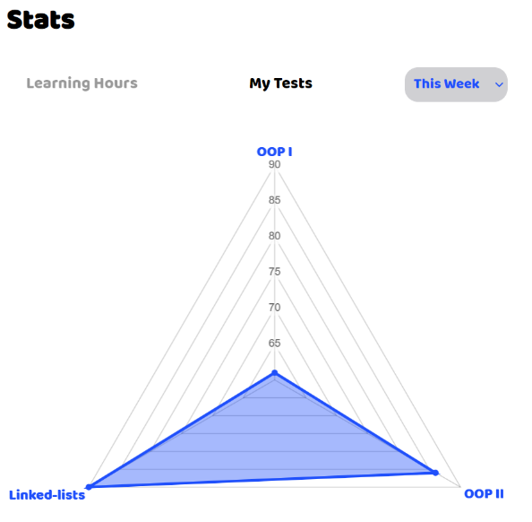
The user can view statistics of how many hours they are spending per day across a week or across the month. He/she can also view the results of the most recent tests
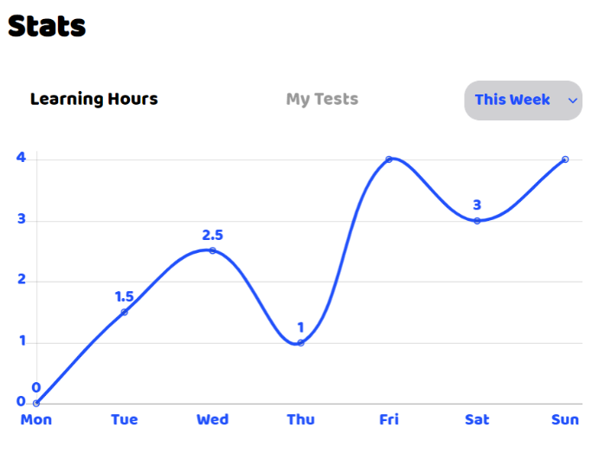

The user selects a topic by pressing “Subtopics” from the interface above. A new component will be displayed showing the subtopics of the select topic. The user clicks on the “Test” button to be taken to the test. Here the user will find more information about the topic and find the amount of questions for each sub-topic and previous results.
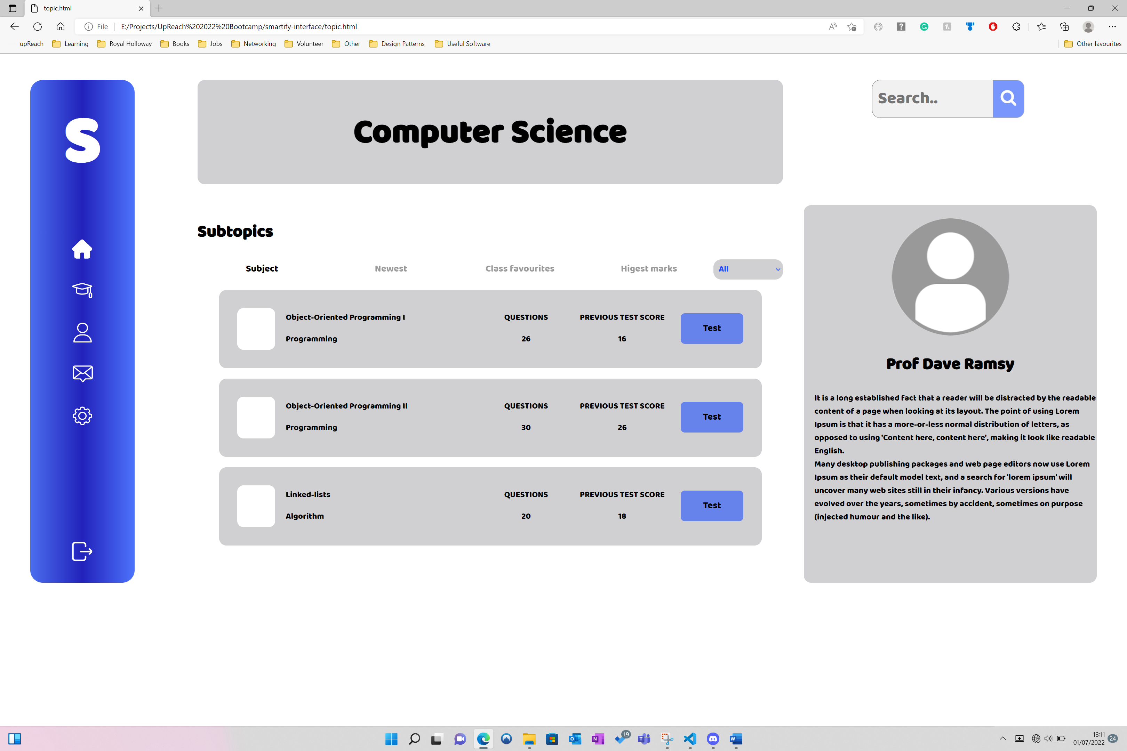

This is the initial test interface, telling the user simple instructions.
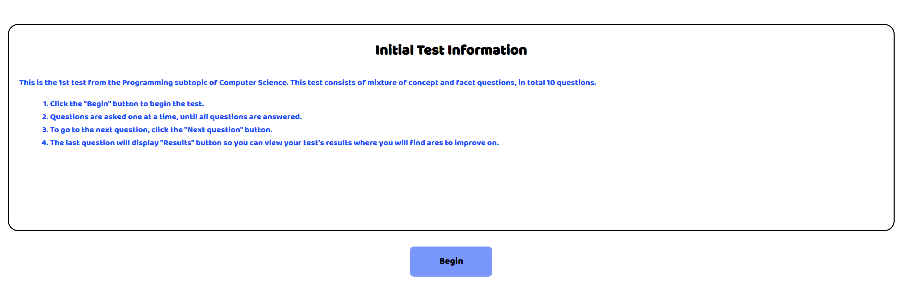
This is the question interface, at the top is a progress bar to track the answered questions.
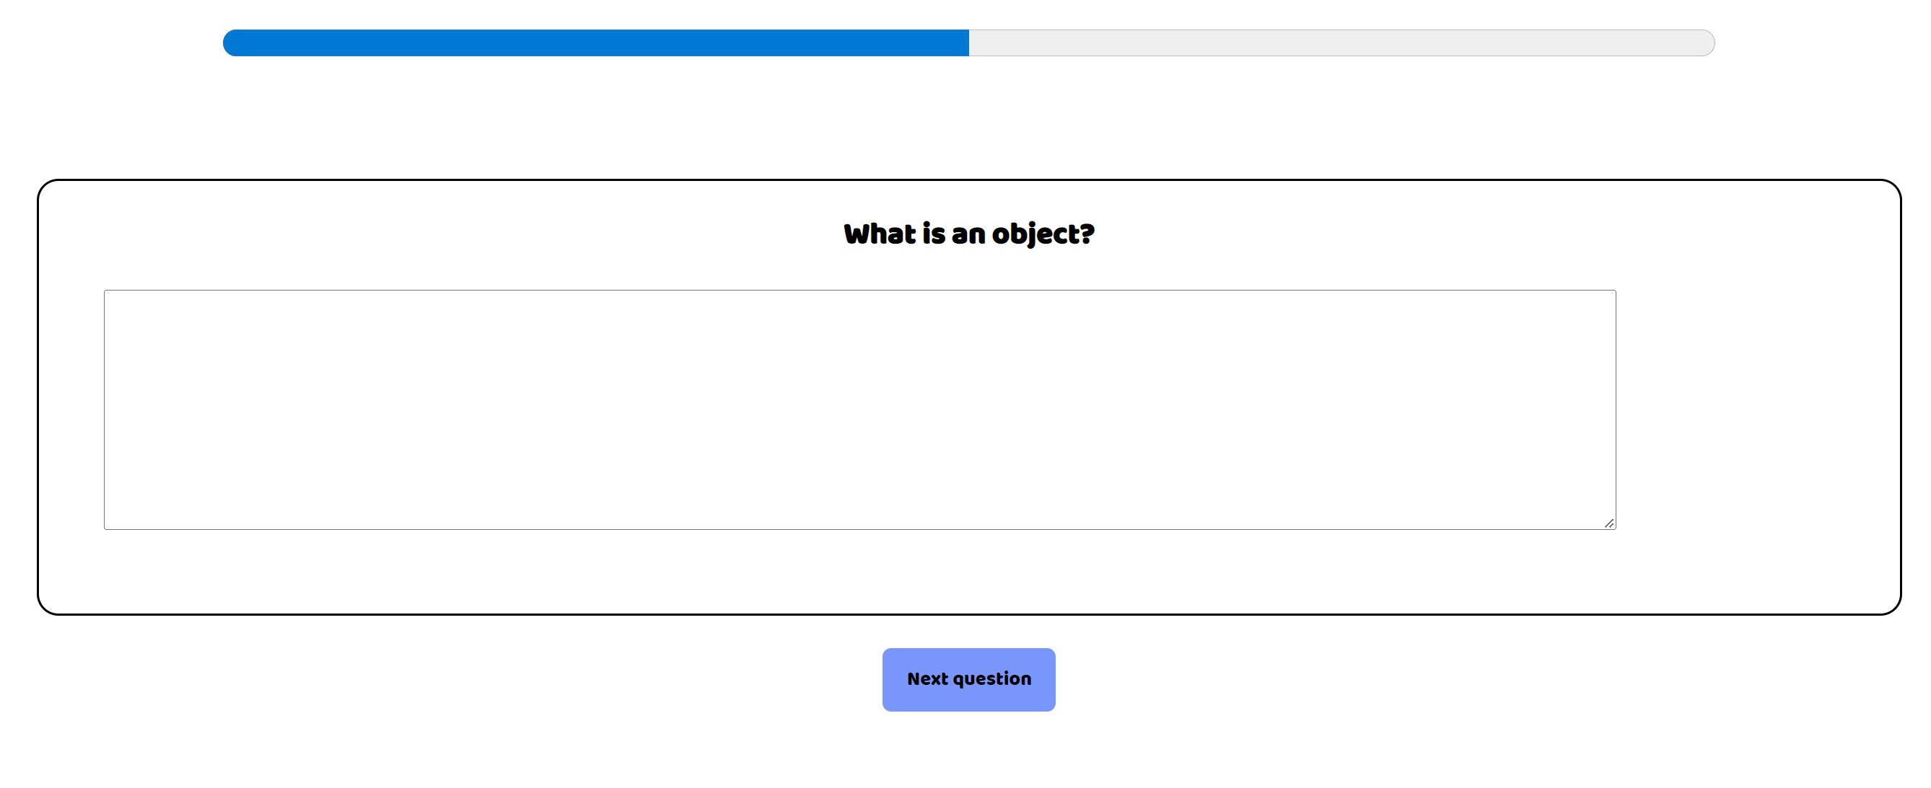
This is the results interface, this will display the questions that have been answered correctly on previously, questions that need improving and questions that have been failed on multiple on occasions.
