Abstract

*An app to keep the elderly people moving and healthy.*

OCTAFIT

[309]

rev. 20220311a

Transferable Skills II – Human-Computer Interaction Module

2021-2022

Contents

Team Identification 3

TASK 01: General Idea Descriptiion 4

Competitors 4

TASK 02: User Characterization 5

Personas 5

TASK 03: Characterization of Use (SCENARIOS) 6

Scenarios 6

TASK 04a: Requirements 8

TASK 04b: Consolidated Idea 9

TASK 05: Low-fidelity Mockup – The Paper Prototype 10

TASK 06: Usability Testing Preparation 11

Methods 11

List of Tasks 11

Consent Form 12

user table 13

Observer Table 14

Post-tasks Questionnaire 15

TASK 07: Prototype Evaluation 16

Participants 16

Evaluation Results 16

Evaluation Discussion 16

TASK 08: Refined Mockup 16

TASK 09: Critical Analysis of the Project 18

Strengths 18

Weaknesses 18

Workload 18

# Team Identification

|  |  |
| --- | --- |
| **Team Name:** | 8Fit |
|  |  |
| **Team Members:** | **Afonso Castanheta** |
|  | 98584 |
|  | LECI |
|  | [Short bio including interests and competences] |
|  | **André Antunes** |
|  | 103901 |
|  | Engenharia Física |
|  | [Short bio including interests and competences] |
|  | **Rafael Santos** |
|  | 98466 |
|  | LECI |
|  | [Short bio including interests and competences]      **Bernardo Campos**  103225  Eng. Biomédica |

# TASK 01: General Idea Descriptiion

An intuitive an minimalist app with the purpose of help elderly people to be more active and healthy through physical exercise.

## Competitors

There are applications like this one on the market like Nike, Adidas, etc, but are specifically for young people to maintain or get in better shape. OctaFit is specifically dedicated to helping elderly people exercise more with a more intuitive design and taking into consideration their age and possible limitations.

# TASK 02: User Characterization

*For the John Doe’s persona we took our experience as role model. When we were younger and more energetic our grandfathers couldn’t keep up with us, we hope to help the younger generations not having the same problem.*

*For Peggy Carter’s persona we thought how difficult can be to take care of all those people in a care home , so we though of an app that could help them manage.*

## Personas

|  |  |
| --- | --- |
| **John Doe, 25 years old Accountant** | |
|  | John Doe is John Doe is an ex-accountant, he retired 10 years ago. He has been married to Jane Doe for 50 years, and they had 3 children together, John Jr, Emma and Amber.  He was born and raised in Aveiro but he traveled a lot during his younger years.  During his work as an accountant, he spent most of the time sitting, which has led now to lower back problems.  He has 2 little grandchildren, Karen and Dave, who he loves very much and wants to spend as many years as he can playing with them.  He was advised by his family members to start doing some exercise to see if it would help, however he didn't know how to start nor what to do. |
| **Motivation:** | John wants to be as healthy as possible so he can play with his grandchildren. |

|  |  |
| --- | --- |
| **Peggy Carter, 35 years old, nurse** | |
|  | Peggy Carter is a nurse who has been working in a nursing home for the past twelve years.  She has been married to Steve Rogers for three years and still doesn’t have kids but wants to.  She was born in Porto but studied in Aveiro and started working at the age of 20.  During her time as a nurse, she has helped and took care of many elderly people and cares a lot about their health and well-being.  She works ten hours a day and usually when she arrives home, she is tired and just wants to rest despite not having much time because she needs to wake up early to go back to the nursing home.  She is generous and a hard worker and wants to help others the best way she can, so she is used to searching for ways to improve her efficiency in her life and her job. |
| **Motivation:** | Peggy Carter has seen many elders with physical problems throughout her years of work that limit their habits and happiness so, she finds in Octafit a way to help her make their life healthier and happier. |

# TASK 03: Characterization of Use (SCENARIOS)

*To reach these scenarios we thought how elderly people can be helped to get them to do more exercise.*

Most of the people with advanced age are always taking pills, we thought we can add a feature to our app to help them remind which one can they take and at what time.

Other way we thought we could help was in nursing homes, more directed to the workers there and to help them monetarize their patients.

## Scenarios

|  |  |
| --- | --- |
| **Title:** | **John was playing with his grandchildren in the park and hurt his back** |
| One morning, John wakes up and decides to take his grandchildren for a walk in the park. Karen sees a swing and runs towards it; she asks John to push her. After doing it for a while he felt an acute pain in his lower back and had to stop.  Later that day, Dave asked him to play catch with him, but he could barely walk due to the pain.  His grandchildren were worried about him so they searched for a way to help him, and they found Octafit. In the 1st contact with the app, the kids found a simplistic layout and an instruction window that explains the functions of each button and can be accessible at any time.  They wrote his personal information and physical limitations (by writing or tapping on the critical body parts) and prepared some physical habits he should to minimize the pain.  They prepared everything for John and then explained everything to him. After a few months of using the app, he started feeling healthier, stronger and less tired when asked by his grandsons to play.  Now he can keep up with them and enjoy as much as he possibly can. | |

|  |  |
| --- | --- |
| **Title:** | **Peggy makes a health-workout plan for an elderly married couple.** |
| In the middle of the morning, a woman arrives at the nursing home to register her parents that don’t have conditions to live just the two in a house and asks to talk to a nurse.  Peggy goes to the reception and they meet, after a few minutes of getting to know the new “patients”, they tell Peggy that someone told them that in this nursing home, the elders have day-by-day routines that are very effective and they ask if they can both do the same routine together.  Peggy opens and shows them Octafit and right there she starts creating their profiles.  With the profiles created she assigns the health-workout plan for both of them and links the plans of one and another so they can and shall complete the routines together.  That way, the couple enjoys their life in the nursing home very much because they are healthier each day that passes thanks to Octafit and to the time they spend together completing the tasks of the app. | |

|  |  |
| --- | --- |
| **Title:** | **John is always reminded by his daughter to take the pills.** |
| Emma is the worried daughter that always reminds John to do the things that he must not forget.  She usually calls him, makes alarms and writes notes to stick in his fridge because John always gets distracted with his hobbies and forgets, for example, to take the pills.  John knows that he must take the pills for his health and to not let down his family, but he doesn´t want to depend on Emma. In fact, one day she had to go to a work meeting so she didn’t call John, despite warning him before, and he forgot to take the pill as she feared he’d do.  One day, they found Octafit and it helped both of them a lot. John installed the app and registered and after that day, he was always reminded to take the pills.  Emma installed Octafit too, and because she had John’s profile in her phone she always knew when he took the pills, with that she started getting less stressed and more confident with the progress of her father. | |

|  |  |
| --- | --- |
| **Title:** | **Peggy can’t make a patient follow any health habits until...** |
| Day by day, Peggy Carter normally works with 13 elderly people, she has access to all the weaknesses and limitations of each of them and there is one patient that has a lot. He is always in his chair watching The Office and heating cookies.  While most of the elders enjoy following Octafit, this man says he doesn´t understand technologies and doesn´t want any to do with that. Peggy finds in this man a challenge because she knows that he feels sad and alone and needs something to make his life more interesting.  One day she’s at home navigating in Octafit and thinking about what can she do for that man and she has an idea just by looking at the app layout...  The next morning, she goes to the elder, shows him Octafit and says “You know what is this? A game that I want you to play, today you will need to follow these steps and then you can go back to sitting here”. He is not very interested but ends up accepting what the nurse is asking.  Miraculously, the simplicity of the app, adequate button size and a group of effective instructions that he follows without the extreme need of another person makes him really think of that like a “game” that he does not want to stop playing.  After that day he still likes to be sitting in his chair watching The Office and eating cookies, but he is always aware of the tasks that he needs to do, and Peggy feels so proud of the progress she made with him. | |

|  |  |
| --- | --- |
| **Title:** | **John does group-workout plan** |
| John and his wife both have profiles and workout plans in Octafit, but every now and then they get together with their same age friends to do some exercises in a group. The idea came from his wife and her friends, but Jonh likes it too and loves the post-workout when he goes to play cards with his friends.  They meet in the house of one of the participants, go to the garden and they all open Octafit. Then they choose the same list of exercises. Every exercise has a “virtual personal trainer” that, in video, exemplifies how to do each exercise (just with a click on the name of the given exercise).  The group activity is always smooth, relaxed and fun but the best part is that they have a shared healthy “experience” not just to do together but also to later talk and discuss it.  It is a healthy hobby that John has and a good excuse to be with his friends having a blast.  Octafit encourages the elderly to be more fit in an organized and fun way with many activities to do alone or in a group and that is why this group of elderly old friends all use it and enjoy it very much. | |

# TASK 04a: Requirements

The requirements were chosen, firstly, thinking from the standpoint of the physical device itself and what characteristics would facilitate its use and accessibility (since this is where the app will run on). Secondly, we chose to think from the perspective of our specific demographic (the elderly) and what limitations or special needs that would entail.

|  |  |  |  |
| --- | --- | --- | --- |
| Priority | Requirement | F | NF |
| 1 | Run on smartphones, but the interface needs to be minimalist so that it can be seen from a 1 to 3 meters’ distance |  | X |
| 7 | Voice assistance and input | X |  |
| 2 | Support user accounts and signing in/up | X |  |
| 6 | Define alarms and notifications for specific events | X |  |
| 3 | User flow must be simple and intuitive |  | X |
| 4 | Users might have bad vision and/or bad hearing |  | X |
| 5 | The system should have an initial tutorial making the user aware of the main features | X |  |

# TASK 04b: Consolidated Idea

The desired equipment is any mobile device which is accessible and easy to carry. The user will interact with the system through a touch screen, and through voice regarding some particular features. The operating system in which it will operate is Android since it is both more economically accessible and widespread.

Platform: Mobile device

Interaction: Touch screen

Device: Any Android

# TASK 05: Low-fidelity Mockup – The Paper Prototype

Figure 2-workouts already done

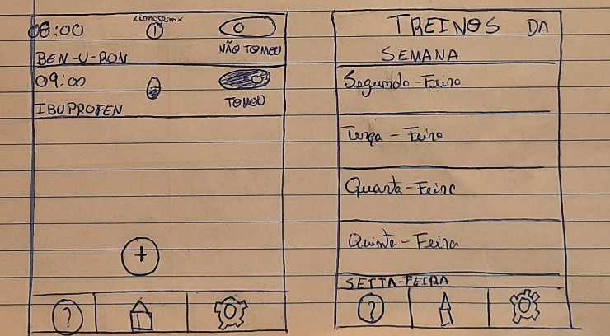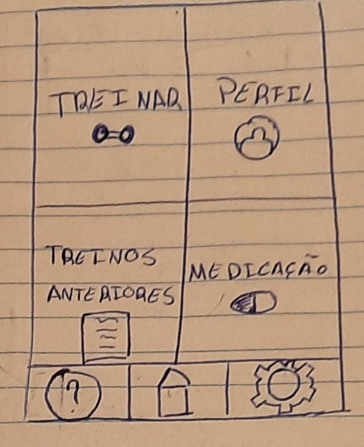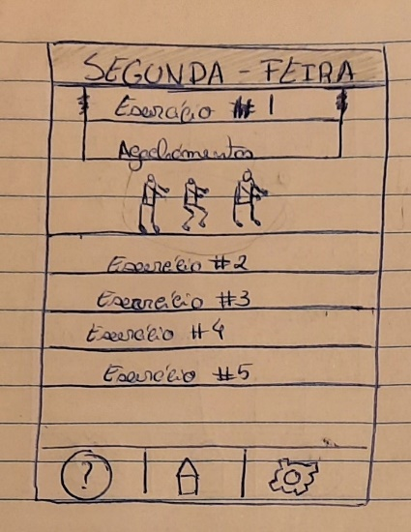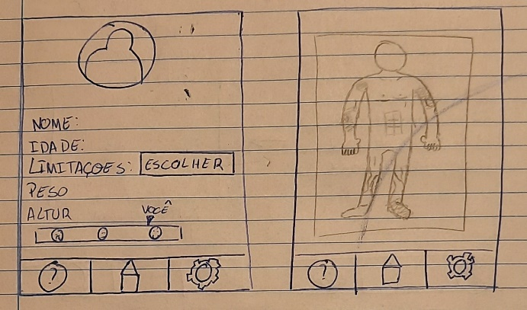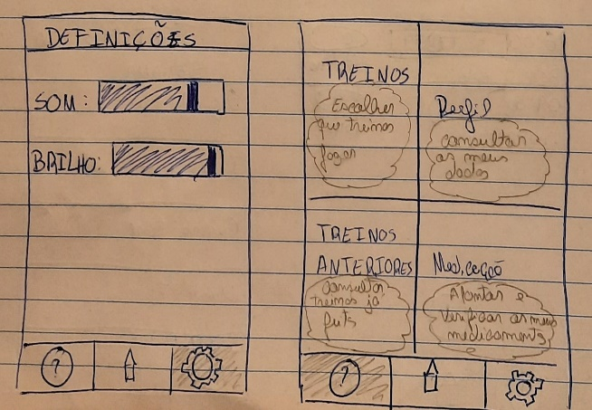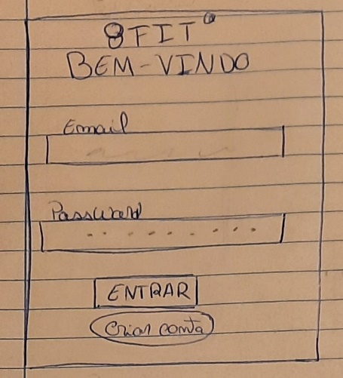

Figure 4-Medication+week workouts

Figure 5-Main page

Figure 3-Monday practice

Figure 7- Profile + limitation pop-up

Figure 6-Settings + tutorial example

Figure 1-Login page

# TASK 06: Usability Testing Preparation

## Methods

For our evaluation we considered opinions from 4 different users. Each one of them tested our app and we collected feedback from their experience using it.

## List of Tasks

We chose our list of tasks bearing in mind what features were most crucial and of most importance for the usage of our app. Secondly, we tried to write instructions in a way that was not too specific but also not so generic that we could conclude if the tasks were completed as intended or not.

1-Entra na aplicação e segue o tutorial da aplicação;

2-Preenche os dados pessoais na página de perfil e seleciona as partes do corpo onde tens algum tipo de limitação;

3-Cria um alarme para a medicação;

4- Escolhe e executa um plano de treino;

5- Vê o teu registo de treinos anteriores. Revê o treino que fizeste ontem.

## Consent Form

I agree to participate in the study conducted by the OctaFit (8Fit).

I understand that participation in this usability study is voluntary and I agree to immediately raise any concerns or areas of discomfort during the session with the study administrator.

Please sign below to indicate that you have read and you understand the information on this form and that any questions you might have about the session have been answered.

*DATE: _________*

*PLEASE SIGN YOUR NAME: _____________________________________________________*

*_____________________________________________________________________________*

*THANK YOU!*

We appreciate your participation.

## user table

OctaFit have as objective to provide a better quality of life to the elderly people. How? Through an exercising app of intuitive and easy use, between other functionalities.

|  |  |
| --- | --- |
| **Tarefa 1** | *Entra na aplicação. Se tiveres alguma dúvida segue o tutorial geral da aplicação.*    ------------------------------------------------------------------------------------------ |
| |  |  |  |  |  |  |  |  | | --- | --- | --- | --- | --- | --- | --- | --- | | Nada Fácil | |  |  |  |  |  | | --- | --- | --- | --- | --- | | 1 | 2 | 3 | 4 | 5 | | Muito Fácil | |

|  |  |
| --- | --- |
| **Tarefa 2** | *Preenche os dados pessoais na página de Perfil e seleciona as partes do corpo onde tens algum tipo de limitação aka “dor”.*  ------------------------------------------------------------------------------------------ |
| |  |  |  |  |  |  |  |  | | --- | --- | --- | --- | --- | --- | --- | --- | | Nada Fácil | |  |  |  |  |  | | --- | --- | --- | --- | --- | | 1 | 2 | 3 | 4 | 5 | | Muito Fácil | |

|  |  |
| --- | --- |
| **Tarefa 3** | *Cria um alarme para a toma de medicação:  9:15 Ibuprofeno, 2 doses.*  *Elimina o alarme.*  ------------------------------------------------------------------------------------------ |
| |  |  |  |  |  |  |  |  | | --- | --- | --- | --- | --- | --- | --- | --- | | Nada Fácil | |  |  |  |  |  | | --- | --- | --- | --- | --- | | 1 | 2 | 3 | 4 | 5 | | Muito Fácil | |

|  |  |
| --- | --- |
| **Tarefa 4** | *Escolhe e executa um plano de treino. Quando acabares preenche os campos indicados.*  ------------------------------------------------------------------------------------------ |
| |  |  |  |  |  |  |  |  | | --- | --- | --- | --- | --- | --- | --- | --- | | Nada Fácil | |  |  |  |  |  | | --- | --- | --- | --- | --- | | 1 | 2 | 3 | 4 | 5 | | Muito Fácil | |

|  |  |
| --- | --- |
| **Tarefa 5** | *Vê o teu registo de treinos anteriores.*  *Revê o treino que fizeste ontem.*  ------------------------------------------------------------------------------------------ |
| |  |  |  |  |  |  |  |  | | --- | --- | --- | --- | --- | --- | --- | --- | | Nada Fácil | |  |  |  |  |  | | --- | --- | --- | --- | --- | | 1 | 2 | 3 | 4 | 5 | | Muito Fácil | |

## Observer Table

|  |  |  |  |  |  |  |  |
| --- | --- | --- | --- | --- | --- | --- | --- |
| NI de utilizador: _________________________                                  **Guião do Observador** | | | | | | | |
| **Tarefa** | **Nº cliques** | **Completou a Tarefa?** | **Tempo Máximo**    **Tempo observado**  **(mm:ss)** | **Cometeu erros?** | **Sentiu-se perdido?** | **Solicitou ajuda** | **Grau de facilidade observada**  **1 – Nada Fácil**  **5 – Muito Fácil** |
| **1** |  | não |   | sim |   | | **2m**  ____:____ | não |   | poucos |   | muitos |   | | não |   | pouco |   | muito |   | | não |   | sim |   | qual? | |  |  |  |  |  | | --- | --- | --- | --- | --- | | 1 | 2 | 3 | 4 | 5 | |
| **2** |  | não |   | sim |   | | **2m**  ____:____ | não |   | poucos |   | muitos |   | | não |   | pouco |   | muito |   | | não |   | sim |   | qual? | |  |  |  |  |  | | --- | --- | --- | --- | --- | | 1 | 2 | 3 | 4 | 5 | |
| **3** |  | não |   | sim |   | | **2m**  ____:____ | não |   | poucos |   | muitos |   | | não |   | pouco |   | muito |   | | não |   | sim |   | qual? | |  |  |  |  |  | | --- | --- | --- | --- | --- | | 1 | 2 | 3 | 4 | 5 | |
| **4** |  | não |   | sim |   || | **2m**  ____:____ | não |   | poucos |   | muitos |   | | não |   | pouco |   | muito |   | | não |   | sim |   | qual? | |  |  |  |  |  | | --- | --- | --- | --- | --- | | 1 | 2 | 3 | 4 | 5 | |
| **5** |  | não |   | sim |   | | **2m**  ____:____ | não |   | poucos |   | muitos |   | | não |   | pouco |   | muito |   | | não |   | sim |   | qual? | |  |  |  |  |  | | --- | --- | --- | --- | --- | | 1 | 2 | 3 | 4 | 5 | |

Observações ______________________________________________________________________________________________________________________________________________________________________________________________________________________________________________________________________________________________________________________________________________________

## Post-tasks Questionnaire

Please enter your participant number: _____

**System Usability Scale (SUS)**

This is a questionnaire that measures the overall usability of 8Fit.

Please select the answer that best expresses how you feel about each statement after using the app today.

|  |  |  |  |  |  |
| --- | --- | --- | --- | --- | --- |
|  | Strongly Disagree | Somewhat Disagree | Neutral | Somewhat Agree | Strongly Agree |
| 1. I think I would like to use this app frequently. | μ | μ | μ | μ | μ |
| 1. I found the app unnecessarily complex. | μ | μ | μ | μ | μ |
| 1. I thought the app was easy to use. | μ | μ | μ | μ | μ |
| 1. I think that I would need the support of a technical person to be able to use this app. | μ | μ | μ | μ | μ |
| 1. I found the various functions in this app were well integrated. | μ | μ | μ | μ | μ |
| 1. I thought there was too much inconsistency in this app. | μ | μ | μ | μ | μ |
| 1. I would imagine that most people would learn to use this app very quickly. | μ | μ | μ | μ | μ |
| 1. I found the app very cumbersome to use. | μ | μ | μ | μ | μ |
| 1. I felt very confident using the app. | μ | μ | μ | μ | μ |
| 1. I needed to learn a lot of things before I could get going with this app. | μ | μ | μ | μ | μ |

How likely are you to recommend this website to others? (please circle your answer)

Not at all likely    0         1         2         3          4          5          6          7          8           9          10    Extremely likely

# TASK 07: Prototype Evaluation

The evaluations were performed all on the same day inside the classroom (controlled environment).

## Participants

*The study was conducted by 4 different people of 20 years old. They showed some easiness using the app and found it simple for the main purpose but some of the functionalities have shown to have high risks of being too difficult for elderly people.*

## Evaluation Results

*After the evaluations of our peers, we came to the conclusion that our prototype was intuitive as expected.*

*However, there was some difficulty understanding its use flow at first.*

* *The help button in the bottom left corner needs to be specific to each page, so if the user doesn’t understand or ever forgets something, by clicking the button a quick run-down of the page (tutorial style) appears.*

*We also received some feedback about the medication page, which should be simpler.*

* *-The toggle button should be removed and replaced with a green/red circle, with the colors indicating if the pill was already taken or not.*

**SUS SCORE**

After the evaluation and calculation of the System Usability Score we came to the median value of 83.75/100 that resulted from 4 different evaluations that scored: 62,5; 92,5 ; 87,5 ; 92,5

## Evaluation Discussion

Through our SUS score we can believe our app was a success.

The first candidate was a bit lost but in our opinion it depended on the way the app was presented, prototype on paper. The other candidates came from other projects and were more adapted to the paper prototype.

However, we understand from user feedback that some features may still be confusing or of a slightly higher degree for an elderly person. We tried to fix that (as you can see on the 08 task) by redefining some features.

# TASK 08: Refined Mockup

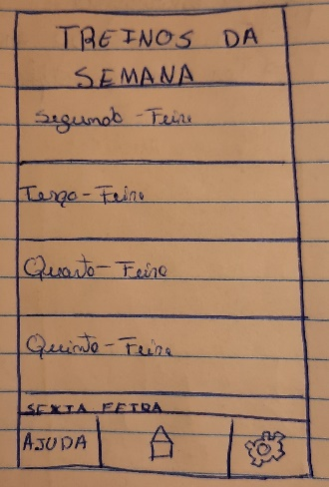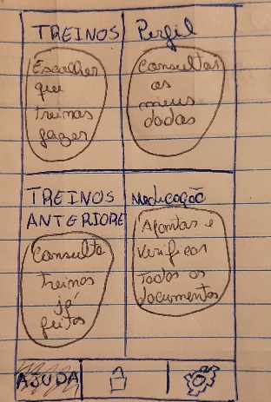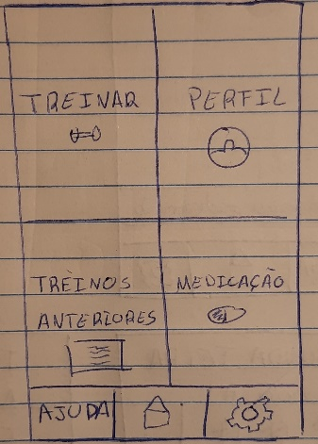

Figure 3-week workouts page

Figure 2-Tutorial demonstration on the main page

Figure 1 - Home page

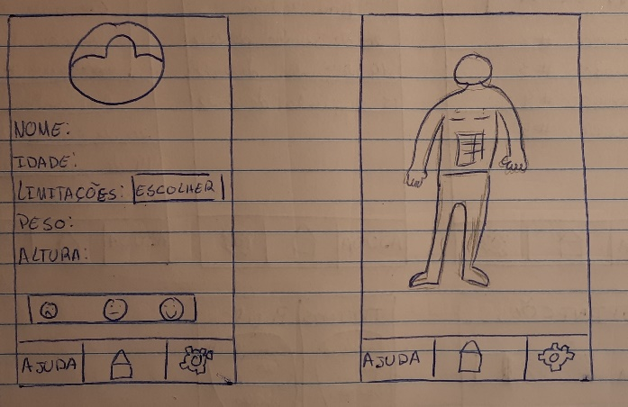

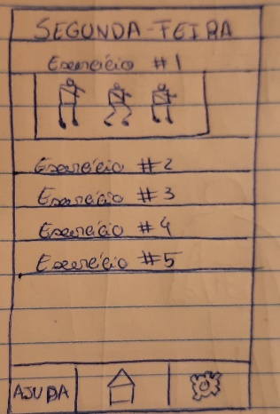

Figure 5-Monday workout

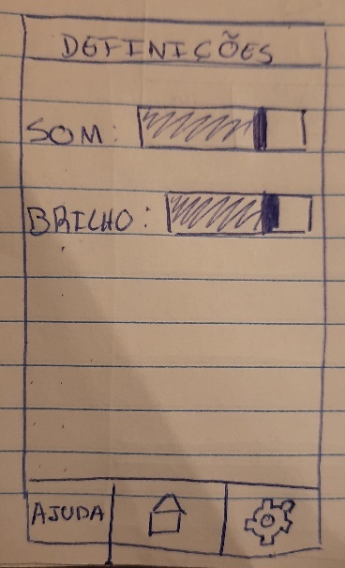

Figure 6-Settings page

Figure 4- Profile + Limitations pop-up

# TASK 09: Critical Analysis of the Project

Through the analysis of our participants, we concluded that we have to get a simpler layout for some of the pages in order to make an elderly person life easier while using the app.

Through the process sometimes we forgot how hard can be for elderly people to understand certain words, or how to use a smartphone.

We tried to fix that, and I think we came a long way but there are things we could improve, like the learning curve witch can be a bit steep.

## Strengths

-Simple layout.

-simple language.

## Weaknesses

- access to a touch screen device.

- steep learning curve (improved by even simpler language).

## Workload

Afonso: 30%

Rafael: 30%

Bernardo: 20%

André: 20%

Ivan: 0%