Metacognitive Exercise 1
(Recommendation: daily in the morning)
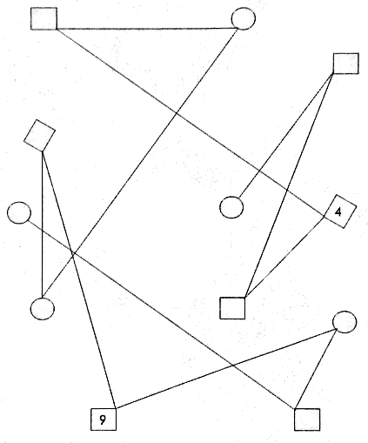
Trace the line with the writing hand with the pencils in colors red, orange, yellow, green, blue, purple (indigo) and violet. Start with the color red, trace the lines while completing the numbers from one through nine in the boxes and circles, to the end. Do that without supporting your elbow on the desk. Then switch to orange and do the same, till you’re through with all seven colors.
Metacognitive Exercise 2
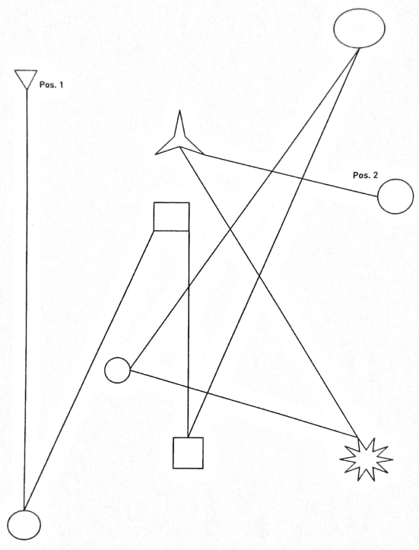
Trace the lines with your non-dominant hand, as described above.
Metacognitive Exercise 3
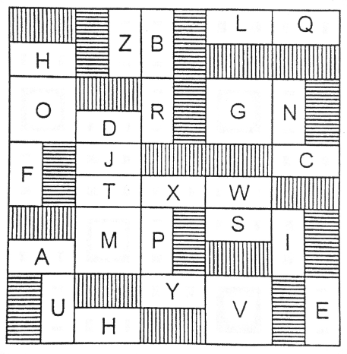
Trce the letters in an alphabetical order as described above. (There’s one letter appearing twice, on purpose. Find your way by not always choosing the same way. :-))

