Part Two

* In the following picture, we can see the active socket on netstat:
where 192.169.1.135 is the ip, using port 5060 for communication between the client and server.

* The following pictures shows the IPV4 packets, captured in Wireshark:
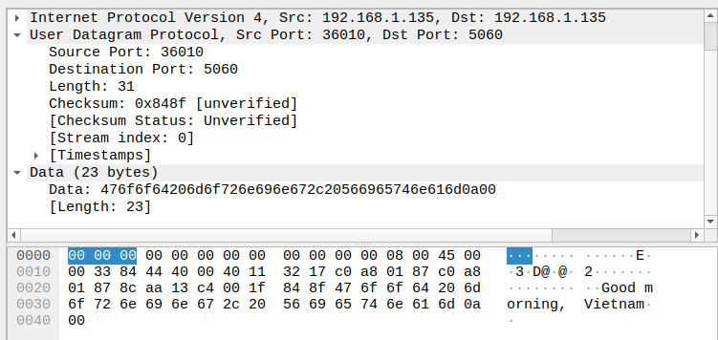
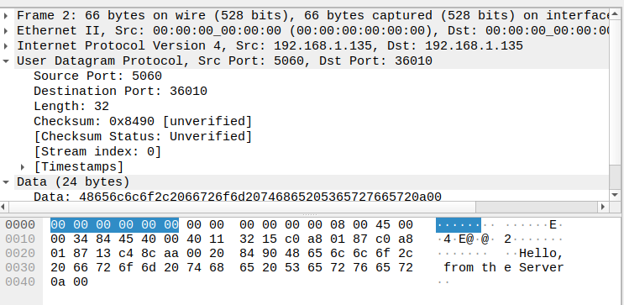

as the following shows the IPV6 packets:
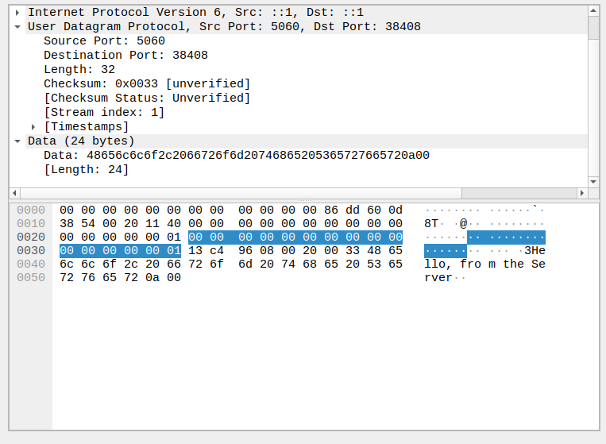
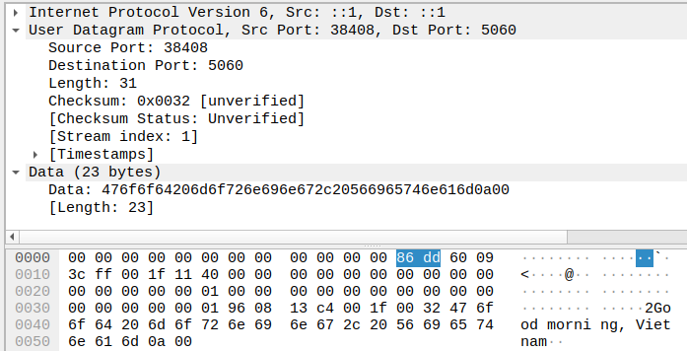

* The main differences between the two is the length - IPV6 header is much more bigger then IPV4’s – do to its larger adress (Ipv4 is 32 bits long while the other is 128 long), therefor IPV6 can produce much more ip adresses, which in modern times are required, dou to the increase of devices usage.

