

**AMERICAN INTERNATIONAL UNIVERSITY-BANGLADESH (AIUB)**

**Faculty of Science and Information Technology**

**Department of Computer Science**

**Undergraduate Program**

**Spring 2018-2019**

***SOFTWARE REQUIREMENT ENGINEERING***

|  |  |  |
| --- | --- | --- |
| **Names of Group Members** | **ID** | Section |
| DUTTA, ARNAB | 16-32068-2 | **B** |
| PLABON, MD. SHAHRIAR HASHIM | 16-32047-2 |
| SARKER, BRISTI RANI | 15-30402-3 |
| SAYEEF, MD. SALMAN | 15-30814-3 |

**CONTENTS**

**PAGES**

1. Reasons behind choosing the topic ----------------------------------- 2
2. Feature Lists ----------------------------------- 2
3. Requirement Analysis ---------------------------------- 2
4. Estimation(**Regular** Costs) ----------------------------------- 3
5. Estimation(**Marketing** Costs) ----------------------------------- 4
6. Profit Estimation ---------------------------------- 4
7. Project Scheduling --------------------------------- 5
8. Marketing Analysis ---------------------------------- 6
9. Social Impact ---------------------------------- 6
10. Risk Analysis ---------------------------------- 6
11. Collecting the requirements ---------------------------------- 6
12. Survey List ----------------------------------- 7
13. Profit Analysis ----------------------------------- 9

**2**

**Project Proposal**

**Topic:** **E-MEDICAL SYSTEM**

**Reasons behind choosing the topic:**

Our target for this project is to help the people through medical service. Suppose if any person has a high blood pressure or suddenly gets a pain that he is unable to move anywhere there is no possibility to get a good treatment. So, we want to make this kind of software that can help this kind of people. We want to target 3rd or 4th year medical student to help the people to overcome this kind of problem. This will be also effective for the medical student because it will be their income source. They can give the service and make money for this service.

**Feature Lists:**

Though we want to make software for this service we want to add some features for this software. The feature lists are given below:

->Login Option for User.

->Login Option for Employee.

->Medical Student Database.

->User Information Table.

**Requirement Analysis:**

Login:

1. User Name input field

2. Password field

3. Submit Button

4. Read User from the Database

5. Log the user into the system.

**3**

Logout:

1. Logout Button.

2. Clear Session.

3. Prevent from Theft.

Homepage:

1. Main page.

2. Doctor

3. Pharmacy.

4. Service.

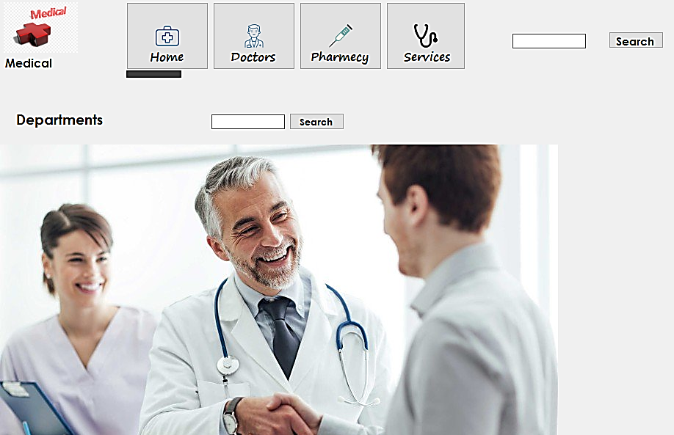

**Estimation(Regular Costs):**

1. Designer Cost = 50,000/-
2. Cost of workers = 5,00,000/-
3. Computers(20 in number) = 8,00,000/-

**4**

1. IPS & Generators cost = 15,000/-
2. Internet Cost = 3,000/-
3. Cost of the Developers = 10,00,000/-
4. Management cost = 2,00,000/-

**Estimation(Marketing Costs):**

1. Advertisement Cost = 20,000/-
2. Facebook Marketing = 5,000/-
3. YouTube Marketing = 5,000/-

So, (Regular + Marketing) cost = 25,98,000/-

**Profit Estimation:**

We found our project very helpful for the good health of the public. As public will become happy or satisfied on our system, there is no doubt for achieving good profit. After providing all the marketing and regular costs, the profit will remain nearly 50,00,000/

**5**

**Project Scheduling:**

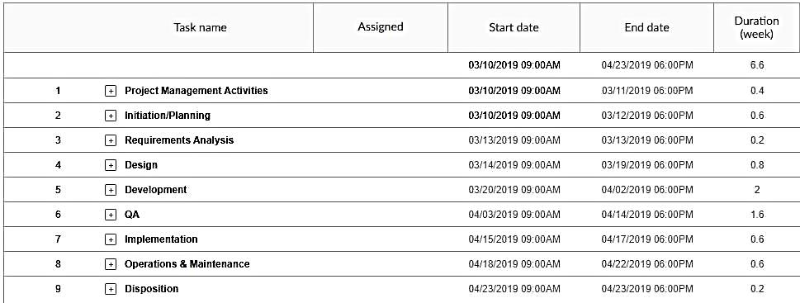

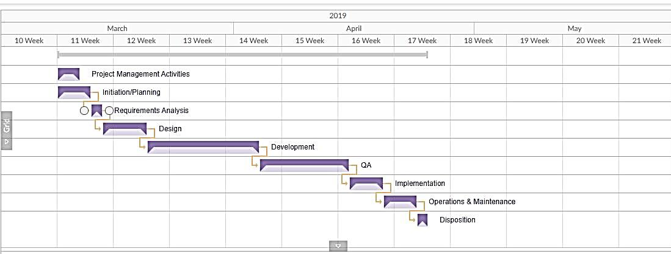

**6**

**Marketing Analysis:**

Pre –Launch marketing plan:

1. Research users and competitors.
2. Start early.
3. Create a website for app.
4. Start a blog.
5. Connect buzz with social media
6. Prepare a press kit.
7. Reach out to influencers.
8. Call for beta testers.
9. Optimize your app store listening.

**Social Impact:**

Our project has a major social impact. Because our project will help hose people who don’t have a way to get the proper treatment at a moment. This app will help them. This application will be a better income source for 3rd and 4th medical students because they are giving the service for helping the patients and earning some money. So, this application or system has a good social impact for the people.

**Risk Analysis:**

We have some problems for this project such as if the medical students are properly trained or not and the behavior from the medical student for the patient. Then, also our negative stakeholder is the key factor for our project. So, these will be our major risks to our project. And if we have to check the system it works properly or not and the patients get the proper treatment. So, these are the risks for our project.

**Collecting the Requirement:**

We are going to use the tool for collecting the requirements. For collecting the requirement we use this type of tool where each stakeholder gives their user story for each sprint. We response every user story as a requirement. So, these are the processes to collect the requirement for our project and to develop the application.

**7**

**Survey List:**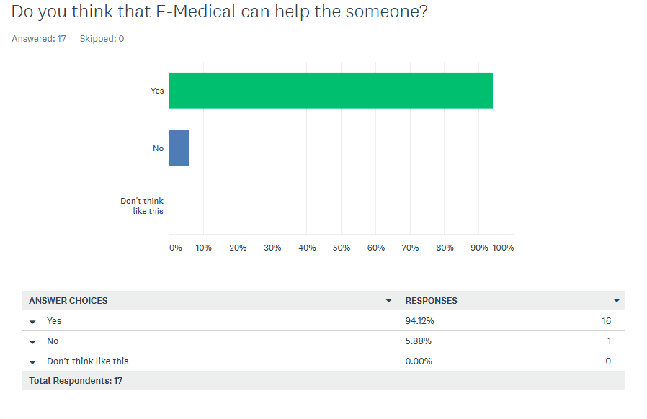

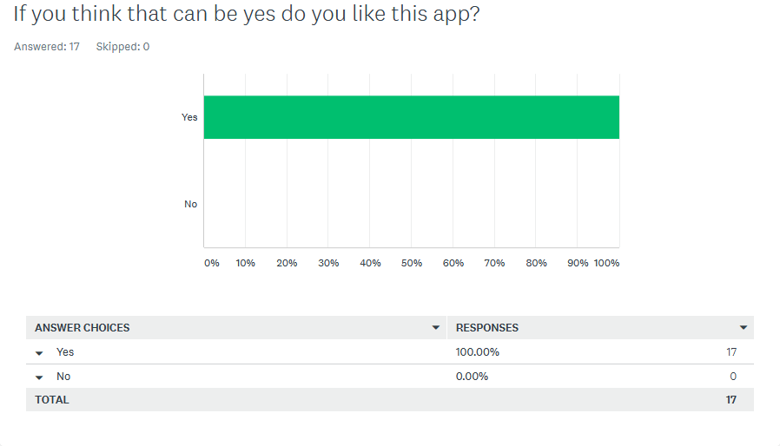

**8**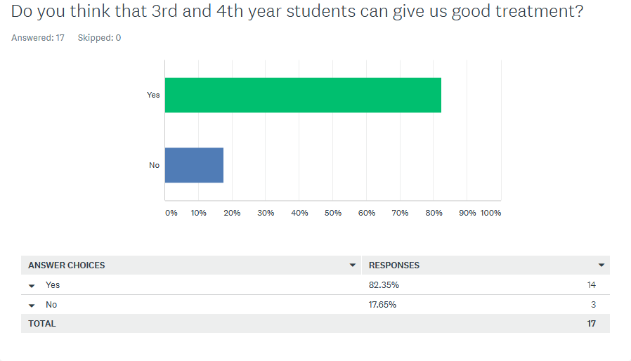

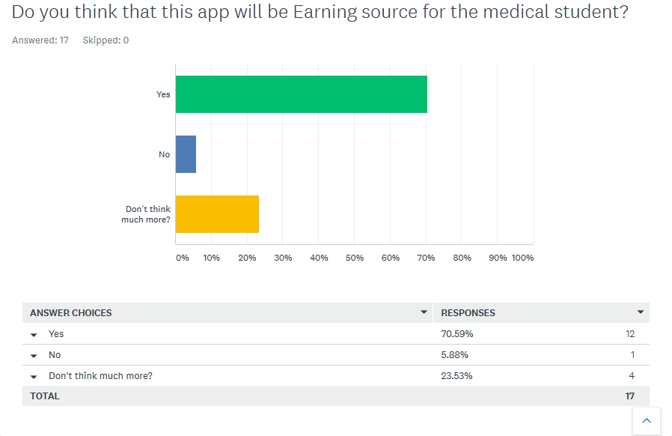

**9**

**Profit Analysis:**

This application will be a more profitable than other application. Because, people do not have to go to the medical for a simple issue. They just login the system and get a treatment. This thing will be profitable for our project management and we can make great income for this .Again, this will be an income source for the medical student and they can do more profit by giving more service to the patients.