Reproductive Cycle and Gametogenesis on Sea Anemones: a Sistematic Review

Rafael Brandão

18/09/2021

## Introduction

The modes of reproduction in sea anemones may be quite variable depending on the species. (Bocharova and Kozevich 2011)

## Material and Methods

In order to get a first glimpse on the universe of articles regarding the field of reproduction on sea anemones we have extracted data from Web of Science using the search line (“sea anemone” OR actiniari*) AND reproducti*. All search results obtained from this search were exported. Using this data we created a thesaurus for the Keywords to avoid bias caused by overlap of terms and did a co-occurence analysis using the VosViewer software.*  
*For the extensive data extraction we have used three different platforms, Web of Science, Scopus and ScienceDirect. The searching engine used was (“actiniaria” OR “sea anemone”) AND (spermatogenesis OR “reproductive cycle” OR “sexual reproduction” OR oogenesis OR “reproductive biology” OR gametogenesis). The use of special characters such as*  was conditioned to each platform. The search was set to filter preceding papers but included reviews and book chapters.  
Due to a low number of articles obtained after the first screening we have proceded with a forward and backward searching. For that pourpose we used four articles, Dunn (1970), Scott & Harisson (2009) and Bocharova & Kozevich (2011) and Young et al. 2021. The first two were chosen due to citation numbers, the third one is the most a recent review on sea anemone reproduction and the last one presents a comprehensive table of articles focused on reproductive studies.

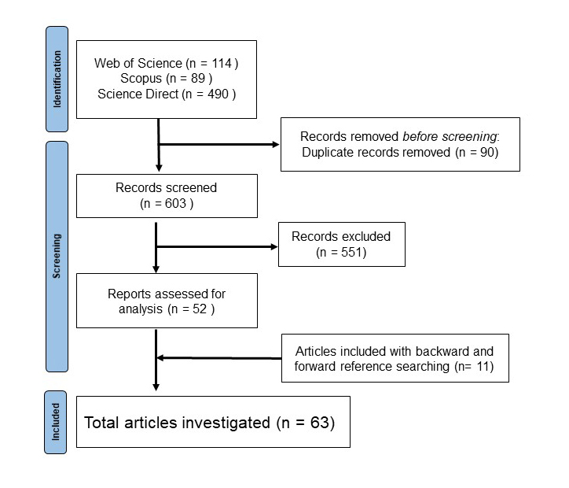

**Figure 1**. Article screening process and total articles included in this study

## Results

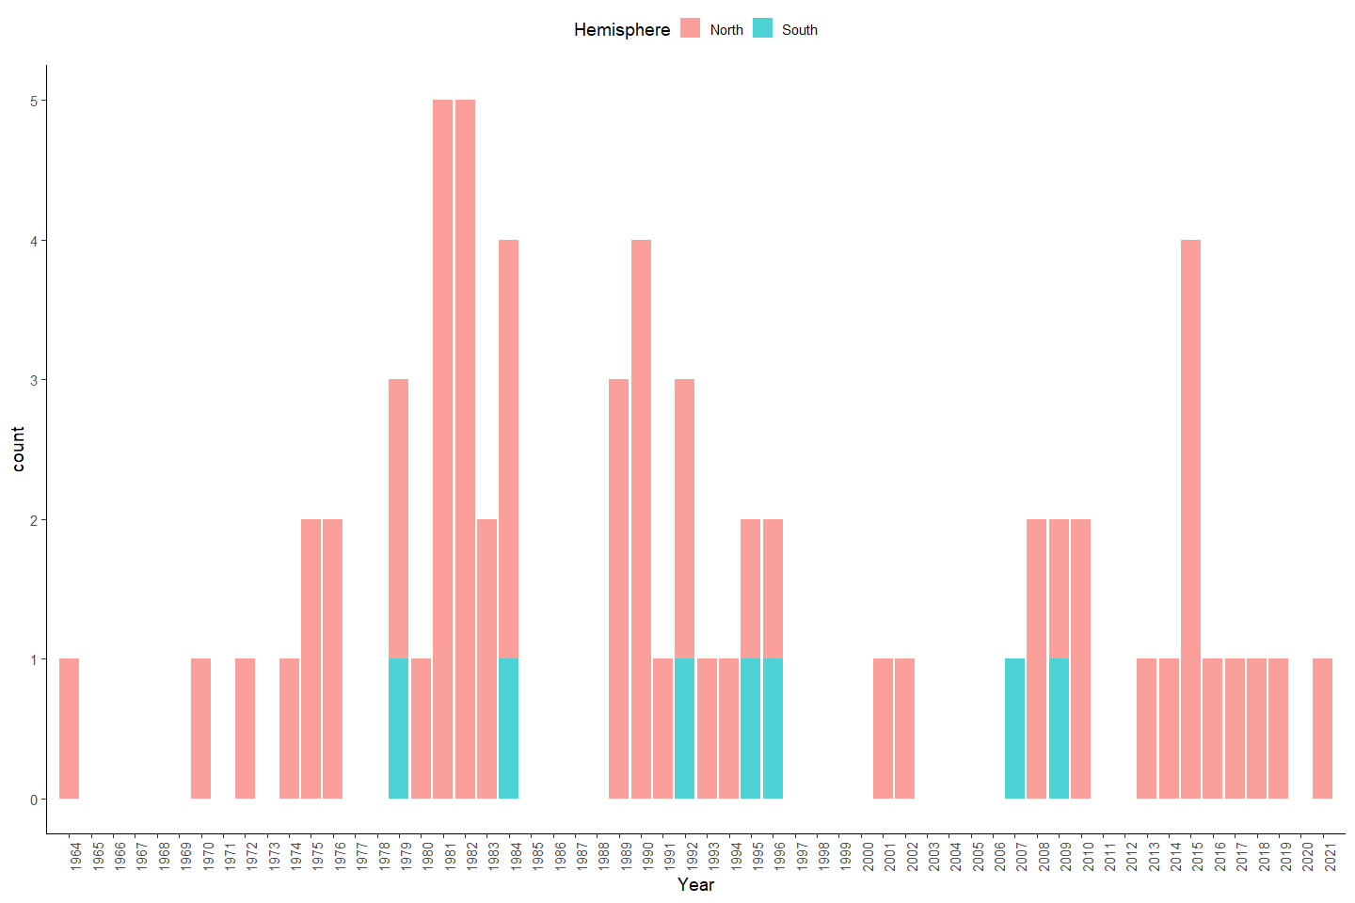

Figure 2. Number of studies published during the last 50 year

## # A tibble: 77 x 15  
## # Groups: Family [15]  
## ï..xx Year N.authors Title First.Author.Cou~ Sampling Hemisphere Species  
## <chr> <int> <int> <chr> <chr> <chr> <chr> <chr>   
## 1 "x" 1994 2 Effects~ Sweden Baltico North "Metri~  
## 2 "x" 1972 2 An Ultr~ USA Gulf of ~ North "Bunod~  
## 3 "x" 2014 5 Trioecy~ Israel Red Sea North "Aipta~  
## 4 "x" 2015 4 Seasona~ China China Sea North "Entac~  
## 5 "x" 1996 2 Genetic~ England Tasman S~ South "Antho~  
## 6 "" 2015 1 Reprodu~ Russia White Se~ North "Aulac~  
## 7 "" 1993 4 Reprodu~ United Kingdom Porcupin~ North "Amphi~  
## 8 "" NA 4 Reprodu~ United Kingdom Porcupin~ North "Kados~  
## 9 "" 1982 1 The ann~ USA Bodega B~ North "Metri~  
## 10 "" 2016 3 Body si~ USA Laborato~ North "Aipta~  
## # ... with 67 more rows, and 7 more variables: Genera <chr>, Family <chr>,  
## # Periodicity <chr>, Sampling.lenght <chr>, Oocyte.mesurement <chr>,  
## # Spermaries.classification <chr>, Temp.Sal.report <chr>

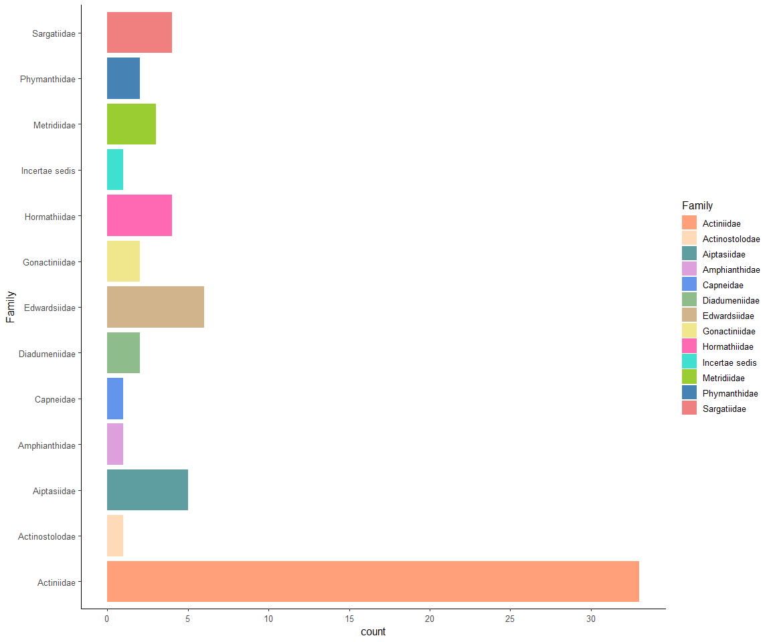

Figure 3. Number of studies published per family.

## # A tibble: 100 x 7  
## # Groups: maturity [1]  
## ï..x Species X Family Hemisphere months maturity  
## <chr> <chr> <chr> <chr> <lgl> <chr> <int>  
## 1 "x" "Entacmaea quadricolor" "" Actinii~ NA Septe~ 1  
## 2 "x" "Entacmaea quadricolor" "" Actinii~ NA Octob~ 1  
## 3 "" "Anthothoe albocincta " "South" Sargati~ NA March 1  
## 4 "" "Anthothoe albocincta " "South" Sargati~ NA April 1  
## 5 "" "Metridium senile" "" Metridi~ NA August 1  
## 6 "" "Metridium senile" "" Metridi~ NA Septe~ 1  
## 7 "" "Actinia equina" "" Actinii~ NA June 1  
## 8 "" "Actinia equina" "" Actinii~ NA July 1  
## 9 "" "Actinia equina" "" Actinii~ NA August 1  
## 10 "" "Anthopleura elegantissima" "" Actinii~ NA Septe~ 1  
## # ... with 90 more rows

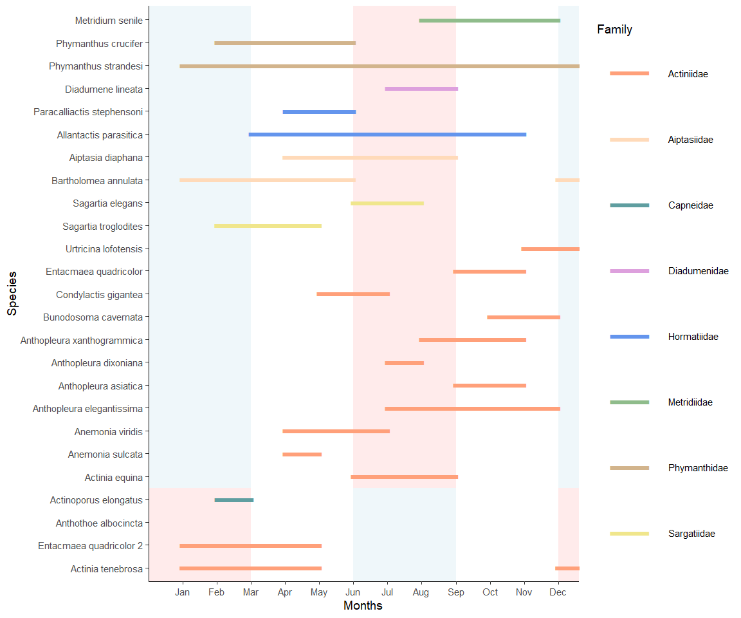 **Figure 4**. Peak reproductive maturity of male sea anemones. The red/blue rectangles represent either winter (blue) or summer(red) depending on the hemisphere. On the left side are the species names, which are grouped by hemisphere (bottom four species) and colored by family. The x axis indicate the months of the year. Each horizontal line on the graph indicates the period in which the males of the corresponding species is at its peak of maturity (most gametes are mature and it is followed by period with none or only immature gametes).

   
   
   
 

## # A tibble: 149 x 8  
## # Groups: Family [8]  
## ï..bla Family Species Hemisphere Depth..m. Local Months Maturity  
## <chr> <chr> <chr> <chr> <chr> <chr> <chr> <int>  
## 1 "x" Metridiidae "Metridium ~ North Shallow Baltico June 1  
## 2 "x" Metridiidae "Metridium ~ North Shallow Baltico July 1  
## 3 "x" Metridiidae "Metridium ~ North Shallow Baltico August 1  
## 4 "x" Metridiidae "Metridium ~ North Shallow Baltico Septe~ 1  
## 5 "" Sargatiidae "Anthothoe ~ South Shallow Tasman ~ March 1  
## 6 "" Sargatiidae "Anthothoe ~ South Shallow Tasman ~ April 1  
## 7 "" Metridiidae "Metridium ~ North Shallow Bodega ~ August 1  
## 8 "" Metridiidae "Metridium ~ North Shallow Bodega ~ Septe~ 1  
## 9 "" Actiniidae "Actinia eq~ North Shallow Mar do ~ June 1  
## 10 "" Actiniidae "Actinia eq~ North Shallow Mar do ~ July 1  
## # ... with 139 more rows

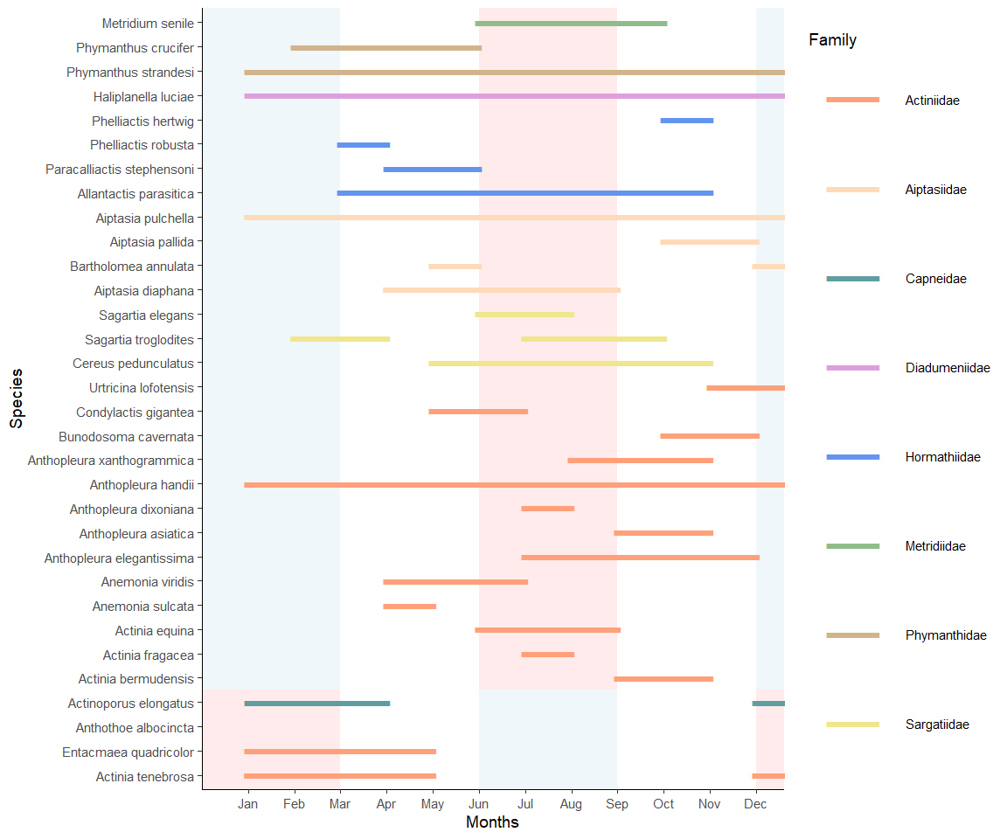

**Figure 5**. Peak reproductive maturity of female sea anemones. The red/blue rectangles represent either winter (blue) or summer(red) depending on the hemisphere. On the left side are the species names, which are grouped by hemisphere (bottom four species) and colored by family. The x axis indicate the months of the year. Each horizontal line on the graph indicates the period in which the males of the corresponding species is at its peak of maturity (Most gametes are mature and it is followed by period with none or only immature gametes).

# Discussion

Bocharova, ES, and IA Kozevich. 2011. “Modes of Reproduction in Sea Anemones (Cnidaria, Anthozoa).” *Biology Bulletin* 38 (9): 849–60.