PROJECT REPORT

CS4085-MLOPS

Name: Abdul Rafay

ID: 21i-2582  
  
  
  
  


*FAST NUCES, Islamabad*

*Department of Computer Science*

Contents

Data Collection Process 2

Data Sources 2

Collection Method 2

Collected features 2

Data Preprocessing 2

Model Development 3

Model Selection 3

Hyperparameter Tuning Strategy 3

Model Evaluation Metrics 3

Model Deployment 3

API Specification 3

Deployment Configuration 4

Monitoring and live testing 4

Prometheus Integration 4

Monitoring Components 4

Key Metrics Tracked 5

Grafana Integration 5

Monitoring Workflow 5

# Data Collection Process

## Data Sources

Data is collected from the following APIs

* OpenWeatherMap API
* AirVisual API (IQAir)

## Collection Method

* Automated script using DVC for version control
* Scheduled data fetching using cron jobs after every hour

**\* 0 * * * /usr/bin/python3 /home/abdulrafay/mlops/course-project-abdul-rafay-1/src/data_collection.py >> /home/abdulrafay/mlops/course>**

## Collected features

* Temperature
* Humidity
* Wind Speed
* Pollutant Concentrations (CO, NO2, O3)
* Particulate Matter (PM2.5, PM10)

## Data Preprocessing

**Following are the data Preprocessing Steps applied**

1. Missing Value Handling
   * Median imputation for missing values
   * Intelligent feature engineering
2. Outlier Removal
   * Interquartile Range (IQR) method
   * Removes extreme values that could skew predictions
3. Feature Engineering
   * Created lag features for time series prediction
   * Temporal feature extraction

# Model Development

## Model Selection

* Time Series Forecasting Model: ARIMA
* Hyperparameter Tuning:
  + Explored multiple ARIMA orders
  + Best Model selection based on RMSE

## Hyperparameter Tuning Strategy

* **Search Space**:
  + p (Autoregressive terms): 0 to 2
  + d (Differencing): 0 to 1
  + q (Moving Average terms): 0 to 2
* **Total Configurations Explored**: 18 unique ARIMA model configurations
* **Tuning Method**: Grid Search
* **Selection Criteria**: Root Mean Square Error (RMSE)

## Model Evaluation Metrics

* Root Mean Square Error (RMSE)
* Mean Square Error (MSE)
* Mean Absolute Error (MAE)

## Model Deployment

### API Specification

* Flask-based prediction endpoint
* Input: No input data. It predicts based on the data on which the model is trained
* Output:
  + Predicted AQI
  + Prediction Confidence Interval
  + Model Parameters

## Deployment Configuration

* Host: 0.0.0.0
* Port: 8000
* Prediction Endpoint: /predict
  + It is used to load model and predict the aqi.
* Health Check Endpoint: /health
  + It is used to check that API is up and running.

# Monitoring and live testing

## Prometheus Integration

* Wrote a monitoring_system.py script that calculates data ingestion and api performance.
* It starts Prometheus metrics sender on 9000 port.
* Configured Prometheus.xml in Prometheus directory

global:

scrape_interval: 15s

scrape_configs:

- job_name: 'prometheus'

static_configs:

- targets: ['localhost:9090']

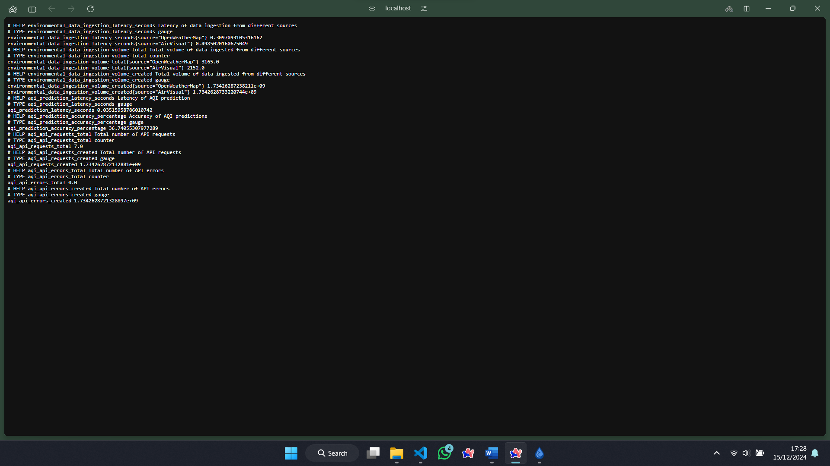

## Monitoring Components

* Prometheus Metrics Tracking
* Simulated Data Ingestion Monitoring
* API Performance Tracking
* Threaded Background Monitoring

## Key Metrics Tracked

* Data Ingestion Latency
* Data Ingestion Volume
* Model Prediction Latency
* API Request Tracking
* API Error Counting
* Prediction Accuracy Estimation

## Grafana Integration

* Sample dashboard configuration
* Graphs for latency and data volume

## Monitoring Workflow

1. Simulates data ingestion from multiple sources
2. Tracks API prediction performance
3. Generates metrics for Prometheus
4. Displays metrics on Grafana



