#include<iomanip>
#include<iostream>
using namespace std;
int main()
{
int i,j;
cout<<setw(4)<<"*";
for(i=1;i<=9;i++)
cout<<setw(4)<<i;
cout<<endl;
for(i=1;i<=9;i++)
{
cout<<setw(4)<<i;
for(j=1;j<=i;j++)
{
cout<<setw(4)<<i*j;
}cout<<endl;
}
return 0;
}
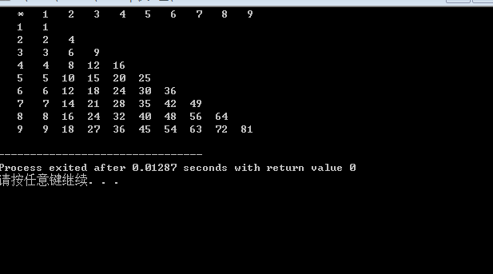
#include<iostream>
using namespace std;
int main()
{
int i,j;
cout<<"*"<<" ";
for(i=1;i<=9;i++)
cout<<i<<" ";
cout<<endl;
for(i=1;i<=9;i++)
{
cout<<i<<" ";
for(j=1;j<=i;j++)
{
cout<<i*j<<" ";
}cout<<endl;
}
return 0;
}
