LAHORE GARRISON UNIVERSITY
Department of Computer Science
Final Year Project
AICC: An AI Campus Companion for Academic Assistance and Campus Navigation
Submitted by
Abdul (BSCS–________–____)
________________ (BSCS–________–____)
________________ (BSCS–________–____)
________________ (BSCS–________–____)
Session 2023–2026
Supervised by
_______________________________
Teacher Name
Department of Computer Science
Lahore Garrison University
Lahore
Complete the underlined blanks before binding: full name, roll number, section, any co-authors, and the internal supervisor. Those details are not stored in the project repository, so they are left blank here rather than guessed.

AICC: An AI Campus Companion for Academic Assistance and Campus Navigation
A project submitted to the
Department of Computer Science
In
Partial Fulfillment of the Requirements for the
Bachelor’s Degree in Computer Science
By
Abdul
________________
________________
________________
Internal Supervisor
_______________________________ _______________________
Teacher Name Designation
Department of Computer Science
External Examiner
_______________________________
Chairperson
Dr. Erum Mehmood _______________________
Assistant Professor
Department of Computer Science

Copyright
This is to certify that the project titled “AICC: An AI Campus Companion for Academic Assistance and Campus Navigation” is the genuine work carried out by Abdul and the group members named on the declaration page, students of BS Computer Science in the Department of Computer Science, Lahore Garrison University, Lahore, during the academic session 2023–2026, in partial fulfilment of the requirements for the award of the degree of Bachelor of Science in Computer Science, and that the project has not formed the basis for the award previously of any other degree, diploma, fellowship, or any other similar title.
Abdul ______________________________
________________ ______________________________
________________ ______________________________
________________ ______________________________

Declaration
This is to declare that the project entitled “AICC: An AI Campus Companion for Academic Assistance and Campus Navigation” is an original work done by the undersigned, in partial fulfilment of the requirements for the degree “Bachelor of Science in Computer Science” at the Department of Computer Science, Lahore Garrison University, Lahore.
All the analysis, design, and system development described in this report have been accomplished by the undersigned. This project has not been submitted to any other college or university. Handbook answers used by the assistant are drawn from institutional student-information material and are not presented as a new statement of university policy. Where a rule and a live office notice disagree, the office notice remains authoritative.
Group Members
Abdul ________________
________________ ________________
________________ ________________
________________ ________________
Supervisor
________________ ________________
Date: ________________

Dedication
This work is dedicated to our families, whose patience covered the long evenings of building, testing, and walking the campus with a phone in hand, and to the students who lose time looking for a room, a teacher, or a document that should have been one question away.
It is also dedicated to the teachers who insist that a useful system must be explainable. A campus assistant that invents a room number or a fee is not a convenience. It is a new problem. This project tries to be the other kind.

Acknowledgements
We thank the Department of Computer Science at Lahore Garrison University for the chance to treat a daily campus difficulty as a final-year engineering problem. We thank our internal supervisor for review of the scope, for insisting that personal academic records stay separate from generated answers, and for the time given to design discussions. The supervisor’s name is to be entered on the title page.
We thank the chairperson and the faculty who reviewed intermediate demonstrations. We thank classmates who tried the chat in English and in Roman Urdu and told us when a place name failed. We thank the authors of the open tools used in the implementation, including Flutter, FastAPI, Firebase, and the map libraries, and the authors of the classical graph-search and retrieval papers cited in this report.
Any remaining error in a route, a coordinate, or a handbook paraphrase is ours. The university’s own offices remain the authority for attendance, fees, examinations, and conduct.

Table of Contents
The entries below follow the heading styles of this document. In Microsoft Word, right-click the field and choose Update Field if page numbers need to be refreshed after a later edit.
Copyright iii
Declaration iv
Dedication v
Acknowledgements vi
Table of Contents vii
List of Tables xii
List of Figures xiii
List of Abbreviations xiv
Abstract xv
Chapter 1 Introduction 1
1.1 Background 1
1.2 The need this project addresses 1
1.3 Aim 2
1.4 Objectives 2
1.5 Scope 2
1.6 Intended users 3
1.7 Significance 3
1.8 Assumptions and constraints 4
1.9 Outcome-based framing 4
1.10 Organisation of the report 4
Chapter 2 Literature Review 6
2.1 Introduction 6
2.2 Campus information systems 6
2.3 Conversational assistants and invented answers 6
2.4 Retrieval-augmented generation 7
2.5 Outdoor pedestrian navigation 8
2.6 Indoor positioning and floor-plan navigation 8
2.7 Graph search for wayfinding 9
2.8 Mobile structure relevant to this system 9
2.9 Comparison with existing approaches 10
2.10 Summary 10
Chapter 3 Problem Definition 11
3.1 Problem statement 11
3.2 Stakeholders 11
3.3 The situation the project starts from 11
3.4 Gaps 12
3.5 Proposed solution 12
3.6 Success criteria 12
3.7 Summary 13
Chapter 4 Software Requirement Specification 14
4.1 Introduction 14
4.2 Product perspective 14
4.3 User classes 14
4.4 Functional requirements 14
4.5 Non-functional requirements 16
4.6 External interface requirements 17
4.6.1 User interface 17
4.6.2 Software interfaces 17
4.6.3 Hardware and communication 17
4.7 Data requirements 17
4.8 Use cases 18
4.8.1 Narrative of the principal use case 19
4.9 Constraints and assumptions carried into design 19
4.10 Summary 20
Chapter 5 Methodology 21
5.1 Development process 21
5.2 Tools and technologies 21
5.3 Conversation and grounding method 22
5.4 Outdoor routing method 22
5.5 Indoor routing method 23
5.6 Data, security, and evaluation method 24
5.7 Summary 24
Chapter 6 Detailed Design and Architecture 25
6.1 System architecture 25
6.1.1 Architecture design approach 25
6.1.2 Architecture design 25
6.1.3 Subsystem architecture 26
6.2 Detailed system design 28
6.2.1 Classification 28
6.2.2 Definition 28
6.2.3 Responsibilities 29
6.2.4 Constraints 29
6.2.5 Composition 29
6.2.6 Uses and interactions 29
6.2.7 Resources 31
6.2.8 Processing 32
6.2.9 Interface and exports 32
6.2.10 Detailed subsystem design 33
6.2.10.1 Use cases 33
6.2.10.2 Information model 33
6.2.10.3 Indoor class responsibilities 35
6.2.10.4 Failure behaviour 36
6.3 Summary 36
Chapter 7 Implementation and Testing 37
7.1 Development environment 37
7.2 Application structure 37
7.3 Core student functions 37
7.4 Campus guide and indoor map 38
7.5 Service implementation 39
7.6 Seed data and content 39
7.7 Testing methodology 40
7.8 Accuracy, performance, and scale 40
7.9 Summary 41
Chapter 8 Results and Discussion 42
8.1 Evaluation setup 42
8.2 Functional test cases 42
8.3 Chatbot checks 43
8.4 Navigation checks 43
8.5 Discussion against the problem 44
8.6 Requirement coverage 44
8.7 Limitations 45
8.8 Summary 45
Chapter 9 Conclusion and Future Work 46
9.1 Conclusion 46
9.2 How the objectives were met 46
9.3 Recommendations 47
9.4 Future work 47
References 48

List of Tables
Tables are numbered by chapter. The captions in this edition are:
• Table 2.1 Comparison of AICC with nearby alternatives
• Table 4.1 User classes and responsibilities
• Table 4.2 Functional requirements
• Table 4.3 Non-functional requirements
• Table 4.4 Use-case catalogue
• Table 5.1 Tools and responsibilities
• Table 5.2 Indoor route costs
• Table 6.1 Subsystem responsibilities
• Table 6.2 Design attributes of the main components
• Table 7.1 Automated test modules
• Table 8.1 Functional test cases
• Table 8.2 Chatbot checks
• Table 8.3 Navigation checks
• Table 8.4 Requirement coverage

List of Figures
The figures in Chapter 6 are:
• Figure 6.1 Use-case diagram
• Figure 6.2 Entity-relationship diagram
• Figure 6.3 System architecture
• Figure 6.4 Activity diagram for a campus question
• Figure 6.5 Sequence diagram for a grounded answer
• Figure 6.6 Component diagram
• Figure 6.7 Navigation state machine
• Figure 6.8 Class diagram of the navigation model
• Figure 6.9 Context data-flow diagram
• Figure 6.10 Database diagram

List of Abbreviations
Abbreviations are written in full at first use in the body. This list is the reference for the remainder of the report.
AICC: AI Campus Companion
API: Application Programming Interface
BM25: Best Matching 25, a ranking function for text search
CGPA: Cumulative Grade Point Average
CRUD: Create, Read, Update, and Delete
DFD: Data Flow Diagram
ER: Entity–Relationship
FCM: Firebase Cloud Messaging
GPS: Global Positioning System
HTTP: Hypertext Transfer Protocol
JSON: JavaScript Object Notation
LGU: Lahore Garrison University
LLM: Large Language Model
OBE: Outcome-Based Education
QR: Quick Response code
RAG: Retrieval-Augmented Generation
REST: Representational State Transfer
SDK: Software Development Kit
SRS: Software Requirements Specification
TTS: Text to Speech
UI: User Interface
UML: Unified Modeling Language

Abstract
Students at Lahore Garrison University already hold several questions at once: where a room is, whether a fee challan is ready, what the attendance rule is, and which office to ask when the rule is unclear. The information exists, but it is split across notices, a handbook, a portal, and the memory of senior students. A general chat model can sound confident while naming a room or a balance that was never stored. A public road map can guide a visitor to the gate and still know nothing about the walkway between that gate and the library.
This project presents AICC, a mobile campus companion for that setting. The Android application, built with Flutter, gives a signed-in student a dashboard of stored academic facts, a conversational assistant, teacher profiles, notifications, an outdoor campus map, and indoor floor directions. A FastAPI service holds student records, places, and the handbook. Place questions are answered on the phone from a maintained list, so a coordinate is never invented. Open questions are answered only after handbook passages are retrieved with BM25 and embeddings. A language model on the server may phrase those passages. It may not invent attendance, a CGPA, a document status, or a teacher’s live location. Outdoor walking uses Dijkstra on a campus graph. Indoor walking uses A* on a building graph, with an explicit cost for stairs and for the lift. Outside the campus outline, the application hands the walk to Google Maps.
The work was built in short, demonstrable increments and checked with automated tests for place matching, intent, outdoor routing, and indoor routing, plus a scripted set of chatbot and navigation checks. A surveyed GPS-error log is still empty, and the Block B floor drawings used in the demonstration are a sketch until official plans are approved. Within those limits, the system keeps answers attached to records the university can edit, and it gives a student a path the public map does not contain.

Chapter 1 Introduction

1.1 Background
A university campus is a small city with its own gates, timings, offices, and language. A new student learns it by asking. A returning student relearns it every semester when a class moves, a challan appears, or a consultation hour changes. Lahore Garrison University, in this project called LGU, already publishes much of that knowledge. The difficulty is not the absence of information. It is that the information does not travel with the student who is standing in a corridor with a question.
Mobile phones are already the tool students use for that question. Messaging a friend works until the friend is wrong. Searching the public web works until the answer is local. Opening a general chatbot works until the chatbot prefers a fluent sentence over a stored fact. Each of those habits is reasonable. Together they produce a daily tax of walking to the wrong block, missing a window at an office, or trusting a number that was never on a challan.
AICC, the AI Campus Companion, is a final-year system built for that tax. It is a Flutter application for the student and for a campus administrator, backed by a FastAPI service. The student can see stored academic facts, ask questions in ordinary language, and follow a walking route that includes paths inside the campus and, for a prepared building, paths between floors. The administrator can correct a place, a student record, or a notice without shipping a new application.

1.2 The need this project addresses
Three needs sit on top of one another. The first is orientation. A visitor or a first-semester student can see the main gate and still not know which walkway leads to the Central Library, the LGU Cafe, or Classroom B-104. Public mapping services are strong on city roads. They are weak on the paved paths, lawns, and indoor stairs that actually join those places.
The second need is a trustworthy answer. Attendance rules, library hours, fee practice, and examination conduct are written down. A student should be able to ask in English or in Roman Urdu and receive the written rule, not a paraphrase that adds a fine or a deadline. When the question is personal, such as “what is my attendance?”, the answer must come from that student’s record. When the question is not in the handbook, the honest answer is to name the office that can confirm it.
The third need is one place to start. Fee challans, roll-number slips, teacher consultation hours, and campus notices already have homes. Students still hunt across screens. A companion does not replace the registrar or the portal. It gives a signed-in student a short path to the record that already exists, and a short path to the place named in that record.

1.3 Aim
The aim of this project is to design and implement a campus companion that answers student questions from maintained data, shows the related place when one exists, and computes a walking route on the university’s own paths. The companion must remain usable when a language model is unavailable, because place lookup and personal records do not depend on one.

1.4 Objectives
• Provide a signed-in student dashboard for CGPA, current-semester courses, attendance, fee challans, and roll-number slips drawn from the campus record.
• Answer place questions from a maintained place list, including aliases, before any language model is called.
• Answer open handbook questions by retrieving passages and allowing a server-side model to phrase only those passages.
• Refuse questions that are outside the handbook, and never let the model invent a personal mark, a fee status, or a coordinate.
• Compute an outdoor walking route with Dijkstra on a published campus graph, and hand off to a public map when the student is outside the campus.
• Compute an indoor route with A* on a building graph, including stairs and lift, and explain the route as steps.
• Give an administrator tools to maintain students, teachers, notices, places, and indoor areas without an application update.
• Support English and Roman Urdu for place names and handbook questions, and keep the language-model key on the server.

1.5 Scope
The delivered scope is the Android application and the campus service that the application calls. Student features are sign-up and sign-in, the home dashboard, UniBot chat with voice input and spoken replies, chat history, notifications, a teacher directory, light and dark appearance, the outdoor campus guide, and the indoor floor map. Administrator features are a dashboard of counts, student and teacher maintenance, a broadcast, an activity log, place editing, walkway editing, QR codes for a start point, and indoor area editing.
The campus record used for demonstration covers three departments in the seed data, BS Computer Science, BS Psychology, and Bachelor of Business Administration, with sections and semesters sufficient to exercise the dashboard. Places include gates, the cafe, the library, the admin block, labs, and Classroom B-104, among others. Outdoor coordinates are a working sketch of the DHA Phase 6 campus and are meant to be replaced by a survey. Indoor geometry is a Block B demonstration building. Live bus tracking, hostel allocation, course registration itself, and official result publication stay outside the system. The assistant may explain where those tasks are done. It does not perform them.

1.6 Intended users
The primary user is an enrolled student who already has, or can create, an application account tied to a registration number such as FA26-BSCS-001. That student may be new to the campus or may simply want a faster answer during the semester. The secondary user is a campus administrator who corrects records, publishes a notice, and keeps the place list aligned with the buildings people actually use. Teachers appear as profiles the student can search. They are not required to operate the application for the student scenarios in this report. A visitor who is not signed in is not a full user. Outdoor handoff to a public map is still available as a direction when a signed-in student is off campus.

1.7 Significance
The practical significance is time and fewer wrong turns. A place card that opens the map, a route that follows internal walkways, and a document that opens from the same conversation remove a chain of separate searches. The academic significance is the separation of duties. Retrieval, a graph, and a student record each do the job they are good at. A language model is used where wording helps and is withheld where a wrong number would matter. That separation is the engineering contribution, more than any single screen.
There is also a maintenance significance. A new cafe alias, a changed library hour, or a moved classroom is a data change. The application does not need to be rebuilt for the place list or the handbook to move. This is why the project does not fine-tune a model on today’s campus facts. Fine-tuning would bury those facts inside weights that an administrator cannot edit on the day the hour changes.

1.8 Assumptions and constraints
• The student has an Android phone with a network connection for the first load of records. Place matching can then use the list already fetched.
• Registration numbers follow the campus pattern of intake, department code, and serial, and the department code must match the stored department.
• GPS inside a building is not treated as a reliable position. An indoor route starts from a chosen node or from a QR code at a door or stair.
• The language-model provider may be rate-limited or offline. Place answers, the dashboard, and graph routing must still function.
• Handbook text is an aid. It is not a substitute for a signed notice from the registrar, the examination office, or the department.
• Demonstration coordinates are not a surveyed map. Distance and time on the outdoor route are only as good as the graph an administrator publishes.

1.9 Outcome-based framing
This report is organised as an outcome-based final-year document. The problem is a complex computing problem in the ordinary sense used for such programmes: it crosses mobile interaction, information retrieval, graph search, security of credentials, and institutional data ownership. The requirements conflict. Students want a short answer, while the institution needs that answer to stay inside published rules. A single public map would be simpler and would miss internal paths. A single chatbot would be simpler and would be free to invent. The design in later chapters is the resolution of that conflict, not a catalogue of features.
No official programme-learning-outcome numbering is printed here, because that numbering belongs to the department’s current outcome map and should be attached by the supervisor at assessment. The objectives in Section 1.4 are written so that they can be mapped onto problem analysis, design, implementation, and evaluation without rewriting the system.

1.10 Organisation of the report
Chapter 2 reviews campus assistants, grounded question answering, outdoor pedestrian graphs, and indoor positioning, and compares this project with a plain chatbot and with a public map alone. Chapter 3 states the problem, the stakeholders, and the success criteria. Chapter 4 is the software requirements specification: users, functions, quality requirements, interfaces, and use cases. Chapter 5 explains the method, the tools, and the routing and retrieval choices. Chapter 6 describes the architecture and the detailed design, including the required diagrams. Chapter 7 describes the implementation and the testing approach. Chapter 8 reports the checks that were defined and what they show, including the limits that remain. Chapter 9 concludes and lists future work.
This chapter has introduced the campus setting, the three needs of orientation, trustworthy answers, and a single starting place, and the boundary of what AICC will and will not do. The next chapter places those choices against published practice.

Chapter 2 Literature Review

2.1 Introduction
The companion sits at an intersection that already has a literature: university information systems, conversational question answering, pedestrian navigation, and indoor positioning. This chapter reads that literature only as far as it changes a design decision. A method is included when it was adopted, rejected, or kept as a boundary. The chapter closes with a comparison against the two alternatives a student would otherwise use, a general chatbot and a public map.

2.2 Campus information systems
Universities have long separated the system of record from the system of conversation. Portals hold registration, attendance, and fees because those facts must be auditable. Notice boards and handbooks hold rules because those rules must be citable. Early campus applications often copied one of those stores onto a phone as a list. The list is reliable and silent. It does not help a student who can describe a need but cannot name the menu that holds it.
Later campus applications added search and, more recently, chat. The gain is that “where can I eat?” is a real question and “Food services” is an administrative category. The loss, documented across knowledge-intensive question answering, is that a generative model will answer even when the store has no passage. Lewis and colleagues showed that retrieval-augmented generation reduces this failure by conditioning the model on retrieved text rather than on the model’s memory alone [3]. That result is the reason AICC retrieves handbook passages before it asks a model to speak.
A second lesson from information systems is ownership. If the assistant is the only copy of a rule, the assistant becomes an ungoverned policy office. AICC therefore treats the handbook file and the student record as the sources. The chat text is a view. An administrator who changes a place or a record changes what the next question can say. This is closer to a maintained knowledge base than to a model trained once and frozen.

2.3 Conversational assistants and invented answers
A large language model is a strong paraphraser and a poor ledger. It will produce a plausible attendance percentage, a plausible room, or a plausible fine because plausibility is what its training rewards. In a campus setting that behaviour is not a minor tone problem. A student may miss an examination or pay the wrong amount. The design response in the research literature is to ground the answer: retrieve, then generate, and decline when retrieval fails.
Grounding still fails if the retriever returns a near miss and the model treats it as a hit. BM25, the ranking function reviewed by Robertson and Zaragoza, scores a passage by how distinctive the shared words are, not by how fluent a later sentence could be [4], [6]. Embedding similarity catches a paraphrase that shares few exact words. AICC uses both scores. It also keeps a separate, non-generative path for questions whose answer is a place or a personal record. Those answers are lookups. Generation is the wrong tool, so it is not used.
Language is part of the same problem. Students at LGU ask in English, in Urdu script, and in Roman Urdu. A retriever that only tokenises English will miss “library kahan hai”. The handbook entries used by the service keep an English question, an Urdu question, and a Roman Urdu question beside one answer. Detection of script and of Roman markers chooses the wording of a refusal. The fact itself stays the stored sentence.

2.4 Retrieval-augmented generation
Retrieval-augmented generation, usually shortened to RAG, splits an answer into a search step and a writing step. The search step is inspectable. A reviewer can see which passage was offered to the model. The writing step is where tone, length, and the student’s last few turns are handled. Lewis and colleagues introduced the pattern for knowledge-intensive tasks and showed gains when the model is allowed to read retrieved text at answer time. The campus service follows that pattern with a small, closed corpus: the student handbook, not the open web.
The closed corpus is a deliberate limit. Web search would answer “who won a cricket final” and would also answer campus questions with pages the university does not control. The system prompt used by the service tells the model to quote numbers, days, and fees as written, to stay within two to four sentences, and to say when no entry matched. If retrieval finds nothing, the spoken fallback names the Registrar or the relevant office. That sentence is also stored, in English, Urdu, and Roman Urdu, so the refusal is not itself generated from imagination.
Place cards are not left to the model. After an answer is planned, place identifiers are copied from the retrieved entry, or from a small food-word rule that points at the cafe. The model never chooses a latitude. This is stricter than generic RAG, and it is the right strictness for a map. A fluent sentence can be slightly loose. A pin cannot.

2.5 Outdoor pedestrian navigation
Road navigation is a solved product for cities. It is the wrong product for a campus interior, because the fastest driving route is irrelevant and the pedestrian graph inside the gate is invisible to the city map. Campus wayfinding research therefore builds a local graph: gates, path junctions, and destinations, with edges that follow walkways rather than roads. Dijkstra’s algorithm computes a minimum-cost path on a graph with non-negative edge weights [1]. It is appropriate here because a walkway cost is a distance, and a distance is non-negative.
A public map remains the right product outside the gate. Re-implementing city routing would add a dependency and would still be worse than the product students already trust on roads. The design boundary is geographic. Inside a published campus outline, AICC routes on its graph. Outside it, the application opens a walking link toward the nearest gate. The student is not asked to understand that split. The session simply changes tool.
Cost quality depends on the survey. An edge with a measured length is an honest cost. An edge with a missing length must still allow a path, or the graph breaks the day an administrator adds a node and forgets a metre value. The outdoor router uses a fallback of 25 metres and marks the route as estimated. The mark matters. A confident time built on a placeholder would repeat the chatbot failure in another form.

2.6 Indoor positioning and floor-plan navigation
Indoor positioning surveys, including the review by Zafari, Gkelias, and Leung, catalogue radio maps, inertial sensors, magnetic fingerprints, and visual methods [5]. All of them can work in a prepared building. All of them need a survey, calibration, and a tolerance for drift. GPS, which students already have, is regularly poor indoors because the satellite signal is blocked or reflected. A navigation feature that trusts that signal between two classrooms will draw the student through walls.
This project rejects live radio positioning for the first delivery. The building is represented as floors, rooms, and a navigation graph in local metres. A stair or a lift is an edge with a floor-change cost, not a guessed vertical GPS jump. The student’s start is a node they choose, or a QR code posted at a door or stair that names the node. QR positioning is coarse. It is also understandable, cheap, and stable. The student can see the code that set their start. A radio fingerprint cannot be shown in the same way.
Floor drawings in the demonstration are a sketch of Block B. Official architectural sheets were not cleared for inclusion. The graph, not the picture, is what the router trusts. A later replacement of the picture does not require a new algorithm if the nodes stay tied to doors and junctions. That split, picture for the eye and graph for the route, is the indoor design.

2.7 Graph search for wayfinding
Dijkstra’s algorithm expands the closest unsettled node until the goal is settled. It is optimal for non-negative costs and it does not need a heuristic. A*, introduced by Hart, Nilsson, and Raphael, uses a heuristic that estimates the remaining cost [2]. When the heuristic never overestimates, A* is also optimal and usually expands fewer nodes. On a building floor the straight-line distance in local metres is such a heuristic, because a person cannot walk shorter than the straight line and may have to walk longer around rooms.
The indoor router implements both. The student path uses A*. A zero heuristic reduces the same code to Dijkstra, which is kept so tests can compare the two searches on one graph. Preferences are costs, not a second algorithm. Preferring stairs adds a penalty to lift edges. A stair flight adds a per-floor cost larger than a lift stop, so the default path takes the lift when both exist, and the student can still ask for stairs. Turn instructions ignore small heading changes so a gently bent corridor does not become a list of tiny turns.

2.8 Mobile structure relevant to this system
The application is a client of two stores. One store is the campus service: records, places, indoor maps, and chat. The other is a mobile Firebase project: authentication, chat transcripts, faculty profiles, and activity. This split follows a common mobile pattern. Authentication and private user documents want a vendor SDK with rules. Shared campus facts want an HTTP API the same administrator can also open in a browser. Putting the language-model key in the phone would make every installed copy a credential. The key stays in the service environment.
State on the phone is intentionally small. A session object holds the signed-in student. Screens ask repositories for lists. Routing is a pure function of a graph and two identifiers. That purity is why the outdoor and indoor routers can be tested without a device. Widget tests cover the screens that must show a banner when location is denied or a card when a place matches. The literature on testable architecture is simply applied here. The algorithm is not mixed into the widget that paints the line.

2.9 Comparison with existing approaches
Table 2.1 compares AICC with the two approaches a student can already attempt, and with a radio-based indoor system of the kind surveyed in the positioning literature. The comparison is about fit to this campus problem, not about which technology is generally superior.
Table 2.1 Comparison of AICC with nearby alternatives
Need | General chatbot | Public map alone | Radio indoor positioning | AICC
Place pin | May invent a place | City pin, not a room | Needs a surveyed radio map | Stored place list and node
Handbook rule | May invent a number | Does not answer | Does not answer | Retrieved passage, then a short wording
Personal CGPA | Must not be guessed | Does not answer | Does not answer | Read from the student record
Path inside campus | Text only | Roads outside the paths | Not a campus graph | Dijkstra on published walkways
Path indoors | Text only | GPS is weak indoors | Possible, costly to maintain | A* on a floor graph, QR start
Update a fact | Retrain or hope | Vendor map update | New survey | Edit the record or the place
Key safety | Key often in the client | Vendor account | Local sensors | Model key only on the server

2.10 Summary
Published practice supports four decisions taken in this project. Answers about rules should be retrieved before they are phrased. Answers about places and personal records should not be phrased by a model at all. Outdoor campus paths need a local graph, while city roads can stay with a public map. Indoor position for a first delivery should be a visible start node, not a fragile GPS fix. Chapter 3 turns those decisions into a problem statement and a set of success criteria.

Chapter 3 Problem Definition

3.1 Problem statement
An LGU student who needs a place, a rule, or a personal document must today assemble the answer from several sources that do not know about each other. The public map does not contain the internal walkway. A general chatbot does not contain today’s challan. The handbook does not open the map at the library it mentions. The result is delay, wrong turns, and answers that sound official without being stored anywhere an office can correct.
The problem, stated as an engineering task, is to provide one mobile companion that (1) reads personal academic facts only from the campus record, (2) answers institutional questions only from a maintained handbook, (3) resolves a named place only from a maintained list, and (4) computes a walk on a graph the campus can edit, indoors and outdoors, handing city roads back to a public map. The companion must keep doing (1), (3), and (4) when the language model is unavailable.

3.2 Stakeholders
Students need short, checkable answers and a route they can follow between classes. Administrators need to correct a place, a notice, or a student row without a developer. Faculty need their consultation hours to be findable, without being asked to chat on the student’s behalf. The department needs a final-year system that can be demonstrated, tested, and explained. The registrar and examination offices are indirect stakeholders: the assistant must not speak for them beyond the text they have already issued. Families and visitors appear only as people a student might guide. They do not receive accounts in this version.

3.3 The situation the project starts from
Before this system, a student with a place question asked a classmate or followed a city map to the gate and then guessed. A student with a rule question searched old messages or a PDF. A student with a challan question opened a portal if they remembered the path. None of these steps is broken on its own. The failure is the gap between them. There is no shared place identifier that a sentence and a map can both use. There is no rule that says a generated sentence may not contain a CGPA. There is no published walkway graph for the paths between the Main Gate, the South walk, the library, and Block B.
The project also starts from a data constraint. Official floor plans were not available for redistribution, and a full GPS survey of every path was not completed during development. Any definition of the problem that required centimetre-accurate blueprints before a route could be shown would have produced no system. The problem definition therefore separates the algorithm, which can be correct on a sketch, from the survey, which must replace the sketch before the distances are treated as operational.

3.4 Gaps
• No single student-facing flow joins a question, a stored place, and a walking route.
• No guard stops a language model from inventing a room, a fee, or a mark.
• No campus-owned graph describes internal walkways, stairs, and lifts.
• No administrator path updates that graph or the handbook without an application release.
• Place questions in Roman Urdu are not first-class in a typical English-only map search.
• Indoor GPS is trusted by habit and is not reliable enough to start a corridor route.

3.5 Proposed solution
The proposed solution is the companion described in Chapter 1, specified in Chapter 4, and designed in Chapter 6. On the phone, an intent step decides whether the utterance is a greeting, a document request, a personal academic question, a faculty question, a place question, or an open question. Place questions resolve against aliases. Personal facts are loaded from the signed-in student. Open questions go to the service, which retrieves handbook passages and only then calls Groq. Outdoor routing runs Dijkstra on published connections. Indoor routing runs A* with stair and lift costs. An administrator edits the same records the student reads.
The solution is intentionally boring at the points where boredom is safety. A place card is a record. A route is a list of nodes. A CGPA is a stored field on a four-point scale. The language model is allowed to be interesting only inside a passage the retriever already selected.

3.6 Success criteria
• A known place name, including a longer name and a cafe alias such as canteen, returns that place’s card and no invented coordinate.
• A handbook question returns the stored rule, and a question outside the handbook is refused without a place card.
• A food question may attach the cafe card because the passage or the food rule already names that place.
• Personal attendance and CGPA on the dashboard match the campus record and are not recomputed by the model.
• An on-campus direction produces an in-application route. An off-campus direction opens a public walking link toward a gate.
• An indoor route from a QR or a chosen start reaches the room and can prefer stairs or the lift.
• An administrator can add a place and see it on the student map after save, without an application update.
• The model key is not present in the mobile application.
These criteria are checked in Chapters 7 and 8. A surveyed metre error for outdoor GPS is not a success criterion of this delivery, because the evaluation log for that error was left blank pending a campus survey. Treating a blank as a pass would be a false result.

3.7 Summary
The problem is the gap between stored campus facts and the student who needs them while walking. The proposed system closes that gap with lookups, retrieval, and two graphs, and it refuses to close it with invention. Stakeholders, gaps, and success criteria are now fixed. Chapter 4 turns the criteria into requirements a design can be checked against.

Chapter 4 Software Requirement Specification

4.1 Introduction
This chapter specifies what AICC must do and the qualities it must keep while doing it. Requirements are written so that a later design decision can be traced to a sentence. Identifiers are stable: FR for a function, NFR for a quality, and UC for a use case. The specification describes the system that was built. It does not list live bus tracking or hostel booking, which were considered and left out.

4.2 Product perspective
AICC is a new companion beside existing university offices and the public map. It does not replace the student portal’s registration workflow, the examination gazette, or Google Maps on city roads. It depends on a campus HTTP service, on Firebase Authentication and Cloud Firestore for the mobile project, on Firebase Cloud Messaging for push notices, and on Groq for handbook wording and for speech-to-text. If the campus service is asleep on a free hosting tier, the phone shows a waking state and retries with a longer timeout. The product must degrade to stored place answers and stored records rather than blocking the whole application on the model.

4.3 User classes
Two people operate the system. Their responsibilities do not overlap, and the phone sends an administrator to a different shell after sign-in.
Table 4.1 User classes and responsibilities
User | Goal | Must not do
Student | Read own record, ask questions, follow routes, open notices | Edit another student, publish a place, see the model key
Administrator | Maintain students, teachers, places, indoor areas, and broadcasts | Receive generated academic advice as if it were policy

4.4 Functional requirements
Table 4.2 lists the functions the delivered system implements. Each row is testable by a screen action or by an automated test named in Chapter 7.
Table 4.2 Functional requirements
ID | Requirement
FR-01 | The system shall create a student account with email and password and bind it to a registration number.
FR-02 | The system shall keep the session until the student signs out, and shall open the admin shell when the account is an administrator.
FR-03 | The home screen shall show the stored CGPA, the current-semester courses, and the average attendance of those courses.
FR-04 | The student shall open a fee challan or roll-number slip when the document status is ready.
FR-05 | UniBot shall classify greetings, document requests, personal academics, faculty questions, place questions, and unknown questions.
FR-06 | A place question shall match the maintained list, preferring a longer name, and shall return that place’s card.
FR-07 | Aliases such as canteen for the LGU Cafe, and Roman Urdu place phrases, shall resolve to the same card.
FR-08 | An open question shall be sent to the campus service, which retrieves handbook passages before calling the model.
FR-09 | The model shall not be given the task of inventing attendance, CGPA, document status, or a teacher’s live location.
FR-10 | A question outside the handbook shall be refused, and no place card shall be attached unless a passage or a food rule already has a place id.
FR-11 | The student shall speak a question. The service shall transcribe the audio. The phone shall be able to speak the reply.
FR-12 | Chat sessions shall be listed, replayed, and deleted.
FR-13 | Notifications shall merge campus notices with push messages, and a notice shall be markable as read.
FR-14 | The student shall search faculty and open a profile with consultation hours.
FR-15 | The campus map shall search places and draw a Dijkstra route on published walkways while the student is inside the campus.
FR-16 | If the student is outside the campus, directions shall open a public walking link toward the nearest gate.
FR-17 | If location permission is denied, the map shall explain that and offer an “I’m at” list when directions start.
FR-18 | A QR code shall set the indoor or campus start node.
FR-19 | The indoor map shall route with A* between nodes, change floors by stairs or lift, and list turn instructions.
FR-20 | The student shall prefer stairs or allow either connector. Costs shall follow the published route-cost table.
FR-21 | An administrator shall create, edit, and remove students, including courses, notices, and documents belonging to that student.
FR-22 | An administrator shall maintain teacher profiles, broadcast a notice, and read an activity log.
FR-23 | An administrator shall add a place by a pin, edit aliases and the linked graph node, and publish or hide it.
FR-24 | An administrator shall edit indoor areas as named points and edges that do not jump through a wall merely because two points are close.
FR-25 | The phone shall offer light and dark appearance and shall show an empty, loading, or error state instead of a blank screen.

4.5 Non-functional requirements
Table 4.3 Non-functional requirements
ID | Quality | Requirement
NFR-01 | Grounding | A coordinate, a CGPA, a fee status, or an attendance figure shown as fact shall come from a store, not from model text.
NFR-02 | Security | The Groq key shall remain in the service environment. Admin routes shall require an administrator credential.
NFR-03 | Privacy | A student shall read their own courses, documents, and chat, not another student’s.
NFR-04 | Availability | Place match, dashboard cache behaviour, and on-phone routing shall not require the model to be up.
NFR-05 | Performance | Place match and a campus route on the demonstration graph shall complete on the phone without a visible wait beyond a tap.
NFR-06 | Scalability | Adding a place or a handbook passage shall be a data change. The search algorithms shall not be rewritten for each new room.
NFR-07 | Usability | Touch targets, typed forms, and a waking-server message shall keep the first request after an idle host understandable.
NFR-08 | Maintainability | Routers and intent classification shall be pure enough to unit test without a device.
NFR-09 | Language | Place names and handbook questions shall be usable in English and Roman Urdu. Urdu script shall be recognised for handbook wording.
NFR-10 | Honesty of estimates | A walkway edge with no measured length shall use a fallback and the route shall be marked estimated.
NFR-11 | Portability | The student application targets Android through Flutter. The service is ordinary HTTP and can move host.
NFR-12 | Audit | Administrative broadcasts and sign-in related activity shall be recordable in an activity log.

4.6 External interface requirements

4.6.1 User interface
The student interface is a shell with Home, UniBot, History, Notifications, and Teachers, plus the campus guide and the indoor map reached from a place or from navigation. The visual language uses the university navy, the Inter typeface, cards with a small radius, and a pill-shaped primary action. Loading uses skeletons. An empty list explains what is missing. An error offers retry. The administrator interface is a separate shell: Dashboard, Students, Teachers, Broadcast, and Activity, with place and indoor tools reached from campus maintenance. Both shells share appearance settings.

4.6.2 Software interfaces
The phone calls the campus service over HTTPS. The base address defaults to the deployed host and can be overridden on the device for a local demonstration. Student reads include the catalogue, one student, that student’s courses, notifications, and documents. Chat posts a message and a short history and receives text plus place identifiers. A separate upload transcribes audio. Place and indoor-map routes serve the graphs. Admin routes require an administrator header and cover passwords, deletion, broadcast, and activity. The phone also uses Firebase Authentication, Firestore listeners for places and chat where configured, and Firebase Cloud Messaging. Outdoor tiles come from a map package. Off-campus walking uses the platform URL launcher.

4.6.3 Hardware and communication
The student device needs a network radio, a screen, and, for spoken questions, a microphone. Location is requested for outdoor routing and is not required to ask a handbook question. The camera is used by the QR scanner. The service needs outbound access to Firestore and to the Groq HTTPS endpoint. No special campus radio infrastructure is required.

4.7 Data requirements
A student row stores name, registration number, department code, semester, section, and overall CGPA. The registration number is the document identity. Courses store a code, a name, an attendance percentage, and a semester. Notifications store a type, a message, a read flag, and a timestamp. Documents store a type of fee challan or roll-number slip, a status of pending or ready, and an optional file address. A place stores an identifier, a display name, aliases, a category, coordinates, an optional entrance, building and floor text, hours, a description, a photo address, a graph node identifier, and an active flag. The outdoor graph stores nodes and connections. A connection may be one-way or two-way and may carry a distance and an instruction. An indoor building stores an origin, floors, rooms, nodes, and edges. Stair and lift nodes may link to another floor. Chat transcripts store sessions and messages under the mobile account. Faculty profiles store the fields needed for search and consultation hours.
Validation rules that protect the data are part of the requirement. A registration number has three parts and the department code inside it must equal the department field. CGPA lies between 0 and 4. Attendance lies between 0 and 100. Place identifiers are lowercase machine names. The model is not a writer of these fields.

4.8 Use cases
Table 4.4 catalogues the use cases drawn in Figure 6.1. The main success path is described. Exceptions that the system must handle are named in the same row.
Table 4.4 Use-case catalogue
ID | Name | Actor | Success | Exceptions
UC-01 | Sign in | Student | Session opens on Home | Unknown account, wrong password, service waking
UC-02 | View dashboard | Student | CGPA, courses, attendance shown | No courses, service error with retry
UC-03 | Open a document | Student | Ready challan or slip opens | Status still pending
UC-04 | Ask a place | Student | Place card, then map | Unknown place falls through to handbook
UC-05 | Ask a rule | Student | Handbook answer | No passage: office refusal, no fake card
UC-06 | Ask something personal | Student | Recorded attendance or CGPA | Model is not asked to invent it
UC-07 | Speak a question | Student | Transcript then the same router | Clip too short or too long
UC-08 | Outdoor directions | Student | On-campus polyline and steps | Off campus opens public map; location denied shows a start list
UC-09 | Indoor directions | Student | Floor route and step list | No path; unknown node
UC-10 | Find a teacher | Student | Profile and hours | No match
UC-11 | Read notices | Student | List, mark read, open from push | Empty inbox
UC-12 | Maintain students | Administrator | Create or edit a valid row | Registration does not match department
UC-13 | Publish a place | Administrator | Pin saved and visible to students | Duplicate identifier, inactive place hidden
UC-14 | Broadcast | Administrator | Students receive a notice | Unauthenticated admin call rejected
UC-15 | Edit indoor area | Administrator | Points and edges saved | Edge list is explicit, not inferred through walls

4.8.1 Narrative of the principal use case
In UC-04 and UC-08 together, the student asks “where is the library?”. The phone normalises the text, matches Central Library because the name or alias is present, and shows the card. The student taps directions. The campus guide checks the campus outline. Inside it, the router runs Dijkstra from the current node, or from a node the student picks, to the library’s node. The map draws the nodes and shows instructions such as the walk from the Main Gate by the south path. The student can end the route. If the same student had asked from outside the outline, the application would open a walking link to the nearest gate instead of pretending the city network is the campus graph.
In UC-05, the student asks “when does the library open?”. This is not treated as a directions request merely because the word library appears. The service retrieves the hour passage. The reply quotes the stored hours. A place card is attached only because that passage is tagged with the library identifier. The student may then choose to open the map. The hours themselves are not a route.

4.9 Constraints and assumptions carried into design
• Semester values in the demonstration record run from 1 to 4, and sections are A or B, matching the seeded catalogue.
• Department codes include BSCS, BSPSY, and BBA.
• Free-tier hosting may sleep. The interface must say so.
• Floor artwork may be a sketch. The graph remains the authority for the route.
• English and Roman Urdu are in scope for place lookup. A full Urdu speech interface is not required for acceptance.

4.10 Summary
The specification fixes twenty-five functions, twelve qualities, two user classes, and fifteen use cases. The qualities of grounding, key handling, and honest distance estimates are requirements, not optional polish. Chapter 5 describes the method by which those requirements were met.

Chapter 5 Methodology

5.1 Development process
The system was built in short milestones that could be shown on a phone before the next one started. Foundations came first: a mobile Firebase project, a reachable campus service, theme tokens, shared widgets, splash and routing, typed API errors, and authentication. The student shell, dashboard, chat, voice, history, notifications, and teacher directory followed. Campus navigation was then added as its own sequence: places, the outdoor graph, place cards in chat, administrator place editing, and indoor floors on the same place identifiers. Each milestone had a visible check. A later milestone was not allowed to break sign-in or chat in order to draw a map.
This is an incremental process rather than a single waterfall handoff. Requirements still precede design in this report, because a reader needs that order. In the workshop, a milestone often sharpened a requirement. The indoor start is an example. Early notes considered a continuous indoor position. Walking a corridor with ordinary GPS showed that the fix was not stable enough to be the start of a route. The requirement became a QR code or a chosen node. The report states the requirement as it stands after that evidence, and Chapter 8 does not claim a radio-positioning result that was abandoned.

5.2 Tools and technologies
Table 5.1 Tools and responsibilities
Tool | Role in AICC
Flutter and Dart | Student and administrator applications, tests, and floor drawing
Provider | Session, theme, and the indoor map controller
Firebase Authentication | Email and password sessions
Cloud Firestore | Mobile chat, faculty, activity, and campus records behind the service
Firebase Cloud Messaging | Push notices that open the inbox
FastAPI and Uvicorn | HTTP API, validation, and the admin browser surface
Pydantic | Request and response shapes, including registration checks
Groq | Handbook wording and audio transcription, server side only
fastembed | Passage embeddings for retrieval
flutter_map and latlong2 | Outdoor map and geographic points
mobile_scanner and qr_flutter | Reading and showing a start-point code
flutter_tts and record | Spoken replies and captured questions
Python unit tests and flutter test | Routers, intent, places, and widgets

The language-model vendor can be replaced without replacing the phone. The phone speaks HTTP. The prompt, the handbook, and the key live in the service. That boundary was a methodology choice as much as a security choice. It keeps a future change of model from becoming a mobile release.

5.3 Conversation and grounding method
Every utterance is normalised: trimmed, lowercased, and collapsed to single spaces. A small ordered classifier then runs. Greetings are answered locally. Requests that mention a challan or a roll slip open the document flow. Faculty wording is routed to teacher search. Personal academic wording that is not a policy question is routed to the signed-in record. If none of those fire, the place matcher runs. It scores the place list and prefers a longer explicit name, so “LGU cafe” beats a shorter fragment. Only after a place miss does the local knowledge list, and then the remote handbook, get the question.
Remote answering is retrieval first. Handbook entries are loaded from a file that stores the question in English, Urdu, and Roman Urdu beside one answer. Tokens drop stop-words and expand a small alias list. BM25 scores lexical overlap. An embedding cosine score catches a paraphrase. The best passages are placed in the model context with an instruction to use two to four sentences, to quote numbers exactly, and to admit a miss. The service also computes place identifiers separately, from passage tags and from a short list of food words that map to the cafe. The model’s text is never parsed to discover a coordinate.
This order is the method’s main safeguard. A classifier that called the model first would spend latency and money on questions that are lookups, and it would give the model a chance to answer them creatively. Lookups are cheaper, faster, and checkable. Generation is reserved for the residue.

5.4 Outdoor routing method
The outdoor graph is a set of labelled nodes with coordinates and a set of connections. Only published items are searched. Each connection has an optional length and an optional instruction, and it may be bidirectional. Dijkstra grows a frontier from the start node. The cost of a step is the stored length, or 25 metres when the length is missing. The route remembers whether any step was estimated. Reconstruction walks the predecessor map back from the goal and reverses it. If the goal was never reached, the route is empty and the interface says so rather than drawing a straight line across buildings.
The straight line was rejected because it is what a public map already approximates, and it crosses lawns and blocks that are not paths. A visibility graph over raw building polygons was also set aside for the outdoor campus. The administrator-authored walkway is easier to correct after one site visit: disable an edge, add a node, publish again. The algorithm does not infer a shortcut the author did not draw.
Off-campus behaviour is a method decision, not a failure. The phone tests the campus outline. Outside it, city walking is delegated. The destination of that handoff is a gate, not an indoor room, because the public map cannot finish the indoor part and should not be asked to.

5.5 Indoor routing method
An indoor building has an origin in latitude and longitude and a rotation, so local metres can be placed on the earth. Floors hold a footprint, rooms with polygons and doors, and navigation nodes joined by explicit edges. A node may be a corridor junction, a door, a stair, or a lift. A vertical link carries the identifier of the node on the other floor. The router builds one graph across floors. The student path is A* with straight-line distance as the heuristic. The same expansion with a zero heuristic is Dijkstra and is used to check that both agree on the demonstration building.
Costs are data. Table 5.2 lists the values the search reads. They are metre-equivalents, not a claim of measured walking time for every student. Time is cost divided by 1.2 metres per second after the path is known. A preference for stairs adds 40 metres to each lift link so the lift stops winning. Turns smaller than 25 degrees are spoken as straight. A simulated position more than 8 metres from the route segment is off the route, which feeds the state in Figure 6.7.
Table 5.2 Indoor route costs
Cost | Value | Meaning
Stairs | 12 per floor | Added when a stair link changes level
Lift | 8 per floor | Added when a lift link changes level
Walking speed | 1.2 m/s | Converts cost to a time after search
Stair preference | 40 on each lift link | Makes the lift less attractive
Turn ignore | 25 degrees | Small bends stay one instruction
Off route | 8 metres | Farther than this, the session leaves the path

Instructions are built from the path after search, not during it. A floor change becomes a stair or lift sentence. A heading change above the ignore threshold becomes a turn. Arrival names the room. The same strings can be shown as a list if the student does not want to watch the line on the floor plan. The method therefore separates search, costing, and language. Each can change without the others.

5.6 Data, security, and evaluation method
Two Firebase projects separate mobile identity from campus demonstration records. The phone signs in against the mobile project. The service uses a service account to read and write campus records. Students are seeded as a repeatable set so a dashboard demonstration does not depend on a private production extract. Secrets are environment values. The repository does not contain the service-account file or the model key. Admin operations check a credential before broadcast, deletion, or password changes.
Evaluation has three layers, described fully in Chapters 7 and 8. Unit tests call the pure functions: place match, intent, outdoor Dijkstra, indoor A* and Dijkstra, coordinate conversion, and graph validation. Service tests check that a handbook plan attaches the cafe when the passage or the food rule says so. A scripted manual list checks the sentences a reviewer will type in a viva, including a refusal and an off-campus handoff. A field log for GPS error exists as a table with blank measurements. The method does not fill that table with hoped-for metres.

5.7 Summary
The method is incremental delivery, lookup before generation, Dijkstra on an authored outdoor graph, A* on an authored indoor graph, and tests aimed at the pure decisions. Chapter 6 shows how those methods are partitioned into subsystems and how the subsystems interact.

Chapter 6 Detailed Design and Architecture

6.1 System architecture
The system is partitioned by who is allowed to decide. The phone decides what a tap means, which place name matched, and which path to draw. The campus service decides which handbook passage is relevant and how a model may phrase it. The stores decide what is true. A language model is not a store. This section names the parts and the reason for the cut. The diagrams that follow are the same cut drawn as structure, behaviour, and data.

6.1.1 Architecture design approach
The approach is a layered client plus a small set of HTTP capabilities, with two deliberately different data homes. A single database for chat transcripts and official student rows would have mixed a private mobile account with records an administrator edits in bulk. A single on-phone database for the handbook would have made every rule change an application update. The rejected alternative of calling the model directly from Flutter was dropped because the key would ship inside the application and because the phone would be free to skip retrieval.
A second rejected cut was one router for indoors and outdoors. The coordinates differ. Outdoor nodes are latitude and longitude. Indoor nodes are local metres on a floor. Forcing one graph would hide floor changes inside fake outdoor edges. The systems share a place identifier and a habit of explicit edges. They do not share a coordinate type. A third rejected cut was inferring indoor edges by proximity. Two points can be close across a wall. An edge exists only when an author joins the point just placed to the previous point, or otherwise writes the edge. The wall stays a wall.

6.1.2 Architecture design
Figure 6.3 shows four bands. The Flutter application paints screens and holds the session. The on-phone decision layer classifies utterances and runs both routers. The FastAPI service exposes records, places, indoor maps, chat, and admin operations. Beneath it sit mobile Firebase, campus records, Groq, and the public map used only off campus. Arrows point downward because a lower band does not call a widget. The phone never receives the model key. The service never paints a route. The map package never decides a handbook sentence.
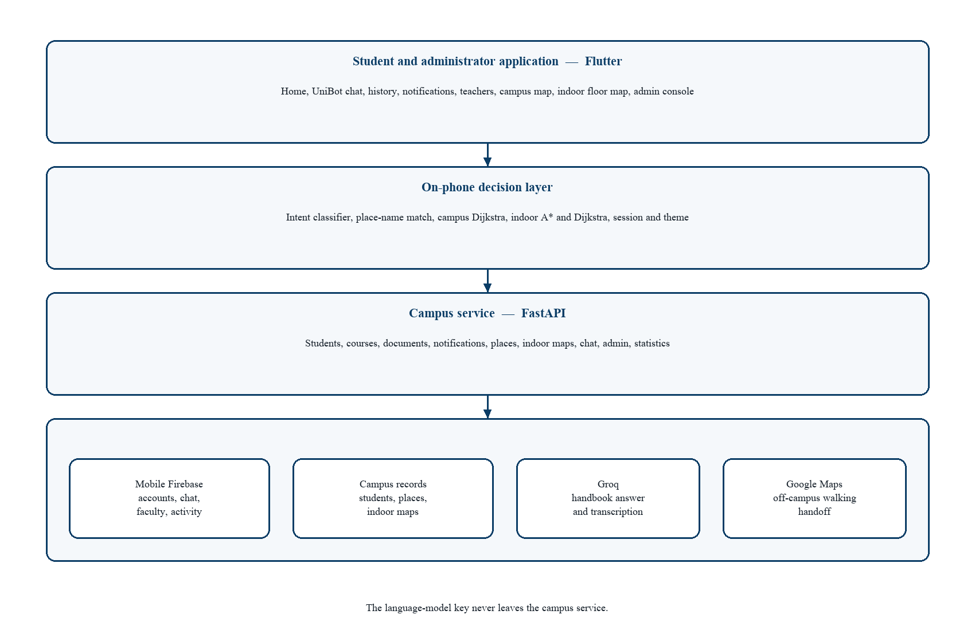
Figure 6.3 System architecture
Collaboration is short. A dashboard load reads the signed-in registration number and calls the student and course endpoints. A place question does not leave the phone when the list already contains the name. An open question posts the text and at most a few previous turns. The reply is text plus place identifiers, which the phone turns into cards from the same place list. A direction request either runs a local router or opens a public walking URL. An administrator save writes a place or an indoor area. The next student fetch sees it. Nothing in that chain requires a store procedure hidden from the diagram.

6.1.3 Subsystem architecture
Table 6.1 names the subsystems used in the rest of this chapter. Figure 6.6 draws the same split as components. Figure 6.9 is the context data flow: the student sends a question or a location and receives an answer or a route; the administrator sends places and notices; the stores sit beside the process rather than inside the actors.
Table 6.1 Subsystem responsibilities
Subsystem | Responsibility | Does not do
Student shell | Navigation, theme, session, push entry | Route search or handbook ranking
UniBot | Classify, call chat, show cards, speak and listen | Invent a place id
Campus guide | Map, outdoor Dijkstra, QR start, off-campus handoff | Indoor floor geometry
Indoor map | Floors, A*, instructions, stair or lift preference | City routing
Admin console | Students, teachers, broadcast, places, indoor edits | Student chat history
Campus service | Validation, retrieval, Groq, admin checks | Drawing the map
Stores | Identity, records, graphs, transcripts | Choosing a sentence

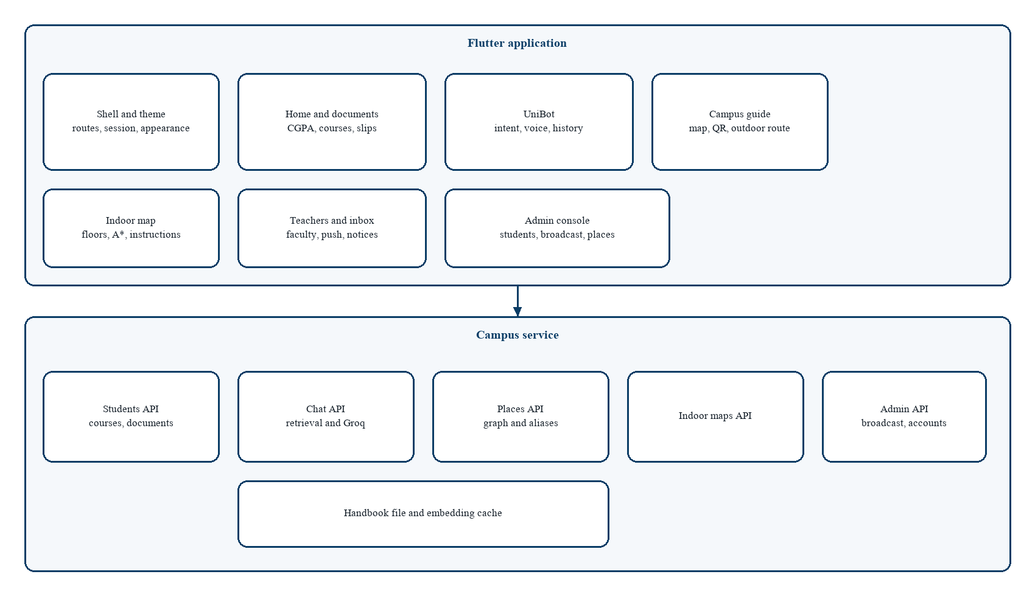
Figure 6.6 Component diagram
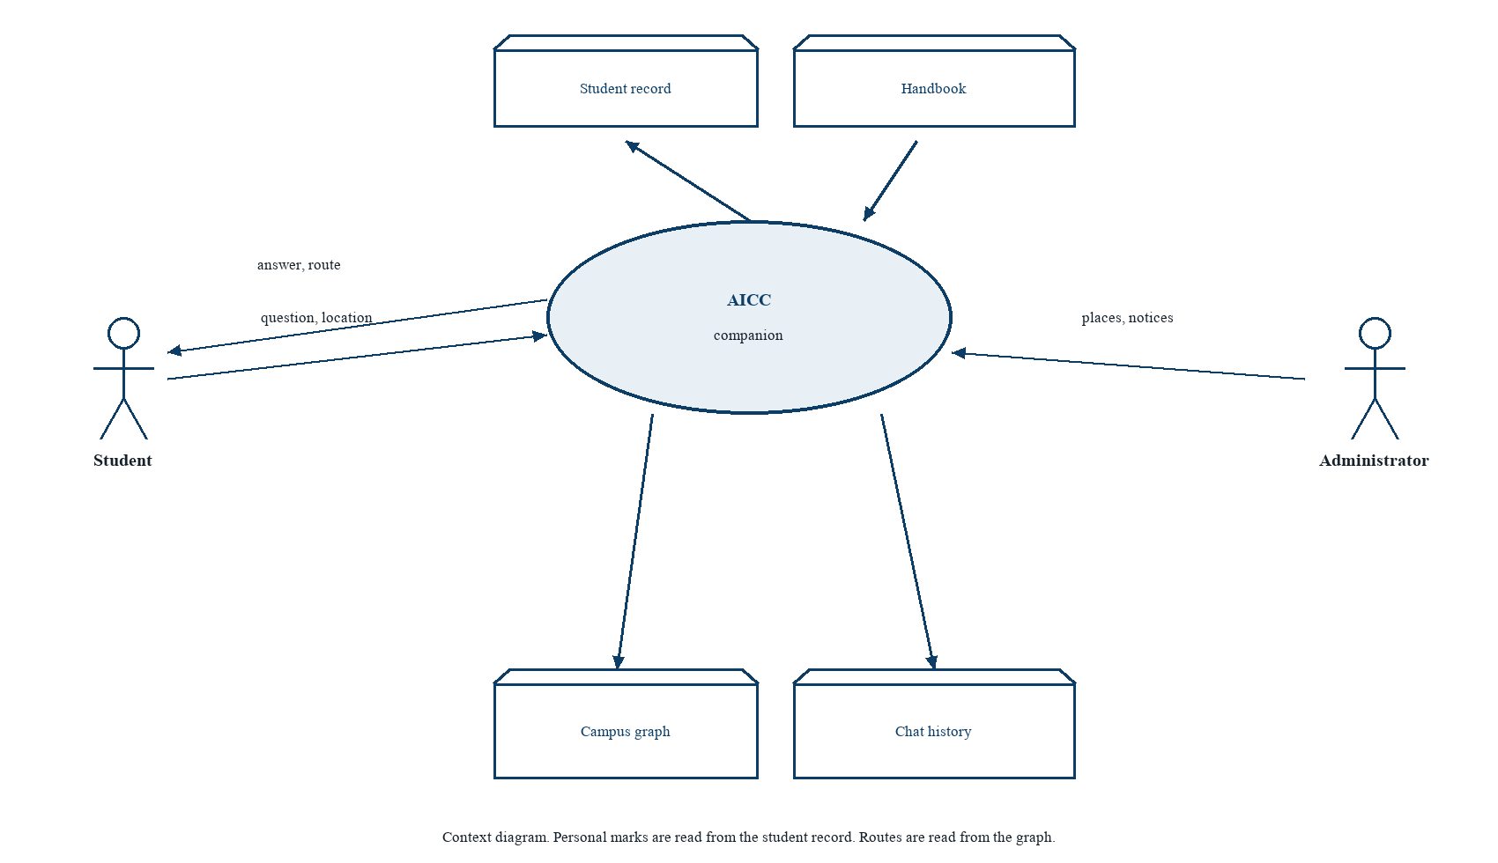
Figure 6.9 Context data-flow diagram

6.2 Detailed system design
The template asks each major component for its kind, purpose, responsibilities, constraints, composition, interactions, resources, processing, and interface. Table 6.2 records those attributes for the six parts that carry the engineering risk. The narratives after the table expand the processing of conversation, outdoor routing, and indoor routing, which are the parts a reviewer will trace by hand. Screen widgets that only arrange text are not repeated. Their behaviour is the requirement row they implement.
Table 6.2 Design attributes of the main components
Component | Kind | Purpose | Constraint | Uses
Flutter client | Application | All student and admin interaction | No model key; Android first | Service, Firebase, map tiles
Intent and place match | Pure functions | Choose a path before generation | Longer place name wins | Place list, local rules
Campus service chat | HTTP module | Retrieve, then phrase | Two to four sentences; quote figures | Handbook, Groq
Campus router | Pure function | Outdoor minimum path | Published edges; 25 m fallback | Campus graph
Indoor router | Pure function | Indoor minimum path | Explicit edges; cost table | Building graph
Record stores | Documents | Facts the UI may state | Student sees own row | Firestore through rules and the service

6.2.1 Classification
The client is an application. Intent, both routers, and the handbook ranker are pure modules: the same inputs give the same outputs and they do not read the clock or the network. The chat HTTP module, the student API, and the admin API are service modules with credentials and side effects. Firestore collections and the handbook file are data modules. Widgets are views. Keeping the pure modules free of widgets is what makes Table 7.1 possible on a desktop test run.

6.2.2 Definition
The client is the signed-in face of FR-01 through FR-25. Intent is the definition of FR-05 through FR-07. The chat module is the definition of FR-08 through FR-11. The campus router is FR-15 through FR-17. The indoor router is FR-18 through FR-20. The stores are the definition of NFR-01: if a fact is not in a store, the interface may not state it. This mapping is the trace from Chapter 4 into design. A component without a requirement identifier was not added to carry the core path.

6.2.3 Responsibilities
• The client collects input, shows loading and errors, and starts the correct pure function or request.
• Intent returns one class and, for a place, one identifier. It does not call the network.
• The chat module returns text and a list of place identifiers that already existed on passages or on the food rule.
• The campus router returns an ordered node list, instructions, a distance, and an estimated flag, or an empty route.
• The indoor router returns a ready route, an unknown node, or no route. Instructions are a second step on a ready route.
• Stores persist the fields in Section 4.7 and reject a registration number that disagrees with the department.

6.2.4 Constraints
Intent must run on the UI isolate without a visible stall on a few dozen places. The chat history sent upward is capped, in the service model, at six turns, and each turn is shortened again before it is placed in the prompt. Audio shorter than a small threshold is rejected as a tap rather than speech. Audio above a few megabytes is rejected. Admin calls without the administrator credential fail. Indoor search treats a missing node as an unknown-node result, not as a crash. Outdoor search treats a disconnected goal as an empty route. A route that used a fallback length must set the estimated flag. These constraints are also the exception columns of the use cases.

6.2.5 Composition
The client is composed of the shell, feature screens, repositories, and the pure modules above. The indoor feature is itself a composition: entities for the building, a graph builder, the router, route costs, an instruction builder, a geographic converter, a validator, and a map controller that the floor painter observes. The service is composed of routers for students, courses, documents, notifications, statistics, places, indoor maps, chat, and admin, plus handbook ranking, the Groq client, and Firebase access. The handbook file is not compiled into the phone.

6.2.6 Uses and interactions
Figure 6.4 is the activity of one question. Figure 6.5 is the sequence when the question is a place and then a follow-up about hours. The phone asks intent first. A place hit returns to the student as a card and never reaches Groq. A later hours question misses the place-only path, is posted to the service, and is retrieved before the model sees it. Figure 6.7 is the life of a route after the student asks for directions. Idle becomes locating, then routing, then on route, then arrived. Leaving the corridor beyond the off-route distance returns to routing. End or cancel finishes the session. Off campus, the transition from locating does not enter routing on the campus graph at all.
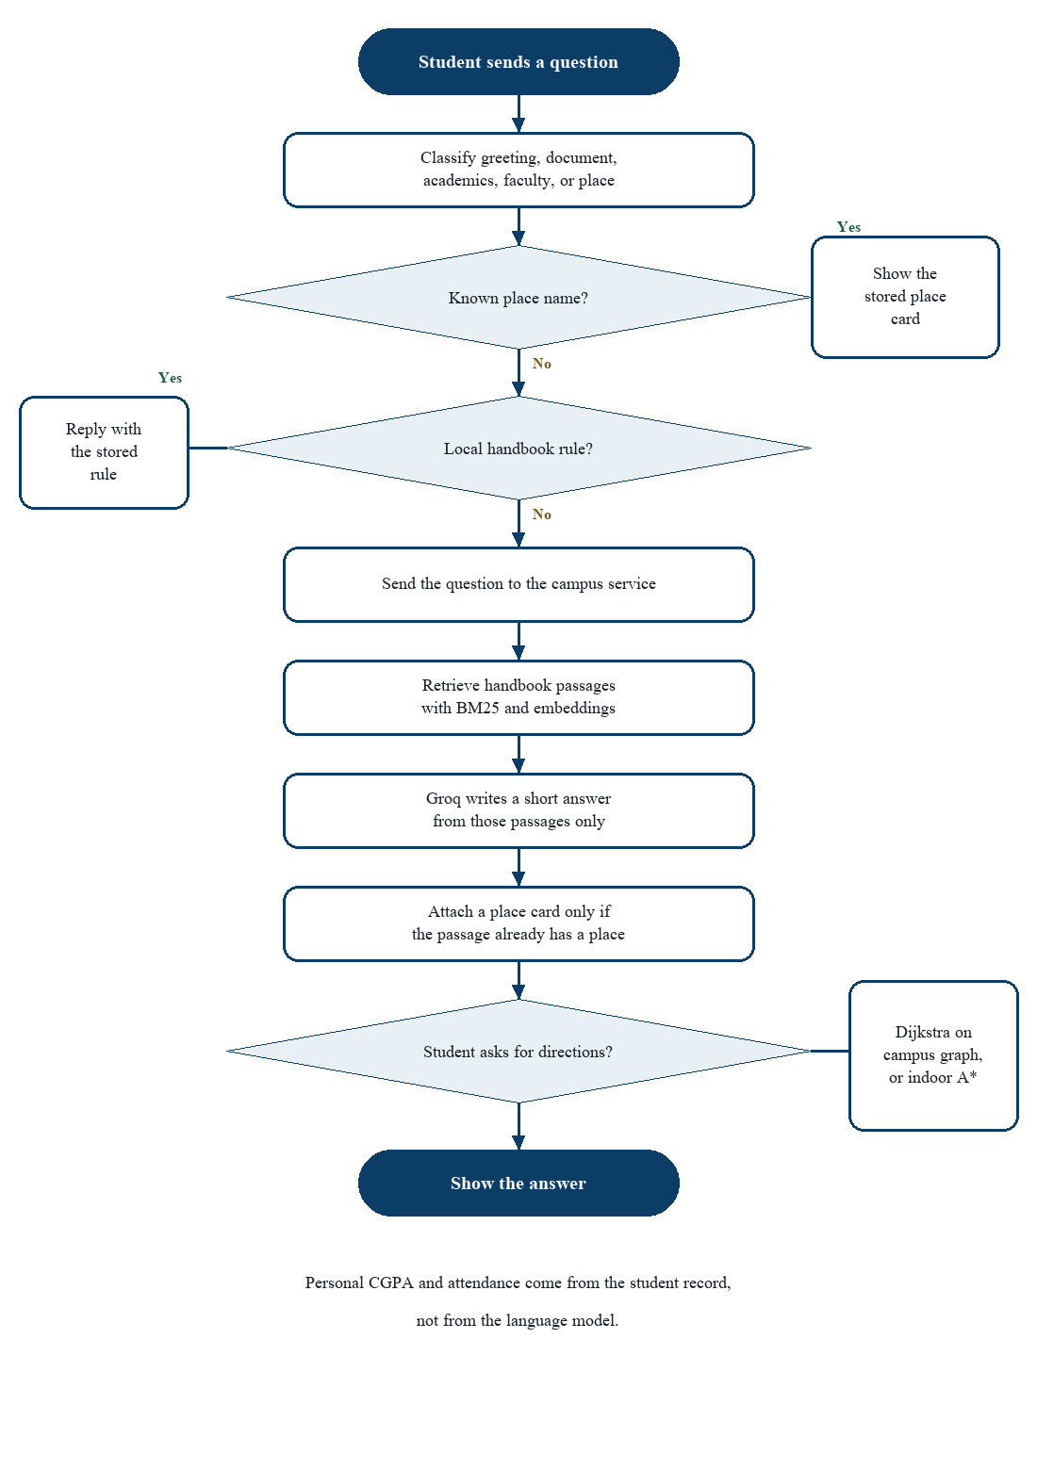
Figure 6.4 Activity diagram for a campus question
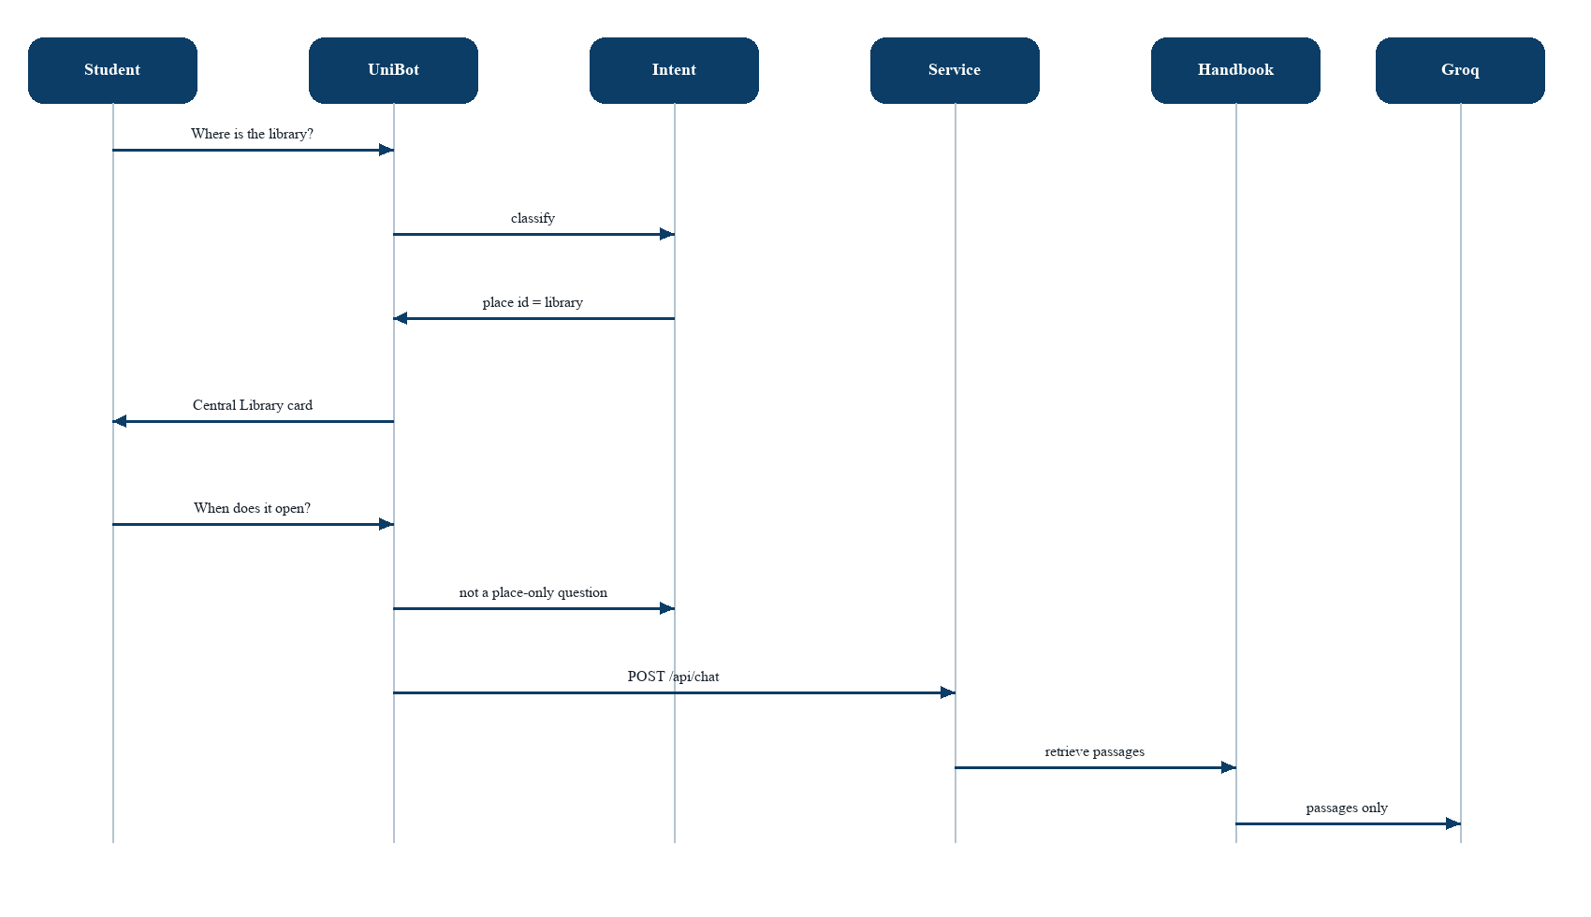
Figure 6.5 Sequence diagram for a grounded answer
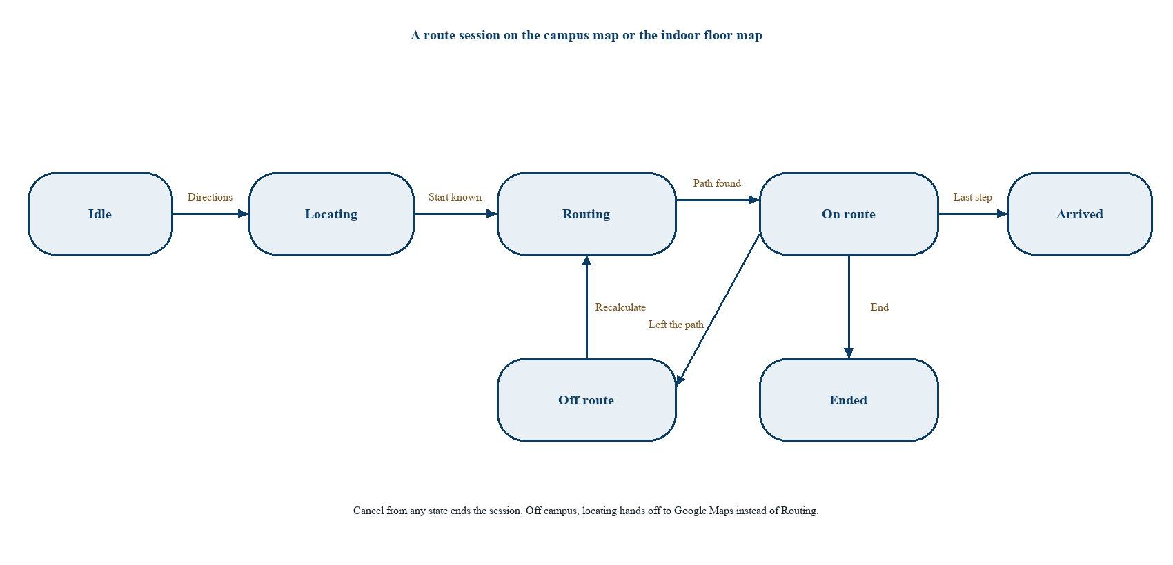
Figure 6.7 Navigation state machine

6.2.7 Resources
The phone needs memory for the place list, the active graph, and the decoded floor image. It needs the network for the first fetch and for chat, the microphone for voice, the camera for QR, and location only for outdoor start. The service needs the handbook file, an embedding cache warmed at startup when the file loads, a Firestore client, and the Groq credential. There is no lock shared between a student’s route computation and an administrator’s save. A save is visible on the next read. The route already on screen is a snapshot, which avoids a deadlock between a painter and a writer. Push delivery depends on the platform messaging service and is allowed to arrive late. The inbox still loads from the record.

6.2.8 Processing
Outdoor processing is Dijkstra, as described in Section 5.4. Indoor processing builds the graph, seeds a binary heap with the start, and expands the lowest f-score. The g-score is the cost from the start. The heuristic is straight-line distance when A* is requested and zero when Dijkstra is requested. A stale heap entry, whose g is worse than the best already stored, is skipped. When the goal is dequeued, predecessors are walked back to the start. Equal f-scores break ties by insertion order so two runs on the same building match. The result is then walked by the instruction builder, which groups a straight corridor, emits a floor-change sentence when the floor id changes, and ends with the room name.
Retrieval processing tokenises the question, scores every handbook entry with BM25 and with cosine similarity, and keeps the leading passages. Language detection looks for Urdu script and for Roman Urdu markers so a refusal can be worded in the language of the question. The model call is a chat completion with a system instruction, the passages, and a short history. A thinking block, if the model emits one, is stripped before the text returns to the phone. Place identifiers are computed from the plan, not from that text.
Neither search is expensive at the demonstration size. Dijkstra on a campus of a few dozen nodes is negligible beside a map tile. A* on one building with a few floors is negligible beside painting the floor. The scalability requirement is therefore about data growth, not about a new algorithm at a thousand nodes. A later campus-wide indoor graph would still be sparse. The heap implementation is the ordinary logarithmic one and does not need replacement for the university’s buildings.

6.2.9 Interface and exports
The outdoor router exports one function from a graph and two node identifiers to a route value. The indoor router exports route and dijkstra, each taking a building, two node identifiers, and a preference. The intent function exports a class and an optional place identifier. The chat endpoint exports text and place identifiers. Student endpoints export the record, courses for a semester, notifications, and documents. Place endpoints export the active list to students and the editable list to administrators. None of these exports includes a free-form coordinate produced by the model. Clients that need a pin read the place.

6.2.10 Detailed subsystem design

6.2.10.1 Use cases
Figure 6.1 places the student on the left of the system boundary and the administrator on the right. The student’s cases are the daily path: sign in, dashboard, question, document, outdoor route, indoor route, teacher, and notices. The administrator’s cases are maintenance: people, places, broadcast, and indoor areas. A student does not have a line to publish a place. An administrator does not have a line to the student’s private chat. Shared data crosses inside the boundary, through the stores, not through a shared screen.
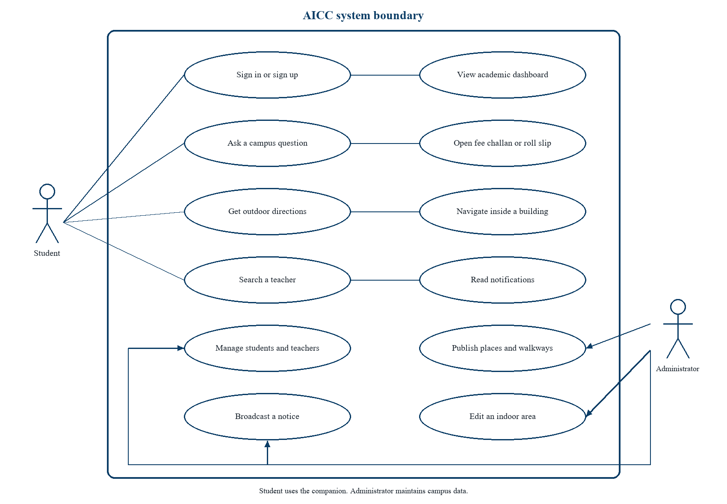
Figure 6.1 Use-case diagram

6.2.10.2 Information model
Figure 6.2 is the entity-relationship view. A student enrols in courses, receives notifications, and owns documents. A place links to a walkway node. Nodes join through connections. A building contains floors. A floor contains rooms. An application account owns chat sessions. The relationship names are the ones the API actually enforces. There is no relationship from a generated sentence to a coordinate. Figure 6.10 draws the same facts as two databases. Figure 6.8 is the class view of the navigation model the phone holds in memory while routing.
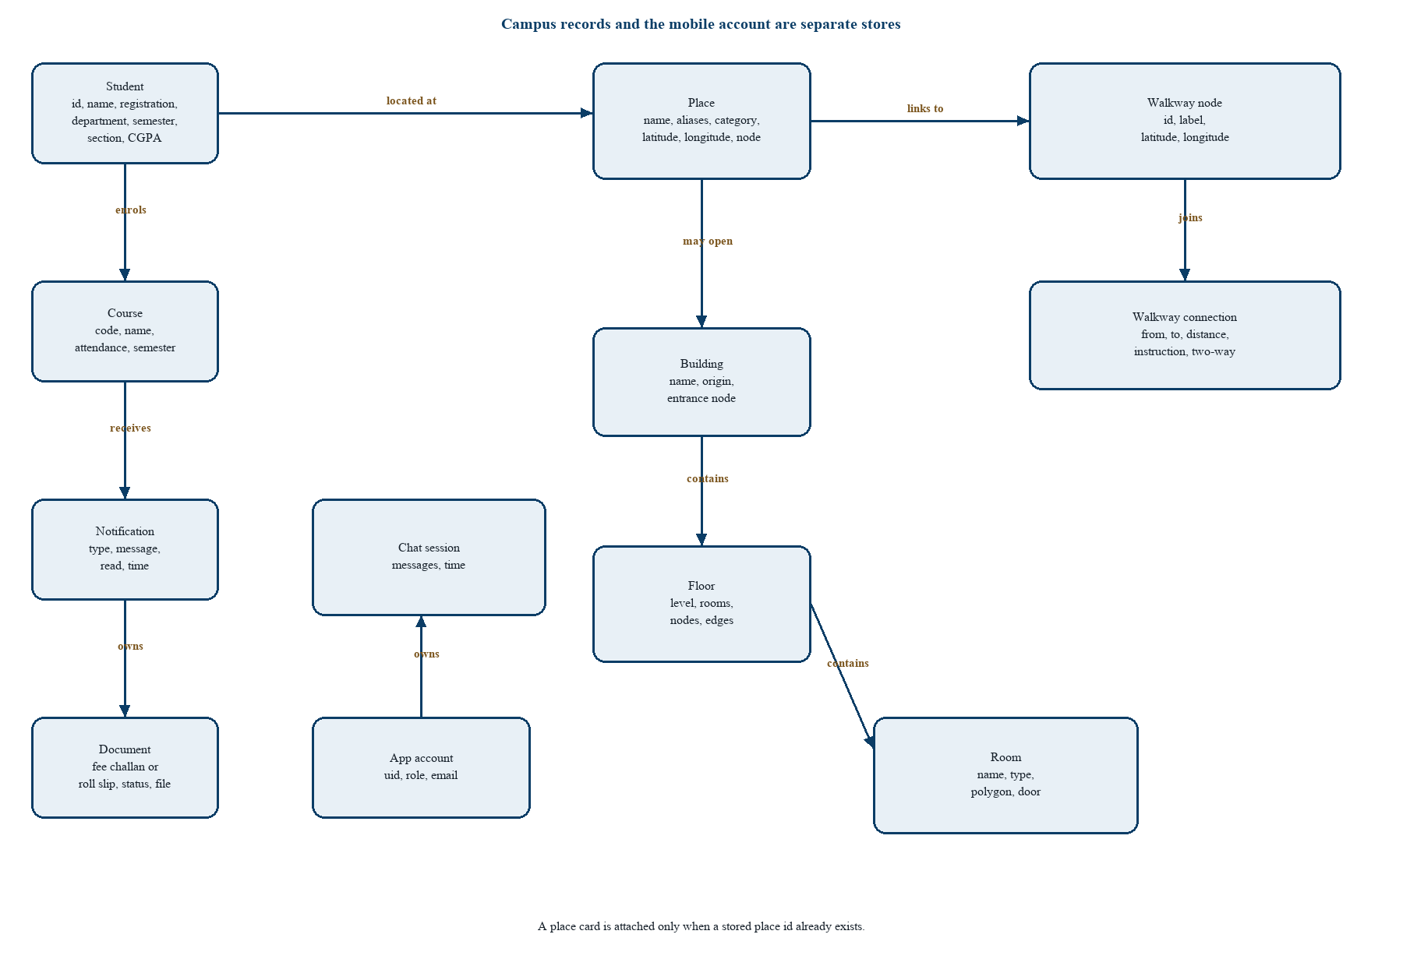
Figure 6.2 Entity-relationship diagram
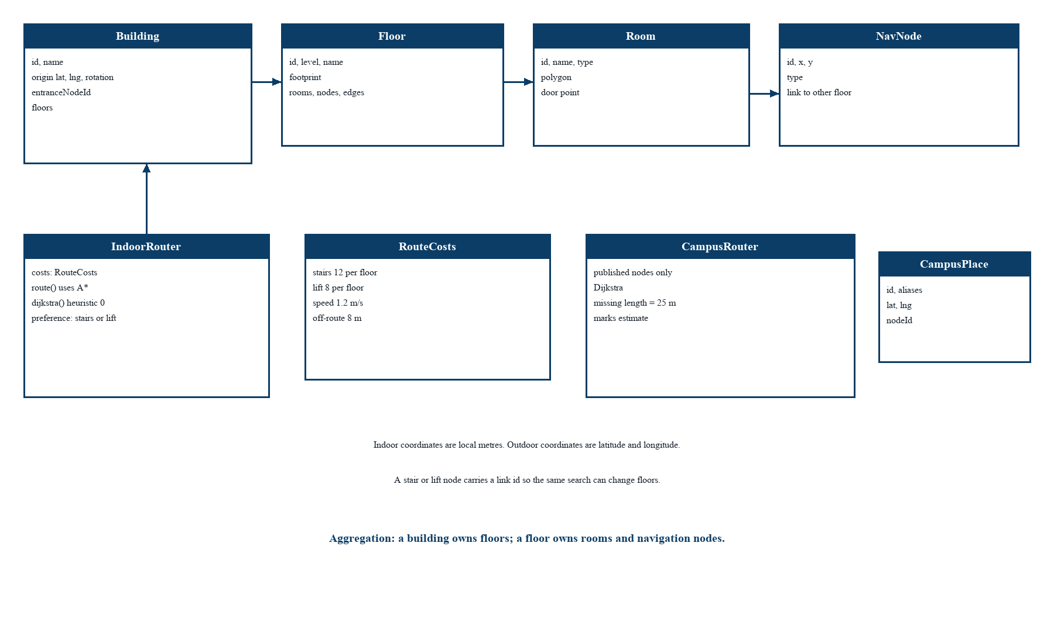
Figure 6.8 Class diagram of the navigation model
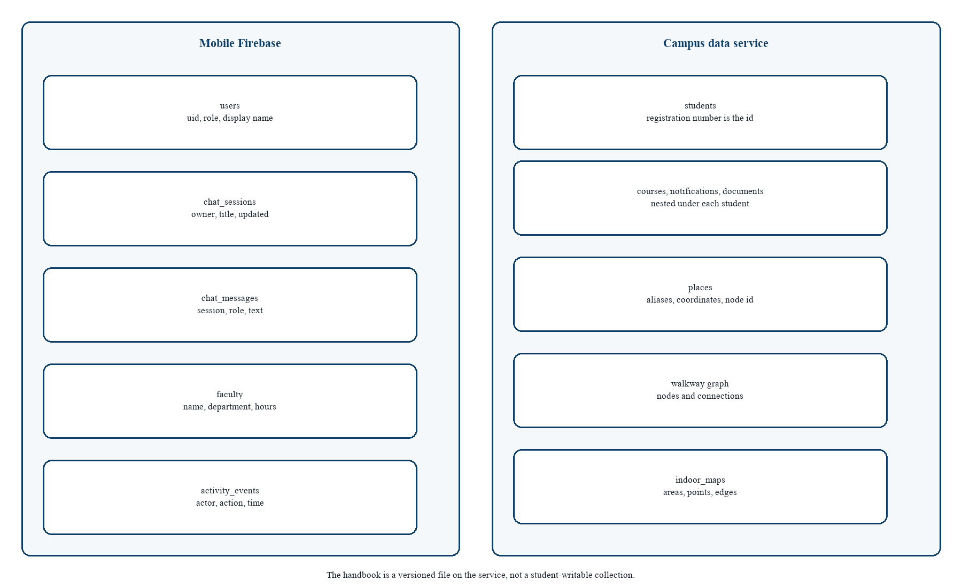
Figure 6.10 Database diagram
The mobile database holds users, chat sessions, chat messages, faculty, and activity events. The campus database holds students, with courses, notifications, and documents nested under the registration number, plus places, the walkway graph, and indoor maps. Nesting courses under the student matches the access rule: a read of courses is always a read for one student. The handbook is a file on the service. It is versioned with the software that understands its headings, and it is not writable from the student application. That is a constraint, not an omission. A student-writable handbook would make NFR-01 unenforceable.

6.2.10.3 Indoor class responsibilities
Building stores the origin and the entrance node used when the student has not chosen a start. Floor stores the level integer so a stair cost can be the absolute difference in levels. Room stores a polygon for paint and a door point for the last step of an instruction. NavNode stores local x and y, growing east and north before the building rotation is applied, and an optional link. IndoorRouter does not store the building. It receives one. RouteCosts is a value object so a test can construct a router with exaggerated stair costs and prove the lift is chosen, or the reverse. CampusPlace is the outdoor twin: aliases and a node identifier, no polygon.
The geographic converter applies the origin and rotation when a local point must be shown on the earth, or the reverse when a QR payload is a geographic hint. The validator checks that edges refer to known nodes and that a floor link points at a real node. A building that fails validation is not routed. The map controller holds the selected floor, the active route, and the preference, and it notifies the painter. The painter does not search.

6.2.10.4 Failure behaviour
Each subsystem has a visible failure. A waking host shows a banner rather than an infinite spinner with no words. A chat refusal names an office. An empty outdoor route does not become a straight line. An unknown indoor node names the identifier that failed. A pending document does not pretend to be a file. A denied location permission explains the “I’m at” list. These behaviours are designed, because a blank failure is how a student ends up trusting a guess from somewhere else.

6.3 Summary
The architecture separates interaction, decision, wording, and truth. The diagrams in this chapter are those separations drawn as use cases, entities, layers, an activity, a sequence, components, route state, classes, a context flow, and two databases. Chapter 7 describes how the separations were implemented and how they are tested.

Chapter 7 Implementation and Testing

7.1 Development environment
The phone application is a Flutter project targeting Android. The service is a Python application run with Uvicorn. Local demonstration uses a machine on the same network as the phone, or the deployed host whose address the login screen can override and remember. Firebase is configured with the FlutterFire options generated for the mobile project. The campus service reads its own service-account credential from the environment. Neither secret is written into the report or the client.
Shared widgets were built before features: primary and secondary buttons, cards, text fields, skeletons, empty states, error states with retry, and status pills. Screens use those widgets so a loading dashboard and a loading map fail in the same way. The theme file holds the navy palette, spacing, and the light and dark themes. Appearance is a preference on the device, not an account setting, so it is available before the first successful read of a student row.

7.2 Application structure
The process starts in the application entry, which prepares shared preferences and Firebase and then runs the root widget. Named routes cover the splash, a setup screen if Firebase is not ready, sign-in, sign-up, the student shell, the administrator shell, and the indoor map. A session object listens to the authentication user. When the account is an administrator, the student shell leaves and the admin shell opens. That split is the implementation of the two user classes in Table 4.1.
The student shell is a tabbed frame: Home, UniBot, History, Notifications, and Teachers. A small campus assistant button can open a new chat from Home. Push messages received in the foreground raise a snack bar. A message that opened the app selects the notification tab. Unread state is refreshed from the inbox service. Sign-out asks for confirmation so a stray tap does not drop the session.

7.3 Core student functions
Home reads the signed-in student and requests courses for that student’s current semester. Average attendance is the mean of the course percentages, not a second number stored beside them and not a number from the model. The CGPA shown is the overall value on the student row, on a 4.0 scale. Documents of type fee challan and roll-number slip render when their status is ready, using a web view for the file address. A pending document stays a status, not a broken page.
UniBot sends text through the classifier in the chat feature. Suggested questions on an empty thread cover the paths a reviewer will try: a challan, a roll slip, attendance, the library, the cafe, a teacher, and the attendance policy. A place hit renders a card with an action to show the map. A remote answer renders the service text and any cards whose identifiers came back with it. Voice capture writes a short recording, uploads it for transcription, and then runs the same classifier on the transcript. Spoken output uses the platform text-to-speech engine and can be turned off. History lists sessions stored for the account, replays a session, and deletes one or all of them.
The teacher directory reads faculty profiles and supports search. A profile shows consultation hours so “where is Dr. Hamza Qureshi?” can become a profile rather than a guessed room. Notifications combine the student’s notice list with push. Marking a notice read sends a small update and does not delete the row, so a student can still find it.

7.4 Campus guide and indoor map
The campus guide loads places and the walkway graph. Search uses the same matcher as chat, so a card and a map pin cannot disagree about which record “canteen” means. Directions call the campus router. The line on the map is the node list. Step text prefers the instruction stored on the edge and otherwise says to continue to the next node’s name. Ending the route clears the session described in Figure 6.7. A QR scan sets the start node from the code an administrator printed for that place, which is how a gate or a stair can be unambiguous when GPS is standing on the wrong side of a wall.
The indoor screen loads a building either from a packaged demonstration file or from the remote indoor repository. The floor painter draws the footprint, rooms coloured by type, and the active route. Changing floor does not restart the search. The path already contains the stair or lift link, and the painter shows the part that lies on the selected level. The room sheet names the room under a tap and can become the destination. Preference for stairs is a control on that screen, passed into the router as a cost change rather than as a filter that deletes the lift from the graph. Deleting the lift would hide a real exit. Penalising it keeps it available and rarely chosen.

7.5 Service implementation
The service process loads environment values, warms handbook embeddings when the file is readable, and mounts the routers under an API prefix. The browser admin surface is a static mount used to inspect demonstration data. Health is a plain status for the milestone that first proved the phone could reach the host. Student writes validate the registration pattern and the department code. Course attendance and CGPA are bounded. Place identifiers are restricted to a machine-readable form so a chat card and a document key cannot drift apart because of a capital letter.
Chat accepts a message and a short history. It asks the model for wording and, independently, asks the handbook plan for place identifiers. A failure of the place step does not invent identifiers. It returns an empty list. Transcription rejects a clip that is too short to be speech and a clip that is too large for the endpoint. Groq errors are mapped to a service-unavailable response when the key is rejected or the quota is exhausted, and the phone shows that as an error with retry rather than as a handbook fact.
Push registration stores a device token on the student and removes it on sign-out. A broadcast walks students and writes a notification, then attempts delivery. The activity log records administrative actions and can show the actor’s profile when it exists. Statistics for the admin dashboard count the campus record and are loaded beside the faculty count from the mobile store. The dashboard therefore admits, by being two numbers from two stores, that identity and campus records were not forced into one database.

7.6 Seed data and content
A seed script can create a repeatable set of students across the departments, semesters, and sections in the catalogue, with courses, notices, and documents. Re-running it is safe. A wipe option exists for a clean demonstration and is not the default, so a manual test student is not destroyed by habit. Places and the walkway graph are generated as data files and packaged with the application as well as served remotely, which is why a place answer can still be shown when a reviewer is standing in a poor network spot after the first launch. The handbook used by retrieval is the institutional question set maintained beside the service, with English, Urdu, and Roman Urdu questions. Policy sentences that also exist on the phone for offline answers are kept aligned with that set so the two paths do not contradict.

7.7 Testing methodology
Testing is layered. Pure functions are unit tested. A small number of widgets are tested for the states a reviewer sees, such as a denied location. The service is tested for the place-link rule and for indoor map validation. A scripted manual pass, written as a demo and as a viva list, covers the sentences that cross the phone and the service together. There is no claim of a full usability trial with a counted cohort. The evaluation that was actually prepared is the one in Chapter 8.
Table 7.1 names the automated modules and the requirement they protect. A module is listed because it exists in the repository and asserts a behaviour. This report does not replace that assertion with a decorative pass rate.
Table 7.1 Automated test modules
Module | What it locks
place_search_test | Longer place names and aliases, including the cafe
navigation_intent_test and intent_test | Place questions versus hours, greetings, and documents
campus_router_test | Dijkstra on the published outdoor graph
indoor_router_test | A* and Dijkstra agreement, stairs and lift
indoor_validator_test and demo_building_test | The demonstration building is a legal graph
geo_converter_test | Local metres and the building origin
indoor_map_controller_test and screen tests | Floor selection and route presentation
signup_format_test and api_models_test | Registration shape and API models
academics_test | Attendance average over the current courses
test_place_links | Cafe card only when the passage or food rule allows it
test_groq_prompt | The prompt carries passages and does not ask for invented marks
test_indoor_maps | Indoor area writes used by the administrator

7.8 Accuracy, performance, and scale
Accuracy is defined here as fidelity to a store, not as a percentage of human preferences. A place answer is accurate when the card is the record that owns that alias. A rule answer is accurate when the numbers match the passage. A route is accurate when it is a minimum path on the published edges. Under that definition the design is accurate by construction for places and routes, and accurate for rules to the extent retrieval returns the right passage. Retrieval can still miss a paraphrase that shares neither words nor embedding neighbourhood. The refusal path is the designed response, and it is preferable to a fluent miss. What is not accurate yet is the outdoor metre error against a surveyed walk. The field log has columns for expected path, actual path, and GPS error, and the measurement cells are empty. Chapter 8 leaves them empty.
Performance on the prepared data is interactive because the graphs are small and the place list is a few dozen records. The model call is the slow step, and it is not on the place path or the route path. A cold host on a free tier can add a long first wait. The waking banner is the performance design for that case. It does not make the host faster. It stops the student from treating a sleep as a crash.
Scale is data scale. A new place is a document. A new walkway is an edge. A new rule is a handbook block. The routers and the ranker do not contain a case for each room. The limit that will arrive first is not algorithmic. It is the quality of the survey and the discipline of keeping aliases unique. Two places that share the alias “office” would make the longer-name rule ambiguous. The admin form is where that discipline has to live.

7.9 Summary
The implementation follows the design cut: Flutter for interaction and local decisions, FastAPI for records and grounded wording, Firebase for identity and transcripts, and explicit graphs for both kinds of walk. Tests lock the decisions that are pure. Chapter 8 reports the scripted checks and the limits a reviewer should say aloud.

Chapter 8 Results and Discussion

8.1 Evaluation setup
The evaluation is a structured demonstration against the success criteria in Section 3.6 and the use cases in Table 4.4. The phone is signed in as a seeded student and, for maintenance cases, as an administrator. The place list includes the Main Gate, Gate 3, LGU Cafe, Central Library, Admin Block, Masjid, Computer Labs, Classroom B-104, and the other published pins. The outdoor graph connects those pins through walkway nodes such as the south walk, the central paved area, and the admin walk. The indoor demonstration is Block B, with a ground floor and a first floor joined by stairs and a lift. No separate radio map was built, so none is reported.

8.2 Functional test cases
Table 8.1 is the system test for the use cases. The expected column is the requirement. The observation column states what the implementation does when the case is followed. Where a measurement was not taken, the cell says so.
Table 8.1 Functional test cases
Case | Use case | Expected | Observation
TC-01 | UC-01 | Valid sign-in opens Home | Session binds the registration number and opens the student shell
TC-02 | UC-01 | Admin sign-in opens the admin shell | The student shell redirects when the role is administrator
TC-03 | UC-02 | Dashboard shows stored CGPA and courses | Values come from the student and course payloads
TC-04 | UC-03 | A ready challan opens | Pending status does not pretend to be a file
TC-05 | UC-04 | “Where is the library?” shows Central Library | Matched on the phone, card without waiting for the model
TC-06 | UC-08 | Directions on campus draw the graph route | Dijkstra node list, steps, and End
TC-07 | UC-08 | Directions off campus | A public walking link opens toward a gate
TC-08 | UC-08 | Location denied | Banner, then an “I’m at” list when directions start
TC-09 | UC-09 | Block B, first floor, room B-104 | Floor switch and an indoor route from entrance or QR
TC-10 | UC-05 | Library hours are not treated as directions | Hours text; card only from the place tag
TC-11 | UC-05 | A question outside the handbook | Refusal, and no place card
TC-12 | UC-13 | Admin drops a pin and saves | The place appears on the student map after save
TC-13 | UC-14 | Broadcast | A notice is written for students and push is attempted
TC-14 | UC-06 | Attendance question | Course breakdown from the record, not from the model

8.3 Chatbot checks
Table 8.2 is the sentence list used to see that the router and the handbook do not steal each other’s jobs. Checks that are pure place or intent decisions are covered by the phone tests named in Table 7.1. The food question that must attach the cafe from a passage tag is covered by the service test. The refusal case is the one a reviewer should type, because a model that answers a cricket question has left the handbook.
Table 8.2 Chatbot checks
Input | Path | Expected
LGU | On-phone place match | LGU Main Campus card
Where is LGU cafe | On-phone place match | LGU Cafe, because the longer name wins
Where is fountain ground | On-phone place match | The fountain place card
Navigate to canteen | Alias | LGU Cafe
Where can I eat lunch? | Retrieval | Handbook text plus the cafe card from the place tag
When does the library open? | Retrieval | Library hours, not a directions session
Who won the cricket world cup? | Retrieval | Polite refusal, no place card
Library kahan hai | On-phone place match | Central Library card

8.4 Navigation checks
Table 8.3 lists the walks a demonstration is expected to show. The expected column is the authored graph, not a measured survey. The GPS-error column of the project’s field log is intentionally not copied in as numbers, because that log has not been filled. Publishing blank cells as “within 5 metres” would be a false result.
Table 8.3 Navigation checks
Route | Expected on the published graph | Measured GPS error
Main Gate to LGU Cafe | South walk, then toward the cafe | Not surveyed in this delivery
Main Gate to Central Library | South, central, west, then the library node | Not surveyed in this delivery
Main Gate to the fountain lawn | South, central, then the fountain node | Not surveyed in this delivery
Main Gate to Classroom B-104 | Outdoor path to Block B, then stairs or lift to the first floor | Not surveyed in this delivery
Any place from off campus | Public map opens toward the nearest gate | Not applicable
Indoor stair preference | Lift links carry the extra penalty and stairs are chosen | Checked by router tests, not by GPS

8.5 Discussion against the problem
The problem in Chapter 3 was the gap between stored facts and a walking student. The checks that pass by construction are the ones that close the gap without a survey: a place card is a record, a personal number is a field, a route is a path on edges an administrator drew, and a question the handbook does not contain does not grow a place card. Those are the results that distinguish this companion from a general chatbot and from a public map, which was the comparison in Table 2.1.
The result that is not yet operational is metre-level trust outdoors. Coordinates in the seed are a sketch of the DHA Phase 6 campus. They are good enough to show the interaction and the algorithm. They are not good enough to tell a student, in a binding way, that the cafe is a certain number of metres from the gate. The interface already has the honesty mechanism for a missing edge length: the route is marked estimated. A future survey fills lengths and the mark disappears where the tape measure exists. Until then, a demonstration should say “this is the published path” and should not say “this is a surveyed distance”.
Indoor results are similarly split. The search, the floor change, and the instruction builder are real and tested. The picture under the route is a Block B sketch. A student can follow the graph relative to rooms drawn on that sketch. A student should not treat the sketch as an architectural sheet. QR start removes the worst indoor GPS failures from the demo, which is a result about the problem definition as much as about the code. The system stopped claiming a position it could not hold.

8.6 Requirement coverage
Table 8.4 Requirement coverage
Requirements | Evidence | Residual risk
FR-01 to FR-04, FR-25 | Session, dashboard, documents, themed states | A sleeping host delays the first load
FR-05 to FR-12 | Intent tests, chatbot table, voice path | A paraphrase may miss and must refuse
FR-13 to FR-14 | Inbox and faculty screens | Push can arrive late; the list remains
FR-15 to FR-20 | Router tests and navigation table | Unsurveyed outdoor metres
FR-21 to FR-24 | Admin shell and place-save check | Alias clashes if editors are careless
NFR-01 to NFR-03 | Lookups, server key, per-student reads | Handbook text can still be outdated relative to a new paper notice
NFR-04 to NFR-08 | On-phone place and route path, unit tests | Model quota surfaces as an error, which is intended
NFR-09 to NFR-12 | Roman Urdu sample, estimated flag, activity log | Full Urdu speech was not required

8.7 Limitations
• Outdoor coordinates still need a campus survey before GPS error can be reported.
• Floor pictures are a sketch until official drawings are cleared and converted.
• Live bus positions, hostel booking, and the registration transaction itself are out of scope.
• The handbook can lag a new office notice. The assistant is not the notice.
• A free hosting tier sleeps. The first question after a pause waits for the host.
• English and Roman Urdu are supported for the prepared phrases. Open Urdu speech was not the acceptance test.

8.8 Summary
The evaluation shows a companion that answers from records, routes on authored graphs, and refuses what it does not store. It does not show a surveyed positioning error, and this chapter does not invent one. Chapter 9 states what that means for the original problem and what should be done next.

Chapter 9 Conclusion and Future Work

9.1 Conclusion
This project set out to give an LGU student one companion for a place, a rule, and a personal document, and to draw a walk on paths the public map does not contain. The delivered system does that by refusing to use one technique for every job. Personal facts are read from the student record. Places are read from a list with aliases. Rules are retrieved from a handbook and only then phrased. Outdoor walks are Dijkstra on published edges. Indoor walks are A* on a building graph with an explicit stair and lift cost. Outside the campus, city walking stays with a public map. The model key stays on the server.
The problem statement asked for those separations because a fluent invention is more damaging on a campus than a slow honest answer. The checks in Chapter 8 support the separations that do not need a survey: the library card, the canteen alias, the hours question that is not a route, the cricket question that is refused, the admin pin that appears after save, and the indoor floor change that can prefer stairs. The evaluation that would turn the outdoor sketch into an operational map was prepared as a log and was not filled. The conclusion is therefore precise. The companion works as a grounded campus system on the data it was given. It is not yet a surveyed positioning product.

9.2 How the objectives were met
• The dashboard objective is met by reading CGPA, courses, attendance, and ready documents from the campus record.
• The place objective is met by on-phone matching, including longer names, the cafe alias, and a Roman Urdu sample.
• The handbook objective is met by BM25 and embeddings in front of a short, quoted answer, with a stored refusal when nothing matches.
• The outdoor objective is met by Dijkstra inside the campus and a public handoff outside it.
• The indoor objective is met by A*, QR or chosen start, and stair versus lift costs.
• The administrator objective is met by student, teacher, notice, place, and indoor editing without an application update.
• The security objective is met by keeping the model credential in the service environment.

9.3 Recommendations
Before an operational rollout, the walkway nodes should be replaced with points taken on site, and edge lengths should be measured so the estimated flag becomes rare. Official floor drawings should replace the Block B sketch under the same node identifiers, so the router does not have to change when the picture does. Handbook passages should be reviewed by the offices they describe, on a calendar, because a grounded answer can still be an old answer. Alias lists should be unique. Administrators should treat a shared nickname as a defect, not as a convenience.
Demonstrations should keep the refusal in the script. A system that only shows its best question teaches the wrong lesson. The cricket question, the pending document, and the off-campus handoff are part of the result.

9.4 Future work
• A surveyed outdoor graph and a filled GPS-error log, published with the same honesty as the present empty cells.
• Replacement of demonstration floor art with cleared architectural plans, without changing the graph contract.
• More buildings, each with its own origin, using the same router.
• A reviewed Urdu handbook pass so open questions in Urdu script are as well covered as the prepared Roman Urdu place phrases.
• Optional inertial smoothing between QR codes, only after the graph itself is trusted, and only as a hint that the student can override.
• A tighter loop with the registrar for challan and slip readiness, still as documents the assistant opens rather than as numbers it invents.
Live bus tracking remains out of scope until a real vehicle feed exists. Adding a guessed bus position would repeat the failure this project was built to avoid. The next useful bus feature is a stored timetable and a stop that is already a place. A live dot can wait for a live source.
The work that should not be undone in that future is the cut itself. Places stay lookups. Rules stay retrieved. Routes stay paths on authored edges. A larger model does not earn the right to skip those steps. If that cut remains, AICC can grow new buildings and new passages without becoming a more confident source of facts the university never stored.

References
[1] E. W. Dijkstra, “A note on two problems in connexion with graphs,” Numerische Mathematik, vol. 1, pp. 269–271, 1959.
[2] P. E. Hart, N. J. Nilsson, and B. Raphael, “A formal basis for the heuristic determination of minimum cost paths,” IEEE Transactions on Systems Science and Cybernetics, vol. 4, no. 2, pp. 100–107, 1968.
[3] P. Lewis et al., “Retrieval-augmented generation for knowledge-intensive NLP tasks,” in Advances in Neural Information Processing Systems, 2020.
[4] S. Robertson and H. Zaragoza, “The probabilistic relevance framework: BM25 and beyond,” Foundations and Trends in Information Retrieval, vol. 3, no. 4, pp. 333–389, 2009.
[5] F. Zafari, A. Gkelias, and K. K. Leung, “A survey of indoor localization systems and technologies,” IEEE Communications Surveys & Tutorials, vol. 21, no. 3, pp. 2568–2599, 2019.
[6] C. D. Manning, P. Raghavan, and H. Schütze, Introduction to Information Retrieval. Cambridge, U.K.: Cambridge University Press, 2008.
[7] I. Sommerville, Software Engineering, 10th ed. Boston, MA: Pearson, 2016.
[8] L. Bass, P. Clements, and R. Kazman, Software Architecture in Practice, 4th ed. Boston, MA: Addison-Wesley, 2021.
[9] ISO/IEC/IEEE 29148:2018, Systems and software engineering — Life cycle processes — Requirements engineering. Geneva, Switzerland: ISO, 2018.
[10] R. S. Pressman and B. R. Maxim, Software Engineering: A Practitioner’s Approach, 9th ed. New York, NY: McGraw-Hill, 2020.
[11] Flutter team, “Flutter documentation,” 2026. [Online]. Available: https://docs.flutter.dev/
[12] S. Ramírez, “FastAPI documentation,” 2026. [Online]. Available: https://fastapi.tiangolo.com/
[13] Google, “Firebase documentation,” 2026. [Online]. Available: https://firebase.google.com/docs
[14] Groq, “Groq API documentation,” 2026. [Online]. Available: https://console.groq.com/docs
[15] Lahore Garrison University, Student information used as the AICC handbook corpus. Lahore, Pakistan: institutional source, maintained with the campus service.
[16] OpenStreetMap contributors, “OpenStreetMap,” 2026. [Online]. Available: https://www.openstreetmap.org/

