PROPOSED THESIS REVISIONS
Study Title: LASA-Quest: A Gamified Learning Web Application for Look-Alike, Sound-Alike Medication Safety
Target Baseline Document: CNS-PROPOSAL-THESIS-DOCUMENT-1.docx
Prepared in accordance with APA 7th Edition & Institutional Thesis Formatting Guidelines
Note: This document contains strictly the revised sections, modified paragraphs, newly integrated academic subsections, and updated system process flow diagrams required to update the thesis manuscript. Unchanged sections of the original proposal have been intentionally excluded to maintain focus on actionable academic revisions.
CHAPTER 1
INTRODUCTION
Scope and Delimitation
[REVISION TARGET & INSTRUCTION]: Replace existing Paragraph 104 in Chapter 1 (page 11) with the following two revised paragraphs. This explicitly classifies LASA-Quest as a Gamified Supplementary Micro-Learning Practice Tool, replaces the outdated five arcade minigames with the true sequential Curriculum Learning Path, and establishes clear clinical boundaries to prevent scope creep.
The study focuses on the design, implementation, and empirical evaluation of LASA-Quest, a gamified web-based supplementary learning tool designed to mitigate look-alike, sound-alike (LASA) medication errors among undergraduate pharmacy students. Crucially, the application is conceptually framed not as an expansive curriculum, comprehensive courseware, or a formal Learning Management System (LMS), but as a specialized, micro-learning deliberate practice instrument analogous to computer-assisted vocabulary and perceptual training systems. Rather than displacing didactic pharmacology lectures, LASA-Quest serves as a focused cognitive reinforcement tool dedicated to accelerating automated perceptual discrimination—specifically the orthographic, acoustic, and visual recognition of high-risk medication pairs.
The functional scope of the software encompasses a structured, sequential Curriculum Learning Path organized across four pedagogical units and twenty-four progressive levels, culminating in Unit Mastery Capstones. Instructional activities are operationalized through four core cognitive challenge types: Look-Alike Visual Matching, Sound-Alike Acoustic Discrimination supported by offline static audio recordings, Tall Man Lettering Application (adhering to FDA/ISMP capitalization standards), and Paired Association Retrieval. Alongside the primary curriculum path, the application incorporates a dedicated Practice Hub providing zero-penalty mistake remediation, continuous spaced repetition reviews, and an auditory pronunciation directory. System mechanics encompass secure session authentication, user profile and accuracy tracking, immediate explanatory feedback drawers, non-punitive heart-based vigilance indicators, experience points (XP), streak tracking, and a virtual reward shop for interface customizations. The application is strictly delimited from teaching comprehensive pharmacological mechanisms of action, complex clinical dosing calculations, electronic health record (EHR) prescription entry, or simulated clinical dispensing judgment, reserving these broader competencies for traditional clinical coursework.
CHAPTER 2
REVIEW OF RELATED LITERATURES AND STUDIES
Pedagogical Mechanics in Mobile-Assisted Learning Tools: Lives, Failure Feedback, and Mastery vs. Lockout Systems
[REVISION TARGET & INSTRUCTION]: Insert the following new subsection into Chapter 2 under 'Published Works', immediately following Paragraph 191 (Zohari et al., 2023, page 24). This provides the academic literature foundation (2020–2025) justifying the use of non-punitive life mechanics, formative feedback, and voluntary practice loops in LASA-Quest.
In modern computer-assisted learning and serious educational games, the architectural selection of gamification mechanics exerts a profound influence on cognitive processing, learner motivation, and empirical retention. Among these mechanics, the inclusion of 'lives' or 'hearts' (health-point penalty systems) has emerged as a critical subject of empirical inquiry. Originally popularized by mobile-assisted language learning (MALL) applications such as Duolingo, the hearts mechanic deducts a finite resource upon an incorrect submission, traditionally terminating or restricting the study session when the resource is exhausted. In their systematic review of gamified mobile learning platforms, Shortt et al. (2023) demonstrated that while incentive structures such as experience points (XP) and daily streaks foster persistent learning habits, rigid penalty-based lockout mechanisms consistently generate an 'avoidance mindset' among learners [38]. Specifically, when students operate under the immediate threat of session termination, they display risk-averse behaviors, intentionally bypassing complex or unfamiliar learning items to preserve their life pool. Furthermore, Shortt et al. identified punitive heart loss as the predominant catalyst for user frustration and platform abandonment, concluding that hard lockout constraints operate primarily as commercial engagement throttles rather than pedagogically valid drivers of long-term mastery [38].
These qualitative observations are robustly corroborated by quantitative meta-analytic evidence. In a meta-analysis examining the differential impacts of individual gamification mechanics across thirty empirical studies, Bai, Shen, and Guan (2020) found that penalty and access-restriction elements yielded negligible to negative correlations with actual post-test academic achievement (g = -0.08 to 0.12) [39]. Conversely, instructional designs that prioritized continuous formative feedback, visual progression indicators (such as progress bars), and low-stakes mastery retrieval demonstrated substantial, statistically significant effect sizes on cognitive retention and procedural fluency (g = 0.61) [39]. In higher education and professional healthcare instruction, Dehghanzadeh et al. (2021) highlighted that punitive game mechanics induce extraneous cognitive load, elevating situational test anxiety and dividing the learner's working memory between task-relevant domain processing and resource-monitoring stress [40]. Sailer and Homner (2020) similarly emphasized that failure states in educational simulations must be coupled with immediate restorative agency, warning that penalizing mistakes without providing an accessible avenue for immediate correction fosters learned helplessness [41].
Nevertheless, the complete absence of performance stakes can introduce alternative instructional vulnerabilities. As established by Baker, Corbett, Koedinger, and Roll (2006), learners interacting with digital multiple-choice learning environments frequently engage in 'gaming the system'—most notably through 'rapid guessing'—wherein options are rapidly and unthinkingly selected until the correct answer is triggered, effectively bypassing cognitive effort [43]. In the specific context of look-alike, sound-alike (LASA) medication training, rapid guessing is exceptionally hazardous, as cultivating clinical safety requires dispensers to exercise deliberate perceptual vigilance over subtle orthographic and phonetic cues (e.g., distinguishing vinBLAStine from vinCRIStine). To reconcile this tension, educational theorists advocate for paradigms of 'productive failure' (Kapur, 2016), wherein errors are treated not as punishable infractions, but as essential cognitive opportunities for schema activation and knowledge consolidation [42].
Reflecting these empirical advancements—and mirroring the wider industry evolution wherein major platforms phased out punitive heart lockouts in favor of continuous practice models—LASA-Quest synthesizes a balanced, 'soft-vigilance' gamified architecture. Within LASA-Quest, hearts function not as a restrictive access barrier, but as a symbolic, real-time barometer of dispensing accuracy, instilling the perceptual seriousness required in clinical pharmacy. Concurrently, incorrect submissions are decoupled from session-halting modals; instead, they immediately trigger an explanatory feedback drawer detailing orthographic distinctions and automatically route the missed item into a persistent mistake queue for remedial rehearsal within the zero-penalty Practice Hub. This architecture successfully prevents rapid guessing while safeguarding uninterrupted formative retrieval.
CHAPTER 3
METHODOLOGY
Proposed System Process Flow
[REVISION TARGET & INSTRUCTION]: Completely excise and replace Section 'Proposed System Process Flow' (Paragraphs 276–283 and Figure 3.2, pages 43–44). The original Figure 3.2 and its narrative described an outdated 5-minigame arcade launcher and an anti-pedagogical error popup modal ('retry now or return to dashboard'). The following revised text and new diagram accurately reflect the implemented Curriculum Learning Path, Explanatory Feedback Drawer, Mistake Queue, and Practice Hub.
The proposed system process flow of LASA-Quest is illustrated in Figure 3.2. The interaction begins when the user accesses the web application through a modern web browser. The system first evaluates the user's authentication state via Supabase session verification. If the user possesses an active authenticated session, the system bypasses credentials verification and navigates directly to the main learning dashboard. If the user is unauthenticated, the system routes them to the authentication interface, where the learner may register a new student account, authenticate using existing credentials, or proceed via an offline-capable guest profile fallback. This multi-tiered entry architecture ensures that lack of immediate internet connectivity does not impede access during on-site classroom or laboratory evaluation sessions.
Upon successful authentication, the system displays the Learning Path Dashboard (/learn), which serves as the core pedagogical and navigation anchor of LASA-Quest. Rather than presenting disconnected arcade minigames, the dashboard renders a structured curriculum tree organized sequentially across four thematic units and twenty-four progressive levels, culminating in Unit Mastery Capstones. From this central interface, the learner is presented with three primary pathways: (1) advancing through the sequential Curriculum Learning Path, (2) entering the zero-penalty Practice Hub (/practice) for remedial and auditory review, or (3) visiting the in-game Shop (/shop) to redeem accumulated reward gems for custom visual themes and heart refills.
When the learner elects to launch an active curriculum level, the application first executes an automated health check to verify that the user possesses sufficient hearts (hearts >= 1). If the user's hearts are fully depleted, the system displays a gentle advisory prompt encouraging the student to either replenish hearts using earned gems in the Shop or engage in free training within the Practice Hub. When hearts are available, the application initializes the lesson session (/lesson/:levelId), dynamically assembling a sequence of multi-modal discrimination questions derived from validated ISMP and WHO confusable drug lists. Each item presents one of four cognitive challenge formats: Look-Alike Visual Matching, Sound-Alike Acoustic Discrimination with integrated audio clips, Tall Man Lettering Selection, or Paired Association Retrieval.
Upon response submission, the system evaluates the answer in real time. If the response is correct, the application renders immediate positive visual and acoustic reinforcement, advances the session progress bar, increments the user's daily streak counter, and awards experience points (XP). If the response is incorrect, the system executes an instructional error-handling sequence designed to support productive failure without cognitive disruption. Specifically, the system deducts one heart to symbolize dispensing vigilance, immediately deploys an Explanatory Feedback Drawer highlighting the critical orthographic or phonetic differences between the confusing medications, and seamlessly enqueues the failed drug pair into the student's persistent mistakes queue (user.mistakes_queue). Crucially, the system does not present an interruptive modal prompting the user to abandon the session; the learner proceeds seamlessly to subsequent items, maintaining cognitive focus and instructional momentum.
Once all questions in the level are completed, the system displays the Level Completion Screen. This interface summarizes the student's accuracy percentage, awards bonus XP, grants milestone reward gems, updates the unit mastery rating, and automatically unlocks the next sequential level in the curriculum tree. All progression metrics and mistake queues are asynchronously synchronized with the PostgreSQL backend. Concurrently, the learner may utilize the dedicated Practice Hub at any time without heart penalties to drill enqueued mistakes, engage in automated spaced repetition (SRS) reviews based on memory interval decay, and access the universal pronunciation directory containing over 100 standardized medication audio recordings. This integrated process flow harmonizes clinical accountability with unhindered, self-directed mastery practice.

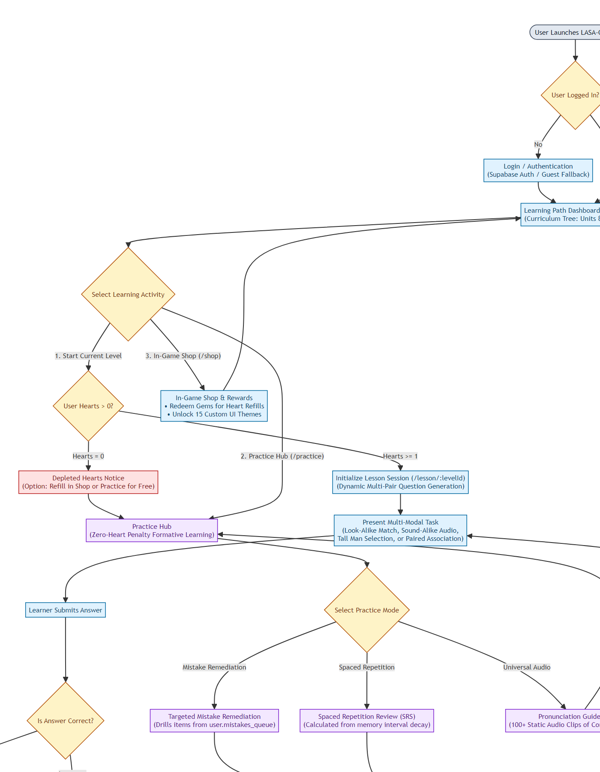
Figure 3.2: Proposed Process Flow for LASA-Quest (Curriculum Learning Path & Spaced Practice Architecture)
CHAPTER REFERENCES
(NEW ENTRIES INTRODUCED BY REVISIONS)
[REVISION TARGET & INSTRUCTION]: Append the following numbered reference entries to the existing References section of the thesis (starting immediately following existing Reference [37], page 50). All citations adhere to IEEE/Numbered format.
[38] M. Shortt, S. Tilak, G. Czarnota, and M. Glassman, "Gamification in mobile-assisted language learning: A systematic review of Duolingo, Babbel, and Memrise," Computer Assisted Language Learning, vol. 36, no. 8, pp. 1624–1655, 2023. DOI: 10.1080/09588221.2021.1969032.
[39] S. Bai, C. Shen, and J. Guan, "The impact of gamification on student motivation and academic performance: A meta-analysis," Educational Research Review, vol. 31, p. 100346, 2020. DOI: 10.1016/j.edurev.2020.100346.
[40] H. Dehghanzadeh, H. Fardanesh, J. Hatami, E. Talaee, and O. Noroozi, "Using gamification to support learning in higher education: A systematic review," Computers & Education, vol. 170, p. 104231, 2021. DOI: 10.1016/j.compedu.2021.104231.
[41] M. Sailer and L. Homner, "The gamification of learning: a meta-analysis," Educational Psychology Review, vol. 32, no. 1, pp. 77–112, 2020. DOI: 10.1007/s10648-019-09498-w.
[42] M. Kapur, "Examining productive failure, disguised teaching, and direct instruction for learning," Educational Psychologist, vol. 51, no. 2, pp. 159–175, 2016. DOI: 10.1080/00461520.2016.1155413.
[43] R. S. J. d. Baker, A. T. Corbett, K. R. Koedinger, and I. Roll, "Generalizing detection of student frustration, gaming the system, and off-task behavior across multiple intelligent tutoring systems," in International Conference on Intelligent Tutoring Systems, Berlin: Springer, 2006, pp. 531–540.

