LASA-Quest: A Gamified Application for Practicing Look-alike and Sound-alike (LASA) Medication Name Recognition for Pharmacy Students
A Research Paper Presented to
School of Information Technology
Mapúa University - Makati
In Partial Fulfillment to the Requirement for the Course
ITS200-1
Submitted by:
Convento, Ron David D.
Narvaez, Crystal Jaisey
Sable, Kyla Fhe C.
Antonette D. Gabriel
Thesis Adviser
September 2026

RECOMMENDATION SHEET

This is to certify that I have supervised the preparation of and read the thesis proposal prepared by Ron David D. Convento, Crystal Jaisey Narvaez, and Kyla Fhe C. Sable entitled LASA-Quest: A Gamified Application for Practicing Look-alike and Sound-alike (LASA) Medication Name Recognition for Pharmacy Students and that the said paper has been submitted for final examination by the Oral Examination Committee.

Antonette D. Gabriel
Thesis Adviser

TABLE OF CONTENTS
CHAPTER 1: INTRODUCTION 4
Background of the Study 4
Gap Analysis 7
Research Question 10
Objectives of the Study 10
General Objective 10
Specific Objectives 11
Scope and Delimitation 11
Significance of the Study 12
CHAPTER 2: REVIEW OF RELATED LITERATURES AND STUDIES 14
Related Terms 14
Published Works 19
Review of Related and Existing Systems 33
Review Synthesis 37
CHAPTER 3: METHODOLOGY 39
Methodological Framework 39
Software Development Life Cycle: Iterative-Incremental Model 39
Proposed System Process Flow 43
A. Research Design 44
B. Research Locale 45
C. Research Respondents 46
D. Research Instrument 46
E. Data Gathering 46
F. Samples and Sampling Techniques 49
G. Statistical Treatment 49
REFERENCES 51

CHAPTER 1
INTRODUCTION
Background of the Study
Gamification is the application of game design elements—such as points, levels, badges, interactive challenges, and immediate feedback—to non-game contexts to increase engagement, motivation, and learning outcomes. In digital applications, gamification transforms conventional instruction into interactive experiences that encourage repeated practice and sustained cognitive effort. Literature demonstrates that gamified approaches enhance user motivation and knowledge retention across various domains, including education, healthcare, and professional training. A scientometric analysis of gamification in medical education shows continued research growth and establishes its positive impact on learning effectiveness [1]. Meta-analytic evidence further indicates that game-informed instructional mechanics—particularly points, immediate feedback, and goal-directed challenges—significantly improve cognitive learning achievement and sustained engagement across diverse instructional environments [2]. Gamified applications are increasingly integrated into medical and professional education, creating strong interest in game-informed learning designs for high-stakes fields like the healthcare sector [3].
Despite advances in healthcare systems, medication errors remain a major threat to patient safety globally. These errors can cause preventable harm, increase healthcare costs, and undermine confidence and quality in health services [4, 5]. Medication errors occur across every stage of the medication process—prescribing, dispensing, administration, and patient self-use. While technical safeguards exist, including labeling standards, workflow protocols, and system-level checks, healthcare professionals require continuous training and skill reinforcement to maintain high-level error-detection competencies. Studies show that skills-focused, interactive training strategies are significantly more effective at preventing medication errors than passive lectures or traditional instructional methods alone [6].
In medication dispensing and administration, healthcare professionals—including pharmacists, nurses, and clinicians—must process high volumes of drug orders quickly and accurately. One common source of medication error is confusion caused by medication names that look alike or sound alike, collectively referred to as look-alike/sound-alike (LASA) medications [7, 8]. The World Health Organization (WHO) identifies LASA medication mix-ups as a leading cause of preventable patient harm worldwide [7].
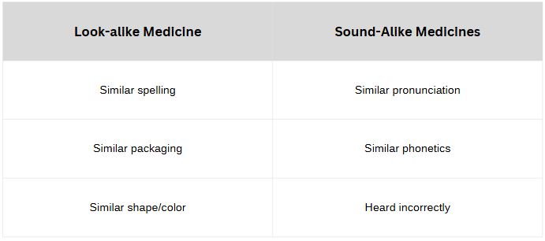
Table 1.1: Types of Look-Alike/Sound-Alike Medication Errors and Real-World Examples [8]
Among medication errors, look-alike/sound-alike (LASA) medicines represent a persistent and pervasive threat across pharmacy and nursing practice [7, 8]. When medication names share orthographic or phonetic characteristics, healthcare practitioners are vulnerable to selection and dispensing errors, especially under conditions of heavy workload, fatigue, distraction, or visual similarity in packaging [8].
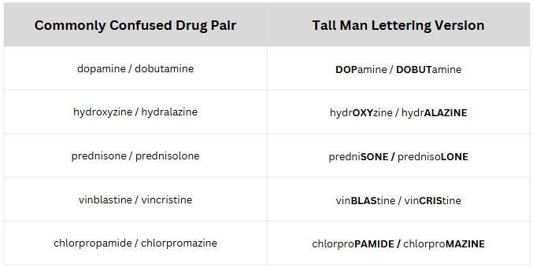
Table 1.2: Sample Tall Man Lettering for LASA Medication Names [9]
Healthcare organizations implement multiple layers of defense against LASA errors, including the Institute for Safe Medication Practices (ISMP) Tall Man Lettering recommendations [9], computerized physician order entry, automated dispensing cabinets, and standardized storage protocols [7, 10, 11]. Despite these interventions, LASA errors continue to occur, underscoring that systemic safeguards must be complemented by individual cognitive readiness and perceptual discrimination skills. The World Health Organization has established specific guidance through its 'Medication Safety for look-alike, sound-alike medicines' technical brief, highlighting the necessity of targeted educational strategies [7]. Traditional educational approaches often rely on didactic lectures, policy manuals, or static reference sheets, which rarely provide the repetitive, application-oriented practice necessary to build durable cognitive recognition habits [11].
To address this gap, the study proposes LASA-Quest: A Gamified Application for Practicing Look-alike and Sound-alike (LASA) Medication Name Recognition. Rather than presenting static memorization lists or passive lecture materials, LASA-Quest structures learning into an active, game-based experience driven by interactive challenges, immediate reinforcement, and systematic progression mechanics [1, 12]. Conceptually comparable to modern gamified learning applications—such as Duolingo's interaction paradigm of bite-sized interactive exercises, streak mechanics, and progressive difficulty—LASA-Quest provides structured, short-duration recognition tasks, immediate corrective feedback, and incremental progress tracking to promote repeated practice and sustained retention without the monolithic overhead of traditional lecture or course-management systems [13]. Empirical reviews demonstrate that bite-sized gamified exercises, streak tracking, experience points, and immediate feedback loops drive sustained learner engagement, motivation, and vocabulary or recognition acquisition through habitual practice [13]. In LASA-Quest, educational practice is delivered through dedicated challenge modes tailored to LASA error checkpoints—including phonetic discrimination tasks (Sound-Alike Detector), visual and orthographic identification drills (Look-Alike Spotter), selective capitalization exercises (Tall Man Rescue), simulated clinical dispensing scenarios (Dispensing Defense), and timed endurance drills (LASA Survival Mode). Player actions are governed by an immediate feedback loop and a finite resource system: answering correctly awards experience points (XP) and score rewards, updates lesson progress, and increments consecutive accuracy streaks, reinforcing correct identification habits. Conversely, incorrect answers trigger corrective feedback, display the correct drug name, and deduct a life point, challenging learners to evaluate their choices before retrying [1, 2, 3, 6, 12, 13].
Gap Analysis
The gap analysis evaluates existing studies and systems to establish the academic and practical necessity of the proposed LASA-Quest application. Table 1.3 examines published research studies in clinical decision support, error prevention, and medical education, identifying key limitations that inform the design of LASA-Quest.
The first mentioned study evaluates physicians' responses to Clinical Decision Support Systems (CDSS) alert overrides [14], noting high alert override rates due to alert fatigue. This highlights the need for educational simulation tools that build practitioner recognition rather than relying solely on automated interruptive alerts. Lizano-Díez et al. (2020) [15] focus on hospital-level interventions such as labeling and Tall Man lettering, but lacks active clinician-learning simulations. Bryan et al. (2021) [10] analyze drivers of LASA errors and calls for improved educational interventions. Ramamurthy et al. (2024) [6] and Xu et al. (2023) [12] demonstrate the superior efficacy of simulation-based and game-based training over traditional passive lectures, providing direct empirical justification for the gamified learning architecture of LASA-Quest.
Table 1.3: Gap Analysis of Existing Studies
Study | Existing Approaches | Gaps Identified | Proposed Solution (LASA-Quest)
Evaluation of Physicians' Responses to CDSS Alert Overrides [14] | Analyzes alert override behavior in hospital electronic health record systems. | Focuses only on system alerts; high override rates due to alert fatigue; lacks proactive learning. | Provides interactive simulation scenarios to train dispensers to recognize high-risk drug pairs independently.
Prevention strategies to identify LASA errors [15] | Emphasizes hospital-level administrative safeguards, labeling standards, and Tall Man lettering. | Lacks individual training components and evaluation of long-term clinician recognition retention. | Integrates Tall Man lettering and brand-generic discrimination into progressive gamified exercises.
The problem of LASA name errors: drivers and solutions [10] | Explores causes of LASA errors, including packaging similarities and orthographic overlap. | Provides conceptual and policy analysis without developing accessible software practice tools. | Translates error drivers into specific gameplay mechanics, including Look-Alike Spotter and Sound-Alike Detector.
Traditional vs. simulation-based teaching in medication error prevention [6] | Compares passive lecture instruction against interactive simulation among nursing students. | Demonstrates simulation superiority but does not address LASA confusion or provide continuous mobile practice. | Delivers a gamified learning application supporting repeated self-paced practice with instant corrective feedback.
Game-based learning in medical education [12] | Reviews gamified learning applications across medical training disciplines. | Highlights gamification benefits generally but does not develop a focused LASA medication safety tool. | Applies proven gamification mechanics (points, streaks, lives, levels) specifically to LASA drug name recognition.
Table 1.4 analyzes existing technological systems related to medication error mitigation and educational training, delineating their operational scope and comparing them against LASA-Quest.
Table 1.4: Gap Analysis of Existing Systems
System | Features / Capabilities | Gaps Identified | Proposed Solution (LASA-Quest)
Food and Drug Administration (FDA) Phonetic and Orthographic Computer Analysis (POCA) Program [18] | Advanced phonetic and orthographic computer analysis calculating similarity scores for drug name approval. | Designed exclusively as an administrative regulatory tool; inaccessible for routine training of healthcare students. | Adapts algorithmic drug similarity concepts into student-accessible recognition drills and challenge levels.
RxNav [19] | Displays RxNorm drug relationships, clinical formulations, and brand-generic linkages. | Operates as a reference search database; provides no instructional exercises, testing, or feedback. | Embeds structured drug name relationships into interactive dispensing and matching challenges.
NPS MedicineWise Medication Safety Online Learning Module [11] | Comprehensive web-based instructional course covering wrong-drug errors, packaging, and Tall Man lettering. | Structured online learning but primarily knowledge-based; lacks interactive gamification, streaks, and repeated drills. | Implements an engaging gamified learning application featuring immediate feedback, points, lives, and progressive levels.
The analysis in Table 1.3 and Table 1.4 highlights a critical gap in medication safety education: while regulatory screening tools and didactic online learning modules exist, there is a clear deficiency in gamified learning applications that offer active, repetitive, and habit-forming LASA recognition practice. Existing educational systems are predominantly didactic and information-centric, failing to provide the interactive simulation and immediate corrective reinforcement necessary for high-stakes clinical error prevention. LASA-Quest directly addresses this gap by combining validated gamification mechanics with targeted LASA discrimination exercises.
Research Question
This study addresses the overarching research question: How can a gamified learning application be designed, developed, and empirically evaluated to support Look-Alike/Sound-Alike (LASA) medication name recognition and medication safety practice among pharmacy students?
To address this question comprehensively, the study examines the following specific sub-questions:
1. What are the key functional, instructional, and game mechanics requirements for developing an engaging LASA medication recognition tool?
2. How can an interactive gamified application (LASA-Quest) be engineered using an Iterative-Incremental software development life cycle to deliver progressive functional modules?
3. What are the respondents' knowledge assessment scores across multiple assessment points—specifically prior to using the application, immediately after using the application, and one week following application use?
4. What is the perceived usability and user satisfaction profile of the LASA-Quest application as measured by standardized evaluation instruments, specifically the Post-Study System Usability Questionnaire (PSSUQ)?

Objectives of the Study
General Objective
The general objective of this study is to design, develop, and empirically evaluate LASA-Quest, a gamified learning application intended to support Look-Alike/Sound-Alike (LASA) medication name recognition and medication-safety practice among pharmacy students.
Specific Objectives
To achieve the general objective, the study will pursue the following specific objectives:
1. To identify and formalize the functional, educational, and usability requirements for LASA medication recognition training, incorporating established guidelines from the World Health Organization (WHO) and Institute for Safe Medication Practices (ISMP).
2. To design and implement LASA-Quest using the Iterative-Incremental Model, delivering progressive increments featuring core challenge modes (Sound-Alike Detector, Look-Alike Spotter, Tall Man Rescue, Dispensing Defense, and LASA Survival Mode) alongside gamified progression elements (XP, points, streaks, lives, and feedback loops).
3. To evaluate respondents' knowledge assessment scores across three assessment points—prior to application use, immediately after application use, and one week post-use—to descriptively characterize knowledge scores over time.
4. To assess the perceived usability, interface satisfaction, and user experience of LASA-Quest using the Post-Study System Usability Questionnaire (PSSUQ).
5. To analyze user feedback and evaluation metrics descriptively to identify system strengths and areas for future software enhancement.

Scope and Delimitation
The study focuses on the design, implementation, and empirical evaluation of LASA-Quest, a gamified learning application intended to support medication safety by mitigating LASA medication errors among pharmacy students. The scope of the software application encompasses five distinct challenge modes: Sound-Alike Detector (phonetic discrimination), Look-Alike Spotter (orthographic and visual discrimination), Tall Man Rescue (application of FDA/ISMP Tall Man lettering), Dispensing Defense (simulated clinical dispensing decisions), and LASA Survival Mode (timed endurance challenges). System mechanics include user authentication, profile and performance tracking, immediate feedback loops, XP/points accumulation, streak maintenance, and life point deduction.
The empirical evaluation is delimited to a descriptive quantitative study conducted among pharmacy students at Mapúa University Makati. The evaluation will measure respondents' knowledge assessment scores across three distinct assessment points: prior to application exposure (baseline), immediately after using the application, and one week after application use to assess knowledge score patterns over time. Perceived usability and user satisfaction will be measured using the Post-Study System Usability Questionnaire (PSSUQ).
The study does not include real-world hospital clinical trials, patient health outcome tracking, automated integration with institutional Electronic Health Records (EHR) or Clinical Decision Support Systems (CDSS), or physical product packaging manufacturing. Furthermore, the descriptive quantitative methodology is designed to characterize respondents' assessment scores and usability ratings descriptively, and does not evaluate comparative intervention effects between separate participant groups.

Significance of the Study
Medication errors continue to pose a major challenge to patient safety worldwide, contributing to preventable adverse drug events, extended hospital stays, and increased healthcare costs [4, 5, 7, 8]. By developing and evaluating an interactive, game-based learning tool targeting LASA medication name recognition, this study offers practical and academic contributions to several stakeholders:
Pharmacy Students and Healthcare Trainees: Provides an accessible, engaging gamified learning tool that facilitates repetitive, habit-forming recognition practice. By practicing with simulated LASA drug pairs, students can build perceptual discrimination and confidence prior to entering high-stakes clinical environments.
Academic Institutions and Healthcare Educators: Offers educators a supplementary instructional tool that enhances traditional didactic lectures with active, experiential learning exercises aligned with WHO and ISMP medication safety guidelines.
Healthcare Organizations and Patient Safety Advocates: Contributes to systemic medication safety initiatives by fostering cognitive readiness and perceptual accuracy in dispensers, supporting broader efforts to reduce LASA-related errors and align with United Nations Sustainable Development Goal 3 (Good Health and Well-Being) [20].
Educational Software Developers and Researchers: Expands the empirical literature on gamified learning applications in healthcare education, demonstrating how game design mechanics can be combined with standardized usability instruments (PSSUQ) and an Iterative-Incremental Software Development Life Cycle (SDLC) to create effective educational tools.

CHAPTER 2
REVIEW OF RELATED LITERATURES AND STUDIES
This chapter presents a comprehensive review of related literature, studies, and existing systems that provide the conceptual and empirical foundation for the study. The review covers core terminologies, published empirical and scoping studies in healthcare gamification and medication safety, comparative analysis of existing technological systems, and a thematic synthesis connecting the literature to the design of LASA-Quest.
Related Terms:
1st Word/Topic: Medication Errors and CDSS Alert Overrides
Medication errors that cause harm to the patient are commonly classified as adverse drug events. These errors affect patient safety and the healthcare system through raising mortality and morbidity rates alongside a slight association with economic burden. Clinical Decision Support Systems (CDSS) have been implemented as a technological safeguard alerting physicians and pharmacists of medication errors. The findings however uncovered inappropriate cases of pharmacist overrides where alerts were neglected, as a product of alert fatigue and workplace pressure. [14]
2nd Word/Topic: Look-Alike / Sound-Alike Errors
Medication prescriptions worldwide are susceptible to look-alike/sound-alike (LASA) errors. Most mitigation strategies for drug names typically focus on prescribing and dispensing. Despite recurring safety concerns, there is no common policy worldwide to counteract these errors. Most prevention strategies to identify LASA errors are developed at a hospital level, with the inclusion of technology assisted analysis, packaging and labelling intervention, and verification and alerts [15].
3rd Word/Topic: Phonetic-Orthographic Drug Error Solutions
LASA medication names and errors are compounded by potential similarities in packaging, tablet appearance, tablet strength, administration methods, or therapeutic indication. Solutions to these errors include minimizing medication administration interruptions and distractions and typographic tweaks. These include selective capitalization or Tall Man letters, boldfacing, italicizing, or color contrasting. Other solutions include barcoding and computerized alerts for potential LASA medication pairs [10].
4th Word/Topic: Drug Name Similarity Software
The study focused on creating and testing software designed to proactively identify confusing drug name pairs using computational similarity scoring. With an adapted algorithm, the software analyzed all medicine names registered in Australia and calculated similarity scores. Though the computed risk categories showed a conservative correlation with pre-established manual risk rankings, the software showed promise as a screening tool for proposed drug names and to supplement incident reporting systems for managing LASA error risk [16].
5th Word/Topic: Clinical Medication Errors
Multiple cases include LASA drug name confusion as perpetrators to actual medication errors. Examples include the confusion of clopidogrel and clozopine, a typo converting edoxaban to endoxaban, and a transcription error mixing meropenem with the antipsychotic melperone. These highlight how errors can arise from legibility issues, transcription mistakes, and workflow in busy clinical settings. The authors underscore the importance of clear prescriptions, electronic systems, and the use of Tall Man lettering to reduce risk [5, 16].
6th Word/Topic: Game Based Learning
Game-based learning integrates instructional content into structured game activities that encourage active participation, experiential practice, and repeated engagement. In medical education, this approach can provide learners with interactive opportunities to apply theoretical knowledge in simulated or controlled situations rather than relying solely on passive instruction. Studies have shown that game-based learning can strengthen learner motivation, knowledge retention, clinical reasoning, and practical decision-making by allowing students to practice skills in an engaging and relatively low-risk environment [12].
Repeated participation in game-based activities may also help reinforce theoretical concepts and practical skills while allowing learners to build confidence before encountering similar situations in actual clinical settings. Although traditional teaching methods remain important, game-based learning can serve as a complementary instructional strategy by providing additional opportunities for active learning, immediate application of knowledge, and repeated practice. In healthcare education, these characteristics make game-based learning particularly relevant to areas such as medication safety, where accurate recognition and decision-making require both knowledge and repeated application [12].
7th Word/Topic: Human-Computer Interaction​
Human-computer interaction in nursing information includes the design and use of digital systems that help nurses access, interpret, and use clinical data. In healthcare settings, good interaction between nurses and computer systems improves the usability of information technologies. This leads to more accurate clinical decisions and smoother workflows. Research shows that when human-computer interaction is improved, it can lessen cognitive strain on practitioners and enhance the safety and quality of patient care, especially by reducing errors tied to information retrieval and system navigation [21].​
8th Word/Topic: E‑Learning Effectiveness in Healthcare​
E-learning effectiveness in healthcare education depends on digital programs achieving key learning objectives. Elements such as learner satisfaction, engagement, accessibility, and perceived usefulness contribute to this outcome. A study applying the Fuzzy Analytic Network Process (Fuzzy ANP) model highlights how these factors shape e-learning results for healthcare professionals and students [22].
9th Word/Topic: Technology-Based Interventions
Technology-based interventions are about the implementation of digital tools and information systems that focus on healthcare processes, improve clinical decision-making, and prevent human errors. This type of intervention is beneficial in medication safety because there are computerized prescribing systems, automated dispensing applications, improved decision making, and digital learning platforms. There are studies that show digital and technology-driven solutions enhance the healthcare sector by minimizing manual errors, standardize workflows, improve efficiency of services, and provide support in clinical decision-making including medication management [23, 24].
10th Word/Topic: Health Information Technology
Health Information Technology (HIT) focuses on the application of information systems and digital technologies. This type of technology provides various benefits, such as managing healthcare data, providing clinical decision support, enhancing patient safety and management, safer medication practices, and improving communication among healthcare professionals. The systems included in Health Information Technology are digitalized health records, electronic physician order entry, barcode medication administration, and clinical decision support systems. Studies have shown that the implementation of HIT significantly provides standardized medication information, error prevention by notifications or alerts, and automated checks that decrease reliance on memory and manual processes [25, 26]. With the integration of health information principles and technology, it provides safe medication use and enhances the overall medication safety framework [26].
11th Word/Topic: E-Learning Systems​
E-learning systems refer to digital platforms that provide educational content through online, interactive, and multimedia-based methods. Also, these systems can be in mobile applications, computer applications, or web-based applications. E-learning systems are widely used in healthcare education for teaching and training students and professionals because of their flexibility, scalability, and self-paced learning. Furthermore, this improves knowledge retention and learning outcomes and provides continuous education and accessibility to medical resources without limitations. Studies proved that well-designed e-learning systems are crucial and effective in enhancing clinical knowledge and skills, specifically if combined with interactive and evaluative features [22, 27, 28].

Published Works:
Medication-Related Alert overrides in clinical decision support systems [14]
Justinia et al. (2021) contributed to medical safety research by examining how physicians respond to medication-related alerts in Clinical Decision Support Systems (CDSS). The study highlights how alert overrides as an ability play a significant factor in influencing medication errors and patient safety outcomes [14]. A major strength of the study is the focus on real-world clinical behavior. It underscores how alert fatigue and perceived irrelevance reduce the effectiveness of safety alerts.
The study, however, evaluates alert override behavior and does not explore alternative intervention strategies beyond system alerts. Because of this, the study does not address educational or training-based solutions that could improve clinician engagement with alerts. The gap lies in exploring interactive or learning oriented interventions that reinforce safe medication practices and reduce alert fatigue.
Prevention strategies to identify LASA errors: building and sustaining a culture of patient safety [15] The study provides an overview of strategies used to prevent look-alike/sound-alike (LASA) medication errors and emphasizes the role of institutional safety culture in mitigating risks. The strength of this work lies in its comprehensive discussion of hospital-level prevention strategies such as labelling, verification processes, and technology-assisted alerts.
The study however, lacks evaluation of long-term effectiveness and does not focus on clinician learning or behavior change [15]. A standardized educational approach is needed to support the study. Current systems, through institutional policies and training, align with the importance of improving clinicians’ ability to recognize and manage LASA risks consistently.
The problem of look‐alike, sound‐alike name errors: Drivers and solutions [10]
This paper contributes by identifying key drivers of LASA errors, extending beyond drug name similarity and analyzing packaging, dosage, administrative methods, and therapeutic indication. Within the study, Bryan et al. (2021) also outline and highlight the importance of commonly used mitigation strategies. [10] Factoring these key drivers, the study succeeded in analyzing multiple contributing factors and practical solutions such as Tall Man lettering and barcoding.
These expand to other textual modifications and compare the recorded perception in detail. The findings, however, are largely descriptive and do not empirically assess the effectiveness of these interventions in mitigating error rates. The study highlights the need for training approaches that address cognitive load and decision-making under pressure, rather than a reliance on visual or system-based safeguards.
Development and exploratory analysis of software to detect look-alike, sound-alike medicine names [16] A proactive software-based approach was created within this study to identify potentially confusing drug name pairs using computational similarity scoring. A baseline had been established to contribute towards the early detection of LASA risks. Within the study, Emmerton et al. (2020) appropriately highlighted the importance of scalability through analyzing an entire national medicine registry and analyzing data relationships within the repository.
The software however, shows only moderate agreement with expert judgement and does not consider clinical context or user interaction [16]. Further research is needed to integrate detection tools with more complex systems for various institutes. Implementation within educational systems may also be focused on helping pharmacists understand and respond to identified LASA risks effectively.
Look‐alikes, sound‐alikes: Three cases of insidious medication errors [17]
This study contributes clinical evidence through case reports, demonstrating how LASA errors occur in real healthcare settings due to name confusion, transcription errors, and workflow pressures. A key strength is the use of real cases that clearly illustrate the consequences and origins of LASA errors. Due to its limitation as a case report study, findings are narrowed down to generalizability and do not evaluate preventative interventions systematically [17] The study points to the need for simulation-based or experiential training methods that allow pharmacists to proactively identify and prevent LASA errors in realistic scenarios.
Artificial intelligence in Pharmacovigilance: An Introduction to terms, concepts, applications, and limitations [29] Artificial intelligence (AI) tools and concepts have grown a substantial amount within the past years, in data and pattern recognition. The study by Aronson related these tools with pharmacovigilance, defined as the systematic monitoring of drug safety after market approval. The study highlights AI terminology, machine learning techniques, Natural Language Processing (NLP), and expert systems in the context of pharmacovigilance workflows showing how advanced computational methods can improve detection of adverse drug reactions and aid in large scale drug safety surveillance [29] Factors such as the integration of AI and drug safety were underscored in this research, depicting how tools like machine learning and NLP can accelerate signal detection from larger, diverse data sources.
The study also outlines and defines essential AI concepts, acting as a baseline for computational topics for drug safety researchers. Findings are heavily limited being a conceptual research. Though covering a wide range of AI topics and tools, specific experience is missing to properly integrate AI tools and concepts with clinical protocol and regulation. The lack of case-based evaluation shows a gap between connecting actual AI models to pharmacovigilance data and traditional methods.
Additionally, deeper analysis is required on how healthcare professionals and safety scientists interpret, trust, and act on AI-assisted signals. A Fuzzy ANP Study Mahdavi et al. (2023) identified and prioritized key factors that influence the effectiveness of e-learning in healthcare education using a structured expert evaluation method, the Fuzzy Analytic Network Process.
The research contributes to the educational literature through quantifying products of e-learning such as success outcomes, learner satisfaction, content readability, accessibility, and engagement. These components were noted as most influential for effective implementation in health professional training [22] The study was successful in identifying the Fuzzy Analytic Network Process as a systematic method for evaluating factors that affect e-learning success.
Findings uncovered factors outside user satisfaction surveys to identify successful design and delivery elements. Most importantly, e-learning challenges were addressed in healthcare contexts, accounting for geographical, resource, and infrastructure constraints and how they affect access and adoption [22] These findings, however, accompanied a concern for expert opinion dependency, which may not fully represent learner experiences or outcomes in varied educational contexts.
Though the study identifies these educational factors, they do not directly measure improved clinical performance or patient safety. Hence, the study uncovered the importance of further studies to link e-learning's effective metrics to actual behavior change and improved safety performance. Suggestions also include e-learning effectiveness over time and comparatively with competing e-learning designs and media, and their impact on knowledge retention and practical skills.
Methodological Approaches for Analyzing medication error reports in patient safety
Reporting Systems: A Scoping Review [23]
This scoping review contributes to the field by systematically mapping the current methods used to analyze medication error reports in patient safety reporting systems, identifying a variety of analytical approaches from traditional quantitative and qualitative techniques to emerging methods like disproportionality analysis, text mining, natural language processing, and AI-assisted analyses [23].
A major strength of this work is its comprehensive overview of the methodological landscape across a large corpus of error-reporting literature, which highlights how different analytic strategies are being applied and where innovation is occurring. The review also underscores the increasing adoption of advanced computational tools that can handle complex or free-text safety data. However, its weakness lies in the lack of evaluation of the effectiveness or practical impact of these varied analytic methods.
Tchijevitch et al. (2025) describe what exists but do not assess which methods truly improve understanding or prevention of errors [23]. As such, there is a gap in demonstrating whether new analytic methods actually enhance error detection quality or lead to actionable safety improvements, particularly in real clinical settings. Future research should focus on validating and comparing these advanced methods to determine which are most useful for real-world medication safety insights and decision support.
Tackling medication errors: how a systems approach improves patient safety [24]
This paper advances medication safety research by emphasizing the systems perspective, arguing that medication errors cannot be sufficiently prevented through isolated interventions. These errors instead require integrated safety governance, technological support, robust processes, and organizational culture improvements [24]. Its strength lies in its holistic analysis, drawing on critical incident data and systematic reviews to identify both latent systemic failures, such as governance and technical resources, and active individual errors, along with root causes across the medication use process.
It also reinforces the shift from a blame culture to a just culture and systems-level thinking in preventing harm [24]. While it proposes a broad set of measures, it does not test or quantify the effectiveness of specific interventions like educational programs, digital learning tools, or human-centered tech solutions. A gap exists in translating these system-level recommendations into evidence on which specific strategies or technologies most effectively reduce errors, particularly when mediated by clinician behavior or training.
Use of technology to reduce medication errors and improve patient safety [25]
This study contributes by exploring how healthcare technology, such as electronic health records, HIT, Computerized Physician Order Entry (CPOE), and other digital tools, is perceived to reduce medication errors and improve patient safety [25]. The study succeeds, applying technology as an intervention, emphasizing that digital systems can play a role in minimizing error rates and improving confidence in care delivery. It aligns with broader safety literature that supports technological integration in medication management workflows.
However, the study shows weakness in its reliance on qualitative perceptions and survey-based data, which may not accurately reflect actual clinical effectiveness or objective outcomes. It does not differentiate how specific technologies perform or which features of digital systems are most influential in reducing LASA errors or alert fatigue. Findings prove a need for rigorous empirical evaluation linking specific digital interventions to measurable reductions in medication errors, error types including LASA errors, and patient outcomes, ideally in controlled or longitudinal studies rather than solely perception-driven research.
Game-based learning in medical education [12]
This study explores the use of game-based learning in medical education and its impact on student engagement, knowledge retention, and clinical skills. Xu et al. (2023) focused on how interactive and immersive learning experiences can support practical decision-making and experiential learning, which are essential in healthcare training [12]. The study found that game-based learning improves motivation, reinforces knowledge, and strengthens clinical reasoning by simulating real-world medical scenarios.
Learners can practice decision-making in a safe, controlled environment, reducing anxiety and building confidence before working in actual clinical settings. The research also highlights that repeated engagement in game-based activities helps consolidate both theoretical knowledge and practical skills [12]. The authors note that while traditional teaching methods remain important, game-based learning provides additional opportunities for active learning and error-free practice.
The study suggests that incorporating game-based strategies into healthcare curricula can better prepare medical and pharmacy students, promote safer clinical practice, and reduce the likelihood of errors [12].
Utilizing human–computer interaction in nursing information: Application and trends [21]
Huang et al. (2024), in their study “Utilizing Human–Computer Interaction in Nursing Information: Application and Trends,” explored how human–computer interaction (HCI) principles are applied in nursing information systems and the emerging trends in this field. The research focuses on the importance of designing digital systems that align with nurses’ cognitive processes and workflow requirements to enhance usability and efficiency in healthcare settings [21].
The study highlights that effective human–computer interaction can improve information accessibility, reduce cognitive load, and support accurate clinical decision-making among nurses. By optimizing interface design and system functionality, nursing information systems can minimize user errors associated with poor navigation or information overload. This is particularly significant in high-risk clinical environments where timely and accurate information processing is critical [21].
The findings emphasize the growing need for user-centered design in healthcare technologies. The authors suggest that integrating HCI principles into nursing information systems can enhance patient safety, improve workflow efficiency, and reduce the likelihood of clinical errors. This study supports the development of digital healthcare solutions that prioritize usability and human factors, reinforcing the role of technology in improving the overall quality of nursing care [21] Facilitating nursing students' skill training in distance education via online game-based learning with the watch-summarize-question approach during the COVID-19 pandemic: A quasi-experimental study [27]. The purpose of this study is to examine how online game-based learning combined with the Watch-Summarize-Question (WSQ) approach can improve nursing students’ practical skills, engagement, and confidence during remote education in the COVID-19 pandemic.
The study addresses the research question of whether an interactive, structured, and gamified learning strategy can enhance skill acquisition compared with traditional video-based instruction. The study used a quasi-experimental design with two groups of nursing students: one received the game-based WSQ approach, and the other received traditional video-based learning. Outcomes measured included skill competence, self-efficacy, learning engagement, and student satisfaction.
The scope focused on essential clinical skills for nursing practice in a distance learning environment. Findings showed that the game-based WSQ group achieved higher skill competence, engagement, self-efficacy, and satisfaction than the control group. This study contributes to nursing education by demonstrating that interactive and structured online learning can effectively improve skill performance in remote settings.
Strengths include the combination of gamification and structured pedagogy, while limitations involve the single-institution setting, small sample size, and lack of long-term skill retention data. The study highlights the potential of gamified learning to enhance remote nursing training but suggests that further research is needed to evaluate long-term outcomes and broader implementation [27]. Comparison of Gamification, Game-Based Learning, and Serious Games in Medical
Education: A Scientometrics Analysis [1]
Zohari et al. (2023) investigated research trends and scholarly output on gamification, game-based learning, and serious games in medical education. Using scientometric methods, they analyzed publication patterns, key themes, and influential studies to understand how each approach contributes to learning in healthcare education. The analysis revealed that while all three modalities—gamification, game-based learning, and serious games—aim to enhance learner engagement and educational outcomes, they differ in their theoretical foundations and practical applications.
Gamification typically incorporates game elements into non-game contexts to motivate learners, game-based learning embeds learning content directly within game activities, and serious games are complete game systems designed primarily for educational purposes. The study highlighted that research on gamification has grown rapidly, especially in relation to learner motivation and behavior change, whereas studies on serious games have focused more on simulation and skill mastery [1].
The authors also identified key gaps in the literature, noting that comparative studies exploring the differential effects of these approaches on specific educational outcomes are still limited. This suggests opportunities for future research to investigate how each strategy uniquely influences aspects such as knowledge retention, clinical skills performance, and long-term behavior change in healthcare education.
Overall, this scientometric analysis provides a structured understanding of how game-related educational approaches have evolved and where research attention is needed most [1] Traditional teaching method versus simulation-based teaching method in the prevention of medication errors among nursing students [6] The researchers, Ramamurthy, Chitra, and Kavitha (2024), in their study “Traditional Teaching Method versus Simulation-Based Teaching Method in the Prevention of Medication Errors Among Nursing Students,” investigated the effectiveness of traditional lecture-based teaching compared with simulation-based learning in reducing medication errors among nursing students.
They aimed to determine which approach better prepares students for safe medication administration and overall patient safety. The study revealed that students trained through simulation-based methods demonstrated greater proficiency in medication administration and made fewer errors than those who received traditional instruction. Simulation-based learning provided interactive, realistic scenarios that promoted hands-on practice, critical thinking, and immediate feedback, highlighting the benefits of experiential learning for clinical preparedness.
Based on their findings, the researchers recommend integrating simulation-based teaching into nursing curricula alongside conventional methods. This strategy enhances practical skills, builds confidence, improves decision-making, and emphasizes patient safety, underscoring the importance of innovative educational approaches to reduce preventable medication errors [6]
Workload as the most Important Influencing Factor of Medication Errors by Nurses [30]
In their 2021 study, “Workload as the Most Important Influencing Factor of Medication Errors by Nurses,” Ratanto, Hariyati, Rr.T.S., Mediawati, A.S., and Eryando explored how nurse workload contributes to the occurrence of medication errors. The study aimed to identify the most significant factors influencing errors in medication administration and to highlight areas for improvement in patient safety management [30].
The researchers found that workload was the leading factor affecting medication errors among nurses. High patient-to-nurse ratios, long working hours, and the complexity of clinical tasks increased fatigue and cognitive load, leading to a higher likelihood of mistakes in medication handling. The study emphasizes that managing workload is critical to reducing errors and ensuring patient safety in healthcare settings [30].
Based on their findings, the authors recommend strategies such as optimized nurse staffing, workload monitoring, and the integration of supportive systems or digital tools to assist nurses in medication administration. These interventions aim to reduce fatigue-related errors, enhance decision-making, and improve overall quality of care. By highlighting workload as a key determinant, the study provides actionable insights for healthcare administrators to implement policies that support safer medication practices [30].
Exploring the invisible work of nursing: A case study of simulated increases in intensity of care on nurses' cognitive load, clinical judgment, stress, and errors [31]. This study looks at the hidden mental work that nurses do and how it affects their decision-making, stress, and chances of making mistakes. Vasel explored what happens when nurses are asked to care for more patients or more complex cases, showing that higher care demands increase the mental effort required to prioritize tasks, make quick decisions, and manage information [31].
Using simulated high-intensity patient care scenarios, the study found that as care demands went up, nurses experienced higher mental workload, made more errors, and felt more stressed. A key strength of the study is that it used realistic simulations to show the “invisible work” nurses do, which is often ignored in regular workload measures. However, because it was based on simulated situations, the results may not completely match what happens in real hospitals [31].
The study suggests that healthcare systems and educators should focus on helping nurses manage mental workload, not just increasing staffing numbers. Recommendations include using simulation training to prepare nurses for challenging situations, designing workflows that reduce mental strain, and adding tools that support decision-making. By highlighting this hidden work, the study shows ways to make patient care safer and reduce errors [31], improving assessment and learning environments for graduate medical trainees to advance healthcare language equity [28] The article by Dube et al. (2024) contributes to medical education research by highlighting the need to improve assessment frameworks and learning environments for graduate medical trainees These frameworks and pathways are highlighted with defined milestones to better prepare them for providing language-appropriate care, which is increasingly recognized as a factor in patient safety and equitable healthcare delivery.
The work succeeds through its multidisciplinary approach, bringing together linguistic, educational, and clinical perspectives to propose a new subcompetency and expanded Clinical Learning Environment Review (CLER) pathways that explicitly address healthcare language equity. Findings offer curricular and assessment guidance for residency and fellowship programs. The study is limited in that it is primarily conceptual and editorial in nature, outlining frameworks and proposals without providing empirical evaluation of how these changes improve learner competence or patient safety outcomes in practice.
These findings suggest further research to validate and measure the real-world impact of these proposed assessment enhancements on trainee communication skills and downstream patient safety metrics. A greater importance is also highlighted in diverse linguistic and clinical settings. The usability aspects of medication-related decision support systems in the inpatient setting: A systematic review [32] This study looks at how usable medication-related decision support systems (CDSS) are in hospitals and how usability affects patient safety.
Knols et al. (2020) reviewed multiple studies to understand how these digital systems help or hinder healthcare professionals when making medication-related decisions [32]. The review found that while decision support systems can reduce medication errors and improve patient safety, many systems have usability problems. Issues such as confusing interfaces, unclear alerts, and poor integration into clinical workflow can cause frustration, reduce effectiveness, and sometimes even contribute to errors.
The study emphasizes that just having a system is not enough; it must be designed so that nurses and doctors can use it easily and efficiently [32]. The authors recommend improving system design by considering user needs, simplifying interfaces, and testing systems in real clinical environments. They also highlight the importance of training healthcare professionals to use these tools effectively.
Overall, the study shows that usability is a critical factor in the success of decision support systems and in preventing medication errors [32] Human factors and safety analysis methods used in the design and redesign of electronic medication management systems: A systematic review [26] This study addresses the role of human factors in designing and improving electronic medication management systems (EMMS) to reduce errors and improve patient safety.
Awad et al. (2023) systematically reviewed research on how safety and usability methods are applied in the development and redesign of these systems in healthcare settings [26]. The review found that many EMMS incorporate safety and usability evaluations, such as workflow analysis, heuristic evaluation, and user testing. These methods help identify potential errors, design flaws, and areas where the system may be difficult for healthcare professionals to use.
However, the study also noted that not all systems consistently apply human factors principles, and some lack formal evaluation during implementation, which can reduce effectiveness and increase the risk of medication errors [26]. The authors recommend that healthcare organizations integrate human factors and safety analysis early in system design and during ongoing updates. This includes involving end-users in testing, considering workflow and cognitive workload, and continuously monitoring system performance.
The study highlights that understanding human factors is essential for designing EMMS that truly support clinicians and minimize errors, ultimately improving patient safety [26]

Review of Related and Existing Systems:
Food and Drug Administration (FDA) Phonetic and Orthographic Computer Analysis (POCA) Program [18]
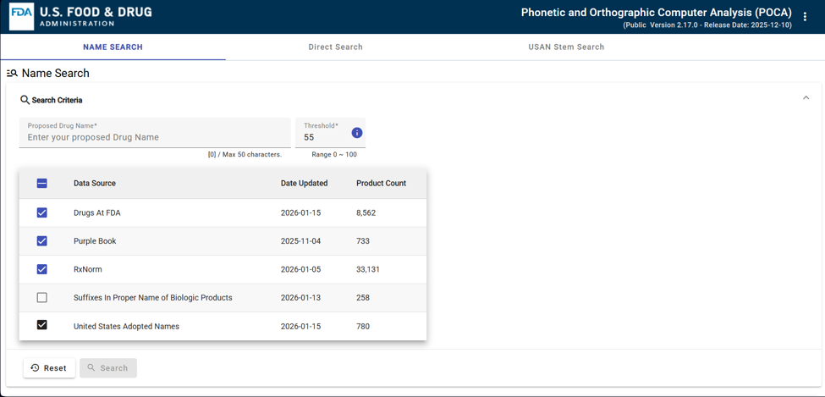
Figure 2.1: User Interface of FDA POCA [18]
POCA is a software tool used to determine how similar two drug names are based on their phonetic and orthographic similarities. According to the U.S. Food and Drug Administration, it applies an algorithm to compute or compare similarity between drug name pairs. Also, it can compare one name against multiple names in various built-in data sources to help identify confusion candidates. POCA is commonly discussed in brand name review, where it helps avoid major safety concerns in look-alike/sound-alike drugs. The FDA made the source code and technical documentation of POCA available for public use in name-similarity screening, which highlights its function as an analytical application to identify drug names that might be confusingly similar [18]. While POCA provides robust computational scoring, it serves solely as a regulatory screening tool and offers no interactive educational practice for dispensing personnel.
RxNav [19]
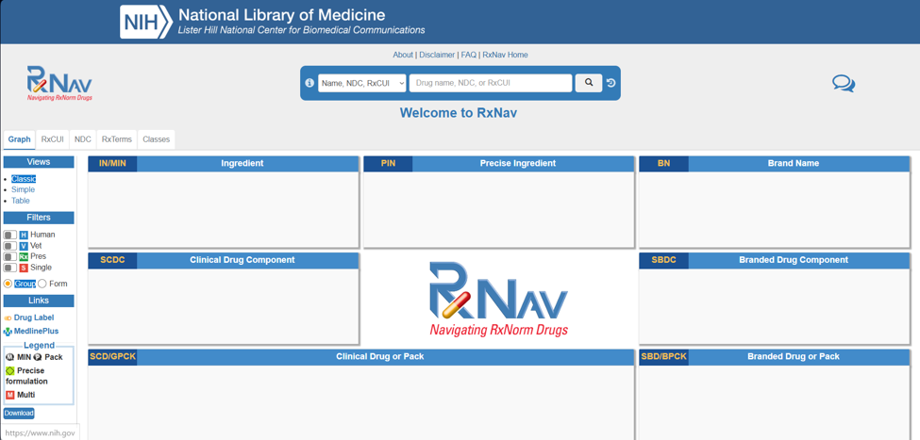
Figure 2.2: RxNav Platform [19]
RxNav is an application that offers searching and browsing of RxNorm drug terminology based on the RxNorm Application Programming Interface (API). RxNorm is a standardized naming system for clinical medications maintained by the U.S. National Library of Medicine. RxNav serves as a browser for multiple drug information sources, including RxNorm and related resources. In this application, users can view branded and generic drugs along with active ingredients, components, related brand names, and associated identifiers such as NDC. It is a structured navigation tool that facilitates user understanding through standardized drug information and terminology mapping [19]. However, RxNav functions strictly as a reference retrieval database and does not provide active gamification, error feedback, or skill-building exercises.

NPS MedicineWise Medication Safety Online Learning Module [11]
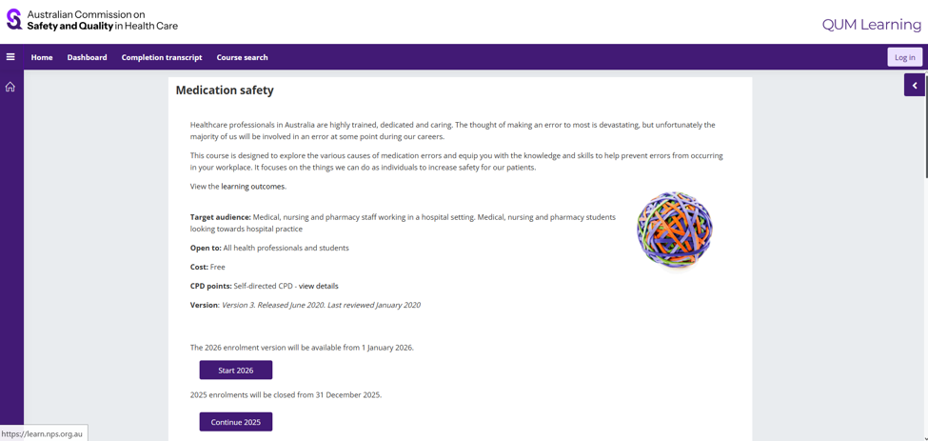
Figure 2.3: NPS MedicineWise Medication Safety Online Learning Module [11]
The NPS MedicineWise Medication Safety Online Learning Module is an online learning tool that provides structured lessons on common medication errors. The module includes topics on the causes of wrong-drug errors, drug name confusion, look-alike drug name errors, and sound-alike drug errors. It also discusses preventive strategies such as Tall Man lettering, avoiding look-alike and sound-alike medication errors, similar packaging and labelling concerns, and barcode scanning. Since the module is organized with learning outcomes and topic sub-sections, it functions more as a formal online course than a quick reference tool [11].

Existing Process Flow of NPS MedicineWise Module
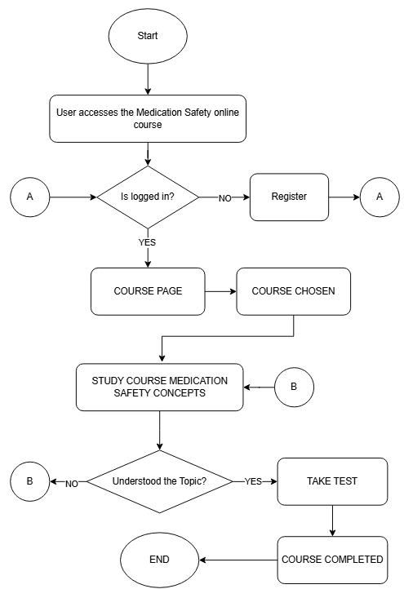
Figure 2.4: NPS MedicineWise Module Derived Existing Process Flow [11]
The process flow of the NPS MedicineWise Medication Safety Online Learning Module begins when the user accesses the Medication Safety online course. The system checks whether the user is already logged in. If not logged in, the user is redirected to registration, completing verification before proceeding. Once logged in, the user reaches the course dashboard and selects the medication safety module. The user studies medication safety concepts including medication errors, wrong-drug errors, drug name confusion, LASA medication risks, Tall Man lettering, packaging similarities, and barcode verification. The user answers knowledge checks and reviews feedback before finishing the course [11]. While comprehensive in theoretical concepts, the flow lacks interactive gamified simulations and repetitive drug recognition practice.
Review Synthesis:
Medication Errors, LASA, and System Limitations
The reviewed literature confirms that medication errors continue to represent a severe, widespread risk to patient safety across healthcare systems [4, 5]. Among these errors, Look-Alike/Sound-Alike (LASA) drug name confusion constitutes an insidious challenge that standard administrative guidelines and passive warning labels fail to eliminate entirely [7, 8, 10]. Although computational tools like POCA [18] and terminology databases like RxNav [19] provide powerful orthographic and phonetic analysis, they remain detached from frontline clinical learning environments. Clinical Decision Support Systems (CDSS) that rely heavily on automated alerts frequently suffer from high alert override rates and cognitive fatigue [14, 26]. Consequently, there is an urgent need for instructional solutions that proactively build perceptual discrimination and cognitive error resistance directly within dispensers prior to clinical practice.
Digital Systems, Human Factors, and Cognitive Load in Healthcare Education
Human factors research emphasizes that usability, clear visual hierarchy, and intuitive information architecture are paramount in designing digital health and educational tools [21, 26, 32]. Heavy cognitive workloads, complex user interfaces, and non-contextualized information exacerbate error rates among healthcare practitioners and trainees [30, 31]. Interactive learning applications must balance information richness with manageable cognitive load, ensuring that critical medication differentiators—such as Tall Man lettering distinctions and dosage forms—are immediately salient [17, 22]. Applying validated human-computer interaction principles ensures that learning tools remain engaging, accessible, and pedagogically effective without inducing fatigue [21, 28].
Gamified Systems and Educational Interventions
Evidence from medical and healthcare education demonstrates that experiential, simulation-based, and gamified instructional strategies significantly outperform traditional passive lectures in fostering clinical skills, decision-making under pressure, and long-term knowledge retention [1, 6, 12, 13, 27]. Game mechanics—such as progressive difficulty levels, immediate corrective feedback, score streaks, and life point deduction—stimulate active cognitive engagement and promote repetitive, habit-forming practice [1, 12, 13]. Integrating standardized evaluation instruments, including the Post-Study System Usability Questionnaire (PSSUQ), provides the rigorous empirical framework necessary to validate whether gamified systems achieve high usability and satisfaction [34] while knowledge assessments characterize respondents’ recognition scores across the three assessments [37]. These insights directly inform the design, implementation, and empirical evaluation of LASA-Quest.

CHAPTER 3
METHODOLOGY
Methodological Framework
This chapter presents the methodology of the study, encompassing the software development process and the empirical research evaluation. To maintain methodological rigor and clarity, the study establishes two distinct, non-conflated methodology pillars:
1. Research Methodology (Descriptive Quantitative): The empirical research design used to evaluate the developed application and analyze quantitative data collected from respondents. It systematically characterizes respondents' knowledge assessment scores across three assessment points and measures their perceived usability and satisfaction through standardized instruments.
2. Software Development Life Cycle Model (Iterative-Incremental Model): The SDLC model that governs the software engineering process. Rather than building the application in a single, monolithic, linear sequence, software development progresses cyclically through successive iterations delivering functional increments across structured phases: Initial Planning, Planning, Requirements, Analysis & Design, Implementation, Testing, Evaluation, Iterate, and Deployment [33].
As established by this framework, the research methodology does not serve as the software development model, nor does the SDLC model substitute for the empirical research evaluation. Instead, the descriptive quantitative research design provides the objective evaluation framework that assesses the software product progressively built through the Iterative-Incremental Model.
Software Development Life Cycle: Iterative-Incremental Model
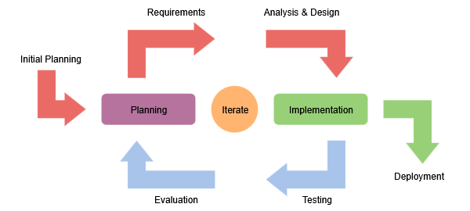
Figure 3.1: Iterative-Incremental Software Development Model
The software development of LASA-Quest will be guided by the Iterative-Incremental Model, an established software engineering process model in which system development is partitioned into repeated cycles that progressively build, verify, and expand functional software increments [33]. Rather than attempting to develop the entire application in a single rigid, one-way sequence, the iterative-incremental approach combines the adaptability of iterative refinement with the structured delivery of operational increments [33]. As illustrated in Figure 3.1, the development process begins with an initial planning phase and progresses through structured iterative stages:
1. Initial Planning: In this preliminary phase, the researchers establish the overarching project scope, technological stack requirements, baseline medication safety objectives, and feasibility considerations before entering iterative development cycles.
2. Planning: In this phase, the researchers plan each specific development cycle, defining the operational scope, targeted features, resource allocations, and deliverables for the upcoming software increment.
3. Requirements: In this phase, functional and educational requirements for Look-Alike/Sound-Alike (LASA) medication recognition are elicited and analyzed, incorporating clinical guidelines, drug name pairs, and Tall Man lettering conventions.
4. Analysis & Design: In this phase, requirements are translated into system architectures, database schemas, interactive gameplay mechanics, and user interface wireframes for the planned increment.
5. Implementation: In this phase, the software components, front-end interfaces, and backend logic for the planned increment are programmed, coded, and integrated into the evolving application codebase.
6. Testing: In this phase, the developed increment undergoes comprehensive technical, functional, and interface testing to verify code stability, feedback responsiveness, and error-free execution.
7. Evaluation: In this phase, the increment is evaluated against instructional objectives, usability guidelines, and user expectations to gather diagnostic feedback for refinement. In the final system iteration, this phase interfaces directly with the study's descriptive quantitative research design, wherein the completed application is empirically evaluated by respondents through knowledge assessments, the Post-Study System Usability Questionnaire (PSSUQ) [34].
8. Iterate: Acting as the central feedback and refinement mechanism between planning, implementation, and evaluation, this stage channels diagnostic findings and empirical insights from evaluation back into the planning phase of subsequent cycles to drive continuous iterative refinement.
9. Deployment: In this phase, a verified, working increment of the application is packaged, hosted, and deployed, establishing a stable operational baseline that culminates in the deployment of the completed system for end-user access and research evaluation.
In the development of LASA-Quest, the Iterative-Incremental Model will structure the progressive construction of the software across planned functional increments:
• Increment 1 (Foundational Architecture and User Management): Development will focus on the initial planning, interface design, programming, and testing of core system infrastructure, including user registration, login authentication, session persistence, and the central dashboard navigation interface.
• Increment 2 (Core Recognition Mechanics and Drug Database Integration): Development will design, implement, and verify the underlying medication database, integrating initial challenge modes—specifically the Sound-Alike Detector and Look-Alike Spotter—along with basic scoring calculations and immediate corrective feedback mechanisms.
• Increment 3 (Advanced Gamified Challenges and Retention Mechanics): Development will expand the application by implementing advanced challenge modes, including Tall Man Rescue (utilizing FDA/ISMP Tall Man lettering conventions), Dispensing Defense, and LASA Survival Mode, accompanied by gamification systems such as XP/points accumulation, streak tracking, life point deduction mechanics, and challenge retry options.
• Increment 4 (System Integration, Progress Tracking, and Deployment): Development will integrate all challenge modules, complete the lesson progress and profile achievement tracking components, execute end-to-end system testing, and deploy the fully functional application in preparation for descriptive quantitative evaluation.
This iterative-incremental approach ensures that each module of LASA-Quest is systematically designed, verified, and refined prior to subsequent feature expansion. This minimizes technical defects, enables early detection of instructional or interface flaws, and ensures consistent, verifiable software development progress. As this describes a proposed methodology, all development activities are framed in the future tense to reflect planned execution.
Proposed System Process Flow
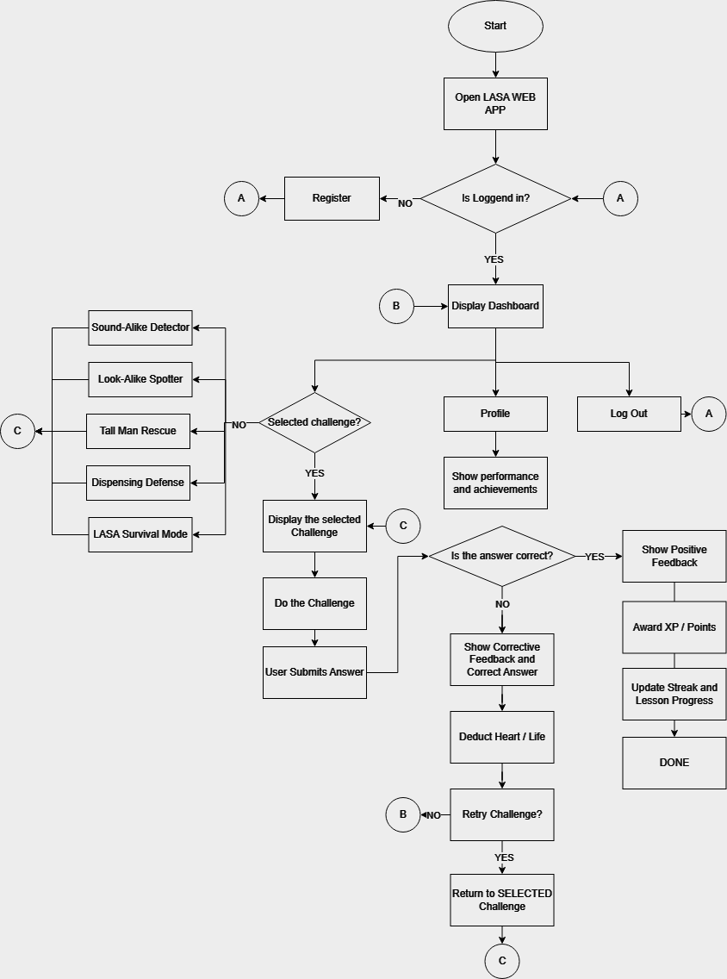
Figure 3.2: Proposed Process Flow for LASA-Quest
The proposed process flow of LASA-Quest is shown in Figure 3.2. The system will begin when the user opens the LASA web application. After accessing the application, the system will verify if the user is already logged in. If the user is not logged in, the user will be directed to the registration process. Once the registration is completed, the user will return to the login verification stage. If the user is already logged in, the system will proceed to display the dashboard.
The dashboard will serve as the main navigation page of the application. From the dashboard, the user will be able to view the profile section, which shows the user's performance and achievements. The user may also choose to log out of the application. If the user continues to the learning activity, the system will check if a challenge has been selected. If no challenge has been selected, the application will display the available challenge modes, including Sound-Alike Detector, Look-Alike Spotter, Tall Man Rescue, Dispensing Defense, and LASA Survival Mode.
After choosing a challenge, the system will display the selected challenge and allow the user to proceed with the activity. The user will answer the given task and submit the response to the system. The system will then check whether the submitted answer is correct. If the answer is correct, the system will show positive feedback, award XP or points, and update the user's streak and lesson progress. This provides reinforcement for correct answers and encourages continued participation in the learning process.
If the submitted answer is incorrect, the system will show corrective feedback and provide the correct answer. A life point will then be deducted from the user. After this, the system will ask if the user wants to retry the challenge. If the user chooses to retry, the user will return to the selected challenge and attempt the activity again. If the user chooses not to retry, the system will return to the dashboard, where the user may choose another challenge, view the profile, or log out.
This proposed process flow shows how LASA-Quest will apply gamified learning to LASA medication safety. The application will not only provide learning content but will also include challenges, immediate feedback, points, streaks, lives, and progress tracking. These features are intended to support repeated practice and sustained engagement.
A. Research Design
The study will employ a descriptive quantitative research design to evaluate the developed LASA-Quest gamified application in terms of respondents' knowledge assessment scores, perceived usability, and user satisfaction [36]. As established in the methodological framework of this chapter, this research design governs the empirical evaluation of the application and is distinct from the software development life cycle model (the Iterative-Incremental Model) utilized to engineer the software.
A descriptive quantitative approach is appropriate for this study because the primary objective is to characterize and describe the respondents' measured responses to the application rather than to establish causal relationships or compare treatment effects between groups [37]. This design enables the researchers to systematically collect numerical data through structured instruments and to summarize findings using descriptive statistical measures, thereby providing an objective account of respondents' experiences and performance outcomes [36].
Data will be gathered through knowledge assessment tests administered at multiple points—prior to application use, immediately after application use, and one week after application use—to characterize respondents' scores at each assessment point. Perceived usability and user satisfaction will be measured using the Post-Study System Usability Questionnaire (PSSUQ) [34]. These standardized instruments will produce quantitative scores that will be analyzed descriptively to summarize the application's usability profile and the respondents' satisfaction levels.
B. Research Locale
The data gathering will be conducted in an on-site setting at Mapúa University Makati using a designated room as the data gathering area. Respondents will access the LASA-Quest system using provided or personal devices while the researchers supervise the session. This ensures that standardized instructions and consistent time allotment will be followed. The researchers will also provide immediate assistance in case of technical issues. Online survey tools, such as Google Forms, will be used to collect questionnaire responses after the session.
C. Research Respondents
The primary respondents of this study will be undergraduate pharmacy students enrolled at Mapúa University. Pharmacy students represent the target user population because dispensing accuracy, drug classification, and Look-Alike/Sound-Alike recognition are foundational competencies in their curriculum and professional practice.
While nursing students also handle medication administration, pharmacy students remain the primary designated cohort in the current approved thesis proposal due to their specialized curricular focus on pharmacology and medication dispensing. The inclusion or substitution of nursing students remains an open institutional option pending final panel confirmation. The sampling framework will draw from eligible pharmacy cohorts who have completed introductory pharmacology coursework.

D. Research Instrument
The study will utilize a two-part research instrument to collect quantitative evaluation data: a Knowledge Assessment Test, and the Post-Study System Usability Questionnaire (PSSUQ) [34].
Knowledge Assessment Test. The knowledge assessment will consist of a 25-item multiple-choice test designed to evaluate respondents' recognition and discrimination of Look-Alike/Sound-Alike medication pairs. Test items will be developed based on the LASA pairs and Tall Man lettering conventions integrated into the application, drawing from established WHO and ISMP reference lists [7, 9]. The test will be administered at three time points: (1) a pre-test prior to application use to establish a baseline score, (2) a post-test immediately after application use to assess immediate recognition, and (3) a follow-up test administered one week later to evaluate knowledge retention over time. Each administration will use isomorphic items of equivalent difficulty to ensure comparability across time points.
Post-Study System Usability Questionnaire (PSSUQ). Usability and user satisfaction will be measured using the standardized PSSUQ (Version 3) [34]. The PSSUQ consists of 16 items rated on a 7-point Likert scale (ranging from 1 = 'Strongly Agree' to 7 = 'Strongly Disagree', with a 'Not Applicable' option). The instrument produces an overall usability score as well as three subscale scores: System Usefulness (SysUse, Items 1–6), Information Quality (InfoQual, Items 7–12), and Interface Quality (IntQual, Items 13–15), with Item 16 contributing to overall satisfaction [34]. Lower scores indicate higher perceived usability. The PSSUQ has demonstrated strong psychometric reliability and construct validity across diverse digital systems [34].
Questionnaire items will use structured Likert-type scales with clearly defined rating anchors. The 7-point Likert scale used for the PSSUQ to measure user satisfaction and system usability will use the following interpretation guide for mean scores (where lower scores indicate higher usability):
• 1.00 – 1.85: Strongly Agree / Very High Usability
• 1.86 – 2.71: Agree / High Usability
• 2.72 – 3.57: Somewhat Agree / Good Usability
• 3.58 – 4.43: Neutral / Moderate Usability
• 4.44 – 5.29: Somewhat Disagree / Below Average Usability
• 5.30 – 6.15: Disagree / Low Usability
• 6.16 – 7: Strongly Disagree / Very Low Usability
E. Data Gathering
The data gathering procedure will follow a structured protocol across six sequential steps to ensure standardized conditions for all respondents:
1. Ethical Clearance and Informed Consent: The researchers will obtain necessary institutional permissions from the School of Information Technology and relevant departments. Eligible students will receive an information sheet detailing the study's purpose, voluntary nature, and confidentiality safeguards. Written informed consent will be secured from all participants prior to any data collection activities.
2. Pre-Test Administration: In the designated testing room, respondents will complete the baseline Knowledge Assessment Test via Google Forms. The pre-test will be timed (approximately 15–20 minutes) and supervised to prevent external reference use.
3. Application Hands-On Session: Respondents will be introduced to LASA-Quest through a brief standardized orientation explaining navigation, rules, and game mechanics. Participants will then engage with the application individually for a designated 30-to-40-minute practice session, progressing through available challenge modes (Sound-Alike Detector, Look-Alike Spotter, Tall Man Rescue, Dispensing Defense, and LASA Survival Mode) at their own pace.
4. Immediate Post-Test Administration: Immediately following the practice session, respondents will complete the post-test Knowledge Assessment via Google Forms to measure immediate recognition performance.
5. Usability Evaluation: Following post-test completion, respondents will complete the PSSUQ questionnaire to capture their immediate perceptions of system usability, interface quality, and user satisfaction.
6. One-Week Follow-Up Assessment: One week after the hands-on session, respondents will complete the follow-up Knowledge Assessment to measure knowledge score retention. The follow-up test will be administered under the same supervised conditions.
F. Samples and Sampling Techniques
The study will utilize purposive sampling to select respondents from the target population of undergraduate pharmacy students at Mapúa University. Purposive sampling is appropriate because it enables the researchers to intentionally select participants who possess the specific educational background relevant to the study's focus—namely, students who are actively studying or have completed coursework in pharmacology and medication management [35].
Specific inclusion criteria are: (1) currently enrolled undergraduate pharmacy students at Mapúa University, (2) completion of at least one introductory pharmacology or dispensing course, and (3) willingness to participate across all data collection phases. Exclusion criteria include: (1) students who have prior access to the LASA-Quest prototype during development, and (2) students who are unable to attend the one-week follow-up session. A sample size of approximately 30 to 50 respondents will be targeted, consistent with prior similar research for usability and educational software evaluation studies [34].
G. Statistical Treatment
Data collected from the knowledge assessments and usability instrument will be organized, tabulated, and analyzed using descriptive statistical measures. Consistent with the descriptive quantitative research design, statistical analysis will focus on summarizing, describing, and characterizing the data distributions without drawing causal inferences or testing hypotheses between groups [36, 37].
The specific descriptive statistical tools will include:
• Frequency and Percentage: Used to summarize respondents' demographic characteristics and the distribution of categorical responses across survey items.
• Mean: Used to compute the central tendency of scores for each knowledge assessment (pre-test, post-test, follow-up test), each PSSUQ item and subscale (System Usefulness, Information Quality, Interface Quality, Overall Satisfaction).
• Standard Deviation: Used to measure the dispersion and variability of respondents' scores around the mean for all continuous variables.
• Knowledge Assessment Scoring: Scores on the 25-item knowledge assessments will be scored as the total number of correct responses (ranging from 0 to 25) and expressed as percentage accuracy. Means and standard deviations will be reported for the pre-test, post-test, and follow-up test to describe the distribution of scores across the three assessment points.
• PSSUQ Analysis: PSSUQ responses (1–7 scale) will be averaged across respondents for each item, for each of the three subscales (SysUse, InfoQual, IntQual), and overall. Results will be presented with means, standard deviations, and benchmark comparisons to established PSSUQ norms [34].
REFERENCES
[1] Mohadeseh Zohari, Neda Karim, Shiva Malgard, Maryam Aalaa, Shadi Asadzandi, and Sharareh Borhani. 2023. Comparison of Gamification, Game-Based Learning, and Serious Games in Medical Education: A Scientometrics Analysis. Journal of Advances in Medical Education & Professionalism 11, 4 (2023), 200–210. https://doi.org/10.30476/jamp.2023.99026.1824
[2] S. Koivisto and J. Hamari. 2019. The rise of motivational information systems: A review of gamification research. International Journal of Information Management 45 (2019), 191–210. https://doi.org/10.1016/j.ijinfomgt.2018.10.013
[3] D. Dicheva, C. Dichev, G. Agre, and G. Angelova. 2015. Gamification in Education: A Systematic Mapping Study. Educational Technology & Society 18, 3 (2015), 75–88.
[4] World Health Organization. 2024. Patient safety. Fact sheet. September 11, 2024. Retrieved February 6, 2026 from https://www.who.int/news-room/fact-sheets/detail/patient-safety
[5] World Health Organization. 2024. Medication without harm: Policy brief. March 7, 2024. Retrieved February 6, 2026 from https://www.who.int/publications/i/item/9789240062764
[6] R. Ramamurthy, F. Chitra, and Kavitha. 2024. Traditional teaching method versus simulation-based teaching method in the prevention of medication errors among nursing students. European Journal of Clinical and Experimental Medicine 22, 1 (2024), 17–29. https://doi.org/10.15584/ejcem.2024.1.2
[7] World Health Organization. 2023. Medication safety for look-alike, sound-alike medicines. October 20, 2023. Retrieved February 6, 2026 from https://www.who.int/publications/i/item/9789240058897
[8] Teeraporn Sadira Supapaan et al. 2024. Look-alike/sound-alike medication errors: An in-depth examination through a hospital case study. Pharmacy Practice 22, 2 (2024), 2959. https://doi.org/10.18549/PharmPract.2024.2.2959
[9] Institute for Safe Medication Practices (ISMP). 2023. ISMP's List of Look-Alike Drug Names with Recommended Tall Man Letters. Retrieved February 6, 2026 from https://www.ismp.org/tools/tall-man-letters
[10] Rachel Bryan, Jeffrey K. Aronson, Alison Williams, and Sue Jordan. 2021. The problem of look‐alike, sound‐alike name errors: Drivers and solutions. British Journal of Clinical Pharmacology 87, 2 (2021), 386–394. https://doi.org/10.1111/bcp.14285
[11] QUM Learning. 2020. Medication safety (Version 3; released June 2020). Retrieved February 6, 2026 from https://learn.nps.org.au/mod/page/view.php?id=4277
[12] Maosen Xu, Yong Luo, Yu Zhang, Ruolan Xia, Hong Qian, and Xiuhe Zou. 2023. Game-based learning in medical education. Frontiers in Public Health 11 (2023), 1113682. https://doi.org/10.3389/fpubh.2023.1113682
[13] M. Shortt, S. Tilak, I. Kuznetcova, B. Martens, and B. Akinkuolie. 2023. Gamification in mobile-assisted language learning: A systematic review of Duolingo literature from public release of 2012 to early 2020. Computer Assisted Language Learning 36, 3 (2023), 517–554. https://doi.org/10.1080/09588221.2021.1933540
[14] T. Justinia, W. Qattan, A. Almenhali, A. Khatwa, O. Alharbi, and T. Alharbi. 2021. Medication errors and patient safety: Evaluation of physicians' responses to Medication-Related Alert overrides in clinical decision support systems. Acta Informatica Medica 29, 4 (2021), 248–252. https://doi.org/10.5455/aim.2021.29.248-252
[15] I. Lizano-Díez, C. Figueiredo-Escribá, M.Á. Piñero-López, C.F. Lastra, E.L. Mariño, and P. Modamio. 2020. Prevention strategies to identify LASA errors: building and sustaining a culture of patient safety. BMC Health Services Research 20, 1 (2020), 63. https://doi.org/10.1186/s12913-020-4922-3
[16] L. Emmerton, C. Curtain, G. Swaminathan, and H. Dowling. 2020. Development and exploratory analysis of software to detect look-alike, sound-alike medicine names. International Journal of Medical Informatics 137 (2020), 104119. https://doi.org/10.1016/j.ijmedinf.2020.104119
[17] J. Heck, A. Groh, D.O. Stichtenoth, S. Bleich, and O. Krause. 2020. Look‐alikes, sound‐alikes: Three cases of insidious medication errors. Clinical Case Reports 8, 12 (2020), 3283–3286. https://doi.org/10.1002/ccr3.3409
[18] Food and Drug Administration (FDA). 2021. Phonetic and Orthographic Computer Analysis (POCA) program. Retrieved February 6, 2026 from https://www.fda.gov/drugs/resources-drugs/phonetic-and-orthographic-computer-analysis-poca-program
[19] National Library of Medicine (NLM). n.d. RxNav Overview. Retrieved February 6, 2026 from https://lhncbc.nlm.nih.gov/RxNav/applications/RxNavDoc.html
[20] United Nations Statistics Division. 2024. The Sustainable Development Goals Report 2024. June 2024. Retrieved February 6, 2026 from https://unstats.un.org/sdgs/report/2024/The-Sustainable-Development-Goals-Report-2024.pdf
[21] C. Huang, H.-Y. Pan, and S.-H. Cao. 2024. Utilizing human–computer interaction in nursing information: Application and trends. Journal of Advanced Nursing 81, 5 (2024), 2842–2843. https://doi.org/10.1111/jan.16350
[22] S.F. Mahdavi Ardestani, S. Adibi, A. Golshan, and P. Sadeghian. 2023. Factors Influencing the Effectiveness of E-Learning in Healthcare: A Fuzzy ANP Study. Healthcare 11, 14 (2023), 2035. https://doi.org/10.3390/healthcare11142035
[23] O. Tchijevitch et al. 2025. Methodological Approaches for Analyzing Medication Error Reports in Patient Safety Reporting Systems: A Scoping Review. The Joint Commission Journal on Quality and Patient Safety 51, 1 (2025), 46–73. https://doi.org/10.1016/j.jcjq.2024.10.005
[24] S. Guntschnig et al. 2026. Tackling medication errors: how a systems approach improves patient safety. European Journal of Hospital Pharmacy 33, 5 (2026), 455–461. https://doi.org/10.1136/ejhpharm-2025-004533
[25] M. Almalki, F. Alsehli, and M. Khayyat. 2023. Use of Technology to Reduce Medication Errors and Improve Patient Safety. SAR Journal - Science and Research 6, 2 (2023), 128–132. https://doi.org/10.18421/sar62-10
[26] S. Awad, K. Amon, A. Baillie, T. Loveday, and M.T. Baysari. 2023. Human factors and safety analysis methods used in the design and redesign of electronic medication management systems: A systematic review. International Journal of Medical Informatics 172 (2023), 105017. https://doi.org/10.1016/j.ijmedinf.2023.105017
[27] C.-Y. Chang, M.-H. Chung, and J.C. Yang. 2022. Facilitating nursing students' skill training in distance education via online game-based learning with the watch-summarize-question approach during the COVID-19 pandemic: A quasi-experimental study. Nurse Education Today 109 (2022), 105256. https://doi.org/10.1016/j.nedt.2021.105256
[28] A.R. Dube et al. 2024. Improving Assessment and Learning Environments for Graduate Medical Trainees to Advance Healthcare Language Equity. Journal of General Internal Medicine 39, 4 (2024), 696–705. https://doi.org/10.1007/s11606-023-08527-3
[29] J.K. Aronson. 2022. Artificial Intelligence in Pharmacovigilance: An Introduction to Terms, Concepts, Applications, and Limitations. Drug Safety 45, 5 (2022), 407–418. https://doi.org/10.1007/s40264-022-01156-5
[30] Ratanto, R.T.S. Hariyati, A.S. Mediawati, and T. Eryando. 2021. Workload as the most Important Influencing Factor of Medication Errors by Nurses. The Open Nursing Journal 15, 1 (2021), 204–210. https://doi.org/10.2174/1874434602115010204
[31] L.A. Vasel. 2020. Exploring the Invisible Work of Nursing: A Case Study of Simulated Increases in Intensity of Care on Nurses' Cognitive Load, Clinical Judgment, Stress, and Errors. Ph.D. Dissertation, Mercer University. ProQuest Dissertations & Theses Global, Order No. 2432515882.
[32] B. Knols, M. Louws, A. Hardenbol, J. Dehmeshki, and M. Askari. 2020. The usability aspects of medication-related decision support systems in the inpatient setting: A systematic review. Health Informatics Journal 26, 1 (2020), 613–627. https://doi.org/10.1177/1460458219841167
[33] R.S. Pressman and B.R. Maxim. 2020. Software Engineering: A Practitioner's Approach (9th ed.). McGraw-Hill Education, New York, NY. ISBN: 978-1260548006.
[34] J.R. Lewis. 2002. Psychometric evaluation of the PSSUQ using a library of usability study data. International Journal of Human-Computer Interaction 14, 3-4 (2002), 463–488. https://doi.org/10.1080/10447318.2002.9669130
[35] D.F. Polit and C.T. Beck. 2021. Nursing Research: Generating and Assessing Evidence for Nursing Practice (11th ed.). Wolters Kluwer, Philadelphia, PA.
[36] J.W. Creswell and J.D. Creswell. 2023. Research Design: Qualitative, Quantitative, and Mixed Methods Approaches (6th ed.). SAGE Publications, Thousand Oaks, CA. ISBN: 978-1071817940.
[37] S. Loeb, S. Dynarski, D. McFarland, P. Morris, S. Reardon, and S. Reber. 2017. Descriptive Analysis in Education: A Guide for Researchers. NCEE 2017-4023. National Center for Education Evaluation and Regional Assistance, Institute of Education Sciences, U.S. Department of Education. Retrieved from https://ies.ed.gov/ncee/pubs/20174023/

