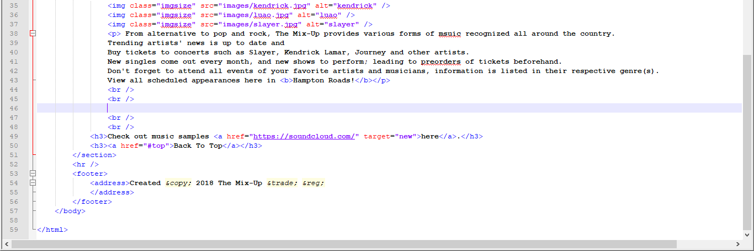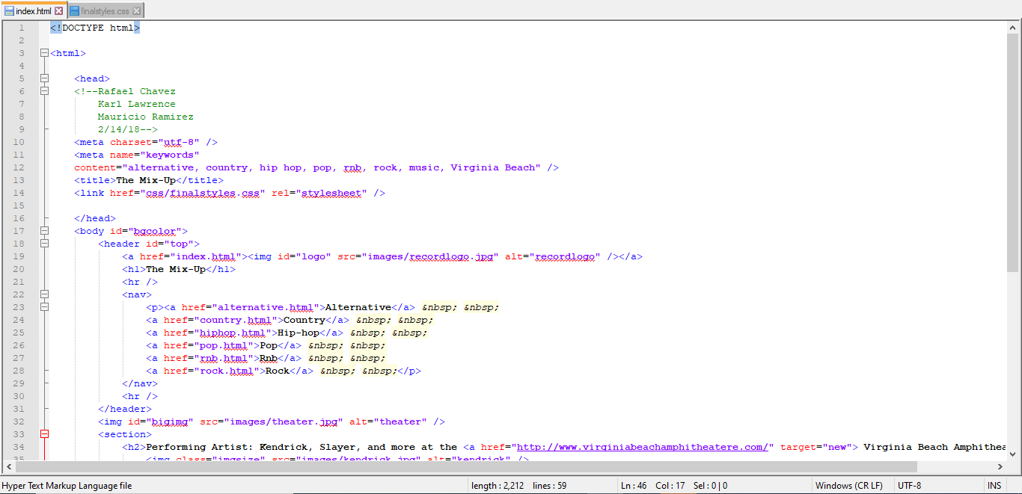 The CIS 282 Intro to Web Design final project was to create a small website with working hyperlinks and proper uses of the cascade styles sheet (or CSS). Each of us were put into teams no bigger than three. This is the explanatory process of that project, pictures included.

The above photo is a screen shot of the code used for main page of the website. It starts with meta tags for search engines, and a title tag as the first header. This is followed by referenced hyperlinks for each genre of music (all using the same structure as the code above). Pictures are referenced after (the next page), with a big picture under the assumption of being the main attraction for that genre; followed by a few smaller photos promoting other artists in the same genre. Then, a paragraph introducing the artists on the pictures plus a few others in a way that sells it as a venue and a website. Finally, near the bottom page, a hyperlink bringing you back to the top, and one that brings you to another site where you can listen to music.

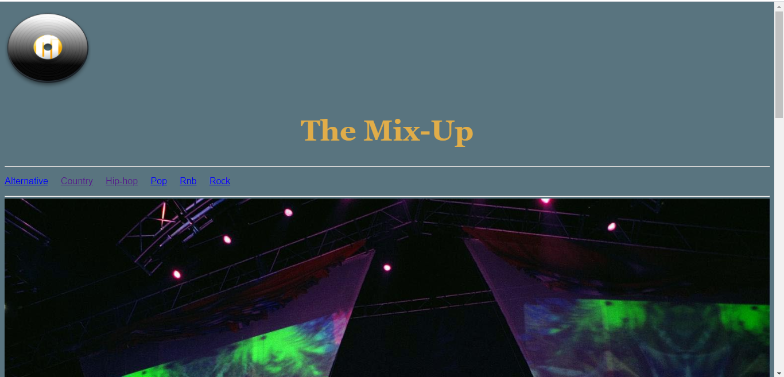

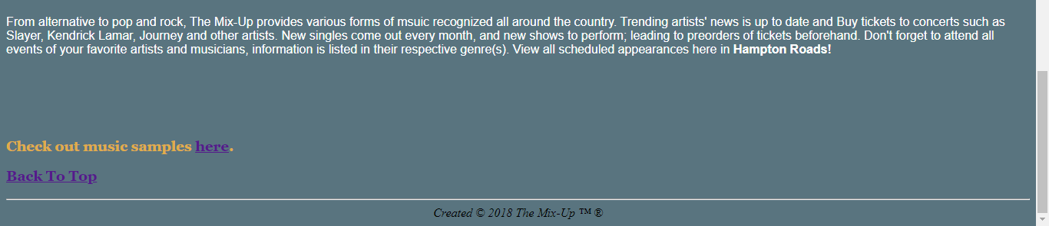

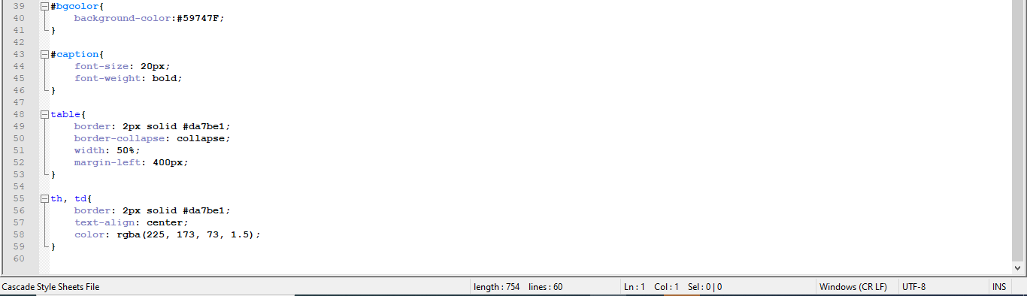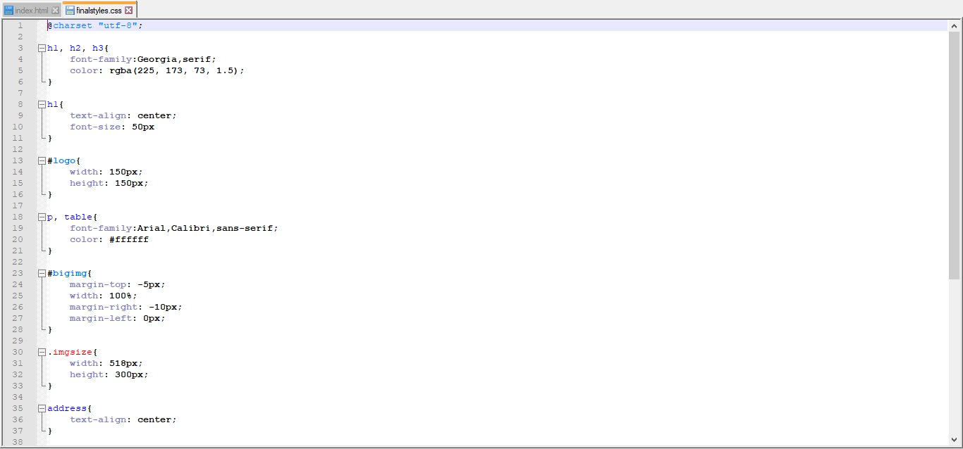

This is the CSS sheet that has specific styles added to the web page. One style changes the image size, another aligns the text, background color, and so forth.