Program Specification

Input Descriptions:

EMPLOYEES

Bruce Wayne

phone = 1-800-BAT-CAVE

email = [batman@batcave.com](mailto:batman@batcave.com)

hire date = 01-JAN-89

job id = 1

salary = 99999999

commission = 0

manager id = 1

department id = 1

Diana Prince

phone = 123-321-1111

email = [wonderwoman@hotmail.com](mailto:wonderwoman@hotmail.com)

hire date = 31-APR-56

job id = 3

salary = 150000

commission = 0

manager id = 1

department id = 4

Arthur Curry

phone = NULL

email = [fishguy@atlantis.com](mailto:fishguy@atlantis.com)

hire date = 03-AUG-92

job id = 1

salary = 35000

commission = 10%

manager id = 1

department id = 1

Barry Allen

phone = 353-382-8992

email = [flash@gmail.com](mailto:flash@gmail.com)

hire date = 12-MAY-93

job id = 4

salary = 820000

commission = 0

manager id = 1

department id = 3

Hal Jordan

phone = 111-555-5555

email = [greenlantern@spacetalk.com](mailto:greenlantern@spacetalk.com)

hire date = 24-FEB-89

job id = 1

salary = 45000

commission = 15%

manager id = 2

department id = 4

Victor Stone

phone = 123-323-2344

email = [cyborg@internet.com](mailto:cyborg@internet.com)

hire date = 12-NOV-96

job id = 6

salary = 850000

commission = 0

manager id = 1

department id = 5

DEPARTMENTS

IT Development

manager id = 3

location id = 1

IT Administration

manager id = 1

location id = 3

Sales

manager id = 2

location id = 1

Human Resources

manager id = 6

location id = 1

Cyber Security

manager id = 5

location id = 4

Accounting

manager id = 4

location id = 5

LOCATIONS

123 Sesame St., 10001 New York, New York, America

999 Bratwurst Ave., 60603 Frankfurt, Central, Germany

13 Marzow St., 00263 Halare, West, Zimbabwe

32 Lumberjack Acres, G0W Quebec City, Quebec, Canada

Av Paulista. 2048 Bela Vista, 18240-000 Rio de Janeiro, Brazil

8228 King Abdul Aziz Rd, 11543 Riyadh, Riyadh, Saudi Arabia

COUNTRIES

America

country code = 1

Germany

country code = 2

Zimbabwe

country code = 3

Canada

country code = 5

Brazil

country code = 6

Saudi Arabia

country code = 4

REGIONS

1 - North America

2 - Europe

3 - Africa

4 - Middle East

5 - Asia

6 - South America

JOBS

Database Administrator

min_salary = 65000

max_salary = 85000

Systems Engineer

min_salary = 85000

max_salary = 120000

Web Developer

min_salary = 35000

max_salary = 55000

Software Developer

min_salary = 55000

max_salary = 75000

System Administrator

min_salary = 50000

max_salary = 70000

Network Administrator

min_salary = 85000

max_salary = 12000

JOB_HISTORY

Bruce Wayne

start_date = 11/13/2018

end_date = NULL

job_id = 4

department_id = 2

Diana Prince

start_date = 11/13/2018

end_date = NULL

job_id = 4

department_id = 2

Arthur Curry

start_date = 10/05/2003

end_date = NULL

job_id = 3

department_id = 2

Barry Allen

start_date = 08/30/2010

end_date = 08/30/2011

job_id = 1

department_id = 3

Hal Jordan

start_date = 01/15/2008

end_date = NULL

job_id = 4

department_id = 4

Victor Stone

start_date = 05/01/2003

end_date = 08/03/2008

job_id = 6

department_id = 1

Output Descriptions

CREATE_TABLES_SP

DROP_TABLES_SP

ALTER_TABLE_FK_SP

POP_TABLES_SP

EMP_LENGTH_SP

SAL_DIFF_SP

EMP_QUERY_SP

UPDATE_JOBHIST_SP

UPDATE_DEPT_SP

CURR_EMP_SP

FOR_LOOP_SP (Raise Min salaries)

LIST_MAN_SF

Report for listing an employee’s department

Report for listing an employee’s profile

Data Structure Descriptions

REGIONS

region_id NUMBER(4) [pk]

region_name VARCHAR2(20)

JOBS

job_id NUMBER(4) [pk]

job_title VARCHAR2(64)

min_salary NUMBER(9,2)

max_salary NUMBER(9,2)

JOB_HISTORY

employee_id NUMBER(4) [pk] [fk]

start_date DATE [fk]

end_date DATE

job_id NUMBER(4) [pk] [fk]

department_id NUMBER(4) [pk] [fk]

EMPLOYEES

employee_id NUMBER(8) [pk]

first_name VARCHAR2(40)

last_name VARCHAR2(50)

email VARCHAR2(64)

phone_number VARCHAR2(25)

hire_date DATE

job_id NUMBER(4)

salary NUMBER(10)

commission_pct NUMBER(3)

manager_id NUMBER(8) [fk]

department_id NUMBER(4) [fk]

DEPARTMENTS

department_id NUMBER(4) [pk]

department_name VARCHAR2(40)

manager_id NUMBER(8) [fk]

location_id NUMBER(10) [fk]

LOCATIONS

location_id NUMBER (10) [pk]

street_address VARCHAR2 (64)

postal_code VARCHAR2(20)

city VARCHAR2 (60)

state_province VARCHAR2 (25)

country_id NUMBER(3) [fk]

COUNTRIES

country_id NUMBER (3) [pk]

country_name VARCHAR2(60)

region_id NUMBER(5) [fk]

Program Description

* We need to create a separate user and database
* We need to create 7 tables: JOBS, JOB_HISTORY, REGIONS, EMPLOYEES, DEPARTMENTS, LOCATIONS, COUNTRIES
* Provide capability to populate all 7 tables above with data
* Validate the data inserted into the above tables
* Create Procedure to drop all DB tables and sequences if they exist (Reset database from scratch)
* Create Procedure to create all tables and sequences (Recreates blank tables)
* Company needs an alter procedure for foreign key constraints (due to issue with foreign keys in two tables dependent on one another)
* Company needs a procedure for populating all tables with data
* Company needs a procedure to determine employee work length status
* Company needs a procedure to determine the difference between a job’s maximum and minimum salary
* Company needs a procedure to output employee info
* Company needs a procedure to update job id of an employee in the job history table (for employees changing jobs)
* Company needs a procedure to insert new department in Departments table
* Company needs a procedure to determine employment status
* Company needs a procedure to display the number of jobs
* Company needs procedure to raise minimum salary (by $5000)
* Create report to show which department each employee works in
* Create report to show employee profiles
* Company needs a function to list the manager of a specified department

Create new user/database

User:

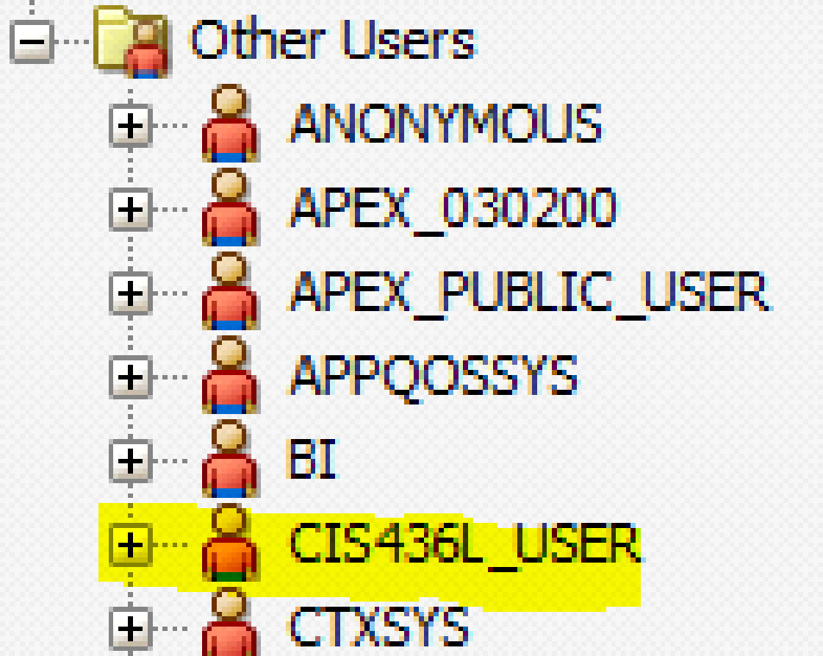

Database Connection:

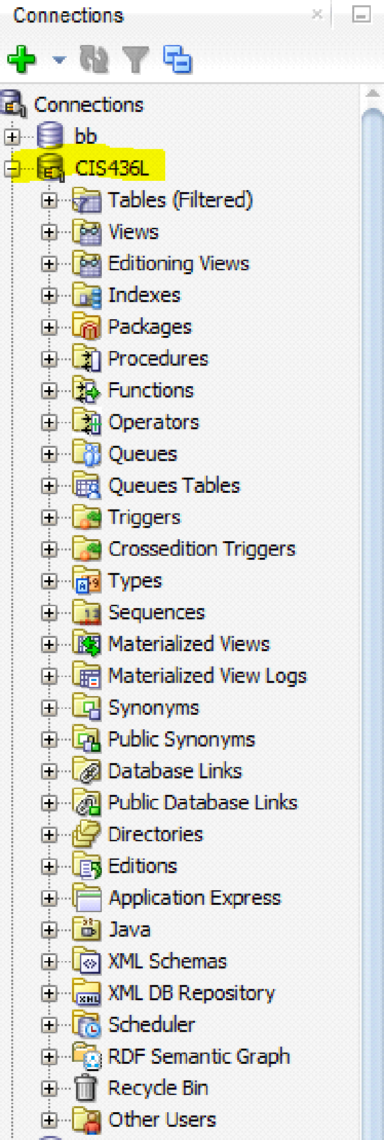

Create Procedure to drop all DB tables and sequences if they exist

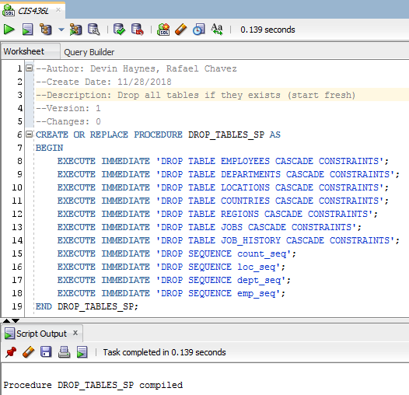

Execute DROP_TABLES_SP

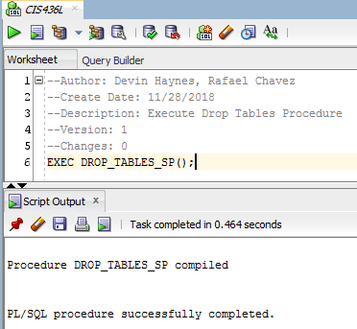

Verify Tables were dropped

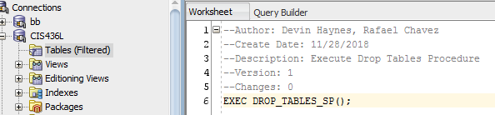

Create Procedure to create all tables and sequences

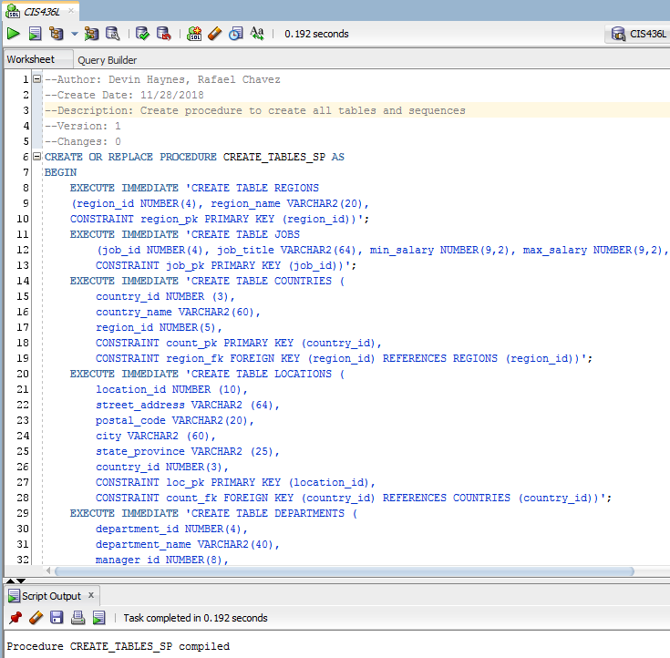

Execute CREATE_TABLES_SP & Verify proper execution

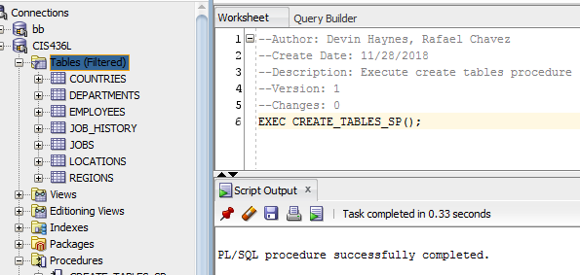

Create Procedure to manage FK constraint error between Departments and Employees table

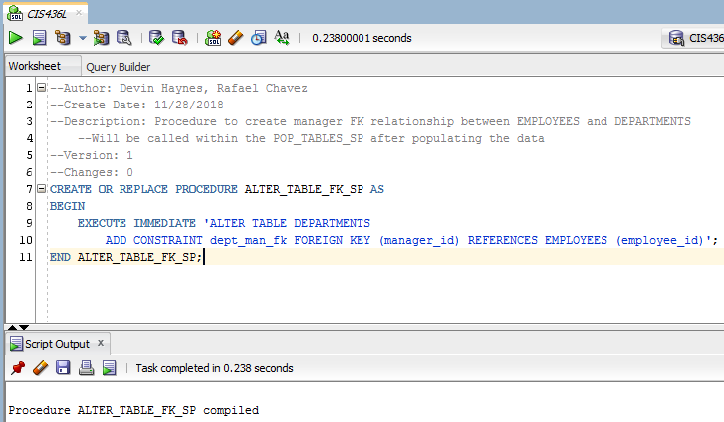

Create Procedure for populating all data [7 Screenshots]

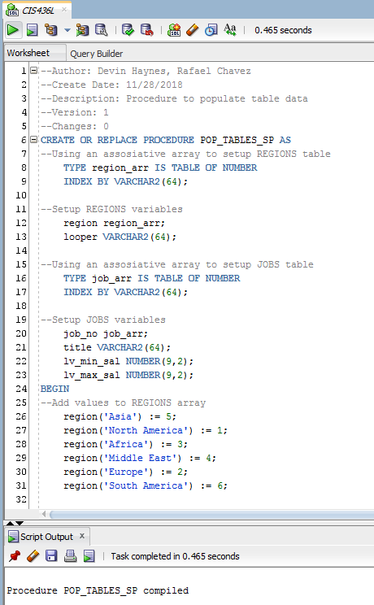

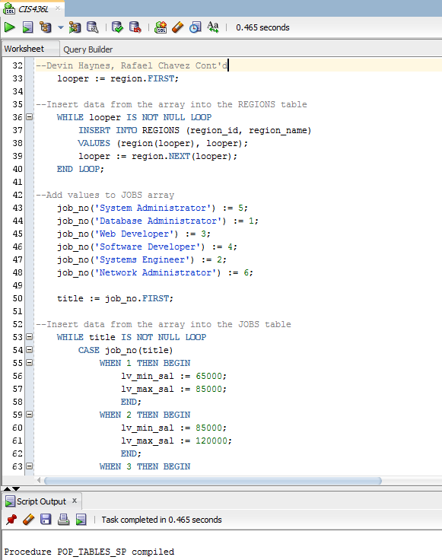

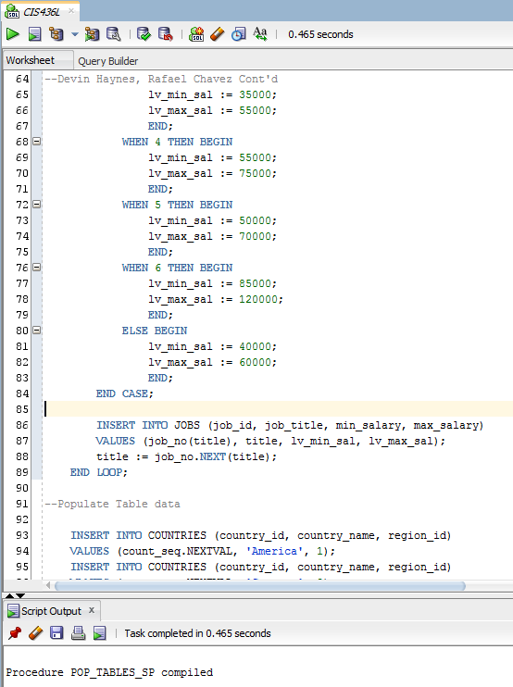

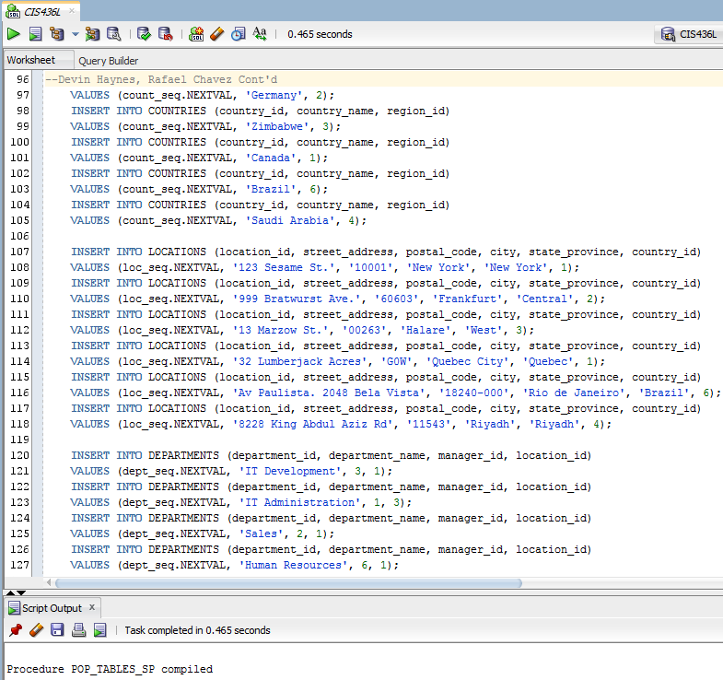

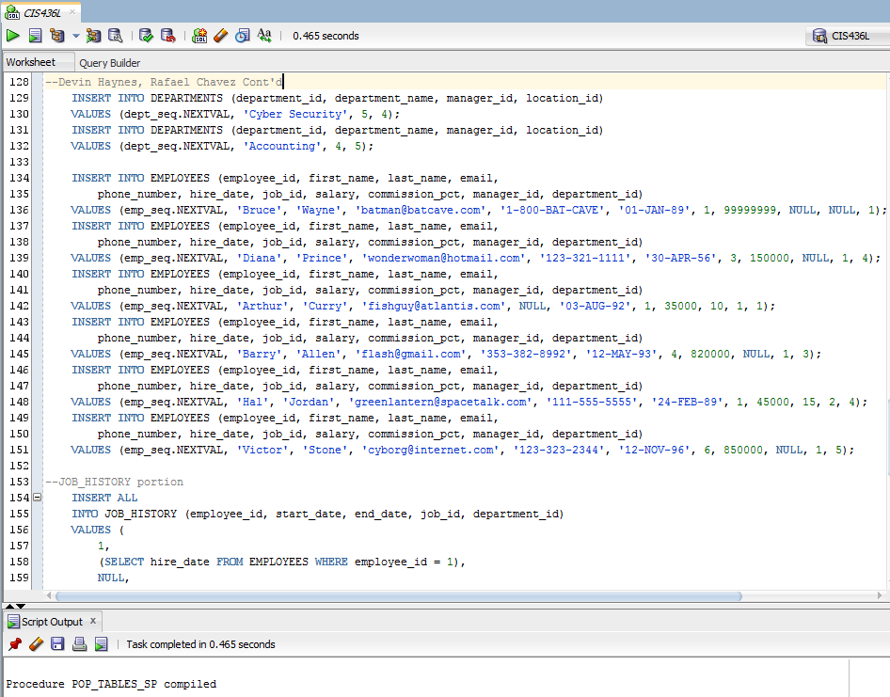

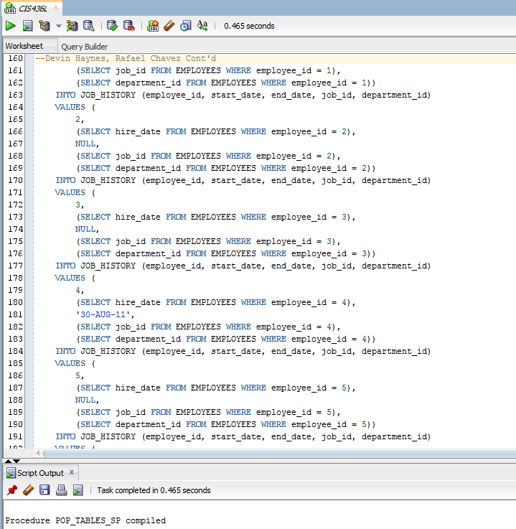

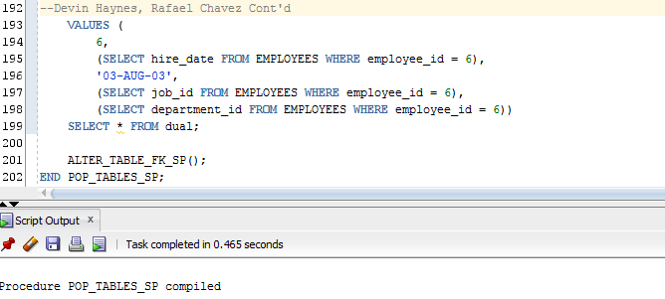

Execute POP_TABLES_SP

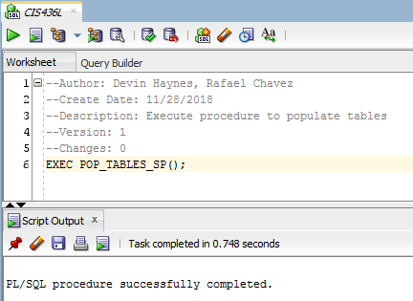

Verify tables were populated

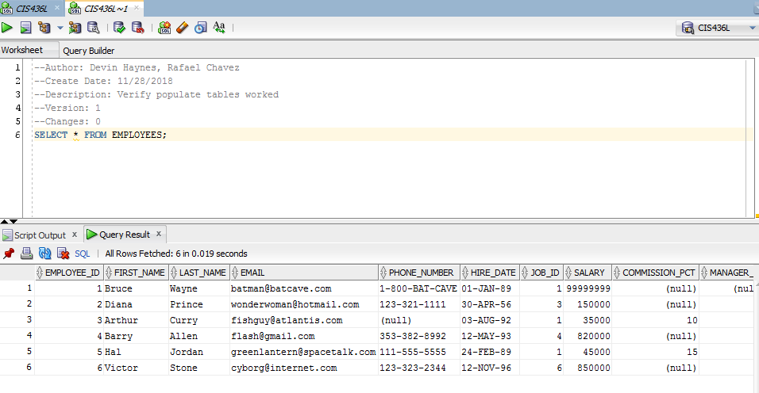

Create procedure to determine employee work length status

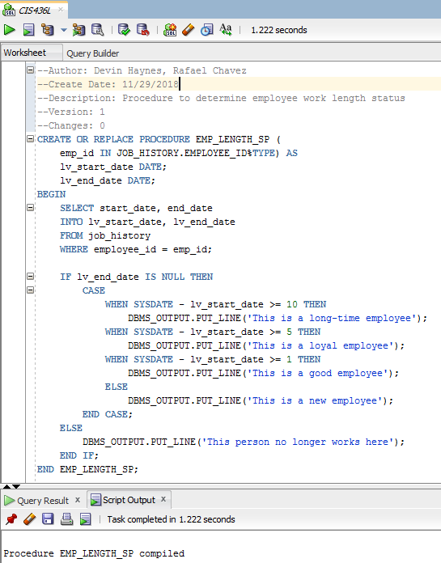

Execute EMP_LENGTH_SP

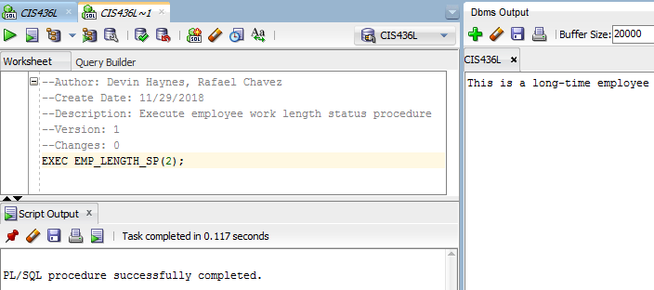

Create procedure to determine the difference between a job’s maximum and minimum salary

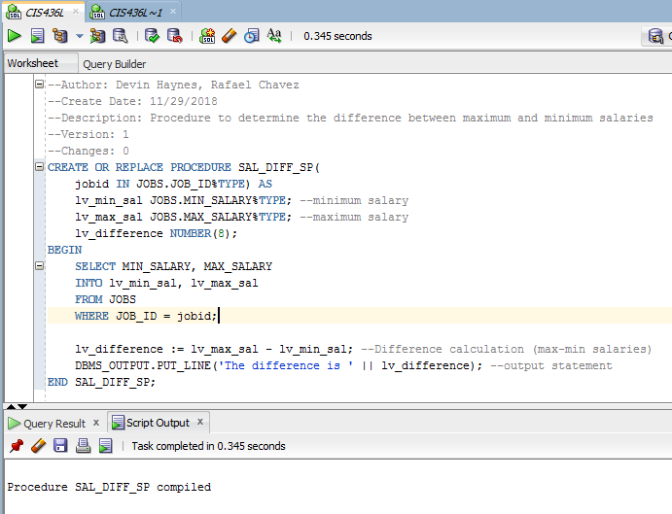

Execute SAL_DIFF_SP

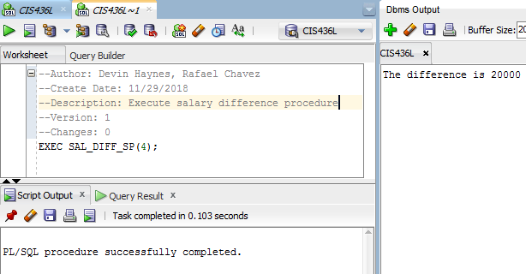

Create procedure to output employee info

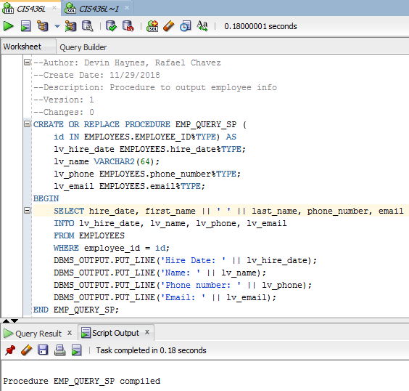

Execute EMP_QUERY_SP

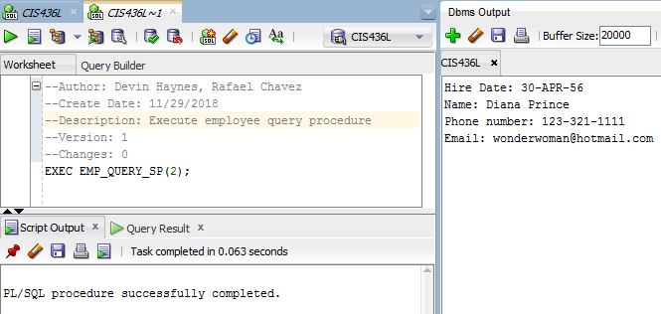

Create procedure to update job id of an employee in the job history table

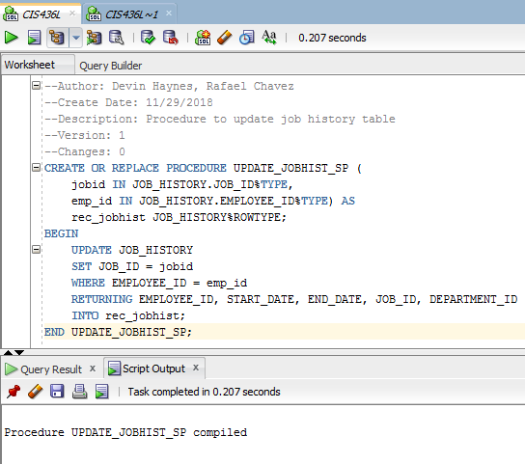

Verify table before executing UPDATE_JOBHIST_SP

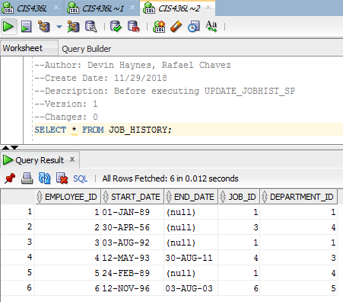

Execute UPDATE_JOBHIST_SP

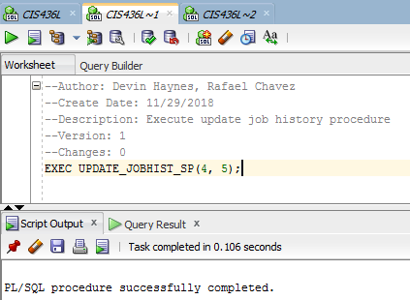

Verify table after executing UPDATE_JOBHIST_SP

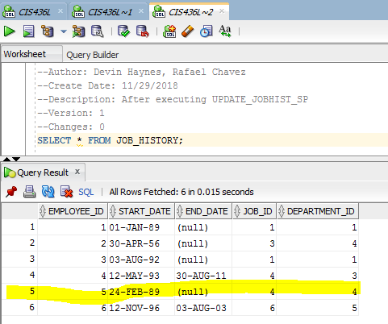

Create procedure to insert new row in Departments table

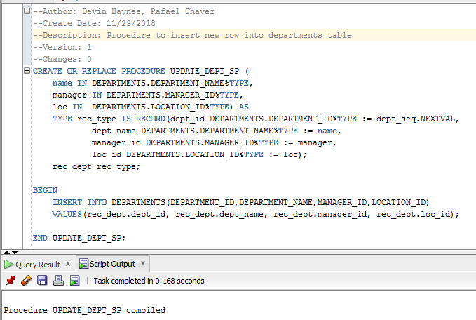

Before adding new row in Departments

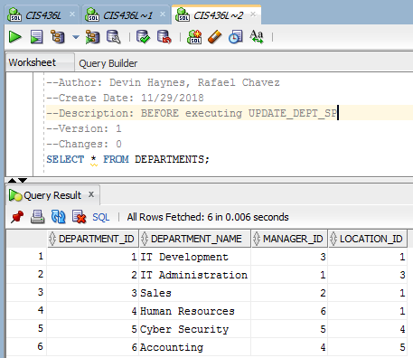

Execute UPDATE_DEPT_SP

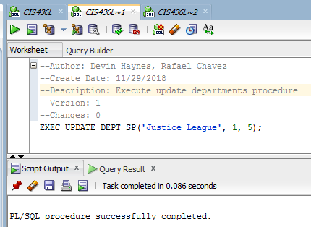

AFTER adding new row in Departments

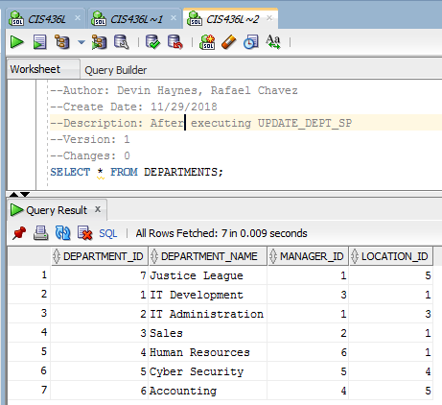

Create procedure to determine employment status (decision statement)

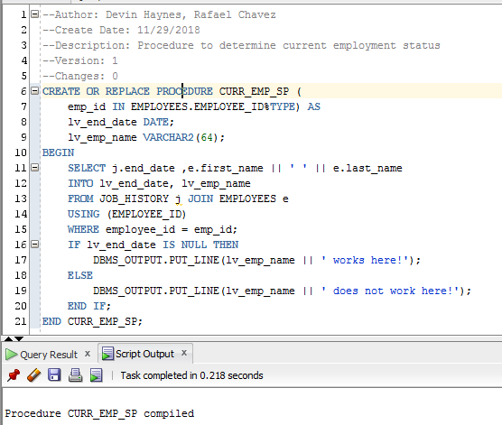

Execute CURR_EMP_SP

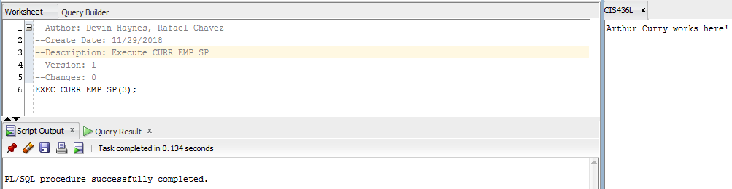

Create procedure to display the number of jobs (aggregate)

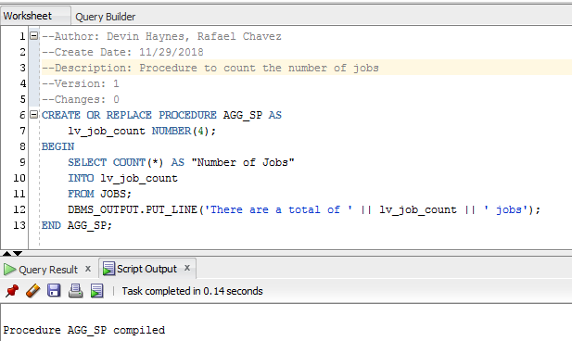

Execute AGG_SP

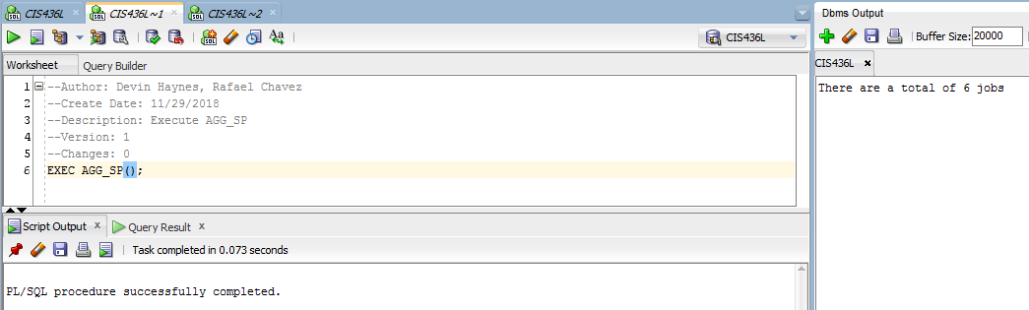

Create procedure to raise minimum salary by 5000 (for loop)

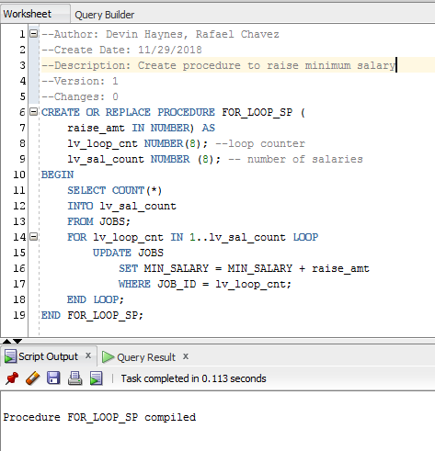

Before adding $5000 to minimum salary

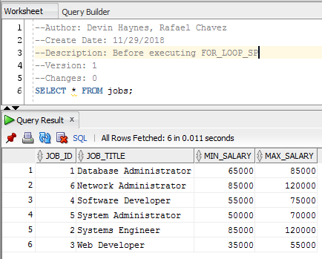

Execute FOR_LOOP_SP

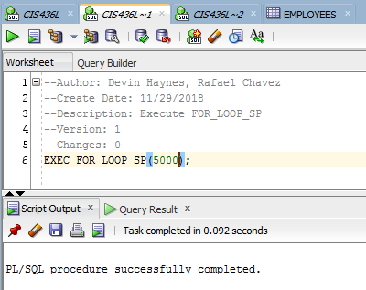

After adding $5000 to minimum salary

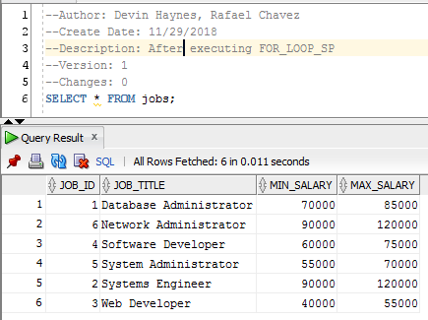

* Create two basic reports. One report that shows what department each employee works. Another report that provides basic employee profiles. Make sure to format the report so that it is readable.

Create report to show which department each employee works in

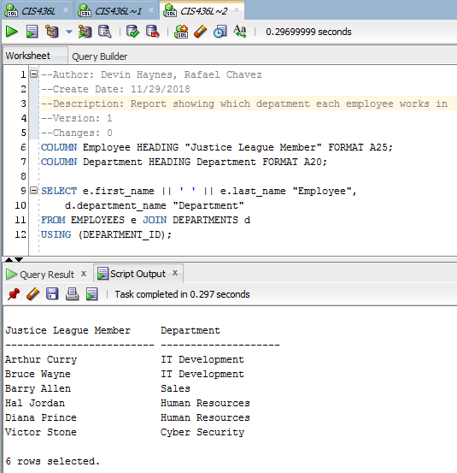

Create report to show employee profiles

