This is the Volunteers database I created for The Up Center summarized. It lists various tables and features of the database. NOTE: All data seen in the screen shots is dummy data used to substitute for real data later.

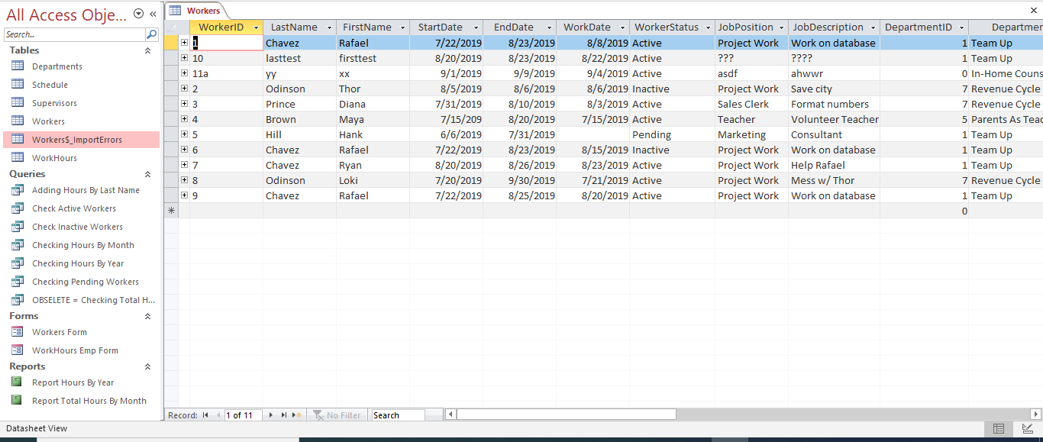This is the main table of the Volunteers database, it lists basic information such as a person’s name, their job position, department, as well as their start/end date. The worker ID for this table (Workers) is the primary key.

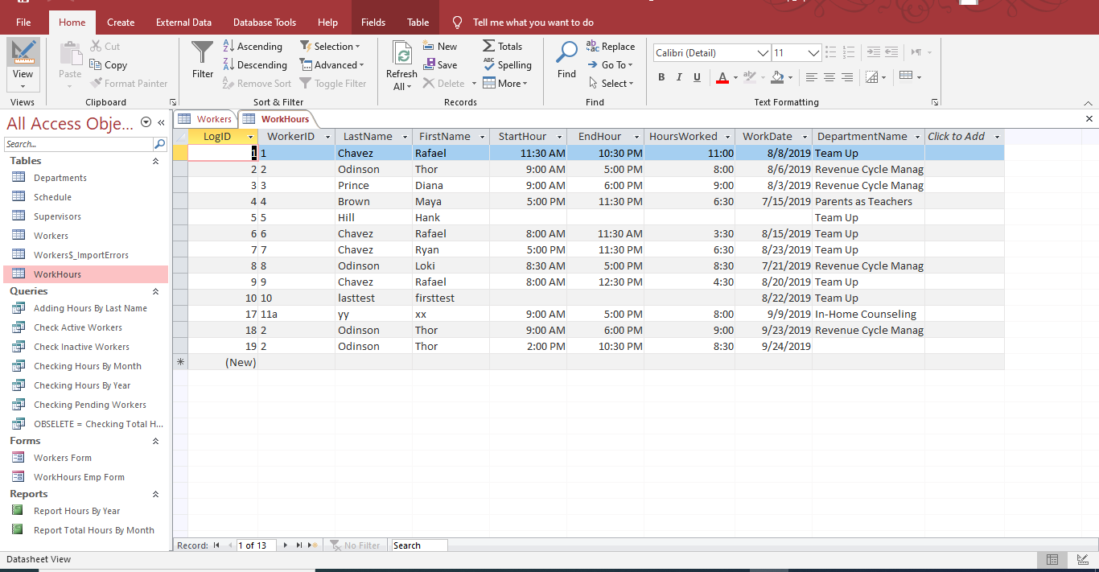The next screen shot below it shows the (WorkHours) table. This table lists the work hours for each person. A person can clock in and out multiple times in a day due to breaks in between the logged hours.

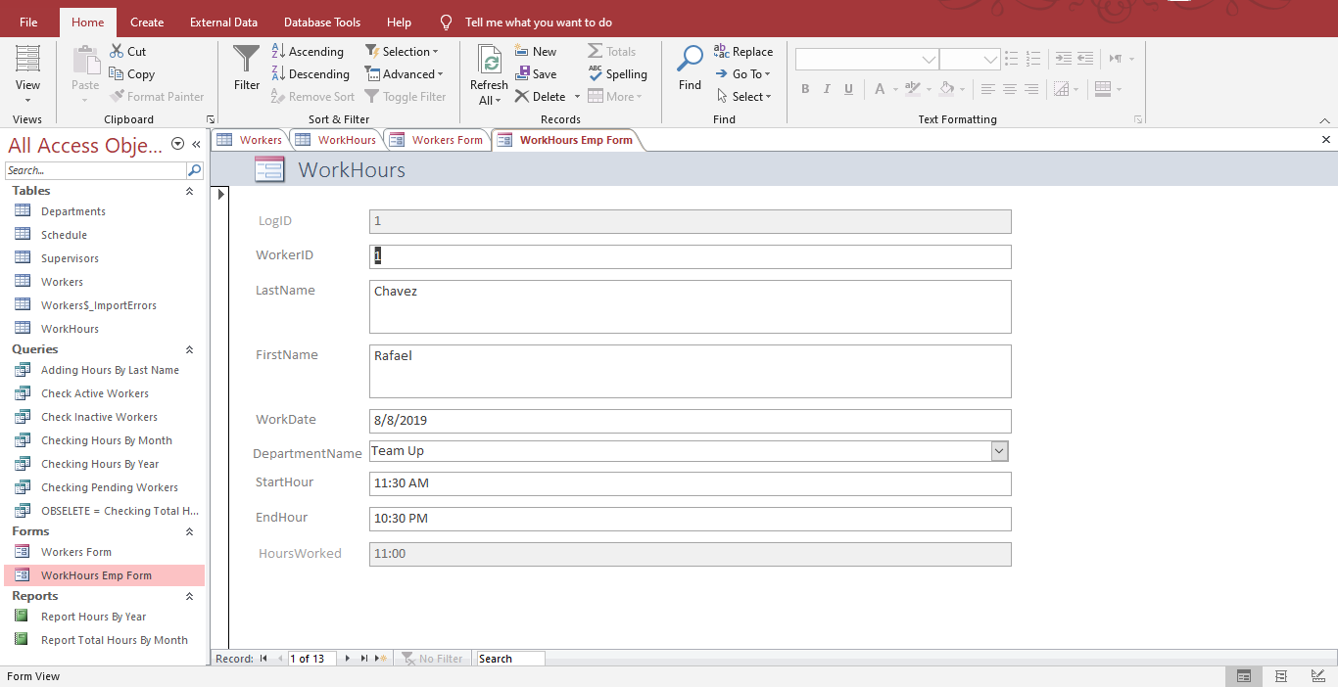This is a form used to take input and put it into the (WorkHours) table. Both forms and queries are used as a basis for the reports.

Below is a generated report for tracking the total hours of workers within a month decided by user input. It pulls this information by running a similar query within the database, the report generated presents the information in an easy to read format.

