**View Classes**

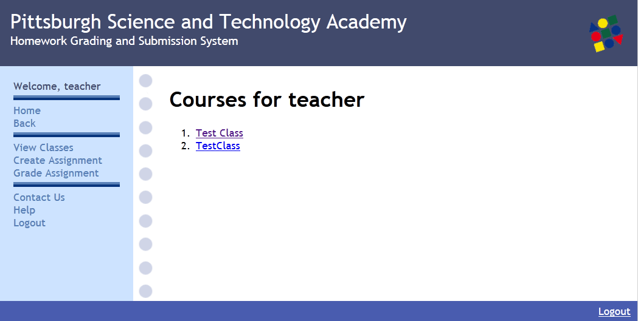

Using the navigation menu on the left hand side of the page you can view all classes for which you are registered as the teacher. You must be added as a teacher by a system administrator before a class will appear in your list. Clicking on the "View Classes" link will take you to a new page containing a list of your classes. Clicking on a specific class will bring you to a page that contains that class's information including any assignments that have previously been created.

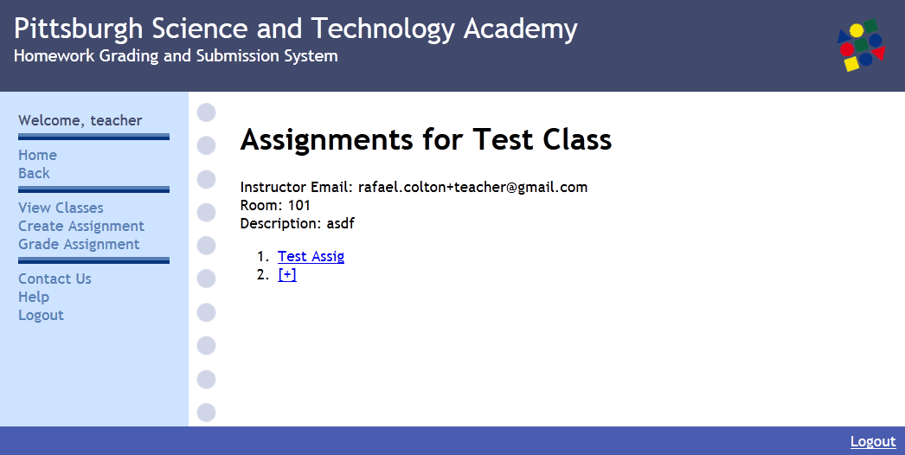

From here you can choose to create an assignment, edit an assignment, or grade an assignment.

**Creating Assignments**

Creating an assignment can be achieved by using the link found on the left hand side of the screen in the navigation menu. This link will take you to new page containing a form that you can fill out to specify any desired details for the assignment.

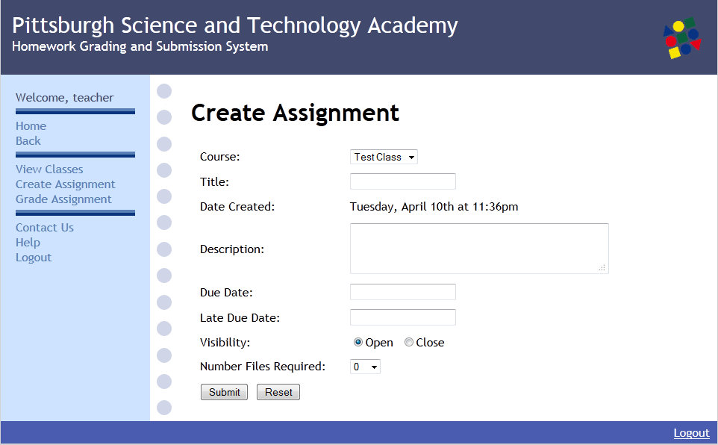You must specify for which class the assignment is intended. You may also create a new assignment by naving to the class page first. This will allow you to create an assignment specifically for this class without having to specify a course from the drop down. Once the desired information has been entered, click the create button to finish creating the assignment. A message will be displayed at the top of the screen, indicatin success or failure. The message will be green if the creation was succesful and red if there was an error. Upon a succesful creation of an assignment, the assignment will be visible to the students enrolled in the class, and the will be able to submit files, provided you listed the assignment as open and not closed.

**Editting Assignments**

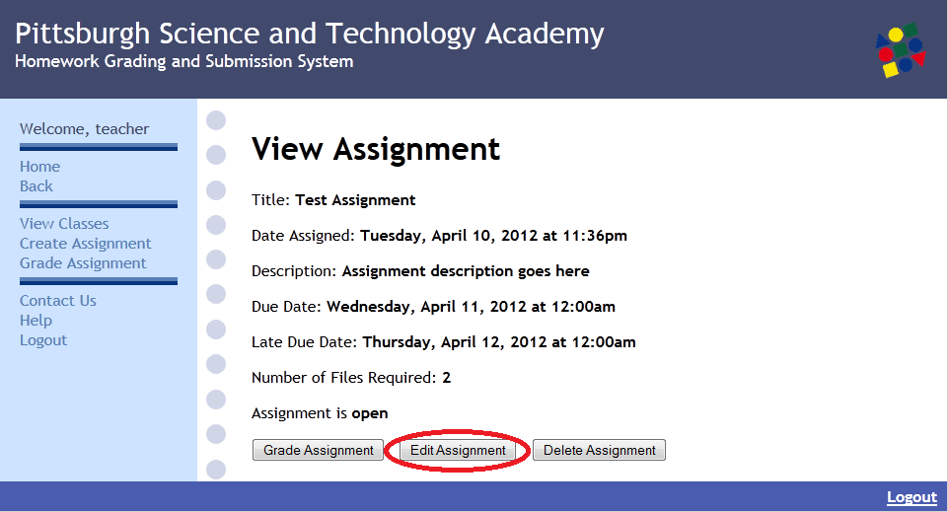

In order to edit an already existing assignment you must navigate to a particular class and then choose the desired assignment from the list of previously created assignments. Once you have chosen the assignment you wish to edit you must click on edit and will be shown the same options that are presented when you create an assignment.

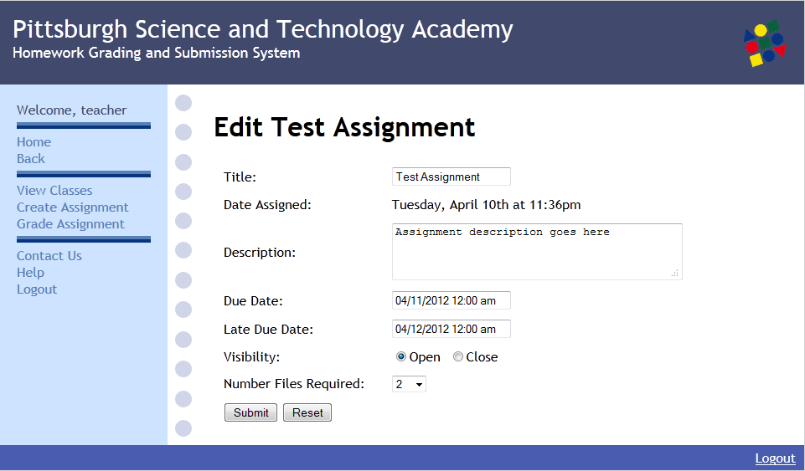 All fields will be preloaded with the current assignment information, so if you submit immediately, no information will be changed. Or, at this screen, you may choose to edit any of the information in the current fields. Once you are finished, click the submit button. A green message will be shown at the top of the page if the edit was succesful, otheriwise a red error message will be shown. Upon a succesful edit, the new information will be reflected when you or a student views the assignment.

**Running Grading Script**

The first part of grading assignments is running the grading script to automatically compile, run, and record the output of the students' submissions. As a teacher you will be given SSH access to the elements.cs.pitt.edu server cluster where the students' files are contained. First it is important to identify the file structure that will be used. Within the file for each class there are files for each assignment made. In these assignment files, there is a file for each student and the grading script, script_grade.php. The script_grade.php file is automatically placed within the assignment folder when the first student submits the first file. Each student's folder contains any files that student has submitted. There may also be a results.txt and late.txt file. The results.txt file will be created after running the grading script and will contain the results. The late.txt file will contain a log of which of the student's files were submitted late. Both files will be visible on the website when grading the assignment.

From the selected assignment file you can compile all of the students' projects and record the output by using the command **"php script_grade.php -c assignment_name.java"**. The -c flag stands for compile and the argument that corresponds to it will indicate the file that will be used to run javac. Note that the grading scrpt also supports Python, which does not need to be compiled. Therefore, if you are grading a Python assignment, you may skip this step. To run a test input file on all of the students' projects and record the output use the command: **"php script_grade.php -t assignment_name -f input_file_name.txt"**. The -t flag stands for test and the argument that corresponds to it indicates the Java class to execute. The -f file stands for file and the argument corresponding to it indicates the test file. To clean all of the Results.txt files for the assignment use the command: **"php script_grade.php -d all"**. The -d flag stands for delete and "all" would delete each students' results.txt file for that project. To clean an individual student's Results.txt file for the assignment use the command: "php script_grade.php -d folder_name". The argument that corresponds to -d will either be "all" or a specific student_folder (like in this example). When a test is run on the the students' projects, the output will be appended on to the end of the results.txt file which already contains the compilation information. If the project did not compile successfully, the resulting errors will be appended for this section. Multiple tests can be run and they will be simply appended to the end of the file in another section. The sections will be distinguished by the title of the input file that was run.

Python projects can be tested in the same way that java files are tested. Simply use the command **"php script_grade.php -t python_file -f testfile.txt"**.

Remember that a test file is not required in order to test a project. If an assignment requires no input to run, simply omit the "-f" and "testfile.txt".

**Grading Assignments**

After running the grading script, the individual student submission can be reviewed via the grading website. On the left hand side of the screen in the navigation menu there is an option to "Grade Assignment". Here you will have to select which class the assignment is in and then pick the desired assignment to grade.

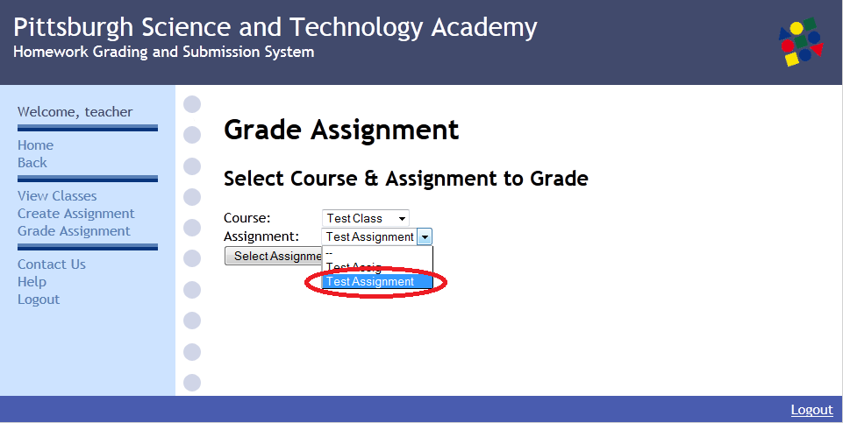

From here you will be brought to a page for the first student listed for that assignment.

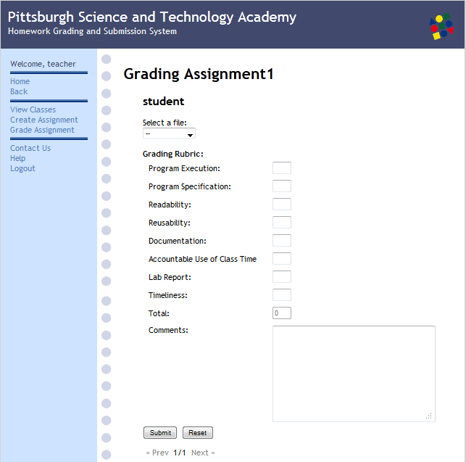

At the top of the screen you can select wich file to view, which will be pulled from the student's folder for that assignment. Results.txt will contain the output generated from the grading script but you can also view the actual source code directly on the page.

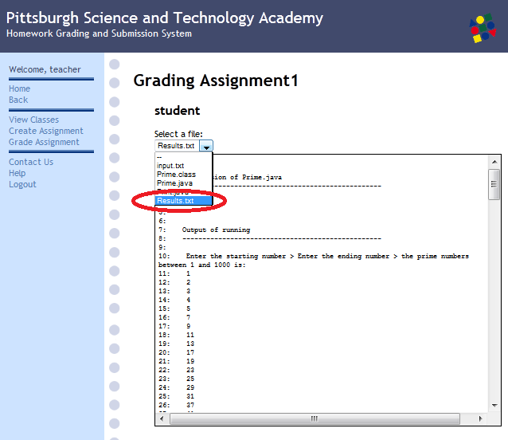 Underneath the view window of the file you selected will be the grading rubric for that student's submission. Whenever values that are entered into the fields will be added together in a total at the bottom. You may also provide comments to the student if you wish. All grading results will be emailed to the student for whom the grade is being submitted.

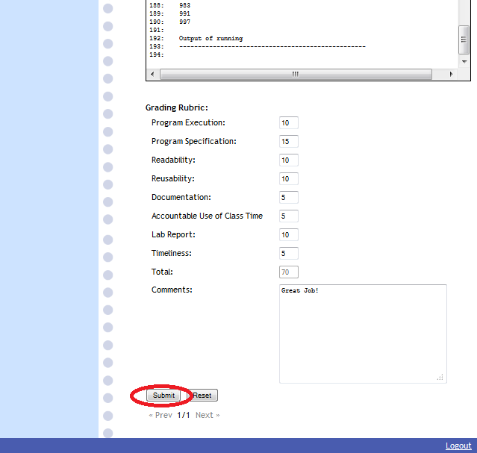Clicking reset will clear all of the rubric fields. Underneath the submit/reset buttons are arrows that allow you to cycle throught the different students for that assignment whose names will be displayed at the top of the screen.