Rafeeq Wilson

Class Project

Shell

Operating systems have interpreters some use graphical user interfaces (GUI) and others use command line interfaces (CLIs), “an interpreter is a program that reads in as input a source program, along with data for the program, and translates the source program instruction by instruction.” Interprets are important for operating systems, indeed, they go beyond only interacting with the computer through the keyboard they are play a role programming as well. The interpreter is a very important part of systems they allow even the beginner level use its advantages and will allow you to understand your computer even more. The interpreter that Linux uses is called Shell, Shell is not part of part of Kernel, however, the system uses kernel to execute programs. There is not just one Shell program there are several that one may have in their computer. Shell is a umbrella program that’s has many

There is not just one Shell program, there are several for example, Koran Shell, C Shell, TCSH and the most used Bash and the oldest Shell Bourne-Again Shell. Although, these are different programs that are created by different people they have syntax and are understood differently by the computer. An example, C Shell’s syntax is similar to that of C programming language and the aforementioned do not. Another instance is that a lot of the Shell programs build on each or have bases in other programs like Korn Bash is based in Bourne Shell. They all are able to do the same functions like find and folders on your desktop and even do math are just some of the simple things one can do while just starting out. One can find all the Shells that are available in their system by simply entering **$ cat /etc/shells.** Which one is better one might ask. Again, they can all do the same functions, however, everyone has their preference, but it’s really easy getting started with Bash.

So how does one open and use their shell if they are using a Linux system?

**How does one invoke Shell?**

First: One would have to find Shell within their desktop by using their search icon. One can type Terminal or Shell in their search icon and that will take them their PowerShell. One should see something that similar to this come up:

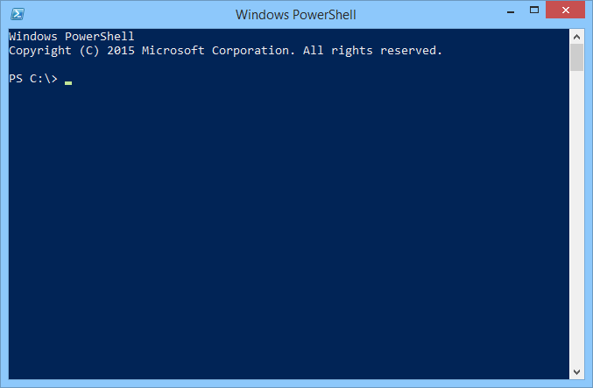

Here is where one can begin to use the PowerShell program. From here there are lists of commands that one can do to manage tasks. For example, I currently use my mine to work with ruby and to go between files. However, there is very big list of commands that we will go through.

**Common Functions**

1. Changing directories: Typing cd in terminal.

[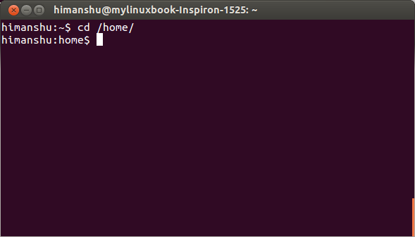](https://www.google.com/url?sa=i&rct=j&q=&esrc=s&source=images&cd=&ved=0ahUKEwiK7tax2sjLAhVH1WMKHWlpBfgQjRwIBw&url=http://www.makeuseof.com/tag/a-quick-guide-to-get-started-with-the-linux-command-line/&psig=AFQjCNGtO7CBByiu45zkbgnvftbzlWUl-g&ust=1458337798574726)

From here one can switch into files on their computer by one using the name of the file like in the example above.

1. List all files: Typing ls.[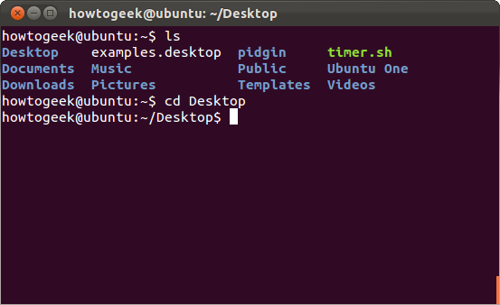](https://www.google.com/url?sa=i&rct=j&q=&esrc=s&source=images&cd=&ved=0ahUKEwiykJLg8s_LAhUC82MKHZIKDHYQjRwIBw&url=http://www.howtogeek.com/107808/how-to-manage-files-from-the-linux-terminal-11-commands-you-need-to-know/&psig=AFQjCNGtO7CBByiu45zkbgnvftbzlWUl-g&ust=1458337798574726)

As one can see the user cded into their desktop folder and then used the ls command to list all the files within that folder.

1. Making a file: Typing mkdir. Here is another useful command that allows the user to create folders.
2. Copying files: Typing cp. Here one can copy files and then move them to where you want them.
3. Moving files: Typing mv. Using this command one can move files.
4. Showing the date and doing math: Typing date. This is just to show that there is a breadth of commands that one can do in shell. Math is also a pretty cool function of the Shell program.
5. Delete files: Typing rm.

[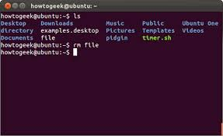](https://www.google.com/url?sa=i&rct=j&q=&esrc=s&source=images&cd=&ved=&url=http://www.howtogeeks.info/view-detail/how-to-manage-files-from-the-linux-terminal-11-commands-you-need-to-know.html&psig=AFQjCNFAnrSH9KE7aMHNug0BETCzDpkQcw&ust=1458587932099919)

Here we see that the user already cded into the folder and then used the ls command and listed all the files within that folder and lastly we see that they are now using the rm command to delete the file File.

**Why does it matter?**

One may ask why is this important? When one starts out using a computer it might seem like a lot of work for nothing. For beginners imagine that you are working on a project and this project requires you to have a lot of files and requires you to move between files. Using Shell would be great for this. Moreover, the above are only the basics when using Shell and there is much more one can do with a little bit of practice. Shell is a powerful tool that is very useful. Interprets are one of our basic ways we are able to communicate with our computers through programming and scripting. Indeed, some even would say that it is a good Segway into computer programming. The Shell program allows us to communicate through different programs such as Bash and Kron. Though there are an array of programs that one can use they are all able to do the same basic functions. Shell is an operation system that is not part of Kernel, but it does use it to execute programs.