**BLE advertising GPS coordinates**

Name of advertisement beacon is BLE_ADV_GPS. Advertisement duration is 10 milli second and interval is 187.5 milli second. “nRF Connect for mobile” android application is used for seeing advertisement packets.

The project file is available on [GIT](https://github.com/rafel02/nRF52_BLE/tree/main/nRF5_SDK_17.0.2_d674dde/examples/ble_central_and_peripheral/experimental/ble_app_interactive/pca10040/s132/ses/). Segger Embedded Studio IDE is used for coding, debugging and programming nrf52 based PCA10040 development kit. Tera-Term terminal emulator is used to giving command line interface command. Baud of 115200 bits per second is used. Serial port setup includes data packet of 8 bits, no parity, no stop bits, no flow control. GPS coordinate is given through Tera-Term CLI. The command format to advertise GPS data is “**advertise on <latitude> <longitude>**”, without angular bracket. For example, “**advertise on -47.3259 to 179.3092**”. The latitude and longitude of value up to four decimal places is supported.

In Figure 1 advertisement information can be seen. “BLE_A” is the short format of the actual “BLE_ADV_GPS”. This is done intentionally to save bytes in advertisement packet having limit of 31 bytes. On connection full name of advertising device can be seen.

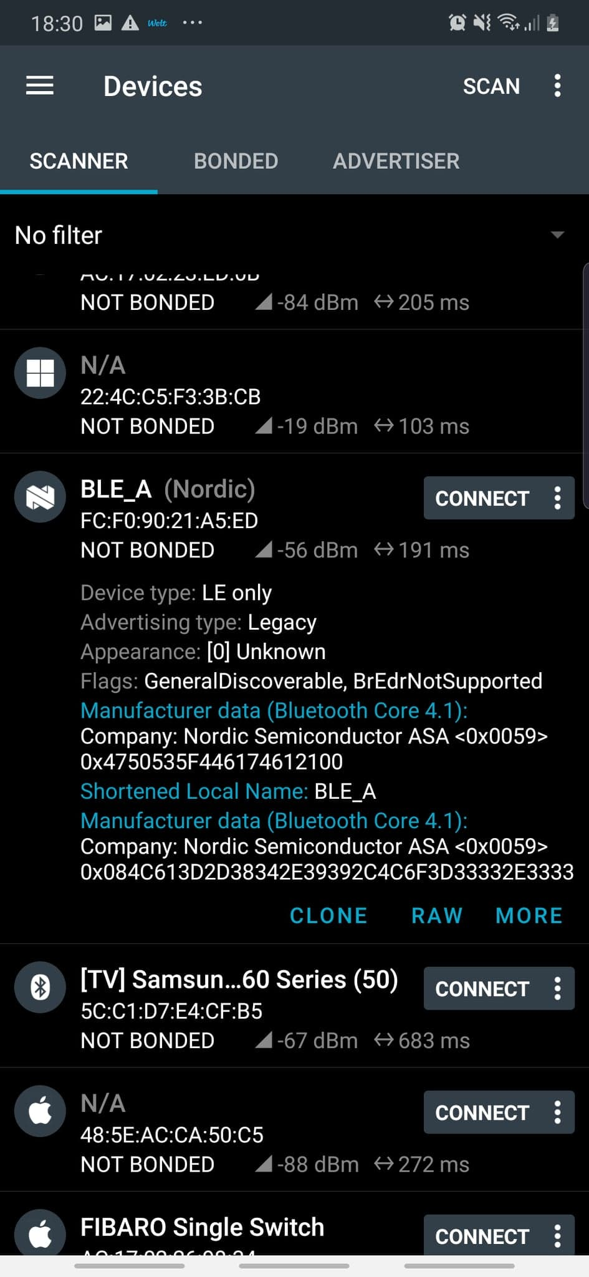

Figure 1 – Advertisement information on “nRF Connect for Mobile android” application.

In Figure 2 advertisement data can be seen in raw format with data type. The GPS coordinated are present in manufacturer datatype. The manufacturer datatype is denoted by hex value 0Xff.

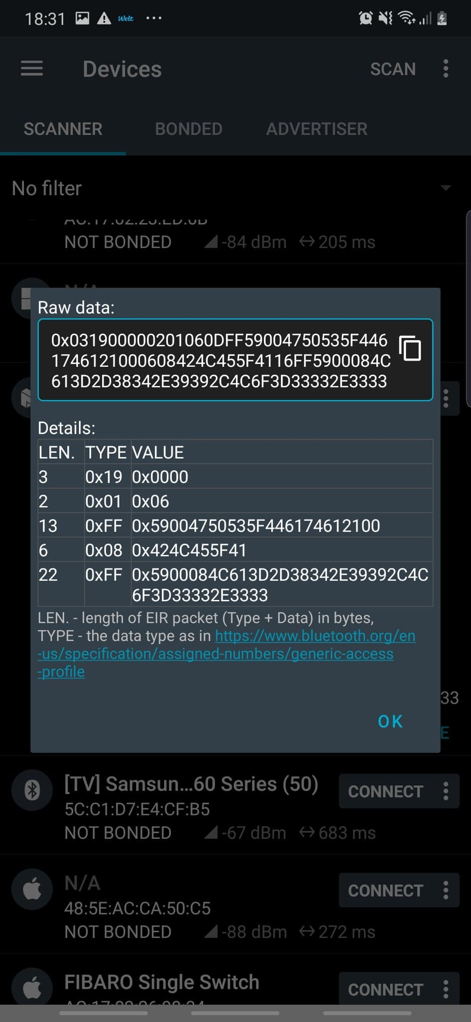 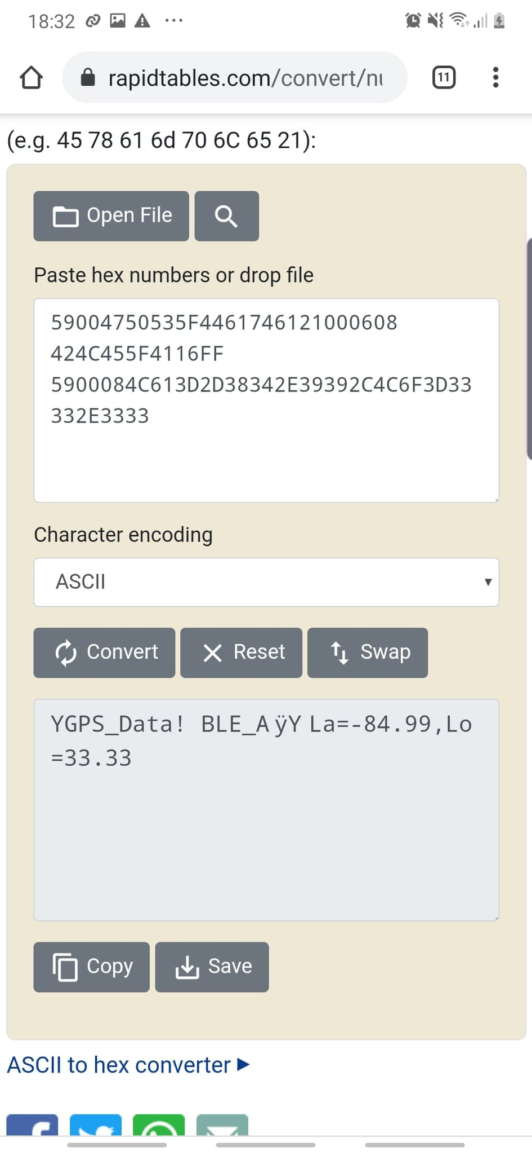

Figure 2 - Advertisement packet in raw format on “nRF Connect for Mobile android” application and it’s equivalent ascii decoding.

Figure 3 show BLE Server information. Phone is acting as the server. Sever is running GATT and GAP services.

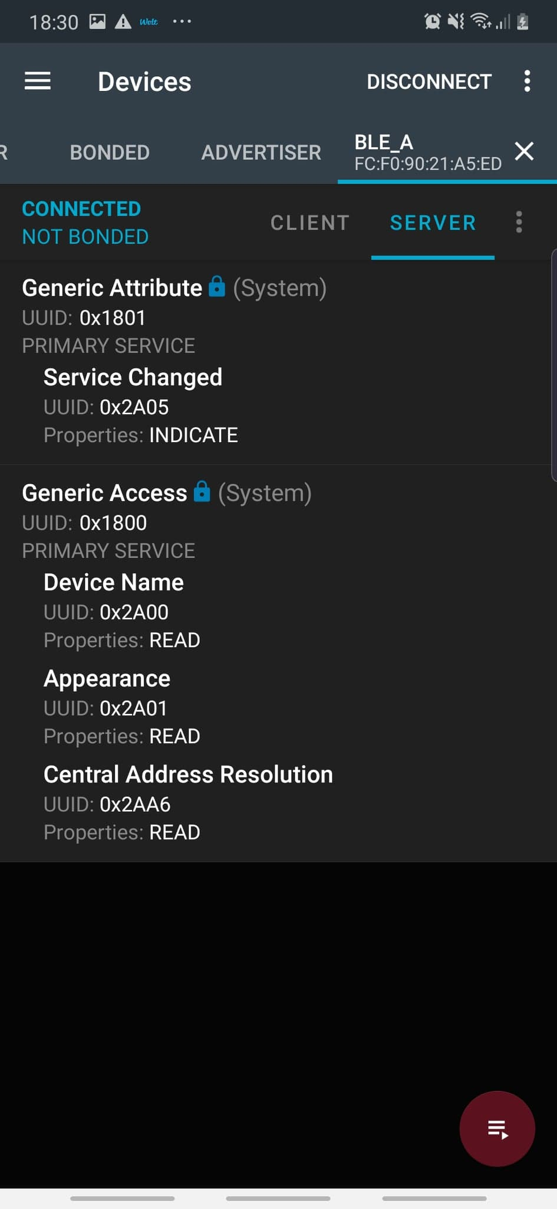

Figure 3 – GATT and GAP services running on server.

Figure 4 show list of services running on BLE client. GATT, GAP and one custom BATTERY service is present on nrf52 BLE. Advertiser complete name “ BLE_ADV_GPS” can be seen in GAP service.

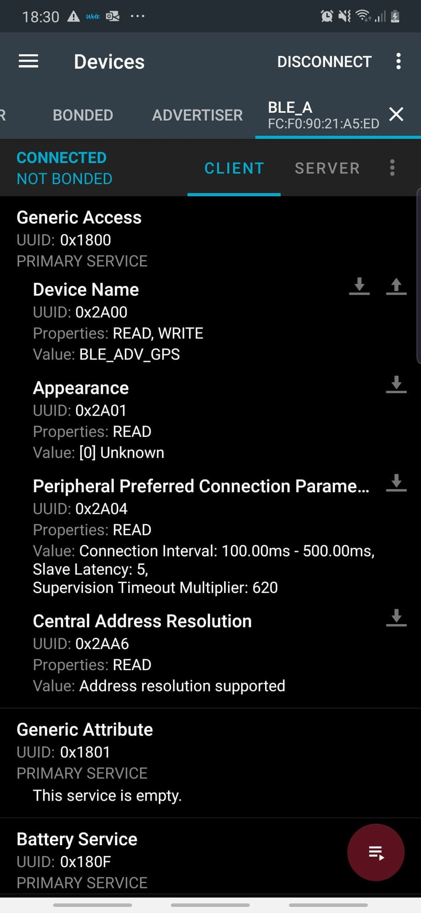

Figure 4 – GATT, GAP, Battery service running on BLE client.