You can create, load, save, copy, etc. databases from the “File” menu.

First tab is for importing data from PDF or text files.

- Clicking on a button takes you to a file dialog screen where you can select multiple files.
- Imported documents are shown in the text box.
- Double clicking on an imported document takes to to the transform tab with that document loaded.
- You can delete documents from here. etc.
- The size is there to let you know if the import actually worked. A small size means it didn’t and you should use another import method.
- There are missing buttons for adding a script etc.

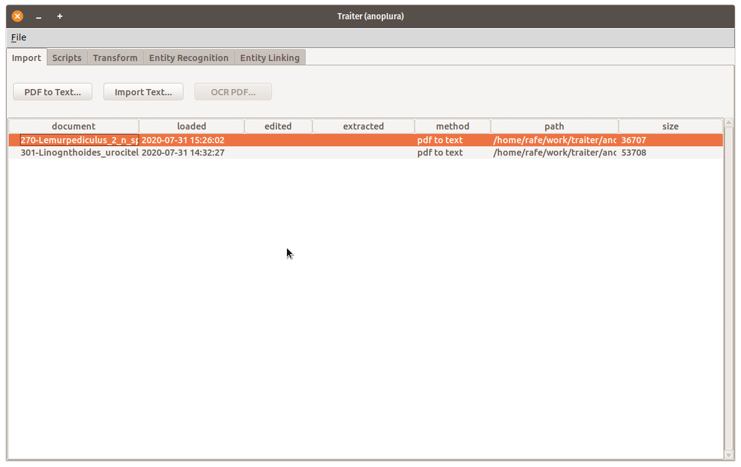
Second tab is for creating “scripts”.
- “Scripts” are pipe-able snippets of code. Here I’m using sed.
- Not shown here, is that you can build up script pipelines.
- We should populate this with some useful examples.
- The name defaults to the action, if you don’t want to name a script.
- You can copy, add, etc. remove scripts and pipelines.

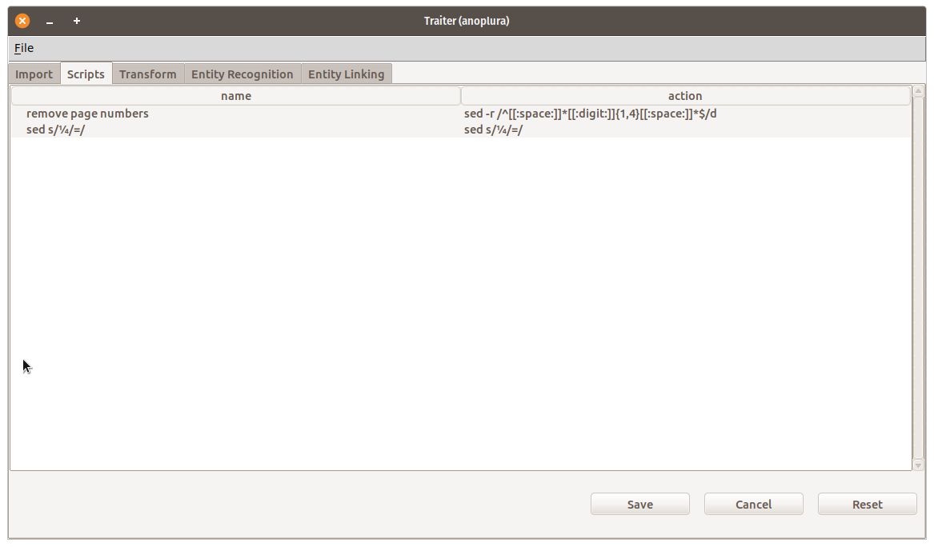

The third tab is one the user will interact with a fair bit. It’s the one where you can transform the text to get it into a form the Named Entity Recognizer (NER) and Named Entity Linker (NEL) can use.
- You select a document up top.
- The document text is shown in the middle. You can edit the document here but that’s not its real purpose.
- Select the script you want to run on the document below.
- Run the script and examine the changes.
- You can save or undo the changes.
- Save writes the changes to the DB.
- Cancel goes back to the last saved state
- Reset goes back to what the imported document looks like.

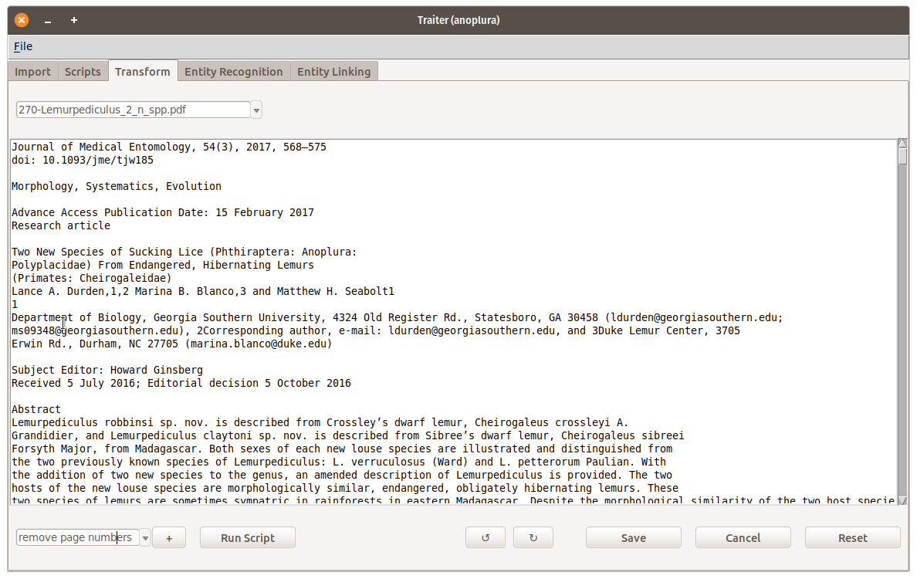

Please note that this is not done and that the last 2 tabs are very sparse. And, there needs to be another tab where you can apply one script (pipeline) to many documents.

