Notes from various NfN expeditions. See for example: https://www.zooniverse.org/lab/18297/workflows/21124

Are there geographic coordinates present?

**Indicate if you see coordinates on the labels. This section will outline the formats and later on we'll get into specifics about how they should be transcribed.**

On these labels you may encounter 3 different types of geographic coordinates:

1. **Latitude / longitude**
2. **UTM** (Universal Transverse Mercator)
3. **Dominion Land Survey** (Dominion Land Survey is technically a survey system, not a coordinate system, but for our purposes we'll record and use them in a similar way)

**Latitude / Longitude:**
Latitude / Longitude tends to take three different formats.
Degrees Minutes and Seconds: 40° 26′ 46″ N, 79° 58′ 56″ W
Degrees Minutes: 40° 26.767′ N, 79° 58.933′ W
Decimal Degrees: 40.446, -79.982

Sometimes you'll see a cardinal direction listed. For example, 37° 45' 08" N where the "N" indicates the northern hemisphere. Note that Degrees Minutes does not always contain decimals on these labels (e.g., 40° 26′ N 79° 58′ W).

Example of a label with **latitude and longitude coordinates**.

![44746_lat_long copy.jpg](https://panoptes-uploads.zooniverse.org/project_attached_image/05f64930-272c-47b2-959e-bb8a9d10878a.jpeg =400x)

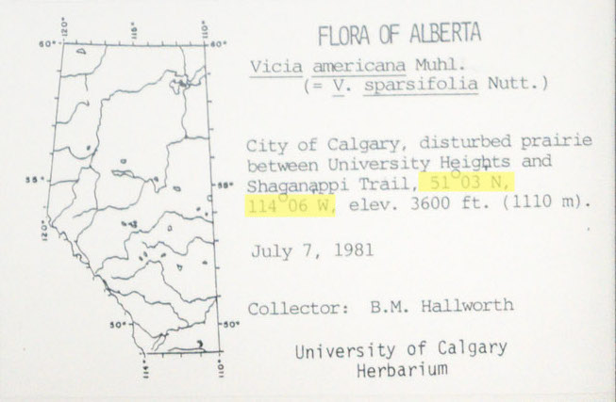

**UTM (Universal Transverse Mercator):**
UTM is denoted by three values, a zone, as well as an x, y coordinate. For example: 17 630084, 4833438. Sometimes you'll see a direction added to the end of the x, y coordinates: 17 630084 E and 4833438 N. The directions may also be written as "easting" and "northing."

However, it is common for collectors to simplify or shorten the formula (which can also include letters). This often involves the zone and the last 3 digits of the x, y coordinate. You might see something like: 11UQF056380. One way you know that this is still UTM format is the zone being listed first. For most of these labels, the UTM values will start with 11U or 12U since the collections are from those zones in western Canada.

Example of a label with **UTM coordinates**.

![UTMexample1.png](https://panoptes-uploads.zooniverse.org/project_attached_image/0598ae4a-4e47-4890-afd2-15cfee85fd11.png =400x)

Example of a label with shortened **UTM coordinates**. You can tell this is still an **UTM coordinate** as it starts with 11U.

![42597_utm copy.jpg](https://panoptes-uploads.zooniverse.org/project_attached_image/0117bdaf-9cb5-400f-bb2a-f1135babae89.jpeg =400x)

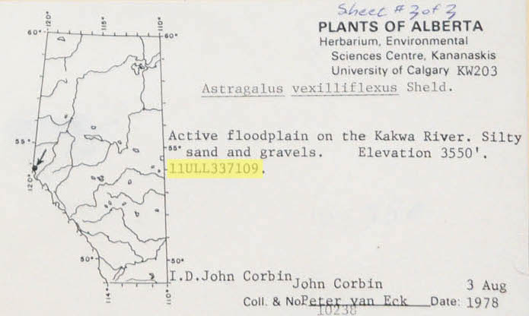

**Dominion Land Survey/LLD/LSD**
This is a method used to divide most of western Canada into one-square-mile (2.6 km2) sections. It can appear as Legal Land Description (LLD) or LSD as well. These codes look like Township-Range-Section (PLSS) codes often seen on specimens collected in the USA.
The codes on these labels typically contains 4 parts; section, township, range and meridian. Written out in full would look something like this:
South Half of Section 12, Township 28, Range 20, West of the 4th Meridian

On these labels you'll see lots of shorthand. The location above might appear like this: S12-28-20-W4

Example of a label with **Domain Land Survey**.

![16234_DLS copy.jpg](https://panoptes-uploads.zooniverse.org/project_attached_image/b772744f-ab6f-4e38-b421-ebbeb2296281.jpeg =400x)

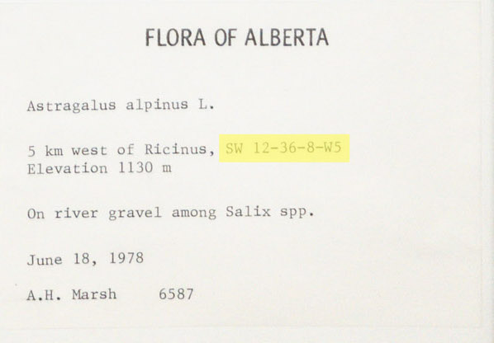

Some labels will have more than one coordinate system. The example below has **latitude and longitude** and **Domain Land Survey**.

![14307_lat_long_DLS copy.jpg](https://panoptes-uploads.zooniverse.org/project_attached_image/5faa1bf9-3524-4976-8509-c0ababda45b4.jpeg =400x)

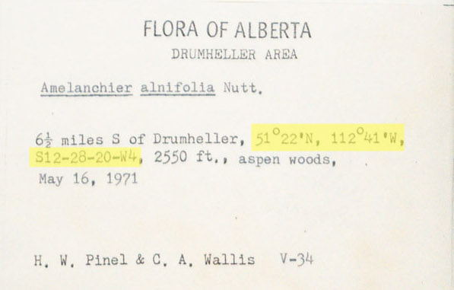

Are the coordinates latitude and longitude?

**If you see latitude and longitude coordinates select yes and the type of coordinates.**

**Latitude / Longitude:**
Latitude / Longitude tends to take three different formats.
Degrees Minutes and Seconds: 40° 26′ 46″ N, 79° 58′ 56″ W
Degrees Minutes: 40° 26.767′ N, 79° 58.933′ W
Decimal Degrees: 40.446, -79.982

Sometimes you'll see a cardinal direction listed. For example, 37° 45' 08" N where the "N" indicates the northern hemisphere.

Note that Degrees Minutes does not always contain decimals on these labels (e.g., 40° 26′ N 79° 58′ W).

Are UTM coordinates present?

**Indicate if you see UTM coordinates on the labels.**

**UTM (Universal Transverse Mercator):**
UTM is denoted by three values, a zone, as well as an *x*, *y* coordinate. For example:
17 630084, 4833438. Sometimes you'll see a direction added as well such as 17 630084 E and 4833438 N. The directions may also be written as such as "easting" and "northing."

However, it is common for collectors to simplify or shorten the formula. There are also sometimes overlay systems with codes. This often involves the last 3 digits of the *x*, *y* coordinate. You might see something like: 11UQF056380. One way you know that this is still UTM format is the zone being listed first. Note that for most of these labels the UTM values will start with 11U or 12U since the collections are from those zones in western Canada.

Example of a label with **UTM coordinates**.

![UTMexample1.png](https://panoptes-uploads.zooniverse.org/project_attached_image/0598ae4a-4e47-4890-afd2-15cfee85fd11.png =400x)

![42597_utm copy.jpg](https://panoptes-uploads.zooniverse.org/project_attached_image/0117bdaf-9cb5-400f-bb2a-f1135babae89.jpeg =400x)

Township Range Section [western U.S. and some southeast U.S. such as Louisiana]
https://web.gccaz.edu/~lynrw95071/Township%20Range%20Explanation.html
​​https://en.wikipedia.org/wiki/Public_Land_Survey_System

Typically shown as:
T2N R2W S8 = Township 2 North, Range 2 West, Section 8

Sections are 1x1 mile, so ¼ sections are often referenced For example:
Section 8 NW1/4 = the northwest ¼ of section 8.

NW1/4

[need to find label examples…]

Are Dominion Land Survey/LLD/LSD values present? [CANADA only?]

**Indicate if you see Dominion Land Survey/LLD/LSD coordinates on the labels.**

**Dominion Land Survey/LLD/LSD**
This is a method used to divide most of western Canada into one-square-mile (2.6 km2) sections. It can appear as Legal Land Description (LLD) or LSD as well. These codes look like Township-Range-Section (PLSS) codes often seen on specimens collected in the USA.
The codes on these labels typically contains 4 parts; section, township, range and meridian. Written out in full would look something like this:
South Half of Section 12, Township 28, Range 20, West of the 4th Meridian

On these labels you'll see lots of shorthand. The location above might appear like this: S12-28-20-W4

Example of a label with **Dominion Land Survey/LLD/LSD.**

![16234_DLS copy.jpg](https://panoptes-uploads.zooniverse.org/project_attached_image/b772744f-ab6f-4e38-b421-ebbeb2296281.jpeg =400x)

