We are building a pipeline for extracting label text from images of herbaria specimens. The images used for this project are of dried plant specimen mounted on a stiff piece of white paper. There are labels and printing on the background paper that describe the provenance of the specimen and, most importantly for this study, a label describing when, where, and under what conditions the specimen was collected. The project’s goal is to extract the information from this label. One advantage to working with herbarium specimens, as opposed to pinned insect specimens, is that the labels are almost always unobscured by the specimen or other labels. See figure 1 for a sample herbarium specimen.

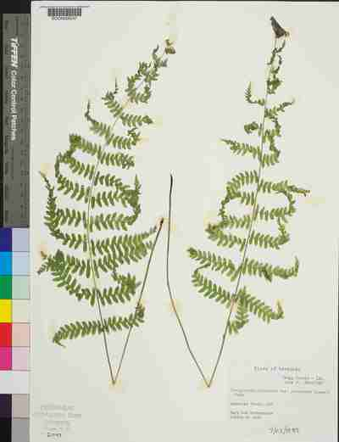

Figure 1: A picture of a herbarium specimen with the target label on the lower right corner.

The pipeline we are building has five steps. We have run a pilot study with 6,086 images which demonstrated the effectiveness of the pipeline and possibilities for improving various steps.

The first step in the pipeline is to collect labeled data for training and scoring the models in the pipeline. To do this we use the citizen science web service, Notes from Nature [link], to crowd source this effort. Citizen scientist note the location of a label by drawing a bounding box around it. They also note what is the predominant type of text is on the label by selecting an option from a drop-down list. The options for label type are: typewritten, printed, cursive, or a mix. And finally we have them transcribe the label content. We will need the entire label content for scoring the quality of the optical character recognition (OCR) results. We will also need the citizen scientists to break the label text into fields of data (like: collection date or collector) using both drop-down select lists and free-form text fields for scoring the information extraction (IE) results.

Three citizen scientist input data for each image called a transcript. We then use a Python script we have developed to reconcile these three transcripts into a single “best” transcript [link]. This script uses heuristics and experience gained from previous transcription projects to arrive at the “best” answer. For the label bounding box we use the average of the extreme coordinates (top, bottom, left, right). For the label text type we use a majority vote of the selected items. And, for the label content we use a combination of a majority vote for select boxes (typically dates or states etc.) and a more involved scoring method for the free-form text fields [link] that involves looking for text overlap between the transcripts.

20% (1216 images in the pilot study) of the data is saved as a test (or holdout) set that is not used until the final scoring of the models. In the second pipeline step we use the remaining 80% (4865 images in pilot) of the data to train an object detection neural network model. Object detection is classification of object in an image along with a bounding box of the classified object. Here we are drawing a bounding box around the specimen label and classifying the label text type. However, we are not training this model from scratch, we are fine-tuning a previously trained model. By using a previously trained model we can cut training times, sometimes by orders of magnitude [ref].The model is Faster-RCNN with a ResNet50 backbone [links x2] that has been trained on the COCO [link] dataset and it is implemented in PyTorch. The Faster-RCNN [ref] part of the model’s primary purpose is to find the bound boxes of the objects (here it’s labels) and the ResNet50 part of the model is used mostly for the image classification part. Note, I looked at other methods for object detection for instance Hough Transforms [ref] and color segmentation [ref]. These methods required significant amounts of ad hoc heuristics and wound up being less effective at the task.

For scoring the neural net’s classification we use a standard multi-class confusion matrix and its associated metrics [ref]. And we used the Intersection over Union (IOU) metric for scoring neural net’s bounding boxes [ref].

When doing the pilot study, we removed the top layer of the neural net and replaced it with a classification layer suited for our label type classification. I trained the neural net for 5 epochs (runs through the data) without data augmentation – techniques for making the training dataset appear larger than it is e.g. color jitter, image rotations, image flips, etc. Even with this light training we achieved very encouraging results. The confusion matrix for the test data looked like figure 3. Please note that the pilot study had two classes of labels (handwritten and typewritten) we will have 4 classes for the project (typewritten, printed, cursive, and mixed).

Confusion matrix for the pilot study classification results. 93% correct.

The results of the pilot study test data for label detection were surprisingly encouraging given the light training. Please note that algorithm found the label regardless of the image orientation and position of the label within the image. To get an idea of what the intersection over union numbers mean please see figure 2.

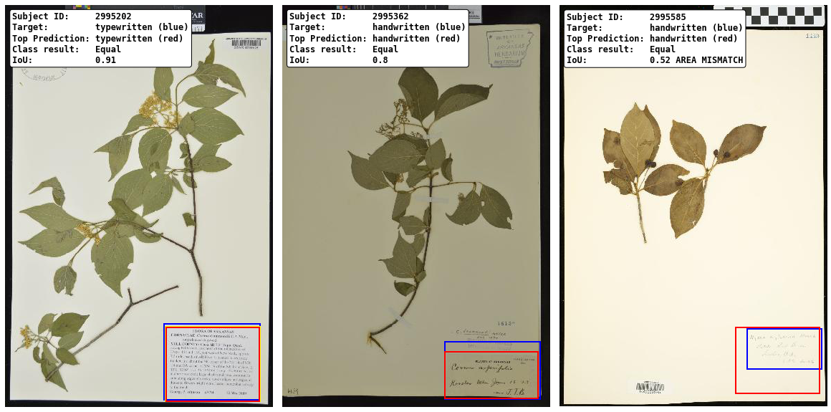
Figure 2: Sample intersection over union (IOU) results. The image on the left has an IOU = 0.91, the middle image IOU = 0.80, and the image on the right = 0.52. The blue boxes are the target boxes, the average of the bounding boxes drawn by the citizen scientist. The red boxes are the label bounding boxes predicted by the model.

After we find the labels in the test data we use optical character recognition (OCR) on the typewritten and possibly the hand printed labels to extract the text in the labels. We are using pytesseract [refs x2] to extract the text. See figure 3 below for the OCR results of a typewritten label. We will score the OCR quality against the entire label content using a normalized edit distance metric [ref].

Finally, we will perform an information extraction (IE) step on the OCR text. This is involves breaking the unstructured text into normalized machine consumable data fields. For instance we want to separate the collection state, county, and date into separate fields. We also want to extract any measurements or counts as well as controlled vocabulary data for habitat or location etc. into their own fields. We have had success using pattern matching methods for extracting this data [ref traiter]. The text patterns are found using nested groups of regular expressions. That is, we use one set of regular expressions to turn the text into a stream of tokens, another set to simplify the token stream, and a third set to convert the token stream into the machine consumable data fields. We will score this step using normalized edit distances against the field extracted data from the citizen scientists.

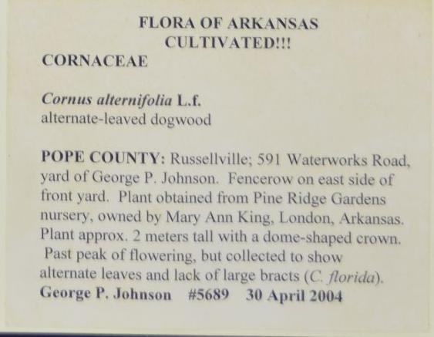
FLORA OF ARKANSAS.
CULTIVATED!
CORNACEAE

Cornus alternifolia L.f.
alternate-leaved dogwood

POPE COUNTY: Russellville; 591 Waterworks Road,
yard of George P. Johnson. Fencerow on east side of
front yard. Plant obtained from Pine Ridge Gardens
nursery, owned by Mary Ann King, London, Arkansas.
Plant approx, 2 meters tall with a dome-shaped crown,
Past peak of flowering, but collected to show

alternate leaves and lack of large bracts (C. florida).
George P. Johnson #5689 30 April 2004

Figure 3: Extracted label (left) vs. the OCR text (right).

