|  |  |
| --- | --- |
| 报告日期  Report Date: |  |

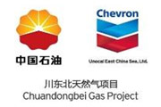

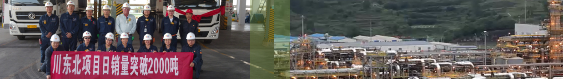

**硫磺库存和交货SULFUR INVENTORY AND DELIVERY**

|  |  |  |  |  |  |  |
| --- | --- | --- | --- | --- | --- | --- |
|  | | Inventory (Tons)  库存（吨） |  |  | | Molten Working  Capacity (Tons)  熔融生产力（吨） |
|  |  | | | | | |
| Molten Working Capacity (days)  熔融生产力（天数） | | |  |  | (full production rate)  满产天数 | |
|  | (target production rate)  目标产能天数 | |

**YTD DELIVERED (Tons)**

|  |  |  |  |  |
| --- | --- | --- | --- | --- |
| Total | Bulk | Molten | Total Target | Sulfur PE |
|  |  |  |  | **%** |