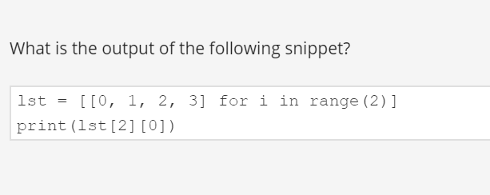

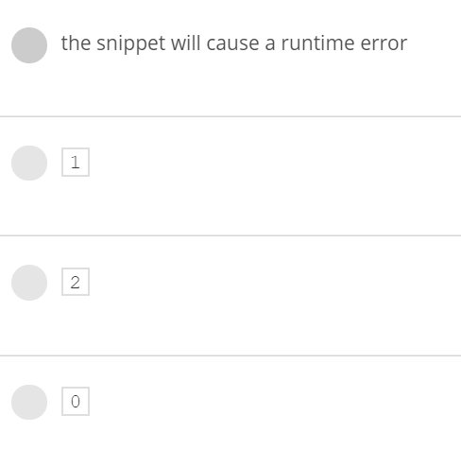

Answer is : the sinppest will cause run time error

Explanation:

lst = [[0,1,2,3] for i in range (2)]

print (lst)

o/p is: [[0, 1, 2, 3], [0, 1, 2, 3]]

print(list[2][0] ) -🡪means list[2] means 3rd element list in o/p but we don’t have 3rd element so error.

2)🡪

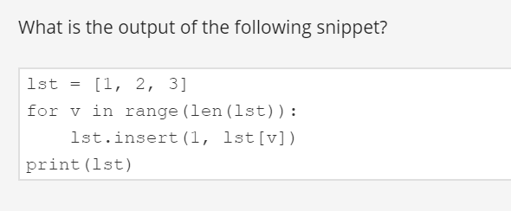

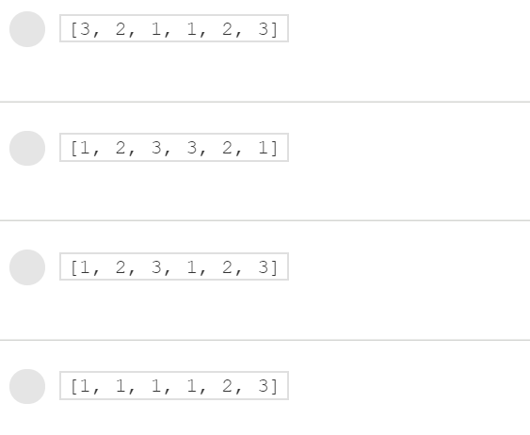

Ans : [1, 1, 1, 1, 2, 3]

Explanation:

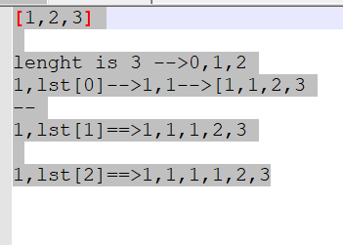

3)🡪

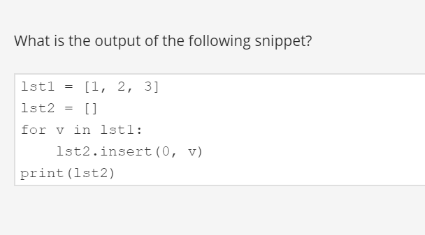

Ans: 3,2,1

Explnations: 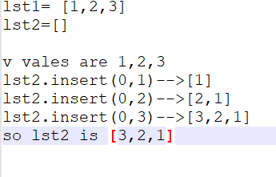

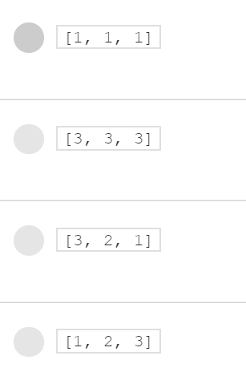

4)🡪

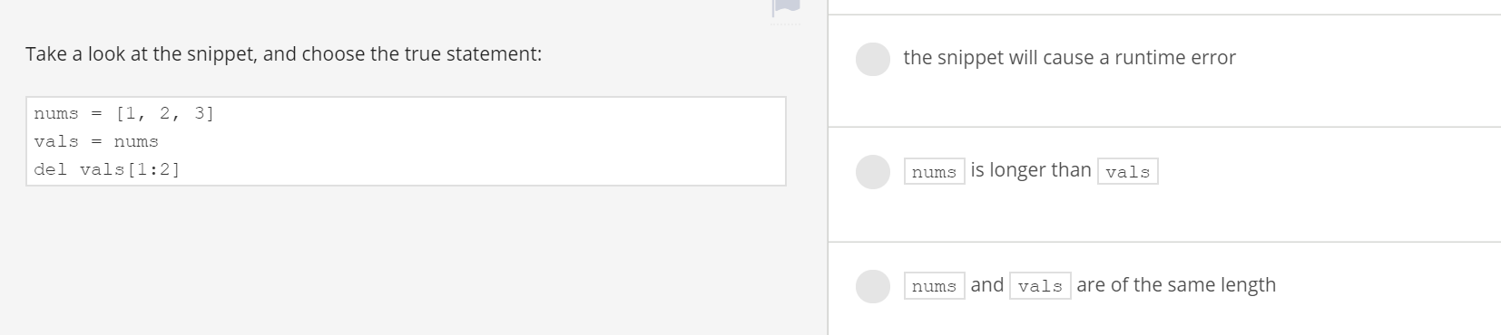

Del vals[1:2]

Means it will delete element at index 1 location i.e element 2 is deleted

So o/p is [1,3] for both vals n nums

Ans: nums and vals are of same length

5)🡪

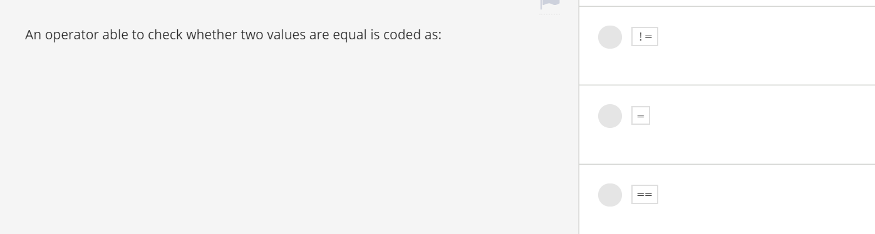

Ans : ==

6)🡪

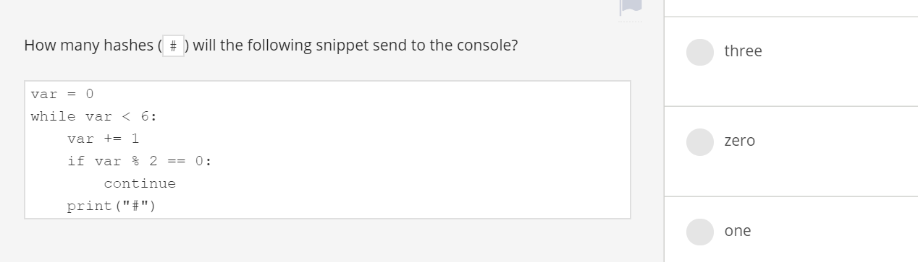

Ans: three

Refer below code .for var 2,4,6 continue will satisfied so it won’t print.var%2==0 is not satisfied for var 1,3,5 so it prints #

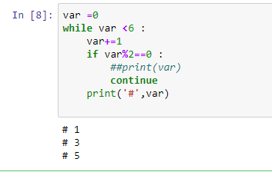

7)

🡪

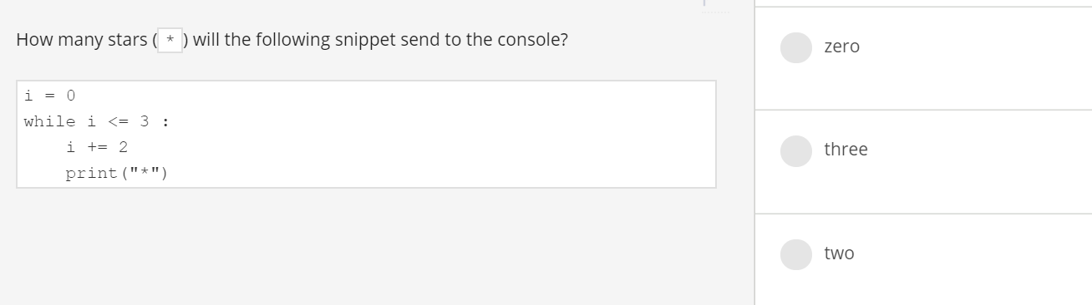

Ans : two

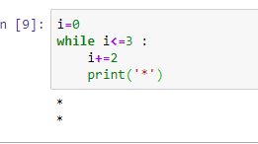

8)

🡪

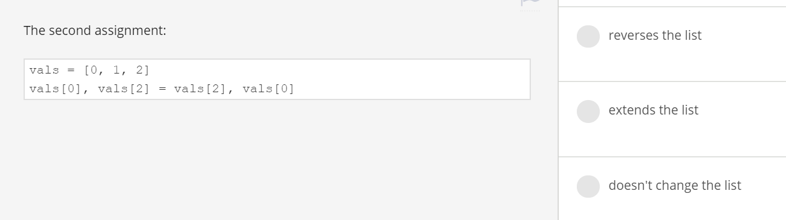

Ans : reverse the list

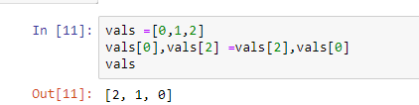

9)🡪

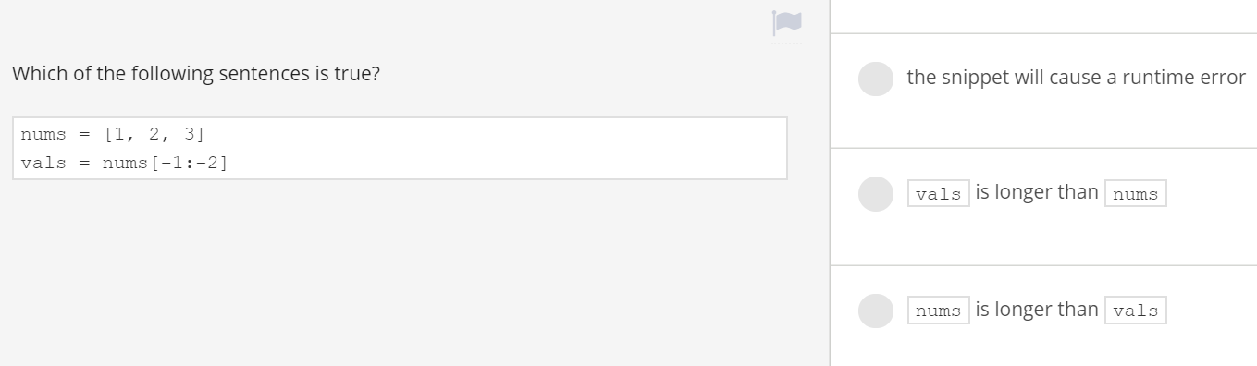

When vals=nums[-1:-2] means starting position is at -1 and end position is -2 means one position lessthan -2. There is no element exist with this so we will get empty list as o/p

So answer is nums is longer than vals

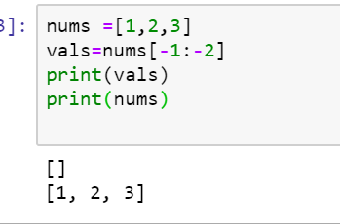

10)

🡪

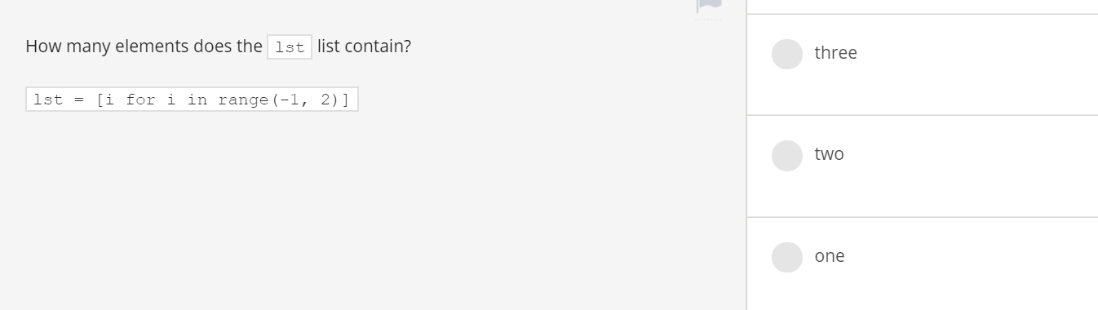

Ans : 3

Refer code below

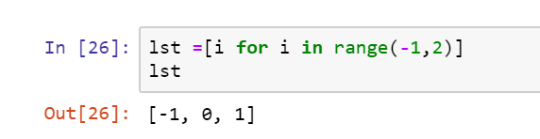

11)🡪

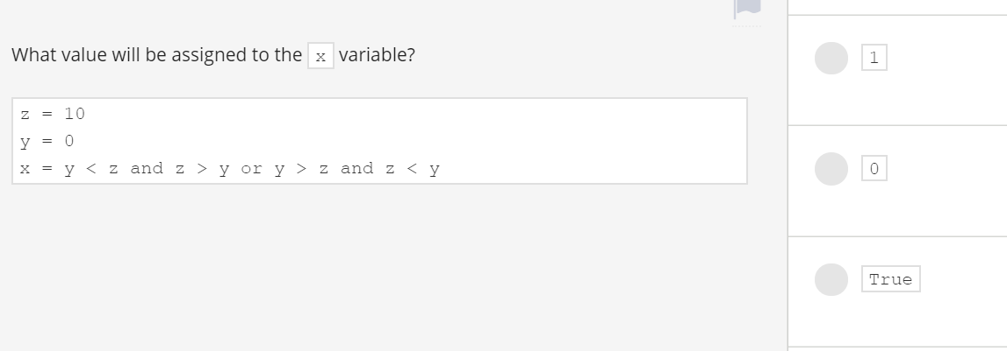

Ans : True

Refer below image for explanation

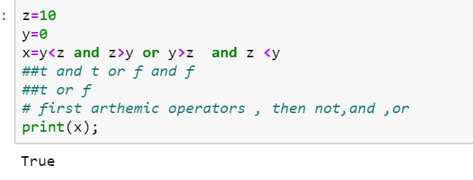

12)🡪

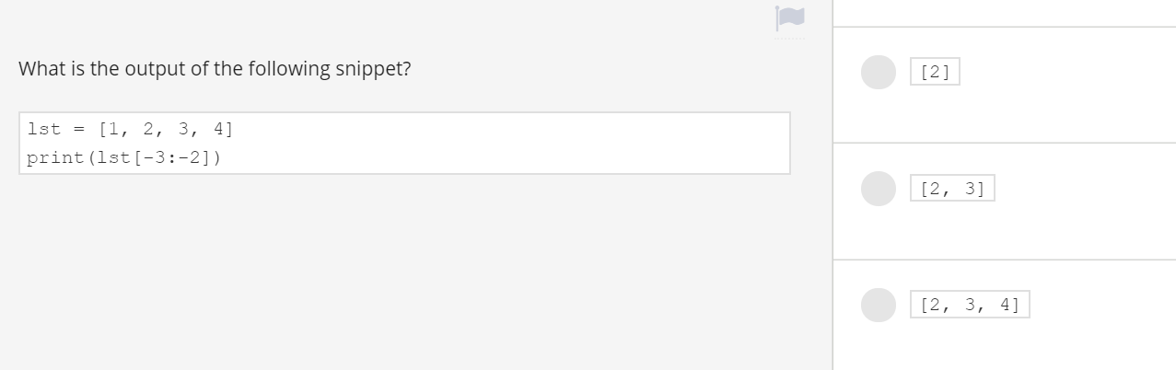

Ans :[2]

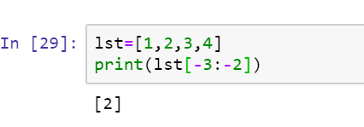

13)🡪

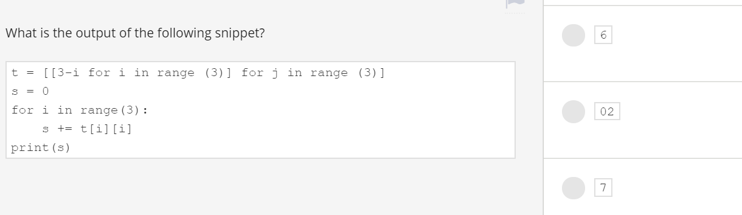

Ans:6

Refer below images

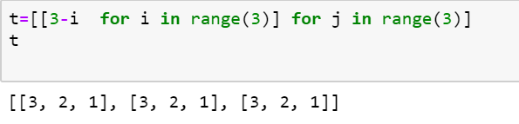

T[i][i]

Means t[0][0] +t[1][1]+t[2][2]

Which is equal to 3 +2+1

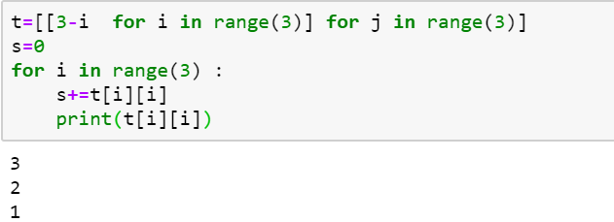

14)🡪

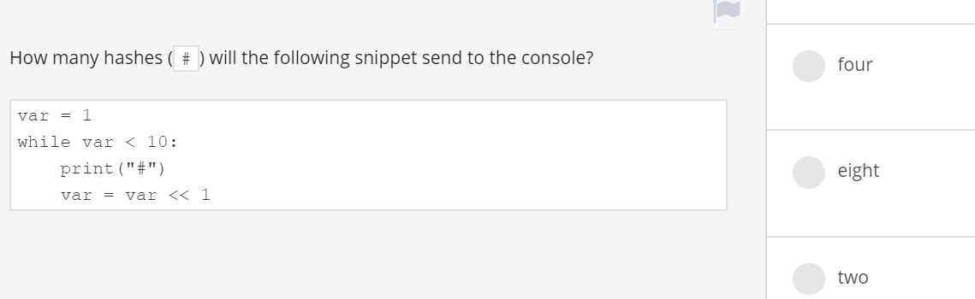

Ans: 4

Refer below for explanation

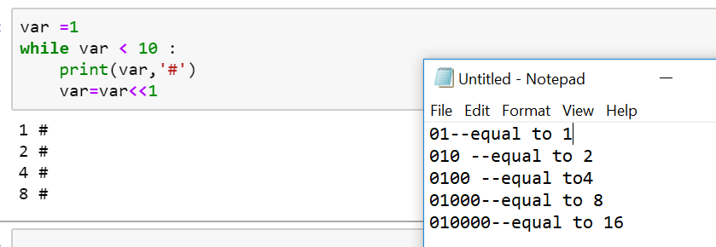

**e. Binary Left-Shift(<<)**

It shifts the value of the left operand the number of places to the left that the right operand specifies. Here, binary of 2 is 10. 2<<2 shifts it two places to the left. This results in 1000, which is binary for 8.

1. >>> 2<<2

Output: 8

**f. Binary Right-Shift(>>)**

It shifts the value of the left operand the number of places to the right that the right operand specifies. Here, binary of 3 is 11. 3>>2 shifts it two places to the right. This results in 00, which is binary for 0. Similarly, 3>>1 shifts it one place to the right. This results in 01, which is binary for 1.

1. >>> 3>>2
2. >>> 3>>1

Output: 1

15)

-->

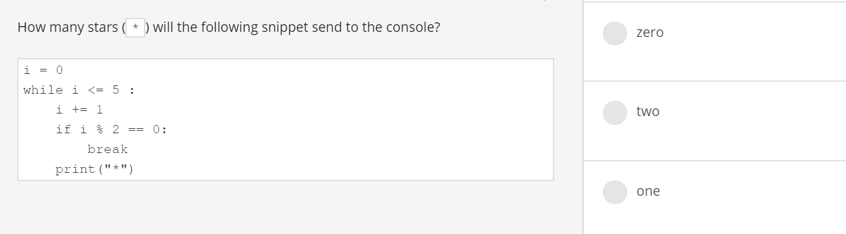

Ans: one

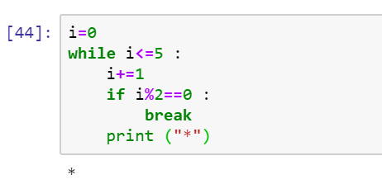

16)

🡪

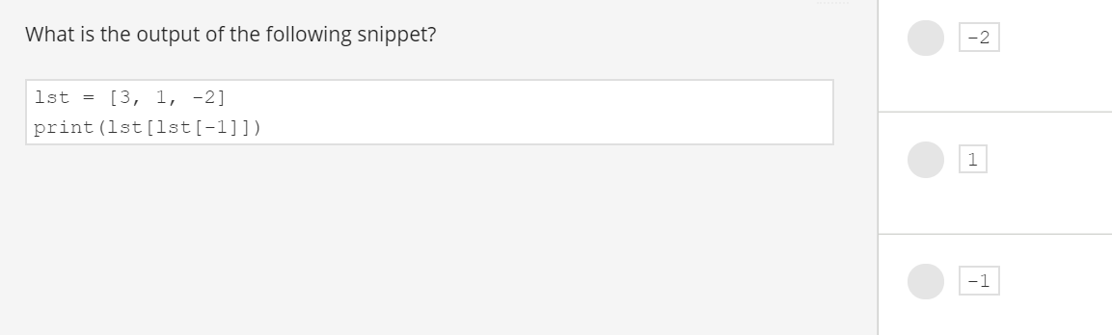

Ans: 1

Lst[-1] is -2

Lst [lst[1-]] means lst[-2]

Lst[-2] value is 1

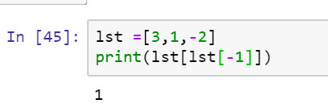

17)

🡪

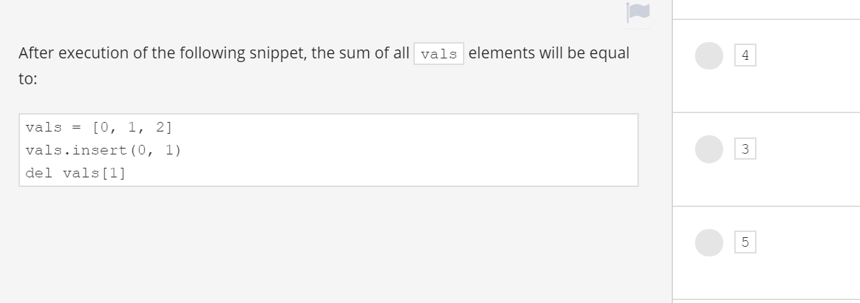

[0,1,2]

Vals.insert (0,1) means value 1 is inserted at index 0

[1,0,1,2]

Del vals[1] means at index 1 value 0 is delted so o/p is [1,1,2]

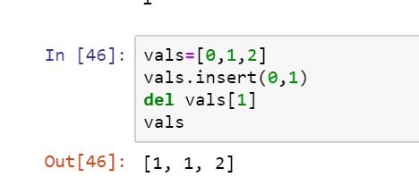

18)🡪

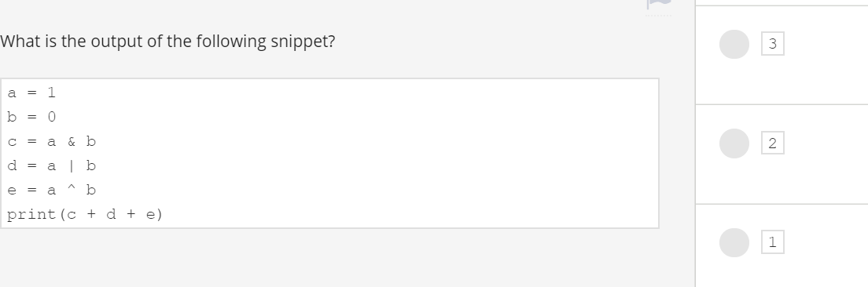

Ans: 2

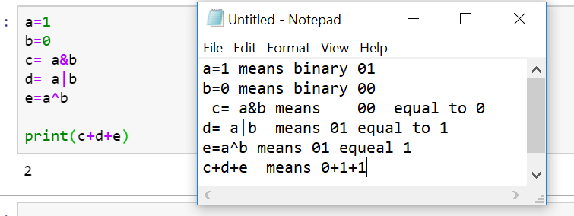

19)🡪

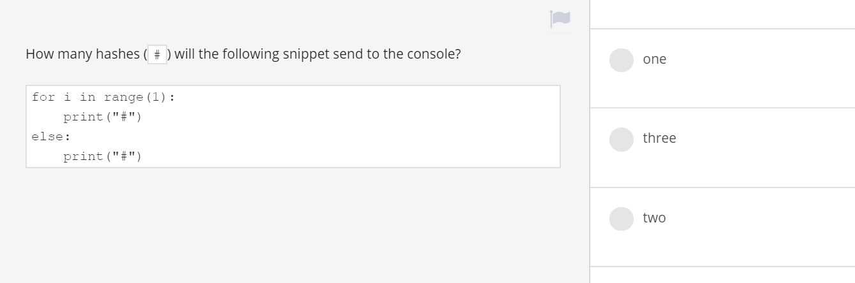

Ans: two

For loop will print one #

Else part will print one #

So total 2

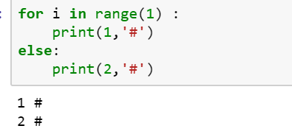

20)🡪

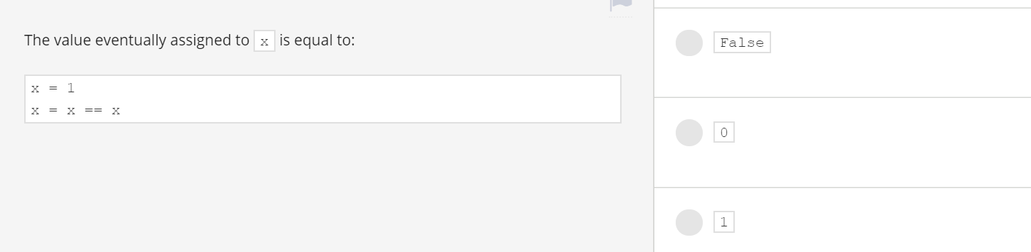

Ans: True

x==x gives True

so true is assigned to x

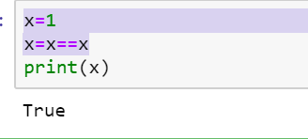

Python swaping of numbers

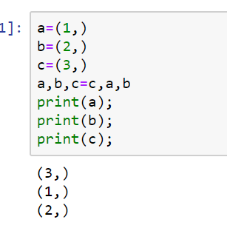

c🡪a

a🡪b

b🡪c

swapping of values shown below

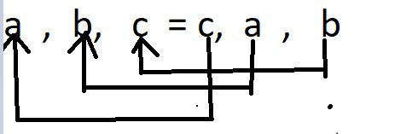

# Module 4 assignments

list = ['mary','had','a','little','lamb']

def list(lst):

del lst[3]

lst[3]='ram'

print(list(list))

o/p : 'function' object does not support item deletion

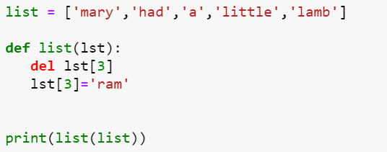

ERROR occurred while executing del lst[3]

Note: if u observe the code function name and list name both are same i.e list

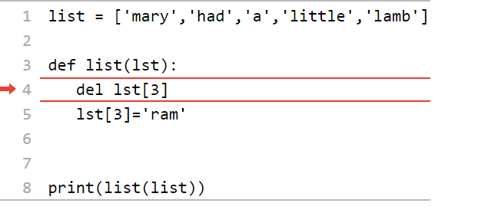

🡪

def fun(x,y,z) :

return x+2*y+3*z

print(fun(0,z=1,y=3))

o/p is 9

x=0 , y=3,z=1

0+ 2*3+3*1

=6+3=9

-🡪

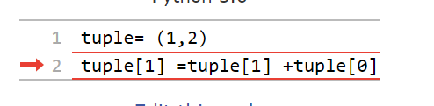

o/p is error: bcz it is immutable it wont support

TypeError: 'tuple' object does not support item assignment

🡪

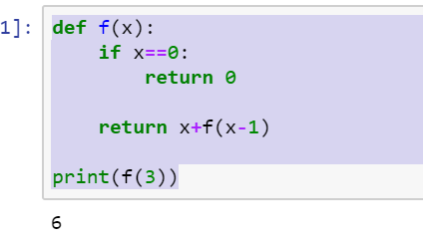

o/p is :6

🡪

dct= {'one':'two','three':'one','two':'three'}

v=dct['one']

for k in range(len(dct)) :

v=dct[v]

print(v)

o/p: two

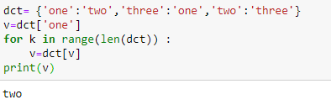

V=dct[‘one’] this gives ‘two’

In loop dct[‘two’] gives v as ‘three’

in next iteration dct[‘three’] gives ‘one’

in next iteration dct[‘one’] gives value ‘two’

this loops runs 3 times as length of dict is 3.

🡪

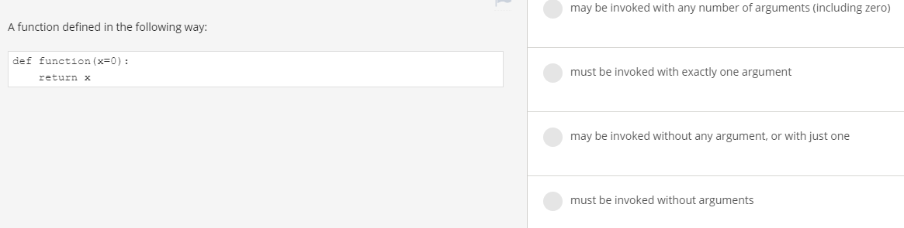

Ans : may be invoked with any argument ,or with just one

🡪

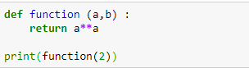

o/p is: **TypeError**: function() missing 1 required positional argument: 'b'

🡪

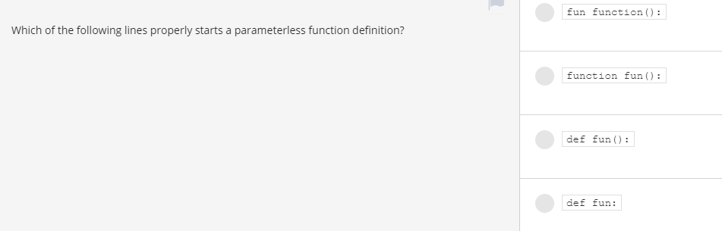

Ans : def fun() :

🡪

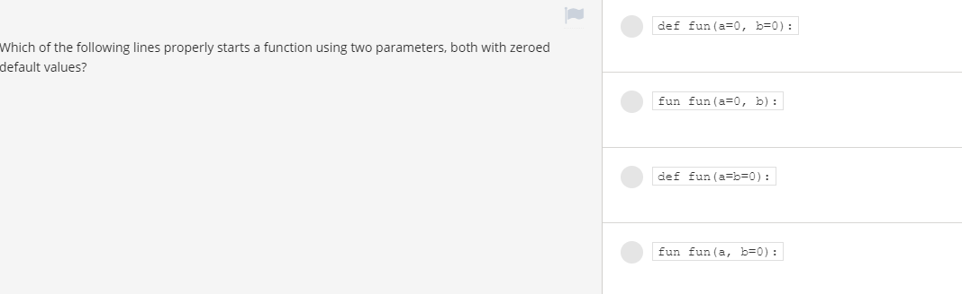

Ans: def fun(a=0,b=0 ) :

🡪

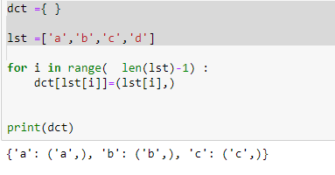

o/p is : {'a': ('a',), 'b': ('b',), 'c': ('c',)}

🡪

def fun(x) :

if x%2==0:

return 1

else :

return

print(fun(fun(2))+1)

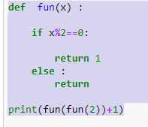

o/p : **TypeError**: unsupported operand type(s) for +: 'NoneType' and 'int'

explanation: fun(fun(2))+1

fun(2) o/p is 1

so fun(fun(2))+1 becomea fun(1) +1

fun(1) value is None 1%2 value is 1 so it returns None

in python None+1 gives error

🡪

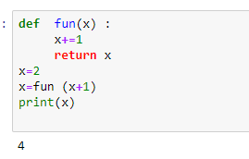

o/p is : 4