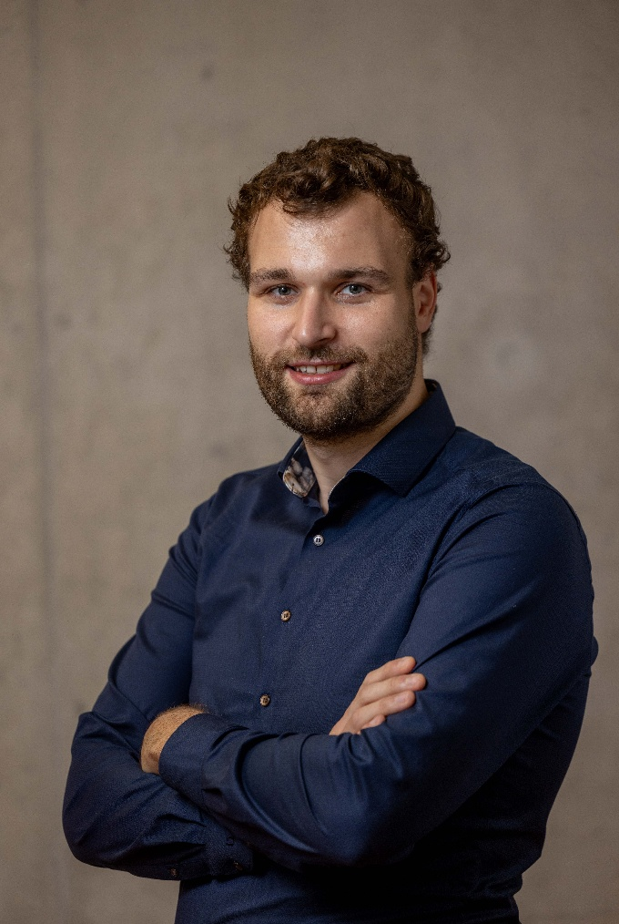  Dr.-Ing. Maximilian Raff  M.Sc. Engineering Cybernetics  —— Contacts ——  Grimmstr. 4  70197 Stuttgart  Germany  +49 162 5907044  maximilianraff@web.de  – Personal Details –  Date of birth: 29.10.1993 in Herrenberg  Citizenship: Germany  Marital status: married, one child  —— Skills ——  German ■■■■■  English ■■■■□  Matlab/Simulink ■■■■■  Python ■■■□□  Julia ■■■■□  C++ ■■□□□  CAD ■■□□□  Latex ■■■■■  Git ■■■■□  —— Hobbies ——  Music: Trombone player in various ensembles; musical and organizational director of a semi-professional jazz band.  Sports: Badminton instructor; cycling enthusiast; enjoy dancing.  Stuttgart, January 2026 |  | Work Experience ——————————————
 |  | 07/2025 –  now | Postdoctoral Researcher at University of Stuttgart, Germany  Institute for Adaptive Mechanical Systems (IAMS)  Located at Max-Planck-Institute for Intelligent-Systems  - Research on co-design of robotic systems, with a focus on hardware development.
 |  | 10/2019 –  07/2025 | Research Associate at University of Stuttgart, Germany  Institute for Adaptive Mechanical Systems (since 04/2025)  Institute for Nonlinear Mechanics (until 03/2025)  - Conducted research on dynamics and control of legged systems, leading to multiple collaborations, publications, and conference presentations.  - Authored and secured two DFG grant proposals.  - Supervised and mentored over 20 Bachelor's and Master's students, guiding them through scientific projects.  - Developed and delivered lecture content, actively contributing to teaching and examination processes.  - Supported the launch of IAMS robotics institute, overseeing IT and recruiting secretary and PhD candidates.
 |  | Internships & Part-Time Positions ——————
 |  | 06/2018 –  12/2018 | Internship at Trumpf GmbH + Co. KG, Ditzingen, Germany  dept. Machine Dynamics  - Modeling/Simulation of laser cutting machine tools  - Development of visualization tools using computational geometry
 |  | 12/2017 –05/2018 | Research Assistant at NC A&T TECHLAV Center,  Greensboro, NC, USA  - Quadcopter trajectory generation and control design
 |  | 2015 –  2017 | Teaching Assistant at University of Stuttgart, Germany  - Institutes for system dynamics (ISYS), systems theory and automatic control (IST) and nonlinear mechanics (INM)
 |  | Education —————————————————
 |  | 07/2020 –  07/2025 | Doctor of Engineering (Dr.-Ing.), University of Stuttgart, Germany (Grade: summa cum laude)  Jointly with Graduate School IMPRS-IS  Thesis: Continuation and Optimization of Gaits and Other Non-Smooth Orbits
 |  | 10/2016 –  10/2019 | Master of Science in Engineering Cybernetics, University of Stuttgart, Germany (Grade: 1.6)  Thesis: Exploring Soft Contact Models in the Optimization of Gaits  - 01/2019 – 04/2019: Visiting Scholar at University of Michigan, Ann Arbor, MI, USA  - Research in legged robotics/locomotion  - Collaborations: RAM-Lab & Barton Research Group  - 08/2017 – 05/2018: Study Abroad in North Carolina, USA  - Exchange student for an academic year  attending two universities:  - NC A&T State University (2 semesters)  - University of North Carolina at Greensboro  (1 semester)
 |  | 10/2013 – 11/2016 | Bachelor of Science in Engineering Cybernetics, University of Stuttgart, Germany (Grade: 2.2)  Thesis: Discrete Optimal Control of Inverted Pendulum with Friction
 |  | 09/2010 – 06/2013 | Abitur, Technisches Gymnasium, Gottlieb-Daimler-Schule Sindelfingen, Germany (Grade: 1.6)  Major in information technology

