OBD BACCABLE

MANUAL
DISCLAIMER: BACCABLE is a project developed exclusively for educational and research purposes. The use of this tool on vehicles operating on public roads or in any context that may cause harm to people, property, or violate applicable regulations is strictly prohibited.
The author of this project assumes no responsibility for any damages, malfunctions, or consequences resulting from the use of BACCABLE. The end user bears full civil, criminal, and legal responsibility for its use.
It is strongly recommended not to use this project in real-world vehicle applications.
The installation in hidden location, requires specific technical skills in automotive electrical and electronic systems to avoid errors that could expose to safety risks.
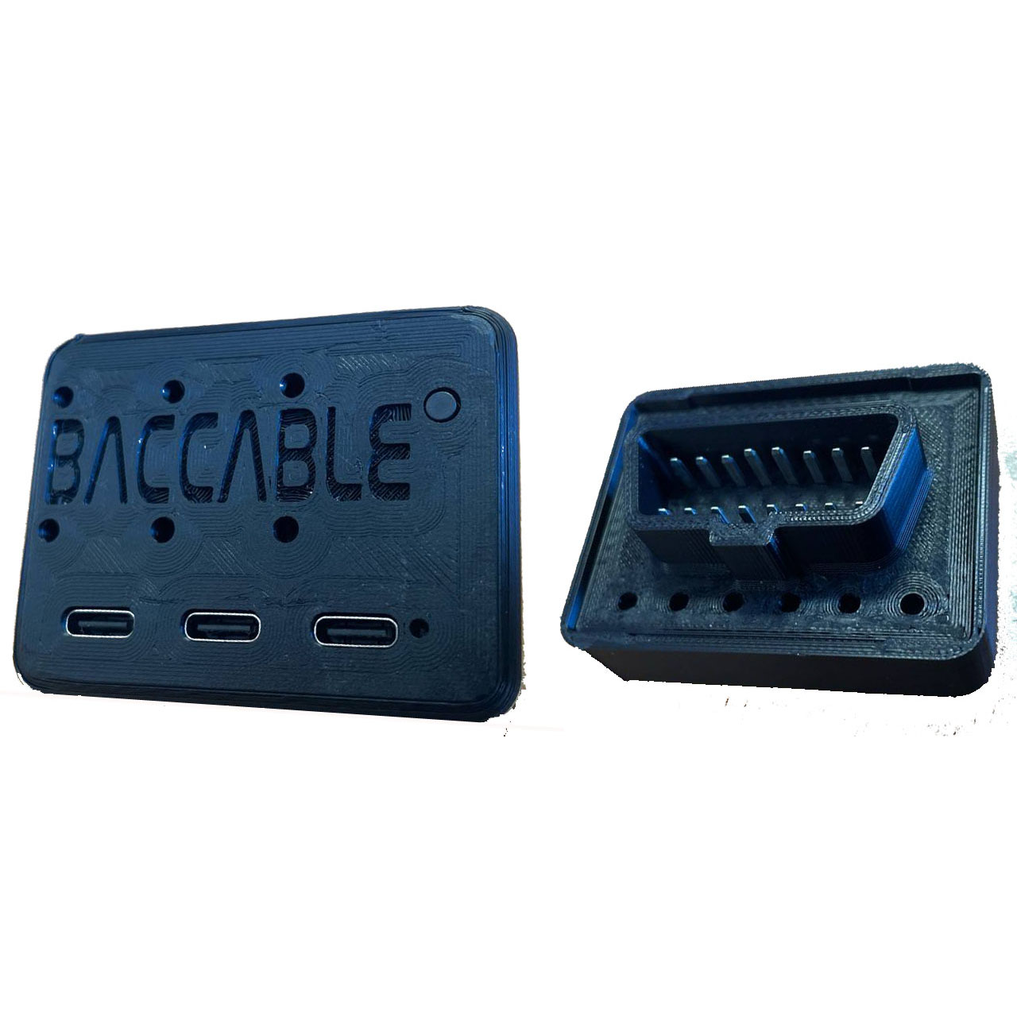

INDEX
1. INSTALL 4
1.1 Composition 4
1.2 Pinout 5
1.3 Install instructions (to OBD port) 6
1.4 OBD Cable install instructions (optional) 7
1.5 First Startup (with additional wiring) 8
1.6 First Startup (insertion into standard OBD port) 8
1.7 Notes on Connections to 5V (optional) 9
1.8 Notes about connections toward can bus 9
1.9 Connection Examples 10
1.10 TECHNICAL CHARACTERISTICS 14
1.11 FIRMWARE UPGRADE 15
1.11.1 Procedure for firmware programming trough PC 16
1.11.2 Procedure for firmware programming through smartphone 19
2. USAGE 22
2.1 First Startup 22
2.2 Sniffer 23
2.2.1 Sniffer with dedicated SLCAN Firmware 23
2.2.2 Sniffer with original Firmware and proprietary app 24
2.3 Start&Stop disabler 25
2.4 Immobilizer 26
2.5 Led Strip Controller 27
2.6 Shift 28
2.7 My23 IPC 28
2.8 Params On Dashboard 28
2.9 Route 34
2.10 ESC+TC Selector 35
2.11 DYNO 36
2.12 ACC Virtual Pad 36
2.13 CLEAR FAULTS 37
2.14 REGENERATION ALERT 37
2.15 4WD DISABLER 37
2.16 BRAKES OVERRIDE 38
2.16.1 Launch Assist 38
2.16.2 Burn Out 38
2.17 REMOTE START 39
2.18 READ FAULTS 39
2.19 ODOMETER BLINK 39
2.20 SEAT BELT ALARM 40
2.21 PEDAL BOOSTER 40
2.22 MAIN SETUP MENU 41
2.23 PARAMS SETUP MENU 41
2.24 SHOW RACE MASK 41
2.25 PARK MIRROR 41
2.26 ACC AUTOSTART 42
2.27 CLOSE WINDOWS 42
2.28 OPEN WINDOWS 43
2.29 HAS VIRTUAL PAD 43
2.30 QV EXHAUST FLAP 43
2.31 FRONT PARK MUTE 43
2.32 ELM327 43
2.33 MAX HOLD 44

INSTALL

1.1 Composition

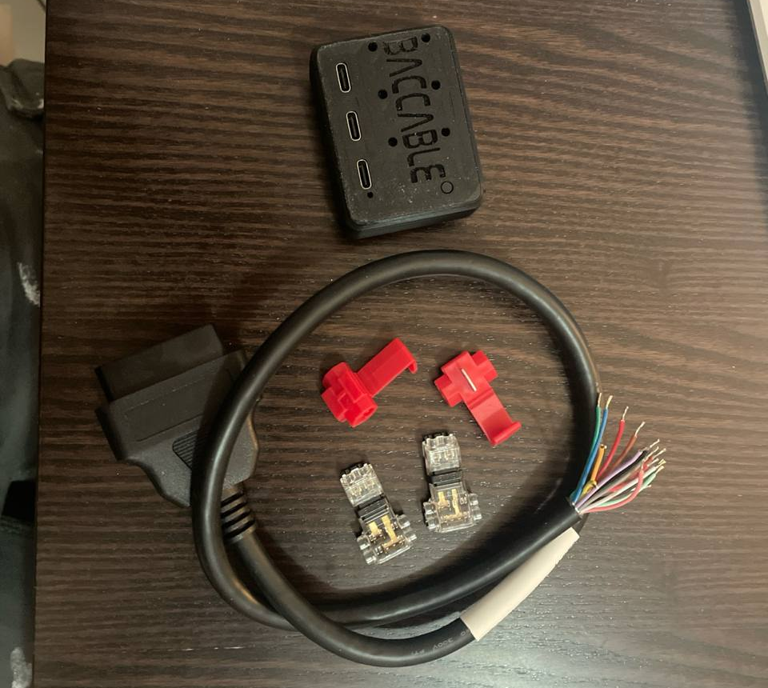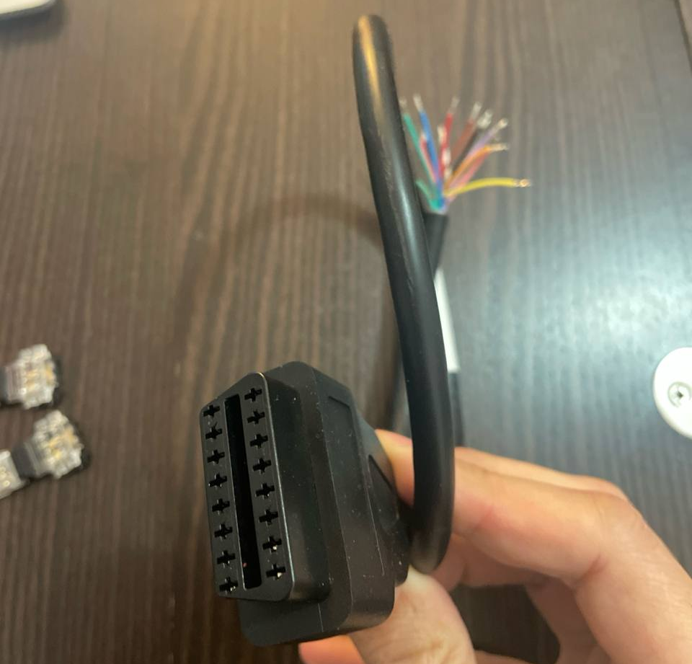
Composition
The cable and the "wire taps" (quick connectors or IDC) shown in the previous photo are optionals. The Baccable can be used by connecting it directly to the OBD if the vehicle is not equipped with an SGW or if it has an SGW bypass (SGW = Secure Gateway). Therefore, using the included cable and quick connectors is not mandatory.

1.2 Pinout

The Baccable OBD V.3 is equipped with an OBD connector with the following pinout:
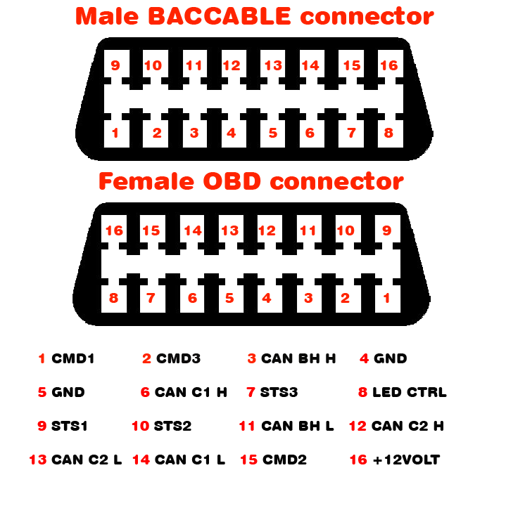
BACCABLE Pinout and OBD cable pinout

Pin 16 corresponds to the 12V power supply of the vehicle's OBD port but can also be connected to a 5V supply if needed, as the BACCABLE supports a wide range of input voltages.

1.3 Install instructions (to OBD port)

- When inserting the BACCABLE into the vehicle's OBD port, be careful not to press the PROGRAMMING button. If this happens, remove the BACCABLE and reinsert it.
PROGRAMMING
PROGRAMMING button

- When removing the BACCABLE from the vehicle's OBD port, do not pull on the casing. Instead, push by inserting your fingertips on the OBD connector side towards yourself to avoid stressing the latch that holds together the case (the part with the "BACCABLE" label) and the part where the OBD connector is located.
If the joint is accidentally disengaged, proceed by completely removing the parts (PCB and case) from the OBD connector. Then, reinsert the PCB (printed circuit board) into the case with the "BACCABLE" label, aligning the parts as shown in the previous image. Next, insert the side with the OBD connector until it touches the case.
WARNING: The OBD connector must have the two longer pins aligned with the long side. If inserted incorrectly, remove the OBD connector side, rotate it, and reinsert it.
Once the OBD connector side is in contact with the case, hold the BACCABLE firmly and press firmly on all four corners, ensuring that the cover gradually snaps into place from all sides until fully secured.

1.4 OBD Cable install instructions (optional)

- In addition to the cable, IDCs (also known as "current taps") are provided. These are quick connectors that allow you to tap the desired signal without interrupting the vehicle's wiring. The dual quick connectors are designed for the H and L pins, while the single ones can be used for power supply or H and L pins.
- The quick connector is capable of crimping a wide range of wire sizes; however, this versatility makes the dual quick connector more complex to use. To secure the wires of the double quick connector on the CAN bus, it is not enough to insert the wires into the slot and close the cover. First, it is necessary, using a small flat-head screwdriver, to push the wire into the guillotine to make it penetrate properly. If this preliminary operation is performed correctly, closing the connector cover firmly should engage the locking clips, ensuring the connector is tightly closed with no gaps between the transparent cover and the black base. The red single quick connector, on the other hand, can be tightened with pliers, so it does not require any preliminary steps. Always check the solidity of the connection after tightening.

The following image shows pins on the OBD diagnostic connector (the connector in the image is viewed from the external pin side, not the wire side). Pins 4 and 5 are the ground (GND), and pin 16 is the 12 Volt.
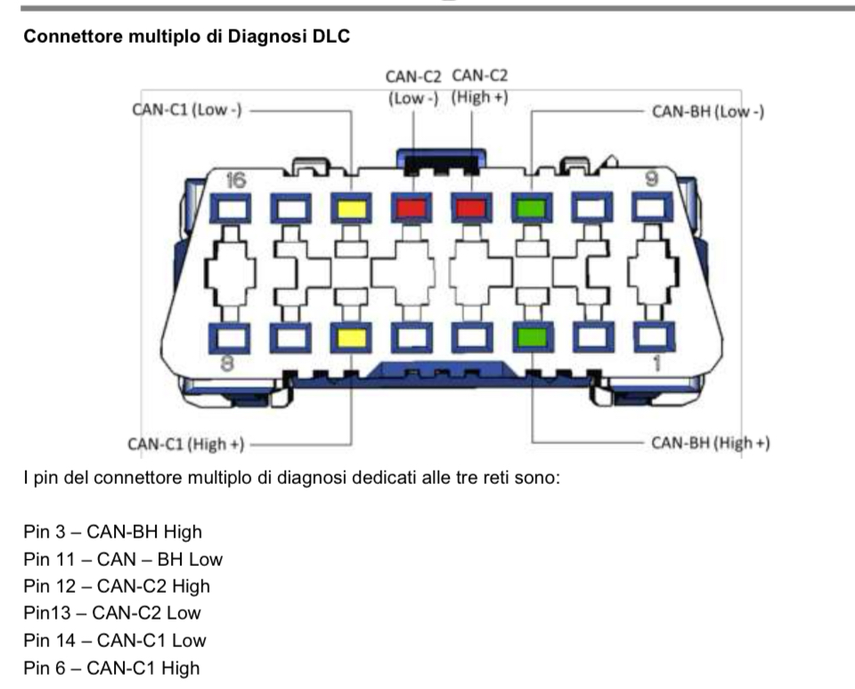

1.5 First Startup (with additional wiring)

During the first startup, perform the following preliminary checks:
- Verify that all connections have been made according to the diagram and the requirements defined in this document.
- With the ignition on, check that the green LED inside the BACCABLE enclosure is illuminated, confirming correct power supply reception.
- If the dashboard does not turn on or random errors appear, check that the H and L pins have not been reversed or that neither has been mistakenly connected to another wire.
- Check that the internal blue LED flashes twice at startup, indicating correct activation of the default-enabled Immobilizer function (note: without perfect alignment between the eye and the LED, it may not be visible—multiple startups may be needed for this check).
- As soon as the BACCABLE is inserted, if the vehicle dashboard is already on, the instrument cluster should flash once to indicate that the immobilizer is active (enabled by default). If this does not happen, check the connections to the CAN bus.

1.6 First Startup (insertion into standard OBD port)

At first use, you must define which functions you wish to use on your vehicle by accessing the SETUP menu.
Instructions for accessing the SETUP menu, scrolling through the list of available functions, enabling/disabling features, and permanently saving the settings are provided in paragraph 2.1.

1.7 Notes on Connections to 5V (optional)

If the BACCABLE is powered by the 5V supply, you can connect to, for example, the USB HUB located in the glove compartment of the center console, next to the handbrake. This voltage is active as soon as you enter the vehicle, but also when connecting to the RF HUB as a thief. To access this voltage, follow these instructions:
- Remove and disconnect the USB HUB from the vehicle.
- Widen the 4 tabs on the back cover using small screwdrivers and tweezers, then remove the printed circuit board.
- Drill a hole in the back plastic in the area not occupied by connectors to allow the wire, as shown in the figure, to pass through (make sure to drill a precise hole to prevent the wire from sliding too loosely; if needed, apply a drop of silicone inside at the end to provide resistance in case the wire is pulled).
- Solder the wire to the USB HUB printed circuit board, at the +5V pin of the USB connector. You can use the reference images below to identify the correct pin to use.
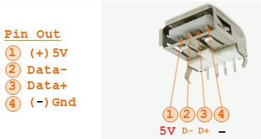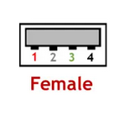

1.8 Notes about connections toward can bus

If the vehicle is equipped with an SGW (Secure Gateway), the pins on the OBD port cannot be used to connect the BACCABLE. Instead, it will be necessary to use an SGW bypass wiring that can be purchased online, which will provide an OBD port for the BACCABLE connection. Alternatively, you can intercept the wires of the desired CAN bus at other points in the vehicle, upstream of the SGW.

1.9 Connection Examples

Example 1 of a point upstream of the SGW where the C1 bus can be detected:
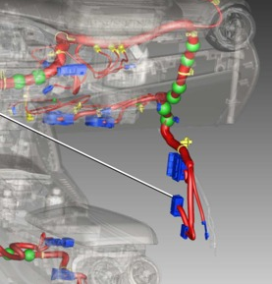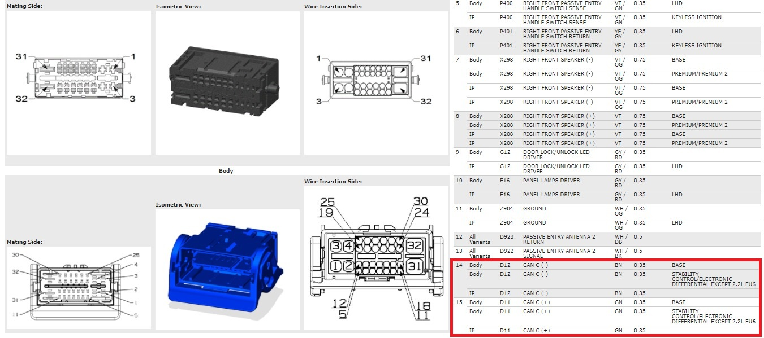
Example 2 of a point upstream of the SGW where the C1 bus can be detected:
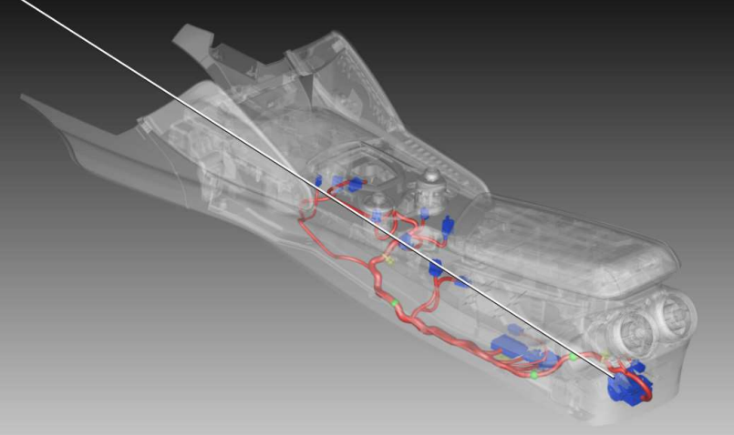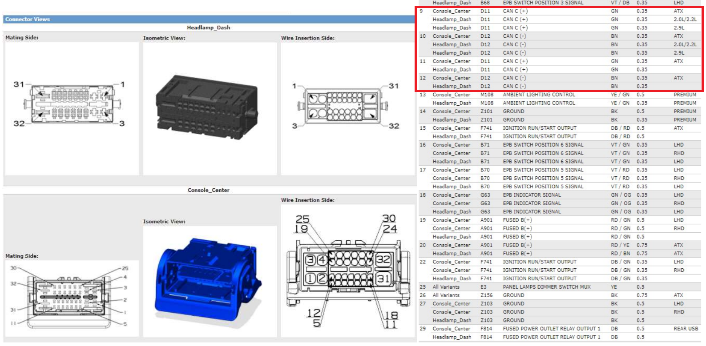

Example 3 of a point upstream of the SGW:
In the case of an automatic transmission, the following excerpt from the manual can be used, along with the pinout of the transmission connector:
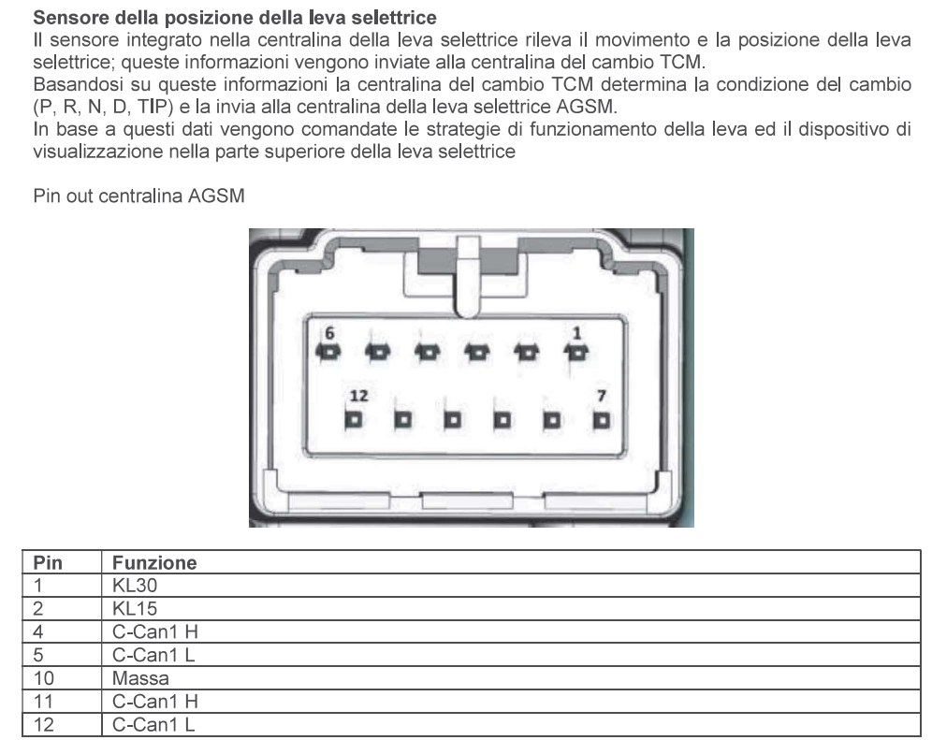

Example 4 of a point upstream of the SGW:
On the Body, located at the passenger footwell, there are all the bus lines and the power supply.
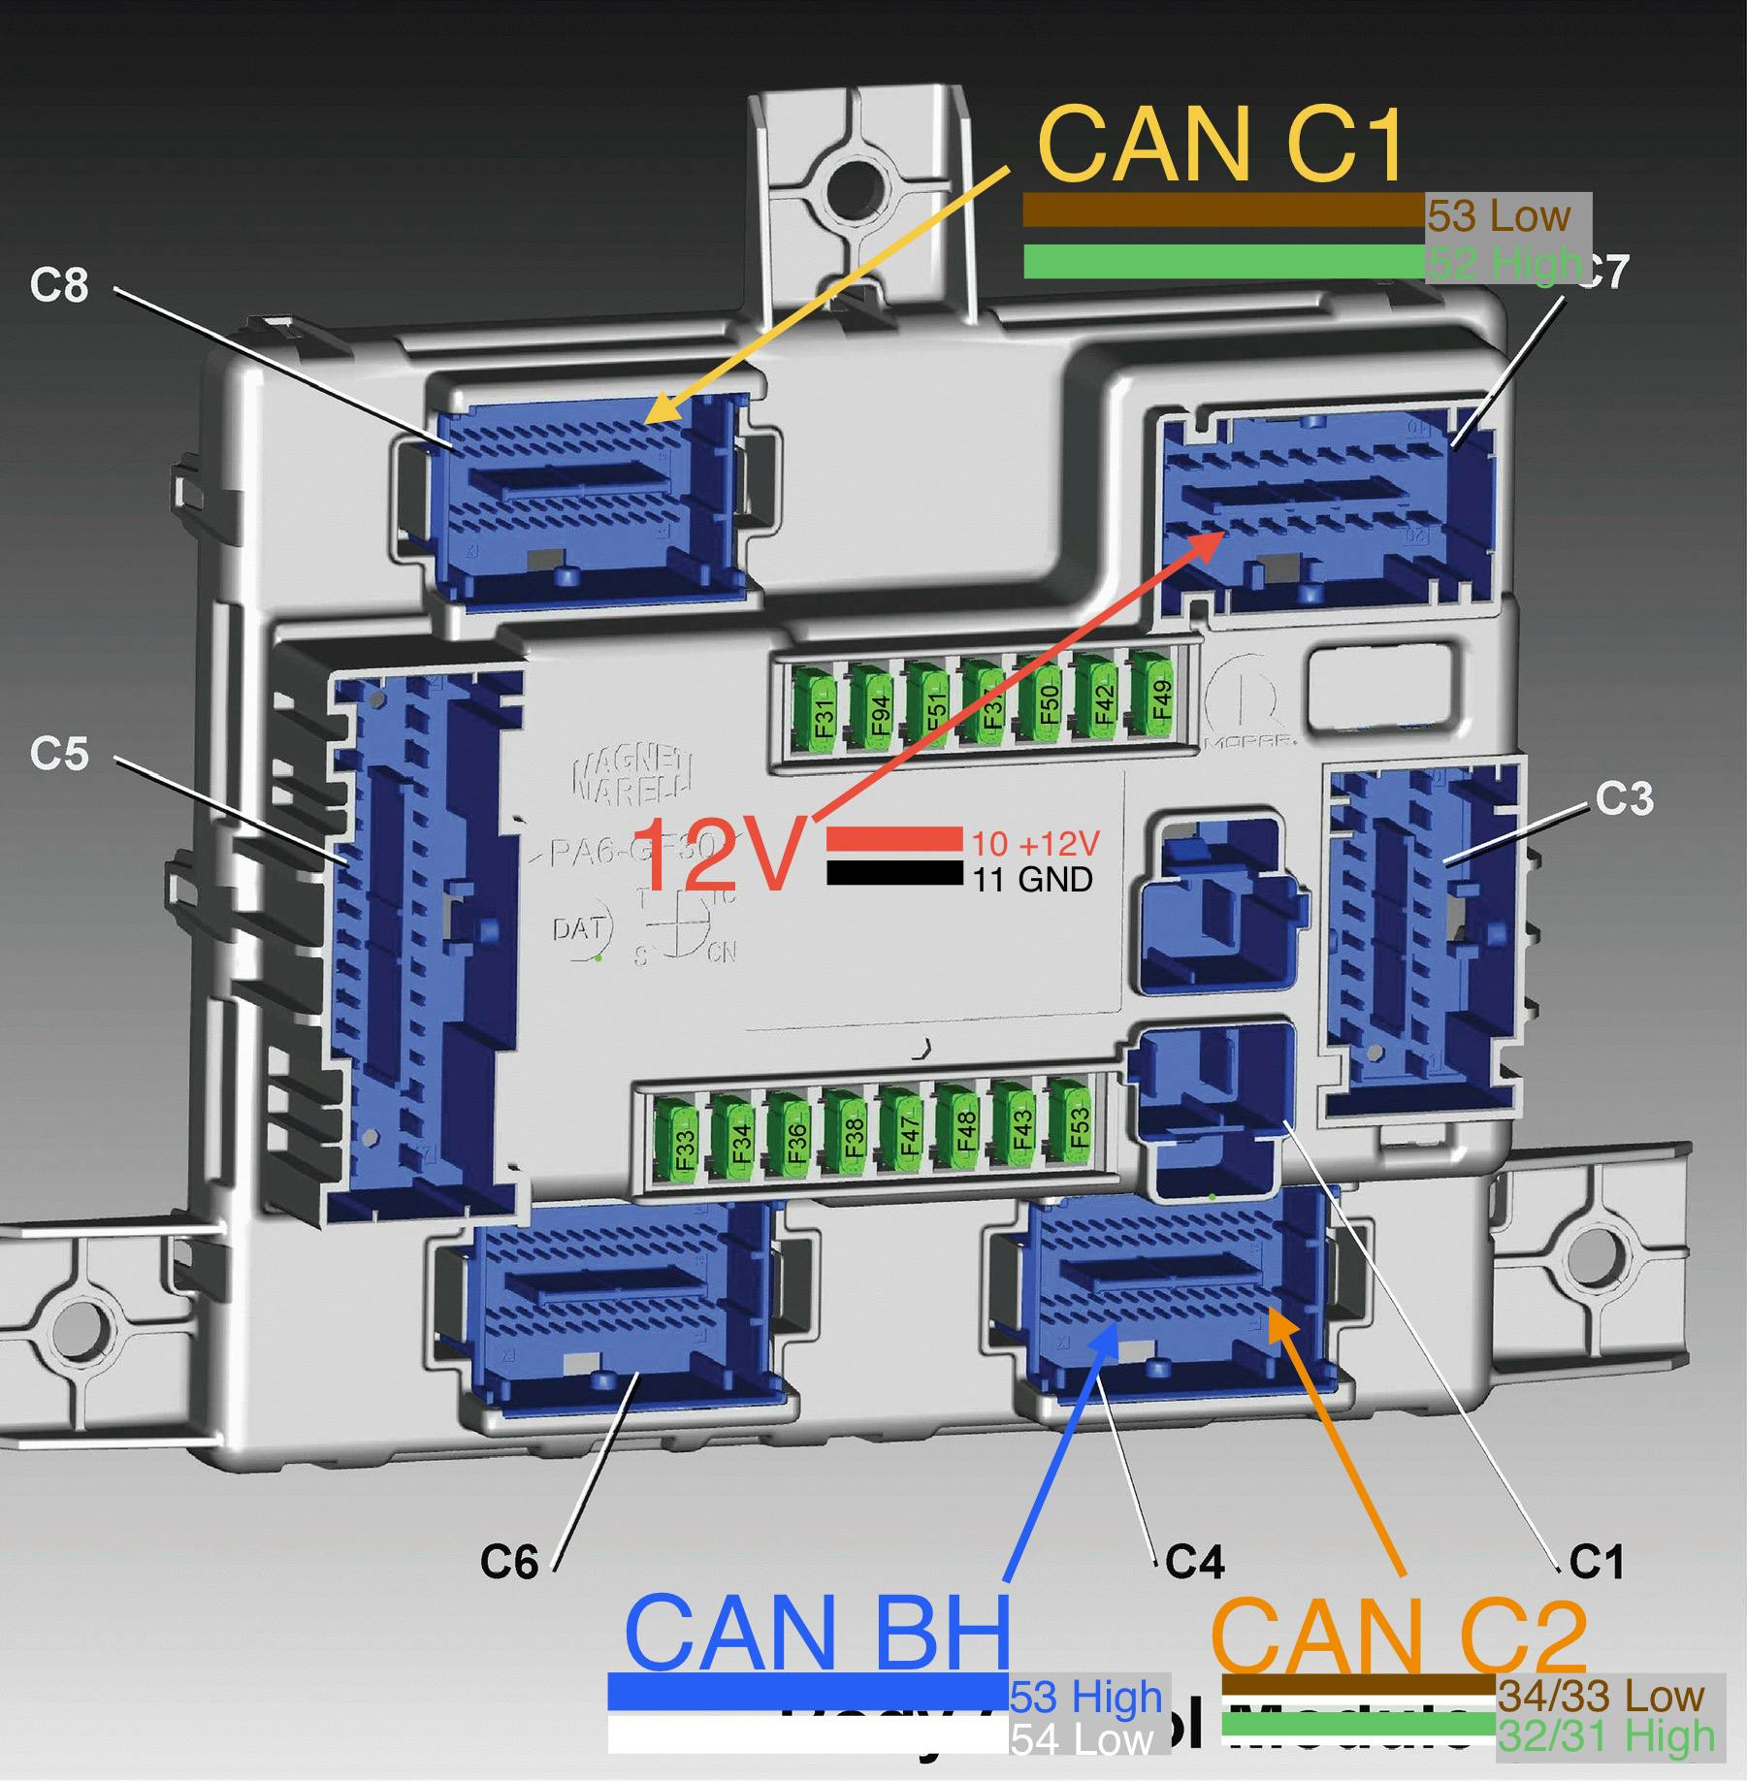
Can Bus and power supply on the Body Computer
The following image shows the Body Connectors Layout:
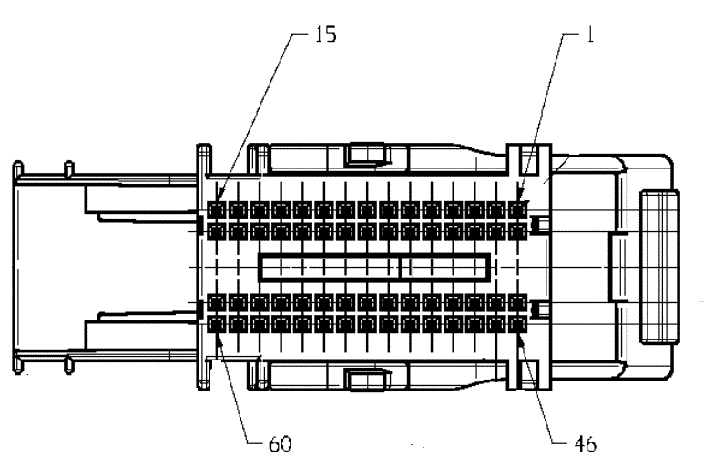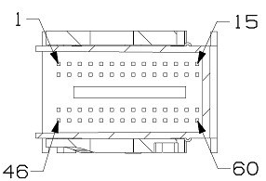
Body C4 connector Body C8 connector

1.10 TECHNICAL CHARACTERISTICS

Dimensions: 57.5mm (width) x 44.5mm (height) x 22mm (depth)
Weight: less than 50 grams
Power supply voltage: 4.5V - 35V (DC)
Current consumption @12V: approximately 11mA with vehicle off in sleep mode. Less than 30mA during operation with vehicle on.

1.11 FIRMWARE UPGRADE
The BACCABLE is delivered pre-programmed with the latest available firmware release; however, it is possible to benefit from future firmware updates via the Firmware Update procedure.
These operations are conveniently performed via the Baccable App for Windows PC and Android smartphone.

Programming Button
USB Bus C1 Connector
USB Bus C2 Connector
USB Bus BH Connector
Programming connectors and button, used during programming phase

Perform the firmware loading procedure on all three USB connectors, uploading the appropriate firmware to each USB port (one per USB).
Two procedures are described below: one for uploading the firmware via a Windows PC, and the other for uploading the firmware via an Android smartphone.

Procedure for firmware programming trough PC

To carry out this procedure you will need:
- a PC running Microsoft Windows with a USB port
- the BaccableAppForWindows application, available at https://www.tr3ma.com/baccable
- a USB cable to connect the PC to the BACCABLE

- To get started, you need to install the drivers for the Baccable on the PC. If STM32CubeProgrammer or ST’s DfuSe is already installed on the PC, nothing else is required; otherwise use Zadig (https://zadig.akeo.ie), putting the board into programming mode, then → Options ▸ List All Devices → select STM32 BOOTLOADER → WinUSB driver → Install Driver. When finished, disconnect the board.
- Press and hold the programming button on the board
- Connect the USB port (C1, C2, BH) to the PC - The board will be recognized by the PC as a serial device named "STM32 Bootloader"
- Only when the green LED is lit, the programming button can be released
Note1: If the green LED on the BACCABLE flickers or emits a weak light, use a shorter USB cable, or replace the USB cable
Note2: If the board is not detected by the PC, make sure the programming button was pressed correctly before connecting the USB cable, and keep it pressed until the USB connector is fully inserted on both sides. If the problem persists, rotate the USB-C connector on the BACCABLE side by 180 degrees and try again
- Open the Baccable app, and select “Update Firmware”
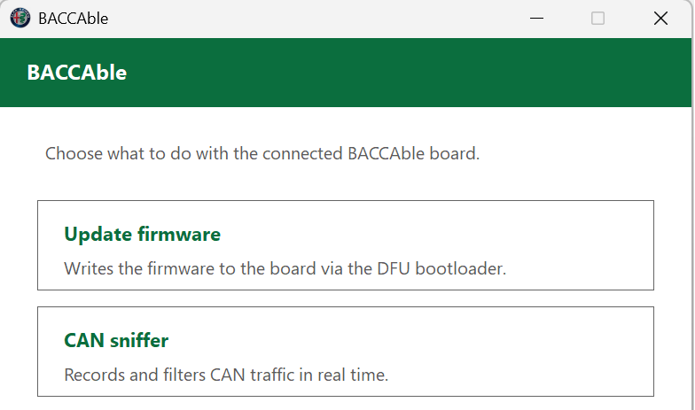
- In the “Choose Firmware” window, select the desired firmware version, then tap the USB connector shown in the window that you have chosen to connect to the device.
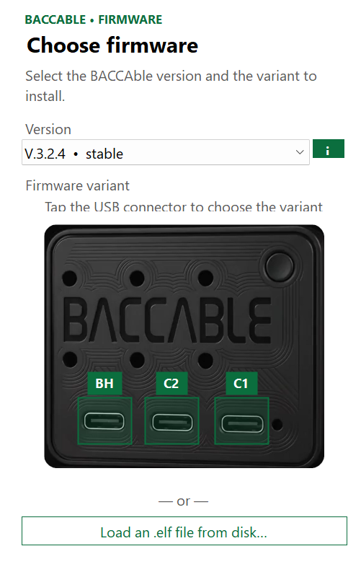
- In the “Connect the board” window, if the board has not been detected, the message “waiting for bootloader” will appear
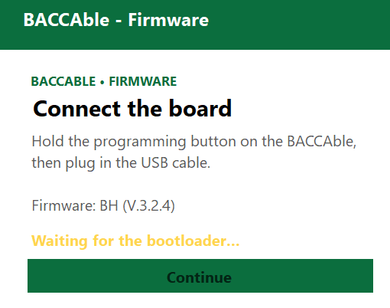
Note: in case of errors, there may be an incompatibility between the USB port chipset of the PC and the chip used in the Baccable. To overcome this error, you can try the procedure again using other USB ports on the PC, use a different PC, or connect a USB hub (preferably a slow one, not a new-generation model) between the Baccable and the PC. The latter method is ideal for newer PCs.
- In the “Connect the board” window, if the board has been detected, the message “Bootloader detected” will appear, and you will be able to press the CONTINUE button.
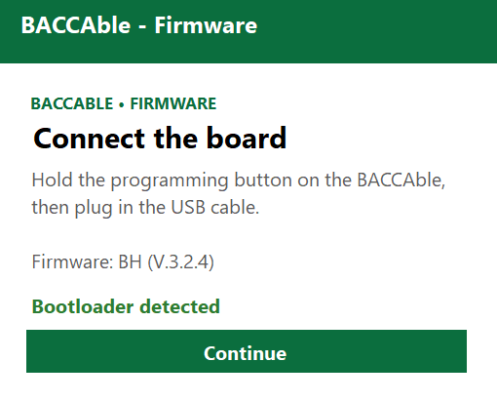
- In the “Erase Options” window, select the desired options, or leave the checkboxes unselected if you only want to update the firmware. Press the Program button to proceed with the firmware update
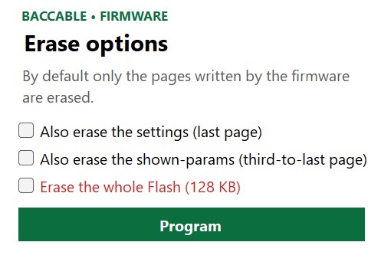
- Wait for the firmware to be written and check the outcome. In case of an error, the “PROGRAMMING FAILED” error window will be shown, while on success the “UPDATE COMPLETE” window will be shown. Repeat the procedure for all 3 USB connectors of the Baccable.
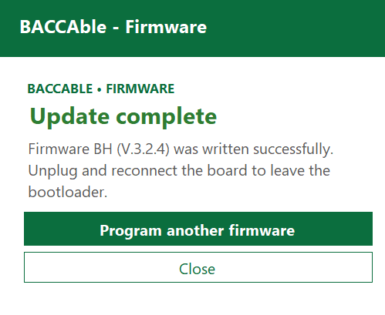

1.11.2 Procedure for firmware programming through smartphone

To carry out this procedure you will need:
- an Android smartphone
- the BaccableApp application, available at https://www.tr3ma.com/baccable
- a USB cable between the smartphone and the BACCABLE

- Press and hold the programming button on the board.
- Connect the USB OTG cable to the smartphone, then connect the BACCABLE USB port (C1, C2 or BH) to the OTG cable.
- Only when the green LED on the BACCABLE is lit, the programming button can be released.
Note: if none of the Baccable’s LEDs light up, you need to go into the settings and enable the Accessibility -> OTG connection option, or check the cable.
- Open the app on the smartphone: on first connection, Android will request permission to access the USB device, which must be granted to continue.
- Press the “Update Baccable” button
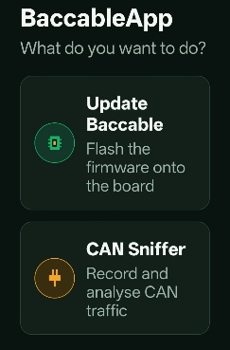
- Select the firmware version you want to install, then press the button corresponding to the USB connector that was connected to the Baccable
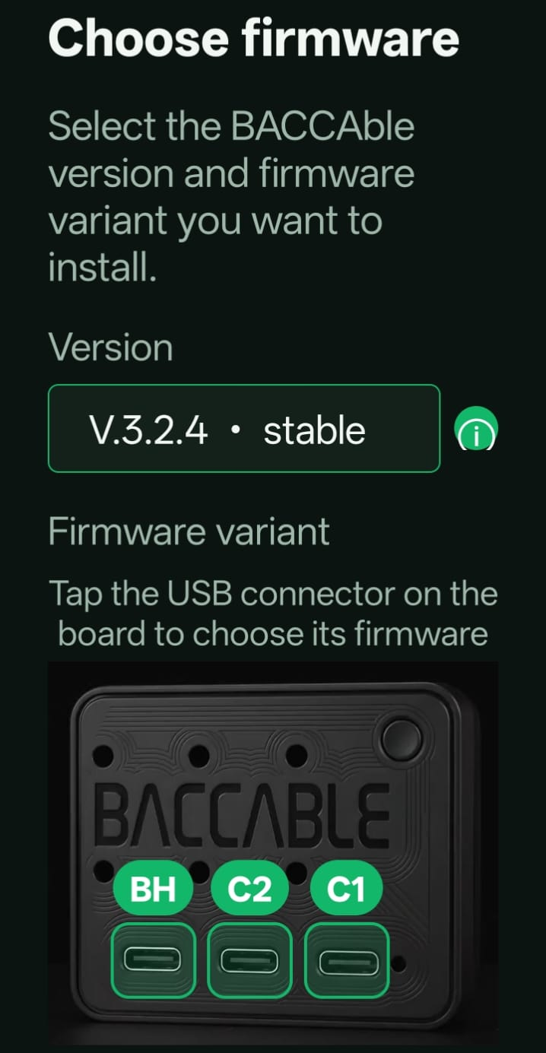
- In the “Connect the board” window, if the board has not been detected, the message “waiting for bootloader” will appear; otherwise you will move directly to the next screen
- Select the desired erase options, or leave the options unselected if you only want to update the firmware. Press the Program button to start the firmware update.
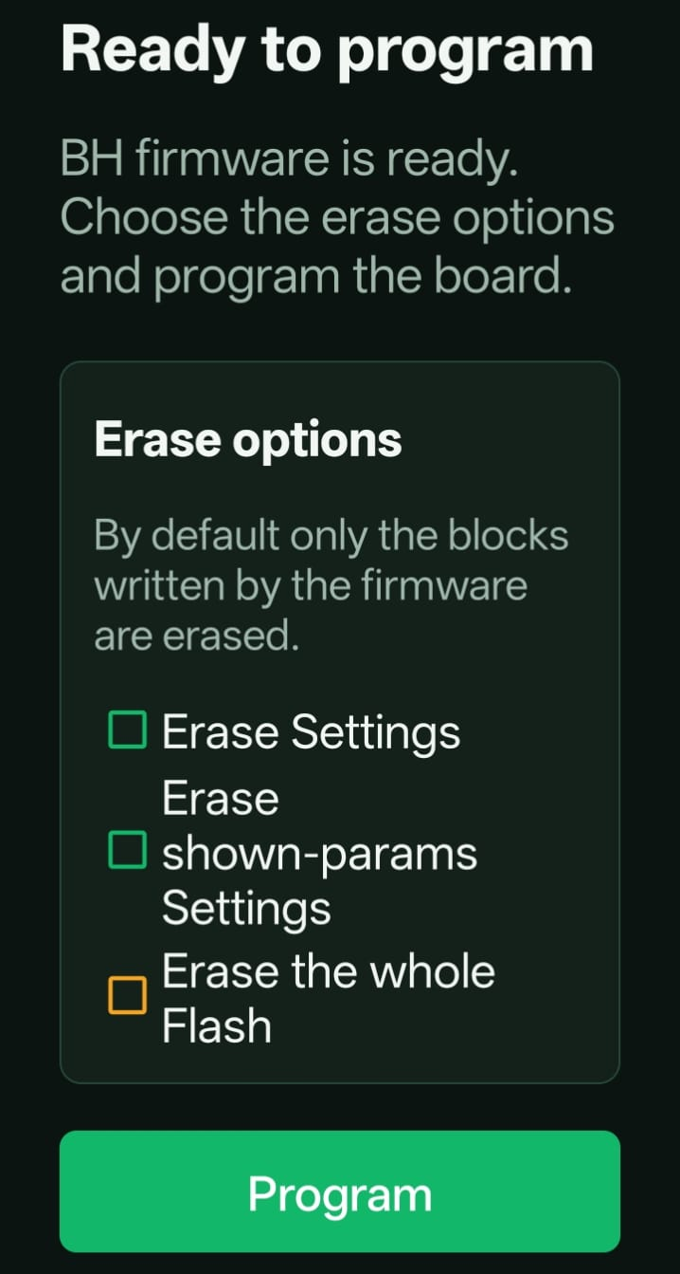
- At the end of programming, a status window will appear showing the result of the firmware update. Repeat the procedure for all 3 USB connectors of the Baccable.
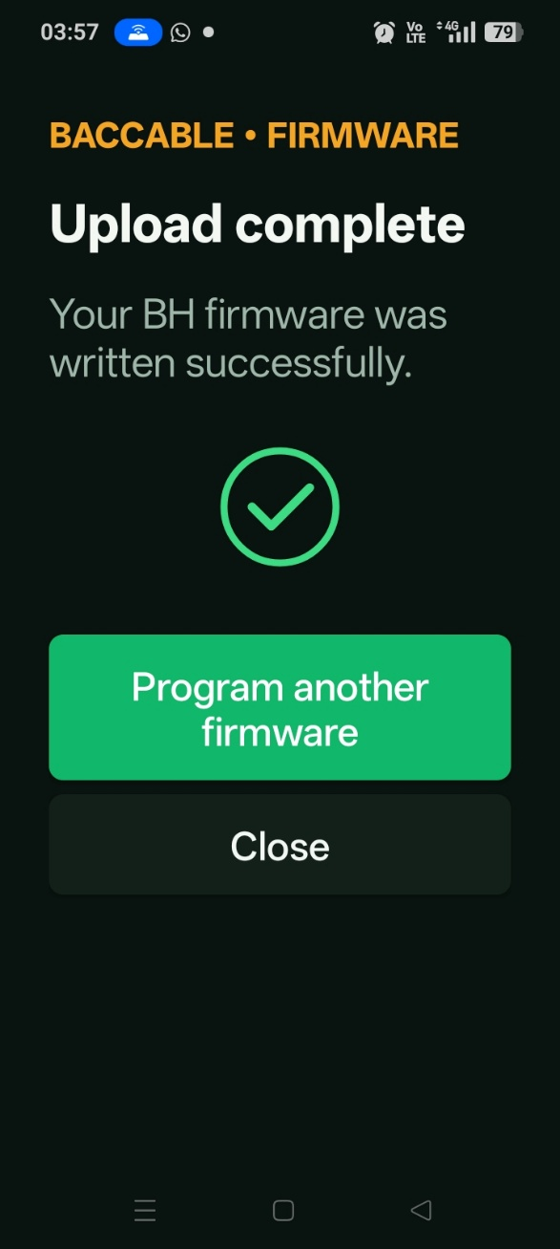

USAGE

2.1 First Startup

When using the BACCABLE for the first time, you need to set up the functions you wish to activate on your vehicle, from among those available, by following the instructions below:
- Insert the BACCABLE into the OBD connector.
- Start the engine.
- With cruise control disabled, press the RES button (or the DISTANCE button) on the steering wheel for about 2 seconds. The display where the radio station name is usually shown will display the text BACCABLE along with the installed version identifier.
- Navigate the circular scrolling menu using the up and down buttons until you reach the item SETUP MENU.
- Press and immediately release the RES button (or the DISTANCE button) to enter the SETUP menu. The text SAVE & EXIT will be displayed.
- Navigate through the circular scrolling menu using the up and down buttons to scroll through the list of available functions. The symbol O to the left indicates that the function is deselected, while the symbol Ø indicates that the function is selected. The functions are described in this chapter and its subchapters.
Note 1: An exception is the engine RPM threshold for the shift function, which is detailed in paragraph 2.6, and the DIESEL/GASOLINE selection, which is detailed in paragraph 2.7.
- Press and immediately release the RES button (or the DISTANCE button) to select or deselect the displayed function.
- After scrolling through the entire list of functions and enabling all desired features, you will return to the SAVE & EXIT item. Press and immediately release the RES button (or the DISTANCE button) on the steering wheel to permanently save the selected settings and return to the main menu.
Note 2: The items shown in the main menu depend on the settings made within the SETUP MENU, which you can access at any time.
- About 40 seconds after turning off the engine, the menu will automatically be disabled. To display it again, press the RES button (or the DISTANCE button) for about 2 seconds.
- In case the vehicle is restarted, the menu will be shown again on the last displayed page before shutdown.
WARNING: The SETUP menu includes two features currently under development which should not be enabled: REMOTE START, READ FAULTS and PEDAL BOOSTER

2.2 Sniffer

Brief description: Act as a sniffer, connected to a Personal Computer or an Android smartphone, i.e. it allows you to record the CAN bus messages.
The baccable can be used to sniff in two different ways:
- with a dedicated firmware that lets you use it with SavvyCan on a Windows PC
- by enabling the SNIFFER function from the BACCABLE MAIN SETUP MENU, to sniff using the BACCABLE LOGGER app from a smartphone (or from a Windows PC), with a quick button to share the sniffed log online (in this case, once the USB cable is disconnected, the baccable goes back to doing its normal job)

2.2.1 Sniffer with dedicated SLCAN Firmware
Brief description: Act as a sniffer, connected to a Personal Computer, i.e. it allows you to record the CAN bus messages.
Note: The use of this function requires reprogramming the BACCABLE. It is not a function that can be enabled or disabled from the SETUP MENU.
- Each USB corresponds to a specific can Bus. Reading the BACCABLE name on the case, from left to right you have BH, C2 and C1 bus.
- Plug usb cable from desired USB bus to the PC (with windows operative System).
- Open SavvyCan (link to the Savvycan opensource project is available in Baccable Repository in Github)
- From top menu “Connection”, select “Open Connection Window”
- From window “Connection Settings” press button “Add new Device Connection”
- From “New connection” window, select option “LAWICEL/SLCAN”
- From “New connection” window, select from drop down menu serial the com port where the Baccable was found (you can check device manager to see which virtual COM serial port is associated to BACCABLE , revealed as ST device)
- From “New connection” window, Leave Serial port speed as default (115000bps)
- From “New connection” window, Set Can bus speed according to the speed of the desired bus (500000bps for C1 and C2, or 125000bps for BH bus)
- From “New connection” window, press button “create new connection”
- Close “connection settings” window
- If ECUs vehicle are communicating, you will see related messages in the main window of Savvycan.
- On the right side of the window it is possible to stop and clear capture, on the bottom right side of the window it is possible to filter shown messages
- From top menu file, you can select Save Log File or Load Log File to save current recording or to open previously recorded messages.
- From bottom central part of the main window you can send messages to the can bus (detailed instrucions in Savvycan repository
- From menu RE TOOLS you can select sniffer to reach a window where you can analyze changing bytes upon specific events.

2.2.2 Sniffer with original Firmware and proprietary app
Brief description: Act as a sniffer, connected to a Personal Computer or an Android smartphone, i.e. it is possible to record the messages present on the CAN bus
To sniff, it is necessary to:
- connect a USB cable between the baccable and the PC, or to an Android smartphone (the USB connector to connect to must be chosen based on the bus you want to sniff from: C1 right connector, C2 central connector, BH left connector).
- access the BACCABLE MAIN SETUP MENU, with the vehicle on, and select the SNIFFER function
- select SAVE&EXIT to save the setting
Right away the baccable will turn into a sniffer, sending packets to the PC (or smartphone).
On the smartphone or PC, the BACCABLE APP application must be installed, downloaded from the website https://www.tr3ma.com/baccable
Note1: 10 seconds after disconnecting the USB cable, the baccable will go back to being just a baccable. If you want to sniff again, you will need to disconnect the baccable from the OBD port and then reconnect the USB cable followed by the OBD connector.
Note2: if you are not using the sniffer, remember to disable it from the main setup menu, in order to reduce the effect of possible interference between the sniffer function and the immobilizer function during the first few seconds of operation.
The "BACCABLE APP" application is very intuitive to use:
- When opened, select the SNIFFER item (grant the requested permissions)
- a connection button is present at the top.
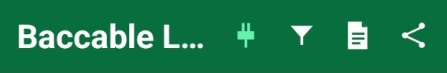

- a button is present at the top to apply a filter to the packets
ù

- a button is present at the top to view the event log (connection errors or packet loss)

- a button is present to share, via Telegram, WhatsApp, email, etc., the just-recorded file (CSV format) and the log file (TXT format). In the Windows version, this button gives access to the folder where all the files are recorded.

In case of packet loss, a red indication at the top of the window will show PACKET LOSS.
Every time the connection button is pressed, a new recording.CSV file and log.TXT file will be created.
The created files are stored in the folder /android/data/it.baccable.logger/files/baccablelogger
- The window immediately shows the recorded messages
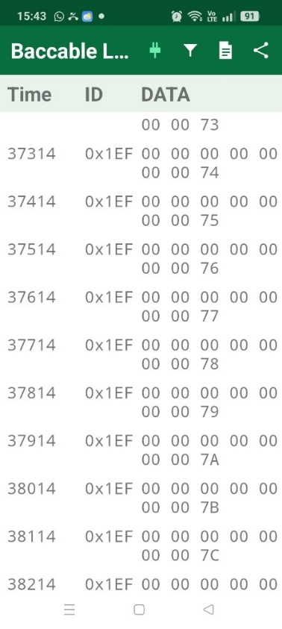

2.3 Start&Stop disabler

Brief description: Disable start&stop, if engine rotates and if start & stop is not disabled. This is a function that can be enabled and disabled from the SETUP MENU described in paragraph 2.1.
No additional instruction is required

2.4 Immobilizer

Brief description: Act as immobilizer. If a connection to the RFHUB is detected, it resets the connection, preventing the addition of a key, disables the ignition, and triggers the panic alarm (if activated on the proxy). The immobilizer can be permanently deactivated and reactivated by pressing the cruise control button upwards for 30 seconds with the engine running and the cruise control deactivated. The dashboard will flash 5-6 times if the immobilizer was successfully deactivated, and 3 times if it was successfully reactivated.

The functionality IMMOBILIZER performs the following:
- Detects if the thief is trying to connect to to RFHUB (they do it to add a key to the car)
- Starts the Panic Alarm after one second
- Continuously Resets the RFHUB in order to reset the thief connection, with this message for 10 seconds
- after 10 seconds stops to send messages and stops alarm, and return listening for thief messages
Panic alarm will start only if you previously enabled panic alarm in your ECU, with the MES proxy alignment procedure.
The Immobilizer functionality will not detect the thief if you power the BACCAble with a voltage available only when the panel is switched on. Therefore, if you use immobilizer function, plug it to OBD port 12V, or directly plug the canable to the 5V usb voltage taken from the connector of the USB interface in the central area, close to cigarette lighter socket. In fact, usb voltage is switched on as soon as the thief wakes up the rfhub.
Once we start to send the rfhub reset message, neither the injition button will work. the car will appear as dead.
Immobilizer at the beginning is enabled by default. To permanently toggle the status you shall be with motor on, cruise control disabled, neutral gear, press cruise control gentle speed up for around 30 seconds. If the immo becomes disabled, it will be blink the dashboard brightness for 5-6 times. If immo becomes activates, the dashboard will blink 3 times. The change is persistent after a power loss. The current status of the Immobilizer is also displayed in the main menu of the BACCABLE with the text “IMMOBILIZER ON” or “IMMOBILIZER OFF”.
When you plug the power to BACCABLE (or if you plug baccable), if immobilizer is enabled, the blue led on BACCABLE will blink twice and the dashboard will blink once. This is useful to understand how the immobilizer is set.
To verify the correct functionality of the immobilizer, it is possible to simulate a theft attempt by connecting to the RF HUB using an ELM327 and the AlfaOBD smartphone app or the Multiecuscan application on a PC. Upon attempting to connect to the RF HUB, the ignition will no longer be possible, and the PANIC ALARM will activate, producing a periodic sound from the horn.
DON’T PANIC: simply disconnect the ELM327, wait 30 seconds, and BACCABLE will stop the panic alarm. In general, remember that by starting the vehicle, engaging gear, and driving, even at very low speeds, the panic alarm is automatically stopped by the vehicle's ECU.

2.5 Led Strip Controller

Brief description: Controls a WS281x LED strip according to the accelerator pedal position (requires connecting pin 8 to the LED strip (optional), while the power supply for the LED strip must be sourced from a voltage that is absent when the vehicle is off). Each gear is associated with a specific color pattern of the strip. Leds are lighted like a vumeter according to accelerator pedal press. With accelerator released, only central leds are lighted. The strip led is controlled assuming that central tunnel of the car is rounded by leds. Therefore central part of the leds strip is on the rear part of the central tunnel.
Note: This is a function that can be enabled and disabled from the SETUP MENU described in paragraph 2.1.

- Connect pin 8 to control pin of the leds strip
- Connect the + and – of the led strip to the desired voltage (5V or 12V of the car) ensuring it is a voltage cutted when the car goes to sleep in order to avoid battery drain. The number of leds in the strip shall correspond to the configured leds number in the firmware.

Example of voltage available only when car is on, therefore suitable for leds strip, is pin 12 (+12V) and 1 (GND) of the connector related to Start&Stop and lights panel.
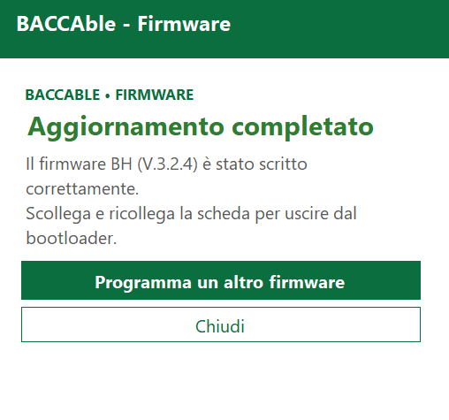
Connector related to Start&Stop and lights panel

2.6 Shift

Brief description: Shows, in race mode, the shift indicator in the dashboard (request to switch gear), when the defined engine RPM speed threshold is overcomed. The threshold is stored in the BACCABLE firmware.

Note: This is a function that can be enabled and disabled via the SETUP MENU described in paragraph 2.1. The engine RPM threshold can be modified by accessing the SETUP menu as indicated in paragraph 2.1, SHIFT RPM menu item. Each time the RES button (or DISTANCE button) is pressed, the threshold changes in a rotating menu.
No further instructions are required.
See also the following paragraph (in case of my23 or newer) and paragraph 2.10 and its connections (related to race enabling).

2.7 My23 IPC

Brief description: Allows, on MY23 dashboards and later versions, the correct display of the SHIFT function described in the previous paragraph.
Note: This is a function that can be enabled and disabled via the SETUP MENU described in paragraph 2.1

2.8 Params On Dashboard

Brief description: Shows additional parameters on the dashboard. It can be enabled with the Cruise Control RES button (or DISTANCE button), if the engine is on and the cruise control is deactivated. Navigate through the menu using the Cruise Control UP and Cruise Control DOWN buttons, and disable the controls when cruise control is activated
Note: From the SETUP MENU described in paragraph 2.1, it is possible to choose whether to set the parameters for a GASOLINE or DIESEL engine.
Usage procedure:
- By default, the dashboard menu is disabled.
- To enable it, the engine must be running and cruise control must be deactivated. Press the RES button (or DISTANCE button) on the steering wheel for about 2 seconds, and the menu will display the BACCABLE version on the dashboard screen where the radio station name is usually shown.
- To navigate the rotating menu, use the cruise control up and down buttons. When you reach the SHOW PARAMS item, press and immediately release the RES button (or DISTANCE button) on the steering wheel to access the SHOW PARAMS menu, where the parameters will be displayed.
- To scroll through the menu, use the cruise control up and down buttons (press lightly to move by 1 parameter, press firmly to move by 10 parameters) in a circular menu.
- When cruise control is enabled, the menu controls are disabled, but the last selected parameter remains on screen and continues to update.
- Parameters are updated every 500 milliseconds.
- To return to the main menu, press and immediately release the RES button (or DISTANCE button) on the steering wheel. The SHOW PARAMS item of the main menu will be displayed.
- To disable the menu, with cruise control deactivated, press the RES button (or DISTANCE button) for about 2 seconds.
- Upon restarting the vehicle, the last parameter displayed before shutdown will automatically appear.
Known issues: It may rarely occur that the radio or Bluetooth devices send text to the dashboard in a way that temporarily freezes the string populated by BACCABLE. In such cases, try disabling and re-enabling the menu using the RES (or DISTANCE) button, or switch the dashboard screen using the right stalk button (TRIP), or perform a vehicle power cycle.

Next pages show available parameters for gasoline engines (first table) and diesel engines (second table):

GASOLINE PARAMETERS
PARAMETER | Unit | Description
PWR&TORQUE | CV & Nm | Power And Torque
Oil Press.%Water T | Bar & °C | Oil pressure and Water temperature
Oil & Water Temp. | °C & °C | Oil and water temperature
Bat SoC & Current | % & A | Battery State of charge and Current in ampere (positive values indcates charge, while negative values indicates discharge)
POWER | CV | Power calculated from torque and engine RPM
TORQUE | Nm | Torque
IC AIR OUT | °C | Intercooler output air temperature
IC AIR IN | °C | Intercooler input air temperature
BOOST ABS | BAR | Absolute Pressure
BOOST | BAR | Turbo pressure, obtained from absolute pressure
TURBO | V | Turbo Sensor Voltage
ODOMETER LAST | km | km since last odometer reset
OIL | L | Oil Quantity
OIL | BAR | Oil Pressure
OIL | °C | Oil Temperature
OIL QUALITY | % | Oil Quality
OIL UN. AIR | °C | Multiair module Oil temperature
GEARBOX | °C | Gearbox temperature
BATTERY | % | Battery charge percentage
BATTERY | A | Battery charging current (positive values mean charge, negative values mean discharge)
BATTERY | V | Battery voltage
AIR COND. | BAR | Air conditioner pressure
CUR. GEAR | - | Current gear
T-ON | m | Time since engine On
OVER RPM | s | Time in which engine was in overrun
EXAUST GAS | °C | Exaust gas temperature
CATAL. | °C | Catalytic Converter Probe Temperature
WATER | °C | Engine Coolant Temperature
KNOCK | mV | Engine Knocking
KEY IGN. | - | Ignition key ID
OVER RPM | - | Number of engine over-rev occurrences
SPARKL.1 | ° | Cylinder 1 correction
SPARKL.2 | ° | Cylinder 2 correction
SPARKL.3 | ° | Cylinder 3 correction
SPARKL.4 | ° | Cylinder 4 correction
R-DNA | - | R-DNA/DNA selector position
SPEED | km/h | speed
Seat Belt Alarm | - | It Indicates whether the acoustic warning system for the seat belts is enabled (ON) or not (OFF)
0-100km/h | Sec | Time taken to accelerate from 0 to 100 km/h. Once the vehicle exceeds 0 km/h, the status changes to GO. After a timeout, if the required speed is not reached, MISS is displayed. Once the vehicle exceeds 100 km/h, the elapsed time is shown in seconds.
100-200km/h | Sec | Time taken to accelerate from 100 to 200 km/h. Once the vehicle exceeds 100 km/h, the status changes to GO. After a timeout, if the required speed is not reached, MISS is displayed. Once the vehicle exceeds 200 km/h, the elapsed time is shown in seconds..
Best 0-100km/h | Sec | Best time in seconds from 0 to 100 km/h permanently stored in baccable
Best 100-200km/h | Sec | Best time in seconds from 100 to 200 km/h permanently stored in baccable

DIESEL PARAMETERS
PARAMETER | Unit | Description
PWR&TORQUE | CV & Nm | Power And Torque
Oil Press.%Water T | Bar & °C | Oil pressure and Water temperature
Oil & Water Temp. | °C & °C | Oil and water temperature
Bat SoC & Current | % & A | Battery State of charge and Current in ampere (positive values indcates charge, while negative values indicates discharge)
POWER | CV | Power calculated from torque and engine RPM
TORQUE | Nm | Torque
DPF | % | DPF occlusion percentage
DPF | °C | DPF temperature
DPF REGEN. | % | DPF regeneration process percentage
LAST REGEN. | km | km since last regeneration
TOT REGEN. | - | Total number of regenerations
MEAN REGEN. | km | Mean distance of regenerations
MEAN REGEN. | min | Mean time of regenerations
REGEN. | - | Type of regeneration in progress
BATT. | V | Battery voltage
BATT. | % | Battery recharge percentage
BATT. | A | Battery charge current (positive values mean in charge, negative values mean discharge)
OIL QUALITY | % | Oil quality
OIL | °C | Oil Temperature
OIL | BAR | Oil Pressure
OIL | mm | Oil level in the oil pan in mm (from 50 to 70 mm)
ADBLUE | L | ADBLUE level in Liters
ADBLUE | % | ADBLUE level in percentage
GEARBOX | °C | Gearbox temperature
EXAUST GAS | °C | Exhaust gas temperature (turbo input)
CUR. GEAR | - | Current gear
WATER | °C | Water temperature
EGR CMD | % | EGR valve command
EGR | % | EGR valve status
TURBO REQ. | BAR | Turbo pressure request
TURBO REQ. | % | Turbo request percentage
TURBO | °C | Turbo temperature
TURBO | BAR | Turbo Pressure
TURBO | % | Turbo Percentage
BOOST REQ. | BAR | Boost request pressure
BOOST | V | Boost sensor voltage
RAIL | BAR | Rail pressure
DIESEL | °C | Diesel temperature
ODOM. LAST | km | km since last odometer reset
AIR COND. | BAR | Air conditioner pressure
FUEL CONS. | L./h | Diesel consume
DEBIMETER | °C | Debimeter temperature
SPEED | km/h | Speed
Seat Belt Alarm | - | It Indicates whether the acoustic warning system for the seat belts is enabled (ON) or not (OFF)
0-100km/h | Sec | Time taken to accelerate from 0 to 100 km/h. Once the vehicle exceeds 0 km/h, the status changes to GO. After a timeout, if the required speed is not reached, MISS is displayed. Once the vehicle exceeds 100 km/h, the elapsed time is shown in seconds.
100-200km/h | Sec | Time taken to accelerate from 100 to 200 km/h. Once the vehicle exceeds 100 km/h, the status changes to GO. After a timeout, if the required speed is not reached, MISS is displayed. Once the vehicle exceeds 200 km/h, the elapsed time is shown in seconds..
Best 0-100km/h | Sec | Best time in seconds from 0 to 100 km/h permanently stored in baccable
Best 100-200km/h | Sec | Best time in seconds from 100 to 200 km/h permanently stored in baccable

Note: Each param can be hidden or shown from the PARAMS SETUP MENU.

2.9 Route

Brief description: Redirect the internal CAN bus messages to OBD peripherals that asks for a specific parameter. This allows displaying parameters on a smartphone that are normally not accessible using just the ELM327.
Note: This is a function that can be enabled and disabled via the SETUP MENU described in paragraph 2.1

You can route native messages encapsulating them in uds parameter response, in order to make them available to diagnostic requests performed with OBD (you can get parameters commonly not available in OBD apps). This functionality performs the following: Upon receive of UDS request with message id 0x18DABAF1 having message data 0622xzyyyyyyyy, Baccable will understand the following:
- 0x18DABAF1 identifies that the message is a Route request (request to route a native message to the diagnostic)
- The route is done just one time (one packet) to avoid bus flood, and it routes only 5 bytes of the requested message
- x (first nibble of third byte of the can message) can be 0 (std Id) or 1 (Ext Id).
- z (second nibble of third byte of the can message) is the offset of the message to route. the number of bytes routed will be only 5. offset will set the part of the message to route
- yyyyyyyy is the requested msg id right aligned.
Example1:
Diagnostic sends msgID 0x18DABAF1 with data 062201000004B2
BACCABLE replies msgID 0x18DAF1BA with data 076201AABBCCDDEE where AA is the second byte of the original 0x4b2 message
Example2:
Diagnostic sends msgID 0x18DABAF1 with data 062210E10204B2
BACCABLE replies msgID 0x18DAF1BA with data 076210AABBCCDDEE where AA is the first byte of the original 0xE10204B2 message

The following image summarizes the route functionality:
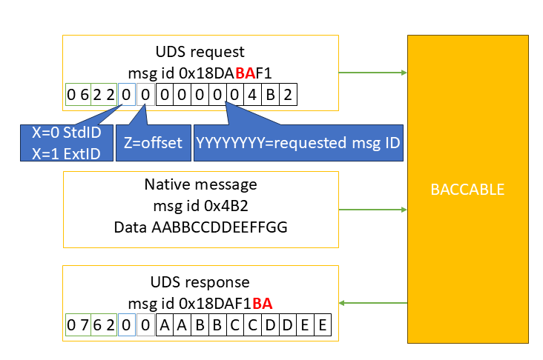
Route messages handshake sequence

2.10 ESC+TC Selector

Brief description: Enables and disables, if the race mode was previously enabled with a proxy alignment procedure (see para.2.19), the ESC (Electronic Stability Control) and TC (Traction Control). It is activated by pressing the button on the left lever (Lane) for at least 3 seconds. When activated, the “ESC OFF” indicator and the collision avoidance disabled icon will be shown on the dashboard, together with standard race masks.
Alternatively, this function can be enabled or disabled from the main menu of the BACCABLE by scrolling through the list and pressing RES (or the DISTANCE button) on the “TOGGLE ESC/TC” item, if it has been previously enabled in the SETUP MENU as described in section 2.1.
Note: This is a function that can be enabled or disabled from the SETUP MENU as detailed in section 2.1.
No further instructions are required.

2.11 DYNO

Brief description: Disables all controls (included ABS, ESC, TC…). This works on stock Giulia/Stelvio too.
Note: This is a function that can be enabled or disabled from the SETUP MENU as detailed in section 2.1.

- The function is activated and deactivated by pressing the PARK button for a few seconds.
- Alternatively, this function can be enabled or disabled from the main menu of the BACCABLE by scrolling through the list and pressing RES (or the DISTANCE button) on the “TOGGLE DYNO” item, if it has been previously enabled in the SETUP MENU as described in section 2.1.
- Once activated, a sequence of alerts will be displayed on the dashboard, indicating that the function is active.
- Pressing the PARK button again, turning off the vehicle, or selecting “TOGGLE DYNO” from the menu will deactivate the function, and the alerts will disappear from the dashboard.
Warning: This function should only be activated or deactivated when the vehicle is stationary.
Known issues: On some Giulia/Stelvio models, it may occasionally happen that some faults remain displayed on the dashboard after deactivating the function. In such cases, perform a vehicle ignition cycle, or select the CLEAR FAULT function as described in section 2.13.
Note: You can quickly scroll through the dashboard alerts by pressing the TRIP button on the right-hand stalk.

2.12 ACC Virtual Pad

Brief description: Detects the button presses on the Cruise Control keypad, replacing them with those of the Adaptive Cruise Control (ACC) keypad. This eliminates the need to purchase the ACC keypad on the steering wheel. It is dependent on performing a proxy alignment to enable ACC and disable CC
Note: This is a function that can be enabled or disabled from the SETUP MENU, as described in section 2.1.

Pressing the Cruise Control button will activate or deactivate the Adaptive Cruise Control.
Pressing the RES button while Adaptive Cruise Control is active will change the distance from the vehicle ahead.
Warning: A proxy alignment must first be performed to enable Adaptive Cruise Control and disable standard Cruise Control, in the same way as required when replacing the standard Cruise Control button panel with the ACC version. The vehicle must, of course, be properly equipped (presence of a front radar with compatible ECU firmware and automatic transmission).

2.13 CLEAR FAULTS

Brief description: Clears all error codes, if present, from all the vehicle's ECUs (across all 3 CAN buses).
Note: This is a function that can be enabled or disabled from the SETUP MENU, as described in section 2.1.
Once this function is enabled, the CLEAR FAULTS option will appear in the BACCABLE main menu. Pressing and immediately releasing the RES button (or DISTANCE button) will display the message WAIT for a few seconds. After the command is executed, the message CLEAR FAULTS will reappear.

2.14 REGENERATION ALERT

Brief description: Triggers a visual and audible alert whenever a DPF regeneration occurs (DIESEL vehicles). By default, only certain types of regeneration are shown to the user. This function allows for a notification to be received every time, starting from the post-injection phase, which is part of the regeneration process.
Note: This is a function that can be enabled or disabled from the SETUP MENU, as described in section 2.1.

2.15 4WD DISABLER

Brief description: Disables all-wheel drive. To be enabled only on vehicles equipped with this feature.
Note 1: This is a function that can be enabled or disabled from the SETUP MENU, as described in section 2.1.
Once the function has been enabled through the SETUP menu, a new option “4WD ENABLED” will appear in the BACCABLE main menu, indicating the default condition for AWD vehicles. Pressing and immediately releasing the RES button (or DISTANCE button) on the steering wheel will change the menu to display “4WD DISABLED.”

Note 2: This function can only be activated while the vehicle is stationary.

2.16 BRAKES OVERRIDE

Brief description: Activates and deactivates the front brakes via the RES button (or DISTANCE button) on the steering wheel.. This function implements the commonly called “launch assist” and “burn out”.
Note1: This is a function that can be enabled or disabled from the SETUP MENU, as described in section 2.1.
Once this function has been enabled via the SETUP menu, an additional option “Front Brake Normal” will appear in the BACCABLE main menu, indicating the default condition.
Note2: before using this function, it is necessary to enable the DYNO in order to ensure maximum power delivery to the wheels.

2.16.1 Launch Assist
By Moving to the Baccable ‘s main menu, on the “Front Brake Normal” item, with the engine running, without engaged handbrake, and the brake pedal released, by p ressing and immediately releasing the RES button (or DISTANCE button) on the steering wheel will change the menu to display “Front Brake ASSIST” and the brake will engage. Only front brakes will be engaged.
In this mode, the brakes will be automatically released upon exceeding the torque value in Nm previously set in the setup menu under the item LAUNCH TORQUE.
As soon as acceleration begins to apply torque to the wheels, the screen will display the current torque and the threshold torque in a string (example: 15Nm/150Nm where 15Nm is the current torque and 150Nm is the threshold torque set in the setup menu).
Once the set torque threshold is exceeded, the brakes are automatically released and the dashboard shows the parameter “Best Time 0-100km/h” (best time in seconds taken to reach 100km/h) from the SHOW PARAMS section. For details on how the “Best Time 0-100km/h” parameter works, refer to paragraph 2.8.

2.16.2 Burn Out
By moving to the Baccable’s main menu, on the “Front Brake Normal” item, with the engine running, the car without the handbrake engaged, and the brake pedal released, pressing and immediately releasing the RES button (or DISTANCE button) on the steering wheel, the menu will display “Front Brake Assist” and the brake engagement will be perceptible. Only the calipers of the front wheels will be activated. Pressing the RES button again, the dashboard will display the message “Front Brake FORCED”.
In this mode, the brake will be released only by pressing the RES button again.
Pressing and immediately releasing the RES button (or DISTANCE button) again will release the brake and the menu will show “Front Brake Normal” again.
Note 3: For a proper burnout on 2WD vehicles, it is mandatory to first disable stability controls by activating the DYNO function. Then activate the front brakes using the function described in this section. After a few seconds of throttle application and once smoke appears from the rear tires, press the button again to release the front brakes.
Note 4: This function can only be activated while the vehicle is stationary.
WARNING: It is strongly recommended to deactivate the BRAKES OVERRIDE function via the SETUP menu when not in use.
WARNING: This function causes significant stress on all mechanical components involved, including suspension, half-shafts, clutch, and flywheel. Apply throttle decisively to quickly overcome the tires’ initial friction, which is the point of highest mechanical stress.

2.17 REMOTE START

Under development. Do not activate this function.

2.18 READ FAULTS

Brief description: Allows you to read fault codes from the vehicle’s control units (for now, only from the Body Computer)
The READ FAULTS function must first be activated by accessing the MAIN SETUP MENU, selecting the READ FAULTS function, and then selecting SAVE&EXIT to permanently save the setting. A new item, READ FAULTS, will now appear in the main menu. Pressing the RES or DISTANCE button (on the steering wheel) after navigating to the READ FAULTS item in the BACCABLE main menu will show a WAIT indication, signalling that you need to wait while the faults are read from the vehicle’s control unit. Once reading is complete, a submenu will automatically open showing the detected faults, identified by their error code and the name of the control unit they belong to. You can then scroll through the list using the up-down buttons on the Cruise Control keypad. To return to the main menu, simply press the RES or DISTANCE button on the steering wheel again.

2.19 ODOMETER BLINK
2.19 ODOMETER BLINK
Brief description: Hides the odometer blinking on the dashboard.
Note: This is a function that can be enabled and disabled from the SETUP MENU described in para.2.1.
Typically, the odometer blinks to indicate an unsuccessful proxy alignment. Once this function is enabled, the odometer blinking will be stopped.
One of the applications of this function is summarized below:
Premise: Proxy alignment is a procedure to be performed with Multiecuscan, an elm327 and suitable cables, which synchronizes the electronic control units (ECUs) with each other so that all modules recognize the current vehicle configuration. Among these configurations is the activation of race mode, which allows the ESC/TC function of the BACCABLE to be used without installing the RDNA selector. The activation of race mode via alignment procedure is well described at the following link: https://giuliatech.com/t/how-to-enable-race-mode-on-non-qv-giulia-2017-2024/21
The above procedure describes the necessary steps for hardware modification of the vehicle and those for proxy alignment. The part relevant to use with the Baccable is only the proxy alignment section.

Activating Race via Proxy alignment causes the loss of pedal maps, meaning all DNA driving styles adopt the N mode map, which has a linear curve, while Dynamic should have a very sensitive tip-in curve. To solve this issue, it is possible to disable race via proxy alignment on the engine ECU only. This way, the pedal maps return to their correct curve, and race remains available. To achieve this result, after successfully completing the race activation procedure as per the link in the Premise, simply set, in proxy setup, the selector type 1 (meaning: disable race), disconnect the elm327 from the vehicle and start the proxy alignment procedure. The first ECU that MES will try to write is the body, then failing to do so (since the elm327 will be disconnected), it will report an error. At that moment, we must reconnect the elm327 because the second ECU to be written will be the engine ECU. As soon as successful writing of the engine ECU is reported, we must again remove the elm327, or disconnect the USB cable if using a USB elm327, to prevent Multiecuscan from writing the other ECUs. At this point, by turning the vehicle off and on again, after a while, the odometer will start blinking to indicate an incomplete proxy alignment, the pedal maps will work as originally intended, and the ESC/TC function of the BACCABLE will operate normally. To eliminate the annoying odometer blinking, we will select the ODOMETER BLINK function in the BACCABLE setup menu.

2.20 SEAT BELT ALARM
Brief description: Disables the acoustic warning indicating unfastened seat belts.
Note: This is a function that can be enabled and disabled from the SETUP MENU described in para.2.1.
By deselecting this function in the setup menu, the acoustic warning indicating unfastened seat belts is disabled. The setting is permanent even after removing the BACCABLE and may require a restart to take effect

2.21 PEDAL BOOSTER

Under development. Do not activate this function.

Brief description: Pedal booster with customized maps based on the selected driving style.
Premise: A pedal booster is an electronic device that connects between the accelerator pedal and the Body (vehicle ECU) to improve vehicle response. It does not increase engine power but makes acceleration more prompt and smooth.
Note: To use this function, a specific connection cable between Baccable and Pedal Booster is required, available separately.
In the setup menu, the function can be set as follows (rotary menu activated by pressing the RES and DISTANCE buttons):
- Pedal Booster Deselected: the function does not control the analog signals from the pedal to the body.
- Pedal Booster Auto: the function assigns different pedal maps to different driving styles, appropriately amplifying and attenuating the analog signals from the accelerator pedal.
- Pedal Booster Bypass: the function does not alter the analog signals from the accelerator pedal but simply repeats them.
- Pedal Booster A Map: the function forces the use of the pedal map associated with driving style A (All weather), appropriately amplifying and attenuating the analog signals from the accelerator pedal.
- Pedal Booster N Map: the function forces the use of the pedal map associated with driving style N (Natural), appropriately amplifying and attenuating the analog signals from the accelerator pedal.
- Pedal Booster D Map: the function forces the use of the pedal map associated with driving style D (Dynamic), appropriately amplifying and attenuating the analog signals from the accelerator pedal.
- Pedal Booster R Map: the function forces the use of the pedal map associated with driving style R (Race), appropriately amplifying and attenuating the analog signals from the accelerator pedal.

2.22 MAIN SETUP MENU
It is accessible from the main menu and allows you to enable and disable each individual function of the baccable. See para. 2.1

2.23 PARAMS SETUP MENU
It is accessible from the main menu and allows you to hide or show each individual parameter of the SHOW PARAMS menu. See para. 2.8

2.24 SHOW RACE MASK
Brief Description: shows race screens on the dashboard and infotainment system when the ESC/TC function is active. See para. 2.10.
WARNING: If flickering of the race display masks occurs on the dashboard or infotainment system of your vehicle, it is recommended to disable and avoid using the SHOW RACE MASK function.

2.25 PARK MIRROR
Brief Description: It moves the side mirrors to display the rear wheels when reverse gear and either the left or right turn signal are activated, in order to assist with parking near curbs.
Note: This function only works on vehicles equipped with mirror encoders. To check compatibility with your vehicle, simply test the feature. In case of incompatibility, disconnect and reconnect the battery negative terminal to restore the initial condition.
Usage Procedure:
- Position both side mirrors so that the rear wheel area is clearly visible.
- Access the MAIN SETUP MENU and enable the PARK MIRROR function. If it is already selected, deselect it and then reselect it. At this stage, the current mirror positions will be stored.
- Select SAVE & EXIT to permanently save the settings and exit the MAIN SETUP MENU. These steps will not need to be repeated.
- Reposition the side mirrors to their normal operating position.
- From now on, whenever reverse gear and the left turn signal are activated, the left mirror will automatically move to the previously stored position set during the function activation. Once reverse gear is disengaged, the mirror will return to its normal position after 10 seconds. The same logic applies to the right mirror when the right turn signal and reverse gear are activated. Turning off the vehicle or shifting into P, the mirrors will immediately return to their normal position.

2.26 ACC AUTOSTART
Brief Description: On vehicles equipped with ACC, when the vehicle with ACC engaged comes to a stop behind the preceding vehicle, this function allows ACC to remain engaged—whereas normally, ACC would automatically disengage approximately 5 seconds after stopping.

This function can be set, in SETUP MENU, as “ACC AUTOSTART R” or “ACC AUTOSTART +”, depending on whether the vehicle in use allows restarting by pressing the RES button or the button to increase the Cruise Control speed. Once the function is activated, the Baccable will ensure the automatic restart of the vehicle after a stop occurred with ACC engaged.

2.27 CLOSE WINDOWS
Brief Description: Allows the activation of the power windows when locking the vehicle, with multiple configuration options.
The CLOSE WINDOWS function supports various options, which can be selected using the RES or DISTANCE button after navigating to the CLOSE WINDOWS item in the MAIN SETUP MENU:
OPZIONE | DESCRIZIONE
O CLOSE WINDOWS 1 | Close windows deselected, the vehicle will act normally
Ø CLOSE WINDOWS 1 | Close windows 1 selected. With a single activation of the vehicle lock via remote control, the vehicle doors are locked and the windows are closed.  With two consecutive activations of the vehicle lock via remote control, the windows are first closed and then slightly reopened to allow air circulation.
Ø CLOSE WINDOWS 2 | Close windows 2 selected. With two consecutive activations of the vehicle lock via remote control, the windows are closed.  With three consecutive activations of the vehicle lock via remote control, the windows are closed and then slightly reopened to allow air circulation.

2.28 OPEN WINDOWS
Brief Description: Allows the activation of the power windows when unlocking the vehicle, with multiple configuration options.
The OPEN WINDOWS function supports various options, which can be selected using the RES or DISTANCE button after navigating to the OEPN WINDOWS item in the MAIN SETUP MENU:
OPZIONE | DESCRIZIONE
O OPEN WINDOWS 1 | OPEN windows deselected, the veichle will act normally
Ø OPEN WINDOWS 1 | OPEN windows 1 selected. With a single activation of the vehicle unlock via remote control, in addition to unlocking the vehicle doors, the windows are fully opened.
Ø OPEN WINDOWS 2 | OPEN windows 2 selected. With a double activation of the vehicle unlock via remote control, in addition to unlocking the vehicle doors, the windows are fully opened.

2.29 HAS VIRTUAL PAD
Brief Description: Simulates the press of the HAS (Highway Assist System) button.

The HAS VIRTUAL PAD function allows the HAS button press to be simulated by double-clicking the LANE button (located on the stalk to the left of the steering wheel). This eliminates the need to purchase the dedicated keypad.

Note: The HAS function requires activation via proxy alignment (Byte 166, bit 2 — i.e., binary format xxxxx1xx to enable it), along with the following prerequisites. Vehicle must be MY20 or later, equipped with a camera with compatible firmware, Steering wheel with touch sensors or a bypass for those sensors, Motorized steering wheel with compatible A420 firmware, Navigation system enabled via proxy and available, Adaptive Cruise Control (ACC).

2.30 QV EXHAUST FLAP
Brief Description: This function opens Giulia Quadrifoglio exhaust valve, by twice pressing RELEASE button located on the gear lever (or by selecting TOGGLE QV VALVE on main menu).

2.31 FRONT PARK MUTE
Brief description: Temporarily mutes the acoustic warning if a frontal obstacle is detected and the vehicle is stationary.

2.32 ELM327
Brief description: Turns the baccable into an ELM327 capable of automatically connecting to the vehicle’s 3 BUSes, without the need for special cables and without moving the USB connector from the C1 port.
To use the ELM327 function, you need to:
- connect a USB cable between the baccable and the PC, or to an Android smartphone, using the right-hand connector of the baccable (C1)
- access the BACCABLE MAIN SETUP MENU, with the vehicle on, and select the ELM327 function
- select SAVE&EXIT to save the setting
Right away the baccable will turn into an ELM327.
On the smartphone or PC, install the desired application (e.g. Multiecuscan, alfaobd, etc.)
Note1: 10 seconds after disconnecting the USB cable, the baccable will go back to being just a baccable. If you want to use it as an ELM327 again, you will need to disconnect the baccable from the OBD port and then reconnect the USB cable followed by the OBD connector.
Note2: if you are not using the ELM327 function, remember to disable it from the main setup menu, in order to reduce the effect of possible interference between the ELM327 function and the immobilizer function during the first few seconds of operation.

2.33 MAX HOLD
Brief description: Keeps the maximum value of the selected parameter on display.

The Max Hold function is always enabled, so it does not need to be enabled in the main setup menu. To use it, the main menu of the Baccable shows the MAX HOLD OFF item. Pressing the RES or DISTANCE button will change it to MAX HOLD ON. Then, moving to the “Show Parameters” menu and selecting one of the parameters, the maximum value recorded for that parameter will be kept on display. Switching to the display of another parameter will clear the previous maximum value. To disable it, go back to MAX HOLD ON and press the RES or DISTANCE button to see it return to disabled (MAX HOLD OFF will be shown).

