Hi, I’ve attached as much information you may need to create my sell sheet. This is my product for men’s restrooms. I would like to include the text below for my one sentence statement.

Text: **The product that keeps men dry after urinating**

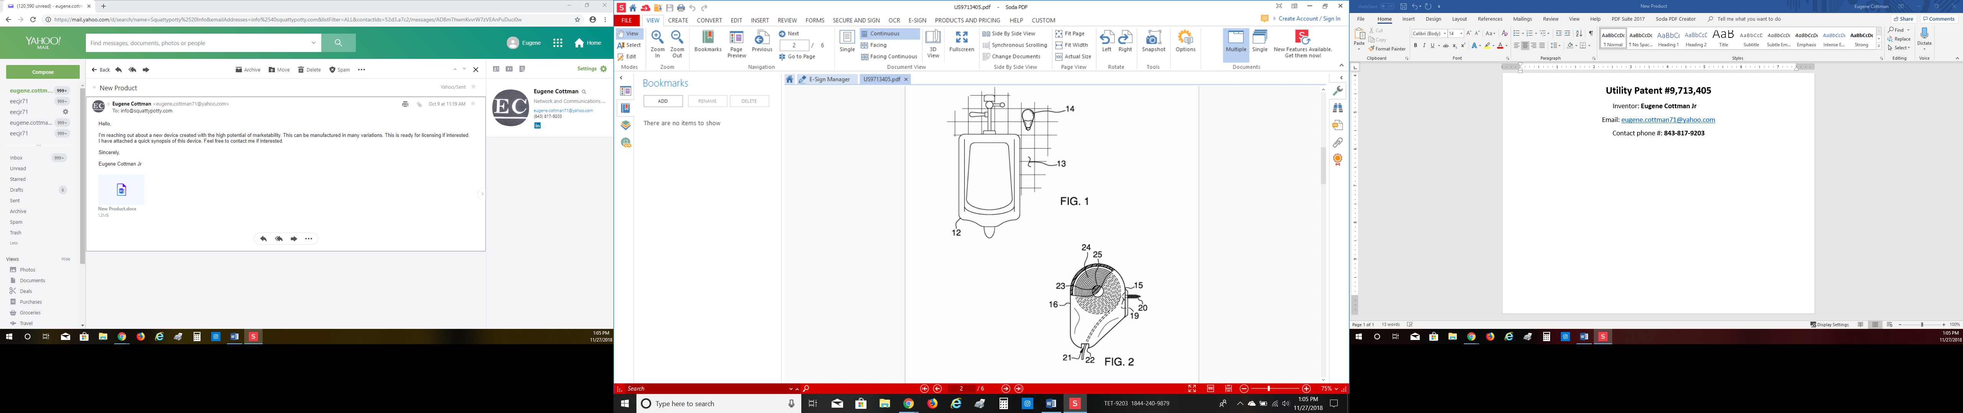

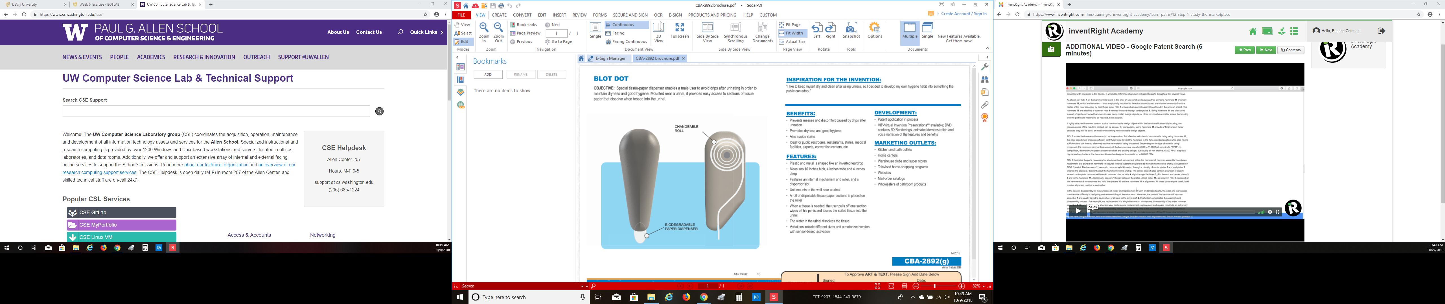

**Utility Patent #9,713,405**

Inventor: **Eugene Cottman Jr**

Email: [eugene.cottman71@yahoo.com](mailto:eugene.cottman71@yahoo.com)

Contact phone #: **843-817-9203**