🇨🇫
CENTRAL AFRICAN REPUBLIC

National Artificial Intelligence Policy
2026 – 2031
A Comprehensive Framework for Ethical, Inclusive, and Economically Transformative AI

Prepared by:
Nafiul Ahmad Rafi
Insights Bangladesh | Policy & Good Governance Research
May 2026

Table of Contents

Executive Summary
The Central African Republic (CAR) stands at a pivotal crossroads in its development trajectory. As one of the world's least developed countries, with a GDP per capita of approximately USD 490, a population of around 5.6 million, and decades of political instability and conflict, the CAR faces extraordinary challenges. Yet, the emergence of artificial intelligence as a transformative global technology offers a rare opportunity to leapfrog traditional development barriers — provided that strategic, context-sensitive, and ethics-driven national AI policy is implemented now.
This National AI Policy 2026–2031 is designed to serve as the foundational governance architecture for the development, deployment, and regulation of artificial intelligence across all sectors of the Central African Republic. It emerges at a time when global AI advancement is accelerating rapidly: generative AI, automated decision-making, predictive analytics, and machine learning systems are reshaping agriculture, healthcare, education, government services, and commerce worldwide. For a nation such as CAR, where more than 70% of the population depends on subsistence agriculture and where institutional capacity remains fragile, AI represents both an extraordinary risk and an unparalleled opportunity.
This policy is structured around five strategic pillars: (1) Ethical AI and Human Rights Protection, ensuring that AI deployment does not entrench inequality or violate fundamental rights; (2) Economic Growth and Industrial AI Adoption, leveraging AI in agriculture, mining, and trade to boost national income; (3) Education, Upskilling, and AI Workforce Development, building the human capital foundation through inclusive, accessible curricula; (4) Public Sector AI and e-Governance, deploying AI to improve state capacity and citizen services in a corruption-resistant framework; and (5) AI Research, Innovation, and Startup Ecosystem, fostering homegrown AI innovation through partnerships with universities, civil society, and the private sector.
Aligned with international frameworks including the UNESCO AI Ethics Recommendation, OECD AI Principles, EU AI Act, and the ITU AI for Good Guidelines, this policy charts a five-year implementation roadmap from legal foundation-setting (Year 1) through national scaling (Years 2–3) to optimization and regional integration (Years 4–5). Key performance indicators, an independent National AI Observatory, and a parliamentary oversight mechanism will ensure accountability and measurable progress. The CAR's National AI Policy is not merely a technocratic document — it is a statement of sovereign intent: to harness the intelligence revolution in the service of peace, development, and human dignity for every citizen of the Central African Republic.

Section 1: National AI Readiness Assessment

1.1 Economic Context
The Central African Republic is classified by the United Nations as a Least Developed Country (LDC) and ranks among the bottom five nations on the Human Development Index (HDI 0.404, rank 188 of 193, 2023). GDP per capita stood at approximately USD 490 in 2024, with an economy heavily dependent on subsistence agriculture (comprising approximately 43% of GDP), artisanal diamond and gold mining, and timber exports. Formal sector employment remains extremely limited. The country faces persistent fiscal challenges: government revenue collection is hampered by weak tax administration, informal economic activity, and decades of conflict-related disruption. External aid and international assistance account for a significant share of public expenditure. However, the government of President Faustin-Archange Touadéra has pursued relative political stabilization since 2016, and the country's natural resource wealth — including substantial deposits of diamonds, gold, uranium, and oil — presents long-term economic potential that AI-assisted resource governance could help unlock responsibly.

1.2 Education and Human Capital
The literacy rate in the CAR stands at approximately 37% for adults, with significant gender and urban-rural disparities — female literacy is estimated at below 25% in many rural prefectures. The gross enrollment ratio in primary education is approximately 78%, but completion rates are far lower, with secondary enrollment at roughly 22%. Tertiary education enrollment is below 5% of the eligible population. The University of Bangui, the country's primary higher education institution, has approximately 12,000 students, with very limited STEM infrastructure. There is virtually no formal AI education curriculum at any level. The country's human capital development is critically constrained by ongoing insecurity in many regions, teacher shortages, inadequate school infrastructure, and very limited internet connectivity in rural areas. Yet, mobile phone penetration has grown to approximately 35%, offering a potential platform for AI-enhanced education delivery.

1.3 Digital Infrastructure
Digital infrastructure in the CAR is among the least developed in Africa. Fixed broadband penetration remains below 0.2% of the population, and reliable electricity access is available to only approximately 14% of citizens, primarily in Bangui and a few urban centers. Mobile internet connectivity (2G/3G) covers roughly 30% of the geographic territory, primarily urban corridors. The country has one submarine cable landing point (through neighboring Cameroon) and relies on satellite communications for rural connectivity. Data center infrastructure is virtually absent. The government's digital governance capacity is extremely limited, with most administrative processes remaining paper-based. While these infrastructure gaps are substantial, they also mean that any AI infrastructure investment — including solar-powered computing hubs, satellite broadband, and government digital platforms — can deliver disproportionate impact at scale.

1.4 Governance and Institutional Capacity
The Central African Republic operates under a presidential republic system with a unicameral National Assembly. Governance capacity has been severely undermined by decades of armed conflict, with significant portions of the national territory remaining outside effective government control as of 2025. The World Bank's Government Effectiveness indicator for CAR scores at approximately -2.1 (on a scale of -2.5 to +2.5), placing it among the lowest globally. However, the United Nations Multidimensional Integrated Stabilization Mission (MINUSCA) has been present since 2014, and the government has made incremental strides in institution-building. The Ministry of Posts, Telecommunications, and New Technologies of Information and Communication (MPTNTIC) serves as the primary digital governance body. This policy recommends embedding AI governance functions within a strengthened MPTNTIC, with a dedicated National AI Secretariat.

1.5 Corruption Risk Assessment
The Transparency International Corruption Perceptions Index (CPI) for 2024 ranks the Central African Republic at a score of 24 out of 100 (rank 171 of 180), indicating extremely high perceived corruption levels. This presents significant AI governance risks: AI systems deployed in public procurement, resource allocation, and service delivery could amplify existing corruption dynamics if not governed with robust transparency and auditability requirements. This policy therefore places anti-corruption AI governance as a first-order priority, mandating algorithmic transparency, public procurement oversight, and mandatory audit trails for all AI-assisted government decisions.

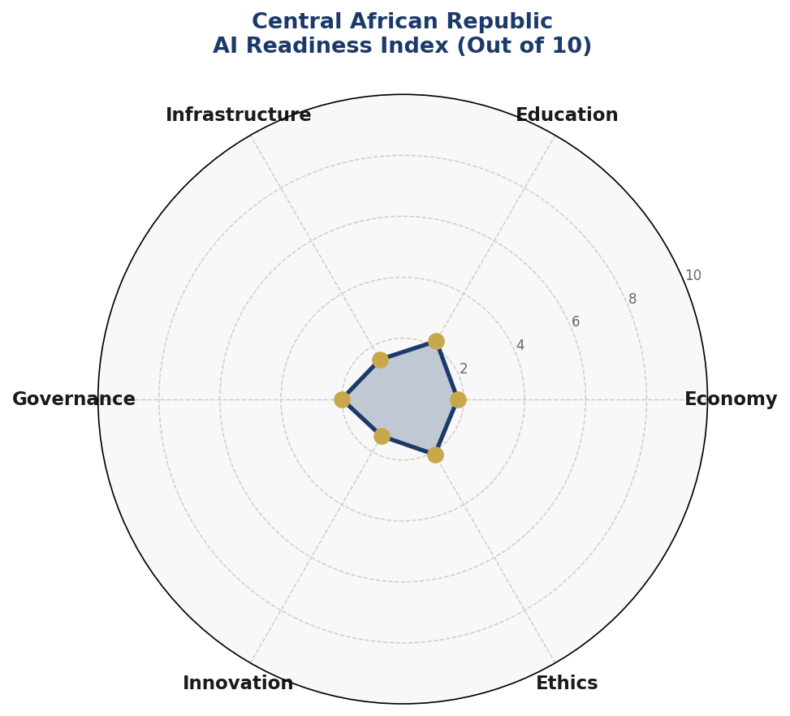
Figure 1.1 — Central African Republic AI Readiness Index: Composite assessment across six dimensions (Score: 1.8/10 Economy, 2.2/10 Education, 1.5/10 Infrastructure, 2.0/10 Governance, 1.4/10 Innovation, 2.1/10 Ethics)
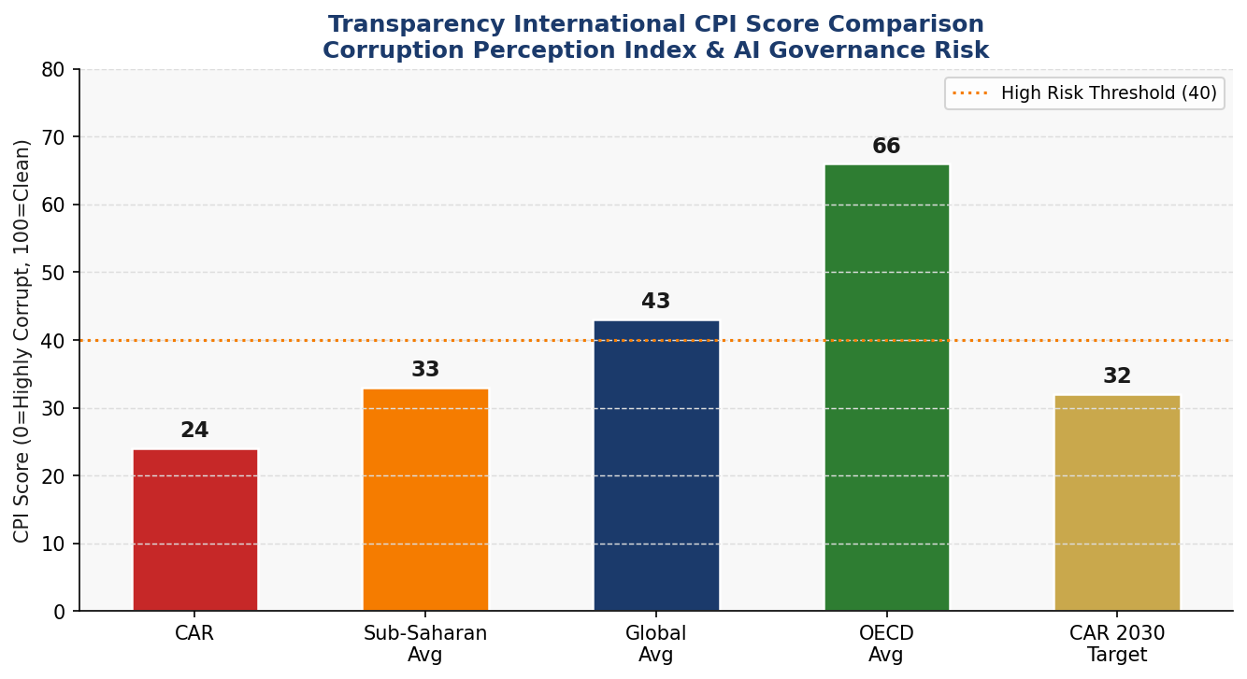
Figure 1.2 — CPI Score Comparison: CAR (24) vs Sub-Saharan Africa Average (33), Global Average (43), OECD Average (66), and CAR's 2030 Reform Target (32)

Section 2: Policy Vision and Strategic Pillars

2.1 National AI Vision
By 2031, the Central African Republic will deploy artificial intelligence as a sovereign tool for peace, development, and dignity — ensuring that every citizen, regardless of location, language, or livelihood, benefits from AI-powered public services, economic opportunity, and protected rights.

2.2 Strategic Pillar 1: Ethical AI and Human Rights Protection
The CAR's AI policy begins with an inviolable commitment to human rights. Given the country's history of conflict and fragility, any AI system that could be weaponized against civilian populations, used for surveillance of political opponents, or deployed to entrench ethnic discrimination will be explicitly prohibited. This pillar encompasses: the establishment of a National AI Ethics Board with independent civil society representation; mandatory human rights impact assessments for all government AI deployments; explicit prohibition of AI-powered social scoring, mass surveillance, and predictive policing without judicial oversight; and guaranteed rights to explainability and appeal for any AI-assisted government decision affecting individuals.

2.3 Strategic Pillar 2: Economic Growth and Industrial AI Adoption
Agriculture, mining, and artisanal trade represent the backbone of the CAR economy. AI can transform these sectors: precision agriculture platforms can guide smallholder farmers on planting, irrigation, and pest management using satellite imagery and weather data; AI-assisted mineral traceability systems can improve diamond and gold certification, unlocking premium ethical sourcing markets; predictive logistics tools can reduce post-harvest loss, a major cause of food insecurity. This pillar prioritizes AI adoption in three sectors: smallholder agriculture (benefiting over 3 million farmers), artisanal and small-scale mining (an estimated 400,000 workers), and micro, small and medium enterprises (MSMEs) in Bangui and regional towns.

2.4 Strategic Pillar 3: Education, Upskilling, and AI Workforce Development
Building human capital for an AI-enabled future requires immediate, systemic investment in AI literacy across all education levels. The CAR will develop a National AI Curriculum Framework spanning primary awareness, secondary literacy, vocational AI tools training, university-level AI engineering, and postgraduate AI research. Special emphasis will be placed on gender equity — with a target that at least 40% of all AI training beneficiaries be women and girls — and on reaching underserved rural communities through mobile, radio, and community-based learning platforms.

2.5 Strategic Pillar 4: Public Sector AI and e-Governance
The government of CAR will deploy AI to improve state capacity where it is most needed: in tax administration (automated revenue collection and compliance monitoring), in health service delivery (AI-assisted disease surveillance and supply chain management for essential medicines), in civil registration (digitized and AI-assisted birth and identity registration), and in anti-corruption monitoring (AI tools to flag anomalies in procurement and public expenditure). All public sector AI deployments will be subject to mandatory transparency disclosures, algorithmic audit requirements, and citizen appeals mechanisms.

2.6 Strategic Pillar 5: AI Research, Innovation, and Startup Ecosystem
The CAR will invest in homegrown AI innovation capacity through partnerships between the University of Bangui, technical institutes, civil society, and the private sector. A National AI Innovation Fund will be established with seed capital from government budget and development partner contributions. The country will pursue active partnerships with the African Union's AI for Africa initiative, the ITU's AI for Good platform, and bilateral cooperation with France, the European Union, China, Russia, and regional African neighbors for technology transfer, research collaboration, and capacity building.

Section 3: International Framework Alignment

3.1 UNESCO AI Ethics Recommendation (2021)
The UNESCO Recommendation on the Ethics of AI, adopted in November 2021 by all 193 member states including the Central African Republic, establishes eleven core values: proportionality and do no harm, safety and security, fairness and non-discrimination, sustainability, right to privacy and data protection, human oversight and determination, transparency and explainability, responsibility and accountability, awareness and literacy, multi-stakeholder and adaptive governance, and promotion of beneficial AI. This policy maps directly to each of these values: the ethical governance framework in Section 6 addresses proportionality, safety, and accountability; the education strategy in Section 5 addresses awareness and literacy; the regulatory framework addresses transparency, explainability, and oversight; and the multi-stakeholder governance structure addresses adaptive governance.

3.2 OECD AI Principles (2019, Updated 2024)
The OECD AI Principles, now adopted by over 50 countries including through the Global Partnership on AI (GPAI), provide five value-based principles and five recommendations for policymakers. This policy aligns with all five value-based principles: inclusive growth and sustainable development (Pillar 2 and Pillar 3), human-centred values and fairness (Pillar 1 and Section 6), transparency and explainability (Section 6 regulatory framework), robustness and safety (AI Risk Classification in Section 6), and accountability (National AI Observatory in Section 9). The five policy recommendations — investing in AI R&D, building digital infrastructure, creating an enabling policy environment, building human capacity, and international cooperation — are addressed in Sections 4, 5, 7, and 10 respectively.

3.3 EU AI Act (2024)
The EU AI Act, the world's first comprehensive legal framework for AI, establishes a risk-based regulatory approach that has become the de facto global standard. The CAR adopts the EU AI Act's four-tier risk classification: Unacceptable Risk systems (prohibited), High Risk systems (mandatory conformity assessment), Limited Risk systems (transparency obligations), and Minimal Risk systems (voluntary codes of conduct). Given the CAR's context, the prohibited category will include AI systems used for social scoring by government authorities, AI-powered mass biometric surveillance in public spaces without prior judicial authorization, and AI systems that exploit vulnerable populations. High Risk systems will include AI in health diagnostics, criminal justice, public resource allocation, and border control.

3.4 World Bank AI Strategy for Development
The World Bank's approach to AI for development emphasizes building foundational digital public infrastructure, ensuring AI benefits the poorest populations, managing AI risks in fragile states, and leveraging AI for climate resilience. This policy aligns with the World Bank framework through its priority focus on agricultural AI for smallholder farmers, health AI for remote communities, and anti-corruption AI governance — all areas where the World Bank has indicated readiness to provide technical and financial support to LDC governments.

3.5 G20 AI Principles and ITU AI for Good
The G20 AI Principles, endorsed at the Osaka Summit 2019 and reaffirmed at subsequent summits, align with the OECD principles and add an emphasis on international cooperation and digital trade. The ITU AI for Good platform specifically connects AI innovation to the Sustainable Development Goals (SDGs). This policy identifies SDG linkages across all ten sections: SDG 1 (No Poverty) and SDG 2 (Zero Hunger) through agricultural AI; SDG 3 (Good Health) through health AI; SDG 4 (Quality Education) through AI education; SDG 16 (Peace, Justice, Strong Institutions) through governance AI; and SDG 17 (Partnerships for the Goals) through international cooperation.

Framework | Principle/Requirement | CAR Policy Section | Alignment Status
UNESCO (2021) | Proportionality & Do No Harm | Section 6 — Ethics Board | ✅ Full
UNESCO (2021) | Fairness & Non-Discrimination | Section 6 — Risk Framework | ✅ Full
UNESCO (2021) | Right to Privacy & Data Protection | Section 6 — Data Act | ✅ Full
UNESCO (2021) | Awareness & AI Literacy | Section 5 — Education | ✅ Full
UNESCO (2021) | Multi-Stakeholder Governance | Section 9 — Observatory | ✅ Full
OECD (2024) | Inclusive Growth | Section 4 — Economic Impact | ✅ Full
OECD (2024) | Transparency & Explainability | Section 6 — Accountability | ✅ Full
OECD (2024) | Robustness & Safety | Section 6 — Risk Classification | ✅ Full
EU AI Act (2024) | Risk-Based Classification | Section 6.2 — Risk Tiers | ✅ Full
EU AI Act (2024) | Prohibited AI Systems | Section 6.2 — Banned Uses | ✅ Full
EU AI Act (2024) | Conformity Assessments | Section 6.3 — Audit Standards | ⚠️ Partial
World Bank | Digital Public Infrastructure | Section 4 — Investment Plan | ✅ Full
World Bank | AI in Fragile States | Sections 1 & 6 | ✅ Full
G20 AI Principles | International Cooperation | Section 10 — Diplomacy | ✅ Full
ITU AI for Good | SDG Linkage | All Sections | ✅ Full
ITU AI for Good | AI Accessibility | Section 5 — Rural Outreach | ✅ Full

Section 4: Economic Impact and Investment Roadmap

4.1 AI's Projected Economic Contribution
McKinsey Global Institute, World Economic Forum, and World Bank research consistently demonstrate that AI adoption can generate GDP gains of 1–4% annually in developing economies — with higher relative impact in LDCs where baseline productivity is lowest. For the Central African Republic, with GDP at approximately USD 2.5 billion (2024 nominal), even conservative AI-driven productivity gains of 0.3–3.5% over the five-year policy period represent USD 7.5 million to USD 87.5 million in annual economic value by 2030. The priority sectors for AI-driven impact are: agriculture (production yield improvement, post-harvest loss reduction), mining (traceability, safety, and premium market access), public administration (efficiency gains, reduced corruption leakage), and health (reduced mortality and treatment costs through early detection and supply chain optimization).

4.2 National AI Investment Framework
The government of the Central African Republic commits to allocating a minimum of 0.5% of annual national budget to AI and digital technology investments, rising to 1.0% by Year 3. This is expected to mobilize development partner co-financing at a ratio of at least 1:3 (government-to-donor). Total projected AI investment over the five-year period is USD 130–160 million, with budget distributed across six priority categories as indicated in the investment allocation chart below.
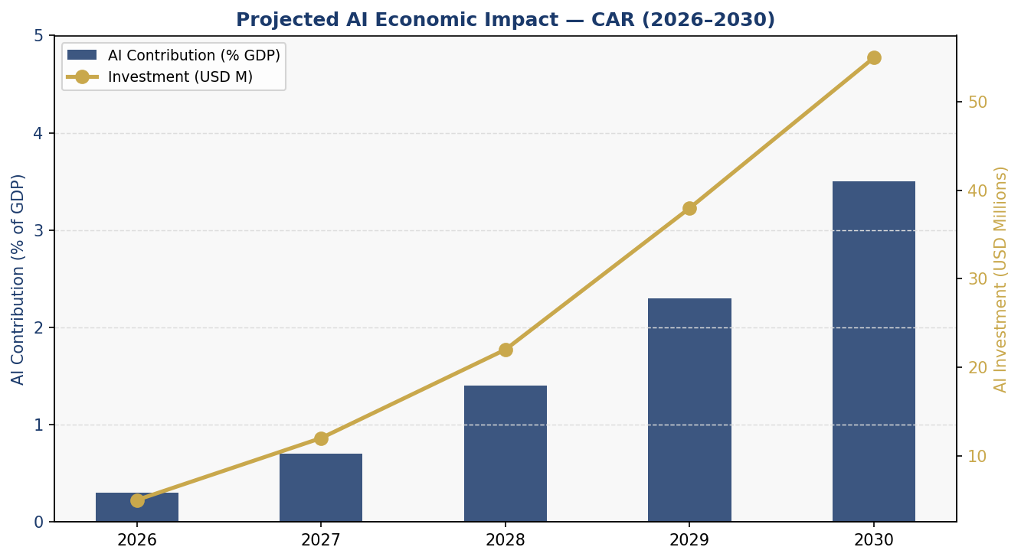
Figure 4.1 — Projected AI Economic Impact: GDP contribution (%) and AI investment (USD Millions) in the Central African Republic, 2026–2030
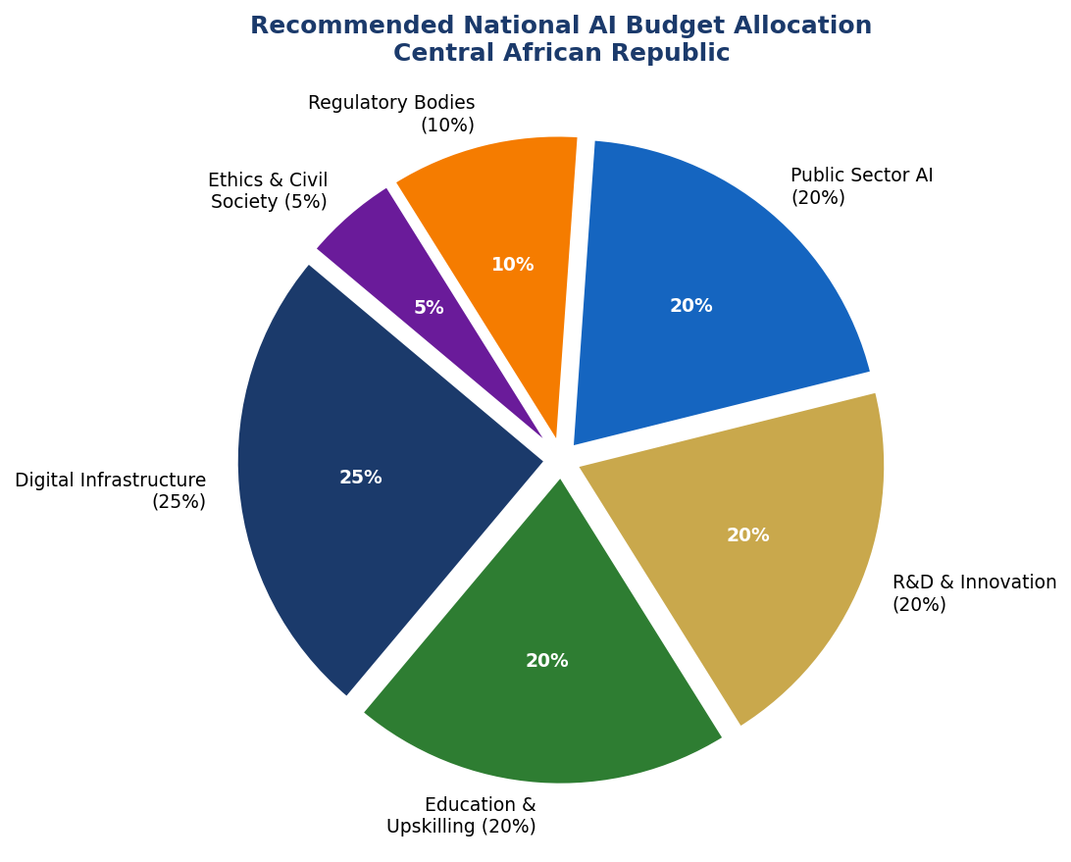
Figure 4.2 — Recommended National AI Budget Allocation across six investment categories

4.3 Priority Sectors for AI Adoption
Sector 1 — Agriculture: Precision agriculture platforms using satellite imagery, SMS-based crop advisory systems, and AI-powered pest and disease early warning. Estimated beneficiary: 3.2 million smallholder farmers. Sector 2 — Mining and Natural Resources: AI-assisted diamond and gold traceability (Kimberley Process compliance), automated geological survey analysis, and safety monitoring in artisanal mining. Sector 3 — Health: AI-assisted malaria, cholera, and outbreak surveillance; drug supply chain optimization; telemedicine platforms for remote diagnosis support. Sector 4 — Public Finance: AI-powered tax compliance monitoring, anomaly detection in procurement, and expenditure tracking.

4.4 Public-Private Partnership Framework
The government will establish a National AI Investment Council comprising representatives from key ministries, private sector chambers, civil society, and development partners including the World Bank, African Development Bank, European Union, and UN agencies. The Council will administer the National AI Innovation Fund, approve investment proposals, and monitor returns. Foreign direct investment in AI and digital infrastructure will receive streamlined business registration, tax incentives for the first five years of operation, and guaranteed access to AI-relevant spectrum and data resources.

Section 5: Education and Human Capital Development

5.1 Current Skills Gap Analysis
As of 2025, the Central African Republic has approximately zero formally trained AI practitioners, fewer than 50 individuals with university-level computer science qualifications, and an estimated 120,000 individuals with any form of digital device usage skills. The country's tertiary STEM enrollment is below 800 students annually. This starting baseline is among the most challenging in the world. However, the country has demonstrated resilience and adaptive capacity: mobile phone uptake has grown significantly despite infrastructure constraints, community radio networks reach rural areas inaccessible by road, and a younger demographic cohort (median age approximately 19 years) presents a significant human capital opportunity if educational investment begins immediately.

5.2 National AI Curriculum Framework
The CAR will develop a tiered National AI Curriculum Framework across five levels: (1) Awareness (Grades 1–6): basic digital literacy, introduction to what AI is and how it affects daily life, delivered in local languages (Sango, French, and regional languages) through radio, mobile, and community programs; (2) Digital Literacy (Grades 7–9): internet use, data privacy, critical thinking about AI-generated content, basic coding concepts; (3) AI Literacy (Grades 10–12): understanding machine learning concepts, ethical implications, AI applications in agriculture and health, practical data skills; (4) Vocational AI (TVET level): AI tools for agriculture, mining safety, business analytics, healthcare data entry and analysis; (5) University AI Programs: AI engineering, data science, and computer science tracks at University of Bangui, with new faculty hired and equipped with international support.

5.3 Gender and Inclusion Targets
A minimum of 40% of all AI training beneficiaries across all levels will be women and girls. All AI education programs will be reviewed for gender bias. Dedicated scholarships for women in AI engineering and data science will be established. The CAR will partner with international organizations including Girls Who Code, African Women in AI, and the African Development Bank's SheTrades program to ensure gender-responsive AI education. Additionally, the policy mandates that curricula and AI tools are developed in Sango (the national language) and in French, with regional language adaptations for major linguistic communities.
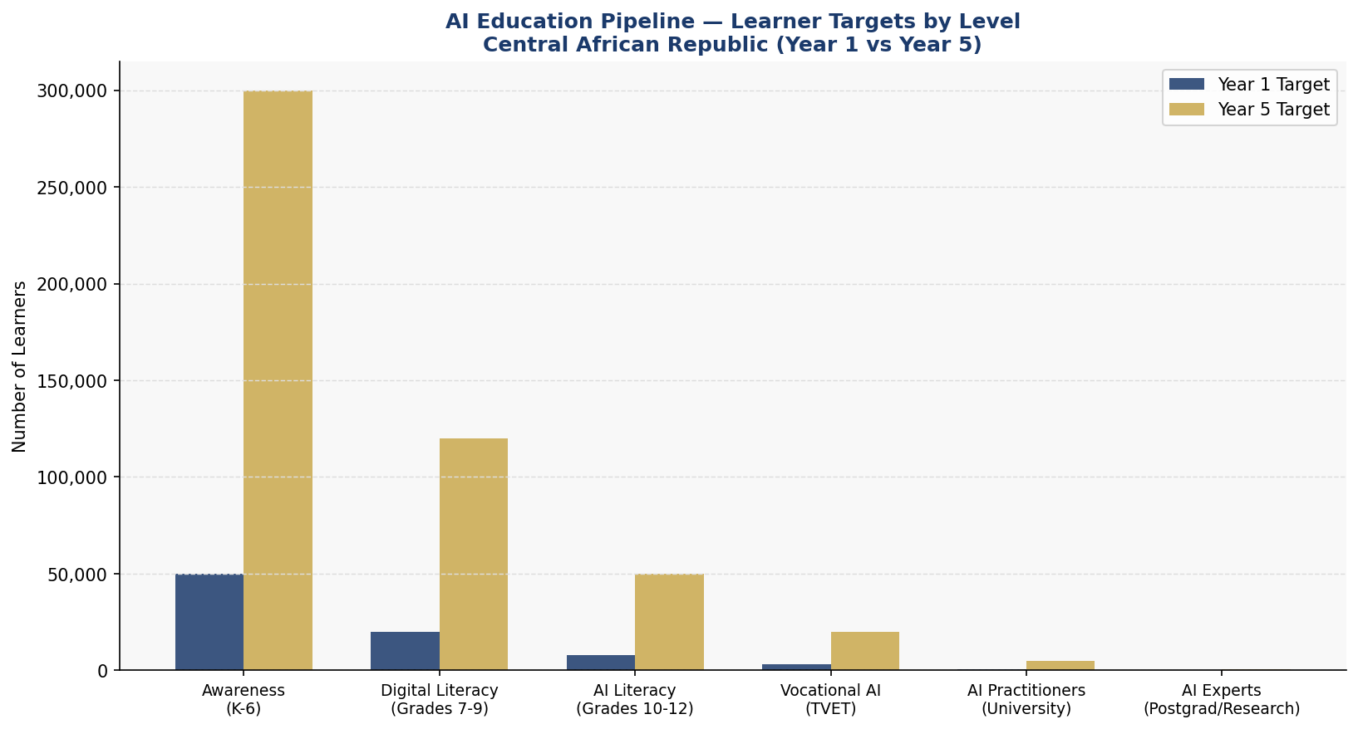
Figure 5.1 — AI Education Pipeline: Learner targets by level, Year 1 vs Year 5 (Central African Republic National AI Curriculum Framework)

5.4 International Scholarships and Exchange
The government will negotiate a minimum of 100 AI-focused scholarships per year at partner universities in France, Morocco, Ghana, Rwanda, Kenya, and China, with a return-service agreement requiring scholarship recipients to contribute a minimum of three years to AI-related public service in the CAR upon completion. Partnership with the African Union's Pan-African University, the AIMS (African Institute for Mathematical Sciences) network, and UNESCO's IESALC will support faculty development and curriculum design.

Section 6: Ethical AI Governance and Regulatory Framework

6.1 National AI Ethics Board
The CAR will establish a National AI Ethics Board (NAEB) as an independent statutory body, reporting to the National Assembly. The NAEB will comprise 11 members: 3 government representatives (Ministries of Digital Affairs, Health, and Justice), 3 civil society representatives (including 1 from women's rights organizations and 1 from human rights groups), 2 academic experts (University of Bangui and international partner), 1 private sector representative, 1 youth representative (age 18–30), and 1 international AI ethics expert. Board members will serve fixed four-year terms, with staggered appointments. The NAEB will have authority to review and certify AI systems deployed in government, issue binding compliance rulings, receive and investigate public complaints, and publish annual AI Ethics State Reports.

6.2 AI Risk Classification System
The CAR AI Risk Classification System adapts the EU AI Act four-tier framework to the national context:
Unacceptable Risk — Prohibited AI Systems
- AI systems used by government authorities to assign social scores affecting citizens' rights or services
- Real-time biometric mass surveillance in public spaces without prior judicial authorization
- AI systems that exploit children, persons with disabilities, or vulnerable populations
- AI tools used for political persecution, ethnic profiling, or targeting of civil society
- AI-generated disinformation campaigns targeting elections or public order
High Risk — Mandatory Conformity Assessment
- AI in criminal justice: predictive policing, recidivism assessment, judicial decision support
- AI in healthcare: diagnostic tools, treatment recommendation, drug dosage
- AI in education: automated grading with high-stakes consequences
- AI in government resource allocation: land rights, welfare benefits, public employment
- AI in border control and migration management
Limited Risk — Transparency Obligations
- AI chatbots and virtual assistants in public-facing government services
- AI-generated content in government communications
- AI tools in media and journalism
Minimal Risk — Voluntary Code of Conduct
- AI in private enterprise for internal productivity
- Agricultural recommendation apps for smallholders
- Entertainment, gaming, and personal productivity AI

6.3 Data Protection and Privacy Act
The government of the CAR commits to enacting a comprehensive Data Protection and Privacy Act within 18 months of this policy's adoption. The Act will establish: a Data Protection Authority (DPA) with investigative and enforcement powers; the right to access, correct, and delete personal data held by government and private entities; mandatory data breach notification requirements; restrictions on cross-border data transfer to non-compliant jurisdictions; and specific protections for sensitive categories of data including health records, ethnic and religious affiliation, political opinions, and biometric data.

6.4 Anti-Corruption AI Use Guidelines
Given the CAR's governance context, all AI systems deployed in public procurement, resource allocation, licensing, and benefit distribution must include: immutable audit logs of all AI-assisted decisions accessible to the National AI Ethics Board and the National Anti-Corruption Agency (NACCA); mandatory human review for any AI decision affecting individual rights or large financial transactions; public disclosure of AI systems in use, their intended purpose, and their performance metrics; and a formal appeals process through which any citizen can challenge an AI-assisted administrative decision.

Section 7: Public Sector and e-Governance AI

7.1 Priority Government Use Cases
The CAR government will prioritize AI deployment in five high-impact domains aligned with the most critical governance gaps: (1) Civil Registration and Identity: AI-assisted birth registration, national ID issuance, and civil records digitization — addressing the estimated 70% of births in CAR that are unregistered; (2) Revenue Administration: AI-powered customs and tax compliance tools to reduce revenue leakage and improve domestic resource mobilization; (3) Health Supply Chain: AI-forecasting tools for essential medicines and medical supplies, integrated with the Ministry of Health's supply chain management system; (4) Agricultural Extension: Government-delivered AI farming advice through mobile and radio platforms, integrated with the Ministry of Agriculture; (5) Public Expenditure Monitoring: AI anomaly detection in budget execution to support the Ministry of Finance's internal audit function and reduce procurement corruption.

7.2 Government AI Procurement Guidelines
All government procurement of AI systems will be subject to: mandatory AI impact assessments before procurement; preference for open-source or open-data AI solutions where technically feasible; prohibition on procurement of AI systems that do not provide explainable outputs; mandatory escrow or open licensing of AI system source code for government-critical infrastructure; and vendor due diligence requirements covering data security, privacy compliance, and anti-corruption warranties.

7.3 Citizen-Facing AI Services Roadmap
Year 1–2: Deploy AI-assisted civil registration kiosks in Bangui and three regional capitals. Launch Sango-language government information chatbot. Pilot AI-assisted health diagnosis support in 10 rural health centers. Year 2–3: Scale health AI to 50 rural health centers. Deploy AI-powered agricultural advisory SMS service to 50,000 smallholder farmers. Year 3–5: Integrate AI across all major government service delivery platforms. Establish national digital identity system with AI-assisted verification. Launch e-Governance portal with AI assistance in French and Sango.

7.4 Interoperability Standards
All government AI systems will be required to comply with interoperability standards developed by the Ministry of Digital Affairs, based on open international standards (ISO/IEC 27001, ITU-T standards, W3C web standards). A Government AI Data Exchange Platform will be established to enable secure, consent-based data sharing between ministries, supporting more integrated and effective public services.

Section 8: Implementation Roadmap

8.1 Phase 1 — Foundation (Year 1, 2026)
Year 1 focuses on legal and institutional setup. Key deliverables include: enactment of the National AI Policy by Presidential Decree and submission of the AI Governance Act to the National Assembly; establishment of the National AI Secretariat within the Ministry of Digital Affairs; appointment of the National AI Ethics Board; launch of an AI Infrastructure Baseline Audit covering digital connectivity, electricity access, and government ICT assets; initiation of the University of Bangui AI Curriculum Pilot in partnership with an international university; launch of AI pilot programs in three ministries (Finance, Health, Agriculture); and establishment of the National AI Data Registry.
KPIs — Year 1: National AI Act submitted to Parliament ✓; NAEB constituted with all 11 members ✓; Infrastructure baseline audit completed ✓; Minimum 500 government officials trained in AI literacy ✓; 3 ministry AI pilots operational ✓.

8.2 Phase 2 — Scaling (Years 2–3, 2027–2028)
Phase 2 focuses on national rollout and scaling of successful pilots. Key deliverables include: passage of the Data Protection and Privacy Act; national rollout of AI agricultural advisory service to 50,000 farmers; expansion of health AI diagnostics to 50 health centers; launch of the National AI Innovation Fund; initiation of national AI education curriculum in secondary schools; and international AI cooperation agreements with at least three bilateral partners.
KPIs — Year 3: Data Protection Act enacted ✓; 50,000 farmers using AI advisory ✓; 50 health centers with AI support ✓; 1,000 students enrolled in AI-specific university programs ✓; National AI Innovation Fund disbursed first tranche ✓.

8.3 Phase 3 — Optimization (Years 4–5, 2029–2031)
Phase 3 focuses on review, optimization, and regional integration. Key deliverables include: comprehensive mid-term review of AI policy outcomes; integration of CAR AI governance standards with African Union AI frameworks; first National AI State Report published by the AI Observatory; launch of CAR participation in the Global Partnership on AI (GPAI); and assessment of AI export potential in areas of comparative advantage such as natural resource AI tools.
KPIs — Year 5: National AI Observatory publishing annual reports ✓; 300,000 learners engaged in AI education programs ✓; AI contributing estimated 3.5% of GDP ✓; CAR participating in 3+ international AI governance forums ✓.
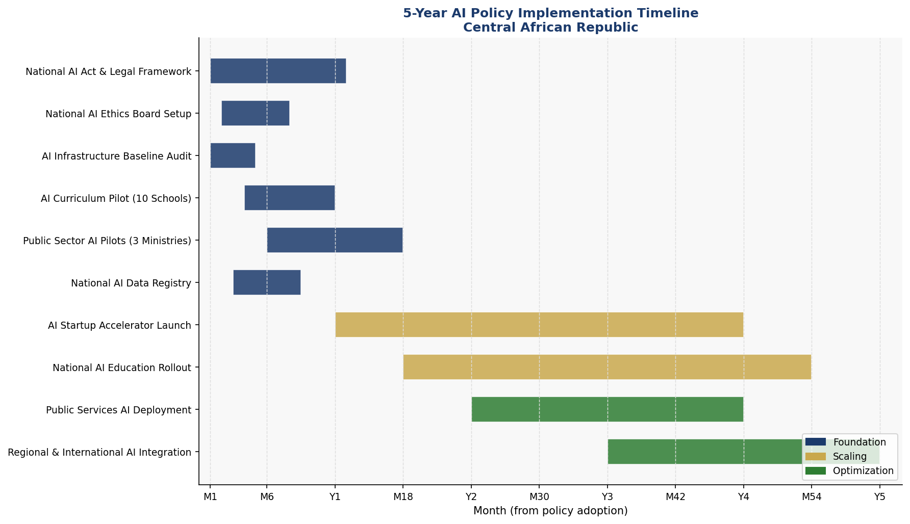
Figure 8.1 — 5-Year AI Policy Implementation Timeline: Three-phase Gantt chart (Foundation, Scaling, Optimization) for the Central African Republic National AI Policy 2026–2031

Section 9: Monitoring, Evaluation, and Accountability

9.1 National AI Observatory
The National AI Observatory (NAIO) will be established as a semi-autonomous body under the National AI Ethics Board, with a mandate to track, measure, and publicly report on AI policy implementation and outcomes. The NAIO will maintain the National AI Registry (a public database of all AI systems deployed in government), publish an Annual AI State Report, conduct independent evaluations of high-risk AI deployments, respond to public complaints about AI systems, and provide technical secretariat support to the National AI Ethics Board. The NAIO will be staffed by a minimum of 10 technical experts in its first year, scaling to 25 by Year 3.

9.2 Parliamentary Oversight Mechanism
A standing parliamentary sub-committee on AI and Digital Technologies will be established within the National Assembly's Committee on Economy, Finance, and Planning. This sub-committee will review all draft AI legislation, receive annual briefings from the National AI Ethics Board and National AI Observatory, have authority to summon ministers and AI system operators for public hearings, and commission independent audits of government AI deployments.

9.3 Civil Society and Independent Audit Role
The policy mandates that the National AI Ethics Board include civil society representatives and that the National AI Innovation Fund allocates 5% of its budget to civil society organizations conducting AI accountability work. An independent technical audit of all High Risk government AI systems will be required annually, with auditors selected through a public procurement process and reports made publicly available.

KPI | Baseline (2026) | Year 1 Target | Year 3 Target | Year 5 Target
AI-trained government officials | 0 | 500 | 2,000 | 5,000
AI Readiness Index Score | 1.8/10 | 2.2/10 | 3.5/10 | 5.0/10
Farmers using AI advisory | 0 | 5,000 | 50,000 | 200,000
Health centers with AI support | 0 | 10 | 50 | 150
AI education learners (all levels) | 0 | 75,000 | 180,000 | 400,000
Women in AI training (%) | 0% | 35% | 40% | 45%
AI contribution to GDP (%) | 0% | 0.3% | 1.4% | 3.5%
Public AI systems audited (%) | 0% | 100% | 100% | 100%
Data Protection Act enacted | No | Draft submitted | Enacted | Fully enforced
CPI Score improvement | 24 | 24 | 27 | 30+
Internet penetration (%) | 14% | 16% | 22% | 30%
National AI Observatory reports | 0 | 1 | 3 | 5

Section 10: International Cooperation and AI Diplomacy

10.1 Bilateral AI Cooperation Priorities
The Central African Republic will pursue bilateral AI cooperation agreements with priority partner countries: France (historical partner, major donor, AI research capacity); Morocco (leading African digital economy, French-speaking, active AI strategy); Rwanda (Africa's leading digital governance success, relevant LDC-to-digital-hub pathway); Ghana and Senegal (West and Central African AI development models); China (telecommunications and infrastructure investment partner); and the European Union (multilateral development finance, regulatory alignment opportunity through EU-Africa Digital Economy Cooperation).

10.2 Regional AI Governance — African Union Framework
The African Union's Continental AI Policy Framework, under development through the AU Commission's Department of Infrastructure and Energy, provides a reference framework for member state AI policies. The CAR's policy explicitly aligns with and supports AU AI governance principles, and the government commits to active participation in the AU's AI working groups. The Economic Community of Central African States (ECCAS) provides the most immediate regional governance platform; the CAR will advocate for ECCAS-level AI regulatory harmonization, data sharing agreements, and joint AI infrastructure investment as a priority diplomatic objective.

10.3 South-South Knowledge Transfer
The CAR will actively pursue knowledge transfer from African countries that have made significant AI governance progress. Rwanda's digital transformation experience (from a post-conflict LDC to a tech-forward economy in two decades) offers the most directly relevant model. Ethiopia's AI strategy in an LDC context, Nigeria's AI policy framework, and Kenya's Silicon Savannah ecosystem all provide valuable lessons. The CAR government will send at least 20 senior officials per year to peer-learning programs in these countries, and will host reciprocal visits from partner country experts.

10.4 Global AI Governance Participation
The CAR commits to active participation in key global AI governance processes: the United Nations High-Level Advisory Body on Artificial Intelligence; the ITU's AI for Good Global Summit; the Global Partnership on AI (GPAI), which the government will apply to join by Year 2; UNESCO's AI Ethics Monitoring Framework; and the International Organization for Standardization (ISO/IEC) AI standards processes. This participation will be supported by the development of national AI diplomacy capacity within the Ministry of Foreign Affairs.

Conclusion
The National Artificial Intelligence Policy 2026–2031 of the Central African Republic represents far more than a technology governance document. It is a declaration of sovereign agency in the age of intelligent machines. In a country where the majority of citizens have yet to experience reliable electricity, where health facilities lack basic diagnostic equipment, and where generations of conflict have depleted institutional memory and human capital, the decision to articulate a comprehensive national AI strategy signals a profound commitment to the future.
The Central African Republic does not have the luxury of approaching AI governance passively. The global AI revolution is moving at a pace that will widen the gap between nations that govern AI strategically and those that do not. Agricultural AI systems already being deployed by neighboring countries, Chinese digital infrastructure investments reshaping Central African connectivity, and global AI-driven commodity pricing systems — all of these forces are already affecting the lives of citizens in the CAR whether or not the government acts. This policy chooses action.
The policy is ambitious in its vision and realistic in its sequencing. It does not promise instant transformation. It sets the legal foundations, institutional structures, investment pathways, and educational infrastructure that will allow AI to serve the CAR's people over the next five years and beyond. It makes explicit the ethical boundaries that no AI system may cross, regardless of the efficiency gains it might offer. And it positions the Central African Republic as a responsible, engaged participant in the global AI governance conversation — a country that has learned from its own history of fragility that technology, like all powerful tools, must be wielded with wisdom, justice, and accountability.
The success of this policy will ultimately be measured not in terabytes of data processed or AI models deployed, but in hectares of farmland made more productive, in children diagnosed earlier and treated more effectively, in government services delivered more fairly and efficiently, in women and girls who access AI-enabled education and economic opportunity, and in a state whose institutions become gradually more trustworthy and effective as AI tools reinforce — rather than undermine — the social contract. That is the purpose, the promise, and the standard by which this policy must be held.

References and Bibliography

International Frameworks and Primary Sources
- UNESCO. (2021). Recommendation on the Ethics of Artificial Intelligence. Paris: United Nations Educational, Scientific and Cultural Organization.
- OECD. (2024, updated). OECD AI Principles. Paris: Organisation for Economic Co-operation and Development. https://oecd.ai/en/ai-principles
- European Parliament. (2024). Regulation (EU) 2024/1689 — The EU Artificial Intelligence Act. Official Journal of the European Union.
- World Bank. (2024). World Development Report 2024: The Middle Income Trap. Washington DC: The World Bank Group.
- International Telecommunication Union. (2023). AI for Good Global Summit Outcome Report. Geneva: ITU.
- G20 Osaka Track. (2019). G20 AI Principles. Osaka: G20 Presidency.
- African Union Commission. (2024). Continental AI Policy Framework — Working Draft. Addis Ababa: AU Commission.

Country Data Sources
- Transparency International. (2024). Corruption Perceptions Index 2024. Berlin: Transparency International.
- United Nations Development Programme. (2023). Human Development Report 2023/24. New York: UNDP.
- World Bank. (2025). Central African Republic Country Overview. Washington DC: World Bank Group. https://data.worldbank.org/country/CF
- Oxford Insights. (2023). Government AI Readiness Index 2023. Oxford: Oxford Insights.
- International Telecommunication Union. (2024). Measuring Digital Development: Facts and Figures 2024. Geneva: ITU.

Research and Policy Reports
- McKinsey Global Institute. (2018). Notes from the AI Frontier: Modeling the Impact of AI on the World Economy. McKinsey & Company.
- World Economic Forum. (2023). The Future of Jobs Report 2023. Geneva: WEF.
- African Development Bank. (2024). African Economic Outlook 2024: Driving Africa's Transformation. Abidjan: AfDB.
- GSMA. (2024). The Mobile Economy Sub-Saharan Africa 2024. London: GSMA Intelligence.
- UNCTAD. (2024). Technology and Innovation Report 2024: Unleashing the Potential of Sustainable Finance. Geneva: UNCTAD.

About the Author

Nafiul Ahmad Rafi
Policy & Good Governance Researcher | BD Civic Tech Architect

Nafiul Ahmad Rafi is a civic technologist, policy researcher, author, photographer, and musician based in Dhaka, Bangladesh. He is the Founder and Director of Insights Bangladesh, a data-driven governance and policy impact analysis institution, and the Founder & Lead Architect of NagorikBD.org — a transparency-first civic platform scaled across Mymensingh Division, connecting citizens with government services across 45 Upazilas.
His work exists at the intersection of institutional reform and artificial intelligence, transforming theoretical governance into scalable, data-driven reality. Without a conventional computer science degree, he self-taught the tools of modern AI and web development to build the infrastructure that enforces the policies he once only researched.

Key Platforms and Projects
- NagorikBD.org — Civic transparency platform, Mymensingh Division
- Insights Bangladesh — Policy impact analysis institution
- FactCheck BD (factcheckbd.org) — Bangladesh's AI-powered fact-checking platform
- Political Insights BD / PIBD (pibbd.org) — Political intelligence and civic tech hub
- PeaceShield BD / National Peace Tracker — AI-powered hate speech and conflict monitoring
- PolicyLens AI (aigovbd.org) — 9-dimensional AI policy audit tool

He has published four books and maintains a personal site at ahmad-rafi.com.

Research Interests
AI Governance · Policy Research · Future of Bangladesh · Climate Policy

Contact
- Website: ahmad-rafi.com
- LinkedIn: nafiul-ahmad-rafi (bd.linkedin.com/in/nafiul-ahmad-rafi)
- Email: contact@ahmad-rafi.com

"I build code to ensure transparency, and I write lyrics to inspire the courage to use it."

