🇸🇿 KINGDOM OF ESWATINI

National Artificial Intelligence Policy
2026–2031
A Comprehensive Framework for Ethical, Inclusive, and Economically Transformative AI

Prepared by:
Nafiul Ahmad Rafi
Insights Bangladesh — Policy & Governance Research
May 2026

Table of Contents

Executive Summary

Eswatini — a landlocked constitutional monarchy in Southern Africa — stands at a critical juncture in its digital transformation journey. With a population of approximately 1.2 million, a GDP per capita of around USD 4,100, and an economy largely driven by sugar production, textiles, forestry, and tourism, Eswatini must strategically harness artificial intelligence (AI) to diversify its economic base, modernize its public services, and ensure its citizens benefit from the Fourth Industrial Revolution. This National AI Policy for 2026–2031 provides the comprehensive roadmap for that transformation.
This policy has been developed in alignment with globally recognized frameworks, including the UNESCO AI Ethics Recommendation (2021), OECD AI Principles (2019/2024), the EU AI Act (2024), World Bank AI Strategy, G20 AI Principles, and ITU AI for Good Guidelines. It positions Eswatini as a proactive, responsible actor in the global AI ecosystem — one that prioritizes ethical deployment, inclusive growth, and measurable development outcomes. The policy is contextualized within Eswatini's Vision 2022 successor framework and the broader Sustainable Development Goals (SDGs).
The policy is built around five strategic pillars: (1) Ethical AI and Human Rights Protection, which establishes a National AI Ethics Board and risk classification system; (2) Economic Growth and Industrial AI Adoption, targeting AI-driven contributions of up to 3.1% of GDP by 2031; (3) Education, Upskilling, and AI Workforce Development, with a target to train 200,000 citizens at various levels of AI competency by Year 5; (4) Public Sector AI and e-Governance, to improve service delivery and reduce corruption through algorithmic transparency; and (5) AI Research, Innovation and Startup Ecosystem development, leveraging the University of Eswatini and regional partnerships.
A realistic 5-year implementation roadmap is provided, organized across three phases: Foundation (Year 1), Scaling (Years 2–3), and Optimization (Years 4–5). The policy calls for an estimated total investment of USD 151 million over five years, with clear KPIs, oversight mechanisms, and annual reporting obligations. Eswatini's commitment to this policy reflects its determination to ensure that AI serves as a vehicle for inclusive prosperity — leaving no community, no region, and no citizen behind.

Section 1: National AI Readiness Assessment

1.1 Economic Context
Eswatini is classified as a lower-middle-income country by the World Bank, with a nominal GDP of approximately USD 4.7 billion and a per capita income of USD 4,100. The economy is heavily dependent on the Southern African Customs Union (SACU) receipts, which constitute a significant portion of government revenue. Key sectors include sugar (accounting for roughly 50% of export earnings), textiles, forestry products, and manufacturing. The informal economy is substantial, employing a majority of the rural workforce.
Despite these structural constraints, Eswatini has demonstrated resilience and strategic intent. The Eswatini Economic Recovery and Stimulus Plan (ERSP) post-COVID-19 recognized the importance of digital transformation. Mobile phone penetration exceeds 85%, and internet penetration has grown to approximately 47% of the population — providing a meaningful base upon which AI infrastructure can be layered. The financial services sector, led by institutions like Standard Bank Eswatini and First National Bank Eswatini, has begun exploring fintech and data analytics applications.

1.2 Education and Human Capital
Eswatini boasts a literacy rate of approximately 88%, relatively high for the region. The University of Eswatini (UNESWA), with campuses in Kwaluseni, Luyengo, and Mbabane, serves as the primary tertiary institution, offering programs in science, engineering, and technology. However, the country faces a significant STEM skills gap, with limited offerings in data science, machine learning, and AI engineering at the undergraduate level. Secondary school curricula have not yet incorporated computational thinking or AI literacy as core components.
Women's participation in STEM fields remains below 35%, and rural communities face disproportionate barriers to digital education. Vocational training institutions — under the Eswatini Qualifications Authority (EQA) — represent an underutilized channel for deploying AI upskilling programs at scale. Partnerships with organizations such as the African Institute for Mathematical Sciences (AIMS) and regional universities in South Africa and Mozambique will be critical to bridging the human capital gap.

1.3 Digital Infrastructure
Eswatini's digital infrastructure has grown substantially, driven by MTN Eswatini and Eswatini Mobile (E-Mobile) expanding 4G coverage across most urban areas. The government's e-Swatini initiative has digitized several public services, and data center capacity exists in Mbabane. However, rural broadband access remains a challenge — particularly in the Lubombo and Shiselweni regions — and last-mile connectivity gaps will need to be addressed as a prerequisite for AI deployment in agriculture, healthcare, and education.
Eswatini is a member of SADC's ICT framework and benefits from regional fiber connectivity through the SEACOM and EASSy submarine cable systems via South Africa and Mozambique. Cloud computing adoption in the public sector is nascent but growing, and the government has expressed interest in establishing a national data center and cloud platform under the Ministry of Information Communication and Technology (MICT).

1.4 Governance and Institutional Capacity
Eswatini is a constitutional monarchy with King Mswati III as Head of State. The government operates a multiparty parliament with a Prime Minister. Political stability is high, and the country scored 0.45 on the World Bank Political Stability Index. However, governance quality scores in areas of rule of law (−0.37) and control of corruption (−0.52) indicate areas requiring institutional strengthening. The Auditor General's Office and the Anti-Corruption Commission (ACC) provide some oversight, but capacity needs reinforcement.
The Ministry of Information Communication and Technology (MICT) will serve as the primary government anchor for AI policy implementation. The Eswatini Communications Commission (ESCCOM) regulates the telecommunications sector. Importantly, Eswatini currently lacks standalone data protection legislation — the development of a Personal Data Protection Act is identified as a foundational legal requirement under this policy.

1.5 Corruption Risk Assessment
Eswatini scored 33 out of 100 on the Transparency International Corruption Perceptions Index (CPI) — placing it in the higher-risk category for AI governance corruption. This score is consistent with the Sub-Saharan Africa regional average of 33 but below the minimum threshold of 60 generally associated with reliable AI governance. The risk is particularly acute in public procurement (a key area for government AI deployment), regulatory capture, and digital service contracting. This policy mandates specific anti-corruption safeguards in all AI procurement, audit trails for algorithmic decisions affecting citizens, and independent civil society monitoring.

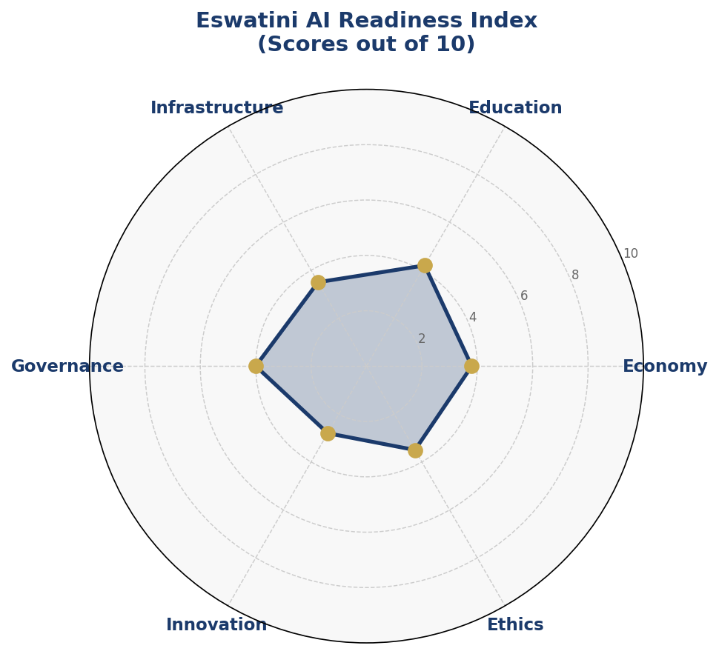
Figure 1.1 — Eswatini AI Readiness Index (Composite Scores across Six Dimensions)

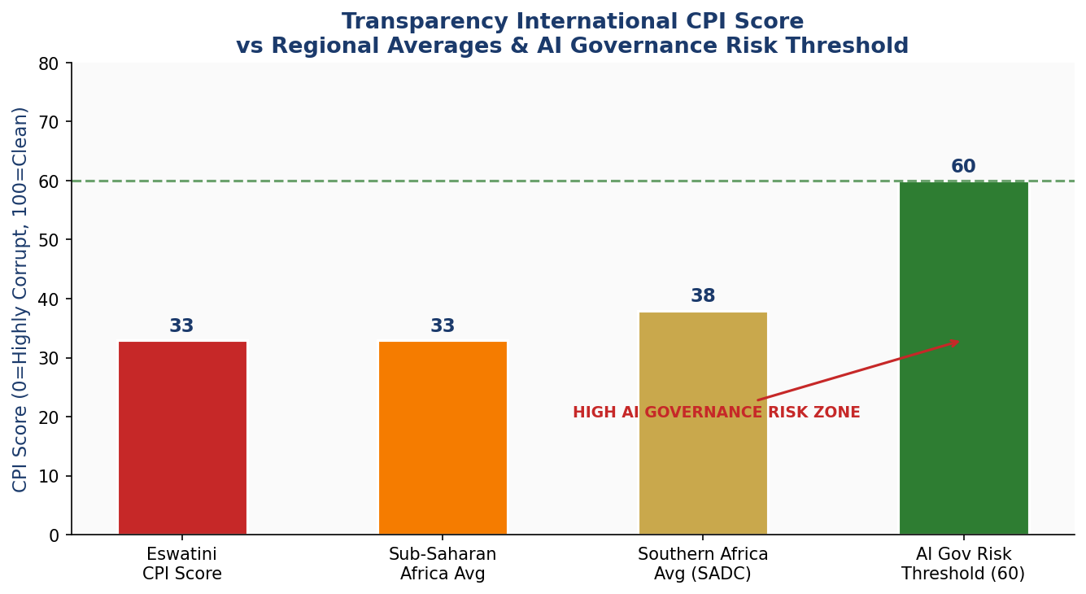
Figure 1.2 — Corruption Perceptions Index: Eswatini vs Regional Averages and AI Governance Risk Threshold

Section 2: Policy Vision and Strategic Pillars

2.1 National AI Vision
By 2031, Eswatini will be a regionally recognized AI-ready nation — one that deploys artificial intelligence ethically, inclusively, and strategically to accelerate economic diversification, improve public service quality, empower its citizens with AI skills, and uphold its commitment to human dignity and democratic governance. Eswatini's AI ecosystem will be grounded in the values of Ubuntu — humanity toward others — ensuring that technological progress serves the collective flourishing of all Swati citizens.

2.2 Strategic Pillar 1: Ethical AI and Human Rights Protection
Eswatini commits to placing human rights, fairness, and dignity at the center of all AI development and deployment. This pillar establishes the National AI Ethics Board (NAEB) — a multistakeholder body comprising government, civil society, academia, private sector, and international experts — with the mandate to develop ethical guidelines, review high-risk AI systems, and advise on regulatory standards. All government AI systems must undergo ethics impact assessments prior to deployment. Algorithmic transparency, explainability, and non-discrimination are mandatory requirements for all public-facing AI applications.
- Establish National AI Ethics Board (NAEB) by Q3 2026
- Develop Eswatini AI Ethics Charter by Q4 2026
- Mandatory AI impact assessment for all government AI procurement
- Annual human rights and AI audit published by the NAEB

2.3 Strategic Pillar 2: Economic Growth and Industrial AI Adoption
Eswatini's economic future depends on diversifying beyond traditional sectors. AI presents specific and immediate opportunities in precision agriculture (automated crop monitoring, soil health prediction for sugarcane and maize), manufacturing optimization (predictive maintenance in the textile sector), financial inclusion (AI-driven microfinance and credit scoring), tourism (personalized visitor experiences and demand forecasting), and healthcare (disease surveillance, telemedicine AI). This pillar identifies these sectors as AI adoption priorities and establishes a framework for public-private investment to realize them.
- Launch AI for Agriculture Pilot Program targeting 5,000 smallholder farmers in Year 1
- Create AI Business Incentive Fund (USD 10M over 5 years) for qualifying enterprises
- Partner with regional development banks for AI-focused FDI attraction strategy

2.4 Strategic Pillar 3: Education, Upskilling, and AI Workforce Development
Human capital is the bedrock of any AI strategy. This pillar establishes a National AI Curriculum Framework across K-12, tertiary, and vocational levels. At the K-12 level, computational thinking and digital literacy will be introduced as core competencies. UNESWA will develop dedicated AI and Data Science degree programs by 2027. A National AI Skills Scholarship Fund will target 500 students annually for AI-related study at home and abroad. Gender equity targets require that at least 40% of all AI scholarship recipients be women.

2.5 Strategic Pillar 4: Public Sector AI and e-Governance
AI can dramatically improve government efficiency, service delivery, and accountability — addressing some of Eswatini's most pressing governance challenges. Priority use cases include: AI-powered tax compliance monitoring (Eswatini Revenue Authority), predictive health systems for disease outbreak detection (Ministry of Health), automated land registry and cadastral systems (Ministry of Housing), AI-assisted judicial case management (judiciary), and intelligent road and infrastructure monitoring (Ministry of Public Works). All public sector AI deployments will be subject to algorithmic accountability standards and citizen grievance mechanisms.

2.6 Strategic Pillar 5: AI Research, Innovation, and Startup Ecosystem
Eswatini must build endogenous AI research and innovation capacity to avoid permanent dependence on imported solutions. This pillar establishes the Eswatini National AI Research Centre (ENARC) — to be hosted at UNESWA Kwaluseni — with initial government seed funding and a mandate to partner with regional universities, the African Union AI initiative, and global research networks. A National AI Startup Accelerator will be launched under the Ministry of Commerce, Industry and Trade, with an initial cohort of 20 AI startups annually, receiving mentorship, funding, and market access support.

Section 3: International Framework Alignment

Eswatini's National AI Policy is designed to be fully aligned with the leading international AI governance frameworks. This section maps specific policy commitments to the principles of each framework, demonstrating Eswatini's good-faith adherence to global AI governance norms.

3.1 UNESCO AI Ethics Recommendation (2021)
The UNESCO Recommendation on the Ethics of AI, adopted by 193 member states including Eswatini, establishes 11 core values and 10 areas of policy action. This policy directly addresses all 11 values: proportionality and do-no-harm (AI risk classification system), safety and security (cybersecurity standards for AI systems), fairness and non-discrimination (algorithmic bias audits), sustainability (AI for climate and SDG tracking), right to privacy (Personal Data Protection Act), human oversight and determination (mandatory human-in-the-loop requirements for high-risk decisions), transparency and explainability (algorithmic transparency obligations), responsibility and accountability (clear AI liability framework), awareness and literacy (national AI curriculum), multi-stakeholder and adaptive governance (NAEB composition and review cycles), and international and multi-stakeholder cooperation (regional and global partnership commitments).

3.2 OECD AI Principles (2019, Updated 2024)
Eswatini aligns its policy with all five OECD AI Principles for responsible stewardship: inclusive growth and sustainable development (AI economic roadmap targeting SDG-aligned outcomes), human-centered values and fairness (AI ethics framework), transparency and explainability (mandatory disclosures for public AI), robustness and safety (AI system performance standards and incident reporting), and accountability (clear ministerial and institutional responsibility chains for AI governance failures).

3.3 EU AI Act (2024)
While Eswatini is not an EU member state, the EU AI Act represents the world's most comprehensive binding AI regulation and serves as a critical reference for Eswatini's domestic AI Risk Classification System. The policy adopts a four-tier risk framework adapted from the EU model: (1) Unacceptable Risk AI — banned uses including mass surveillance of citizens, social scoring systems, and AI-enabled manipulation of vulnerable populations; (2) High-Risk AI — systems used in critical infrastructure, education, employment, biometric identification, and judicial processes, subject to mandatory conformity assessment; (3) Limited Risk AI — chatbots and AI-generated content, subject to transparency obligations; and (4) Minimal Risk AI — subject to voluntary codes of conduct.

3.4 World Bank AI Strategy for Development
The World Bank's AI engagement emphasizes AI for development impact — particularly in low- and middle-income countries. This policy aligns with the World Bank's focus on building AI enabling environments (legal, regulatory, and infrastructure), strengthening human capital for AI, using AI to improve public service delivery, and ensuring AI does not exacerbate existing inequalities. Eswatini plans to actively seek World Bank technical assistance and financing for AI readiness infrastructure under IDA programs.

3.5 G20 AI Principles and GPAI
Eswatini endorses the G20 AI Principles, which draw from the OECD framework and emphasize responsible AI innovation for inclusive growth. As a SADC and African Union member, Eswatini will participate in the Global Partnership on AI (GPAI) through African regional representation mechanisms and contribute to the AU-EU AI partnership dialogues. The policy specifically endorses the GPAI working group recommendations on data governance, climate change, and future of work.

3.6 ITU AI for Good and SDG Alignment
This policy explicitly maps each strategic pillar to relevant SDGs, operationalizing the ITU AI for Good framework: AI for Agriculture (SDGs 1, 2, 8), AI in Health (SDG 3), AI in Education (SDG 4), AI for Gender Equity (SDG 5), AI and Digital Infrastructure (SDG 9), AI for Inequality Reduction (SDG 10), AI for Climate (SDG 13), and AI Governance (SDG 16). Eswatini will report AI-SDG progress through its Voluntary National Review (VNR) process annually.

Framework / Principle | Pillar 1  Ethics | Pillar 2  Economy | Pillar 3  Education | Pillar 4  Gov't AI | Pillar 5  Innovation
UNESCO — Proportionality & Do No Harm | ✅ | ✅ | ⚠️ | ✅ | ⚠️
UNESCO — Transparency & Explainability | ✅ | ⚠️ | ✅ | ✅ | ⚠️
UNESCO — Fairness & Non-Discrimination | ✅ | ✅ | ✅ | ✅ | ⚠️
UNESCO — Privacy & Data Protection | ✅ | ⚠️ | ⚠️ | ✅ | ⚠️
UNESCO — Human Oversight | ✅ | ✅ | ⚠️ | ✅ | ⚠️
OECD — Inclusive Growth | ⚠️ | ✅ | ✅ | ✅ | ✅
OECD — Accountability | ✅ | ✅ | ⚠️ | ✅ | ⚠️
EU AI Act — Risk Classification | ✅ | ✅ | ⚠️ | ✅ | ⚠️
World Bank — Public Service AI | ⚠️ | ✅ | ✅ | ✅ | ⚠️
G20 / GPAI — Responsible Innovation | ✅ | ✅ | ✅ | ⚠️ | ✅
ITU — SDG Alignment | ⚠️ | ✅ | ✅ | ✅ | ✅
Legend: ✅ Fully Aligned ⚠️ Partially Aligned 🔲 To Be Developed

Section 4: Economic Impact and Investment Roadmap

4.1 Projected AI Economic Contribution
According to McKinsey Global Institute, AI could deliver up to 1.2% of GDP annually for lower-middle-income countries with targeted implementation. For Eswatini, with its GDP of approximately USD 4.7 billion and targeted investment, this policy projects AI contributing approximately 0.3% of GDP in Year 1, scaling to 3.1% by Year 5 — representing approximately USD 145 million in additional economic value annually by 2031. This trajectory is conditional on disciplined implementation of the infrastructure, education, and regulatory pillars of this policy.
These gains are expected to accrue primarily through: productivity improvements in the agricultural sector (15–20% efficiency gains through precision AI tools), reduction of government operational costs through automation (estimated 12–18% savings in targeted departments), job creation in the AI services export sector (an estimated 1,200 new technical jobs by Year 5), and increased foreign direct investment attracted by a stable, AI-ready regulatory environment.

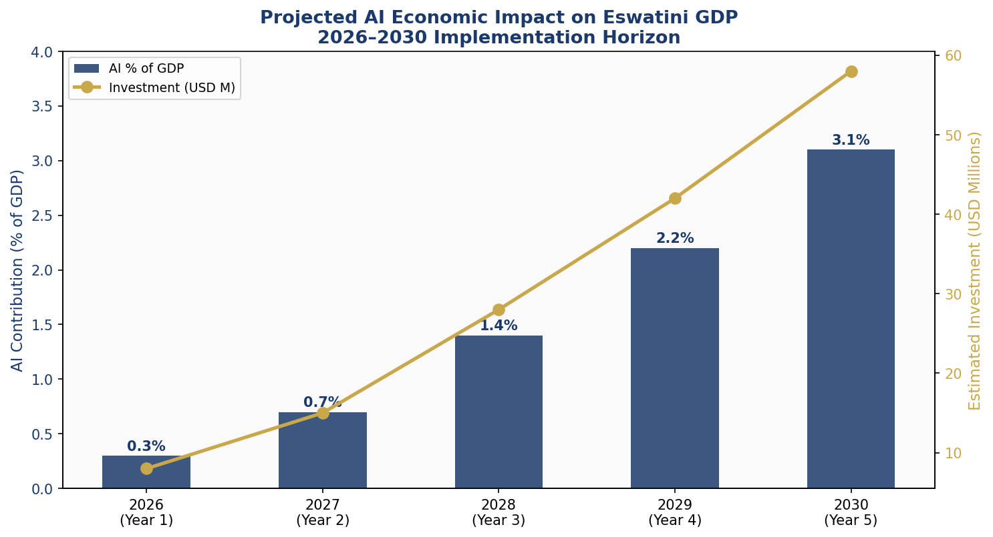
Figure 4.1 — Projected AI Contribution to Eswatini GDP and Estimated Investment (2026–2030)

4.2 National AI Investment Framework
The total 5-year AI investment requirement is estimated at USD 151 million, sourced from government budget allocations, SACU revenue sharing, development bank financing (World Bank IDA, African Development Bank), bilateral aid partnerships, and private sector co-investment. The recommended allocation across budget lines reflects both the foundational requirements and the long-term economic priorities of this policy.

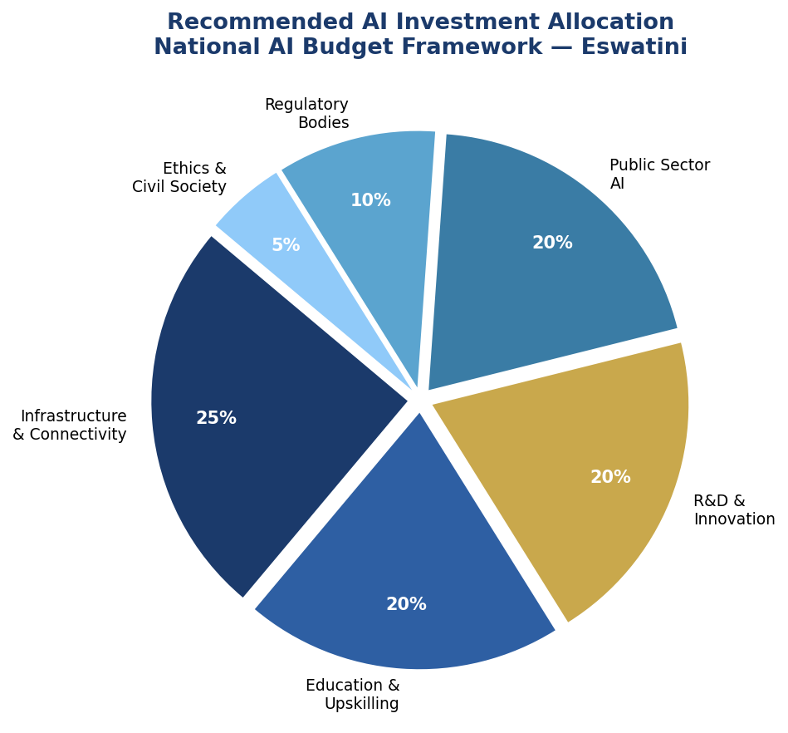
Figure 4.2 — Recommended National AI Budget Allocation by Category (2026–2031)

4.3 Priority Sectors for AI Adoption
Agriculture remains Eswatini's largest employer and a critical food security sector. AI-driven precision agriculture — including satellite imagery analysis, weather prediction models, and yield optimization algorithms — can directly increase smallholder farmer incomes. Healthcare AI, including outbreak prediction, telemedicine AI triage, and diagnostic imaging support at referral hospitals, can address critical health infrastructure gaps. The financial sector, particularly inclusive fintech and AI-driven credit access for SMEs, can accelerate economic participation. Tourism, leveraging AI-personalized visitor management and demand forecasting, presents growth potential. Textiles and manufacturing can benefit from AI-powered quality control and predictive maintenance systems.

4.4 Public-Private Partnership Framework
This policy establishes the Eswatini AI Investment Partnership Framework (EAIPF), administered by the Eswatini Investment Promotion Authority (EIPA). The framework provides: tax incentives for AI R&D expenditure (150% deduction allowance), fast-track investment registration for qualifying AI enterprises, co-investment matching for AI infrastructure projects, and market access support for AI startups exporting services. International technology companies entering Eswatini under this framework must commit to technology transfer, local hiring targets, and compliance with the national AI ethics standards.

Section 5: Education and Human Capital Development

5.1 Current Skills Gap Analysis
Eswatini's AI skills gap is significant but bridgeable. Current estimates suggest fewer than 200 professionals in the country have meaningful AI or machine learning competency. UNESWA graduates approximately 120 IT and computer science students annually, of whom fewer than 10% have exposure to AI concepts. The vocational training system, while serving approximately 8,000 students annually, has no AI-relevant curricula. Women represent only 31% of STEM graduates, and rural communities — comprising approximately 73% of the population — have near-zero exposure to computational education beyond basic digital literacy.
This gap presents both a challenge and an opportunity. Eswatini's relatively small population and centralized education system allow for rapid, national-scale curriculum reform. The country's high literacy rate (88%) provides a strong foundation. And Eswatini's young population (median age 21) means that investments in AI education will yield returns over multi-decade working careers.

5.2 National AI Curriculum Framework
This policy mandates the development and deployment of a tiered National AI Curriculum Framework, implemented by the Ministry of Education and Training in coordination with the Eswatini Qualifications Authority (EQA):
- K-8 (Primary): Computational thinking, logic games, basic programming concepts (Scratch/Python foundations), and AI awareness modules
- Forms 1-3 (Junior Secondary): Data literacy, algorithmic thinking, introduction to machine learning concepts, and responsible digital citizenship
- Forms 4-5 and A-Level (Senior Secondary): Applied AI and data science elective, programming fundamentals (Python), and AI ethics module
- Tertiary (UNESWA and colleges): Full BSc in Data Science and AI by 2027, AI-integrated modules across engineering, agriculture, health, and business programs
- Vocational and TVET: AI-enabled manufacturing, digital agriculture, and AI-assisted service delivery certifications

5.3 AI Education Pipeline Targets

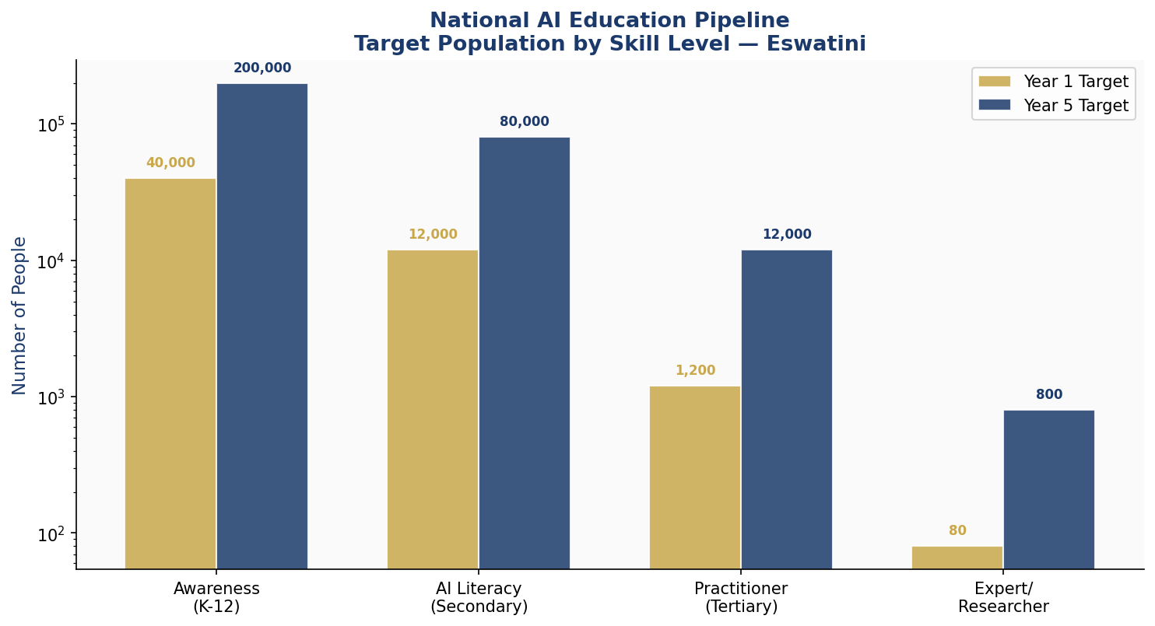
Figure 5.1 — National AI Education Pipeline: Target Population by Skill Level (Year 1 vs Year 5)

5.4 National AI Skills Scholarship Fund
The National AI Skills Scholarship Fund (NASSF) will be established under the Ministry of Education with initial capitalization of USD 5 million, growing to USD 15 million by Year 3 through co-financing with development partners. The fund will provide 500 scholarships annually for AI-relevant study — including domestic UNESWA programs and international partnerships with institutions in South Africa, Rwanda (Carnegie Mellon Africa), Kenya (Strathmore University), India (IITs), and Europe. Gender equity targets mandate that at least 40% of scholarship recipients are women, and at least 20% are from rural constituencies.

5.5 Women and Underrepresented Groups
Eswatini is committed to ensuring that the benefits of the AI economy are shared equitably across gender and regional lines. The AI Gender Equity Action Plan, developed under this policy, includes: targeted AI awareness campaigns in rural communities (via community radio and mobile platforms), dedicated women-in-AI coding bootcamps (targeting 2,000 women by Year 3), preferential scholarship allocations, mentorship programs connecting women in AI with established professionals in South Africa and globally, and a monitoring mechanism tracking women's representation across the AI education and employment pipeline annually.

Section 6: Ethical AI Governance and Regulatory Framework

6.1 National AI Ethics Board (NAEB)
The National AI Ethics Board (NAEB) will be established by executive order within six months of this policy's adoption. The NAEB will comprise 15 members: four government representatives (MICT, Ministry of Justice, Ministry of Health, Prime Minister's Office), three academic representatives (UNESWA and research institutions), three civil society representatives (including at least one women's rights organization and one disability rights representative), two private sector representatives (from technology and financial services), one independent international AI ethics expert, and the ICT Commissioner as ex-officio member. The NAEB Chairperson will be an independent appointment confirmed by Parliament.
The NAEB's mandate includes: developing and updating the Eswatini AI Ethics Charter, reviewing and approving high-risk AI systems proposed for government deployment, maintaining the national AI incident registry, publishing annual AI human rights impact assessments, advising Parliament on AI-related legislation, and representing Eswatini in regional and international AI governance forums.

6.2 AI Risk Classification System
Tier 1 — Unacceptable Risk (Prohibited)
The following AI applications are prohibited in Eswatini under this policy and any successor legislation:
- AI systems that deploy real-time biometric surveillance of citizens in public spaces without prior judicial authorization
- Social scoring systems that assess or rank citizens' trustworthiness, social behavior, or creditworthiness in ways that produce discriminatory or punitive outcomes
- AI systems that manipulate human behavior through subliminal techniques that bypass rational agency
- AI systems designed to exploit vulnerable populations, including children, elderly persons, or persons with disabilities
- AI-enabled autonomous lethal weapons systems
Tier 2 — High Risk (Regulated with Mandatory Assessment)
High-risk AI systems — those deployed in critical infrastructure, education assessment, employment, credit scoring, biometric identification, border control, judicial decision support, or emergency services — must undergo a mandatory Conformity Assessment and Ethics Review prior to deployment. Operators of high-risk AI must maintain audit logs, provide human override mechanisms, and submit annual performance and bias reports to the NAEB.
Tier 3 — Limited Risk (Transparency Obligations)
AI systems that interact with citizens through automated means — including chatbots, virtual assistants, and AI-generated content systems — must clearly disclose their AI nature to users. Deepfake and synthetic media generation tools must include embedded disclosure metadata.
Tier 4 — Minimal Risk (Voluntary Code of Conduct)
All other AI applications are subject to a voluntary National AI Code of Good Practice, encouraging industry self-regulation, ethics training, and transparency reporting.

6.3 Personal Data Protection Act
This policy mandates the development and parliamentary passage of a Personal Data Protection Act (PDPA) within 18 months of policy adoption. The PDPA will align with GDPR principles and the SADC Cyber Security Model Law, establishing: rights to access, rectify, delete, and port personal data; requirements for lawful basis of data processing; mandatory data breach notification within 72 hours; restrictions on cross-border data transfers; a Data Protection Commissioner with enforcement powers; and sector-specific standards for health, financial, and government data.

6.4 Algorithmic Accountability Standards
All AI systems used in public-sector decision-making — including in social welfare allocation, tax assessment, land administration, and criminal justice — must meet the Eswatini Algorithmic Accountability Standards (EAAS). These standards require: documentation of training data provenance and bias testing; mandatory human review for all algorithmic decisions that materially affect citizens' rights or interests; a citizen-accessible explanation mechanism (plain language summaries of how AI-assisted decisions are made); and an independent appeals pathway for citizens who contest AI-assisted decisions.

6.5 Anti-Corruption AI Guidelines
Given Eswatini's governance context, this policy recognizes that AI systems — if improperly designed or deployed — can enable or amplify corruption rather than reduce it. The Anti-Corruption AI Guidelines, developed jointly by the NAEB and the Anti-Corruption Commission (ACC), require: transparent, publicly documented procurement processes for all government AI contracts; independent technical audits of AI procurement outcomes; prohibition on AI systems that create opaque or non-auditable government decision-making; mandatory disclosure of beneficial ownership for AI vendors contracting with government; and whistleblower protections for persons reporting AI-related corruption.

Section 7: Public Sector and e-Governance AI

7.1 Strategic Government AI Use Cases
Eswatini's public sector offers significant opportunities for AI-driven transformation. The following priority use cases are identified for phased deployment over the 5-year implementation period:
- AI-powered Tax Compliance Analytics (Eswatini Revenue Authority): Machine learning models trained on taxpayer behavioral data to identify under-reporting, optimize audit selection, and improve VAT compliance — projected to increase revenue collection by 8–12%.
- Predictive Disease Surveillance (Ministry of Health): Early warning AI systems for HIV/AIDS treatment adherence monitoring, malaria outbreak prediction, and COVID-variant tracking — integrated with WHO GOARN international reporting systems.
- Intelligent Land Registry (Ministry of Housing and Urban Development): Automated cadastral mapping using satellite imagery and AI-assisted boundary dispute resolution, reducing processing time from months to days.
- AI Judicial Case Management (Judiciary of Eswatini): Natural language processing tools for legal document classification, case scheduling optimization, and precedent retrieval — addressing the court backlog without replacing judicial discretion.
- Smart Road Infrastructure Monitoring (Ministry of Public Works): IoT sensor data combined with AI predictive models to prioritize road maintenance in the national road network, reducing infrastructure deterioration costs by an estimated 20%.
- AI-driven Agricultural Extension Services (Ministry of Agriculture): Mobile AI advisory tools providing smallholder farmers with personalized crop management, weather, and market price information in SiSwati language.

7.2 Government AI Procurement Guidelines
All government AI procurement must comply with the Government AI Procurement Guidelines, developed jointly by MICT and the Public Procurement Regulatory Authority (PPRA). Key requirements include: mandatory AI ethics and risk assessment as part of the Request for Proposals (RFP) process; preference for AI solutions offering source code escrow or open-source components; vendor lock-in mitigation requirements; local skills transfer obligations for all international AI vendors; performance-based contracting with transparency KPIs; and mandatory post-deployment bias audits within 12 months of system launch.

7.3 Citizen-Facing AI Services Roadmap
Eswatini will develop a suite of citizen-facing AI services under the eSwatini Digital Government Platform, to be launched in phases: Phase 1 (Year 1) — AI chatbot for government service navigation and information, available in SiSwati and English via WhatsApp and USSD; Phase 2 (Year 2) — AI-assisted social grant eligibility assessment; Phase 3 (Year 3) — AI-powered national ID and business registration services; Phase 4 (Year 4–5) — comprehensive AI health triage tool integrated with the national health information system. All citizen-facing AI must include accessible design features for persons with disabilities and elderly citizens.

7.4 Data Interoperability and Standards
Eswatini will adopt open data interoperability standards — including ISO/IEC standards for data management and SADC cross-border data frameworks — to enable AI systems across government departments to share data securely and effectively. The Government Enterprise Architecture will be updated to include AI-ready data exchange protocols. A national master data management system will be established to provide authoritative data on citizens, enterprises, and land — the three core data domains for AI governance.

Section 8: Implementation Roadmap

8.1 Phased Implementation Strategy
This policy is implemented across three phases over five years, each with distinct priorities, milestones, and accountability structures. The phases are not sequential in isolation — many workstreams overlap — but each phase has a defining strategic focus that guides resource allocation and leadership attention.

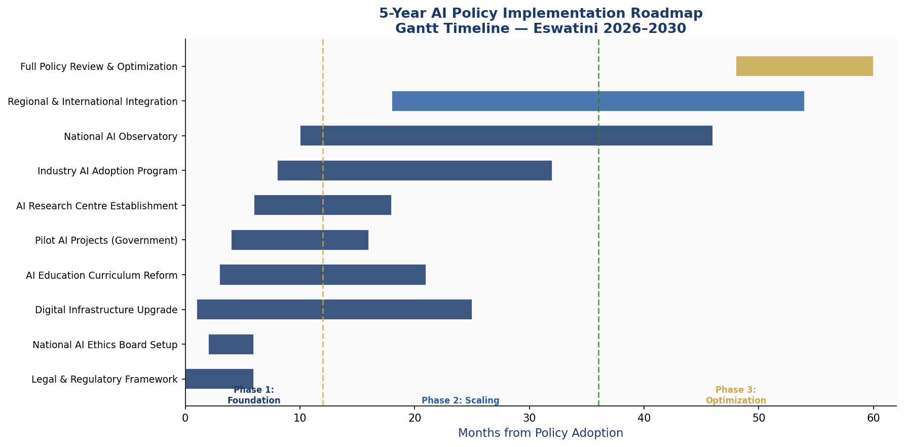
Figure 8.1 — 5-Year AI Policy Implementation Gantt Timeline (2026–2031)

8.2 Phase 1 — Foundation (Year 1: 2026)
Phase 1 establishes the legal, institutional, and technical foundations for Eswatini's AI ecosystem. Without these foundations in place, subsequent phases risk fragmentation and misalignment.
- Pass the Personal Data Protection Act (PDPA) in Parliament
- Establish the National AI Ethics Board (NAEB) with full membership and charter
- Create the AI Policy Implementation Unit within MICT
- Launch the National AI Skills Scholarship Fund (NASSF) with 200 initial scholars
- Commence digital infrastructure audit and rural broadband expansion planning
- Deploy AI for Agriculture Pilot Program targeting 5,000 farmers
- Develop and publish Government AI Procurement Guidelines
- Commence Personal Data Protection Act implementing regulations
- KPI target: NAEB operational, PDPA passed, 200 AI scholarships awarded, pilot program launched

8.3 Phase 2 — Scaling (Years 2–3: 2027–2028)
Phase 2 scales the foundational investments into national programs, deepens industry engagement, and begins the institutional transformation of government services through AI.
- Launch AI curriculum reform across 80% of secondary schools
- Deploy three priority government AI systems (tax, health surveillance, land registry)
- Establish Eswatini National AI Research Centre (ENARC) at UNESWA
- Launch National AI Startup Accelerator (first cohort of 20 startups)
- Complete rural broadband expansion covering Lubombo and Shiselweni regions
- Publish first Annual National AI State Report
- Achieve 30% women representation in AI scholarship programs
- KPI target: 60,000 students in AI curriculum, 3 government AI systems live, ENARC established

8.4 Phase 3 — Optimization (Years 4–5: 2029–2031)
Phase 3 consolidates gains, optimizes underperforming programs, integrates AI governance into all major public institutions, and begins positioning Eswatini as a regional AI knowledge-sharing hub.
- Conduct comprehensive policy review and update based on 3-year performance data
- Achieve GPAI formal membership and contribute to international AI governance dialogues
- Scale AI education to 200,000 trained citizens
- AI contribution to GDP reaching 2.5–3.1%
- Launch AI for Climate initiative tracking biodiversity and agricultural resilience
- Explore AI services export to regional markets (SADC member states)
- KPI target: AI GDP contribution 3%+, 200,000 trained, formal international participation

Section 9: Monitoring, Evaluation, and Accountability

9.1 National AI Observatory
The National AI Observatory (NAO) will be established as a semi-autonomous unit within MICT, with a mandate to track the implementation of this policy, collect and analyze AI-related data, and publish independent progress reports. The NAO will maintain the National AI Registry — a public database of all AI systems deployed by or under contract to the Government of Eswatini — and will operate a public-facing AI Incident Reporting Portal. The NAO will publish quarterly progress dashboards and an Annual National AI State Report, submitted to Parliament and made publicly available.

9.2 Parliamentary Oversight Mechanism
The Parliamentary Committee on Information and Communications Technology will serve as the primary legislative oversight body for this policy. The Minister of MICT will appear before the committee at least annually to report on AI policy implementation. The NAEB Chairperson will submit an annual independent report to Parliament on AI ethics and human rights implications. Parliament retains the right to establish a Special Select Committee on AI at any point during the policy period.

9.3 Civil Society and Independent Audit Role
Independent civil society organizations — including media, academic institutions, and NGOs — play an essential accountability role in Eswatini's AI governance framework. This policy commits the government to: proactive disclosure of AI system deployment information to civil society; funding for independent AI audit capacity building within Eswatini's civil society sector; an annual government-civil society AI dialogue forum; and protection of civil society actors who lawfully investigate or report on AI-related harms.

9.4 KPI Dashboard

KPI Metric | Baseline  (2026) | Year 1  Target | Year 3  Target | Year 5  Target
AI % of GDP | 0% | 0.3% | 1.4% | 3.1%
Citizens with AI Skills (any level) | < 500 | 5,000 | 60,000 | 200,000
Women in AI Scholarship Programs | < 10% | 30% | 40% | 45%
Government AI Systems Deployed | 0 | 1 | 4 | 8
AI Startups in Accelerator | 0 | 20 | 80 | 200
Internet Penetration (%) | 47% | 52% | 65% | 80%
NAEB Ethics Reviews Completed | 0 | 5 | 20 | 50
Personal Data Protection Act Status | Draft | Enacted | Fully Enforced | Regional Model
AI Research Publications (ENARC) | 0 | 5 | 30 | 100
CPI Score Improvement Target | 33 | 35 | 38 | 42

Section 10: International Cooperation and Diplomacy

10.1 Bilateral AI Cooperation Priorities
Eswatini will prioritize AI cooperation with South Africa — its dominant economic and technical partner — through the South Africa-Eswatini AI Bilateral Working Group, to be established under the existing bilateral cooperation framework. Key areas of cooperation include: joint AI research programs, cross-border digital infrastructure investment, shared AI ethics standards under the SADC framework, and training access for Eswatini professionals at South African institutions including the University of Witwatersrand's Wits AI Institute and Stellenbosch University. Additional bilateral AI partnerships will be pursued with India, the European Union (under the AU-EU Partnership), and Rwanda — a regional AI leader.

10.2 Regional AI Governance — African Union and SADC
Eswatini is a committed member of both the African Union and the Southern African Development Community (SADC), and this policy is explicitly designed to support the AU Continental AI Strategy (2022) and SADC Digital Economy Strategy objectives. Eswatini will actively participate in the AU AI High-Level Panel and will seek to host a SADC AI Policy Exchange Forum in Mbabane by Year 3. The country commits to adopting SADC Data Governance frameworks as they are developed, and will advocate for a regional AI skills mobility agreement allowing certified AI professionals to practice across SADC borders.

10.3 South-South Knowledge Transfer
Eswatini recognizes the immense value of South-South knowledge transfer in AI governance — particularly from African nations with more advanced AI ecosystems. This policy establishes a formal program of structured exchange with Rwanda (known for its AI governance leadership through the Rwanda ICT Chamber and Kigali Innovation City), Ghana (AI for Development program), and Kenya (Nairobi's Silicon Savannah ecosystem). Eswatini will also participate in the Smart Africa Alliance AI working group and the African Observatory on Responsible AI (AObRA).

10.4 Global AI Governance Participation
Eswatini will formally apply for observer status at the Global Partnership on AI (GPAI) by Year 2 and full membership by Year 3. It will contribute to UNESCO's AI Ethics Recommendation implementation review process, engage with the UN Secretary-General's High-Level Advisory Body on AI, and participate in ITU's AI for Good global summits. Eswatini's participation in these forums will be used to advocate for: recognition of small states' specific AI governance challenges, access to AI capacity-building programs for low-income countries, and fair representation of African perspectives in global AI norms development.

Conclusion

The Kingdom of Eswatini's National AI Policy 2026–2031 represents a bold, realistic, and ethically grounded commitment to harnessing artificial intelligence for the benefit of all Swati citizens. It acknowledges the country's genuine challenges — infrastructure gaps, skills shortages, governance capacity constraints, and corruption risks — while firmly positioning Eswatini as a nation that chooses to confront these challenges head-on through strategic, globally-aligned action.
The policy is not a statement of aspiration alone. It is a binding framework with specific institutional mandates, legal requirements, investment targets, and measurable KPIs. Its five strategic pillars — ethical AI, economic growth, education, public sector transformation, and innovation — are mutually reinforcing and are designed to create systemic change rather than isolated interventions. The three-phase implementation roadmap provides a practical sequencing of actions that respects Eswatini's absorptive capacity while maintaining momentum toward transformational outcomes.
AI is not a panacea for development challenges, and this policy does not pretend otherwise. But applied responsibly, it is among the most powerful tools available to a small, determined nation seeking to chart its own path in the twenty-first century global economy. Eswatini's Ubuntu values — humanity, community, shared dignity — are not obstacles to AI adoption; they are its moral compass. When AI is deployed in accordance with these values, it becomes a genuinely liberating force.
The Government of Eswatini calls on all stakeholders — citizens, the private sector, academia, civil society, development partners, and the international community — to partner in the realization of this policy. The future of Eswatini's AI ecosystem begins now.

References and Bibliography

African Union (2022). Continental AI Strategy: Harnessing AI for Africa's Development. African Union Commission, Addis Ababa.
European Parliament and Council of the EU (2024). Regulation on Artificial Intelligence (EU AI Act). Official Journal of the European Union.
G20 (2019). G20 AI Principles. Osaka Leaders' Declaration, Annex, June 2019.
Global Partnership on AI — GPAI (2023). GPAI Work Programme and Recommendations. GPAI Secretariat, Paris.
International Telecommunication Union — ITU (2023). AI for Good Global Summit Outcomes Report. Geneva: ITU.
McKinsey Global Institute (2023). The Economic Potential of Generative AI: The Next Productivity Frontier. McKinsey & Company.
OECD (2024). OECD AI Principles — Updated Framework for Responsible AI. OECD Publishing, Paris.
Oxford Insights (2023). Government AI Readiness Index 2023. Oxford Insights, Oxford.
Transparency International (2024). Corruption Perceptions Index 2024. Berlin: Transparency International.
UNESCO (2021). Recommendation on the Ethics of Artificial Intelligence. UNESCO, Paris.
World Bank (2023). World Development Report 2023: Migrants, Refugees, and Societies. Washington DC: World Bank Group.
World Bank (2024). AI for Africa: Building an Enabling Environment. World Bank Digital Development Global Practice.
World Bank World Governance Indicators (2023). Eswatini Country Data. Washington DC: World Bank Group.
World Economic Forum (2023). The Future of Jobs Report 2023. Geneva: World Economic Forum.

About the Author

Nafiul Ahmad Rafi
Policy & Good Governance Researcher | BD Civic Tech Architect
Nafiul Ahmad Rafi is a civic technologist, policy researcher, author, photographer, and musician based in Dhaka, Bangladesh. He is the Founder and Director of Insights Bangladesh, a data-driven governance and policy impact analysis institution, and the Founder & Lead Architect of NagorikBD.org — a transparency-first civic platform scaled across Mymensingh Division, connecting citizens with government services across 45 Upazilas.
His work exists at the intersection of institutional reform and artificial intelligence, transforming theoretical governance into scalable, data-driven reality. Without a conventional computer science degree, he self-taught the tools of modern AI and web development to build the infrastructure that enforces the policies he once only researched.

Key Platforms & Projects:
- NagorikBD.org — Civic transparency platform, Mymensingh Division
- Insights Bangladesh — Policy impact analysis institution
- FactCheck BD (factcheckbd.org) — Bangladesh's AI-powered fact-checking platform
- Political Insights BD / PIBD (pibbd.org) — Political intelligence and civic tech hub
- PeaceShield BD / National Peace Tracker — AI-powered hate speech and conflict monitoring
- PolicyLens AI (aigovbd.org) — 9-dimensional AI policy audit tool

He has published four books and maintains a personal site at ahmad-rafi.com.

Research Interests:
AI Governance · Policy Research · Future of Bangladesh · Climate Policy

Contact:
Website: ahmad-rafi.com
LinkedIn: linkedin.com/in/nafiul-ahmad-rafi
Email: contact@ahmad-rafi.com

"I build code to ensure transparency, and I write lyrics to inspire the courage to use it."

