🇪🇹

FEDERAL DEMOCRATIC REPUBLIC OF ETHIOPIA
National Artificial Intelligence Policy 2025–2030
A Comprehensive Framework for Ethical, Inclusive, and Economically Transformative AI

Prepared by:
Nafiul Ahmad Rafi
Policy & Good Governance Researcher | Insights Bangladesh

May 2025

Table of Contents

Executive Summary
Ethiopia stands at a pivotal moment in its national development trajectory. With a population of over 126 million people, a rapidly urbanizing economy, and an increasingly connected digital environment, the country possesses both the need and the latent potential to harness Artificial Intelligence as a transformative force for equitable growth, improved governance, and accelerated human development. This National AI Policy 2025–2030 establishes Ethiopia's comprehensive strategic framework for developing, deploying, and governing AI technologies in a manner consistent with national priorities, international ethical standards, and the aspirations of the Ethiopian people.
Ethiopia's AI readiness presents a mixed picture. The country's economy, historically anchored in agriculture, has undergone significant structural reforms through the Homegrown Economic Reform Agenda, with emerging growth in manufacturing, digital services, and fintech. However, significant challenges persist: internet penetration stands at approximately 22%, digital literacy gaps are acute, and institutional capacity for technology regulation remains nascent. Corruption, with a Transparency International CPI score of 38/100 (2024), poses a meaningful governance risk that must be addressed as a precondition for trustworthy AI deployment in the public sector.
This policy is structured around five strategic pillars: (1) Ethical AI and Human Rights Protection, ensuring that AI systems deployed in Ethiopia respect fundamental rights, promote transparency, and avoid discriminatory outcomes; (2) Economic Growth and Industrial AI Adoption, which targets high-impact sectors including agriculture, health, financial inclusion, and infrastructure; (3) Education, Upskilling, and AI Workforce Development, with a target to equip 3 million Ethiopians with practitioner-level AI skills by 2030; (4) Public Sector AI and e-Governance, deploying AI to modernize service delivery, reduce corruption, and improve administrative efficiency; and (5) AI Research, Innovation, and Startup Ecosystem Development, cultivating a domestic AI innovation base linked to global knowledge networks.
The policy is fully aligned with the UNESCO Recommendation on the Ethics of AI (2021), the OECD AI Principles (updated 2024), the EU AI Act risk-based governance framework, the World Bank's AI for Development strategy, and the AU Digital Transformation Strategy 2020–2030. Implementation is structured across three phases — Foundation (2025–2026), Scaling (2027–2028), and Optimization (2029–2030) — with total projected public AI investment of USD 1.2 billion over five years. At full implementation, AI is projected to contribute between 2.5% and 4.2% of Ethiopia's GDP by 2030, generating over 200,000 new digital economy jobs and significantly improving public service delivery for millions of citizens.

Section 1: National AI Readiness Assessment

1.1 Economic Context
Ethiopia is classified as a Low-Income Country (LIC) by the World Bank, with a GDP of approximately USD 155 billion (2024) and a per capita income of approximately USD 1,300. The economy has sustained average annual growth of 7–9% over the past decade, making it one of Africa's fastest-growing economies. The primary sector (agriculture) accounts for approximately 34% of GDP and employs over 70% of the labor force, though this share is declining as manufacturing and services expand. The government's Homegrown Economic Reform Agenda (HERA), launched in 2019 and extended through the 2030 Growth and Transformation Plan, prioritizes industrialization, export diversification, and digital economy development. Ethiopia's foreign exchange constraints, high public debt, and ongoing regional security challenges create a complex macroeconomic environment for AI investment planning.
Ethiopia's digital economy is nascent but rapidly expanding. Mobile money adoption has grown significantly following the liberalization of the telecom sector in 2021 with the entry of Safaricom Ethiopia. The fintech sector, creative industries, and agri-tech startups are experiencing acceleration in Addis Ababa's emerging innovation ecosystem, particularly around Sheba Valley — Ethiopia's answer to Silicon Valley — and the Africa Innovation Foundation's programs in the country.

1.2 Education and Human Capital
Ethiopia's adult literacy rate stands at approximately 52%, one of the lower rates in Sub-Saharan Africa, reflecting decades of underinvestment and a large rural population with limited access to formal education. Tertiary enrollment is approximately 9%, though the government has made significant investments in expanding higher education through universities in all regional states. STEM education remains weak relative to population size: fewer than 15,000 graduates per year have meaningful computing or data skills, and formal AI education programs exist at only a handful of universities including Addis Ababa University (AAU), Bahir Dar University, and Mekelle University. Significant digital skills gaps exist across the public sector, private sector, and civil society, making education and upskilling a central pillar of this policy.

1.3 Digital Infrastructure
Ethiopia's digital infrastructure is improving but remains significantly below the level needed to support widespread AI deployment. Internet penetration stands at approximately 22% (2024), with mobile broadband accounting for the vast majority of connections. Fixed broadband coverage is limited to urban centers. Ethio Telecom, the state-owned operator, remains the dominant provider despite partial liberalization. National data center capacity is limited, and cloud computing adoption in the public sector is minimal. The government's National Broadband Plan targets 80% coverage by 2030, which — if achieved — would create the connectivity foundation for AI service delivery at scale. The National ID (Fayda ID) digital infrastructure, launched in recent years, provides an important foundation for digital government services and AI-enabled service personalization.

1.4 Governance and Institutional Capacity
Ethiopia has a federal governance structure with significant regional autonomy. The Ministry of Innovation and Technology (MInT) is the primary institution responsible for ICT and digital transformation policy. The Ethiopian Information Network Security Administration (INSA) oversees cybersecurity. Regulatory capacity for emerging technologies is limited, and Ethiopia does not yet have dedicated AI governance legislation. The country has a Personal Data Protection Proclamation in draft stages. The Ethiopian Standards Institute (ESI) has limited capacity for technology standards. Building institutional capacity for AI governance is a prerequisite for effective policy implementation and will require significant investment in technical expertise, regulatory tools, and cross-ministerial coordination mechanisms.

1.5 Corruption Risk Assessment
Transparency International's 2024 Corruption Perceptions Index (CPI) ranks Ethiopia at 38/100, classifying it in the 'high corruption risk' tier. World Bank Worldwide Governance Indicators (WGI) rate Ethiopia as below the 30th percentile globally on Control of Corruption and Rule of Law. These findings have direct implications for AI governance: high-risk AI applications in the public sector — such as automated benefits systems, law enforcement analytics, and judicial support tools — must be subject to independent auditing and strong accountability mechanisms to prevent AI from amplifying existing governance failures. This policy requires all government AI systems to undergo mandatory algorithmic audits and establishes an anti-corruption AI deployment protocol.
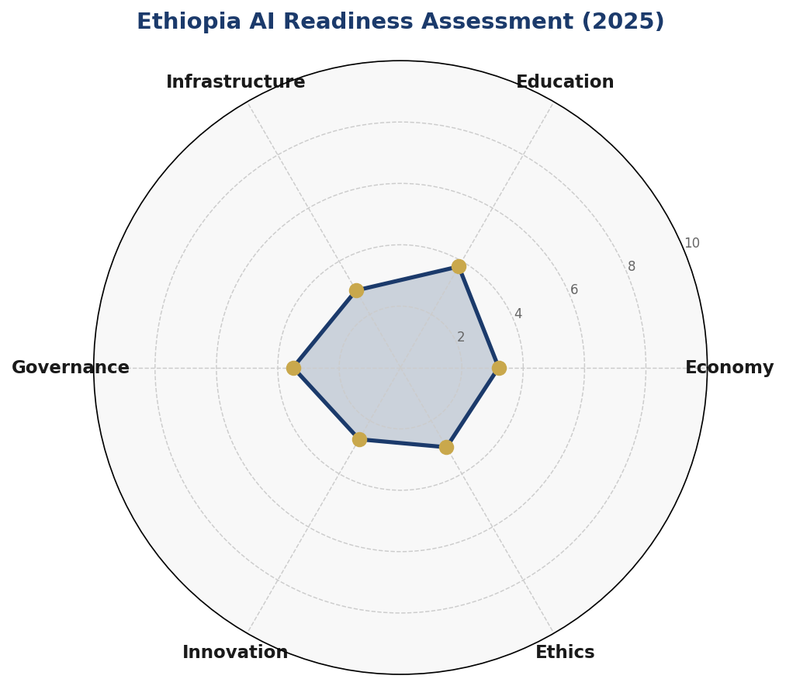
Figure 1.1: Ethiopia AI Readiness Assessment — Six-Dimension Radar (2025, Scores out of 10)
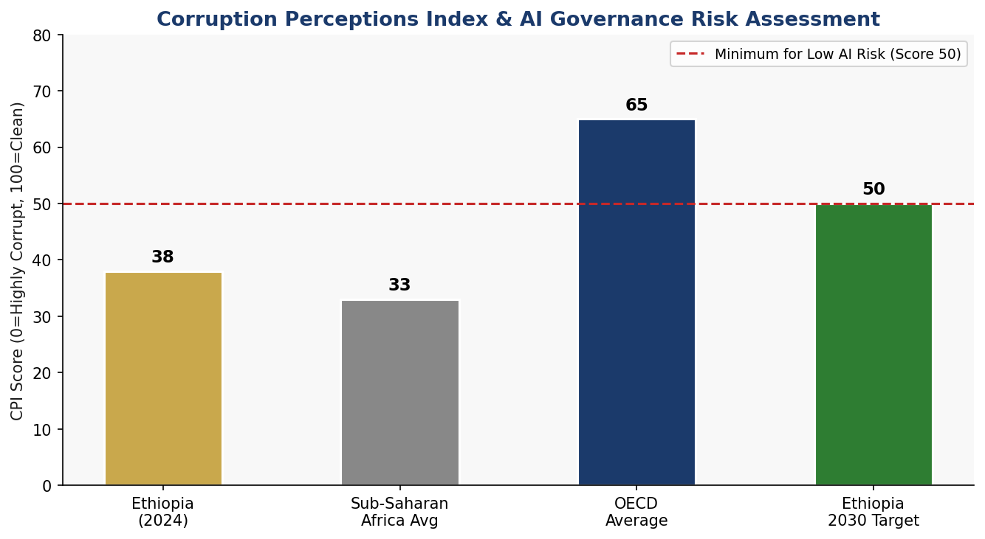
Figure 1.2: Corruption Perceptions Index — Ethiopia vs. Benchmarks and 2030 Target

Section 2: Policy Vision and Strategic Pillars

2.1 Vision Statement
"By 2030, Ethiopia will be a Pan-African leader in human-centered, ethically governed Artificial Intelligence — deploying AI as an equalizer of opportunity, an engine of sustainable growth, and a guardian of democratic governance — ensuring that no Ethiopian is left behind in the Fourth Industrial Revolution."

2.2 Strategic Pillar 1: Ethical AI and Human Rights Protection
Ethiopia commits to developing and deploying AI systems that respect and promote fundamental human rights, democratic values, and the rule of law. This pillar establishes the ethical foundation upon which all other policy pillars rest. It encompasses the creation of a National AI Ethics Board, the adoption of an AI Bill of Rights for Ethiopian citizens, and the integration of human rights impact assessments as a mandatory step in public sector AI procurement. Specific protections will be instituted to prevent AI systems from reinforcing existing structural inequalities based on ethnicity, gender, religion, or economic status — particularly relevant in Ethiopia's diverse multi-ethnic federal context.
Key commitments include: prohibition on mass surveillance AI systems without judicial oversight; mandatory explainability requirements for AI decisions affecting citizens' rights; independent algorithmic auditing for high-risk government AI; and a Civil Society AI Oversight Panel with meaningful enforcement powers.

2.3 Strategic Pillar 2: Economic Growth and Industrial AI Adoption
AI adoption in Ethiopia's priority economic sectors — agriculture, health, financial inclusion, manufacturing, and infrastructure — offers the highest-impact pathway to accelerated human development. This pillar establishes a sectoral AI adoption roadmap, a Public-Private Partnership (PPP) framework for AI investment, and fiscal incentives for domestic and foreign AI companies investing in priority sectors. Agriculture AI applications — including precision farming analytics, crop disease detection, and market price AI — will target Ethiopia's 14 million smallholder farming households, with pilot programs in Oromia, Amhara, and Southern Ethiopia regions.
Health AI applications will prioritize diagnostic support tools for understaffed rural health facilities, maternal health monitoring, and disease surveillance — building on existing digital health platforms like DHIS2. Financial AI will expand credit scoring and mobile lending for the 70% of Ethiopians currently outside formal financial services.

2.4 Strategic Pillar 3: Education, Upskilling and AI Workforce Development
Ethiopia's AI ambitions can only be realized through a massive, sustained investment in human capital. This pillar establishes a National AI Education Framework spanning K-12 digital literacy, university AI degree programs, TVET-level AI user training, and lifelong learning for the existing workforce. A target of 3 million AI-competent workers by 2030 — from basic AI users to advanced researchers — will require a tripling of STEM graduates, the establishment of six regional AI Centres of Excellence, and aggressive international scholarship and fellowship programs. Gender equity targets require that 40% of all AI education program beneficiaries are women and girls by Year 3, rising to 50% by Year 5.

2.5 Strategic Pillar 4: Public Sector AI and e-Governance
Ethiopia's government faces acute capacity challenges in delivering quality services to 126 million citizens across diverse geographies. AI offers significant potential to augment public sector capacity in tax administration, land registry, health service delivery, agricultural extension, judicial efficiency, and anti-corruption enforcement. This pillar establishes an e-Government AI Masterplan, mandatory AI readiness assessments for all federal ministries, and a Government AI Procurement Framework that ensures responsible, interoperable, and cost-effective AI adoption. Citizen-facing AI services — including AI-powered grievance redress, multilingual government chatbots in Amharic, Oromo, Tigrinya, and Somali — will be prioritized.

2.6 Strategic Pillar 5: AI Research, Innovation and Startup Ecosystem
Ethiopia's long-term AI competitiveness depends on building a domestic research and innovation base. This pillar establishes the Ethiopian AI Research Fund (EAIF) with USD 50 million in initial capitalization, supports the Sheba Valley Innovation Ecosystem in Addis Ababa, establishes AI-focused incubators at five universities, and creates a regulatory sandbox for AI startups. International partnerships with leading AI research institutions — including MBZUAI (UAE), KAIST (Korea), MIT Media Lab, and AI4D Africa — will accelerate knowledge transfer. Ethiopia will also position itself as a Pan-African AI training data hub, leveraging its 80+ languages and diverse ecological datasets as a unique comparative advantage in the global AI ecosystem.

Section 3: International Framework Alignment
This National AI Policy is designed in full recognition of Ethiopia's responsibilities as a signatory to international human rights instruments and an active participant in global AI governance fora. The following subsections detail how this policy maps to each major international AI governance framework, ensuring Ethiopia's approach is globally credible, interoperable, and positioned for international AI cooperation.

3.1 UNESCO Recommendation on the Ethics of Artificial Intelligence (2021)
Ethiopia adopts all 11 core values of the UNESCO AI Ethics Recommendation as binding principles for public sector AI and as voluntary guidelines for private sector AI. These values — human rights and dignity, social and environmental wellbeing, diversity and inclusiveness, environment and ecosystem flourishing, transparency and explainability, responsibility and accountability, safety and security, fairness and non-discrimination, privacy and data protection, sharing benefits, and sustainable development — are woven throughout the five strategic pillars of this policy. Ethiopia participated in the UNESCO AI Readiness Assessment Methodology (RAM) in 2023, which informed the baseline diagnostics in Section 1.

3.2 OECD AI Principles (Updated 2024)
Although Ethiopia is not an OECD member, the OECD AI Principles represent the global gold standard for AI governance and have been adopted by the G20, G7, and over 46 countries. This policy endorses all five OECD AI Principles: inclusive growth and wellbeing; human-centered values; transparency and explainability; robustness, security, and safety; and accountability. The National AI Ethics Board established under Section 6 will use the OECD AI Policy Observatory framework as a reference for annual benchmarking of Ethiopia's AI governance progress.

3.3 EU AI Act (2024) — Risk-Based Framework Adoption
Ethiopia adopts a risk-tiered AI governance framework modeled on the EU AI Act's four-category approach, adapted for the Ethiopian legal, institutional, and developmental context. Category adaptations reflect Ethiopia's specific risks around ethnic bias in algorithmic systems, the limited judicial independence context, and the primacy of development-focused AI applications. The four risk tiers are defined in detail in Section 6 of this policy.

3.4 World Bank AI for Development Strategy
The World Bank's AI for Development approach emphasizes human capital investment, responsible data governance, and AI adoption in public service delivery as key levers for development impact. This policy aligns with all three emphases: Pillar 3 constitutes a massive human capital investment; Section 6 establishes data governance; and Pillar 4 focuses AI deployment on public services. Ethiopia will engage the World Bank's Digital Development Partnership and the GovTech Maturity Index as benchmarking tools.

3.5 African Union Digital Transformation Strategy 2020–2030
The AU Digital Transformation Strategy provides the continental framework within which Ethiopia's national AI policy operates. Ethiopia commits to contributing to the development of the Continental AI Policy Framework, sharing lessons from national implementation, and supporting the AU's vision of a Single Digital Market for Africa by 2030. Ethiopia will seek to co-chair the AU Working Group on AI Governance and position Addis Ababa — home of the AU Commission — as a center for Pan-African AI governance dialogue.

3.6 Comprehensive Framework Alignment Matrix

Framework / Principle | Policy Pillar Alignment | Status | Notes
UNESCO: Human Dignity & Autonomy | Pillar 1 (Ethics) | ✅ Full | AI Bill of Rights, Ethics Board
UNESCO: Transparency & Explainability | Pillar 1, Pillar 4 | ✅ Full | Mandatory explainability for govt AI
UNESCO: Sustainability | Pillar 2, Pillar 5 | ✅ Full | Green AI targets in infrastructure
UNESCO: Privacy & Data Governance | Pillar 1, Pillar 4 | ⚠️ Partial | Data Protection Law pending
UNESCO: Safety & Security | Pillar 1, Pillar 4 | ✅ Full | INSA oversight, risk classification
OECD: Inclusive Growth | Pillar 2, Pillar 3 | ✅ Full | Smallholder AI, gender targets
OECD: Robustness & Security | Pillar 1 | ⚠️ Partial | Technical capacity still developing
OECD: Accountability | Pillar 4, Pillar 9 | ✅ Full | AI Observatory, Parliamentary oversight
EU AI Act: Unacceptable Risk | Pillar 1, Section 6 | ✅ Full | Mass surveillance ban adopted
EU AI Act: High Risk Controls | Pillar 1, Section 6 | ✅ Full | Mandatory audit for govt AI
EU AI Act: Transparency | Pillar 1, Pillar 4 | ✅ Full | Disclosure obligations adopted
World Bank: Human Capital | Pillar 3 | ✅ Full | 3M workforce target by 2030
World Bank: Governance | Pillar 4 | ✅ Full | Anti-corruption AI protocols
G20: AI for Good (SDGs) | All Pillars | ✅ Full | SDG linkage in all pillars
ITU AI for Good: Connectivity | Pillar 4, Pillar 2 | ⚠️ Partial | Infrastructure investment ongoing
AU Digital Transformation Strategy | All Pillars | ✅ Full | Aligned with AU 2030 targets

Section 4: Economic Impact and Investment Roadmap

4.1 Projected AI Economic Contribution
Modeling based on World Bank, McKinsey Global Institute, and African Development Bank estimates for low-income African economies with comparable AI adoption potential suggests that Ethiopia's GDP could see an AI-attributable contribution of between 2.5% (conservative) and 4.2% (optimistic) by 2030. These estimates assume sustained public investment in digital infrastructure, successful skills development at scale, and effective private sector engagement through the PPP framework. In absolute terms, this represents between USD 4.5 billion and USD 7.5 billion in annual economic value by 2030 — a significant contribution for an economy of Ethiopia's size.
The agriculture sector alone — which employs 70% of the population — offers the single largest near-term AI opportunity: precision agriculture analytics, climate-smart advisory services, and supply chain AI for smallholder farmers could increase agricultural productivity by 15–25%, adding USD 2 billion+ to agricultural output annually by 2028. Health AI in diagnostics and disease surveillance could reduce preventable deaths by an estimated 45,000–80,000 annually by 2030, with significant human welfare and economic productivity implications.
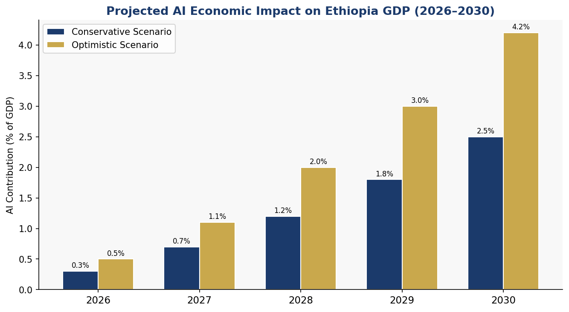
Figure 4.1: Projected AI Contribution to Ethiopia's GDP (2026–2030, % of GDP)

4.2 Investment Allocation Framework
The National AI Investment Plan targets total public expenditure of USD 1.2 billion over 2025–2030, sourced from a combination of federal budget allocation, development partner contributions (World Bank, AfDB, EU, bilateral donors), and the AI Sovereign Fund established under this policy. The recommended sectoral allocation balances near-term infrastructure needs with the longer-term imperatives of education, research, and regulatory capacity building.
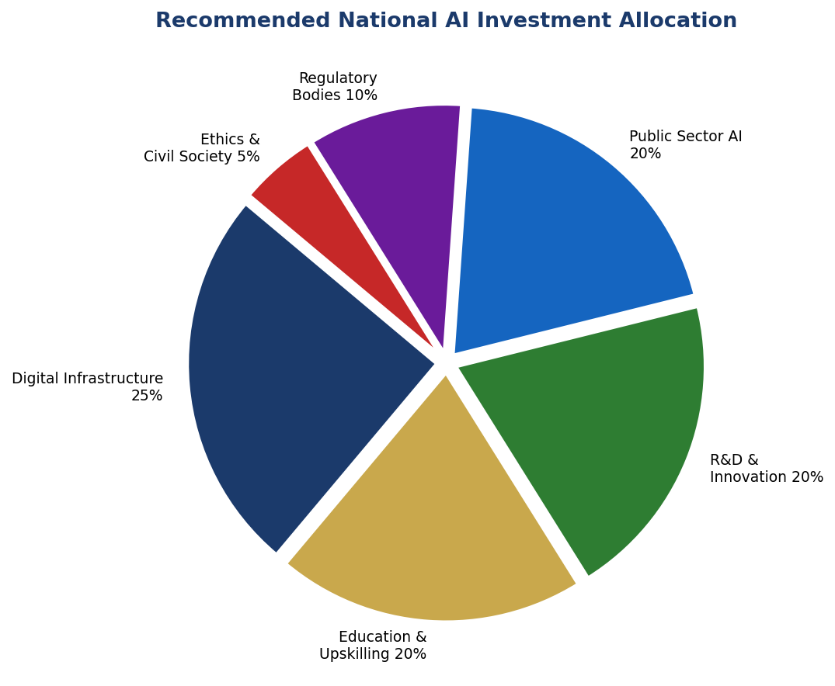
Figure 4.2: National AI Investment Allocation by Sector (2025–2030)

4.3 Priority Sectors for AI Adoption
Agriculture and Food Security: AI-powered pest detection, yield prediction, and climate advisory tools targeting 14 million smallholder households. Partnerships with Digital Green, Precision Development, and domestic agri-tech startups including Hahu Jobs and Gebeya.
Healthcare: AI diagnostic support at primary health care units, maternal and child health monitoring, malaria and tuberculosis AI detection tools. Building on the Community Health Information System (CHIS) and DHIS2 platforms already deployed nationally.
Financial Services: AI-powered credit scoring for unbanked populations, fraud detection in mobile money, micro-insurance risk modeling. Target: 20 million new financially included citizens by 2028 through AI-enabled financial services.
Infrastructure and Construction: AI-optimized logistics for the Grand Ethiopian Renaissance Dam (GERD) power distribution network, road and rail asset management AI, and urban planning analytics for rapidly growing cities including Addis Ababa, Dire Dawa, and Hawassa.
Education Technology: AI-powered adaptive learning platforms in Amharic and regional languages, teacher training support tools, and dropout prediction algorithms for early intervention in the school system.

4.4 Public-Private Partnership Framework
The Ethiopian AI PPP Framework establishes clear roles for government (regulation, infrastructure investment, public sector AI deployment), private sector (product development, service delivery, innovation), academia (research, talent development, standards), and civil society (accountability, user advocacy). Tax incentives for AI companies — including a 5-year corporate tax holiday for qualifying AI startups and an R&D tax credit of 150% for AI-related expenditure — will be introduced through amendments to the Investment Proclamation. A Regulatory Sandbox with a 24-month fast-track licensing regime will enable AI product testing without full regulatory compliance burden.

Section 5: Education, Upskilling, and Human Capital Development

5.1 Current Skills Gap Analysis
Ethiopia's AI human capital gap is profound. Of a working-age population of approximately 65 million, fewer than 50,000 individuals have meaningful data science or AI skills. University AI program output is approximately 2,000 graduates per year across all institutions — wholly inadequate to support the ambitions of this policy. Digital literacy, defined as the ability to use basic digital tools and navigate online services, covers only approximately 15% of the adult population. This reality demands a multi-track, multi-speed education strategy that simultaneously addresses basic digital literacy, mid-level AI tool use, professional AI practitioner skills, and advanced research capability.

5.2 National AI Curriculum Framework
K-12 (Ages 6–18): Integrate computational thinking from Grade 1. Introduce data literacy and AI ethics concepts from Grade 5. Full coding and basic machine learning modules from Grade 9. Target: 100% of public school students with AI literacy by 2028. Tool: Partnership with Code.org, African School of Excellence, and national curriculum development institute.
Technical and Vocational Education (TVET): Develop AI-augmented curricula for 12 priority vocational tracks including healthcare, construction, agriculture, and manufacturing. Target: 500,000 TVET graduates with AI tool proficiency by 2029.
University Level: Establish AI degree programs at all 11 government universities. Create the Ethiopian Graduate School of AI (EG-SAI) as a national centre of excellence for advanced AI research and postgraduate education. Target: 10,000 AI graduates annually by 2028.
Lifelong Learning: National AI Reskilling Program targeting 500,000 working professionals through a mix of online courses (partnering with Coursera, edX, and local platforms), weekend bootcamps, and employer-based training subsidies.
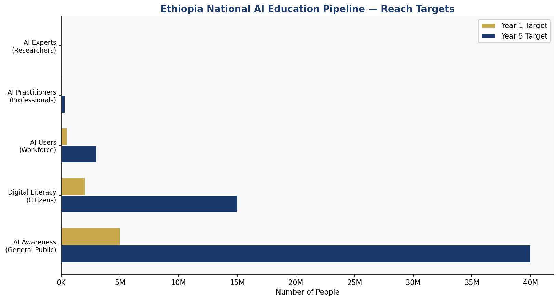
Figure 5.1: Ethiopia National AI Education Pipeline — Reach Targets (Year 1 vs. Year 5)

5.3 Women and Underrepresented Groups Inclusion
Ethiopia's AI education and workforce strategy must explicitly address the gender digital divide. Women represent only 28% of current ICT workers and have significantly lower rates of internet access, smartphone ownership, and digital literacy than men. This policy mandates that all government-funded AI education programs achieve a minimum 40% female enrollment by Year 2 and 50% by Year 4. Dedicated scholarships, childcare support at training centers, and community-based digital literacy programs targeting rural women will be established. Similar inclusion targets apply for youth from conflict-affected regions, persons with disabilities, and linguistically marginalized communities.

5.4 International Partnerships
Ethiopia will seek bilateral AI scholarship agreements with the UAE (Mohamed bin Zayed University of AI), South Korea (KAIST AI program), India (IIT AI fellowships), and the EU (Erasmus+ AI cohorts). The Ethiopian AI Diaspora Network will mobilize Ethiopian AI professionals globally to contribute as remote mentors, visiting faculty, and startup advisors. Ethiopia will also anchor the African AI Fellowship Program — a Pan-African competitive fellowship placing 200 African AI researchers at Ethiopian universities annually.

Section 6: Ethical AI Governance and Regulatory Framework

6.1 National AI Ethics Board
The National AI Ethics Board (NAEB) will be established within 12 months of this policy's adoption, housed under the Office of the Prime Minister to ensure cross-ministerial authority. The NAEB will comprise 15 members: 3 government representatives (MInT, Ministry of Justice, Ministry of Health); 3 representatives from academia and research institutions; 3 from private sector and startup ecosystem; 3 from civil society and human rights organizations; and 3 independent international AI ethics experts. The Board will have regulatory power to issue binding guidelines, investigate complaints, commission audits of high-risk AI systems, and recommend legislative action to Parliament. A rotating chairperson ensures no single sector dominates governance.

6.2 AI Risk Classification System
Ethiopia adopts a four-tier AI risk classification system, adapted from the EU AI Act and calibrated to Ethiopia's specific governance context, institutional capacity, and development priorities:

Risk Category | Definition | Examples in Ethiopia Context | Requirements
Unacceptable Risk  (PROHIBITED) | AI posing fundamental threat to rights and safety | Mass ethnic surveillance; Predictive policing without oversight; Social credit scoring | Absolute prohibition; Criminal penalties for deployment
High Risk  (REGULATED) | AI with significant potential for rights violations | Judicial sentencing support; Benefits eligibility AI; Refugee screening; Biometric ID | Mandatory human review; Independent audit; Transparency; Liability rules
Limited Risk  (TRANSPARENCY) | AI interacting with citizens or generating content | Government chatbots; Automated tax notices; AI-generated public comms | Disclosure to users; Right to human review; Opt-out mechanisms
Minimal Risk  (VOLUNTARY) | AI with negligible rights impact | AI spam filters; Crop disease detection tools; Traffic optimization | Voluntary code of conduct; Industry self-regulation encouraged

6.3 Data Protection and Privacy
Ethiopia's Data Protection Proclamation, currently in draft, will be fast-tracked for Parliamentary adoption within the first year of this policy's implementation. The proclamation will establish: individual rights to data access, correction, and deletion; consent requirements for AI data collection; mandatory data breach notification; cross-border data transfer restrictions; and a National Data Protection Authority with enforcement powers. All government AI systems will be subject to Privacy Impact Assessments before deployment. Special category data — including ethnic background, health data, financial data, and political affiliation — will require explicit consent and heightened protection.

6.4 Algorithmic Accountability Standards
All high-risk government AI systems will be subject to mandatory Algorithmic Impact Assessments (AIAs) before deployment, annual independent audits during operation, and public disclosure of system purpose, training data sources, and key design decisions. Ethiopia will develop a national AI audit framework in partnership with the African Union's AI governance initiative and the Partnership on AI. Citizens affected by algorithmic decisions — including in benefits, criminal justice, or immigration contexts — will have a guaranteed right to human review and meaningful explanation.

6.5 Anti-Corruption AI Protocol
Given Ethiopia's corruption risk profile, this policy establishes a specific Anti-Corruption AI Protocol applying to all public sector AI procurements. This protocol requires: open tender procurement for all AI systems above USD 100,000 in value; mandatory publication of AI vendor contracts; prohibition on AI systems procured from vendors with corruption convictions; independent technical review of AI systems before deployment; and real-time audit logging of all AI decisions in high-risk government contexts. The Ethiopian Anti-Corruption Commission will be given specific oversight authority over public sector AI procurement.

Section 7: Public Sector AI and e-Governance

7.1 Priority Government Use Cases
The government will prioritize eight AI use cases in the first phase of public sector AI deployment, selected based on development impact, technical feasibility, and governance safety:
- Agricultural Extension Services: AI-powered crop advisory delivered via SMS and IVR to 5 million smallholder farmers in Amharic, Oromo, Tigrinya, and Afar languages.
- Tax Administration AI: Automated VAT compliance checking and audit selection in the Ethiopian Revenue and Customs Authority (ERCA), targeting a 20% increase in domestic revenue mobilization.
- Land Registry Digitization: AI-assisted document processing and satellite imagery analysis for the 40-million-parcel national land registry — addressing a root cause of investment uncertainty and rural conflict.
- Health Diagnostics Support: AI-powered X-ray and ultrasound analysis tools for district hospitals and health centers lacking specialist physicians.
- Court Case Management AI: AI tools for scheduling, translation, and document processing in federal courts — reducing average case resolution time from 4.2 years to under 2 years.
- Social Protection Targeting: AI analysis of household survey, mobile money, and proxy means test data to improve targeting of the Productive Safety Net Programme (PSNP) reaching 8 million beneficiaries.
- Multilingual Government Chatbot: Citizen-facing AI assistant for government services in 6 Ethiopian languages, deployed via mobile apps, USSD, and web.
- AI-powered Anti-Corruption Reporting: Machine learning analysis of procurement data, asset declarations, and financial flows to flag corruption risks for investigation.

7.2 Government AI Procurement Framework
All government AI procurements above USD 50,000 will follow a standardized AI Procurement Framework that includes: pre-procurement AI readiness assessment; requirements for algorithmic transparency; mandatory pilot testing with affected communities; independent technical review; privacy impact assessment; and post-deployment monitoring plans. Preference will be given to solutions that can be locally maintained, are open-source where appropriate, and involve meaningful knowledge transfer to Ethiopian technical staff. Foreign AI vendors will be required to establish local offices and partner with Ethiopian firms for procurements above USD 500,000.

7.3 Interoperability Standards
Ethiopia will adopt the open data and API standards recommended by the Digital Public Infrastructure (DPI) framework — including OpenID Connect for identity, FHIR for health data, and ISO/IEC 42001 for AI management systems — to ensure that government AI systems can share data, integrate services, and be audited consistently. The National AI Interoperability Registry, managed by MInT, will maintain a live catalog of all government AI systems, their data inputs, outputs, and governance status.

Section 8: Five-Year Implementation Roadmap

8.1 Implementation Phases Overview
The implementation of this National AI Policy is structured across three overlapping phases, each with distinct objectives, institutional requirements, and measurable outcomes. The phases are designed to be sequenced — with Foundation activities creating the conditions for Scaling, and Scaling creating the conditions for Optimization — while allowing for adaptive management as the technology landscape and Ethiopia's own capacity evolve.
Phase | Period | Key Milestones | Target KPIs
Phase 1: Foundation | 2025–2026 | Legal framework enacted; Ethics Board established; 3 AI pilots launched; AI curriculum for 500 schools | Data Protection Law passed; 50,000 citizens in AI training; USD 100M investment mobilized
Phase 2: Scaling | 2027–2028 | National AI rollout across all ministries; University AI programs in 8 universities; 500 AI startups supported; PPP fund operational | 1M citizens with AI skills; 15% increase in public service efficiency; 100 AI products commercialized
Phase 3: Optimization | 2029–2030 | AI Observatory fully operational; International AI exports; Policy review and update cycle; Pan-African AI leadership | 3M AI-competent workers; 2.5%+ GDP contribution; AI regulatory model adopted by 5 African nations

8.2 Five-Year Implementation Timeline
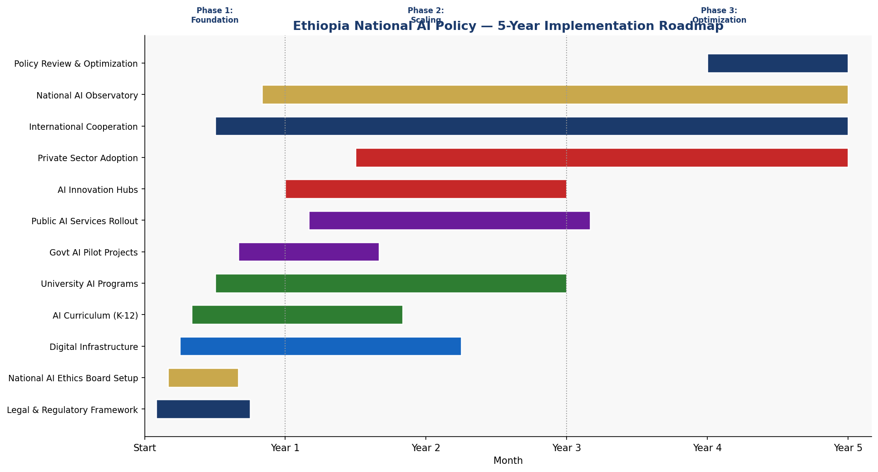
Figure 8.1: Ethiopia National AI Policy — Five-Year Implementation Roadmap (Gantt Chart)

8.3 Phase 1: Foundation (2025–2026)
The Foundation phase prioritizes the legal, institutional, and infrastructure prerequisites for responsible AI deployment. The National AI Ethics Board will be established within 6 months. The Data Protection Proclamation will be passed within 12 months. A National AI Center — hosted at Addis Ababa University with satellite hubs at four regional universities — will be launched by Month 9. Three sectoral AI pilots (agriculture advisory, health diagnostics, and tax compliance) will complete their first full operating cycles by end of Year 1, providing evidence for national scaling decisions. The National AI Literacy Campaign will reach 5 million citizens through radio, television, and community education programs.

8.4 Phase 2: Scaling (2027–2028)
The Scaling phase extends successful pilots to national programs, deepens institutional capacity, and activates the private sector through the PPP framework and Regulatory Sandbox. All federal ministries will complete AI Readiness Assessments and deploy at least one AI use case by the end of Phase 2. The Ethiopian AI Research Fund will make its first 50 research grants. The Africa AI Fellowship program will host its inaugural cohort. University AI enrollment will reach 5,000 students annually. The Ethiopian AI Startup Accelerator will complete its second cohort.

8.5 Phase 3: Optimization (2029–2030)
The Optimization phase focuses on refining policy based on evidence, deepening international integration, and positioning Ethiopia as a Pan-African AI leader. A comprehensive policy review — informed by the National AI Observatory's five years of monitoring data — will produce an updated AI Policy for 2031–2035. Ethiopia will seek active leadership roles in the AU's AI governance structures, the UN AI Advisory Body, and ITU's AI for Good platform. The target of 3 million AI-competent workers will be achieved or surpassed, and Ethiopia will begin exporting AI products and services to neighboring African markets.

Section 9: Monitoring, Evaluation, and Accountability

9.1 National AI Observatory
The National AI Observatory (NAIO) will be established as an independent institution under the Prime Minister's Office, with a mandate to monitor the implementation of this policy, assess Ethiopia's AI readiness progress, and publish annual reports to Parliament and the public. The NAIO will maintain a live AI System Registry cataloging all government AI deployments; conduct annual surveys of AI adoption in the private sector; commission independent evaluations of major AI programs; and produce the Annual State of AI in Ethiopia Report. The NAIO's budget will be ring-fenced from political interference, and its Director will be appointed through a Parliamentary process with a fixed 5-year term.

9.2 KPI Dashboard

KPI | Baseline (2024) | Year 1 (2026) | Year 3 (2028) | Year 5 (2030)
AI-skilled workers | ~50,000 | 200,000 | 1,000,000 | 3,000,000
Internet penetration | 22% | 30% | 50% | 75%
Govt AI use cases deployed | 0 | 5 | 25 | 60+
AI startups registered | ~80 | 300 | 1,000 | 3,000
Women in AI workforce (%) | 28% | 35% | 45% | 50%
AI contribution to GDP (%) | ~0.1% | 0.5% | 1.5% | 2.5–4.2%
CPI Score (TI) | 38 | 40 | 44 | 50+
AI audits completed | 0 | 10 | 50 | 200+
AI-enabled health diagnoses | 0 | 500K/yr | 2M/yr | 5M/yr
Farmers with AI advisory access | 0 | 1M | 5M | 10M

9.3 Parliamentary Oversight
A dedicated Parliamentary Sub-Committee on AI and Digital Transformation will be established with authority to summon government ministers, review NAIO reports, and pass resolutions on AI policy adjustments. The National AI Ethics Board will submit mandatory annual reports to Parliament. All major AI procurements above USD 1 million will require Parliamentary notification. Citizens will have a right to petition the Sub-Committee on AI grievances.

9.4 Civil Society and Independent Audit Role
Civil society organizations — including human rights groups, media associations, consumer protection bodies, and religious institutions — will be formally integrated into Ethiopia's AI accountability architecture through the Civil Society AI Oversight Panel (CSAOP). The CSAOP will receive government funding equivalent to 1% of the total AI budget to conduct independent monitoring, publish shadow reports, and represent citizen interests in AI governance processes. Independent technical auditors will be accredited by the NAEB to conduct algorithmic audits of government AI systems, with all audit reports made publicly available.

Section 10: International Cooperation and Digital Diplomacy

10.1 Bilateral AI Cooperation Priorities
Ethiopia will prioritize formal AI cooperation agreements with the following countries and regions in the first phase of implementation:
- United Arab Emirates: The UAE's Mohamed bin Zayed University of AI (MBZUAI) and the UAE-Ethiopia Digital Partnership will provide technical assistance, faculty exchange, and scholarship programs. The UAE's experience in government AI adoption offers directly applicable lessons for Ethiopia's public sector transformation agenda.
- Republic of Korea: Korea's AI One-Team initiative and KAIST's AI research programs will be leveraged for graduate fellowships and joint research on AI applications in agriculture and health. Korea's experience transitioning from a developing to a technology-leading economy offers a compelling development model.
- India: India's National AI Strategy and Digital India initiative share many parallels with Ethiopia's ambitions. Bilateral cooperation will focus on frugal AI innovation, multilingual AI for low-literacy populations, and AI for agriculture — all directly relevant to Ethiopian conditions.
- European Union: EU-Ethiopia engagement through the Global Gateway Digital Initiative will provide regulatory capacity building, cybersecurity cooperation, and access to EU research programs through the Horizon partnerships.
- China: Ethiopia's existing Belt and Road infrastructure partnerships create opportunities for technology transfer in AI for infrastructure management, though procurement will be subject to the Anti-Corruption AI Protocol and technology dependency risk assessments.

10.2 African Union and Regional Cooperation
As the host country of the African Union Commission, Ethiopia has a unique responsibility and opportunity to lead Pan-African AI governance development. Ethiopia will actively champion the development of a Continental AI Governance Framework through the AU's Digital Transformation Strategy working groups. A Pan-African AI Governance Forum — hosted annually in Addis Ababa — will convene Ministers of Technology and AI governance practitioners from across the 55 AU member states. Ethiopia will share its national AI policy framework, implementation tools, and monitoring data as a regional public good.
Within the Intergovernmental Authority on Development (IGAD) regional bloc — covering Ethiopia, Kenya, Uganda, Sudan, South Sudan, Eritrea, Djibouti, and Somalia — Ethiopia will lead the development of a Regional AI Data Sharing Framework, enabling cross-border AI applications in disaster response, disease surveillance, and trade facilitation.

10.3 Global AI Governance Participation
Ethiopia will seek active participation in the following global AI governance institutions and processes: the UN AI Advisory Body on Governing AI for Humanity; the ITU AI for Good Global Summit; the Global Partnership on AI (GPAI) as an observer and candidate member; the OECD AI Policy Observatory data contribution program; and UNESCO's AI Ethics Review Process. Ethiopia will nominate qualified national experts to serve on international AI governance panels and standard-setting bodies, building the country's global AI governance profile and ensuring African perspectives are integrated into global frameworks.

10.4 South-South Knowledge Transfer
Ethiopia will actively engage in South-South AI cooperation, positioning itself as a knowledge-sharing partner for other African nations and global south countries navigating similar AI development challenges. The Ethiopian AI Policy toolkit — comprising this policy document, implementation guides, AI ethics training materials in Amharic, and monitoring frameworks — will be made freely available to all AU member states under Creative Commons licensing. Ethiopia will host regional capacity building workshops for Francophone African nations in partnership with the AUC and the Agence Universitaire de la Francophonie.

Conclusion
Ethiopia's National AI Policy 2025–2030 represents a generational commitment to harnessing the transformative potential of Artificial Intelligence in service of the Ethiopian people's aspirations for dignity, prosperity, and opportunity. The policy is ambitious by design — because the challenges Ethiopia faces, from food insecurity to limited healthcare access to governance deficits — demand transformative rather than incremental responses.
The path ahead is not without risk. AI technologies, deployed without adequate governance, can entrench discrimination, amplify corruption, and deepen digital divides. This policy has been designed with a clear-eyed understanding of these risks and establishes multiple layers of institutional safeguards — the National AI Ethics Board, risk-tiered regulation, mandatory algorithmic audits, civil society oversight, and Parliamentary accountability — to ensure that AI serves Ethiopia's citizens rather than exploiting them.
Success will require sustained political will, significant public investment, active private sector partnership, and the engagement of Ethiopia's vibrant civil society. It will require building technical capacity that does not yet exist at scale. It will require honest monitoring, adaptive management, and the willingness to change course when evidence demands it. And it will require that Ethiopia's AI development remains grounded in the values and priorities of all its citizens — across its diverse regions, languages, ethnic communities, and economic circumstances.
Ethiopia's AI journey begins not with machines, but with people. The 126 million Ethiopians whose lives this policy is designed to improve are not simply the beneficiaries of AI — they are its most important architects. Their needs, their voices, and their futures must remain at the center of every decision made in the name of this policy.
The Federal Democratic Republic of Ethiopia is ready to lead. The work begins now.

References and Bibliography
[1] African Union Commission (2020). Digital Transformation Strategy for Africa (2020-2030). Addis Ababa: African Union.
[2] Ethiopian Ministry of Innovation and Technology (2023). National Digital Ethiopia Strategy 2021-2025. Addis Ababa: MInT.
[3] European Parliament and Council (2024). Regulation (EU) 2024/1689 on Artificial Intelligence (EU AI Act). Brussels: European Union.
[4] Global Partnership on Artificial Intelligence (2024). GPAI Responsible AI Framework. Paris: GPAI.
[5] International Telecommunication Union (2023). AI for Good Global Summit Report. Geneva: ITU.
[6] McKinsey Global Institute (2023). The Economic Potential of Generative AI: The Next Productivity Frontier. New York: McKinsey.
[7] OECD (2024). OECD AI Principles Updated Recommendations. Paris: Organisation for Economic Co-operation and Development.
[8] Oxford Insights (2023). Government AI Readiness Index 2023. Oxford: Oxford Insights.
[9] Transparency International (2024). Corruption Perceptions Index 2024. Berlin: Transparency International.
[10] UNESCO (2021). Recommendation on the Ethics of Artificial Intelligence. Paris: UNESCO.
[11] World Bank (2024). World Development Report 2024: The Middle Income Trap. Washington DC: World Bank.
[12] World Bank (2023). Ethiopia Country Economic Memorandum 2023. Washington DC: World Bank.
[13] World Bank (2024). Worldwide Governance Indicators 2024. Washington DC: World Bank.
[14] World Economic Forum (2024). Future of Jobs Report 2025. Geneva: WEF.
[15] African Development Bank (2023). African Economic Outlook 2023: Ordinary African Countries. Abidjan: AfDB.
[16] ITU (2023). Measuring Digital Development — Facts and Figures 2023. Geneva: ITU.
[17] Global System for Mobile Communications Association (GSMA) (2024). State of Mobile Internet Connectivity 2024. London: GSMA.
[18] AI4D Africa (2023). African AI Research Landscape Report. Nairobi: AI4D.
[19] Partnership on AI (2024). PAI Responsible Practices for Synthetic Media. San Francisco: PAI.
[20] United Nations (2024). Governing AI for Humanity: Final Report of the UN AI Advisory Body. New York: UN.

About the Author
Nafiul Ahmad Rafi
Policy & Good Governance Researcher | BD Civic Tech Architect

Nafiul Ahmad Rafi is a civic technologist, policy researcher, author, photographer, and musician based in Dhaka, Bangladesh. He is the Founder and Director of Insights Bangladesh, a data-driven governance and policy impact analysis institution, and the Founder & Lead Architect of NagorikBD.org — a transparency-first civic platform scaled across Mymensingh Division, connecting citizens with government services across 45 Upazilas.
His work exists at the intersection of institutional reform and artificial intelligence, transforming theoretical governance into scalable, data-driven reality. Without a conventional computer science degree, he self-taught the tools of modern AI and web development to build the infrastructure that enforces the policies he once only researched.

Key Platforms & Projects
- NagorikBD.org — Civic transparency platform, Mymensingh Division
- Insights Bangladesh — Policy impact analysis institution
- FactCheck BD (factcheckbd.org) — Bangladesh's AI-powered fact-checking platform
- Political Insights BD / PIBD (pibbd.org) — Political intelligence and civic tech hub
- PeaceShield BD / National Peace Tracker — AI-powered hate speech and conflict monitoring
- PolicyLens AI (aigovbd.org) — 9-dimensional AI policy audit tool

He has published four books and maintains a personal site at ahmad-rafi.com.

Research Interests
AI Governance · Policy Research · Future of Bangladesh · Climate Policy

Contact
- Website: ahmad-rafi.com
- LinkedIn: linkedin.com/in/nafiul-ahmad-rafi
- Email: contact@ahmad-rafi.com

"I build code to ensure transparency, and I write lyrics to inspire the courage to use it."

