🇬🇭

REPUBLIC OF GHANA
National Artificial Intelligence Policy 2026–2031
A Comprehensive Framework for Ethical, Inclusive, and Economically Transformative AI

Prepared by:
Nafiul Ahmad Rafi
Insights Bangladesh

May 2026 | Dhaka, Bangladesh

Table of Contents

Executive Summary
Ghana stands at a pivotal moment in its development trajectory. With a population of approximately 34 million, an emerging technology ecosystem anchored in Accra's growing tech hub, and strategic national ambitions articulated through the Ghana Beyond Aid agenda and the Digital Ghana Agenda, the country possesses the foundational conditions to position itself as West Africa's leading AI-powered economy. This National Artificial Intelligence Policy 2026–2031 provides the comprehensive governance architecture necessary to translate that potential into measurable national outcomes.

The rationale for this policy is both urgent and strategic. Globally, artificial intelligence is projected to contribute $15.7 trillion to the world economy by 2030 (PricewaterhouseCoopers, 2023). Africa's share of this dividend will be determined not by passive participation but by proactive policy intervention. Ghana's AI Readiness score of 4.7 out of 10, its growing internet penetration of 58%, and its Corruption Perception Index score of 43 out of 100 collectively signal both significant opportunity and governance challenges that must be addressed for AI to serve, rather than undermine, national development goals. This policy responds to both dimensions.

This policy is structured around five Strategic Pillars: (1) Ethical AI and Human Rights Protection, ensuring that AI deployment in Ghana upholds constitutional rights and international standards; (2) Economic Growth and Industrial AI Adoption, targeting productivity gains in agriculture, fintech, healthcare, and extractive industries; (3) Education, Upskilling and AI Workforce Development, building a pipeline from school-age AI literacy to postgraduate research capacity; (4) Public Sector AI and e-Governance, modernizing state functions and expanding citizen access to government services; and (5) AI Research, Innovation and Startup Ecosystem, nurturing homegrown AI solutions to African problems.

The expected outcomes of this policy by 2031 include a 3.7% AI contribution to GDP, the creation of over 80,000 AI-related jobs, a National AI Ethics Board fully operational since 2027, and Ghana's recognition as a leading African voice in global AI governance forums including the UN AI Advisory Body and the Global Partnership on Artificial Intelligence (GPAI). This document provides the legislative recommendations, institutional mandates, investment roadmap, and monitoring framework to achieve these targets.

Section 1: National AI Readiness Assessment

1.1 Economic Context
Ghana is classified by the World Bank as a lower-middle-income economy with a GDP of approximately USD 76.6 billion (2023) and a GDP per capita of approximately USD 2,300. The country has been one of Africa's fastest-growing economies, averaging 6% annual GDP growth over the past decade, though macro-fiscal pressures from 2022 onwards, including currency depreciation, high inflation, and sovereign debt restructuring under an IMF program, have introduced significant headwinds.

Key economic sectors include gold and cocoa (primary foreign exchange earners), petroleum, services (including telecommunications and financial services), and an emergent technology sector concentrated in Accra. The Ghana Revenue Authority, National Petroleum Corporation, and Ghana Cocoa Board all represent priority candidates for early AI adoption to improve efficiency, reduce leakage, and increase domestic revenue mobilization.

The digital economy is estimated to contribute approximately 3.2% of GDP, with mobile money services (led by MTN Mobile Money and Vodafone Cash) serving as a critical driver of financial inclusion for over 17 million registered users. This mobile financial infrastructure represents a significant asset for AI-powered fintech development and digital service delivery.

1.2 Education and Human Capital
Ghana's adult literacy rate stands at 79%, with tertiary enrollment of approximately 19%. The country has 10 technical universities and 6 established universities, including the University of Ghana (Legon), Kwame Nkrumah University of Science and Technology (KNUST), and the Ghana Institute of Management and Public Administration (GIMPA). KNUST in particular has a developing computer science and data science department that can anchor AI research.

A significant digital skills gap persists, particularly at the secondary and vocational levels. Current ICT curricula in basic and secondary schools are outdated relative to the demands of the AI economy. STEM enrollment at tertiary level is approximately 28% of total enrollment, and female representation in STEM fields remains low at an estimated 22%. Addressing this gap is central to Section 5 of this policy.

1.3 Digital Infrastructure
Ghana's internet penetration stands at approximately 58%, driven primarily by mobile connectivity (over 90% of connections). Fixed broadband penetration remains low at under 5%. The National Fibre Infrastructure Project has expanded backbone connectivity significantly, but last-mile connectivity in rural areas, particularly in the Northern, Savannah, Upper East, Upper West, and Bono East regions, remains a critical constraint for inclusive AI deployment.

Data centre infrastructure is nascent but growing, with Accra serving as a West African hub for several regional cloud providers. Ghana participates in the Africa Data Centres Association and has attracted investments from companies such as Liquid Intelligent Technologies. 5G rollout began in 2022, but coverage remains confined to urban centres.

1.4 Governance and Institutional Capacity
Ghana operates as a constitutional democracy with a stable multiparty political system and regular peaceful transitions of power. The country ranks 57th on the 2023 Ibrahim Index of African Governance, with particular strengths in political participation and human rights, and relative weaknesses in economic governance and rule of law consistency. The Data Protection Commission (DPC), established under the Data Protection Act 2012 (Act 843), provides a partial regulatory foundation for AI data governance, though its mandate requires significant expansion to address AI-specific risks.

Relevant institutions for AI governance include the Ministry of Communications and Digitalisation, the National Information Technology Agency (NITA), the National Communications Authority (NCA), the Ghana Statistical Service, and the Cybersecurity Authority (CSA) established under the Cybersecurity Act 2020 (Act 1038). These institutions will require coordination mechanisms and capacity building to fulfil AI governance mandates.

1.5 Corruption Risk Assessment
Ghana's Corruption Perception Index (CPI) score of 43/100 (Transparency International, 2023) places it at 70th globally and above the Sub-Saharan African average of 33/100. While Ghana performs better than many regional peers, a CPI below 50 indicates that corruption remains a material risk to AI governance. Specifically, risks include procurement corruption in AI infrastructure contracts, algorithmic capture by political interests in public sector AI systems, and inadequate whistleblower protection for those reporting AI misuse.

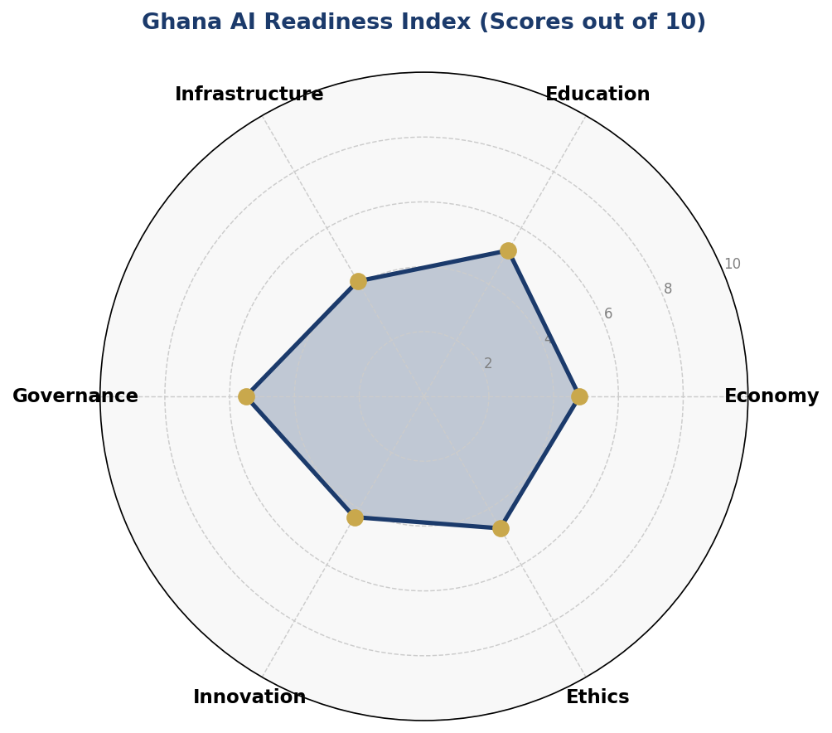
Figure 1.1: Ghana AI Readiness Index — Six-Axis Assessment (2025 Baseline)
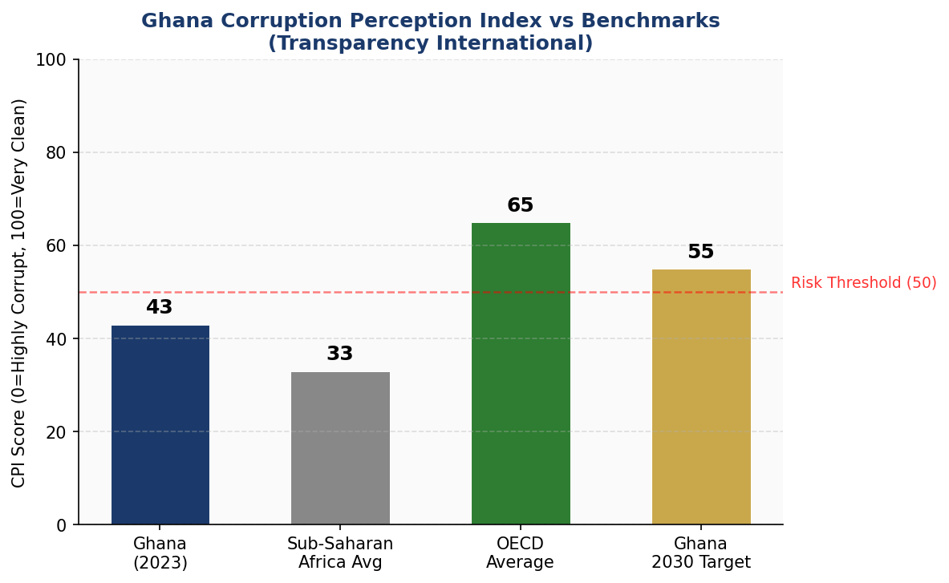
Figure 1.2: Ghana CPI Score vs Regional and OECD Benchmarks, with 2030 Target

Section 2: Policy Vision and Strategic Pillars

2.1 Vision Statement
"By 2031, Ghana shall be a leading African nation where artificial intelligence is developed and deployed ethically, inclusively, and innovatively — empowering citizens, modernising governance, and accelerating sustainable economic transformation for the benefit of all Ghanaians."

2.2 Mission
To establish an enabling ecosystem for responsible AI development and deployment in Ghana, anchored in human rights, democratic accountability, economic opportunity, and Pan-African solidarity.

2.3 Strategic Pillar 1: Ethical AI and Human Rights Protection
This pillar ensures that AI systems developed or deployed in Ghana uphold the rights guaranteed under the 1992 Constitution, international human rights law, and the African Charter on Human and Peoples' Rights. It establishes the National AI Ethics Board, mandates algorithmic impact assessments for high-risk AI systems, and prohibits AI applications that discriminate based on ethnicity, religion, gender, disability, or political opinion.

2.4 Strategic Pillar 2: Economic Growth and Industrial AI Adoption
Ghana's economic transformation agenda will be significantly accelerated by AI adoption in agriculture (precision farming and crop disease detection for cocoa and food crops), fintech (credit scoring for unbanked populations, fraud detection), healthcare (diagnostic AI for maternal and child health), mining (predictive maintenance and environmental monitoring), and tourism (personalised visitor experiences). This pillar provides sector-specific AI adoption frameworks, tax incentives for AI-investing companies, and a Public-Private Partnership (PPP) fund.

2.5 Strategic Pillar 3: Education, Upskilling and AI Workforce Development
A nationally coordinated AI literacy and skills programme spanning primary school through postgraduate research is essential for Ghana to capture the economic benefits of AI domestically rather than relying on imported expertise. This pillar funds curriculum reform, establishes AI Centres of Excellence at KNUST and the University of Ghana, supports women-in-AI initiatives, and creates a National AI Scholarship Programme targeting students from underserved regions.

2.6 Strategic Pillar 4: Public Sector AI and e-Governance
Government is the single largest potential deployer of AI in Ghana, with applications ranging from tax compliance prediction and public health surveillance to judicial case management and social protection targeting. This pillar mandates responsible AI procurement standards for government agencies, establishes interoperability standards for government AI systems, and creates a Citizen AI Ombudsman to receive and investigate complaints about government AI use.

2.7 Strategic Pillar 5: AI Research, Innovation and Startup Ecosystem
Ghana's AI startup ecosystem, anchored in hubs such as iSpace, MEST Africa, and Accra's emerging tech corridor, requires policy support to scale. This pillar establishes a National AI Innovation Fund (seeded with USD 20 million over five years), supports competitive research grants at Ghanaian universities, facilitates regulatory sandboxes for AI startups, and positions Ghana as a hub for Africa-focused AI research addressing agriculture, health, language (Twi, Ga, Ewe, Hausa NLP), and climate adaptation.

Section 3: International Framework Alignment

3.1 UNESCO Recommendation on the Ethics of AI (2021)
The UNESCO Recommendation on the Ethics of Artificial Intelligence, adopted unanimously by 193 member states in November 2021, provides 11 core values that serve as a foundational compass for this policy. Ghana's alignment across these values is as follows:
- Proportionality and Do No Harm: AI systems must be proportionate to their intended purpose; Ghana prohibits AI systems where risks outweigh benefits.
- Safety and Security: Mandatory security assessments for critical infrastructure AI systems.
- Right to Privacy and Data Protection: Strengthened through the Data Protection (Amendment) Bill recommended in Section 6.
- Multi-stakeholder and Adaptive Governance: The National AI Ethics Board includes civil society, academia, private sector, and government.
- Responsibility and Accountability: Clear liability frameworks for AI developers and deployers established.
- Transparency and Explainability: High-risk AI systems must provide human-interpretable explanations.
- Human Oversight and Determination: All consequential AI decisions have a human review mechanism.
- Sustainability: AI projects assessed for environmental impact, with green AI procurement preferences.
- Awareness and Literacy: National AI literacy programme (Section 5) directly addresses this.
- Fairness and Non-Discrimination: Algorithmic fairness audits required for public-sector AI.
- International Cooperation: Section 10 articulates Ghana's multilateral AI cooperation strategy.

3.2 OECD AI Principles (2019, Updated 2024)
The OECD AI Principles, endorsed by 46 countries including several African nations, articulate five value-based principles and five recommendations for governments. Ghana aligns with all five value-based principles: inclusive growth and sustainable development; human-centred values and fairness; transparency and explainability; robustness, security and safety; and accountability. The five government recommendations — investment in AI R&D, enabling AI environments, shaping an enabling governance framework, building human capacity, and international cooperation — map directly onto this policy's five Strategic Pillars.

3.3 EU AI Act (2024) Risk-Based Approach
The European Union AI Act, which entered into force in August 2024, establishes the world's first comprehensive legal framework for AI based on a four-tier risk classification system. Ghana adopts and adapts this risk framework in Section 6, calibrating risk categories to the Ghanaian legal and institutional context. The EU AI Act's list of prohibited AI practices (social scoring, mass biometric surveillance, exploiting vulnerabilities) is adopted wholesale, while the high-risk category list is expanded to include AI used in customary land dispute resolution, chieftaincy administration, and electoral boundary delimitation — areas with specific Ghanaian constitutional significance.

3.4 World Bank Digital Development Strategy
The World Bank's approach to AI in development contexts emphasises human capital development, digital public infrastructure, and enabling regulatory environments as preconditions for beneficial AI deployment. This policy's investment framework (Section 4) aligns with World Bank evidence on the sequencing of AI investments in lower-middle-income countries, prioritising foundational infrastructure and skills before advanced AI deployment at scale.

3.5 Framework Alignment Matrix

Framework Principle | Section 2  Vision | Section 3  Intl. | Section 6  Ethics | Section 7  Gov. | Section 8  Roadmap
UNESCO: Human Rights | ✅ | ✅ | ✅ | ✅ | ⚠️
UNESCO: Transparency | ✅ | ✅ | ✅ | ✅ | ✅
UNESCO: Sustainability | ⚠️ | ✅ | ⚠️ | ✅ | ✅
OECD: Inclusive Growth | ✅ | ✅ | ⚠️ | ✅ | ✅
OECD: Robustness & Safety | ⚠️ | ✅ | ✅ | ✅ | ⚠️
EU AI Act: Risk Classification | ⚠️ | ✅ | ✅ | ✅ | ✅
EU AI Act: Prohibited Uses | 🔲 | ✅ | ✅ | ⚠️ | 🔲
World Bank: Dev. Alignment | ✅ | ✅ | ⚠️ | ✅ | ✅
G20: Innovation Ecosystem | ✅ | ⚠️ | ⚠️ | ⚠️ | ✅
ITU: SDG Linkage | ✅ | ✅ | ⚠️ | ✅ | ✅
GPAI: Responsible Stewardship | ⚠️ | ✅ | ✅ | ✅ | ⚠️
Legend: ✅ Full Alignment | ⚠️ Partial Alignment | 🔲 To Be Developed

Section 4: Economic Impact and Investment Roadmap

4.1 Projected AI Economic Contribution
Based on income-tier comparable analysis from the McKinsey Global Institute (2023) and the World Economic Forum AI Futures report (2024), AI adoption in Ghana is projected to contribute between 3.5% and 4.2% of GDP by 2031. For the purposes of this policy, a conservative estimate of 3.7% GDP contribution is used, representing approximately USD 3.5 billion in incremental economic value at projected 2031 GDP levels. This estimate assumes full implementation of this policy's education, infrastructure, and regulatory reform components.

The largest sectoral contributions are expected from agriculture (AI-powered precision farming, cocoa disease detection, and supply chain optimisation), financial services (credit scoring, fraud detection, and regulatory compliance automation), healthcare (diagnostic assistance and patient management in public hospitals), and public administration (tax compliance AI, customs automation, and public procurement analytics).

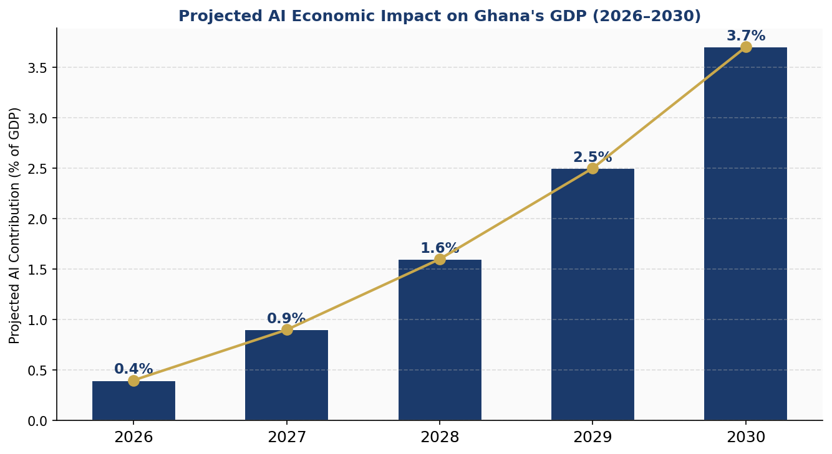
Figure 4.1: Projected AI Contribution to Ghana GDP (2026–2030)

4.2 Investment Allocation Framework
The Government of Ghana, in coordination with development finance institutions and private sector partners, commits to mobilising a minimum of USD 200 million in AI-related investments over the 2026–2031 period. This includes direct government expenditure, World Bank and African Development Bank (AfDB) concessional financing, private sector co-investment, and diaspora investment. The recommended allocation across categories is as follows:

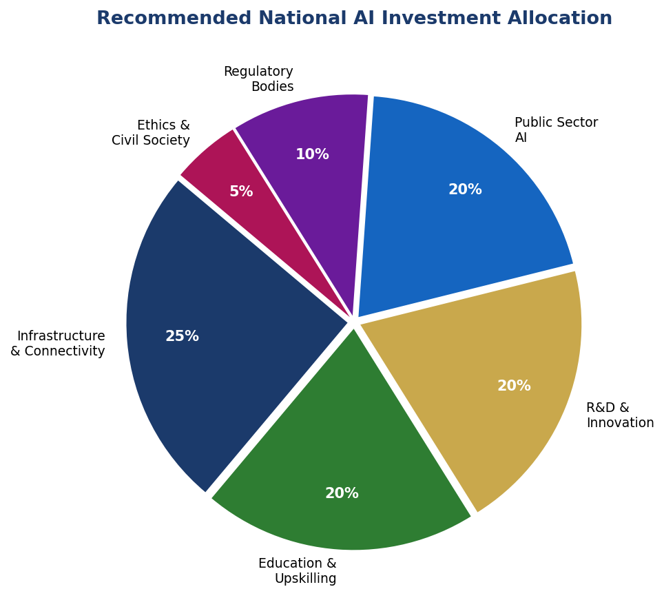
Figure 4.2: Recommended National AI Investment Allocation by Category

4.3 Priority Sectors for AI Adoption
The following sectors are designated as Priority AI Adoption Sectors for the 2026–2031 period, based on economic significance, existing data availability, and potential for demonstrable impact:
- Agriculture and Agro-processing: Cocoa disease detection using satellite imagery and mobile apps; smallholder farmer advisory systems in local languages; supply chain traceability for export markets.
- Financial Services and Fintech: Credit scoring for the unbanked; real-time fraud detection for mobile money; AI-powered anti-money laundering for banking sector.
- Healthcare: AI-assisted diagnostics at district hospitals; maternal and child health monitoring; disease surveillance and epidemic early warning systems.
- Natural Resources and Mining: Predictive maintenance for mining equipment; environmental impact monitoring; artisanal and small-scale mining (ASM) formalisation tools.
- Education: Adaptive learning platforms in Ghanaian languages; teacher training support tools; student dropout prediction and intervention systems.
- Public Administration: Tax compliance prediction (Ghana Revenue Authority); customs intelligence; social protection targeting and fraud prevention.

4.4 Public-Private Partnership Framework
The National AI PPP Framework establishes mechanisms for structured government-industry collaboration on AI adoption. Government contributes regulatory clarity, data access (subject to privacy protections), co-investment through the National AI Innovation Fund, and anchor procurement of AI services. The private sector contributes technology expertise, capital, market access, and entrepreneurial capacity. A dedicated AI PPP Unit within the Ministry of Communications and Digitalisation will coordinate joint projects, manage intellectual property rights arising from co-funded research, and ensure that PPP agreements include technology transfer and local capacity building obligations.

Section 5: Education and Human Capital Development

5.1 Current Skills Gap Analysis
Ghana's AI talent ecosystem is nascent. A 2024 survey by the Ghana ICT4AD Policy Working Group estimates fewer than 500 professionals with advanced AI/ML skills in the country, concentrated almost entirely in Accra. University-level data science and AI programmes are offered at KNUST and the University of Ghana, but enrolment is limited and curricula have not kept pace with industry requirements. At the secondary level, ICT curricula were last substantively revised in 2012. At the primary level, computational thinking is not systematically taught.

The gender gap in AI skills is a critical equity concern. Women represent approximately 22% of STEM graduates and an estimated 18% of AI practitioners. Regional disparities are also significant: northern Ghana regions account for fewer than 5% of tech workers despite representing over 20% of the population. Closing these gaps requires deliberate, targeted policy interventions.

5.2 National AI Curriculum Framework
The National AI Curriculum Framework establishes age-appropriate AI learning standards across four levels:
- Foundational Level (Primary 1–6): Computational thinking, basic algorithms, AI as a concept. Integrated into existing subjects. Target: 800,000 students by Year 1, 2,500,000 by Year 5.
- Literacy Level (Junior High and Senior High School): Practical AI tools, data literacy, AI ethics, career awareness. Dedicated ICT lessons plus cross-curricular integration. Target: 120,000 students by Year 1.
- Practitioner Level (University and TVET): AI programming, machine learning fundamentals, AI application development. Revised curricula at all accredited tertiary institutions. Target: 18,000 students by Year 1.
- Expert Level (Postgraduate Research): Advanced AI research, PhD programmes, international collaborations. Centres of Excellence at KNUST and University of Ghana. Target: 800 researchers by Year 1.

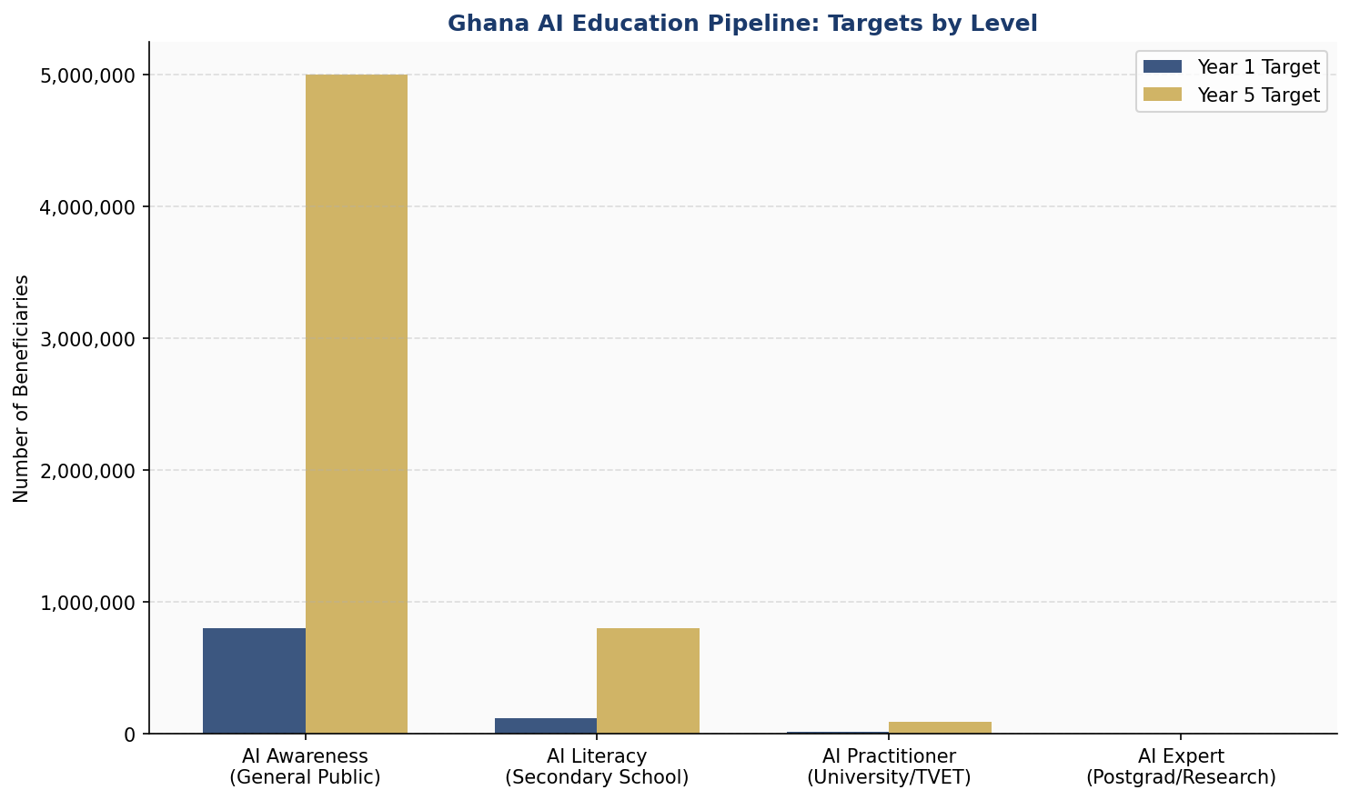
Figure 5.1: Ghana AI Education Pipeline — Year 1 vs Year 5 Targets by Level

5.3 Women and Underrepresented Groups
The policy establishes binding inclusion targets: 45% female participation in AI practitioner programmes by 2031; 25% of National AI Scholarship Programme awards directed to students from the three Northern regions; dedicated AI literacy programmes for persons with disabilities. The Ghana Education Trust Fund (GETFund) is directed to prioritise AI skills development for female students in STEM. The Ministry of Gender, Children and Social Protection co-chairs the AI Education Inclusivity Committee.

5.4 International Partnerships and Exchange
Ghana will pursue bilateral AI education partnerships with South Korea (KAIST), India (IITs), Germany (DAAD), Canada (CIFAR), and regional institutions including the African Institute for Mathematical Sciences (AIMS) network. A National AI Scholarship Programme (NASP) will fund 200 postgraduate scholarships annually at international AI programmes, with mandatory return-of-service obligations of three years in Ghana.

Section 6: Ethical AI Governance and Regulatory Framework

6.1 National AI Ethics Board (NAEB)
The National AI Ethics Board is hereby established as an independent statutory body under this policy, pending enactment of the National Artificial Intelligence Governance Act. The NAEB shall comprise 15 members: three representatives from government ministries (Communications, Justice, Health), three from academia (including at least one from KNUST), two from the private sector (nominated by the Ghana Chamber of Commerce), two from civil society (including one representing persons with disabilities), one from the Human Rights Commission, one from the Data Protection Commission, one international AI ethics expert, and two at-large members appointed by the President on the advice of Parliament.

The NAEB mandate includes: reviewing high-risk AI deployments by government agencies; conducting annual AI State of the Nation assessments; issuing binding guidelines on algorithmic fairness and transparency; investigating complaints of AI harm; and representing Ghana in international AI governance forums. The NAEB reports annually to Parliament and operates with a budget ring-fenced from the Communications Sector Levy.

6.2 AI Risk Classification System
Ghana adopts a four-tier risk classification system adapted from the EU AI Act framework and calibrated to the Ghanaian context:

Risk Category | Examples in Ghana Context | Regulatory Requirement
🚫 Unacceptable Risk | Social scoring by government, mass surveillance AI systems, manipulation of vulnerable groups, subliminal behavior influence | BANNED — no deployment permitted under any circumstances
🔴 High Risk | AI in criminal justice, hiring/HR, education grading, loan decisions, medical diagnosis, law enforcement biometrics | Mandatory conformity assessment, audit trail, human oversight, registration in national database
🟡 Limited Risk | Chatbots, emotion-recognition tools, deepfake generation, recommendation systems | Transparency obligations — users must know they are interacting with AI
🟢 Minimal Risk | Spam filters, AI games, content suggestion, productivity tools | Voluntary code of conduct; no mandatory regulatory burden

6.3 Data Protection and Privacy Framework
The Data Protection Act 2012 (Act 843) requires amendment to address AI-specific data processing realities. Recommended amendments include: explicit requirements for AI systems to disclose automated decision-making to affected individuals; the right to explanation for algorithmic decisions affecting rights or significant interests; data minimisation requirements for AI training datasets; mandatory data localisation requirements for sensitive public datasets used in AI training; and expanded powers for the Data Protection Commission to conduct AI audits.

6.4 Algorithmic Accountability Standards
Public sector AI systems must meet the following accountability standards before deployment: algorithmic impact assessment completed and published; technical documentation submitted to the NAEB; independent bias audit conducted; human review mechanism operational; incident reporting protocol established; and annual performance and fairness review scheduled. Private sector AI systems operating in high-risk categories must meet equivalent standards and register with the NAEB national AI registry.

6.5 Anti-Corruption AI Guidelines
Given Ghana's CPI score and the elevated risk of corruption in public procurement, the following specific anti-corruption AI guidelines apply: all government AI procurement contracts above USD 500,000 must undergo public competitive tender with NAEB observer participation; AI systems used in tax assessment, customs clearance, or social protection targeting must include immutable audit logs accessible to the Ghana Audit Service; AI systems used in electoral administration require Parliamentary approval before deployment; and any government official found to have manipulated AI outputs for personal gain is subject to criminal prosecution under the Criminal Offences (Amendment) Act.

Section 7: Public Sector AI and e-Governance

7.1 Priority Government AI Use Cases
The following government AI use cases are designated as priority deployments for the 2026–2028 period, selected on the basis of available data, institutional capacity, and potential citizen impact:
- Ghana Revenue Authority: AI-assisted tax compliance risk scoring, VAT fraud detection, and customs classification.
- Ministry of Health / Ghana Health Service: AI-assisted diagnostics for tuberculosis and malaria at district hospital level; maternal mortality risk prediction; disease surveillance and outbreak detection.
- Ministry of Food and Agriculture: Crop disease early warning systems for cocoa; market price prediction for smallholder farmers; climate adaptation advisory services.
- Electoral Commission: Voter roll verification using AI (with strict prohibitions on facial recognition in voting processes); petition and complaint triage.
- Judicial Service: Case management and backlog reduction tools; legal research assistance for judges and court staff.
- Ghana Education Service: Early warning systems for student dropout; teacher performance analytics for professional development targeting.
- Ministry of Roads and Highways: Predictive maintenance for road infrastructure; traffic management in Accra and Kumasi.

7.2 Government AI Procurement Guidelines
All government AI procurement must adhere to the National AI Procurement Standards, developed jointly by the Ministry of Finance, NITA, and the NAEB. Key standards include: mandatory algorithmic impact assessment before procurement; preference for AI systems with explainable outputs; requirement for source code escrow in critical infrastructure AI contracts; mandatory technology transfer and local capacity building components; post-deployment performance review at 12 and 36 months; and citizen feedback mechanisms embedded in all citizen-facing AI applications.

7.3 Interoperability and Data Sharing Standards
The Government of Ghana shall develop a National AI Interoperability Framework within 18 months of this policy's adoption, establishing common data standards, API protocols, and security requirements for AI systems across government agencies. The Ghana Integrated Financial Management Information System (GIFMIS), the National Identification Authority (NIA) database, and the Ghana Statistical Service's data repositories will serve as anchor data infrastructures for government AI applications, subject to strict data governance protocols.

Section 8: Implementation Roadmap

8.1 Phase 1: Foundation (Months 1–12, 2026)
The Foundation Phase establishes the legal, institutional, and infrastructure prerequisites for AI deployment at scale. Key milestones include:
- Draft and table the National Artificial Intelligence Governance Act before Parliament.
- Constitute the National AI Ethics Board and appoint all 15 members.
- Establish the National AI Innovation Fund with initial capitalisation of USD 5 million.
- Launch the AI Education Reform Programme in 500 pilot schools.
- Commence 5 priority government AI pilot projects (tax compliance, health diagnostics, agriculture advisory, road maintenance, education early warning).
- Publish Ghana's National AI Strategy document and launch public consultation.
- Accede to the Council of Europe's Framework Convention on AI and Human Rights.

8.2 Phase 2: Scaling (Months 13–36, 2027–2028)
The Scaling Phase drives national rollout of foundational programmes and deepens AI adoption in priority sectors. Key milestones include:
- Enact the National Artificial Intelligence Governance Act.
- Roll out AI literacy curriculum to all public secondary schools.
- Launch 35 government AI deployments across 10 ministries.
- Operationalise the National AI Centre of Excellence at KNUST.
- Establish the National AI Innovation Fund co-investment programme with private sector.
- Ghana joins the Global Partnership on Artificial Intelligence (GPAI) as a full member.
- Publish first Annual AI State of the Nation Report.

8.3 Phase 3: Optimisation (Months 37–60, 2029–2031)
The Optimisation Phase consolidates gains, addresses implementation challenges, and positions Ghana for AI leadership at the continental and global level. Key milestones include:
- Comprehensive review and update of National AI Governance Act based on implementation experience.
- Scale AI practitioner training to 90,000 active enrolments.
- Achieve USD 200 million total AI investment mobilised.
- Launch Ghana AI Export Promotion Programme — supporting Ghanaian AI firms to serve regional markets.
- Host first West Africa AI Governance Summit in Accra.
- Submit Ghana National AI Progress Report to UN AI Advisory Body.

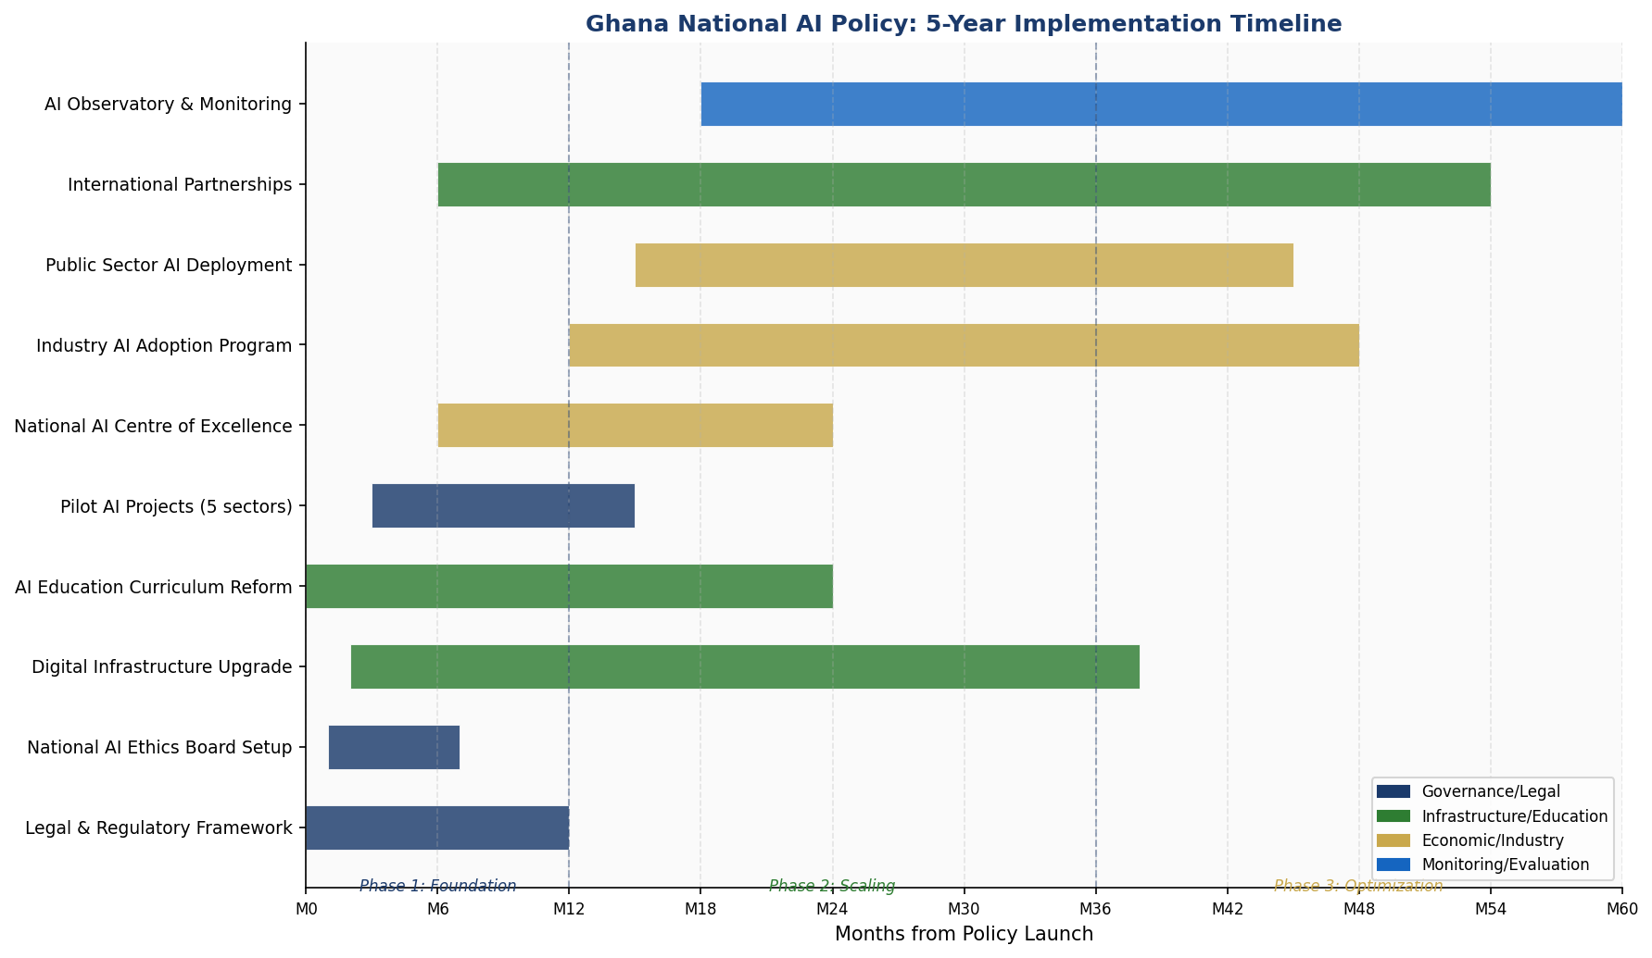
Figure 8.1: Ghana AI Policy Implementation Gantt Chart (2026–2031)

Section 9: Monitoring, Evaluation and Accountability

9.1 National AI Observatory
The National AI Observatory (NAIO) is established as a functional unit within the Ministry of Communications and Digitalisation, with technical support from the Ghana Statistical Service. The NAIO's mandate is to collect, analyse, and publish data on AI adoption, impact, and governance performance across all sectors. The NAIO publishes a quarterly AI Sector Dashboard and an Annual AI State of the Nation Report presented to Parliament.

9.2 Parliamentary Oversight
The Parliamentary Select Committee on Communications shall have primary oversight responsibility for this policy's implementation. The Minister of Communications and Digitalisation shall appear before the Committee annually to present progress against KPI targets. The Committee may summon the Chair of the NAEB, the Director of NITA, and the Data Protection Commissioner for evidence sessions on AI governance matters.

9.3 Civil Society and Independent Audit
An independent Civil Society AI Oversight Coalition shall be established, funded through a 2% levy on the National AI Innovation Fund. The Coalition shall commission biennial independent audits of government AI systems, publish shadow reports on AI policy implementation, and represent citizen interests in NAEB consultations. Freedom of information rights explicitly extend to algorithmic impact assessments and NAEB decisions, subject to legitimate commercial confidentiality exemptions.

9.4 KPI Dashboard

KPI Metric | Baseline (2025) | Year 1 Target | Year 3 Target | Year 5 Target
AI Readiness Index Score | 4.7/10 | 5.5/10 | 6.8/10 | 7.5/10
AI Companies Registered | 45 | 120 | 350 | 800
Students in AI Curriculum | 2,000 | 18,000 | 65,000 | 120,000
Public Sector AI Projects | 3 | 12 | 35 | 75
AI Ethics Board Cases Reviewed | N/A | 25 | 80 | 150
Female AI Practitioners (%) | 18% | 25% | 35% | 45%
GDP Contribution from AI | 0.1% | 0.4% | 1.6% | 3.7%
AI Research Publications | 12/yr | 30/yr | 90/yr | 200/yr
Broadband Penetration | 42% | 55% | 72% | 85%
Annual AI Investment (USD) | $8M | $25M | $80M | $200M

Section 10: International Cooperation and AI Diplomacy

10.1 Bilateral AI Cooperation Priorities
Ghana will prioritise bilateral AI cooperation agreements with the following countries and blocs: the European Union (regulatory alignment and market access); India (technology transfer, IT workforce development); South Korea (AI R&D partnerships, smart government); the United States (investment facilitation, AI safety research); and China (infrastructure investment, with appropriate technology sovereignty safeguards). Each bilateral agreement will include provisions for AI governance alignment, data protection reciprocity, and joint AI ethics standards.

10.2 Africa Union and ECOWAS AI Governance
Ghana is a founding supporter of the African Union's Continental AI Strategy and commits to active participation in its implementation. As the current Chair of the ECOWAS Authority on Information Technology (when applicable), Ghana will champion the development of a regional West Africa AI Governance Protocol, harmonising data protection standards, risk classification systems, and AI procurement rules across the 15 ECOWAS member states. A harmonised regional approach is essential for enabling cross-border AI services and preventing regulatory arbitrage.

10.3 South-South Knowledge Transfer
Ghana commits to active AI knowledge sharing with less AI-ready African nations through the African Union Development Agency (AUDA-NEPAD) AI Capacity Building Programme. Ghanaian AI expertise in cocoa agriculture, mobile fintech, and public health surveillance — developed through this policy — will be packaged as transferable models for interested African partner countries. The NAIB will establish a dedicated South-South AI Cooperation desk.

10.4 Global AI Governance Participation
Ghana actively participates in the following global AI governance bodies and processes: the UN AI Advisory Body (observer status, with full membership sought by 2027); the Global Partnership on Artificial Intelligence (GPAI) — full membership application in Phase 1; the ITU AI for Good Initiative (active participation and hosting of West African node); the UNESCO AI Ethics Recommendation implementation monitoring process; and the OECD AI Policy Observatory (data contribution partnership).

Ghana advocates in all international forums for: a development-sensitive approach to global AI governance that addresses the needs of lower-middle-income countries; mandatory technology transfer provisions in AI trade agreements; fair access to AI foundation model technologies for Global South researchers; and the inclusion of African perspectives and languages in multilateral AI safety research.

Conclusion
Ghana's National Artificial Intelligence Policy 2026–2031 represents a decisive commitment by the Republic of Ghana to shape, rather than merely receive, the AI-driven transformation of the 21st century. The policy's five Strategic Pillars — Ethical AI, Economic Growth, Education, Public Sector Modernisation, and Innovation Ecosystem — are mutually reinforcing and deliberately sequenced to build from governance foundations to economic transformation over a five-year horizon.

The path forward is not without challenge. Ghana must navigate macro-fiscal constraints while mobilising ambitious AI investment; must build regulatory capacity while avoiding regulatory overreach that stifles innovation; must ensure that AI's benefits reach rural and Northern Ghana, not only Accra's tech corridor; and must participate as a credible voice in global AI governance while focusing on urgent domestic development priorities. This policy provides the framework for navigating these tensions.

The vision articulated here — of Ghana as a leading African nation where AI is ethical, inclusive, and economically transformative — is achievable. The academic talent at KNUST and the University of Ghana is real. The entrepreneurial energy of Accra's tech ecosystem is real. The governance tradition that has made Ghana a beacon of African democracy is real. What this policy provides is the coordinated national strategy to channel these assets toward an AI-powered future that benefits all Ghanaians. The work begins now.

References and Bibliography

International Frameworks and Standards
- UNESCO Recommendation on the Ethics of Artificial Intelligence. United Nations Educational, Scientific and Cultural Organization, Paris, November 2021.
- OECD Principles on Artificial Intelligence. Organisation for Economic Co-operation and Development, May 2019, updated 2024.
- Regulation (EU) 2024/1689 — EU Artificial Intelligence Act. European Parliament and Council of the European Union, 2024.
- G20 AI Principles. G20 Osaka Summit, June 2019.
- ITU Guidelines for AI for Good. International Telecommunication Union, Geneva.
- Council of Europe Framework Convention on Artificial Intelligence and Human Rights. Council of Europe, 2024.

Ghana National Sources
- The Constitution of the Republic of Ghana, 1992.
- Data Protection Act, 2012 (Act 843). Ghana Data Protection Commission.
- Cybersecurity Act, 2020 (Act 1038). Cybersecurity Authority of Ghana.
- Digital Ghana Agenda. Ministry of Communications and Digitalisation, 2017.
- Ghana Beyond Aid Charter and Strategy Document. Government of Ghana, 2019.
- National Information Technology Agency (NITA) Annual Reports, 2022–2024.

Research and Data Sources
- Oxford Insights Government AI Readiness Index 2023.
- Transparency International Corruption Perceptions Index 2023.
- World Bank World Governance Indicators 2023.
- McKinsey Global Institute: The Economic Potential of Generative AI, 2023.
- PricewaterhouseCoopers: Sizing the Prize — What's the Real Value of AI for Your Business and How Can You Capitalise, 2023.
- World Economic Forum: AI Governance Alliance Annual Report 2024.
- African Development Bank: Digital Infrastructure in Africa Report, 2023.
- GSMA Mobile Economy Sub-Saharan Africa 2024.
- Ghana Statistical Service: Population and Housing Census 2021.

About the Author

Nafiul Ahmad Rafi
Policy & Good Governance Researcher | BD Civic Tech Architect
Nafiul Ahmad Rafi is a civic technologist, policy researcher, author, photographer, and musician based in Dhaka, Bangladesh. He is the Founder and Director of Insights Bangladesh, a data-driven governance and policy impact analysis institution, and the Founder & Lead Architect of NagorikBD.org — a transparency-first civic platform scaled across Mymensingh Division, connecting citizens with government services across 45 Upazilas.

His work exists at the intersection of institutional reform and artificial intelligence, transforming theoretical governance into scalable, data-driven reality. Without a conventional computer science degree, he self-taught the tools of modern AI and web development to build the infrastructure that enforces the policies he once only researched.

Key Platforms and Projects
- NagorikBD.org — Civic transparency platform, Mymensingh Division
- Insights Bangladesh — Policy impact analysis institution
- FactCheck BD (factcheckbd.org) — Bangladesh's AI-powered fact-checking platform
- Political Insights BD / PIBD (pibbd.org) — Political intelligence and civic tech hub
- PeaceShield BD / National Peace Tracker — AI-powered hate speech and conflict monitoring
- PolicyLens AI (aigovbd.org) — 9-dimensional AI policy audit tool

He has published four books and maintains a personal site at ahmad-rafi.com.

Research Interests
AI Governance · Policy Research · Future of Bangladesh · Climate Policy

Contact
- Website: ahmad-rafi.com
- LinkedIn: linkedin.com/in/nafiul-ahmad-rafi
- Email: contact@ahmad-rafi.com

"I build code to ensure transparency, and I write lyrics to inspire the courage to use it."

