🇬🇳 GUINEA 🇬🇳
NATIONAL ARTIFICIAL INTELLIGENCE POLICY
2025–2030

A Comprehensive Framework for Ethical, Inclusive, and Economically Transformative AI

Prepared by:
Nafiul Ahmad Rafi
Insights Bangladesh
Date: 11 May 2026

Table of Contents

Executive Summary
Guinea — officially the Republic of Guinea — stands at a critical juncture. With a population of approximately 14 million, significant natural resource wealth in bauxite, gold, and iron ore, and a rapidly growing youth demographic, the country holds enormous potential to harness artificial intelligence as a transformative engine of national development. This National AI Policy establishes the Republic of Guinea's strategic framework for the responsible, inclusive, and economically impactful adoption of artificial intelligence from 2025 through 2030.
Guinea's current AI readiness landscape presents both challenges and opportunities. Internet penetration remains below 30%, digital literacy is nascent, and governance institutions require strengthening. At the same time, the country boasts a young, motivated population — over 60% under the age of 25 — a growing mobile technology ecosystem, and a government committed to economic diversification beyond extractive industries. This policy is designed to realistically address existing gaps while building a foundation for long-term AI-driven prosperity.
This framework is built upon five strategic pillars: Ethical AI and Human Rights Protection; Economic Growth and Industrial AI Adoption; Education, Upskilling, and AI Workforce Development; Public Sector AI and e-Governance; and AI Research, Innovation, and Startup Ecosystem Development. Each pillar contains concrete policy measures, institutional responsibilities, investment allocations, and measurable key performance indicators. The policy is fully aligned with the UNESCO Recommendation on the Ethics of AI (2021), the OECD AI Principles (updated 2024), the EU AI Act (2024), World Bank AI Strategy, G20 AI Principles, and the ITU AI for Good Guidelines.
Implementation is structured across three phases: a Foundation Phase (Year 1) focused on legal frameworks, institutional setup, and pilot programs; a Scaling Phase (Years 2–3) featuring national rollout, education reform, and broad industry adoption; and an Optimization Phase (Years 4–5) that emphasizes review, international integration, and Guinea's emergence as a potential AI knowledge exporter within the West African region. With targeted investment, international partnerships, and strong institutional will, Guinea can achieve a 3.5% AI contribution to GDP by 2030 and position itself as a model for AI governance across francophone Africa.

Section 1: National AI Readiness Assessment

1.1 Economic Context
Guinea is classified as a low-income country with a GDP per capita of approximately USD 1,100 (World Bank, 2024). The economy remains heavily dependent on the extractive sector — particularly bauxite mining, which accounts for over 80% of export revenues and approximately 25% of GDP. The digital economy contributes less than 2% of GDP, reflecting the nascent state of the country's technology ecosystem. However, ongoing infrastructure investments, including the Simandou iron ore project and expanding mobile network coverage, signal growing economic momentum.
Economic diversification is a stated national priority, and AI presents a compelling vehicle for this transformation. The agricultural sector — employing over 60% of the population — stands to benefit significantly from AI-driven precision agriculture, market linkage platforms, and climate adaptation tools. Tourism, fisheries, and light manufacturing represent additional sectors where AI adoption can drive efficiency and competitiveness.

1.2 Education and Human Capital
Guinea's adult literacy rate is approximately 45%, placing it among countries with significant human capital development challenges (UNESCO, 2024). Tertiary enrollment rates remain low at around 12%, and STEM capacity is concentrated in the capital Conakry, with acute shortages in secondary cities. However, mobile phone ownership exceeds 85%, and smartphone penetration is growing, creating a viable pathway for digital skills delivery through mobile-first platforms.
The gender gap in education presents a significant challenge for AI workforce inclusion. Female literacy stands approximately 15 percentage points below male literacy, and women's participation in STEM education is below 20%. This policy includes targeted interventions to address this disparity and ensure AI's benefits are equitably distributed.

1.3 Digital Infrastructure
Internet penetration in Guinea stands at approximately 28% (DataReportal, 2024), with significant urban-rural disparities. Conakry and major urban centers have access to 4G networks, while rural areas depend primarily on 2G and 3G connectivity. The country has two submarine cable connections — ACE and WACS — providing international bandwidth, but last-mile infrastructure investment is critically needed. Data center capacity is minimal, with most cloud services accessed via international providers.
Mobile money adoption has grown rapidly, with Orange Money and MTN Mobile Money serving millions of users, demonstrating the population's capacity to adapt to digital financial services. This ecosystem provides a practical foundation for AI-powered fintech, agriculture applications, and government service delivery.

1.4 Governance and Institutional Capacity
Guinea's government has made notable progress in political stabilization following the 2021 transition. Institutional capacity, however, remains a constraint across most ministries. Procurement systems, data management, and inter-ministerial coordination all require modernization. The Ministry of Digital Economy and Telecommunications (MDET) serves as the primary institutional anchor for this AI policy, with the Ministry of Education and Scientific Research serving as a key co-implementor.
Guinea's World Bank Government Effectiveness score of -0.89 (2023) reflects the real governance gaps that this AI policy must address head-on. Anti-corruption mechanisms, transparency tools, and algorithmic accountability frameworks are therefore central — not peripheral — to this policy design.

1.5 Corruption Risk Assessment
Guinea scored 26 out of 100 on the Transparency International Corruption Perceptions Index (2024), ranking 156th globally. This places the country among the high-corruption-risk tier. For AI policy, this translates to specific risks: procurement corruption in AI contracts, data manipulation in government AI systems, and regulatory capture by powerful interests. This policy responds with mandatory independent audits, open procurement processes, civil society oversight, and a specific Anti-Corruption AI Guidelines module within the regulatory framework.

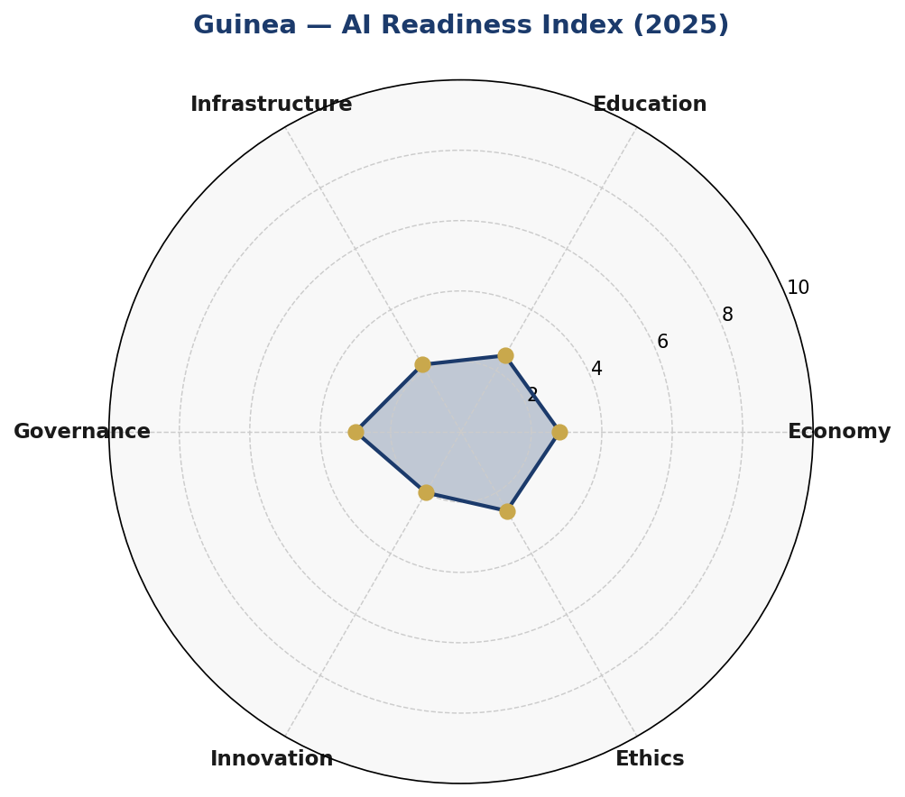
Figure 1: Guinea AI Readiness Index — Six-Axis Assessment (2025)
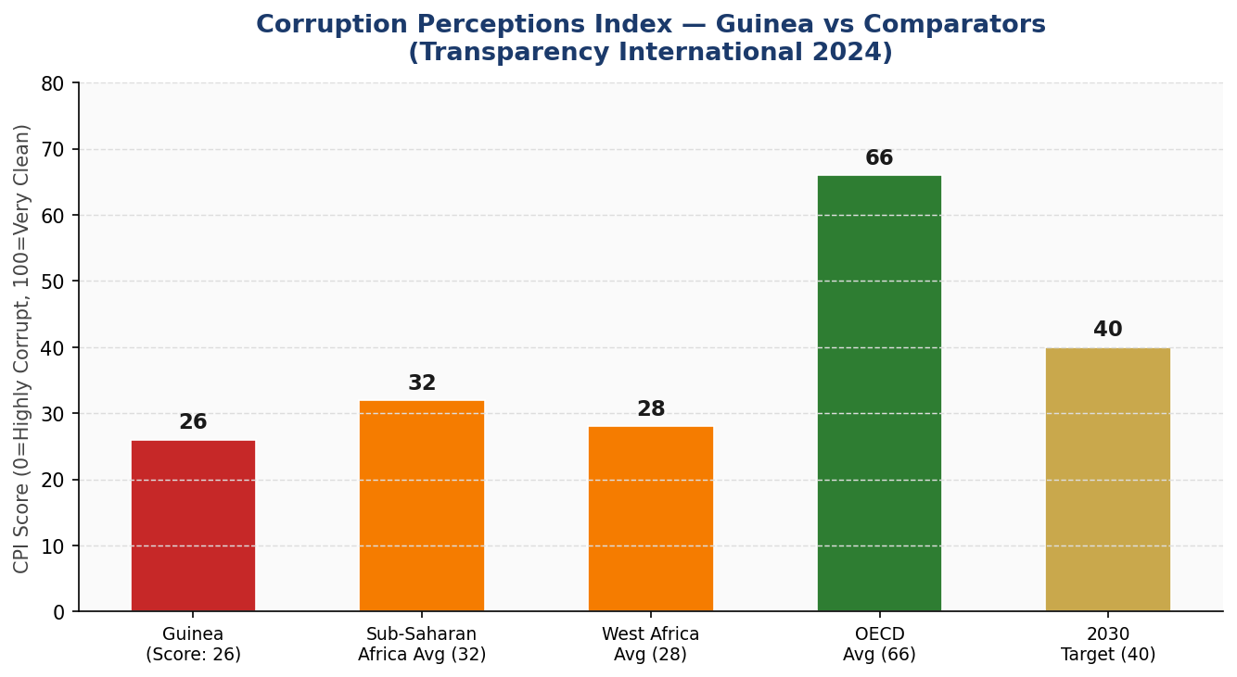
Figure 2: Corruption Perceptions Index — Guinea vs Regional and Global Comparators

Section 2: Policy Vision and Strategic Pillars

2.1 Vision Statement
"By 2030, Guinea shall be a nation where artificial intelligence serves every citizen — amplifying the voices of the voiceless, unlocking the potential of our youth, protecting the rights of our people, and transforming our natural wealth into a diversified, knowledge-driven economy that leads francophone Africa in ethical AI governance."

2.2 Strategic Pillar 1: Ethical AI and Human Rights Protection
Guinea's AI ecosystem must be built on an unshakeable ethical foundation. This pillar establishes the National AI Ethics Board, mandatory human rights impact assessments for all high-risk AI deployments, algorithmic transparency requirements, and citizen grievance mechanisms. Special protections are established for vulnerable groups — including women, youth, ethnic minorities, and persons with disabilities — ensuring AI systems cannot be used to discriminate, surveille without cause, or circumvent due process.
- Key Measure: Establishment of a 15-member National AI Ethics Board with representatives from government, civil society, academia, private sector, and international observers.
- Key Measure: Mandatory AI Human Rights Impact Assessment (HRIA) for all government AI procurement above a defined risk threshold.
- Key Measure: Ban on AI-powered social credit systems, predictive policing without judicial oversight, and mass biometric surveillance of civilians.

2.3 Strategic Pillar 2: Economic Growth and Industrial AI Adoption
AI offers Guinea an unprecedented opportunity to leapfrog conventional development stages. This pillar focuses on accelerating AI adoption in key sectors — mining, agriculture, healthcare, and financial services — through sector-specific roadmaps, public-private partnerships, and targeted fiscal incentives. Special economic zones with AI-friendly regulatory environments will attract international technology companies, creating jobs and technology transfer opportunities.
- Key Measure: AI Sector Adoption Fund of GNF 50 billion (approx. USD 5.5 million) to co-finance AI integration projects in priority industries.
- Key Measure: Tax incentives for companies that invest in local AI research and development, with a 30% R&D tax credit.
- Key Measure: AI-powered agricultural advisory platform reaching 500,000 farmers by Year 3, improving crop yield forecasting and market access.

2.4 Strategic Pillar 3: Education, Upskilling and AI Workforce Development
Without a skilled AI workforce, Guinea cannot benefit from the AI revolution. This pillar transforms Guinea's education system to build AI awareness, literacy, and expertise at every level — from primary school digital awareness to graduate-level research programs. Partnerships with international universities, online learning platforms, and diaspora networks form the backbone of this effort, ensuring access even in resource-constrained settings.
- Key Measure: Introduction of AI literacy modules in all secondary schools by Year 2, reaching 80,000 students.
- Key Measure: Establishment of three national AI Centres of Excellence at universities in Conakry, Kankan, and Labé.
- Key Measure: 100 annual AI scholarships for study at internationally accredited institutions, with a return-of-service requirement.

2.5 Strategic Pillar 4: Public Sector AI and e-Governance
Government services are often the first point of citizen contact with technology. This pillar deploys AI to improve the efficiency, transparency, and accessibility of public services — from tax collection and customs management to healthcare delivery and land registration. AI-powered anti-corruption tools are prioritized, recognizing that governance improvement directly enables better implementation of all other pillars.
- Key Measure: Deployment of AI-powered customs management system in Year 1 to reduce revenue leakage and processing time by 40%.
- Key Measure: National e-Health AI platform providing diagnostic support to 200 rural health centers by Year 3.
- Key Measure: AI-powered citizen feedback system for government service quality monitoring, accessible via USSD and smartphone.

2.6 Strategic Pillar 5: AI Research, Innovation and Startup Ecosystem
Guinea must cultivate its own AI innovators, not merely import solutions designed elsewhere. This pillar establishes an enabling environment for AI startups, research institutions, and innovation hubs — with Conakry positioned as a nascent West African AI hub. Open government data initiatives, AI sandbox regulations, and international research partnerships create the conditions for homegrown innovation that addresses Guinea's specific challenges.
- Key Measure: Guinea AI Innovation Hub established in Conakry by Year 1, providing co-working space, mentorship, and seed funding to 50+ startups in Year 1.
- Key Measure: National AI Open Data Portal publishing 50+ curated government datasets for AI development by Year 2.
- Key Measure: AI Sandbox Regulatory Framework allowing controlled testing of innovative AI applications with temporary regulatory exemptions.

Section 3: International Framework Alignment

3.1 UNESCO AI Ethics Recommendation (2021)
The UNESCO Recommendation on the Ethics of AI identifies 11 core values and principles. This policy adopts all 11 as foundational commitments. Proportionality and Do No Harm are reflected in the risk-based regulatory framework (Section 6). Safety and Security underpin all government AI procurement guidelines (Section 7). Fairness and Non-Discrimination inform the algorithmic accountability standards and the gender inclusion targets in education (Section 5). Privacy and data protection are addressed through the recommended Data Protection Act (Section 6). Transparency and explainability requirements apply to all high-risk AI deployments. Human oversight and determination are preserved through the Ethics Board and parliamentary oversight mechanism (Section 9). Responsibility and accountability are embedded throughout through mandatory audit trails and grievance mechanisms.

3.2 OECD AI Principles (2019, Updated 2024)
The OECD AI Principles — inclusive growth, human-centred values, transparency, robustness, and accountability — are structurally mapped to this policy. The updated 2024 principles, which emphasize AI system lifecycle governance and international interoperability, directly inform Guinea's procurement guidelines and the proposed National AI Observatory. Guinea, while not an OECD member, seeks adherence to these internationally recognized standards as part of its international AI cooperation strategy.

3.3 EU AI Act (2024)
The EU AI Act's risk-based classification system is adapted for Guinea's context in Section 6. Uses classified as Unacceptable Risk — including social scoring, real-time biometric surveillance of civilians, and AI exploitation of vulnerable groups — are prohibited outright. High-Risk applications (healthcare diagnostics, critical infrastructure, law enforcement) require mandatory pre-deployment conformity assessments and post-deployment monitoring. Limited Risk applications require transparency disclosures to users. Minimal Risk applications operate under voluntary codes of conduct. This classification system provides Guinea with a scalable, internationally credible regulatory architecture.

3.4 World Bank AI Strategy
The World Bank's AI for Development framework emphasizes AI's role in poverty reduction, financial inclusion, and public service delivery improvement — all central to this policy. Guinea's alignment with World Bank development priorities positions it for AI-related technical assistance, IDA financing for digital infrastructure, and participation in the World Bank's AI governance learning network. The investment roadmap in Section 4 is designed to attract concessional financing aligned with World Bank frameworks.

3.5 G20 AI Principles and ITU AI for Good
The G20 AI Principles — which prioritize inclusive growth, sustainable development, and international cooperation — are embedded in Guinea's international cooperation strategy (Section 10). The ITU AI for Good framework's focus on SDG alignment is reflected throughout this policy, with explicit linkages drawn between AI applications and SDG targets across health (SDG 3), education (SDG 4), economic growth (SDG 8), reduced inequalities (SDG 10), and governance (SDG 16).

3.6 Comprehensive Framework Alignment Matrix

Framework Principle | Sec 2 | Sec 3 | Sec 4 | Sec 5 | Sec 6 | Sec 7
UNESCO: Human dignity & autonomy | ✅ | ✅ | ⚠️ | ✅ | ✅ | ✅
UNESCO: Transparency & explainability | ✅ | ✅ | ⚠️ | ⚠️ | ✅ | ✅
UNESCO: Accountability & responsibility | ✅ | ✅ | 🔲 | 🔲 | ✅ | ✅
UNESCO: Sustainability & environment | ⚠️ | ✅ | ✅ | 🔲 | 🔲 | ⚠️
OECD: Inclusive growth | ✅ | ✅ | ✅ | ✅ | ⚠️ | ✅
OECD: Robustness & safety | ✅ | ⚠️ | 🔲 | 🔲 | ✅ | ✅
EU AI Act: Risk-based regulation | ⚠️ | ✅ | 🔲 | 🔲 | ✅ | ✅
World Bank: Development alignment | ✅ | ✅ | ✅ | ✅ | ⚠️ | ✅
G20: International cooperation | ✅ | ✅ | ⚠️ | 🔲 | ⚠️ | ✅
ITU / SDG alignment | ✅ | ✅ | ✅ | ✅ | ⚠️ | ✅
Table 1: International Framework Alignment Matrix. ✅ = Fully aligned | ⚠️ = Partially aligned | 🔲 = Future alignment planned

Section 4: Economic Impact and Investment Roadmap

4.1 Projected AI Economic Contribution
Based on McKinsey Global Institute and World Bank estimates for low-income economies with comparable structural profiles, Guinea can realistically expect AI to contribute approximately 3.5% of GDP by 2030, representing approximately USD 500 million in annual economic value at projected GDP levels. This projection assumes successful implementation of the infrastructure, education, and regulatory pillars of this policy. The primary economic gains will accrue through productivity improvements in agriculture (estimated 15–25% yield enhancement), mining operations (10–15% efficiency gains through predictive maintenance), healthcare cost savings (20–30% reduction in diagnostic delays), and government revenue optimization through AI-enhanced tax and customs administration.
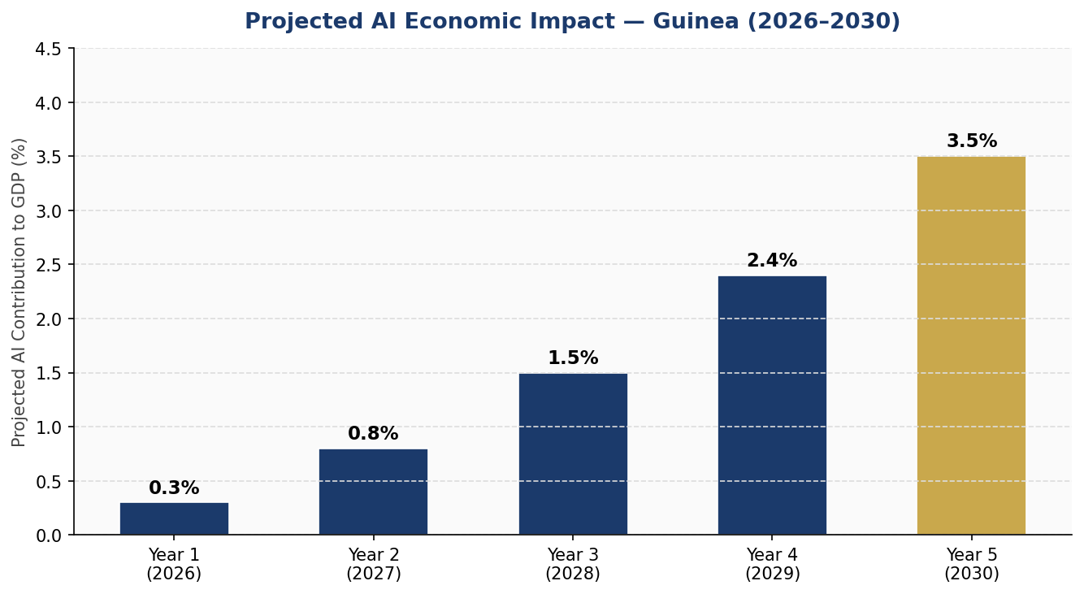
Figure 3: Projected AI Contribution to Guinea's GDP (2026–2030)
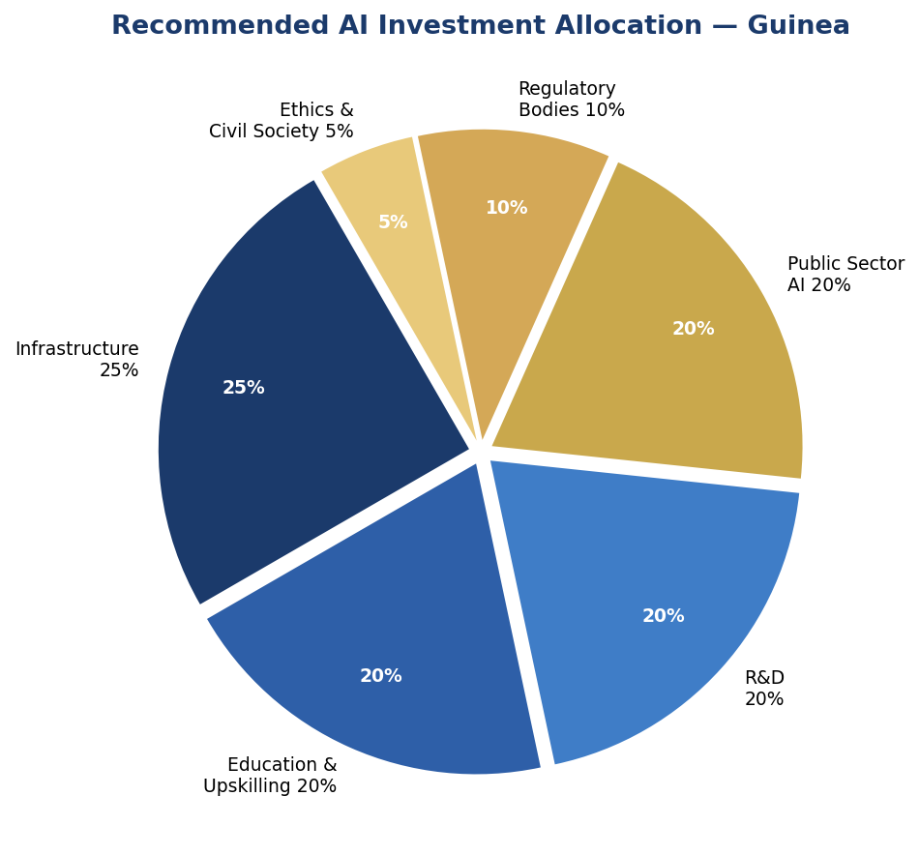
Figure 4: Recommended AI Investment Allocation by Category

4.2 Priority Sectors for AI Adoption
- Mining and Natural Resources: Predictive maintenance for equipment, environmental compliance monitoring, supply chain transparency using AI and blockchain, and artisanal mining safety systems.
- Agriculture: AI-powered crop advisory services via mobile platforms, satellite imagery analysis for smallholder farms, climate adaptation modeling, and food systems market linkage platforms.
- Healthcare: AI-assisted diagnostics for priority diseases (malaria, tuberculosis, maternal health), telemedicine platforms, medical supply chain optimization, and community health worker decision support tools.
- Financial Services: Credit scoring for the unbanked population using alternative data, fraud detection in mobile money systems, and AI-powered microinsurance products.
- Education: Adaptive learning platforms in local languages, AI-powered teacher support tools, attendance and performance analytics, and scholarship matching systems.

4.3 Public-Private Partnership Framework
The Government of Guinea commits to a structured Public-Private Partnership (PPP) framework for AI investment. The framework establishes risk-sharing mechanisms, IP ownership guidelines for government co-funded research, data sharing agreements between public and private entities, and a Guinea AI Investment Board to coordinate inflows from development finance institutions, bilateral donors, and private investors. Companies that establish local AI training programs and commit to 60% local hiring within three years receive priority PPP partnership status.

Section 5: Education and Human Capital Development

5.1 Current Skills Gap Analysis
Guinea currently has fewer than 500 individuals with formal AI or data science training. There are no dedicated AI degree programs at Guinean universities, limited data science coursework, and a critical shortage of qualified AI instructors. The country's low electricity access in rural areas — approximately 35% nationally — constrains digital device usage, requiring a mobile-first and offline-capable approach to AI education delivery.
Language presents a specific challenge: while French is the official language of instruction, the majority of Guineans speak Pular, Mandinka, Soussou, or other national languages. AI education materials and eventually AI tools themselves must be developed in local languages to achieve genuine inclusion.

5.2 National AI Curriculum Framework
- Primary Level (Grades 1–6): Digital citizenship, basic computational thinking, internet safety, and introductory coding concepts. Target: All 4,000+ primary schools by Year 5.
- Secondary Level (Grades 7–12): AI literacy modules covering what AI is, how it works, its applications and risks, data privacy, and critical thinking about algorithmic outputs. Target: 500,000 secondary students reached by Year 5.
- Vocational and Technical: AI application in specific trades — precision agriculture, healthcare data management, logistics, and business analytics. Target: 20 vocational centers with AI tracks by Year 3.
- Tertiary Level: Full AI and data science degree programs at three universities. Integrated AI modules across all disciplines — from law to medicine to engineering. Target: 2,500 graduates per year by Year 5.
- Continuous Professional Development: AI upskilling programs for current government employees, teachers, healthcare workers, and private sector professionals. Target: 40,000 professionals trained by Year 5.
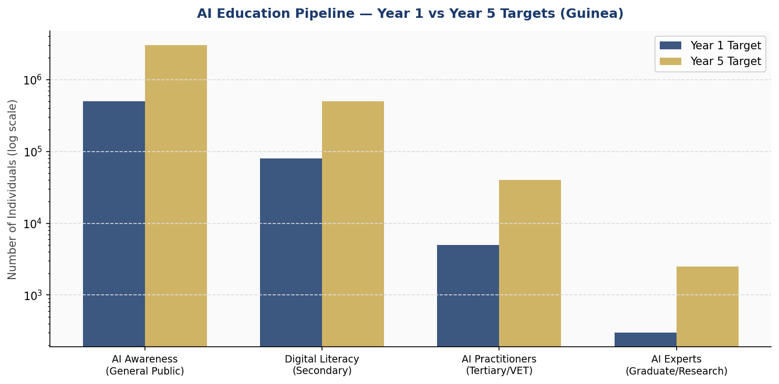
Figure 5: AI Education Pipeline — Year 1 vs Year 5 Population Targets (Guinea)

5.3 Gender and Inclusion Targets
This policy sets a binding target of 45% female participation in all government-funded AI education and training programs by Year 5. Specific interventions include women-only AI bootcamps, mentorship networks connecting female AI professionals (especially from the diaspora) with young Guinean women, scholarships prioritizing female applicants in STEM fields, and community awareness campaigns addressing social barriers to girls' participation in technology education. Ethnic minority communities and persons with disabilities receive dedicated outreach and accessible materials.

Section 6: Ethical AI Governance and Regulatory Framework

6.1 National AI Ethics Board
The National AI Ethics Board (NAEB) is established as an independent statutory body with a mandate to review, advise, audit, and where necessary prohibit AI deployments in Guinea. The Board comprises 15 members: four government representatives (including the Ministries of Digital Economy, Justice, Health, and Education); four academic and research institution representatives; three civil society and human rights organization representatives; two private sector representatives; and two international observer members from recognized AI governance bodies.
The NAEB operates with full financial independence, publishing annual reports to the National Assembly. It has investigative powers, can issue binding remediation orders for non-compliant AI systems, and maintains a public AI Systems Registry accessible to all Guinean citizens.

6.2 AI Risk Classification System
- Unacceptable Risk — PROHIBITED: AI systems that deploy subliminal manipulation techniques; exploit vulnerabilities of specific groups; are used for social scoring or mass predictive profiling of citizens; enable real-time biometric mass surveillance in public spaces (except with specific judicial authorization for national security); or facilitate systematic discrimination based on ethnicity, gender, religion, or political opinion. No exceptions. Operators face criminal penalties.
- High Risk — REGULATED: AI in healthcare diagnostics, judicial or law enforcement decision support, critical infrastructure management, employment screening, education assessment, and banking credit scoring. Mandatory pre-deployment conformity assessment by accredited auditor, registration in the National AI Registry, algorithmic impact assessment, and post-deployment quarterly reporting to NAEB. Mandatory human override capability.
- Limited Risk — TRANSPARENCY OBLIGATIONS: Chatbots, AI-generated content, emotion recognition systems. Users must be informed they are interacting with an AI system. Operators must clearly label AI-generated content.
- Minimal Risk — VOLUNTARY: Spam filters, inventory optimization, recommendation systems with no significant impact on individuals. Encouraged to adhere to voluntary codes of conduct.

6.3 Data Protection and Privacy
This policy calls for the enactment of a comprehensive Guinea Data Protection Act within Year 1 of implementation, modeled on the ECOWAS Supplementary Act on Data Protection and aligned with GDPR principles. The Act establishes data subject rights including access, correction, deletion, and portability. It mandates data localization requirements for sensitive government and health data. An independent Data Protection Authority is established under the NAEB umbrella with enforcement powers including fines of up to 4% of annual turnover for serious violations.

6.4 Anti-Corruption AI Guidelines
Given Guinea's governance challenges, specific Anti-Corruption AI Guidelines are integrated into the regulatory framework. These require: open source or independently audited code for AI systems used in government procurement, revenue collection, and judicial decisions; mandatory logging and audit trails for all government AI system outputs; prohibition on AI systems that concentrate decision-making power in ways that remove accountability; and mandatory disclosure of any AI system training data that includes historical government records, to prevent perpetuation of past corrupt patterns.

Section 7: Public Sector and e-Governance AI

7.1 Priority Government AI Use Cases
- Tax and Customs Administration: AI-powered anomaly detection for customs declarations, reducing revenue leakage estimated at 30% of potential customs revenue. Expected Year 1 revenue improvement: GNF 200 billion.
- Public Health Surveillance: AI-driven disease outbreak detection and response coordination, building on Guinea's experience with Ebola response and integrating with WHO AFRO surveillance networks.
- Agricultural Extension Services: AI chatbot and SMS advisory service for farmers, providing localized crop management advice, weather alerts, and market price information in national languages.
- Land Registration and Cadastre: AI-powered digitization of land records, conflict resolution support, and community mapping to reduce land disputes — a significant driver of rural insecurity.
- Education Management: AI-powered school enrollment tracking, teacher allocation optimization, learning outcome analytics, and early-warning systems for dropout risk.
- National Identity and Civil Registration: AI-assisted biometric identity system to expand civil registration — currently covering less than 50% of births — enabling more equitable access to public services.

7.2 Government AI Procurement Guidelines
All government AI procurement above GNF 500 million (approx. USD 55,000) must follow the Guinea AI Procurement Standard, which requires: open competitive tender with mandatory technical specifications including explainability, security, and fairness requirements; independent technical review by NAEB-approved evaluators; mandatory pilot phase with citizen impact assessment before full deployment; contractual requirements for source code escrow and technology transfer; post-deployment audit rights for the NAEB and Inspection Générale d'État.

7.3 Interoperability and Data Standards
All government AI systems must adhere to open data standards — including JSON-LD, OGC standards for geospatial data, and FHIR for health data — to ensure interoperability across ministries and with regional ECOWAS digital systems. A Government AI Interoperability Framework is published by MDET within Year 1, providing technical standards, API design guidelines, and data sharing protocols.

Section 8: Implementation Roadmap

8.1 Phase 1 — Foundation (Year 1: 2025–2026)
- Legal and Institutional: Enact Data Protection Act and AI Governance Act. Establish National AI Ethics Board. Launch National AI Registry. Publish AI Procurement Guidelines.
- Infrastructure: Expand national data center capacity. Initiate last-mile connectivity project in 100 rural communes. Launch Guinea Government Cloud.
- Education: Develop national AI curriculum for secondary schools. Train 500 AI teachers. Launch Guinea AI Innovation Hub in Conakry.
- Pilots: Launch five sector pilots: customs AI, agricultural advisory, health diagnostics, land registry, and education analytics.
- KPIs: NAEB operational by Month 6. Data Protection Act enacted by Month 9. Five pilots launched by Month 12. 250 schools with AI awareness curriculum.

8.2 Phase 2 — Scaling (Years 2–3: 2026–2028)
- Legal: Review and update AI Governance Act based on pilot learnings. Ratify bilateral AI cooperation agreements with three partner countries.
- Industry: Roll out AI Sector Adoption Fund. Launch 20 PPP AI projects. Support 200 AI startups through Innovation Hub and regional hubs.
- Education: National AI curriculum in all secondary schools. First cohort of AI university degree graduates. 20 vocational AI tracks operational.
- Government: All five pilots scaled nationally. AI systems reducing customs revenue leakage. National e-Health AI reaching 100 health centers.
- KPIs: 3% internet penetration increase. 5,000 AI practitioners trained. 200 startups supported. 10 government AI systems operational.

8.3 Phase 3 — Optimization (Years 4–5: 2028–2030)
- Review: Comprehensive policy review. Update AI risk classifications. Publish Guinea AI State Report (Year 3 and Year 5).
- International: Seek GPAI (Global Partnership on AI) observer status. Publish Guinea AI Governance Model for regional knowledge sharing. Explore AI export opportunities.
- Advanced: Deploy AI in 35 government services. Achieve 3.5% AI GDP contribution target. Launch Guinea AI Research Fund.
- KPIs: GDP AI contribution 3.5%. 80,000 AI practitioners. 800 AI startups. 68% internet penetration target progress.

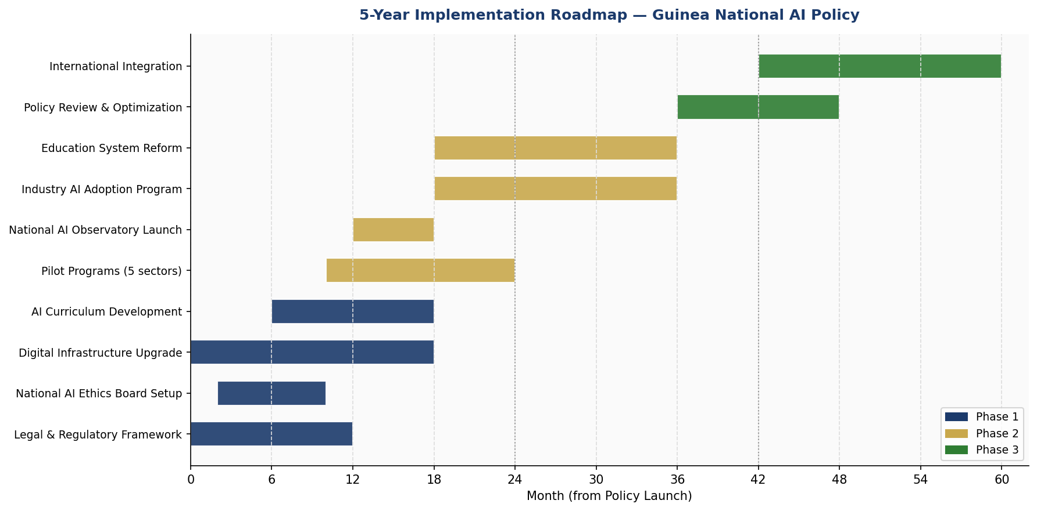
Figure 6: 5-Year Implementation Roadmap — Guinea National AI Policy (Gantt Timeline)

Section 9: Monitoring, Evaluation and Accountability

9.1 National AI Observatory
The National AI Observatory (NAIO) is established as a dedicated monitoring unit within the Ministry of Digital Economy and Telecommunications, with operational independence and a mandate to track, measure, and publicly report on AI policy implementation. The NAIO maintains the National AI Registry, conducts annual AI maturity assessments, commissions independent evaluations of high-risk AI systems, and produces the annual Guinea AI State Report, submitted to the National Assembly and published online.

9.2 Parliamentary Oversight
The National Assembly's Digital Economy and Telecommunications Committee is designated as the primary parliamentary oversight body for AI policy. The Committee receives the annual AI State Report, may call witnesses including NAEB members and AI system operators, and has the power to recommend legislative amendments. A cross-party AI Sub-Committee meets quarterly during the Foundation Phase to provide more intensive oversight during the critical early implementation period.

9.3 Civil Society and Independent Auditing
Civil society organizations play a formal role in AI governance through representation on the NAEB, participation in AI system audits, and the right to petition the NAEB with formal complaints about AI system impacts. Independent auditing firms accredited by the NAEB may be engaged to conduct conformity assessments of high-risk AI systems. International organizations including the African Union, ITU, and UNESCO are invited to participate in the Year 3 and Year 5 comprehensive policy reviews.

9.4 KPI Dashboard

KPI Metric | Baseline (2025) | Year 1 Target | Year 3 Target | Year 5 Target
AI contribution to GDP (%) | ~0.1% | 0.3% | 1.5% | 3.5%
Internet penetration rate | 28% | 35% | 52% | 68%
AI-trained workforce | <500 | 5,000 | 25,000 | 80,000
Gov't AI services deployed | 0 | 5 | 18 | 35
National AI Ethics Board operational | No | Yes | Yes | Yes
AI startups registered | <50 | 120 | 350 | 800
AI in school curriculum (schools) | 0 | 250 | 1,500 | 4,000
CPI (TI) Score | 26 | 27 | 32 | 40
Women in AI programs (%) | 12% | 20% | 35% | 45%
AI policy audit compliance (%) | N/A | 60% | 85% | 95%
Table 2: Guinea National AI Policy KPI Dashboard (2025–2030)

Section 10: International Cooperation and Diplomacy

10.1 Bilateral AI Cooperation Priorities
Guinea prioritizes bilateral AI cooperation agreements with: France (as the primary development partner and French-speaking AI research hub), the Republic of Korea (a leading AI technology exporter with strong development cooperation programs), Japan (JICA AI cooperation programs and robotics expertise), China (Belt and Road digital infrastructure investments and AI technology transfer), and Senegal and Ghana (as West African peers with more advanced AI ecosystems from whom Guinea can learn and eventually co-develop solutions).

10.2 Regional AI Governance — ECOWAS
Guinea is an active member of the Economic Community of West African States (ECOWAS). This policy commits Guinea to engagement in emerging ECOWAS digital economy governance frameworks, support for a West African AI Ethics Common Framework, interoperability of digital identity and data systems across ECOWAS member states, and joint AI research initiatives with ECOWAS partner countries through the proposed West Africa AI Research Consortium.

10.3 South-South Knowledge Transfer
Guinea recognizes the value of learning from peers navigating similar development challenges. Priority South-South AI knowledge partnerships are sought with Rwanda (recognized for AI-driven governance modernization), Ethiopia (African Union AI governance leadership), Uruguay (responsible AI policy development model), and Morocco (francophone African AI research capacity). These partnerships prioritize non-commercial, government-to-government technical assistance and researcher exchange.

10.4 Global AI Governance Participation
Guinea commits to active participation in global AI governance forums: seeking observer status at the OECD AI Policy Observatory; engaging with the UN Secretary-General's AI Advisory Body; participating in ITU AI for Good annual summits; and contributing Guinea's perspective as a low-income francophone African country to global AI governance deliberations. Guinea's voice in these forums will advocate for AI governance frameworks that are genuinely inclusive of the Global South's needs, constraints, and aspirations.

Conclusion
The Republic of Guinea's National Artificial Intelligence Policy 2025–2030 represents a bold, realistic, and globally aligned commitment to harnessing AI for inclusive national development. This framework does not pretend that AI is a magic solution to Guinea's complex development challenges — poverty, governance gaps, infrastructure deficits, and educational inequities cannot be solved by technology alone. But it asserts, with evidence-based confidence, that responsibly implemented AI can meaningfully accelerate progress on all these fronts.
The policy's strength lies in its specificity: concrete institutional arrangements, measurable targets, sector-specific roadmaps, and genuine framework alignment with international standards. It is honest about Guinea's constraints — including corruption risks and capacity limitations — and designs governance mechanisms that address these challenges rather than assuming them away.
Implementation will require sustained political will, adequate financing (estimated at USD 80–100 million over five years across public and private sources), and genuine multi-stakeholder engagement including communities whose lives AI will touch. The National AI Ethics Board, the National AI Observatory, and parliamentary oversight mechanisms are not bureaucratic additions — they are the accountability architecture that determines whether this policy delivers its promise.
Guinea's youth — the majority of its population — are watching, and many are already engaging with AI tools through their mobile devices. This policy gives formal institutional expression to their aspirations: a Guinea where intelligence, artificial and human, serves the people.

References and Bibliography
- African Union Commission (2024). African Union AI Continental Strategy for Africa 2021–2030: Progress Review. Addis Ababa: AUC.
- DataReportal (2024). Digital 2024: Guinea. Available at: datareportal.com.
- European Parliament and Council of the European Union (2024). Regulation (EU) 2024/1689 — The EU Artificial Intelligence Act. Official Journal of the European Union.
- International Telecommunication Union (2024). AI for Good: Sustainable Development Goals Alignment Framework. Geneva: ITU.
- McKinsey Global Institute (2023). The Economic Potential of Generative AI: The Next Productivity Frontier. New York: McKinsey.
- OECD (2024). OECD AI Principles: Updated Framework for Trustworthy AI. Paris: OECD Publishing.
- Transparency International (2024). Corruption Perceptions Index 2024. Berlin: TI.
- UNESCO (2021). Recommendation on the Ethics of Artificial Intelligence. Paris: UNESCO.
- UNESCO (2024). Global Education Monitoring Report: Technology in Education. Paris: UNESCO.
- World Bank (2024). Guinea Country Overview and Data Portal. Washington DC: World Bank.
- World Bank (2023). Worldwide Governance Indicators: Guinea. Washington DC: World Bank.
- World Economic Forum (2023). Future of Jobs Report 2023 — AI and Labour Markets. Geneva: WEF.
- World Bank (2024). AI in Development Finance: Opportunities and Governance for Low-Income Countries. Washington DC: World Bank.
- Global Partnership on AI (GPAI) (2024). Responsible AI Practices for Emerging Economies. Montreal: GPAI Secretariat.

About the Author

Nafiul Ahmad Rafi
Policy & Good Governance Researcher | BD Civic Tech Architect
Nafiul Ahmad Rafi is a civic technologist, policy researcher, author, photographer, and musician based in Dhaka, Bangladesh. He is the Founder and Director of Insights Bangladesh, a data-driven governance and policy impact analysis institution, and the Founder & Lead Architect of NagorikBD.org — a transparency-first civic platform scaled across Mymensingh Division, connecting citizens with government services across 45 Upazilas.
His work exists at the intersection of institutional reform and artificial intelligence, transforming theoretical governance into scalable, data-driven reality. Without a conventional computer science degree, he self-taught the tools of modern AI and web development to build the infrastructure that enforces the policies he once only researched.

Key Platforms and Projects
- NagorikBD.org — Civic transparency platform, Mymensingh Division
- Insights Bangladesh — Policy impact analysis institution
- FactCheck BD (factcheckbd.org) — Bangladesh's AI-powered fact-checking platform
- Political Insights BD / PIBD (pibbd.org) — Political intelligence and civic tech hub
- PeaceShield BD / National Peace Tracker — AI-powered hate speech and conflict monitoring
- PolicyLens AI (aigovbd.org) — 9-dimensional AI policy audit tool

He has published four books and maintains a personal site at ahmad-rafi.com.

Research Interests
AI Governance | Policy Research | Future of Bangladesh | Climate Policy

Contact
- Website: ahmad-rafi.com
- LinkedIn: linkedin.com/in/nafiul-ahmad-rafi
- Email: contact@ahmad-rafi.com

"I build code to ensure transparency, and I write lyrics to inspire the courage to use it."

