🇰🇪 REPUBLIC OF KENYA
NATIONAL ARTIFICIAL INTELLIGENCE POLICY
2025 – 2030

A Comprehensive Framework for Ethical, Inclusive,
and Economically Transformative Artificial Intelligence

Prepared by:
Nafiul Ahmad Rafi
Insights Bangladesh | Policy & Good Governance Research
Publication Date: 2025

Executive Summary

Kenya stands at a transformative inflection point. As Sub-Saharan Africa's most dynamic technology hub — home to the celebrated "Silicon Savannah" ecosystem in Nairobi — Kenya possesses the foundational assets, entrepreneurial culture, and regional influence to position itself as Africa's leading AI nation by 2030. This National Artificial Intelligence Policy 2025–2030 provides the strategic, regulatory, and institutional architecture required to translate this potential into measurable national development outcomes.
Kenya's AI readiness profile is promising but uneven. The country ranks 83rd out of 181 nations on the Oxford Insights AI Readiness Index — the highest in East Africa — yet faces structural constraints including a Corruption Perception Index score of 31/100, internet penetration of approximately 40%, and tertiary enrollment rates of just 12%. This policy directly addresses these constraints by embedding AI governance within anti-corruption frameworks, prioritizing digital infrastructure investment, and establishing a national AI education pipeline targeting 8 million citizens at awareness level and 12,000 AI experts by 2030.
The policy is organized around five strategic pillars: (1) Ethical AI and Human Rights Protection, ensuring that Kenya's AI deployment respects constitutional rights and international standards; (2) Economic Growth and Industrial AI Adoption, targeting a 6.1% AI contribution to GDP by 2030 representing approximately USD $6.5 billion in additional economic value; (3) Education, Upskilling, and AI Workforce Development, building a nationally competitive AI talent pipeline; (4) Public Sector AI and e-Governance, deploying AI to enhance service delivery, reduce corruption, and improve citizen outcomes; and (5) AI Research, Innovation, and Startup Ecosystem, consolidating Nairobi's position as Africa's premier AI innovation hub.
This policy aligns comprehensively with international frameworks including UNESCO's AI Ethics Recommendation (2021), OECD AI Principles (2024), the EU AI Act (2024), the African Union AI Strategy, ITU AI for Good Guidelines, and the G20 AI Principles — ensuring Kenya's approach is globally credible and regionally influential. Implementation will proceed through three phases: Foundation (2025–2026), Scaling (2026–2028), and Optimization (2028–2030), governed by the newly established National AI Ethics Board and monitored through the National AI Observatory with annual parliamentary reporting.

SECTION 1 National AI Readiness Assessment

1.1 Economic Context
Kenya is classified as a lower-middle-income country with a GDP per capita of approximately USD $2,100 (2024). The economy has demonstrated remarkable resilience, achieving 5.0% GDP growth despite global headwinds, driven by services (accounting for approximately 45% of GDP), agriculture (23%), and an emerging digital economy estimated at 8–10% of GDP. Kenya's ICT sector grew at 12.7% in 2023, making it one of the fastest-growing economic segments. M-Pesa's global recognition has demonstrated that Kenya can leapfrog traditional economic infrastructure through technology, establishing a template directly applicable to AI adoption.

1.2 Digital Infrastructure & Connectivity
Internet penetration stands at approximately 40% of the population, with significant urban-rural disparities: Nairobi achieves over 80% penetration while remote counties in North Eastern Province fall below 15%. Mobile penetration exceeds 130% (multiple SIM ownership), providing a critical delivery channel for mobile-first AI services. Kenya has invested significantly in submarine cable connectivity (TEAMS, EASSy, SEACOM) and has expanded 4G coverage to approximately 65% of the population. The ongoing National Broadband Strategy targets universal connectivity by 2027, directly enabling this AI policy's rural inclusion objectives.

1.3 Education & Human Capital
Kenya maintains a literacy rate of approximately 82%, with notable improvements in gender parity at primary level. Tertiary enrollment, however, stands at a relatively low 12%, representing a significant constraint on the advanced AI talent pipeline. The country has 71 accredited universities, with institutions such as the University of Nairobi, Strathmore University, and the African Institute for Mathematical Sciences (AIMS) providing emerging AI research capacity. Existing STEM initiatives including the Kenya National Examinations Council's coding curriculum reform and the Google AI programme partnership provide a platform for accelerated AI education integration.

1.4 Governance & Institutional Capacity
Kenya operates as a constitutional republic with a multi-party democratic system. The 2010 Constitution enshrines fundamental rights relevant to AI governance, including the right to privacy (Article 31), freedom of expression, and access to information. Institutional capacity for technology regulation is emerging: the Communications Authority of Kenya, the Office of the Data Protection Commissioner (established under the Data Protection Act 2019), and the Kenya ICT Authority provide regulatory foundations upon which AI-specific governance can be layered.

1.5 Corruption Risk Assessment
Kenya's Corruption Perception Index score of 31/100 (Transparency International, 2024) represents the single greatest systemic risk to effective AI governance. Historically, public procurement corruption, ethnic patronage networks, and weak enforcement of anti-corruption laws have undermined governance effectiveness. This policy explicitly integrates AI as an anti-corruption tool — deploying AI-assisted procurement monitoring, automated audit systems, and algorithmic accountability frameworks — while simultaneously establishing robust safeguards to prevent AI itself from becoming a new vector for corrupt practice or authoritarian misuse.

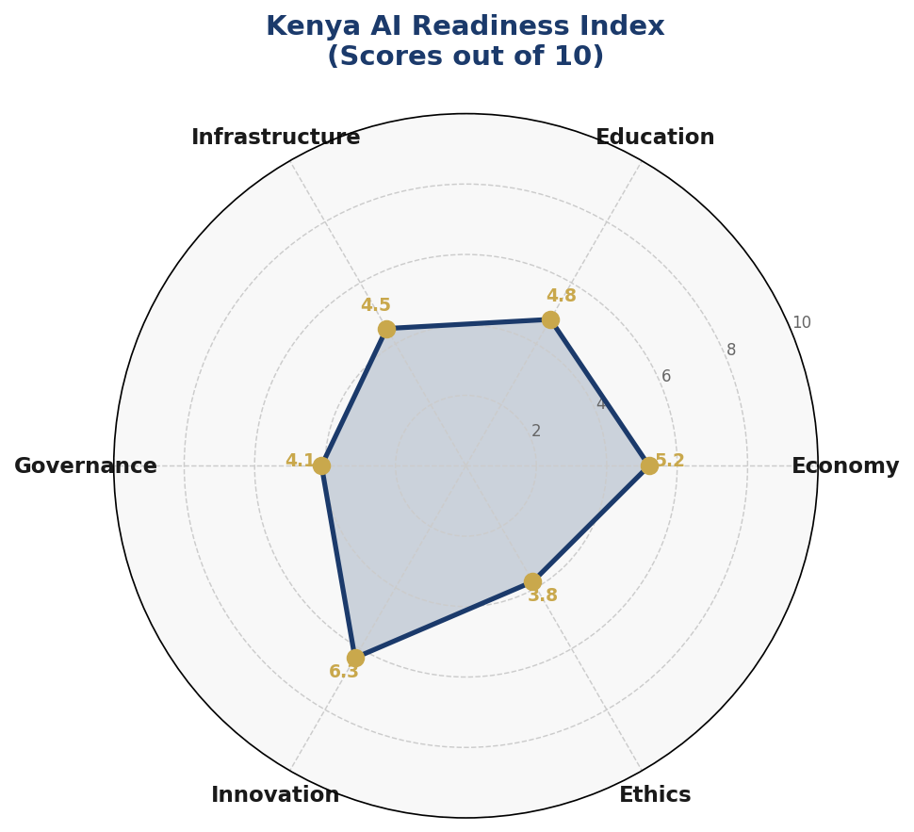
Figure 1.1: Kenya AI Readiness Radar — 6-Dimension Assessment (Scores out of 10)
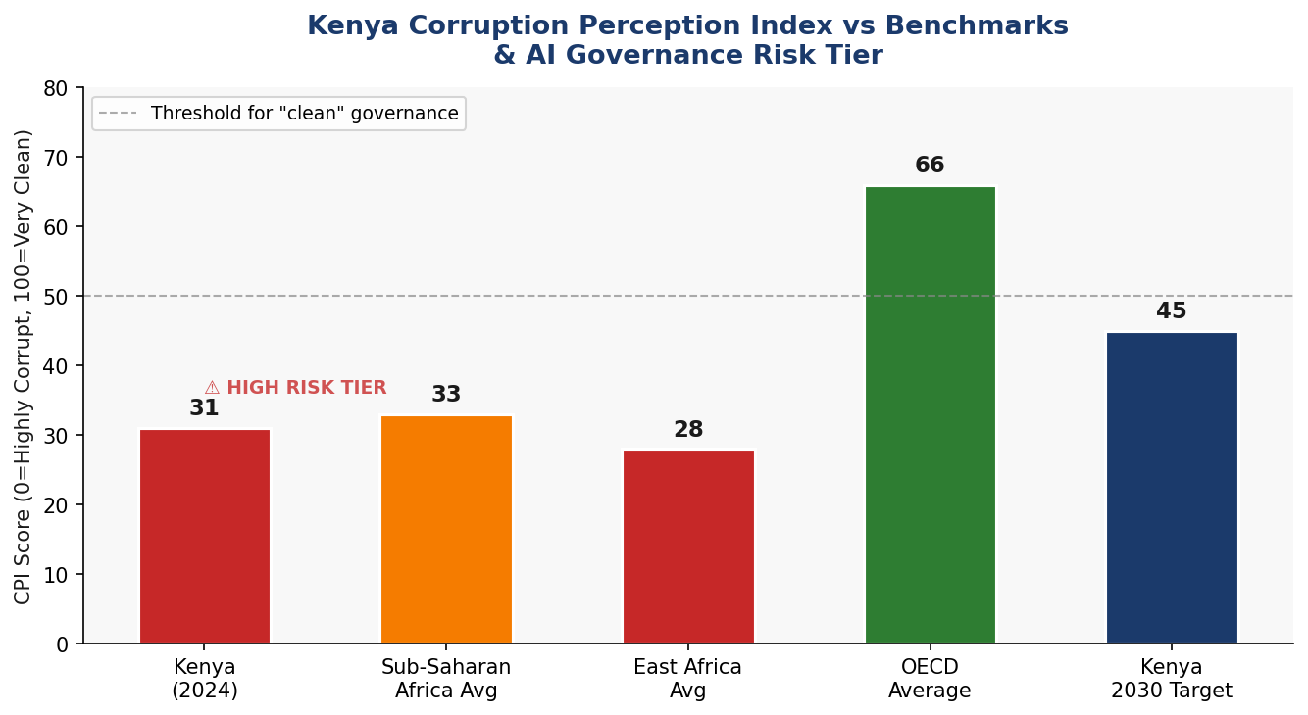
Figure 1.2: Kenya CPI Score vs Regional Benchmarks & AI Governance Risk Tier Classification
Kenya's National AI Readiness Assessment Summary:
Dimension | Data / Score | Policy Implication
GDP per Capita | ~USD $2,100 (2024) | Lower-middle income; high growth potential
GDP Growth Rate | 5.0% (2024 est.) | Resilient; agriculture + services dominant
Oxford AI Readiness | Rank 83/181 (Score 44) | Top performer in Sub-Saharan Africa
Internet Penetration | ~40% (2024) | Gap in rural areas; fiber expansion ongoing
Mobile Penetration | ~130% | High mobile-first opportunity for AI delivery
Tertiary Enrollment | ~12% | Low but growing; STEM priority needed
CPI Score | 31/100 (Rank 128) | Significant governance risk for AI deployment
Literacy Rate | ~82% | Solid base for AI literacy programs
Tech Ecosystem | Silicon Savannah Hub | Nairobi is Africa's premier AI/tech hub

SECTION 2 Policy Vision & Strategic Pillars

2.1 Vision Statement
"By 2030, Kenya shall be Africa's most trusted, inclusive, and innovative AI nation — harnessing the transformative power of artificial intelligence to accelerate economic development, strengthen democratic governance, protect human dignity, and position Kenya as a global model for responsible AI deployment in the Global South."

2.2 Strategic Pillars

Pillar 1: Ethical AI & Human Rights Protection
Every AI system deployed in Kenya — by government, private sector, or civil society — must uphold constitutional rights, prevent algorithmic discrimination, and be subject to independent oversight. This pillar establishes the National AI Ethics Board, Kenya AI Risk Classification System, and mandatory algorithmic impact assessments for high-risk applications. Special protections are embedded for marginalized communities, women and girls, persons with disabilities, and ethnic minorities who face disproportionate AI harms.

Pillar 2: Economic Growth & Industrial AI Adoption
AI will be the primary driver of Kenya's transition from a lower-middle-income to an upper-middle-income economy by 2035. This pillar targets AI adoption across agriculture (precision farming, climate adaptation), financial services (expanding M-Pesa ecosystem into AI-powered credit and insurance), healthcare (AI diagnostics for maternal health and infectious disease), manufacturing, and tourism. Sector-specific AI adoption roadmaps, public-private partnership frameworks, and AI investment incentives are central to implementation.

Pillar 3: Education, Upskilling & AI Workforce Development
Kenya's AI ambitions require a comprehensive national talent pipeline. This pillar establishes AI literacy as a core competency across all levels of education, funds 12,000 AI expert scholarships by 2030, deploys AI upskilling programs for 250,000 workers in automation-vulnerable sectors, and establishes five National AI Research Centers at leading universities. A particular emphasis is placed on women and girls in AI — targeting 40% female participation in the AI workforce by 2030.

Pillar 4: Public Sector AI & e-Governance
Government is both the largest employer and the largest service delivery system in Kenya. This pillar deploys AI to transform 80 government services by 2030 — from agricultural extension services to court case management, tax compliance to public health surveillance. AI-assisted procurement monitoring will directly reduce corruption in government contracting, while automated audit systems will increase fiscal accountability and public trust in institutions.

Pillar 5: AI Research, Innovation & Startup Ecosystem
Nairobi's Silicon Savannah must evolve from a consumer of global AI products to a producer of AI solutions tailored to African contexts. This pillar funds 2,000 AI startups by 2030, establishes Kenya as a regional AI research hub with 1,000+ annual publications, creates three international AI research partnerships, and positions Kenya's AI exports as a new foreign exchange earner. The Kenya AI Innovation Fund, seeded at KES 10 billion, will drive this transformation.

SECTION 3 International Framework Alignment

3.1 UNESCO AI Ethics Recommendation (2021)
UNESCO's 11 core values — proportionality, safety, fairness, sustainability, privacy, human oversight, transparency, responsibility, awareness, multistakeholder governance, and adaptive governance — are comprehensively reflected throughout this policy. Kenya's National AI Ethics Board is directly modeled on UNESCO's institutional governance recommendations, and the AI Risk Classification System (Section 6) operationalizes proportionality and safety requirements.

3.2 OECD AI Principles (2024)
The five OECD AI Principles — inclusive growth, human-centered values, transparency, robustness, and accountability — are embedded in Kenya's policy architecture. The mandatory Algorithmic Impact Assessments required for high-risk AI systems directly implement the OECD's accountability principle, while the National AI Observatory's annual reporting requirement satisfies transparency standards. Kenya's membership in the OECD's Global Partnership on AI (GPAI) as an associate member supports ongoing alignment.

3.3 EU AI Act (2024) — Risk-Based Categorization
The EU AI Act's risk-based regulatory architecture is adapted to Kenya's constitutional and institutional context. The four-tier risk classification (Unacceptable, High, Limited, Minimal) is implemented in Section 6 with Kenya-specific examples. Key adaptations include: heightened protections against ethnic and regional discrimination given Kenya's 44+ ethnic groups; specific safeguards for AI in election contexts given historical electoral violence; and proportionate implementation timelines acknowledging Kenya's institutional capacity constraints.

3.4 African Union AI Strategy
Kenya's policy is explicitly designed to support and advance the African Union's emerging AI strategy and Agenda 2063 digital transformation goals. Kenya will serve as a regional AI governance leader, sharing its regulatory frameworks with the East African Community (EAC) and the broader continent, hosting pan-African AI governance dialogues, and contributing Kenyan AI talent to AU institutional capacity building.

3.5 Comprehensive Framework Alignment Matrix
Framework | Ethics & Rights | Governance | Economy | Implementation | Monitoring
UNESCO AI Ethics (2021) | ✅ Sec 2, 6 | ✅ Sec 6 | ✅ Sec 5 | ✅ Sec 7 | ✅ Sec 9
OECD AI Principles (2024) | ✅ Sec 2 | ✅ Sec 6 | ✅ Sec 4 | ✅ Sec 8 | ⚠️ Partial
EU AI Act (2024) | ✅ Sec 6 | ✅ Sec 6 | ⚠️ Partial | ✅ Sec 7 | ✅ Sec 9
World Bank AI Strategy | ✅ Sec 4 | ✅ Sec 5 | ✅ Sec 4 | ✅ Sec 7 | ✅ Sec 8
G20 AI Principles | ✅ Sec 2 | ⚠️ Partial | ✅ Sec 4 | ✅ Sec 8 | ✅ Sec 10
ITU AI for Good / SDGs | ✅ Sec 5 | ✅ Sec 6 | ✅ Sec 4 | ✅ Sec 7 | ✅ Sec 8
African Union AI Strategy | ✅ Sec 10 | ✅ Sec 2 | ✅ Sec 5 | ✅ Sec 4 | ✅ Sec 10

SECTION 4 Economic Impact & Investment Roadmap

4.1 Projected AI Economic Contribution
McKinsey Global Institute estimates that AI could contribute 1.2–1.5% of GDP annually to Sub-Saharan African economies that achieve full AI adoption. For Kenya, with a GDP of approximately USD $107 billion (2024), this translates to an annual AI contribution of USD $1.3–1.6 billion at full implementation. The World Economic Forum projects that AI-enabled automation and productivity gains could add USD $6.5 billion cumulatively to Kenya's economy over the 2025–2030 policy period — equivalent to approximately 6.1% of current GDP.
Priority sectors for AI-driven economic transformation include: agriculture (AI-powered precision farming, crop disease detection, and climate adaptation tools for Kenya's 4.6 million smallholder farmers), financial services (AI credit scoring expanding formal financial access to the 40% of Kenyans currently unbanked), healthcare (AI diagnostics addressing the country's 1:16,000 doctor-to-patient ratio), and manufacturing (AI-enabled quality control supporting the Big Four Agenda's industrialization targets).
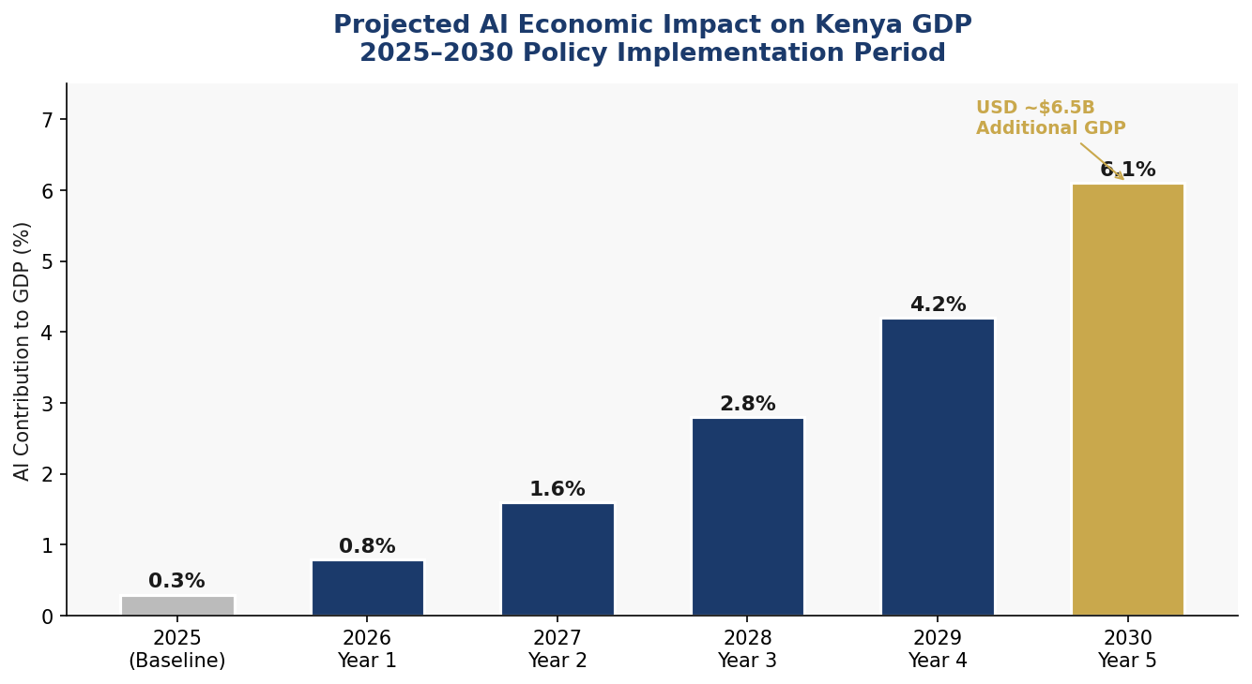
Figure 4.1: Projected AI Contribution to Kenya GDP (2025–2030)
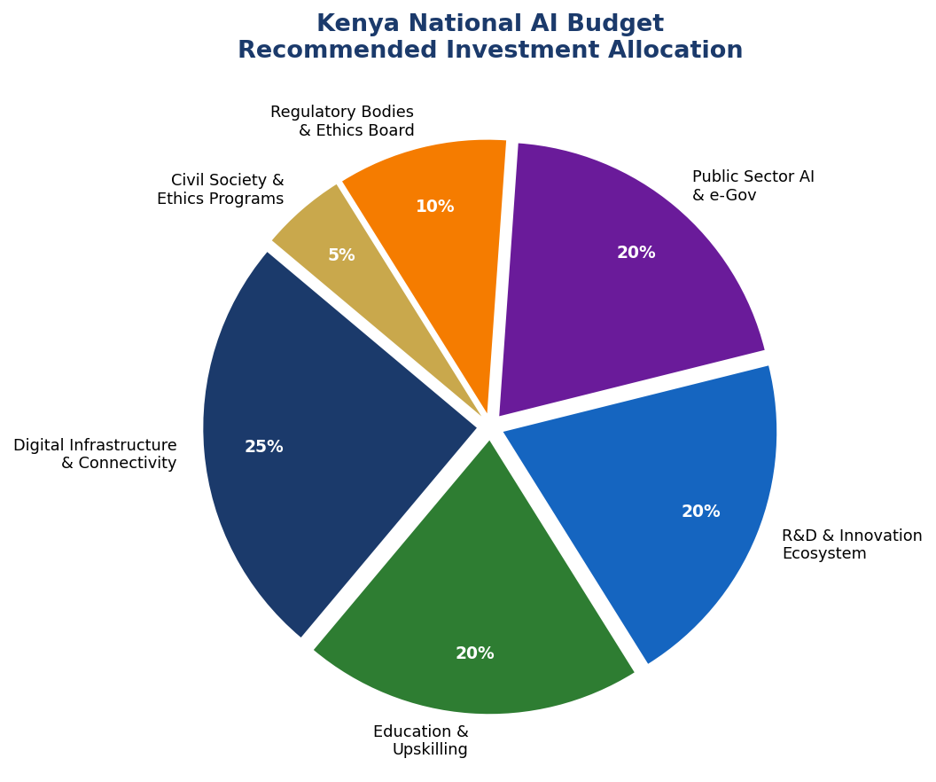
Figure 4.2: Kenya National AI Budget — Recommended Investment Allocation

4.2 Public-Private Partnership Framework
The Kenya AI Investment Fund (KAIF), seeded with KES 10 billion from the national budget, will leverage 3:1 private co-investment through structured Public-Private Partnership (PPP) agreements. The Kenya National Treasury, in coordination with the Kenya Private Sector Alliance (KEPSA) and the ICT Authority, will establish AI Investment Tax Credits, AI Startup Fast-Track Licensing, and International AI Partnership Grants to catalyze private sector AI investment across all five strategic pillars.

SECTION 5 Education & Human Capital Development

5.1 Current Skills Gap Analysis
Kenya faces a significant AI skills gap at every level of the talent pipeline. At the awareness level, the majority of Kenya's 55 million citizens have limited understanding of AI's implications for employment, privacy, and civic life. At the practitioner level, Kenya has approximately 5,000–8,000 individuals with functional AI/ML skills — primarily concentrated in Nairobi and meeting only 30% of current industry demand. At the expert/research level, fewer than 200 Kenyans hold PhD-level qualifications in AI-related fields, with approximately 40 AI research publications produced annually — compared to South Africa's 400+ and Egypt's 350+.

5.2 National AI Curriculum Framework
The Kenya National Curriculum Development Centre (KNEC) will integrate AI literacy into the Competency-Based Curriculum (CBC) at all levels. At primary level (Grades 4–9), computational thinking, data concepts, and AI ethics will be embedded across subjects. At secondary level, dedicated AI electives and project-based AI applications will be introduced. At tertiary level, all public universities will integrate AI modules into every degree program, and five universities will establish dedicated AI Schools by 2027.
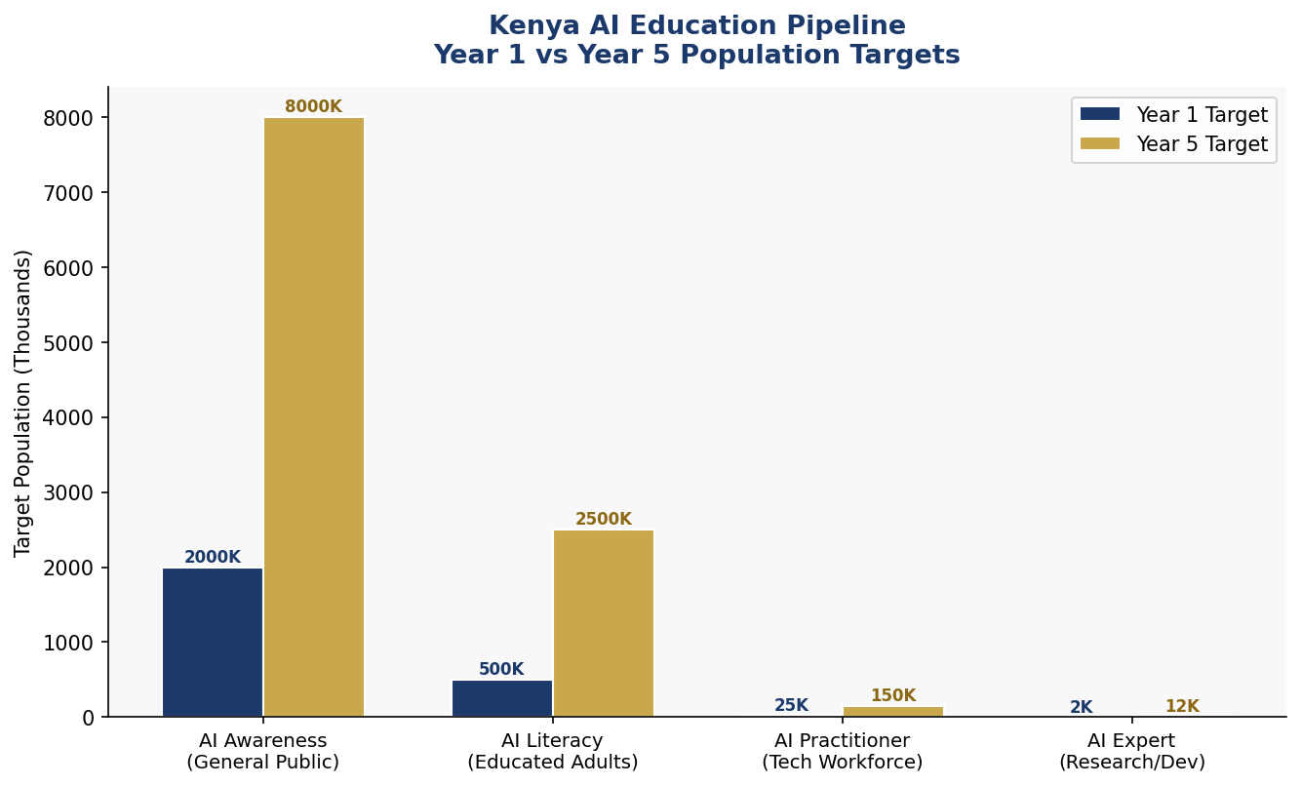
Figure 5.1: Kenya AI Education Pipeline — Year 1 vs Year 5 Population Targets

5.3 Women & Marginalized Groups
Kenya's AI future cannot be built on a foundation of gender or ethnic exclusion. The policy targets 40% female participation in the AI workforce by 2030, backed by: the Kenya Women in AI Scholarship (2,500 awards annually), mandatory 40% female enrollment quotas for government-funded AI training programs, AI mentorship networks linking female professionals across East Africa, and partnerships with organizations including Women in Machine Learning (WiML) and the AI4D Africa programme. Special programs will target youth from historically marginalized counties in North Eastern, Coast, and Rift Valley regions.

SECTION 6 Ethical AI Governance & Regulatory Framework

6.1 National AI Ethics Board
The National AI Ethics Board (NAEB) will be established by Act of Parliament within 12 months of policy adoption. The Board will comprise 15 members: three government representatives (from the Ministry of ICT, the Office of the Attorney General, and the National Treasury), three private sector representatives, three civil society representatives (including at least one human rights organization and one women's rights body), three academic/research representatives, and three independent public members appointed through a transparent competitive process. NAEB will have statutory powers to investigate, audit, and sanction AI deployments that violate this policy.

6.2 AI Risk Classification System
Risk Tier | Kenya-Specific Examples & Applications
🚫 UNACCEPTABLE | Social scoring by state; mass surveillance of ethnicity/religion; real-time biometric ID in public without consent; AI-generated election misinformation
⚠️ HIGH RISK | AI in criminal justice/policing; medical diagnosis AI; loan/credit scoring; education assessment; critical infrastructure control; border management AI
ℹ️ LIMITED RISK | Chatbots interacting with citizens; emotion recognition systems; deepfake generation tools; AI-generated content in media
✅ MINIMAL RISK | AI spam filters; AI-powered productivity tools; entertainment recommendation systems; basic data analytics; language translation tools

6.3 Data Protection & Algorithmic Accountability
The Data Protection Act 2019 established Kenya's foundational data protection framework. This policy requires the National Assembly to enact the AI-Specific Data Governance Act by 2026, which will establish: mandatory data impact assessments for AI systems using personal data; the right to explanation for automated decisions affecting citizens; prohibition on AI systems trained on unlawfully obtained data; sector-specific data sharing standards for health AI, agricultural AI, and financial AI; and cross-border data transfer restrictions ensuring Kenya's AI data sovereignty.
Algorithmic Accountability Standards will require all High-Risk AI systems used by government or critical infrastructure operators to undergo annual third-party algorithmic audits by certified AI auditors. Kenya will invest in training 500 certified AI auditors by 2030 through the Kenya School of Governance and the Kenya ICT Authority.

SECTION 7 Public Sector AI & e-Governance

7.1 Priority Government Use Cases
Kenya's public sector AI deployment will be prioritized in six high-impact domains aligned with the Bottom-Up Economic Transformation Agenda (BETA):
- Agricultural Extension AI: Precision farming advisory systems, crop disease detection via satellite and mobile image analysis, and climate-smart agriculture recommendations for Kenya's 4.6 million smallholder farmers, delivered via USSD/mobile channels for offline-first accessibility.
- Healthcare AI: AI-powered maternal mortality prediction models for 48 high-risk counties, tuberculosis and HIV/AIDS treatment adherence monitoring, community health worker support tools, and AI-assisted telemedicine for rural health facilities.
- Judicial AI: Case management optimization for Kenya's backlogged court system (over 650,000 pending cases), AI-assisted legal aid for self-represented litigants, and predictive analytics for bail and sentencing support (subject to mandatory human review).
- Revenue & Anti-Corruption AI: KRA (Kenya Revenue Authority) AI-powered tax compliance monitoring, AI-assisted Integrated Financial Management Information System (IFMIS) anomaly detection for procurement fraud, and automated beneficial ownership transparency.
- Education AI: Personalized learning systems for CBC implementation, AI-powered teacher professional development, automated marking and assessment analytics, and early warning systems for school dropout prevention.
- Disaster & Climate AI: National Drought Monitoring System AI integration, flood prediction for Nairobi's informal settlements, AI-powered early warning for conflict and insecurity in Northern Kenya.

7.2 Government AI Procurement Guidelines
All government AI procurement must comply with the Kenya Government AI Procurement Framework (GAIPF), which establishes: mandatory AI impact assessments prior to procurement; open-source preference policy for non-sensitive government AI applications; mandatory data residency requirements (government AI data must be processed on Kenyan soil or in certified East African data centers); prohibition on procurement from vendors with documented human rights violations; and mandatory interoperability standards to prevent vendor lock-in.

SECTION 8 Implementation Roadmap
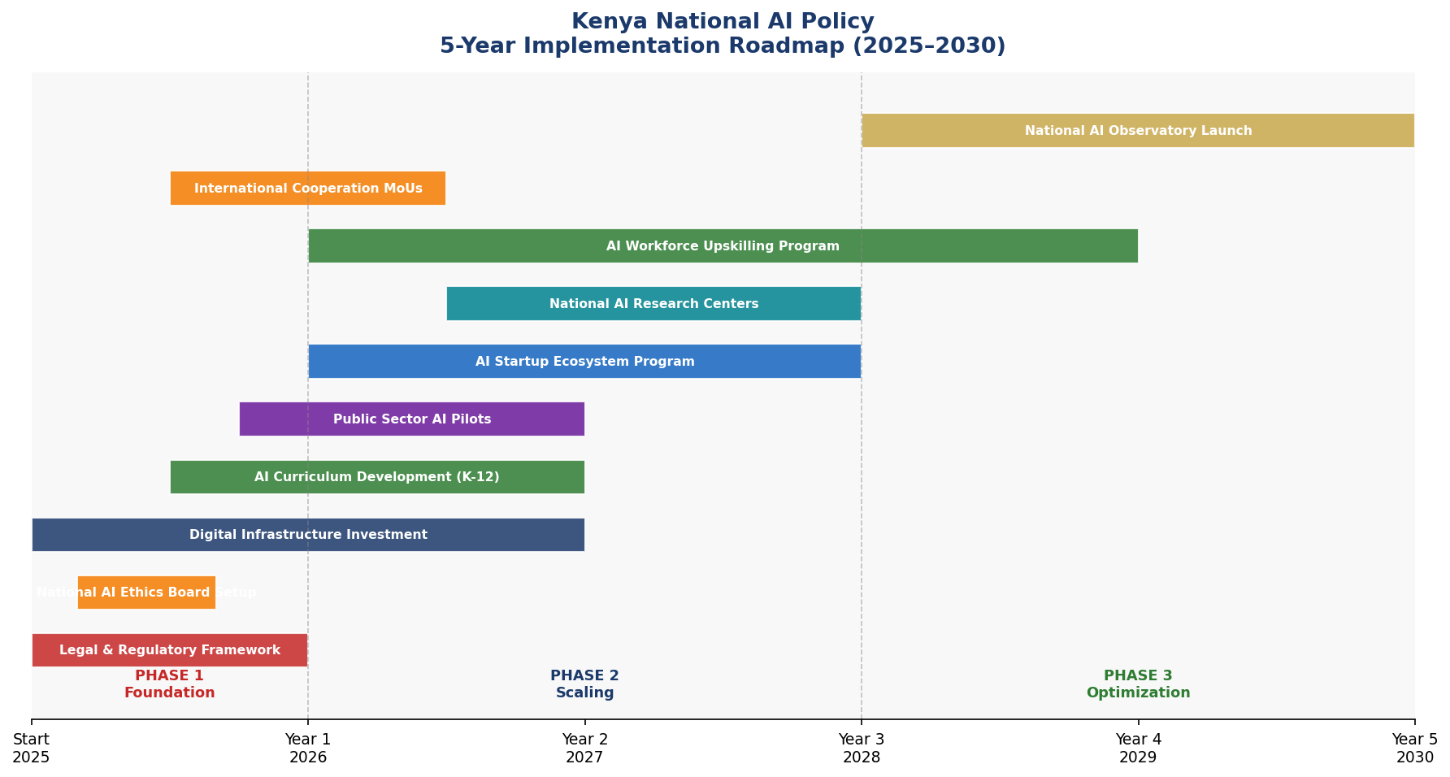
Figure 8.1: Kenya National AI Policy — 5-Year Implementation Gantt (2025–2030)

Phase 1: Foundation (2025–2026)
The Foundation Phase establishes the legal, institutional, and infrastructure prerequisites for Kenya's AI transformation. Critical milestones include: passage of the National AI Governance Act; establishment of the National AI Ethics Board; launch of the Kenya AI Innovation Fund (KES 10 billion); integration of AI literacy into CBC curriculum at primary level; launch of five government AI pilot programs; and signing of bilateral AI cooperation agreements with at least three countries.

Phase 2: Scaling (2026–2028)
The Scaling Phase deploys AI across government, industry, and education at national scale. Milestones include: 35 government AI services operational; 100,000 Kenyan workers retrained through the AI Upskilling Program; establishment of two National AI Research Centers; launch of the Kenya AI Startup Acceleration Program (800 startups funded); passage of the AI-Specific Data Governance Act; and achieving AI readiness rank improvement to top 70 globally.

Phase 3: Optimization (2028–2030)
The Optimization Phase positions Kenya as a net exporter of AI governance models and AI-powered solutions. Milestones include: 80 government AI services operational; 12,000 AI experts trained; 2,000 AI startups registered; National AI Observatory fully operational with annual parliamentary reporting; hosting of the inaugural Africa AI Governance Summit in Nairobi; and commencement of AI exports generating foreign exchange.

8.1 KPIs by Phase
- Phase 1 KPIs: Legal framework enacted; NAEB operational; 5 govt AI pilots live; 2M citizens reached with AI awareness; KES 10B fund established
- Phase 2 KPIs: 35 govt services AI-powered; 100K workers upskilled; 800 AI startups funded; AI Research Center network established; CPI improvement to 38+
- Phase 3 KPIs: 80 govt services AI-powered; 250K workforce trained; 12K experts; 2K startups; 1K+ research publications; 6.1% GDP contribution

SECTION 9 Monitoring, Evaluation & Accountability

9.1 National AI Observatory
The National AI Observatory (NAO), housed within the Kenya ICT Authority and jointly overseen by the National AI Ethics Board, will serve as Kenya's central AI monitoring and evaluation institution. The NAO will produce an annual Kenya AI State Report, conduct bi-annual AI ecosystem surveys, maintain a public AI systems registry, and provide quarterly performance reports to Parliament's Committee on ICT and Innovation. The Observatory will partner with the African Union AI Observatory and international bodies to ensure Kenya's monitoring data contributes to global AI governance knowledge.

9.2 KPI Dashboard
KPI Metric | Baseline  2025 | Year 1  2026 | Year 3  2028 | Year 5  2030
AI Contribution to GDP | 0.3% | 0.8% | 2.8% | 6.1%
AI Startups Registered | ~120 | 250 | 800 | 2,000+
AI-trained Workforce | 5,000 | 27,000 | 100,000 | 250,000
Govt AI Services Deployed | 2 | 10 | 35 | 80
National AI Ethics Cases Resolved | – | 50 | 200 | 500+
AI Research Publications (annual) | 40 | 120 | 400 | 1,000+
CPI Score Improvement (AI-assisted) | 31 | 33 | 38 | 45
Women in AI Workforce (%) | 18% | 22% | 30% | 40%
Internet Penetration (%) | 40% | 50% | 65% | 80%
AI Policy Compliance Rate (%) | – | 60% | 80% | 95%

9.3 Parliamentary Oversight & Civil Society Accountability
The National Assembly's Select Committee on Artificial Intelligence will be established by 2026 with the mandate to: conduct annual parliamentary hearings on Kenya's AI State Report; review the National AI Ethics Board's annual enforcement report; approve any amendments to the AI Risk Classification System; and investigate citizen complaints regarding government AI systems that have not been resolved by the NAEB within 90 days. Civil society organizations, including the Kenya Human Rights Commission and the Kenya ICT Action Network (KICTANet), will be funded to provide independent AI accountability monitoring with guaranteed access to government AI audit reports.

SECTION 10 International Cooperation & AI Diplomacy

10.1 Bilateral AI Cooperation Priorities
Kenya will pursue strategic bilateral AI partnerships with: the European Union (AI governance standards and research collaboration), the United States (AI innovation, startup ecosystems, and AGOA digital trade provisions), India (AI for agriculture, healthcare, and government services — leveraging the India-Africa Forum Summit framework), South Korea (AI manufacturing and smart city applications), and China (digital infrastructure, with robust intellectual property and data sovereignty safeguards).

10.2 Regional AI Governance Leadership
Kenya will leverage its position as the de facto leader of East African technology to drive regional AI governance harmonization through the East African Community (EAC) and the Intergovernmental Authority on Development (IGAD). Kenya will propose a harmonized East African AI Standards Framework by 2026, establish the East African AI Centre of Excellence in Nairobi by 2027, and host the inaugural Africa AI Governance Summit by 2029 — bringing together 54 AU member states to develop a continental AI governance architecture.

10.3 South-South Knowledge Transfer
Kenya has achieved internationally recognized innovations in mobile money, digital identity (Huduma Namba), and agricultural technology that carry direct lessons for other developing nations. Through the South-South Knowledge Transfer Program, Kenya will share AI governance models with at least 20 developing countries by 2030, positioning Kenya as an AI governance thought leader in the Global South alongside Brazil, India, and Indonesia.

10.4 Global AI Governance Participation
Kenya will maintain active representation at: the UN Secretary-General's AI Advisory Body; the Global Partnership on AI (GPAI); the ITU AI for Good Global Summit; the OECD Global Forum on AI; the G20 AI Working Group (as an invited participant through the African Union); and UNESCO's Intergovernmental Bioethics Committee AI Working Group. Kenya's global AI diplomacy will be coordinated by a dedicated AI Attache position within the Ministry of Foreign Affairs by 2026.

Conclusion

Kenya's National Artificial Intelligence Policy 2025–2030 represents more than a technology strategy — it is a national development vision, a governance reform agenda, and a statement of Kenya's values as a democratic, rights-respecting, and economically ambitious nation. The policy acknowledges Kenya's challenges honestly: corruption undermines institutional trust, infrastructure gaps exclude millions, and skills shortages limit ambition. But it responds to these challenges not with caution, but with strategic ambition backed by concrete investment, institutional reform, and international partnerships.
The 2030 vision is achievable. Silicon Savannah is not a marketing slogan — it reflects a genuine ecosystem of entrepreneurs, developers, researchers, and civil society actors who have built world-class innovations from Nairobi. This policy gives that ecosystem the legal framework it needs, the institutional support it deserves, and the international credibility it has earned. Kenya's AI journey, done right, will not only transform Kenya — it will write the playbook for responsible AI adoption across the African continent.
The measure of this policy's success will not be the number of AI systems deployed, but the number of Kenyan lives improved — farmers receiving precision agricultural advice in their local languages, mothers receiving AI-assisted maternal care in rural clinics, young graduates launching AI startups that solve African problems, and citizens trusting that government algorithms serve their interests and not those of corrupt elites. That Kenya is what this policy exists to build.

References & Bibliography

International Frameworks & Standards:
- UNESCO. (2021). Recommendation on the Ethics of Artificial Intelligence. United Nations Educational, Scientific and Cultural Organization, Paris.
- OECD. (2024). OECD AI Principles (Updated). Organisation for Economic Co-operation and Development, Paris.
- European Parliament and Council. (2024). Regulation (EU) 2024/1689 — Artificial Intelligence Act. Official Journal of the European Union.
- World Bank Group. (2024). World Bank Strategy for AI in Development. International Bank for Reconstruction and Development, Washington DC.
- G20. (2019, updated 2023). G20 AI Principles. G20 Digital Economy Task Force.
- ITU. (2023). AI for Good Global Summit Guidelines. International Telecommunication Union, Geneva.
- African Union. (2024). Artificial Intelligence for Africa: Toward an AU AI Strategy. African Union Commission, Addis Ababa.
Kenya National References:
- Republic of Kenya. (2022). Bottom-Up Economic Transformation Agenda (BETA). Government of Kenya, Nairobi.
- Republic of Kenya. (2019). Data Protection Act (No. 24 of 2019). Government of Kenya, Nairobi.
- Kenya ICT Authority. (2023). Kenya Digital Economy Blueprint (Updated). ICT Authority, Nairobi.
- Communications Authority of Kenya. (2024). Annual Report 2023/2024. Communications Authority, Nairobi.
Research & Data Sources:
- Oxford Insights. (2024). AI Readiness Index 2024. Oxford Insights, Oxford.
- Transparency International. (2024). Corruption Perceptions Index 2024. Transparency International, Berlin.
- McKinsey Global Institute. (2022). Pathways to AI in Africa. McKinsey & Company.
- World Economic Forum. (2024). Future of Jobs Report 2024. WEF, Davos.
- GSMA. (2024). Mobile Economy Sub-Saharan Africa 2024. GSMA, London.

About the Author

Nafiul Ahmad Rafi
Policy & Good Governance Researcher | BD Civic Tech Architect
Nafiul Ahmad Rafi is a civic technologist, policy researcher, author, photographer, and musician based in Dhaka, Bangladesh. He is the Founder and Director of Insights Bangladesh, a data-driven governance and policy impact analysis institution, and the Founder and Lead Architect of NagorikBD.org — a transparency-first civic platform scaled across Mymensingh Division, connecting citizens with government services across 45 Upazilas.
His work exists at the intersection of institutional reform and artificial intelligence, transforming theoretical governance into scalable, data-driven reality. Without a conventional computer science degree, he self-taught the tools of modern AI and web development to build the infrastructure that enforces the policies he once only researched.

Key Platforms & Projects
- NagorikBD.org — Civic transparency platform, Mymensingh Division
- Insights Bangladesh — Policy impact analysis institution
- FactCheck BD (factcheckbd.org) — Bangladesh's AI-powered fact-checking platform
- Political Insights BD / PIBD (pibbd.org) — Political intelligence and civic tech hub
- PeaceShield BD / National Peace Tracker — AI-powered hate speech and conflict monitoring
- PolicyLens AI (aigovbd.org) — 9-dimensional AI policy audit tool

He has published four books and maintains a personal site at ahmad-rafi.com.

Research Interests
AI Governance · Policy Research · Future of Bangladesh · Climate Policy · Civic Technology · Anti-Corruption Systems

Contact
- 🌐 ahmad-rafi.com
- 🔗 LinkedIn: nafiul-ahmad-rafi (bd.linkedin.com/in/nafiul-ahmad-rafi)
- ✉️ contact@ahmad-rafi.com

"I build code to ensure transparency, and I write lyrics to inspire the courage to use it."

