🇲🇬
REPUBLIC OF MADAGASCAR

National Artificial Intelligence Policy
2025–2030

A Comprehensive Framework for Ethical, Inclusive,
and Economically Transformative AI

Prepared by: Nafiul Ahmad Rafi / Insights Bangladesh
Date: May 2025
Policy Reference: MDG-AI-POL-2025

Table of Contents

Section : Executive Summary
Madagascar stands at a defining juncture in its developmental trajectory. With a population of approximately 30 million people, a GDP per capita of around USD 520, and an economy anchored in agriculture, mining, and emerging tourism, the island nation possesses both the imperative and the unique opportunity to leverage artificial intelligence as a transformative lever for inclusive development. This National AI Policy 2025–2030 articulates a comprehensive framework that is not merely aspirational but operationally grounded in Madagascar's socioeconomic realities, governance structures, and long-term development priorities.
The policy is premised on a fundamental conviction: that artificial intelligence, thoughtfully governed and equitably deployed, can serve as a powerful equalizer — accelerating agricultural productivity, improving healthcare delivery in remote regions, enhancing the quality of public governance, and creating new economic pathways for Malagasy youth. However, the same technologies, if unregulated, can amplify inequality, concentrate power, enable surveillance, and erode democratic accountability. This policy seeks to harness the former while consciously preventing the latter.
Madagascar's current AI readiness is modest by international standards, reflecting structural challenges in digital infrastructure, education, and institutional capacity. Internet penetration stands at approximately 24%, with mobile connectivity reaching roughly 50% of the population. The country ranks in the lower quartile of the Oxford Insights Government AI Readiness Index and scores 26 on the Transparency International Corruption Perceptions Index — a score that demands particular vigilance in designing AI governance mechanisms resistant to capture by vested interests. These realities do not diminish Madagascar's AI potential; they shape it.
This policy is structured around five strategic pillars: Ethical AI and Human Rights Protection; Economic Growth and Industrial AI Adoption; Education, Upskilling, and AI Workforce Development; Public Sector AI and e-Governance; and AI Research, Innovation, and Startup Ecosystem Development. Across these pillars, the policy aligns with the UNESCO AI Ethics Recommendation (2021), the OECD AI Principles (2019/2024), the EU AI Act (2024), the World Bank AI Strategy, G20 AI Principles, and ITU AI for Good Guidelines. A phased 5-year implementation roadmap, supported by robust monitoring, evaluation, and parliamentary oversight mechanisms, ensures accountability and adaptive management. By 2030, this policy envisions Madagascar as a credible participant in the global AI economy — one that has harnessed technology for human dignity, environmental stewardship, and shared prosperity.

Section 1: National AI Readiness Assessment

1.1 Economic Context
Madagascar is classified as a Least Developed Country (LDC) by the United Nations, with a GDP of approximately USD 14.5 billion (2024 estimates) and a per capita income of around USD 520. The economy is predominantly agricultural, with rice, vanilla, cloves, and sapphires representing major export commodities. The digital economy contributes less than 5% of GDP, though this share is growing. Remittances from the Malagasy diaspora contribute approximately 3% of GDP annually. Structural constraints include high commodity export dependency, limited domestic value addition, persistent fiscal deficits, and vulnerability to climate shocks — particularly cyclones, which have devastated infrastructure in recent years.
Despite these constraints, Madagascar presents compelling opportunities for AI-driven economic transformation. The agricultural sector, employing over 70% of the workforce, remains chronically under-digitized and under-productive. AI-powered precision agriculture, crop disease monitoring, and climate-adaptive farming systems could deliver substantial productivity gains. The extractive sector — mining for chromite, cobalt, graphite, and ilmenite — presents opportunities for AI-driven geological survey optimization and resource management. The emerging eco-tourism sector could leverage AI for conservation monitoring and personalized visitor experiences.

1.2 Education and Human Capital
Madagascar's adult literacy rate stands at approximately 77%, with significant rural-urban disparities. Tertiary enrollment ratios are low, at around 10% of eligible age groups, and STEM graduates constitute a small fraction of that cohort. The University of Antananarivo and a small number of private institutions provide ICT-related programs, but curricula remain largely unaligned with contemporary AI competencies. Digital skills gaps are pervasive across all professional sectors, including the public service. Women's participation in STEM education remains below 30%, reflecting cultural and structural barriers that this policy seeks to directly address.
Despite these challenges, Madagascar has a growing youth population — with 65% of citizens under the age of 25 — representing a demographic dividend that, if channelled through targeted AI education pathways, could yield a significant human capital return over the policy period. Mobile-first learning platforms, aligned with Madagascar's high mobile penetration relative to fixed broadband, present a scalable pathway for mass AI literacy.

1.3 Digital Infrastructure
Internet penetration in Madagascar is approximately 24% of the population, with fixed broadband reaching fewer than 2% of households. Mobile internet access, primarily through 3G/4G networks operated by Telma, Airtel, and Orange Madagascar, constitutes the primary connectivity pathway for the majority of users. Antananarivo and a handful of secondary cities — Toamasina, Mahajanga, Fianarantsoa — have relatively reliable connectivity, but rural areas, which host the majority of the population, remain severely underserved. Energy access is a parallel constraint, with national electrification rates below 30%, limiting the deployability of compute-intensive AI systems without complementary infrastructure investment. Cloud computing remains nascent, with limited domestic data centre capacity, creating dependence on international providers and data sovereignty risks.

1.4 Governance and Institutional Capacity
Madagascar's governance landscape is characterised by periodic political instability, limited state capacity in rural areas, and ongoing challenges of public sector corruption and clientelism. The Transparency International CPI score of 26 (2023) places Madagascar in the bottom quartile globally, underscoring the critical importance of embedding strong anti-corruption safeguards in AI governance design. The government has undertaken various e-governance initiatives in recent years, including digital land registries and mobile tax payment platforms, with mixed success. Judicial independence remains constrained, raising concerns about the enforceability of AI regulatory frameworks without robust civil society oversight.
Institutional capacity for AI regulation is currently nascent. There is no dedicated national AI body, no AI-specific legislation, and limited data protection law. The policy therefore recommends the creation of a National AI Ethics Board and supporting regulatory infrastructure as first-order priorities.

1.5 Corruption Risk Assessment
With a CPI score of 26, Madagascar faces elevated risks of AI governance capture, preferential AI procurement, and algorithmic bias in public benefit allocation. Key risk vectors include: AI-enabled surveillance deployed for political control; biased algorithmic systems in social protection targeting that entrench patronage networks; non-transparent procurement of AI systems by government ministries; and digital identity systems that exclude marginalised communities. This policy embeds specific anti-corruption safeguards including mandatory open-source requirements for government AI systems, independent third-party auditing, civil society observer rights, and whistleblower protections for AI procurement irregularities.

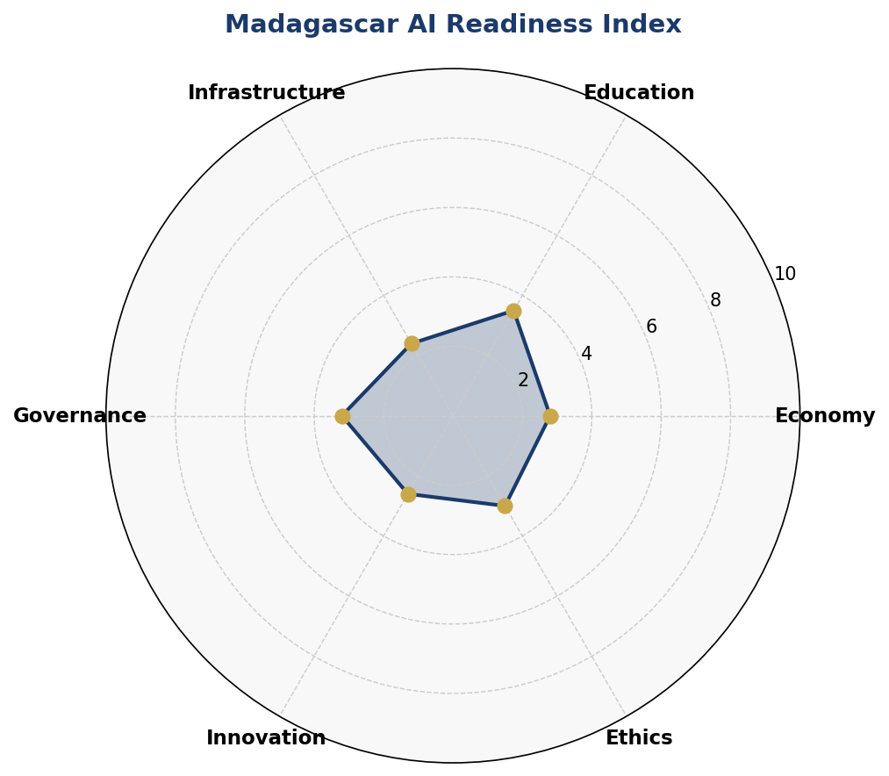
Figure 1: Madagascar AI Readiness Index — Multi-Dimensional Radar Assessment (Scores out of 10)

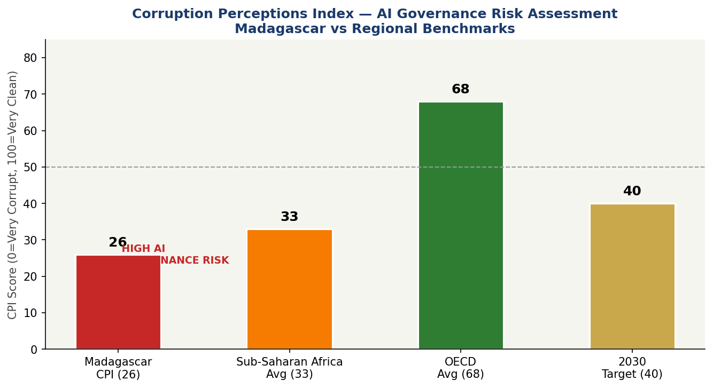
Figure 2: Corruption Perceptions Index — Madagascar vs Regional and OECD Benchmarks, with AI Governance Risk Annotation

Section 2: Policy Vision & Strategic Pillars

2.1 Vision Statement
"By 2030, Madagascar will leverage artificial intelligence as a sovereign instrument of human development — cultivating a digitally empowered citizenry, a productive and diversified economy, transparent and responsive governance, and a globally connected innovation ecosystem, rooted in Malagasy cultural values and guided by the principles of ethical technology for all."

2.2 Strategic Pillar 1: Ethical AI & Human Rights Protection
All AI systems deployed in Madagascar — by government, private sector, or civil society — must respect the fundamental rights of Malagasy citizens as enshrined in the Constitution and international human rights instruments. This pillar establishes the regulatory baseline: a National AI Ethics Board, a tiered risk classification system, mandatory human rights impact assessments for high-risk AI applications, and enforceable standards for algorithmic transparency, data privacy, and non-discrimination.
- Objective: Establish a National AI Ethics Board with enforcement powers by end of Year 1.
- Objective: Enact Data Protection and Algorithmic Accountability legislation by Year 2.
- Objective: Prohibit AI uses that violate human dignity, including social scoring and mass surveillance.
- Objective: Require algorithmic impact assessments for all AI systems affecting citizen rights.

2.3 Strategic Pillar 2: Economic Growth & Industrial AI Adoption
Madagascar's economic transformation requires targeted AI adoption in agriculture, mining, fisheries, tourism, and financial services. This pillar creates enabling conditions: tax incentives for AI investment, a National AI Innovation Fund, sector-specific AI adoption roadmaps, and a Public-Private Partnership framework to mobilise domestic and foreign capital.
- Objective: Deploy AI-powered agricultural advisory systems in at least 5 regions by Year 3.
- Objective: Leverage AI for artisanal and small-scale mining safety and productivity.
- Objective: Pilot AI-driven marine resource management in coastal communities by Year 2.
- Objective: Attract USD 50 million in AI-related FDI by Year 5 through strategic partnerships.

2.4 Strategic Pillar 3: Education, Upskilling & AI Workforce Development
Human capital is Madagascar's most sustainable competitive advantage in the AI era. This pillar introduces a National AI Curriculum Framework from primary school to postgraduate level, a National AI Scholarship Programme targeting STEM students from underrepresented regions, gender equity targets in AI education, and mobile-first learning platforms accessible in rural areas.
- Objective: Integrate AI literacy into national K-12 curriculum by Year 2.
- Objective: Train 5,000 AI practitioners through university and vocational programmes by Year 3.
- Objective: Achieve 40% women's participation in AI education programmes by Year 4.
- Objective: Establish AI Centres of Excellence at 3 universities by Year 3.

2.5 Strategic Pillar 4: Public Sector AI & e-Governance
The state must be among Madagascar's most capable AI users if AI is to serve the public good. This pillar focuses on deploying AI in agriculture extension services, healthcare diagnostics, tax administration, land registry, judicial case management, and disaster response — while establishing procurement standards that ensure transparency, interoperability, and citizen rights protection.
- Objective: Deploy AI-assisted crop monitoring in the Ministry of Agriculture by Year 2.
- Objective: Implement AI-driven tax gap analysis to increase domestic revenue mobilization.
- Objective: Launch citizen-facing AI services (chatbots, service navigators) in Antananarivo by Year 2.
- Objective: All government AI procurement to meet open-source and auditability standards.

2.6 Strategic Pillar 5: AI Research, Innovation & Startup Ecosystem
Long-term AI sovereignty requires domestic research capacity and a thriving startup ecosystem. This pillar creates a National AI Innovation Hub in Antananarivo, establishes an AI Research Grant Programme, connects Malagasy researchers to global networks, and creates a regulatory sandbox for AI startups. Special attention is given to localisation of AI in Malagasy language and culturally appropriate applications.
- Objective: Launch National AI Innovation Hub by Year 2 with 50 resident startups.
- Objective: Fund 20 AI research projects per year from Year 2 through National AI Fund.
- Objective: Develop Malagasy-language NLP models for public service accessibility.
- Objective: Connect Madagascar to pan-African AI networks (AU, Smart Africa Alliance).

Section 3: International Framework Alignment

3.1 UNESCO AI Ethics Recommendation (2021)
The UNESCO Recommendation on the Ethics of Artificial Intelligence, adopted by 193 member states in 2021, identifies eleven core values and principles as the foundation of ethical AI governance. This policy aligns with all eleven, as detailed in the comprehensive framework alignment matrix below. Key UNESCO principles that directly shape this policy include: human dignity (embedded in the risk classification and prohibited uses framework); non-discrimination and fairness (embedded in algorithmic accountability requirements); sustainability (linking AI policy to Madagascar's National Development Plan and SDG commitments); and transparency and explainability (mandatory for all high-risk government AI systems).
The UNESCO Recommendation's emphasis on the importance of diverse, culturally sensitive AI development is particularly salient for Madagascar, where linguistic diversity (French and Malagasy official languages, with over 18 regional dialects), strong biodiversity conservation imperatives, and a unique cultural heritage require AI systems that are not mere transplants of Northern-developed models but are adapted to local realities.

3.2 OECD AI Principles (2019, Updated 2024)
The OECD AI Principles — inclusive growth and well-being; human-centred values and fairness; transparency and explainability; robustness, security, and safety; and accountability — form the backbone of this policy's governance architecture. Although Madagascar is not an OECD member, adherence to these principles signals policy credibility to international investors and development partners and facilitates data-sharing agreements with OECD jurisdictions. The 2024 updates, which strengthened provisions on foundation models and generative AI, are incorporated in the policy's risk classification system, particularly in requirements for large language model deployment in government services.

3.3 EU AI Act (2024)
The EU AI Act — the world's first comprehensive binding AI regulatory framework — provides the technical architecture for Madagascar's AI risk classification system. This policy adopts the EU Act's four-tier risk structure (unacceptable, high, limited, minimal) and adapts it to Madagascar's specific context. Unacceptable-risk AI uses prohibited in Madagascar include: biometric mass surveillance in public spaces for political purposes, social scoring by public authorities, and AI systems that exploit vulnerable populations. High-risk applications — including AI in healthcare triage, judicial risk assessment, and social benefit allocation — require mandatory conformity assessments, human oversight mechanisms, and post-deployment audits.

3.4 World Bank AI Strategy & Development Finance
The World Bank's AI for Development framework emphasises AI's role in achieving the Sustainable Development Goals, particularly in LDCs. This policy aligns with World Bank priorities in three areas: AI for agricultural transformation, AI for digital public infrastructure (DPI), and AI governance capacity building. Madagascar's engagement with World Bank IDA financing mechanisms specifically includes advocacy for AI-dedicated grant windows under the Digital Economy for Africa initiative.

3.5 G20 AI Principles & ITU AI for Good
The G20 AI Principles (2019) provide a high-level framework consistent with OECD principles, with additional emphasis on international cooperation. The ITU AI for Good guidelines connect AI policy explicitly to SDG achievement, which is the primary lens through which Madagascar's development community evaluates policy priorities. This policy explicitly links each strategic pillar to relevant SDGs: Pillar 2 (Economic Growth) to SDG 8; Pillar 3 (Education) to SDG 4; Pillar 4 (e-Governance) to SDG 16; and the overall framework to SDG 17 (Partnerships).

3.6 Comprehensive Framework Alignment Matrix

Framework Principle | Pillar 1  Ethics | Pillar 2  Economy | Pillar 3  Education | Pillar 4  e-Gov | Pillar 5  R&D
UNESCO: Human Dignity & Non-Discrimination | ✅ | ⚠️ | ✅ | ✅ | ⚠️
UNESCO: Privacy & Data Protection | ✅ | ⚠️ | 🔲 | ✅ | ⚠️
UNESCO: Transparency & Explainability | ✅ | ⚠️ | ✅ | ✅ | ✅
UNESCO: Sustainability & SDG Linkage | ⚠️ | ✅ | ✅ | ✅ | ✅
UNESCO: Inclusive Development | ✅ | ✅ | ✅ | ✅ | ✅
OECD: Human-Centred Values | ✅ | ⚠️ | ✅ | ✅ | ⚠️
OECD: Robustness & Security | ✅ | ⚠️ | 🔲 | ✅ | ⚠️
OECD: Accountability | ✅ | ⚠️ | ⚠️ | ✅ | ⚠️
EU AI Act: Risk Classification | ✅ | ✅ | 🔲 | ✅ | ⚠️
EU AI Act: Prohibited AI Practices | ✅ | ✅ | 🔲 | ✅ | 🔲
World Bank: DPI & Financial Inclusion | ⚠️ | ✅ | ✅ | ✅ | ✅
G20: International Cooperation | ⚠️ | ✅ | ✅ | ⚠️ | ✅
ITU: SDG Integration | ⚠️ | ✅ | ✅ | ✅ | ✅

Legend: ✅ = Fully Aligned | ⚠️ = Partially Aligned / Under Development | 🔲 = Planned for Future Policy Cycle

Section 4: Economic Impact & Investment Roadmap

4.1 Projected AI Economic Contribution
Based on McKinsey Global Institute modelling for low-income African economies, AI adoption could contribute between 1.5% and 4% of GDP annually by 2030 in countries that achieve meaningful adoption at scale. For Madagascar, given its structural starting point and the focused investments proposed in this policy, a conservative estimate projects AI contributing approximately 0.3% of GDP in Year 1 (primarily through quick-win applications in agriculture and public administration), rising to approximately 3.2% by Year 5, as sector-wide adoption deepens and the domestic innovation ecosystem matures. This represents an estimated cumulative economic contribution of USD 1.1 billion to Madagascar's GDP over the policy period — equivalent to approximately 7.5% of current annual GDP.
The sectors with the highest AI economic multiplier in Madagascar's context are: agriculture and agri-processing (AI-driven productivity gains and supply chain optimization), public administration (efficiency gains from AI-assisted service delivery and fraud detection), health services (AI-assisted diagnostics in underserved regions reducing referral costs and improving outcomes), and extractive industries (AI-optimised geological survey and resource management).

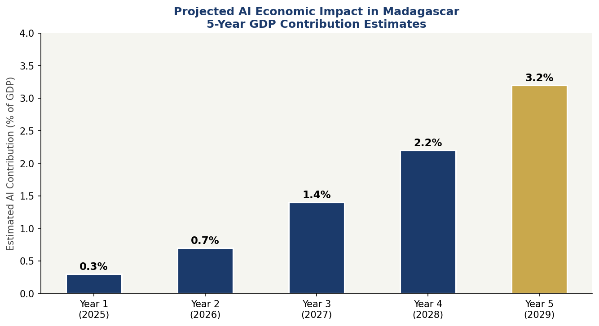
Figure 3: Projected AI Economic Impact in Madagascar — 5-Year GDP Contribution Estimates (%)

4.2 Investment Allocation Framework
The National AI Investment Programme proposes an initial 5-year public commitment of approximately USD 120 million (subject to parliamentary appropriation and international development partner co-financing), distributed as follows: digital infrastructure and connectivity (25%), education and upskilling (20%), research and development (20%), public sector AI deployment and e-governance (20%), regulatory and institutional capacity (10%), and ethics, civil society, and accountability mechanisms (5%). This allocation reflects a deliberate emphasis on the foundational prerequisites — infrastructure and human capital — without which sector-level AI applications cannot be sustainably scaled.

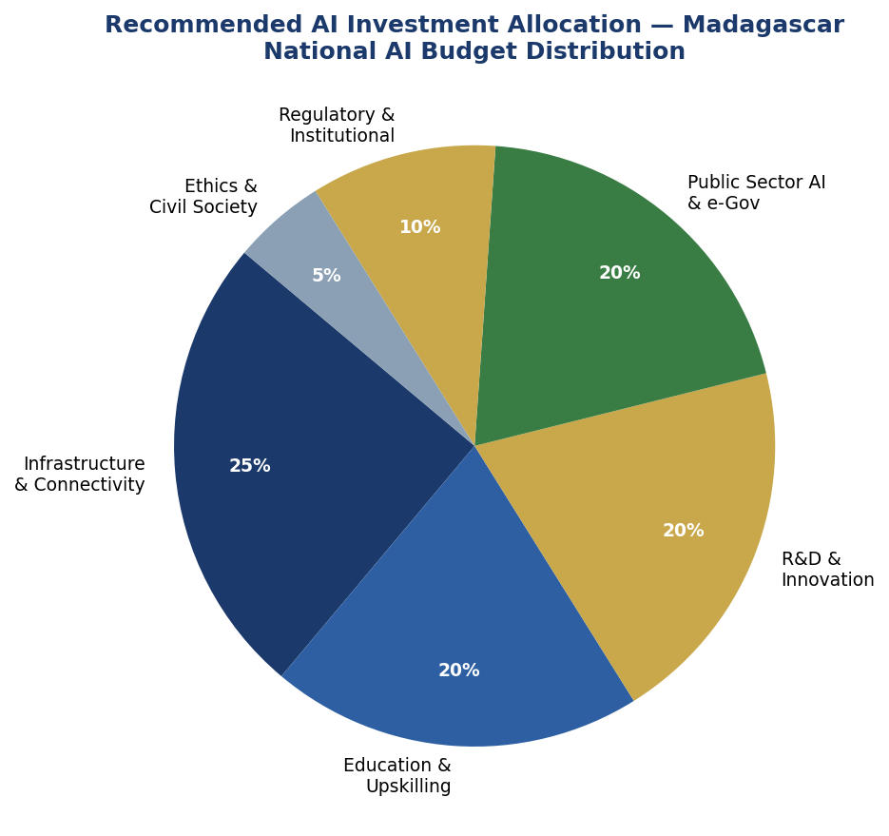
Figure 4: Recommended National AI Investment Allocation — Madagascar 2025–2030 (USD 120M Programme)

4.3 Priority Economic Sectors
- Agriculture & Agri-Processing: Crop disease detection, precision irrigation, market price prediction, supply chain traceability for vanilla and cloves export quality assurance.
- Mining & Extractives: AI-assisted geological modelling, automated safety monitoring, environmental compliance tracking, artisanal miner support systems.
- Health Services: AI-assisted medical image analysis for district hospitals, remote patient monitoring, supply chain optimization for essential medicines, malaria and plague epidemic prediction.
- Financial Services & Fintech: Credit scoring for unbanked populations, mobile money fraud detection, agricultural insurance parametric products using satellite data.
- Marine & Fisheries: AI-powered illegal fishing detection, marine protected area monitoring, fish stock assessment, sustainable catch optimization.
- Tourism & Conservation: AI-powered biodiversity monitoring, visitor flow optimization, eco-tourism route personalization, wildlife poaching detection.

4.4 Public-Private Partnership Framework
A National AI PPP Framework will be established by Year 1, providing standardised contractual templates, risk-sharing mechanisms, and performance-based payment structures for AI projects involving government and the private sector. International technology companies wishing to deploy AI systems in Madagascar will be required to: establish local data processing partnerships, contribute to national AI education programmes, provide technology transfer to Malagasy counterpart institutions, and submit to independent third-party audits of their systems' performance and fairness characteristics.

Section 5: Education & Human Capital Development

5.1 Current Skills Gap Analysis
Madagascar's AI skills gap is both quantitative and qualitative. There are estimated to be fewer than 500 professionals with applied AI competencies in the country, against a baseline requirement of at least 5,000 practitioners by 2030 to support the policy's economic objectives. University ICT programmes produce approximately 300 graduates annually, fewer than 10% of whom have meaningful exposure to machine learning, data science, or AI ethics. Secondary school curricula have no computational thinking or data literacy components. Primary education remains focused on basic literacy and numeracy, with no digital learning infrastructure in rural areas.
Gender gaps in digital education are pronounced: women account for fewer than 25% of ICT students at tertiary level. Regional disparities are equally significant — Antananarivo captures over 70% of available digital education resources, leaving the six other provinces severely underserved. An estimated 40% of primary school teachers lack the digital literacy to deliver even basic ICT components, underscoring the need for concurrent teacher training investment.

5.2 National AI Curriculum Framework
Primary Level (Ages 6-12): AI Awareness and Computational Thinking. Introduction to the concept of intelligent machines, basic pattern recognition through games and activities, introduction to algorithms through unplugged activities, digital citizenship, and online safety. Content to be delivered primarily in Malagasy language.
Secondary Level (Ages 13-18): Digital Literacy and Data Fundamentals. Coding fundamentals (Python basics), data collection and analysis, introduction to AI tools and their applications in everyday life, AI ethics and societal impacts, and introduction to career pathways in technology. Both Malagasy and French instruction with bilingual digital learning materials.
Tertiary Level (Ages 18+): AI Practitioner Programmes. Full undergraduate and certificate programmes in machine learning, data science, AI engineering, and AI ethics. Mandatory AI ethics and responsible technology module in all ICT programmes. Industry-linked internship requirements. English proficiency development to enable participation in global AI communities.
Vocational and Continuing Education: AI Upskilling for Existing Workforce. Short-course programmes (3-6 months) for government officials, agricultural extension workers, healthcare workers, journalists, and entrepreneurs. Mobile-first delivery for rural participants. Partnership with international platforms (Coursera, edX) for validated credentials.

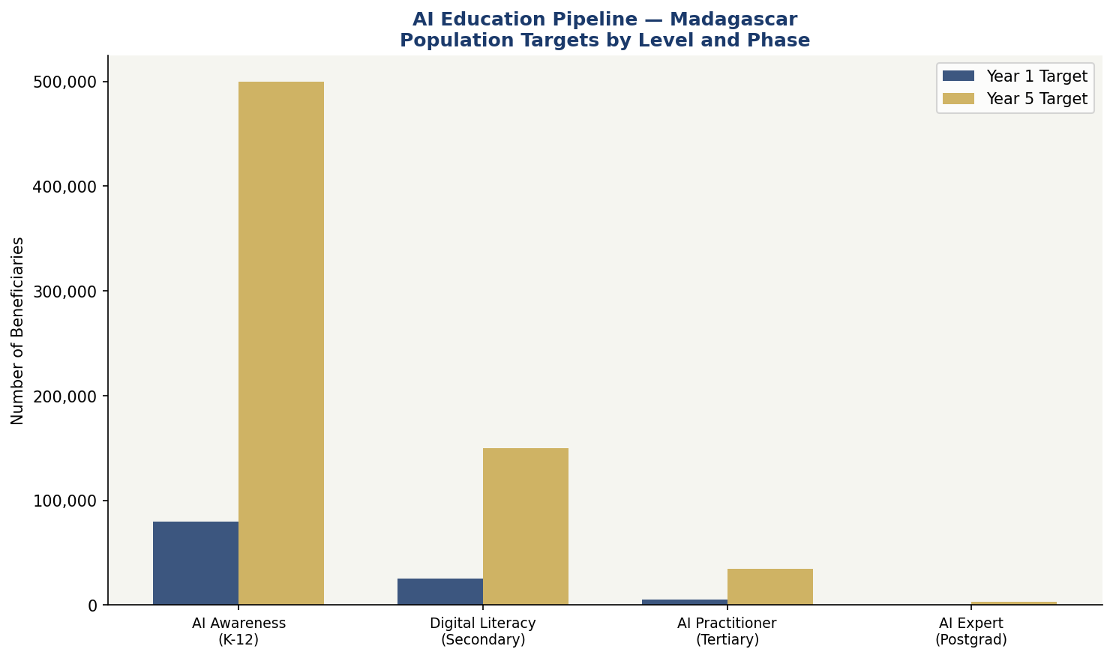
Figure 5: AI Education Pipeline — Madagascar Population Targets by Competency Level, Year 1 vs Year 5

5.3 Gender Equity and Inclusion
The policy establishes binding gender equity targets: 40% female participation in AI education programmes by Year 4, rising to 50% by Year 7. Specific interventions include: targeted scholarships for women in STEM (minimum 50% of National AI Scholarship awards); mentorship programmes connecting female students with Malagasy women technologists; partnerships with women's civil society organisations to develop gender-sensitive AI literacy content; elimination of textbook content that reinforces gender stereotypes around technology; and family support services (childcare provision at training venues, flexible scheduling) to enable participation by mothers.
The policy also addresses inclusion of marginalised communities: persons with disabilities will be guaranteed accessible AI learning materials and assistive technology support; residents of the most isolated provinces will be prioritised for mobile-first distance learning programmes; and the policy explicitly recognises the right to AI education in the Malagasy language, committing resources to Malagasy-language content development.

Section 6: Ethical AI Governance & Regulatory Framework

6.1 National AI Ethics Board
A National AI Ethics Board (NAEB) will be established by Presidential Decree within 12 months of policy adoption. The NAEB will comprise: a Chairperson (independent techno-legal expert appointed by Parliament), representatives from the Ministry of Digital Economy, Ministry of Justice, Ministry of Health, Ministry of Education, the Office of the Ombudsman, one civil society organisation representative, one private sector technology representative, one academic AI expert, and one representative of persons with disabilities. The NAEB will be fully independent from executive interference in its regulatory and adjudicatory functions.
The NAEB's mandate includes: reviewing and approving high-risk government AI deployments; investigating complaints of algorithmic harm; issuing guidance on emerging AI ethics challenges; conducting annual AI State of Madagascar Reports; engaging with international AI governance bodies; and advising Parliament on proposed AI legislation. The Board will be funded through a dedicated AI Governance Levy of 0.5% on commercial AI deployments with annual revenue exceeding MGA 500 million.

6.2 AI Risk Classification System

Risk Tier | Definition | Examples in Madagascar Context | Regulatory Treatment
UNACCEPTABLE RISK | AI that poses an unacceptable threat to fundamental rights, democracy, or human dignity | Social scoring systems; political mass surveillance; AI manipulation of election information; covert biometric profiling | PROHIBITED: No deployment permitted under any circumstances
HIGH RISK | AI in critical infrastructure or decisions with significant rights or safety implications | AI in healthcare triage; judicial risk assessment; social benefit allocation; critical infrastructure control; educational assessment | Mandatory NAEB conformity assessment; human oversight; explainability logs; annual audit
LIMITED RISK | AI with transparency obligations but lower rights impact | Customer service chatbots; AI content generation tools; automated customer scoring (non-credit) | Mandatory disclosure to users; basic logging; voluntary code of conduct
MINIMAL RISK | AI applications with negligible rights or safety implications | AI-powered spam filters; basic recommendation engines; AI tools in creative software | Voluntary AI ethics guidelines; encouraged NAEB registration

6.3 Data Protection & Privacy
Madagascar does not yet have a comprehensive data protection law aligned with international standards. This policy mandates the enactment of a National Data Protection Act by Year 2, establishing: the right to data access, correction, and deletion; requirements for explicit, informed consent for personal data processing; mandatory data breach notification within 72 hours; sector-specific requirements for health, financial, and biometric data; and the establishment of a Data Protection Authority as a division of the NAEB. The Act will be modelled on the African Union Data Policy Framework and will be interoperable with the EU GDPR to facilitate international data flows.

6.4 Anti-Corruption AI Safeguards
Given Madagascar's governance context, the policy includes specific anti-corruption provisions for all government AI systems: mandatory open-source code publication for AI systems used in public benefit allocation; randomised algorithmic audits by the Office of the Ombudsman; prohibition on AI procurement from vendors with pending corruption investigations; whistleblower protection for civil servants reporting AI procurement irregularities; and annual parliamentary review of all government AI contracts above MGA 1 billion.

Section 7: Public Sector AI & e-Governance

7.1 Priority Government Use Cases
Agriculture Ministry: AI-powered crop disease identification apps for extension workers; satellite-based crop yield prediction; drought early warning systems; vanilla supply chain traceability using blockchain and AI for international export quality assurance.
Ministry of Public Health: AI-assisted malaria and plague epidemic surveillance using syndromic data; AI support for diagnosis of tuberculosis and malnutrition in district hospitals; medicine supply chain optimization; maternal and child health risk prediction in rural settings.
Ministry of Finance: AI-powered tax compliance analytics to reduce revenue leakage; customs fraud detection; social protection beneficiary de-duplication using biometric AI systems with appropriate rights safeguards.
Ministry of Justice: AI-assisted case management and court scheduling to reduce backlog; legal aid navigation tools in Malagasy language; land dispute resolution support systems.
National Disaster Management Agency: Cyclone damage assessment using satellite imagery AI; predictive flood modelling; AI-optimised disaster relief logistics.

7.2 Procurement Guidelines
All government AI procurement must comply with the following principles: requirement for explainability documentation; prohibition on vendor lock-in for critical systems; mandatory local data processing requirements; minimum 30% local content provisions in AI service contracts; open-source preference for non-critical government systems; and multi-year post-deployment performance accountability clauses.

7.3 Interoperability Standards
Madagascar will adopt open standards for government AI systems to ensure interoperability across ministries and with regional partners. The Digital Madagascar Interoperability Framework will be developed by the Ministry of Digital Economy in Year 1, building on ITU and World Bank Digital Public Infrastructure standards. All government AI systems must register with the National AI Registry maintained by the NAEB.

Section 8: Implementation Roadmap

8.1 Phase 1 — Foundation (Year 1: 2025–2026)
The Foundation Phase focuses on establishing the legal, institutional, and infrastructural prerequisites for AI deployment at scale. Key deliverables include: enactment of the AI Governance Act and National Data Protection Act; establishment of the National AI Ethics Board; launch of the National AI Strategy Secretariat within the Ministry of Digital Economy; publication of the National AI Risk Classification Guidelines; commencement of AI literacy integration in the national curriculum; launch of 3 sector pilot projects (agriculture, health, tax administration); and establishment of the National AI Innovation Hub in Antananarivo.
Phase 1 KPIs: NAEB operational within 12 months; AI Governance Act passed by Parliament; 5 government AI pilot projects live; 10,000 public servants enrolled in AI literacy programmes; National AI Investment Fund established.

8.2 Phase 2 — Scaling (Years 2–3: 2026–2028)
The Scaling Phase transitions from pilots to national deployment, with AI integrated into core government services, the private sector beginning systematic AI adoption, and the first cohort of AI practitioners entering the workforce. Key deliverables include: national rollout of agricultural AI extension services; AI-assisted healthcare diagnostics in 50 district hospitals; implementation of AI-powered tax compliance analytics; launch of the National AI Scholarship Programme; accreditation of AI practitioner programmes at 5 universities; and completion of the national digital infrastructure connectivity programme.
Phase 2 KPIs: 200,000 farmers using AI advisory services; 50 district hospitals with AI diagnostic tools; MGA 50 billion in additional tax revenue identified through AI analytics; 2,000 AI practitioners trained; 30% increase in AI-related startup registrations.

8.3 Phase 3 — Optimisation (Years 4–5: 2028–2030)
The Optimisation Phase consolidates gains, addresses gaps identified through monitoring and evaluation, deepens international integration, and positions Madagascar as a regional AI knowledge hub. Key deliverables include: comprehensive review and revision of the AI Governance Act; launch of Madagascar's National AI Observatory annual reporting programme; accession to relevant international AI governance frameworks; hosting of the first Madagascar AI for Development Summit; and establishment of the AI export services sector (training data, localisation services, AI for development consultancy).
Phase 3 KPIs: AI contributing 3.2% of GDP; 35,000 AI practitioners in workforce; 40% female participation in AI education; National AI Observatory publishing annual AI State of Madagascar Report; Madagascar joining GPAI as an associate member.

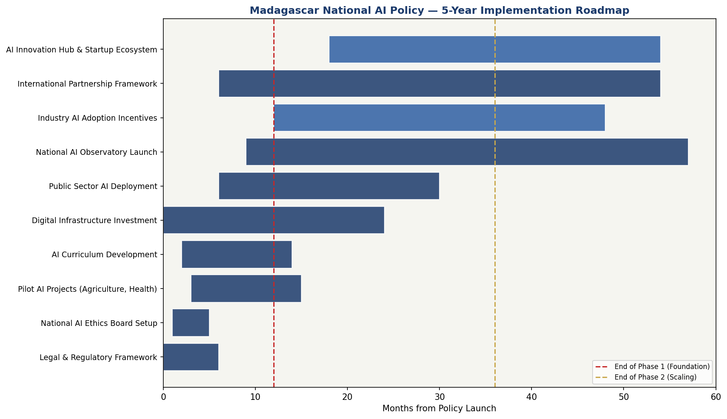
Figure 6: Madagascar National AI Policy — 5-Year Implementation Roadmap (Gantt-Style Timeline)

Section 9: Monitoring, Evaluation & Accountability

9.1 National AI Observatory
A National AI Observatory (NAO) will be established within the NAEB by end of Year 1. The NAO is responsible for: collecting and analysing data on AI deployment across sectors; monitoring policy KPIs and reporting to Parliament biannually; engaging civil society and independent researchers in participatory monitoring; liaising with international AI monitoring bodies including GPAI and OECD.AI; and publishing the Annual AI State of Madagascar Report, a public document assessing progress against all policy targets.

9.2 Parliamentary Oversight
A Parliamentary AI Oversight Committee will be established, with powers to: summon government ministers and NAEB officials for AI policy accountability hearings; commission independent audits of high-risk government AI systems; review and approve annual AI budget allocations; receive and deliberate the Annual AI State of Madagascar Report; and propose legislative amendments in response to emerging AI governance challenges. Committee membership will include representatives of opposition parties, ensuring AI governance remains a cross-partisan public interest function.

9.3 KPI Dashboard

KPI Metric | 2025 Baseline | Year 1 Target | Year 3 Target | Year 5 Target (2030)
AI contribution to GDP (%) | ~0% | 0.3% | 1.4% | 3.2%
AI practitioners in workforce | <500 | 1,000 | 10,000 | 35,000
Women in AI education (%) | ~20% | 28% | 36% | 40%
Farmers using AI advisory tools | 0 | 20,000 | 100,000 | 300,000
District hospitals with AI diagnostics | 0 | 10 | 35 | 75
Government AI systems audited (annual) | 0 | 5 | 20 | All high-risk
NAEB complaints resolved annually | N/A | 50 | 200 | 500+
AI startups registered | <50 | 80 | 200 | 500
National AI Observatory reports published | 0 | 1 | 3 | 5
CPI Score (target) | 26 | 28 | 32 | 40

Section 10: International Cooperation & Diplomacy

10.1 Bilateral AI Cooperation Priorities
Madagascar will pursue bilateral AI cooperation agreements with the following partner countries and blocs within Year 2: France (existing colonial and linguistic ties; Agence Française de Développement AI programme); India (South-South AI cooperation; Digital Public Infrastructure exchange); Mauritius (Indian Ocean Island States AI governance alignment); United States (MCC and USAID AI for development programmes); China (Belt and Road digital infrastructure; caution required on data sovereignty); and the European Union (EU-AU Digital Partnership; potential EU AI Act conformity mutual recognition pathway for Malagasy exports).

10.2 Regional AI Governance — African Union
Madagascar will align its AI governance framework with the African Union's continental AI strategy and the Smart Africa Alliance's digital transformation framework. Key regional priorities include: contributing to the development of African AI standards that reflect African development contexts; participating in the African Continental Free Trade Area (AfCFTA) digital trade provisions relevant to AI services; and advocating for LDC-sensitive provisions in global AI governance frameworks through the African Group at the ITU and UNESCO.

10.3 South-South Knowledge Transfer
Madagascar will engage in structured South-South AI knowledge exchange with comparable LDCs and lower-middle income countries that have demonstrated AI governance innovation. Specifically: Rwanda (model for digital leapfrogging and AI in public services); Bangladesh (model for mobile-first AI applications at scale and AI governance institutions); Ethiopia (model for national AI strategy development); and Senegal (model for Francophone Africa AI ecosystem development). Madagascar will seek to host a biennial South-South AI for Small Island and LDC Development Forum from Year 3.

10.4 Global AI Governance Participation
Madagascar will seek Associate Membership of the Global Partnership on AI (GPAI) by Year 3. Madagascar's diplomatic mission at the UN in Geneva will be strengthened to enable active participation in ITU AI for Good, UNESCO AI Ethics processes, and the proposed UN High-Level Advisory Body on AI intergovernmental process. Madagascar will use its SIDS (Small Island Developing State) status to advocate for AI governance frameworks that are sensitive to the particular vulnerabilities and opportunities of island and least developed economies.

Conclusion
The National AI Policy of Madagascar 2025–2030 is not a document of ambition alone — it is a document of accountability. The Malagasy state, its development partners, the private sector, and above all the Malagasy people, are entitled to hold this policy to the targets, timelines, and principles it articulates. The governance mechanisms embedded in this framework — the National AI Ethics Board, the National AI Observatory, the Parliamentary Oversight Committee, and the independent civil society audit function — exist precisely to ensure that this policy does not become one more well-intentioned document that gathers dust in a ministry archive while the technological revolution proceeds without Madagascar.
Madagascar's AI journey begins from a position of constraint but not of disadvantage. The constraints are real: limited infrastructure, skills gaps, governance challenges, and fiscal pressures. But the advantages are equally real: a young, growing population hungry for economic opportunity; a unique biodiversity and environmental context that creates global demand for AI-powered conservation solutions; a diaspora skilled in global technology sectors; and a tradition of cultural resilience that has enabled Madagascar to navigate far greater challenges than the governance of an emerging technology.
Artificial intelligence will reshape the global economy over the next decade. The question for Madagascar is not whether to engage with that transformation but on whose terms. This policy answers that question: on Madagascar's terms, in service of Madagascar's people, guided by Madagascar's values, and accountable to Madagascar's democratic institutions. The implementation begins now.

References & Bibliography
1. UNESCO (2021). Recommendation on the Ethics of Artificial Intelligence. Paris: UNESCO. https://unesdoc.unesco.org/ark:/48223/pf0000381137
2. OECD (2024). OECD AI Principles (Updated). Paris: OECD. https://oecd.ai/en/ai-principles
3. European Parliament and Council of the European Union (2024). Regulation (EU) 2024/1689 — Artificial Intelligence Act. Official Journal of the European Union.
4. World Bank Group (2023). AI in Government: A Framework for Responsible Use in Developing Countries. Washington DC: World Bank.
5. G20 (2019). G20 AI Principles. Osaka Summit Declaration.
6. ITU (2023). AI for Good — Thematic Areas and SDG Alignment. Geneva: International Telecommunication Union.
7. African Union (2024). Continental Artificial Intelligence Strategy. Addis Ababa: African Union Commission.
8. Transparency International (2024). Corruption Perceptions Index 2023. Berlin: Transparency International.
9. Oxford Insights (2023). Government AI Readiness Index 2023. Oxford: Oxford Insights.
10. McKinsey Global Institute (2022). The Economic Potential of Generative AI in Africa. New York: McKinsey & Company.
11. World Economic Forum (2023). Global AI Action Alliance: AI for Least Developed Countries. Geneva: WEF.
12. Smart Africa Alliance (2023). Smart Africa Digital Economy Report 2023. Kigali: Smart Africa.
13. Republic of Madagascar (2023). Plan Emergence Madagascar (PEM) 2023–2028. Antananarivo: Presidency of the Republic.
14. UNDP (2024). Human Development Report 2024 — Madagascar Country Profile. New York: UNDP.
15. ITU/UNESCO (2023). Digital Connectivity and AI Readiness: LDC Benchmarking Report. Geneva: ITU.

About the Author

Nafiul Ahmad Rafi
Policy & Good Governance Researcher | BD Civic Tech Architect
Nafiul Ahmad Rafi is a civic technologist, policy researcher, author, photographer, and musician based in Dhaka, Bangladesh. He is the Founder and Director of Insights Bangladesh, a data-driven governance and policy impact analysis institution, and the Founder & Lead Architect of NagorikBD.org — a transparency-first civic platform scaled across Mymensingh Division, connecting citizens with government services across 45 Upazilas.
His work exists at the intersection of institutional reform and artificial intelligence, transforming theoretical governance into scalable, data-driven reality. Without a conventional computer science degree, he self-taught the tools of modern AI and web development to build the infrastructure that enforces the policies he once only researched.

Key Platforms & Projects
- NagorikBD.org — Civic transparency platform, Mymensingh Division
- Insights Bangladesh — Policy impact analysis institution
- FactCheck BD (factcheckbd.org) — Bangladesh's AI-powered fact-checking platform
- Political Insights BD / PIBD (pibbd.org) — Political intelligence and civic tech hub
- PeaceShield BD / National Peace Tracker — AI-powered hate speech and conflict monitoring
- PolicyLens AI (aigovbd.org) — 9-dimensional AI policy audit tool

He has published four books and maintains a personal site at ahmad-rafi.com.

Research Interests: AI Governance · Policy Research · Future of Bangladesh · Climate Policy

Contact
- ahmad-rafi.com
- LinkedIn: nafiul-ahmad-rafi (bd.linkedin.com/in/nafiul-ahmad-rafi)
- contact@ahmad-rafi.com

"I build code to ensure transparency, and I write lyrics to inspire the courage to use it."

