🇲🇼
REPUBLIC OF MALAWI

National Artificial Intelligence Policy
2025 – 2030
A Comprehensive Framework for Ethical, Inclusive, and Economically Transformative AI

Prepared by:
Nafiul Ahmad Rafi
Insights Bangladesh
May 2025

Table of Contents

Executive Summary

Malawi stands at a pivotal crossroads. As one of Sub-Saharan Africa's least developed countries — with a GDP per capita of approximately USD 590, an internet penetration rate of 23%, and an economy heavily reliant on agriculture — the nation faces profound structural challenges. Yet artificial intelligence presents an unprecedented opportunity: the chance to leapfrog conventional development trajectories and harness data-driven tools to address Malawi's most urgent national priorities in health, food security, governance, and economic inclusion.
This National Artificial Intelligence Policy (2025–2030) is designed to serve as the foundational framework through which the Government of Malawi, civil society, the private sector, and international partners will coordinate efforts to develop, deploy, and govern AI technologies in ways that are ethical, people-centred, and aligned with Malawi's Vision 2063 and the Africa Union's Agenda 2063. The policy responds to a clear imperative: without deliberate policy direction, AI adoption in Malawi risks deepening existing inequalities, amplifying corruption, and creating technological dependency rather than sovereign capacity.
The policy is organised around five strategic pillars: (1) Ethical AI and Human Rights Protection; (2) Economic Growth and Industrial AI Adoption; (3) Education, Upskilling, and AI Workforce Development; (4) Public Sector AI and e-Governance; and (5) AI Research, Innovation, and Startup Ecosystem. Each pillar is underpinned by a robust regulatory architecture, international framework alignment, and a phased 5-year implementation roadmap.
Projected outcomes of full policy implementation by 2030 include an AI contribution of up to 5% of GDP, the creation of over 140,000 direct and indirect jobs, the training of 500,000 AI-literate citizens, and the deployment of AI tools in at least 25 government service areas. These targets are ambitious but achievable, provided that Malawi mobilises public investment of approximately 1.5% of GDP annually toward AI infrastructure, education, research, and governance by Year 5. The international community, regional partners — particularly within the Southern African Development Community (SADC) — and development finance institutions are expected to be critical co-investors in this journey.
Malawi's AI policy is not merely a technology strategy. It is a social contract: a commitment to ensuring that the benefits of intelligent systems reach the most vulnerable Malawians first, that no automated system may be used to discriminate, surveil, or oppress, and that every citizen — including women, rural communities, and persons with disabilities — has access to the opportunities AI creates. This document is a living framework, subject to annual review, parliamentary oversight, and civil society accountability mechanisms to ensure that Malawi's AI future is built by Malawians, for Malawians.

Section 1: National AI Readiness Assessment

1.1 Economic Context
Malawi is classified as a Least Developed Country (LDC) by the United Nations, with a nominal GDP of approximately USD 13.5 billion (2024 estimates) and a per-capita income of roughly USD 590. The economy is predominantly agrarian, with tobacco accounting for over 50% of export earnings, alongside tea, sugar, and coffee. Services represent a growing share of GDP at approximately 52%, while manufacturing remains underdeveloped at around 10%. Economic growth averaged approximately 1.5% per annum between 2020 and 2024, suppressed by climate shocks, the legacy of the COVID-19 pandemic, currency depreciation of the Malawian Kwacha, and structural fiscal imbalances.
The digital economy remains nascent. E-commerce, fintech (notably mobile money through operators such as Airtel Money and TNM Mpamba), and digital agriculture services are emerging but operate without a coherent national AI or data strategy. AI adoption in the private sector is extremely limited, largely confined to multinational enterprises and a small number of technology-oriented startups in Lilongwe and Blantyre.

1.2 Education and Human Capital
Malawi's adult literacy rate stands at approximately 65%, with significant gender and geographic disparities — rural literacy among women is considerably lower. Tertiary enrolment rates are among the lowest in the region at approximately 1.4% of the eligible population. The University of Malawi, Mzuzu University, Lilongwe University of Agriculture and Natural Resources (LUANAR), and Malawi University of Science and Technology (MUST) collectively graduate fewer than 2,000 STEM students annually. There is currently no dedicated AI or machine learning degree programme offered at any public university in Malawi.
Digital skills gaps are profound at all levels. Most civil servants have limited exposure to data analytics, and only a small fraction of secondary school students have access to computing facilities. The national ICT curriculum, while recently revised, does not yet incorporate coding, data science, or AI fundamentals in any systematic way.

1.3 Digital Infrastructure
Internet penetration stands at approximately 23% of the population, with mobile internet comprising the overwhelming majority of connections. Fixed broadband is accessible mainly in urban centres and reaches fewer than 1% of households. Mobile penetration stands at approximately 45%, though smartphone ownership is estimated at around 20% of the adult population. Data costs remain among the highest in the region relative to income, limiting the practical use of AI-driven digital services. Malawi participates in several submarine cable landing stations through regional consortia, and ongoing investment in fibre backbone infrastructure — including the Malawi Backbone Network — has improved domestic bandwidth, though last-mile connectivity remains a critical bottleneck.

1.4 Governance and Institutional Capacity
Malawi operates as a multi-party presidential republic. The country has demonstrated democratic resilience, notably through the historic 2020 Constitutional Court ruling that nullified the 2019 presidential election results, and the subsequent peaceful transfer of power — a landmark moment for African constitutional democracy. However, institutional capacity for technology governance remains weak. There is no dedicated ministry of digital transformation or AI; oversight functions are spread across the Ministry of Information and Digitalisation, the Malawi Communications Regulatory Authority (MACRA), and the National Statistical Office. Coordination mechanisms are fragmented, and technical expertise within government on AI policy is limited.

1.5 Corruption Risk Assessment
Malawi scored 31 out of 100 on the 2024 Transparency International Corruption Perceptions Index, ranking approximately 116th globally. Corruption in public procurement, healthcare, and agricultural subsidies has historically been a significant governance challenge. The infamous 'Cashgate' scandal of 2013, which revealed the looting of approximately USD 32 million in public funds, underscored structural vulnerabilities in public financial management. For AI governance, corruption risk is critical: AI systems used in public procurement, social transfers, or law enforcement carry elevated risk of manipulation, discriminatory application, or misuse to entrench elite interests. This policy mandates specific anti-corruption safeguards across all AI deployment in the public sector.
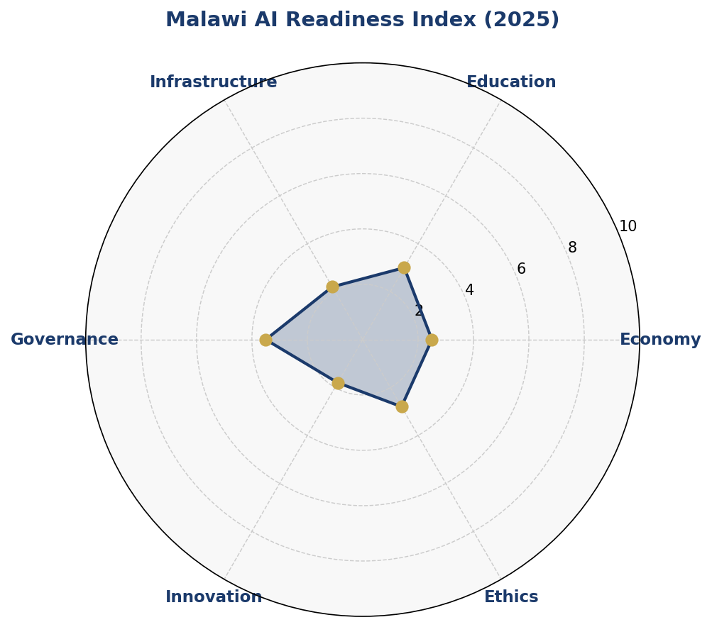
Figure 1: Malawi AI Readiness Index — 6-Dimensional Assessment (2025)
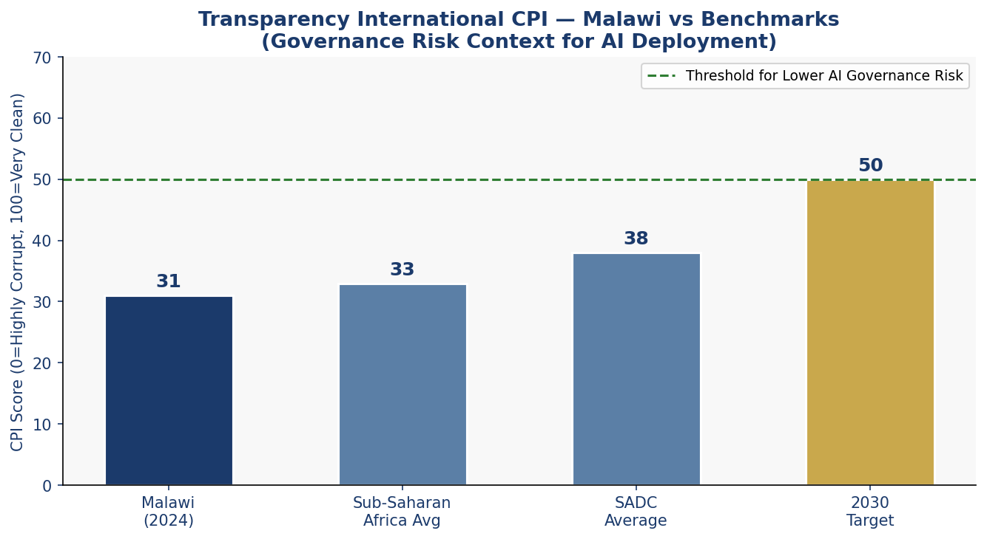
Figure 2: Transparency International CPI — Malawi vs Benchmarks

Section 2: Policy Vision and Strategic Pillars

2.1 Vision Statement
"By 2030, Malawi will be a leader in African human-centred AI — deploying intelligent technologies to eradicate poverty, strengthen institutions, empower citizens, and ensure that every Malawian participates in and benefits from the digital economy, without exception."
This vision is rooted in Malawi's Vision 2063 aspirations of becoming an inclusively wealthy and self-reliant nation. It acknowledges Malawi's development constraints while affirming the country's sovereign right and responsibility to shape its AI trajectory on its own terms.

2.2 Strategic Pillar 1: Ethical AI and Human Rights Protection
Every AI system deployed in Malawi — by government, private sector, or civil society — must respect the dignity, rights, and freedoms of all Malawians. This pillar establishes the ethical red lines: no AI system may be used for mass surveillance, political repression, or discriminatory targeting based on ethnicity, gender, religion, or disability. A National AI Ethics Board, operating independently of the executive, will enforce these standards through mandatory audits and a citizen grievance mechanism.

2.3 Strategic Pillar 2: Economic Growth and Industrial AI Adoption
AI will be deployed as a deliberate economic lever across Malawi's priority sectors: agriculture, health, financial services, and energy. AI-driven precision agriculture tools will help smallholder farmers — who represent approximately 80% of Malawi's workforce — increase yields, manage climate risk, and access markets. AI in health will support diagnostic assistance in under-resourced district hospitals, disease surveillance, and maternal health monitoring. Targeted tax incentives, AI adoption grants, and public-private partnerships will accelerate uptake in the private sector.

2.4 Strategic Pillar 3: Education, Upskilling, and AI Workforce Development
Malawi cannot leverage AI without a pipeline of AI-literate citizens, practitioners, and researchers. This pillar mandates the integration of computational thinking and AI concepts into the national curriculum from primary school, establishes a National AI Scholarship Programme, and creates AI Centres of Excellence at MUST, the University of Malawi, and Mzuzu University. A special focus is placed on women, rural communities, and persons with disabilities to ensure AI opportunity is distributed equitably.

2.5 Strategic Pillar 4: Public Sector AI and e-Governance
Government is both the largest potential deployer of AI in Malawi and its most consequential user. This pillar governs AI adoption in public administration: from tax collection and social protection to court case management and agricultural subsidy distribution. All public AI systems must comply with the AI Risk Classification System, undergo mandatory pre-deployment impact assessments, and publish algorithmic audit results annually. Procurement of AI tools by government must follow an open, competitive process with mandatory disclosure of source code or algorithmic logic for high-risk applications.

2.6 Strategic Pillar 5: AI Research, Innovation, and Startup Ecosystem
Malawi must build sovereign AI capacity — not merely consume AI tools developed abroad. This pillar funds domestic AI research through a new National AI Research Fund, creates regulatory sandboxes for AI start-ups, and establishes innovation hubs in Lilongwe, Blantyre, and Mzuzu. The policy targets the registration of at least 400 AI-related start-ups by 2030 and the establishment of Malawi as a regional hub for AI applied to agriculture, climate adaptation, and public health — domains where the country has both unique data assets and acute need.

Section 3: International Framework Alignment

This policy has been developed in deliberate alignment with the leading global and regional frameworks governing responsible AI development. Malawi's approach is not merely compliant with these frameworks — it adapts their principles to the specific economic, cultural, and institutional realities of a Least Developed Country navigating the AI transition.

3.1 UNESCO Recommendation on the Ethics of AI (2021)
The UNESCO Recommendation identifies 11 core values including human rights, fairness, transparency, sustainability, and safety. This policy maps directly to each value: the National AI Ethics Board operationalises the fairness and non-discrimination mandates; the Risk Classification System implements the safety and security principles; and the mandatory Environmental Impact Assessment for large-scale AI deployments addresses sustainability. Malawi was a signatory to the UNESCO recommendation and treats its provisions as binding guidance in the absence of domestic legislation.

3.2 OECD AI Principles (2019, Updated 2024)
The OECD principles — inclusive growth, human-centred values, transparency, robustness, and accountability — inform the governance architecture at every level. The requirement for explainable AI in all government applications directly implements the OECD transparency principle. The mandatory algorithmic impact assessment framework maps to the robustness and accountability principles. While Malawi is not an OECD member, adherence to OECD AI principles signals alignment with international best practice and facilitates technology partnership with OECD member states.

3.3 EU Artificial Intelligence Act (2024)
The EU AI Act's risk-based categorisation has been adapted to Malawi's context within Section 6 of this policy. High-risk categories are re-mapped to Malawi's governance challenges: biometric identification systems, AI used in judicial or administrative proceedings, and AI in social protection are all classified as High Risk and subject to mandatory pre-deployment assessment. Certain uses — including AI-enabled political surveillance or automated social scoring — are classified as Unacceptable Risk and are prohibited under this policy.

3.4 World Bank AI Strategy for Development
The World Bank's framework emphasises AI as a tool for closing development gaps rather than widening them. Malawi's policy reflects this by mandating that at least 40% of AI investments target rural populations, smallholder farmers, and informal sector workers. The policy commits to publishing open government datasets to enable AI development aligned with Sustainable Development Goals, and to participating in World Bank-facilitated AI capacity-building programmes for LDC governments.

3.5 G20 AI Principles and ITU AI for Good Guidelines
The G20 AI Principles on inclusive growth and the ITU's AI for Good guidelines — specifically their emphasis on AI's contribution to the Sustainable Development Goals — frame the economic and social impact targets in Sections 4 and 5. Malawi commits to reporting annually to the ITU on AI for Good progress and to participating in the Global Partnership on AI (GPAI) as an observer with the intent to seek full membership by 2027.

3.6 Framework Alignment Matrix

Framework Principle | Vision &  Pillars | Ethics &  Governance | Education | Public  Sector | Economic  Impact
UNESCO: Human Rights & Dignity | ✅ | ✅ | ✅ | ✅ | ✅
UNESCO: Fairness & Non-Discrimination | ✅ | ✅ | ✅ | ⚠️ | ✅
UNESCO: Transparency & Explainability | ⚠️ | ✅ | ✅ | ✅ | ⚠️
UNESCO: Safety & Security | ✅ | ✅ | 🔲 | ✅ | ✅
UNESCO: Sustainability | ✅ | ⚠️ | ✅ | ✅ | ✅
OECD: Inclusive Growth | ✅ | ✅ | ✅ | ✅ | ✅
OECD: Human-Centred Values | ✅ | ✅ | ✅ | ⚠️ | ⚠️
OECD: Transparency & Accountability | ⚠️ | ✅ | ✅ | ✅ | ⚠️
OECD: Robustness & Security | ⚠️ | ✅ | 🔲 | ✅ | ⚠️
EU AI Act: Risk-Based Approach | ✅ | ✅ | ⚠️ | ✅ | ⚠️
EU AI Act: Prohibited AI Uses | 🔲 | ✅ | 🔲 | ⚠️ | 🔲
World Bank: Development Impact | ✅ | ⚠️ | ✅ | ✅ | ✅
G20: Inclusive Digital Economy | ✅ | ✅ | ✅ | ⚠️ | ✅
ITU/SDG: AI for Good | ✅ | ✅ | ✅ | ✅ | ✅
Table 1: Comprehensive International Framework Alignment Matrix (✅ = Full Alignment | ⚠️ = Partial/Planned | 🔲 = Not Yet Addressed)

Section 4: Economic Impact and Investment Roadmap

McKinsey Global Institute estimates that AI could add between 1.2% and 3.5% of GDP annually to Sub-Saharan African economies by 2030, depending on the pace and breadth of adoption. For Malawi — a country where smallholder agriculture dominates, where healthcare access is severely constrained, and where public service delivery is hampered by resource shortages — the potential gains from AI are disproportionately large relative to investment costs. This section details Malawi's economic opportunity and the investment pathway to realise it.

4.1 Priority Sectors for AI Adoption
Agriculture: AI-powered crop advisory services, satellite-based yield prediction, and pest and disease early-warning systems can directly benefit Malawi's estimated 2.5 million smallholder farming families. Pilot programmes by organisations such as One Acre Fund and the International Maize and Wheat Improvement Center (CIMMYT) have already demonstrated yield improvements of 15–30% through data-driven inputs. Scaling these interventions nationally through mobile delivery platforms represents the single largest near-term AI opportunity in Malawi.
Healthcare: Malawi has a ratio of approximately 2 doctors per 100,000 population — one of the lowest in the world. AI-powered diagnostic tools, telemedicine platforms, and predictive disease surveillance can materially extend the reach of Malawi's health system. The Kamuzu Central Hospital and Queen Elizabeth Central Hospital are priority sites for AI pilot deployment in radiology assistance and patient flow management.
Financial Inclusion: Malawi's formal financial sector reaches less than 35% of adults. AI-driven credit scoring using alternative data (mobile money transaction history, agricultural output records) can extend credit access to the un-banked, with particular potential for women entrepreneurs and rural smallholders.
Climate Adaptation: As a country highly vulnerable to cyclones, droughts, and floods — increasingly intensified by climate change — Malawi can deploy AI-powered climate modelling to improve early-warning systems, disaster preparedness, and agricultural planning under climate uncertainty.
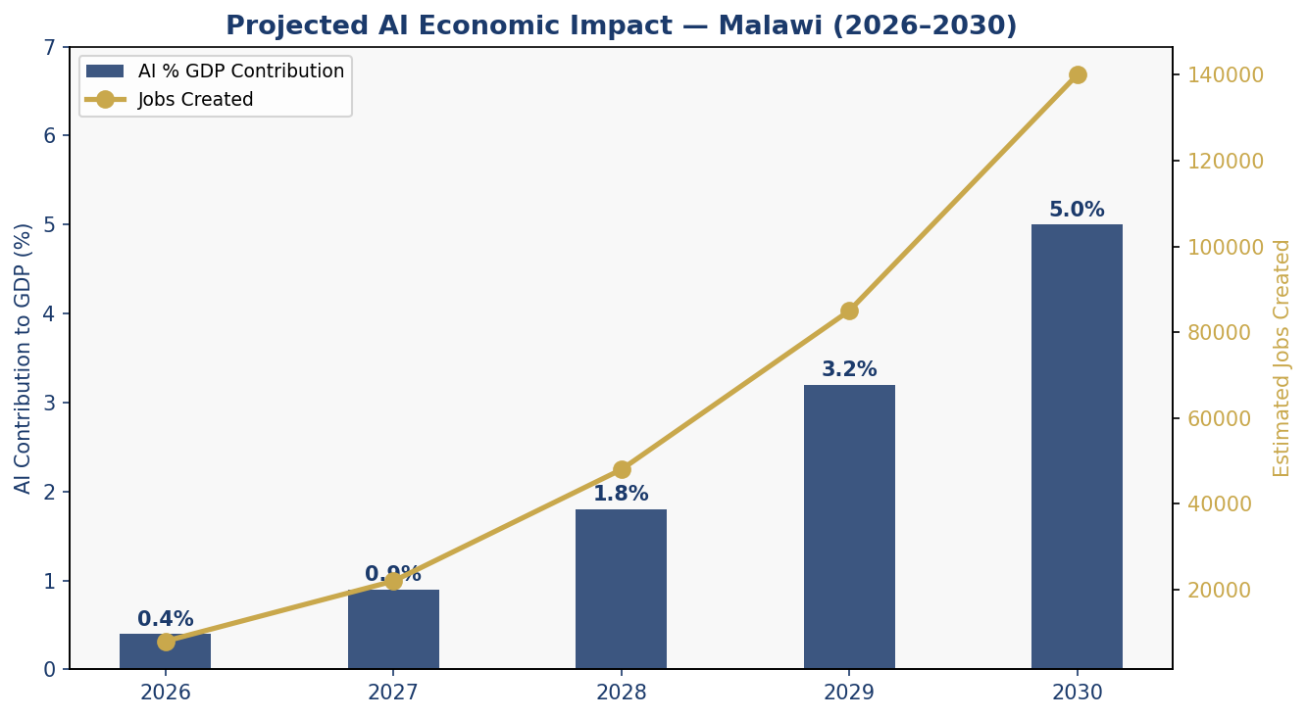
Figure 3: Projected AI Economic Impact — GDP Contribution and Jobs Created (2026–2030)
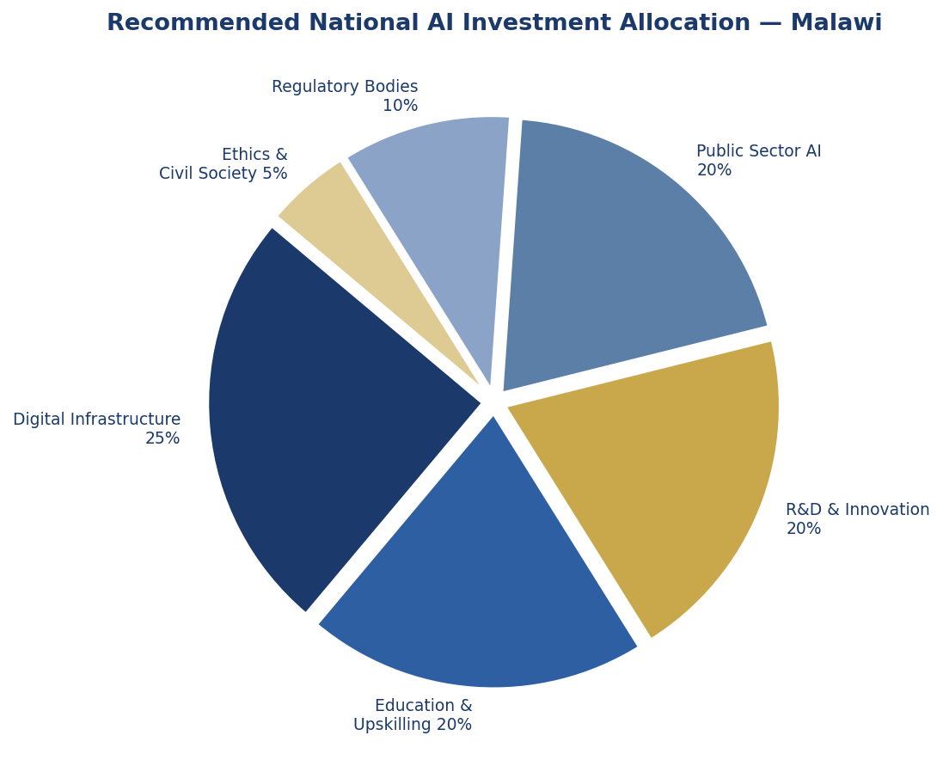
Figure 4: Recommended National AI Investment Allocation

4.2 Public-Private Partnership Framework
The Government of Malawi will establish an AI Investment Facilitation Unit within the Malawi Investment and Trade Centre (MITC) to coordinate public and private investment in AI. Tax incentives for AI-related R&D expenditure, fast-track regulatory approval for AI health applications, and a Malawi AI Fund — capitalised at an initial MWK 5 billion — will be established in Year 1. Development finance from the African Development Bank, World Bank IDA, and bilateral partners (UK, EU, US) will be actively solicited to co-finance infrastructure, education, and research components.

Section 5: Education and Human Capital Development

AI capability is ultimately a human capability. No national AI strategy can succeed without a deep, sustained investment in the skills of citizens at every level — from primary school children learning computational thinking, to university researchers pushing the boundaries of AI applied to African contexts, to civil servants applying data tools to improve service delivery. This section establishes Malawi's pathway from near-zero AI workforce capacity to a vibrant, inclusive AI talent ecosystem by 2030.

5.1 National AI Curriculum Framework
Primary School (Standards 1–8): Introduction of computational thinking, basic logic, and digital literacy. Teachers will receive dedicated training through the Malawi Institute of Education (MIE). By Year 3, all public primary schools will have access to at least one tablet or computer lab for digital learning.
Secondary School (Forms 1–4): Introduction of coding (Python and Scratch), data literacy, and an AI and Society module exploring the ethical, economic, and social dimensions of AI. The Malawi National Examinations Board (MANEB) will develop and administer a new AI Foundations certificate.
Tertiary Level: All universities will be required to offer at least one AI or data science course by Year 2. Dedicated AI degree programmes will be established at MUST and the University of Malawi by Year 3, with a combined enrolment target of 500 students per year by Year 5.
Vocational and Continuing Education: A National AI Upskilling Programme will offer short courses (4–12 weeks) for working adults, civil servants, healthcare workers, and agricultural extension officers. Priority will be given to women and rural participants, with blended online/offline delivery to accommodate connectivity constraints.
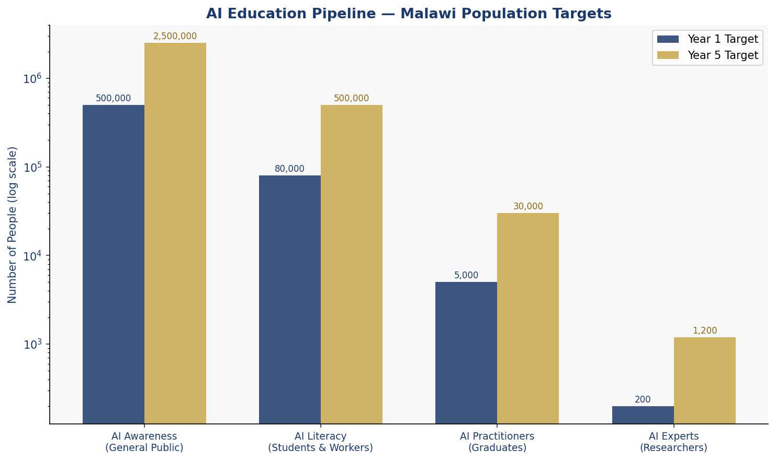
Figure 5: AI Education Pipeline — Population Targets by Level (Year 1 vs Year 5)

5.2 Women and Underrepresented Groups
Malawi's AI future must be built by all Malawians. This policy sets a binding target of 45% female participation in AI education programmes by Year 5. The National AI Gender Inclusion Fund will provide scholarships, mentorship, and community-based learning support specifically for women and girls. Partnerships with organisations such as Girls Who Code, the African Women in Technology network, and UNICEF will be formalised in Year 1. AI curricula will be developed in Chichewa and other local languages to reduce language-based exclusion.

5.3 International Scholarships and Exchange
The Government of Malawi will negotiate AI scholarship agreements with universities in South Africa, Rwanda, Kenya, India, the United Kingdom, and the United States. A Malawi AI Excellence Award — providing funding for 50 students annually to pursue postgraduate AI studies — will be established in Year 2. All scholarship recipients will be subject to a 3-year return-of-service obligation to contribute to Malawi's AI ecosystem.

Section 6: Ethical AI Governance and Regulatory Framework

6.1 National AI Ethics Board
A National AI Ethics Board (NAEB) will be established by statute within 12 months of this policy's adoption. The NAEB will comprise 11 members drawn from: the judiciary (2 members), civil society and human rights organisations (2 members), academia (2 members), the private sector (2 members), government (2 members), and persons with disabilities (1 member). Board members serve staggered 3-year terms and may not be removed except by a parliamentary resolution. The NAEB will have enforcement powers including the authority to issue binding orders, impose fines, and refer cases to the Malawi Human Rights Commission or relevant prosecutors.

6.2 AI Risk Classification System
Adapted from the EU AI Act and calibrated to Malawi's governance context, all AI systems operating in Malawi will be classified into one of four risk tiers:
Unacceptable Risk (Prohibited): AI systems designed for mass surveillance of citizens without judicial warrant; social scoring systems that deny public services based on behaviour; AI that manipulates persons through subliminal techniques; AI used to target individuals based on ethnicity, religion, or political opinion; and AI-generated disinformation campaigns. These uses are strictly prohibited and carry criminal penalties of up to MWK 100 million and 5 years imprisonment.
High Risk (Mandatory Regulation): AI used in judicial decisions or administrative determinations; AI in social protection, tax collection, or subsidy allocation; AI in medical diagnosis or treatment recommendation; AI in educational assessment; and AI in critical national infrastructure. All high-risk AI must undergo a mandatory pre-deployment Algorithmic Impact Assessment (AIA), receive NAEB certification, and publish annual transparency reports.
Limited Risk (Transparency Obligations): AI used in customer service chatbots, content recommendation, and marketing must disclose to users that they are interacting with an AI system. Deepfake content must be labelled. Providers must maintain a public AI register.
Minimal Risk (Voluntary Code of Conduct): AI used in entertainment, personal productivity, and non-consequential decision-making. Providers are encouraged but not required to adopt the Malawi AI Code of Good Practice.

6.3 Data Protection and Privacy
This policy calls for the urgent enactment of a comprehensive Personal Data Protection Act, modelled on the SADC Model Law on Data Protection and the African Union Convention on Cyber Security and Personal Data Protection (Malabo Convention). Until such legislation is enacted, this policy establishes interim data protection guidelines requiring: lawful basis for data processing; data minimisation; purpose limitation; data subject rights (access, correction, deletion); and mandatory breach notification to MACRA within 72 hours.

6.4 Anti-Corruption AI Safeguards
Given Malawi's governance challenges, this policy mandates specific anti-corruption provisions for public sector AI: all government AI systems must be subject to independent third-party audit before deployment and annually thereafter; algorithmic decisions affecting citizens' rights or entitlements must be explainable and subject to human review on request; public procurement of AI systems must be conducted through open tender, with mandatory disclosure of beneficial ownership of all bidders; and a dedicated AI corruption reporting mechanism will be established within the Anti-Corruption Bureau.

Section 7: Public Sector and e-Governance AI

The Government of Malawi is the most consequential potential deployer of AI in the country. Applied wisely, AI can transform public service delivery — making government faster, less corrupt, and more responsive to citizens. Applied carelessly, AI can entrench discrimination, erode public trust, and deepen inequality. This section establishes the framework for responsible government AI adoption.

7.1 Priority Government Use Cases
Agricultural Subsidy Management: The Farm Input Subsidy Programme (FISP), Malawi's largest social transfer, has historically been subject to significant corruption and targeting failures. AI-powered beneficiary verification — using national ID data, satellite land mapping, and mobile money records — will improve accuracy, reduce leakage, and accelerate payment processing. A pilot in three districts will be conducted in Year 1.
Disease Surveillance and Health System Management: AI models trained on anonymised patient data will support early detection of disease outbreaks (including malaria, cholera, and COVID variants) and optimise the distribution of medicines and vaccines across Malawi's 840 health facilities.
Tax Revenue Administration: The Malawi Revenue Authority (MRA) will deploy AI-powered risk analytics to identify tax evasion patterns, improve VAT compliance, and reduce the tax gap — estimated at over 30% of potential revenue. This has transformative potential for Malawi's fiscal space.
Judiciary Case Management: Malawi's courts face chronic case backlogs. An AI-assisted case management and scheduling system — combined with legal research AI tools — will reduce average case resolution time and improve access to justice, particularly for citizens unable to afford private legal representation.
Land Registry and Titling: AI-powered digitisation and analysis of Malawi's land records will reduce disputes, improve tenure security for smallholder farmers, and create a reliable foundation for agricultural lending and investment.

7.2 Government AI Procurement Guidelines
All government AI procurement must: specify functional requirements independently of vendor solutions; conduct a mandatory Algorithmic Impact Assessment for all high-risk applications; require open-source or source-code disclosure for systems making binding decisions about citizens; include a vendor data localisation requirement for sensitive public data; and mandate interoperability with the Government of Malawi's existing e-Government platform standards.

7.3 Citizen-Facing AI Services Roadmap
By the end of Year 2, the Government of Malawi will launch an AI-powered citizen service portal (accessible via mobile, USSD, and community service points) offering: automated birth and death registration status queries; agricultural advisory services; health facility locator with real-time availability data; and access to social protection eligibility information. All services will be available in Chichewa and English.

Section 8: Implementation Roadmap

Implementation of this policy will proceed in three phases over 60 months, each with clear milestones, institutional responsibilities, and resource requirements. Progress will be reported publicly through the annual National AI State Report.

8.1 Phase 1 — Foundation (Months 1–12)
- Establish the National AI Ethics Board through parliamentary legislation
- Enact interim Data Protection Guidelines and initiate drafting of the Personal Data Protection Act
- Launch the Malawi AI Fund with an initial capitalisation of MWK 5 billion
- Commence national AI literacy awareness campaign
- Deploy FISP subsidy management AI pilot in three districts
- Negotiate AI scholarship agreements with at least 5 international university partners
- Publish Malawi's National AI Register (mandatory listing of all government AI systems)
- Establish the AI Investment Facilitation Unit within MITC

8.2 Phase 2 — Scaling (Months 13–36)
- Integrate AI curriculum into primary and secondary national syllabi
- Launch AI degree programmes at MUST and University of Malawi
- Deploy AI in MRA tax risk analytics nationally
- Establish AI Centres of Excellence at three universities
- Launch citizen-facing AI service portal (mobile, USSD)
- Achieve certification of first cohort of AI practitioners through National AI Upskilling Programme
- Deploy disease surveillance AI in all 28 districts
- Publish first Annual National AI State Report and Parliamentary Review

8.3 Phase 3 — Optimisation and Integration (Months 37–60)
- Conduct mid-term review of all policy targets and recalibrate as needed
- Seek full membership of Global Partnership on AI (GPAI)
- Launch Malawi AI Export Initiative — packaging AI tools developed in Malawi for regional markets
- Complete legislative framework: Personal Data Protection Act, AI Regulation Act
- Achieve 400 registered AI start-ups and 1,200 active AI researchers
- Establish Malawi as a SADC AI Centre of Excellence for agricultural and climate AI
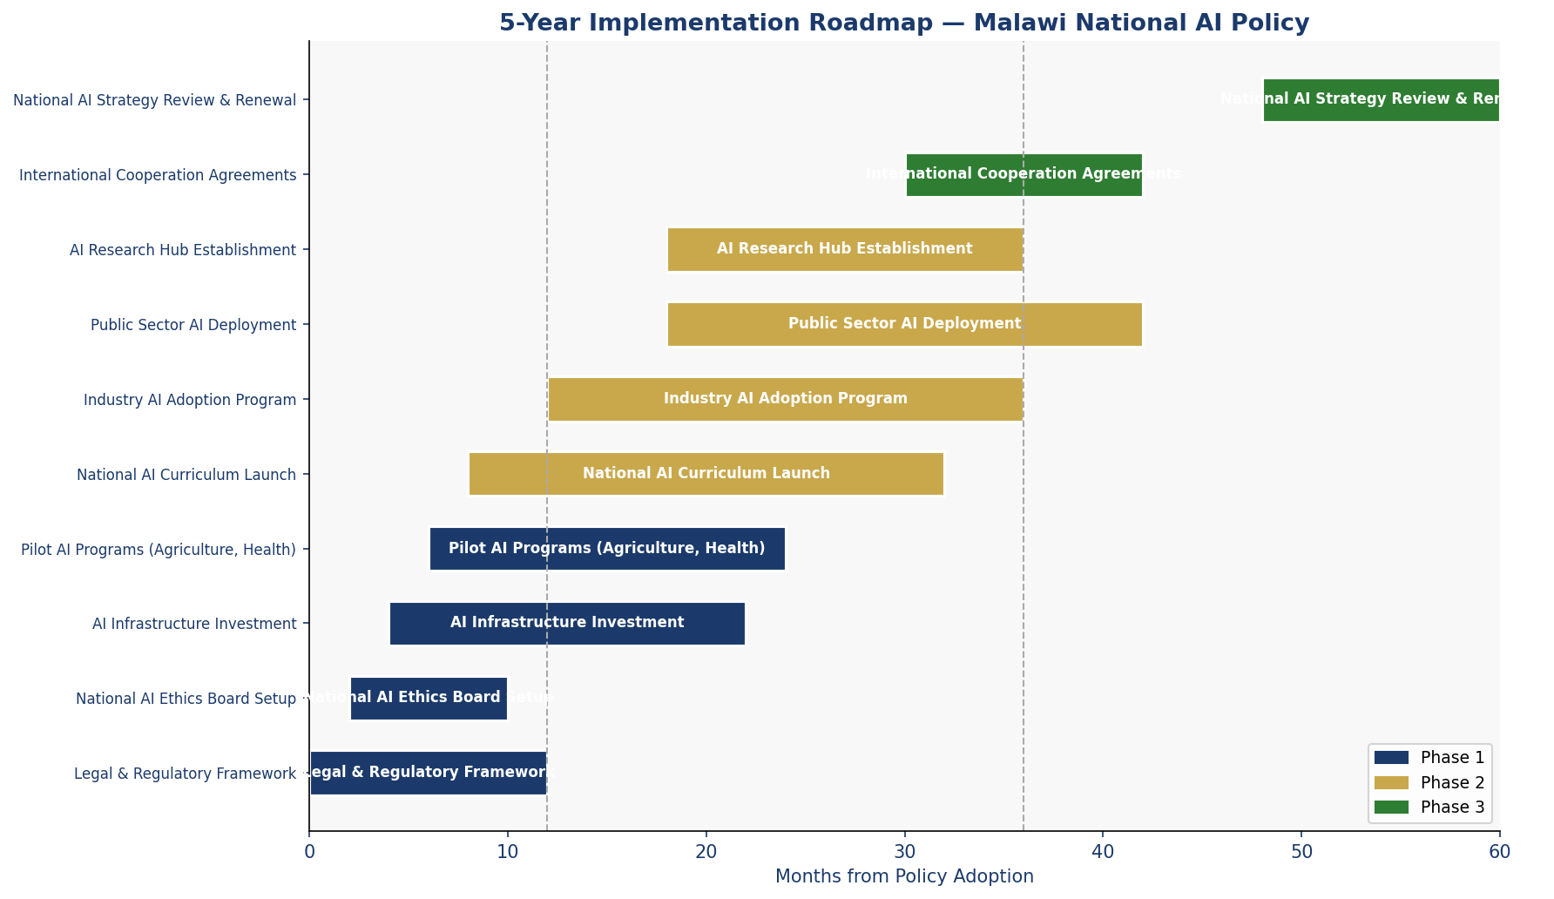
Figure 6: 5-Year Implementation Roadmap — Gantt Overview (Months 0–60)

Section 9: Monitoring, Evaluation, and Accountability

Accountability is not a postscript to this policy — it is its foundation. The experience of development policy in Malawi and across Sub-Saharan Africa demonstrates that without robust monitoring, evaluation, and independent oversight, well-intentioned policies fail to deliver. This section establishes the architecture of accountability for Malawi's AI future.

9.1 National AI Observatory
A National AI Observatory (NAIO) will be established within the National Statistical Office (NSO) as a semi-autonomous unit. The NAIO will maintain Malawi's National AI Register, conduct annual assessments of AI adoption across government and private sector, commission independent audits of high-risk AI systems, and publish the Annual National AI State Report. The NAIO will have an open data mandate: all aggregated AI statistics and audit findings will be published on a publicly accessible digital platform.

9.2 Parliamentary Oversight
The Parliamentary Committee on Information and Communications Technology will be designated as the primary parliamentary oversight body for AI governance. The committee will review the Annual National AI State Report, summon the NAEB Chairperson for testimony at least twice annually, and initiate legislative review if AI governance gaps or harms are identified. A dedicated parliamentary budget line for AI oversight activities will be established in the national budget.

9.3 Civil Society and Independent Auditor Role
Civil society organisations working on digital rights, human rights, consumer protection, and technology access will be formally recognised as co-stakeholders in AI governance. The NAEB will convene a quarterly Civil Society AI Dialogue and publish responses to civil society submissions within 30 days. Independent AI auditors — certified by the NAEB — will be authorised to conduct mandatory third-party audits of High Risk government AI systems.

9.4 KPI Dashboard

KPI Metric | Baseline (2025) | Year 1 Target | Year 3 Target | Year 5 Target
Internet Penetration (%) | 23% | 30% | 45% | 60%
AI Practitioners in Workforce | ~50 | 300 | 3,000 | 15,000
National AI Budget (% of GDP) | 0% | 0.3% | 0.8% | 1.5%
Government Services Using AI | 0 | 3 | 12 | 25
AI Start-ups Registered | ~5 | 30 | 150 | 400
Women in AI Workforce (%) | 15% | 25% | 35% | 45%
CPI Score (Transparency Intl) | 31 | 33 | 38 | 45
AI Ethics Cases Reviewed/Year | 0 | 10 | 60 | 150
University AI Courses Offered | 2 | 10 | 35 | 60
Annual AI Research Publications | ~3 | 20 | 80 | 200
Table 2: National AI Policy KPI Dashboard — Baseline to 2030 Targets

Section 10: International Cooperation and Diplomacy

AI is a global technology requiring global governance. Malawi cannot develop its AI ecosystem in isolation, nor can it afford to be a passive recipient of AI norms determined by more powerful nations without regard for developing country realities. This section articulates Malawi's proactive strategy for international AI engagement.

10.1 Bilateral Cooperation Priorities
Priority bilateral AI cooperation partners include: Rwanda and Kenya (African AI leaders with relevant experience in e-government and agri-AI); South Africa (regional economic powerhouse with significant AI research capacity); India (complementary development context, strong AI education ecosystem, and existing development partnership); the United Kingdom (historical bilateral relationship, active FCDO digital development programmes); the European Union (AI Act alignment, significant development finance); and the United States (USAID digital development programmes, strong university linkages).
Bilateral agreements will cover: AI researcher exchange programmes; joint research projects on agricultural AI and climate AI; technology transfer on fair and open terms; co-investment in Malawi's AI infrastructure; and mutual recognition of AI ethics standards where compatible.

10.2 Regional AI Governance — SADC and African Union
Malawi will actively participate in the Southern African Development Community's emerging digital economy agenda and advocate for the development of a SADC Regional AI Governance Framework, harmonised with the African Union's AI Continental Strategy for Africa. Malawi will offer to host a SADC AI Working Group Secretariat in Lilongwe, leveraging its central location and strong diplomatic relationships within the region. Alignment with the African Union's Agenda 2063 and the AU's Digital Transformation Strategy for Africa provides the strategic compass for Malawi's regional AI engagement.

10.3 South-South Knowledge Transfer
Malawi will actively pursue South-South cooperation on AI, recognising that countries at similar development levels often generate the most practical and contextually relevant AI innovations. Partnerships with Ethiopia, Ghana, Tanzania, and Zambia — countries navigating comparable AI adoption challenges — will be formalised through joint government working groups and shared research programmes. Malawi will participate in the UNESCO Global Observatory on AI and contribute anonymised case studies to the global body of knowledge on AI in LDC contexts.

10.4 Global AI Governance Participation
Malawi will seek to participate as an observer in the Global Partnership on AI (GPAI) from Year 1, with a target of full membership by 2027. Malawi's representatives to the United Nations and the International Telecommunication Union will be briefed and empowered to advocate for LDC-sensitive AI governance principles in global forums — including binding norms on algorithmic transparency, meaningful technology transfer, and the special development needs of countries like Malawi in the global AI transition.

Conclusion

The advent of artificial intelligence is not a distant horizon for Malawi — it is a present reality that is already reshaping the global economy, governance systems, and social fabric. The question Malawi must answer is not whether AI will affect its citizens, but whether Malawians will be architects or subjects of that transformation.
This National Artificial Intelligence Policy 2025–2030 is Malawi's answer. It is a declaration that this nation — despite its economic constraints, its infrastructure gaps, and its institutional challenges — has both the right and the capacity to shape its own AI future. It commits the Government of Malawi to building the institutional, regulatory, educational, and technological foundations without which AI cannot deliver on its promise. And it commits to doing so in a manner that is accountable to every Malawian citizen.
The policy is ambitious, but its ambition is grounded in Malawi's specific realities. It does not pretend that Malawi can become a global AI superpower within five years. It does insist that Malawi can, within five years, ensure that AI is deployed ethically in its public sector, that its citizens begin to acquire AI literacy, that its entrepreneurs find an enabling environment for AI innovation, and that its institutions are equipped to govern intelligent systems in the public interest.
The stakes are high. Countries that invest strategically in AI governance today will help define the norms that govern AI globally tomorrow. Malawi has a legitimate voice in that conversation — and this policy ensures that voice is heard, grounded in principle, and backed by action.
Implementation of this policy begins immediately. Every Malawian deserves no less.

References and Bibliography

African Union. (2020). The Digital Transformation Strategy for Africa (2020–2030). Addis Ababa: African Union Commission.
African Union. (2024). Continental AI Strategy for Africa. Addis Ababa: African Union Commission.
European Parliament. (2024). Regulation (EU) 2024/1689 — Artificial Intelligence Act. Official Journal of the European Union.
G20 Digital Economy Task Force. (2023). G20 AI Principles and Ministerial Declaration on AI. New Delhi: G20 Secretariat.
Government of Malawi. (2020). Malawi Vision 2063: An Inclusively Wealthy and Self-Reliant Nation. Lilongwe: Ministry of Finance, Economic Planning and Development.
Government of Malawi. (2022). Malawi Digital Economy Strategy. Lilongwe: Ministry of Information and Digitalisation.
International Telecommunication Union. (2023). AI for Good: Connecting AI to the Sustainable Development Goals. Geneva: ITU.
McKinsey Global Institute. (2023). The State of AI in 2023: Generative AI's Breakout Year. New York: McKinsey & Company.
OECD. (2024). OECD AI Principles — Updated Recommendations of the Council on Artificial Intelligence. Paris: OECD Publishing.
Oxford Insights. (2023). Government AI Readiness Index 2023. Oxford: Oxford Insights.
Transparency International. (2024). Corruption Perceptions Index 2024. Berlin: Transparency International Secretariat.
UNESCO. (2021). Recommendation on the Ethics of Artificial Intelligence. Paris: United Nations Educational, Scientific and Cultural Organization.
World Bank Group. (2023). World Development Report 2024: The Middle Income Trap. Washington DC: The World Bank.
World Bank Group. (2022). Digital Technologies for Malawi: Landscape Assessment. Washington DC: World Bank Digital Development Global Practice.
World Economic Forum. (2024). The Future of Jobs Report 2024. Geneva: World Economic Forum.

About the Author

Nafiul Ahmad Rafi
Policy & Good Governance Researcher | BD Civic Tech Architect

Nafiul Ahmad Rafi is a civic technologist, policy researcher, author, photographer, and musician based in Dhaka, Bangladesh. He is the Founder and Director of Insights Bangladesh, a data-driven governance and policy impact analysis institution, and the Founder and Lead Architect of NagorikBD.org — a transparency-first civic platform scaled across Mymensingh Division, connecting citizens with government services across 45 Upazilas.
His work exists at the intersection of institutional reform and artificial intelligence, transforming theoretical governance into scalable, data-driven reality. Without a conventional computer science degree, he self-taught the tools of modern AI and web development to build the infrastructure that enforces the policies he once only researched.
Key Platforms and Projects
- NagorikBD.org — Civic transparency platform, Mymensingh Division
- Insights Bangladesh — Policy impact analysis institution
- FactCheck BD (factcheckbd.org) — Bangladesh's AI-powered fact-checking platform
- Political Insights BD / PIBD (pibbd.org) — Political intelligence and civic tech hub
- PeaceShield BD / National Peace Tracker — AI-powered hate speech and conflict monitoring
- PolicyLens AI (aigovbd.org) — 9-dimensional AI policy audit tool

He has published four books and maintains a personal site at ahmad-rafi.com.
Research Interests
AI Governance · Policy Research · Future of Bangladesh · Climate Policy
Contact
- Website: ahmad-rafi.com
- LinkedIn: linkedin.com/in/nafiul-ahmad-rafi
- Email: contact@ahmad-rafi.com

"I build code to ensure transparency, and I write lyrics to inspire the courage to use it."

