🇷🇼 REPUBLIC OF RWANDA

NATIONAL ARTIFICIAL INTELLIGENCE POLICY

2025 – 2030
A Comprehensive Framework for Ethical, Inclusive, and
Economically Transformative Artificial Intelligence

Prepared by:
Nafiul Ahmad Rafi
Policy & Good Governance Researcher | BD Civic Tech Architect
Insights Bangladesh

May 2025

Executive Summary
Rwanda stands at a transformative crossroads. With one of Africa's most stable governance environments, a government deeply committed to technology-led development, and a growing digital economy anchored by the Vision 2050 long-term development strategy, Rwanda is uniquely positioned to become the continent's premier AI innovation hub. This National Artificial Intelligence Policy (2025–2030) provides the comprehensive framework required to harness the immense potential of artificial intelligence while ensuring that its benefits are distributed equitably, its risks are managed responsibly, and its governance reflects Rwanda's commitment to ethical leadership on the global stage.
The policy is constructed around five strategic pillars: Ethical AI and Human Rights Protection; Economic Growth and Industrial AI Adoption; Education, Upskilling, and AI Workforce Development; Public Sector AI and e-Governance; and AI Research, Innovation, and Startup Ecosystem Development. Each pillar is supported by concrete implementation mechanisms, measurable key performance indicators, and institutional accountability structures that align with Rwanda's existing governance architecture, including the Rwanda Information Society Authority (RISA), the Ministry of ICT and Innovation, and the Rwanda Utilities Regulatory Authority (RURA).
Rwanda's AI readiness profile is promising but requires deliberate investment. The country scores above the Sub-Saharan African average on digital infrastructure, governance quality, and institutional capacity. However, significant gaps remain in advanced STEM talent, domestic AI research output, and data infrastructure depth. This policy addresses these gaps through a phased five-year roadmap: a Foundation Phase (Year 1) establishing the legal, regulatory, and institutional architecture; a Scaling Phase (Years 2–3) driving national adoption across education, industry, and government services; and an Optimization Phase (Years 4–5) refining systems, expanding international cooperation, and positioning Rwanda as an AI exporter and thought leader.
The policy is fully aligned with international frameworks including the UNESCO AI Ethics Recommendation (2021), OECD AI Principles (2024 update), EU AI Act (2024), World Bank AI Strategy, G20 AI Principles, and ITU AI for Good Guidelines. Rwanda's implementation of this framework is expected to contribute 4.2% of GDP through AI-related activity by 2029, create over 130,000 AI-adjacent jobs, and establish Rwanda as the leading African voice in global AI governance dialogues at the UN, ITU, and Global Partnership on AI (GPAI).

Section 1: National AI Readiness Assessment

1.1 Economic Context
Rwanda is a lower-middle-income country with a GDP per capita of approximately USD 980 (2023), reflecting sustained economic growth averaging 7–8% annually over the past decade. The economy is driven by services (49%), agriculture (26%), and industry (17%), with a growing digital economy contributing an estimated 7.5% of GDP. Rwanda's Vision 2050 targets upper-middle-income status by 2035, with digital transformation as the primary accelerant. The government's Economic Recovery Plan and Smart Rwanda Master Plan explicitly identify AI, big data, and the Internet of Things as foundational technologies for this transition.
The financial services sector has seen significant AI-adjacent innovation, including mobile money penetration exceeding 90% of adults through MTN Rwanda and Airtel Rwanda. The agricultural sector — employing over 60% of the population — presents vast untapped potential for AI applications in crop monitoring, yield prediction, market linkage, and climate-resilient farming. Tourism, Rwanda's largest foreign exchange earner, offers AI opportunities in visitor experience personalization and wildlife conservation monitoring.

1.2 Education and Human Capital
Rwanda has achieved significant progress in education access, with a primary enrollment rate exceeding 95% and secondary enrollment at approximately 42%. The adult literacy rate stands at approximately 73%, with urban literacy approaching 87%. However, tertiary enrollment remains low at approximately 8%, and STEM graduates number only around 5,000–6,000 annually from institutions including the University of Rwanda, Carnegie Mellon University Africa (CMU-Africa), and the African Institute for Mathematical Sciences (AIMS Rwanda). These institutions form the nucleus of Rwanda's AI talent pipeline but must be significantly scaled to meet the workforce demands of a national AI strategy.
Rwanda has demonstrated political will to invest in technical education. The Coding Bootcamp Rwanda initiative, the Digital Ambassadors Program, and the government's partnership with CMU-Africa for a Master's in Information Technology program reflect a government that understands the link between STEM capacity and economic transformation. The AI skills gap, however, remains substantial — estimated at approximately 15,000 skilled AI practitioners needed by 2030 against a current base of approximately 1,200.

1.3 Digital Infrastructure
Rwanda's digital infrastructure is among the strongest in Sub-Saharan Africa, with 4G LTE coverage reaching approximately 95% of the population and fiber optic backbone spanning over 5,000 kilometers connecting all 30 districts. Internet penetration stands at approximately 62%, with mobile internet the dominant access modality. The Kigali Innovation City development, anchored by Carnegie Mellon University Africa, represents a flagship effort to create an enabling environment for tech entrepreneurship and AI R&D. Cloud infrastructure remains nascent domestically, with most enterprises dependent on hyperscaler cloud providers (AWS, Google Cloud, Microsoft Azure) hosted outside Rwanda — a critical consideration for data sovereignty and AI model hosting at scale.

1.4 Governance and Institutional Capacity
Rwanda ranks among Africa's top performers on governance quality metrics. The World Bank's Worldwide Governance Indicators place Rwanda in the top quartile for Sub-Saharan Africa on government effectiveness, rule of law, and control of corruption. The Rwanda Development Board (RDB) and RISA have demonstrated the institutional capacity to implement complex technology initiatives at national scale. The establishment of the Smart Rwanda Master Plan coordinating office provides a governance precedent for the proposed National AI Office that this policy recommends.

1.5 Corruption Risk Assessment
Rwanda's Transparency International Corruption Perceptions Index (CPI) score of 53 out of 100 (2023) places it 49th globally and ranks it as the least corrupt country in Sub-Saharan Africa alongside Mauritius. This is a critical asset for AI governance: countries with lower corruption scores demonstrate stronger capacity to implement AI regulatory frameworks fairly, to protect procurement integrity in AI systems acquisition, and to maintain public trust in government AI deployments. This policy identifies anti-corruption AI as both a policy priority and an area where Rwanda can demonstrate global leadership — using AI to further reduce corrupt practices in public administration.

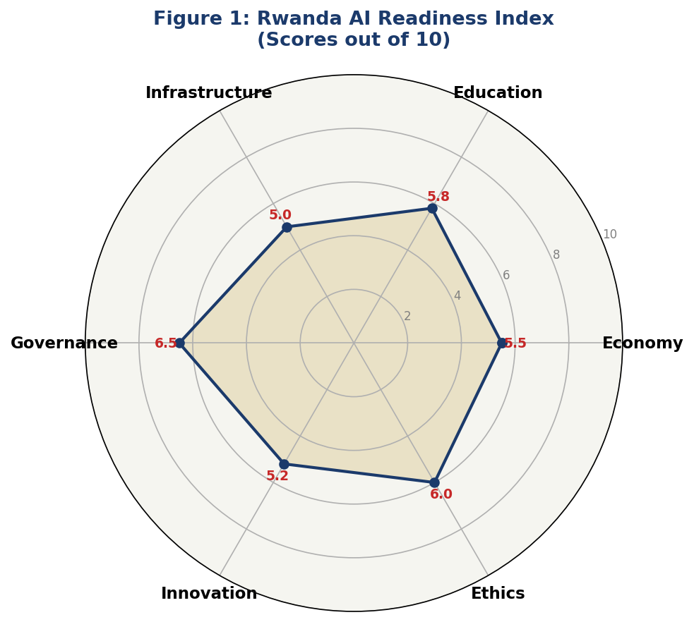
Figure 1: Rwanda AI Readiness Index — Multi-Dimensional Assessment (Scores out of 10)

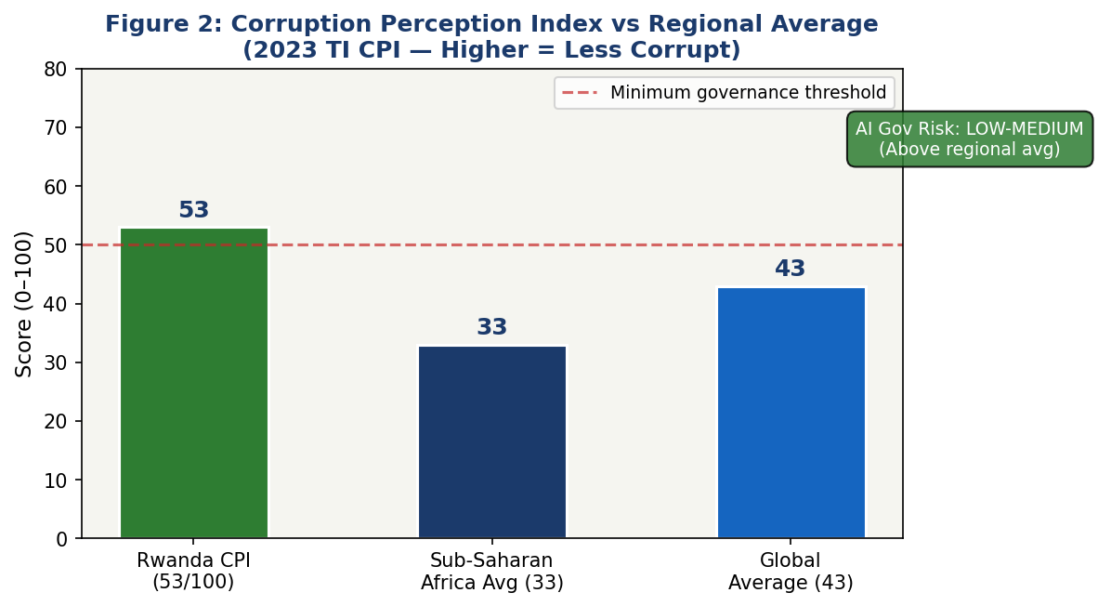
Figure 2: Corruption Perception Index — Rwanda vs Regional and Global Averages (2023 TI CPI)

Section 2: Policy Vision and Strategic Pillars

2.1 National AI Vision
"By 2030, Rwanda will be recognized as Africa's most trusted, ethical, and innovative AI nation — harnessing the power of artificial intelligence to eliminate poverty, accelerate public service delivery, empower its citizens, and lead the continent toward a future where technology serves humanity."

2.2 Strategic Pillar 1: Ethical AI and Human Rights Protection
Rwanda's commitment to human dignity and the rule of law — hallmarks of its post-genocide national reconstruction — provides a powerful foundation for ethical AI governance. This pillar establishes that all AI systems deployed in Rwanda must respect the fundamental rights of citizens, be transparent in their decision-making, and be subject to independent oversight. Key initiatives include the establishment of a National AI Ethics Board, mandatory algorithmic impact assessments for all high-risk government AI systems, and a citizen AI rights charter that establishes enforceable entitlements to explanation, redress, and opt-out from automated decision-making.
Rwanda will adopt a risk-based regulatory approach modeled on the EU AI Act but adapted to Rwanda's legal, cultural, and development context. AI systems used in criminal justice, credit scoring, healthcare triage, and social benefits allocation will be classified as High-Risk and subject to mandatory third-party audits before deployment. The use of AI for mass surveillance, social scoring, and manipulation of vulnerable populations will be explicitly prohibited.

2.3 Strategic Pillar 2: Economic Growth and Industrial AI Adoption
AI presents Rwanda with a leapfrogging opportunity across its key economic sectors. Agriculture — Rwanda's largest employer — will be transformed through AI-powered precision farming, satellite crop monitoring, and market price prediction systems that connect smallholder farmers directly to market intelligence. Financial services will leverage AI for credit scoring of the unbanked, fraud detection in mobile money systems, and insurance risk modeling for climate-vulnerable agricultural communities.
Tourism will deploy AI-powered visitor personalization, wildlife anti-poaching surveillance using computer vision, and predictive maintenance for national park infrastructure. The manufacturing sector — a government priority under Made in Rwanda — will adopt AI-driven quality control, predictive maintenance, and supply chain optimization. Rwanda will also develop a sovereign AI services export industry, positioning itself as a provider of AI training data, annotation services, and AI-powered BPO for global markets.

2.4 Strategic Pillar 3: Education, Upskilling, and AI Workforce Development
Human capital is Rwanda's most critical AI asset and most significant constraint. This pillar establishes a national AI education ecosystem spanning from primary school AI literacy through doctoral-level AI research. A revised national curriculum will introduce computational thinking and basic AI concepts at the primary level, dedicated data science and machine learning modules at secondary level, and full AI engineering programs at the tertiary level. The Rwanda Coding Academy model will be scaled nationally, with at least one AI specialization per province.
Workforce upskilling for working adults will be delivered through a national AI Skills Passport program — a government-certified micro-credentialing system accessible via mobile — targeting 500,000 adults by 2030. Special emphasis will be placed on gender equity: Rwanda's already strong female participation in technology (women hold 61% of parliamentary seats) provides a model for achieving at least 45% female representation in AI education programs.

2.5 Strategic Pillar 4: Public Sector AI and e-Governance
Government is Rwanda's most powerful lever for AI adoption at scale. Building on the Irembo e-governance platform — which already delivers over 100 government services digitally — this pillar drives the intelligent automation of public service delivery. AI-powered chatbots will handle routine citizen inquiries in Kinyarwanda, English, and French. Predictive analytics will optimize resource allocation in health, education, and infrastructure. AI-assisted document processing will reduce administrative burden across all ministries.
Critical safeguards will accompany government AI deployment. Every citizen-facing AI system will include a human escalation pathway. Algorithmic decisions affecting individual rights (welfare eligibility, visa applications, tax audits) will be subject to mandatory human review and citizen appeal rights. Rwanda will develop Africa's first Government AI Procurement Standard, ensuring that all AI systems acquired with public funds meet ethical, security, and interoperability requirements.

2.6 Strategic Pillar 5: AI Research, Innovation, and Startup Ecosystem
Rwanda cannot be a sustainable AI leader through adoption alone — it must develop indigenous AI research capacity. This pillar establishes the Rwanda AI Research Consortium (RAIRC), a formal collaboration between the University of Rwanda, CMU-Africa, AIMS Rwanda, and the Rwandan government, with a mandate to produce peer-reviewed AI research, develop Rwanda-specific AI models (including Kinyarwanda NLP systems), and commercialize research through university spin-offs.
The Kigali AI Innovation Fund — capitalized at RWF 50 billion over five years — will provide grant funding, soft loans, and equity investment for AI startups. Rwanda's Business Development Fund (BDF) will introduce an AI-specific credit guarantee scheme. The Rwanda ICT Chamber will establish an AI working group to coordinate industry engagement with government policy. Rwanda will also develop Africa's first AI-dedicated Special Economic Zone within the Kigali Innovation City framework, offering tax incentives, regulatory sandboxes, and infrastructure subsidies for qualifying AI enterprises.

Section 3: International Framework Alignment

3.1 UNESCO AI Ethics Recommendation (2021)
Rwanda's National AI Policy is designed to embody all eleven core values of the UNESCO Recommendation on the Ethics of AI: proportionality and do no harm; safety and security; fairness and non-discrimination; sustainability; right to privacy and data protection; human oversight and determination; transparency and explainability; responsibility and accountability; awareness and literacy; multistakeholder and adaptive governance; and international cooperation. The Ethical AI pillar directly maps to UNESCO's governance and human rights values, while the Education pillar operationalizes the awareness and literacy principle through the National AI Skills Passport and revised school curricula.

3.2 OECD AI Principles (2019, Updated 2024)
The OECD's five principles for responsible AI stewardship — inclusive growth and sustainable development; human-centered values and fairness; transparency and explainability; robustness, security, and safety; and accountability — are institutionalized throughout this policy. The proposed National AI Ethics Board serves as the primary accountability mechanism. The Government AI Procurement Standard operationalizes transparency and robustness requirements. Rwanda's alignment with OECD principles positions it to apply for observer status in OECD AI governance working groups, accelerating knowledge transfer and signaling regulatory maturity to international investors.

3.3 EU AI Act (2024) — Risk-Based Adaptation
Rwanda adapts the EU AI Act's risk-based classification system to its national context. Unacceptable Risk (Prohibited) uses include: AI systems for social scoring by government, real-time biometric mass surveillance in public spaces (with narrow security exceptions), AI systems targeting children with manipulative content, and AI systems exploiting psychological vulnerabilities for commercial gain. High-Risk (Regulated) AI includes systems used in justice, credit, employment screening, education assessment, critical infrastructure, and healthcare. Limited Risk AI requires transparency obligations (chatbot disclosure). Minimal Risk AI is governed by voluntary codes of conduct developed by the Rwanda ICT Chamber.

3.4 World Bank AI Strategy — Development Focus
The World Bank's focus on AI for sustainable development aligns directly with Rwanda's development priorities. This policy explicitly maps to World Bank AI principles: country ownership and leadership (AI governance led by Rwandan institutions); inclusion (gender equity targets, disability access requirements); safety and ethics; scalability; sustainability (environmental impact assessments for AI data centers). Rwanda's participation in the World Bank's AI for Development initiative provides access to technical assistance, financing, and peer learning networks with fellow developing country AI policymakers.

3.5 G20 AI Principles and ITU AI for Good
Rwanda, while not a G20 member, aligns with G20 AI Principles through its African Union membership and participation in G20 engagement mechanisms. The policy's focus on AI for inclusive growth directly mirrors the G20's emphasis on human-centered AI development. Rwanda's ITU AI for Good alignment is demonstrated through explicit SDG linkage: AI in agriculture (SDG 1, 2), AI in health (SDG 3), AI in education (SDG 4), AI in clean energy optimization (SDG 7), AI in economic growth (SDG 8), and AI in governance transparency (SDG 16).

Table 1: Comprehensive Framework Alignment Matrix

Framework | Pillar 1  (Ethics) | Pillar 2  (Economy) | Pillar 3  (Education) | Pillar 4  (Gov) | Pillar 5  (Research)
UNESCO AI Ethics (2021) | ✅ Full | ✅ Full | ✅ Full | ✅ Full | ⚠️ Partial
OECD AI Principles (2024) | ✅ Full | ✅ Full | ⚠️ Partial | ✅ Full | ✅ Full
EU AI Act (2024) | ✅ Full | ⚠️ Partial | 🔲 Limited | ✅ Full | ⚠️ Partial
World Bank AI Strategy | ⚠️ Partial | ✅ Full | ✅ Full | ✅ Full | ✅ Full
G20 AI Principles | ✅ Full | ✅ Full | ✅ Full | ⚠️ Partial | ✅ Full
ITU AI for Good / SDGs | ✅ Full | ✅ Full | ✅ Full | ✅ Full | ⚠️ Partial

✅ Full Alignment ⚠️ Partial Alignment (implementation underway) 🔲 Limited Alignment (requires further development)

Section 4: Economic Impact and Investment Roadmap

4.1 Projected AI Economic Contribution
Based on World Economic Forum and McKinsey Global Institute models applied to Rwanda's lower-middle-income country profile, AI is projected to contribute an additional 4.2% of GDP by Year 5 of implementation (2029), representing approximately USD 650 million in annual economic value added. This projection encompasses direct value creation (AI-powered productivity gains in agriculture, manufacturing, and services), indirect effects (supply chain and distribution efficiency), and induced impacts (higher household incomes driving consumption). Early-stage contributions in Years 1–2 will be modest (0.4–0.9% of GDP), reflecting the foundation-building nature of the initial phase, with acceleration in Years 3–5 as adoption reaches critical scale.
The agriculture sector alone — where AI-powered precision farming can increase smallholder yields by 20–35% according to CGIAR research on similar African contexts — is projected to generate USD 180 million in additional agricultural value by 2029. Financial services AI (credit scoring, fraud prevention, insurance) is projected to contribute USD 90 million through expanded financial inclusion. Public sector efficiency gains from AI automation are estimated at USD 75 million annually in reduced administrative costs by Year 5.

4.2 Investment Framework
The National AI Investment Framework recommends total public investment of approximately RWF 250 billion (USD 200 million equivalent) over five years, drawn from the national budget, development partner contributions, and the Kigali AI Innovation Fund. This public investment is expected to catalyze private sector AI investment of at least 3x, or approximately RWF 750 billion, in the same period. Investment allocation follows a deliberate prioritization reflecting Rwanda's development needs.
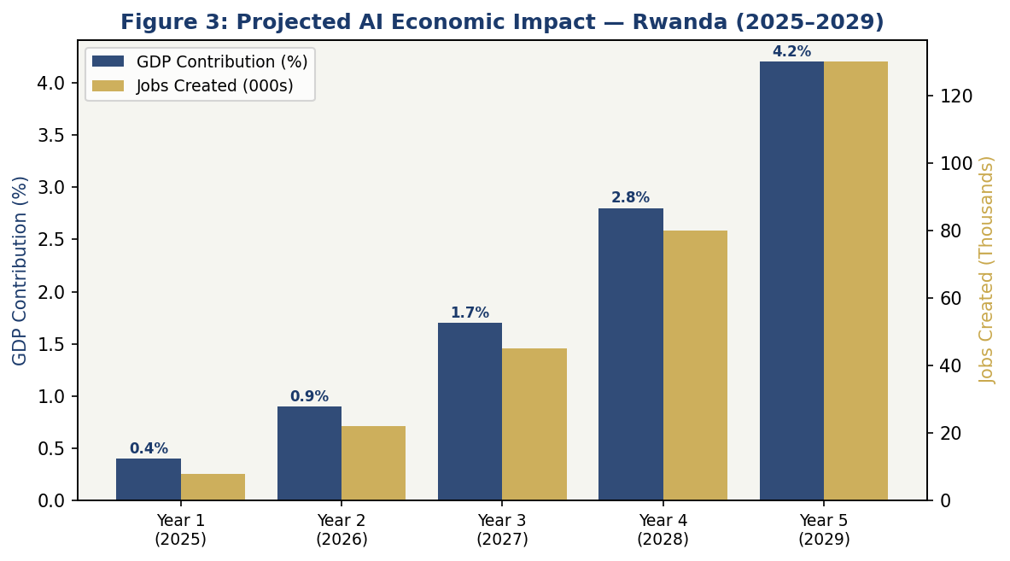
Figure 3: Projected AI Economic Impact — Rwanda 2025–2029 (GDP Contribution % and Jobs Created)

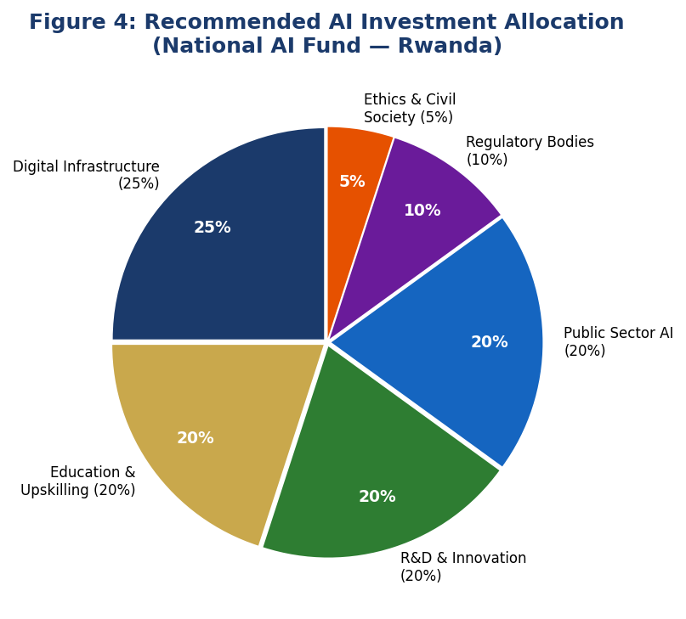
Figure 4: Recommended AI Investment Allocation — National AI Fund Rwanda

4.3 Priority Sectors for AI Adoption
Agriculture and food systems will receive the highest AI investment priority, given the sector's role as the primary employer and food security determinant. AI applications include satellite-enabled crop monitoring, soil health prediction, market price aggregation, and climate adaptation advisory services delivered via USSD and mobile app to smallholder farmers. Partnership with existing platforms such as e-Soko and Agro Insight will be prioritized over building new systems from scratch.
Healthcare is the second priority sector. Rwanda's community health worker (CHW) network — one of Africa's most extensive — will be augmented with AI diagnostic support tools, medication adherence monitoring, and disease surveillance analytics. The Rwanda Biomedical Center will lead a national health AI initiative targeting tuberculosis detection, maternal health risk stratification, and malaria outbreak prediction using environmental and clinical data.
Public administration, financial services, tourism, and manufacturing will follow as AI adoption priorities, each with dedicated sector AI working groups under the proposed National AI Office coordinating body.

4.4 Public-Private Partnership Framework
Rwanda's proven PPP model — demonstrated through the Kigali Special Economic Zone, Kigali Convention Centre, and the Zipline drone delivery partnership — will be replicated for AI infrastructure. The government will anchor AI PPPs through three mechanisms: the AI Infrastructure Fund (government equity stake in shared AI compute infrastructure); AI Procurement Innovation Contracts (challenge-based procurement for government AI use cases); and AI Data Partnerships (government-owned data made available to private sector innovators under controlled access frameworks consistent with data protection law).

Section 5: Education and Human Capital Development

5.1 Current Skills Gap Analysis
Rwanda currently has an estimated 1,200–1,500 professionals with meaningful AI and machine learning skills, concentrated primarily in Kigali and affiliated with CMU-Africa, AIMS Rwanda, or international technology companies. Against the estimated 15,000 skilled AI practitioners needed by 2030 to sustain a national AI economy, this gap of approximately 13,500 practitioners represents the single most critical constraint on Rwanda's AI ambitions. Addressing this gap requires a simultaneous effort at multiple levels of the educational pipeline — from embedding computational thinking in primary schools to funding doctoral AI research — rather than focusing exclusively on high-end talent development.
Gender disparities in STEM, while narrowing, remain a challenge. Women represent approximately 38% of STEM tertiary enrollment nationally. Given Rwanda's constitutional commitment to gender equality and its global reputation for female political leadership, achieving gender parity in AI education by 2030 is both an ethical imperative and a doubling of the available talent pool. Targeted scholarships, female role model programs, and gender-sensitive AI education design will be mandatory components of all government-funded AI education initiatives.

5.2 National AI Curriculum Framework
Primary level (P1–P6) curriculum will integrate computational thinking, basic logic, and problem-solving using unplugged (non-computer) activities adapted for resource-constrained classroom settings. Lower secondary (S1–S3) will introduce coding fundamentals using Scratch and Python, along with data literacy concepts. Upper secondary (S4–S6) will offer a dedicated AI and Data Science elective covering machine learning concepts, responsible AI, and practical applications using open-source tools. One Hour of Code initiatives will be institutionalized nationally, targeting all 3.5 million primary and secondary students.
At tertiary level, all university degree programs will include a mandatory AI literacy module (minimum 3 credit hours) by Year 2 of the policy. Dedicated Bachelor's programs in AI, Data Science, and Machine Learning will be established at the University of Rwanda's College of Science and Technology and at the Rwanda Polytechnic. CMU-Africa's graduate programs will be expanded with government co-funding, targeting 300 AI Master's graduates annually by Year 5. AIMS Rwanda will double its cohort size with government support, prioritizing AI for development research.

5.3 National AI Skills Passport
The AI Skills Passport is a government-backed micro-credentialing framework that provides working adults with a recognized, portable certification of AI competencies at four levels: AI Awareness, Digital AI User, AI Practitioner, and AI Developer. Delivered through mobile-accessible online learning in partnership with platforms including Coursera, edX, and locally developed content, the Skills Passport targets 500,000 certified adults by 2030. Priority outreach will target teachers, nurses, agricultural extension workers, and civil servants — the professions with the highest AI augmentation potential.
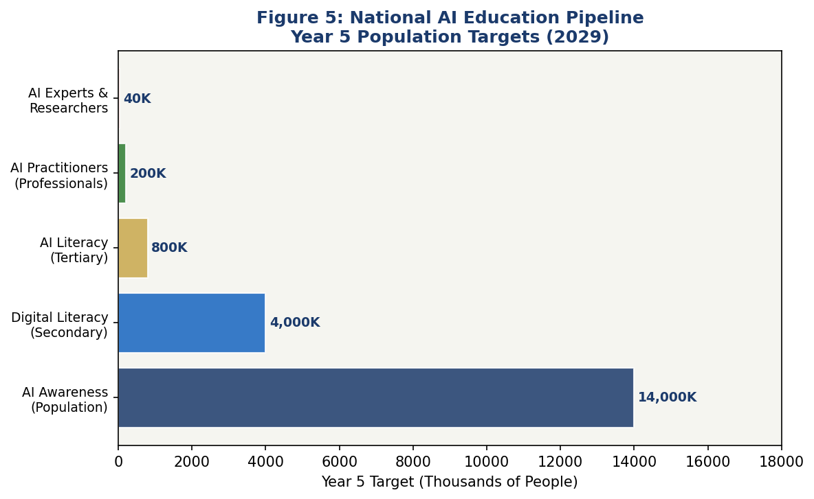
Figure 5: National AI Education Pipeline — Year 5 Population Targets (2029)

5.4 International Partnerships and Scholarships
Rwanda will negotiate bilateral AI education partnerships with South Korea (a global leader in AI education policy), Germany (through DAAD), Singapore (through NUS and NTU partnerships), and the United States (through the YALI network and Fulbright program). A Rwanda AI Scholarship Fund of RWF 5 billion will provide 1,000 international scholarships over five years for Rwandan students to pursue AI-related graduate education at partner institutions. Returnee incentive packages — including research grants, startup support, and civil service fast-track programs — will be established to reverse brain drain.

Section 6: Ethical AI Governance and Regulatory Framework

6.1 National AI Ethics Board
The National AI Ethics Board (NAEB) will be established by executive order in Year 1, with permanent legislative foundation by Year 2. The NAEB will comprise 15 members: three government appointees (from Ministry of ICT, Ministry of Justice, and Office of the Ombudsman); three representatives from civil society organizations; two representatives from the private sector (nominated by the Rwanda ICT Chamber); two academic representatives (University of Rwanda and CMU-Africa); two independent international AI ethics experts; one representative from the National Women's Council; and the chairperson appointed by the President. The NAEB will hold quarterly public sessions, publish annual AI ethics state reports, and have binding authority to order the suspension of AI systems found to be in violation of this policy.

6.2 AI Risk Classification System
Rwanda adopts a four-tier AI risk classification system adapted from the EU AI Act to the Rwandan regulatory context:
- Tier 1 — Unacceptable Risk (Prohibited): Social scoring systems that rank citizens based on behavioral data; real-time biometric mass surveillance in public spaces without judicial warrant; AI systems designed to manipulate political opinion or voting behavior; AI targeting children with exploitative content; AI systems that deny access to essential services based on protected characteristics.
- Tier 2 — High Risk (Regulated with Mandatory Audit): AI in criminal justice (sentencing support, recidivism prediction, parole decisions); AI in credit and insurance underwriting; AI in employment screening and performance management; AI in healthcare diagnosis and treatment recommendation; AI in educational assessment and student progression; AI in critical national infrastructure management.
- Tier 3 — Limited Risk (Transparency Obligations): AI chatbots and virtual assistants (must disclose AI identity); AI-generated content used in media and communications (must be labeled); AI recommendation systems in consumer-facing platforms.
- Tier 4 — Minimal Risk (Voluntary Code of Conduct): AI in entertainment, gaming, and personal productivity applications; AI-assisted creative tools; basic automation software.

6.3 Data Protection and Privacy Framework
This policy calls for the urgent passage of a comprehensive Data Protection Act aligned with the GDPR framework, updating Rwanda's existing Law No. 058/2021 on personal data protection. Key amendments required include: mandatory data protection impact assessments for all AI systems processing personal data; explicit consent requirements for AI training data collection; data minimization principles applied to AI datasets; right to explanation for automated decisions; and cross-border data transfer restrictions to jurisdictions without adequate protection standards.
A National Data Strategy will establish frameworks for data sharing between government, private sector, and research institutions — enabling AI innovation while protecting citizen privacy. Government data — collected from citizens through public services — will not be shared with private AI developers without explicit legislative authority and public consultation. A National AI Data Commons, modeled on similar initiatives in Singapore and Canada, will make selected anonymized government datasets available to researchers under controlled-access agreements.

6.4 Algorithmic Accountability Standards
All high-risk AI systems deployed in Rwanda — whether by government or private sector — will be subject to mandatory algorithmic impact assessments conducted by accredited third-party auditors. Audit requirements include: documentation of training data sources, demographics, and known biases; explanation of model architecture and decision logic; testing for differential impact on protected groups including women, persons with disabilities, and historically marginalized communities; performance benchmarking against minimum accuracy and fairness thresholds; and incident reporting obligations for AI failures causing harm.

6.5 Anti-Corruption AI Guidelines
Rwanda's strong anti-corruption track record provides an opportunity to use AI as a tool for further reducing corrupt practices while guarding against AI-enabled corruption risks. Government AI systems involved in procurement decisions, permit issuance, tax assessment, and public benefits allocation must incorporate anti-bias auditing and anomaly detection to flag unusual patterns. AI systems must not be used to circumvent procurement regulations or to direct contracts toward politically connected parties. The Office of the Ombudsman will have jurisdiction to investigate citizen complaints about AI-facilitated corruption or discrimination in government services.

Section 7: Public Sector and e-Governance AI

7.1 Priority Government Use Cases
Building on the existing Irembo platform — which processes over 1 million transactions monthly — the government AI program will prioritize eight high-impact use cases in Year 1: (1) Kinyarwanda-language AI chatbot for citizen service inquiries; (2) AI-assisted land registration processing (reducing turnaround from 7 days to 24 hours); (3) Predictive healthcare analytics for the Rwanda Biomedical Center; (4) AI-powered agricultural advisory via USSD for smallholder farmers; (5) Intelligent document management for the Rwanda Revenue Authority; (6) AI fraud detection for the social protection program Ubudehe; (7) Predictive maintenance for urban road infrastructure in Kigali; and (8) AI-enhanced environmental monitoring for the Rwanda Environment Management Authority.

7.2 Government AI Procurement Standard
Rwanda will develop Africa's first Government AI Procurement Standard, establishing minimum requirements for all AI systems acquired with public funds. Requirements include: mandatory open-source or source-available components for national security-sensitive systems; data residency obligations requiring training data and model outputs to be stored on Rwandan infrastructure or certified partner infrastructure; mandatory bias testing before deployment with results published; accessible design requirements (screen-reader compatibility, multilingual support in Kinyarwanda); contractual liability clauses holding vendors responsible for AI failures causing citizen harm; and mandatory training for civil servants who will operate or oversee AI systems.

7.3 Citizen-Facing AI Services Roadmap
Year 1 services will focus on information and inquiry functions — chatbots, search, and FAQ automation — where AI failure carries low risk and citizen benefit is immediately apparent. Year 2–3 services will extend to AI-assisted form completion, document verification, and eligibility screening for social services. Year 4–5 services will introduce AI-assisted decision support for complex administrative processes, always with mandatory human review and citizen appeal rights. Every AI-powered citizen service will include a clearly marked "Speak to a Human" pathway.

7.4 Interoperability Standards
All government AI systems will adhere to the Rwanda Government Enterprise Architecture (RGEA) interoperability standards, ensuring that AI outputs can be consumed by other government systems without proprietary lock-in. A Government AI API Registry will catalog all government AI services and their interfaces, enabling inter-ministerial data sharing under controlled access agreements. Rwanda will also pursue bilateral AI interoperability agreements with East African Community (EAC) partner states to enable cross-border digital service delivery.

Section 8: Implementation Roadmap

8.1 Phased Implementation Strategy
The five-year implementation roadmap is organized into three phases reflecting the maturation trajectory of Rwanda's AI ecosystem. Each phase builds on the preceding one, with clear gating conditions and KPI checkpoints to ensure that scaling occurs only when foundational elements are solidly in place. The roadmap is designed to be adaptive — quarterly reviews by the National AI Office will enable real-time adjustment of implementation priorities in response to changing technological, economic, or geopolitical conditions.

8.2 Phase 1 — Foundation (Year 1: 2025)
The Foundation Phase focuses on creating the enabling conditions for Rwanda's AI ecosystem: legal, institutional, and infrastructural. Key milestones include: passage of the updated Data Protection Act; establishment of the National AI Office and National AI Ethics Board; launch of the National AI Strategy website and public consultation portal; completion of a National AI Audit inventorying all existing government AI systems; launch of five priority government AI pilots under the Irembo expansion; establishment of the Rwanda AI Research Consortium (RAIRC); and launch of the AI Skills Passport platform in beta. Total Phase 1 investment: RWF 35 billion.

8.3 Phase 2 — Scaling (Years 2–3: 2026–2027)
The Scaling Phase drives national adoption across education, industry, and government services. Key milestones include: full passage of the Government AI Procurement Standard; national rollout of AI literacy curriculum in secondary schools; launch of the Kigali AI Innovation Fund with first portfolio of 25 AI startups; deployment of eight priority government AI services nationally; establishment of the first AI-dedicated Special Economic Zone within Kigali Innovation City; launch of the Rwanda AI Data Commons with initial 15 government datasets; and Rwanda's first national AI governance dialogue at the African Union. Total Phase 2 investment: RWF 85 billion.

8.4 Phase 3 — Optimization (Years 4–5: 2028–2030)
The Optimization Phase refines Rwanda's AI ecosystem, expands international engagement, and positions Rwanda as an AI thought leader and exporter. Key milestones include: first annual AI State Report published with full parliamentary debate; Rwanda joins Global Partnership on AI (GPAI) as full member; launch of Rwanda AI Export Initiative targeting AI-as-a-service revenue from East African markets; completion of first cohort of 300 AI Master's graduates from expanded CMU-Africa program; Rwanda hosts inaugural East African AI Governance Summit; 100,000 active AI Skills Passport holders; and Rwanda AI Index launched — a public dashboard tracking all policy KPIs. Total Phase 3 investment: RWF 130 billion.

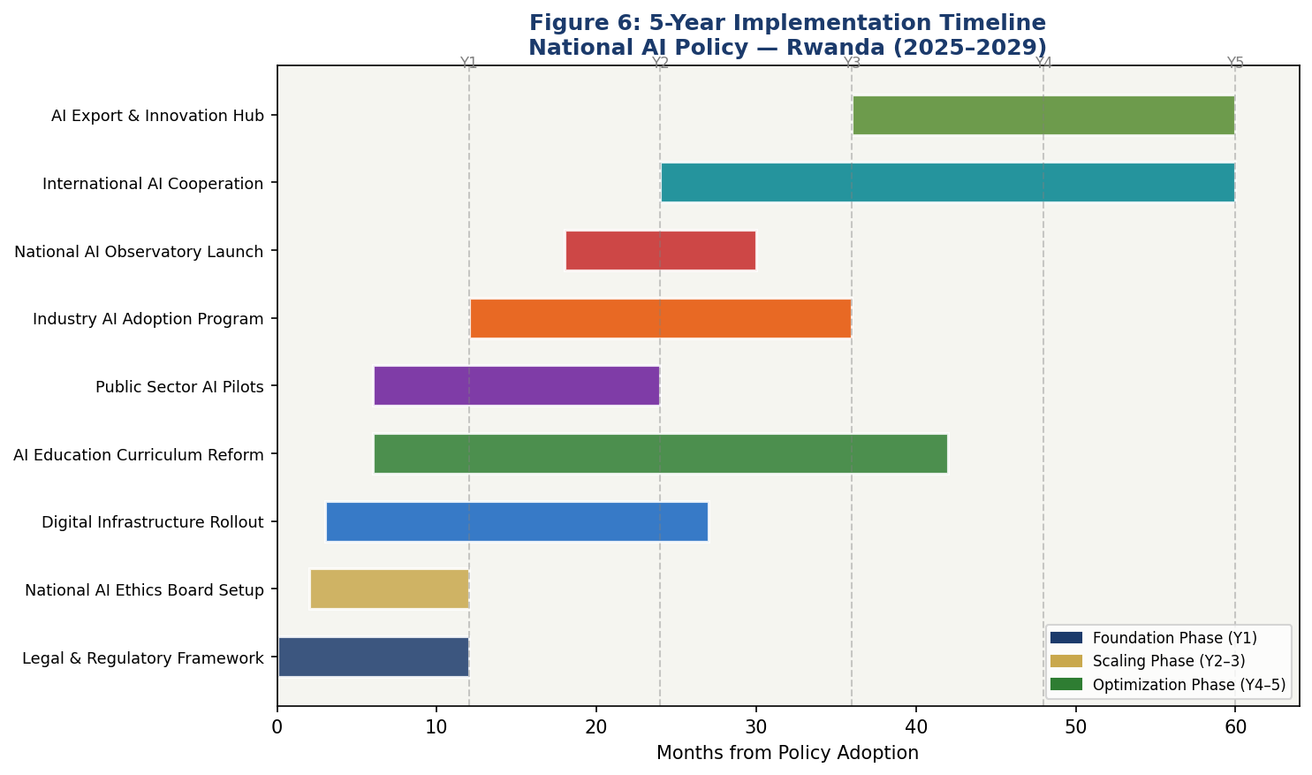
Figure 6: 5-Year Implementation Timeline — National AI Policy Rwanda (2025–2029)

8.5 Phase KPIs
KPI | Baseline (2024) | Year 1 Target | Year 3 Target | Year 5 Target
AI practitioners (skilled) | 1,200 | 2,500 | 7,000 | 15,000
Govt AI services deployed | 3 | 8 | 25 | 50
AI startup companies | 40 | 80 | 200 | 400
AI Skills Passport holders | 0 | 10,000 | 80,000 | 500,000
AI contribution to GDP (%) | 0.2% | 0.4% | 1.7% | 4.2%
Female AI education share | 38% | 41% | 44% | 48%

Section 9: Monitoring, Evaluation, and Accountability

9.1 National AI Observatory
The National AI Observatory (NAO) will be established as a semi-autonomous unit within the Ministry of ICT and Innovation, with a mandate to monitor, evaluate, and report on Rwanda's AI policy implementation. The NAO will produce quarterly progress dashboards (published online), annual AI State Reports (tabled in Parliament), and triennial comprehensive policy reviews. The NAO will maintain the Rwanda AI Index — a composite indicator tracking progress across 24 metrics spanning economic impact, social equity, governance quality, and international standing. The Rwanda AI Index will be benchmarked against comparable African nations annually.

9.2 Parliamentary Oversight
The Parliament of Rwanda will establish a standing Committee on Artificial Intelligence and Digital Transformation with jurisdiction over AI policy, regulation, and government AI spending. The committee will receive mandatory quarterly briefings from the Minister of ICT and annual testimony from the National AI Ethics Board. All high-risk government AI deployments will require parliamentary notification within 30 days of launch. The committee will have authority to order independent audits of any government AI system and to subpoena AI system documentation from government contractors.

9.3 Civil Society and Independent Auditor Role
Civil society organizations will be formally integrated into AI governance through the Civil Society AI Observatory — a network of accredited NGOs, media organizations, and academic institutions with rights of access to government AI documentation and outputs. Accredited civil society organizations will receive government funding support for AI monitoring activities. Independent algorithmic auditors — certified by the National AI Ethics Board — will constitute a new professional category with regulatory standing to conduct mandatory high-risk AI audits. Rwanda will develop Africa's first AI auditor certification program in partnership with the Institute of Certified Public Accountants of Rwanda (ICPAR).

9.4 KPI Dashboard
Metric | Baseline | Y1 Target | Y3 Target | Y5 Target
AI GDP contribution (%) | 0.2% | 0.4% | 1.7% | 4.2%
AI-related jobs created | — | 8,000 | 45,000 | 130,000
AI startups registered | 40 | 80 | 200 | 400
Govt AI services (deployed) | 3 | 8 | 25 | 50
AI Skills Passport holders | 0 | 10,000 | 80,000 | 500,000
AI ethics board cases resolved | — | 12 | 50 | 120
AI audits completed | 0 | 5 | 30 | 80
AI research publications (annual) | 8 | 20 | 60 | 150
Female AI practitioners (%) | 28% | 32% | 40% | 48%
Public trust in gov AI (%) | — | 55% | 68% | 78%
Internet penetration (%) | 62% | 68% | 78% | 88%
AI investment (private, RWF bn) | 15 | 50 | 200 | 600

Section 10: International Cooperation and Diplomacy

10.1 Bilateral AI Cooperation Priorities
Rwanda will pursue structured bilateral AI cooperation agreements with ten priority partners over the five-year policy period. South Korea, Singapore, and Finland lead the priority list, given their exceptional AI policy maturity, education system excellence, and track records of successful technology transfer to developing nations. Germany and the European Union are prioritized for regulatory alignment — Rwanda's proximity to EU AI Act standards will facilitate trade and investment. The United States is prioritized for access to research networks, venture capital, and technology platform partnerships. China, India, and Japan are prioritized for infrastructure and manufacturing AI applications. Bilateral agreements will specify technology transfer commitments, capacity building programs, joint research initiatives, and data-sharing frameworks.

10.2 Regional AI Governance — African Union and EAC
Rwanda will actively champion the development of an African Union AI Policy Framework, building on the AU's Artificial Intelligence Continental Strategy for Africa (2021). Rwanda's governance credibility, policy infrastructure, and English/French bilingualism position it as a natural convener for East African AI governance dialogue. Within the East African Community (EAC), Rwanda will propose a regional AI regulatory harmonization initiative to reduce compliance fragmentation for tech companies operating across the bloc and to facilitate cross-border AI-powered service delivery.
The proposed East African AI Governance Summit — to be hosted in Kigali in Year 4 — will bring together AI policymakers, regulators, civil society, and private sector representatives from all EAC member states to develop a shared AI governance architecture for the region.

10.3 South-South Knowledge Transfer
Rwanda will leverage its AI policy experience to support capacity building in lower-income African nations through South-South cooperation programs. The Rwanda AI Policy Academy — a short-course program delivered in Kigali — will train AI policymakers from francophone and anglophone Africa, building Rwanda's diplomatic influence while exporting governance expertise. Partnerships with the African Development Bank, UNDP, and the Smart Africa Alliance will mobilize funding for these knowledge transfer programs, positioning Rwanda as a development partner rather than solely a recipient.

10.4 Global AI Governance Participation
Rwanda will seek full membership in the Global Partnership on AI (GPAI) by Year 3, having demonstrated through the Rwanda AI Index that it meets the governance maturity threshold for membership. Rwanda will be an active participant in ITU AI for Good annual summits, contributing Rwandan use cases — particularly in agriculture and health AI — to the global evidence base. Rwanda will engage in UN processes on AI governance, including the work of the UN Secretary-General's High-Level Advisory Body on AI, advocating for the interests of developing nations in global AI rule-setting.

Conclusion
Rwanda's National AI Policy 2025–2030 represents more than a technology strategy. It is a declaration of intent: that Rwanda will not be a passive recipient of AI technologies developed elsewhere and governed by others, but an active architect of the AI-powered future it wants for its people. The policy is grounded in Rwanda's extraordinary strengths — political stability, governance quality, a track record of technology adoption, gender equality leadership, and a young, growing population hungry for economic opportunity — while being clear-eyed about the constraints that must be overcome: limited AI talent, nascent research capacity, infrastructure gaps, and the challenges of governing fast-moving technology with limited regulatory experience.
The five-year roadmap is ambitious but achievable. Rwanda has exceeded comparable development ambitions before — the Irembo platform, the drone delivery network, the recovery from genocide to middle-income aspirant in three decades. The National AI Policy asks Rwanda to repeat this pattern of transformational achievement in a new domain. The stakes are high: countries that establish AI governance leadership now will shape the global rules of AI development for decades. Rwanda has earned the credibility and built the institutions to claim a seat at that table.
Success will require genuine partnership between government, civil society, academia, and the private sector; between Rwanda and its regional and global partners; and between the present generation of policymakers and the next generation of AI practitioners they are training. This policy creates the framework for that partnership. Rwanda's AI future begins now.

References and Bibliography

International Frameworks and Standards
- UNESCO. (2021). Recommendation on the Ethics of Artificial Intelligence. United Nations Educational, Scientific and Cultural Organization, Paris.
- OECD. (2024, updated). OECD AI Principles. Organisation for Economic Co-operation and Development, Paris.
- European Parliament. (2024). Regulation (EU) 2024/1689 on Artificial Intelligence (EU AI Act). Official Journal of the European Union.
- World Bank Group. (2021). World Bank Group Artificial Intelligence Strategy. World Bank, Washington D.C.
- G20. (2019). G20 AI Principles. G20 Ministerial Statement on Trade and Digital Economy.
- ITU. (2023). AI for Good: Guidelines for Ethical Use of AI in the SDG Context. International Telecommunication Union, Geneva.
- Global Partnership on AI. (2023). GPAI Responsible AI Guidelines. GPAI Secretariat, Paris.

Rwanda National Policy Documents
- Government of Rwanda. (2020). Vision 2050. Ministry of Finance and Economic Planning, Kigali.
- Republic of Rwanda. (2021). Smart Rwanda Master Plan 2021–2025. Ministry of ICT and Innovation, Kigali.
- Republic of Rwanda. (2021). Law No. 058/2021 on the Protection of Personal Data and Privacy in Rwanda. Official Gazette, Kigali.
- Rwanda Development Board. (2023). Rwanda Innovation Strategy. RDB, Kigali.

Research and Analytics Sources
- Transparency International. (2023). Corruption Perceptions Index 2023. Berlin.
- Oxford Insights. (2023). AI Readiness Index 2023. Oxford Insights, Oxford.
- McKinsey Global Institute. (2022). The Economic Potential of Generative AI. McKinsey & Company.
- World Economic Forum. (2023). Future of Jobs Report 2023. WEF, Geneva.
- CGIAR. (2022). AI in Agriculture: Evidence from Sub-Saharan Africa. CGIAR Research Program.
- ITU. (2023). Measuring Digital Development: ICT Price Baskets 2023. ITU, Geneva.
- African Union. (2021). The Digital Transformation Strategy for Africa 2020–2030. AU Commission, Addis Ababa.

About the Author
Nafiul Ahmad Rafi
Policy & Good Governance Researcher | BD Civic Tech Architect

Nafiul Ahmad Rafi is a civic technologist, policy researcher, author, photographer, and musician based in Dhaka, Bangladesh. He is the Founder and Director of Insights Bangladesh, a data-driven governance and policy impact analysis institution, and the Founder & Lead Architect of NagorikBD.org — a transparency-first civic platform scaled across Mymensingh Division, connecting citizens with government services across 45 Upazilas.
His work exists at the intersection of institutional reform and artificial intelligence, transforming theoretical governance into scalable, data-driven reality. Without a conventional computer science degree, he self-taught the tools of modern AI and web development to build the infrastructure that enforces the policies he once only researched.
Key Platforms and Projects
- NagorikBD.org — Civic transparency platform, Mymensingh Division
- Insights Bangladesh — Policy impact analysis institution
- FactCheck BD (factcheckbd.org) — Bangladesh's AI-powered fact-checking platform
- Political Insights BD / PIBD (pibbd.org) — Political intelligence and civic tech hub
- PeaceShield BD / National Peace Tracker — AI-powered hate speech and conflict monitoring
- PolicyLens AI (aigovbd.org) — 9-dimensional AI policy audit tool

He has published four books and maintains a personal site at ahmad-rafi.com.
Research Interests
AI Governance · Policy Research · Future of Bangladesh · Climate Policy
Contact
- Website: ahmad-rafi.com
- LinkedIn: linkedin.com/in/nafiul-ahmad-rafi
- Email: contact@ahmad-rafi.com

"I build code to ensure transparency, and I write lyrics to inspire the courage to use it."

Insights Bangladesh | insights-bd.org | Dhaka, Bangladesh

