🇸🇳
REPUBLIC OF SENEGAL

National Artificial Intelligence Policy
2026 – 2031

A Comprehensive Framework for Ethical, Inclusive, and Economically Transformative AI

Prepared by:
Nafiul Ahmad Rafi / Insights Bangladesh
Date of Publication: May 2026

Table of Contents

Executive Summary

Senegal stands at a pivotal crossroads. With the commencement of offshore oil and gas production at the Sangomar field in 2024, a rapidly growing digital economy, and one of West Africa's most vibrant startup ecosystems centered in Dakar, Senegal possesses the foundational conditions necessary to leverage artificial intelligence as a transformative force for sustainable development. Yet the nation also faces structural challenges — a literacy rate of approximately 56%, significant digital skills gaps, and the governance pressures inherent to a country managing its first major hydrocarbon revenues — that demand a careful, rights-respecting approach to AI adoption.
This National Artificial Intelligence Policy 2026–2031 provides Senegal with a comprehensive, globally-aligned framework to guide the responsible development, deployment, and governance of AI technologies across public and private sectors. The policy is grounded in Senegal's own Plan Sénégal Emergent (PSE) and its successor digital transformation ambitions, while drawing on best practices from UNESCO, the OECD, the EU AI Act, the African Union's AI continental strategy, and the G20 AI Principles.
The policy is organized around five strategic pillars: (1) Ethical AI and Human Rights Protection; (2) Economic Growth and Industrial AI Adoption; (3) Education, Upskilling, and AI Workforce Development; (4) Public Sector AI and e-Governance; and (5) AI Research, Innovation, and Startup Ecosystem Development. These pillars are operationalized through six regulatory instruments, eight targeted public investment programmes, and a phased 5-year implementation roadmap with measurable KPIs.
By 2031, this policy is projected to contribute up to 4.2% of GDP through AI-enabled productivity gains, create over 55,000 specialist AI jobs, bring four million citizens to baseline AI awareness, and position Senegal as a continental leader in ethical AI governance — a model for fellow ECOWAS member states navigating the same developmental trajectory. The Government of Senegal is called upon to adopt this framework as national policy, allocate dedicated budget lines, and establish the institutional architecture necessary for its implementation without delay.

Section 1: National AI Readiness Assessment

1.1 Economic Context
Senegal is classified as a Least Developed Country (LDC) but has demonstrated remarkable economic resilience and growth momentum. GDP growth reached 8.3% in 2023–2024, driven by new hydrocarbon production and sustained growth in services, tourism, and agriculture. GDP per capita stands at approximately USD 1,700 (2024), with the World Bank projecting significant upward trajectory as oil and gas revenues are deployed into infrastructure and social investment.
Key economic sectors include agriculture (employing ~70% of the workforce), fishing and aquaculture, tourism (particularly in the Casamance and Dakar regions), telecommunications and digital services, and the nascent extractives industry. The government's PSE vision articulates an ambition for Senegal to achieve emerging-economy status by 2035 — a goal for which AI-driven productivity enhancement is essential.
AI's economic opportunity for Senegal is concentrated in agriculture (precision farming, climate prediction, market access platforms), financial services (digital credit scoring, mobile money optimization), health (diagnostics in underserved regions), and public administration (revenue optimization, service delivery). The McKinsey Global Institute estimates that AI could contribute 1.2–1.5% of annual GDP growth for lower-middle income African economies that invest strategically — a conservative baseline for Senegal's projections.

1.2 Education and Human Capital
Senegal's adult literacy rate stands at approximately 56%, with significant urban-rural disparities — Dakar achieves near-universal literacy while rural areas in Tambacounda and Kédougou regions lag considerably. Tertiary enrollment is approximately 14%, with the Université Cheikh Anta Diop (UCAD) and newer institutions like the Université du Sine Saloum El-Hadj Ibrahima Niass (USSEIN) producing graduates in engineering, computer science, and mathematics.
The digital skills gap is acute. Fewer than 3% of Senegalese workers possess advanced digital competencies, and the AI specialist pipeline is extremely limited — estimated at fewer than 200 qualified AI practitioners nationwide. However, Dakar's growing tech community, including hubs like the Dakar Innovation Institute and incubators such as CTIC Dakar, provides fertile ground for rapid upskilling if supported by national policy and investment.

1.3 Digital Infrastructure
Mobile penetration exceeds 110%, making Senegal one of West Africa's most connected nations by mobile access. Internet penetration stands at approximately 65%, with significant growth driven by 4G expansion under Sonatel (Orange Senegal), Expresso, and Free Senegal. Fibre optic backbone infrastructure is expanding, and Senegal serves as a landing point for multiple undersea cables (SAT-3/WASC, ACE, Djoliba), providing international connectivity bandwidth.
However, broadband quality and data center capacity remain limiting factors for AI deployment at scale. Cloud infrastructure is nascent and largely dependent on foreign providers. The government's Smart Senegal digital transformation programme aims to address connectivity gaps and expand e-government infrastructure through 2025–2030, providing complementary investments that this AI policy should align with.

1.4 Governance and Institutional Capacity
Senegal is one of West Africa's more stable democracies, with a functional multi-party political system, independent judiciary, and reasonably competent civil service. The country scores 5.0 out of 10 on governance readiness for AI policy implementation — above regional average — reflecting adequate institutional structures but significant capacity gaps in technical expertise within regulatory bodies.
Existing legal frameworks relevant to AI governance include the Personal Data Protection Law (Law 2008-12 on Personal Data Protection), the Commission de Protection des Données Personnelles (CDP), and e-commerce regulations. However, no specific AI regulatory framework exists, and the CDP lacks the technical mandate and resources to oversee algorithmic systems. This policy recommends significant institutional reform to address these gaps.

1.5 Corruption Risk Assessment
Transparency International's Corruption Perceptions Index (2024) assigns Senegal a score of 43 out of 100, ranking it 71st globally — moderate by regional standards but significantly below the 50-point threshold considered indicative of low corruption risk. This moderate score has direct implications for AI governance: government AI procurement processes, public sector algorithmic decision-making, and AI-enabled revenue collection systems all carry elevated corruption risk without robust safeguards.
The management of new hydrocarbon revenues — with which AI-enabled fiscal systems will interact — represents a particular governance challenge. This policy mandates anti-corruption impact assessments for all high-value government AI contracts and requires algorithmic transparency in all AI systems affecting public resource allocation.

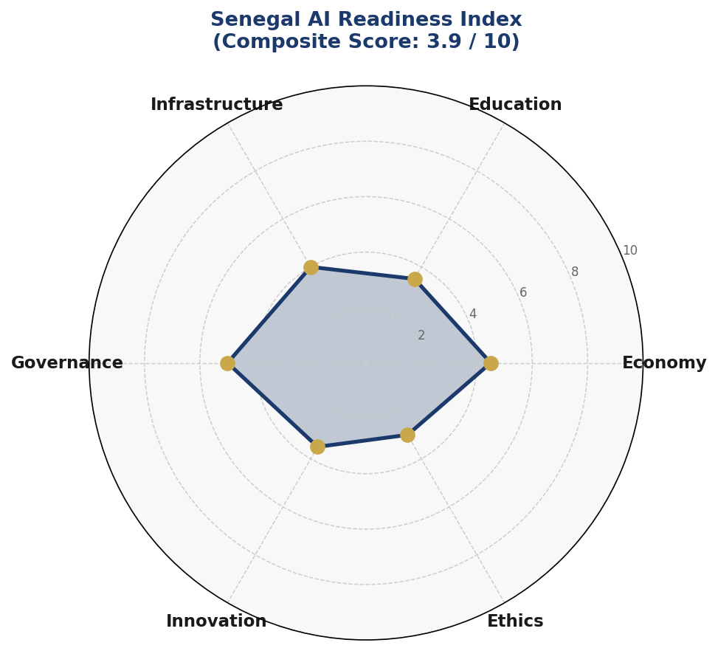
Figure 1: Senegal AI Readiness Index — Composite Radar Assessment (Score: 3.9/10)

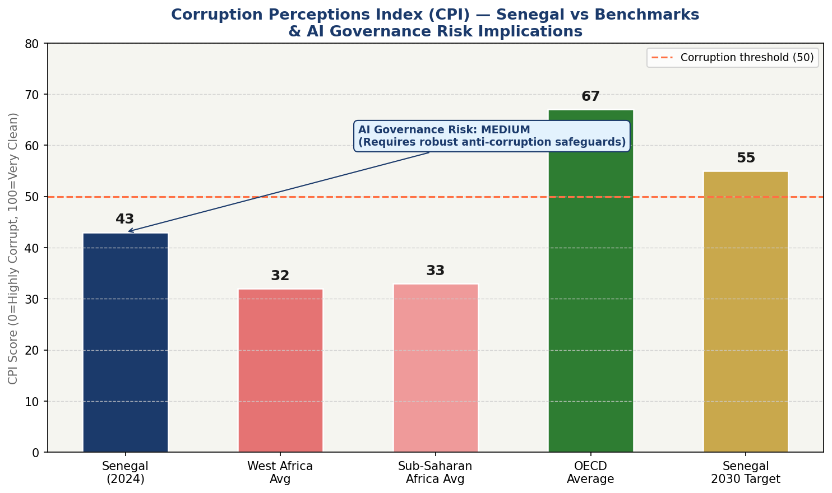
Figure 2: Corruption Perceptions Index — Senegal vs Regional & Global Benchmarks with AI Governance Risk Tier

Section 2: Policy Vision and Strategic Pillars

2.1 National Vision Statement
"Senegal will harness the power of artificial intelligence to build a just, prosperous, and technologically sovereign future — where AI amplifies our human capital, preserves our cultural heritage, strengthens democratic governance, and ensures that no citizen is left behind in the digital age."

This vision builds on Senegal's long tradition of educational excellence (the country of Léopold Sédar Senghor, Africa's first Nobel-adjacent statesman-poet), its role as a regional anchor in ECOWAS, and its constitutional commitment to the dignity and rights of all citizens. AI is not seen as a technological end in itself, but as an instrument of human flourishing.

2.2 Strategic Pillar 1: Ethical AI and Human Rights Protection
Senegal's Constitution guarantees fundamental rights to privacy, equality, and non-discrimination. This pillar ensures that AI systems deployed within Senegal — whether by the government, private sector, or foreign entities — are subject to rigorous human rights impact assessment, and that affected communities have meaningful avenues for redress.
Key initiatives include: establishment of a National AI Ethics Board with civil society representation; mandatory algorithmic impact assessments for high-risk AI systems; prohibition of social scoring, mass surveillance AI, and predictive policing systems without judicial authorization; and special protections for AI systems affecting women, children, ethnic minorities, and rural communities.

2.3 Strategic Pillar 2: Economic Growth and Industrial AI Adoption
Senegal's economic transformation agenda requires AI adoption across agriculture, fisheries, financial services, logistics, tourism, and the extractives sector. This pillar creates incentives, standards, and capacity for private sector AI adoption through a National AI Adoption Fund (FNAI), AI-readiness certification for Senegalese enterprises, and targeted support for AI integration in SMEs.
Priority economic applications include: precision agriculture advisory platforms for smallholder farmers; AI-powered fisheries management to combat illegal fishing and optimize sustainable yields; credit scoring and insurtech for the 60% of Senegalese adults without formal financial access; and AI-enhanced mineral revenue management to maximize the value of new extractives wealth.

2.4 Strategic Pillar 3: Education, Upskilling, and AI Workforce Development
This pillar addresses Senegal's human capital gap through a National AI Curriculum Reform covering primary through tertiary education, a National AI Skills Programme for adult workers, and partnerships with international universities and tech companies to establish AI centres of excellence at UCAD and other institutions.
Gender equity is central: women currently represent fewer than 25% of Senegal's ICT workforce. This pillar mandates a minimum 40% female participation target in all government-funded AI training programmes and establishes a Girls in AI scholarship programme offering 500 annual grants for women pursuing AI-related tertiary education.

2.5 Strategic Pillar 4: Public Sector AI and e-Governance
Senegal's government has an opportunity to use AI to dramatically improve service delivery, tax compliance, agricultural extension services, and judicial administration. This pillar establishes standards for responsible government AI procurement, creates a Government AI Lab within the Ministry of Digital Economy, and funds priority AI deployments in health, education, agriculture, and fiscal administration.

2.6 Strategic Pillar 5: AI Research, Innovation, and Startup Ecosystem
Dakar's startup ecosystem — ranked among Africa's top five by Partech Africa — requires AI-specific support to scale. This pillar establishes a National AI Research Fund (FNRIA) of XOF 15 billion over five years, co-invests in an AI Centre of Excellence at UCAD in partnership with African and international universities, and creates a fast-track visa and incentive programme for AI talent from the diaspora and the continent.

Section 3: International Framework Alignment

This policy is designed to be fully interoperable with the principal international AI governance frameworks. The table below provides a comprehensive alignment matrix mapping the key principles of each framework to specific sections of this policy.

3.1 UNESCO AI Ethics Recommendation (2021)
The UNESCO Recommendation on the Ethics of Artificial Intelligence (2021) — the world's first global normative instrument on AI ethics, endorsed by all 193 UNESCO member states including Senegal — establishes 11 core values: proportionality and do no harm; safety and security; fairness and non-discrimination; sustainability; right to privacy and data protection; human oversight and determination; transparency and explainability; responsibility and accountability; awareness and literacy; multi-stakeholder and adaptive governance; and international cooperation. This policy maps directly to all 11 values through Sections 6, 7, 5, 4, 6, 6, 6, 9, 5, 8, and 10 respectively.

3.2 OECD AI Principles (2019, Updated 2024)
The OECD AI Principles — adopted by Senegal as a non-OECD adherent through the Global Partnership on AI (GPAI) — establish five principles for trustworthy AI: inclusive growth and sustainable development; human-centred values and fairness; transparency and explainability; robustness, security and safety; and accountability. Senegal's alignment with all five is detailed below.

3.3 EU AI Act (2024) — Risk-Based Framework
While the EU AI Act is a European regulation, its risk-based architecture provides the most operationally useful template for national AI classification systems, particularly for countries like Senegal that export to European markets or seek AI investment from European partners. This policy adopts the EU's four-tier risk classification (Unacceptable/High/Limited/Minimal) with Senegal-specific contextual adaptations, detailed in Section 6.

3.4 African Union Continental AI Strategy
The AU's AI for Africa strategy (2023) emphasizes data sovereignty, continental AI talent development, and the use of AI for SDG acceleration. This policy aligns with AU priorities by establishing data localization requirements for sensitive Senegalese data, participating in the AU AI peer review mechanism, and targeting four SDGs for AI-enabled acceleration: SDG 2 (Zero Hunger), SDG 3 (Good Health), SDG 4 (Quality Education), and SDG 8 (Decent Work).

Table 1: Comprehensive International Framework Alignment Matrix

Framework / Principle | Policy Section | Alignment | Gap/Action
UNESCO — Proportionality & Do No Harm | Section 6 | ✅ Full | Ethics Board to monitor
UNESCO — Fairness & Non-Discrimination | Sections 5, 6 | ✅ Full | Bias audit standards
UNESCO — Right to Privacy | Section 6 | ✅ Full | Data Protection Act reform
UNESCO — Transparency & Explainability | Section 6 | ✅ Full | XAI standards for govt AI
UNESCO — Responsibility & Accountability | Section 9 | ✅ Full | National AI Observatory
UNESCO — Awareness & Literacy | Section 5 | ✅ Full | National curriculum reform
UNESCO — International Cooperation | Section 10 | ✅ Full | Bilateral & AU partnerships
OECD — Inclusive Growth | Sections 4, 5 | ✅ Full | Rural AI access targets
OECD — Human-Centred Values | Section 6 | ✅ Full | Rights-based AI law
OECD — Transparency | Section 6 | ✅ Full | Algorithmic transparency regs
OECD — Robustness & Safety | Section 6 | ⚠️ Partial | Technical standards TBD
OECD — Accountability | Section 9 | ✅ Full | Parliamentary oversight
EU AI Act — Unacceptable Risk Prohibition | Section 6.2 | ✅ Full | Enacted in AI Law
EU AI Act — High Risk Regulation | Section 6.2 | ⚠️ Partial | Audit body to be created
EU AI Act — Limited Risk Transparency | Section 6.2 | ✅ Full | Disclosure requirements
AU AI Strategy — Data Sovereignty | Section 6 | ✅ Full | Data localization reqs
AU AI Strategy — Talent Development | Sections 5, 10 | ✅ Full | UCAD AI Centre
G20 AI Principles — Human Oversight | Section 6 | ✅ Full | Human review mandates
ITU AI for Good — SDG Linkage | Sections 4, 7 | ✅ Full | SDG targeting in pilots
World Bank AI Strategy — Inclusion | Sections 5, 7 | ✅ Full | Rural & gender targets

Section 4: Economic Impact and Investment Roadmap

4.1 Projected Economic Impact of AI
Drawing on McKinsey Global Institute and World Economic Forum projections for lower-middle income African economies, combined with Senegal-specific sectoral analysis, this policy projects AI's cumulative contribution to Senegal's GDP at approximately XOF 1.0 trillion (USD 1.68 billion) by 2030, representing 4.2% of forecast GDP at that year. This conservative projection assumes: 60% public sector AI adoption in priority services; 40% private sector uptake in agriculture, finance, and logistics; and sustained annual AI investment of 0.4% of GDP.
The most significant economic gains are expected in: agricultural productivity (AI-driven yield improvements of 15–20% for smallholder farmers representing XOF 180 billion annually by 2030); financial inclusion (mobile AI credit scoring extending formal financial services to 2 million additional adults); and public sector efficiency (AI-enabled tax administration increasing VAT compliance by an estimated 8–12%, yielding XOF 120 billion in additional annual revenues by 2030).
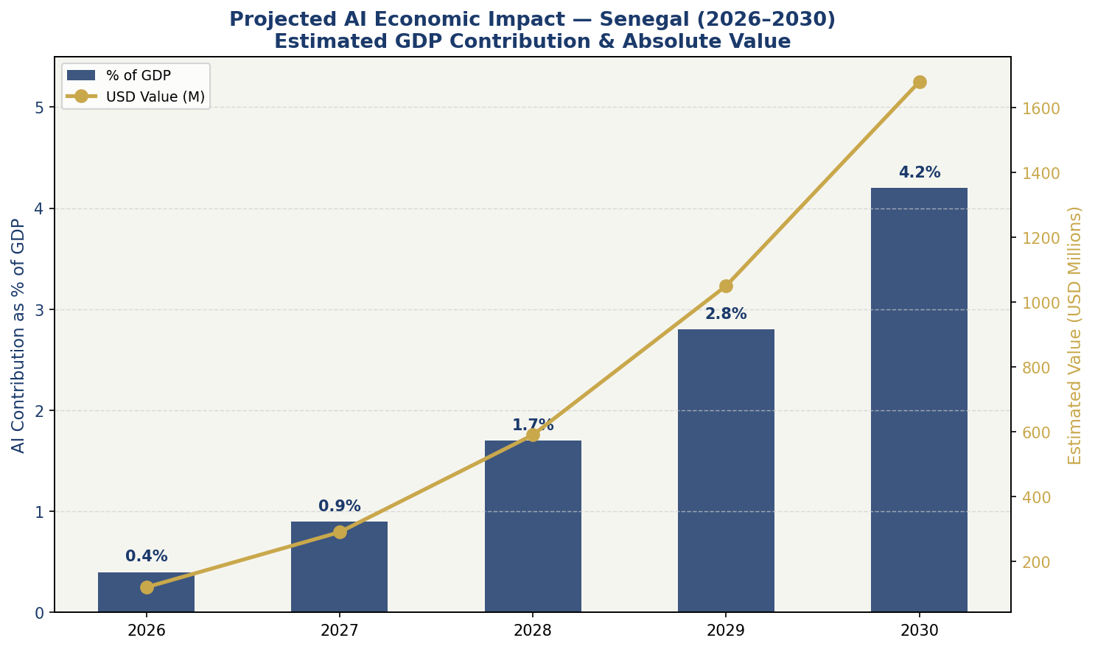
Figure 3: Projected AI Economic Impact — Senegal GDP Contribution (%) and Absolute Value (USD M), 2026–2030

4.2 National AI Investment Framework
The government of Senegal is recommended to establish a dedicated National AI Investment Fund of XOF 75 billion (approximately USD 120 million) over five years, representing 0.4% of projected annual GDP. This is comparable to AI investment commitments made by peers such as Rwanda (which committed 1% of GDP to digital transformation), Morocco, and Egypt. The investment should be allocated as follows, drawing on the framework below:
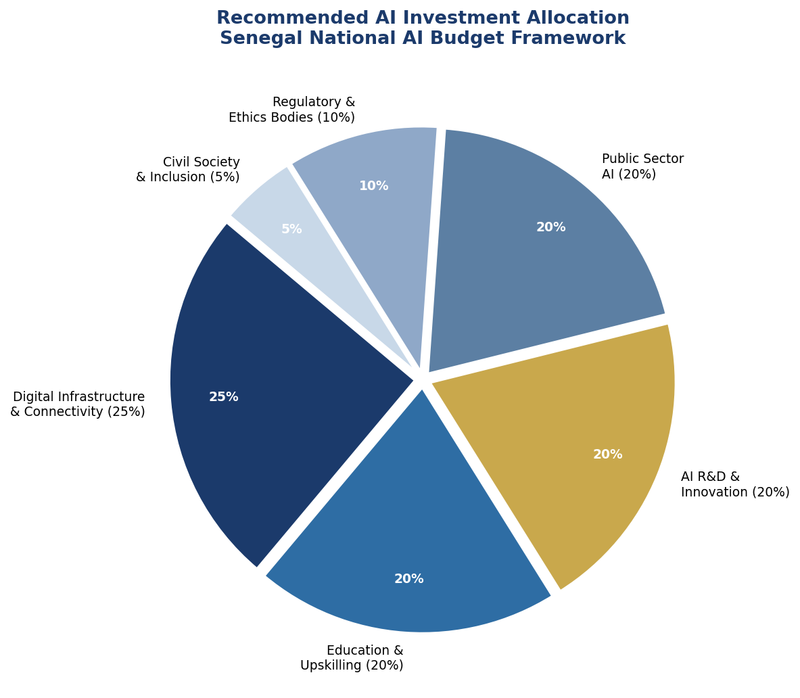
Figure 4: Recommended National AI Budget Allocation — Senegal 2026–2031

4.3 Priority Sectors for AI Adoption
Based on Senegal's economic structure, AI adoption should be prioritized in the following sectors, in order of projected impact and implementation feasibility:
- Agriculture & Food Security: AI-powered advisory platforms (weather, crop disease, market prices) for 3 million smallholder farmers; satellite-based monitoring for crop monitoring and livestock management; AI-driven irrigation optimization in Senegal River valley agro-industrial zones.
- Fisheries & Blue Economy: Machine learning systems for sustainable catch quota management; AI surveillance for detection of illegal, unreported, and unregulated (IUU) fishing in Senegal's EEZ; aquaculture optimization AI for the growing mariculture sector.
- Financial Services & Fintech: Alternative credit scoring using mobile data for the unbanked population; AI-powered fraud detection for mobile money platforms; automated microinsurance for farmers and SMEs vulnerable to climate shocks.
- Healthcare & Public Health: AI-assisted diagnostic tools for rural health posts with limited specialist access (TB, malaria, maternal health); epidemiological surveillance AI linked to the WHO Africa regional health intelligence system; AI-powered medical supply chain optimization.
- Education Technology: Adaptive learning platforms in French and Wolof for primary and secondary students; AI tutoring tools for self-directed learning aligned with the Senegalese national curriculum; automated grading and learning analytics for teachers.
- Extractives & Fiscal Administration: AI-enabled fiscal revenue tracking and optimization for oil and gas royalties; anti-corruption monitoring AI for public procurement in the extractives sector; environmental monitoring AI for Sangomar and offshore operations.

4.4 Public-Private Partnership Framework
The government will establish a National AI Partnership Council (Conseil National de Partenariat IA — CNPIA) co-chaired by the Ministry of Digital Economy and the private sector federation CNES (Conseil National du Patronat du Sénégal). The CNPIA will coordinate co-investment in AI infrastructure, develop AI adoption incentive frameworks for SMEs, facilitate international technology transfer agreements, and oversee the National AI Fund allocation process.

Section 5: Education and Human Capital Development

5.1 Current Skills Gap Analysis
Senegal's AI skills gap is one of the most significant barriers to policy implementation. Current estimates suggest fewer than 200 qualified AI/ML practitioners in the country, compared to approximately 2,500 in Nigeria, 1,800 in South Africa, and 800 in Kenya — countries with larger or more established tech ecosystems. The University of Dakar's computer science programmes produce approximately 300–400 graduates annually, of whom fewer than 15% have substantive machine learning exposure.
Digital literacy remains a fundamental challenge: fewer than 30% of the working-age population possesses basic digital skills, and rural populations — particularly women over 40 — face near-total digital exclusion. The 2021 World Bank Digital Skills for Africa assessment rated Senegal's digital skills ecosystem as 'nascent' with 'significant investment needed' across all skill tiers.

5.2 National AI Curriculum Framework
This policy mandates the development and rollout of a National AI Curriculum Framework across all education levels, to be developed by the Ministry of National Education in collaboration with the Ministry of Digital Economy, UCAD, and international partners including UNESCO and the Allen Institute for AI Africa Programme:
- Primary Education (CE1–CM2, Ages 8–12): Introduction to computational thinking, digital citizenship, and algorithmic concepts through game-based learning. Target: 500,000 students per year by 2028.
- Secondary Education (Collège & Lycée, Ages 12–18): Dedicated 'AI and Society' module in the national baccalaureate curriculum covering AI fundamentals, ethics, career pathways, and practical applications. Programming literacy (Python) integrated into mathematics curriculum. Target: 200,000 students per year by 2029.
- Tertiary Education: AI specialization tracks at UCAD (Computer Science, Mathematics, Economics departments); new national AI degree programme; research MSc in AI with full scholarship support; AI literacy modules mandatory for all degree students by 2030.
- Vocational and Technical Education (TVET): AI tools courses integrated into TVET programmes in agriculture, healthcare, business administration, and mechanics — equipping technical workers with AI-augmented skills. Target: 30,000 TVET students trained per year by 2028.
- Adult and Continuing Education: National AI Upskilling Programme (Programme National de Montée en Compétences IA — PNMCIA) offering 3–12 month reskilling courses for workers in sectors undergoing AI transformation; delivered through regional training centres, mobile learning, and Wolof-language digital platforms.
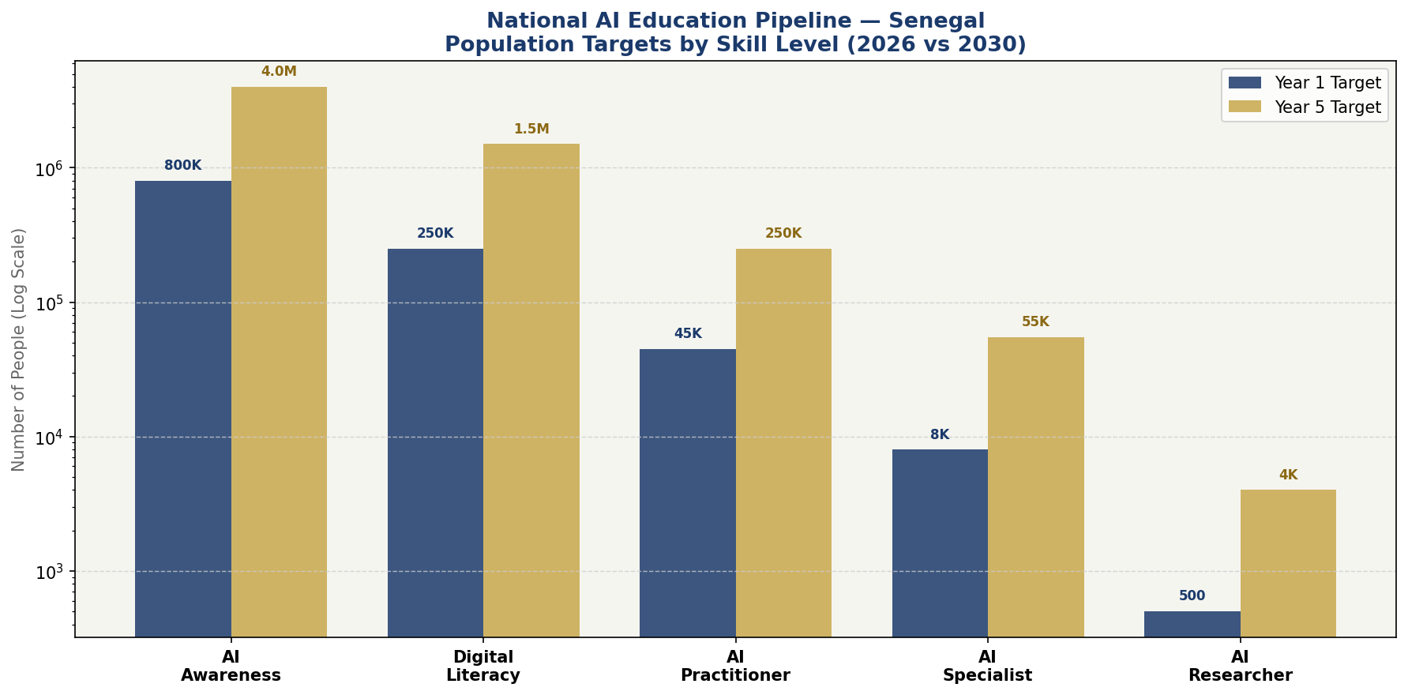
Figure 5: National AI Education Pipeline — Population Targets by Skill Level, Year 1 vs Year 5

5.3 Gender and Inclusion Targets
Women's participation in Senegal's digital economy is structurally limited by educational gaps, cultural norms, and economic barriers. This policy establishes legally binding gender targets for all government-funded AI programmes: minimum 40% female participation in all AI training cohorts; 500 annual Girls in AI tertiary scholarships; a Women AI Entrepreneurs Fund of XOF 2 billion supporting female-led AI startups; and mandatory gender disaggregation in all AI programme reporting.
Inclusion for rural populations requires Wolof-language AI tools, offline-capable AI educational content for low-connectivity areas, and mobile training units for remote communities. The policy also ensures that persons with disabilities are considered in AI design standards and that sign-language AI translation tools are prioritized for public service applications.

5.4 International Partnerships
Senegal will actively pursue AI education partnerships with Francophone AI research institutions (INRIA, École Polytechnique, Université de Montréal — MILA), African AI centres (AIMS, Deep Learning Indaba, Masakhane), and global technology companies. A National AI Exchange Programme will send 100 Senegalese researchers annually to international AI labs, while hosting 50 international AI researchers per year at UCAD and affiliated institutions.

Section 6: Ethical AI Governance and Regulatory Framework

6.1 National AI Ethics Board (Comité National d'Éthique de l'IA — CNEIA)
A National AI Ethics Board will be established by executive decree within six months of this policy's adoption, and subsequently enshrined in AI law within 18 months. The CNEIA will be an independent body with the following composition: two representatives of the judiciary (appointed by the Conseil Supérieur de la Magistrature); two representatives of civil society (appointed by civil society umbrella organisations); two AI technical experts (appointed by UCAD and the private sector jointly); one representative of women's organizations; one representative of religious communities; and the Chair of the Commission de Protection des Données Personnelles (CDP) as ex-officio member.
The CNEIA will be mandated to: issue binding opinions on AI systems affecting fundamental rights; investigate complaints from citizens regarding AI harms; advise the government on AI legislation and international negotiations; publish an Annual AI Ethics Report; and conduct public consultations on AI policy matters. The Board will have an operating budget of XOF 500 million per year and enforcement powers including the authority to suspend deployment of harmful AI systems pending investigation.

6.2 AI Risk Classification System
Adapted from the EU AI Act's risk-based architecture to Senegal's developmental context, AI systems deployed in Senegal will be classified into four risk tiers:
Tier 1 — Unacceptable Risk (Prohibited)
The following AI applications are absolutely prohibited in Senegal: AI systems that deploy subliminal manipulation techniques likely to cause harm; social scoring systems by government or private entities; real-time biometric mass surveillance in public spaces (except with judicial authorization for specific criminal investigation); AI systems that exploit the vulnerability of children; and predictive policing systems that target ethnic or religious communities.
Tier 2 — High Risk (Regulated, Mandatory Audit)
High-risk AI systems — those affecting individual rights in consequential domains — require pre-deployment registration with the CNEIA, algorithmic impact assessment, human oversight requirements, audit trails, and regular third-party audit. High-risk categories in Senegal include: AI in education (assessment, enrollment decisions); AI in employment (hiring, performance evaluation); AI in credit scoring and financial services; AI in health diagnostics; AI in judicial and law enforcement contexts; AI systems used in public procurement; and AI in border management and immigration.
Tier 3 — Limited Risk (Transparency Obligations)
AI systems that interact with users without necessarily disclosing AI involvement must meet transparency obligations: chatbots and virtual assistants must disclose AI identity; AI-generated content must be appropriately labelled; deep-fake video or audio must carry watermarking and disclosure.
Tier 4 — Minimal Risk (Voluntary Code of Conduct)
Low-risk AI applications (spam filters, AI-enabled translation tools, basic recommendation systems) are encouraged to adhere to voluntary codes of conduct developed by the CNEIA and the private sector, but are not subject to mandatory regulatory requirements.

6.3 Data Protection and Privacy
This policy recommends comprehensive reform of Senegal's data protection framework. The existing Law 2008-12 predates the AI era and must be updated to address: algorithmic processing of personal data; data subject rights in automated decision-making (including the right to explanation and human review); cross-border data transfers in the context of cloud AI services; special categories of data (biometric, health, political opinion) in AI systems; and data retention and purpose limitation for AI training datasets.
The Commission de Protection des Données Personnelles (CDP) should be strengthened with AI-specialized technical staff, increased budget, and expanded enforcement powers including the ability to impose proportionate fines on AI operators that breach data protection rules.

6.4 Anti-Corruption AI Safeguards
Given Senegal's moderate CPI score and the high-value AI contracts that implementation of this policy will generate, specific anti-corruption safeguards are mandatory: all government AI contracts above XOF 200 million must undergo independent procurement audit; beneficial ownership of AI vendors must be disclosed publicly; AI systems involved in public resource allocation (tax, benefits, licensing) must have full audit trail capability; and the OFNAC (Office National de Lutte contre la Fraude et la Corruption) will have explicit AI-oversight responsibilities.

Section 7: Public Sector AI and e-Governance

7.1 Priority Government AI Use Cases
The Government of Senegal will prioritize the following AI applications in the public sector, to be implemented through the Government AI Lab (Laboratoire IA Gouvernemental — LIAG) established within the Ministry of Digital Economy and Telecommunications:
- Agricultural Extension Services: AI chatbot advisory in Wolof and French for smallholder farmers, providing real-time advice on planting, pest management, and market prices. Integrated with the national agricultural extension network. Target: 500,000 farmers served by Year 3.
- Health Diagnostics Support: AI-assisted chest X-ray interpretation for TB diagnosis at district health centres; AI maternal health monitoring tools for community health workers; AI-powered epidemiological surveillance dashboard for the Ministry of Health.
- Fiscal and Tax Administration: AI-powered VAT compliance monitoring integrated with the Direction Générale des Impôts et Domaines (DGID); predictive analytics for identifying non-compliant taxpayers; AI-enhanced customs risk management at Dakar Port and Blaise Diagne Airport.
- Justice and Legal Aid: AI-assisted case management for Senegal's overburdened judiciary; AI-powered legal information tools for citizens without access to lawyers; AI-enabled document translation for citizens in Pulaar, Serer, Diola, and other national languages.
- Education Management: AI-powered student learning analytics for the Ministry of Education; automated early warning system for at-risk students; AI-assisted national examination management and anti-cheating systems.
- Disaster Risk Management: AI-powered flood prediction integrated with Senegal's Met service for the Senegal River basin; locust infestation early warning using satellite imagery and ML; AI-enhanced disaster response coordination platform.

7.2 Government AI Procurement Standards
All government AI procurement must comply with the following standards: vendor algorithmic transparency requirements (source code audit rights for high-risk systems); Senegalese language capability (French and at minimum Wolof); data sovereignty clauses requiring government data to remain within Senegal or designated ECOWAS cloud providers; interoperability requirements with existing e-government platforms; and gender bias auditing for all AI systems affecting citizens.

7.3 Citizen-Facing AI Services Roadmap
By 2028, all major government services accessible through the Sen Services national e-government platform should offer AI-powered assistance, including intelligent form completion, real-time status tracking, automated eligibility checking, and multilingual support. A national AI-powered identity verification system — built with biometric privacy safeguards — will underpin seamless access to government services for all Senegalese citizens, including those in rural areas using mobile phones.

Section 8: Implementation Roadmap

Implementation of this policy follows a three-phase approach designed to ensure institutional foundations precede large-scale deployment, and that each phase delivers measurable public value:

Phase 1 — Foundation (2026, Months 1–12)
Year 1 is dedicated to establishing the legal, institutional, and human capital foundations for AI governance and adoption. Key deliverables: enact AI Framework Law (by Month 9); establish CNEIA (by Month 6); launch National AI Education Curriculum reform (by Month 8); create Government AI Lab (by Month 6); commence 5 government AI pilots in health, agriculture, and tax administration (by Month 12); launch Girls in AI scholarship round 1 (by Month 9); sign bilateral AI cooperation agreements with at least 3 partners (by Month 12).

Phase 2 — Scaling (2027–2028, Months 13–36)
Phase 2 deploys AI across priority sectors at national scale. Key deliverables: roll out agricultural AI advisory to 1 million farmers (by Month 24); national AI education curriculum operational in all secondary schools (by Month 30); 10 government AI services live on Sen Services (by Month 30); National AI R&D Centre at UCAD operational (by Month 24); AI startup accelerator programme: 50 companies supported (by Month 36); data protection law reform enacted (by Month 24).

Phase 3 — Optimization (2029–2031, Months 37–60)
Phase 3 consolidates gains, optimizes systems based on evidence, and positions Senegal as a continental AI leader. Key deliverables: 4 million citizens at AI awareness level (by Month 54); 55,000 AI specialist jobs created (by Month 60); first National AI Review published (by Month 42); ECOWAS AI governance framework contribution (by Month 48); first AI export partnerships for Senegalese AI products to neighboring states (by Month 54).

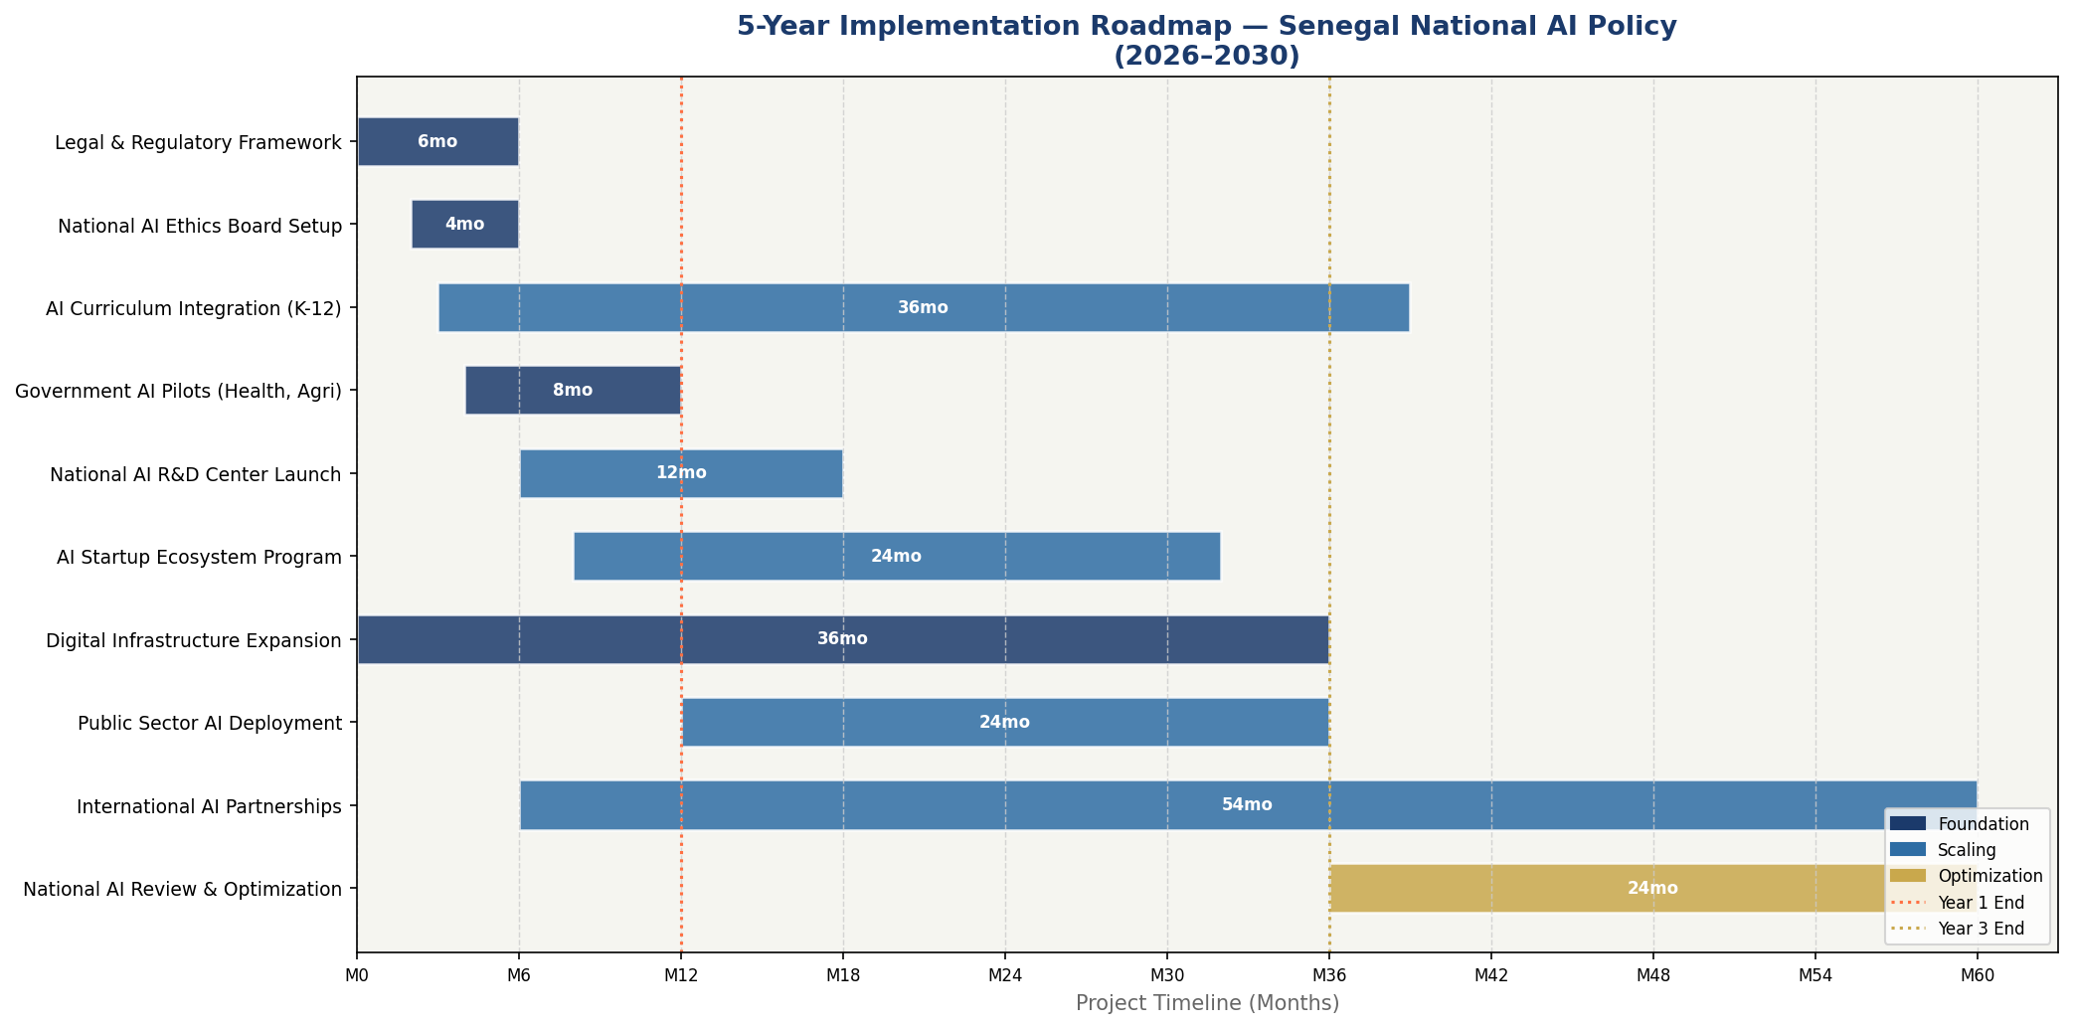
Figure 6: 5-Year Implementation Roadmap — Senegal National AI Policy (Gantt Chart, 2026–2031)

Section 9: Monitoring, Evaluation, and Accountability

9.1 National AI Observatory
A National AI Observatory (Observatoire National de l'IA — ONIA) will be established as an independent monitoring body, housed within the Statistics and Planning Directorate of the Ministry of Economy. ONIA will: collect, analyse, and publish annual data on AI adoption and impact across Senegal; conduct citizen surveys on AI awareness and perception; evaluate government AI project outcomes against declared objectives; and produce the Annual National AI Report presented to the National Assembly.

9.2 Parliamentary Oversight
The National Assembly will establish a Standing Sub-Committee on Digital Technologies and AI within the Committee on Information Technology and Communication. This Sub-Committee will: review the Annual National AI Report; hold hearings on major government AI deployments; commission independent audits of AI systems upon petition; and scrutinize AI-related budget allocations.

9.3 KPI Dashboard

KPI Metric | 2026 Baseline | Year 1 Target | Year 3 Target | Year 5 Target
AI Readiness Score (Oxford Insights) | ~32/100 | 35/100 | 45/100 | 58/100
AI practitioners (national) | ~200 | 600 | 8,000 | 55,000
Citizens with AI awareness | ~100K | 800K | 2.5M | 4.0M
Govt AI services live | 0 | 5 | 15 | 25
GDP contribution from AI (%) | 0.1% | 0.4% | 1.7% | 4.2%
Female AI training participation | ~15% | 30% | 38% | 45%
Farmers using AI advisory | ~5,000 | 100,000 | 1,000,000 | 2,500,000
TI CPI Score (target) | 43 | 44 | 48 | 55
AI-enabled govt revenue uplift | — | +2% | +6% | +12%
AI startups registered | ~30 | 80 | 250 | 600

Table 2: National AI Policy KPI Dashboard — Senegal 2026–2031

Section 10: International Cooperation and Diplomacy

10.1 Bilateral AI Cooperation Priorities
Senegal will pursue strategic bilateral AI cooperation agreements in 2026–2027 with the following partners, leveraging existing diplomatic and development relationships:
- France: Building on the Franco-Senegalese Partnership, establish a bilateral AI Research Fund of €5 million over three years with INRIA and École Polytechnique; AI governance dialogue on Francophone AI standards; support for French-language AI tools relevant to Senegalese development needs.
- Canada: Leverage the Senegal–Canada strong diaspora connection and MILA (Université de Montréal) AI leadership to establish an AI talent exchange programme; Canadian development finance for AI infrastructure in agriculture and health.
- European Union: Align with the EU-AU Digital Investment Package; participate as an African partner in EU-funded AI research projects under Horizon Europe; seek EU technical assistance for AI regulatory capacity building.
- China: Negotiate an AI cooperation agreement with guardrails on data sovereignty and technology transfer; engage with Huawei, Alibaba, and other Chinese AI operators to ensure compliance with Senegalese data protection and AI risk standards.
- United States: U.S. International Development Finance Corporation (DFC) co-investment in Senegalese AI startups; collaboration with US government on AI safety research; AI skills exchange with Howard University and HBCU networks, building on African-American diaspora connections.

10.2 Regional AI Governance — ECOWAS
Senegal should champion the development of an ECOWAS regional AI governance framework, building on its role as the host of ECOWAS institutions and its reputation as a rule-of-law anchor in West Africa. A regional framework would harmonize AI risk classification, enable cross-border AI data flows under privacy safeguards, facilitate the movement of AI talent within the region, and prevent regulatory arbitrage that could undermine member states' AI governance systems.

10.3 Global AI Governance Participation
Senegal should actively participate in: the Global Partnership on AI (GPAI) as a member country; UNESCO AI ethics implementation mechanisms; the ITU AI for Good summits; the UN AI Advisory Body processes; and the African Union AI peer review mechanism. Senegal's voice in these forums — as a democratic, development-oriented Francophone African state managing new resource wealth — is uniquely valuable for ensuring that global AI governance frameworks reflect the realities and priorities of the Global South.

10.4 South-South AI Knowledge Transfer
Senegal commits to proactive South-South AI knowledge transfer, including: sharing this policy framework and implementation experience with fellow ECOWAS member states, particularly through the CEDEAO Digital Agenda; participating in the AU's AI Centre of Excellence network; and hosting annual West Africa AI Policy Forums bringing together government officials, civil society, and technologists from across the region to share learning and build collective governance capacity.

Conclusion

Senegal's moment has arrived. The confluence of new hydrocarbon revenues, a youthful and entrepreneurial population, a resilient democratic tradition, and the global AI revolution creates a historic opportunity to leapfrog conventional development pathways and build a prosperous, equitable knowledge economy. The National AI Policy 2026–2031 charts the course.
This policy is not merely a technical document. It is a statement of values — that Senegal's government exists to serve all its citizens, not just those in Dakar's tech hubs; that the dignity and rights of every Senegalese person must be protected as AI reshapes labour markets, public services, and social life; and that Senegal's participation in the global AI revolution should be on its own terms, preserving national sovereignty over data and digital infrastructure.
The investments required are significant but proportionate: XOF 75 billion over five years, equivalent to less than 0.4% of projected GDP. The returns — in economic productivity, human capital, public service quality, and international standing — are projected to be transformative. Most importantly, the cost of inaction is far greater: a Senegal that fails to develop AI governance and adoption capacity in this decade risks being on the receiving end of others' AI systems, with no local capacity to evaluate, challenge, or redirect them.
The Government of Senegal is called upon to: formally adopt this policy by Cabinet decision; present enabling AI legislation to the National Assembly within 12 months; allocate dedicated AI budget lines in the 2027 Loi de Finances; and establish the institutional architecture — CNEIA, LIAG, ONIA, CNPIA — necessary to begin implementation. Senegal has the leadership, the talent, and the will. The future is ours to build.

References and Bibliography

International Frameworks and Policy Documents
- UNESCO (2021). Recommendation on the Ethics of Artificial Intelligence. Paris: UNESCO.
- OECD (2019, updated 2024). OECD Principles on Artificial Intelligence. Paris: OECD Publishing.
- European Parliament (2024). Regulation (EU) 2024/1689 — Artificial Intelligence Act. Official Journal of the European Union.
- African Union (2023). Continental Artificial Intelligence Strategy for Africa. Addis Ababa: AU Commission.
- G20 (2019). G20 AI Principles. G20 Japan Presidency, Osaka.
- ITU (2023). AI for Good: 2023 Global Summit Report. Geneva: International Telecommunication Union.
- World Bank (2021). World Bank Strategy for Disruptive Technologies. Washington DC: World Bank Group.

Country Data and Development Reports
- Transparency International (2024). Corruption Perceptions Index 2024. Berlin: Transparency International.
- Oxford Insights (2023). AI Readiness Index 2023. London: Oxford Insights.
- World Bank (2024). Senegal Economic Update: The Promise of the Extractive Industries. Washington DC: World Bank.
- McKinsey Global Institute (2023). Generative AI and the Future of Work in Africa. McKinsey & Company.
- Partech Africa (2023). Africa Tech Venture Capital Report 2023. Partech Partners.
- Republic of Senegal (2014). Plan Sénégal Emergent (PSE) — Vision 2035. Dakar: Primature.
- Commission de Protection des Données Personnelles (CDP) (2023). Annual Report 2023. Dakar: CDP.

Academic and Technical References
- Choudhury, P. et al. (2023). 'The Economic Impact of AI in Lower-Middle Income Countries.' Harvard Business Review, May 2023.
- Masakhane (2022). 'Participatory Research for Low-Resource Natural Language Processing.' Proceedings of ACL 2022.
- Abebe, R. et al. (2021). 'Roles for Computing in Social Change.' Proceedings of FAccT 2021.
- United Nations Development Programme (2023). Human Development Report: Breaking the Gridlock. New York: UNDP.
- African Development Bank (2023). African Economic Outlook 2023: Mobilizing Private Finance for Climate and Green Growth in Africa. Abidjan: AfDB.

About the Author

Nafiul Ahmad Rafi
Policy & Good Governance Researcher | BD Civic Tech Architect
Nafiul Ahmad Rafi is a civic technologist, policy researcher, author, photographer, and musician based in Dhaka, Bangladesh. He is the Founder and Director of Insights Bangladesh, a data-driven governance and policy impact analysis institution, and the Founder & Lead Architect of NagorikBD.org — a transparency-first civic platform scaled across Mymensingh Division, connecting citizens with government services across 45 Upazilas.
His work exists at the intersection of institutional reform and artificial intelligence, transforming theoretical governance into scalable, data-driven reality. Without a conventional computer science degree, he self-taught the tools of modern AI and web development to build the infrastructure that enforces the policies he once only researched.

Key Platforms and Projects
- NagorikBD.org — Civic transparency platform, Mymensingh Division
- Insights Bangladesh — Policy impact analysis institution
- FactCheck BD (factcheckbd.org) — Bangladesh's AI-powered fact-checking platform
- Political Insights BD / PIBD (pibbd.org) — Political intelligence and civic tech hub
- PeaceShield BD / National Peace Tracker — AI-powered hate speech and conflict monitoring
- PolicyLens AI (aigovbd.org) — 9-dimensional AI policy audit tool

He has published four books and maintains a personal site at ahmad-rafi.com.

Research Interests
AI Governance · Policy Research · Future of Bangladesh · Climate Policy

Contact
- 🌐 ahmad-rafi.com
- 🔗 LinkedIn: nafiul-ahmad-rafi (bd.linkedin.com/in/nafiul-ahmad-rafi)
- ✉️ contact@ahmad-rafi.com

"I build code to ensure transparency, and I write lyrics to inspire the courage to use it."

