🇹🇿

United Republic of Tanzania
National Artificial Intelligence Policy
2026 – 2031

A Comprehensive Framework for Ethical, Inclusive, and Economically Transformative AI

Prepared by:
Nafiul Ahmad Rafi
Insights Bangladesh | Policy & Good Governance Research

May 2026

Executive Summary

Tanzania stands at a pivotal crossroads in its developmental trajectory. As one of Sub-Saharan Africa's fastest-growing economies, with GDP growth averaging 6–7% annually, the country possesses significant latent capacity to harness Artificial Intelligence (AI) as a force multiplier for inclusive economic growth, improved public service delivery, and enhanced global competitiveness. This National AI Policy 2026–2031 provides the strategic scaffolding within which Tanzania will responsibly adopt, develop, and govern AI technologies across all sectors of society.
Tanzania's AI readiness is currently modest — reflecting its status as a lower-middle-income country with emerging digital infrastructure, developing human capital in STEM disciplines, and governance institutions undergoing reform. The country's Corruption Perception Index (CPI) score of 40 (Transparency International, 2025) signals the need for particular vigilance in deploying AI within government systems. Nonetheless, Tanzania's young population (median age 17.7 years), rapidly expanding mobile penetration (over 50%), and ambitious Vision 2025 and Vision 2050 development frameworks create a uniquely fertile environment for AI adoption.
This policy is organized around five strategic pillars: (1) Ethical AI and Human Rights Protection, (2) Economic Growth and Industrial AI Adoption, (3) Education, Upskilling, and AI Workforce Development, (4) Public Sector AI and e-Governance, and (5) AI Research, Innovation, and Startup Ecosystem Development. Each pillar is supported by concrete implementation mechanisms, regulatory structures, investment allocations, and measurable KPIs.
The policy is fully aligned with international frameworks, including the UNESCO AI Ethics Recommendation (2021), the OECD AI Principles (updated 2024), the EU AI Act risk classification system, the World Bank AI Strategy, and the ITU AI for Good Guidelines. By anchoring itself in globally recognized standards, Tanzania's national AI governance will be credible, interoperable, and internationally respected.
Expected outcomes by 2031 include: AI contributing an estimated 3.5% of GDP, over 8 million citizens achieving baseline AI literacy, 60,000 trained AI practitioners in the workforce, 25 operational government AI services, and Tanzania ranking among the top 10 most AI-ready nations in Africa. This policy is not merely a document — it is a declaration of intent that Tanzania will harness the power of AI for its people, with equity, accountability, and ambition.

Section 1: National AI Readiness Assessment

1.1 Economic Context
Tanzania is classified as a lower-middle-income country by the World Bank, with a GDP of approximately USD 79 billion (2024) and a per capita income of around USD 1,200. The economy is driven primarily by agriculture (25% of GDP), services (40%), and a rapidly expanding construction and manufacturing sector. The digital economy, while nascent, is growing — mobile money adoption through M-Pesa and Tigopesa has transformed financial inclusion, with over 60% of adults now accessing mobile financial services.
Tanzania's GDP growth rate of 6.5% (2024) significantly outpaces the global average, reflecting strong macroeconomic fundamentals. However, structural vulnerabilities — including dependence on commodity exports, limited industrial diversification, and high youth unemployment (approximately 13%) — underscore the urgency of AI-driven economic transformation to create new sectors and improve productivity across existing ones.

1.2 Education and Human Capital
Tanzania has achieved near-universal primary school enrollment, with rates exceeding 95%. However, secondary and tertiary participation remains lower, with a gross tertiary enrollment rate of approximately 4% — well below the Sub-Saharan African average of 9%. The University of Dar es Salaam, Sokoine University of Agriculture, and Nelson Mandela African Institution of Science and Technology (NM-AIST) lead STEM education, but graduate output in computer science, data science, and engineering remains insufficient to meet projected AI workforce demands.
Adult literacy stands at approximately 77%, with significant urban-rural disparities. Digital skills gaps are acute: while urban youth demonstrate growing familiarity with smartphones and social media, foundational computational thinking, data literacy, and AI concepts are largely absent from the national curriculum. Bridging this gap is central to this policy's education pillar.

1.3 Digital Infrastructure
Mobile penetration in Tanzania exceeds 50%, and smartphone adoption is accelerating — particularly among the 15–35 age cohort. The national fibre-optic backbone (NICTBB) spans over 7,000 km, and submarine cable connectivity through SEACOM, EASSy, and TEAMS ensures international bandwidth. However, rural broadband coverage remains limited, with the majority of fast connectivity concentrated in Dar es Salaam, Arusha, Mwanza, and Dodoma.
Cloud infrastructure is almost exclusively hosted internationally. Government digital services have expanded through GovNet and the e-Government Agency (eGA), but interoperability between systems, data standardisation, and cybersecurity remain ongoing challenges. Investment in domestic data centres and AI compute infrastructure is an explicit priority of this policy.

1.4 Governance and Institutional Capacity
Tanzania operates as a unitary republic with a relatively stable democratic tradition, though the political environment has experienced increased civil society constraints in recent years. The Tanzania Communications Regulatory Authority (TCRA) and the eGA provide the primary institutional anchor for digital governance. The Tanzania Data Protection Act (2022) established foundational data rights, though enforcement capacity requires strengthening.
Government institutional capacity for AI governance is currently limited. There is no dedicated national AI advisory body, no AI risk classification system, and no standardised procurement guidelines for AI systems used in public services. This policy creates these structures through the National AI Ethics Board and the National AI Observatory.

1.5 Corruption Risk Assessment
Tanzania's CPI score of 40/100 (ranked 104th globally, Transparency International 2025) indicates a high-risk environment for AI deployment in public sector contexts. Corrupt procurement processes, opaque decision-making, and weak accountability mechanisms can amplify AI-related harms — biased automated decisions can be harder to challenge when governance is weak. This policy therefore mandates anti-corruption safeguards as an integral element of all government AI deployments, including mandatory algorithmic audits, open-source preference in public procurement, and civil society observer roles in high-risk AI systems.

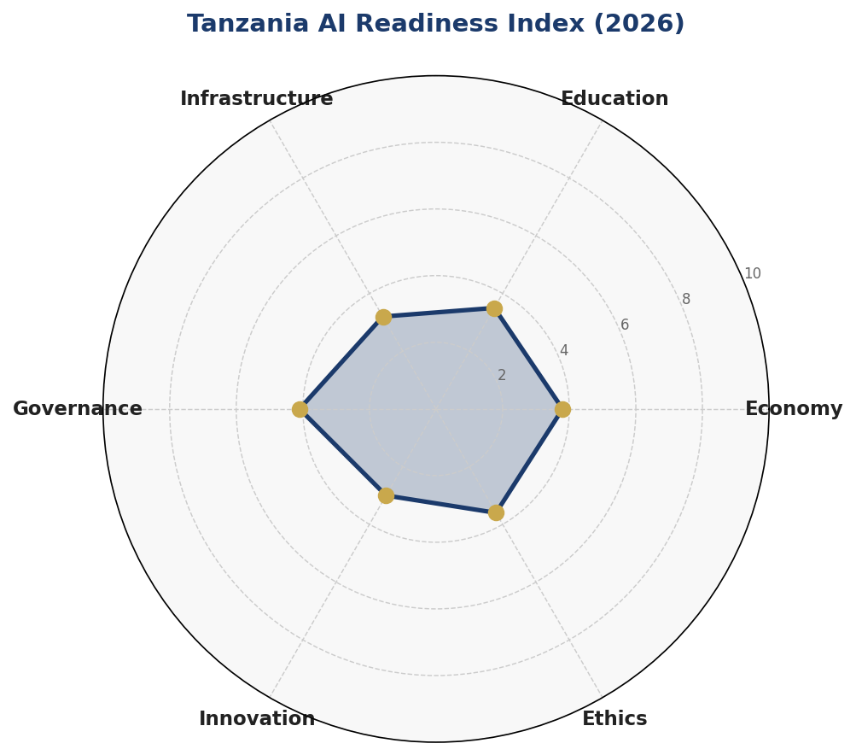
Figure 1.1: Tanzania AI Readiness Index — Six-Dimension Assessment (Scores out of 10, 2026 Baseline)

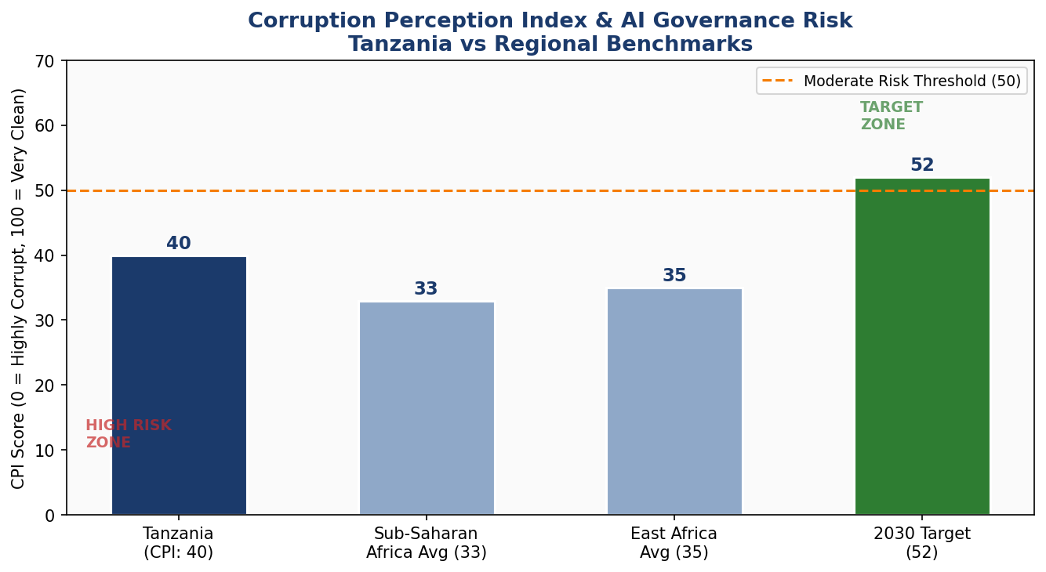
Figure 1.2: Corruption Perception Index — Tanzania vs Regional Benchmarks and 2030 Target

Section 2: Policy Vision and Strategic Pillars

2.1 Vision Statement
"By 2031, Tanzania will be a responsible, inclusive, and innovation-driven AI nation — where artificial intelligence accelerates sustainable development, empowers every citizen, strengthens public accountability, and positions Tanzania as a leader in African digital governance."

2.2 Strategic Pillar 1: Ethical AI and Human Rights Protection
Tanzania commits to placing human dignity, fairness, and accountability at the core of all AI systems. This pillar establishes the National AI Ethics Board, a multi-stakeholder body comprising government representatives, civil society, academia, and private sector actors, with a mandate to classify AI risks, investigate complaints, and publish annual ethics audits. Tanzania adopts a risk-based regulatory model aligned with international best practice, prohibiting AI uses that violate fundamental rights and mandating transparency for high-risk applications in justice, healthcare, and social welfare.

2.3 Strategic Pillar 2: Economic Growth and Industrial AI Adoption
AI adoption will be prioritised in sectors where Tanzania holds comparative advantage or faces acute productivity deficits: agriculture (precision farming, crop disease detection, supply chain optimisation), tourism (AI-powered visitor experience, demand forecasting), mining (safety monitoring, geological analysis), healthcare (diagnostic AI, telemedicine), and financial services (credit scoring, fraud detection). A Public-Private Partnership (PPP) framework will co-fund sector-specific AI adoption programmes, with international development partners (World Bank, AfDB, GIZ, USAID) targeted as co-investors.

2.4 Strategic Pillar 3: Education, Upskilling and AI Workforce Development
Tanzania will reform its national curriculum from Grade 4 upward to introduce computational thinking and AI literacy. At the tertiary level, five new Centre of Excellence in AI (CEAI) units will be established within existing universities. A national AI scholarship programme will target 2,000 students annually for undergraduate and postgraduate AI-related study, with priority given to women, students from rural regions, and persons with disabilities. A National AI Skills Voucher Scheme will enable working adults to access short-course AI upskilling through accredited providers.

2.5 Strategic Pillar 4: Public Sector AI and e-Governance
AI will be harnessed to improve the efficiency, transparency, and accessibility of government services. Priority applications include: automated tax compliance assistance, AI-powered health diagnosis support in district hospitals, intelligent agricultural extension services, predictive maintenance of national infrastructure, and natural language processing (NLP) systems for citizen feedback in Swahili. All government AI systems must undergo mandatory algorithmic impact assessments before deployment, with findings made publicly available.

2.6 Strategic Pillar 5: AI Research, Innovation and Startup Ecosystem
Tanzania will establish a National AI Innovation Fund of USD 50 million (2026–2031), co-financed by government and development partners, to support AI startups, academic research, and open-source AI tool development tailored to Tanzanian contexts. A flagship annual Tanzania AI Summit will convene stakeholders, showcase innovations, and position Tanzania as a regional AI hub. A regulatory sandbox mechanism will allow AI startups to test products under supervised conditions before full-market launch.

Section 3: International Framework Alignment

Tanzania's National AI Policy is not developed in isolation. It is deliberately anchored in the strongest internationally recognised frameworks for responsible AI governance, ensuring compatibility with global standards, eligibility for international partnerships, and credibility with development finance institutions.

3.1 UNESCO AI Ethics Recommendation (2021)
The UNESCO Recommendation on the Ethics of AI identifies 11 core values: respect for human rights and fundamental freedoms, peaceful living together, diversity and inclusiveness, environment and ecosystem flourishing, gender equality, data protection and privacy, sustainability, non-maleficence, fairness, transparency and explainability, and human oversight. Tanzania's policy maps each of these to specific regulatory provisions — for instance, the National AI Ethics Board directly enforces transparency obligations, while the Data Protection Act (2022) operationalises the privacy principle.

3.2 OECD AI Principles (2019, updated 2024)
The OECD AI Principles encompass five recommendations: inclusive growth and sustainable development; human-centred values and fairness; transparency and explainability; robustness, security, and safety; and accountability. Tanzania's risk-classification system and algorithmic accountability standards directly operationalise these principles. As a non-OECD member, Tanzania's voluntary adoption of these principles signals commitment to international best practice beyond treaty obligations.

3.3 EU AI Act (2024) — Risk-Based Categorisation
The EU AI Act establishes a four-tier risk classification: Unacceptable Risk (banned), High Risk (mandatory audit), Limited Risk (transparency), and Minimal Risk (voluntary). Tanzania adopts this classification structure adapted to local context. Unacceptable uses — including AI systems for social scoring by public authorities, real-time biometric surveillance without judicial warrant, and subliminal manipulation — are explicitly prohibited. High-risk applications in justice, immigration, education, and healthcare are subject to mandatory pre-deployment audits.

3.4 World Bank AI Strategy — Development Focus
The World Bank's AI framework emphasises AI for poverty reduction, human capital development, and institution building. Tanzania's policy aligns by dedicating 40% of public AI investment to education and human capital, prioritising AI applications in agriculture and healthcare (sectors employing the majority of Tanzania's poor), and establishing anti-corruption safeguards that address governance dimensions of development effectiveness.

3.5 G20 AI Principles and ITU AI for Good Guidelines
G20 AI Principles, adopted in 2019 and endorsed by Tanzania through African Union representation at G20, emphasise inclusivity and privacy. The ITU AI for Good framework links AI deployment to the Sustainable Development Goals (SDGs). Tanzania's AI strategy explicitly maps each pillar to relevant SDGs: AI in agriculture contributes to SDG 2 (Zero Hunger); AI in healthcare to SDG 3 (Good Health); AI in education to SDG 4 (Quality Education); and AI in e-governance to SDG 16 (Peace, Justice and Strong Institutions).

Framework / Principle | Policy Section | Ethics Board | Economic Pillar | Education Pillar | Governance AI
UNESCO: Human Rights & Dignity | Sec 2, 6 | ✅ | ⚠️ | ✅ | ✅
UNESCO: Transparency | Sec 6 | ✅ | ⚠️ | 🔲 | ✅
UNESCO: Gender Equality | Sec 5 | ✅ | ⚠️ | ✅ | ⚠️
UNESCO: Data Privacy | Sec 6 | ✅ | 🔲 | 🔲 | ✅
OECD: Inclusive Growth | Sec 4 | ⚠️ | ✅ | ✅ | ⚠️
OECD: Accountability | Sec 6, 9 | ✅ | ⚠️ | 🔲 | ✅
EU AI Act: Risk Classification | Sec 6 | ✅ | ✅ | 🔲 | ✅
World Bank: Poverty Reduction | Sec 4, 5 | 🔲 | ✅ | ✅ | ⚠️
G20: Inclusivity & Privacy | Sec 2, 6 | ✅ | ⚠️ | ✅ | ✅
ITU: SDG Linkage | All Sections | ⚠️ | ✅ | ✅ | ✅
African Union AI Strategy | Sec 10 | ⚠️ | ✅ | ✅ | ⚠️
GPAI: Innovation | Sec 5 | 🔲 | ✅ | ✅ | ⚠️
Table 3.1: Comprehensive International Framework Alignment Matrix (✅ = Fully Aligned | ⚠️ = Partially Aligned | 🔲 = In Development)

Section 4: Economic Impact and Investment Roadmap

Artificial intelligence is estimated to add between 1.2% and 4.4% to global GDP by 2030 (McKinsey Global Institute). For lower-middle-income countries with the right foundational investments, the gains can be disproportionately large — AI can compress decades of productivity improvement into years. Tanzania's economy, with its concentration in agriculture, services, and a large informal sector, is well-positioned to benefit from AI's capacity to reduce transaction costs, improve decision-making in data-sparse environments, and extend expert capabilities to under-served populations.
By 2031, this policy projects AI contributing approximately 3.5% of Tanzania's GDP, equivalent to roughly USD 2.8 billion at projected GDP levels. This estimate is based on sector-by-sector modelling: agriculture (USD 600M gain through precision inputs and supply chain efficiency), healthcare (USD 400M through diagnostic AI and resource optimisation), financial services (USD 550M through credit expansion and fraud reduction), tourism (USD 300M through personalisation and demand forecasting), and manufacturing and logistics (USD 950M through process automation and predictive maintenance).
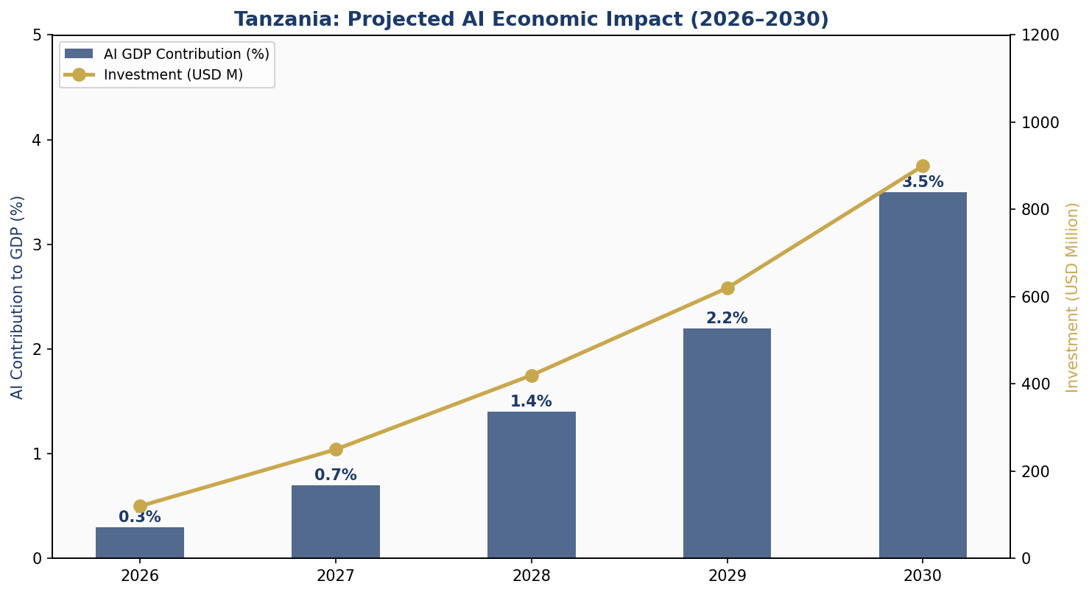
Figure 4.1: Projected AI Economic Impact — GDP Contribution (%) and Cumulative Investment (USD M), 2026–2030

4.1 Recommended Investment Allocation
The Government of Tanzania, in partnership with international development partners and the private sector, will mobilise an estimated USD 450 million in public AI investment over the 2026–2031 period. This represents approximately 0.57% of current GDP annually — a level consistent with investments made by comparable middle-income countries at early AI strategy adoption phases. The recommended allocation prioritises foundational infrastructure and human capital, recognising that sustainable AI adoption requires capable people and reliable connectivity above all else.
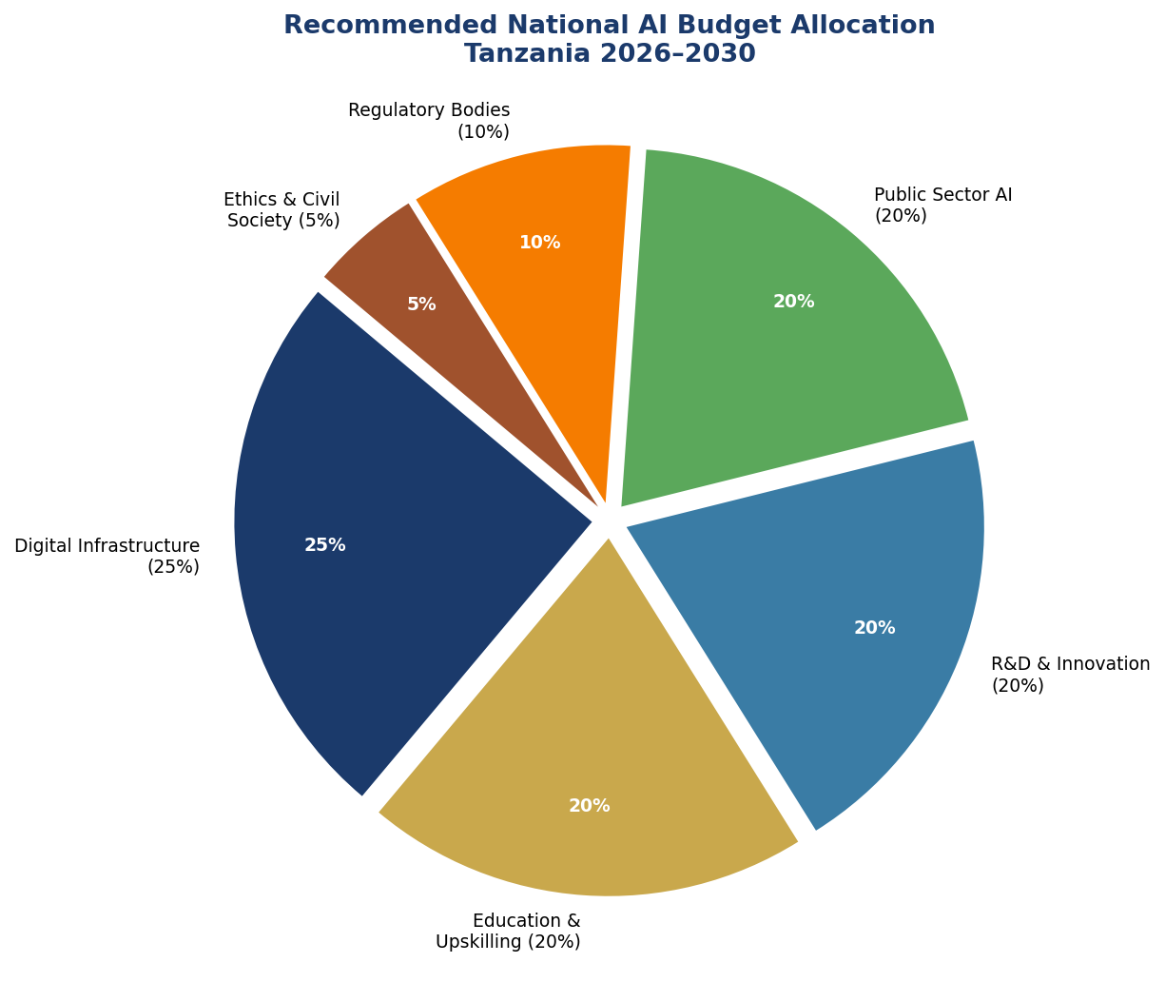
Figure 4.2: Recommended National AI Budget Allocation 2026–2031 by Sector

4.2 Priority Sectors for AI Adoption
Agriculture and Food Security: Tanzania's agricultural sector employs approximately 65% of the population. AI applications — including satellite-based crop monitoring, soil health sensors, weather prediction for smallholders, and AI-driven agricultural extension via SMS/USSD — can increase yields by 20–30% with minimal capital investment per farmer. The National AI Policy mandates an Agricultural AI Pilot Programme in five regions within 18 months.
Healthcare: With a doctor-to-patient ratio of approximately 1:25,000, Tanzania faces extreme healthcare human resource constraints. AI diagnostic tools for malaria, tuberculosis, and maternal health, deployed on low-bandwidth mobile platforms, can extend diagnostic capacity to rural health centres. The Ministry of Health will establish three AI Health Innovation Centres in partnership with universities by 2028.
Tourism: Tanzania is one of Africa's premier tourist destinations (Serengeti, Kilimanjaro, Zanzibar). AI-powered visitor personalisation, wildlife monitoring drones, real-time capacity management, and multilingual AI tourism assistants can increase tourist spending per visitor and reduce pressure on sensitive ecosystems.

4.3 Public-Private Partnership Framework
The Tanzania AI Investment Partnership (TAIP) will be established as a Special Purpose Vehicle co-governed by the Ministry of Information, Communications and IT (MICOIT), Tanzania Revenue Authority, and private sector representatives. TAIP will administer the AI Innovation Fund, structure co-investment agreements with multinationals, and manage the regulatory sandbox. Eligible companies investing in qualifying AI activities will receive a five-year tax holiday on AI-related R&D expenditure.

Section 5: Education and Human Capital Development

5.1 Current Skills Gap Analysis
Tanzania produces approximately 4,200 STEM graduates annually from its universities, of whom fewer than 300 specialise in computer science, software engineering, or data science. The AI talent pipeline is therefore severely undersized relative to the ambitions of this policy. At mid-career and senior levels, there is almost no formal AI expertise within the civil service. This dual gap — insufficient entry-level talent and near-zero senior AI capacity — requires a comprehensive, multi-track response.
Gender disparity compounds the skills gap: women represent only 28% of STEM students at Tanzanian universities, and fewer than 15% of technology-sector employees. Without deliberate corrective action, AI adoption risks perpetuating and amplifying existing gender inequalities in economic participation.

5.2 National AI Curriculum Framework
Grades 4–7 (Primary): Introduction of computational thinking as a standalone subject, using unplugged activities and locally adapted materials in Swahili. Focus on pattern recognition, sequencing, and problem decomposition. No device required — designed for rural schools with no electricity.
Grades 8–12 (Secondary): Dedicated module on AI and society: how AI systems work, their societal implications, data literacy fundamentals, and Tanzanian case studies. Introduction to block-based programming (Scratch, MIT App Inventor). Mobile lab programme for schools without computer labs.
Tertiary Level: Five Centres of Excellence in AI (CEAI) embedded within University of Dar es Salaam, NM-AIST, Sokoine University, Ardhi University, and State University of Zanzibar. Each CEAI will offer an undergraduate AI specialisation track, a two-year MSc in AI for Development, and continuing professional development certificates.
Vocational and Adult Learning: National AI Skills Voucher Scheme providing TZS 500,000 (approx. USD 200) per person for accredited short courses (4–16 weeks) in AI applications relevant to their sector — agriculture, health, finance, retail.
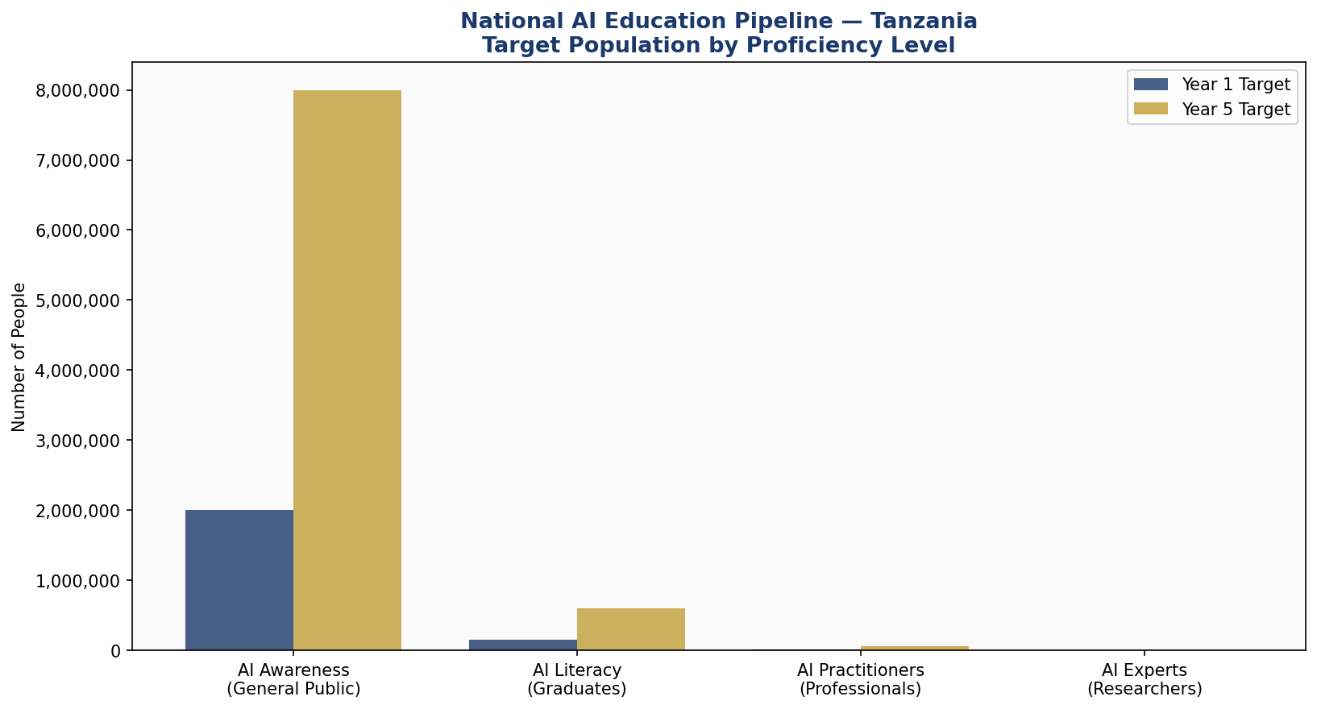
Figure 5.1: National AI Education Pipeline — Target Population by Proficiency Level, Year 1 vs Year 5

5.3 Women and Underrepresented Groups
This policy mandates a 40% minimum female enrolment target in all CEAI programmes, enforced through gender-targeted scholarships. A Women in AI Tanzania (WAITZ) initiative will provide mentoring, networking, and business incubation support for women building AI ventures. Special provisions for persons with disabilities include accessible AI curriculum materials and priority scholarship allocation.

Section 6: Ethical AI Governance and Regulatory Framework

6.1 National AI Ethics Board
The National AI Ethics Board (NAEB) will be established by statute within 12 months of policy adoption. Composition: 15 members — 5 government representatives (MICOIT, Attorney General, Ministry of Health, Ministry of Finance, Ministry of Education), 3 civil society representatives, 3 academic researchers (including at least one AI expert), 2 private sector representatives, and 2 international observers from recognised AI governance bodies. Appointments require Parliamentary ratification. The NAEB Chairperson is appointed by the President and ratified by Parliament.
Mandate: The NAEB will classify AI systems by risk, investigate complaints, issue binding guidance on AI ethics, conduct annual audits of all high-risk government AI systems, publish public AI impact assessments, and advise Parliament on emerging AI risks. The Board has power to suspend deployment of AI systems pending investigation and to levy administrative fines.

6.2 AI Risk Classification System
Risk Level | Definition | Examples in Tanzania Context | Regulatory Requirement
UNACCEPTABLE  (Prohibited) | AI that poses unacceptable threat to rights or safety | Social scoring by government; mass biometric surveillance without warrant; child manipulation AI | BANNED — criminal liability for deployment
HIGH RISK  (Regulated) | AI with significant impact on fundamental rights or safety | Criminal sentencing AI; student exam scoring AI; medical diagnosis AI; credit scoring for social welfare | Mandatory algorithmic audit pre-deployment; NAEB registration; annual review; public impact assessment
LIMITED RISK  (Transparency) | AI interacting with humans or generating content | Chatbots; AI-generated government communications; deepfake detection; recommendation systems | Mandatory disclosure that user is interacting with AI; labelling of AI-generated content
MINIMAL RISK  (Voluntary) | AI with negligible rights or safety impact | AI spam filters; AI-powered weather apps; entertainment recommendations | Voluntary code of conduct; encouraged (not mandatory) transparency
Table 6.1: Tanzania AI Risk Classification System — Adapted from EU AI Act Framework

6.3 Data Protection and Privacy
Tanzania's Data Protection Act (2022) provides the foundational legal framework. This policy calls for the establishment of a dedicated Personal Data Protection Commission (PDPC) with investigative and enforcement powers, replacing the current arrangement where data protection is administered through TCRA. The PDPC will be empowered to issue data transfer restrictions, conduct investigations, and impose fines of up to TZS 5 billion (approx. USD 2 million) for serious violations.

6.4 Anti-Corruption AI Guidelines
Given Tanzania's governance environment, all AI systems deployed by the public sector must adhere to anti-corruption safeguards: open-source preference in procurement; mandatory disclosure of vendor interests and AI system training data sources; prohibition on closed-box AI in judicial, tax, or benefit determination contexts; and mandatory civil society observer seats on AI oversight committees for high-risk government deployments. All government AI procurement must be published on an open government procurement portal.

Section 7: Public Sector AI and e-Governance

Tanzania's e-Government Agency (eGA) will serve as the primary implementation body for public sector AI. The following applications are identified as priority deployments based on both feasibility and development impact:

7.1 Priority Government AI Applications
- Tanzania Revenue Authority (TRA) Tax Compliance AI: NLP-based system to assist small businesses with tax filing, flag anomalies, and reduce manual audit burden. Projected to increase domestic tax collection by 15–20%.
- District Hospital Diagnostic Support AI: Image-based diagnostic assistance for malaria, tuberculosis, and maternal health complications at district-level health facilities. Designed for low-bandwidth, offline-capable operation.
- Agricultural Extension AI (via USSD/SMS): AI-powered crop advisory system accessible to farmers without smartphones. Provides personalised recommendations based on GPS location, crop type, and local weather data.
- National Infrastructure Predictive Maintenance: AI analysis of road, water, and electricity infrastructure sensor data to predict maintenance needs before failure. Priority for roads and water systems in rural regions.
- AI-Powered Citizen Feedback Platform: Swahili-language NLP system to collect, classify, and route citizen feedback on government services. Integrated with the President's Office — Regional Administration and Local Government (PORALG).
- Judiciary Case Management AI: AI system to assist courts with case scheduling, legal document classification, and backlog prioritisation. Deployed in 10 pilot courts in Year 2, with national rollout by Year 4.
- National Social Welfare Eligibility AI: AI-assisted targeting of social protection programmes, replacing manual means-testing. Mandatory human oversight of all final eligibility determinations.
- Border and Customs Intelligence: AI anomaly detection at border crossings to flag high-risk shipments, reducing smuggling and increasing revenue. Developed with Tanzania Revenue Authority and Tanzania Ports Authority.

7.2 Government AI Procurement Guidelines
All government AI procurement above TZS 100 million must: (1) be subject to NAEB risk classification; (2) include data sovereignty clauses requiring primary data storage in Tanzania or a designated data residency zone; (3) disclose algorithmic parameters to the NAEB; (4) include mandatory human override mechanisms in all decision-relevant applications; and (5) be published on the open procurement portal within 30 days of contract award. Foreign AI vendors must partner with a Tanzanian entity holding at least 30% of the contract value.

Section 8: Implementation Roadmap

Tanzania's National AI Policy will be implemented in three phases over a five-year horizon: Foundation (2026–2027), Scaling (2027–2029), and Optimisation (2029–2031). Each phase has defined deliverables, responsible ministries, and measurable KPIs.

8.1 Phase 1 — Foundation (2026–2027)
- Enact National AI Ethics Board legislation; constitute Board within 12 months.
- Establish National AI Observatory within MICOIT.
- Publish national AI risk classification guidelines and mandatory algorithmic impact assessment framework.
- Launch AI curriculum pilot in 500 primary and secondary schools across five regions.
- Establish Tanzania AI Innovation Fund (TAIF) with seed funding of USD 15 million.
- Launch first three government AI pilot programmes: TRA Tax Compliance AI, District Hospital Diagnostic AI, and Agricultural Extension AI.
- Negotiate international AI cooperation MoUs with at least five partner countries.
- Publish national open AI dataset repository (Tanzanian languages, agricultural, health data).

8.2 Phase 2 — Scaling (2027–2029)
- Expand AI curriculum to all secondary schools nationally; establish five CEAIs.
- Launch National AI Scholarship Programme (2,000 scholarships annually).
- Scale government AI pilots from five to twenty-five services.
- Activate AI Startup Regulatory Sandbox; support 50 AI startups.
- Establish three AI Health Innovation Centres.
- Host inaugural Tanzania AI Summit (Year 3).
- Achieve 30% female participation in CEAI programmes.

8.3 Phase 3 — Optimisation (2029–2031)
- Conduct comprehensive mid-term AI policy review; update based on technology and economic developments.
- Position Tanzania as a net AI knowledge exporter to the region — policy, talent, and open tools.
- Achieve AI Readiness Index score improvement of at least 2 points across all six dimensions.
- Integrate Tanzania AI governance framework into African Union AI Strategy.
- Host African AI Governance Centre of Excellence in Dar es Salaam.

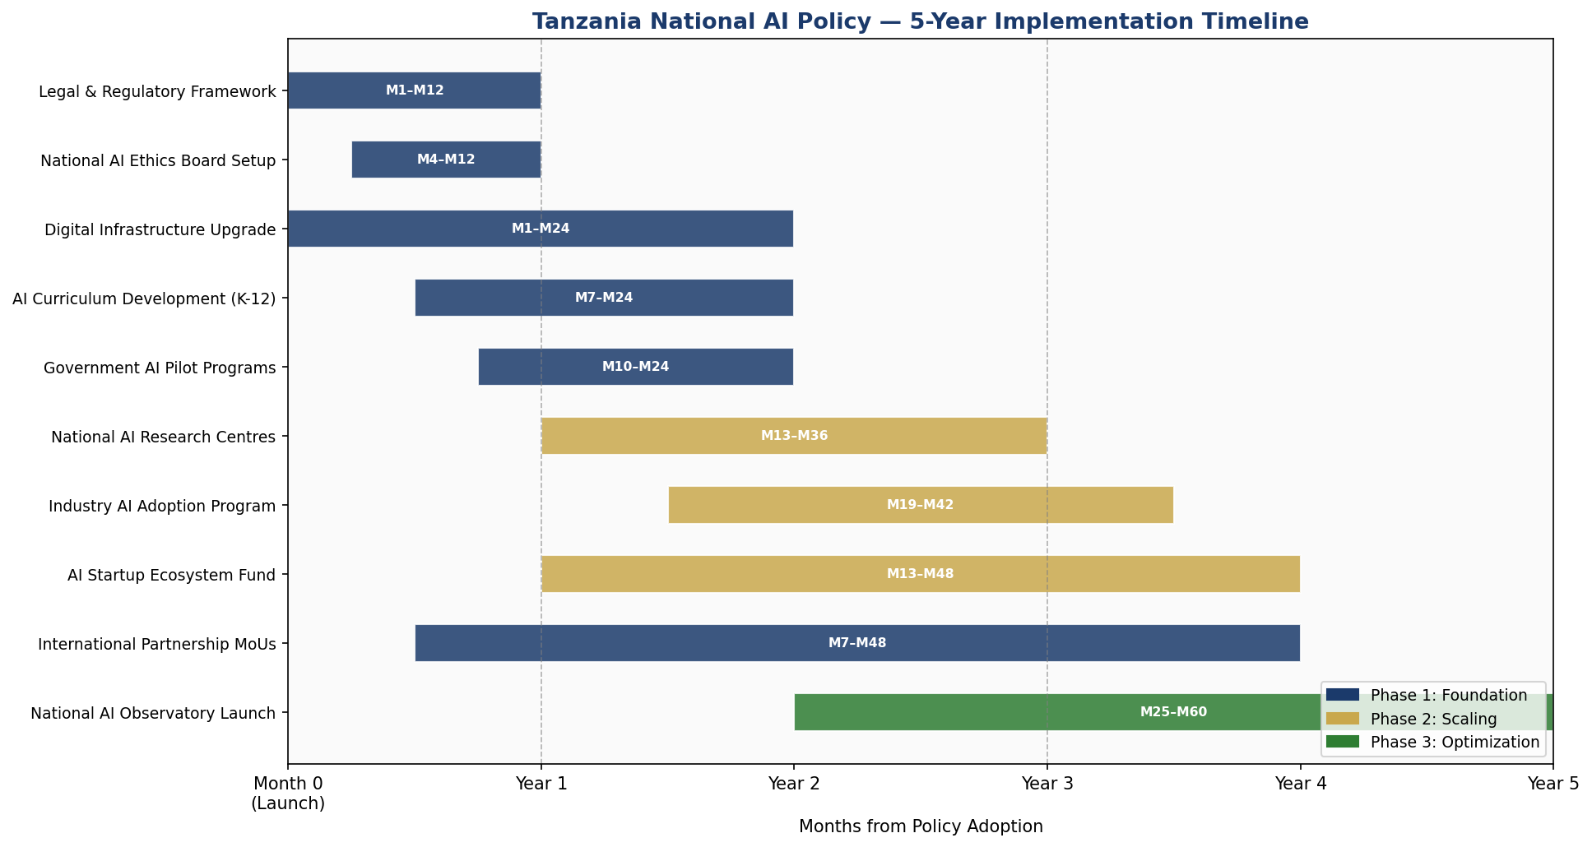
Figure 8.1: Tanzania National AI Policy — 5-Year Implementation Timeline (Gantt Chart, 2026–2031)

Section 9: Monitoring, Evaluation and Accountability

The National AI Observatory (NAO), housed within MICOIT with operational independence guaranteed by statute, will serve as Tanzania's primary AI monitoring institution. The NAO will publish an Annual AI State Report submitted to Parliament, maintain the national AI system registry, conduct or commission independent algorithmic audits of all high-risk government AI systems, and publish quarterly AI adoption statistics.

9.1 Parliamentary Oversight
A dedicated Parliamentary AI Oversight Committee (PAOC) will be constituted within 18 months of policy adoption. The PAOC will review the Annual AI State Report, summon Ministers to account for AI system failures, commission independent technical audits, and hold public hearings on emerging AI risks. The PAOC has power to recommend suspension of any government AI system pending investigation.

9.2 KPI Dashboard
KPI | Baseline (2026) | Year 1 Target | Year 3 Target | Year 5 Target
AI GDP Contribution (%) | 0.1% | 0.3% | 1.4% | 3.5%
Citizens with AI Literacy | ~50,000 | 500,000 | 3,000,000 | 8,000,000
AI Practitioners Trained | ~2,000 | 8,000 | 30,000 | 60,000
Government AI Services Active | 0 | 5 | 15 | 25
AI Startups in Ecosystem | ~30 | 80 | 250 | 500
Female CEAI Enrolment (%) | ~15% | 25% | 35% | 40%
CPI Score (target) | 40 | 42 | 46 | 52
AI Readiness Index Composite | 3.5/10 | 4.0/10 | 5.5/10 | 7.0/10
Open Gov AI Procurements Published | 0% | 100% | 100% | 100%
High-Risk AI Audits Completed | N/A | 100% | 100% | 100%
Table 9.1: National AI Policy KPI Dashboard — Baseline, Year 1, Year 3, and Year 5 Targets

Section 10: International Cooperation and AI Diplomacy

Tanzania's AI governance cannot succeed in isolation. International cooperation accelerates knowledge transfer, attracts investment, improves regulatory interoperability, and enables Tanzania to contribute to shaping global AI governance norms that reflect the interests of developing nations.

10.1 Bilateral Partnerships
Priority bilateral AI cooperation partners include: the European Union (AI governance, regulatory alignment, Horizon programme access); the United States (USAID digital development, Google.org AI partnerships, NSF joint research); Japan (JICA technology transfer, robotics, AI for aging-society innovations); China (Huawei AI Cloud, digital infrastructure, ICT skills training under Belt and Road frameworks); India (AI for agriculture and healthcare, India-Africa AI Cooperation Forum); and the United Kingdom (AI safety research, FCDO development programmes).
Each partnership will be governed by a bilateral MoU on AI Cooperation, specifying joint research programmes, data sharing protocols (where applicable), technical assistance, and scholarship exchanges. All bilateral AI data sharing agreements must be subject to NAEB review and Parliamentary notification.

10.2 African Union and Regional Integration
Tanzania is a founding signatory of the African Union's Digital Transformation Strategy for Africa and supports the AU's emerging AI continental framework. Within the East African Community (EAC), Tanzania will champion harmonised AI governance standards — particularly on data localisation, algorithmic accountability, and AI in cross-border trade. Tanzania will propose hosting the EAC Secretariat on Digital and AI Governance.

10.3 Global AI Governance Participation
Tanzania will seek full membership of the Global Partnership on AI (GPAI) and will participate actively in ITU AI for Good, UNESCO AI governance processes, and UN Secretary-General's AI Advisory Board successor mechanisms. Tanzania will advocate, in all multilateral forums, for AI governance frameworks that are development-sensitive, technologically neutral, and respect the right of nations to adopt AI at their own pace without intellectual property barriers imposed by dominant technology economies.

10.4 South-South Knowledge Transfer
Tanzania will formalise AI knowledge exchange programmes with Rwanda (recognised as Africa's leading AI governance model), Kenya (AI startup ecosystem), Ghana (AI ethics policy), and Senegal (AI in agriculture and climate). A Tanzania-led Africa AI Policy Network will publish annual comparative policy assessments and facilitate policy learning across 15 African nations by 2030.

Conclusion

Tanzania's National AI Policy 2026–2031 is a declaration of ambition anchored in realism. It acknowledges the country's current constraints — in infrastructure, skills, institutional capacity, and governance quality — while charting a credible, sequenced pathway to a future where AI accelerates Tanzania's development aspirations.
The policy does not promise miracles. AI is a tool — powerful, versatile, and potentially transformative, but ultimately dependent on the quality of governance, the depth of human capital, and the integrity of the institutions that deploy it. Tanzania's success with AI will be determined less by the sophistication of the algorithms it adopts and more by the strength of the ethical, educational, and accountability frameworks this policy establishes.
The road ahead will require sustained political commitment, cross-party consensus, meaningful civil society engagement, and international solidarity. It will require investment — in classrooms, in research labs, in regulatory bodies, and above all in Tanzanian people. It will require honesty about what is working and the courage to course-correct when it is not.
Tanzania has navigated greater challenges. The same spirit of Ujamaa — collective effort toward shared prosperity — that defined the nation's founding generation must now animate Tanzania's AI journey. Artificial intelligence is not a foreign import to be feared or uncritically embraced. It is a new instrument in Tanzania's hands, to be shaped in service of Tanzanian values, Tanzanian needs, and Tanzania's extraordinary future.

— End of Policy Document —

References and Bibliography

African Union. (2020). The Digital Transformation Strategy for Africa (2020–2030). Addis Ababa: African Union Commission.
European Parliament and Council. (2024). Regulation (EU) 2024/1689 — Artificial Intelligence Act. Brussels: European Union.
Government of Tanzania. (2022). Tanzania Data Protection Act. Dodoma: Government Printer.
Government of Tanzania. (2023). Tanzania Development Vision 2025 Progress Report. Dodoma: Ministry of Finance and Planning.
International Telecommunication Union. (2023). AI for Good Global Summit Report. Geneva: ITU.
McKinsey Global Institute. (2023). The Economic Potential of Generative AI: The Next Productivity Frontier. New York: McKinsey & Company.
OECD. (2024). Revised Recommendation of the Council on Artificial Intelligence. Paris: OECD Publishing.
Oxford Insights. (2024). Government AI Readiness Index 2024. Oxford: Oxford Insights.
Transparency International. (2025). Corruption Perceptions Index 2024. Berlin: Transparency International.
UNESCO. (2021). Recommendation on the Ethics of Artificial Intelligence. Paris: UNESCO.
United Nations. (2023). Governing AI for Humanity: Interim Report. New York: Secretary-General's Advisory Body on AI.
World Bank. (2024). World Development Report 2024: The Middle Income Trap. Washington DC: World Bank Group.
World Economic Forum. (2024). Global Technology Governance Report 2024. Geneva: WEF.

About the Author

Nafiul Ahmad Rafi
Policy & Good Governance Researcher | BD Civic Tech Architect

Nafiul Ahmad Rafi is a civic technologist, policy researcher, author, photographer, and musician based in Dhaka, Bangladesh. He is the Founder and Director of Insights Bangladesh, a data-driven governance and policy impact analysis institution, and the Founder & Lead Architect of NagorikBD.org — a transparency-first civic platform scaled across Mymensingh Division, connecting citizens with government services across 45 Upazilas.
His work exists at the intersection of institutional reform and artificial intelligence, transforming theoretical governance into scalable, data-driven reality. Without a conventional computer science degree, he self-taught the tools of modern AI and web development to build the infrastructure that enforces the policies he once only researched.

Key Platforms and Projects:
- NagorikBD.org — Civic transparency platform, Mymensingh Division
- Insights Bangladesh — Policy impact analysis institution
- FactCheck BD (factcheckbd.org) — Bangladesh's AI-powered fact-checking platform
- Political Insights BD / PIBD (pibbd.org) — Political intelligence and civic tech hub
- PeaceShield BD / National Peace Tracker — AI-powered hate speech and conflict monitoring
- PolicyLens AI (aigovbd.org) — 9-dimensional AI policy audit tool

He has published four books and maintains a personal site at ahmad-rafi.com.

Research Interests:
AI Governance · Policy Research · Future of Bangladesh · Climate Policy

Contact:
Website: ahmad-rafi.com
LinkedIn: linkedin.com/in/nafiul-ahmad-rafi
Email: contact@ahmad-rafi.com

"I build code to ensure transparency, and I write lyrics to inspire the courage to use it."

