🇺🇬 Republic of Uganda
National Artificial Intelligence Policy 2026–2031
A Comprehensive Framework for Ethical, Inclusive, and Economically Transformative AI

Prepared by
Nafiul Ahmad Rafi
Policy & Good Governance Researcher | Insights Bangladesh

May 2026
Insights Bangladesh | aigovbd.org

Table of Contents

Executive Summary
Uganda stands at a pivotal moment in its development trajectory. As the country works to achieve the aspirations of its Vision 2040 and the National Development Plan III, artificial intelligence presents an unparalleled opportunity to accelerate economic transformation, strengthen governance, and improve the quality of life for its more than 47 million citizens. This National AI Policy 2026-2031 charts a deliberate, inclusive, and ethically grounded pathway for Uganda to harness the power of AI in a manner consistent with its national values, developmental priorities, and international obligations.
Uganda's economic profile as a low-income country with strong agricultural foundations, a rapidly urbanizing population, and an emerging ICT sector provides both the context and the imperative for a carefully calibrated AI strategy. With a GDP per capita of approximately USD 930, a youthful population with a median age of 16.7 years, and mobile internet penetration exceeding 45%, Uganda possesses a latent digital dividend waiting to be unlocked through strategic AI adoption. The country's National Broadband Policy and the National ICT Policy lay the groundwork upon which this AI framework is constructed.
This policy is organized around five strategic pillars: Ethical AI and Human Rights Protection; Economic Growth and Industrial AI Adoption; Education, Upskilling and AI Workforce Development; Public Sector AI and e-Governance; and AI Research, Innovation and Startup Ecosystem Development. Together, these pillars ensure that Uganda's AI journey is anchored in human dignity, economic pragmatism, and institutional accountability. The policy explicitly acknowledges the risks associated with AI deployment in contexts of constrained governance capacity and elevated corruption risk, and proposes robust safeguards to mitigate these challenges.
Internationally, this framework aligns comprehensively with the UNESCO Recommendation on the Ethics of Artificial Intelligence (2021), the OECD AI Principles (updated 2024), the EU AI Act's risk-based categorization, the World Bank's Digital Development Strategy, the G20 AI Principles, and ITU's AI for Good Guidelines. Uganda seeks to position itself not merely as a consumer of AI technologies developed elsewhere, but as an active participant in shaping global AI governance norms that reflect the needs and aspirations of low- and middle-income countries. Through South-South cooperation and active engagement with the African Union's AI continental strategy, Uganda aims to contribute to an inclusive global AI ecosystem.
The five-year implementation roadmap is structured in three phases: Foundation (2026), covering legal architecture, institutional setup, and pilot programs; Scaling (2027-2028), encompassing national rollout, education reform, and industrial adoption; and Optimization (2029-2031), focused on review, international integration, and AI export potential. Key performance indicators track progress across all pillars, with annual reporting to Parliament and independent civil society oversight ensuring accountability. The National AI Observatory will serve as the primary monitoring mechanism, producing annual State of AI Reports for public dissemination.
Uganda's AI ambition is grounded in realism. The country faces significant structural challenges including limited digital infrastructure in rural areas, a nascent research and development ecosystem, and governance deficits that must be proactively managed. This policy does not promise transformative outcomes without effort; rather, it provides a rigorous framework for mobilizing national and international resources, building institutional capacities, and creating the conditions under which AI can genuinely serve Uganda's development goals. With political will, sustained investment, and active citizen engagement, Uganda can achieve a projected AI contribution of 3.8% to GDP by 2031.

Section 1: National AI Readiness Assessment

1.1 Economic Context
Uganda is classified as a Low-Income Country (LIC) by the World Bank, with a GDP of approximately USD 45 billion (2024) and a GDP per capita of around USD 930. The economy has maintained average growth rates of 5-6% annually over the past decade, driven primarily by agriculture (which accounts for approximately 24% of GDP and employs over 70% of the workforce), services (50%), and a growing industrial sector (26%). Uganda's economic profile is characterized by significant informality, with the informal sector estimated to account for over 80% of total employment.
The digital economy is nascent but growing. Mobile money penetration exceeds 60% of adults, providing a foundation for digital financial services and potentially AI-powered fintech applications. The ICT sector contributes approximately 2.5% of GDP directly, with indirect contributions significantly higher. Uganda's Vision 2040 aspires to transform the country into a competitive upper-middle-income nation, making AI adoption a strategic imperative rather than a luxury.

1.2 Education and Human Capital
Uganda's adult literacy rate stands at approximately 79%, with significant urban-rural disparities. Tertiary enrollment is around 9%, and STEM capacity at the university level remains limited, with Makerere University, Kyambogo University, and Uganda Martyrs University as the primary institutions with AI-relevant programs. The country faces a pronounced digital skills gap, with fewer than 15% of secondary school students having access to functional computer laboratories.
The Government of Uganda has initiated several programs to address human capital gaps, including the Skilling Uganda strategy and initiatives under the Ministry of ICT and National Guidance. However, the pace of digital skills development has not kept up with the economy's needs. This policy calls for a dramatic acceleration of AI literacy programs across all educational levels, with particular attention to girls and rural communities.

1.3 Digital Infrastructure
Uganda's digital infrastructure has improved significantly over the past decade, yet significant gaps remain. Internet penetration stands at approximately 47% of the population, with mobile internet accounting for the vast majority of connections. Fixed broadband penetration is below 1%, reflecting the challenges of last-mile connectivity in a predominantly rural country. The National Backbone Infrastructure (NBI) connects major urban centers, and Uganda has invested in submarine cable landing stations that provide international bandwidth.
Data centers are concentrated in Kampala, with limited geographic distribution. Cloud adoption is growing among large enterprises and government entities, with Amazon Web Services, Microsoft Azure, and Google Cloud all establishing local presence. The NITA-U (National Information Technology Authority) plays a critical role in coordinating digital infrastructure development and setting technology standards for government systems.

1.4 Governance and Institutional Capacity
Uganda has a unitary presidential republic with a Parliament of Uganda, a Cabinet, and a Judiciary. The country has existing ICT governance structures including NITA-U, the Uganda Communications Commission (UCC), and the Personal Data Protection Office (PDPO) established under the Data Protection and Privacy Act 2019. These institutions provide the regulatory infrastructure upon which AI governance can be built, though capacity strengthening will be essential.
The country scores 4.0 out of 10 on the governance dimension of AI readiness, reflecting both existing institutional frameworks and the challenges of regulatory capacity, enforcement, and inter-agency coordination. The establishment of a dedicated National AI Governance Committee within the Office of the Prime Minister is recommended as a first step.

1.5 Corruption Risk Assessment
Uganda scores 26 out of 100 on the 2024 Transparency International Corruption Perceptions Index, ranking 142nd out of 180 countries. This positions Uganda in the high corruption risk tier, which has direct implications for AI governance. In high-corruption environments, AI systems deployed in public procurement, social benefit distribution, law enforcement, and regulatory functions carry elevated risks of being captured by corrupt interests or weaponized for political purposes.
This policy mandates specific anti-corruption safeguards for all AI deployments in the public sector, including mandatory algorithmic impact assessments, independent audit requirements, public procurement transparency for AI contracts, and whistleblower protections for those reporting AI-related corruption. The National AI Ethics Board will have an explicit anti-corruption mandate and must include civil society representation.

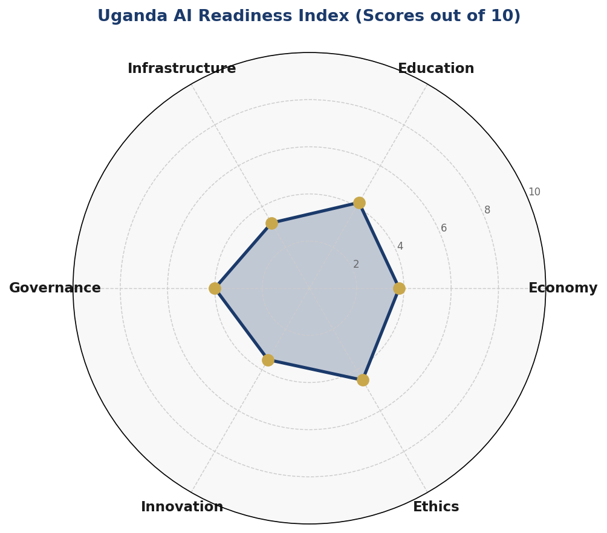
Figure 1.1: Uganda AI Readiness Index — Six-Dimensional Assessment (Scores out of 10)

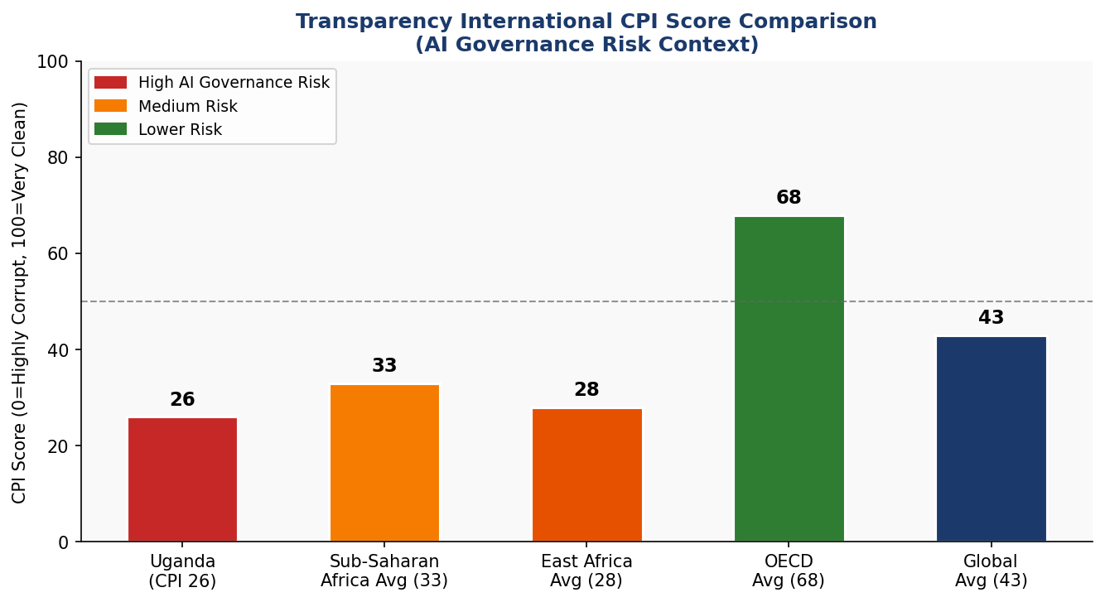
Figure 1.2: Uganda CPI Score vs Regional and Global Benchmarks — AI Governance Risk Context

Section 2: Policy Vision and Strategic Pillars

2.1 Vision Statement
"By 2031, Uganda will be a regional leader in responsible, inclusive, and economically transformative AI — harnessing emerging technologies to accelerate equitable development, strengthen democratic governance, and secure a prosperous future for all Ugandans."
This vision is grounded in three core principles: Responsibility (ensuring AI operates within ethical, legal, and human rights frameworks); Inclusivity (ensuring the benefits of AI reach all Ugandans, including rural communities, women, and marginalized groups); and Transformation (deploying AI to genuinely accelerate Uganda's developmental aspirations, not merely adopting technology for its own sake).

2.2 Strategic Pillar 1: Ethical AI and Human Rights Protection
Uganda's AI ecosystem must be anchored in the protection of fundamental human rights, including dignity, privacy, non-discrimination, freedom of expression, and due process. This pillar establishes the National AI Ethics Board, enacts a comprehensive AI Risk Classification System, mandates algorithmic transparency, and ensures independent oversight of all government AI deployments.
The pillar specifically addresses risks unique to Uganda's context: the potential use of AI-powered facial recognition for political surveillance; algorithmic bias in credit scoring that disadvantages rural and female applicants; AI-mediated disinformation in electoral contexts; and the concentration of AI economic benefits among Kampala-based elites to the exclusion of the 76% of Ugandans living in rural areas.

2.3 Strategic Pillar 2: Economic Growth and Industrial AI Adoption
AI presents transformative opportunities across Uganda's key economic sectors. In agriculture — the backbone of Uganda's economy — AI-powered precision farming, crop disease detection, weather prediction, and supply chain optimization can dramatically increase yields and farmer incomes. The Uganda National Farmers Federation (UNFFE) and agricultural cooperatives will be key partners in piloting AI agriculture applications.
In financial services, AI-driven credit scoring for unbanked populations, fraud detection in mobile money systems, and insurance underwriting for smallholder farmers represent high-impact applications. Uganda's tourism sector, healthcare system, and manufacturing base all present significant AI adoption opportunities with GDP multiplier effects. This pillar establishes a USD 50 million AI Industrial Adoption Fund, to be capitalized through a combination of government allocation, Development Finance Institution (DFI) lending, and private sector co-investment.

2.4 Strategic Pillar 3: Education, Upskilling and AI Workforce Development
Building a pipeline of AI-literate citizens, competent AI practitioners, and world-class AI researchers is the most critical long-term investment Uganda can make. This pillar mandates the integration of computational thinking and AI literacy into the national curriculum from Primary 5 onwards, establishes AI specialization tracks at 20 Technical Vocational Education and Training (TVET) institutions, and creates Uganda AI Scholarship programs at partner international universities.
Special attention is given to gender equity in AI education. The current gender gap in STEM enrollment at Ugandan universities (approximately 30% female in computer science programs) must be addressed through targeted scholarships, female mentorship programs, and partnerships with organizations such as the African Women in Technology Forum. The goal is to achieve 40% female representation in AI practitioner programs by 2031.

2.5 Strategic Pillar 4: Public Sector AI and e-Governance
Government is both the largest potential user of AI in Uganda and the domain where AI risks are most consequential. This pillar establishes guidelines for responsible government AI procurement, identifies priority use cases for AI in public service delivery, and mandates citizen-facing AI services to be accessible in local languages including Luganda, Acholi, Runyankole, and Langi.
Priority government AI applications include: agricultural extension services AI chatbots; tax compliance prediction and fraud detection for the Uganda Revenue Authority (URA); healthcare diagnostic support for rural health centers III and IV; judicial case management AI for the Ministry of Justice; and predictive maintenance AI for the Uganda National Roads Authority (UNRA). All government AI systems will be subject to mandatory algorithmic impact assessments and independent audits.

2.6 Strategic Pillar 5: AI Research, Innovation and Startup Ecosystem
Uganda cannot remain permanently dependent on AI technologies and models developed elsewhere. This pillar aims to cultivate an indigenous AI research and innovation ecosystem anchored at Makerere University's AI and Data Science research group (one of Africa's leading AI research institutions), complemented by innovation hubs including the Hive Colab, Outbox Hub, and the newly established Uganda AI Innovation Centre.
The Uganda AI Startup Fund will provide seed and early-stage funding for AI ventures, with a particular focus on solutions addressing local challenges in agriculture, health, and financial inclusion. The policy establishes a Uganda AI Grand Challenge — an annual competition with significant prize money — to stimulate AI innovation focused on Uganda's most pressing developmental problems.

Section 3: International Framework Alignment

3.1 UNESCO Recommendation on the Ethics of AI (2021)
The UNESCO Recommendation on the Ethics of Artificial Intelligence, adopted unanimously by 193 Member States in November 2021, provides the most comprehensive global normative framework for AI ethics. Uganda's National AI Policy maps comprehensively to all eleven core values articulated in the UNESCO Recommendation.
Proportionality and Do No Harm: Uganda's AI Risk Classification System (Section 6) ensures that AI interventions are proportionate to legitimate aims and that potential harms are assessed prior to deployment. Safety and Security: Mandatory Algorithmic Impact Assessments and the National AI Ethics Board's oversight mandate directly address safety requirements. Fairness and Non-Discrimination: The policy mandates bias audits for all high-risk AI systems, with particular attention to gender, ethnicity, and geographic bias. Sustainability: AI applications in agriculture and environmental monitoring are aligned with Uganda's National Environment Management Authority (NEMA) guidelines. Right to Privacy and Data Protection: Full alignment with Uganda's Data Protection and Privacy Act 2019. Human Oversight: No fully autonomous AI decision-making in high-stakes domains affecting citizens' rights. Transparency and Explainability: Public sector AI systems must be explainable in plain language. Responsibility and Accountability: Clear liability frameworks for AI developers, deployers, and government procurers. Awareness and Literacy: the education pillar directly addresses AI literacy. Multi-stakeholder and Adaptive Governance: The National AI Observatory and annual review process embody adaptive governance. International and Multi-stakeholder Cooperation: Uganda commits to active participation in UNESCO's global AI ethics follow-up mechanisms.

3.2 OECD AI Principles (2019, Updated 2024)
Though Uganda is not an OECD member, the OECD AI Principles represent globally respected guidelines that shape international AI governance discourse and investment decisions. Uganda's alignment with these principles strengthens its credibility with international technology partners and investors.
The five OECD AI Principles — Inclusive Growth and Sustainable Development; Human-centred Values and Fairness; Transparency and Explainability; Robustness, Security and Safety; and Accountability — are addressed throughout Uganda's policy framework, with the economic growth pillar specifically responding to the inclusive growth principle in the context of a low-income developing country.

3.3 EU AI Act (2024) — Risk-Based Approach
The EU AI Act, which entered into force in August 2024, establishes the world's most comprehensive legally binding AI regulatory framework. While Uganda is not subject to EU jurisdiction, the Act's risk-based categorization provides a valuable model for Uganda's own regulatory architecture. Uganda's AI Risk Classification System (detailed in Section 6) adapts the EU approach to Uganda's specific context.
Uganda's policy adopts the four-tier risk classification: Unacceptable Risk (banned); High Risk (regulated with mandatory audit); Limited Risk (transparency obligations); and Minimal Risk (voluntary code of conduct). Adaptations from the EU framework reflect Uganda's developmental context, including provisions for AI-powered agricultural tools that might fall under limited regulation in the EU but warrant closer oversight given Uganda's rural vulnerability context.

3.4 Framework Alignment Matrix

Framework Principle | Sec 2  Vision | Sec 4  Economy | Sec 5  Education | Sec 6  Ethics | Sec 7  Govt AI
UNESCO: Proportionality & Do No Harm | ✅ | ✅ | ⚪ | ✅ | ✅
UNESCO: Safety & Security | ⚪ | ✅ | ⚪ | ✅ | ✅
UNESCO: Fairness & Non-Discrimination | ✅ | ⚪ | ✅ | ✅ | ✅
UNESCO: Privacy & Data Protection | ⚪ | ⚪ | ⚪ | ✅ | ✅
OECD: Inclusive Growth | ✅ | ✅ | ✅ | ⚪ | ✅
OECD: Transparency & Explainability | ⚪ | ⚪ | ⚪ | ✅ | ✅
OECD: Robustness & Security | ⚪ | ✅ | ⚪ | ✅ | ✅
EU AI Act: Risk Classification | ⚪ | ⚪ | ⚪ | ✅ | ✅
EU AI Act: Human Oversight | ✅ | ⚪ | ⚪ | ✅ | ✅
G20: Human-Centric AI | ✅ | ✅ | ✅ | ✅ | ⚪
ITU: AI for Good / SDG Linkage | ✅ | ✅ | ✅ | ⚪ | ✅
World Bank: Digital Dev Strategy | ⚪ | ✅ | ✅ | ⚪ | ✅
AU: Continental AI Strategy | ✅ | ✅ | ✅ | ✅ | ✅
Table 3.1: International Framework Alignment Matrix (✅ = Full Alignment | ⚪ = Partial Alignment)

Section 4: Economic Impact and Investment Roadmap

4.1 Projected AI Economic Contribution
Drawing on McKinsey Global Institute, World Economic Forum, and World Bank modeling for low-income countries at Uganda's stage of economic development, AI adoption in Uganda is projected to contribute between 3.5% and 4.2% of GDP by 2031, assuming full implementation of this policy framework. This translates to an additional USD 1.6-1.9 billion in annual economic output at current GDP levels, with multiplier effects across agriculture, services, and manufacturing sectors.
The agricultural sector presents the highest near-term AI potential, given its scale and the severity of productivity gaps relative to comparable economies. AI-powered precision agriculture, crop disease detection via mobile applications, and climate-adaptive farming guidance delivered through USSD and voice interfaces could increase agricultural productivity by 15-25% for participating farmers. The financial services sector offers the fastest adoption potential, leveraging Uganda's strong mobile money infrastructure.

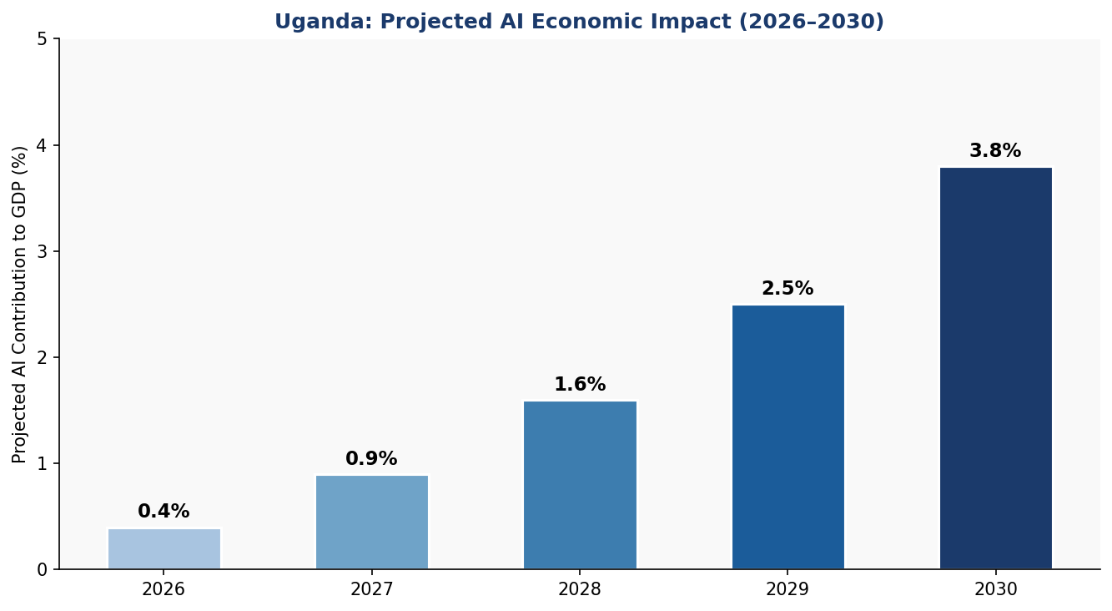
Figure 4.1: Projected AI Contribution to Uganda GDP (2026–2030) — Conservative Scenario

4.2 Investment Allocation Framework
Uganda's National AI Investment Framework calls for a dedicated National AI Fund capitalized at UGX 350 billion (approximately USD 95 million) over the five-year policy period, to be disbursed across the six investment categories outlined below. This fund represents a combination of national budget allocation, development partner contributions, and catalytic private sector investment mobilized through matching grant mechanisms.

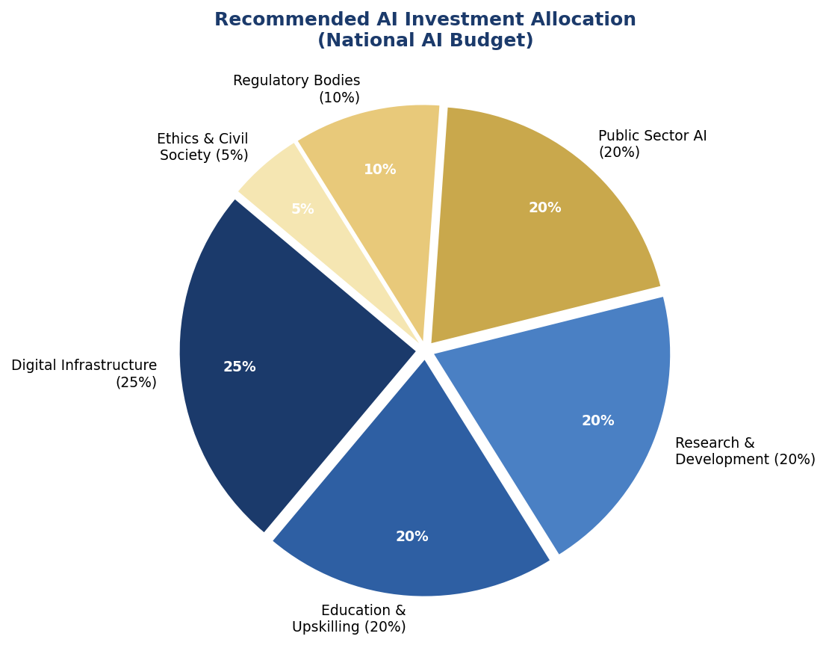
Figure 4.2: Recommended AI Investment Allocation — National AI Fund (5-Year Period)

4.3 Priority Sectors for AI Adoption
Agriculture and Agri-tech: AI applications in soil analysis, crop disease detection, precision irrigation, and supply chain optimization. Target: 500,000 smallholder farmers benefiting from AI-assisted services by 2028.
Financial Inclusion and Fintech: AI credit scoring for unbanked populations, fraud detection, insurance underwriting. Target: 2 million additional adults accessing formal financial services through AI-enabled platforms by 2029.
Healthcare: Diagnostic AI support at rural health centers, epidemic surveillance, supply chain optimization for essential medicines. Target: AI diagnostic tools deployed in 200 health facilities by 2028.
Education Technology: Adaptive learning platforms, AI tutoring in national languages, automated assessment. Target: 500,000 students benefiting from AI-enhanced learning by 2030.
Tourism and Hospitality: AI-powered visitor experience personalization, wildlife monitoring for conservation, multilingual AI guides. Target: 20% increase in tourism revenue attributable to AI-enhanced experiences by 2031.

4.4 Public-Private Partnership Framework
Successful AI adoption requires sustained collaboration between government, private sector, civil society, and development partners. Uganda's AI PPP Framework establishes clear roles: Government provides regulatory clarity, public data access, and anchor procurement; Private sector contributes technology, capital, and market expertise; Universities and research institutions provide talent and applied research; Development partners provide concessional finance, technical assistance, and international knowledge transfer; Civil society organizations provide community engagement, rights protection, and accountability.

Section 5: Education and Human Capital Development

5.1 Current Skills Gap Analysis
Uganda's AI skills gap is profound and must be addressed at every level of the education system. Currently, fewer than 500 Ugandan professionals can be classified as AI practitioners with genuine machine learning and data science expertise. University programs in computer science and data science collectively enroll approximately 8,000 students annually, of whom fewer than 10% receive meaningful exposure to AI-specific content. At the secondary school level, less than 20% of schools have functional computer laboratories, and the current curriculum does not include computational thinking as a core subject.
The gender dimension of the skills gap is particularly acute. Female enrollment in computer science at Ugandan universities stands at approximately 28%, declining to around 15% in advanced technical AI programs. Without targeted intervention, Uganda risks replicating global patterns of AI gender exclusion that have contributed to biased AI systems and unequal economic benefits from AI adoption.

5.2 National AI Curriculum Framework
Primary Level (P4-P7): Introduction of computational thinking, basic algorithmic logic, and age-appropriate AI concepts as part of the Mathematics and ICT curriculum. No programming required; emphasis on logical reasoning and problem-solving.
Secondary Level (S1-S6): Progressive curriculum covering programming fundamentals, data literacy, AI applications in everyday life, and ethical considerations of AI. Computer science designated as a core subject rather than elective. Investment in computer laboratory infrastructure for all government secondary schools.
Tertiary Level: Establishment of AI specialization tracks within existing computer science and engineering programs at all public universities. Creation of standalone BSc in Artificial Intelligence at Makerere University. Development of 18-month AI practitioner certification programs at TVET institutions.

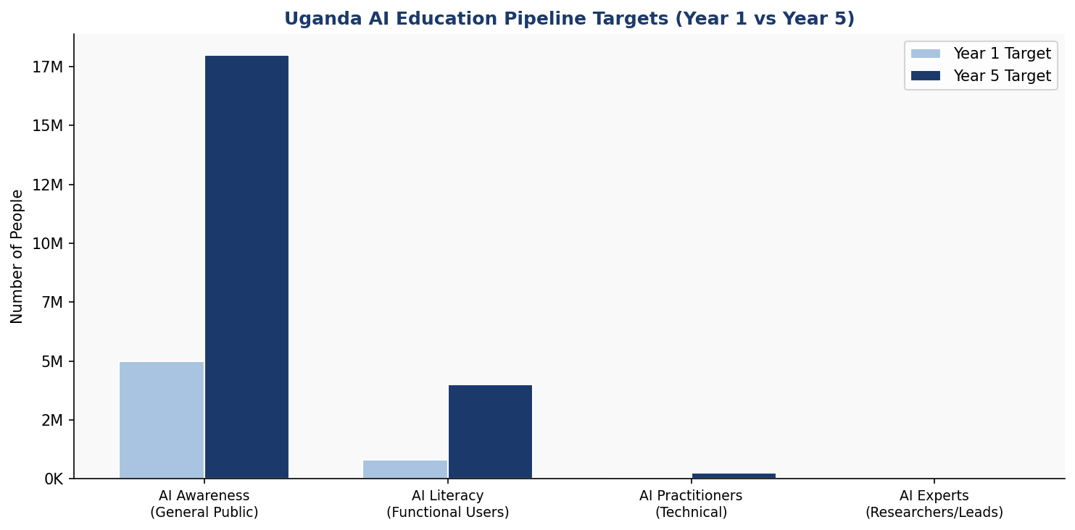
Figure 5.1: Uganda AI Education Pipeline — Population Targets by Competency Level (Year 1 vs Year 5)

5.3 Women and Marginalized Groups Inclusion
The Uganda AI Gender Equity Initiative will provide 2,000 scholarships annually for girls and women pursuing AI-related education at secondary and tertiary levels. Partnerships with female role model networks, corporate mentorship programs, and community sensitization campaigns will address cultural barriers to female participation in technology. Similar targeted programs will address inclusion of youth with disabilities, northern Uganda communities affected by historical conflict, and Karamoja region youth.

5.4 International Programs and Capacity Building
Uganda will negotiate AI scholarship and fellowship programs with leading international AI research institutions including the African Institute for Mathematical Sciences (AIMS), Carnegie Mellon University Africa, and the Turing Institute. The Uganda AI Diaspora Network will engage qualified Ugandan AI professionals abroad to contribute to capacity building through remote mentorship, curriculum advisory, and knowledge transfer programs.

Section 6: Ethical AI Governance and Regulatory Framework

6.1 National AI Ethics Board
The National AI Ethics Board (NAEB) shall be established by statutory instrument under the Ministry of ICT and National Guidance, with an independent secretariat and a mandate to advise, audit, and when necessary enforce AI governance standards across Uganda's public and private AI ecosystem.
Composition: The NAEB shall comprise 15 members including: representatives from NITA-U, the Personal Data Protection Office, the Uganda Human Rights Commission, Makerere University, Uganda National Academy of Sciences, Uganda Law Society, Uganda Journalists Association, Uganda Consumer Protection Association, private sector (technology and telecommunications), and three civil society representatives nominated through an open public process. The board shall maintain gender parity.
Mandate: The NAEB shall conduct mandatory pre-deployment algorithmic impact assessments for all government AI systems; audit high-risk private sector AI applications; maintain a public National AI Registry; investigate citizen complaints related to AI; and produce quarterly public reports. The NAEB shall have the power to issue compliance notices, impose fines, and recommend suspension of AI systems found to violate this policy.

6.2 AI Risk Classification System
UNACCEPTABLE RISK (Prohibited): AI systems that manipulate human behavior through subliminal techniques; social scoring systems that rate citizens based on social behavior or personal characteristics; real-time biometric surveillance in public spaces for law enforcement purposes; AI systems that exploit the vulnerabilities of specific groups; predictive policing AI that makes enforcement decisions without human review.
HIGH RISK (Regulated — Mandatory Pre-deployment Audit): AI in employment decisions (hiring, firing, promotion); AI in credit and financial services decisions; AI in educational assessment and certification; AI in healthcare diagnosis and treatment recommendation; AI in criminal justice applications; AI in benefits eligibility determination; AI in immigration and border control.
LIMITED RISK (Transparency Obligations): AI chatbots used in commercial or government customer service must disclose AI nature; AI-generated content must be labeled; AI systems that personalize information feeds must provide transparency about algorithmic curation.
MINIMAL RISK (Voluntary Code of Conduct): AI used in spam filtering, AI-powered productivity tools, AI in entertainment and gaming, AI in basic agricultural advisory applications.

6.3 Data Protection and Privacy
Uganda's Data Protection and Privacy Act 2019, administered by the Personal Data Protection Office (PDPO), provides the foundational legal framework for data governance in AI systems. This policy calls for strengthening the PDPO's capacity and mandate to address AI-specific data challenges, including: specific provisions for automated decision-making; data minimization requirements for AI training datasets; mandatory data protection impact assessments for AI systems processing sensitive personal data; and cross-border data transfer safeguards.

6.4 Algorithmic Accountability
All high-risk AI systems deployed in Uganda must maintain an audit trail sufficient to reconstruct the basis for any individual decision. Citizens shall have the right to request explanation of any AI-assisted decision that affects their rights or interests. AI developers and deployers shall maintain liability for harms caused by their systems, with a strict liability standard for high-risk applications. The Anti-Corruption Court shall have jurisdiction over cases involving AI-facilitated corruption in public procurement or service delivery.

Section 7: Public Sector AI and e-Governance

7.1 Priority Government Use Cases
Uganda Revenue Authority (URA) — Tax Compliance AI: Machine learning models to identify patterns of tax underreporting, optimize audit selection, and improve VAT compliance. Estimated revenue impact: UGX 800 billion additional annual tax collection by 2029.
Ministry of Agriculture — Agricultural Extension AI: Mobile and USSD-accessible AI advisory services providing personalized crop management guidance, weather alerts, and market price information to smallholder farmers in local languages. Target: 1 million farmers reached by 2028.
Ministry of Health — Diagnostic Support AI: AI-powered diagnostic support tools for clinical officers at rural health centers III and IV, covering TB, malaria, maternal health, and childhood nutrition. Priority districts: Karamoja, northern Uganda, and high-burden rural districts.
Uganda National Roads Authority (UNRA) — Infrastructure AI: Predictive maintenance AI using satellite imagery and sensor data to optimize road maintenance scheduling, reducing infrastructure degradation costs.
Office of the Auditor General — Public Finance AI: AI-assisted analysis of government financial data to identify anomalous spending patterns, procurement irregularities, and potential corruption indicators. Critical anti-corruption application.

7.2 Government AI Procurement Guidelines
All government procurement of AI systems must comply with the Uganda Public Procurement and Disposal of Public Assets Authority (PPDA) Act and specific AI procurement guidelines to be issued by NITA-U. Key requirements include: mandatory algorithmic impact assessment before procurement; source code escrow for critical government AI systems; local data hosting requirements for sensitive government data; mandatory transparency clauses; and prohibition on procurement of AI systems from vendors with documented human rights violations.

7.3 Citizen-Facing AI Services
Uganda's e-Government portal (www.gov.ug) will integrate AI-powered multilingual chatbot services capable of responding to citizen queries in English, Luganda, Acholi, Runyankole, and Langi. AI-powered complaint management systems will be deployed across all ministries, with automated routing, status tracking, and escalation protocols. All citizen-facing AI must comply with accessibility standards for persons with disabilities.

Section 8: Implementation Roadmap

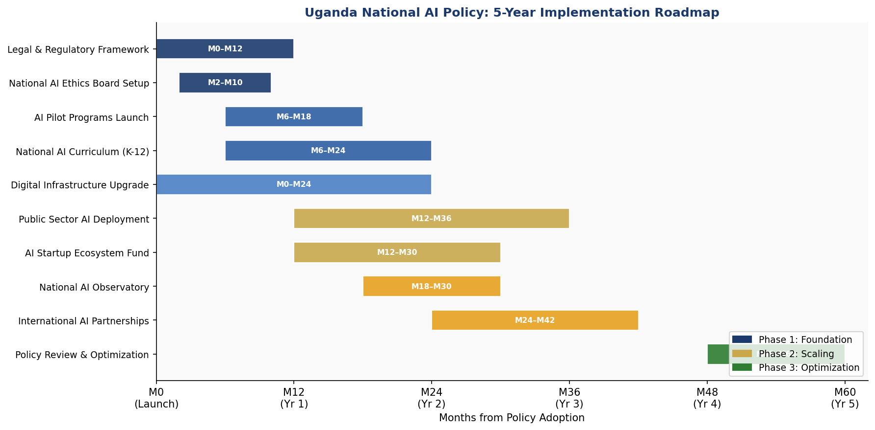
Figure 8.1: Uganda National AI Policy — 5-Year Implementation Timeline (Gantt Chart)

8.1 Phase 1 — Foundation (2026)
Legal and Regulatory Architecture: Enact National AI Policy into law; establish AI-specific provisions in revised ICT Act; issue NAEB statutory instrument; publish AI Risk Classification Regulations; strengthen PDPO mandate for AI governance. Target completion: Q4 2026.
Institutional Setup: Formally establish National AI Ethics Board with full complement of members; establish National AI Governance Committee in OPM; launch National AI Observatory secretariat; designate AI Focal Points in all ministries. Target completion: Q3 2026.
Pilot Programs: Launch five flagship AI pilot programs across agriculture, health, tax compliance, education, and road maintenance. Establish baseline metrics for all KPIs. Target completion: Q4 2026.

8.2 Phase 2 — Scaling (2027–2028)
National Rollout: Scale successful pilots to national deployment; begin AI curriculum integration in secondary schools; launch TVET AI practitioner programs; activate Uganda AI Startup Fund; operationalize government AI procurement guidelines.
Education Reform: Integrate computational thinking into P4-P7 curriculum; launch female AI scholarship program; establish Makerere University BSc AI program; sign international AI scholarship agreements.
Industrial Adoption: Activate Uganda AI Industrial Adoption Fund; launch Uganda AI Grand Challenge; establish Uganda AI Innovation Centre; begin AI extension services to 500,000 farmers.

8.3 Phase 3 — Optimization (2029–2031)
Review and Refinement: Conduct comprehensive mid-term policy evaluation; revise regulatory framework based on emerging evidence; update AI Risk Classifications based on technological developments; review and strengthen NAEB mandate.
International Integration: Negotiate bilateral AI cooperation agreements with Kenya, Rwanda, Tanzania, South Africa, India, EU, and UAE; join Global Partnership on AI (GPAI); achieve full alignment with AU Continental AI Strategy.
AI Export Potential: Support Ugandan AI companies to develop exportable AI products, particularly in agriculture, health, and fintech verticals suited to other African markets; position Uganda as a regional AI hub within the East African Community.

8.4 Key Performance Indicators by Phase
KPI Indicator | Baseline  (2026) | Year 1  Target | Year 3  Target | Year 5  Target
AI contribution to GDP (%) | 0.1% | 0.4% | 1.6% | 3.8%
AI practitioners (professionals) | 500 | 2,000 | 15,000 | 50,000
Farmers using AI advisory ('000) | 0 | 50K | 350K | 1,000K
Govt. AI systems with impact assessment | 0% | 30% | 75% | 100%
Female AI practitioners (%) | 15% | 20% | 30% | 40%
AI startups registered | 12 | 40 | 150 | 400
Citizens with AI literacy (%) | 5% | 10% | 25% | 45%
Secondary schools with AI curriculum | 0% | 15% | 50% | 95%
Table 8.1: Uganda AI Policy — KPI Dashboard (2026–2031)

Section 9: Monitoring, Evaluation and Accountability

9.1 National AI Observatory
The National AI Observatory (NAIO) shall be established as a semi-autonomous unit within NITA-U with a dedicated research staff, an independent advisory committee, and a mandate to produce authoritative annual reports on the state of AI in Uganda. The NAIO will maintain the National AI Registry, track implementation of this policy framework, commission independent research on AI impacts, and provide technical secretariat support to the National AI Ethics Board.
The NAIO shall produce: Annual State of AI in Uganda Report (public); Quarterly AI Implementation Dashboard (public); Bi-annual AI Ethics Incident Register (public); Confidential briefings to Cabinet and Parliamentary Committee on ICT.

9.2 Parliamentary Oversight
The Parliamentary Committee on Information and Communication Technology shall conduct an annual review of AI policy implementation, with authority to summon ministers, NITA-U officials, and NAEB members for public testimony. The Auditor General shall include a dedicated AI governance audit chapter in the annual report to Parliament, examining compliance with procurement guidelines, algorithmic impact assessment requirements, and budget utilization.

9.3 Civil Society and Independent Audit Role
Uganda's vibrant civil society sector plays an essential accountability role in AI governance. The policy formally recognizes the right of civil society organizations to access government AI system documentation (subject to legitimate security exceptions), conduct shadow monitoring of AI policy implementation, submit formal observations to the NAEB, and advocate for AI-affected communities in formal accountability processes.
The government will establish a Civil Society AI Monitoring Grant to provide modest funding for qualified civil society organizations to conduct independent AI monitoring activities, with grant management handled by the NAIO to ensure independence from political interference.

9.4 Grievance and Redress Mechanisms
Citizens who believe they have been harmed by an AI system — whether government or private — shall have access to: NAEB complaint mechanism (primary channel); Uganda Human Rights Commission (for human rights violations); Courts of Law (including Small Claims Court for minor AI-related commercial disputes); Parliamentary Ombudsman (for government AI grievances). All complaint mechanisms shall be accessible in multiple languages and via USSD for citizens without internet access.

Section 10: International Cooperation and AI Diplomacy

10.1 Bilateral AI Cooperation Priorities
Uganda will pursue bilateral AI cooperation agreements prioritizing: technology transfer; joint research programs; AI talent exchange; development finance for AI infrastructure; and market access for AI products. Priority bilateral partners include: Kenya and Rwanda (regional AI ecosystem development); India (AI for agriculture and health); Estonia (e-governance expertise); Republic of Korea (technology transfer); United Arab Emirates (AI investment); European Union (regulatory cooperation and research funding).

10.2 Regional and Continental AI Governance
Uganda is an active member of the East African Community (EAC) and the African Union. Uganda will champion the development of an EAC AI Regulatory Framework that harmonizes AI governance standards across the region, reducing regulatory fragmentation that currently hinders cross-border AI applications and investment. At the continental level, Uganda commits to full implementation of the African Union's AI Continental Strategy and to contributing Uganda's national experience to AU policy learning processes.
South-South Cooperation: Uganda will establish AI knowledge exchange programs with other African nations, particularly sharing experience from agricultural AI, mobile-first AI delivery, and governance of AI in high-corruption-risk contexts. The Uganda AI Academy will offer short-course capacity building programs for AI policymakers and regulators from other African countries.

10.3 Global AI Governance Participation
Uganda commits to active participation in: Global Partnership on AI (GPAI) — seeking membership by 2027; UNESCO AI Ethics implementation follow-up processes; ITU AI for Good platform; UN AI Advisory Body processes; World Trade Organization discussions on AI and digital trade. Uganda will advocate in these forums for AI governance frameworks that account for the developmental contexts and priorities of low-income countries, and against AI governance architectures that inadvertently perpetuate digital colonialism.

Conclusion
Uganda's National AI Policy 2026-2031 represents more than a technology strategy. It is a development manifesto — a declaration that Ugandans will not be passive recipients of an AI revolution designed elsewhere, but active architects of an AI future that serves their needs, reflects their values, and amplifies their aspirations. The policy is ambitious, drawing on the best of international thinking and global standards, while remaining firmly grounded in Uganda's own economic realities, governance challenges, and cultural context.
The five strategic pillars — Ethical AI, Economic AI, Educational AI, Governmental AI, and Innovative AI — are mutually reinforcing. Ethics without economic application risks irrelevance. Economic adoption without ethical safeguards risks exploitation. Education without economic opportunity produces frustration. Government AI without citizen trust produces resistance. Innovation without a skilled workforce produces dependency. Uganda's policy seeks to build all five pillars simultaneously, accepting the complexity this entails in exchange for the resilience it provides.
The road ahead is demanding. Uganda must build institutions, pass laws, train educators, invest in infrastructure, and cultivate an innovation culture — all while managing the real risks that AI poses to privacy, employment, governance integrity, and social cohesion. This policy does not minimize these challenges. It confronts them directly, providing frameworks for risk management rather than promises of effortless transformation.
With sustained political will, adequate investment, genuine multi-stakeholder partnership, and the energy and ingenuity of Uganda's predominantly young population, this policy can deliver on its promise: an Uganda where AI accelerates progress towards Vision 2040, where no Ugandan is left behind by the digital transformation, and where Uganda's experience becomes a model for responsible AI adoption across Africa and the developing world. The future is artificial intelligence. Uganda's future is Ugandan AI.

References and Bibliography

International Frameworks and Standards
- UNESCO. (2021). Recommendation on the Ethics of Artificial Intelligence. Paris: UNESCO.
- OECD. (2024). OECD AI Principles — Updated Recommendations. Paris: OECD Publishing.
- European Parliament and Council. (2024). EU Artificial Intelligence Act (Regulation 2024/1689). Brussels: Official Journal of the European Union.
- G20 Japan. (2019). G20 AI Principles. Osaka: G20.
- ITU. (2023). AI for Good Guidelines. Geneva: International Telecommunication Union.
- World Bank. (2024). Digital Development Strategy 2021-2025. Washington DC: World Bank Group.
- African Union. (2024). Continental Artificial Intelligence Strategy. Addis Ababa: African Union Commission.

Uganda National Documents
- Republic of Uganda. (2019). Data Protection and Privacy Act 2019. Kampala: Uganda Printing and Publishing Corporation.
- Republic of Uganda. (2020). Third National Development Plan (NDP III) 2020/21-2024/25. Kampala: National Planning Authority.
- Republic of Uganda. (2040). Uganda Vision 2040. Kampala: National Planning Authority.
- NITA-U. (2020). National ICT Policy 2020. Kampala: Ministry of ICT and National Guidance.
- Ministry of ICT. (2018). National Broadband Policy. Kampala: Republic of Uganda.

Research and Reports
- McKinsey Global Institute. (2024). The Economic Potential of Generative AI: The Next Productivity Frontier. New York: McKinsey.
- Oxford Insights. (2024). Government AI Readiness Index 2024. Oxford: Oxford Insights.
- Transparency International. (2024). Corruption Perceptions Index 2024. Berlin: Transparency International.
- World Economic Forum. (2024). The Future of Jobs Report 2025. Geneva: WEF.
- Makerere University AI and Data Science Research Group. (2023). State of AI Research in East Africa. Kampala: Makerere University.
- World Bank. (2024). Uganda Economic Update, 21st Edition: Closing the Digital Divide. Washington DC: World Bank.

About the Author
Nafiul Ahmad Rafi
Policy & Good Governance Researcher | BD Civic Tech Architect
Nafiul Ahmad Rafi is a civic technologist, policy researcher, author, photographer, and musician based in Dhaka, Bangladesh. He is the Founder and Director of Insights Bangladesh, a data-driven governance and policy impact analysis institution, and the Founder and Lead Architect of NagorikBD.org — a transparency-first civic platform scaled across Mymensingh Division, connecting citizens with government services across 45 Upazilas.
His work exists at the intersection of institutional reform and artificial intelligence, transforming theoretical governance into scalable, data-driven reality. Without a conventional computer science degree, he self-taught the tools of modern AI and web development to build the infrastructure that enforces the policies he once only researched.

Key Platforms and Projects
- NagorikBD.org — Civic transparency platform, Mymensingh Division
- Insights Bangladesh — Policy impact analysis institution
- FactCheck BD (factcheckbd.org) — Bangladesh's AI-powered fact-checking platform
- Political Insights BD / PIBD (pibbd.org) — Political intelligence and civic tech hub
- PeaceShield BD / National Peace Tracker — AI-powered hate speech and conflict monitoring
- PolicyLens AI (aigovbd.org) — 9-dimensional AI policy audit tool

He has published four books and maintains a personal site at ahmad-rafi.com.

Research Interests
AI Governance · Policy Research · Future of Bangladesh · Climate Policy

Contact
- Website: ahmad-rafi.com
- LinkedIn: bd.linkedin.com/in/nafiul-ahmad-rafi
- Email: contact@ahmad-rafi.com

"I build code to ensure transparency, and I write lyrics to inspire the courage to use it."

