🇿🇲
REPUBLIC OF ZAMBIA
National Artificial Intelligence Policy 2025–2030
A Comprehensive Framework for Ethical, Inclusive, and Economically Transformative AI
Building an AI-Ready Zambia for the 21st Century

Prepared by:
Nafiul Ahmad Rafi
Insights Bangladesh
Policy & Good Governance Research Institution
May 2025

Executive Summary

Zambia stands at a pivotal moment in its development trajectory. With a population of 20 million, an economy anchored in copper mining and agriculture, and a youthful demographic profile where over 60 percent of citizens are under the age of 25, the country possesses the raw ingredients for a transformative leap into the digital age. Artificial intelligence (AI) represents not merely a technological opportunity but a fundamental lever for economic diversification, improved public service delivery, and enhanced governance — precisely the areas where Zambia has the most urgent need and the most potential for accelerated progress.
This National AI Policy 2025–2030 establishes a comprehensive, evidence-based framework to guide Zambia's engagement with artificial intelligence over the next five years and beyond. It is grounded in the country's current AI readiness profile — a context characterized by nascent digital infrastructure, growing mobile connectivity, a developing STEM education sector, and governance institutions in need of technological modernization. Rather than framing these as deficits, this policy treats them as strategic entry points: every investment in AI readiness is simultaneously an investment in the foundations of a more equitable, transparent, and prosperous Zambia.
The policy is organized around five strategic pillars: Ethical AI and Human Rights Protection; Economic Growth and Industrial AI Adoption; Education, Upskilling, and AI Workforce Development; Public Sector AI and e-Governance; and AI Research, Innovation, and Startup Ecosystem Development. These pillars are not siloed; they are deeply interconnected, designed to reinforce one another through coordinated institutional action, multi-stakeholder partnerships, and a shared national vision of AI as a public good.
Critically, this framework aligns with and is reinforced by the major international AI governance standards: the UNESCO Recommendation on the Ethics of AI (2021), the OECD AI Principles (updated 2024), the EU AI Act (2024), World Bank AI Strategy for Development, G20 AI Principles, and ITU AI for Good Guidelines. Zambia's adoption of globally accepted norms will not only protect citizens but will also unlock international cooperation, investment, and knowledge transfer that are essential to the country's AI ambitions. The policy projects that well-implemented AI adoption could contribute up to 3.2 percent of GDP by 2029, equivalent to approximately USD 940 million in new economic value, while creating tens of thousands of skilled AI jobs and modernizing public services for millions of Zambians.

Section 1: National AI Readiness Assessment

A rigorous assessment of Zambia's current capabilities and constraints is foundational to this policy. The following analysis draws on World Bank data, the Oxford Insights Government AI Readiness Index, Transparency International's Corruption Perceptions Index, and other authoritative sources to provide an honest baseline from which to measure progress.

1.1 Economic Context
Zambia is classified as a lower-middle-income country by the World Bank, with a GDP of approximately USD 28 billion and a GDP per capita of around USD 1,100 (2024). The economy has historically been dominated by copper mining, which accounts for over 70 percent of export revenues, making Zambia vulnerable to global commodity price fluctuations. Agriculture employs approximately 54 percent of the workforce but contributes only around 7 percent of GDP, reflecting deep structural inefficiencies that AI-powered precision agriculture and supply chain optimization could help address. The services sector, including financial services and telecommunications, has shown dynamic growth and represents the most immediate domain for AI-driven economic diversification.
Zambia's economic development challenges — including high debt servicing costs, persistent unemployment (especially youth unemployment at over 20 percent), and limited foreign direct investment in non-extractive sectors — make the AI opportunity both more urgent and more context-specific. AI investments in this context must prioritize high-impact, rapidly deployable applications in sectors that affect the most Zambians, rather than cutting-edge research for its own sake.

1.2 Education and Human Capital
Zambia has made significant progress in education access, with an adult literacy rate of approximately 87 percent and primary school enrollment approaching universal levels. However, tertiary enrollment remains low at around 5 percent, and STEM graduate output is insufficient to support a robust AI talent pipeline. The country has one major research university (University of Zambia), a number of technology institutes, and a growing private higher education sector. Digital skills remain scarce, particularly outside Lusaka and the Copperbelt region. The gender gap in STEM education, with women comprising only about 28 percent of STEM graduates, requires targeted policy intervention. These realities shape the education strategy outlined in Section 5 of this policy.

1.3 Digital Infrastructure
Internet penetration in Zambia stands at approximately 17 percent, with mobile internet being the primary mode of access. Mobile phone penetration exceeds 100 percent (SIM cards per capita), creating a foundation for AI applications delivered through mobile platforms. However, rural connectivity remains a critical gap, with over 60 percent of the population in rural areas having limited or no reliable internet access. The national fiber optic backbone has expanded significantly under government-led infrastructure programs, and Zambia participates in multiple submarine cable landing systems through regional connectivity agreements. Cloud computing infrastructure is nascent, with limited domestic data center capacity. Addressing this infrastructure deficit is a prerequisite for meaningful AI deployment at scale.

1.4 Governance and Institutional Capacity
Zambia is a constitutional republic with competitive multiparty elections and a functioning, if resource-constrained, judicial system. The country ranks in approximately the 40th percentile on World Bank Governance Indicators for voice and accountability, and shows moderate scores for government effectiveness. The public sector has demonstrated institutional capacity for digital transformation through initiatives such as the National Registration Card digitization program and the e-government portal. However, inter-ministerial coordination on technology policy has historically been weak, and the country lacks a dedicated AI regulatory body — a gap this policy directly addresses through the establishment of the National AI Governance Commission.

1.5 Corruption Risk Assessment
Zambia scores 33 out of 100 on Transparency International's Corruption Perceptions Index (2024), placing it in the high-corruption-risk tier and ranking it 121st out of 180 countries. This context is directly relevant to AI governance: AI systems deployed in procurement, tax administration, law enforcement, or social benefit distribution carry elevated risks of misuse, manipulation, or opaque decision-making in high-corruption environments. This policy therefore includes specific anti-corruption guardrails in its AI governance framework, including mandatory algorithmic audit requirements for all high-risk public sector AI, full public access to AI procurement records, and civil society oversight mechanisms designed specifically for the Zambian context.
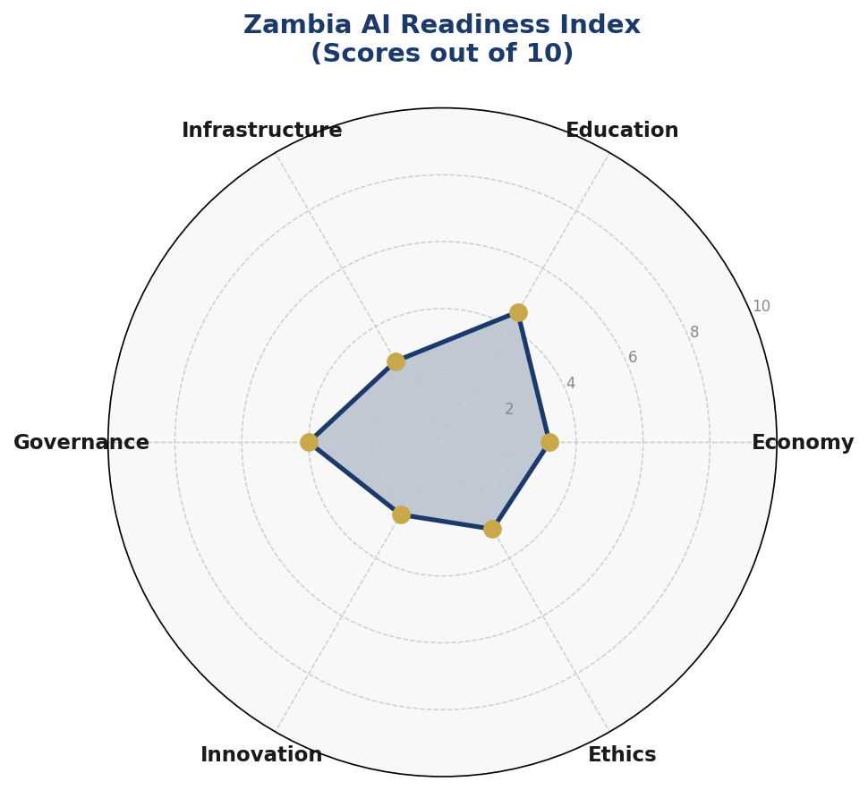
Figure 1.1: Zambia AI Readiness Index — Six-Dimension Radar Assessment (Scores out of 10)

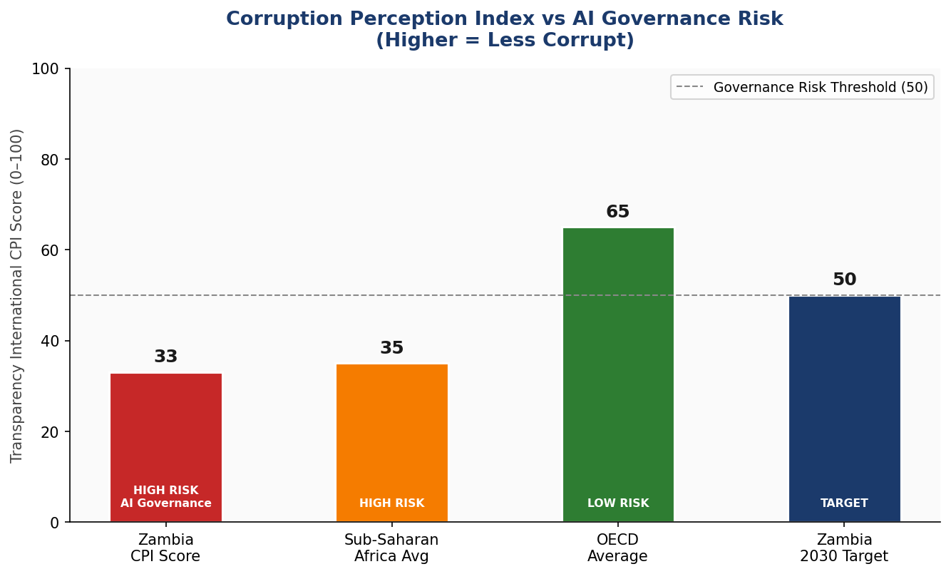
Figure 1.2: Corruption Perceptions Index Comparative Analysis — Governance Risk Tier Assessment

Section 2: Policy Vision and Strategic Pillars

National Vision Statement
By 2030, Zambia will be a nation where artificial intelligence serves as a catalyst for inclusive economic growth, ethical governance, and empowered citizens — where every Zambian, regardless of geography, gender, or socioeconomic background, benefits from AI-driven improvements in health, education, agriculture, and public services, and where Zambian AI talent and innovation are recognized contributors to the global knowledge economy.

This vision is expressed through five interlocking strategic pillars, each addressing a critical dimension of Zambia's AI development journey. Together, they form a unified framework that is simultaneously ambitious and grounded in Zambia's real capacities and constraints.

Pillar 1: Ethical AI and Human Rights Protection
Zambia commits to developing and deploying AI systems that respect human dignity, protect fundamental rights, and uphold the rule of law. This pillar establishes the ethical foundation on which all other AI activity rests. It mandates the creation of a National AI Ethics Board, requires impact assessments for high-risk AI applications, and embeds fairness, transparency, and accountability into procurement standards for all AI systems used by the government.
Key commitments under this pillar include: prohibition of AI-powered mass surveillance without judicial oversight; mandatory explainability standards for AI systems affecting individual rights (welfare, criminal justice, employment); protections for vulnerable populations including women, children, and ethnic minorities; and alignment with international human rights frameworks including the ICCPR and UDHR.

Pillar 2: Economic Growth and Industrial AI Adoption
Zambia's economic diversification agenda is fundamentally supported by targeted AI adoption in high-impact sectors. This pillar focuses on deploying AI in copper mining (predictive maintenance, safety optimization), agriculture (precision farming, yield prediction, market price forecasting), financial services (credit scoring for the unbanked, fraud detection), and health (disease surveillance, diagnostic support, supply chain optimization).
A dedicated AI Economic Zones program will offer regulatory sandboxes, tax incentives, and infrastructure support to companies deploying AI solutions that address Zambia's development challenges. The government will establish public-private partnership frameworks for AI in each priority sector, with co-investment requirements ensuring domestic technology transfer and skills development alongside any foreign AI solution deployment.

Pillar 3: Education, Upskilling, and AI Workforce Development
No AI strategy can succeed without the human capital to implement it. This pillar establishes a National AI Curriculum Framework spanning K-12, tertiary education, and vocational training. It sets ambitious targets: 3 million Zambians with basic AI literacy by 2030, 50,000 AI practitioners trained through universities and TVET institutions, and 500 AI specialists and researchers at postgraduate level. Special focus is placed on women and girls in AI, with gender parity targets for all government-funded AI scholarship programs.

Pillar 4: Public Sector AI and e-Governance
Government is both the largest potential user of AI in Zambia and the institution citizens most depend on for essential services. This pillar mandates AI-driven improvements in healthcare delivery, agricultural extension services, tax administration, judicial case management, and anti-corruption enforcement. It establishes an AI Procurement Framework to ensure government AI acquisitions are ethical, cost-effective, interoperable, and locally empowering rather than creating dependency on foreign technology vendors.

Pillar 5: AI Research, Innovation, and Startup Ecosystem
Zambia's long-term AI competitiveness depends on building domestic research and innovation capacity. This pillar establishes the Zambia AI Innovation Fund (ZAIIF) with seed funding of USD 20 million over five years, supports AI research centers at UNZA and Copperbelt University, creates an AI startup incubation program in Lusaka's new innovation district, and connects Zambian researchers to global AI networks including the Global Partnership on AI (GPAI) and the African Union's Digital Transformation Strategy.

Section 3: International Framework Alignment

This policy is explicitly designed to align with the leading international AI governance frameworks. Zambia's adoption of these globally recognized standards serves multiple purposes: it protects citizens through proven governance mechanisms; it signals commitment to responsible AI to international partners and investors; it positions Zambia favorably for bilateral AI cooperation agreements; and it prepares Zambian institutions for integration into global AI governance structures.

3.1 UNESCO Recommendation on the Ethics of AI (2021)
The UNESCO Recommendation — endorsed by all 193 UNESCO member states including Zambia — articulates 11 core values and principles for ethical AI. This policy embeds each of these values into specific sections and mechanisms. The UNESCO framework's emphasis on proportionality, safety, inclusiveness, environmental sustainability, privacy, and human oversight maps directly onto this policy's governance architecture, particularly Sections 6 and 9.

3.2 OECD AI Principles (2019, Updated 2024)
The OECD AI Principles, updated in 2024 to address generative AI and large language models, provide the most detailed operational guidance for national AI policy. Zambia, while not an OECD member, has chosen to align with these principles as they represent the consensus of the world's most advanced AI-deploying nations. The alignment matrix below maps each key principle to the relevant policy section.

3.3 EU AI Act (2024)
The EU AI Act — the world's first comprehensive AI regulation — introduces a risk-based framework for AI governance that this policy adapts for the Zambian context. The Act's four-tier risk classification (Unacceptable, High, Limited, and Minimal Risk) has been adopted in Section 6 of this policy, with adaptations to reflect Zambia's specific institutional capacity and priority use cases. Zambia's adoption of this framework also facilitates future AI trade and technology cooperation with the European Union.

3.4 World Bank AI Strategy for Development
The World Bank's framework for AI in developing countries emphasizes infrastructure investment, human capital development, and institutional capacity building as prerequisites for AI-driven economic growth. This policy's sequencing — infrastructure first, then skills, then deployment — directly reflects World Bank recommendations for lower-middle-income countries. The Bank's emphasis on anti-corruption guardrails in AI governance is particularly reflected in this policy's Section 6.

3.5 G20 AI Principles and ITU AI for Good
The G20 AI Principles, aligned with OECD standards, underscore responsible stewardship of AI and the importance of international cooperation. The ITU AI for Good Guidelines provide specific guidance on using AI to advance the UN Sustainable Development Goals, with particular relevance to SDG 1 (No Poverty), SDG 2 (Zero Hunger), SDG 3 (Good Health), SDG 4 (Quality Education), and SDG 16 (Peace, Justice and Strong Institutions) — all areas where this policy's AI deployment roadmap is targeted.

3.6 Comprehensive Framework Alignment Matrix

Framework | Principle | This Policy Section | Status
UNESCO AI Ethics (2021) | Proportionality & do no harm | Section 6 Risk Classification | ✅
UNESCO AI Ethics (2021) | Safety & security | Section 6 Ethics Board | ✅
UNESCO AI Ethics (2021) | Fairness & non-discrimination | Section 6 Algorithmic Accountability | ✅
UNESCO AI Ethics (2021) | Sustainability | Section 4 Investment Strategy | ✅
UNESCO AI Ethics (2021) | Privacy & data protection | Section 6 Data Protection Act | ✅
UNESCO AI Ethics (2021) | Human oversight | Section 9 AI Observatory | ✅
OECD AI Principles (2024) | Inclusive growth | Section 2 Pillar 2 & 5 | ✅
OECD AI Principles (2024) | Human-centered values | Section 2 Pillar 1 | ✅
OECD AI Principles (2024) | Transparency & explainability | Section 6 Standards | ✅
OECD AI Principles (2024) | Robustness & security | Section 7 Procurement Guidelines | ✅
OECD AI Principles (2024) | Accountability | Section 9 KPI Framework | ✅
EU AI Act (2024) | Unacceptable risk prohibition | Section 6 Banned AI Uses | ✅
EU AI Act (2024) | High-risk AI regulation | Section 6 Mandatory Audit | ✅
EU AI Act (2024) | Limited risk transparency | Section 6 Disclosure Rules | ✅
EU AI Act (2024) | General purpose AI | Section 7 Procurement | ⚠️
World Bank AI Strategy | Development-focused AI | Section 4 Priority Sectors | ✅
World Bank AI Strategy | Institutional capacity | Section 1 Governance | ✅
G20 AI Principles | Human-centered AI | Section 2 Vision | ✅
G20 AI Principles | Responsible stewardship | Section 6 Governance | ✅
ITU AI for Good | SDG alignment | Section 4 Economic Impact | ✅
ITU AI for Good | Digital inclusion | Section 5 Education Pipeline | ✅

Section 4: Economic Impact and Investment Roadmap

AI's potential contribution to economic growth in developing countries like Zambia has been documented by multiple authoritative sources. The McKinsey Global Institute estimates that AI could add 1.2 percent of GDP annually to sub-Saharan African economies by 2030; the World Bank's analysis of AI adoption in lower-middle-income countries suggests productivity gains of 0.5 to 1.0 percent annually in sectors where AI is deployed at scale. For Zambia, with its USD 28 billion economy and heavy sectoral concentration in mining and agriculture, targeted AI deployment in high-impact areas offers a realistic pathway to diversified growth.

4.1 Projected Economic Contribution
The projections below are based on conservative estimates calibrated to Zambia's current infrastructure and institutional capacity. Year 1 projections assume primarily pilot-scale deployments; Years 2-3 reflect scaling of successful pilots; Years 4-5 assume sector-wide AI adoption in priority areas. These figures assume steady-state implementation of this policy with consistent government investment and private sector co-financing.
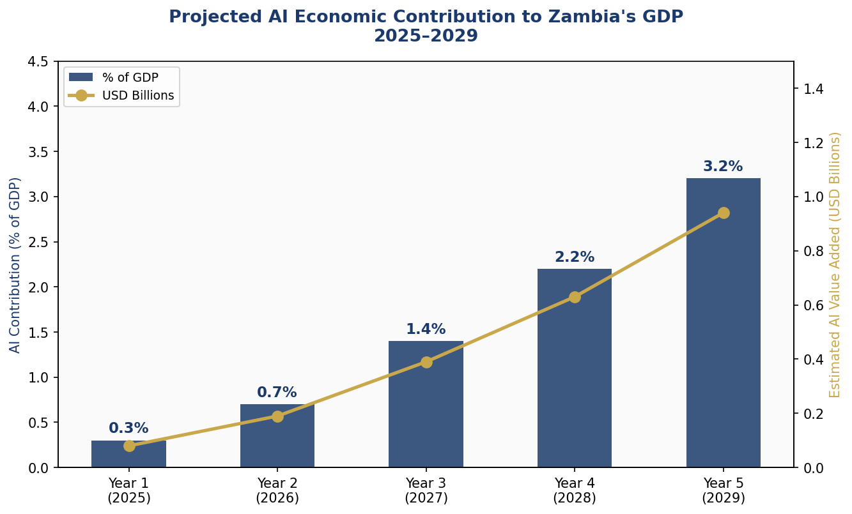
Figure 4.1: Projected AI Contribution to Zambia's GDP (2025–2029) — Conservative Scenario

4.2 Priority Sectors for AI Adoption
Four sectors have been identified as highest priority for AI deployment, selected on the basis of economic weight, social impact, existing data ecosystems, and near-term deployment feasibility:
- Mining and Extractives: Predictive maintenance for mining equipment (estimated 15-20% reduction in unplanned downtime), safety monitoring through computer vision, ore grade prediction to optimize extraction efficiency, and environmental impact monitoring. The mining sector's existing sensor infrastructure provides a strong foundation for AI deployment.
- Agriculture and Food Security: Precision agriculture using satellite imagery and weather data, crop disease detection through mobile-based computer vision, market price forecasting for smallholder farmers, and agricultural supply chain optimization. With 54% of Zambia's workforce in agriculture, even modest AI-driven productivity gains create transformative economic impact.
- Health Systems: Disease surveillance and outbreak prediction (particularly for malaria, cholera, and tuberculosis), diagnostic support tools for rural health workers, pharmaceutical supply chain optimization, and maternal health monitoring through mobile health platforms. Zambia's high disease burden creates both urgency and scale for AI health applications.
- Financial Services and FinTech: Credit scoring for the 60% of Zambians who lack formal credit histories, insurance risk assessment for smallholder farmers, fraud detection for mobile money platforms, and AI-powered regulatory compliance tools for the formal banking sector.

4.3 Investment Framework
The National AI Investment Framework allocates projected government AI spending across six priority categories, designed to build mutually reinforcing capabilities. Private sector co-investment is expected to match public investment 2:1 in infrastructure and R&D, and 1:1 in education and public sector AI by Year 3.
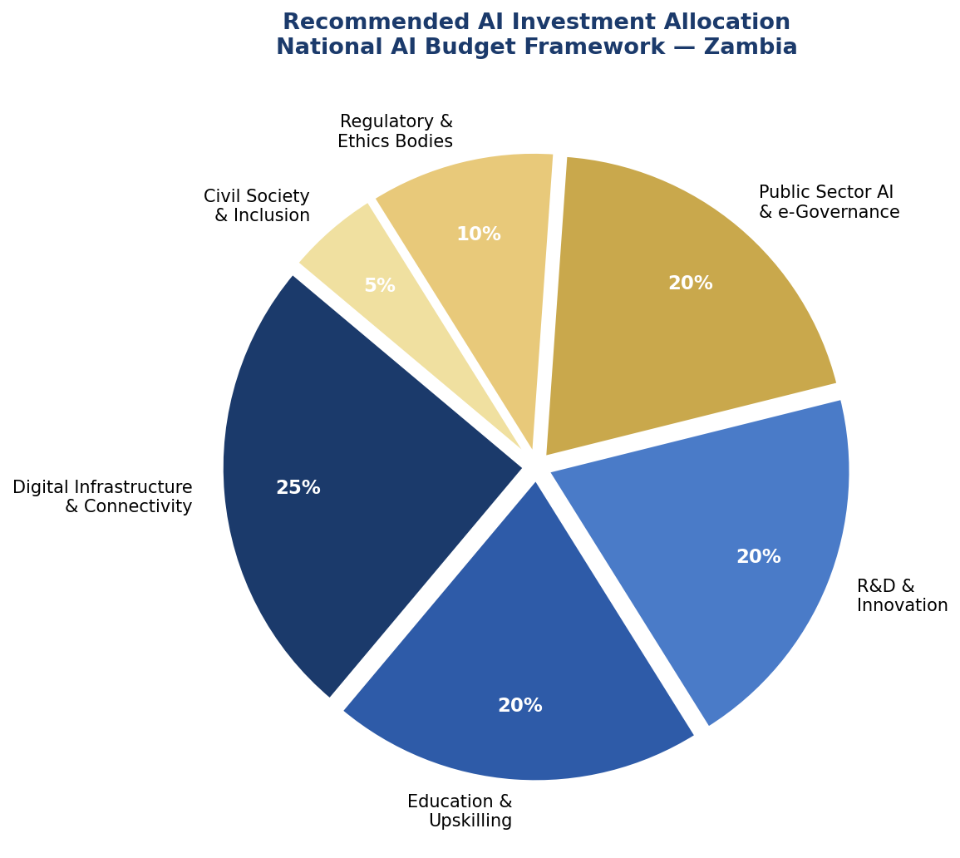
Figure 4.2: Recommended AI Investment Allocation — National Budget Framework

4.4 Public-Private Partnership Framework
The government will establish a National AI Investment Council (NAIC) co-chaired by the Ministry of Technology and Science and the Zambia Development Agency, with private sector representatives from mining, agriculture, financial services, and telecommunications. The NAIC will oversee a co-investment matching fund, coordinate regulatory sandbox applications, and ensure that AI investments are structured to maximize domestic technology transfer and skills development.
International technology companies seeking to deploy AI in Zambia will be required to establish local partnerships, commit to training programs for Zambian technologists, and contribute to the national AI data commons — a framework for sharing non-sensitive datasets that can be used to train AI models relevant to Zambian contexts.

Section 5: Education and Human Capital Development

The most sophisticated AI policy framework will fail without the human capital to implement, regulate, use, and innovate within it. Zambia's AI human capital strategy is deliberately ambitious, recognizing that the demographic dividend of a young population — with a median age of 17 — represents both a challenge and an extraordinary opportunity. The strategy is organized as a pipeline that moves citizens from awareness through literacy, practice, specialization, and research.

5.1 Current Skills Gap Analysis
Zambia currently has fewer than 200 professionals with formal AI/machine learning qualifications, concentrated in Lusaka and the Copperbelt. UNZA and Copperbelt University offer data science courses but not dedicated AI degree programs. No TVET institution currently offers AI-related qualifications. The private sector reports critical shortages in data science, machine learning engineering, and AI product management skills, which currently constrain technology adoption in all priority sectors. The gap between current capacity and the human capital required to implement this policy is significant but addressable within the 5-year timeframe through coordinated action across all education levels.

5.2 National AI Curriculum Framework
The curriculum framework operates at four levels simultaneously:
- K-12: AI literacy integrated into existing ICT and mathematics curricula from Grade 5 onward. Practical, hands-on modules using offline-compatible tools (reflecting rural connectivity constraints). Age-appropriate ethics discussions from Grade 7. Target: 500,000 students engaged with AI learning by end of Year 1, 3,000,000 by Year 5.
- Tertiary Education: New AI and Data Science degree programs at UNZA and CBU, launched Year 2. AI specialization tracks integrated into engineering, agriculture, health sciences, and public administration programs. Target: 5,000 AI-capable graduates per year by Year 5.
- TVET and Vocational: AI-adjacent skills programs (data collection and labeling, AI tool operation, digital support) at all 20 TEVET Authority institutions. Target: 10,000 TVET graduates with AI-relevant skills annually by Year 4.
- Continuing Professional Development: Online and hybrid upskilling programs for existing government workers, healthcare professionals, agricultural extension officers, and business owners. Certificates designed for working adults with limited time. Target: 50,000 professionals upskilled by Year 3.

5.3 AI Education Pipeline Targets
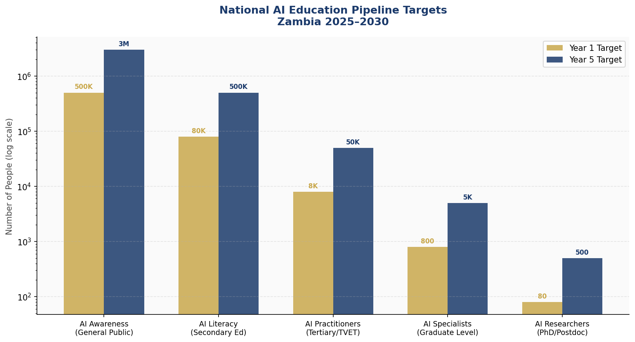
Figure 5.1: National AI Education Pipeline — Year 1 vs Year 5 Targets by Level

5.4 Gender Inclusion and Equity
Zambia commits to gender parity in all government-funded AI education programs by Year 3. Specific mechanisms include: 50% minimum gender quotas for all AI scholarship programs; targeted outreach programs to girls' schools in rural provinces; mentorship networks connecting female AI professionals with students; childcare support for women in AI training programs; and a national campaign — 'AI Iyo' (AI Is Yours) — to reframe AI as relevant to the everyday lives of Zambian women, from farmers to teachers to health workers.

5.5 International Partnerships
Zambia will pursue bilateral AI education partnerships with India (leveraging India's National Programme on AI), Rwanda (Kigali's emerging AI education model), and South Korea (KOICA AI cooperation programs). Within Africa, Zambia will seek to join the Pan-African AI Education Network being developed under the African Union's Digital Transformation Strategy. A National AI Scholarship Programme will fund 100 Zambian students per year to study AI at international institutions, with mandatory 3-year return-service agreements.

Section 6: Ethical AI Governance and Regulatory Framework

Zambia's AI governance architecture is designed to be effective, proportionate, and adapted to the country's institutional capacity and resource constraints. It draws heavily on international best practice — particularly the EU AI Act and UNESCO recommendation — while being grounded in Zambia's political economy, legal system, and governance challenges.

6.1 National AI Governance Commission (NAIGC)
The National AI Governance Commission will be established by Act of Parliament within 18 months of this policy's adoption. It will be an independent statutory body reporting to the National Assembly, with the following composition: three commissioners appointed by the President (one with AI/technology expertise, one with legal expertise, one with civil society/human rights background); two commissioners elected by the ICT Association of Zambia; two commissioners from academia (UNZA and CBU); and one representative from the Human Rights Commission.
The NAIGC's mandate encompasses: developing and updating AI technical standards; conducting mandatory conformity assessments for high-risk AI systems; issuing AI operating licenses to government agencies and regulated private sector actors; investigating complaints from citizens affected by AI decisions; publishing annual State of AI in Zambia reports; and recommending legislative updates to Parliament as the AI landscape evolves.

6.2 AI Risk Classification System
Adapted from the EU AI Act's four-tier risk framework, Zambia's AI Risk Classification System provides clear, operational guidance for developers, deployers, and regulators:

Risk Tier | Covered Applications | Color Code
Unacceptable Risk (PROHIBITED) | Mass biometric surveillance of citizens without judicial order; AI used to manipulate citizens against their interests; Social scoring systems; AI for torture or inhuman treatment; Real-time facial recognition in public spaces without court authorization | #C62828
High Risk (REGULATED) | AI in criminal justice and sentencing; Welfare and social benefits allocation; Healthcare diagnosis and treatment systems; Employment screening at scale; Critical infrastructure control; Educational assessment and credentialing | #E65100
Limited Risk (TRANSPARENCY) | Customer service chatbots; AI-generated content platforms; Recommendation algorithms in commercial media; AI in non-critical public communications | #1565C0
Minimal Risk (VOLUNTARY CODE) | AI in games and entertainment; AI in non-critical industrial applications; Internal business process optimization; Research and development AI tools | #2E7D32

6.3 Data Protection and Privacy Framework
Zambia's existing Data Protection Act (2021) provides a foundational but incomplete framework for AI-specific data governance. This policy calls for the following amendments and supplementary regulations: mandatory data protection impact assessments for all AI systems processing personal data at scale; a right to explanation for all automated decisions affecting individual rights; sector-specific data retention limits for AI training data; mandatory breach notification within 72 hours; and enhanced protections for sensitive categories including health data, financial data, biometric data, and data relating to children.

6.4 Algorithmic Accountability Standards
All high-risk AI systems deployed by government agencies must undergo mandatory pre-deployment algorithmic impact assessments conducted by accredited independent auditors. Assessment criteria include: accuracy and error rate analysis disaggregated by gender, age, and geographic region; bias testing against protected characteristics; explainability and interpretability review; security vulnerability assessment; and human oversight mechanism review. Audit results will be published in a public AI Audit Registry maintained by the NAIGC.

6.5 Anti-Corruption AI Governance
Given Zambia's corruption context (CPI score 33), this policy mandates additional safeguards for AI use in high-corruption-risk domains: all AI procurement contracts above USD 100,000 must be published in the AI Procurement Registry within 30 days of signing; AI systems used in tax assessment, customs, procurement, or law enforcement must log all decisions with full audit trails retained for 7 years; whistleblower protections specifically covering reporting of AI misuse by government agencies; and annual parliamentary hearings on the use of AI in government operations.

Section 7: Public Sector and e-Governance AI

Government is simultaneously Zambia's largest potential AI deployer and the institution that most directly affects citizens' daily lives. This section establishes the framework for responsible, effective AI adoption across the public sector, with priority use cases selected for high impact, deployment feasibility, and alignment with citizens' most pressing service needs.

7.1 Priority Government AI Use Cases
The following use cases have been prioritized based on citizen impact, existing data availability, and institutional readiness:
- Health: AI-assisted malaria prediction and prevention, early warning systems for cholera outbreaks, clinical decision support tools for rural health centers, and AI-optimized medical supply chain management. Pilot in 3 provinces by Year 2; national rollout by Year 4.
- Agriculture: AI-powered agricultural extension services delivering crop disease diagnosis, weather-adaptive planting advice, and market price information to smallholder farmers via USSD and basic smartphone apps. Integration with Zambia's Food Reserve Agency for early warning of food security risks.
- Education: AI-adaptive learning platforms for mathematics and literacy, teacher performance support tools, and AI-powered school inspection scheduling. Pilots in Lusaka Province schools by Year 2.
- Tax and Revenue: AI fraud detection in VAT and customs, automated compliance risk scoring, and AI-assisted audit targeting — projected to increase ZRA revenue collection by 8-12% within 3 years without increasing the taxpayer burden.
- Justice: AI case management and scheduling optimization for courts, legal aid matching, and predictive analytics for prison population management — reducing case backlog and improving access to justice without replacing judicial decision-making.
- Land Administration: AI-powered land title verification, drone-based surveying integration, and automated identification of illegal land occupation — directly addressing one of Zambia's most persistent governance challenges.

7.2 Government AI Procurement Guidelines
All government AI procurement must adhere to the following principles: Buy-and-Build preference (procure existing solutions and build domestic capacity to maintain and adapt them, rather than creating perpetual vendor dependency); Interoperability mandate (all government AI must use open standards and APIs); Data sovereignty (no government AI system may process sensitive citizen data outside Zambia's jurisdiction without explicit NAIGC authorization); and Local content requirements (minimum 30% local technology partner involvement in all AI contracts above USD 500,000).

7.3 Citizen-Facing AI Services Roadmap
By Year 3, Zambia's e-government portal (SmartZambia) will integrate AI capabilities including: conversational AI in English, Bemba, Nyanja, Tonga, and Lozi for citizen service navigation; automated document processing for birth certificates, business licenses, and tax filings; AI-powered complaints tracking with automatic escalation; and a citizen feedback loop for government AI service improvement.

7.4 Interoperability and Data Sharing Standards
A Government AI Data Architecture will establish common data standards across ministries, enabling AI systems to share data securely and responsibly. The architecture includes a National AI Data Commons (non-personal, aggregated data shared across government for AI training), sector-specific data lakes (health, agriculture, finance), and a cross-ministry AI platform for shared AI services to avoid duplication of investment.

Section 8: Implementation Roadmap

Zambia's AI implementation is structured in three phases, each building on the foundation of the previous. The phasing is designed to be realistic about institutional capacity constraints while maintaining the ambition necessary to achieve transformative change within 5 years. Phase timelines are indicative; the National AI Governance Commission will conduct annual reviews and adjust implementation pace based on measured progress against KPIs.

Phase 1: Foundation (Year 1 — 2025)
The foundation phase prioritizes the institutional and legal architecture that will enable everything else. Key Year 1 deliverables include: passage of the NAIGC Enabling Act; publication of the National AI Technical Standards (first edition); launch of 5 AI pilot projects across priority sectors; integration of AI literacy modules into 200 secondary schools; establishment of the Zambia AI Innovation Fund; and Zambia's formal accession to the GPAI and AU AI governance frameworks.

Phase 2: Scaling (Years 2–3 — 2026–2027)
The scaling phase deploys successful pilots at national scale, launches new AI degree programs, and achieves significant private sector AI adoption. Key deliverables include: national rollout of priority government AI services (health, agriculture, tax); launch of AI degree programs at UNZA and CBU; activation of the AI Economic Zones with first 10 tenant companies; 50 NAIGC conformity assessments completed; and 1.5 million Zambians reached by AI literacy programs.

Phase 3: Optimization (Years 4–5 — 2028–2029)
The optimization phase focuses on maximizing impact from established systems, integrating Zambia into global AI networks, and positioning Zambia as a regional AI knowledge hub. Key deliverables include: AI contribution reaching 3.2% of GDP; Zambia hosting first Pan-African AI Governance Forum; first cohort of 100 PhD-level AI researchers graduating; and review and update of this policy for 2031–2035.

8.1 Implementation Timeline
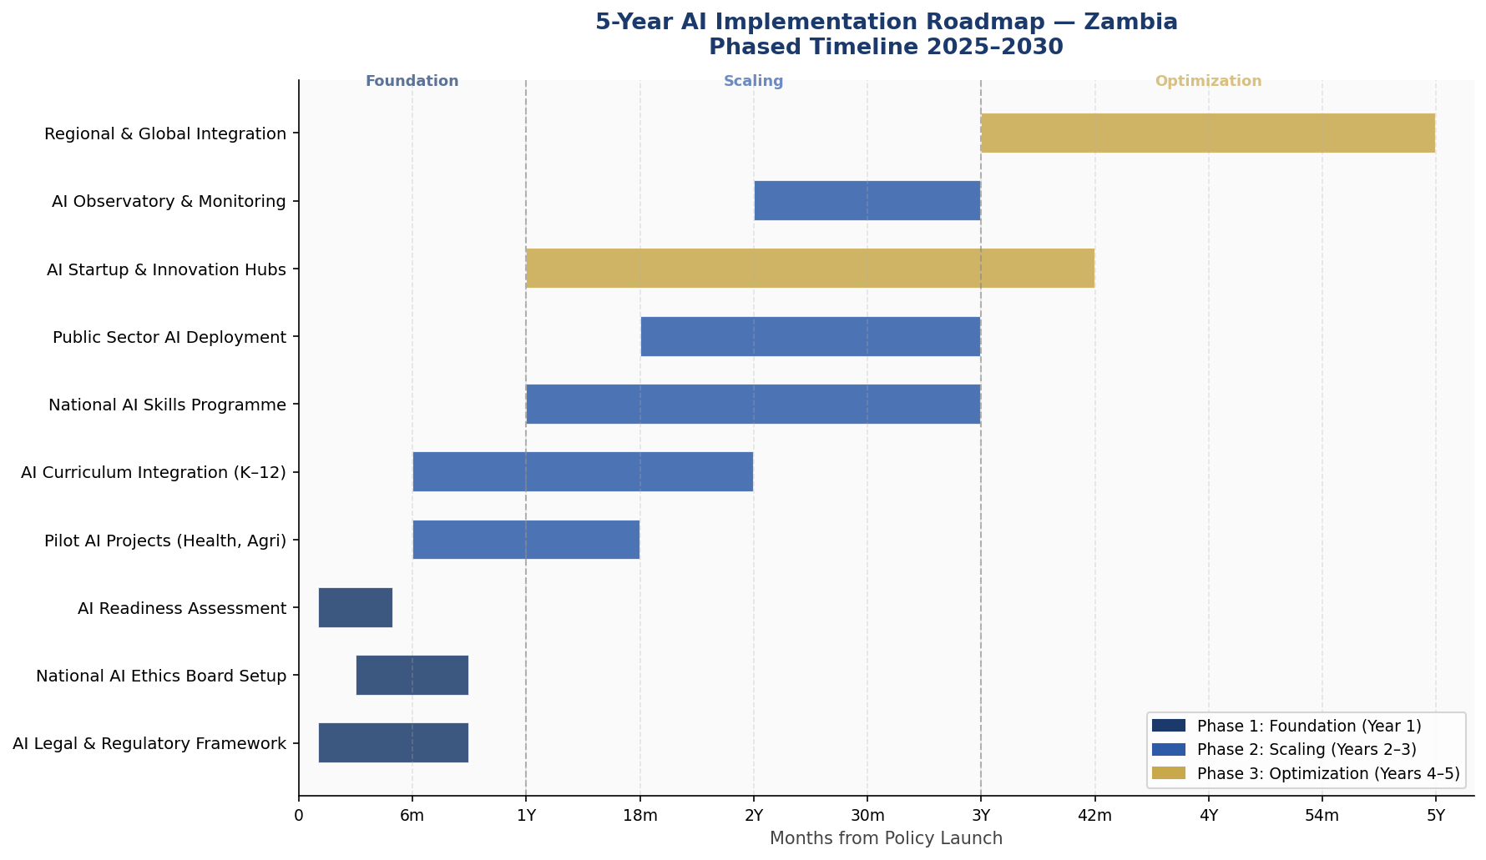
Figure 8.1: 5-Year AI Implementation Roadmap — Gantt-Style Phase Timeline

8.2 KPI Dashboard

KPI Metric | Baseline (2024) | Year 1 Target | Year 3 Target | Year 5 Target
Internet penetration | 17% | 22% | 35% | 50%
Zambians with AI literacy | < 5,000 | 500,000 | 1,500,000 | 3,000,000
AI practitioners trained | ~200 | 2,000 | 15,000 | 50,000
Government AI services online | 2 | 8 | 20 | 35
AI companies registered | ~10 | 50 | 150 | 350
NAIGC audits completed | 0 | 15 | 60 | 150
AI GDP contribution (%) | < 0.1% | 0.3% | 1.4% | 3.2%
Women in AI programs (%) | ~15% | 30% | 40% | 50%
CPI Score improvement | 33 | 35 | 40 | 45
Patents / AI publications | < 5 | 20 | 75 | 200

Section 9: Monitoring, Evaluation, and Accountability

Accountability is not a bureaucratic afterthought but a core design principle of this policy. Zambia's AI governance architecture includes multiple, overlapping accountability mechanisms designed to catch failures at different levels and ensure that AI development remains aligned with citizens' interests throughout the implementation period.

9.1 National AI Observatory
The National AI Observatory (NAO) will operate as a semi-independent unit within the NAIGC, with a dedicated research mandate. Its functions include: continuous monitoring of AI system performance across government; tracking of KPIs in the dashboard above; maintaining the public AI Audit Registry; publishing quarterly AI landscape reports; conducting citizen surveys on AI awareness and experience; and flagging emerging risks to the NAIGC Board.
The Observatory will be staffed by 12 full-time researchers by Year 2, including data scientists, legal experts, social scientists, and a gender specialist. It will maintain partnerships with UNZA and CBU research departments and international AI research institutions including Oxford Internet Institute, AI Now Institute, and the Partnership on AI.

9.2 Annual State of AI Report
The NAIGC will publish a comprehensive Annual State of AI in Zambia Report to be tabled in the National Assembly and made publicly available in full. The report will cover: progress against all KPIs; sector-by-sector AI adoption assessment; NAIGC enforcement actions taken; citizen complaint statistics and resolution rates; international framework compliance assessment; and forward-looking recommendations for policy adjustment.

9.3 Parliamentary Oversight
A dedicated Parliamentary Committee on AI and Digital Technology will receive the Annual State of AI Report and hold public hearings with the NAIGC Commissioner, relevant Ministers, civil society organizations, and technology companies. The Committee will have power to recommend legislative amendments, call for independent investigations of AI incidents, and commission independent expert reviews of specific AI systems used by government.

9.4 Civil Society and Independent Oversight
Zambia's civil society ecosystem will be actively engaged in AI governance through: a Civil Society AI Oversight Network with accreditation and funded participation in NAIGC processes; an AI Citizen Hotline for reporting AI-related harms or concerns; an annual AI Civil Society Forum; and provisions allowing civil society organizations to request independent audits of government AI systems where there is evidence of systemic harm.

Section 10: International Cooperation and AI Diplomacy

AI governance increasingly requires international coordination. Data flows across borders; AI systems developed in one country affect citizens in others; global AI standards require broad participation to be effective. Zambia's international AI cooperation strategy is designed to ensure that the country is a net beneficiary of global AI governance arrangements rather than a passive recipient of standards set by others.

10.1 Bilateral AI Cooperation Priorities
Zambia will pursue bilateral AI cooperation agreements with the following priority partners within 3 years:
- India: Leveraging India's emerging status as a global AI powerhouse and its Digital Public Infrastructure model, which is highly relevant to Zambia's public sector AI aspirations. Focus areas: AI for agriculture, digital identity, and health.
- Rwanda: Africa's most advanced AI governance model, with the Rwanda Utilities Regulatory Authority's AI regulatory framework offering directly applicable lessons. Focus: regulatory capacity building and knowledge transfer.
- China: Through FOCAC's Digital Silk Road programs, significant AI infrastructure investment potential, with this policy's procurement safeguards ensuring technology sovereignty. Focus: infrastructure and connectivity.
- United Kingdom: Through the UK-Zambia Development Partnership, UK FCDO support for AI governance institutional building. Focus: NAIGC capacity building and AI ethics.
- European Union: Through the EU-AU Digital Economy Partnership, access to EU AI technical standards and governance expertise. Focus: regulatory alignment and market access.

10.2 African Union and Regional AI Governance
Zambia will actively contribute to and align with the African Union's Continental AI Strategy and the AU Digital Transformation Strategy 2020–2030. In the SADC region, Zambia will seek to initiate a Regional AI Interoperability Framework — beginning with data sharing standards for cross-border agricultural and health surveillance — which would create a regional AI governance model that the continent could scale. Zambia's strong relationships within COMESA provide an additional regional cooperation channel for e-commerce and financial services AI.

10.3 Global AI Governance Participation
Zambia will apply for full membership in the Global Partnership on AI (GPAI) by Year 2 and will actively participate in the UN High-Level Advisory Body on AI. Zambia's national AI positions will be coordinated across the ITU, UNESCO, and UN system through a dedicated AI Diplomacy Unit within the Ministry of Foreign Affairs. The country will advocate in global fora for AI governance frameworks that reflect the development needs and institutional capacities of lower-middle-income countries, rather than simply replicating standards designed for high-income nations.

10.4 South-South Knowledge Transfer
Zambia commits to sharing AI policy learning with other African nations at comparable development stages. Within 5 years, Zambia aims to position itself as a regional hub for AI governance knowledge, hosting training programs for AI regulators from SADC countries and contributing AI governance expertise to AU technical working groups. This positions Zambia not as a passive recipient of global AI governance but as an active shaper of the standards that will govern AI development across the Global South.

Conclusion

The National AI Policy 2025–2030 charts a clear and achievable course for Zambia to harness artificial intelligence in service of its people, its economy, and its governance aspirations. It is a policy built on realism about current constraints and ambition about future potential — recognizing that AI is not a solution to all of Zambia's development challenges but, when properly governed and strategically deployed, can be a powerful accelerant for progress on the challenges that matter most.
The success of this policy will ultimately depend not on the quality of the written document but on the commitment of the institutions, professionals, citizens, and partners who implement it. The National AI Governance Commission, the universities, the teachers, the farmers and health workers who use AI tools, the parliamentarians who provide oversight, and the civil society organizations that hold government accountable — all of these actors are co-authors of the AI future this policy imagines.
Zambia's youth — 60 percent of the population under 25 — represent both the primary beneficiaries and the primary implementers of this vision. A 15-year-old student in Mongu who studies AI literacy under this policy's curriculum framework will be a practicing AI professional by 2035. A smallholder farmer in Eastern Province who uses an AI-powered crop advisory app developed under this policy's innovation ecosystem by 2027 may become the entrepreneur who builds the next generation of that tool. This policy is ultimately an investment in their potential.
Zambia moves forward: deliberately, inclusively, and with the confidence that a nation that has navigated independence, economic reform, and democratic transition can also navigate the AI century — on its own terms, in alignment with global standards, and in service of every Zambian.

References and Bibliography

- African Union. (2022). Continental Artificial Intelligence Strategy. African Union Commission, Addis Ababa.
- European Parliament and Council of the European Union. (2024). Regulation (EU) 2024/1689 on Artificial Intelligence (EU AI Act). Official Journal of the European Union.
- G20. (2019). G20 AI Principles. Annex to G20 Ministerial Statement on Trade and Digital Economy, Tsukuba, Japan.
- International Telecommunication Union. (2023). AI for Good: Applying AI to Advance the SDGs. ITU Publications, Geneva.
- McKinsey Global Institute. (2023). The Economic Potential of Generative AI: The Next Productivity Frontier. McKinsey & Company.
- OECD. (2024). OECD AI Principles (Updated). OECD Publishing, Paris.
- Oxford Insights. (2023). Government AI Readiness Index 2023. Oxford Insights, Oxford.
- Transparency International. (2024). Corruption Perceptions Index 2024. Transparency International, Berlin.
- UNESCO. (2021). Recommendation on the Ethics of Artificial Intelligence. United Nations Educational, Scientific and Cultural Organization, Paris.
- World Bank. (2023). World Development Report 2023: Migrants, Refugees, and Societies. World Bank Group, Washington DC.
- World Bank. (2024). World Development Indicators: Zambia Country Data. World Bank Open Data.
- World Economic Forum. (2023). AI Governance Alliance: Guardrails for Responsible AI Development. WEF White Paper.
- Zambia Information and Communications Technology Authority. (2024). ICT Survey Report. ZICTA, Lusaka.
- Zambia Statistics Agency. (2023). Zambia in Figures 2023. ZamStats, Lusaka.
- Ministry of Technology and Science, Republic of Zambia. (2023). Smart Zambia National ICT Master Plan 2023–2027. Government of the Republic of Zambia, Lusaka.

About the Author

Nafiul Ahmad Rafi
Policy & Good Governance Researcher | BD Civic Tech Architect
Nafiul Ahmad Rafi is a civic technologist, policy researcher, author, photographer, and musician based in Dhaka, Bangladesh. He is the Founder and Director of Insights Bangladesh, a data-driven governance and policy impact analysis institution, and the Founder and Lead Architect of NagorikBD.org — a transparency-first civic platform scaled across Mymensingh Division, connecting citizens with government services across 45 Upazilas.
His work exists at the intersection of institutional reform and artificial intelligence, transforming theoretical governance into scalable, data-driven reality. Without a conventional computer science degree, he self-taught the tools of modern AI and web development to build the infrastructure that enforces the policies he once only researched.

Key Platforms and Projects
- NagorikBD.org — Civic transparency platform, Mymensingh Division
- Insights Bangladesh — Policy impact analysis institution
- FactCheck BD (factcheckbd.org) — Bangladesh's AI-powered fact-checking platform
- Political Insights BD / PIBD (pibbd.org) — Political intelligence and civic tech hub
- PeaceShield BD / National Peace Tracker — AI-powered hate speech and conflict monitoring
- PolicyLens AI (aigovbd.org) — 9-dimensional AI policy audit tool

He has published four books and maintains a personal site at ahmad-rafi.com.

Research Interests
AI Governance · Policy Research · Future of Bangladesh · Climate Policy

Contact
- Website: ahmad-rafi.com
- LinkedIn: linkedin.com/in/nafiul-ahmad-rafi
- Email: contact@ahmad-rafi.com

"I build code to ensure transparency, and I write lyrics to inspire the courage to use it."

