🇿🇼
REPUBLIC OF ZIMBABWE
National Artificial Intelligence Policy
2026–2031

A Comprehensive Framework for Ethical, Inclusive,
and Economically Transformative Artificial Intelligence

Prepared by
Nafiul Ahmad Rafi
Policy & Good Governance Researcher | BD Civic Tech Architect
Insights Bangladesh | NagorikBD.org
May 2026

Table of Contents

Executive Summary 3
Section 1: National AI Readiness Assessment 4
Section 2: Policy Vision & Strategic Pillars 7
Section 3: International Framework Alignment 10
Section 4: Economic Impact & Investment Roadmap 14
Section 5: Education & Human Capital Development 17
Section 6: Ethical AI Governance & Regulatory Framework 20
Section 7: Public Sector & e-Governance AI 24
Section 8: Implementation Roadmap 27
Section 9: Monitoring, Evaluation & Accountability 30
Section 10: International Cooperation & Diplomacy 33
Conclusion 36
References & Bibliography 37
About the Author 39

Executive Summary

Zimbabwe stands at a pivotal moment in its developmental trajectory. Having navigated decades of economic turbulence, the nation now confronts both a profound challenge and an extraordinary opportunity: the global rise of artificial intelligence. With a GDP per capita of approximately USD 1,500, an internet penetration rate of 35%, and a youthful population of over 15 million people — 65% under the age of 35 — Zimbabwe possesses the demographic foundation upon which an AI-enabled economic renaissance can be built.
This National Artificial Intelligence Policy (2026–2031) represents Zimbabwe's formal commitment to harnessing the transformative potential of AI while safeguarding human rights, democratic governance, and national sovereignty. The policy is grounded in Zimbabwe's Vision 2030 aspirations for an upper-middle-income economy and aligns comprehensively with the African Union's AI Continental Strategy, UNESCO's Recommendation on the Ethics of AI, the OECD AI Principles, and the G20 AI Principles.
The policy is structured around five strategic pillars: Ethical AI and Human Rights Protection; Economic Growth and Industrial AI Adoption; Education, Upskilling and AI Workforce Development; Public Sector AI and e-Governance; and AI Research, Innovation and Startup Ecosystem. These pillars are operationalised through a phased five-year implementation roadmap spanning foundation-building in Year 1, scaling from Years 2–3, and optimisation and internationalisation in Years 4–5.
Zimbabwe's AI journey will be measured against six key outcome targets by 2031: AI contributing 3.2–5.0% of GDP; 8 million citizens with foundational AI literacy; 120,000 trained AI practitioners; 10 government ministries deploying AI-assisted services; a functioning National AI Ethics Board; and formal bilateral AI cooperation agreements with at least 8 nations. This policy is not merely aspirational — it is a blueprint for urgent, structured, and nationally transformative action.

Section 1: National AI Readiness Assessment

1.1 Economic Context
Zimbabwe's economy is characterised by resilience in the face of structural adversity. The country's GDP stood at approximately USD 26 billion in 2025, with a per capita income of roughly USD 1,500 — placing it in the lower-middle-income tier by World Bank classification. Key economic sectors include agriculture (contributing 12% of GDP), mining (16%), manufacturing (11%), and services (52%). The economy has shown modest growth averaging 3.8% annually between 2022 and 2025, driven largely by mineral exports (gold, platinum, lithium), tobacco production, and remittances.
Zimbabwe holds significant lithium deposits — a critical mineral for the global AI hardware supply chain — positioning the country as a potential upstream contributor to the global AI economy. The Harare-based tech scene has produced a small but vibrant cohort of fintech startups, including EcoCash, Mukuru, and several agritech platforms, demonstrating latent entrepreneurial capacity. However, hyperinflation legacies, dollarisation challenges, and limited access to international capital markets constrain large-scale private investment in AI.

1.2 Education & Human Capital
Zimbabwe boasts one of the highest literacy rates in Sub-Saharan Africa at 89.7%, a remarkable achievement and one of the country's most significant AI-readiness assets. The University of Zimbabwe, Harare Institute of Technology (HIT), and the National University of Science and Technology (NUST) offer computer science and engineering programmes, though curricula are not yet aligned with contemporary AI and machine learning demands. The tertiary enrollment rate stands at approximately 9%, with a persistent gender gap in STEM fields — women represent only 28% of STEM graduates.
The secondary school ICT curriculum remains hardware-deficient: fewer than 20% of secondary schools have functional computer labs, and only 8% have reliable internet connectivity. Vocational training institutions lack AI-specific modules entirely. Despite these gaps, Zimbabwean students consistently perform above Sub-Saharan African averages in mathematics and science — a foundational competency for AI education.

1.3 Digital Infrastructure
Zimbabwe's digital infrastructure presents a mixed picture. Mobile penetration stands at approximately 95% (SIM connections), with smartphone penetration at around 55%. Mobile money platforms like EcoCash reach over 7 million users, demonstrating robust mobile data ecosystem readiness. However, fixed broadband penetration is a meagre 2.3%, and internet speeds average 12 Mbps — significantly below the global median of 55 Mbps. Rural connectivity remains the most critical infrastructure deficit: over 65% of the rural population lacks reliable internet access.
The National Data Centre, established in Harare, provides government cloud hosting but operates at less than 30% capacity with limited cybersecurity protocols. Energy unreliability — with daily load-shedding of up to 12 hours in some regions — poses a structural barrier to data centre expansion and AI workload hosting. Zimbabwe's participation in the TEAMS and EASSy undersea cable systems provides international bandwidth, but domestic last-mile connectivity investments remain inadequate.

1.4 Governance & Institutional Capacity
Zimbabwe operates as a constitutional republic with significant executive power vested in the presidency. Democratic institutions, while formally established, face challenges of judicial independence, civil society space, and freedom of press. The government has demonstrated increasing interest in digital governance: the Postal and Telecommunications Regulatory Authority (POTRAZ) regulates digital communications, while the Ministry of Information Communication Technology (ICT) has published a National Digital Economy Strategy (NDES) 2030. However, AI-specific regulatory capacity is entirely absent, creating both a governance gap and an opportunity for this policy to establish foundational frameworks.

1.5 Corruption Risk Assessment
Transparency International's 2024 Corruption Perceptions Index (CPI) assigns Zimbabwe a score of 24 out of 100, ranking it 157th out of 180 countries — placing it in the high-corruption risk tier. This score carries direct implications for AI governance: procurement processes for AI systems, data collection mandates, and algorithmic decision-making in public services all carry elevated risks of capture, bias, or misuse in high-corruption contexts. This policy specifically addresses anti-corruption safeguards in AI procurement and deployment (Section 6.4), and recommends independent civil society oversight of all public sector AI implementations.

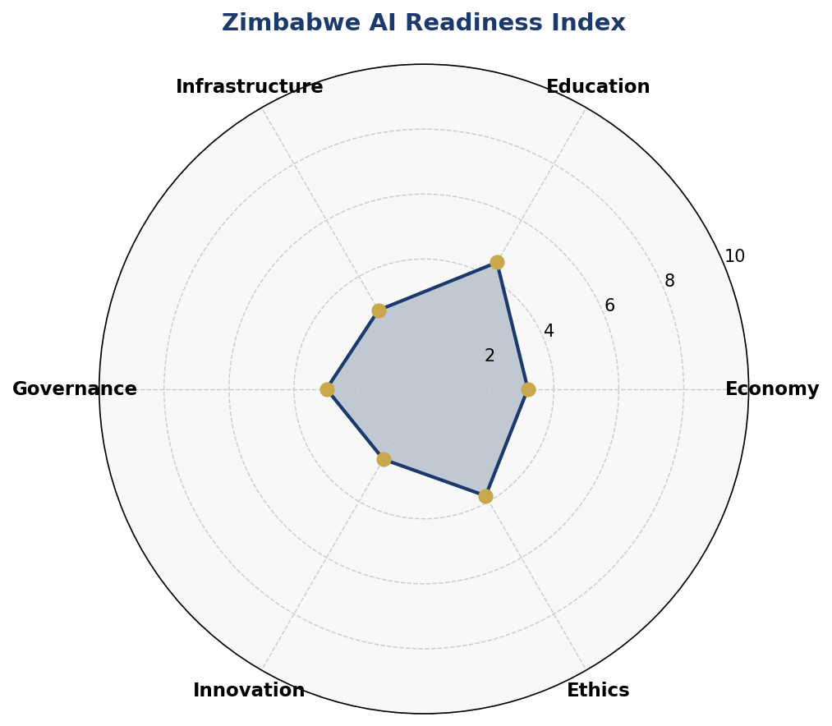
Figure 1.1: Zimbabwe AI Readiness Index — Six-Dimension Assessment (Scores out of 10)
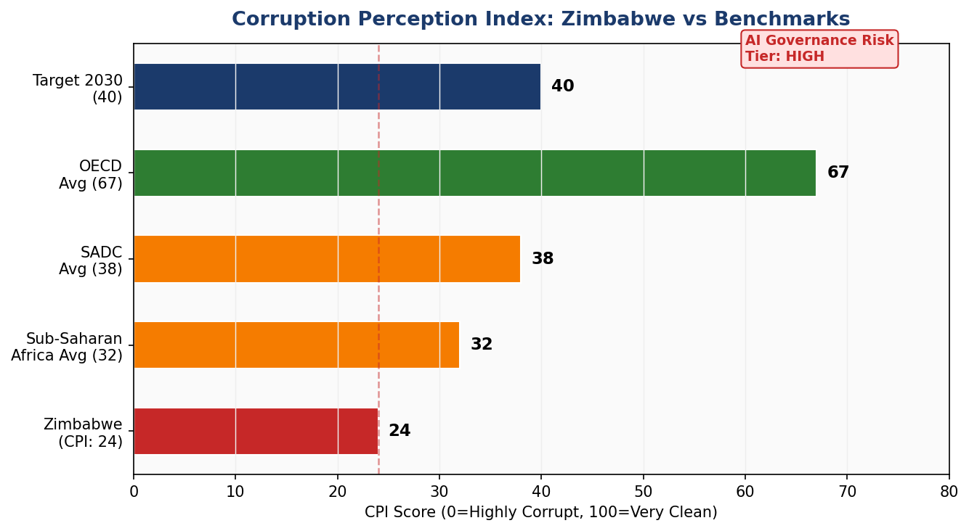
Figure 1.2: Corruption Perception Index — Zimbabwe vs Regional and Global Benchmarks

Section 2: Policy Vision & Strategic Pillars

2.1 Policy Vision
"By 2031, Zimbabwe will be a nation where Artificial Intelligence amplifies human potential, drives inclusive economic growth, strengthens transparent governance, and positions Zimbabwe as the AI Innovation Hub of Southern Africa — leaving no citizen behind in the age of intelligent machines."

2.2 Policy Mission
The mission of this policy is to establish Zimbabwe as a regional leader in responsible AI adoption by building a robust ecosystem that integrates ethical principles, economic ambition, educational transformation, and state capacity — rooted in Zimbabwe's cultural values of Ubuntu: humanity, community, and shared prosperity.

2.3 Strategic Pillars

Pillar 1: Ethical AI & Human Rights Protection
Zimbabwe shall adopt a rights-based approach to AI development and deployment. All AI systems used in public or private contexts shall be designed, audited, and governed in accordance with the National AI Ethics Charter (to be enacted within 12 months of this policy's adoption). Key commitments include prohibition of social scoring systems, mandatory algorithmic transparency for all government AI deployments, explicit prohibition of AI-based surveillance without judicial oversight, and protection of data rights for all citizens with particular attention to vulnerable groups.
- Establish a National AI Ethics Board with multi-stakeholder representation (government, civil society, academia, private sector)
- Mandate algorithmic impact assessments for all high-risk AI applications in public services
- Ratify the African Union's AI Ethics Framework and implement domestically within 18 months
- Develop AI-specific amendments to the Zimbabwe Cyber and Data Protection Act (2021)

Pillar 2: Economic Growth & Industrial AI Adoption
AI presents a transformational opportunity to modernise Zimbabwe's core economic sectors. Agriculture — which employs over 60% of the workforce — can be transformed through AI-powered precision farming, crop disease detection, weather analytics, and supply chain optimisation. The mining sector, particularly lithium and gold extraction, can leverage AI for safer operations, predictive maintenance, and environmental monitoring. Financial services, already digitally mature through mobile money, are primed for AI-driven credit scoring, fraud detection, and inclusive financial products.
- Launch a National AI for Industry Programme targeting agriculture, mining, manufacturing, and financial services
- Establish an AI Enterprise Fund providing seed capital and technical assistance to AI-driven SMEs
- Create Zimbabwe AI Special Economic Zones in Harare and Bulawayo with regulatory sandboxes and tax incentives
- Partner with the Zimbabwe Investment and Development Agency (ZIDA) to attract AI-focused FDI

Pillar 3: Education, Upskilling & AI Workforce Development
Human capital is Zimbabwe's most significant competitive advantage for AI development. This pillar transforms the education system to produce AI-capable citizens at every level — from primary school computational thinking to PhD-level AI research. The National AI Curriculum Framework will be integrated across K–12, tertiary, and vocational training systems, with particular focus on reducing the gender gap in AI education.
- Integrate computational thinking and AI fundamentals into the national O-Level and A-Level curriculum by 2027
- Establish AI Centres of Excellence at University of Zimbabwe, HIT, and NUST with 500 postgraduate fellowships annually
- Launch a Zimbabwe AI Skills Bootcamp Programme training 10,000 professionals annually
- Achieve gender parity in AI education — target: 50% female enrollment in AI programmes by 2029

Pillar 4: Public Sector AI & e-Governance
Government is both the largest potential deployer of AI in Zimbabwe and the sector where AI governance failures carry the greatest societal risk. This pillar establishes a rigorous, transparency-first framework for government AI adoption, beginning with low-risk administrative efficiency applications and progressively moving to citizen-facing services as governance capacity matures.
- Deploy AI in ZIMRA (tax administration), ZINARA (road network management), and the Ministry of Health for disease surveillance within Year 2
- Develop the Zimbabwe Government AI Procurement Standard — mandatory for all government AI contracts
- Create the Zimbabwe National Digital Identity (NatID 2.0) platform with AI-enhanced service delivery and privacy-by-design
- Launch the Zimbabwe Open Government AI Dashboard for real-time monitoring of public sector AI deployments

Pillar 5: AI Research, Innovation & Startup Ecosystem
Zimbabwe's long-term AI competitiveness depends on developing indigenous research capacity and a thriving startup ecosystem. This pillar prioritises building research infrastructure, incentivising private innovation, and positioning Zimbabwe in global AI knowledge networks. Zimbabwe's unique contexts — agricultural informality, mining operations, multilingual populations, and post-colonial development challenges — create genuine research opportunities for Africa-relevant AI innovations.
- Establish the Zimbabwe National AI Research Fund with USD 5 million annual budget by Year 2
- Create the Harare AI Innovation Hub — a co-working and incubation space for AI startups with 200 annual cohort slots
- Facilitate 10 joint research projects with international universities annually by Year 3
- Develop AI datasets in Shona, Ndebele, and other Zimbabwean languages for NLP research

Section 3: International Framework Alignment

3.1 UNESCO Recommendation on the Ethics of AI (2021)
The UNESCO Recommendation on the Ethics of AI, adopted by all 193 UNESCO Member States including Zimbabwe in November 2021, provides the most comprehensive global normative framework for AI governance. This policy aligns with all eleven core values articulated in the Recommendation.
Proportionality and Do No Harm: Zimbabwe's AI Risk Classification System (Section 6.3) adopts a harm-proportionate regulatory approach, applying the strictest controls to high-stakes applications in criminal justice, healthcare, and social welfare. Safety and Security: The policy mandates pre-deployment risk assessments and continuous monitoring for all public sector AI. Fairness and Non-Discrimination: Algorithmic impact assessments must specifically test for bias against Zimbabwe's historically marginalised groups. Sustainability: AI applications in climate adaptation, precision agriculture, and energy management are prioritised. Privacy: The policy calls for explicit AI-specific amendments to the Cyber and Data Protection Act. Human Oversight: All high-risk government AI deployments require a human-in-the-loop for consequential decisions. Transparency and Explainability: Public sector AI must publish model cards and algorithmic audit reports. Responsibility and Accountability: Mandatory liability frameworks for AI developers and deployers. Education and Awareness: National AI literacy is a core deliverable of this policy. Multi-stakeholder and Adaptive Governance: The National AI Ethics Board includes civil society and private sector representatives with biennial policy review cycles. International and Multi-stakeholder Cooperation: Zimbabwe commits to active participation in AU, UN, and GPAI AI governance processes.

3.2 OECD AI Principles (2019, Updated 2024)
Zimbabwe adopts the five OECD AI Principles as foundational to its national framework. The Inclusive Growth principle drives this policy's explicit focus on rural AI connectivity and gender equity in AI education. The Human-centred Values principle is operationalised through the National AI Ethics Board and mandatory human rights impact assessments. Transparency and Explainability requirements are embedded in the Government AI Procurement Standard. Robustness, Security and Safety standards will be incorporated into the Zimbabwe AI Certification Scheme. Accountability is assured through the National AI Observatory and annual parliamentary reporting requirements.

3.3 EU AI Act (2024) — Risk-Based Framework Adaptation
While Zimbabwe is not subject to EU jurisdiction, the EU AI Act represents the world's most comprehensive legally binding AI regulation and provides the risk classification architecture that this policy adapts for the Zimbabwean context. The four-tier risk framework — Unacceptable, High, Limited, and Minimal — is adopted with appropriate modifications for Zimbabwe's institutional capacity and developmental priorities. Specific adaptations include recognising that regulatory capacity must be built progressively; the full suite of EU AI Act compliance requirements will be phased in over the five-year implementation period, beginning with prohibited uses and high-risk applications.

3.4 African Union AI Continental Strategy
The African Union's AI for Africa: Artificial Intelligence Continental Strategy for Africa (2020) is the primary regional framework to which this policy aligns. Zimbabwe commits to: contributing to pan-African AI data sharing initiatives; supporting the development of AI standards through the African Organisation for Standardisation (ARSO); participating in the Continental AI Governance Network; and advocating for Africa-representative training datasets in global AI development. Zimbabwe specifically endorses the AU's position that AI development must reflect African linguistic diversity, cultural contexts, and development priorities.

3.5 Comprehensive Framework Alignment Matrix

Framework | Pillar 1  Ethics | Pillar 2  Economy | Pillar 3  Education | Pillar 4  Gov AI | Pillar 5  Innovation
UNESCO AI Ethics (2021) | ✅ Full | ✅ Full | ✅ Full | ✅ Full | ⚠️ Partial
OECD AI Principles (2024) | ✅ Full | ✅ Full | ⚠️ Partial | ✅ Full | ✅ Full
EU AI Act (2024) | ✅ Full | ⚠️ Partial | 🔲 Planned | ✅ Full | ⚠️ Partial
AU AI Strategy (2020) | ✅ Full | ✅ Full | ✅ Full | ⚠️ Partial | ✅ Full
G20 AI Principles | ✅ Full | ✅ Full | ⚠️ Partial | ⚠️ Partial | ⚠️ Partial
World Bank AI Strategy | ⚠️ Partial | ✅ Full | ✅ Full | ✅ Full | ⚠️ Partial
ITU AI for Good / SDGs | ✅ Full | ✅ Full | ✅ Full | ⚠️ Partial | ✅ Full
UN Secretary-General AI Advisory | ✅ Full | ⚠️ Partial | ✅ Full | ✅ Full | 🔲 Planned
Table 3.1: Zimbabwe AI Policy — International Framework Alignment Matrix | ✅ Full Alignment ⚠️ Partial Alignment 🔲 Planned

Section 4: Economic Impact & Investment Roadmap

4.1 AI's Projected Economic Contribution
According to McKinsey Global Institute estimates, AI adoption in lower-middle-income economies with structural characteristics similar to Zimbabwe — high agricultural employment, growing mobile digital ecosystems, and significant infrastructure gaps — can generate GDP contributions of 3–5% within five years of sustained policy implementation. Zimbabwe's specific sectoral opportunities include USD 800 million in agricultural productivity gains through AI-powered precision farming; USD 400 million in mining sector efficiency improvements through predictive maintenance and autonomous operations; USD 300 million in healthcare system efficiency gains through AI-assisted diagnostics; and USD 500 million in financial inclusion through AI-driven credit scoring and fraud detection. These projections, while modelled conservatively, are predicated on the successful implementation of this policy's infrastructure, education, and governance provisions.
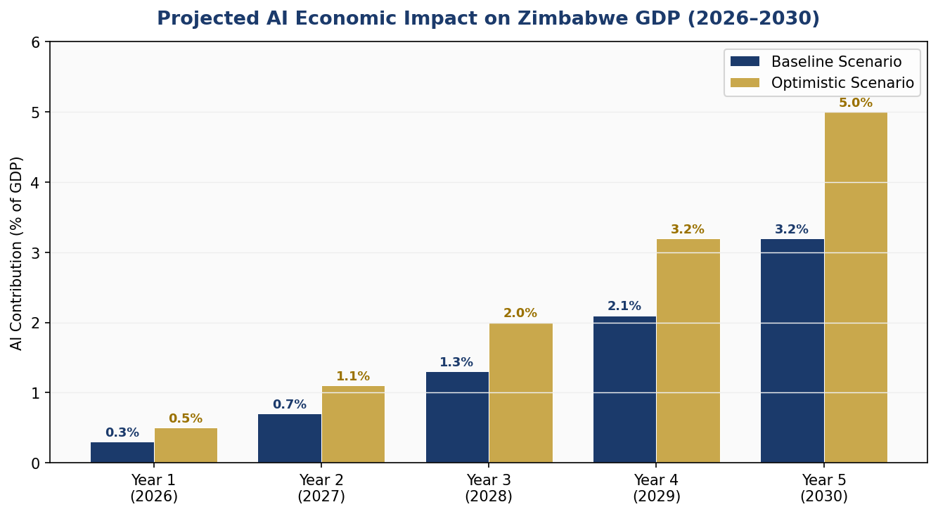
Figure 4.1: Projected AI Economic Contribution to Zimbabwe GDP, 2026–2030 (Baseline and Optimistic Scenarios)

4.2 Priority Sectors for AI Adoption
Agriculture employs 66% of Zimbabwe's labour force and is the sector where AI can generate the most immediate and broadly shared economic impact. Priority applications include satellite and drone imagery analysis for crop health monitoring; AI-powered commodity price forecasting for smallholder farmers; digital extension services delivering personalised agronomic advice via SMS and voice AI; and climate-adaptive crop rotation recommendations based on rainfall and soil data modelling.
The mining sector — Zimbabwe's largest foreign exchange earner — offers opportunities for AI-powered ore grade analysis, real-time ventilation and safety monitoring in underground operations, environmental impact modelling, and supply chain traceability systems that can command premium prices in ethical mineral markets. Zimbabwe's lithium reserves are particularly significant: as global demand for EV batteries drives lithium prices, AI-optimised extraction and refining can capture substantial value.
Healthcare represents a humanitarian and economic priority. AI applications in medical imaging diagnosis, disease outbreak prediction, supply chain management for pharmaceuticals, and community health worker decision support can address Zimbabwe's severe physician shortfall (0.2 per 1,000 population, against a WHO target of 1.0) through intelligent task-shifting.

4.3 National AI Investment Framework
The Government of Zimbabwe, in partnership with development finance institutions and private sector partners, commits to mobilising USD 120 million over the five-year policy period for AI ecosystem development. Funding sources include the national treasury (30%), international development partners including World Bank and AfDB (35%), private sector investment facilitated through tax incentives and regulatory sandboxes (25%), and diaspora and philanthropic capital (10%).
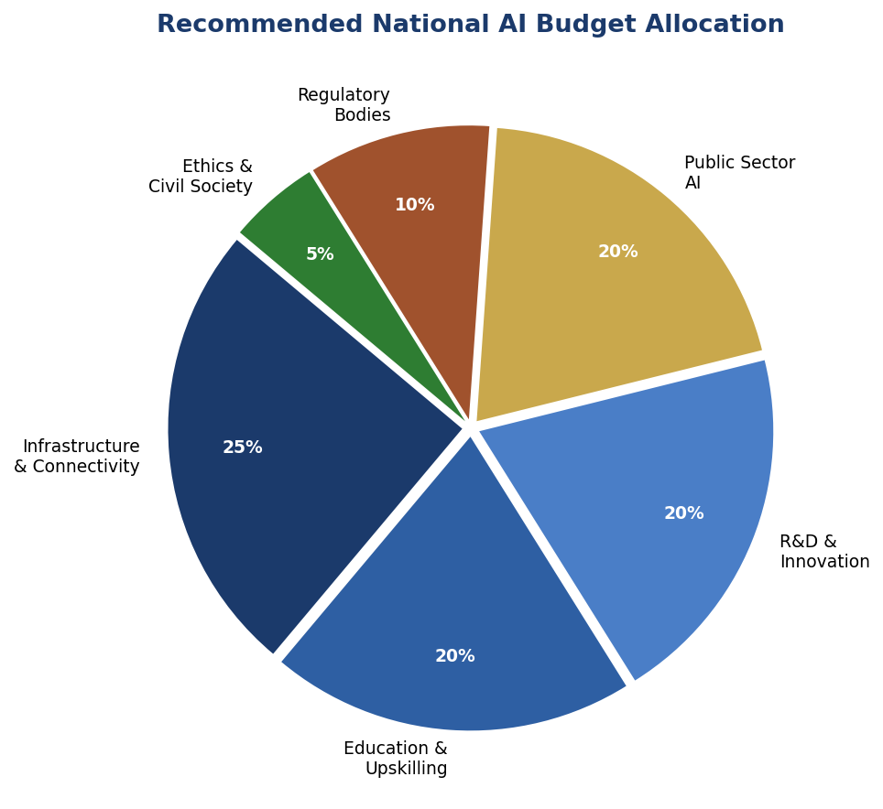
Figure 4.2: Recommended National AI Budget Allocation by Category

4.4 Public-Private Partnership Framework
Zimbabwe's AI investment will leverage public-private partnerships (PPPs) structured around clearly defined roles: the public sector provides policy certainty, data access, and regulatory clarity; the private sector provides capital, technological expertise, and market reach; and development partners provide grant funding, technical assistance, and capacity building. All PPPs involving AI in public service delivery will require open-book auditing, published APIs for data interoperability, and mandatory community benefit sharing arrangements.

Section 5: Education & Human Capital Development

5.1 Current Skills Gap Analysis
Zimbabwe currently has an estimated 2,500–3,500 practitioners with advanced AI or machine learning skills, the vast majority concentrated in Harare and Bulawayo. This represents a per-capita AI skills density of approximately 0.02 per 1,000 population — compared to 0.4 in South Africa, 0.8 in Kenya, and 2.1 in the global average. The AI skills gap is compounded by brain drain: an estimated 40% of Zimbabwe's university STEM graduates emigrate within five years of graduation, primarily to South Africa, the United Kingdom, and Canada. This policy addresses the skills gap through supply-side expansion of AI education and demand-side creation through AI industry development, while creating economic incentives for diaspora return.

5.2 National AI Curriculum Framework
Primary Schools (Grade 1–7) will introduce computational thinking, logical reasoning, and digital citizenship — building the cognitive foundations for AI literacy without requiring technology access. Secondary Schools (Form 1–6) will introduce programming fundamentals (Python), data literacy, and AI ethics as mandatory components of the ICT curriculum by 2027. A-Level AI elective will be developed for Form 5–6 students. Tertiary Institutions will establish AI degree programmes at undergraduate and postgraduate levels, with a minimum of 5,000 AI-focused graduates annually by 2029. Vocational Training Centres will develop AI-for-Industry modules tailored to the agriculture, construction, and manufacturing sectors, targeting 20,000 vocational certifications annually by 2030.
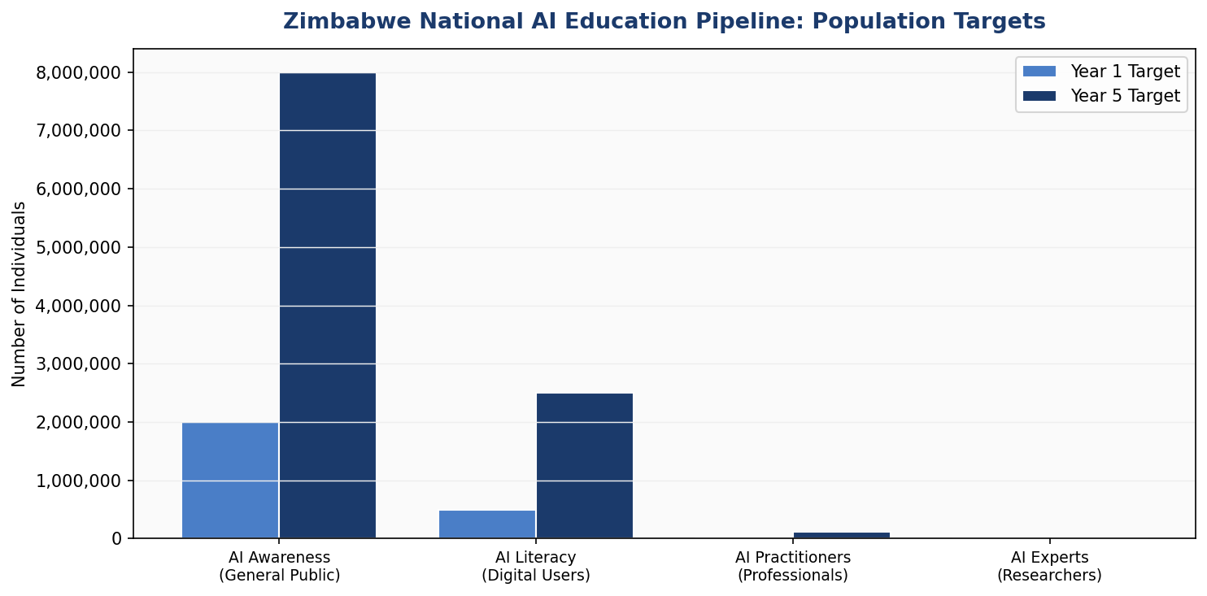
Figure 5.1: Zimbabwe National AI Education Pipeline — Population Targets by Level (Year 1 vs Year 5)

5.3 Women & Underrepresented Groups
This policy adopts explicit gender equity targets for AI education: 45% female participation in AI tertiary programmes by 2028 and 50% by 2031. To achieve these targets, dedicated scholarships for women in AI (500 annually), safe digital learning spaces in rural areas, female AI mentorship networks, and targeted outreach to girls' secondary schools will be implemented. Marginalised communities — including rural populations, persons with disabilities, and informal sector workers — will be served through mobile AI learning units, audio-based AI literacy content in Shona and Ndebele, and subsidised smartphone access programmes.

5.4 International Partnerships & Knowledge Transfer
Zimbabwe will establish formal AI education partnerships with the African Institute for Mathematical Sciences (AIMS), the Mastercard Foundation Scholars Programme, Google Africa's Digital Skills initiative, and the African Development Bank's Digital Academy. Bilateral AI education agreements will be pursued with India's IIT network (given India's significant AI capacity-building experience), Rwanda's Kigali Innovation City, and South Africa's AI Institute at Stellenbosch University. A Zimbabwe AI Diaspora Fellowship will provide 100 annual grants for diaspora AI professionals to return and teach in Zimbabwean universities.

Section 6: Ethical AI Governance & Regulatory Framework

6.1 National AI Ethics Board
The National AI Ethics Board (NAEB) shall be established by Act of Parliament within 12 months of this policy's adoption. The NAEB will comprise 15 members: 3 government representatives (ICT Ministry, Justice Ministry, POTRAZ); 3 civil society representatives; 3 academics from Zimbabwean universities; 2 private sector representatives (at least one from an AI company); 2 international AI ethics experts; and 2 citizen representatives selected through a transparent public nomination process. At least 40% of NAEB members shall be women. The NAEB will be structurally independent of the executive with secure parliamentary funding, and its decisions on AI bans and restrictions will be legally binding.

6.2 Mandate & Enforcement
The NAEB's mandate includes: reviewing and approving all government AI deployments; investigating complaints of AI-related harm from citizens; commissioning independent audits of high-risk AI systems; publishing annual AI Governance Reports; and advising Parliament on AI legislation. The NAEB will be empowered to impose fines of up to USD 1 million on organisations deploying AI systems that cause demonstrable harm, and to order the suspension of AI systems pending safety reviews. All NAEB meetings and audit reports will be publicly accessible.

6.3 AI Risk Classification System
Zimbabwe adopts a four-tier AI Risk Classification System adapted from the EU AI Act framework:
- AI systems used for real-time biometric mass surveillance in public spaces
- Social credit scoring systems that aggregate citizen behaviour across domains
- AI systems that exploit psychological vulnerabilities, particularly targeting children
- AI systems for subliminal manipulation influencing political behaviour
- Predictive policing systems that profile individuals based on demographic characteristics
- AI systems in criminal justice (sentencing, bail, parole decisions)
- AI in healthcare diagnostics and treatment recommendations
- AI in educational assessment and scholarship selection
- AI in employment hiring, promotion, and termination decisions
- AI in border control and migration management
- AI in credit scoring and financial product eligibility
- Chatbots and virtual assistants must disclose AI nature to users
- AI-generated content (text, images, video) must be labelled
- Emotion recognition systems must obtain informed consent
- AI-powered spam filters, recommendation systems, and customer service automation
- AI in entertainment, gaming, and creative tools

6.4 Anti-Corruption AI Safeguards
Given Zimbabwe's high-corruption risk tier (CPI: 24), this policy includes specific anti-corruption provisions for all government AI deployments. All government AI procurement contracts must be published on the e-Procurement Zimbabwe platform with full technical specifications. AI systems must not be procured from companies in which government officials hold financial interests — enforced through mandatory beneficial ownership disclosure. Independent civil society organisations will have the right to audit government AI deployments with access to training data documentation and model performance reports. AI systems used in revenue collection (ZIMRA), social grants, or resource allocation must publish explainability reports accessible to affected citizens.

6.5 Data Protection & Privacy
This policy calls for targeted amendments to the Zimbabwe Cyber and Data Protection Act (2021) to address AI-specific data governance challenges. Required amendments include: explicit requirements for algorithmic transparency in automated decision-making; data minimisation requirements for AI training datasets; prohibition on cross-purpose data use without explicit re-consent; mandatory data localisation for sensitive government datasets; and right to meaningful explanation for any individual subject to significant automated decisions. A Data Protection Commissioner with AI-specific technical capacity will be appointed within 18 months.

Section 7: Public Sector & e-Governance AI

7.1 Priority Government AI Use Cases
The deployment of AI across Zimbabwe's public sector will follow a risk-proportionate, capacity-matched sequencing. Year 1 will focus on administrative efficiency and low-risk analytics; Year 2 will introduce citizen-facing services in high-impact domains; Years 3–5 will integrate AI across the full government digital stack.

Healthcare (Ministry of Health & Child Care)
AI-powered disease surveillance using mobile data and health facility records to predict outbreaks of cholera, malaria, and typhoid with 72-hour advance warning. AI-assisted chest X-ray diagnosis for tuberculosis in rural clinics, reducing diagnostic time from 14 days to under 2 hours. AI-powered supply chain optimisation for essential medicines, reducing stockout rates by an estimated 40%.

Agriculture (Ministry of Lands, Agriculture, Fisheries, Water & Rural Development)
Satellite-based AI crop monitoring covering all 39 districts, providing early warning for drought stress, pest infestations, and flood risk. AI-powered commodity price forecasting disseminated via USSD to registered smallholder farmers. Digital agricultural extension services delivering personalised farming advice in Shona and Ndebele via voice AI.

Tax Administration (ZIMRA)
AI-powered risk-based audit selection to improve tax compliance and reduce arbitrariness in enforcement. Natural language processing for automated processing of VAT returns and customs declarations. AI fraud detection in import and export declarations.

Education (Ministry of Primary and Secondary Education)
AI-powered student performance analytics to identify at-risk students for early intervention. Personalised learning recommendations for students in under-resourced schools. AI-assisted teacher professional development and curriculum support tools.

7.2 Government AI Procurement Standard
All government ministries and agencies procuring AI systems must comply with the Zimbabwe Government AI Procurement Standard (ZGAPS), to be developed by the Ministry of ICT within 12 months. ZGAPS will require: open competitive tendering with technical evaluation panels including AI ethics expertise; mandatory algorithmic impact assessments prior to deployment; source code escrow arrangements for all government AI systems; vendor diversity requirements to prevent monopolistic AI infrastructure dependencies; and performance benchmarks tied to payment milestones.

7.3 Citizen-Facing AI Services Roadmap
By 2029, citizens should be able to access the following AI-enhanced government services: real-time ZIMRA tax status enquiries and payment through AI chat; AI-powered guidance for business registration and licensing through ZIDA; personalised social grant eligibility advice and application assistance; multi-lingual AI citizen information service in Shona, Ndebele, Tonga, Kalanga, and English; and AI-assisted legal aid information for citizens unable to access formal legal services.

Section 8: Implementation Roadmap

8.1 Overview
The implementation of this policy follows a three-phase, five-year roadmap. Phase 1 (Foundation, Year 1: 2026) focuses on institutional establishment, legal framework, and pilot programmes. Phase 2 (Scaling, Years 2–3: 2027–2028) drives national rollout of AI education, industry adoption, and priority government deployments. Phase 3 (Optimisation, Years 4–5: 2029–2031) consolidates gains, integrates international AI cooperation, and positions Zimbabwe as an AI exporter.
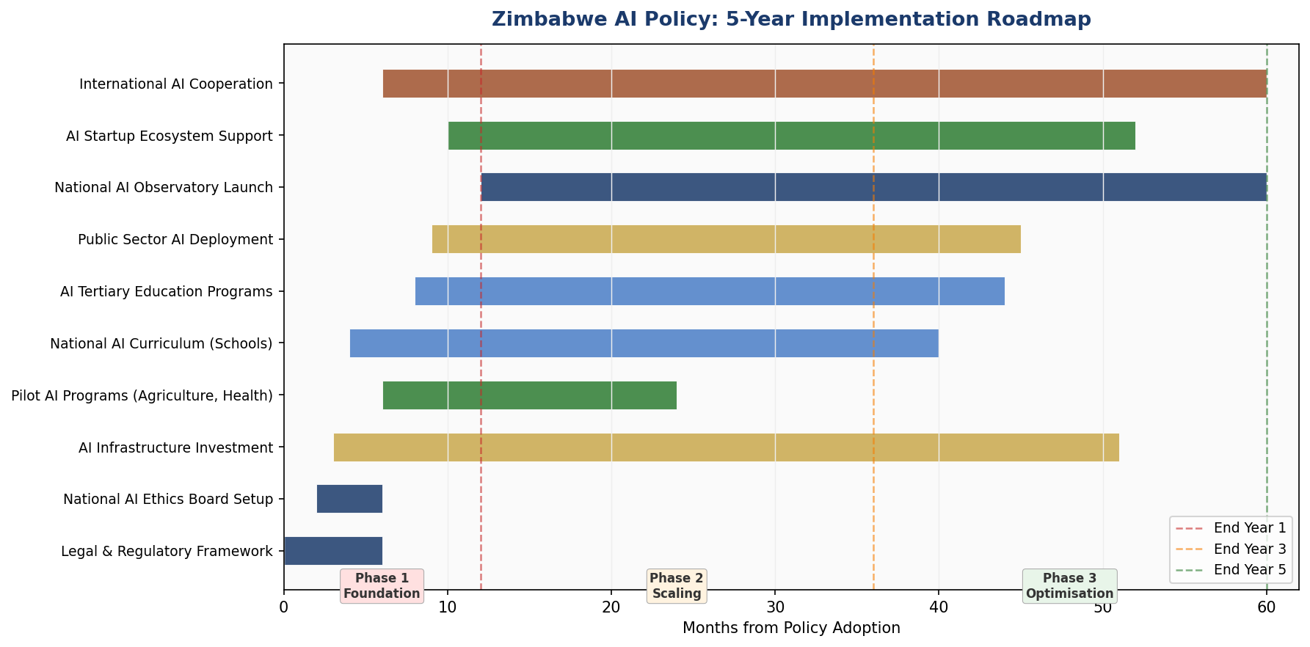
Figure 8.1: Zimbabwe AI Policy — 5-Year Implementation Roadmap (2026–2031)

8.2 Phase 1 — Foundation (Year 1: 2026)
The foundation phase establishes the institutional, legal, and technical prerequisites for AI adoption. Key deliverables include: enactment of the National AI Ethics Board Act; publication of the Zimbabwe Government AI Procurement Standard; launch of 5 AI pilot programmes in agriculture, health, tax, education, and civil registration; establishment of the AI Centre of Excellence at HIT Harare; and signature of the first three bilateral AI cooperation agreements. A dedicated AI policy implementation unit within the Ministry of ICT will coordinate cross-ministerial actions.

8.3 Phase 2 — Scaling (Years 2–3: 2027–2028)
The scaling phase transitions from pilots to national programmes. AI education enters the secondary school curriculum; the AI Enterprise Fund begins disbursements; ZIMRA, Ministry of Health, and Ministry of Agriculture deploy full AI systems; the Harare AI Innovation Hub opens; and the National AI Observatory begins publishing quarterly AI State Reports. Targets for this phase include 1 million citizens with foundational AI literacy and 25,000 trained AI practitioners.

8.4 Phase 3 — Optimisation (Years 4–5: 2029–2031)
The optimisation phase consolidates, reviews, and internationalises Zimbabwe's AI ecosystem. Biennial policy review is conducted; Zimbabwe applies for observer status at the Global Partnership on AI (GPAI); AI export programmes are piloted with SADC partner countries; and Zimbabwe hosts the first Zimbabwe AI Summit attracting regional governments, investors, and researchers. By 2031, AI should be contributing measurably to national GDP, with tracking through the National AI Observatory.

8.5 Phase KPIs
KPI | Year 1 Target | Year 3 Target | Year 5 Target
AI-literate citizens | 200,000 | 3,000,000 | 8,000,000
Trained AI practitioners | 3,000 | 40,000 | 120,000
Government AI deployments | 5 pilots | 7 ministries | 12 ministries
AI startups registered | 20 | 150 | 400
Bilateral AI agreements | 3 | 6 | 10
AI % of GDP contribution | 0.3–0.5% | 1.3–2.0% | 3.2–5.0%
NAEB audits conducted | — | 15 | 50
Rural internet coverage | 35% | 55% | 75%
Table 8.1: Zimbabwe AI Policy — Key Performance Indicators by Phase

Section 9: Monitoring, Evaluation & Accountability

9.1 National AI Observatory
The National AI Observatory (NAIO) will be established as a semi-autonomous unit under the Ministry of ICT, staffed by AI policy specialists, data scientists, and civil society liaisons. The NAIO's mandate is to track, measure, and publicly report on the progress of this policy's implementation, the state of AI adoption across public and private sectors, emerging AI risks, and Zimbabwe's position in regional AI competitiveness rankings. The NAIO will publish: quarterly AI Deployment Dashboards (public, online); annual AI State Reports (submitted to Parliament and publicly released); incident reports on AI system failures or harms (within 30 days of confirmed incident); and biennial policy effectiveness reviews.

9.2 Parliamentary Oversight
The Parliamentary Portfolio Committee on ICT and Cyber Security will receive quarterly briefings from the NAIB and annual reports from the NAIO. The Committee will be empowered to subpoena government AI system documentation, conduct public hearings on AI governance, and recommend policy amendments to the Minister. Civil society organisations will have standing to present evidence to Committee hearings on AI-related harms. The Committee will publish its own annual AI Governance Assessment Report, independent of executive government.

9.3 Civil Society & Independent Audit Role
Registered civil society organisations in Zimbabwe will have statutory rights under this policy to: request algorithmic audit information for any public sector AI system; submit formal complaints to the NAEB on behalf of affected citizens; participate as observers in government AI procurement evaluations; and publish independent AI impact assessments without restriction. The policy allocates USD 500,000 annually from the AI budget to support civil society AI watchdog capacity, distributed through a competitive grants process administered by the NAEB.

9.4 KPI Dashboard
Metric | Baseline (2026) | Y1 Target | Y3 Target | Y5 Target
AI literacy rate (% population) | 0.2% | 1.3% | 18% | 50%
Female AI practitioners (%) | 18% | 25% | 38% | 50%
Internet penetration (rural) | 12% | 20% | 45% | 70%
Gov AI systems audited annually | 0 | 5 | 20 | 45
AI-related job growth (formal) | 2,500 | 5,000 | 35,000 | 120,000
AI Ethics complaints resolved | — | 95% in 60d | 95% in 45d | 95% in 30d
AI export revenues (USD M) | 0 | 0.5 | 8 | 25
CPI Score (Transparency Intl) | 24 | 26 | 32 | 38
Table 9.1: Zimbabwe AI Policy KPI Dashboard — Baseline and Phased Targets

Section 10: International Cooperation & Diplomacy

10.1 Bilateral AI Cooperation Priorities
Zimbabwe will prioritise AI cooperation agreements with nations that offer complementary strengths to Zimbabwe's developmental needs and AI ambitions. Priority bilateral partners include: Rwanda (African AI governance model, ICT-led development experience); India (large-scale AI capacity building through initiatives like India-Africa tech partnerships, IIT knowledge transfer); China (infrastructure financing, AI applications in agriculture and healthcare in African contexts); the United Kingdom (research collaboration, diaspora AI community engagement); Germany (vocational AI training, industrial AI in mining sector); and Kenya (East African AI ecosystem co-development, data sharing for NLP research).

10.2 Regional AI Governance — SADC & AU
Zimbabwe will play an active role in the Southern African Development Community (SADC) AI working group, advocating for common AI ethics standards, cross-border data sharing agreements, and coordinated AI regulatory frameworks that reduce compliance fragmentation for regional businesses. At the African Union level, Zimbabwe will participate in the Continental AI Governance Network and contribute to the development of the AU Digital Transformation Strategy 2030. Zimbabwe specifically advocates for: African representation in global AI governance bodies (UN, G20, GPAI); Africa-specific training datasets developed and maintained on the continent; and South-South AI capacity transfer within the AU framework.

10.3 Global AI Governance Participation
Zimbabwe will seek to join the Global Partnership on Artificial Intelligence (GPAI) as an Associate Member by 2028, contributing African and developing-country perspectives to global AI governance deliberations. Zimbabwe will participate in: the ITU AI for Good Global Summit; the UNESCO Internet Governance Forum AI track; the UN Secretary-General's High-Level Advisory Body on AI; and G77+China AI coordination processes to ensure developing country interests are represented in emerging global AI governance norms.

10.4 South-South Knowledge Transfer
Zimbabwe commits to sharing its AI governance experience and tools with SADC partner nations — particularly Zambia, Mozambique, and Malawi — which face similar developmental contexts and AI governance challenges. The Zimbabwe AI Policy Toolkit (including the NAIB Act template, Government AI Procurement Standard, and AI Risk Classification framework) will be made freely available to all AU member states under a Creative Commons licence, consistent with the spirit of pan-African solidarity and shared development.

Conclusion

Zimbabwe's National Artificial Intelligence Policy 2026–2031 represents a bold, principled, and pragmatic commitment to harnessing the fourth industrial revolution in service of the Zimbabwean people. It acknowledges, honestly, the structural challenges that Zimbabwe must navigate: infrastructure deficits, governance quality concerns, economic constraints, and the brain drain that has deprived the nation of much of its human capital. But it refuses to allow these challenges to become reasons for inaction.
The nations that will lead the AI era are not necessarily those with the greatest existing resources, but those with the greatest institutional clarity, the most coherent national strategy, and the strongest commitment to ethical foundations. Zimbabwe's high literacy rate, youthful population, vibrant entrepreneurial energy, and enormous agricultural and mineral potential are genuine competitive assets. This policy provides the framework to transform these assets into AI-enabled prosperity.
The five strategic pillars — Ethical AI, Economic Transformation, Education, Public Sector AI, and Innovation — are mutually reinforcing. Progress in one pillar accelerates progress in all others. An ethically governed AI ecosystem attracts investment; investment creates AI jobs; AI jobs create demand for AI education; AI education builds the human capital for public sector AI; public sector AI generates data and experience that fuels innovation. Zimbabwe's AI journey is, in this sense, a virtuous cycle waiting to be ignited.
The international frameworks to which this policy aligns — from UNESCO and OECD to the African Union — are not constraints imposed from outside. They are the accumulated wisdom of the global community about how to develop AI in ways that expand human freedom rather than curtail it, create shared prosperity rather than concentrate it, and build trust rather than erode it. Zimbabwe chooses to build its AI future on these foundations.
Implementation begins now. The institutional structures, the legal frameworks, the education programmes, and the pilot deployments — all must begin within the first year. Urgency is not incompatible with thoughtfulness. Zimbabwe's people cannot wait for a perfect AI governance regime; they need the benefits of AI — better healthcare, more productive farms, more transparent government — now. This policy charts the path.
"AI is not Zimbabwe's future. AI is Zimbabwe's tool to build the future its people deserve."

References & Bibliography

International Frameworks & Standards
- UNESCO. (2021). Recommendation on the Ethics of Artificial Intelligence. Paris: UNESCO. https://unesdoc.unesco.org/ark:/48223/pf0000381137
- OECD. (2024). OECD Principles on Artificial Intelligence (Updated). Paris: OECD Publishing. https://oecd.ai/en/ai-principles
- European Parliament. (2024). Regulation (EU) 2024/1689 — Artificial Intelligence Act. Official Journal of the European Union.
- African Union. (2020). The Digital Transformation Strategy for Africa (2020–2030). Addis Ababa: African Union Commission.
- G20. (2023). G20 AI Principles and New Delhi Leaders' Declaration — AI Chapter. New Delhi: G20 Secretariat.
- International Telecommunication Union. (2023). ITU AI for Good Global Summit Report. Geneva: ITU.
- United Nations Secretary-General's Advisory Body on AI. (2024). Governing AI for Humanity — Interim Report. New York: United Nations.

Zimbabwe National Documents
- Republic of Zimbabwe. (2021). Cyber and Data Protection Act [Chapter 12:07]. Government Gazette. Harare: Government Printer.
- Ministry of Information Communication Technology. (2020). National Digital Economy Strategy 2030. Harare: Government of Zimbabwe.
- Office of the President. (2018). Vision 2030: Towards a Prosperous and Empowered Upper Middle Income Society by 2030. Harare: Government of Zimbabwe.
- Zimbabwe National Statistics Agency (ZIMSTAT). (2024). Zimbabwe Population Projections 2022–2032. Harare: ZIMSTAT.

Research & Data Sources
- McKinsey Global Institute. (2023). The Economic Potential of Generative AI: The Next Productivity Frontier. McKinsey & Company.
- Oxford Insights. (2023). Government AI Readiness Index 2023. Oxford: Oxford Insights.
- Transparency International. (2024). Corruption Perceptions Index 2024. Berlin: Transparency International.
- World Bank. (2024). World Development Indicators: Zimbabwe. Washington DC: World Bank Group. https://data.worldbank.org
- GSMA Intelligence. (2024). Mobile Economy Sub-Saharan Africa 2024. London: GSMA.
- ITU. (2024). Measuring Digital Development: Facts and Figures 2024. Geneva: International Telecommunication Union.
- Postal and Telecommunications Regulatory Authority of Zimbabwe (POTRAZ). (2024). Abridged Postal and Telecommunications Sector Performance Report Q4 2024. Harare: POTRAZ.

About the Author

Nafiul Ahmad Rafi
Policy & Good Governance Researcher | BD Civic Tech Architect
Nafiul Ahmad Rafi is a civic technologist, policy researcher, author, photographer, and musician based in Dhaka, Bangladesh. He is the Founder and Director of Insights Bangladesh, a data-driven governance and policy impact analysis institution, and the Founder & Lead Architect of NagorikBD.org — a transparency-first civic platform scaled across Mymensingh Division, connecting citizens with government services across 45 Upazilas.
His work exists at the intersection of institutional reform and artificial intelligence, transforming theoretical governance into scalable, data-driven reality. Without a conventional computer science degree, he self-taught the tools of modern AI and web development to build the infrastructure that enforces the policies he once only researched.

Key Platforms & Projects
- NagorikBD.org — Civic transparency platform, Mymensingh Division
- Insights Bangladesh — Policy impact analysis institution
- FactCheck BD (factcheckbd.org) — Bangladesh's AI-powered fact-checking platform
- Political Insights BD / PIBD (pibbd.org) — Political intelligence and civic tech hub
- PeaceShield BD / National Peace Tracker — AI-powered hate speech and conflict monitoring
- PolicyLens AI (aigovbd.org) — 9-dimensional AI policy audit tool

He has published four books and maintains a personal site at ahmad-rafi.com.

Research Interests
AI Governance · Policy Research · Future of Bangladesh · Climate Policy

Contact
- 🌐 ahmad-rafi.com
- 🔗 LinkedIn: nafiul-ahmad-rafi (bd.linkedin.com/in/nafiul-ahmad-rafi)
- ✉️ contact@ahmad-rafi.com

"I build code to ensure transparency, and I write lyrics to inspire the courage to use it."

