🇧🇩
PEOPLE'S REPUBLIC OF BANGLADESH
National Artificial Intelligence Policy 2026–2031

A Comprehensive Framework for Ethical, Inclusive, and
Economically Transformative Artificial Intelligence

Prepared by
Nafiul Ahmad Rafi
Policy & Good Governance Researcher | Founder, Insights Bangladesh

May 2026
INSIGHTS BANGLADESH · ahmad-rafi.com

Executive Summary
Bangladesh stands at a pivotal juncture in its digital transformation. With a population of over 170 million, a rapidly growing digital economy, and a youthful demographic dividend — over 65% of citizens are below the age of 35 — the country possesses remarkable latent potential to become a regional leader in artificial intelligence adoption and governance. This National AI Policy 2026–2031 is designed to unlock that potential through a structured, rights-respecting, and economically grounded framework for AI development and deployment.
The policy was developed against the backdrop of Bangladesh's Vision 2041 — Smart Bangladesh — and aligns fully with the country's 8th Five-Year Plan. It takes account of the nation's current AI Readiness Index score of approximately 4.9 out of 10, its Corruption Perception Index (CPI) score of 24 (Transparency International, 2024), a digital infrastructure penetration rate of approximately 42%, and a tertiary education enrollment rate of 20%. These indicators reveal both the urgency and the opportunity: Bangladesh must move quickly, but it must move wisely.
The policy is organised around five Strategic Pillars: (1) Ethical AI and Human Rights Protection; (2) Economic Growth and Industrial AI Adoption; (3) Education, Upskilling, and AI Workforce Development; (4) Public Sector AI and e-Governance; and (5) AI Research, Innovation, and Startup Ecosystem. Each pillar contains specific programmes, institutional mechanisms, and measurable KPIs calibrated to Bangladesh's social and economic realities.
Over the five-year horizon of this policy (2026–2031), Bangladesh is projected to increase its AI contribution to GDP from 0.5% to 4.8%, create over 500,000 AI-related jobs, bring 5 million students into structured AI literacy programmes, and establish a fully operational National AI Ethics Board, AI Observatory, and AI Risk Classification System aligned with international best practice including the EU AI Act, UNESCO AI Ethics Recommendation (2021), and OECD AI Principles (2024). This document is a living instrument — it will be reviewed annually and comprehensively updated at Year 3.

Section 1: National AI Readiness Assessment

1.1 Economic Context
Bangladesh is classified as a Lower-Middle-Income Country (LMIC) by the World Bank, with a GDP per capita of approximately USD 2,800 (2024). The economy has sustained remarkable growth averaging 6.5% annually over the last decade, driven by the ready-made garment (RMG) industry (which accounts for over 80% of export earnings), remittances, and a burgeoning services sector. The digital economy's share of GDP stands at approximately 3.2%, with ambitions to raise it to 12% by 2031 under the Smart Bangladesh initiative.
For Bangladesh, AI is not a luxury technology horizon — it is an economic necessity. As global trade partners increasingly adopt AI in supply chains, procurement, and compliance, Bangladesh's export competitiveness will depend on its ability to integrate intelligent systems into manufacturing, logistics, and quality assurance. The fintech sector, microfinance ecosystem, and agricultural supply chains offer equally compelling near-term opportunities for AI-driven productivity gains.

1.2 Education & Human Capital
Bangladesh's adult literacy rate stands at approximately 74.9% (UNESCO 2023), with tertiary enrollment at 20% — below the South Asian average of 26%. STEM graduates number approximately 150,000 annually, but AI-specific curricula remain nascent, confined largely to a handful of public universities including BUET, SUST, and CUET. The country's digital skills gap is estimated at over 3 million workers, and women represent less than 28% of ICT-sector employment.
This policy addresses the human capital gap through a tiered National AI Education Pipeline — from awareness campaigns targeting the general population, to certification programmes for practitioners, to postdoctoral research fellowships at national AI centres of excellence.

1.3 Digital Infrastructure
Internet penetration in Bangladesh has reached approximately 42% (BTRC 2024), driven largely by mobile broadband adoption. 4G coverage extends to approximately 95% of the country's geography, though meaningful connectivity in rural areas, particularly in Haor zones, coastal belts, and char lands, remains inconsistent. Data centre capacity is expanding — the Government's Tier-IV National Data Centre in Kaliakair provides a critical foundation — but cloud infrastructure dependency on foreign providers remains a sovereignty and latency concern.
The government's Hi-Tech Park Authority has established 28 IT parks across divisions, and the Bangladesh Computer Council (BCC) has piloted e-government services reaching over 40 million citizens. These assets form the institutional and physical backbone upon which AI infrastructure will be built under this policy.

1.4 Governance & Institutional Capacity
Bangladesh operates as a parliamentary democracy with a functioning but resource-constrained civil service. The Ministry of Posts, Telecommunications and Information Technology (MoPTIT) and the ICT Division provide the primary institutional home for digital policy. Judicial capacity for AI-related disputes is limited, and there is currently no dedicated AI regulatory body or data protection legislation, though the Digital Security Act (2018) and proposed Data Protection Act provide partial coverage.
This policy calls for the establishment of a National AI Ethics Board with statutory authority, cross-ministerial AI coordination mechanisms, and dedicated AI legal capacity within the Attorney General's Office.

1.5 Corruption Risk Assessment
Bangladesh's CPI score of 24 out of 100 (Transparency International 2024) places it among the higher-corruption-risk nations globally, ranking 149th of 180 countries. This is not merely a governance metric — it is a direct AI governance risk. Corrupt procurement processes can distort AI system acquisition; biased government data can encode institutional prejudice into automated systems; and weak whistleblower protections reduce accountability for AI-driven public sector decisions.
This policy therefore includes an Anti-Corruption AI Design Protocol, mandatory third-party audits for all government AI procurements above BDT 10 crore, and a requirement that all public sector AI systems undergo bias audits prior to deployment. The National AI Ethics Board will include representatives from Transparency International Bangladesh (TIB) and civil society watchdog groups.
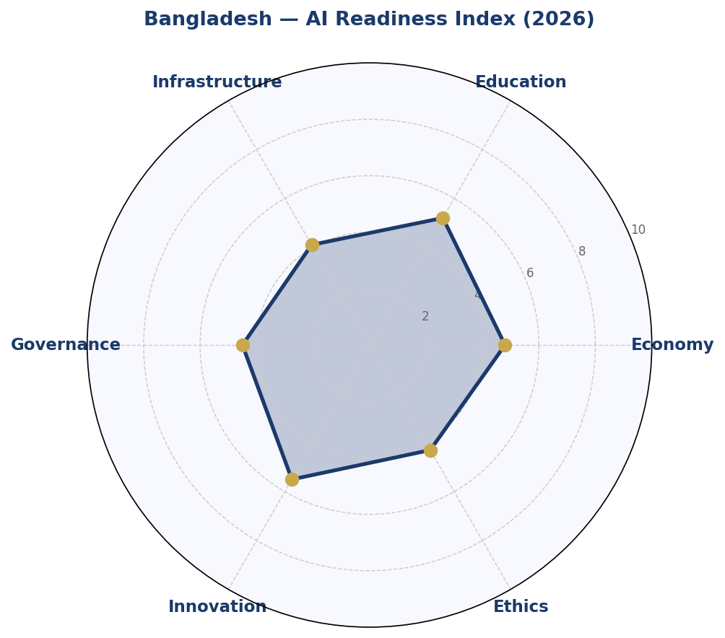
Figure 1.1 — Bangladesh AI Readiness Index: Six-Dimension Radar Profile (2026 Baseline)

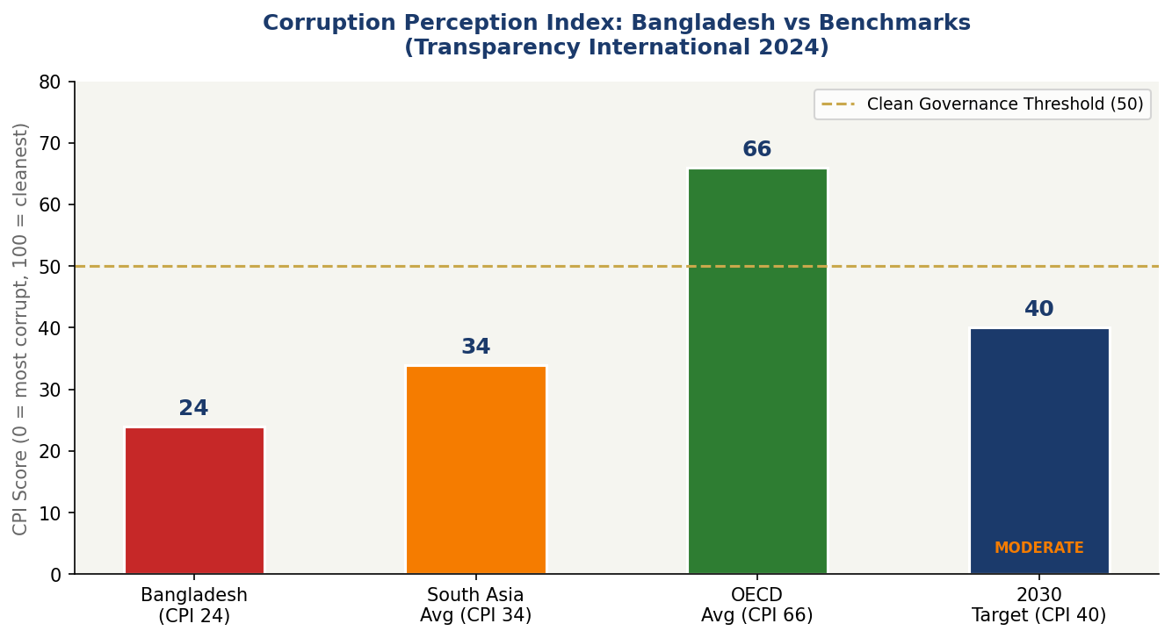
Figure 1.2 — Corruption Perception Index: Bangladesh vs Regional and Global Benchmarks with AI Governance Risk Tiers

Section 2: Policy Vision & Strategic Pillars

2.1 Vision Statement
"By 2031, Bangladesh shall be a nation where artificial intelligence is a shared asset — developed with integrity, governed with accountability, and deployed in the service of all citizens, leaving no district, no community, and no generation behind."

2.2 Strategic Pillar I — Ethical AI & Human Rights Protection
Bangladesh's AI governance will be anchored in the fundamental rights guaranteed by its Constitution, particularly Articles 27 (Equality), 31 (Right to Protection of Law), and 39 (Freedom of Expression). Every AI system deployed in the public sector must demonstrate compliance with the National AI Ethics Standards, and private sector systems affecting citizens' rights must meet a public accountability threshold.
Key initiatives include: mandatory algorithmic impact assessments for high-risk AI; a National Citizen AI Rights Charter; prohibition of AI-powered predictive policing without judicial oversight; and an AI grievance redress mechanism accessible via the national 333 Helpline.

2.3 Strategic Pillar II — Economic Growth & Industrial AI Adoption
Bangladesh's AI economic strategy targets five high-priority sectors: (1) Ready-Made Garments — AI-assisted quality control, pattern optimisation, and supply chain management; (2) Agriculture — crop disease detection, precision irrigation, and weather-responsive advisory systems via mobile; (3) Financial Services — AI-powered credit scoring for the unbanked, fraud detection, and microfinance optimisation; (4) Healthcare — AI diagnostic tools for rural health centres, telemedicine AI assistants, and drug supply chain integrity; (5) Climate Resilience — AI-based flood prediction, disaster early warning, and cyclone evacuation routing.
The Bangladesh Investment Development Authority (BIDA) will offer a 5-year tax holiday to AI-focused enterprises establishing operations in designated AI Economic Zones within Hi-Tech Parks. A matching grant scheme will co-fund R&D expenditure by SMEs adopting AI systems.

2.4 Strategic Pillar III — Education, Upskilling & AI Workforce Development
Bangladesh cannot import its way into an AI-capable workforce. This pillar mandates: integration of computational thinking and AI literacy into the National Curriculum Framework from Grade 6 onwards; establishment of at least one AI Centre of Excellence in each of the eight divisions; a National AI Certification Framework aligned with international standards (AWS, Google, Microsoft) but with Bangladeshi language and context; and a Women in AI initiative targeting 50% female participation in all government-funded AI training programmes.

2.5 Strategic Pillar IV — Public Sector AI & e-Governance
Government is both the largest employer and the largest service provider in Bangladesh. Priority AI deployments will include: AI-powered tax compliance monitoring under the National Board of Revenue; intelligent case management for the overburdened judicial system; automated passport and NID document verification; and AI-enhanced agricultural extension advisory services delivered via Union Digital Centres.
All government AI procurements will follow a standardised AI Procurement Protocol requiring open tender, algorithmic transparency disclosure, data localisation compliance, and post-deployment impact monitoring.

2.6 Strategic Pillar V — AI Research, Innovation & Startup Ecosystem
The National AI Research Fund (NAIF), seeded with BDT 500 crore, will support investigator-led research, applied AI grants, and international collaborations. Bangladesh's eight public universities with engineering faculties will be required to establish AI research clusters. A national AI Startup Accelerator — the "Dhishon Lab" programme — will provide equity-free grants of up to BDT 50 lakh to early-stage AI ventures, with preference for solutions addressing Bangladesh-specific challenges.

Section 3: International Framework Alignment
This policy has been designed from the outset to align with the most authoritative international AI governance frameworks. The alignment is substantive, not cosmetic: each framework's principles are mapped to specific policy provisions, institutional mechanisms, and monitoring requirements.

3.1 UNESCO AI Ethics Recommendation (2021)
The UNESCO Recommendation on the Ethics of AI — the first global normative instrument on AI ethics — identifies 11 core values. This policy maps directly to each:
- Proportionality and Do No Harm — addressed through the AI Risk Classification System and mandatory impact assessments.
- Safety and Security — addressed through the National AI Security Standards and cybersecurity provisions in Section 6.
- Fairness and Non-Discrimination — addressed through the Algorithmic Accountability Framework and bias audit requirements.
- Sustainability — addressed through AI applications for climate resilience and green data centre standards.
- Right to Privacy and Data Protection — addressed through the Data Protection Act recommendations in Section 6.
- Human Oversight and Determination — addressed through the prohibition on fully autonomous high-risk AI decisions without human review.
- Transparency and Explainability — addressed through public disclosure requirements for all government AI systems.
- Responsibility and Accountability — addressed through the National AI Ethics Board mandate.
- Awareness and Literacy — addressed through Pillar III's National AI Education Pipeline.
- Multi-stakeholder and Adaptive Governance — addressed through the National AI Observatory and Annual AI State Report.
- International and Transboundary Cooperation — addressed through Section 10 (International Cooperation).

3.2 OECD AI Principles (2019, updated 2024)
As an OECD partner country, Bangladesh adopts the five OECD AI Principles as foundational: Inclusive Growth and Sustainable Development; Human-centred Values and Fairness; Transparency and Explainability; Robustness, Security, and Safety; and Accountability. The Bangladesh AI Ethics Board will use the OECD AI Policy Observatory as a benchmark for annual self-assessment.

3.3 EU AI Act (2024) — Risk-Based Adaptation
The EU AI Act's risk-based classification system has been adapted to Bangladesh's legal and institutional context. The Bangladesh AI Risk Classification System (Section 6) mirrors the EU's four-tier structure but incorporates Bangladesh-specific prohibited uses (including AI-powered surveillance of political assemblies without warrant) and context-appropriate high-risk categories covering digital loan applications, agricultural advisory systems, and student assessment tools given their wide societal impact in this context.

3.4 World Bank AI Strategy for Development
This policy aligns with the World Bank's AI for Development framework by prioritising AI applications in agriculture, health, and social protection — the sectors with greatest impact on Bangladesh's poverty reduction trajectory. The policy's investment roadmap reflects the World Bank's recommendation that developing nations allocate a minimum of 0.3% of GDP to AI R&D by Year 3.

3.5 G20 AI Principles & ITU AI for Good
As a G20 partner nation and active ITU member, Bangladesh adopts the G20 AI Principles on inclusive growth and the ITU AI for Good guidelines on SDG linkage. This policy's climate AI provisions (flood prediction, early warning systems) directly advance SDG 13 (Climate Action), while the Women in AI initiative advances SDG 5 (Gender Equality) and SDG 9 (Industry, Innovation, Infrastructure).

3.6 Framework Alignment Matrix

Framework Principle | Ethics  §6 | Economy  §2.3 | Education  §5 | Gov AI  §7 | Research  §2.6 | M&E  §9
UNESCO — Proportionality & No Harm | ✅ | ✅ | ⚠️ | ✅ | ⚠️ | ✅
UNESCO — Safety & Security | ✅ | ⚠️ | 🔲 | ✅ | ⚠️ | ✅
UNESCO — Fairness & Non-Discrimination | ✅ | ✅ | ✅ | ✅ | ⚠️ | ✅
UNESCO — Privacy & Data Protection | ✅ | ⚠️ | 🔲 | ✅ | 🔲 | ✅
UNESCO — Transparency & Explainability | ✅ | ✅ | ⚠️ | ✅ | ⚠️ | ✅
OECD — Inclusive Growth | ⚠️ | ✅ | ✅ | ✅ | ✅ | ✅
OECD — Human-Centred Values | ✅ | ⚠️ | ✅ | ✅ | ⚠️ | ✅
OECD — Accountability | ✅ | ✅ | ⚠️ | ✅ | ⚠️ | ✅
EU AI Act — Risk Classification | ✅ | ✅ | ✅ | ✅ | ⚠️ | ✅
EU AI Act — Prohibited Uses | ✅ | ✅ | 🔲 | ✅ | 🔲 | ⚠️
World Bank — Poverty Reduction AI | ⚠️ | ✅ | ✅ | ✅ | ✅ | ✅
G20 — Innovation Ecosystem | ⚠️ | ✅ | ✅ | ⚠️ | ✅ | ✅
ITU — SDG Alignment | ⚠️ | ✅ | ✅ | ✅ | ✅ | ✅
Table 3.1 — Comprehensive International Framework Alignment Matrix (✅ Fully aligned ⚠️ Partially aligned 🔲 Future phase)

Section 4: Economic Impact & Investment Roadmap

4.1 Projected AI Economic Contribution
Based on McKinsey Global Institute estimates for lower-middle-income countries at Bangladesh's level of AI readiness, and calibrated against World Economic Forum projections for South Asia, this policy targets a cumulative AI-driven GDP contribution of approximately USD 52 billion over the 2026–2031 period. This represents a trajectory from 0.5% of GDP in Year 1 to 4.8% by Year 5, consistent with comparable economies that have adopted structured national AI strategies.
Key economic multipliers include: productivity gains in the RMG sector (estimated 15–20% cost reduction through AI-assisted production optimisation); agricultural yield improvements of 10–15% through precision advisory systems; financial inclusion expansion of 8–10 million previously unbanked citizens through AI credit scoring; and healthcare efficiency gains estimated at BDT 2,000 crore annually through AI diagnostic assistance in public hospitals.
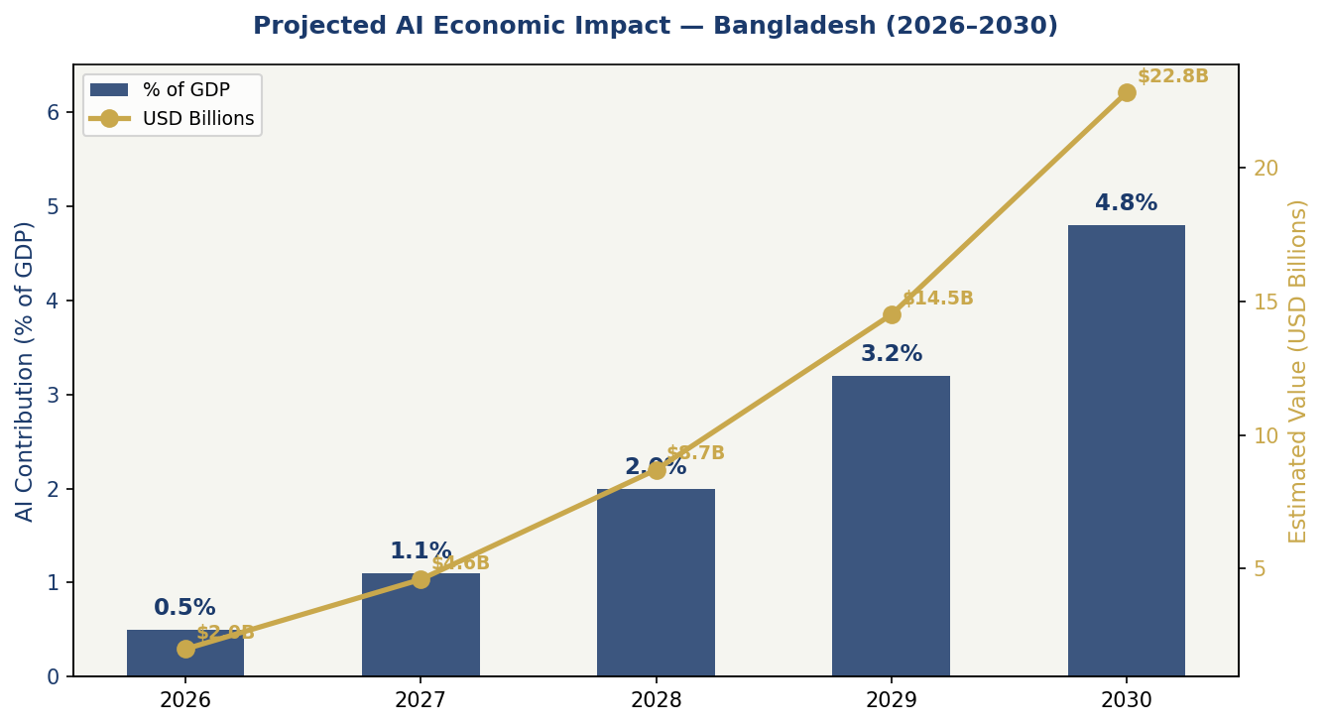
Figure 4.1 — Projected AI Economic Impact: GDP Contribution % and Estimated USD Value (Bangladesh 2026–2030)

4.2 National AI Investment Framework
The Government of Bangladesh, in partnership with multilateral development banks including the World Bank, Asian Development Bank, and Islamic Development Bank, will establish a National AI Fund (NAF) with an initial capitalisation of BDT 3,000 crore (approximately USD 270 million) over the five-year policy period. The investment allocation follows the proportions recommended by the OECD AI Policy Observatory for countries at Bangladesh's development stage:
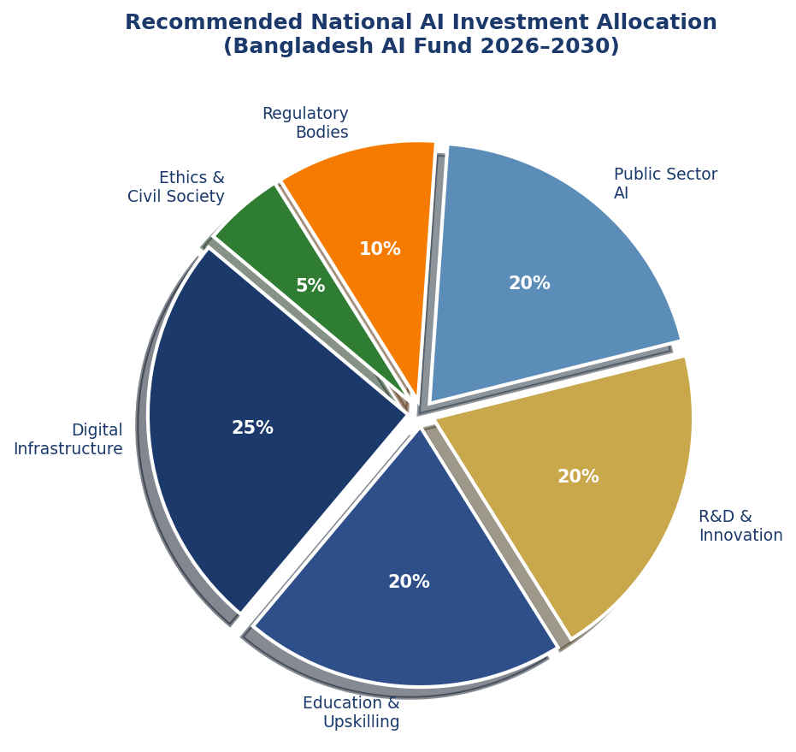
Figure 4.2 — Recommended National AI Investment Allocation by Priority Area (2026–2031)

4.3 Public-Private Partnership Framework
The Bangladesh PPP Authority will develop AI-specific PPP instruments, including: Build-Operate-Transfer (BOT) models for AI data centre infrastructure; revenue-sharing arrangements for AI applications in public healthcare and education; and co-investment agreements with international tech firms establishing Bangladesh-based AI research and development operations. Special incentives will apply to partnerships that guarantee minimum technology transfer, local workforce development commitments, and open-source publication of at least 30% of research outputs.

4.4 Priority Sectors for AI Adoption
The following sectors are designated as Priority AI Adoption Zones for Year 1–2 implementation, selected on the basis of economic significance, AI readiness of existing digital infrastructure, and social impact potential:
- Ready-Made Garments (RMG) — Quality control, pattern recognition, sustainable manufacturing optimisation.
- Agriculture and Food Security — Crop advisory via mobile, market price prediction, pest and disease early warning.
- Healthcare and Telemedicine — AI triage, diagnostic imaging support, medicine supply chain optimisation.
- Financial Services and Fintech — Credit scoring, anti-money laundering, digital insurance underwriting.
- Climate Resilience and Disaster Risk Reduction — Flood modelling, cyclone track prediction, evacuation planning.
- Education Technology — Adaptive learning platforms, automated assessment, dropout prediction.

Section 5: Education & Human Capital Development

5.1 Current Skills Gap Analysis
A 2025 ICT Division survey of 1,200 Bangladeshi enterprises found that 78% cite lack of AI-skilled personnel as the primary barrier to AI adoption. Of the estimated 65 million working-age Bangladeshis, fewer than 50,000 have any formal AI training, and fewer than 5,000 hold advanced AI qualifications. This gap is sharpest in Divisions outside Dhaka — Rajshahi, Khulna, Barisal, Rangpur, Mymensingh, Sylhet, and Chattogram — where access to quality STEM education remains severely constrained.
Gender disparity compounds the challenge: women constitute only 28% of ICT sector workers and approximately 15% of AI practitioners. This policy sets a binding 50% gender parity target for all government-funded AI training initiatives by Year 3.

5.2 National AI Curriculum Framework
The National Curriculum and Textbook Board (NCTB) will integrate AI literacy into the formal school curriculum through three tiers: (1) K–8: Computational thinking, digital citizenship, and basic algorithmic concepts as part of ICT and Mathematics; (2) Grade 9–12: Introduction to machine learning concepts, data ethics, and AI applications in the context of Bangladesh's economy; (3) Tertiary: Mandatory AI Ethics module for all undergraduate degrees; dedicated AI/ML Engineering and Applied AI programmes at public universities.
The National Skills Development Authority (NSDA) will develop a parallel Vocational AI Certification Track for workers in the RMG, agriculture, and logistics sectors, delivered through 500 Technical and Vocational Education and Training (TVET) centres.

5.3 AI Education Pipeline Targets
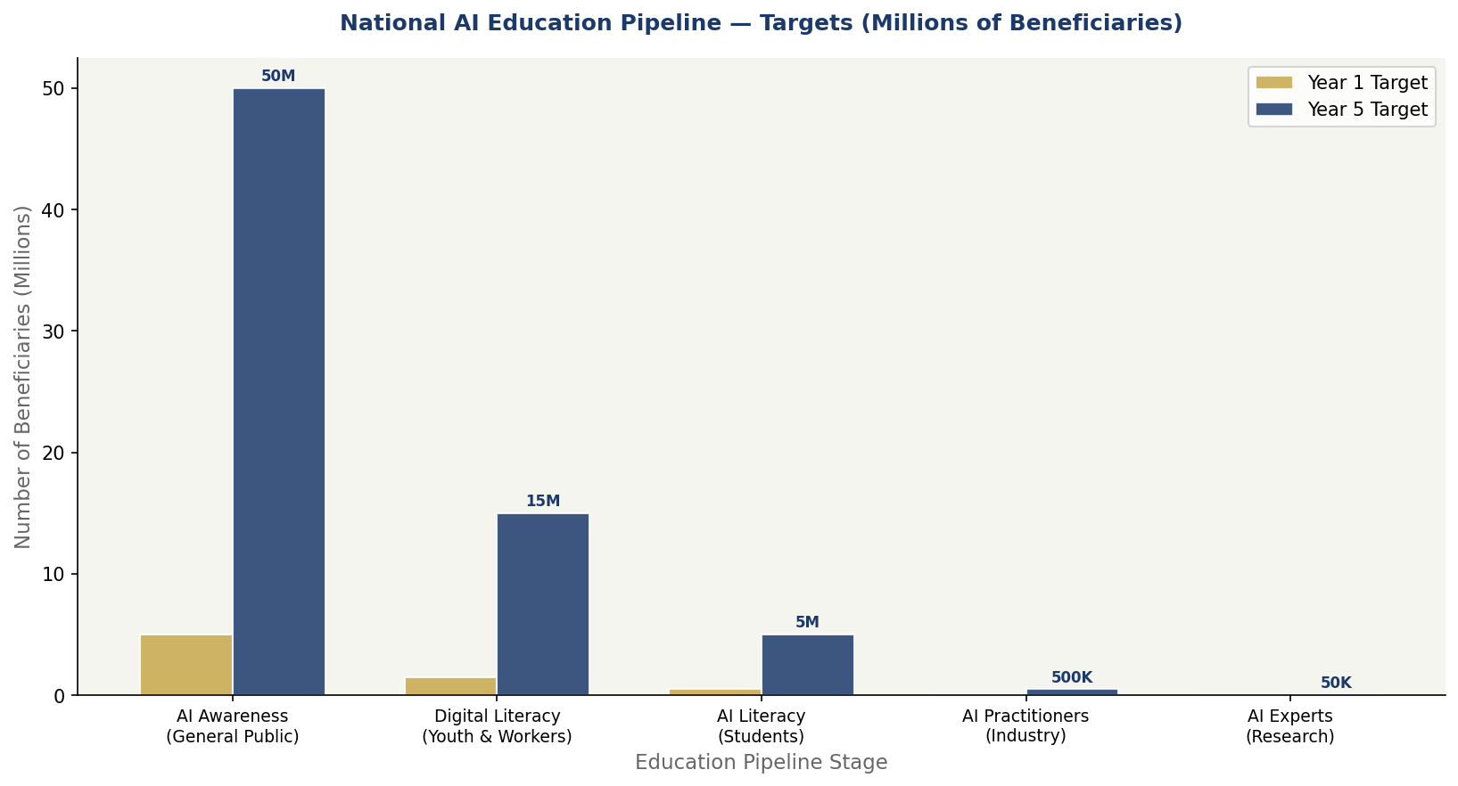
Figure 5.1 — National AI Education Pipeline: Beneficiary Targets Year 1 vs Year 5 (Millions)

5.4 Women & Underrepresented Groups
The "She Codes AI" programme, managed by the ICT Division, will provide fully funded AI training to 100,000 women per year through partnerships with BRAC, Grameen Bank, and 64 district Women Affairs offices. Quotas of 20% will apply to AI training cohorts for persons with disabilities. Rohingya refugee camps in Cox's Bazar will receive dedicated AI literacy programming aligned with UNHCR digital education frameworks.

5.5 International Scholarships & Collaboration
The Government will establish 200 annual AI postgraduate scholarships for Bangladeshi students at leading AI universities globally, with a mandatory two-year return-and-serve requirement upon completion. Bilateral agreements with India's IITs, South Korea's KAIST, Japan's RIKEN, Canada's Vector Institute, and UK universities will provide research exchange and faculty development opportunities. The diaspora network — over 10 million Bangladeshis globally, including significant numbers in the tech sector — will be engaged through the "Brain Link Bangladesh" programme to attract reverse knowledge transfer.

Section 6: Ethical AI Governance & Regulatory Framework

6.1 National AI Ethics Board
The National AI Ethics Board (NAEB) will be established as a statutory body under the Ministry of Law, Justice and Parliamentary Affairs, reporting to Parliament rather than the executive — a critical independence provision. The NAEB will comprise 15 members: 4 technical AI experts, 3 legal scholars, 2 civil society representatives (including one from TIB), 2 sector representatives (health and finance), 1 parliamentary representative, 1 academic ethicist, 1 representative from the National Human Rights Commission, and 1 representative from the media.
The NAEB's core mandates will include: issuing binding AI Ethics Standards; conducting mandatory reviews of proposed high-risk government AI deployments; investigating complaints of AI-related rights violations; publishing an Annual AI Ethics Report; and advising Parliament on proposed AI legislation.

6.2 Bangladesh AI Risk Classification System
Adapted from the EU AI Act, the Bangladesh AI Risk Classification System establishes four risk tiers:

Tier 1: Unacceptable Risk (Prohibited Uses)
- AI systems that deploy subliminal techniques to manipulate behaviour without users' knowledge.
- AI-powered social scoring systems that evaluate citizens' trustworthiness for government benefits.
- Real-time biometric surveillance of public political gatherings without judicial warrant.
- AI systems designed to exploit vulnerabilities of minors, elderly, or persons with disabilities.
- Lethal autonomous weapons systems without meaningful human oversight.

Tier 2: High Risk (Regulated with Mandatory Audit)
- AI in credit scoring and financial inclusion assessments affecting individual citizens.
- AI diagnostic tools used in public healthcare without certified specialist oversight.
- AI-assisted recruitment and employment decisions.
- AI-based student assessment, grading, and educational streaming.
- AI systems used in law enforcement, border management, and judicial decision support.
- AI in critical national infrastructure (power grid, water management, financial system).

Tier 3: Limited Risk (Transparency Obligations)
- AI chatbots and virtual assistants that must disclose AI identity to users.
- Emotion-recognition systems in commercial settings — disclosure required.
- AI-generated content — watermarking and disclosure requirements apply.

Tier 4: Minimal Risk (Voluntary Code of Conduct)
- AI in entertainment, gaming, spam filtering, inventory management, and similar low-stakes applications.
- Open-source AI development tools used for research and education.

6.3 Data Protection & Privacy
Bangladesh will enact a comprehensive Data Protection Act (DPA) by end of Year 1 of this policy, incorporating: data minimisation principles; purpose limitation; citizens' right of access and erasure; data localisation requirements for sensitive categories; mandatory breach notification within 72 hours; and an independent Data Protection Commissioner with authority to impose sanctions. The DPA will be compatible with the EU General Data Protection Regulation (GDPR) to facilitate cross-border data flows with trading partners.

6.4 Algorithmic Accountability Standards
All high-risk AI systems deployed by government or government-contracted entities must comply with: (1) Algorithmic Impact Assessments (AIA) prior to deployment; (2) Annual algorithmic audits by an accredited independent body; (3) Public disclosure of model purpose, data sources, and decision logic in non-technical language; (4) A mandatory human review mechanism for automated decisions affecting individual rights or benefits; (5) Demographic bias testing across gender, age, religion, and geographic dimensions before and after deployment.

6.5 Anti-Corruption AI Protocols
Given Bangladesh's governance context, this policy mandates specific anti-corruption provisions for all government AI deployments: open-source code repositories for all publicly funded AI systems (unless national security applies); blockchain-based audit trails for AI-assisted procurement decisions; prohibition of AI vendors employing serving or recently retired civil servants involved in procurement; and mandatory whistleblower protections for anyone reporting AI procurement irregularities.

Section 7: Public Sector AI & e-Governance

7.1 Priority Government Use Cases
The Government of Bangladesh will prioritise the following AI deployments in the public sector, selected on the basis of citizen impact, technical feasibility, and institutional readiness:
- National Board of Revenue (NBR) — AI-powered tax gap analysis, VAT compliance monitoring, and customs risk profiling to increase domestic revenue mobilisation by an estimated BDT 8,000 crore annually.
- Bangladesh Judiciary — AI-assisted case management, document classification, and bail risk assessment tools, targeting a 25% reduction in case backlog by Year 3.
- Department of Agricultural Extension (DAE) — AI crop advisory services delivered via USSD and mobile app to 15 million smallholder farmers, integrated with the e-Krishok platform.
- Directorate General of Health Services (DGHS) — AI-powered triage tools for Upazila Health Complexes; automated medicine stock monitoring; and outbreak detection through syndromic surveillance.
- Bangladesh Police — AI-assisted financial crime investigation tools (explicitly not real-time public surveillance); predictive maintenance of police infrastructure.
- Passport & Immigration — AI-automated document verification; biometric matching upgrade for all land ports.
- BRAC, DSS & Social Safety Net Programmes — AI beneficiary targeting to reduce inclusion/exclusion errors in programmes covering 13 million households.

7.2 Citizen-Facing AI Services Roadmap
By Year 2, every Union Digital Centre (UDC) — of which there are 4,554 across Bangladesh — will offer at least three AI-enhanced citizen services: (1) an intelligent chatbot for government service navigation in Bengali, English, and regional dialects; (2) AI-assisted form completion for land records, birth registration, and social protection applications; and (3) an AI grievance tracker enabling citizens to monitor complaint status in real time.

7.3 AI Procurement Guidelines
All government AI procurements above BDT 10 crore must comply with the Government AI Procurement Protocol (GAIPP), which mandates: open competitive tender with technical and ethical scoring criteria; mandatory vendor disclosure of training data sources; data localisation compliance certification; post-deployment monitoring plan; and a designated AI Responsible Officer within each procuring ministry.

7.4 Interoperability Standards
The Bangladesh National Enterprise Architecture (BNEA) framework will be extended to include AI interoperability standards, ensuring that AI systems procured by different agencies can communicate, share data under appropriate consent frameworks, and avoid siloed, duplicative deployment. The Bangladesh Computer Council (BCC) will maintain a Government AI Register listing all active AI systems, their purpose, data sources, and risk classification.

Section 8: Implementation Roadmap
The policy is implemented across three phases over 60 months. Each phase has defined deliverables, responsible agencies, and measurable milestones.
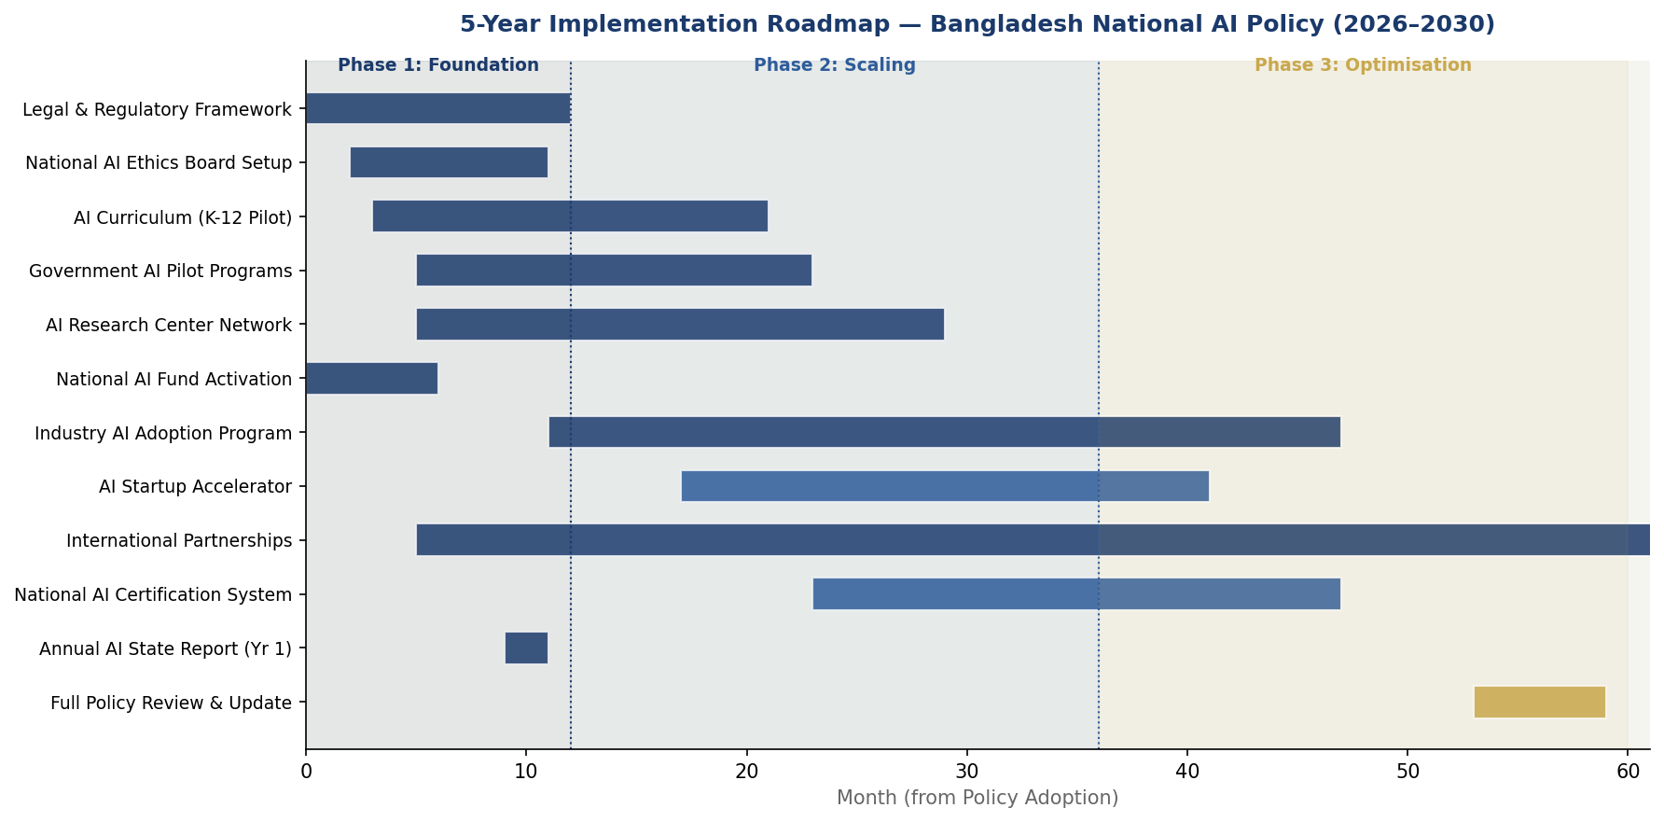
Figure 8.1 — 5-Year Implementation Timeline: Bangladesh National AI Policy 2026–2031 (Gantt)

Phase 1 — Foundation (Months 1–12)
The first 12 months are dedicated to establishing the legal, institutional, and infrastructural preconditions for AI development. Priority actions include:
- Enact Data Protection Act and National AI Ethics Act through Parliament.
- Establish National AI Ethics Board with full statutory authority.
- Launch National AI Fund (NAF) with initial BDT 1,000 crore capitalisation.
- Deploy AI curriculum pilot in 200 secondary schools across all 8 divisions.
- Establish AI Centre of Excellence at BUET, SUST, and CUET.
- Complete Government AI Register baseline (all existing public sector AI systems).
- Launch first National AI Readiness Survey.
- Publish Year 1 Annual AI State Report.
Phase 1 KPIs: Data Protection Act enacted ✓; NAEB operational ✓; NAF launched ✓; 200 pilot schools ✓; 3 AI Centres established ✓.

Phase 2 — Scaling (Months 13–36)
Phase 2 expands successful pilots nationally, accelerates private sector adoption, and deepens international partnerships.
- Scale AI curriculum to all 20,000 secondary schools.
- Launch Dhishon Lab AI Startup Accelerator — first cohort of 50 startups.
- Deploy AI agricultural advisory to 5 million farmers via e-Krishok.
- Implement NBR AI tax compliance system — target BDT 4,000 crore additional revenue.
- Establish AI Economic Zones in 5 Hi-Tech Parks with tax incentive activation.
- Complete AI bias audits for all Tier 2 government systems.
- Launch 200 annual postgraduate AI scholarships.
Phase 2 KPIs: AI schools scaled ✓; 50 startups in accelerator ✓; 5M farmers reached ✓; AI tax system live ✓.

Phase 3 — Optimisation (Months 37–60)
Phase 3 consolidates gains, conducts comprehensive policy review, and positions Bangladesh for AI export and regional leadership.
- Comprehensive 3-year policy review with public consultation.
- Launch Bangladesh AI Export Initiative — targeting AI services exports of USD 500 million by 2031.
- Full UDC AI service deployment across all 4,554 Union Digital Centres.
- Establish Bangladesh as regional hub for SAARC AI governance dialogue.
- Publish updated National AI Strategy 2031–2036 based on review findings.
Phase 3 KPIs: Policy review complete ✓; USD 500M export target set ✓; All UDCs AI-enabled ✓; SAARC AI dialogue hosted ✓.

Section 9: Monitoring, Evaluation & Accountability

9.1 National AI Observatory
The National AI Observatory (NAO) will be established as a division of the Bangladesh Bureau of Statistics (BBS), with technical support from the ICT Division and the National AI Ethics Board. The Observatory's mandate includes: annual data collection on AI adoption rates, workforce metrics, economic impact, and rights incidents; quarterly dashboard updates published on a public-facing platform; independent survey of citizen perceptions of AI; and benchmarking against Oxford Insights AI Readiness Index and OECD AI Policy Observatory indicators.

9.2 Annual AI State Report
The Annual AI State Report will be tabled in Parliament by the Minister of ICT no later than March 31 of each year. The Report will cover: progress against all KPIs in this policy; the National AI Ethics Board's findings and recommendations; a summary of AI-related complaints received and resolved; economic impact data; and a forward-looking priorities section.

9.3 KPI Dashboard

KPI | Baseline  (2026) | Year 1  Target | Year 3  Target | Year 5  Target
AI Contribution to GDP (%) | 0.2% | 0.5% | 2.0% | 4.8%
AI-related jobs created | 50,000 | 80,000 | 250,000 | 500,000
Students in AI literacy programmes | 200,000 | 500,000 | 2,000,000 | 5,000,000
Women in AI training (% parity) | 15% | 25% | 40% | 50%
Government AI systems audited | 0 | 20 | 80 | 150+
AI startups (Dhishon Lab) | 0 | 50 | 200 | 500+
Citizens reached by AI govt services | 500,000 | 5,000,000 | 30,000,000 | 80,000,000
AI research publications (annual) | 120 | 250 | 600 | 1,200
Data Protection Act enacted | Not enacted | Enacted | Reviewed | Revised
CPI Score target (TI) | 24 | 26 | 30 | 35+
Oxford AI Readiness Index rank | Tier 4 | Tier 4 | Tier 3 | Tier 3 upper
National AI Fund deployed (BDT cr) | 0 | 600 | 2,000 | 3,000
Table 9.1 — National AI Policy KPI Dashboard: Baseline and Targets 2026–2031

9.4 Parliamentary Oversight & Civil Society Role
A Parliamentary Standing Committee on AI Policy will be established with the mandate to receive and scrutinise the Annual AI State Report, summon the NAEB Chairperson for annual testimony, commission independent technical reviews, and propose legislative amendments. Civil society organisations, including Transparency International Bangladesh (TIB), Article 19, and the Bangladesh Legal Aid Services Trust (BLAST), will be formally recognised as independent AI accountability actors with the right to submit parallel reports to Parliament and access to the Government AI Register.

Section 10: International Cooperation & Diplomacy

10.1 Bilateral AI Cooperation Priorities
Bangladesh will pursue formal AI cooperation agreements with key strategic partners prioritised as follows:
- India — Given geographic proximity, shared language communities, and growing tech sector ties, a bilateral AI cooperation framework with India's Ministry of Electronics and Information Technology (MeitY) will be established, focusing on AI infrastructure, research collaboration, and regulatory harmonisation to facilitate cross-border AI services.
- Japan — Japan's Society 5.0 vision and advanced robotics/AI manufacturing ecosystem offer direct relevance to Bangladesh's RMG sector modernisation. JICA partnership for AI workforce training will be pursued.
- South Korea — Korea's KOICA and NIPA agencies provide AI capacity building programmes. A focused partnership for fintech AI and agri-AI will be established.
- United Kingdom — The UK AI Safety Institute's international cooperation programme and the British Council's digital skills initiatives represent high-value partnership opportunities.
- United States — Partnership with USAID's Digital Strategy, MIT-led research collaborations, and Silicon Valley diaspora engagement through the Brain Link Bangladesh programme.

10.2 Regional AI Governance — SAARC & Beyond
Bangladesh will seek to establish a SAARC AI Governance Working Group, bringing together the AI policy leads of Bangladesh, India, Nepal, Sri Lanka, Pakistan, and Bhutan to develop shared principles on cross-border data flows, AI safety standards for regional infrastructure, and coordinated responses to AI-enabled misinformation. Bangladesh will bid to host the inaugural SAARC AI Summit in 2027.

10.3 South-South Knowledge Transfer
Bangladesh's experience with mobile financial services (bKash, Nagad), agricultural extension via digital platforms, and disaster risk reduction technologies represents genuine comparative knowledge that can benefit other LMICs. Bangladesh will establish a South-South AI Knowledge Hub under the Foreign Ministry's development cooperation framework, offering technical assistance to African Union member states, Pacific Island nations, and LDC partners through a "Bangladesh AI for Development" programme backed by BDT 100 crore in ODA.

10.4 Global AI Governance Participation
Bangladesh will seek election to the Governing Board of the Global Partnership on AI (GPAI) in 2027, building on its existing engagement in UNESCO AI governance processes and ITU AI for Good. The Government will designate a dedicated Ambassador for Digital and AI Affairs within the Ministry of Foreign Affairs, ensuring Bangladesh's voice in emerging global AI governance institutions including the UN High-Level Advisory Body on AI, the ITU AI for Good Summit, and future OECD AI Policy Ministerial processes.

Conclusion
The National Artificial Intelligence Policy 2026–2031 represents Bangladesh's most consequential technological commitment since the launch of Digital Bangladesh in 2009. It is both a development strategy and a rights framework — recognising that AI without ethics is merely a powerful tool for existing inequalities, while AI without ambition fails the generation that most needs it.
Bangladesh has proven its capacity to leapfrog. A nation that brought mobile banking to 90 million people without a bank account, that reduced under-5 mortality by 60% through community health workers with mobile devices, and that has become the world's second-largest RMG exporter — this is a nation that does not need to ask permission to innovate.
What Bangladesh needs is a framework that channels that innovation: that ensures the fruits of AI are shared from Teknaf to Tetulia, from garment workers to government clerks, from Dhaka's startup scene to Sylhet's tea gardens. This policy is that framework.
Implementation begins now. The institutions will be built, the laws enacted, the curricula written, and the investments made. Bangladesh's AI future will not be handed to it — it will be built, line by line, policy by policy, and person by person.

Nafiul Ahmad Rafi | Insights Bangladesh | May 2026

References & Bibliography
The following sources and frameworks have informed the development of this policy:
- UNESCO (2021). Recommendation on the Ethics of Artificial Intelligence. Paris: UNESCO.
- OECD (2024). OECD AI Principles (Updated). Paris: OECD Publishing.
- European Union (2024). Regulation on Artificial Intelligence (EU AI Act). Official Journal of the EU.
- World Bank (2024). Digital Development: AI Strategy for Development. Washington DC: World Bank Group.
- G20 AI Principles (2019, reiterated 2023). Osaka Track Digital Economy Outcomes.
- ITU (2024). AI for Good: Guidelines for Sustainable Development. Geneva: ITU Publications.
- Transparency International (2024). Corruption Perceptions Index 2024. Berlin: TI.
- Oxford Insights (2024). Government AI Readiness Index 2024. Oxford: Oxford Insights.
- McKinsey Global Institute (2023). The Economic Potential of Generative AI. New York: MGI.
- World Economic Forum (2023). Future of Jobs Report. Geneva: WEF.
- Bangladesh Planning Commission (2020). 8th Five Year Plan 2021–2025. Dhaka: GED.
- Bangladesh ICT Division (2022). Smart Bangladesh Vision 2041. Dhaka: MoPTIT.
- Bangladesh Bureau of Statistics (2024). Statistical Yearbook of Bangladesh. Dhaka: BBS.
- BTRC (2024). Quarterly Industry Information. Dhaka: Bangladesh Telecommunication Regulatory Commission.
- Insights Bangladesh (2025). AI Governance Readiness Assessment: Bangladesh Country Report. Dhaka: Insights Bangladesh.
- Global Partnership on AI (GPAI) (2024). Responsible AI. Montreal/Paris: GPAI Secretariat.
- Asian Development Bank (2023). Digital Technology for Development: Country Report Bangladesh. Manila: ADB.

About the Author

Nafiul Ahmad Rafi
Policy & Good Governance Researcher | BD Civic Tech Architect

Nafiul Ahmad Rafi is a civic technologist, policy researcher, author, photographer, and musician based in Dhaka, Bangladesh. He is the Founder and Director of
Insights Bangladesh, a data-driven governance and policy impact analysis institution, and the Founder & Lead Architect of NagorikBD.org — a transparency-first civic platform scaled across Mymensingh Division, connecting citizens with government services across 45 Upazilas.
His work exists at the intersection of institutional reform and artificial intelligence, transforming theoretical governance into scalable, data-driven reality. Without a conventional computer science degree, he self-taught the tools of modern AI and web development to build the infrastructure that enforces the policies he once only researched.

Key Platforms & Projects
- NagorikBD.org — Civic transparency platform, Mymensingh Division
- Insights Bangladesh — Policy impact analysis institution
- FactCheck BD (factcheckbd.org) — Bangladesh's AI-powered fact-checking platform
- Political Insights BD / PIBD (pibbd.org) — Political intelligence and civic tech hub
- PeaceShield BD / National Peace Tracker — AI-powered hate speech and conflict monitoring
- PolicyLens AI (aigovbd.org) — 9-dimensional AI policy audit tool

He has published four books and maintains a personal site at ahmad-rafi.com.

Research Interests
AI Governance · Policy Research · Future of Bangladesh · Climate Policy

Contact
- 🌐 ahmad-rafi.com
- 🔗 LinkedIn: nafiul-ahmad-rafi (bd.linkedin.com/in/nafiul-ahmad-rafi)
- ✉️ contact@ahmad-rafi.com

"I build code to ensure transparency, and I write lyrics to inspire the courage to use it."

