🇧🇴
PLURINATIONAL STATE OF BOLIVIA
National Artificial Intelligence Policy
2026–2031

A Comprehensive Framework for Ethical, Inclusive,
and Economically Transformative Artificial Intelligence

Prepared by:
Nafiul Ahmad Rafi
Policy & Good Governance Researcher | Insights Bangladesh
May 2026

Executive Summary
Bolivia stands at a historic inflection point. As artificial intelligence reshapes global economies, governance systems, and human opportunity, the Plurinational State of Bolivia must act decisively to harness its transformative potential while protecting the rights, cultures, and dignity of its 12 million citizens. This National Artificial Intelligence Policy 2026–2031 provides a comprehensive, actionable framework to guide Bolivia's transition into an AI-enabled society rooted in equity, transparency, and inclusive growth.

Bolivia presents a unique profile for AI adoption. With a GDP per capita of approximately USD 3,400, significant natural resource wealth (including the world's largest lithium reserves—a critical mineral for AI hardware), a youthful population, and a government committed to technological sovereignty, the country possesses untapped foundational assets. However, challenges persist: limited digital infrastructure outside urban centres, a 31/100 Corruption Perception Index score, a digital skills gap particularly in rural and Indigenous communities, and nascent institutional capacity for AI governance.

This policy is organized around five strategic pillars: (1) Ethical AI and Human Rights Protection, ensuring AI systems respect Bolivia's multicultural identity and constitutional rights; (2) Economic Growth and Industrial AI Adoption, leveraging AI in mining, agriculture, and services to diversify the economy; (3) Education, Upskilling, and AI Workforce Development, building human capital from primary school through postgraduate research; (4) Public Sector AI and e-Governance, modernizing state services for efficiency and accountability; and (5) AI Research, Innovation, and Startup Ecosystem, cultivating domestic innovation capacity.

Aligned with UNESCO's AI Ethics Recommendation, the OECD AI Principles, the EU AI Act risk framework, World Bank development guidelines, G20 AI Principles, and ITU AI for Good Guidelines, this policy positions Bolivia as a responsible AI actor within the global community. By 2031, Bolivia targets a 3.5% GDP contribution from AI-enabled activities, 75% AI awareness among the adult population, and full operationalization of a National AI Ethics Board and AI Observatory.

The policy is structured across ten substantive sections: a national AI readiness assessment, policy vision and strategic pillars, international framework alignment, economic impact and investment roadmap, education and human capital development, ethical AI governance, public sector AI, implementation roadmap, monitoring and evaluation, and international cooperation. Together, these sections constitute a living governance document to be reviewed annually and updated every three years.

Section 1: National AI Readiness Assessment
Understanding Bolivia's current position is essential to designing a realistic, impactful AI policy. This section examines Bolivia's readiness across six dimensions: economic context, education and human capital, digital infrastructure, governance and institutional capacity, innovation ecosystem, and AI ethics awareness.

1.1 Economic Context
Bolivia's economy, with a nominal GDP of approximately USD 43 billion (2024), is dominated by natural resources, particularly natural gas, minerals, and increasingly lithium. The country holds the world's largest known lithium reserves—estimated at 21 million tonnes—positioning it strategically in the global AI and battery technology supply chain. GDP growth has averaged 2.8% annually (2020–2024). However, income inequality (Gini coefficient ~0.42) and vulnerability to commodity price shocks necessitate economic diversification, where AI can play a catalytic role.
Key economic sectors for AI adoption include: mining and resource extraction, agribusiness and food production, financial services and microfinance, tourism and cultural heritage, and public infrastructure management.

1.2 Education & Human Capital
Bolivia's literacy rate stands at approximately 92.5%, with significant regional disparities. Tertiary enrollment is around 38% of the eligible population, concentrated in La Paz, Cochabamba, and Santa Cruz. STEM education is underdeveloped at secondary level, and existing university curricula rarely include data science, machine learning, or AI-adjacent subjects. The country has an estimated shortage of 12,000 technology professionals annually, a gap that will widen as AI adoption accelerates globally.
Indigenous language speakers constitute approximately 36% of the population. AI education and government AI interfaces must account for Quechua, Aymara, Guarani, and over 30 other recognized languages.

1.3 Digital Infrastructure
Internet penetration stands at approximately 58% (2024), with significant urban-rural divide. Mobile connectivity reaches 85% of the population, offering a platform for AI delivery. Fixed broadband penetration remains low at 12%. Bolivia's National Fiber Optic Ring covers major urban areas but rural connectivity remains critically underdeveloped. Data centre capacity is limited, with most government and enterprise data hosted offshore.

1.4 Governance & Institutional Capacity
Bolivia's governance environment is characterized by active state intervention in strategic sectors, a plurinational constitutional framework recognizing Indigenous peoples' rights, and recent digital government initiatives. The Ministry of Works, Services and Public Works oversees ICT policy. However, interoperability between government systems remains limited, and there is no dedicated AI regulatory body. Institutional capacity for AI oversight will require significant investment.

1.5 Corruption Risk Assessment
Bolivia scores 31 out of 100 on the 2024 Transparency International Corruption Perceptions Index, ranking 103rd globally—below the Latin American average of 43. This score signals elevated risk of AI systems being captured for corrupt purposes: biased procurement, surveillance misuse, algorithmic manipulation of public services. This policy specifically addresses anti-corruption AI governance mechanisms, mandatory audit trails, and civil society oversight to mitigate these risks.

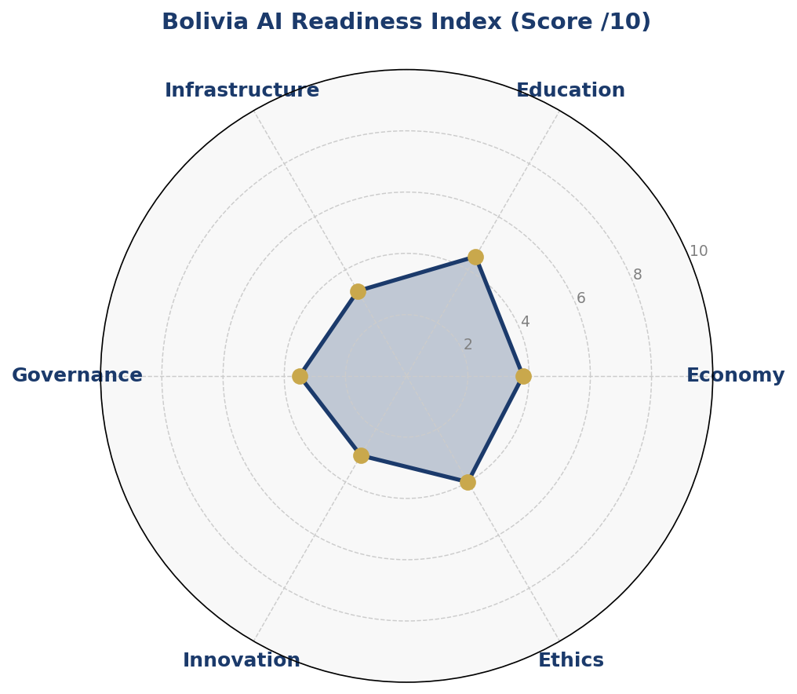
Figure 1: Bolivia AI Readiness Index — Multi-dimensional assessment (scores out of 10)
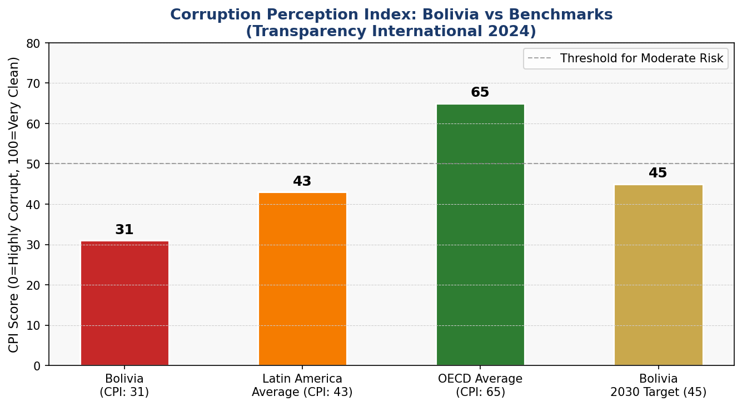
Figure 2: Corruption Perception Index — Bolivia vs Regional and Global Benchmarks (Transparency International 2024)

Section 2: Policy Vision & Strategic Pillars

"By 2031, Bolivia will be a sovereign, inclusive, and ethically responsible AI nation — where artificial intelligence amplifies the voice of every citizen, honours the wisdom of every culture, and drives prosperity for every community."

This vision is grounded in Bolivia's Plurinational Constitution, which guarantees dignity, self-determination, and access to development for all peoples. AI must serve this constitutional mandate, not undermine it.

Pillar 1: Ethical AI & Human Rights Protection
All AI systems deployed in Bolivia must respect the fundamental rights enshrined in the Plurinational Constitution, including the rights of Indigenous peoples to self-determination, cultural identity, and Free, Prior, and Informed Consent (FPIC) for projects affecting their communities. A National AI Ethics Board will be established within Year 1 to review high-risk AI deployments.
- Mandatory human rights impact assessment for all government AI systems
- Prohibition of facial recognition systems in public spaces without judicial oversight
- FPIC requirement for AI systems affecting Indigenous territories or data
- Anti-discrimination auditing for AI used in employment, credit, and justice

Pillar 2: Economic Growth & Industrial AI Adoption
AI will be positioned as a national economic modernization tool. Priority sectors include lithium and mining (predictive maintenance, geological AI), agribusiness (precision agriculture, market forecasting), financial inclusion (AI-powered microfinance), and tourism (multilingual AI cultural guides).
- National AI for Industry Fund: USD 200M over 5 years for sectoral AI adoption
- Tax incentives for SMEs adopting AI tools (30% deduction on AI software investment)
- Strategic partnerships with global AI companies requiring local data hosting and skills transfer
- Export strategy: Bolivia as an AI solutions provider for landlocked developing nations

Pillar 3: Education, Upskilling & AI Workforce Development
No AI policy succeeds without people who can build, use, and govern AI. Bolivia will implement a National AI Skills Strategy targeting every level of the education system, with special focus on closing gender and geographic gaps.
- AI integrated into national K–12 curriculum by Year 2
- 100 AI scholarships per year for international postgraduate study
- Public AI Bootcamp Programme: 50,000 workers retrained by Year 3
- 50% women enrollment target in all AI education programmes

Pillar 4: Public Sector AI & e-Governance
The government will lead by example, deploying AI to improve service delivery, reduce corruption, and increase efficiency in public administration. Citizen-facing AI services will be designed for accessibility and multilingual use.
- AI-powered tax compliance and fraud detection for AGIT (Tax Authority)
- Automated land registry and cadastre systems to reduce disputes
- AI health diagnostics in rural clinics (telemedicine AI)
- Multilingual AI chatbots for citizen government service access

Pillar 5: AI Research, Innovation & Startup Ecosystem
Bolivia will build domestic AI innovation capacity through research centres, startup incubators, and academic partnerships. The National AI Research Centre (CENIA-Bolivia) will serve as the anchor institution.
- CENIA-Bolivia: national AI research centre, USD 30M initial endowment
- AI Startup Fund: USD 5M seed grants for Bolivian AI ventures
- University AI Clusters in La Paz (UMSA), Cochabamba (UMSS), and Santa Cruz (UAGRM)
- Open Data Portal: government datasets published for AI research use

Section 3: International Framework Alignment
Bolivia's National AI Policy is designed to align with the leading international AI governance frameworks, ensuring interoperability, international credibility, and access to global cooperation. This section maps each framework's core principles to corresponding sections of this policy.

3.1 UNESCO AI Ethics Recommendation (2021)
UNESCO's Recommendation on the Ethics of AI establishes 11 core values and 47 recommendations. Bolivia's policy aligns with these as follows:
- Proportionality & Do No Harm: AI risk classification system (Section 6) ensures proportionate regulatory responses
- Safety & Security: Mandatory security audits for high-risk AI (Section 6.2)
- Fairness & Non-Discrimination: Anti-discrimination standards in employment and justice AI (Pillars 1 & 4)
- Sustainability: AI for environmental monitoring and climate adaptation prioritized (Section 4)
- Right to Privacy: Data Protection Act recommendations align with UNESCO privacy principles (Section 6.3)
- Human Oversight & Determination: Human-in-the-loop requirement for high-risk AI decisions (Section 6)
- Transparency & Explainability: Algorithmic accountability standards (Section 6.4)
- Responsibility & Accountability: National AI Ethics Board enforcement mandate (Section 6.1)
- Education & Awareness: National AI Skills Strategy (Section 5)
- Multi-stakeholder & Adaptive Governance: Annual AI State Report and civil society involvement (Section 9)
- International & Regional Cooperation: Bilateral and multilateral cooperation framework (Section 10)

3.2 OECD AI Principles (2019, Updated 2024)
Bolivia, while not an OECD member, adopts the OECD AI Principles as a reference framework given their global influence. The five principles map as follows:
- Inclusive growth, sustainable development and well-being: Economic impact roadmap (Section 4) targets equitable distribution of AI benefits
- Human-centred values and fairness: Pillar 1 and Section 6 operationalize these values
- Transparency and explainability: Algorithmic accountability standards (Section 6.4)
- Robustness, security and safety: AI risk classification and audit requirements (Section 6.2)
- Accountability: National AI Observatory and parliamentary oversight (Section 9)

3.3 EU AI Act (2024) — Risk-Based Framework Adaptation
Bolivia adopts the EU AI Act's four-tier risk classification as the foundation of its domestic regulatory architecture, adapted to Bolivian constitutional and legal context:
- Unacceptable Risk (Banned): Social scoring systems by government; AI manipulation of vulnerable persons; real-time biometric surveillance in public spaces without judicial order; AI systems targeting Indigenous peoples' cultural practices for commercial exploitation
- High Risk (Mandatory Audit): AI in justice and law enforcement; health diagnosis AI; educational assessment AI; employment screening AI; public benefits eligibility AI; critical infrastructure AI
- Limited Risk (Transparency Required): AI chatbots must disclose AI identity; deepfake labelling mandatory; AI-generated content in media must be disclosed
- Minimal Risk (Voluntary Code): Spam filters, AI games, productivity tools—encouraged to adopt voluntary code of conduct

3.4 World Bank AI Strategy — Development Alignment
Bolivia's policy aligns with the World Bank's emphasis on AI for development outcomes. Priority alignments include: AI for financial inclusion (Bolivia has 40% unbanked population), AI for agricultural productivity (supporting smallholders), AI for health system strengthening (rural access), and AI-enhanced public financial management to reduce corruption.

3.5 G20 AI Principles & ITU AI for Good Guidelines
Bolivia aligns with G20 AI Principles on responsible stewardship, international cooperation, and inclusive access. Linkage to ITU AI for Good and the SDGs is operationalized through the following mappings: SDG 1 (No Poverty)—AI for social protection targeting; SDG 3 (Good Health)—AI diagnostics in rural clinics; SDG 4 (Quality Education)—National AI curriculum; SDG 8 (Decent Work)—AI upskilling; SDG 16 (Peace & Justice)—anti-corruption AI governance; SDG 17 (Partnerships)—bilateral AI cooperation agreements.

3.6 Framework Alignment Matrix
Policy Principle / Area | UNESCO | OECD | EU AI Act | World Bank | G20 | ITU/SDG
Human Rights & Dignity | ✅ | ✅ | ✅ | ✅ | ✅ | ✅
Transparency & Explainability | ✅ | ✅ | ✅ | ⚠️ | ✅ | ✅
Fairness & Non-Discrimination | ✅ | ✅ | ✅ | ✅ | ✅ | ✅
Safety & Security | ✅ | ✅ | ✅ | ✅ | ✅ | ⚠️
Privacy & Data Protection | ✅ | ✅ | ✅ | ⚠️ | ✅ | ✅
Accountability & Oversight | ✅ | ✅ | ✅ | ✅ | ✅ | ✅
Inclusive Economic Growth | ✅ | ✅ | ⚠️ | ✅ | ✅ | ✅
Environmental Sustainability | ✅ | ⚠️ | ⚠️ | ✅ | ⚠️ | ✅
Education & Skills | ✅ | ⚠️ | ⚠️ | ✅ | ✅ | ✅
International Cooperation | ✅ | ✅ | ⚠️ | ✅ | ✅ | ✅
Indigenous & Cultural Rights | ✅ | ◻️ | ⚠️ | ✅ | ◻️ | ✅
Table 1: International Framework Alignment Matrix. ✅ = Full alignment | ⚠️ = Partial alignment | ◻️ = Not explicitly addressed in framework

Section 4: Economic Impact & Investment Roadmap
According to McKinsey Global Institute estimates for lower-middle income economies, AI could contribute between 1.2% and 4.5% of GDP annually by 2030 in countries that invest in foundational infrastructure and skills. For Bolivia, with GDP approximately USD 43 billion, a conservative 3.5% contribution by 2031 represents approximately USD 1.7 billion in annual AI-driven economic value—a transformational figure.

4.1 Priority Sectors for AI Adoption
- Mining & Lithium Processing: Predictive maintenance AI can reduce downtime by 30–40%. AI-driven geological modelling can accelerate lithium exploration. Bolivia's strategic lithium advantage makes this the highest-value AI opportunity.
- Agribusiness: Precision agriculture AI for smallholder farmers (60% of rural population). Crop disease detection via satellite and mobile AI. Market price prediction AI for subsistence farmers.
- Financial Inclusion: AI credit scoring for the unbanked (40% of population). Fraud detection AI for mobile money platforms. Automated microfinance eligibility AI.
- Healthcare: AI diagnostic support in rural clinics. AI-powered telemedicine triage. Disease surveillance and outbreak prediction AI.
- Tourism & Culture: Multilingual AI guides for Tiwanaku, Salar de Uyuni, and other sites. AI preservation tools for Indigenous languages and oral traditions.

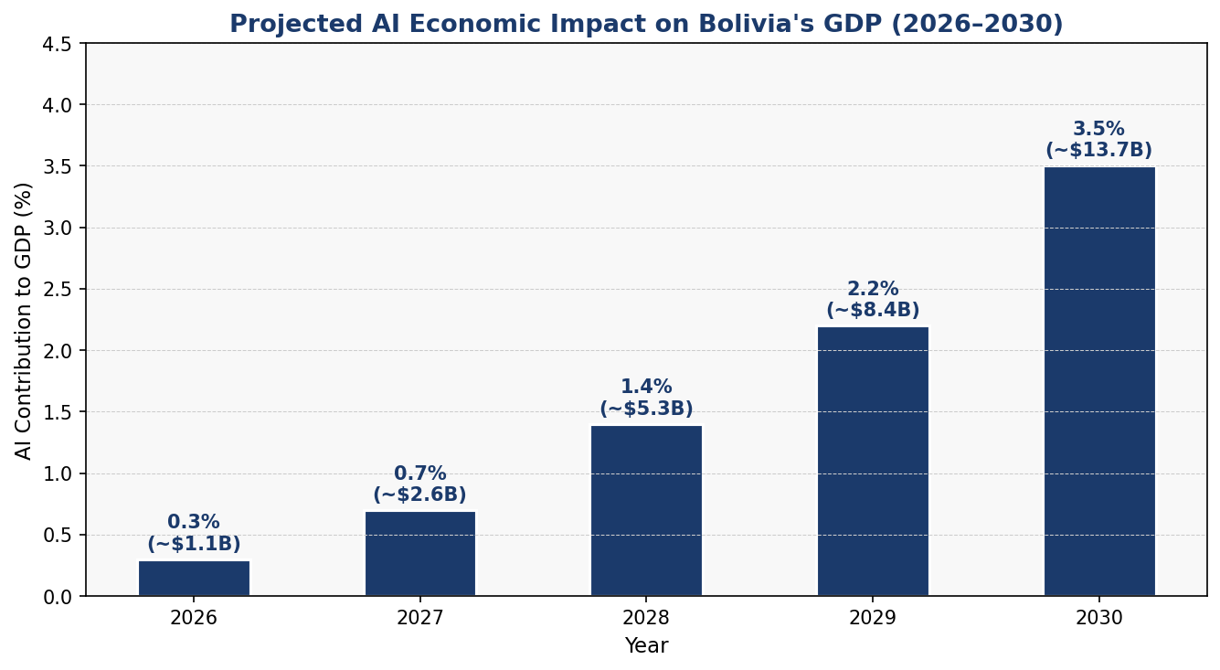
Figure 3: Projected AI Contribution to Bolivia's GDP (2026–2030)

4.2 National AI Investment Framework
The government commits to a USD 400 million national AI investment package over five years (2026–2031), sourced from a combination of national budget allocation (40%), multilateral development bank loans (35%), and private sector co-investment (25%). The allocation framework is as follows:
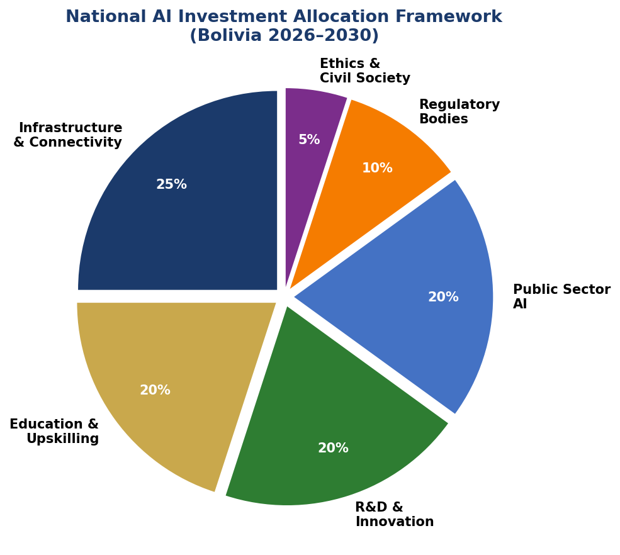
Figure 4: National AI Investment Allocation by Category (2026–2031)

4.3 Public-Private Partnership Framework
Bolivia will establish a National AI Partnership Council comprising government ministries, the private sector, civil society, and international development partners. PPP guidelines will require:
- Mandatory data sovereignty clause: all AI solutions must store Bolivian citizen data within Bolivia or in treaty-compliant partner states
- Technology transfer requirement: all major AI contracts (>USD 5M) must include local skills transfer components
- Indigenous community benefit-sharing for AI applications using Indigenous knowledge or affecting Indigenous territories
- SME subcontracting quota: 30% of AI project value must flow to Bolivian SMEs

Section 5: Education & Human Capital Development
Bolivia's AI future depends on its people. This section establishes the National AI Skills Strategy — a systemic, multi-level approach to building AI literacy, competence, and expertise across the entire population, with particular attention to historically marginalized groups.

5.1 Current Skills Gap Analysis
Bolivia currently has an estimated 2,400 AI-qualified professionals — data scientists, machine learning engineers, AI researchers — against a projected demand of 18,000 by 2031. The skills gap spans all levels: primary education lacks computational thinking foundations; secondary education has minimal programming curricula; universities offer few AI-specific programmes; and the existing workforce lacks digital upskilling pathways.
Women represent only 28% of ICT graduates. Rural regions and Indigenous communities have near-zero access to AI education resources. These gaps are not merely technical — they are equity failures that this policy addresses directly.

5.2 National AI Curriculum Framework

K–12: Computational Thinking and AI Awareness
- Grades 1–6: Computational thinking, logical reasoning, basic coding through play-based learning
- Grades 7–9: Introduction to algorithms, data literacy, AI examples in everyday life
- Grades 10–12: AI concepts, ethics of AI, basic Python, data analysis, career pathways in AI
- All curricula available in Spanish, Quechua, and Aymara

Tertiary Education: AI Competence
- All university degrees include a mandatory 3-credit AI Literacy module by Year 2
- New Bachelor's programmes in AI, Data Science, and Machine Learning at UMSA, UMSS, and UAGRM
- Master's programme in AI for Public Policy (unique in Latin America) at UMSA
- PhD scholarship programme: 20 annual PhD scholarships in AI at international universities

Vocational & Workforce Upskilling
- National AI Bootcamp: 12-week intensive programmes for working adults, 50,000 graduates by Year 3
- AI for Farmers: mobile-based AI literacy for rural agricultural workers
- AI for Health Workers: digital diagnostics training for nurses and community health workers
- AI for Civil Servants: mandatory AI literacy for all government employees above grade 7 by Year 2

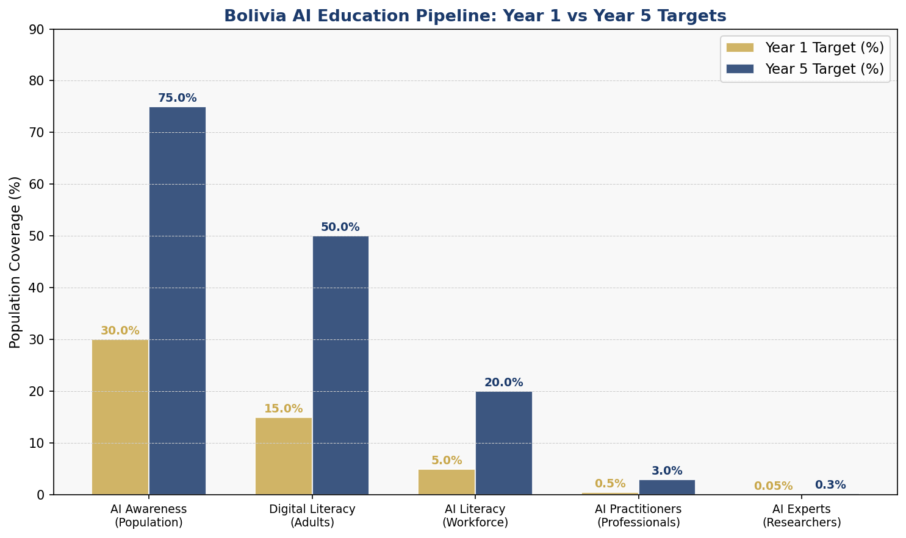
Figure 5: Bolivia AI Education Pipeline — Year 1 vs Year 5 Population Coverage Targets

5.3 Inclusion & Equity Targets
- 50% women in all AI education programmes by Year 3
- 30% of AI scholarship recipients from rural/Indigenous communities
- 20 AI Community Learning Centres established in Indigenous territories by Year 2
- AI curriculum translated into 5 major Indigenous languages by Year 2

Section 6: Ethical AI Governance & Regulatory Framework
Effective AI governance is the backbone of trustworthy AI deployment. Bolivia's regulatory framework is designed to be risk-proportionate, corruption-resistant, culturally sensitive, and institutionally robust.

6.1 National AI Ethics Board (NAEB)
The National AI Ethics Board (NAEB) shall be established by executive decree within 6 months of policy adoption. The NAEB will function as an independent oversight body with the following mandate:
- Review and approve High-Risk AI system deployments in government and regulated sectors
- Investigate complaints of AI-related harm, discrimination, or rights violations
- Issue binding ethical guidelines and non-binding codes of conduct
- Publish annual AI Ethics State Report
- Coordinate with the Comptroller General on anti-corruption AI audits

Composition: 11 members serving 4-year terms — 3 legal/constitutional experts, 2 AI technologists, 2 civil society representatives (including 1 from Indigenous communities), 1 economist, 1 public health expert, 1 educator, and 1 international AI governance expert. Members may not hold government or private AI sector positions during tenure.

6.2 AI Risk Classification System
Risk Tier | Examples | Regulatory Response
Unacceptable Risk (BANNED) | Social credit scoring; covert biometric surveillance; AI targeting Indigenous beliefs for manipulation | Absolute prohibition. Criminal penalties for development, deployment, or use.
High Risk (REGULATED) | Justice, police, benefits eligibility, health diagnosis, educational assessment, credit scoring | Mandatory pre-deployment NAEB approval; annual audit; public impact assessment; appeals mechanism; human oversight required.
Limited Risk (TRANSPARENCY) | AI chatbots, recommendation systems, deepfakes, AI-generated content | Mandatory disclosure that content is AI-generated. Deepfake labelling law. No prior approval needed.
Minimal Risk (VOLUNTARY) | Spam filters, productivity tools, AI games, recommendation engines | Encouraged to adopt voluntary Code of Conduct. No mandatory regulatory requirement.
Table 2: Bolivia National AI Risk Classification System (adapted from EU AI Act 2024)

6.3 Data Protection & Privacy
Bolivia will enact a comprehensive Data Protection and AI Act within Year 1, establishing: a National Data Protection Authority with enforcement powers; data minimization and purpose limitation principles for AI systems; mandatory data breach notification within 72 hours; explicit consent requirements for biometric data collection; right to explanation for automated decisions affecting citizens; data localization requirements for sensitive government data.

6.4 Algorithmic Accountability Standards
All government AI systems must meet the following algorithmic accountability standards: documentation of training data sources and known biases; bias testing disaggregated by gender, ethnicity, and region before deployment; audit logs retained for minimum 5 years; public algorithmic impact statements for high-risk systems; independent third-party audits every 2 years.

6.5 Anti-Corruption AI Governance
Given Bolivia's elevated corruption risk, this policy includes specific anti-corruption provisions for AI governance: all AI procurement must go through open, transparent competitive process with technical oversight from the Comptroller General's office; AI systems used in public service delivery must have auditable decision logs; no single vendor may provide more than 30% of government AI services; revolving door restrictions for NAEB members joining AI firms for 3 years post-service.

Section 7: Public Sector AI & e-Governance
The Bolivian government will harness AI to transform public service delivery, reduce administrative burden, combat corruption, and bring government closer to citizens across the country's diverse geography and linguistic landscape.

7.1 Priority Government Use Cases
- Tax Administration (AGIT): AI for VAT compliance monitoring, fraud detection, taxpayer service chatbot in Spanish/Quechua/Aymara. Target: 15% increase in tax compliance by Year 3.
- Health Ministry: AI triage support for rural health posts; disease outbreak surveillance AI linked to PAHO regional system; AI-assisted maternal health monitoring.
- Justice System: AI for case management and backlog reduction; risk assessment AI for pre-trial detention decisions (with mandatory human review and bias audits); AI-assisted legal aid access for rural communities.
- Agriculture Ministry: AI crop advisory service via SMS/WhatsApp for smallholder farmers; satellite-based drought early warning AI; livestock disease surveillance AI.
- Education Ministry: AI-personalized learning platforms for rural students; automated school infrastructure monitoring; AI dropout prediction and early intervention.
- Social Protection (SEDESOL): AI-targeted social transfer eligibility; fraud detection in benefit distribution; automated beneficiary verification.

7.2 Government AI Procurement Guidelines
All government AI procurement must adhere to the following principles:
- Open source preference: preference for open-source AI solutions where technically feasible
- Data sovereignty: all citizen data must remain within Bolivia's legal jurisdiction
- Interoperability: all government AI systems must use API-first architecture and open standards
- Accessibility: all citizen-facing AI must meet WCAG 2.1 AA accessibility standards and be available in at least Spanish, Quechua, and Aymara
- Exit strategy: no vendor lock-in; contracts must include data portability and migration clauses

7.3 Citizen-Facing AI Services Roadmap
Year 1: National AI chatbot for government services (Asistente Digital Bolivia). Year 2: AI-powered one-stop digital government portal integrating 50+ services. Year 3: Mobile-first AI services reaching rural communities without broadband. Year 4: Proactive AI government services (push notifications for citizen entitlements). Year 5: Fully integrated AI-enabled e-governance ecosystem with 80% of government services available digitally.

Section 8: Implementation Roadmap
Bolivia's National AI Policy will be implemented in three phases over five years, with clear milestones, responsible ministries, and accountability mechanisms at each stage.

Phase 1: Foundation (Months 1–12)
- Establish National AI Ethics Board (NAEB) by Month 6
- Enact Data Protection & AI Act by Month 9
- Launch National AI Research Centre (CENIA-Bolivia) planning process
- Integrate AI into Year 7–12 national curriculum framework
- Launch 5 government AI pilot programmes (tax, health, agriculture, justice, education)
- Establish National AI Observatory within the Ministry of Planning
- Sign 3 bilateral AI cooperation agreements
- Publish Bolivia's first National AI State Report

Phase 2: Scaling (Months 13–36)
- Open CENIA-Bolivia research centre with initial 50 researchers
- Launch National AI Bootcamp: target 20,000 graduates by Month 36
- Roll out AI-enhanced government services nationally (50+ services digitized)
- Establish AI Community Learning Centres in all 9 departments
- Launch AI for Industry Fund: first 50 SME AI adoption grants
- Complete first NAEB annual audit cycle of High-Risk AI deployments
- Achieve 50% internet penetration in rural areas (in coordination with connectivity programme)

Phase 3: Optimization (Months 37–60)
- First 5-year policy review and update
- Target: 75% AI awareness among adult population
- Target: 3.5% AI contribution to GDP
- CENIA-Bolivia first international research publications and patents
- Bolivia joins GPAI (Global Partnership on AI) as associate member
- AI export initiative: Bolivia providing AI solutions to landlocked developing country partners
- Full operationalization of AI regulatory framework with enforcement track record

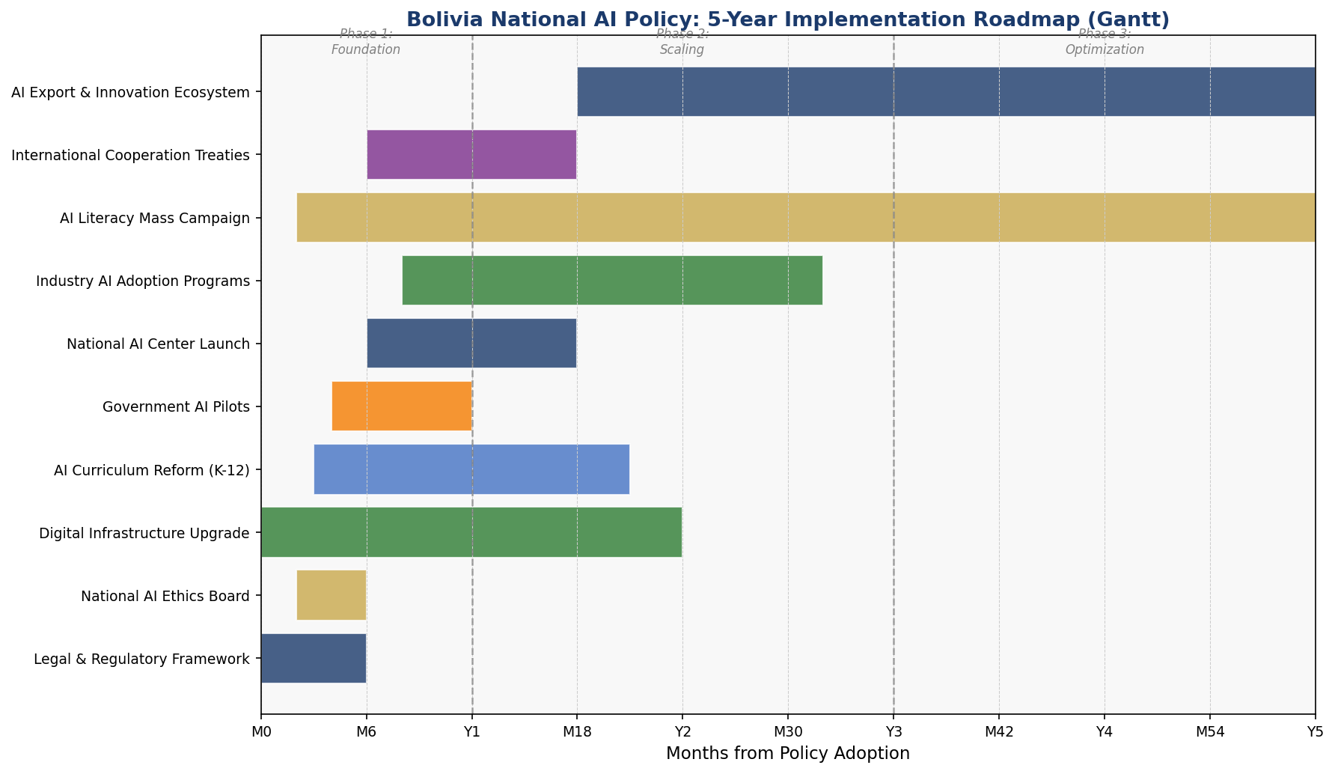
Figure 6: Bolivia National AI Policy — 5-Year Implementation Roadmap (Gantt Chart)

Section 9: Monitoring, Evaluation & Accountability
Robust monitoring and evaluation is essential to ensure the policy delivers its intended outcomes, adapts to rapidly changing AI technology, and remains accountable to all Bolivian citizens.

9.1 National AI Observatory
The National AI Observatory (Observatorio Nacional de Inteligencia Artificial — ONIA) will be established within the Ministry of Planning and Development by Year 1. ONIA's mandate includes: annual data collection on AI deployment across government and private sector; publication of the National AI State Report (mandatory annual publication); independent assessment of policy implementation against KPIs; research coordination with CENIA-Bolivia and international partners; public dashboard with real-time AI policy progress data.

9.2 Parliamentary Oversight
The Plurinational Legislative Assembly will establish a Joint Committee on Artificial Intelligence and Digital Technologies by Year 1. This committee will: review the Annual National AI State Report; conduct public hearings on emerging AI issues; exercise oversight of NAEB activities; approve major policy revisions; and invite citizen testimony through online participation platforms (in Spanish, Quechua, and Aymara).

9.3 KPI Dashboard
KPI Metric | Baseline (2026) | Year 1 Target | Year 3 Target | Year 5 Target
AI-qualified professionals | 2,400 | 4,000 | 10,000 | 18,000
AI awareness (adult pop.) | 12% | 30% | 55% | 75%
AI contribution to GDP | ~0.1% | 0.3% | 1.4% | 3.5%
Women in AI programmes | 28% | 35% | 45% | 50%
Government AI services digitized | 8 | 20 | 50 | 80+
Rural internet penetration | 32% | 45% | 60% | 80%
NAEB complaints investigated | N/A | 100% | 100% | 100%
AI startups registered | ~15 | 50 | 150 | 300
Bilateral AI agreements | 0 | 3 | 8 | 15
AI curriculum schools coverage | 0% | 40% | 80% | 100%
Table 3: Bolivia National AI Policy KPI Dashboard (2026–2031)

Section 10: International Cooperation & Diplomacy
Bolivia's AI development cannot succeed in isolation. Strategic international partnerships will accelerate technology transfer, build institutional capacity, and amplify Bolivia's voice in global AI governance discussions.

10.1 Bilateral AI Cooperation Priorities
- Brazil: AI for agriculture and mining; digital infrastructure investment; joint research programmes between CENIA-Bolivia and Brazilian AI institutes
- Argentina: AI startup ecosystem; fintech AI collaboration; academic exchange for AI researchers
- Chile: Cross-border digital services; AI for Atacama Desert environmental monitoring; shared lithium supply chain AI
- Uruguay: e-Government AI best practices transfer; Uruguay's advanced digital government serves as model
- Spain / European Union: Access to EU AI Act implementation expertise; Horizon Europe research collaboration; Spanish language AI development
- China: Digital infrastructure investment with data sovereignty safeguards; AI for mining technology; Belt and Road digital component with equity clauses
- United States: Academic partnerships; AI for development programmes; bilateral investment in AI-enabled natural resource management
- India: IT skills development collaboration; telemedicine AI; affordable AI solutions transfer

10.2 Regional AI Governance: Latin America
Bolivia will actively engage in regional AI governance through: CELAC Digital Agenda AI Working Group (seeking chair role by Year 3); Andean Community (CAN) AI interoperability standards development; UNASUR digital economy revival efforts; LAC-AI Research Network participation. Bolivia will advocate for a Latin American AI Governance Charter that centers Indigenous rights and equitable access.

10.3 Global AI Governance Participation
Bolivia will pursue formal engagement in: GPAI (Global Partnership on AI) — application for associate membership by Year 3; UN AI Advisory Body — active participation in civil society coalition track; ITU AI for Good — annual summit participation and showcase of Bolivia's AI for development model; UNESCO AI Ethics Global Observatory — national focal point designation; and OECD Global AI Policy Observatory — data submission and peer learning participation.

10.4 South-South Knowledge Transfer
Bolivia will establish an AI for Landlocked Developing Nations (AI-LDN) programme to share its experiences with peer countries including Paraguay, Nepal, Bhutan, Kazakhstan, and Ethiopia. The programme will include: annual AI governance conference hosted in Sucre or La Paz; open-source sharing of government AI tools developed under this policy; exchange scholarships for AI researchers from LDC and SIDS countries at CENIA-Bolivia.

Conclusion
Bolivia stands before a generational opportunity. The artificial intelligence revolution is not merely a technological shift — it is a civilizational inflection point that will reshape power, opportunity, and human dignity on a global scale. Bolivia's National AI Policy 2026–2031 is a declaration that this nation will be an active, sovereign, and ethical participant in that future — not a passive recipient of others' AI choices.

This policy recognizes Bolivia's unique strengths: its extraordinary natural resource endowments (especially lithium, the material foundation of AI hardware), its youthful and culturally rich population, its constitutional commitment to plurinationalism and dignity, and its emerging generation of technology innovators. These are not merely assets to be exploited by global AI powers — they are the foundation upon which Bolivia will build its own AI future.

At the same time, this policy confronts Bolivia's challenges honestly: governance deficits, infrastructure gaps, skills shortages, and corruption risks. It does not pretend these challenges will dissolve through good intentions. Instead, it establishes concrete institutions, legal frameworks, investment commitments, and accountability mechanisms designed to transform aspirations into measurable outcomes.

The measure of this policy's success will not be found in policy documents or government reports alone. It will be found in the farmer in Beni who receives AI crop advice in Quechua. In the girl in Potosi who studies machine learning at her village learning centre. In the tax officer in La Paz who investigates corruption using AI audit tools. In the researcher at CENIA-Bolivia who publishes Bolivia's first internationally cited AI paper. And in the voice of every Bolivian citizen who can access government services in their own language, with dignity and speed, because AI made it possible.

Bolivia has always found its path forward through resilience, solidarity, and the genius of its peoples. This National AI Policy is the next step on that path.

References & Bibliography
International Frameworks & Standards
- UNESCO. (2021). Recommendation on the Ethics of Artificial Intelligence. Paris: United Nations Educational, Scientific and Cultural Organization.
- OECD. (2019, updated 2024). Recommendation of the Council on Artificial Intelligence. OECD Legal Instruments, OECD/LEGAL/0449.
- European Parliament and Council. (2024). Regulation (EU) 2024/1689 — Artificial Intelligence Act. Official Journal of the European Union.
- World Bank Group. (2023). Governing Data and Artificial Intelligence for All: Models for Safe, Beneficial and Inclusive AI. Washington, D.C.
- G20. (2023). G20 New Delhi Leaders' Declaration — AI Annex. G20 India Presidency.
- ITU. (2023). AI for Good Global Summit Guidelines. International Telecommunication Union, Geneva.
- UN Secretary-General. (2024). Interim Report: Governing AI for Humanity. New York: United Nations.

Country Data & Indices
- Transparency International. (2024). Corruption Perceptions Index 2024. Berlin: Transparency International.
- Oxford Insights. (2023). Government AI Readiness Index 2023. Oxford: Oxford Insights.
- World Bank. (2024). World Development Indicators: Bolivia. Washington, D.C.: World Bank.
- ITU. (2024). Digital Development Dashboard: Bolivia. Geneva: International Telecommunication Union.
- UNDP. (2024). Human Development Report 2024: Bolivia Country Profile. New York: United Nations Development Programme.
- Banco Central de Bolivia. (2024). Informe de Estabilidad Financiera 2024. La Paz: BCB.

AI Economic Impact Research
- McKinsey Global Institute. (2023). The Economic Potential of Generative AI: The Next Productivity Frontier. McKinsey & Company.
- World Economic Forum. (2023). The Future of Jobs Report 2023. Geneva: WEF.
- Inter-American Development Bank (IDB). (2023). The Promise of Artificial Intelligence in Latin America and the Caribbean. Washington, D.C.: IDB.

Bolivian Policy & Governance Context
- Plurinational State of Bolivia. (2009). Constitución Política del Estado Plurinacional de Bolivia. Gaceta Oficial de Bolivia.
- Ministerio de Obras Públicas, Servicios y Vivienda. (2023). Agenda Digital Bolivia 2025. La Paz: MOPSV.
- Agencia de Tecnologías de Información y Comunicación (ATIC). (2024). Estado de la Digitalización en Bolivia. La Paz: ATIC.

About the Author

Nafiul Ahmad Rafi
Policy & Good Governance Researcher | BD Civic Tech Architect
Nafiul Ahmad Rafi is a civic technologist, policy researcher, author, photographer, and musician based in Dhaka, Bangladesh. He is the Founder and Director of Insights Bangladesh, a data-driven governance and policy impact analysis institution, and the Founder & Lead Architect of NagorikBD.org — a transparency-first civic platform scaled across Mymensingh Division, connecting citizens with government services across 45 Upazilas.

His work exists at the intersection of institutional reform and artificial intelligence, transforming theoretical governance into scalable, data-driven reality. Without a conventional computer science degree, he self-taught the tools of modern AI and web development to build the infrastructure that enforces the policies he once only researched.

Key Platforms & Projects:
- NagorikBD.org — Civic transparency platform, Mymensingh Division
- Insights Bangladesh — Policy impact analysis institution
- FactCheck BD (factcheckbd.org) — Bangladesh's AI-powered fact-checking platform
- Political Insights BD / PIBD (pibbd.org) — Political intelligence and civic tech hub
- PeaceShield BD / National Peace Tracker — AI-powered hate speech and conflict monitoring
- PolicyLens AI (aigovbd.org) — 9-dimensional AI policy audit tool

He has published four books and maintains a personal site at ahmad-rafi.com.

Research Interests:
AI Governance · Policy Research · Future of Bangladesh · Climate Policy

Contact:
- Website: ahmad-rafi.com
- LinkedIn: linkedin.com/in/nafiul-ahmad-rafi
- Email: contact@ahmad-rafi.com

"I build code to ensure transparency, and I write lyrics to inspire the courage to use it."

