🇪🇨
REPUBLIC OF ECUADOR
National Artificial Intelligence Policy
2025–2030
A Comprehensive Framework for Ethical, Inclusive, and Economically Transformative AI

Prepared by:
Nafiul Ahmad Rafi | Insights Bangladesh
May 2025

TABLE OF CONTENTS

Executive Summary

Ecuador stands at a pivotal juncture in its development trajectory. As one of Latin America's mid-sized economies with a population of approximately 18 million and a GDP of around USD 118 billion, Ecuador possesses significant potential to harness Artificial Intelligence (AI) as a catalyst for inclusive economic growth, improved governance, and enhanced citizen welfare. This National AI Policy (2025–2030) establishes the comprehensive framework, governance architecture, and investment roadmap required to position Ecuador as a competitive, ethical, and innovation-driven AI adopter within the region.
The policy is grounded in a rigorous assessment of Ecuador's current AI readiness landscape — examining digital infrastructure maturity, human capital capacity, institutional governance quality, and the integrity of public institutions. Ecuador's Transparency International Corruption Perception Index (CPI) score of 34 out of 100 signals that anti-corruption safeguards must be central to any AI governance framework. The integration of AI in public administration presents both an opportunity to improve transparency and a risk of amplifying existing institutional weaknesses if left ungoverned.
Anchored by five strategic pillars — Ethical AI and Human Rights Protection; Economic Growth and Industrial AI Adoption; Education, Upskilling and Workforce Development; Public Sector AI and e-Governance; and AI Research, Innovation and Startup Ecosystem — this policy charts a five-year course of phased implementation. It aligns fully with UNESCO's AI Ethics Recommendation (2021), OECD AI Principles, the EU AI Act risk-based framework, World Bank AI Strategy, G20 AI Principles, and ITU AI for Good Guidelines.
By 2030, Ecuador aims to achieve measurable outcomes: a 3.8% AI-related GDP contribution, upskilling of 800,000 individuals in AI literacy, deployment of AI in at least 15 key government services, and establishment of a National AI Ethics Board with binding enforcement authority. This document provides the roadmap, accountability mechanisms, and international cooperation framework to make that vision a reality.

Section 1: National AI Readiness Assessment

1.1 Economic Context
Ecuador is an upper-middle-income country with a GDP of approximately USD 118 billion (2023), heavily dependent on petroleum exports, agriculture (bananas, shrimp, cocoa, roses), and remittances. The economy has undergone significant structural reform pressures following the COVID-19 pandemic, falling oil revenues, and persistent fiscal deficits. The digital economy accounts for an estimated 3.2% of GDP, significantly below the Latin American regional average of 5.1%, underscoring the urgency for a comprehensive digital and AI transformation agenda.
Key economic indicators: GDP per capita: USD 6,400 (2023); GDP growth rate: 2.3% (2023 est.); Unemployment rate: 4.2%; Informal economy: ~45% of workforce. AI is projected to add between 1–4% to Ecuador's GDP by 2030 if policy conditions are met, consistent with World Bank and McKinsey estimates for economies at Ecuador's income tier.

1.2 Education and Human Capital
Ecuador's adult literacy rate stands at approximately 94%, with tertiary enrollment at around 36%. The country has made notable strides in expanding public education, though significant gaps remain in STEM education quality, particularly outside Quito, Guayaquil, and Cuenca. The National Secretariat of Higher Education, Science, Technology and Innovation (SENESCYT) has initiated digital inclusion programs, but AI-specific curricula remain nascent at all levels of education.
The digital skills gap is estimated at approximately 620,000 workers who lack foundational digital competencies, with an AI-skilled workforce of fewer than 3,000 professionals nationally. Addressing this gap is a central pillar of this policy framework. Indigenous communities, rural populations, and women in technology represent priority groups for inclusion.

1.3 Digital Infrastructure
Internet penetration in Ecuador reached approximately 77% in 2023, with mobile broadband coverage at 85%. Fixed broadband penetration remains at around 42%, significantly concentrated in urban centers. Ecuador's National Fiber Optic Plan has connected provincial capitals but significant rural gaps persist. Cloud computing adoption among SMEs is at an estimated 22%, and data center capacity is limited, with most high-performance computing infrastructure concentrated in Quito.
The country operates under the Organic Law of Personal Data Protection (LOPDP) enacted in 2021, providing a foundational legal basis for data governance — a prerequisite for trustworthy AI deployment. However, the implementing regulations require strengthening to meet international standards for AI-specific data use.

1.4 Governance and Institutional Capacity
Ecuador operates as a presidential republic with a unicameral National Assembly. The country has seen significant political volatility over the past decade, with multiple presidents and significant executive-legislative tensions. The Ministry of Telecommunications and Information Society (MINTEL) currently anchors digital transformation efforts, but a dedicated AI governance body does not yet exist. Institutional capacity for technology regulation is limited, and interoperability between government information systems remains a challenge.
The World Bank Worldwide Governance Indicators (WGI) place Ecuador in the 35th percentile for government effectiveness, 28th percentile for control of corruption, and 40th percentile for regulatory quality — all areas requiring targeted improvement to enable effective AI governance.

1.5 Corruption Risk Assessment
Ecuador's CPI score of 34/100 (Transparency International, 2023) places it in the 'high corruption risk' tier. Key vulnerability areas include public procurement, judicial institutions, law enforcement, and customs. In the context of AI deployment, these risks manifest as: procurement fraud in AI system contracts; biased algorithmic decision-making in benefit distribution; political interference in AI model training and output; and misuse of AI surveillance without judicial oversight.
This policy mandates that all government AI deployments undergo mandatory algorithmic audits, that AI procurement follows open and competitive tendering processes, and that an independent AI Ethics Board with civil society representation has oversight authority over all high-risk public sector AI applications.

1.6 AI Readiness Radar
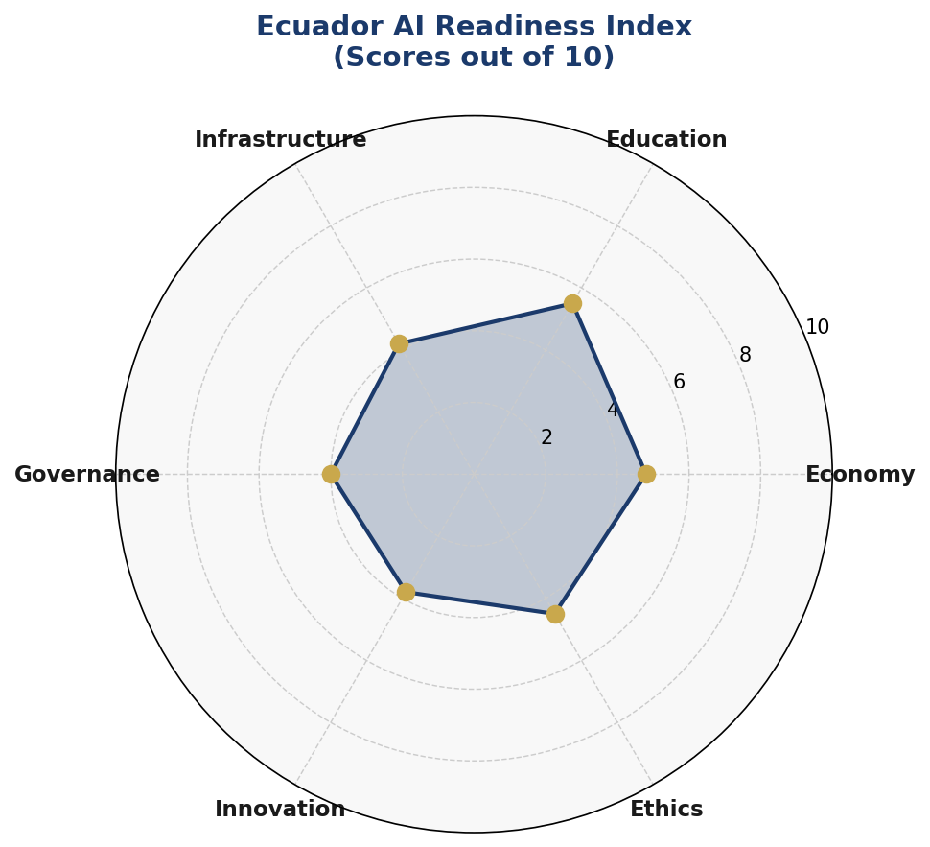
Figure 1.1: Ecuador AI Readiness Index — Six-Axis Assessment (Scores out of 10)
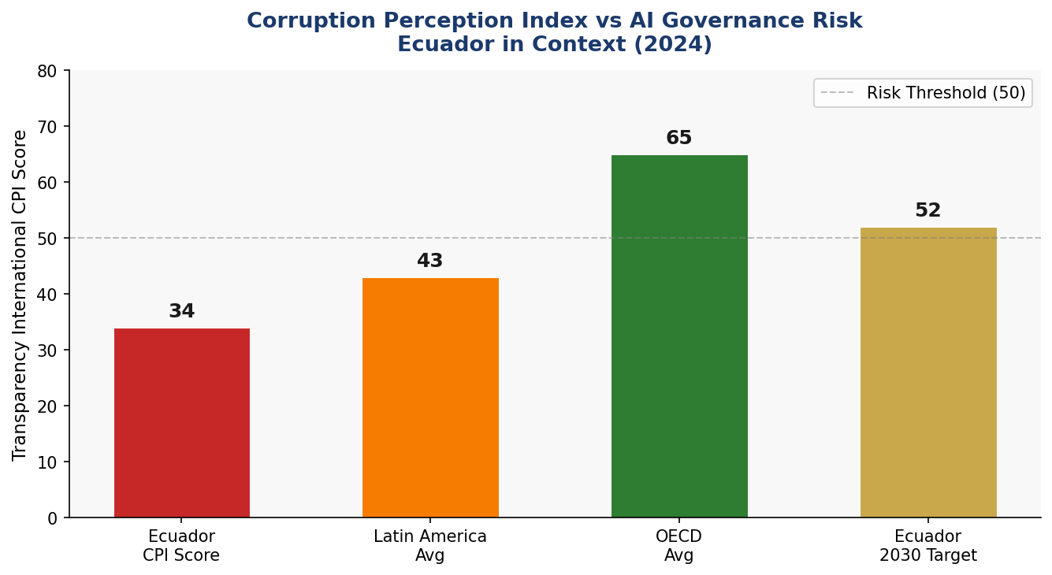
Figure 1.2: Ecuador Corruption Perception Index vs Regional and OECD Comparators

Section 2: Policy Vision and Strategic Pillars

2.1 Vision Statement
"An Ecuador where Artificial Intelligence empowers every citizen, strengthens democratic institutions, and drives equitable, sustainable prosperity — governed with transparency, anchored in human rights, and built for the future."
This vision reflects Ecuador's dual imperative: to leverage AI as an engine of economic competitiveness and social equity, while rigorously safeguarding against the institutional, ethical, and human rights risks that unregulated AI can amplify. Ecuador's AI journey must be distinctly Ecuadorian — responsive to its biodiversity, its cultural and linguistic diversity, its democratic aspirations, and its development challenges.

2.2 Strategic Pillar 1: Ethical AI and Human Rights Protection
Ecuador commits to placing human dignity, non-discrimination, and constitutional rights at the center of all AI development and deployment. This pillar establishes the National AI Ethics Board, mandates human rights impact assessments for high-risk AI applications, prohibits surveillance AI without judicial authorization, and ensures meaningful redress mechanisms for citizens affected by AI decisions.
- Establish National AI Ethics Board within 12 months of policy adoption
- Mandate algorithmic transparency reports for all government AI systems
- Prohibit social scoring systems and mass biometric surveillance without court order
- Develop Ecuadorian AI Ethics Charter aligned with UNESCO Recommendation
- Ensure all AI systems are auditable, explainable, and contestable by affected citizens

2.3 Strategic Pillar 2: Economic Growth and Industrial AI Adoption
Ecuador will accelerate AI adoption across priority economic sectors — petroleum and extractives optimization, agricultural value chain digitization, eco-tourism and biodiversity monitoring, financial inclusion, and manufacturing — to enhance productivity and competitiveness. The policy establishes an AI for Industry Program with targeted sectoral roadmaps and a National AI Fund seeded with public investment and designed to attract international development finance.
- Launch AI for Agriculture Program (smallholder yield optimization, pest detection)
- Deploy AI in petroleum sector for extraction efficiency and environmental monitoring
- Establish AI-powered financial inclusion platform for unbanked populations
- Create Ecuador AI Startup Fund with USD 50 million public seed capital
- Develop AI for Biodiversity monitoring aligned with Galapagos conservation goals

2.4 Strategic Pillar 3: Education, Upskilling and AI Workforce Development
Recognizing that AI's benefits will only materialize if Ecuador's workforce is equipped to work with and alongside intelligent systems, this pillar mandates a national AI skills transformation. From K-12 computational thinking integration to university AI specializations and workplace retraining programs, Ecuador will build the human capital necessary for AI-driven economic transformation.
- Integrate AI literacy into national K-12 curriculum by Year 2
- Establish AI Centers of Excellence at ESPOL, PUCE, UCE, and UTPL
- Launch 'Ecuador AI Skills' national upskilling platform — free to all citizens
- Create 500 AI scholarships annually for indigenous and rural students
- Partner with international universities for AI faculty development programs

2.5 Strategic Pillar 4: Public Sector AI and e-Governance
AI in Ecuador's public sector represents both the highest-impact and highest-risk domain. This pillar establishes rigorous procurement standards, mandatory pilot-to-scale evaluation frameworks, and citizen-facing AI services in health, education, justice, and social protection — all subject to continuous independent audit.
- Deploy AI diagnostic support in 50 public hospitals within 3 years
- Launch AI-powered tax compliance system to reduce Ecuador's USD 4B tax gap
- Implement AI-assisted judicial case management (non-decisional) in courts
- Create AI chatbot for citizen services in Spanish, Kichwa, and Shuar
- Establish Government AI Procurement Standards and open-source code repository

2.6 Strategic Pillar 5: AI Research, Innovation and Startup Ecosystem
Ecuador will build a self-sustaining AI innovation ecosystem centered on its universities, national research institutes, and the emerging startup sector in Quito's innovation district (Yachay Tech) and Guayaquil's digital economy hub. International research partnerships, IP frameworks adapted for AI outputs, and a regulatory sandbox will nurture homegrown AI solutions.
- Establish National AI Research Institute with SENESCYT co-funding
- Create AI Regulatory Sandbox for startups to test products with regulatory guidance
- Develop Ecuador AI Innovation Prizes — annual awards across 5 sectors
- Sign bilateral AI research MOUs with Spain, Germany, Canada, and Brazil
- Publish open government datasets to fuel local AI model development

Section 3: International Framework Alignment

3.1 UNESCO AI Ethics Recommendation (2021)
Ecuador's National AI Policy aligns with all eleven core values of UNESCO's Recommendation on the Ethics of AI: proportionality and do no harm; safety and security; fairness and non-discrimination; sustainability; right to privacy and data protection; human oversight and determination; transparency and explainability; responsibility and accountability; awareness and literacy; multi-stakeholder and adaptive governance; and international cooperation. Specific policy provisions map to each value as detailed in the alignment matrix below.

3.2 OECD AI Principles (2019, Updated 2024)
The five OECD AI Principles — inclusive growth and sustainable development; human-centred values and fairness; transparency and explainability; robustness, security and safety; and accountability — are directly operationalized through Ecuador's regulatory framework, ethics board mandate, algorithmic audit requirements, and procurement standards.

3.3 EU AI Act Risk-Based Framework (2024)
Ecuador adopts the EU AI Act's risk-based categorization, adapted to national context. Unacceptable risk applications (social scoring by government, real-time biometric surveillance of public spaces without court order, AI manipulation of vulnerable groups) are prohibited. High-risk applications in health, justice, employment, and critical infrastructure require mandatory conformity assessment, registration, and ongoing audit. Limited-risk applications require transparency disclosure. Minimal-risk applications are subject to voluntary codes of conduct.

3.4 World Bank AI Strategy
Ecuador's policy integrates the World Bank's development-focused AI principles: AI for poverty reduction and human capital development; AI for public sector efficiency and anti-corruption; AI for climate resilience and environmental protection; and data infrastructure as a public good. The investment framework specifically allocates resources toward AI applications serving Ecuador's bottom 40% income group.

3.5 G20 AI Principles and ITU AI for Good
Ecuador, as a Pacific Alliance member and active UN participant, aligns with G20 AI Principles on inclusive growth and the ITU AI for Good framework's SDG linkages. AI applications are mapped to SDG goals: SDG 1 (no poverty), SDG 3 (health), SDG 4 (education), SDG 8 (decent work), SDG 16 (institutions), and SDG 17 (partnerships). Ecuador commits to reporting AI's SDG contribution in its annual Voluntary National Review.

3.6 Comprehensive Framework Alignment Matrix
Framework Principle | Section 1  Assessment | Section 2  Vision | Section 3  Frameworks | Section 6  Ethics | Section 7  Gov't AI | Section 8  Roadmap
UNESCO: Proportionality & Do No Harm | ✅ | ✅ | ✅ | ✅ | ✅ | ⚠️
UNESCO: Safety & Security | ✅ | ✅ | ✅ | ✅ | ✅ | ✅
UNESCO: Fairness & Non-discrimination | ✅ | ✅ | ✅ | ✅ | ⚠️ | 🔲
UNESCO: Sustainability | ⚠️ | ✅ | ✅ | ⚠️ | 🔲 | ⚠️
UNESCO: Privacy & Data Protection | ✅ | ✅ | ✅ | ✅ | ✅ | ✅
UNESCO: Human Oversight | ✅ | ✅ | ✅ | ✅ | ✅ | ✅
UNESCO: Transparency | ✅ | ✅ | ✅ | ✅ | ✅ | ✅
UNESCO: Accountability | ✅ | ✅ | ✅ | ✅ | ✅ | ✅
UNESCO: Awareness & Literacy | ⚠️ | ✅ | ✅ | 🔲 | 🔲 | ✅
OECD: Inclusive Growth | ✅ | ✅ | ✅ | ⚠️ | ✅ | ✅
OECD: Robustness & Security | ⚠️ | ✅ | ✅ | ✅ | ✅ | ⚠️
EU AI Act: Risk Classification | 🔲 | ⚠️ | ✅ | ✅ | ✅ | ✅
World Bank: Dev. Finance Alignment | ✅ | ✅ | ✅ | 🔲 | ✅ | ✅
G20: AI Governance | ✅ | ✅ | ✅ | ✅ | ⚠️ | ✅
ITU: SDG Linkage | ✅ | ✅ | ✅ | ⚠️ | ✅ | ✅
Legend: ✅ Fully Addressed ⚠️ Partially Addressed 🔲 Future Development Required

Section 4: Economic Impact and Investment Roadmap

4.1 Projected AI Economic Contribution
Drawing on McKinsey Global Institute, World Economic Forum, and World Bank projections for upper-middle-income economies in Latin America, Ecuador's AI adoption is projected to generate cumulative GDP gains of approximately USD 4.5 billion over five years, reaching a 3.8% GDP contribution by 2029. These projections assume successful implementation of all five strategic pillars, sustained public investment of at least 0.3% of GDP annually in AI infrastructure and skills, and an enabling regulatory environment.
The sectoral distribution of economic impact is estimated as follows: Agriculture and food exports (28% of AI gains), petroleum and extractives (22%), financial services and fintech (18%), public health and social protection efficiency (15%), manufacturing and logistics (12%), and tourism and creative industries (5%).
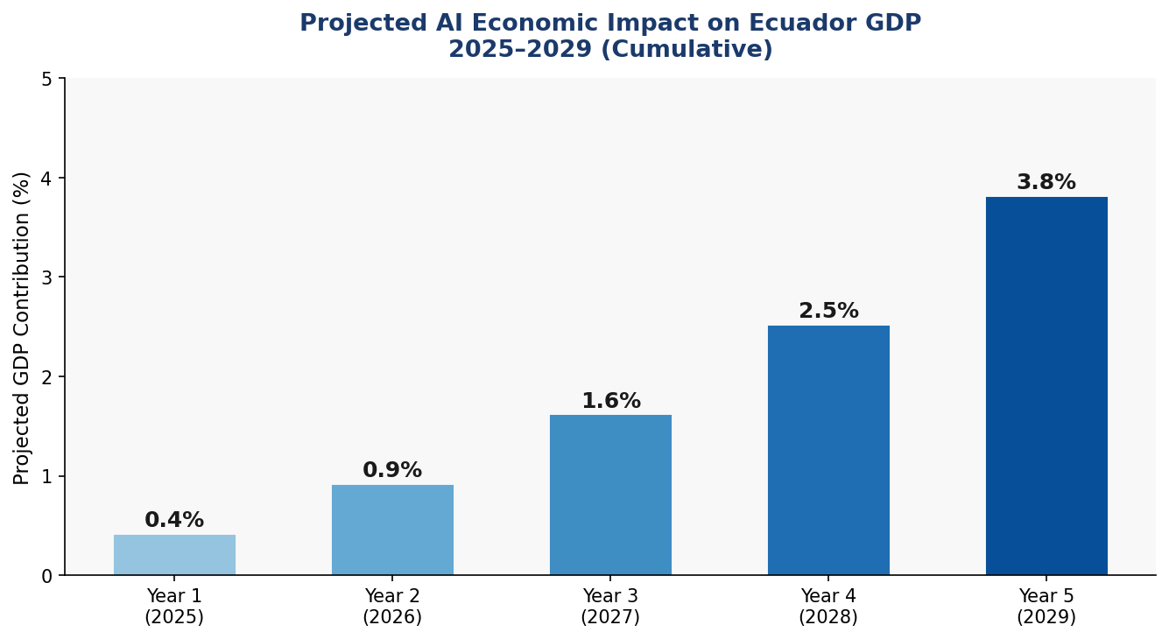
Figure 4.1: Projected AI Economic Impact on Ecuador GDP (2025–2029, Cumulative)

4.2 Investment Allocation Framework
Ecuador commits to a five-year National AI Investment Program of USD 450–550 million, structured across six priority areas. This investment will be mobilized through the national budget (40%), multilateral development bank financing (35%, primarily IDB, CAF, and World Bank), and private sector co-investment leveraged through PPP structures (25%). The allocation reflects both the urgency of infrastructure development and the foundational importance of human capital.
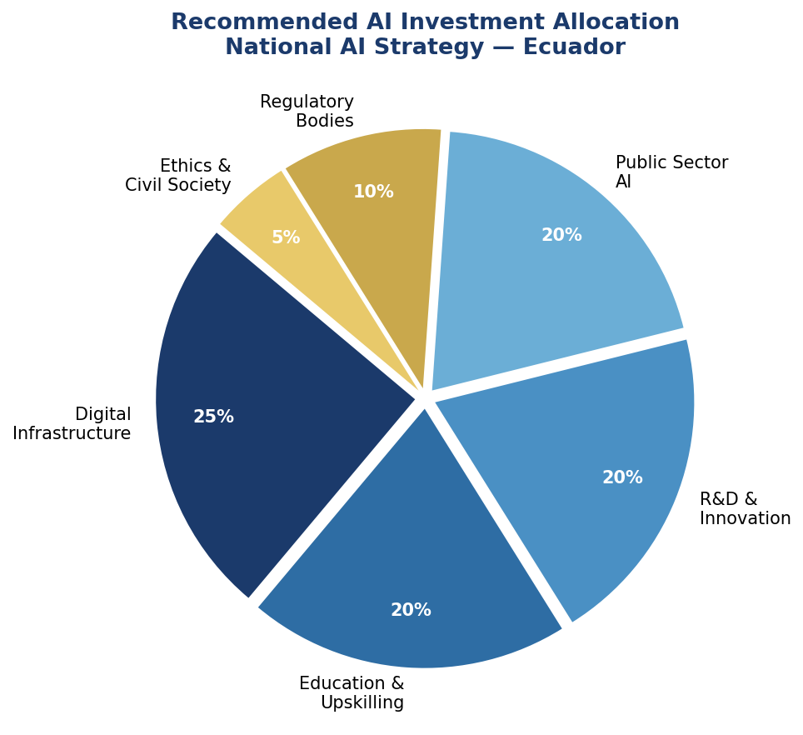
Figure 4.2: Recommended National AI Investment Allocation by Priority Area

4.3 Priority Sectors for AI Adoption
Agriculture and Agri-Tech
Ecuador is among the world's top exporters of bananas, shrimp, cocoa, and roses. AI applications in precision agriculture — crop disease detection via satellite and drone imagery, yield prediction, and climate-adaptive planting optimization — could add 8–12% to export value within five years. Smallholder AI advisory apps, available in Spanish and Kichwa, will democratize access to precision agriculture tools.
Petroleum and Energy
Petroecuador and the private petroleum sector can deploy AI for reservoir optimization, predictive maintenance of pipeline infrastructure, and environmental impact monitoring — reducing extraction costs by an estimated 15% and significantly improving spill detection response times.
Healthcare
AI-powered diagnostic support in radiology, pathology, and disease surveillance can address Ecuador's physician-to-population ratio challenges (2.2 per 1,000 — below the WHO target). Telemedicine AI will extend specialist access to rural provinces including Napo, Morona Santiago, and Esmeraldas.

4.4 Public-Private Partnership Framework
Ecuador will establish a National AI Partnership Council co-chaired by MINTEL and the Ministry of Production. PPP agreements will govern data sharing, model co-development, and risk distribution between government and industry. All PPP contracts will include algorithmic transparency clauses, public audit rights, and data sovereignty protections ensuring government retains rights over citizen data.

Section 5: Education and Human Capital Development

5.1 Current Skills Gap Analysis
Ecuador's AI skills gap is characterized by three dimensions: foundational digital literacy deficits affecting approximately 620,000 workers; a shortage of mid-level AI practitioners capable of implementing and maintaining AI systems (estimated gap: 45,000 professionals); and a critical shortage of AI researchers, ethicists, and policy specialists (estimated gap: 2,500 specialists). Women represent only 28% of Ecuador's technology workforce, and indigenous and Afro-Ecuadorian communities are severely underrepresented.
Ecuador's tertiary institutions collectively offer fewer than 15 AI-specific degree programs, and AI content in secondary education is limited to isolated initiatives in elite private schools. The rural-urban education quality gap means that AI skills development must include both curriculum reform and infrastructure investment — particularly broadband connectivity and device access in the Amazon basin and coastal rural provinces.

5.2 National AI Curriculum Framework
K-12 Integration
By Year 2, Ecuador's Ministry of Education will integrate AI literacy into the national curriculum: computational thinking and algorithmic logic from Grade 3; data literacy and digital ethics from Grade 7; AI fundamentals, programming, and applied AI projects from Grade 10. Teacher training will be mandatory, with 15,000 teachers trained annually through the National Pedagogical University.
Tertiary and Vocational
SENESCYT will mandate AI course requirements for all STEM degrees by Year 3. Four AI Centers of Excellence will be established at leading public universities. Technical-vocational institutions will offer AI Operator certificates, preparing 30,000 technicians annually for AI-adjacent roles in agriculture, manufacturing, and services.
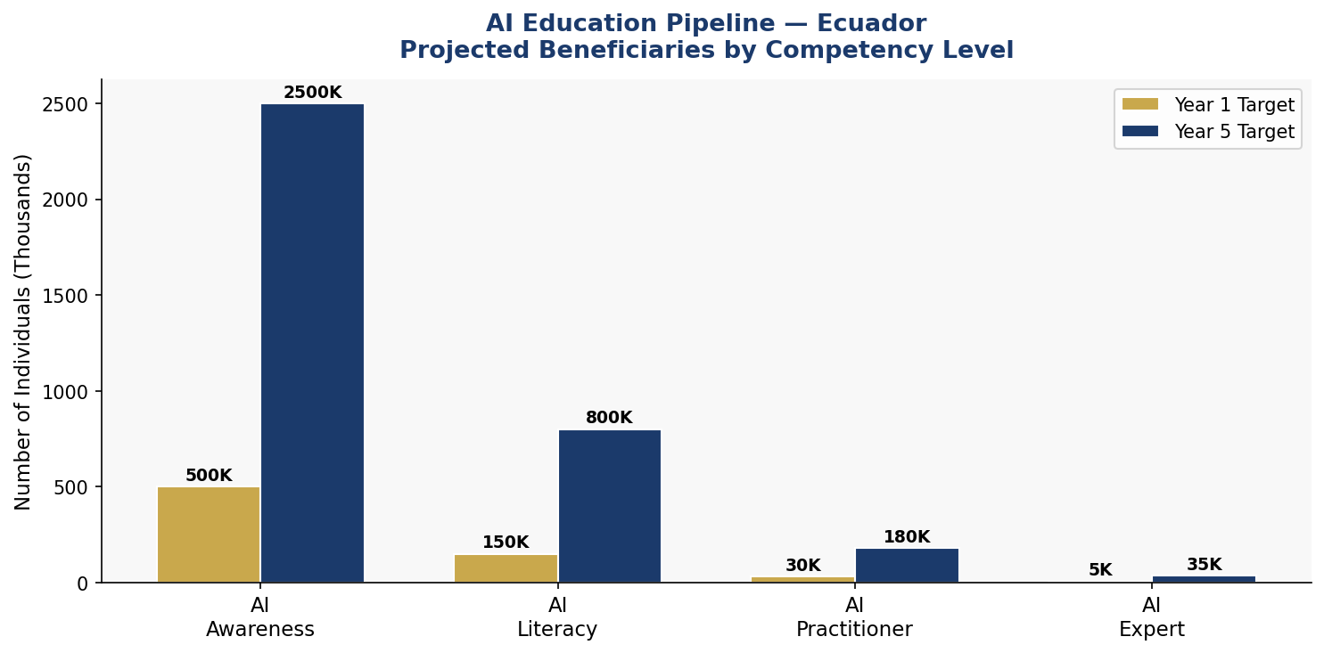
Figure 5.1: Ecuador AI Education Pipeline — Projected Beneficiaries by Competency Level

5.3 Women and Underrepresented Groups
Ecuador commits to gender parity in AI education programs within five years. Specific interventions include: Women in AI Ecuador scholarship program (200 full scholarships annually); indigenous community AI education pilots in partnership with CONAIE; bilingual AI literacy content in Kichwa and Shuar; and AfroEcuadorian digital inclusion centers in Esmeraldas and El Oro provinces.

5.4 International Partnerships
Ecuador will sign educational exchange agreements with Spain's National Polytechnic University, Germany's DAAD for AI research fellowships, Canada's CIFAR AI for Humanity program, and Brazil's FAPESP for South-South collaboration. A minimum of 100 Ecuadorian AI researchers will participate in international postdoctoral programs by Year 3.

Section 6: Ethical AI Governance and Regulatory Framework

6.1 National AI Ethics Board
The National AI Ethics Board (NAEB) will be established by executive decree within 12 months of this policy's adoption. The NAEB will comprise 15 members: 4 from government ministries (MINTEL, Health, Education, Justice); 3 from universities and research institutions; 3 from civil society and human rights organizations; 2 from the private technology sector; 2 from indigenous and Afro-Ecuadorian community representatives; and 1 international AI ethics expert. Members serve staggered four-year terms, with appointment by the National Assembly to ensure independence.
The NAEB's mandate includes: mandatory review of all high-risk government AI deployments; annual State of AI Ethics Report to the National Assembly; issuance of binding ethical guidelines and non-binding recommendations; administration of the AI Incident Registry; and coordination with the Defensoría del Pueblo on citizen AI rights complaints.

6.2 AI Risk Classification System
Unacceptable Risk — Prohibited
- AI systems for social scoring of citizens by government or corporations
- Real-time biometric surveillance in public spaces without specific judicial authorization
- AI systems designed to exploit psychological vulnerabilities of individuals
- AI for autonomous lethal weapons without human oversight
- AI systems that discriminate on grounds of race, gender, ethnicity, religion, or sexual orientation
High Risk — Mandatory Audit and Registration
- AI in healthcare diagnostics and treatment recommendation
- AI in judicial risk assessment, bail decisions, and sentence recommendations
- AI in employment screening, hiring, and performance evaluation
- AI in critical infrastructure: power grid, water systems, transportation
- AI in social benefit eligibility determination and administration
- AI in educational assessment and credentialing
Limited Risk — Transparency Obligations
- Chatbots and virtual assistants must disclose AI nature to users
- AI-generated content (text, images, audio, video) must be labeled
- AI recommendation systems must provide explanation on request
Minimal Risk — Voluntary Code of Conduct
- AI in creative applications, gaming, and entertainment
- AI in research and development environments
- AI in personal productivity and consumer applications

6.3 Data Protection and Privacy
Ecuador's Organic Law of Personal Data Protection (LOPDP, 2021) will be updated with AI-specific provisions within 18 months, including: mandatory data minimization for AI training; algorithmic impact assessments for high-risk AI; right to explanation for automated decisions; prohibition of sensitive personal data (health, ethnicity, religion, political opinion) in AI systems without explicit informed consent; and mandatory data breach notification within 72 hours.

6.4 Anti-Corruption AI Guidelines
Given Ecuador's elevated corruption risk, all government AI procurement will require: open competitive tender with technical evaluation by independent experts; mandatory source code escrow for government-owned AI systems; rotating auditor requirements — no single auditor may review the same system for more than two consecutive years; whistleblower protection for public officials reporting AI system manipulation; and criminal liability for public officials who manipulate AI systems to distort government benefit distribution or procurement outcomes.

Section 7: Public Sector AI and e-Governance

7.1 Priority Government Use Cases
Healthcare: IESS and MSP Integration
AI-powered medical imaging analysis will be deployed across 50 IESS and Ministry of Health hospitals in the first three years, beginning with radiology (chest X-ray, CT analysis) and expanding to pathology and dermatology screening. An AI early warning system for dengue, malaria, and COVID-19 surveillance will be integrated with PAHO's regional disease intelligence network.
Tax and Revenue Administration — SRI
The Servicio de Rentas Internas will deploy AI for tax gap analysis, fraud detection, and taxpayer risk scoring. Estimated recovery: USD 400–600 million annually from improved compliance, representing a significant contribution to Ecuador's fiscal consolidation without new tax burdens.
Education: Ministry of Education
An AI-powered learning analytics platform will track student progression across Ecuador's public school system, enabling early intervention for at-risk students. AI will support teachers with personalized lesson plan recommendations and automated administrative tasks, freeing approximately 2 hours per teacher per week.
Social Protection: MIES and BDH
AI will improve targeting of Ecuador's Bono de Desarrollo Humano and other social transfers, reducing inclusion and exclusion errors through multi-source data integration — while maintaining mandatory human review of all adverse benefit decisions.

7.2 Government AI Procurement Standards
All government AI procurement above USD 50,000 will require: publication on the SERCOP national procurement portal; independent technical review; algorithmic transparency documentation including model architecture, training data provenance, and validation metrics; contractual audit rights for NAEB; mandatory pilot evaluation before national rollout; and human override capability for all AI-assisted decisions affecting citizen rights.

7.3 Citizen-Facing AI Services
Ecuador will launch 'AsistenteEC' — a unified government AI assistant available in Spanish, Kichwa, and Shuar — providing citizens with 24/7 access to government service information, document tracking, complaint filing, and appointment scheduling across 120 government services. The platform will be accessible via smartphone, web browser, and SMS for populations with limited smartphone access.

7.4 Interoperability Standards
The National Government Digital Interoperability Framework will be updated to include AI-specific standards: API standards for AI service integration; data exchange protocols for AI model inputs and outputs; identity verification standards compatible with AI processing; and cybersecurity standards for AI systems handling citizen data. All government AI systems will comply with ISO/IEC 42001:2023 AI Management System standards.

Section 8: Implementation Roadmap

8.1 Overview
Ecuador's AI implementation follows a three-phase approach: Foundation (Year 1), Scaling (Years 2–3), and Optimization (Years 4–5). Each phase builds on the previous, with formal evaluation gates at Month 12, Month 36, and Month 60 to assess progress against KPIs and adjust course where necessary.
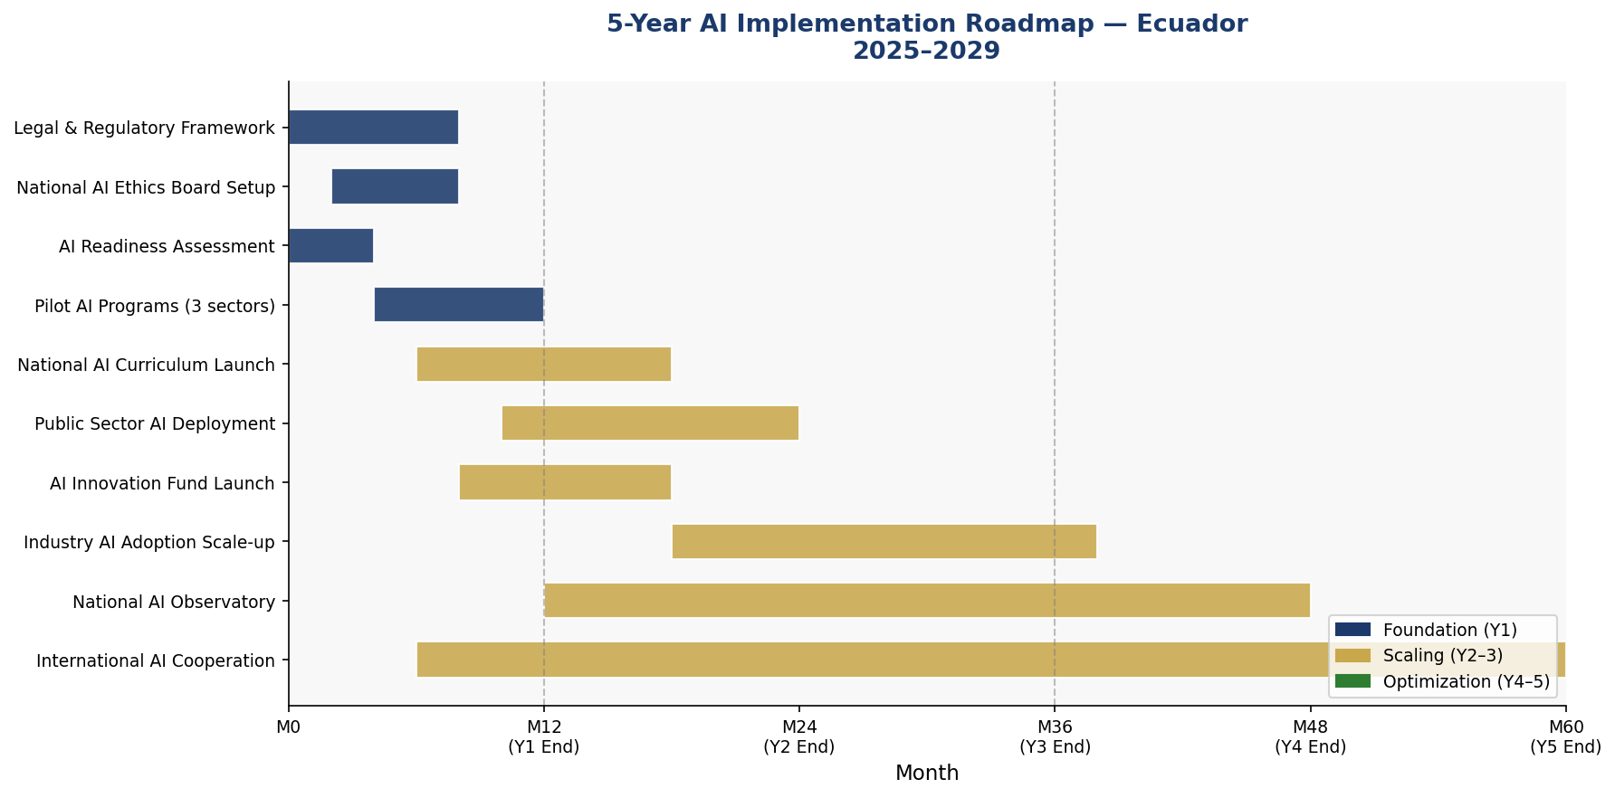
Figure 8.1: 5-Year AI Implementation Gantt — Ecuador National AI Strategy (2025–2029)

8.2 Phase 1 — Foundation (Year 1: 2025)
The Foundation phase establishes the institutional and legal architecture without which no subsequent phase can succeed. Key deliverables:
- Enact National AI Policy by Presidential Decree and National Assembly endorsement
- Establish National AI Ethics Board — appoint all 15 members
- Publish LOPDP AI Amendment for public consultation
- Complete National AI Readiness Assessment across all 24 provinces
- Launch 3 pilot AI programs: SRI tax fraud detection, IESS radiology AI, MINEDUC early warning
- Establish National AI Registry for high-risk AI systems
- Sign first bilateral AI cooperation agreements (Spain, Germany)

8.3 Phase 2 — Scaling (Years 2–3: 2026–2027)
The Scaling phase deploys, expands, and iterates on successful pilots while rolling out the education transformation and industry adoption programs. Key deliverables:
- Integrate AI literacy into national K-12 curriculum
- Deploy AI in 25 additional public hospitals
- Launch Ecuador AI Skills national upskilling platform
- Operationalize AI Innovation Fund — first cohort of 50 startups
- Publish first Annual AI State Report
- Expand AsistenteEC to 120 government services
- Complete NAEB's first high-risk AI system audits (20 systems)

8.4 Phase 3 — Optimization (Years 4–5: 2028–2029)
The Optimization phase focuses on quality improvement, international integration, and sustainability. Ecuador begins exporting AI expertise to neighboring countries and deepen participation in global AI governance. Key deliverables:
- Comprehensive policy review and update based on 3-year evaluation
- Achieve gender parity in AI education program enrollment
- Ecuador joins Global Partnership on AI (GPAI) as full member
- AI contribution to GDP exceeds 3%
- National AI Observatory publishes comprehensive AI impact measurement framework
- Ecuador's AI governance framework recognized as regional best practice

Section 9: Monitoring, Evaluation and Accountability

9.1 National AI Observatory
The National AI Observatory (Observatorio Nacional de IA — ONIA) will be established under SENESCYT in Year 1 with a mandate to: monitor AI adoption across sectors; collect, validate, and publish AI system incident reports; track progress against all policy KPIs; produce the Annual AI State Report; and coordinate with international AI observatories. ONIA will maintain a publicly accessible AI Dashboard updated quarterly.

9.2 Annual AI State Report
The President of Ecuador shall transmit an Annual AI State Report to the National Assembly no later than June 30 each year. The report shall include: progress against all KPIs; summary of NAEB ethics decisions; AI system incidents and remediation; investment and expenditure summary; international cooperation activities; and recommendations for policy adjustments. The National Assembly's Committee on Science, Technology, and Innovation shall hold public hearings on the report within 60 days.

9.3 KPI Dashboard
KPI Metric | Baseline (2024) | Year 1 Target | Year 3 Target | Year 5 Target
AI contribution to GDP (%) | 0.2% | 0.5% | 1.8% | 3.8%
AI-literate citizens (thousands) | 120K | 500K | 1.5M | 2.5M+
AI practitioners trained | 3,000 | 8,000 | 35,000 | 90,000
Govt. AI services deployed | 2 | 8 | 25 | 50+
High-risk AI systems audited | 0 | 10 | 40 | 100+
Women in AI programs (%) | 28% | 35% | 45% | 50%
NAEB complaints resolved (%) | N/A | 75% | 85% | 95%
AI startups receiving support | 5 | 25 | 80 | 200+
Rural broadband for AI (%) | 42% | 55% | 72% | 88%
Ecuador CPI Score (target) | 34 | 36 | 42 | 52
Table 9.1: National AI Policy KPI Dashboard — Ecuador 2025–2029

9.4 Parliamentary and Civil Society Oversight
The National Assembly's Committee on Science, Technology, and Innovation will receive quarterly briefings from MINTEL on AI policy implementation. An independent Civil Society AI Oversight Coalition — comprising human rights organizations, academic institutions, and media — will be formally recognized and provided with access to all non-classified AI policy documentation. The Coalition may submit formal observations to the NAEB and ONIA at any time.

Section 10: International Cooperation and AI Diplomacy

10.1 Bilateral AI Cooperation Priorities
Ecuador will pursue strategic bilateral AI cooperation agreements with: Spain (AI in Spanish language NLP, cultural heritage digitization, judicial AI); Germany (Industry 4.0 AI, environmental monitoring AI, standards alignment); Canada (AI ethics, indigenous data sovereignty, CIFAR partnership); United States (USAID AI for development programs, NIST AI standards); Brazil (South American AI governance harmonization, agricultural AI); and China (infrastructure AI, smart city technology — with enhanced human rights safeguards attached to all agreements).

10.2 Regional AI Governance — Pacific Alliance and CELAC
Ecuador, as a Pacific Alliance member alongside Chile, Colombia, and Peru, will champion a Pacific Alliance AI Governance Framework — harmonizing risk classifications, AI procurement standards, and data sharing protocols across the four economies. Within CELAC, Ecuador will co-lead the AI Working Group alongside Brazil and Mexico, developing a Latin American AI governance agenda for representation at G20 and UN venues.

10.3 South-South Knowledge Transfer
Ecuador commits to sharing its AI governance experience with smaller economies in the region — particularly Central American nations and Caribbean SIDS — through the SELA and IDB's IDB Lab. Ecuador's regulatory sandbox model, AI education curriculum, and government AI procurement standards will be published as open-source governance tools for adaptation by other nations.

10.4 Global AI Governance Participation
Ecuador will: apply for full membership in the Global Partnership on AI (GPAI) by Year 2; actively participate in ITU's AI for Good Global Summit; contribute national AI use cases to the UNESCO AI Observatory; engage in UN Secretary-General's AI Advisory Body processes; and advocate at the WTO for AI-related trade provisions that protect developing countries' data sovereignty and technology transfer rights.

Conclusion

Ecuador's National AI Policy 2025–2030 represents a generational commitment — a recognition that the decisions made today about how artificial intelligence is governed, deployed, and democratized will shape Ecuador's economic trajectory, social fabric, and democratic institutions for decades to come.
The policy is deliberate in its ambition and honest about its constraints. Ecuador faces real challenges: institutional capacity gaps, infrastructure deficits, digital skills shortages, and elevated corruption risks that must be addressed in parallel with AI adoption — not after it. The framework presented here does not offer easy solutions, but it provides a rigorous, globally-aligned, and distinctly Ecuadorian roadmap for navigating the AI transition with integrity.
Success will require sustained political will across electoral cycles, genuine multi-stakeholder participation including from communities historically excluded from technological decision-making, and a long-term view that prizes human development alongside economic indicators. The Galapagos Islands remind us that Ecuador's greatest competitive advantage lies in its extraordinary natural inheritance and the ingenuity of its people. AI, governed wisely, can serve both.
Ecuador calls on its international partners, development finance institutions, and civil society to accompany this journey — sharing expertise, resources, and accountability. The future of AI governance will be written by nations willing to lead with values. Ecuador chooses to be one of them.

References and Bibliography

International Frameworks and Guidelines
- UNESCO. (2021). Recommendation on the Ethics of Artificial Intelligence. Paris: UNESCO.
- OECD. (2024, updated). OECD Principles on Artificial Intelligence. Paris: OECD Publishing.
- European Parliament and Council. (2024). Regulation (EU) 2024/1689 on Artificial Intelligence (EU AI Act). Strasbourg: European Union.
- World Bank Group. (2021). World Bank Group Approach to AI. Washington D.C.: World Bank.
- G20. (2023). G20 New Delhi Leaders' Declaration — AI Annex. New Delhi: G20 Secretariat.
- ITU. (2023). AI for Good Global Summit Report. Geneva: International Telecommunication Union.

National and Regional Sources
- Gobierno de Ecuador / MINTEL. (2022). Agenda Digital Ecuador 2022–2025. Quito: MINTEL.
- Transparencia Internacional. (2024). Corruption Perceptions Index 2023. Berlin: Transparency International.
- SENESCYT. (2023). Informe de Ciencia, Tecnología e Innovación Ecuador. Quito: SENESCYT.
- Banco Central del Ecuador. (2024). Estadísticas Macroeconómicas. Quito: BCE.
- Oxford Insights. (2023). Government AI Readiness Index 2023. Oxford: Oxford Insights.

Research and Analysis
- McKinsey Global Institute. (2023). The Economic Potential of Generative AI. New York: McKinsey & Company.
- World Economic Forum. (2023). Future of Jobs Report 2023. Geneva: WEF.
- Inter-American Development Bank. (2022). AI and the Future of Work in Latin America and the Caribbean. Washington D.C.: IDB.
- CEPAL/ECLAC. (2023). Perspectivas económicas de América Latina 2023: Invirtiendo en una recuperación sostenible. Santiago: CEPAL.

About the Author

Nafiul Ahmad Rafi
Policy & Good Governance Researcher | BD Civic Tech Architect
Nafiul Ahmad Rafi is a civic technologist, policy researcher, author, photographer, and musician based in Dhaka, Bangladesh. He is the Founder and Director of Insights Bangladesh, a data-driven governance and policy impact analysis institution, and the Founder & Lead Architect of NagorikBD.org — a transparency-first civic platform scaled across Mymensingh Division, connecting citizens with government services across 45 Upazilas.
His work exists at the intersection of institutional reform and artificial intelligence, transforming theoretical governance into scalable, data-driven reality. Without a conventional computer science degree, he self-taught the tools of modern AI and web development to build the infrastructure that enforces the policies he once only researched.
Key Platforms and Projects
- NagorikBD.org — Civic transparency platform, Mymensingh Division
- Insights Bangladesh — Policy impact analysis institution
- FactCheck BD (factcheckbd.org) — Bangladesh's AI-powered fact-checking platform
- Political Insights BD / PIBD (pibbd.org) — Political intelligence and civic tech hub
- PeaceShield BD / National Peace Tracker — AI-powered hate speech and conflict monitoring
- PolicyLens AI (aigovbd.org) — 9-dimensional AI policy audit tool
He has published four books and maintains a personal site at ahmad-rafi.com.
Research Interests
AI Governance · Policy Research · Future of Bangladesh · Climate Policy
Contact
- Website: ahmad-rafi.com
- LinkedIn: linkedin.com/in/nafiul-ahmad-rafi
- Email: contact@ahmad-rafi.com
"I build code to ensure transparency, and I write lyrics to inspire the courage to use it."

