🇭🇳
REPUBLIC OF HONDURAS
National Artificial Intelligence Policy 2026–2031
A Comprehensive Framework for Ethical, Inclusive, and Economically Transformative AI
────────────────────────────────────────────────────────────
Prepared by:
Nafiul Ahmad Rafi
Policy & Governance Researcher | Insights Bangladesh
May 2026

Table of Contents

Executive Summary
Honduras stands at a pivotal juncture in its economic and social development trajectory. With a GDP per capita of approximately USD 2,900 and a young, growing population of nearly 10.3 million, the country possesses untapped human capital potential that strategically deployed artificial intelligence can catalyze into sustained prosperity. This National Artificial Intelligence Policy 2026–2031 represents the Government of Honduras's formal commitment to harnessing AI technologies for inclusive development, transparent governance, and economic competitiveness.
The policy emerges in recognition of both the transformative opportunities and tangible risks that AI presents to a lower-middle-income nation. Honduras faces structural challenges: a Corruption Perceptions Index score of 23 out of 100 (Transparency International, 2024), significant digital infrastructure gaps particularly in rural and indigenous communities, and a technology talent deficit that constrains the country's innovation capacity. This policy directly addresses these vulnerabilities while positioning Honduras to leapfrog traditional development pathways through AI-enabled solutions in agriculture, public health, justice, and financial inclusion.
Grounded in internationally recognized frameworks including the UNESCO AI Ethics Recommendation (2021), OECD AI Principles (2024), EU AI Act (2024), and the World Bank AI Strategy for Development, this policy establishes five strategic pillars: Ethical AI and Human Rights Protection; Economic Growth and Industrial AI Adoption; Education, Upskilling and AI Workforce Development; Public Sector AI and e-Governance; and AI Research, Innovation and Startup Ecosystem. Under a five-year roadmap spanning Foundation (Year 1), Scaling (Years 2–3), and Optimization (Years 4–5) phases, Honduras aims to achieve measurable improvements in governance transparency, economic productivity, and citizen wellbeing.
Implementation will be overseen by a newly constituted National AI Ethics Board operating under the Secretariat of Science, Technology and Innovation (SENACIT), with mandatory annual reporting to the National Congress. Projected outcomes include a conservative AI-attributable GDP contribution of 2.5% by 2031, 800,000 citizens with AI literacy, 25,000 AI-capable practitioners in the workforce, and measurable anti-corruption dividends from algorithmic public procurement and judicial case management systems.

Section 1: National AI Readiness Assessment

1.1 Economic Context
Honduras is classified as a lower-middle-income country by the World Bank, with a nominal GDP of approximately USD 34.2 billion (2024 estimates). The economy is anchored by agricultural exports — primarily coffee, bananas, and palm oil — alongside a growing manufacturing sector centered on textile and apparel maquilas in the Sula Valley free trade zones. Remittances constitute approximately 26% of GDP, underscoring deep structural dependence on the Honduran diaspora in the United States. This economic architecture creates both constraints and opportunities for AI deployment: agricultural AI and precision farming can directly serve the dominant economic sector, while digital financial services can improve remittance efficiency and financial inclusion.
Macroeconomic stability has improved modestly under the Xiomara Castro government's administration, with inflation declining from a 2022 peak of 9.1% to approximately 4.8% in 2024. However, poverty rates remain elevated — approximately 48% of the population lives below the national poverty line — and inequality measured by the Gini coefficient stands at 0.52, one of the highest in Latin America. AI-enabled solutions in social protection, conditional cash transfers, and targeted subsidy delivery represent high-impact intervention domains aligned with Honduras's development imperatives.

1.2 Digital Infrastructure
Internet penetration in Honduras reached approximately 49% of the population by end-2024, with significant urban-rural disparities: Tegucigalpa and San Pedro Sula exceed 70% connectivity, while rural municipalities in departments like Gracias a Dios, Lempira, and Copan register below 15%. Mobile penetration is substantially higher at 68%, with 4G coverage reaching approximately 72% of the population. Fiber-optic backbone infrastructure is concentrated along the Pacific corridor and northern coast, leaving interior regions underserved.
The government's National Telecommunications Commission (CONATEL) has articulated a broadband expansion agenda targeting 80% internet penetration by 2028, creating a foundational infrastructure trajectory that this AI policy must align with and reinforce. Data center capacity is limited, with most enterprise-grade cloud services hosted offshore — primarily in the United States — creating data sovereignty vulnerabilities that this policy directly addresses through provisions for national data residency standards.

1.3 Education and Human Capital
Honduras's tertiary education enrollment rate stands at approximately 23%, significantly below the Latin American average of 52%. The country has 20 accredited universities, with only 3 offering dedicated computer science or information technology degree programs with AI-adjacent curricula. STEM enrollment constitutes roughly 18% of tertiary students. Digital literacy among secondary school students is nascent — the Ministry of Education estimates that only 31% of secondary students have regular access to computing devices, and teacher capacity in digital subjects remains a critical constraint.
The country's talent pipeline for AI-related roles is therefore severely underdeveloped relative to regional peers. Honduras graduates fewer than 800 computer science professionals annually, compared to Costa Rica's 3,500 and Panama's 2,100 despite larger population. This policy's education pillar represents the most transformative long-term investment, targeting a fivefold increase in AI-capable graduates over the policy period through curriculum reform, scholarship programs, and partnerships with international technology institutions.

1.4 Governance and Institutional Capacity
Honduras's governance landscape reflects deep institutional challenges that AI policy must navigate carefully. The country ranked 157th out of 180 countries in Transparency International's 2024 Corruption Perceptions Index, with a score of 23 — placing it in the lowest quartile globally. Judicial independence, civil service merit-based hiring, and public procurement integrity have been identified by the United Nations Office on Drugs and Crime (UNODC) as structurally compromised. These realities demand that AI governance mechanisms be designed with anti-capture provisions, independent oversight, and civil society participation to prevent AI systems from entrenching or amplifying existing corruption networks.
Institutional reforms undertaken since 2022, including the re-establishment of the Anti-Corruption Council (CNA) and cooperation agreements with the United Nations Integrated Transition Assistance Mission in Honduras (UNAMI), provide a framework within which AI governance institutions can be embedded with international oversight and accountability standards.

1.5 AI Readiness Radar
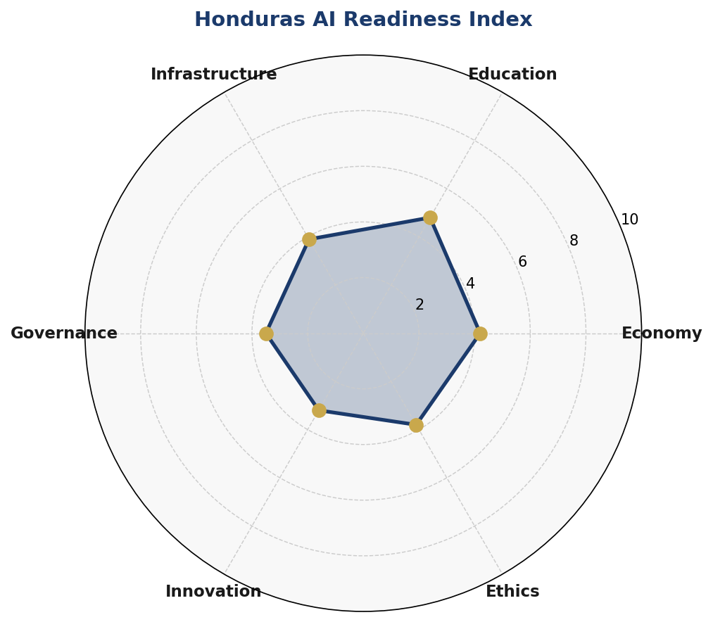
Figure 1.1: Honduras AI Readiness Index — Six-Dimensional Assessment (Scores out of 10)
The radar assessment reveals Honduras's relative strengths in education commitment and ethics awareness, tempered by significant gaps in infrastructure, innovation ecosystem, and governance quality. The 3.5 governance score reflects institutional corruption challenges and demands that AI policy design embed robust anti-capture mechanisms from inception.

1.6 Corruption Risk Matrix
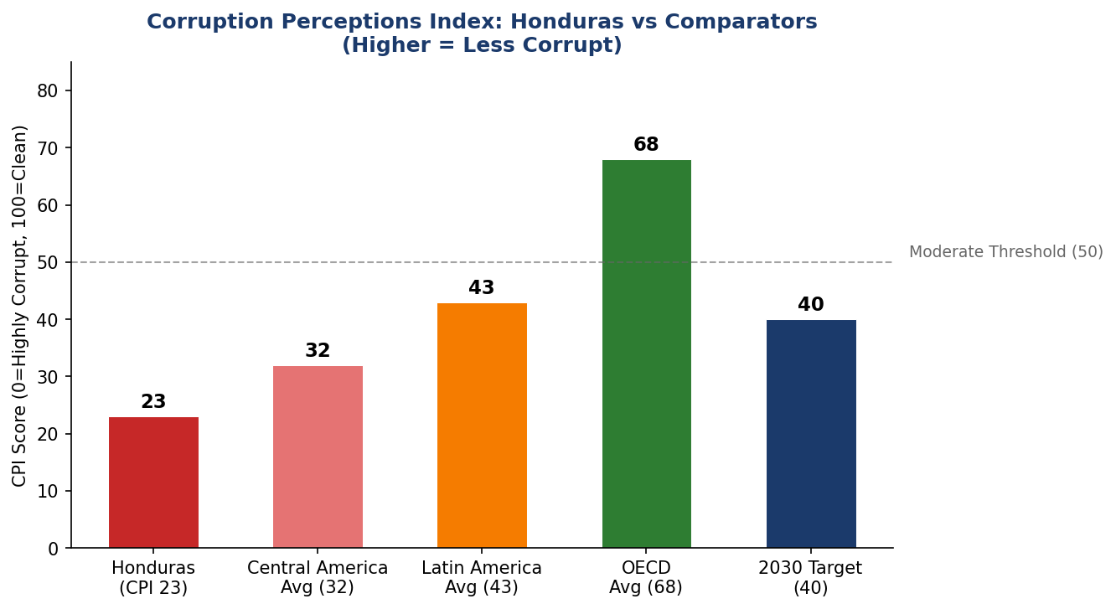
Figure 1.2: Corruption Perceptions Index — Honduras vs Regional and Global Comparators (2024)
Honduras's CPI score of 23 represents the most significant structural risk factor for AI governance integrity. Historical evidence from comparable lower-income contexts demonstrates that AI systems deployed in high-corruption environments without independent oversight tend to amplify rather than reduce rent-seeking behaviors. This policy therefore establishes mandatory algorithmic audits for all public sector AI deployments, with results published on the National AI Observatory's open-data portal.

Section 2: Policy Vision and Strategic Pillars

2.1 Vision Statement
"By 2031, Honduras will be a nation where artificial intelligence amplifies human dignity, strengthens democratic institutions, accelerates economic opportunity for all citizens, and positions Central America as a beacon of ethical AI governance in the Global South."

2.2 Strategic Pillars

Pillar I: Ethical AI and Human Rights Protection
Honduras commits to developing and deploying AI systems that unconditionally respect the human rights of all residents — with particular protections for indigenous and Afro-Honduran communities (Garifuna, Miskito, Lenca), women, LGBTQ+ individuals, children, persons with disabilities, and migrants. All AI systems deployed in judicial, law enforcement, healthcare, and social welfare contexts will require prior human rights impact assessments, algorithmic bias audits, and post-deployment monitoring.
The National AI Ethics Board will maintain a public registry of all high-risk AI deployments, publish annual compliance reports, and enforce mandatory corrective action protocols for systems demonstrating discriminatory outcomes. Biometric surveillance of public spaces without judicial warrant will be classified as prohibited-use AI under this policy.

Pillar II: Economic Growth and Industrial AI Adoption
AI will be strategically deployed across Honduras's priority economic sectors: precision agriculture for coffee and banana production, AI-enhanced supply chain management for maquila manufacturers, tourism demand forecasting and personalization, and financial technology for remittance optimization and micro-credit risk scoring. The government will establish a dedicated AI Economic Transformation Fund capitalized at USD 50 million over five years, leveraging multilateral development bank co-financing from the IDB, World Bank, and CABEI.
Special Economic Zones for AI and technology enterprises will be established in Tegucigalpa and San Pedro Sula, offering tax incentives for AI-intensive businesses while requiring local talent employment quotas and technology transfer obligations. A National AI Procurement Portal will use algorithmic matching to connect Honduran SMEs with government contracts, increasing supply chain inclusion.

Pillar III: Education, Upskilling and AI Workforce Development
The Ministry of Education will integrate AI literacy curricula into all secondary schools by Year 3 of this policy, with age-appropriate content spanning ethical AI use, computational thinking, data literacy, and creative AI applications. At the tertiary level, all public universities will establish AI and Data Science tracks by Year 4, supported by faculty development programs and international partnership agreements.
A National AI Scholarship Program will fund 500 STEM students annually to pursue graduate-level AI studies domestically and at partner institutions in Costa Rica, Mexico, Chile, Spain, and the United States. A Returning AI Talent Program will incentivize diaspora AI professionals to return to Honduras through streamlined employment pathways, tax incentives, and startup support.

Pillar IV: Public Sector AI and e-Governance
The government will deploy AI to enhance service delivery efficiency, reduce corruption, and improve citizen experience across priority ministries. Initial deployments will focus on automated document processing in the National Registry of Persons (RNP), predictive maintenance for public infrastructure, AI-assisted case management in the public defender's office, and data-driven targeting of social protection beneficiaries under the Bono Vida Mejor program.
All government AI deployments will adhere to a Government AI Procurement Standard that mandates explainability, auditability, data minimization, and vendor accountability provisions. Contracts with AI vendors will include mandatory source code escrow and data portability requirements to prevent vendor lock-in.

Pillar V: AI Research, Innovation and Startup Ecosystem
Honduras will establish the National Center for Artificial Intelligence Research (NCAIR) as a joint initiative between the National Autonomous University of Honduras (UNAH) and the Technological University of Honduras (UTH), with co-funding from the government and technology sector. NCAIR will prioritize research in Spanish-language natural language processing, agricultural AI for tropical contexts, climate adaptation AI, and healthcare diagnostics for disease burden endemic to Honduras.
The Honduras AI Startup Accelerator will provide 20 early-stage AI ventures annually with seed funding (USD 25,000–75,000), mentorship, and market access facilitation. Partnerships with Silicon Valley's Honduras diaspora network and regional accelerators in Bogota, Mexico City, and Santiago will integrate Honduran AI startups into global innovation ecosystems.

Section 3: International Framework Alignment

3.1 UNESCO AI Ethics Recommendation (2021)
Honduras aligns this policy with all 11 values articulated in UNESCO's Recommendation on the Ethics of AI: proportionality and do-no-harm (embedded in the risk classification system); safety and security (mandatory for high-risk deployments); fairness and non-discrimination (enforced through bias audit requirements); sustainability (AI-enabled climate adaptation as a policy priority); privacy and data protection (national data protection law reform); human oversight and determination (human-in-the-loop requirements for consequential decisions); transparency and explainability (explainability standards for public sector AI); responsibility and accountability (the AI Ethics Board enforcement mandate); awareness and literacy (the national education program); multi-stakeholder governance (civil society representation on the Ethics Board); and adaptive governance (five-year policy review cycle).

3.2 OECD AI Principles (2024)
Honduras formally adopts the five OECD AI Principles as foundational commitments: AI systems must benefit people and the planet, with human-centered values and fairness at the core; AI systems must be transparent and explainable; AI must be robust, secure, and safe; organizations and individuals developing AI must be accountable; and governments must foster a supportive AI policy environment. Honduras will apply for associate status in the OECD.AI Policy Observatory to access peer learning and benchmarking resources.

3.3 EU AI Act (2024) Risk Framework
Honduras adopts the EU AI Act's risk-based categorization as the foundation of its domestic AI regulatory framework, adapted for national context. Systems using social scoring by public authorities, real-time biometric surveillance without judicial authorization, and AI that exploits psychological vulnerabilities are classified as unacceptable risk and prohibited. High-risk systems in critical infrastructure, education, employment, essential services, migration, and law enforcement require mandatory conformity assessments, human oversight, and registration in the national AI database. Limited and minimal risk systems are subject to transparency obligations and voluntary codes of conduct respectively.

3.4 Framework Alignment Matrix

Framework | Core Principle | Policy Section Alignment | Status
UNESCO AI Ethics | Human rights & dignity | Pillars I, III, IV | ✅ Full
UNESCO AI Ethics | Environmental sustainability | Pillar II, Section 7 | ✅ Full
OECD AI Principles | Transparency & explainability | Section 6, Pillar IV | ✅ Full
OECD AI Principles | Accountability | Ethics Board (Section 6) | ✅ Full
EU AI Act | Risk-based regulation | Section 6 (Risk Classification) | ✅ Full
EU AI Act | Prohibited uses (biometric surv.) | Section 6.2 | ✅ Full
World Bank AI Strategy | Inclusive growth | Pillars II, III | ✅ Full
World Bank AI Strategy | Governance capacity | Section 7, Section 9 | ⚠️ Partial
G20 AI Principles | International cooperation | Section 10 | ✅ Full
ITU AI for Good | SDG alignment | Sections 4, 5, 7 | ✅ Full
ITU AI for Good | Digital divide reduction | Pillar III, Section 5 | ✅ Full

Table 3.1: International Framework Alignment Matrix — Honduras National AI Policy 2026–2031

Section 4: Economic Impact and Investment Roadmap

4.1 AI Economic Contribution Projections
Drawing on World Bank economic modeling for lower-middle-income countries and McKinsey Global Institute projections for Latin America, AI adoption in Honduras is projected to contribute between 2.5% (conservative) and 4.2% (optimistic) of GDP by 2031. These projections assume successful execution of this policy's infrastructure, education, and regulatory pillars, with the agriculture and public administration sectors serving as primary productivity drivers in the near term and manufacturing and services emerging as dominant contributors in the medium term.
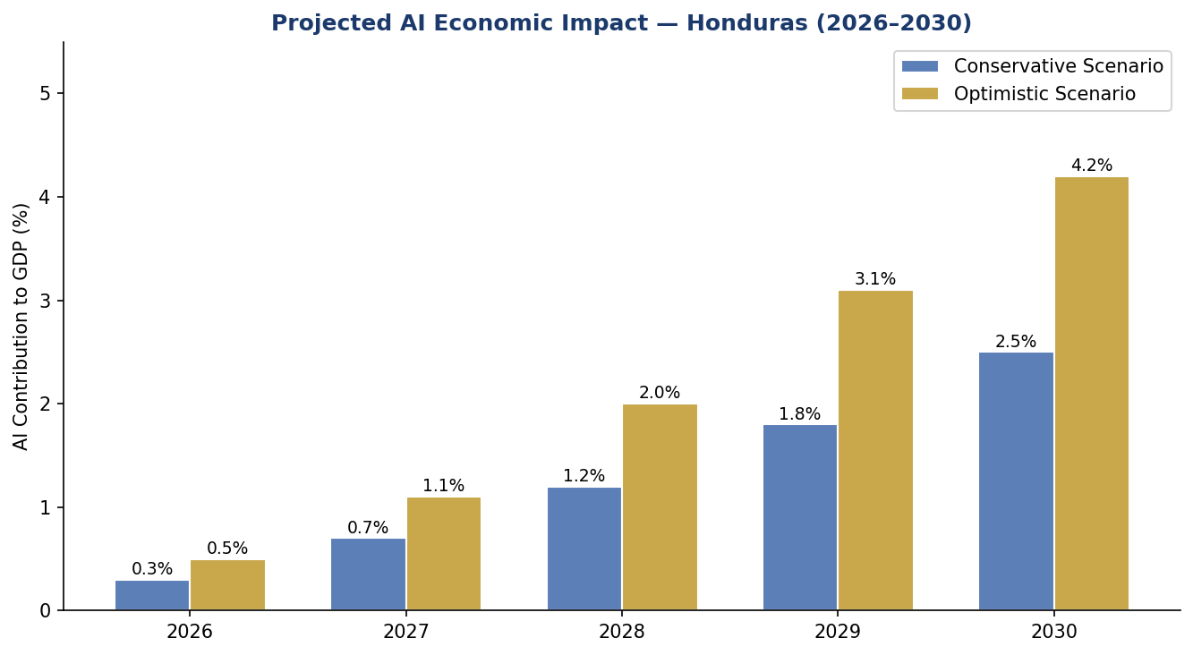
Figure 4.1: Projected AI Contribution to Honduras GDP (2026–2030, Conservative vs Optimistic Scenarios)

4.2 Investment Allocation
Total recommended public investment over the five-year policy period is USD 180 million, comprising USD 80 million in government budget allocation and USD 100 million in multilateral development bank financing (IDB, World Bank, CABEI). Private sector co-investment is projected at an additional USD 120 million, catalyzed by the AI Economic Transformation Fund's leverage mechanisms.
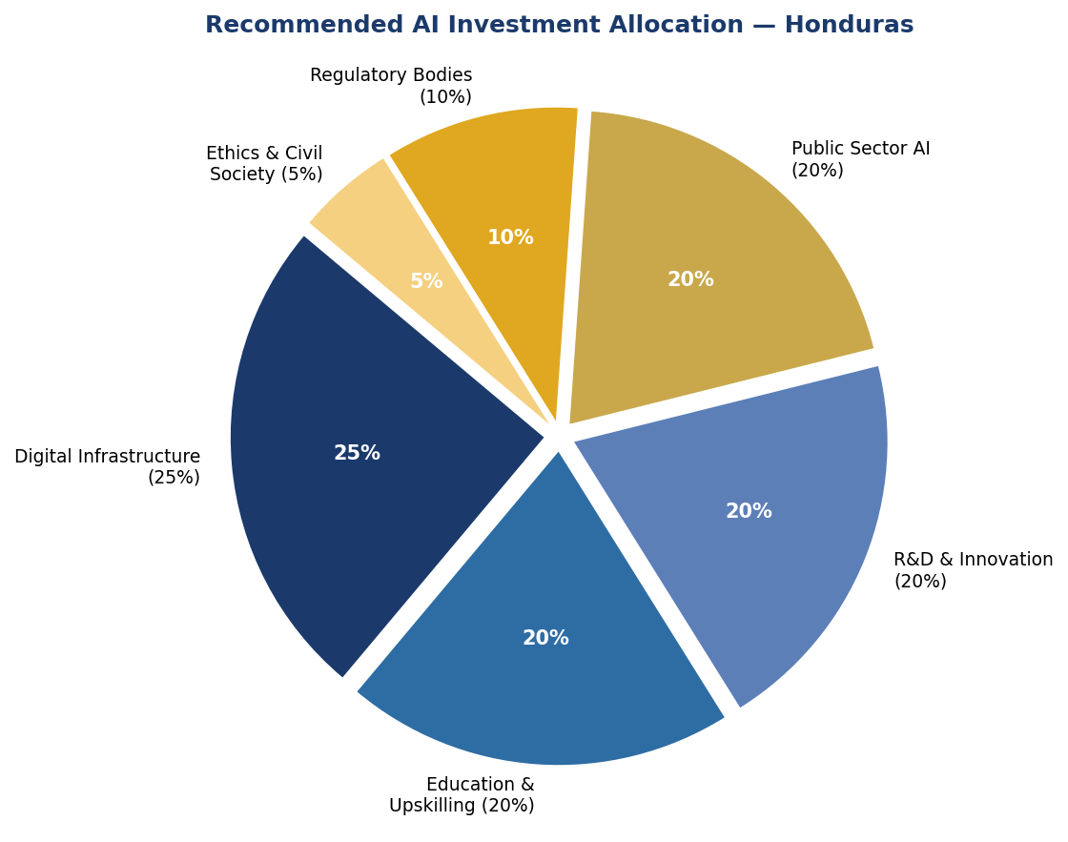
Figure 4.2: Recommended AI Investment Allocation — Honduras National AI Policy 2026–2031

4.3 Priority Sectors for AI Adoption

Sector | AI Application | Projected Impact | Timeline
Agriculture | Precision farming, crop disease detection | +18% yield efficiency | Years 1–3
Public Health | Disease surveillance, diagnostic AI | 30% faster diagnosis | Years 2–4
Justice & Courts | Case management, legal aid AI | 40% case backlog reduction | Years 2–4
Finance & Remittances | Fraud detection, credit scoring | +USD 120M remittance efficiency | Years 1–3
Tourism | Demand forecasting, visitor experience | +15% tourist revenue | Years 3–5
Education | Adaptive learning, dropout prediction | 10% completion rate increase | Years 2–5
Public Safety | Crime prediction (judicial oversight req.) | 20% targeted response improvement | Years 3–5

Table 4.1: Priority Sectors for AI Adoption with Projected Impact Estimates

Section 5: Education and Human Capital Development

5.1 Skills Gap Analysis
Honduras currently graduates approximately 800 technology professionals annually — insufficient to support a nascent AI economy that will require an estimated 25,000 AI-capable practitioners by 2031. The skills gap is compounded by brain drain: the Central American Migration Research Network estimates that 35% of Honduran STEM graduates emigrate within five years of graduation, primarily to the United States and Spain. This policy addresses both supply (expanding the talent pipeline) and retention (creating attractive employment opportunities domestically).
Women are significantly underrepresented in the technology workforce — comprising approximately 22% of ICT professionals — and indigenous and Afro-Honduran communities are nearly absent from the formal technology sector. Targeted interventions including gender-responsive AI scholarships, indigenous community technology centers, and mentorship programs are core to this policy's equity commitments.

5.2 National AI Curriculum Framework
The Ministry of Education, in coordination with SENACIT and the private sector technology council, will develop a tiered national AI curriculum: Awareness Level (Grades 7–9) covering AI concepts, digital citizenship, and ethical use; Literacy Level (Grades 10–12) including data literacy, AI tools application, and computational thinking; Practitioner Level (Tertiary undergraduate) encompassing machine learning, data science, and AI application development; Expert Level (Graduate and professional) covering advanced AI research, AI systems architecture, and specialized domain AI. Teacher training programs will upskill 5,000 secondary educators in AI-adjacent subjects over the policy period.

5.3 AI Education Pipeline Targets
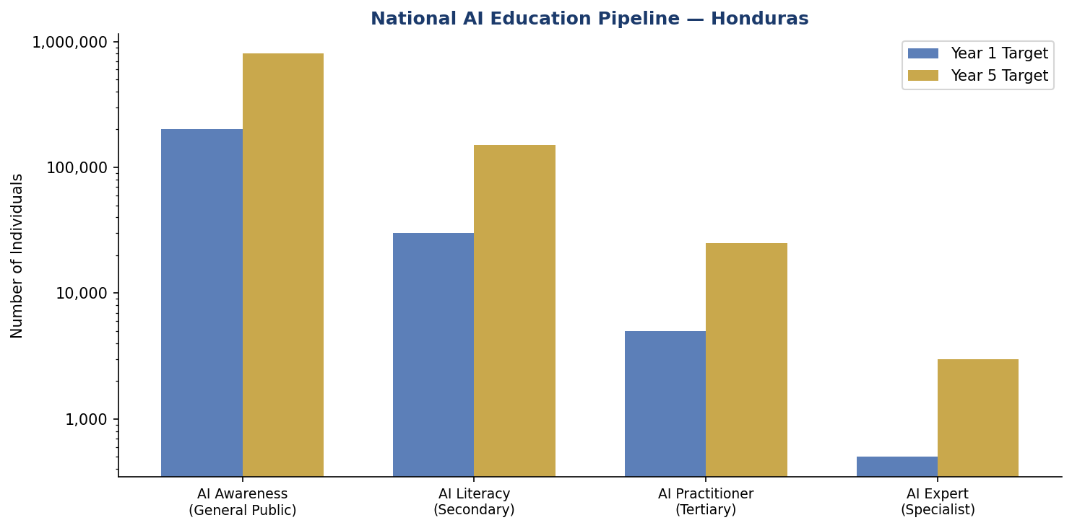
Figure 5.1: National AI Education Pipeline — Honduras Year 1 vs Year 5 Population Targets

5.4 International Partnerships
Honduras will establish formal AI education partnerships with leading regional and global institutions: Universidad de Costa Rica (computational intelligence); Universidad Nacional Autónoma de México (Spanish-language AI research); Universidad de Chile (data science); Massachusetts Institute of Technology (MIT OpenCourseWare AI curriculum adaptation); and Google's AI Education program for underserved markets. These partnerships will provide curriculum resources, faculty exchange, joint research opportunities, and professional certification pathways accessible to Honduran students.

Section 6: Ethical AI Governance and Regulatory Framework

6.1 National AI Ethics Board
The National AI Ethics Board (Junta Nacional de Ética en Inteligencia Artificial — JNEIA) will be established by executive decree within 180 days of this policy's adoption, operating as an autonomous body under SENACIT with functional independence guaranteed by statute. The JNEIA will comprise 13 members: 3 government representatives (SENACIT, Ministry of Justice, National Registry of Persons); 3 academic experts (appointed by UNAH, UTH, and UNITEC through open competition); 2 civil society representatives (appointed by the Civil Society Network for Human Rights); 2 private sector representatives (appointed by the Honduras Chamber of Commerce's Technology Council); 1 indigenous and Afro-Honduran community representative; 1 international observer (UNDP or OAS nomination); and the National Commissioner for Human Rights (ex officio).
Board members will serve staggered three-year terms renewable once. The JNEIA will have statutory authority to investigate AI systems in both public and private sectors, issue binding compliance orders, impose graduated financial penalties, recommend legislative amendments, and refer criminal matters to the Attorney General for prosecution.

6.2 AI Risk Classification System

Risk Level | Description | Examples in Honduras Context | Requirements
Unacceptable Risk | Prohibited — no deployment permitted | Social scoring by authorities, mass biometric surveillance | Banned — criminal penalties for deployment
High Risk | Regulated — mandatory conformity assessment | AI in courts, hospitals, social welfare, immigration | Mandatory audit, human oversight, JNEIA registration
Limited Risk | Transparency obligations | Chatbots, AI content generation | Disclosure to users, data handling transparency
Minimal Risk | Voluntary code of conduct | Spam filters, AI recommendations | Encouraged to adopt ethics guidelines

Table 6.1: Honduras AI Risk Classification System (Adapted from EU AI Act 2024)

6.3 Data Protection and Privacy Framework
Honduras does not currently have a comprehensive personal data protection law. This policy mandates the introduction of a National Data Protection Act within Year 1, establishing rights to data access, rectification, erasure, and portability; principles of data minimization and purpose limitation; mandatory data breach notification within 72 hours; and independent enforcement by a Data Protection Ombudsman within the National Human Rights Commission. International data transfers will require adequacy determinations or contractual safeguards consistent with international standards.

6.4 Anti-Corruption AI Use Guidelines
Given Honduras's elevated corruption risk, this policy establishes specific guidelines for AI use in public procurement, customs, tax administration, and judicial systems. All AI systems used in public procurement evaluation must produce explainable outputs with documented decision trails. Procurement AI systems must undergo annual independent bias and manipulation audits. Whistleblower protections will be extended to technology workers who report AI system manipulation. The Anti-Corruption Council (CNA) will have standing access to audit logs of all government AI systems.

Section 7: Public Sector and e-Governance AI

7.1 Priority Government Use Cases
- National Registry of Persons (RNP): AI-automated civil registry processing, reducing average document issuance time from 15 days to 48 hours
- Tax Administration Service (SAR): Machine learning fraud detection in VAT compliance, targeting 15% improvement in tax collection efficiency
- Social Protection: AI-driven targeting and monitoring of Bono Vida Mejor beneficiaries, reducing leakage by an estimated 20%
- Public Defender's Office: AI-assisted legal research and case management to address the backlog of 85,000 pending criminal cases
- Ministry of Agriculture (SAG): Satellite-AI integration for crop disease detection, food security early warning, and subsidy targeting
- National Police: AI-assisted evidence analysis (with mandatory judicial oversight and bias audit requirements)
- Ministry of Health (SESAL): AI-powered disease surveillance integration with the Pan American Health Organization (PAHO) regional network

7.2 Government AI Procurement Standard
All government procurement of AI systems, whether developed domestically or acquired from vendors, must comply with the Government AI Procurement Standard (GAPS) administered by JNEIA. GAPS requirements include: full source code or algorithm documentation escrow; data residency in Honduras or approved jurisdictions; explainability documentation in Spanish; bias testing across gender, ethnicity, age, and geographic variables; mandatory contractual liability provisions; and interoperability with government data exchange standards.

7.3 Citizen-Facing AI Services Roadmap
The National e-Government Portal (Portal del Estado) will integrate an AI-powered citizen assistance system by Year 2, enabling Hondurans to access government services in Spanish and the country's four major indigenous languages (Garífuna, Miskito, Lenca, and Ch'orti'). This multilingual AI interface represents a fundamental equity commitment, ensuring that AI-enhanced governance serves all citizens regardless of linguistic background.

Section 8: Implementation Roadmap

8.1 Five-Year Implementation Timeline
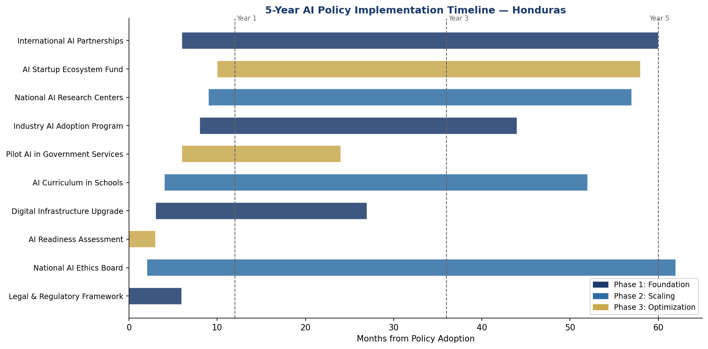
Figure 8.1: Honduras National AI Policy — Five-Year Implementation Gantt Chart (2026–2031)

8.2 Phase 1: Foundation (Year 1, 2026–2027)
Phase 1 establishes the institutional, legal, and infrastructural prerequisites for AI deployment at scale. Critical milestones include: enactment of the National Data Protection Act; establishment of the National AI Ethics Board (JNEIA) with full staffing; launch of the AI Readiness National Baseline Survey; initiation of the National Broadband Expansion Plan Year 1 targets; pilot deployment of AI-assisted document processing in RNP (3 regional offices); launch of AI Curriculum Development Commission; and formalization of 3 international AI partnership agreements.

8.3 Phase 2: Scaling (Years 2–3, 2027–2029)
Phase 2 focuses on national rollout of piloted solutions, education system reform, and industry adoption acceleration. Milestones include: full deployment of AI-assisted government services across all ministerial portals; secondary school AI curriculum integration in 500 schools (Phase 1 cohort); launch of the Honduras AI Startup Accelerator (Cohort 1: 20 ventures); national deployment of agricultural AI advisory services through SAG; formal opening of the National Center for AI Research (NCAIR); and publication of the first Annual AI State Report to the National Congress.

8.4 Phase 3: Optimization (Years 4–5, 2029–2031)
Phase 3 consolidates gains, evaluates impact, and positions Honduras for regional AI leadership. Milestones include: comprehensive policy review and second-generation strategy development; Honduras AI Export Initiative targeting Central American and Caribbean markets for AI services; full operationalization of the National AI Observatory with public-facing dashboard; achievement of 800,000 AI-literate citizens target; and formal submission of Honduras AI Governance Model to GPAI (Global Partnership on AI) as a case study for lower-middle-income country AI policy.

8.5 Phase KPIs

KPI | Baseline (2026) | Year 1 Target | Year 3 Target | Year 5 Target
AI-literate citizens | 50,000 | 200,000 | 500,000 | 800,000
AI practitioners trained | 800 | 2,000 | 12,000 | 25,000
AI Ethics Board cases resolved | 0 | 25 | 120 | 250+
Govt. services with AI integration | 0 | 3 | 12 | 25
AI startups funded | 0 | 20 | 60 | 120
AI contribution to GDP (%) | 0.1% | 0.5% | 1.8% | 2.5%+
Women in AI workforce (%) | 22% | 25% | 32% | 40%

Table 8.1: Key Performance Indicators — Honduras National AI Policy 2026–2031

Section 9: Monitoring, Evaluation and Accountability

9.1 National AI Observatory
The National AI Observatory (Observatorio Nacional de Inteligencia Artificial — ONIA) will be established within SENACIT as a semi-autonomous research and monitoring unit. ONIA will maintain the national AI database (register of all high-risk AI deployments), publish quarterly AI Governance Bulletins, conduct annual AI impact assessments across all policy pillars, maintain the public-facing AI Accountability Dashboard, and coordinate with international AI observatories including OECD.AI and UNESCO's AI Observatory.

9.2 Annual AI State Report
The Secretary of Science, Technology and Innovation will present an Annual AI State of Honduras Report to the National Congress each January, covering: AI deployment statistics by sector and risk classification; JNEIA enforcement actions and outcomes; education pipeline progress; economic impact measurements; international commitments compliance; and recommended policy adjustments. Reports will be published in full on the ONIA open-data portal in machine-readable formats.

9.3 Civil Society and Independent Auditor Role
Recognizing the elevated governance risks in Honduras's institutional environment, this policy mandates a robust civil society oversight function independent of government control. The National Civil Society AI Watch Network (RCSI-AI) will receive dedicated government funding to conduct independent algorithmic audits of public sector AI systems, publish shadow reports on JNEIA enforcement effectiveness, operate a citizen complaint hotline for AI-related grievances, and provide annual testimony to the National Congress Human Rights Commission. International organizations including UNDP, OAS/IACHR, and NDI will be formally invited to observe JNEIA proceedings as part of transparency commitments.

Section 10: International Cooperation and Diplomacy

10.1 Regional AI Governance — SICA
Honduras will champion the development of a Central American System for Integration (SICA) Regional AI Framework, drawing on this national policy as a model for sub-regional harmonization. A common AI governance standard for the SICA bloc will facilitate cross-border data flows, joint AI research initiatives, shared regulatory capacity, and coordinated representation in global AI governance forums. Honduras proposes to host the SICA Regional AI Summit in Tegucigalpa in 2027.

10.2 Bilateral AI Cooperation Priorities
Priority bilateral AI cooperation partnerships will be pursued with: the United States (USAID digital development programming and diaspora talent bridge); Spain (Ibero-American AI ecosystem and language technology collaboration); Costa Rica (regional AI excellence center and talent pipeline); Germany (GTZ technical cooperation on AI governance standards); South Korea (technology transfer and education system digitalization); and Taiwan (digital infrastructure and ICT capacity building consistent with Honduras-Taiwan diplomatic relations).

10.3 Multilateral and Global AI Governance
Honduras will actively participate in the following multilateral AI governance mechanisms: United Nations Intergovernmental Panel on AI (IPAI); Global Partnership on AI (GPAI) as an observer advancing toward associate member status; ITU AI for Good Forum; UNESCO AI Ethics Recommendation implementation review processes; and the World Bank's Digital Development Partnership. Honduras will align its AI policy reporting with the UN Secretary-General's Roadmap for Digital Cooperation and contribute to the collective articulation of AI governance perspectives from lower-middle-income countries in the Global South.

10.4 South-South Knowledge Transfer
Honduras recognizes the particular value of peer learning from countries that have navigated AI policy development under comparable resource constraints and governance challenges. Formal South-South knowledge exchange programs will be established with Rwanda (AI policy and civic tech), Uruguay (e-governance AI), and Bangladesh (AI governance institutions and citizen-facing AI services). The Insights Bangladesh AI Policy methodology — which informed this document — will be acknowledged as a foundational reference framework.

Conclusion
Honduras's National Artificial Intelligence Policy 2026–2031 represents more than a technology strategy — it is a governance compact between the State and its citizens, grounded in the conviction that AI can serve as a force for dignity, equity, and democratic accountability when developed and deployed responsibly. The challenges Honduras faces — deep poverty, institutional corruption, digital exclusion, and environmental vulnerability — are precisely the domains where carefully governed AI can make the greatest difference.
The success of this policy will be measured not in patents filed or algorithms deployed, but in the number of Honduran children who learn to understand and shape AI systems that will define their futures; in the corruption cases detected and prosecuted through algorithmic transparency; in the farmers who receive timely, AI-powered agricultural guidance in their indigenous languages; and in the trust that citizens come to place in institutions that use AI as a tool for service rather than control.
Honduras invites its international partners, civil society organizations, academic institutions, technology enterprises, and most importantly its citizens to join in the implementation of this policy as co-owners of a shared vision for an AI-enabled future that leaves no Honduran behind.

References and Bibliography
European Parliament and Council of the European Union. (2024). Regulation (EU) 2024/1689 on Artificial Intelligence (EU AI Act). Official Journal of the European Union.
OECD. (2024). Recommendation of the Council on Artificial Intelligence (Updated). OECD/LEGAL/0449. Organisation for Economic Co-operation and Development, Paris.
Transparency International. (2024). Corruption Perceptions Index 2024. Transparency International, Berlin.
UNESCO. (2021). Recommendation on the Ethics of Artificial Intelligence. UNESCO, Paris. SHS/BIO/PI/2021/1.
United Nations Development Programme (UNDP). (2024). Human Development Report 2024. UNDP, New York.
World Bank. (2024). World Development Indicators 2024. Washington D.C.: The World Bank Group.
World Bank. (2021). World Bank AI Strategy: Maximizing AI for Development. Washington D.C.: The World Bank Group.
McKinsey Global Institute. (2023). The Economic Potential of Generative AI: The Next Productivity Frontier. McKinsey & Company.
ITU. (2023). AI for Good: Accelerating Sustainable Development Goals. International Telecommunication Union, Geneva.
Oxford Insights. (2024). Government AI Readiness Index 2024. Oxford Insights, London.
CONATEL Honduras. (2024). Plan Nacional de Banda Ancha 2024–2028. Comisión Nacional de Telecomunicaciones, Tegucigalpa.
Secretaría de Educación de Honduras. (2024). Plan de Educación Digital Nacional 2024–2030. SEDUC, Tegucigalpa.
G20. (2023). G20 AI Principles: New Delhi Leaders' Declaration Annex. G20 Summit, New Delhi.
OECD/IDB. (2023). Digital Landscape in Latin America and the Caribbean. IDB, Washington D.C.
SICA. (2023). Estrategia Regional de Transformación Digital 2023–2030. Sistema de la Integración Centroamericana, San Salvador.

About the Author

Nafiul Ahmad Rafi
Policy & Good Governance Researcher | BD Civic Tech Architect
Nafiul Ahmad Rafi is a civic technologist, policy researcher, author, photographer, and musician based in Dhaka, Bangladesh. He is the Founder and Director of Insights Bangladesh, a data-driven governance and policy impact analysis institution, and the Founder & Lead Architect of NagorikBD.org — a transparency-first civic platform scaled across Mymensingh Division, connecting citizens with government services across 45 Upazilas.
His work exists at the intersection of institutional reform and artificial intelligence, transforming theoretical governance into scalable, data-driven reality. Without a conventional computer science degree, he self-taught the tools of modern AI and web development to build the infrastructure that enforces the policies he once only researched.

Key Platforms & Projects
- NagorikBD.org — Civic transparency platform, Mymensingh Division
- Insights Bangladesh — Policy impact analysis institution
- FactCheck BD (factcheckbd.org) — Bangladesh's AI-powered fact-checking platform
- Political Insights BD / PIBD (pibbd.org) — Political intelligence and civic tech hub
- PeaceShield BD / National Peace Tracker — AI-powered hate speech and conflict monitoring
- PolicyLens AI (aigovbd.org) — 9-dimensional AI policy audit tool

He has published four books and maintains a personal site at ahmad-rafi.com.
Research Interests: AI Governance · Policy Research · Future of Bangladesh · Climate Policy

Contact:
Website: ahmad-rafi.com
LinkedIn: bd.linkedin.com/in/nafiul-ahmad-rafi
Email: contact@ahmad-rafi.com

"I build code to ensure transparency, and I write lyrics to inspire the courage to use it."

