🇯🇲
JAMAICA
National Artificial Intelligence Policy 2026–2031
A Comprehensive Framework for Ethical, Inclusive,
and Economically Transformative AI

Prepared by:
Nafiul Ahmad Rafi
Policy & Good Governance Researcher | Insights Bangladesh / NagorikBD.org
May 2026

Executive Summary

Jamaica stands at a pivotal juncture in its economic and social development. As a small island developing state (SIDS) with a GDP per capita of approximately USD 5,700, a well-educated labour force, and a strategically located economy anchored in tourism, remittances, agriculture, and a growing business process outsourcing (BPO) sector, Jamaica possesses a unique set of strengths and vulnerabilities that make artificial intelligence (AI) both an imperative and an opportunity. This National AI Policy 2026–2031 is designed to chart a deliberate, inclusive, and ethics-grounded course for Jamaica's AI transformation.
The global AI economy is projected to contribute over USD 15.7 trillion to global GDP by 2030 (PwC, 2023). For a small, open economy like Jamaica, the question is not whether AI will affect its industries, institutions, and citizens — it will — but whether Jamaica will be a passive recipient or an active, sovereign participant in that transformation. This policy provides the strategic architecture to ensure the latter: that Jamaican citizens, workers, businesses, and government institutions are equipped, protected, and empowered to harness AI's potential while guarding against its risks.
The policy is structured around five strategic pillars: (1) Ethical AI and Human Rights Protection; (2) Economic Growth and Industrial AI Adoption; (3) Education, Upskilling, and AI Workforce Development; (4) Public Sector AI and e-Governance; and (5) AI Research, Innovation, and Startup Ecosystem Development. These pillars are reinforced by a robust regulatory framework aligned with international standards including the UNESCO AI Ethics Recommendation (2021), the OECD AI Principles (2024), the EU AI Act (2024), and ITU AI for Good Guidelines, ensuring Jamaica's policy is not only domestically relevant but globally credible.
Over the five-year implementation horizon (2026–2031), this policy targets a cumulative AI-driven GDP contribution of up to 4.2%, the creation of over 15,000 AI-capable practitioners, deployment of at least twelve AI-powered public services, and positioning Jamaica as the leading AI governance hub in the Caribbean Community (CARICOM). Success will be measured through a national KPI dashboard overseen by a newly established National AI Observatory, with annual parliamentary reporting and independent civil society audits.

Section 1: National AI Readiness Assessment

1.1 Economic Context
Jamaica is an upper-middle-income country with a nominal GDP of approximately USD 19.9 billion (World Bank, 2024) and a GDP per capita of around USD 5,700. The Jamaican economy has historically been anchored by four pillars: tourism (which accounts for approximately 35% of GDP), remittances (approximately 20% of GDP), bauxite and alumina exports, and a growing BPO/information technology-enabled services (ITES) sector. The BPO sector in particular has emerged as a major employer, with over 55,000 workers and annual revenues exceeding USD 600 million, making it a natural candidate for AI augmentation.
Economic vulnerabilities include high public debt (approximately 95% of GDP in 2024, down from over 140% a decade ago), susceptibility to climate-related shocks including hurricanes and sea-level rise, and structural unemployment — particularly among youth — at rates exceeding 15%. AI presents significant opportunities to diversify the economy, boost productivity, and build resilience: from AI-assisted agricultural monitoring to smart tourism platforms and AI-enabled financial inclusion tools.

1.2 Education and Human Capital
Jamaica has a literacy rate of approximately 88%, a tertiary education gross enrolment ratio of around 22%, and a well-established technical and vocational education network through the Human Employment and Resource Training (HEART)/NSTA Trust. The University of the West Indies (UWI) Mona campus, located in Kingston, offers computing and information sciences programmes but has limited dedicated AI or data science curriculum. The skills gap in AI, data science, and cybersecurity is significant, representing both a challenge and a primary target of this policy.
Jamaica has a diaspora of approximately one million highly educated Jamaicans abroad — particularly in North America and the United Kingdom — many of whom work in technology, medicine, finance, and research. Engaging this diaspora as a knowledge and investment resource is a strategic asset that this policy explicitly targets through its international cooperation and talent attraction mechanisms.

1.3 Digital Infrastructure
Internet penetration in Jamaica stands at approximately 62% of the population, with mobile internet penetration at 73% (ITU, 2024). The country has a functional fibre optic backbone and 4G LTE coverage reaching approximately 80% of the geographic area, though rural communities in parishes such as Portland, St. Thomas, and Trelawny remain underserved. Cloud infrastructure is primarily accessed through international providers. Jamaica's Special Economic Zones — particularly in Kingston and Montego Bay — are increasingly attracting technology-sector investment, and the government's Digital Jamaica initiative has laid early groundwork for digital public infrastructure.

1.4 Governance and Institutional Capacity
Jamaica is a parliamentary democracy with a strong rule-of-law tradition, an independent judiciary, and a free press. The World Bank's Worldwide Governance Indicators rank Jamaica at approximately the 55th percentile for rule of law and 50th percentile for government effectiveness — above regional averages but with significant room for improvement. Jamaica has existing data protection legislation (the Data Protection Act, 2020) and a functioning Office of the Information Commissioner, providing a foundational regulatory architecture upon which AI-specific governance can be built.

1.5 Corruption Risk Assessment
Jamaica's Transparency International Corruption Perceptions Index (CPI) score stands at 44 out of 100 in 2024, ranking the country 70th globally. While this score places Jamaica above the Latin American and Caribbean average (36), it signals meaningful corruption risk that must be explicitly addressed in AI governance design. AI systems deployed in public procurement, social benefit distribution, and law enforcement must be subject to enhanced transparency, auditability, and anti-corruption safeguards. The establishment of an independent AI Ethics Board with investigative powers is a direct response to this risk.

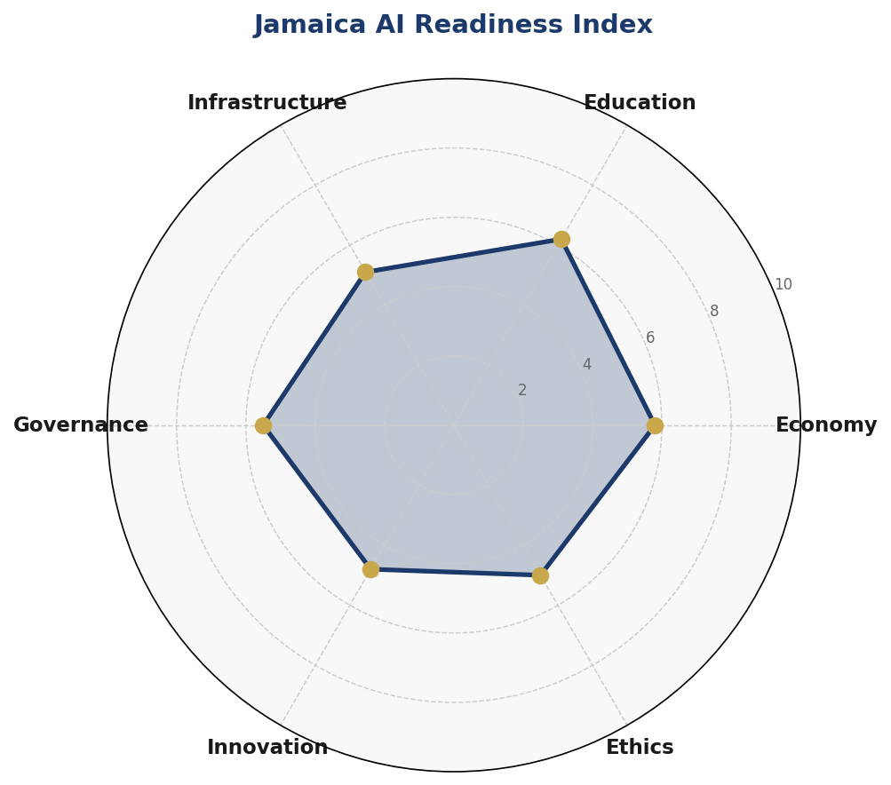
Figure 1: Jamaica AI Readiness Index — Multi-dimensional assessment across six dimensions (scores out of 10)

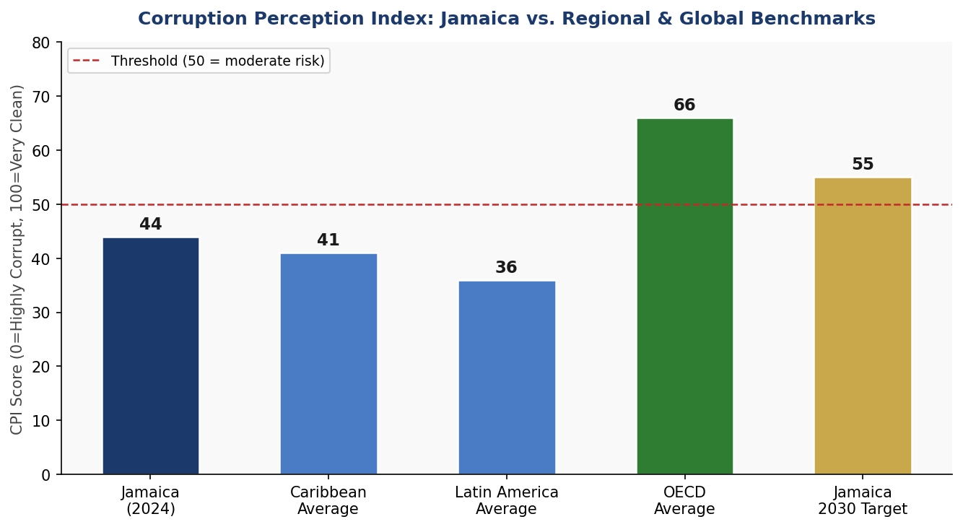
Figure 2: Corruption Perception Index — Jamaica compared to regional and global benchmarks, with 2030 governance target

Section 2: Policy Vision and Strategic Pillars

Vision Statement
"Jamaica will be the Caribbean's leading AI-enabled nation — a society where artificial intelligence amplifies human creativity, dignity, and opportunity; strengthens governance and public trust; drives inclusive economic prosperity; and positions Jamaica as a global model of ethical, sovereign, and development-centred AI governance."

Strategic Pillar 1: Ethical AI and Human Rights Protection
Jamaica's AI development will be anchored in a commitment to human dignity, non-discrimination, transparency, and accountability. This pillar establishes the National AI Ethics Board, the National AI Risk Classification System, and the legal basis for algorithmic accountability. It ensures that AI systems — particularly those used in criminal justice, healthcare, social benefits, and hiring — are auditable, explainable, and subject to independent oversight. It also enshrines citizens' rights to an explanation when consequential AI decisions affect them.

Strategic Pillar 2: Economic Growth and Industrial AI Adoption
Jamaica's economic transformation through AI will target four priority sectors: (a) Tourism and Hospitality, where AI can enhance visitor experiences, predict demand, and optimize supply chains; (b) BPO and ITES, where AI augmentation can boost productivity and transition workers into higher-value roles; (c) Agriculture and Food Security, where AI-powered precision agriculture, climate-resilient crop modelling, and supply chain tracking can improve yields and reduce post-harvest losses; and (d) Financial Services and Fintech, where AI can expand financial inclusion, improve credit scoring for the unbanked, and detect fraud.

Strategic Pillar 3: Education, Upskilling, and AI Workforce Development
By 2031, Jamaica will establish a National AI Education Framework spanning K–12, tertiary, and vocational levels. Every Jamaican secondary school student will receive foundational digital and AI literacy education. At least 50,000 adults will be reskilled or upskilled through a National AI Skills Programme delivered through HEART/NSTA Trust, community colleges, and online platforms. The UWI Mona campus will launch dedicated AI and Data Science degree programmes, and a national AI scholarship programme will support advanced studies abroad with return-of-service requirements.

Strategic Pillar 4: Public Sector AI and e-Governance
The Government of Jamaica will lead by example in responsible AI adoption. Priority use cases include AI-assisted healthcare triage and disease surveillance, smart land administration and property registration, AI-powered fraud detection in tax collection and customs, predictive maintenance for public infrastructure, and natural disaster early warning systems. All government AI deployments will be subject to mandatory pre-deployment AI impact assessments, public disclosure, and annual independent audits.

Strategic Pillar 5: AI Research, Innovation, and Startup Ecosystem
Jamaica will invest in its own AI research capacity through a National AI Research Fund administered through UWI Mona, the University of Technology Jamaica (UTech), and Northern Caribbean University (NCU). A Jamaica AI Innovation Hub — physically located in Kingston's Creative Economy District — will provide co-working space, compute access, mentorship, and seed funding for AI startups. Special incentives including tax holidays, accelerated depreciation for AI R&D spending, and streamlined intellectual property registration will encourage domestic AI product development.

Section 3: International Framework Alignment

This National AI Policy has been developed in explicit alignment with the leading international AI governance frameworks. The following subsections describe how each framework's core principles are operationalised within Jamaica's policy architecture.

3.1 UNESCO AI Ethics Recommendation (2021)
The UNESCO Recommendation on the Ethics of Artificial Intelligence (2021) establishes 11 core values: proportionality and do no harm; safety and security; fairness and non-discrimination; sustainability; right to privacy and data protection; human oversight and determination; transparency and explainability; responsibility and accountability; awareness and literacy; multi-stakeholder and adaptive governance; and international cooperation. Jamaica's policy maps directly to each of these values: the National AI Ethics Board enforces proportionality and accountability; the AI Risk Classification System operationalises safety; the anti-discrimination provisions in the Data Protection Act (to be amended) address fairness; and the National AI Education Framework advances awareness and literacy.

3.2 OECD AI Principles (2019, Updated 2024)
The OECD AI Principles — encompassing inclusive growth, human-centred values, transparency, robustness, and accountability — are embedded throughout this policy. Jamaica's decision to adopt a risk-based regulatory approach mirrors the OECD's tiered governance model. The policy's emphasis on public-private partnership and open data aligns with the OECD's vision of AI as a driver of inclusive growth.

3.3 EU AI Act (2024)
As the world's first comprehensive AI legislation, the EU AI Act provides Jamaica with a tested model for risk-based AI regulation. Jamaica's National AI Risk Classification System adopts the EU Act's four-tier architecture: Unacceptable Risk (banned uses such as social scoring, subliminal manipulation, and real-time biometric surveillance in public spaces); High Risk (regulated uses requiring conformity assessment, including AI in healthcare, criminal justice, education, and employment); Limited Risk (transparency obligations for AI in customer interaction); and Minimal Risk (voluntary code of conduct for all other AI systems). Jamaica's classification system is calibrated to its own context: for example, AI tools used in visa or asylum processing are classified as High Risk due to their direct impact on human rights.

3.4 G20 AI Principles and ITU AI for Good
Jamaica's policy aligns with the G20 AI Principles on responsible stewardship and the ITU AI for Good framework by explicitly linking AI deployment targets to the United Nations Sustainable Development Goals (SDGs). Specifically: AI in healthcare supports SDG 3 (Good Health); AI in education supports SDG 4 (Quality Education); AI in agriculture supports SDG 2 (Zero Hunger) and SDG 13 (Climate Action); and AI in financial inclusion supports SDG 1 (No Poverty) and SDG 10 (Reduced Inequalities).

Framework / Principle | Section 2  (Vision) | Section 4  (Economic) | Section 5  (Education) | Section 6  (Ethics) | Section 7  (Gov)
UNESCO: Proportionality & Do No Harm | ✅ | ⚠️ | ✅ | ✅ | ✅
UNESCO: Safety & Security | ✅ | ✅ | ⚠️ | ✅ | ✅
UNESCO: Fairness & Non-Discrimination | ✅ | ⚠️ | ✅ | ✅ | ✅
UNESCO: Transparency & Explainability | ✅ | ✅ | ✅ | ✅ | ✅
OECD: Inclusive Growth | ✅ | ✅ | ✅ | ⚠️ | ✅
OECD: Human-Centred Values | ✅ | ✅ | ✅ | ✅ | ✅
OECD: Accountability | ⚠️ | ✅ | ⚠️ | ✅ | ✅
EU AI Act: Risk-Based Approach | ✅ | ✅ | ⚠️ | ✅ | ✅
G20: Responsible Stewardship | ✅ | ✅ | ✅ | ✅ | ✅
ITU: SDG Linkage | ✅ | ✅ | ✅ | ⚠️ | ✅
Table 1: International Framework Alignment Matrix — ✅ Fully Aligned | ⚠️ Partially Aligned | 🔲 Not Yet Addressed

Section 4: Economic Impact and Investment Roadmap

McKinsey Global Institute (2023) estimates that AI could contribute between 1.2% and 2.6% of GDP annually to middle-income economies through productivity gains, new sector creation, and labour market transformation over a five-year period. For Jamaica — with its BPO-heavy service sector and tourism dependence — the productivity dividend is particularly significant. PwC's global AI economic impact model projects that, for upper-middle-income small states in the Caribbean region, cumulative AI contribution to GDP could reach 3.5%–5% over a decade if policy and investment conditions are met. Jamaica's 4.2% target for Year 5 (2030) is therefore ambitious but achievable, contingent on the execution of this policy's investment and regulatory framework.
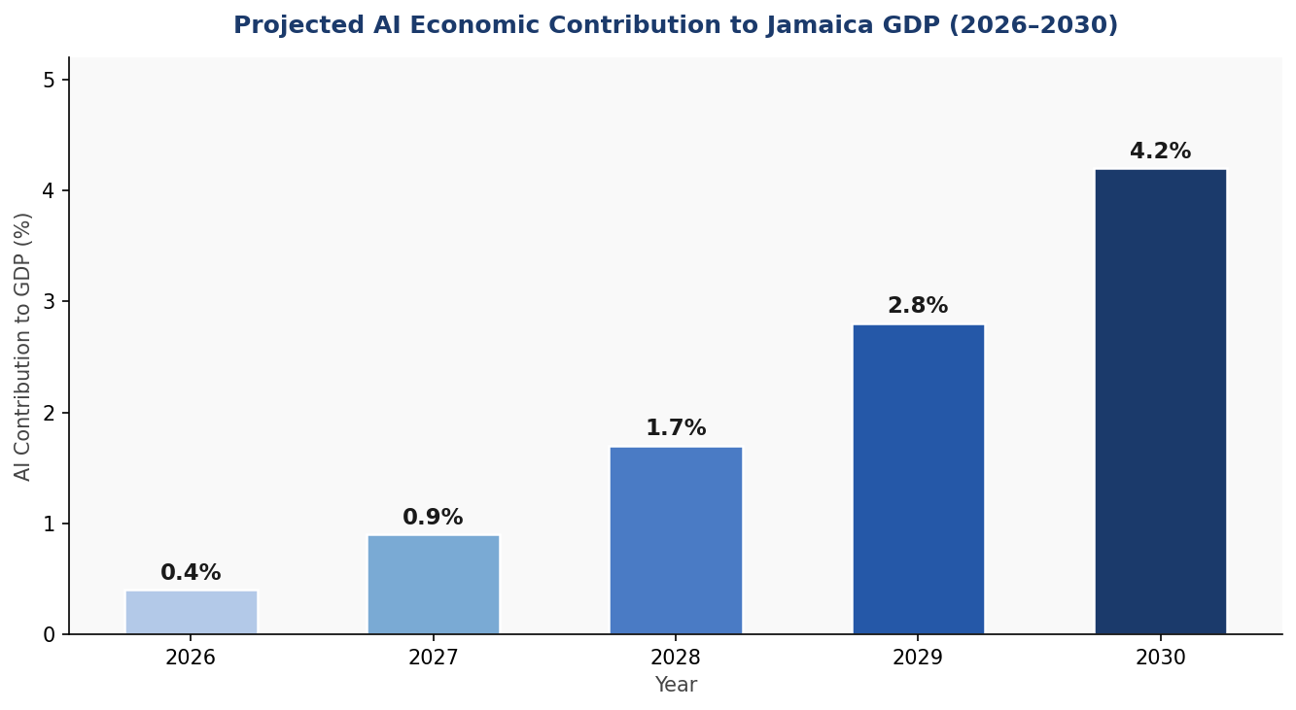
Figure 3: Projected AI Economic Contribution to Jamaica GDP (2026–2030)

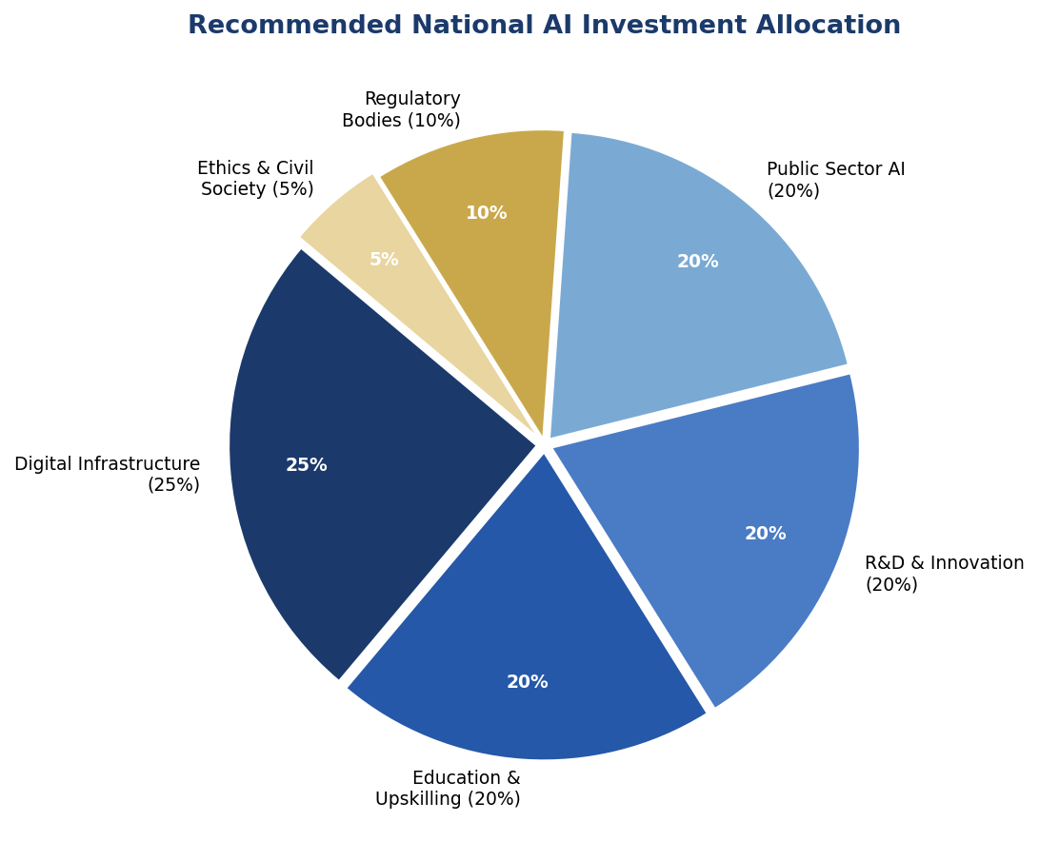
Figure 4: Recommended National AI Budget Allocation Across Priority Domains

4.1 Priority Sectors for AI Adoption
Tourism and Hospitality: Jamaica welcomed approximately 4.7 million visitors in 2023, generating over USD 3.6 billion in revenue. AI applications — including personalised itinerary platforms, dynamic pricing engines, AI chatbots for visitor services, and predictive maintenance for hotel infrastructure — can boost visitor spending per head and improve operational efficiency across the sector.
Business Process Outsourcing (BPO): With 55,000+ direct employees and growing, the BPO sector is Jamaica's fastest-growing non-agricultural private sector employer. AI augmentation — including intelligent process automation, AI-assisted quality monitoring, and natural language processing tools — can shift Jamaican BPO from low-margin voice work to higher-value knowledge process outsourcing (KPO), increasing per-worker revenue and wage levels.
Agriculture: Jamaica's agricultural sector employs approximately 17% of the workforce but contributes only 6% of GDP, indicating significant productivity gaps. AI-powered precision agriculture tools — including drone-based crop health monitoring, AI weather modelling for climate-resilient planting schedules, and blockchain-backed supply chain traceability — can improve yields, reduce post-harvest losses (currently estimated at 30–40% for fruits and vegetables), and open premium export markets.
Financial Services and Fintech: Approximately 25% of Jamaican adults remain unbanked or underbanked. AI-powered credit scoring using alternative data sources (mobile money usage, utility payments, social data) can dramatically expand access to formal credit. The Bank of Jamaica's regulatory sandbox initiative provides an existing framework for piloting AI-driven fintech products under supervised conditions.

4.2 Public-Private Partnership Framework
Jamaica's AI investment strategy is premised on a 60/40 private-public split: the government will primarily provide enabling infrastructure, regulatory certainty, talent development, and catalytic funding (through a National AI Innovation Fund), while private sector actors — domestic and foreign — are expected to drive sectoral AI adoption, product development, and scale-up. Memoranda of Understanding (MOUs) with leading global AI companies will be pursued through the Jamaica Promotions Corporation (JAMPRO) to attract cloud infrastructure investment, data centre development, and AI research partnerships.

Section 5: Education and Human Capital Development

5.1 Current Skills Gap Analysis
Jamaica faces a structural digital skills gap that, if unaddressed, will prevent the country from capturing AI's economic benefits. Current tertiary enrolment in computing and IT-related programmes is estimated at fewer than 3,500 students annually, against a projected demand for over 15,000 AI-capable workers by 2031. The gender dimension is critical: women represent less than 30% of ICT degree enrolments and approximately 18% of the technology workforce, a disparity that both reflects and reinforces broader economic inequality.

5.2 National AI Curriculum Framework
K–12 Level: By 2028, the Ministry of Education and Youth will introduce mandatory digital literacy and AI literacy modules across the secondary school curriculum. These modules — adapted from international models including Finland's Elements of AI programme and Rwanda's Smart Schools initiative — will cover basic programming logic, data concepts, AI applications in everyday life, and ethical considerations of automated systems.
Tertiary Level: UWI Mona, UTech, and NCU will develop and offer dedicated Bachelor of Science programmes in Artificial Intelligence and Data Science by 2027. Existing computer science programmes will be updated to include mandatory AI ethics, machine learning, and data governance modules. A national online learning platform — Jamaica Learning Online — will host accredited AI courses accessible to working adults.
Vocational and TVET Level: HEART/NSTA Trust will develop AI-adjacent skills certificates in areas including data annotation, AI-assisted customer service, drone operation and AI monitoring, and digital agriculture. These programmes will target adult workers in sectors at risk of automation — particularly lower-skill BPO roles and traditional agricultural work.
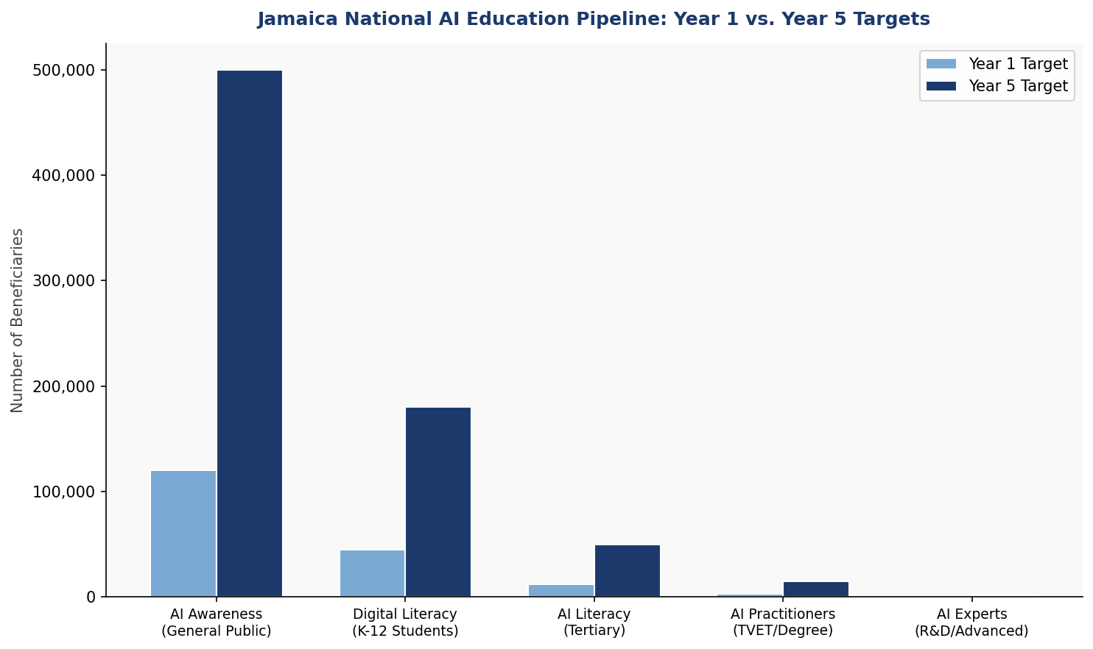
Figure 5: Jamaica AI Education Pipeline — Target beneficiary counts at each skill level, Year 1 vs. Year 5

5.3 Women and Underrepresented Groups
The National AI Skills Programme will set an explicit target of 50% female participation across all training cohorts, with dedicated outreach to rural communities, young mothers, and women in traditionally male-dominated agricultural and construction sectors. Partnerships with organisations including the Women's Resource and Outreach Centre (WROC) and the Jamaica Association for the Deaf will ensure AI education is accessible and inclusive.

5.4 Diaspora Engagement
A Jamaica AI Diaspora Network will be established under the Ministry of Foreign Affairs and Foreign Trade, targeting Jamaicans working in AI, technology, finance, and research abroad. The network will facilitate knowledge transfer through annual summits, remote mentorship programmes for domestic students and entrepreneurs, and a structured return-to-serve grant scheme for diaspora AI professionals willing to relocate to Jamaica for a minimum of three years.

Section 6: Ethical AI Governance and Regulatory Framework

6.1 National AI Ethics Board
A National AI Ethics Board (NAEB) will be established through primary legislation as an independent statutory body. The NAEB will comprise fifteen members: three representatives of the academic community (nominated by UWI, UTech, and NCU); two representatives of civil society; two representatives of the private sector technology industry; two representatives of consumer rights organisations; two government representatives (non-voting, from the Ministry of Science, Energy, Telecommunications and Transport, and the Ministry of Finance); one representative of the Office of the Information Commissioner; one representative of the Jamaica Constabulary Force's Digital Crimes Unit; one international expert nominated by the Inter-American Development Bank; and an independent Chair appointed by the Governor-General on the recommendation of the Prime Minister, subject to parliamentary confirmation.
The NAEB will have the power to investigate complaints, conduct mandatory audits of high-risk AI systems, issue binding recommendations, and refer cases involving serious breaches to law enforcement or the courts. Annual NAEB reports will be tabled in both Houses of Parliament.

6.2 AI Risk Classification System
Risk Tier | Definition & Examples | Regulatory Treatment
Unacceptable Risk (BANNED) | Social scoring by public authorities; subliminal manipulation; real-time biometric surveillance in public spaces for law enforcement; AI used to exploit vulnerable groups. | Prohibited. Development, import, and deployment are criminal offences.
High Risk (REGULATED) | AI in criminal justice / sentencing; healthcare diagnosis or treatment; education assessment; employment screening; immigration and asylum processing; critical infrastructure management. | Mandatory pre-deployment AI Impact Assessment; conformity certification by NAEB; annual independent audit; public registry entry; explainability requirement.
Limited Risk (TRANSPARENT) | AI chatbots; AI-generated content platforms; emotion recognition systems in commercial settings. | Mandatory disclosure to users that they are interacting with an AI system. Labelling requirements for AI-generated content.
Minimal Risk (VOLUNTARY) | AI-powered spam filters; AI in video games; AI content recommendation engines; general productivity AI tools. | Voluntary Code of AI Conduct. Encouraged to adopt best-practice standards. Eligible for National AI Certification Mark.
Table 2: Jamaica National AI Risk Classification System (adapted from EU AI Act 2024)

6.3 Data Protection and Privacy
Jamaica's Data Protection Act (2020) and its forthcoming implementing regulations provide the foundational legal framework for AI-related data governance. This policy calls for specific amendments to the DPA to: (a) extend coverage to automated decision-making and profiling; (b) establish a right to human review of consequential automated decisions; (c) mandate data minimisation and purpose limitation for AI training datasets; (d) introduce mandatory Data Protection Impact Assessments (DPIAs) for any AI system processing sensitive personal data; and (e) require cross-border data transfer agreements to include AI-specific safeguards.

6.4 Anti-Corruption AI Safeguards
Given Jamaica's CPI score of 44, AI systems deployed in public procurement, customs, tax administration, and social benefit distribution are classified as mandatory High Risk and subject to enhanced transparency requirements. All AI-assisted procurement decisions must generate an explainability report accessible to the Contractor General. An AI-powered Public Procurement Audit Tool will be developed in partnership with the Office of the Contractor General to detect bid manipulation, vendor concentration, and anomalous contract award patterns.

Section 7: Public Sector AI and e-Governance

The Government of Jamaica will adopt a 'Government as First Mover' strategy, deploying AI in targeted public services to demonstrate responsible use, build citizen trust, and create domestic demand for AI capabilities. All government AI systems will be subject to the High Risk regulatory tier by default, with mandatory public disclosure and annual audits.

7.1 Priority Government AI Use Cases
Healthcare: AI-assisted diagnostic support tools will be piloted at the Kingston Public Hospital and Cornwall Regional Hospital for radiology image analysis, disease outbreak surveillance, and patient triage prioritisation. An AI-powered National Health Dashboard will aggregate data from the Ministry of Health's surveillance systems to enable real-time epidemiological monitoring, particularly for dengue fever, COVID-19 variants, and non-communicable disease trends.
Land Administration: Jamaica's land tenure system is characterised by significant informality, with an estimated 40% of land parcels lacking formal title. An AI-powered Land Formalisation Platform will be developed to automate the cross-referencing of historical survey maps, aerial imagery, and property tax records, accelerating the Land Administration and Management Programme (LAMP) and reducing title formalisation timelines from years to months.
Tax Administration and Customs: The Tax Administration Jamaica (TAJ) will deploy AI-powered risk-scoring models to prioritise audit selection among large taxpayers, identify VAT refund fraud, and detect customs undervaluation. These tools will be developed in partnership with the Inter-American Development Bank's Digital Transformation for Competitiveness programme.
Disaster Risk Reduction: Given Jamaica's vulnerability to Category 4–5 hurricanes, an AI-enhanced Natural Disaster Early Warning and Response System will be developed, integrating data from the Caribbean Meteorological Organisation, the National Works Agency, and satellite imagery providers to generate granular, parish-level impact predictions and optimise evacuation routing.

7.2 Government AI Procurement Guidelines
All government AI procurement will follow a 'Sovereign AI First' principle: where a domestic AI capability exists or can be developed within eighteen months, international procurement will be deferred. All AI vendor contracts will include mandatory source code escrow, data sovereignty provisions ensuring that Jamaican citizen data remains within Jamaican-jurisdiction cloud infrastructure or under Government of Jamaica contractual control, and provisions for independent security and algorithmic audits.

7.3 Interoperability and Digital Public Infrastructure
Jamaica's AI-enabled public services will be built on a common Digital Public Infrastructure (DPI) architecture consisting of: (a) a National Digital Identity System (building on the existing National Identification System — NIDS); (b) a Government AI Service Bus enabling secure data sharing across ministries and agencies; and (c) a Jamaica Open Data Portal providing anonymised, high-quality government datasets for AI training and research.

Section 8: Implementation Roadmap

The 5-Year Implementation Roadmap is structured in three phases. Phase 1 (Foundation, Year 1) prioritises legal and institutional setup. Phase 2 (Scaling, Years 2–3) drives national rollout and sector adoption. Phase 3 (Optimisation and Integration, Years 4–5) focuses on performance review, refinement, and positioning Jamaica as a regional AI governance model.
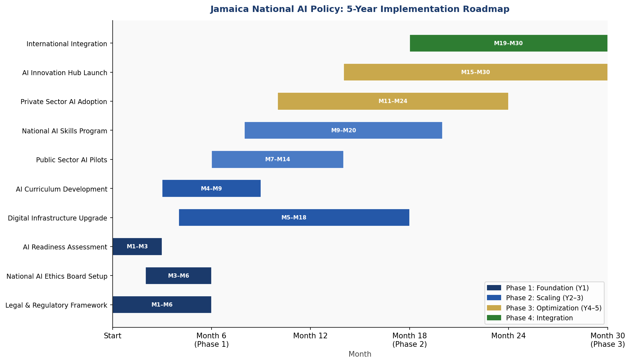
Figure 6: Jamaica National AI Policy — 5-Year Implementation Gantt Roadmap

Phase 1: Foundation (2026 — Year 1)
- Enact National AI Governance Act establishing the National AI Ethics Board
- Amend the Data Protection Act to include AI-specific provisions
- Establish the National AI Observatory within the Planning Institute of Jamaica (PIOJ)
- Publish the National AI Risk Classification System and implementing regulations
- Launch the Jamaica AI Readiness Assessment (commissioned through PIOJ / UNDP)
- Initiate Digital Infrastructure Upgrade Programme targeting rural connectivity gap
- Sign MOU with UWI Mona for AI Curriculum Development
- Commence pilot deployment of AI in healthcare and tax administration

Phase 2: Scaling (2027–2028 — Years 2–3)
- Launch National AI Skills Programme through HEART/NSTA Trust
- UWI Mona and UTech launch first AI/Data Science degree cohorts
- Deploy AI-powered Land Formalisation Platform nationally
- Open Jamaica AI Innovation Hub in Kingston
- Publish first Annual National AI State Report
- Achieve 50,000 adults trained in AI literacy
- Launch Disaster Risk Reduction AI System
- Operationalise Government AI Service Bus

Phase 3: Optimisation and International Integration (2029–2030 — Years 4–5)
- Comprehensive mid-term review by independent international panel
- Jamaica assumes CARICOM AI Governance Secretariat role
- Accession to OECD AI Policy Observatory as Observer State
- Launch AI Export Readiness Programme for Jamaican AI startups targeting Caribbean and diaspora markets
- Achieve 4.2% AI contribution to GDP target
- Complete Parliamentary Review of National AI Governance Act

8.1 Phase KPIs
KPI | Baseline (2026) | Year 1 Target | Year 3 Target | Year 5 Target
AI Contribution to GDP | 0.1% | 0.4% | 1.7% | 4.2%
AI Practitioners Trained | ~500 | 3,000 | 9,000 | 15,000+
Government AI Services Live | 0 | 3 | 8 | 12+
AI Startups Registered | ~20 | 50 | 150 | 350+
Women in AI Training (%) | ~28% | 40% | 48% | 50%+
CPI Score | 44 | 46 | 50 | 55
Internet Penetration | 62% | 67% | 74% | 82%
High-Risk AI Systems Audited | 0 | 10 | 30 | 75+
Table 3: National AI KPI Dashboard — Baseline and Phased Targets (2026–2030)

Section 9: Monitoring, Evaluation, and Accountability

9.1 National AI Observatory
The National AI Observatory (NAIO) will be established within the Planning Institute of Jamaica (PIOJ) as a dedicated unit responsible for tracking AI policy implementation, collecting data on AI adoption across sectors, monitoring international AI governance developments, and producing the Annual National AI State Report. The NAIO will be staffed by a Director of AI Policy Research, three senior analysts, and a data engineering team, with an annual operating budget approved by Parliament.

9.2 Annual AI State Report
The Annual National AI State Report will be tabled in the Jamaican Parliament each year within ninety days of the fiscal year close. The report will include: a comprehensive assessment of progress against the KPI Dashboard; case studies of notable AI deployments in the public and private sectors; an inventory of all High Risk and Unacceptable Risk AI systems identified during the year; analysis of emerging AI risks including safety incidents, bias cases, and data breaches; and recommendations for policy adjustments by the National AI Ethics Board.

9.3 Parliamentary Oversight
A standing Joint Select Committee on Artificial Intelligence and Digital Governance will be established by Parliament, comprising eight members drawn equally from the Senate and the House of Representatives, with cross-party representation. The Committee will hold quarterly public hearings, summon the NAIB Chair and NAIO Director to testify annually, and issue advisory reports on proposed AI legislation and major government AI procurement decisions.

9.4 Civil Society and Independent Audit
An independent AI Civil Society Forum — comprising up to twenty civil society organisations — will be accredited by the NAEB to participate in public consultations on AI regulation and to submit shadow reports alongside official government progress reports. Certified independent AI auditors, qualified under a national AI Auditor Accreditation Programme administered by the Jamaica Institute of Management, will be empowered to conduct third-party audits of High Risk AI systems on behalf of affected citizens or the NAEB.

Section 10: International Cooperation and AI Diplomacy

10.1 CARICOM Regional AI Leadership
Jamaica will leverage its status as one of the largest and most economically diverse economies in the Caribbean Community (CARICOM) to drive the development of a Regional AI Governance Framework. Under Jamaican leadership, a CARICOM AI Working Group will be proposed at the next CARICOM Heads of Government Summit, tasked with developing common AI risk standards, regional data sharing agreements, and a Caribbean AI Innovation Challenge for student entrepreneurs.

10.2 Bilateral AI Cooperation Priorities
The United States: Given Jamaica's deep cultural, economic, and diaspora links to the United States — and the US Government's AI Safety Institute and Global AI Initiative commitments — Jamaica will prioritise a bilateral AI cooperation MOU with the US Government, building on existing economic partnership frameworks. Priority areas include AI in financial crime prevention, disaster response, and tourism analytics.
Canada: Canada is a major development partner and destination for Jamaican migrants. Bilateral cooperation with the Government of Canada's AI Institute (CIFAR) and the International Development Research Centre (IDRC) will be pursued for AI education curriculum development and agricultural AI research.
United Kingdom: The UK-Jamaica relationship, anchored in the CARICOM-UK CARIFORUM Economic Partnership Agreement, provides a framework for AI skills exchange through the UK-Caribbean Tech Hub initiative and partnerships with Alan Turing Institute affiliated universities.

10.3 South-South and Triangular Cooperation
Jamaica will actively participate in South-South AI cooperation mechanisms, particularly with peer SIDS in the Pacific, the Indian Ocean, and West Africa that face analogous AI governance challenges. Specific partnerships will be pursued with Rwanda (an African AI governance leader), Mauritius (SIDS AI readiness model), and Barbados (climate-AI synergy) for knowledge exchange and joint capacity building programmes funded through UNDP and the Commonwealth Secretariat.

10.4 Global AI Governance Participation
Jamaica will seek formal Observer Status at the OECD AI Policy Observatory, active participation in the ITU AI for Good Global Summit, representation on the UN Secretary-General's AI Advisory Board processes, and accession to the Global Partnership on AI (GPAI) as a collaborating member. Jamaica's position as a voice for small developing states in global AI governance fora will be a distinct diplomatic asset, ensuring that SIDS perspectives on AI risk, climate-AI nexus, and digital sovereignty are heard in multilateral governance architecture.

Conclusion

Jamaica's National AI Policy 2026–2031 is more than a technology strategy — it is a developmental compact. It represents the Government of Jamaica's commitment to ensuring that the transformative power of artificial intelligence serves the Jamaican people: expanding opportunity, strengthening governance, protecting rights, and building the sovereign capacity to participate in the global AI economy on Jamaica's own terms.
The five strategic pillars — ethical governance, economic transformation, education and human capital, public sector leadership, and research and innovation — are mutually reinforcing. AI ethics without economic investment produces policy without impact. Economic AI adoption without ethical governance produces risk without accountability. Education without institutional reform produces graduates without opportunity. This policy is designed as an integrated system, not a collection of initiatives.
Jamaica has repeatedly demonstrated the capacity to punch above its weight: in sports, in music, in culture, and in diplomacy. The National AI Policy 2026–2031 is Jamaica's commitment to punching above its weight in the defining technological transformation of the twenty-first century — not by abandoning Jamaica's values, but by applying them, rigorously and creatively, to the challenge of governing intelligent machines in a human world.
The road ahead requires sustained political will, cross-party consensus, private sector partnership, civil society engagement, and international solidarity. With these conditions in place, Jamaica is positioned not merely to adapt to the AI age, but to help shape it.

References and Bibliography

1. Anthropic. (2023). Constitutional AI: Harmlessness from AI Feedback. Anthropic Research.
2. Bank of Jamaica. (2024). Financial Stability Report 2024. Kingston: Bank of Jamaica.
3. European Parliament. (2024). Regulation (EU) 2024/1689 — The Artificial Intelligence Act. Brussels: European Parliament.
4. Inter-American Development Bank. (2023). The Future of Work in Latin America and the Caribbean: Automation, AI and the Future of Jobs. Washington DC: IDB.
5. International Telecommunication Union. (2024). Measuring Digital Development: Facts and Figures 2024. Geneva: ITU.
6. Jamaica Information Service. (2024). Digital Jamaica Strategy 2024–2028. Kingston: Government of Jamaica.
7. McKinsey Global Institute. (2023). The Economic Potential of Generative AI: The Next Productivity Frontier. New York: McKinsey & Company.
8. OECD. (2024). OECD AI Principles (Updated 2024). Paris: OECD Publishing.
9. PwC. (2023). Sizing the Prize: What's the Real Value of AI for Your Business and How Can You Capitalise? London: PricewaterhouseCoopers.
10. Transparency International. (2024). Corruption Perceptions Index 2024. Berlin: Transparency International.
11. UNESCO. (2021). Recommendation on the Ethics of Artificial Intelligence. Paris: UNESCO.
12. United Nations Development Programme. (2023). Human Development Report 2023/24: Breaking the Gridlock. New York: UNDP.
13. World Bank. (2024). World Development Indicators 2024. Washington DC: World Bank Group.
14. World Economic Forum. (2023). Future of Jobs Report 2023. Geneva: WEF.

About the Author

Nafiul Ahmad Rafi
Policy & Good Governance Researcher | BD Civic Tech Architect
Nafiul Ahmad Rafi is a civic technologist, policy researcher, author, photographer, and musician based in Dhaka, Bangladesh. He is the Founder and Director of Insights Bangladesh, a data-driven governance and policy impact analysis institution, and the Founder & Lead Architect of NagorikBD.org — a transparency-first civic platform scaled across Mymensingh Division, connecting citizens with government services across 45 Upazilas.
His work exists at the intersection of institutional reform and artificial intelligence, transforming theoretical governance into scalable, data-driven reality. Without a conventional computer science degree, he self-taught the tools of modern AI and web development to build the infrastructure that enforces the policies he once only researched.
Key Platforms and Projects
- NagorikBD.org — Civic transparency platform, Mymensingh Division
- Insights Bangladesh — Policy impact analysis institution
- FactCheck BD (factcheckbd.org) — Bangladesh's AI-powered fact-checking platform
- Political Insights BD / PIBD (pibbd.org) — Political intelligence and civic tech hub
- PeaceShield BD / National Peace Tracker — AI-powered hate speech and conflict monitoring
- PolicyLens AI (aigovbd.org) — 9-dimensional AI policy audit tool

He has published four books and maintains a personal site at ahmad-rafi.com.
Research Interests
AI Governance · Policy Research · Future of Bangladesh · Climate Policy
Contact
- Website: ahmad-rafi.com
- LinkedIn: linkedin.com/in/nafiul-ahmad-rafi
- Email: contact@ahmad-rafi.com

"I build code to ensure transparency, and I write lyrics to inspire the courage to use it."

