🇵🇦
REPUBLIC OF PANAMA
National Artificial Intelligence Policy 2026–2031
A Comprehensive Framework for Ethical, Inclusive, and Economically Transformative AI

Prepared by
Nafiul Ahmad Rafi
Civic Tech Architect & AI Governance Researcher
Insights Bangladesh | PolicyLens AI (aigovbd.org)
May 2026

Executive Summary
Panama stands at a pivotal juncture in its national development trajectory. As a upper-middle-income economy anchored by the Panama Canal, a thriving logistics corridor, and a growing international financial services sector, the Republic of Panama possesses unique structural advantages to emerge as a regional leader in artificial intelligence adoption and governance. This National Artificial Intelligence Policy 2026–2031 provides a comprehensive, actionable, and globally-aligned framework for harnessing AI's transformative potential while safeguarding citizens' rights, democratic institutions, and environmental sustainability.
The policy is grounded in a rigorous assessment of Panama's AI readiness across six dimensions: economic capacity, educational infrastructure, digital connectivity, governance quality, innovation ecosystem, and ethical preparedness. Panama's strategic geographic position connecting North and South America, its dollarized economy, and its well-developed banking sector create a fertile environment for AI-driven financial technology, smart logistics, and digital government services. However, persistent governance challenges reflected in Panama's Corruption Perceptions Index (CPI) score of 33/100 necessitate a robust anti-corruption framework embedded within all AI governance mechanisms to ensure that AI adoption does not exacerbate existing institutional weaknesses.
This policy is structured around five strategic pillars: Ethical AI and Human Rights Protection; Economic Growth and Industrial AI Adoption; Education, Upskilling, and AI Workforce Development; Public Sector AI and e-Governance; and AI Research, Innovation, and Startup Ecosystem. Across these pillars, the policy is fully aligned with the UNESCO AI Ethics Recommendation (2021), the OECD AI Principles (updated 2024), the EU AI Act (2024) risk classification framework, World Bank AI strategy, G20 AI Principles, and ITU AI for Good guidelines. Panama's obligations under international human rights law and its commitments to the United Nations Sustainable Development Goals are central to the policy's ethical architecture.
Implementation is organized into three phases over five years: Foundation (Year 1), Scaling (Years 2–3), and Optimization (Years 4–5). By 2031, Panama aims to achieve a projected 3.5% AI contribution to GDP, train 180,000 AI-literate professionals, launch a National AI Ethics Board, establish a fully operational National AI Observatory, and position itself as a model for responsible AI governance in Latin America and the Caribbean. The investment roadmap calls for $915 million USD over five years, allocated across digital infrastructure, education and upskilling, research and development, public sector AI deployment, regulatory capacity building, and civil society engagement.

Section 1: National AI Readiness Assessment

1.1 Economic Context
Panama is one of the fastest-growing economies in Latin America, with a GDP per capita of approximately USD 16,500 and a GDP growth rate averaging 4.5% annually over the past decade. The economy is heavily service-oriented, with logistics (Canal operations), financial services, tourism, and trade serving as the primary drivers. The Canal generates approximately USD 4 billion annually in revenues, providing the government with a stable fiscal foundation to invest in transformative technologies. Panama's dollarized economy and the Colon Free Trade Zone position it as a natural hub for digital commerce and cross-border AI-enabled services.
The digital economy currently accounts for an estimated 8–10% of GDP, with growing contributions from fintech, e-commerce, and digital government services. Panama ranks 57th globally on the IMD Digital Competitiveness Ranking (2024), reflecting solid foundational competitiveness but also highlighting areas requiring investment. Significant opportunities exist in AI-driven logistics optimization, smart port management, financial risk analytics, climate resilience modeling, and precision agriculture for the interior provinces.

1.2 Education and Human Capital
Panama's adult literacy rate stands at 95.7%, and tertiary enrollment has grown to approximately 80 students per 1,000 population. The Universidad Tecnológica de Panamá (UTP), Universidad de Panamá, and Universidad Latina de Panamá constitute the primary institutions with existing STEM and computer science programs. However, a significant digital skills gap persists: fewer than 3% of the working-age population possesses advanced digital or data science competencies, and AI-specific curricula are limited to a handful of graduate programs.
The 2023 World Bank Skills Survey for Panama identified data literacy, programming, and computational thinking as the top three skills deficits among university graduates entering the workforce. Women are underrepresented in STEM fields, comprising only 28% of technology graduates, a gap this policy seeks to actively close through targeted scholarships and affirmative support mechanisms. Indigenous communities in Guna Yala, Ngäbe-Buglé, and Emberá Wounaan regions face additional barriers due to limited connectivity and language-specific educational resources.

1.3 Digital Infrastructure
Panama's internet penetration rate stands at approximately 65% of the population, with significant urban-rural disparities: penetration in Panama City and Colón exceeds 85%, while interior provinces such as Darién, Veraguas, and the Comarcas register rates below 35%. Mobile connectivity covers approximately 85% of populated areas. Panama has a growing data center sector, including the recently established Latam Data Center facility in Panama City, but cloud computing adoption among SMEs and government agencies remains nascent.
5G rollout commenced in 2022 and is progressing, with full metropolitan coverage projected by 2027. The government's Digital Agenda 2030 has allocated USD 200 million for broadband infrastructure expansion, providing a complementary investment stream that this AI policy leverages and extends. Cybersecurity infrastructure requires significant strengthening, as Panama ranks 79th globally on the ITU Global Cybersecurity Index, leaving AI systems and data assets vulnerable.

1.4 Governance and Institutional Capacity
Panama's governance quality presents a mixed picture. The country scores 4.4/10 on governance indicators relevant to AI policy, reflecting functional democratic institutions and rule of law alongside persistent challenges of corruption, institutional capture, and uneven enforcement. The Ministerio de Economía y Finanzas (MEF) and the Autoridad Nacional para la Innovación Gubernamental (AIG) have demonstrated capacity for technology-driven reform, having successfully deployed the Panamá Digital platform for government services. However, inter-institutional coordination remains a challenge, and digital transformation initiatives have historically suffered from political discontinuity across electoral cycles.

1.5 Corruption Risk Assessment
Panama's CPI score of 33/100 (Transparency International, 2024) places it in the lower quartile of Latin American countries on anti-corruption metrics and represents a critical risk factor for AI governance. Corruption vulnerabilities in AI deployment include: biased algorithmic procurement favoring politically connected vendors; use of public surveillance AI for political monitoring; lack of transparency in government AI contracting; and susceptibility of AI-generated government datasets to manipulation. This policy establishes mandatory algorithmic transparency and anti-corruption safeguards as foundational requirements for all public sector AI systems, detailed in Section 6.
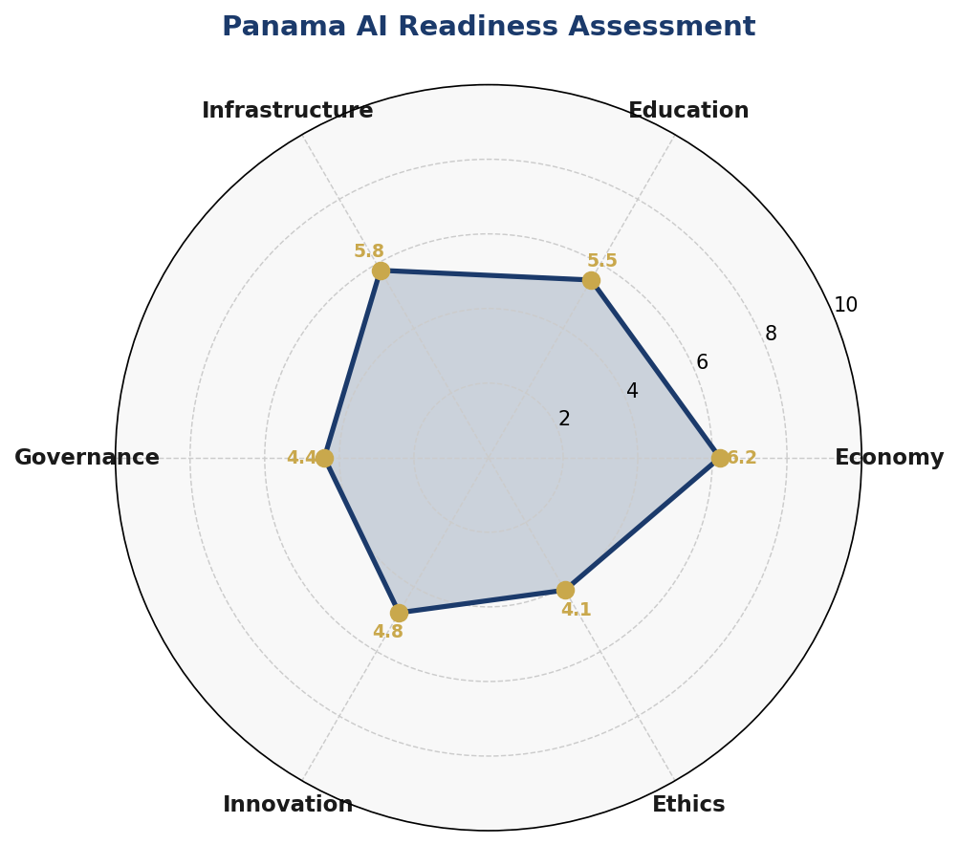
Figure 1.1 — Panama AI Readiness Assessment: 6-Dimensional Radar (Scores out of 10)
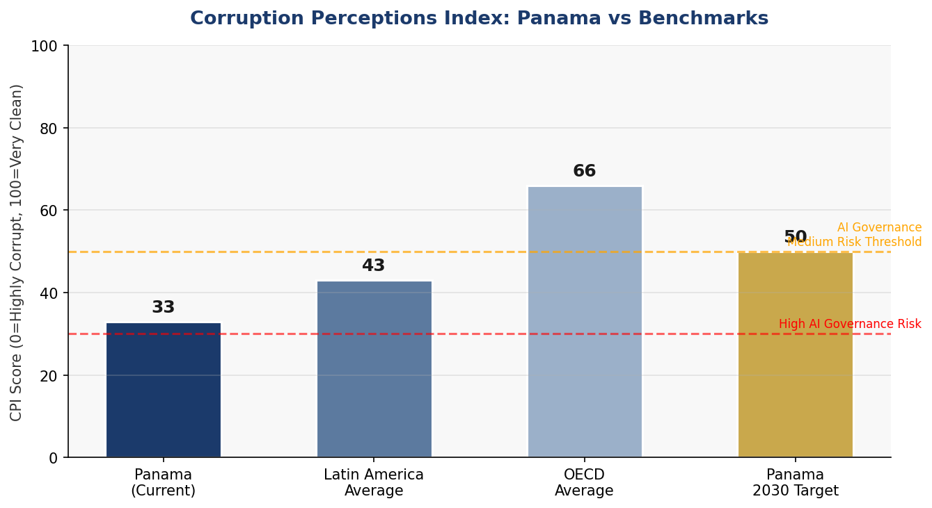
Figure 1.2 — Corruption Perceptions Index: Panama vs Regional and OECD Benchmarks, with AI Governance Risk Tiers

Section 2: Policy Vision and Strategic Pillars

2.1 Vision Statement
"By 2031, Panama will be recognized as Latin America's most trustworthy, inclusive, and innovation-driven artificial intelligence nation — a country where AI amplifies the Canal's legacy of connection by linking every citizen to opportunity, every institution to accountability, and every industry to the future."

2.2 Mission
To create a nationally coordinated, internationally aligned, and citizen-centric artificial intelligence ecosystem that drives equitable economic growth, strengthens democratic governance, protects human rights, and positions Panama as a global model for responsible AI in small-to-medium open economies.

2.3 Strategic Pillars
Pillar 1: Ethical AI and Human Rights Protection
Panama's AI governance will be anchored in a rights-based approach consistent with international human rights law. All AI systems deployed in public life must uphold due process, non-discrimination, privacy, and access to remedy. Panama will establish a National AI Ethics Board with independent oversight authority, mandate algorithmic impact assessments for high-risk AI, and enact data protection legislation aligned with the GDPR principles. Special protections will apply to vulnerable populations including indigenous communities, migrants, minors, and persons with disabilities.
Pillar 2: Economic Growth and Industrial AI Adoption
AI will be deployed strategically across Panama's key economic sectors to maximize competitive advantage. Priority sectors include: logistics and smart ports (Canal operations, Balboa and Cristóbal ports), financial services and fintech (regulatory technology, fraud detection, credit scoring for the unbanked), tourism (AI-powered visitor experience, demand forecasting), healthcare (diagnostic AI, telemedicine for rural areas), and agriculture (precision farming, climate-adaptive crop management for Chiriquí and Veraguas provinces). Panama will establish AI-focused economic zones linked to the existing Colon Free Zone and Panama Pacifico special economic zone.
Pillar 3: Education, Upskilling, and AI Workforce Development
Panama will undertake a comprehensive national AI literacy initiative targeting all levels of society: primary and secondary students through a reformed STEM curriculum; tertiary students through new AI degree programs and specializations; working professionals through a National AI Upskilling Program; and public servants through mandatory digital government training. The Ministry of Education will partner with leading international universities including MIT, Stanford, and the Inter-American Development Bank's technology programs to bring globally competitive AI education to Panama.
Pillar 4: Public Sector AI and e-Governance
The Government of Panama will position itself as a model AI adopter, deploying AI to improve service delivery, reduce corruption, and enhance regulatory effectiveness. Priority government AI applications include: predictive analytics for tax compliance and fiscal management; AI-powered customs and border management at Panama's ports of entry; intelligent procurement monitoring to detect irregularities; natural language processing tools for citizen services in Spanish and indigenous languages; and environmental monitoring AI for the Canal watershed and coastal zones.
Pillar 5: AI Research, Innovation, and Startup Ecosystem
Panama will invest in creating a vibrant AI innovation ecosystem anchored by a new National AI Research Institute (NAIRI) affiliated with the Universidad Tecnológica de Panamá. The Institute will focus on applied AI research aligned with Panama's strategic economic sectors, with particular emphasis on tropical climate AI, maritime logistics optimization, and financial inclusion technology. A national AI startup accelerator program will provide seed funding, regulatory sandboxes, and mentorship for Panamanian AI ventures, with a target of launching 50 AI startups by 2031.

Section 3: International Framework Alignment
Panama's National AI Policy is designed to achieve comprehensive alignment with the principal global AI governance frameworks. This alignment is not merely declaratory — each framework's specific principles are mapped to concrete policy mechanisms, institutional structures, and implementation actions described in subsequent sections. The following matrix provides an overview of alignment status.

3.1 UNESCO AI Ethics Recommendation (2021)
The UNESCO Recommendation on the Ethics of AI (2021) — the first global normative instrument on AI ethics, ratified by 193 UNESCO Member States including Panama — establishes 11 core values and principles: respect for human rights and dignity; transparency and explainability; safety and security; fairness and non-discrimination; sustainability; privacy; human oversight and determination; proportionality and non-harm; protection and promotion of cultural diversity and linguistic diversity; right to education and access to quality information; and inclusive international governance. Panama's policy incorporates all 11 values, with particular attention to cultural and linguistic diversity given the country's seven indigenous peoples and their distinct languages.

3.2 OECD AI Principles (Updated 2024)
The OECD AI Principles (2019, updated 2024), adopted by Panama through its OECD accession process, establish five principles for responsible AI: inclusive growth, sustainable development and well-being; human-centred values and fairness; transparency and explainability; robustness, security and safety; and accountability. Panama's policy is structured to satisfy each of these principles, with the National AI Ethics Board serving as the primary accountability mechanism and the risk classification system providing the operational backbone for transparency and safety requirements.

3.3 EU AI Act (2024)
The EU AI Act (2024) — the world's first comprehensive AI regulation — provides the most detailed operational framework for AI risk management. Panama adopts the Act's four-tier risk classification as the basis for its own regulatory framework: Unacceptable Risk (prohibited), High Risk (regulated with mandatory conformity assessment), Limited Risk (transparency obligations), and Minimal Risk (voluntary codes of conduct). Given Panama's significant trade and investment relationship with the European Union and its importance as a financial services hub with European institutional clients, alignment with the EU AI Act also serves Panama's commercial interests by facilitating market access and demonstrating regulatory credibility.

3.4 World Bank, G20, and ITU Alignment
Panama's status as a developing upper-middle-income country with development aspirations makes the World Bank AI Strategy's focus on inclusive AI for development particularly relevant. The policy's emphasis on rural AI connectivity, AI for agricultural productivity, and financial inclusion technology directly responds to World Bank development AI priorities. G20 AI Principles and ITU AI for Good guidelines provide complementary normative frameworks that reinforce the policy's SDG alignment, particularly SDG 9 (Industry, Innovation, and Infrastructure), SDG 10 (Reduced Inequalities), and SDG 16 (Peace, Justice, and Strong Institutions).

3.5 Framework Alignment Matrix
Framework | Key Principle | Panama Policy Alignment | Status
UNESCO AI Ethics  (2021) | Proportionality & Non-Harm | Section 6 Ethics Board + Risk Classification | ✅
UNESCO AI Ethics  (2021) | Human Oversight & Determination | Section 6 Algorithmic Accountability Standards | ✅
UNESCO AI Ethics  (2021) | Privacy & Data Protection | Section 6 Data Protection Act Recommendations | ✅
UNESCO AI Ethics  (2021) | Cultural & Linguistic Diversity | Section 5 Indigenous Language AI Tools | ⚠️
OECD AI Principles  (2024) | Transparency & Explainability | Section 6 AI Risk Classification + Audit | ✅
OECD AI Principles  (2024) | Robust, Secure & Safe AI | Section 4 Infrastructure Investment | ✅
OECD AI Principles  (2024) | Accountability | Section 9 National AI Observatory | ✅
EU AI Act (2024) | Prohibited AI Practices | Section 6 Unacceptable Risk Bans | ✅
EU AI Act (2024) | High-Risk AI Requirements | Section 6 Mandatory Audit Requirements | ✅
EU AI Act (2024) | Transparency Obligations | Section 6 Limited Risk Provisions | ✅
World Bank AI Strategy | Inclusive AI for Development | Section 5 Underrepresented Groups | ✅
World Bank AI Strategy | Governance & Accountability | Section 7 Public Procurement Guidelines | ✅
G20 AI Principles | Human-Centric AI | Section 2 Rights-Based Vision | ✅
G20 AI Principles | Inclusive Growth | Section 4 Economic Impact Roadmap | ✅
ITU AI for Good | SDG Alignment (SDG 9, 10, 16) | Section 10 International Cooperation | ✅
ITU AI for Good | Digital Inclusion | Section 5 Rural Connectivity AI | ⚠️
Table 3.1 — Panama National AI Policy: International Framework Alignment Matrix (✅ Full Alignment | ⚠️ Partial Alignment | 🔲 Planned)

Section 4: Economic Impact and Investment Roadmap

4.1 AI's Projected Economic Contribution to Panama
Drawing on McKinsey Global Institute estimates for Latin American upper-middle-income economies and World Economic Forum projections, AI adoption is projected to contribute an incremental 3.5% of GDP by 2031 — equivalent to approximately USD 5.2 billion in additional annual economic output at current GDP levels. This projection assumes sustained public investment in the enablers outlined in this policy: digital infrastructure, AI education, and regulatory certainty. The logistics and financial services sectors alone are estimated to capture 60% of the total AI-driven value creation, leveraging Panama's existing competitive advantages.
The McKinsey 2023 State of AI Report identifies small open economies with strong international financial and logistics sectors as disproportionate beneficiaries of AI automation, as these sectors have high documentation, optimization, and data processing burdens ideally suited to AI augmentation. Panama's Canal operations, which process over 13,000 vessels annually and generate USD 4 billion in tolls, represent the single largest AI optimization opportunity in the country, with AI-enabled traffic management, predictive maintenance, and environmental monitoring projected to generate USD 200–400 million in annual efficiency gains by 2030.
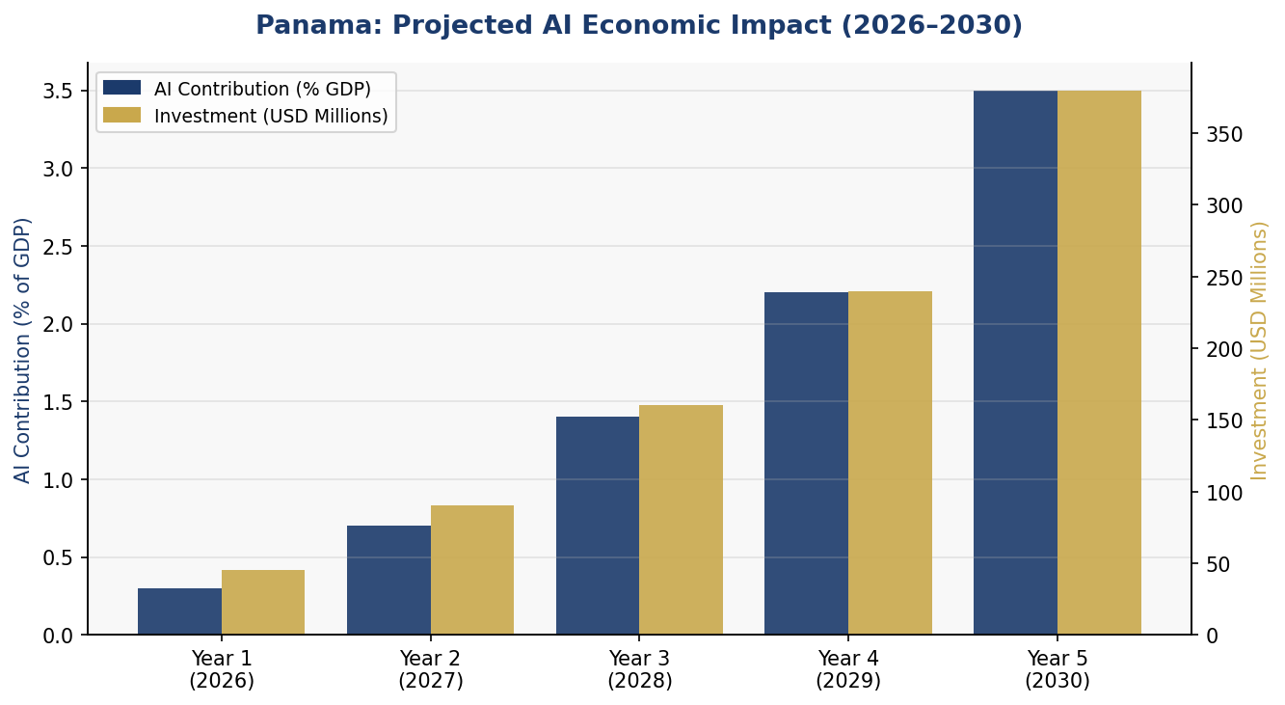
Figure 4.1 — Panama: Projected AI Economic Impact and Investment Trajectory (2026–2030)

4.2 Investment Allocation Framework
The National AI Investment Framework establishes a total public investment target of USD 915 million over five years (2026–2031), allocated across six priority areas. This public investment is expected to catalyze an additional USD 1.5–2 billion in private sector AI investment, yielding a total ecosystem investment of approximately USD 2.5 billion over the policy period. The allocation is designed to front-load foundational infrastructure and regulatory investments in Years 1–2, enabling accelerated private sector uptake in Years 3–5.
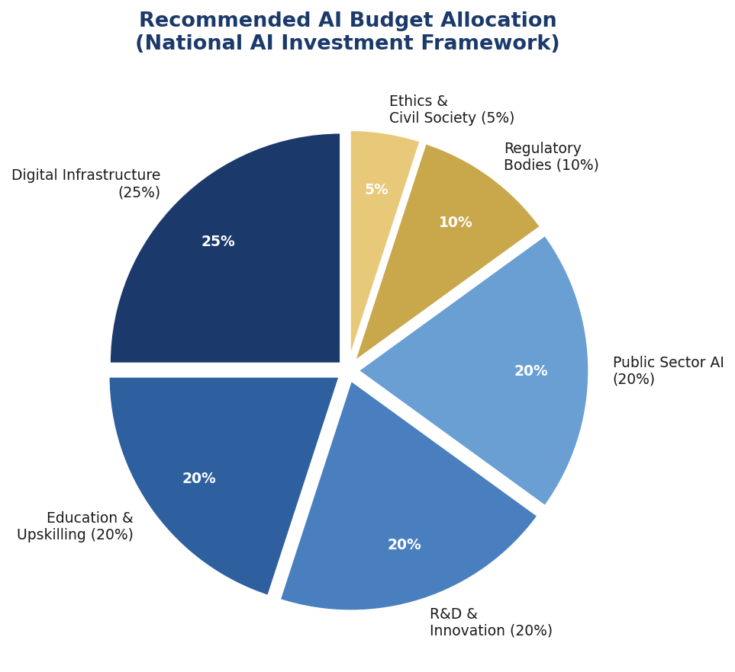
Figure 4.2 — Recommended National AI Budget Allocation by Category (Total: USD 915 Million, 2026–2031)

4.3 Priority Sectors for AI Adoption
The following sectors are designated as AI Priority Sectors and will be eligible for accelerated regulatory approval, co-investment through the Panama AI Investment Fund, and preferential access to national AI research infrastructure:
- Maritime Logistics and Canal Operations — AI-driven vessel routing, predictive maintenance, environmental compliance monitoring, and cargo optimization for the Canal and ports
- Financial Services and Fintech — Credit risk modeling, regulatory technology (RegTech), AML/fraud detection, financial inclusion tools for the unbanked population
- Healthcare and Telemedicine — AI-assisted diagnostics for tropical diseases, telemedicine platforms for rural provinces, hospital resource optimization, epidemiological surveillance
- Agriculture and Food Security — Precision agriculture systems for Chiriquí and Veraguas, climate adaptation crop modeling, supply chain optimization for agricultural exports
- Tourism and Cultural Economy — AI-powered visitor experience systems, demand forecasting, Panamanian natural heritage monitoring using remote sensing AI
- Public Security and Justice — Predictive analytics for crime prevention (with strict civil liberties safeguards), AI-assisted court case management, DNA analysis systems

4.4 Public-Private Partnership Framework
Panama will establish a National AI Investment Fund (NAIF) capitalized at USD 100 million in its first year, co-funded by the government, the Inter-American Development Bank, the International Finance Corporation, and selected private sector anchor investors. The Fund will operate through competitive grant mechanisms, co-investment structures, and regulatory sandbox arrangements. International AI companies seeking market entry in Panama will be required to commit to technology transfer, local talent development, and data localization requirements as conditions of operating licenses.

Section 5: Education and Human Capital Development

5.1 Current Skills Gap Analysis
Panama's AI workforce gap is one of the most significant structural constraints on AI adoption. A 2025 assessment by the Autoridad Nacional para la Innovación Gubernamental (AIG) and the Ministerio de Educación (MEDUCA) identified the following critical shortfalls: fewer than 200 PhD-level AI researchers, approximately 1,500 practicing machine learning engineers, under 15,000 workers with any formal data literacy training, and an estimated structural deficit of 35,000 AI-capable professionals by 2030. Without deliberate policy intervention, this gap will widen as AI adoption accelerates regionally and globally.
The gap is not uniform across Panama's population: women represent only 28% of STEM graduates; indigenous communities have near-zero representation in technology professions; and the interior provinces (Veraguas, Los Santos, Herrera, Coclé) are severely underrepresented in digital skill distributions. Addressing these structural inequalities is both a moral imperative and an economic necessity, as the full productivity gains from AI require broad workforce participation.

5.2 National AI Curriculum Framework
Panama will implement a three-tier National AI Curriculum Framework covering the full educational pipeline from primary school through continuing professional education:
Tier 1: K-12 AI Foundations (Age 6–18)
Computational thinking will be integrated into the primary school curriculum from Grade 3. Secondary schools will introduce dedicated Technology and Society courses covering AI fundamentals, data literacy, algorithmic thinking, and digital ethics. The Ministry of Education will partner with Code.org, AI4K12, and regional initiatives to adapt internationally proven curricula to Panama's cultural and linguistic context. Bilingual AI education materials (Spanish and English) will be developed, with versions in Ngäbere, Guna, and Emberá languages for use in Comarca schools.
Tier 2: Tertiary AI Programs (Age 18+)
The Universidad Tecnológica de Panamá will establish a new School of Artificial Intelligence by 2027, offering undergraduate and graduate degrees in AI, Machine Learning, Data Science, and AI Ethics and Policy. All other national universities will be required to include AI literacy modules as general education requirements across all faculties by 2028. Panama will establish a government scholarship program providing 500 fully-funded STEM scholarships annually, with 30% reserved for women and 10% for students from indigenous communities.
Tier 3: Professional Upskilling (Working Adults)
The National AI Upskilling Program (NAUP) will provide subsidized online and in-person AI training for working adults through a public-private partnership with Coursera, edX, and local technology companies. Priority will be given to workers in at-risk sectors (manufacturing, customer service, data entry) facing AI-driven displacement. The program targets 150,000 workers upskilled by Year 3 and 700,000 by Year 5.
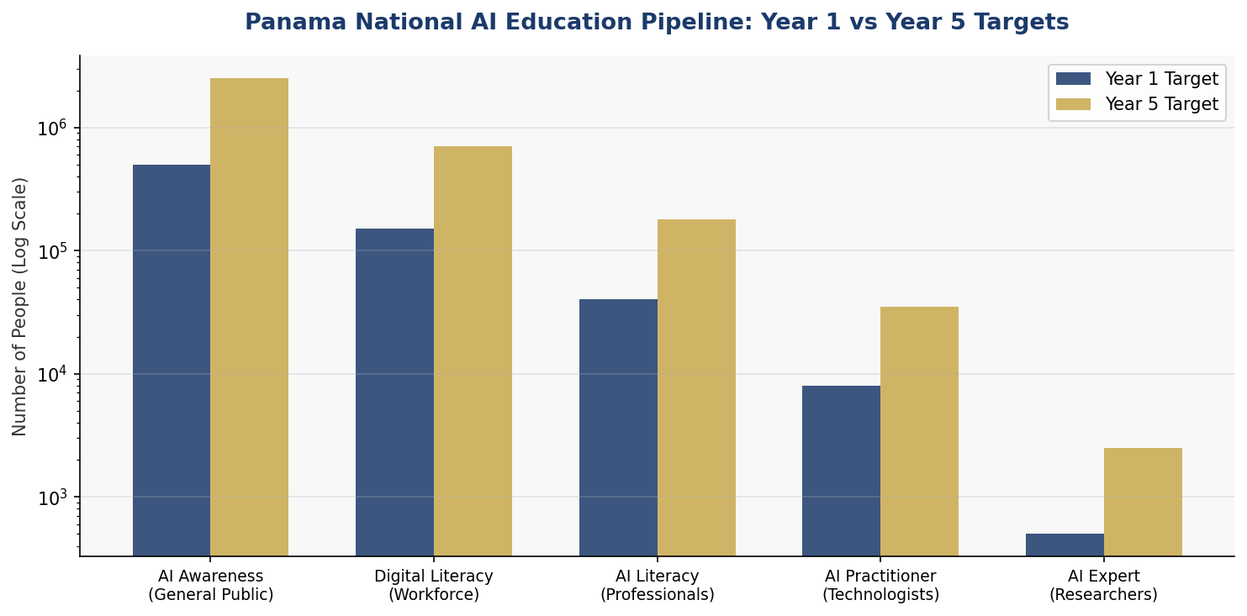
Figure 5.1 — Panama National AI Education Pipeline: Year 1 vs Year 5 Population Targets by Skill Level

5.3 Women and Underrepresented Groups
Panama commits to achieving 40% women's representation in AI programs by 2028 and 50% by 2031 through a combination of targeted scholarships, mentorship programs, female AI role model campaigns, and institutional accountability metrics. The Panama Women in AI Initiative will be established as a public-private partnership to promote female leadership in the AI sector. Indigenous communities will receive dedicated AI education programs developed in consultation with community leaders, respecting cultural protocols and prioritizing applications relevant to indigenous community needs including environmental monitoring, cultural preservation, and health service delivery.

Section 6: Ethical AI Governance and Regulatory Framework

6.1 National AI Ethics Board
Panama will establish a National AI Ethics Board (NAEB) as an independent statutory body under the Asamblea Nacional, insulated from executive branch political influence. The Board will comprise 15 members serving staggered four-year terms, drawn from academia (4 members), civil society (3 members), the private sector (3 members), government (3 members, non-political career officials), and indigenous community representatives (2 members). The NAEB will have investigative authority, the power to issue binding compliance directives, and the capacity to impose administrative sanctions on entities deploying AI systems that violate the provisions of this policy.
The Board's mandate includes: reviewing and approving high-risk AI systems deployed by government agencies; conducting annual audits of AI systems in priority sectors; publishing an Annual State of AI in Panama Report; investigating citizen complaints regarding algorithmic harm; and advising the executive and legislative branches on AI-related legislation. The NAEB Secretariat will be staffed by a professional team of AI technical specialists, lawyers, ethicists, and social scientists.

6.2 AI Risk Classification System
Level 1: Unacceptable Risk — Prohibited AI Practices
The following AI applications are absolutely prohibited in Panama and may not be deployed by any public or private entity:
- Social scoring systems that rate citizens based on behavior, social associations, or political views
- Real-time biometric mass surveillance in public spaces without prior judicial authorization
- AI systems that manipulate persons through subliminal techniques causing psychological harm
- Emotion recognition AI in employment and educational contexts
- AI systems used to generate deepfake political disinformation
- Predictive policing systems that generate risk scores for individuals based solely on demographic characteristics
Level 2: High Risk — Regulated with Mandatory Audit
AI systems in the following categories are classified as High Risk and require mandatory conformity assessment, registration with the National AI Ethics Board, annual independent audits, and documented human oversight mechanisms before deployment:
- AI systems used in judicial decisions, parole determinations, and criminal sentencing
- AI in employment screening, job allocation, and worker performance management
- AI systems in healthcare diagnosis, treatment recommendation, and medical device control
- AI-assisted credit scoring and financial services decision-making affecting individuals
- AI systems used for border management, immigration processing, and asylum determination
- Critical infrastructure management AI including water, energy, and Canal operations
Level 3: Limited Risk — Transparency Obligations
AI systems including chatbots, content recommendation systems, AI-generated content tools, and customer service AI are subject to mandatory disclosure requirements. Users must be clearly informed when they are interacting with an AI system and must have the right to request human review of any AI-generated decision affecting their interests.
Level 4: Minimal Risk — Voluntary Code of Conduct
The vast majority of AI applications including spam filters, AI-assisted writing tools, gaming AI, and industrial process optimization fall into the minimal risk category and are subject only to a voluntary code of conduct developed by the NAEB in consultation with industry.

6.3 Data Protection and Privacy
Panama will enact a comprehensive Personal Data Protection Law aligned with GDPR principles by 2027, replacing the existing Ley 81 of 2019. The new law will extend to AI-specific provisions including: rights against purely automated decision-making with significant effects; rights to explanation of algorithmic decisions; mandatory data protection impact assessments for AI systems processing sensitive data; and provisions for algorithmic auditing by the data protection authority. Panama's status as a regional data center hub creates both commercial incentives and governance obligations to establish world-class data protection standards.

6.4 Anti-Corruption AI Safeguards
Given Panama's governance challenges, anti-corruption provisions are integrated throughout the regulatory framework. All government AI procurement contracts must be published on the government's open data portal within 30 days of signing. AI systems used in government decision-making must provide complete audit trails accessible to the NAEB and, where appropriate, to the public. Panama will pioneer AI-powered anti-corruption monitoring tools deployed by the Contraloría General de la República to detect irregular procurement patterns, conflicts of interest, and budget irregularities in real time.

Section 7: Public Sector AI and e-Governance

7.1 Government AI Vision
Panama's government will transition from a digitally enabled administration to an AI-augmented state by 2031. This transition is not about replacing human public servants but about augmenting their capacity to serve citizens more effectively, make better policy decisions, and deploy public resources with greater precision and accountability. The Autoridad Nacional para la Innovación Gubernamental (AIG) will serve as the lead coordinating body for government AI, with a new dedicated AI Division responsible for whole-of-government AI strategy, standards, and support.

7.2 Priority Government AI Applications
- Tax Administration — AI-powered risk assessment for the Dirección General de Ingresos (DGI) to identify non-compliance patterns, with projected 15–20% improvement in revenue collection efficiency
- Customs and Trade Facilitation — Intelligent document processing and risk-based cargo inspection at Panama Canal ports, reducing clearance times by 40% while improving contraband detection
- Healthcare Delivery — AI-assisted teleconsultation routing for the Caja de Seguro Social (CSS) rural health network, prioritizing underserved communities in Darién, Guna Yala, and Ngäbe-Buglé
- Education Quality Monitoring — Predictive analytics for student at-risk identification and early intervention programs in the national school system
- Environmental Protection — AI-based deforestation monitoring for the Canal watershed using satellite imagery, supporting Panama's commitment to 65% forest cover under Law 1 of 1994
- Judicial Efficiency — NLP-based case classification and legal research tools for the Órgano Judicial to reduce case backlogs
- Disaster Risk Management — AI-enhanced SINAPROC emergency response systems integrating meteorological, hydrological, and social vulnerability data for flood, landslide, and earthquake preparedness

7.3 AI Procurement Guidelines for Government
All government AI procurement must comply with the following mandatory requirements: publication of algorithmic impact assessments prior to procurement; international competitive tendering with mandatory technology transfer provisions; source code escrow requirements for critical system AI; supplier diversity requirements favoring Panamanian and regional AI companies; mandatory sunset review provisions after 3 years of deployment; and post-deployment monitoring plans with citizen feedback mechanisms. The Contraloría General de la República will develop specialized AI procurement audit protocols by 2027.

7.4 Citizen-Facing AI Services Roadmap
By 2031, Panama commits to offering the following AI-powered services to all citizens through the Panamá Digital platform: a bilingual AI citizen assistant capable of handling queries about government services in Spanish and the major indigenous languages; an AI-powered complaints and petitions tracking system; automated benefit eligibility determination for social programs with human review for all denials; and predictive scheduling for government offices to eliminate waiting times. All citizen-facing AI systems will be tested for bias and accessibility compliance prior to deployment.

Section 8: Implementation Roadmap

8.1 Phased Implementation Strategy
The National AI Policy 2026–2031 is implemented through three sequential but overlapping phases designed to build the institutional, human, and technical foundations before scaling to national deployment. Each phase has clearly defined milestones, accountability mechanisms, and resource requirements.
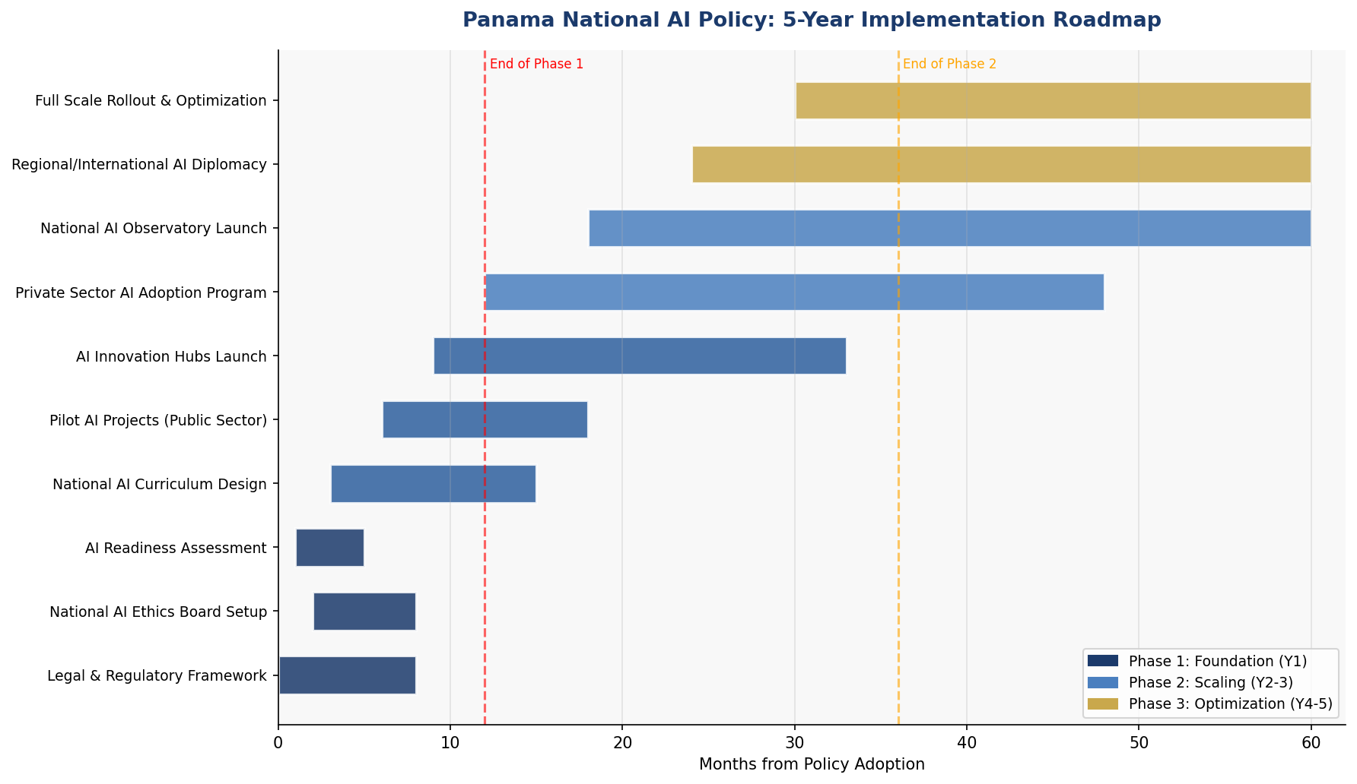
Figure 8.1 — Panama National AI Policy: 5-Year Implementation Gantt Chart (2026–2031)

8.2 Phase 1: Foundation (Year 1 — 2026)
The Foundation Phase establishes the institutional, legal, and infrastructural prerequisites for sustainable AI development. Key milestones include:
- Enact the National AI Governance Act establishing the NAEB and the legal framework for AI risk classification
- Establish the National AI Ethics Board, recruit its secretariat, and publish the first NAEB Work Programme
- Conduct the National AI Readiness Audit across all ministries and publish findings
- Launch the National AI Curriculum Task Force and begin curriculum redesign for K-12 and tertiary levels
- Establish the National AI Investment Fund (NAIF) and recruit its inaugural board
- Launch three government AI pilot programs in tax administration, health, and environmental monitoring
- Publish Panama's National AI Open Data Portal with foundational government datasets
- Begin broadband infrastructure expansion in the 10 lowest-connectivity districts

8.3 Phase 2: Scaling (Years 2–3 — 2027–2028)
The Scaling Phase deploys AI initiatives nationwide, reforms educational institutions, and builds the private sector AI ecosystem. Key milestones include:
- Enact the Personal Data Protection Law (GDPR-aligned) and establish the Data Protection Authority
- Launch the School of Artificial Intelligence at the Universidad Tecnológica de Panamá
- Deploy the National AI Upskilling Program reaching 150,000 workers
- Launch the Panama AI Innovation Hubs in Panama City, Colón, and David
- Commence the Panama AI Startup Accelerator first cohort (25 startups)
- Expand government AI deployment to 12 priority services across all ministries
- Achieve 75% internet penetration nationally through infrastructure investments
- Publish the first Annual State of AI in Panama Report

8.4 Phase 3: Optimization (Years 4–5 — 2029–2031)
The Optimization Phase consolidates gains, integrates AI across the national economy, and positions Panama as a regional AI governance leader. Key milestones include:
- Achieve 3.5% AI contribution to GDP
- Train 700,000 AI-literate workers; establish 2,500 AI experts
- Complete 50 Panama AI startup graduates generating export revenue
- Assume leadership of CELAC AI Governance Working Group
- Conduct comprehensive five-year policy review and publish Panama AI Policy 2031–2036
- Achieve regional recognition as Latin America's leading AI governance model

Section 9: Monitoring, Evaluation, and Accountability

9.1 National AI Observatory
Panama will establish a National AI Observatory (NAIO) under the joint auspices of the AIG, the NAEB, and the Universidad Tecnológica de Panamá. The Observatory will monitor AI deployment trends, track policy KPIs, publish an Annual State of AI in Panama Report, and conduct independent assessments of AI's social and economic impacts. The NAIO will maintain a public-facing AI Systems Registry listing all registered high-risk AI systems, their operators, their purposes, and their audit status.

9.2 Parliamentary Oversight
The Asamblea Nacional will establish a permanent Standing Committee on Artificial Intelligence and Digital Transformation with authority to summon the NAEB Chair for testimony, conduct legislative inquiries into AI-related harms, and review and amend AI-related legislation. The NAEB will submit an Annual Report to the Asamblea Nacional, which will be published and open to public comment for 60 days before parliamentary consideration.

9.3 Civil Society and Independent Auditor Role
Panama recognizes the essential role of civil society organizations, academic researchers, and independent auditors in ensuring the accountability and integrity of the national AI governance system. The government will establish a Civil Society AI Advisory Council with formal consultation rights in NAEB proceedings. Independent AI auditors accredited by the NAEB may be contracted by the government, the private sector, or directly by civil society organizations to conduct algorithmic audits. Whistleblower protections will be enacted to protect individuals who report AI-related governance violations.

9.4 KPI Dashboard
KPI | Baseline (2025) | Year 1 Target | Year 3 Target | Year 5 Target
AI Contribution to GDP (%) | ~0.1% | 0.3% | 1.4% | 3.5%
AI Investment (USD M, cumulative) | 0 | 45 | 295 | 915
AI-Literate Workers (thousands) | ~15k | 40k | 180k | 700k
AI PhD Researchers | <200 | 250 | 500 | 1,500
Internet Penetration (%) | 65% | 70% | 78% | 88%
NAEB Investigations Completed | 0 | 12 | 36 | 60
Government AI Services Deployed | 3 | 8 | 18 | 30
AI Startups Launched (cumulative) | 0 | 5 | 25 | 50
Female AI Program Enrollment (%) | 28% | 32% | 40% | 50%
CPI Score Improvement (Target) | 33 | 34 | 38 | 45
National AI Open Datasets Published | 0 | 50 | 150 | 300
Table 9.1 — Panama National AI Policy: KPI Dashboard (2025 Baseline through 2031 Target)

Section 10: International Cooperation and AI Diplomacy

10.1 Bilateral AI Cooperation Priorities
Panama will pursue strategic bilateral AI cooperation agreements with the United States, the European Union, Japan, Republic of Korea, and Brazil — countries that combine technological AI leadership with active development cooperation programs. With the United States, Panama seeks a Technology Partnership Agreement that includes AI research exchanges, cybersecurity cooperation, and access to US federal AI governance expertise. With the European Union, Panama seeks Market Access Dialogue status under the EU AI Act framework, enabling Panamanian AI companies to demonstrate compliance with EU requirements and access the European market.
Panama will establish a bilateral AI Centre of Excellence with Costa Rica focused on climate AI and biodiversity monitoring, leveraging both countries' commitments to environmental leadership in Central America. With Colombia, Panama will pursue an AI in Logistics Partnership to create an AI-optimized digital trade corridor from the Canal to South America's Pacific ports.

10.2 Regional AI Governance
Panama will assume an active leadership role in AI governance within the CELAC (Community of Latin American and Caribbean States) framework, proposing the establishment of a CELAC AI Governance Working Group modeled on the OECD AIGO. Panama will advocate for a Latin American AI Governance Compact that establishes common standards for high-risk AI, shared AI safety research infrastructure, and a regional AI incident reporting system. Panama's experience as a treaty-based international institution host (canal treaties, extradition frameworks) positions it well to serve as the permanent secretariat of a future CELAC AI Governance body.

10.3 South-South Knowledge Transfer
Panama is committed to sharing its AI governance experience with other developing nations through South-South and triangular cooperation. Through the Agencia Panameña de Cooperación Internacional (APCI), Panama will offer AI policy training programs for government officials from Caribbean SIDS, Central American nations, and Andean Community countries. Panama's bilingual capacity (Spanish-English), its international financial expertise, and its proximity to the United States and Europe position it as a natural intermediary for translating cutting-edge AI governance lessons into applicable frameworks for the Global South.

10.4 Global AI Governance Participation
Panama will strengthen its representation in global AI governance fora including the UN Secretary-General's AI Advisory Body, the International Telecommunication Union's AI for Good platform, the Global Partnership on AI (GPAI), and the UNESCO AI Ethics Recommendation implementation processes. Panama will commit 0.1% of the National AI Investment Fund annually to multilateral AI safety research through the International Scientific Panel on AI (IPAI), reinforcing its commitment to global AI governance as a small state with disproportionate international connectivity.

Conclusion
Panama's National AI Policy 2026–2031 represents a historic commitment to ensuring that artificial intelligence serves the Panamanian people — all of them, not just the connected few. It is a framework built on the understanding that AI is not a value-neutral technology: it amplifies the institutional qualities of the societies that deploy it. For Panama, that means addressing governance vulnerabilities head-on, building inclusive pathways to AI literacy, and asserting Panama's right and responsibility to shape the global AI governance agenda.
The Canal taught the world that Panama can build transformative infrastructure that connects civilizations. The Digital Agenda 2030 demonstrated that Panama can modernize government services at scale. This National AI Policy is the third chapter in that story — the chapter where Panama uses intelligence, not just geography, as its strategic asset. If implementation proceeds as planned, by 2031 Panama will not merely be using AI: it will be leading the developing world in showing how to govern it well.
Success requires sustained political will across electoral cycles, genuine partnership between government and civil society, rigorous accountability mechanisms, and the patient investment of public resources in the human and institutional foundations that AI requires to flourish equitably. Panama has the capacity. This policy provides the roadmap. The work begins now.

References and Bibliography

International Frameworks and Agreements
- UNESCO Recommendation on the Ethics of Artificial Intelligence (2021). UNESCO. Paris: UNESCO Publishing.
- OECD Principles on Artificial Intelligence (2019, updated 2024). OECD. Paris: Organisation for Economic Co-operation and Development.
- Regulation (EU) 2024/1689 of the European Parliament and of the Council — Artificial Intelligence Act. Official Journal of the European Union.
- World Bank Group Artificial Intelligence Strategy (2021). Washington D.C.: World Bank Group.
- G20 AI Principles. (2019). G20 Osaka Leaders' Declaration. Tokyo: Government of Japan.
- ITU AI for Good Global Summit Guidelines (2023). Geneva: International Telecommunication Union.
- Global Partnership on Artificial Intelligence (GPAI) — Work on Responsible AI (2024). Paris: OECD Secretariat.

Panama Government Sources
- Autoridad Nacional para la Innovación Gubernamental (AIG). (2023). Digital Agenda Panama 2030. Panama City: AIG.
- Ministerio de Economía y Finanzas (MEF). (2024). Panama Economic Outlook 2024–2028. Panama City: MEF.
- Autoridad del Canal de Panamá (ACP). (2023). Annual Report 2023. Panama City: ACP.
- Ministerio de Educación (MEDUCA). (2023). National Education Statistics 2023. Panama City: MEDUCA.

Research and Data Sources
- IMD World Digital Competitiveness Ranking (2024). Lausanne: International Institute for Management Development.
- McKinsey Global Institute. (2023). The State of AI in 2023: Generative AI's Breakout Year. New York: McKinsey & Company.
- Oxford Insights. (2024). Government AI Readiness Index 2024. Oxford: Oxford Insights.
- Transparency International. (2024). Corruption Perceptions Index 2024. Berlin: Transparency International.
- ITU Global Cybersecurity Index (2024). Geneva: International Telecommunication Union.
- World Economic Forum. (2024). Future of Jobs Report 2025. Geneva: World Economic Forum.
- Inter-American Development Bank (IDB). (2024). The Future of Work in Latin America and the Caribbean. Washington D.C.: IDB.
- World Bank. (2024). Digital Economy for Latin America and the Caribbean. Washington D.C.: World Bank Group.

About the Author
Nafiul Ahmad Rafi
Policy & Good Governance Researcher | BD Civic Tech Architect
Nafiul Ahmad Rafi is a civic technologist, policy researcher, author, photographer, and musician based in Dhaka, Bangladesh. He is the Founder and Director of Insights Bangladesh, a data-driven governance and policy impact analysis institution, and the Founder & Lead Architect of NagorikBD.org — a transparency-first civic platform scaled across Mymensingh Division, connecting citizens with government services across 45 Upazilas.
His work exists at the intersection of institutional reform and artificial intelligence, transforming theoretical governance into scalable, data-driven reality. Without a conventional computer science degree, he self-taught the tools of modern AI and web development to build the infrastructure that enforces the policies he once only researched.

Key Platforms and Projects
- NagorikBD.org — Civic transparency platform, Mymensingh Division
- Insights Bangladesh — Policy impact analysis institution
- FactCheck BD (factcheckbd.org) — Bangladesh's AI-powered fact-checking platform
- Political Insights BD / PIBD (pibbd.org) — Political intelligence and civic tech hub
- PeaceShield BD / National Peace Tracker — AI-powered hate speech and conflict monitoring
- PolicyLens AI (aigovbd.org) — 9-dimensional AI policy audit tool

He has published four books and maintains a personal site at ahmad-rafi.com.

Research Interests
AI Governance · Policy Research · Future of Bangladesh · Climate Policy

Contact
- 🌐 ahmad-rafi.com
- 🔗 LinkedIn: nafiul-ahmad-rafi (bd.linkedin.com/in/nafiul-ahmad-rafi)
- ✉️ contact@ahmad-rafi.com

"I build code to ensure transparency, and I write lyrics to inspire the courage to use it."

