🇪🇬 ARAB REPUBLIC OF EGYPT

National Artificial Intelligence Policy
2026 – 2031

A Comprehensive Framework for Ethical, Inclusive, and Economically Transformative AI

Prepared by: Nafiul Ahmad Rafi
Policy Researcher & Civic Technologist | Insights Bangladesh
May 2026

Executive Summary

Egypt stands at a defining inflection point in its developmental trajectory. As Africa's most populous Arab nation and the continent's third-largest economy, Egypt possesses the demographic weight, geographic centrality, and economic ambition to emerge as a regional AI powerhouse — yet critical structural challenges in governance, infrastructure, and human capital require deliberate, evidence-based policy intervention to unlock this potential.
This National Artificial Intelligence Policy (NAIP) for 2026–2031 establishes a comprehensive, globally-aligned framework to harness the transformative power of artificial intelligence in service of Egypt's national development goals, including Vision 2030 and the broader Sustainable Development Goals (SDGs). The policy is grounded in Egypt's Oxford Insights AI Readiness score of approximately 51.4/100 (2023), placing it in the upper-middle tier among African nations but well behind global leaders, signalling both credible capability and significant improvement headroom.
The policy is organized around five strategic pillars: (1) Ethical AI and Human Rights Protection, establishing robust governance structures and risk-based regulation; (2) Economic Growth and Industrial AI Adoption, targeting high-impact sectors including tourism, agriculture, energy, and manufacturing; (3) Education, Upskilling and AI Workforce Development, building a talent pipeline from K-12 through graduate research; (4) Public Sector AI and e-Governance, modernizing service delivery and anti-corruption mechanisms; and (5) AI Research, Innovation and Startup Ecosystem, seeding a sovereign AI innovation culture.
Under conservative projections, AI-driven productivity gains could contribute 4.2% to Egypt's GDP by 2030, representing over USD 20 billion in annual economic value. Realizing this potential requires coordinated investment of approximately EGP 85–100 billion across a five-year horizon, with clear accountability mechanisms, parliamentary oversight, and meaningful civil society engagement. This document provides the strategic architecture, implementation roadmap, and internationally benchmarked standards to guide that journey.

Section 1: National AI Readiness Assessment

1.1 Economic Context
Egypt is classified as a lower-middle-income country with a GDP of approximately USD 476 billion (2023, nominal) and a GDP per capita of roughly USD 4,350. The economy has historically relied on remittances (USD 26.8 billion in 2023), Suez Canal revenues, tourism, natural gas exports, and agriculture. The digital economy currently contributes an estimated 3.5–4% of GDP, a figure projected to reach 8–10% by 2030 under Egypt's Digital Transformation Strategy (2021–2025).
The Egyptian government has demonstrated commitment to technology investment through its Smart Egypt initiative and the establishment of the Ministry of Communications and Information Technology (MCIT). The ICT sector has grown at 15–18% annually since 2018, and Egypt ranked 92nd in the UN E-Government Development Index 2022, reflecting meaningful but uneven digital state capacity.

1.2 Education and Human Capital
Egypt's population of approximately 105 million includes a youth-heavy demographic profile, with over 60% under the age of 30 — a potential AI workforce dividend that policy must actively cultivate. Adult literacy stands at approximately 73.9%, with significant gender and urban-rural disparities. Tertiary enrollment rates hover around 34%, with STEM disciplines accounting for roughly 40% of enrolled students. The American University in Cairo, Cairo University, and Ain Shams University have established nascent AI research programs, though output quality and international collaboration remain below regional peers such as the UAE.
The World Bank's Human Capital Index places Egypt at 0.50 (2020), meaning a child born in Egypt today will be only 50% as productive as they could be with full health and education. Closing this gap is both a moral imperative and a prerequisite for AI readiness.

1.3 Digital Infrastructure
Internet penetration in Egypt reached approximately 72% in 2023, with mobile subscription rates exceeding 95%. The government's National Broadband Network (NBN) aims for universal connectivity by 2025. However, data center capacity, cloud computing adoption, and fiber coverage remain concentrated in Cairo and Alexandria, leaving a significant infrastructure gap in Upper Egypt and rural areas. Egypt's digital payments ecosystem has grown rapidly following the Tahwilat programme and the CBE's instant payment framework, suggesting infrastructure for fintech AI applications.

1.4 Governance and Institutional Capacity
Egypt's governance context is characterized by a strong centralized executive, a historically fragmented civil society, and an emerging regulatory modernization drive under MCIT. The World Bank Worldwide Governance Indicators rate Egypt at the 32nd percentile for Rule of Law and the 28th percentile for Voice and Accountability (2022), reflecting significant institutional constraints on independent AI oversight. Any effective AI governance architecture must account for these structural realities through the design of independent regulatory mechanisms with genuine enforcement authority.

1.5 Corruption Risk Assessment
Egypt scored 35 out of 100 on Transparency International's 2023 Corruption Perceptions Index, ranking 108th globally. This represents an improvement from 28 in 2013, but Egypt still falls well below the OECD average of 65. In AI governance terms, a CPI of 35 signals HIGH RISK: procurement corruption, regulatory capture, and data misuse are material threats to any public AI deployment. This policy therefore embeds anti-corruption safeguards at every institutional layer.

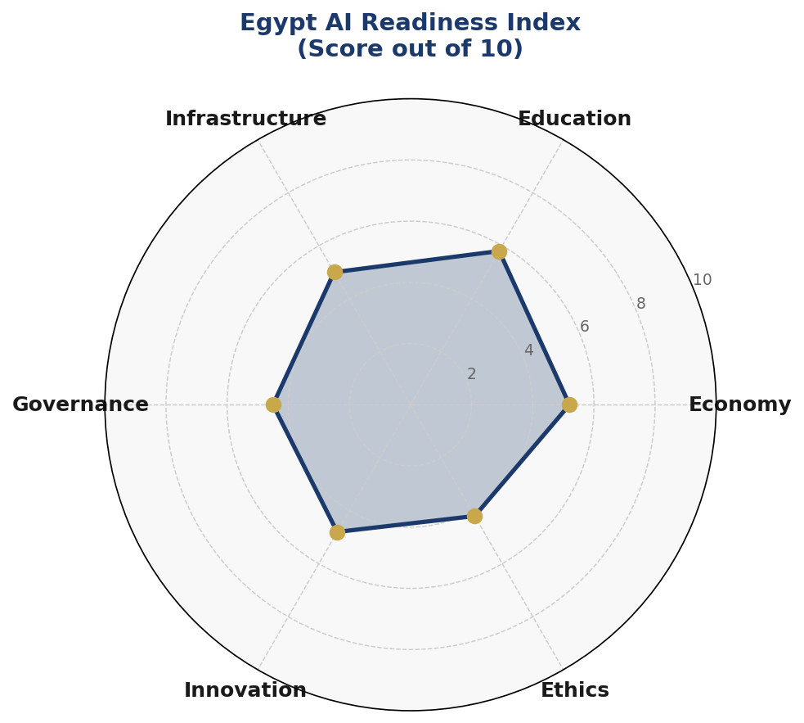
Figure 1: Egypt AI Readiness Index — Six-Dimension Assessment (Scores out of 10)

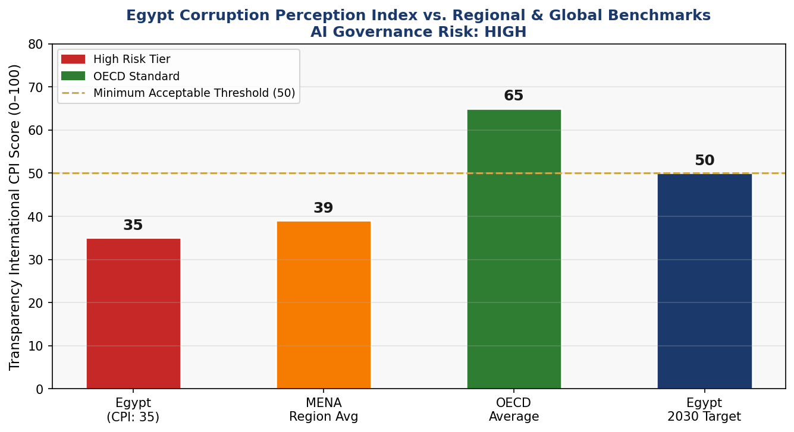
Figure 2: Egypt Corruption Perceptions Index vs. Regional & Global Benchmarks (AI Governance Risk: HIGH)

Section 2: Policy Vision and Strategic Pillars

Vision Statement
"Egypt shall harness the transformative power of Artificial Intelligence to build a just, prosperous, and technologically sovereign nation — where AI serves every Egyptian, protects every right, and elevates every voice."

Pillar 1: Ethical AI and Human Rights Protection
Egypt's AI governance framework will establish comprehensive protections for fundamental rights in the face of AI-enabled risks. The National AI Ethics Board (NAEB), modeled on best practices from the EU AI Act and UNESCO's 2021 Ethics Recommendation, will provide independent oversight of all government AI deployments. Surveillance AI, predictive policing systems, and social scoring applications will face the highest scrutiny under Egypt's risk classification regime.
The policy mandates algorithmic impact assessments for any AI system affecting citizens' rights, employment, creditworthiness, or access to public services. Egypt will enact a comprehensive Personal Data Protection enforcement regime building upon the 2020 Personal Data Protection Law (Law No. 151) to ensure AI systems comply with data minimization, purpose limitation, and consent principles.

Pillar 2: Economic Growth and Industrial AI Adoption
AI will be deployed as a strategic instrument of industrial transformation in Egypt's highest-impact economic sectors. In agriculture, precision AI tools for crop yield prediction, water optimization, and pest detection will target Egypt's 4 million smallholder farmers across the Nile Delta and Valley. In tourism, AI-powered visitor experience platforms, predictive maintenance for heritage sites, and multilingual virtual guides will augment Egypt's USD 13 billion tourism sector. In energy, AI optimization of Egypt's growing solar and wind capacity — including the Benban Solar Park — will improve grid efficiency and reduce carbon intensity.
Manufacturing and logistics, particularly along the Suez Canal Economic Zone (SCZone), will benefit from AI-driven supply chain optimization, predictive maintenance, and quality control systems. Egypt's status as a gateway between Africa, the Arab world, and Europe positions it uniquely as a logistics AI hub if the regulatory and infrastructure environment is strengthened.

Pillar 3: Education, Upskilling, and AI Workforce Development
Egypt's youth demographic presents a historic opportunity: with over 22 million students in primary and secondary education and approximately 2.7 million in higher education, a well-designed AI education reform can yield compound returns over decades. This pillar establishes a National AI Curriculum Framework spanning K-12 computational thinking integration, tertiary AI and data science degree programmes, and vocational AI application certifications for mid-career workers.
A National AI Scholarship Fund will target 5,000 graduate-level scholarships annually for AI, machine learning, and data engineering programmes, with a minimum 40% women's participation quota. Egypt will establish AI Centers of Excellence at five universities: Cairo University, Alexandria University, Ain Shams University, Assiut University, and Mansoura University — with a mandate to publish open-access research.

Pillar 4: Public Sector AI and e-Governance
Egypt's government, serving over 105 million citizens with historically limited administrative capacity, will use AI to dramatically improve public service delivery efficiency, transparency, and quality. Priority use cases include AI-assisted land registration and cadastral dispute resolution (a historically corrupt domain), intelligent tax compliance analytics, fraud detection in public procurement through e-GP system integration, and AI-powered healthcare triage in rural clinics.
All government AI procurements will be subject to an AI Procurement Transparency Standard (APTS), requiring public disclosure of algorithms used, training data provenance, and independent technical audit before deployment. This standard directly addresses Egypt's corruption risk profile.

Pillar 5: AI Research, Innovation, and Startup Ecosystem
Egypt will build a sustainable AI innovation economy through a National AI Research Fund (NARF) of EGP 5 billion over five years, supporting Arabic NLP, computer vision for hieroglyphics preservation, climate AI, and healthcare diagnostics. Three AI Innovation Hubs — in Cairo, Alexandria, and Assiut — will co-locate startups, university researchers, and government innovation labs, modeled on Jordan's PSUT Tech Park and Tunisia's El Ghazala.
Egypt's regional diaspora network — encompassing hundreds of thousands of Egyptian technologists in the Gulf, Europe, and North America — will be engaged through a Diaspora AI Bridge Programme offering matching grants for technology transfer partnerships and reverse brain drain incentives.

Section 3: International Framework Alignment

Egypt's National AI Policy is designed for comprehensive alignment with the six most globally recognized AI governance frameworks. This section maps each framework's core principles to specific policy provisions, demonstrating Egypt's commitment to internationally accepted standards.

3.1 UNESCO AI Ethics Recommendation (2021)
The UNESCO Recommendation on the Ethics of AI, adopted by 193 member states including Egypt, establishes eleven core values: respect for human rights and dignity, environmental flourishing, diversity and inclusiveness, living in peaceful societies, right to privacy and data protection, human oversight of AI, transparency and explainability, responsibility and accountability, awareness and literacy, multi-stakeholder adaptive governance, and fairness and non-discrimination.
Egypt's policy addresses all eleven values through its Ethics Board mandate, data protection law enforcement, algorithmic accountability standards, mandatory AI literacy programmes, and multi-stakeholder governance councils. Particular attention is paid to the right to privacy (Section 6) given Egypt's surveillance AI risks, and to awareness and literacy given documented digital skills gaps.

3.2 OECD AI Principles (2019, Updated 2024)
The OECD AI Principles — inclusive growth, human-centred values, transparency, robustness, and accountability — inform Egypt's risk classification regime and public sector AI governance standards. While Egypt is not an OECD member, it has observer status and has been an active participant in OECD MENA regional dialogues. This policy adopts the OECD's updated 2024 emphasis on foundation model governance, drawing explicit rules for large language model deployments in public sector contexts.

3.3 EU AI Act (2024) — Risk-Based Framework Adaptation
Egypt adapts the EU AI Act's four-tier risk classification architecture to its national context. The risk categories — Unacceptable Risk (prohibited), High Risk (mandatory audit), Limited Risk (transparency obligations), and Minimal Risk (voluntary code of conduct) — are applied with Egypt-specific adjustments reflecting the country's governance context. Systems for social scoring, real-time biometric surveillance in public spaces, and AI that exploits vulnerabilities of marginalized groups are classified as Unacceptable Risk and prohibited.

3.4 World Bank AI Strategy — Development-Focused Alignment
The World Bank's AI strategy emphasizes AI for development: poverty reduction, service delivery, and inclusive economic growth. Egypt's policy directly operationalizes these priorities through agricultural AI targeting smallholder farmers, healthcare AI for rural clinics, and educational AI for underserved governorates. The policy adopts the World Bank's Open Government Data principles, requiring that AI systems trained on public data release anonymized datasets for research use.

3.5 G20 AI Principles and ITU AI for Good
Egypt engages actively with the G20 AI Principles through its G20 Observer status and direct participation in the Global Partnership on AI (GPAI). The ITU's AI for Good Guidelines, particularly their emphasis on SDG alignment, directly inform Egypt's Section 4 economic impact targets and Section 9 KPI framework. Egypt commits to reporting annually to the ITU AI for Good platform on progress against SDG indicators linked to AI deployment.

Framework | Core Principle | Egypt Policy Section | Alignment Status
UNESCO 2021 | Human dignity & rights | Sec. 6 — Ethics Framework | ✅ Full
UNESCO 2021 | Transparency & explainability | Sec. 6 — Algorithmic Accountability | ✅ Full
UNESCO 2021 | Environmental flourishing | Sec. 4 — Green AI targets | ⚠️ Partial
OECD 2024 | Inclusive growth | Sec. 4 — Economic Impact | ✅ Full
OECD 2024 | Robustness & security | Sec. 6 — Risk Classification | ✅ Full
OECD 2024 | Foundation model governance | Sec. 6 — LLM standards | ⚠️ In development
EU AI Act | Prohibited AI (Unacceptable Risk) | Sec. 6 — Banned use cases | ✅ Full
EU AI Act | High-risk AI oversight | Sec. 6 — Audit requirements | ✅ Full
EU AI Act | Transparency obligations | Sec. 7 — Gov AI disclosure | ✅ Full
World Bank | AI for development (poverty) | Sec. 4 — Agriculture AI | ✅ Full
World Bank | Open data principles | Sec. 9 — AI Observatory | ⚠️ Partial
G20 / GPAI | Human-centred AI values | Sec. 2 — Pillar 1 | ✅ Full
ITU AI for Good | SDG linkage | Sec. 9 — KPI Dashboard | ✅ Full
ITU AI for Good | Digital inclusion | Sec. 5 — Education pipeline | ✅ Full
Table 1: International Framework Alignment Matrix (✅ Full ⚠️ Partial 🔲 Planned)

Section 4: Economic Impact and Investment Roadmap

4.1 Projected Economic Contribution of AI
According to McKinsey Global Institute and World Economic Forum projections adapted for lower-middle-income economies with Egypt's profile, AI adoption could contribute between 4.2% (conservative) and 7.5% (optimistic) of GDP annually by 2030. This translates to USD 20–36 billion in additional annual economic value at Egypt's current GDP scale — comparable to total annual Suez Canal revenues of approximately USD 9.4 billion. The IMF's 2024 regional outlook for MENA confirms that AI-driven productivity gains disproportionately benefit economies with young, adaptable workforces and strong agricultural and manufacturing bases — precisely Egypt's profile.
The highest AI economic impact will be concentrated in five sectors: healthcare (improved diagnostics and drug discovery), agriculture (yield optimization and resource efficiency), financial services (credit scoring for the unbanked), manufacturing (predictive maintenance and quality control), and government services (process automation and fraud reduction). Combined, these sectors represent approximately 55% of Egypt's GDP.

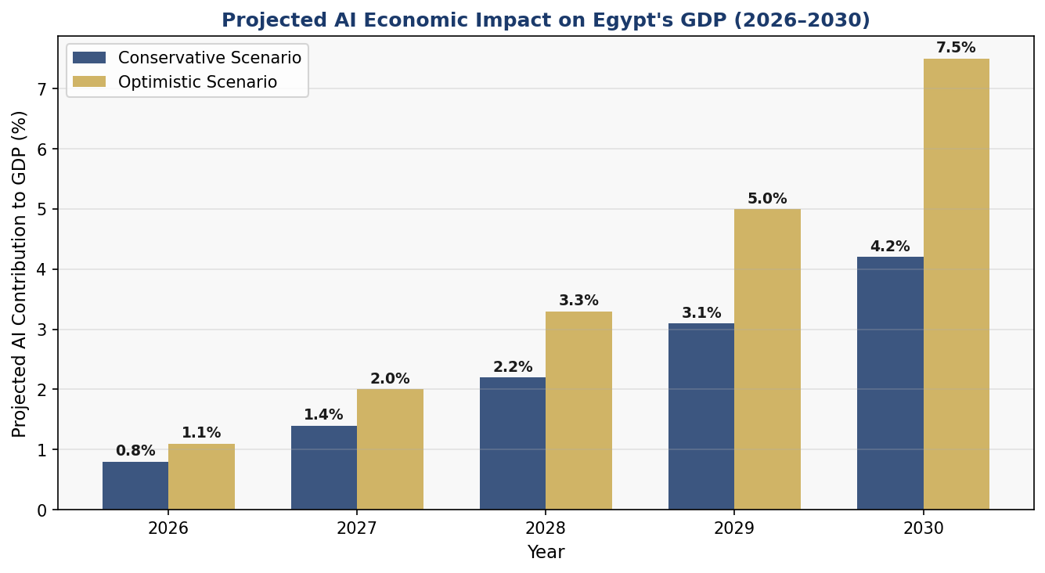
Figure 3: Projected AI Contribution to Egypt GDP (%) — Conservative vs. Optimistic Scenarios (2026–2030)

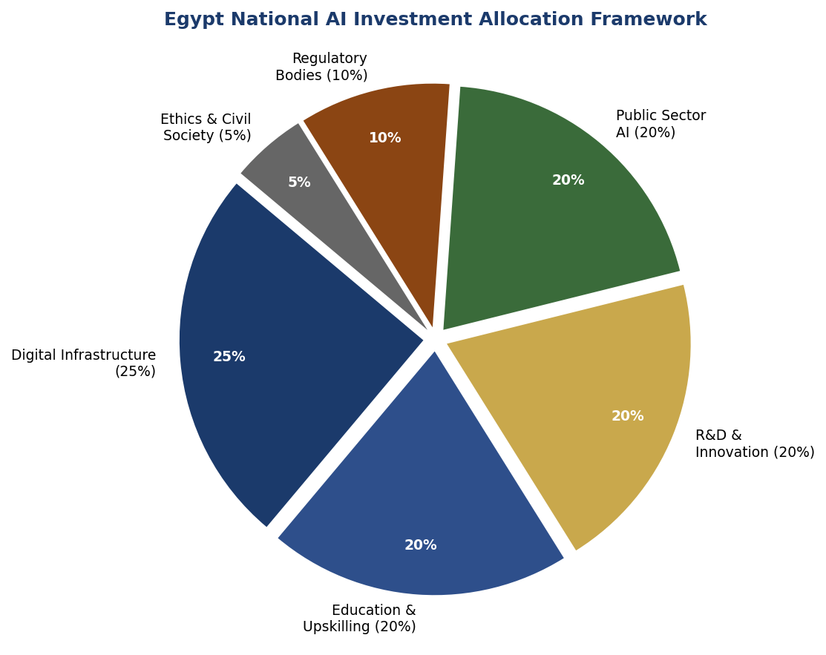
Figure 4: Recommended National AI Investment Allocation (5-Year Budget Framework)

4.2 Investment Requirements and Allocation
Egypt's five-year National AI Investment Programme (NAIP Fund) requires a total commitment of EGP 85–100 billion, sourced from the national budget (40%), multilateral development banks including the African Development Bank and World Bank IFC (35%), and public-private partnerships with domestic and international technology companies (25%). The recommended allocation — Digital Infrastructure (25%), Education and Upskilling (20%), R&D and Innovation (20%), Public Sector AI (20%), Regulatory Bodies (10%), and Ethics and Civil Society (5%) — balances short-term deployment capacity with long-term sovereign capability.

4.3 Priority Sectors for AI Adoption
- Agriculture: AI-powered precision farming, irrigation optimization, satellite crop monitoring for 9.8 million feddan of cultivated land
- Healthcare: AI diagnostics for 5,000 rural health units, NLP-based Arabic clinical documentation, AI drug repurposing for tropical and neglected diseases
- Tourism and Heritage: AI visitor management, predictive maintenance for archaeological sites, multilingual AI guides for 10,000+ historical monuments
- Energy: Smart grid AI for renewable energy integration (50 GW target by 2040), AI-optimized Benban Solar Park management
- Financial Services: AI credit scoring for 40+ million unbanked Egyptians, AML transaction monitoring, InsurTech AI for smallholder crop insurance
- Logistics and Trade: Suez Canal Zone AI optimization, predictive customs clearance, AI freight routing for USD 300+ billion annual canal trade

4.4 Public-Private Partnership Framework
Egypt will establish a National AI Investment Committee (NAIC) under the Prime Minister's Office to oversee PPP negotiations with technology companies seeking access to Egypt's 105 million consumer market. All PPP agreements will require: technology transfer provisions with minimum 30% Egyptian technical employment, open-source component commitments for non-sensitive AI modules, and joint venture requirements for large-scale government AI contracts exceeding EGP 500 million.

Section 5: Education and Human Capital Development

5.1 Current Skills Gap Analysis
Egypt faces a three-layered AI skills deficit. At the foundational level, digital literacy penetration — the ability to use basic digital tools confidently — reaches only approximately 38% of adults, with stark disparities between urban governorates (Cairo: ~65%) and rural Upper Egypt (Assiut: ~18%). At the practitioner level, Egypt produces an estimated 2,500 data scientists and ML engineers annually against a projected demand of 15,000+ by 2028. At the research level, Egypt published approximately 1,200 AI-related academic papers in 2023 — less than Israel's 2,100 and far below the UAE's 3,400, despite Egypt's much larger population and academic infrastructure.
Gender disparity in AI education is a critical constraint: women represent only 28% of STEM graduates and approximately 18% of employed AI professionals. Closing this gap is not merely a matter of equity — it represents the largest single untapped source of AI talent in Egypt's economy.

5.2 National AI Curriculum Framework
K-12 Computational Thinking Integration (Years 1–2)
Integration of computational thinking, data literacy, and AI ethics into the national curriculum from Grade 4 onward. Mandatory coding education from Grade 6 using Arabic-language programming environments. AI elective coursework for secondary students in partnership with MCIT's CodeEgypt initiative, targeting 2 million students annually by Year 2.
Tertiary AI Degree Programmes (Years 1–3)
Establishment of accredited Bachelor's and Master's programmes in AI and Data Science at fifteen universities by Year 3. Mandatory AI literacy modules in all tertiary disciplines — law, medicine, economics, education — recognizing that AI competence is a universal professional requirement. Partnership with international universities for joint degree programmes, prioritizing Francophone partnerships (France, Belgium, Morocco) and Anglophone programmes (UK, US, Australia).
Vocational and Continuing Education (Years 1–5)
A National AI Micro-certification Framework providing stackable credentials in AI application domains: agricultural AI operator, healthcare AI assistant, financial AI analyst, logistics AI coordinator. Targeted retraining programmes for 500,000 public sector workers displaced or augmented by government AI deployments, delivered through Egypt's Technical Education and Vocational Training Authority (TEVTA).

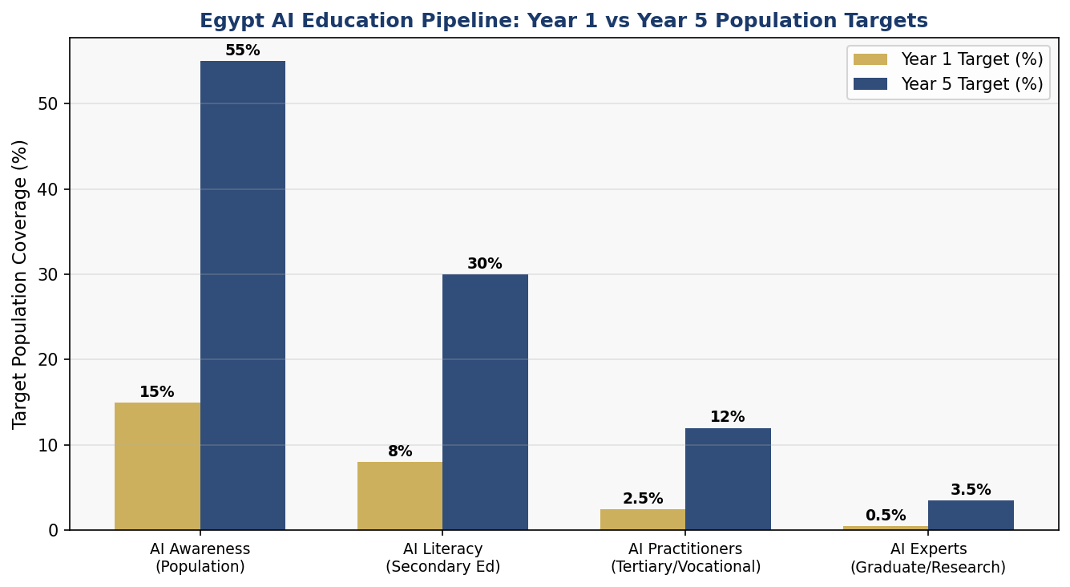
Figure 5: Egypt AI Education Pipeline — Population Coverage Targets, Year 1 vs. Year 5 (%)

5.3 Inclusion Targets
- Women and Girls: Minimum 40% participation quota in all AI scholarship programmes; STEM girls' scholarship fund of EGP 2 billion over 5 years; 50 Girls in AI academies in underserved governorates
- Rural and Upper Egypt: 50% of AI Innovation Hub infrastructure investment allocated to non-Cairo governorates; mobile AI training units for rural areas; rural connectivity prerequisite for all AI education investments
- Persons with Disabilities: Universal design requirements for all government AI applications; AI accessibility lab at each Center of Excellence; Arabic AI assistive technology development fund
- Refugees and Stateless Persons: UNHCR partnership for AI skills training in refugee communities (Egypt hosts approximately 500,000 UNHCR-registered refugees); AI-powered refugee legal aid services

Section 6: Ethical AI Governance and Regulatory Framework

6.1 National AI Ethics Board (NAEB)
The National AI Ethics Board (NAEB) will be established as an independent statutory body under legislation, with a composition designed to prevent regulatory capture: three academic AI researchers (appointed by university councils), two civil society representatives (appointed by NGO federation), two industry representatives (appointed by MCIT), two government representatives (MCIT and Ministry of Justice), and one international expert (appointed by UNESCO Regional Office Cairo). The NAEB will be funded through a dedicated AI Regulatory Levy of 0.5% on revenue of companies deploying AI systems in Egypt, ensuring financial independence from both government and industry.
The NAEB's mandate includes: annual publication of Egypt's AI State Report; investigation of algorithmic harm complaints; review and approval of High-Risk AI deployments; development of sector-specific AI ethics guidelines; and representation of Egypt in international AI governance forums including GPAI and the UN AI Governance Panel.

6.2 AI Risk Classification System
Tier 1 — Unacceptable Risk (Prohibited)
- Social scoring systems that determine citizens' access to public services, employment, or credit based on behavior aggregation
- Real-time mass biometric surveillance in public spaces without judicial authorization
- AI systems that exploit psychological vulnerabilities, addiction mechanisms, or manipulate political behavior
- Autonomous lethal weapons systems operated without meaningful human control
- AI-generated deepfakes used for political manipulation or non-consensual intimate imagery
Tier 2 — High Risk (Mandatory Audit and Registration)
- AI in employment decisions: hiring, promotion, performance evaluation, and termination
- AI in credit and insurance: scoring, eligibility determination, and premium calculation
- AI in criminal justice: predictive policing, sentencing recommendations, and recidivism assessment
- AI in education: student assessment, scholarship allocation, and academic progression decisions
- AI in healthcare: diagnostic tools, treatment recommendations, and triage systems
- AI in critical infrastructure: power grid management, water systems, transportation control
Tier 3 — Limited Risk (Transparency Obligations)
- Chatbots and virtual assistants must disclose AI identity to users
- AI-generated content must be labeled, including synthetic media and automated journalism
- Emotion recognition systems require disclosure and consent
Tier 4 — Minimal Risk (Voluntary Code of Conduct)
AI applications with minimal potential for harm — spam filters, product recommendation engines, basic process automation — are governed by a voluntary Code of Responsible AI Deployment published by the NAEB and updated annually.

6.3 Data Protection and Privacy
Egypt's Personal Data Protection Law (Law No. 151/2020) provides a foundational framework that this policy strengthens through AI-specific regulations. All AI systems processing personal data must undergo Data Protection Impact Assessments (DPIA) prior to deployment. The Personal Data Protection Centre (PDPC) will be empowered with AI-specific enforcement authority, including the right to order algorithmic audits, data deletion, and system suspension.

6.4 Anti-Corruption AI Guidelines
Given Egypt's corruption risk profile, this policy establishes specific anti-corruption requirements for AI in procurement and public administration: all AI procurement decisions must be logged in a public AI Procurement Registry; no single company may hold AI contracts exceeding EGP 5 billion per ministry per year; algorithmic decision systems in tax, customs, and land registration must include mandatory human review override mechanisms; and all AI system source code used in public procurement decisions must be placed in escrow with the Egyptian Competition Authority.

Section 7: Public Sector and e-Governance AI

7.1 Priority Government Use Cases
Ministry / Agency | AI Application | Primary Benefit | Timeline
Ministry of Finance | AI tax compliance analytics & fraud detection | Revenue increase, corruption reduction | Year 1–2
Ministry of Health | Rural clinic AI triage and diagnostics | Healthcare access, cost reduction | Year 1–3
Ministry of Agriculture | Precision farming AI for smallholders | Yield increase, water conservation | Year 2–4
Ministry of Interior | Border management AI (non-surveillance) | Processing efficiency, security | Year 2–3
Ministry of Education | AI personalized learning platform | Learning outcomes, dropout reduction | Year 2–4
Egyptian e-Government | AI citizen service chatbot (Arabic NLP) | Service access, cost reduction | Year 1–2
Customs Authority | AI cargo risk assessment & clearance | Trade facilitation, fraud reduction | Year 1–2
Social Solidarity | AI benefit targeting and fraud detection | Reach improvement, waste reduction | Year 2–3
Table 2: Priority Government AI Use Cases and Implementation Timeline

7.2 AI Procurement Transparency Standard (APTS)
All government AI procurements valued above EGP 10 million must comply with Egypt's AI Procurement Transparency Standard, requiring: public tender with mandatory technical specification disclosure; independent technical evaluation committee including at least two non-government AI experts; algorithmic impact assessment before contract award; post-deployment audit at 6-month intervals; and public disclosure of system performance metrics in plain Arabic.

7.3 Interoperability and Data Standards
Egypt will adopt the W3C Data Catalogue Vocabulary (DCAT) and the International Data Spaces (IDS) architecture as national AI data sharing standards. All government AI systems must expose standardized APIs enabling cross-agency data sharing under the National Data Exchange Framework (NDEF). Citizen data portability — the right to access and transfer one's own government data — will be enshrined in the AI Rights Charter.

Section 8: Implementation Roadmap

8.1 Five-Year Phased Implementation
Phase 1 — Foundation (Months 1–12, 2026)
- Enact National AI Policy Law establishing NAEB, NARF, and APTS
- Establish NAEB with full composition and operational budget
- Launch National AI Skills Audit (comprehensive baseline assessment)
- Publish Egypt AI Risk Classification Registry (initial 500 systems)
- Launch AI Procurement Transparency Portal (all government AI contracts)
- Announce three AI Innovation Hub locations and begin construction/conversion
- Initiate G20 GPAI membership application and UNESCO AI consultation
- Deploy three government AI pilots: tax analytics, rural health triage, customs AI
Phase 2 — Scaling (Months 13–36, 2027–2028)
- National AI Curriculum reform: integrate AI literacy in all Grade 4–12 classrooms
- Launch 5 AI Centers of Excellence at target universities with research mandates
- Open first National AI Innovation Hub (Cairo) and begin second (Alexandria)
- Scale government AI to 15 use cases across 8 ministries
- Deploy Arabic NLP national service chatbot with 10+ ministry integrations
- Establish National AI Observatory with annual reporting framework
- Bilateral AI cooperation agreements: UAE, Saudi Arabia, France, South Korea
- Launch National AI Startup Fund — first cohort of 100 startups funded
Phase 3 — Optimization (Months 37–60, 2029–2031)
- Comprehensive policy review against KPI dashboard (Year 3 milestones)
- Open third AI Innovation Hub (Assiut) with Upper Egypt focus
- Scale AI education: 55% population AI awareness; 12% practitioner coverage
- Achieve OECD AI Principles compliance certification
- Launch AI export initiative: position Egyptian AI products for African market
- Enact second-generation AI law incorporating foundation model governance
- Host inaugural Cairo AI Governance Summit (global convening)

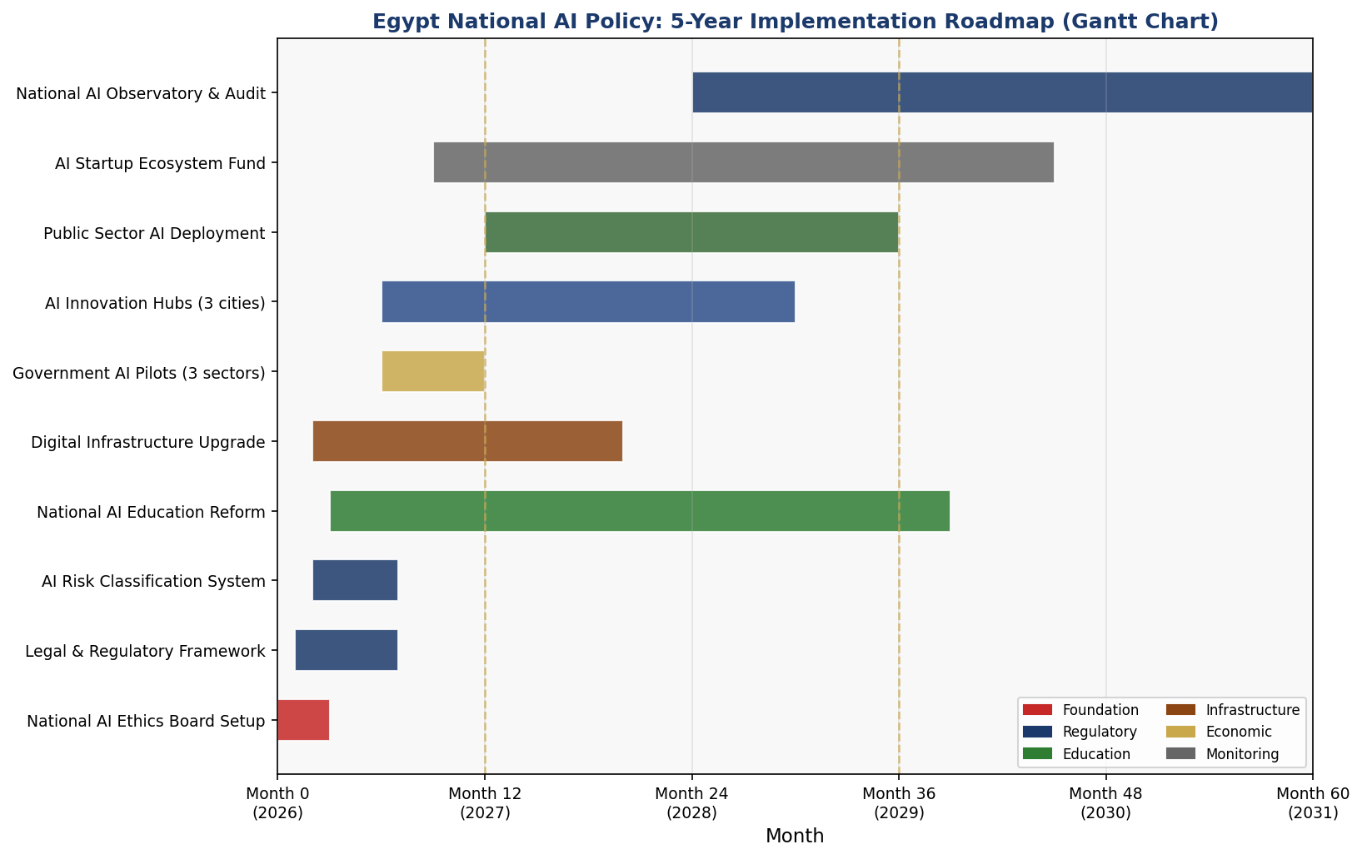
Figure 6: Egypt National AI Policy — 5-Year Implementation Gantt Chart (2026–2031)

Section 9: Monitoring, Evaluation, and Accountability

9.1 National AI Observatory
Egypt's National AI Observatory (NAIO) will be established within the first year as Egypt's authoritative source of AI deployment data, impact measurement, and accountability reporting. The Observatory will publish an Annual AI State of Egypt Report, available in both Arabic and English, covering government AI deployments, private sector adoption rates, algorithmic harm incidents, skills pipeline progress, and international framework compliance. The Observatory's governing board will include parliamentary representatives, civil society organizations, and international observers from UNESCO and the ITU.

9.2 Parliamentary Oversight Mechanism
A standing Parliamentary Committee on Artificial Intelligence and Digital Governance will be established to provide legislative oversight of AI policy implementation. The Committee will convene quarterly hearings with the NAEB, MCIT, and relevant ministers; hold annual public hearings on the AI State Report; and have authority to commission independent technical audits of any government AI system. Committee proceedings will be publicly broadcast in Arabic.

9.3 KPI Dashboard
KPI Indicator | 2026 Baseline | Year 1 Target | Year 3 Target | Year 5 Target
Oxford AI Readiness Index Score | 51.4 / 100 | 54 / 100 | 60 / 100 | 67 / 100
AI contribution to GDP (%) | ~0.5% | 0.8% | 2.2% | 4.2%
AI-skilled workforce (thousands) | ~8,000 | 12,000 | 28,000 | 55,000
Women in AI workforce (%) | 18% | 22% | 32% | 40%
Gov AI deployments (use cases) | ~5 | 15 | 40 | 80
AI Innovation Hubs operational | 0 | 1 | 3 | 3+
AI startups funded (cumulative) | 0 | 100 | 400 | 900
NAEB complaints resolved (%) | N/A | 70% | 85% | 92%
AI transparency reports published | 0 | 1 | 3 | 5
Population AI literacy (%) | ~8% | 15% | 35% | 55%
TI CPI Score (Egypt) | 35 | 37 | 42 | 46
AI patents filed (annual) | ~50 | 150 | 500 | 1200
Table 3: Egypt National AI Policy KPI Dashboard (2026–2031)

Section 10: International Cooperation and Diplomacy

10.1 Bilateral AI Cooperation Priorities
Egypt's strategic position — bridging Africa, the Arab world, and the Mediterranean — gives it exceptional leverage for bilateral AI diplomacy. Priority partnerships are structured across three tiers: (1) Technology Transfer Partners: France (historical Francophone ties, EU AI Act expertise), South Korea (AI national strategy leadership, Samsung Research Cairo presence), and China (Belt and Road digital investment, Arabic NLP co-development); (2) Capacity Building Partners: UAE (Gulf AI ecosystem access, Mohammed Bin Zayed University AI linkage), Germany (industrial AI, engineering talent exchange), and Canada (AI safety research, MILA/Vector Institute partnership); (3) Market Access Partners: Nigeria, Kenya, Ethiopia, and South Africa (African AI product export markets, South-South cooperation).

10.2 Regional AI Governance
Egypt will champion AI governance within the Arab League, COMESA, and the African Union. Egypt co-chairs the Arab League Digital Transformation Committee and will propose a binding Arab AI Ethics Charter, modeled on the EU AI Act's risk classification approach but adapted for Arab governance contexts. Within the African Union, Egypt will leverage its role in the AU Digital Transformation Strategy 2020–2030 to advocate for a continent-wide AI regulatory harmonization framework, reducing fragmentation and enabling data flows that benefit all 55 AU member states.

10.3 South-South Knowledge Transfer
Egypt's AI policy experience — particularly in deploying AI under high corruption-risk, low-income conditions — offers directly transferable lessons for Global South partners. Egypt will establish a South-South AI Cooperation Fund of USD 50 million over five years, co-funded by Egyptian development finance institutions and international partners, to support AI policy development, digital infrastructure, and AI talent training in African and Arab LDCs. Priority recipients include Sudan, Somalia, Djibouti, Mauritania, and Comoros.

10.4 Global AI Governance Participation
Egypt will actively pursue membership in the Global Partnership on AI (GPAI) and contribute substantively to the UN AI Governance Panel (successor to the UN Secretary-General's AI Advisory Body). Egypt will propose a Global South AI Governance Coalition — encompassing Egypt, South Africa, Nigeria, India, Brazil, Bangladesh, and Indonesia — to ensure emerging economy perspectives are centered in global AI standard-setting. Egypt will host the inaugural Cairo AI Governance Summit in 2029, convening governments, civil society, and researchers from 80+ nations.

Conclusion

Egypt's National Artificial Intelligence Policy 2026–2031 represents more than a technology strategy — it is a social contract for the digital age. It is a commitment to 105 million Egyptians that the transformative power of artificial intelligence will be wielded in service of their rights, their livelihoods, and their dignity. It is a declaration that Egypt, with its 7,000-year civilizational history, its unparalleled geographic centrality, and its dynamic youth population, is ready to claim its place in the AI century not as a passive recipient of foreign technology, but as an active architect of AI governance for the Global South.
The challenges are real and acknowledged: Egypt's corruption risk profile demands institutional safeguards of unusual stringency; the skills gap demands investment at a scale that will stretch public finance; the surveillance risk demands governance architecture with genuine independence from executive pressure. This policy does not minimize these challenges — it is designed specifically to address them.
The opportunity is equally real. Egypt's demographic profile, its agricultural and tourism AI potential, its regional connectivity, and its growing digital infrastructure provide a foundation that many middle-income economies would envy. With political will, international support, and genuine partnership with civil society, Egypt can achieve the ambitious but achievable targets set forth in this policy — and in doing so, demonstrate to the world that ethical, inclusive AI development is possible in a developing country context.
Implementation begins now. The first year is decisive. The institutions must be built, the frameworks enacted, and the investments committed before momentum dissipates. Egypt has the talent, the ambition, and — with this policy — the roadmap. The rest is leadership.

References and Bibliography

- UNESCO. (2021). Recommendation on the Ethics of Artificial Intelligence. United Nations Educational, Scientific and Cultural Organization, Paris.
- OECD. (2024). OECD AI Principles (Updated). Organisation for Economic Co-operation and Development, Paris.
- European Parliament and Council. (2024). Regulation (EU) 2024/1689 on Artificial Intelligence (EU AI Act). Official Journal of the European Union.
- World Bank Group. (2023). Egypt — AI Readiness and Digital Economy Assessment. World Bank, Washington D.C.
- McKinsey Global Institute. (2022). The economic potential of generative AI: The next productivity frontier. McKinsey & Company.
- Oxford Insights. (2023). Government AI Readiness Index 2023. Oxford Insights, Oxford, UK.
- Transparency International. (2023). Corruption Perceptions Index 2023. Transparency International, Berlin.
- World Economic Forum. (2023). The Future of Jobs Report 2023. WEF, Geneva.
- ITU. (2023). AI for Good — Global Summit 2023 Outcome Document. International Telecommunication Union, Geneva.
- African Union. (2020). Digital Transformation Strategy for Africa 2020–2030. African Union Commission, Addis Ababa.
- Ministry of Communications and Information Technology (MCIT), Egypt. (2021). Egypt Digital Economy Strategy 2021–2025. MCIT, Cairo.
- Global Partnership on AI (GPAI). (2023). Responsible AI Deployment: Guidance for Governments. GPAI, Paris.
- Egyptian Personal Data Protection Law, Law No. 151 of 2020, Official Gazette, Egypt.
- World Bank. (2022). Worldwide Governance Indicators 2022 — Egypt Country Profile. World Bank, Washington D.C.
- United Nations Development Programme (UNDP). (2023). Human Development Report 2023/24. UNDP, New York.
- IMF. (2024). Regional Economic Outlook: Middle East and Central Asia. International Monetary Fund, Washington D.C.

About the Author

Nafiul Ahmad Rafi
Policy & Good Governance Researcher | BD Civic Tech Architect
Nafiul Ahmad Rafi is a civic technologist, policy researcher, author, photographer, and musician based in Dhaka, Bangladesh. He is the Founder and Director of Insights Bangladesh, a data-driven governance and policy impact analysis institution, and the Founder & Lead Architect of NagorikBD.org — a transparency-first civic platform scaled across Mymensingh Division, connecting citizens with government services across 45 Upazilas.
His work exists at the intersection of institutional reform and artificial intelligence, transforming theoretical governance into scalable, data-driven reality. Without a conventional computer science degree, he self-taught the tools of modern AI and web development to build the infrastructure that enforces the policies he once only researched.
Key Platforms and Projects
- NagorikBD.org — Civic transparency platform, Mymensingh Division
- Insights Bangladesh — Policy impact analysis institution
- FactCheck BD (factcheckbd.org) — Bangladesh's AI-powered fact-checking platform
- Political Insights BD / PIBD (pibbd.org) — Political intelligence and civic tech hub
- PeaceShield BD / National Peace Tracker — AI-powered hate speech and conflict monitoring
- PolicyLens AI (aigovbd.org) — 9-dimensional AI policy audit tool

He has published four books and maintains a personal site at ahmad-rafi.com.

Research Interests
AI Governance · Policy Research · Future of Bangladesh · Climate Policy

Contact
- Website: ahmad-rafi.com
- LinkedIn: linkedin.com/in/nafiul-ahmad-rafi
- Email: contact@ahmad-rafi.com

"I build code to ensure transparency, and I write lyrics to inspire the courage to use it."

