🇰🇼

STATE OF KUWAIT
National Artificial Intelligence Policy 2026–2031

A Comprehensive Framework for Ethical, Inclusive,
and Economically Transformative Artificial Intelligence

Prepared by:
Nafiul Ahmad Rafi | Insights Bangladesh
Policy & Good Governance Research Institution

May 2026 | Dhaka, Bangladesh

Table of Contents

Executive Summary
Kuwait stands at a decisive inflection point. As the global economy undergoes rapid transformation driven by artificial intelligence, the State of Kuwait — endowed with significant sovereign wealth, a young and educated population, and an ambitious Vision 2035 diversification agenda — has both the opportunity and the responsibility to position itself as a regional AI leader. This National Artificial Intelligence Policy 2026–2031 provides the legislative, institutional, and strategic architecture to enable that transition.
Kuwait's current macroeconomic profile presents a compelling case for urgency. Despite a GDP per capita of approximately USD 33,500 and near-universal internet penetration of 99%, Kuwait remains heavily dependent on hydrocarbon revenues, which account for over 85% of government income. Artificial intelligence offers a transformative pathway to diversify the economy, enhance public service delivery, develop a knowledge-based workforce, and attract foreign investment — all core goals of the New Kuwait Vision 2035. This policy estimates that AI could contribute up to 6.8% of Kuwait's GDP (approximately USD 11.3 billion) by 2030, with significant multiplier effects across financial services, healthcare, logistics, smart infrastructure, and tourism.
This policy is organized around five strategic pillars: (1) Ethical AI and Human Rights Protection; (2) Economic Growth and Industrial AI Adoption; (3) Education, Upskilling, and AI Workforce Development; (4) Public Sector AI and e-Governance; and (5) AI Research, Innovation, and Startup Ecosystem. Each pillar is backed by a detailed implementation roadmap, institutional mandate, funding allocation, and measurable KPIs reviewed annually by the proposed National AI Observatory and Parliament.
Internationally, this policy aligns comprehensively with the UNESCO AI Ethics Recommendation (2021), OECD AI Principles (2019, updated 2024), the EU AI Act (2024), World Bank AI Strategy, G20 AI Principles, and ITU AI for Good Guidelines. This multi-framework alignment ensures Kuwait's AI governance meets global standards while remaining contextually appropriate for Gulf Cooperation Council dynamics. The policy mandates a National AI Ethics Board, risk-based regulation modeled on EU AI Act categories, and mandatory algorithmic accountability standards — setting a governance benchmark for the GCC region.

Section 1: National AI Readiness Assessment

1.1 Economic Context
Kuwait is a high-income, oil-dependent economy with a nominal GDP of approximately USD 165 billion (2024) and a GDP per capita of USD 33,500. The government's Vision 2035 plan — 'New Kuwait' — envisions transforming the country into a regional financial and commercial hub. The digital economy currently contributes an estimated 4–6% of GDP, with growth concentrated in financial technology, e-commerce, and government digitization. However, the reliance on oil creates structural vulnerabilities that AI-led economic transformation can directly address through productivity enhancement across non-oil sectors.
Key economic sectors poised for AI disruption include: financial services and banking; healthcare and medical diagnostics; logistics and port management (Shuwaikh and Mina Al-Ahmadi ports); construction and smart city infrastructure; and retail and e-commerce. The Kuwait Fund for Arab Economic Development (KFAED) and Kuwait Investment Authority (KIA) — which manages the world's fifth-largest sovereign wealth fund — represent potential anchor investors in domestic AI ventures.

1.2 Education & Human Capital
Kuwait maintains a literacy rate of 96.3% and high tertiary enrollment at approximately 62% of eligible youth. Kuwait University, Gulf University for Science and Technology (GUST), Australian College of Kuwait, and the American University of Kuwait offer relevant STEM programs. However, AI-specific graduate programs remain nascent, and the talent pipeline for machine learning engineers, data scientists, and AI ethicists is inadequate relative to policy ambitions. An estimated 70% of the private sector workforce in Kuwait is composed of expatriates, highlighting the critical need to rapidly upskill Kuwaiti nationals — a core Kuwaitization goal that AI education directly supports.

1.3 Digital Infrastructure
Kuwait boasts robust digital infrastructure: 99% internet penetration, 5G rollout completed in major urban areas, and mobile penetration exceeding 160%. The country's fiber optic backbone and data center capacity are sufficient for initial AI workloads, though sovereign cloud infrastructure and AI-specific compute clusters (GPU farms) will require targeted investment. The National Center for Information Technology (NCIT) and the Communications and Information Technology Regulatory Authority (CITRA) provide institutional anchors for infrastructure governance.

1.4 Governance & Institutional Capacity
Kuwait operates as a constitutional emirate with an elected National Assembly, one of the most active parliaments in the Arab world. The country scores moderately on the World Bank's Governance Indicators, with Regulatory Quality and Rule of Law presenting opportunities for improvement. Institutional capacity for technology regulation is developing: CITRA governs digital communications, and Kuwait's Cybersecurity Center provides nascent information security infrastructure. A dedicated National AI Authority — proposed in Section 6 — would fill the critical gap in AI-specific regulatory capacity.

1.5 Corruption Risk Assessment
Kuwait scores 47 out of 100 on the 2024 Transparency International Corruption Perceptions Index (CPI), ranking 75th globally — above the regional median but below the GCC leaders (UAE at 68, Qatar at 58). This score positions Kuwait in a 'moderate-high' AI governance risk tier, meaning that without proactive anti-corruption safeguards, AI systems procured or deployed in public sector contexts carry elevated risks of biased procurement, opaque algorithmic decision-making, and data governance irregularities. This policy mandates anti-corruption AI audits, open procurement standards, and civil society oversight mechanisms to mitigate these risks.
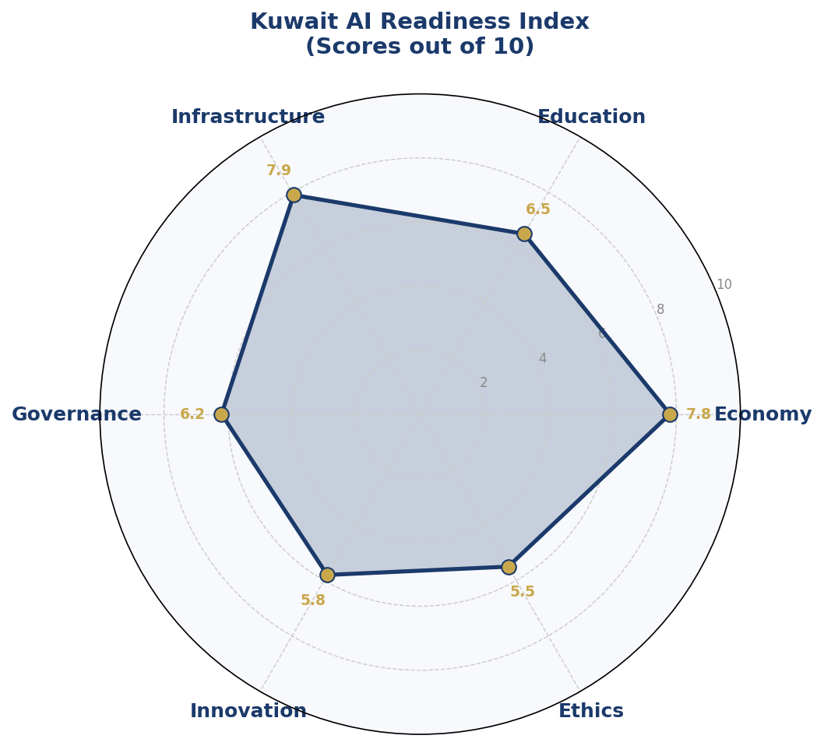
Figure 1.1 — Kuwait AI Readiness Index: Six-Dimensional Assessment (Scores out of 10)
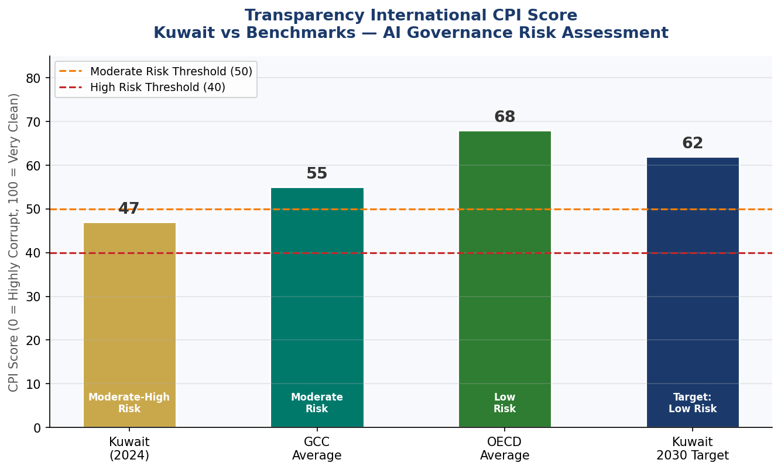
Figure 1.2 — CPI Scores: Kuwait vs GCC Average, OECD Average, and 2030 Target

Section 2: Policy Vision & Strategic Pillars

2.1 National AI Vision Statement
"By 2031, Kuwait will be the Gulf region's most trusted, inclusive, and ethically governed AI economy — where artificial intelligence amplifies human potential, diversifies national wealth, and upholds the values of justice, transparency, and dignity for every citizen and resident."

2.2 Strategic Pillar 1: Ethical AI & Human Rights Protection
Kuwait's AI development must be anchored in its constitutional commitments to human dignity, equal rights, and the rule of law. This pillar establishes a National AI Ethics Board with enforcement powers, mandatory algorithmic impact assessments for all high-stakes AI systems, and a citizen rights framework covering AI-driven decisions in employment, credit, healthcare, and law enforcement. Special protections will be enacted for migrant workers — a population particularly vulnerable to algorithmic bias — given Kuwait's large expatriate workforce (approximately 70% of residents).

2.3 Strategic Pillar 2: Economic Growth & Industrial AI Adoption
This pillar operationalizes AI as Kuwait's second economic engine alongside hydrocarbons. It encompasses an AI Industrial Adoption Fund (KD 200 million over five years), sector-specific AI adoption roadmaps for finance, healthcare, ports/logistics, and retail, and a Foreign Direct Investment (FDI) attraction strategy targeting global AI companies. Tax incentives, regulatory sandboxes, and fast-track licensing will reduce barriers to AI entrepreneurship. The Kuwait Investment Authority will allocate a proportion of its portfolio to domestic AI ventures as a sovereign co-investor.

2.4 Strategic Pillar 3: Education, Upskilling & AI Workforce Development
Kuwait's national AI ambition cannot be realized without a domestic workforce capable of building, deploying, and governing AI systems. This pillar mandates AI literacy integration in the K-12 curriculum by Year 2, establishment of an AI Centre of Excellence at Kuwait University, and a National AI Scholarship Program offering 500 fully-funded postgraduate scholarships annually for Kuwaiti nationals in AI-related disciplines at global partner universities. Vocational retraining programs will target workers in sectors at highest displacement risk.

2.5 Strategic Pillar 4: Public Sector AI & e-Governance
Government ministries, municipalities, and statutory bodies will adopt AI through a centrally coordinated Public Sector AI Program. Priority use cases include: smart traffic management across Kuwait City; AI-assisted patient triage and diagnostics at public hospitals; predictive maintenance for the Ministry of Electricity and Water's infrastructure; and natural language processing chatbots for citizen service centers. All government AI deployments will undergo mandatory pre-deployment ethical review and post-deployment performance auditing.

2.6 Strategic Pillar 5: AI Research, Innovation & Startup Ecosystem
Kuwait will establish itself as a regional AI research hub through investment in three National AI Innovation Clusters — Kuwait City (Fintech AI), Sabah Al-Ahmad City (Health AI), and Shuwaikh (Industrial AI). A Kuwait AI Startup Accelerator, modeled on successful GCC accelerators, will provide seed funding, mentorship, and market access to early-stage AI companies. International research partnerships with institutions such as MIT, Oxford, ETH Zurich, and KAUST will anchor Kuwait's global research credibility.

Section 3: International Framework Alignment

3.1 UNESCO AI Ethics Recommendation (2021)
The UNESCO Recommendation on the Ethics of AI — the first global normative instrument on AI ethics — identifies 11 core values: proportionality and do no harm; safety and security; fairness and non-discrimination; sustainability; right to privacy and data protection; human oversight and determination; transparency and explainability; responsibility and accountability; awareness and literacy; multistakeholder and adaptive governance; and international solidarity. This Kuwait AI Policy maps comprehensively to all 11 values. The National AI Ethics Board will serve as Kuwait's primary enforcement mechanism for UNESCO alignment, with annual compliance reporting submitted to UNESCO's COMEST.

3.2 OECD AI Principles (2019, Updated 2024)
Kuwait, while not an OECD member, adopts the OECD AI Principles as the operational framework for its AI governance architecture. The five OECD principles — inclusive growth and sustainable development; human-centered values and fairness; transparency and explainability; robustness, security and safety; and accountability — are each operationalized through specific policy mechanisms. Kuwait's application for OECD Observer status is recommended as a diplomatic objective under Section 10.

3.3 EU AI Act (2024) — Risk-Based Application
The EU AI Act's risk-based regulatory architecture — Unacceptable, High, Limited, and Minimal Risk — is adopted as Kuwait's primary AI risk classification system. Applications classified as Unacceptable Risk (including social scoring systems, real-time mass biometric surveillance in public spaces without judicial authorization, and AI systems that manipulate human behavior subliminally) are explicitly prohibited. High-Risk applications (including AI in hiring, credit scoring, medical diagnostics, and law enforcement) require mandatory conformity assessments, human oversight, and registration in the Kuwait AI Systems Register.

3.4 World Bank AI Strategy
Kuwait's policy aligns with the World Bank's twin goals of ending extreme poverty and promoting shared prosperity through AI's capacity to improve public service delivery, enhance tax collection efficiency, and reduce infrastructure costs. The World Bank's emphasis on data governance, digital ID systems, and open government data informs Kuwait's e-governance AI roadmap in Section 7.

3.5 G20 AI Principles & ITU AI for Good
The G20 AI Principles — which Kuwait supports through its GCC engagement with G20 — emphasize responsible stewardship of trustworthy AI. The ITU AI for Good Framework links Kuwait's AI development to the Sustainable Development Goals, particularly SDG 3 (Good Health), SDG 4 (Quality Education), SDG 8 (Decent Work), SDG 9 (Innovation Infrastructure), SDG 16 (Strong Institutions), and SDG 17 (Partnerships). Kuwait's AI National Observatory will publish annual SDG-AI linkage reports.

Table 3.1: Comprehensive International Framework Alignment Matrix

Framework / Principle | Section 2  Pillars | Section 6  Ethics | Section 4  Economy | Section 5  Education | Section 8  Roadmap
UNESCO – Proportionality & Safety | ✅ | ✅ | ⚠️ | ✅ | ✅
UNESCO – Human Dignity & Autonomy | ✅ | ✅ | 🔲 | 🔲 | 🔲
UNESCO – Data Governance | ✅ | ✅ | 🔲 | 🔲 | ✅
UNESCO – Environmental Sustainability | ✅ | ⚠️ | 🔲 | ✅ | ✅
OECD – Inclusive Growth | ✅ | ✅ | ✅ | ✅ | ✅
OECD – Human-centred Values | ✅ | ✅ | ✅ | 🔲 | ✅
OECD – Transparency & Explainability | ⚠️ | ✅ | ⚠️ | 🔲 | ✅
EU AI Act – Risk Classification | 🔲 | ✅ | ⚠️ | 🔲 | ✅
World Bank – Digital Development | ✅ | ✅ | ✅ | ✅ | ✅
G20 – Responsible AI | ✅ | ✅ | ✅ | ✅ | ✅
ITU – AI for Good / SDG Alignment | ✅ | ⚠️ | ✅ | ✅ | ✅
Legend: ✅ Full Alignment | ⚠️ Partial / In Progress | 🔲 Planned (Year 2–3)

Section 4: Economic Impact & Investment Roadmap

4.1 Projected Economic Contribution of AI
According to McKinsey Global Institute estimates for high-income Gulf economies, AI could add between 5–9% of GDP in net economic value by 2030 in countries that invest decisively in AI infrastructure, education, and adoption. For Kuwait — with a 2026 GDP of approximately USD 165 billion — this translates to a conservative projection of USD 1.2 billion in Year 1 rising to USD 11.3 billion (6.8% of GDP) by Year 5. These projections assume sustained policy implementation, public-private investment of KD 500 million over five years, and a 15% annual increase in AI talent capacity.
The economic impact will be distributed across six priority sectors: Financial Services (highest near-term impact through credit scoring, fraud detection, and algorithmic trading); Healthcare (diagnostic AI, drug discovery, hospital management); Oil & Gas (predictive maintenance, reservoir simulation, supply chain optimization — extending rather than replacing this sector); Logistics & Ports (automated cargo handling, predictive shipping analytics); Construction & Smart Cities (BIM AI, traffic optimization, utilities management); and Government Services (efficiency gains estimated at 20–30% in processing times).
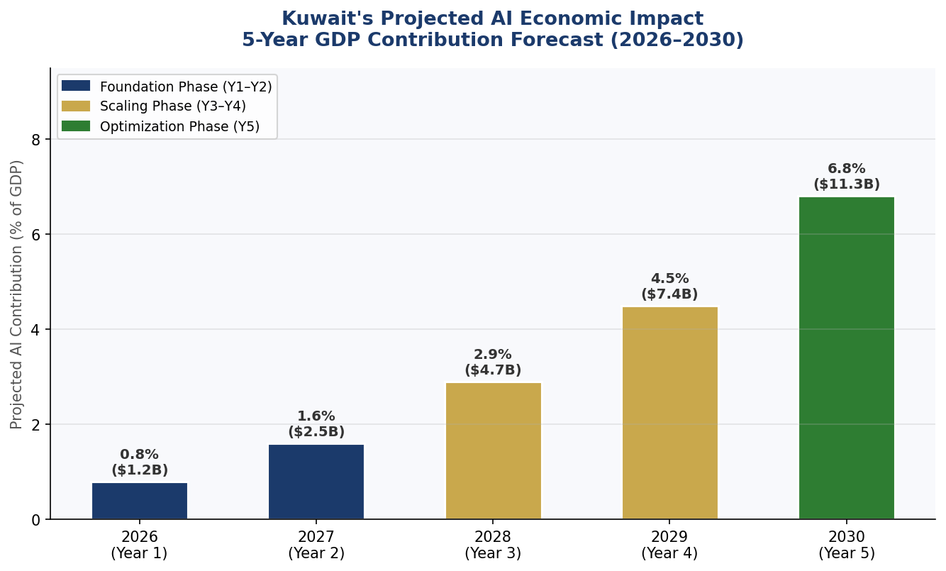
Figure 4.1 — Kuwait Projected AI Economic Impact: Year-by-Year GDP Contribution Estimates (2026–2030)

4.2 Recommended Investment Allocation
The National AI Investment Framework recommends a five-year public commitment of KD 500 million (approximately USD 1.65 billion), deployed across six categories: Digital Infrastructure and Connectivity (25%); Education and Upskilling (20%); Research and Development (20%); Public Sector AI Adoption (20%); Regulatory Bodies and Compliance Infrastructure (10%); and Ethics, Civil Society, and Independent Oversight (5%). Private sector co-investment through regulatory incentives is projected to add an additional KD 300–400 million over the same period.
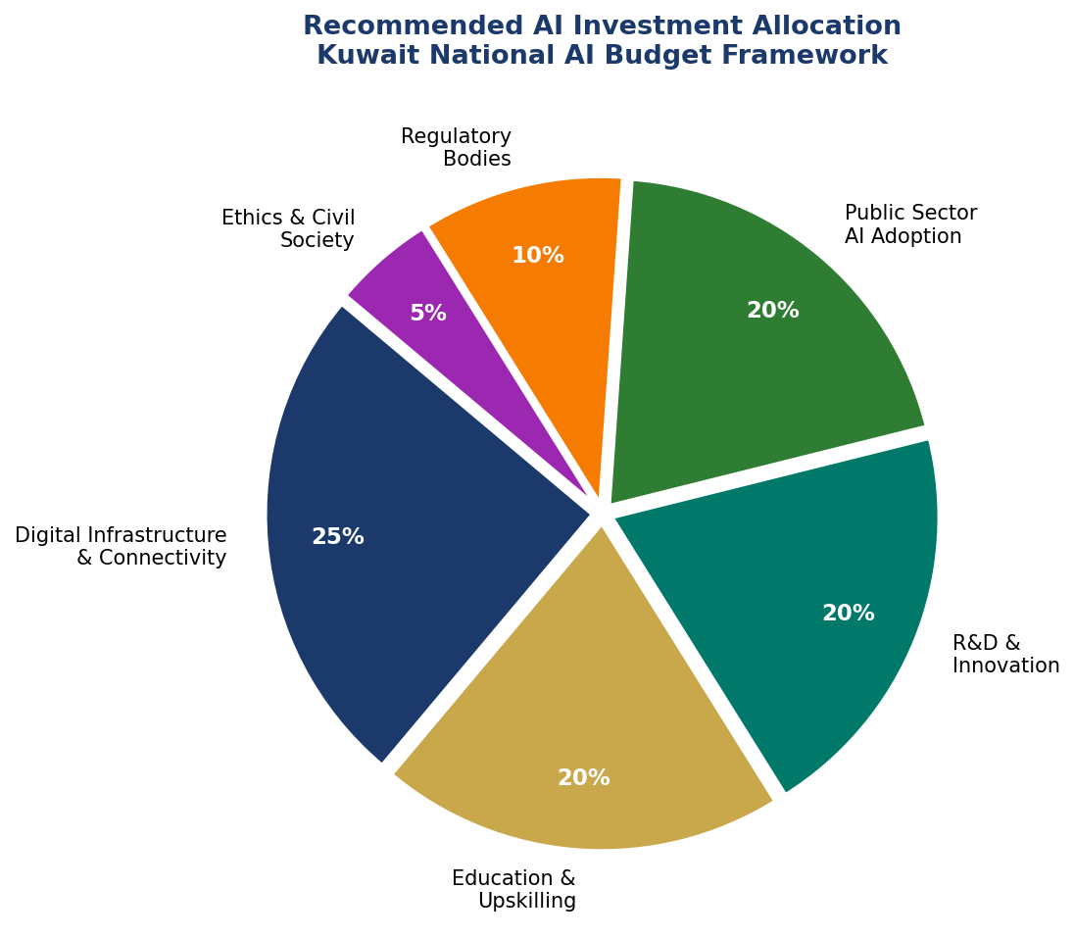
Figure 4.2 — Kuwait National AI Investment Allocation Framework (% of KD 500M, 2026–2031)

4.3 Public-Private Partnership Framework
Kuwait will establish a Kuwait AI Investment Partnership (KAIP) — a formal mechanism enabling private sector co-investment in national AI infrastructure, matched by government incentives including tax credits, preferential land allocation in innovation zones, and procurement priority for Kuwaiti-built AI products. International technology firms establishing AI R&D centers in Kuwait will be eligible for a 10-year corporate tax holiday and expedited licensing under the Kuwait Direct Investment Promotion Authority (KDIPA).

Section 5: Education & Human Capital Development

5.1 Current Skills Gap Analysis
Kuwait's AI talent gap is substantial. The country currently produces approximately 120 AI-qualified graduates annually, against an estimated demand of 5,000+ by 2028 across public and private sectors. Computer science enrollment at Kuwaiti universities has grown 40% since 2020, but AI-specific specializations remain rare. The private sector's reliance on expatriate tech talent — particularly from South and Southeast Asia — creates both dependency risk and an opportunity: targeted upskilling of resident non-Kuwaiti workers can accelerate overall AI capacity while the Kuwaiti national pipeline matures.

5.2 National AI Curriculum Framework
AI literacy will be integrated into Kuwait's national school curriculum by 2027 through a phased approach: Grades 1–6 will receive computational thinking and digital literacy modules; Grades 7–9 will include introductory data science and algorithmic reasoning; Grades 10–12 will offer optional AI specialization tracks. Universities will be mandated to include AI ethics as a compulsory credit in all bachelor's degree programs. The Kuwait Institute for Scientific Research (KISR) will develop the national AI curriculum in partnership with MIT OpenCourseWare and UNESCO's IESALC.

5.3 Women and Underrepresented Groups
Kuwait currently has 18% women in its AI and technology workforce — below the GCC average of 22% and well below the target of 45% by 2031. The Kuwait Women in AI Initiative will provide dedicated scholarships, mentorship networks, and workplace anti-discrimination protections. Particular attention will be paid to including Bedoon (stateless residents) and expatriate communities in vocational AI training programs, ensuring the benefits of AI-driven economic growth are broadly shared.
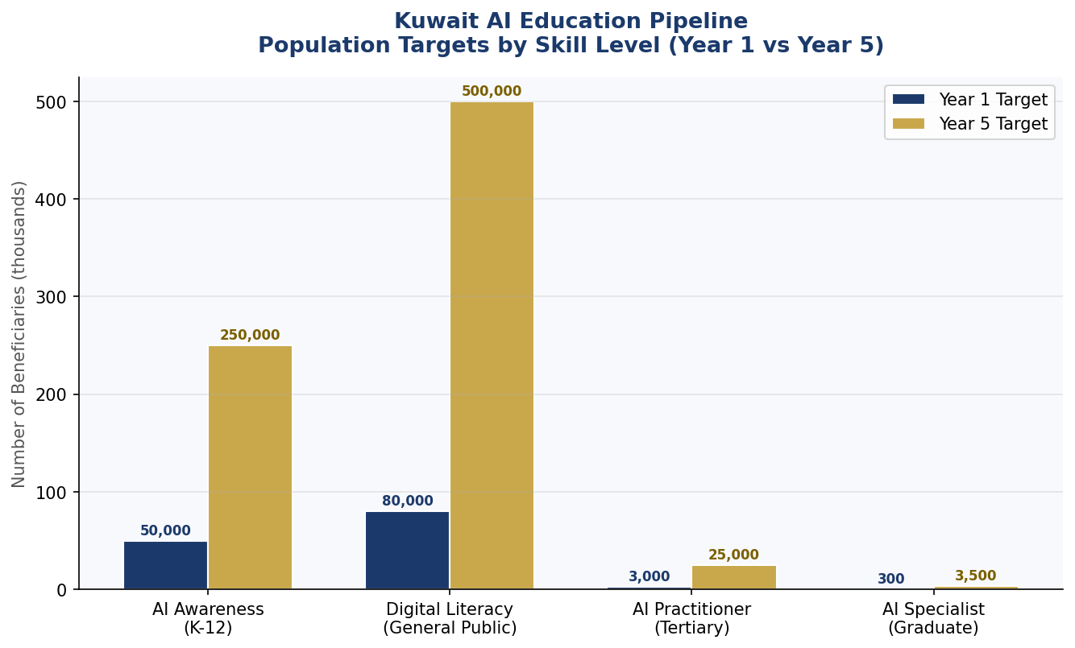
Figure 5.1 — Kuwait AI Education Pipeline: Beneficiary Targets by Skill Level (Year 1 vs Year 5)

5.4 International Scholarship & Exchange
The Kuwait National AI Scholarship Program will fund 500 postgraduate scholarships annually at partner universities including MIT, Oxford, Carnegie Mellon (Qatar Campus), and King Abdullah University of Science and Technology (KAUST). Return-of-service requirements will bind scholarship recipients to contribute a minimum of five years to Kuwait's public or private AI sector. Exchange programs with Estonia (e-governance excellence), Singapore (Smart Nation experience), and the UAE (GCC AI leadership) will supplement formal education with practical, internationally-benchmarked exposure.

Section 6: Ethical AI Governance & Regulatory Framework

6.1 National AI Ethics Board
A National AI Ethics Board (NAEB) will be established by Royal Decree within Year 1 of this policy. The NAEB will comprise 15 members: five senior government representatives (Ministries of Interior, Health, Finance, Education, and the Prime Minister's Office); four independent technical experts; three civil society and human rights representatives; two international AI ethics advisors; and one representative from Kuwait's academic sector. The NAEB will have statutory powers to investigate, audit, issue compliance notices, and recommend legislative remedies for AI-related rights violations.

6.2 AI Risk Classification System
Unacceptable Risk (Prohibited)
- Social credit scoring systems that aggregate citizen behavior for social control purposes
- AI systems that exploit psychological vulnerabilities or subliminal manipulation
- Real-time mass biometric surveillance in public spaces without prior judicial authorization
- AI that enables discrimination based on protected characteristics (race, religion, gender, disability)
- Autonomous lethal weapons systems not subject to meaningful human control
High Risk (Mandatory Audit & Human Oversight)
- AI used in hiring, promotion, or termination decisions
- AI credit scoring and financial exclusion systems
- AI-assisted medical diagnostics, triage, or treatment recommendations
- AI in law enforcement (predictive policing, facial recognition with judicial warrant)
- AI in educational assessment and student performance grading
Limited Risk (Transparency Obligations)
- Chatbots and AI customer service agents (must disclose AI nature)
- AI-generated content in news, social media, or government communications
- AI recommendation systems in e-commerce and social platforms
Minimal Risk (Voluntary Code of Conduct)
- AI in gaming, entertainment, and creative applications
- AI productivity tools in non-sensitive professional contexts
- AI research and academic tools with no direct public impact

6.3 Data Protection & Privacy Act
Kuwait's existing Personal Data Protection Law (Law No. 13 of 2016) will be revised and expanded to incorporate AI-specific data governance requirements: purpose limitation for AI training data; mandatory data protection impact assessments for AI systems processing personal data; right to explanation for automated decisions; and data localization requirements for sensitive government and health data. An independent Data Protection Commissioner with enforcement powers will be established as a subsidiary of the NAEB.

6.4 Anti-Corruption AI Use Guidelines
Given Kuwait's CPI score of 47, this policy mandates specific anti-corruption safeguards for AI in public procurement: all government AI procurement above KD 50,000 must undergo open tender with technical evaluation panels independent of the procuring ministry; AI systems for revenue collection or regulatory enforcement must include immutable audit trails; and the National AI Observatory will publish quarterly reports on AI procurement patterns, flagging statistical anomalies consistent with procurement irregularities.

Section 7: Public Sector & e-Governance AI

7.1 Priority Government Use Cases
The following government AI applications have been prioritized based on feasibility, citizen impact, and alignment with Kuwait Vision 2035 goals:
- Smart Traffic Management: AI-optimized signal timing across Kuwait City's 1,800+ intersections, targeting a 25% reduction in average commute time by Year 3
- Healthcare Triage AI: Natural language processing triage assistant for Public Authority for Health Insurance portal, reducing ER wait times by an estimated 30%
- Tax & Revenue Compliance: AI anomaly detection for Kuwait's General Tax Authority, targeting a 15% increase in compliance rates among businesses
- Border & Port Management: AI-assisted customs screening at Shuwaikh Port and Kuwait International Airport, reducing clearance times by 40%
- Predictive Infrastructure Maintenance: Ministry of Electricity and Water AI maintenance scheduling, targeting a 20% reduction in unplanned outages
- Employment & Social Benefits: Automated eligibility assessment for PACI (Public Authority for Civil Information) citizen services
- Judicial Document Processing: AI-assisted case management for Kuwait's courts, reducing case backlog by an estimated 25%

7.2 Government AI Procurement Guidelines
All government AI procurement will adhere to the Kuwait Government AI Procurement Standard (KGAPS), developed in Year 1. KGAPS will require vendors to: provide algorithmic transparency documentation; demonstrate data provenance and bias testing results; commit to data sovereignty (no transfer of Kuwaiti citizen data outside GCC without Ministerial approval); provide source code escrow for mission-critical systems; and accept post-deployment audit by independent technical reviewers appointed by NAEB.

7.3 Interoperability Standards
Kuwait will adopt the GCC Government Digital Interoperability Framework as the baseline standard for all government AI systems, ensuring interoperability with Saudi Arabia, UAE, and Bahrain government platforms — facilitating cross-border digital services under the GCC Digital Transformation Strategy 2025–2030. The National Information Center (NIC) will serve as the technical custodian of interoperability standards.

Section 8: Implementation Roadmap

8.1 Phase 1 — Foundation (Months 1–12)
The Foundation Phase establishes the legal, institutional, and technical prerequisites for Kuwait's AI transformation. Key deliverables include: enactment of the Kuwait National AI Act by the National Assembly; establishment of the National AI Ethics Board and National AI Authority; launch of the Kuwait Government AI Procurement Standard; completion of a baseline National AI Readiness Assessment; initiation of five government AI pilot programs; and commencement of the National AI Curriculum development process. Phase 1 KPIs: 100% legal framework enacted; NAEB operational with full membership; 5 pilots launched.

8.2 Phase 2 — Scaling (Months 13–36)
The Scaling Phase extends successful pilots to national rollout, deepens education reform, and activates industry AI adoption programs. Key deliverables include: AI curriculum live in 50% of schools; Kuwait AI Startup Accelerator launched with 30 cohort companies; 10 government ministries fully AI-integrated; Kuwait AI Systems Register publicly launched; international AI cooperation agreements signed with 8 partner nations; and the Kuwait Women in AI Initiative reaching 5,000 beneficiaries. Phase 2 KPIs: AI contribution to GDP at 1.6%; 10,000 AI-trained professionals; CPI score target 49+.

8.3 Phase 3 — Optimization (Months 37–60)
The Optimization Phase reviews, refines, and internationalizes Kuwait's AI ecosystem. Key deliverables include: comprehensive policy review by the National AI Observatory; Kuwait AI Export Strategy launched (offering AI governance expertise and platforms to regional partners); fintech and health AI clusters operational at full capacity; Kuwait representation at GPAI Ministerial and UN AI Safety Summit; and first annual Kuwait AI State Report published. Phase 3 KPIs: AI contribution to GDP at 6.8%; 25,000 AI-trained professionals; 500 registered AI startups.
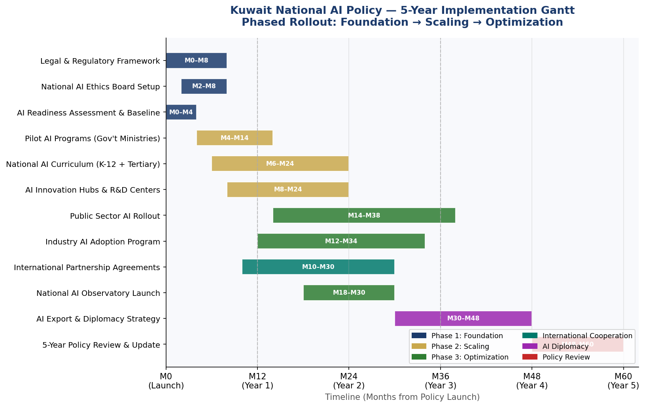
Figure 8.1 — Kuwait National AI Policy: 5-Year Implementation Gantt Chart (Phased Rollout, 60 Months)

Section 9: Monitoring, Evaluation & Accountability

9.1 National AI Observatory
A National AI Observatory (NAO) will be established as an independent statutory body reporting jointly to the National Assembly and the Council of Ministers. The NAO will: publish the Annual Kuwait AI State Report each February; maintain a public AI Systems Register listing all government and licensed commercial AI deployments; conduct quarterly performance reviews against policy KPIs; commission independent third-party audits of high-risk AI systems; and manage a public AI Incident Reporting Portal for citizens and organizations to flag AI-related harms.

9.2 Parliamentary Oversight Mechanism
The National Assembly will establish a Standing Committee on Artificial Intelligence and Digital Governance with powers to: summon ministers and AI Authority officials for questioning; commission independent technical reviews; propose legislative amendments based on AI Observatory reports; and hold annual public hearings on Kuwait's AI performance relative to regional and global benchmarks.

9.3 KPI Dashboard

Table 9.1: Kuwait AI Policy KPI Dashboard

Metric | Baseline (2026) | Year 1 Target | Year 3 Target | Year 5 Target
AI Governance Index Rank (GCC) | 5th/6 | 4th/6 | 3rd/6 | 2nd/6
AI Contribution to GDP | 0.3% | 0.8% | 2.9% | 6.8%
AI Trained Graduates / Year | 120 | 1,500 | 10,000 | 25,000
Gov't Services Digitized via AI | 5% | 20% | 55% | 80%
AI Ethics Audit Completion Rate | 0% | 60% | 90% | 100%
Women in AI Workforce | 18% | 25% | 38% | 45%
AI Startups Registered | 15 | 60 | 200 | 500
CPI Score (Transparency Intl) | 47 | 49 | 54 | 62
Public AI Literacy Rate | 8% | 20% | 50% | 75%
International AI Agreements | 2 | 5 | 12 | 20

Section 10: International Cooperation & Diplomacy

10.1 Bilateral AI Cooperation Priorities
Kuwait will pursue bilateral AI cooperation agreements with a prioritized set of partner nations selected for complementarity, trust, and strategic value. Priority partners include: United States (AI safety research and defense-grade AI standards); United Kingdom (financial AI regulation and fintech collaboration); France (EU AI Act implementation expertise and cultural AI ethics); Singapore (Smart Nation experience and GovTech knowledge transfer); South Korea (manufacturing AI and robotics); India (talent pipeline and IT services); and Japan (healthcare AI and robotics). Each agreement will include joint research programs, talent mobility frameworks, and data-sharing protocols.

10.2 Regional AI Governance — GCC Leadership
Kuwait is positioned to play a leadership role in GCC AI governance, given its constitutional parliamentary tradition and the credibility this lends to multilateral governance proposals. Kuwait will champion a GCC AI Governance Charter — a voluntary framework for harmonizing AI regulations across the Gulf — and will propose the establishment of a GCC AI Regulatory Sandbox to enable cross-border AI pilots without duplicative regulatory burden. Kuwait's National AI Observatory will serve as the secretariat for the proposed GCC AI Observatory Network.

10.3 Global AI Governance Participation
Kuwait will seek full membership in the Global Partnership on AI (GPAI), representation at the United Nations AI Advisory Body, and observer status at the OECD's AI Policy Observatory. Kuwait will participate in ITU AI for Good summits, UNESCO's International Expert Group on AI Ethics, and the International AI Safety Forum convened by the UK and US governments. Kuwait's diplomatic missions in Geneva, New York, and Brussels will be equipped with dedicated AI Governance Attaches to represent national interests in multilateral AI negotiations.

10.4 South-South Knowledge Transfer
As a high-income developing country with significant institutional experience in managing resource-driven development, Kuwait is well-placed to share its AI governance journey with lower-income GCC and Arab League partners. The Kuwait Fund for Arab Economic Development (KFAED) will extend its mandate to include grants for AI readiness building in LDC Arab nations, including Yemen, Somalia, Djibouti, and Comoros. Kuwait's Insights-sharing Program will publish open-access Arabic-language AI governance toolkits adapted from this policy.

Conclusion
Kuwait's National Artificial Intelligence Policy 2026–2031 represents more than a technology strategy — it is a social compact between the State, its citizens, residents, and the global community on how artificial intelligence will serve human flourishing in one of the world's most consequential economies. It does not treat AI as an end in itself, but as an instrument of diversification, equity, transparency, and long-term prosperity.
The five pillars of this policy — Ethics, Economy, Education, Governance, and Innovation — are mutually reinforcing. Ethical governance creates the trust needed for AI adoption. Economic investment creates the resources needed for education. Education builds the human capacity needed for innovation. And innovation, governed well, generates the prosperity that finances further progress. Kuwait's Vision 2035 set the destination; this policy provides the route.
The success of this framework depends on political commitment sustained across election cycles, cross-sectoral collaboration between ministries, universities, and the private sector, meaningful civil society participation, and the active, informed engagement of Kuwait's citizens. With these conditions met, Kuwait is not merely following the global AI wave — it is positioned to shape it.

References & Bibliography
- UNESCO. (2021). Recommendation on the Ethics of Artificial Intelligence. United Nations Educational, Scientific and Cultural Organization. Paris.
- OECD. (2024, updated). OECD Principles on Artificial Intelligence. Organisation for Economic Co-operation and Development. Paris.
- European Union. (2024). Regulation (EU) 2024/1689 — Artificial Intelligence Act. Official Journal of the European Union.
- World Bank. (2023). World Bank Group Artificial Intelligence Strategy. Washington, D.C.
- G20. (2023). G20 AI Principles and New Delhi Declaration on Responsible AI. G20 Secretariat.
- ITU. (2023). AI for Good — Guidelines for Aligning AI with the Sustainable Development Goals. International Telecommunication Union. Geneva.
- Transparency International. (2024). Corruption Perceptions Index 2024. Berlin.
- Oxford Insights. (2024). Government AI Readiness Index 2024. Oxford Insights Ltd. Oxford.
- McKinsey Global Institute. (2023). The Economic Potential of Generative AI: The Next Productivity Frontier. McKinsey & Company.
- World Economic Forum. (2024). The Future of Jobs Report 2025. WEF. Davos.
- Kuwait Central Statistical Bureau. (2024). Annual Statistical Abstract 2024. State of Kuwait.
- Kuwait Communications and Information Technology Regulatory Authority (CITRA). (2023). Annual Telecommunications and ICT Report. Kuwait City.
- State of Kuwait. (2017). Kuwait Vision 2035 — New Kuwait. Government of Kuwait. Kuwait City.
- KFAED. (2023). Annual Report 2023. Kuwait Fund for Arab Economic Development. Kuwait City.
- GPAI. (2024). Responsible AI Practices: Recommendations for National Governments. Global Partnership on AI.

About the Author

Nafiul Ahmad Rafi
Policy & Good Governance Researcher | BD Civic Tech Architect
Nafiul Ahmad Rafi is a civic technologist, policy researcher, author, photographer, and musician based in Dhaka, Bangladesh. He is the Founder and Director of Insights Bangladesh, a data-driven governance and policy impact analysis institution, and the Founder & Lead Architect of NagorikBD.org — a transparency-first civic platform scaled across Mymensingh Division, connecting citizens with government services across 45 Upazilas.
His work exists at the intersection of institutional reform and artificial intelligence, transforming theoretical governance into scalable, data-driven reality. Without a conventional computer science degree, he self-taught the tools of modern AI and web development to build the infrastructure that enforces the policies he once only researched.
Key Platforms & Projects
- NagorikBD.org — Civic transparency platform, Mymensingh Division
- Insights Bangladesh — Policy impact analysis institution
- FactCheck BD (factcheckbd.org) — Bangladesh's AI-powered fact-checking platform
- Political Insights BD / PIBD (pibbd.org) — Political intelligence and civic tech hub
- PeaceShield BD / National Peace Tracker — AI-powered hate speech and conflict monitoring
- PolicyLens AI (aigovbd.org) — 9-dimensional AI policy audit tool

He has published four books and maintains a personal site at ahmad-rafi.com.

Research Interests
AI Governance · Policy Research · Future of Bangladesh · Climate Policy

Contact
- 🌐 ahmad-rafi.com
- 🔗 LinkedIn: nafiul-ahmad-rafi (bd.linkedin.com/in/nafiul-ahmad-rafi)
- ✉️ contact@ahmad-rafi.com

"I build code to ensure transparency, and I write lyrics to inspire the courage to use it."

