🇴🇲

SULTANATE OF OMAN

National Artificial Intelligence Policy 2026–2031

A Comprehensive Framework for Ethical, Inclusive, and Economically Transformative AI

Prepared by:
Nafiul Ahmad Rafi
Insights Bangladesh | Policy & Good Governance Researcher

May 2026

Table of Contents

Executive Summary
The Sultanate of Oman stands at a pivotal inflection point in its development trajectory. With Vision 2040 charting an ambitious course toward economic diversification away from hydrocarbon dependency, and with a young, educated population representing over 40% of citizens under the age of 30, Oman possesses both the strategic imperative and demographic foundation to emerge as a regional leader in artificial intelligence adoption and governance. This National AI Policy 2026–2031 translates that potential into a structured, evidence-based framework aligned with global best practices.
Oman's current AI readiness profile reflects a nation in transition. The country ranks 55th globally on the Oxford Insights Government AI Readiness Index, demonstrating meaningful progress in digital infrastructure — with 97% internet penetration and 5G coverage across major urban centres — alongside acknowledged gaps in AI-specific human capital, indigenous research capacity, and regulatory infrastructure. GDP per capita stands at approximately USD 17,900 (2025), the digital economy contributes an estimated 5.8% of GDP, and government commitment to technology-driven growth is evidenced by the establishment of InnvoCom, the Oman Technology Fund, and the Digital Oman Strategy (2021–2026).
This policy is structured around five strategic pillars: (1) Ethical AI and Human Rights Protection, anchored in UNESCO and OECD frameworks; (2) Economic Growth and Industrial AI Adoption, targeting key sectors including logistics, fisheries, tourism, manufacturing, and financial services; (3) Education, Upskilling and AI Workforce Development, addressing Oman's STEM-to-practitioner pipeline from school curricula through to doctoral research; (4) Public Sector AI and e-Governance, modernising citizen services while ensuring accountability and transparency; and (5) AI Research, Innovation, and Startup Ecosystem, transforming Oman into a hub for Gulf-region AI entrepreneurship and applied research.
Aligned with the UNESCO AI Ethics Recommendation (2021), OECD AI Principles, the EU AI Act's risk-based framework, G20 AI Principles, and the ITU AI for Good Guidelines, this document provides a 5-year implementation roadmap with phased milestones, measurable KPIs, and a governance architecture that positions Oman as both a responsible and competitive AI nation. Successful implementation is projected to add 4.2% of GDP in AI-attributable economic value by 2030, establish 3,000 AI specialists in the national workforce, and digitise 80% of core government services by 2031.

Section 1: National AI Readiness Assessment

1.1 Economic Context
Oman is an upper-middle-income economy with a GDP of approximately USD 108 billion (2025, nominal). The country derives approximately 35% of government revenues from oil and gas, though this share has declined significantly from 60%+ a decade ago — reflecting the government's deliberate and ongoing diversification strategy under Vision 2040. Key non-oil sectors include tourism, logistics (Port of Salalah, Duqm Special Economic Zone), fisheries, mining, and manufacturing. The Omani Riyal's peg to the US dollar provides monetary stability, while inflation remains moderate at approximately 2.1%.
The digital economy has emerged as a priority growth lever. E-commerce penetration grew 28% year-on-year in 2024. Fintech adoption is rising sharply, driven by a young urban population comfortable with mobile-first services. The Oman Technology Fund has committed OMR 200 million to technology investment. However, the contribution of technology-intensive industries to GDP remains below the GCC average, signalling significant upside potential from AI-enabled productivity gains.

1.2 Education & Human Capital
Oman's adult literacy rate stands at 93.4%, among the highest in the Arab world. Gross tertiary enrolment has reached 45%, with Sultan Qaboos University, the German University of Technology (GUtech), and the University of Technology and Applied Sciences (UTAS) leading STEM education. However, the transition from STEM graduates to technology practitioners and AI specialists remains a structural weakness. Approximately 1,200 Omani nationals hold AI-relevant postgraduate qualifications, and fewer than 200 hold doctoral-level credentials in machine learning, data science, or related disciplines.
A gender dimension also warrants attention: while Omani women represent 49% of university graduates, their participation in the technology workforce stands at only 18%. Targeted interventions through the Women in AI Oman Initiative and Ministry of Labour scholarship programmes have begun to address this gap, though progress requires acceleration to meet Vision 2040 gender parity objectives.

1.3 Digital Infrastructure
Oman's digital infrastructure foundation is solid relative to regional peers. The country's 5G network, operated by Omantel and Ooredoo, covers all major urban and industrial zones, with 4G coverage extending to 98% of the population. Internet penetration stands at 97%, one of the highest in the Arab world. The Muscat Data Centre Park and plans for a national cloud infrastructure under the e-Oman initiative provide the physical substrate for AI workloads. However, edge computing capacity, GPU/TPU compute availability for research institutions, and national AI cloud services for government agencies remain nascent.

1.4 Governance & Institutional Capacity
Oman's governance profile is characterised by political stability, a well-functioning bureaucracy relative to regional peers, and a centralised decision-making model anchored by the Diwan of Royal Court and the Council of Ministers. The Ministry of Transport, Communications and Information Technology (MoCIT) serves as the primary institutional custodian of digital and AI policy. The Information Technology Authority (ITA) executes digital government programmes. Oman ranks 52nd globally on the World Bank's Government Effectiveness Index — respectable performance that nonetheless highlights areas for capacity enhancement, particularly in regulatory agility and multi-stakeholder consultation processes.

1.5 Corruption Risk Assessment
Oman scores 52 out of 100 on the Transparency International Corruption Perceptions Index (2025), ranking 56th globally — above the regional average of 48 and improving from 47 in 2020. This places Oman in a 'medium-risk' category for AI governance purposes. Key risks include: procurement opacity in large technology contracts, potential for AI tools to be deployed in ways that entrench existing patronage networks, and limited whistleblower protection. The policy framework responds to these risks through mandatory algorithm audits, open procurement for AI contracts above OMR 500,000, and civil society participation requirements in the National AI Ethics Board.

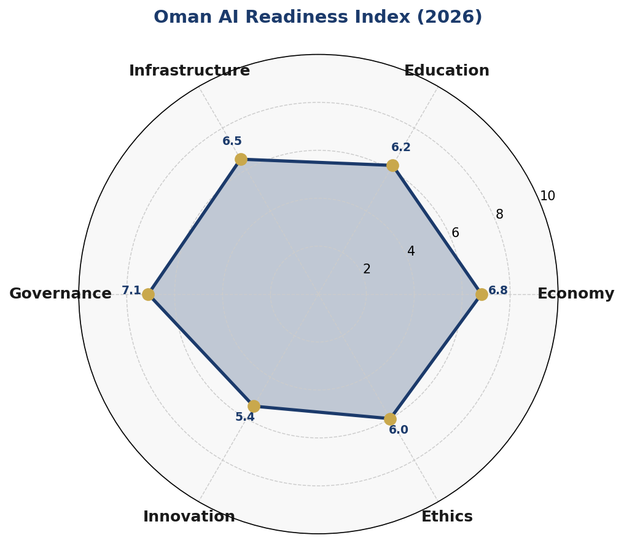
Figure 1: Oman AI Readiness Radar — Composite scores across 6 dimensions (scale: 0–10). Source: Author analysis drawing on Oxford Insights, World Bank WDI, ITU, Transparency International (2025).

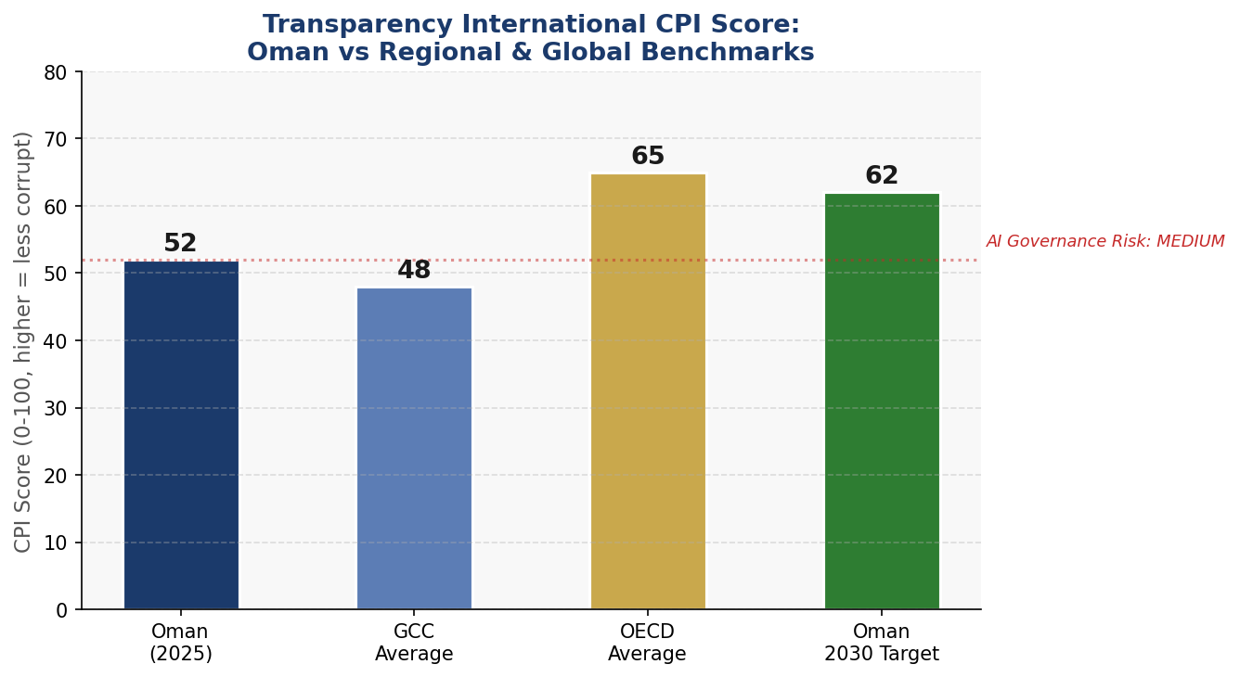
Figure 2: Transparency International CPI Score — Oman versus GCC average, OECD average, and 2030 policy target. A score above 60 reduces AI governance risk to 'low' tier.

Section 2: Policy Vision & Strategic Pillars

2.1 Vision Statement
"Oman will harness the transformative power of artificial intelligence to accelerate economic diversification, empower its citizens, strengthen its governance institutions, and uphold its historic values of harmony, wisdom, and dignity — becoming the Arab world's most trusted and innovative AI nation by 2031."
This vision is operationalised through five interlocking strategic pillars, each with dedicated governance structures, budget allocations, and accountability mechanisms.

2.2 Strategic Pillar I: Ethical AI & Human Rights Protection
Oman's Islamic heritage and cultural values of consultation (shura), justice (adalah), and mercy (rahma) provide a natural ethical substrate for responsible AI deployment. Pillar I establishes the legal, institutional, and normative foundations that ensure AI systems deployed in Oman respect human dignity, prevent discrimination, ensure transparency, and are subject to meaningful human oversight.
Key initiatives include the National AI Ethics Charter (enacted in Year 1), the establishment of a citizen AI complaints mechanism, mandatory AI impact assessments for all public-sector deployments, and a 'Trustworthy AI' certification scheme for private-sector operators. Oman will seek full alignment with the UNESCO AI Ethics Recommendation across all 11 core values, with the National AI Ethics Board serving as the primary accountability institution.

2.3 Strategic Pillar II: Economic Growth & Industrial AI Adoption
AI is projected to contribute up to 4.2% of Oman's GDP by 2030 under the scenarios modelled in this policy, drawing on GCC-specific estimates from the McKinsey Global Institute and World Economic Forum. Priority sectors for AI adoption have been identified based on their economic weight, AI technical receptiveness, and strategic alignment with Vision 2040 diversification targets:
- Logistics & Maritime: AI-powered port operations at Salalah and Sohar; predictive maintenance for Oman's shipping fleet; intelligent supply chain optimisation at Duqm SEZ
- Tourism & Hospitality: AI-driven visitor experience personalisation; predictive booking and demand management; multilingual AI services supporting Oman's 3.5 million annual visitor target
- Fisheries & Agriculture: Computer vision for aquaculture yield monitoring; AI-driven water management in agricultural zones; market price prediction for Oman's 600,000-tonne annual fish catch
- Financial Services: AI-powered fraud detection in the Central Bank of Oman's regulatory sandbox; robo-advisory for Muscat Stock Exchange retail investors; credit scoring models for SME lending
- Healthcare: AI-assisted diagnostics at Sultan Qaboos University Hospital; predictive outbreak modelling; AI-powered Arabic-language health information chatbots
- Energy: AI-optimised LNG production at Qalhat LNG; renewable energy grid management for Oman's 30% renewable target by 2030; AI-driven carbon capture monitoring

2.4 Strategic Pillar III: Education, Upskilling & AI Workforce Development
Omanisation of the AI talent pipeline is both an economic imperative and a social contract. Pillar III commits to a comprehensive, multi-level AI education transformation: embedding AI literacy into national school curricula by Year 2, establishing dedicated AI degree programmes at three universities by Year 3, and creating a National AI Scholarship Programme providing 500 fully-funded overseas postgraduate places by Year 5.

2.5 Strategic Pillar IV: Public Sector AI & e-Governance
Government is both Oman's largest employer and the primary interface between citizens and services. Pillar IV mandates the deployment of AI across 15 priority government use cases by Year 3, including intelligent permit processing, AI-assisted tax compliance at the Tax Authority, and predictive healthcare demand modelling for the Ministry of Health. All government AI deployments must comply with the National AI Governance Standard (NAGS-1), undergo mandatory third-party audit, and publish annual transparency reports.

2.6 Strategic Pillar V: AI Research, Innovation & Startup Ecosystem
Oman's ambition extends beyond AI consumption to AI production. Pillar V establishes two National AI Research Centres — one at Sultan Qaboos University focused on Arabic NLP and Islamic ethics of AI, and one at GUtech focused on industrial and environmental AI applications. The Oman AI Startup Accelerator, operating under the Oman Technology Fund, will support 50 AI startups annually by Year 3, with a dedicated OMR 20 million seed fund and access to public-sector data for product development.

Section 3: International Framework Alignment

3.1 UNESCO AI Ethics Recommendation (2021)
The UNESCO Recommendation on the Ethics of Artificial Intelligence, adopted by 193 member states in November 2021, provides the most comprehensive normative framework for AI governance globally. Its 11 core values — covering human dignity, sustainability, privacy, non-discrimination, fairness, transparency, explainability, safety, security, human oversight, and multi-stakeholder governance — form the ethical bedrock of Oman's AI policy architecture.
Oman's National AI Ethics Board will conduct an annual UNESCO alignment audit, publishing results in the National AI State Report. Key areas requiring sustained attention include: ensuring AI systems used in employment and credit decisions do not encode historical discrimination against women or expatriate workers; establishing meaningful human oversight mechanisms for AI in judicial and welfare contexts; and expanding civil society participation in AI governance beyond consultation to co-design.

3.2 OECD AI Principles (2019, Updated 2024)
The OECD AI Principles, endorsed by 46 countries and adopted by the G20, establish five value-based principles and five operational recommendations for responsible AI development. Oman's alignment strategy maps each principle to specific policy instruments: the principle of 'robust, secure and safe AI' is operationalised through mandatory vulnerability assessments and sector-specific AI safety standards; 'transparency and explainability' is addressed through the algorithmic transparency registry maintained by the National AI Observatory; and 'inclusive growth and well-being' underpins the education pipeline and SME AI adoption programmes.

3.3 EU AI Act (2024)
The EU Artificial Intelligence Act — the world's first comprehensive binding AI regulation — provides the most detailed risk-based classification framework available. While Oman is not subject to EU law, the Act's four-tier risk architecture (unacceptable risk, high risk, limited risk, minimal risk) is adopted wholesale in Section 6 of this policy as the most technically rigorous and internationally credible classification available. Omani technology companies seeking to export AI products to EU markets will benefit directly from alignment with these standards.

3.4 Additional Framework Alignments
Beyond UNESCO and OECD, this policy aligns with: the G20 AI Principles (endorsed at Japan 2019, reaffirmed at India 2023) on responsible stewardship and international cooperation; the ITU AI for Good Guidelines linking AI deployment to SDG achievement across health, climate, education, and financial inclusion; and the World Bank's AI Strategy for Development, which emphasises AI as a tool for poverty reduction, public service delivery, and institutional capacity building.

3.5 Framework Alignment Matrix
The following table maps key principles from each international framework to Oman's five strategic pillars. ✅ = Full alignment with specific policy mechanism; ⚠️ = Partial alignment, additional measures planned; 🔲 = Not yet addressed, under development.

Framework Principle | S1: Ethics | S2: Economy | S3: Education | S4: Gov | S5: R&D
UNESCO: Human dignity & autonomy | ✅ | ✅ | ✅ | ✅ | ✅
UNESCO: Non-discrimination & fairness | ✅ | ✅ | ✅ | ⚠️ | ✅
UNESCO: Privacy & data protection | ✅ | ⚠️ | ✅ | ✅ | ⚠️
UNESCO: Multi-stakeholder governance | ✅ | ⚠️ | ⚠️ | ✅ | ⚠️
OECD: Robust, secure & safe AI | ✅ | ✅ | ✅ | ✅ | ✅
OECD: Transparency & explainability | ✅ | ⚠️ | ✅ | ✅ | ⚠️
OECD: Inclusive growth & sustainability | ⚠️ | ✅ | ✅ | ✅ | ✅
EU AI Act: Risk-based classification | ✅ | ✅ | ✅ | ⚠️ | 🔲
EU AI Act: Fundamental rights impact | ✅ | ⚠️ | ✅ | ⚠️ | 🔲
G20: Responsible stewardship | ✅ | ✅ | ✅ | ✅ | ✅
ITU/SDG: Inclusive AI for development | ⚠️ | ✅ | ✅ | ✅ | ✅
World Bank: AI for development | ⚠️ | ✅ | ✅ | ✅ | ✅
Table 1: International Framework Alignment Matrix. S1–S5 = Strategic Pillars 1–5.

Section 4: Economic Impact & Investment Roadmap

4.1 Macroeconomic Projections
Drawing on McKinsey Global Institute's GCC AI economic impact modelling, World Economic Forum scenario analyses, and World Bank AI for growth estimates calibrated to Oman's sectoral structure, this policy projects that AI adoption could contribute between 3.5% and 5.0% of GDP by 2030, with the central scenario of 4.2% representing approximately USD 4.5 billion in additional annual economic output at 2025 prices.
These projections are conditional on: sustained public investment in AI infrastructure and education; a regulatory environment that encourages private-sector AI adoption without creating compliance barriers for SMEs; and success in attracting international AI companies to establish GCC regional operations in Oman. The Duqm Special Economic Zone, with its favourable tax regime and strategic location, is identified as the preferred location for attracting AI data centre and technology company investments.

4.2 National AI Investment Framework
The National AI Fund, established by Royal Decree in Year 1 of policy implementation, will manage a 5-year capital commitment of OMR 500 million (approximately USD 1.3 billion) sourced from the State General Reserve Fund (40%), private sector co-investment commitments (35%), and international development finance institutions including the Islamic Development Bank and World Bank (25%). Investment allocation follows the framework below:
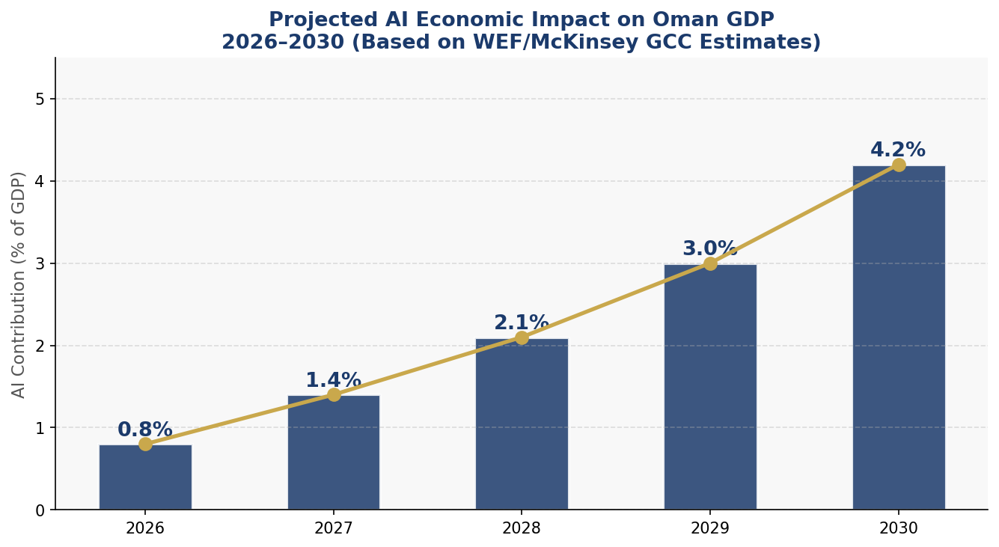
Figure 3: Projected AI Contribution to Oman GDP (%), 2026–2030. Central scenario based on GCC-calibrated McKinsey/WEF modelling. Actual results contingent on implementation fidelity.

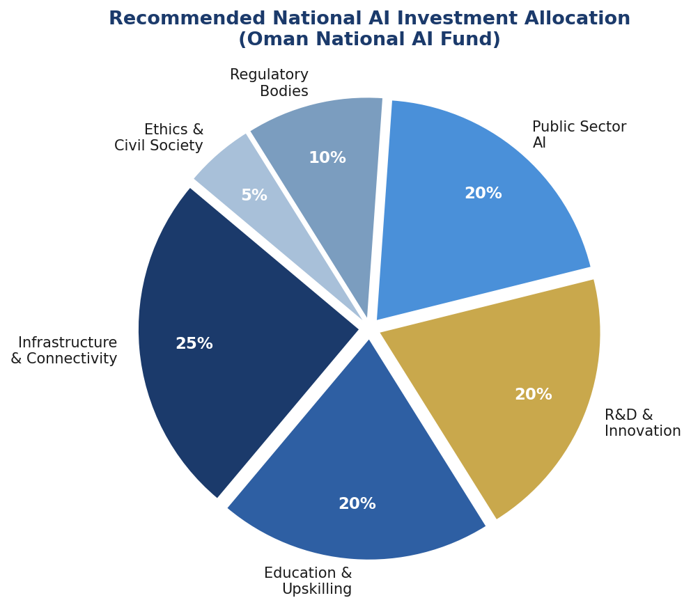
Figure 4: National AI Fund — Recommended Investment Allocation by Category (5-year total: OMR 500 million / ~USD 1.3 billion).

4.3 Priority Sector Investment
Sector-specific AI investment guidelines will be published annually by the Ministry of Economy in partnership with the National AI Observatory. Priority sectors for Years 1–3 are logistics and maritime (OMR 50M), healthcare AI (OMR 40M), tourism and hospitality (OMR 30M), and financial services AI (OMR 35M). Each sector will have a dedicated AI Sector Adoption Council co-chaired by the relevant ministry and private sector representatives.

4.4 Public-Private Partnership Framework
The National AI PPP Framework establishes three tiers of partnership: Strategic Partnerships (global AI firms committing minimum USD 50M investment over 5 years, receiving preferential data access and regulatory sandboxes); Growth Partnerships (GCC and emerging market AI companies receiving market access support and co-investment); and Innovation Partnerships (Omani AI startups receiving grant funding, public procurement preferences, and mentorship). Microsoft, Google, Oracle, Huawei, and several regional technology groups have indicated interest in Strategic Partnership status pending framework finalisation.

Section 5: Education & Human Capital Development

5.1 Current Skills Gap Analysis
Oman faces a three-layer AI talent deficit that this policy is designed to systematically address over five years. At the base layer, general AI literacy — the ability to understand, critically evaluate, and interact with AI systems as a citizen or consumer — is estimated to be present in fewer than 15% of the working-age population. At the practitioner layer, the ability to deploy, configure, and manage AI tools in professional contexts is estimated at approximately 8,000 individuals, predominantly expatriate workers. At the expert layer, the capacity to develop novel AI systems, conduct AI research, or design AI governance frameworks is estimated at fewer than 200 Omani nationals.
Without deliberate policy intervention, this deficit will widen as the global demand for AI talent intensifies and as Oman's economy's need for AI capabilities in both private and public sectors deepens. This section provides the comprehensive response.

5.2 National AI Curriculum Framework

K-12 Education
From Year 2 of policy implementation, AI concepts will be embedded across the national school curriculum through three progressively sophisticated stages: AI Awareness (Grades 1–6) introducing concepts of algorithms, data, and automation through age-appropriate activities; Digital Literacy and Computational Thinking (Grades 7–9) developing coding fundamentals, data analysis skills, and critical AI literacy; and AI Foundations (Grades 10–12) providing hands-on experience with machine learning tools, ethical reasoning about AI, and career pathway exploration in AI-related fields.

Tertiary Education
Sultan Qaboos University, GUtech, and UTAS will jointly offer Oman's first dedicated Bachelor of Science in Artificial Intelligence by September 2027, with a curriculum co-designed with leading international universities. Three interdisciplinary AI specialisations will be created: AI for Healthcare (with SQUH), AI for Maritime and Logistics (with Port of Salalah), and AI Ethics and Governance (with the Ministry of Justice and the National AI Ethics Board). Target: 500 AI degree graduates annually by 2031.

Vocational and Professional Training
The National Vocational Training Authority will develop an Omani AI Skills Certification (OASC) framework at three levels — Associate (100-hour programme), Professional (300-hour programme), and Expert (600-hour programme with project component). Delivery through existing VTCs, online platforms, and corporate training partnerships. Target: 10,000 professional certifications annually by Year 4.

5.3 AI Education Pipeline Targets
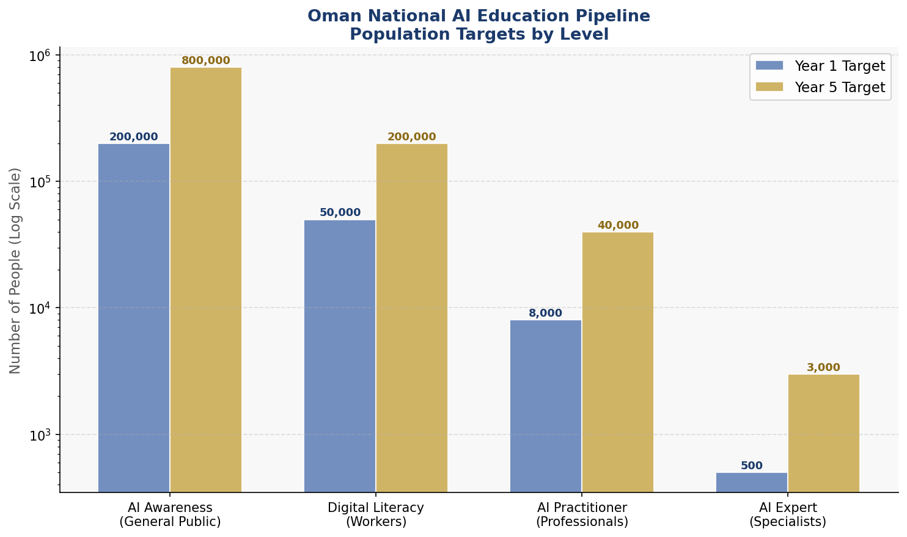
Figure 5: National AI Education Pipeline — Population targets by competency level, Year 1 vs Year 5 (log scale). Note: Practitioner and Expert levels are on a logarithmic axis for readability.

5.4 Inclusion & Diversity
Women in AI Oman (WAI-Oman), established as a government-civil society partnership, will administer the Oman Women AI Leadership Scholarship providing 200 fully-funded places per year for women in AI-related graduate programmes. A mandatory 40% gender representation target applies to all government-funded AI research projects and to the National AI Ethics Board membership. Rural and remote connectivity improvement under the Digital Oman Strategy will ensure AI education resources reach all governorates.

Section 6: Ethical AI Governance & Regulatory Framework

6.1 National AI Ethics Board
The National AI Ethics Board (NAEB) is established as Oman's primary AI governance institution, operating under a Royal Decree with a mandate for independence from both commercial and political pressures. The Board comprises 15 members serving staggered 3-year terms:
- Three government representatives: Ministry of Transport, Communications and IT; Ministry of Justice; Royal Oman Police
- Three independent technical experts (AI, cybersecurity, data science)
- Three civil society representatives (consumer rights, human rights, disability inclusion)
- Two religious scholars from the Ministry of Endowments (ensuring Islamic ethics integration)
- Two private sector representatives (technology industry and SME associations)
- Two international observers (UNESCO, OECD)
The NAEB has binding authority to: approve or reject government AI deployments above defined risk thresholds; issue mandatory compliance notices; recommend Royal Decrees on AI regulation; publish annual AI State Reports to the Council of State (Majlis al-Dawla); and receive citizen complaints regarding AI-related rights violations.

6.2 AI Risk Classification System
Oman's AI Risk Classification System adopts the EU AI Act's four-tier architecture, adapted to Oman's legal context under the Sultanic Decree framework and calibrated to reflect Oman's specific economic sectors, cultural values, and governance context:

Risk Tier | Examples in Oman Context | Regulatory Requirements
Unacceptable Risk  (BANNED) | AI systems that manipulate human behaviour through subliminal techniques; social scoring by government; real-time biometric surveillance in public spaces without judicial warrant; AI that exploits vulnerabilities of specific groups | Absolute prohibition. Criminal penalties of up to OMR 500,000 and 10 years imprisonment for operators and deployers
High Risk  (REGULATED) | AI in critical infrastructure; AI for recruitment and employment screening; AI in education assessment; AI used in law enforcement; AI for credit scoring and financial exclusion decisions; AI in healthcare diagnosis | Mandatory conformity assessment before deployment; registration in National AI Registry; continuous monitoring; annual third-party audit; mandatory transparency reports
Limited Risk  (TRANSPARENCY) | Chatbots and virtual assistants; AI-generated content; emotion recognition in commercial settings; deepfake tools | Mandatory disclosure to users that they are interacting with AI; content provenance labelling requirements
Minimal Risk  (VOLUNTARY) | AI-enabled spam filters; AI in video games; AI for inventory management and pricing optimisation | Voluntary Code of Responsible AI Practice; encouraged self-assessment against national standards
Table 2: Oman AI Risk Classification Framework (Adapted from EU AI Act, 2024, contextualised for Sultanate of Oman legal and cultural context).

6.3 Data Protection & Privacy Framework
Oman's Personal Data Protection Law (Royal Decree 6/2022) provides the foundational legal layer for AI data governance. This policy recommends a comprehensive AI Data Supplement to that law, addressing: special category data processing by AI systems; automated decision-making rights and the right to human review; data localisation requirements for AI systems processing sensitive government data; and cross-border AI data transfer agreements with GCC partners and international partners.

6.4 Algorithmic Accountability Standards
All AI systems classified as High Risk must comply with the Oman Algorithmic Accountability Standard (OAAS), requiring: algorithmic impact assessments conducted by accredited auditors before deployment; explanation mechanisms enabling affected individuals to understand AI decisions; bias testing against protected characteristics including gender, nationality, religion, and disability; and incident reporting within 72 hours for any AI system failure with significant public impact.

6.5 Anti-Corruption AI Guidelines
Given Oman's medium-tier CPI score and the risk that AI could either entrench or expose corruption dynamics, this policy establishes specific anti-corruption AI guidelines: all government AI procurement above OMR 500,000 must be conducted through open competitive tender with published evaluation criteria; AI systems used in government resource allocation must be subject to civil society audit; and an AI-powered procurement monitoring tool, operated by the State Audit Institution, will cross-reference all government contracts for anomalous patterns.

Section 7: Public Sector AI & e-Governance

7.1 Priority Government Use Cases
Fifteen priority AI use cases have been identified for government deployment in Years 1–3, selected based on: potential impact on citizen experience, technical feasibility within Oman's existing digital infrastructure, alignment with Vision 2040 governance priorities, and compatibility with the AI Risk Classification Framework. Key use cases include:
- Intelligent Permit Processing: AI-assisted building and commercial permit review at municipal level, reducing processing time from 45 to 5 days (Ministry of Housing and Urban Planning)
- Predictive Healthcare Demand: AI modelling of emergency department demand to optimise staffing and resource allocation across 71 hospitals (Ministry of Health)
- AI-Powered Tax Compliance: Machine learning models to identify anomalous tax filing patterns, improving compliance rates and reducing the tax gap (Tax Authority)
- Intelligent Traffic Management: AI-controlled traffic signal systems in Muscat and Salalah, reducing average commute times by estimated 20% (Royal Oman Police)
- Agricultural Water Management: AI-driven falaj (aflaj) irrigation monitoring and optimisation, preserving Oman's UNESCO-listed water heritage (Ministry of Agriculture)
- Customs and Border AI: AI-assisted cargo screening at Muscat International Airport and Port of Salalah, improving efficiency and security (Royal Oman Customs)
- Social Benefits Eligibility: AI-assisted means testing for social support programmes, reducing administrative burden while improving targeting accuracy (Ministry of Social Development)

7.2 Government AI Procurement Guidelines
All government AI procurement must comply with the National AI Governance Standard (NAGS-1), published by MoCIT in Year 1. Key requirements include: vendors must demonstrate ISO 42001 AI Management System certification or equivalent; source code escrow arrangements for critical government AI systems; mandatory Omani data residency for all government data processed by AI systems; and 5-year vendor support commitments to prevent system orphaning.

7.3 Citizen-Facing AI Services Roadmap
By 2031, 80% of citizen-government interactions will be AI-supported through the Hukumati ('My Government') digital platform. Year 1 priority: Arabic-language natural language processing chatbots for 15 most-accessed government services. Year 3 priority: Proactive AI-driven notifications for citizen entitlements and service renewals. Year 5 priority: Fully integrated AI case management for complex multi-ministry citizen interactions, such as business licensing, social housing applications, and retirement services.

7.4 Interoperability Standards
The Oman Government AI Interoperability Framework (OG-AIF) establishes mandatory API standards, data exchange protocols, and shared AI service components for use across all ministries. A National AI Service Bus, operated by ITA, will enable secure AI model sharing, preventing the costly proliferation of redundant AI systems across government entities. Common AI services — including Arabic OCR, facial recognition (limited to approved use cases), machine translation, and voice-to-text — will be provided as shared infrastructure.

Section 8: Implementation Roadmap

8.1 Five-Year Implementation Architecture
Implementation is structured across three overlapping phases, each building on the foundations of the previous while scaling up ambition:
- Phase 1 — Foundation (Months 1–12): Legal framework enactment; institutional establishment; pilot programmes; needs assessment finalisation
- Phase 2 — Scaling (Months 13–36): National education reform rollout; 15 government AI use case deployment; private sector adoption programme launch; R&D centre operationalisation
- Phase 3 — Optimisation & Consolidation (Months 37–60): Policy review and refinement; international integration; AI export capability development; full KPI assessment
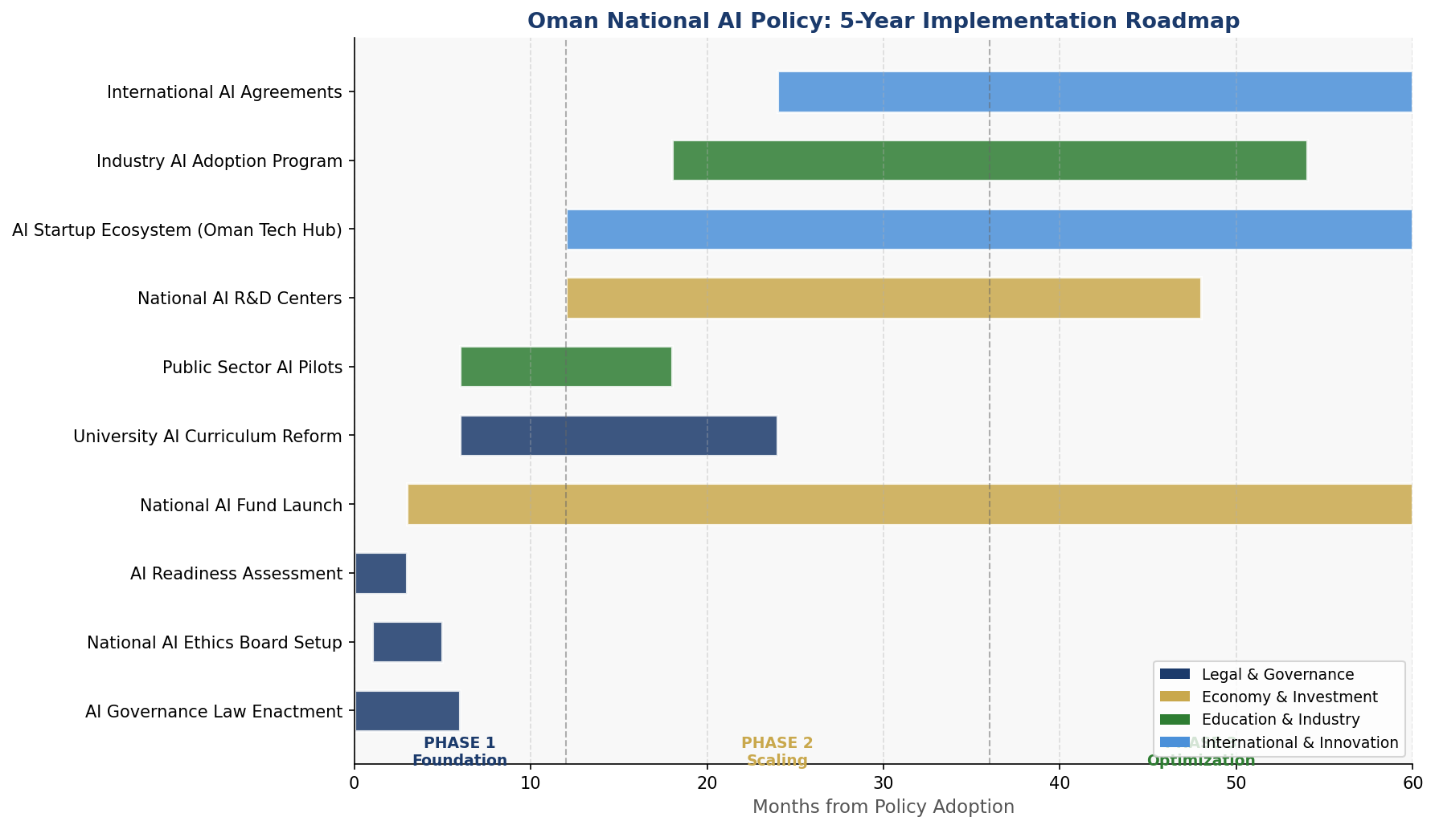
Figure 6: 5-Year Oman National AI Policy Implementation Timeline (Gantt Chart). Colours indicate initiative category: Navy = Legal & Governance; Gold = Economy & Investment; Green = Education & Industry; Blue = International & Innovation.

8.2 Phase 1: Foundation (Year 1)
Year 1 activities are sequenced to establish the enabling conditions for all subsequent phases. Critical path items include the enactment of the National AI Governance Law by Royal Decree (Q1), appointment of the National AI Ethics Board (Q2), establishment of the National AI Observatory at ITA (Q2), publication of the National AI Governance Standard (Q3), and launch of the National AI Fund with initial capital commitment (Q4).
Three pilot programmes will be launched in Year 1 to generate learning before national scaling: an AI-assisted permit processing pilot in Muscat (Ministry of Housing); an AI Arabic language curriculum pilot in 50 schools across all governorates (Ministry of Education); and an AI fraud detection pilot in the Tax Authority.

8.3 Phase 2: Scaling (Years 2–3)
Phase 2 represents the major investment and deployment phase. All 15 government AI use cases will be live by Month 30. The AI degree programmes at SQU, GUtech, and UTAS will receive their first cohorts by September 2027. The National AI Startup Accelerator will complete its first cohort by Month 18. The National AI Research Centres will publish their first research outputs by Month 24.

8.4 Phase 3: Optimisation (Years 4–5)
Phase 3 focuses on evaluation, refinement, and international positioning. A comprehensive policy review — drawing on KPI data from the National AI Observatory, civil society input through the NAEB, and international peer review — will be completed by Month 48. Refined policy directions for the next 5-year period (2032–2036) will be drafted by Month 54, ensuring continuity of strategic direction while incorporating lessons learned.

KPI | Baseline (2026) | Year 1 Target | Year 3 Target | Year 5 Target
AI GDP Contribution | ~0.3% | 0.8% | 2.1% | 4.2%
Omani AI Specialists | ~200 | 500 | 1,500 | 3,000
AI Literacy (Adults) | ~15% | 25% | 50% | 75%
Women in AI Workforce | 18% | 25% | 35% | 45%
Govt Services Digitised | 40% | 55% | 70% | 80%
AI Startups (Active) | ~15 | 30 | 80 | 200
AI Research Papers | ~50/yr | 100/yr | 250/yr | 500/yr
CPI Score (Target) | 52 | 54 | 58 | 62
AI Ethics Audits Done | 0 | 25 | 80 | 150+
Table 3: National AI Policy KPI Dashboard — Baseline and Targets. Annual reporting through the National AI Observatory.

Section 9: Monitoring, Evaluation & Accountability

9.1 National AI Observatory
The National AI Observatory (NAO), established within the Information Technology Authority, serves as Oman's central data collection and analysis institution for AI policy monitoring. The NAO is mandated to: collect annual data on all AI KPIs from public and private sector entities; maintain the National AI System Registry (all high-risk AI deployments); publish the Annual AI State Report by 31 March each year; and provide quarterly briefings to the National AI Ethics Board and the Ministry of Transport, Communications and IT.
The NAO will operate with a staff of 40 specialists, a dedicated technology infrastructure for data collection and analysis, and a formal partnership with Oxford Insights for annual participation in the Government AI Readiness Index to enable international benchmarking.

9.2 Annual AI State Report
The Annual AI State Report — published openly and available in Arabic and English — will cover: progress against all KPIs in the dashboard above; case studies of successful and unsuccessful AI deployments; updates on international framework alignment; emerging AI risks identified during the year; and recommendations for policy adjustment. The Report will be presented to the Council of State (Majlis al-Dawla) within 30 days of publication, ensuring parliamentary visibility.

9.3 Parliamentary & Executive Oversight
The Majlis al-Dawla (Council of State) will establish a permanent AI Oversight Sub-Committee with access to all National AI Observatory data, the right to summon ministers and NAEB members for testimony, and the power to recommend policy amendments to the Council of Ministers. The AI Oversight Sub-Committee will conduct an annual public hearing on AI policy implementation, open to civil society organisations and the media.

9.4 Civil Society & Independent Audit Role
Oman recognises that effective AI governance requires voices beyond government and industry. The National AI Civil Society Forum — convened biannually by the NAEB — will bring together consumer organisations, academic institutions, legal aid NGOs, disability rights groups, and women's associations to provide independent assessments of AI's societal impact. Three independent AI auditors, accredited under the National Audit Framework, will conduct mandatory audits of all government high-risk AI deployments annually, with results published in full.

Section 10: International Cooperation & AI Diplomacy

10.1 Bilateral AI Cooperation Priorities
Oman's strategic location at the intersection of Gulf, Indian Ocean, and South Asian geopolitical spheres positions it uniquely for AI diplomacy. Priority bilateral AI cooperation partnerships are identified with:
- United Arab Emirates: AI regulatory harmonisation within the GCC; joint AI startup ecosystem development; shared data infrastructure for cross-border logistics AI
- India: Joint AI research programmes building on existing bilateral ties; Indian IT talent reciprocal training exchange; collaboration on AI for maritime trade route management
- United Kingdom: AI governance knowledge transfer through UK FCDO; joint research with Oxford and Cambridge on Arabic NLP; AI regulatory alignment building on UK-GCC free trade agreement
- China: Technology partnership within the Belt and Road digital framework; collaboration on smart port technology at Salalah; data security protocols to govern AI data sharing
- Germany: Industrial AI collaboration through GUtech partnership; AI for sustainability and climate monitoring programmes; joint research through Fraunhofer Institute affiliations

10.2 Regional AI Governance — Gulf Cooperation Council
Oman supports the development of a GCC AI Framework to harmonise AI regulations across the six member states, creating a unified Gulf digital market for AI products and services. Key priorities for GCC AI coordination: mutual recognition of AI conformity assessments; cross-border data sharing agreements for AI research; joint GCC AI startup fund; coordinated response to international AI governance developments at UNESCO, OECD, and UN level.

10.3 Arab World AI Cooperation
Through the Arab League's Ministerial Council on Digitalisation, Oman will advance the adoption of a unified Arab AI Ethics Charter based on shared cultural and religious values, including Arabic language AI development as a collective Arab world priority. Oman will offer its National AI Ethics Board model as a template for adoption by Arab League members seeking to establish independent AI governance institutions.

10.4 Global AI Governance Participation
Oman commits to active participation in the emerging global AI governance architecture: full implementation and annual reporting under the UNESCO AI Ethics Recommendation; participation in the Global Partnership on AI (GPAI) as an associate member by 2027, with a pathway to full membership; engagement in the ITU AI for Good global summit as a regular presenter of Oman's AI development experience; and contribution to the UN Secretary-General's AI Advisory Body work, particularly on AI governance for developing and middle-income countries.

10.5 South-South Knowledge Transfer
Oman will share its AI governance experience with developing and middle-income countries through the Oman Development Bureau's technical assistance programme. Priority recipients of Oman AI governance knowledge transfer: Zanzibar and Tanzania (Arabic-language AI tools); Bangladesh (AI for fisheries management); Sri Lanka (AI for tourism development); Jordan and Morocco (AI governance institutional design). This south-south cooperation reinforces Oman's global reputation as a responsible, constructive middle power in the AI age.

Conclusion
Artificial intelligence is not merely a technology: it is the defining infrastructure of the 21st-century economy, the most consequential governance challenge of our generation, and — deployed with wisdom and values — a profound opportunity for human flourishing. The Sultanate of Oman enters the AI age with real advantages: political stability, strategic geography, a young and increasingly educated population, a government committed to transformation, and a cultural heritage that prizes knowledge, consultation, and justice.
This National AI Policy 2026–2031 provides the comprehensive architecture to translate those advantages into tangible outcomes: a more diversified, productive economy; a more skilled and empowered workforce; more responsive and accountable government services; a more dynamic innovation ecosystem; and a more confident Omani voice in shaping the global AI governance order.
The policy's success will depend on three foundations: sustained political commitment from the highest levels of government; genuine partnership between government, private sector, academia, civil society, and citizens; and the courage to learn, adapt, and course-correct as AI technology evolves and as implementation lessons accumulate. With these foundations in place, Oman is positioned not merely to participate in the AI revolution, but to help lead it — with wisdom, integrity, and care for the human beings at its centre.

— End of Policy Document —

References & Bibliography

International Frameworks & Standards
- UNESCO. (2021). Recommendation on the Ethics of Artificial Intelligence. Paris: United Nations Educational, Scientific and Cultural Organization.
- OECD. (2019, updated 2024). OECD Principles on AI. Paris: Organisation for Economic Cooperation and Development. OECD/LEGAL/0449.
- European Parliament & Council. (2024). Regulation (EU) 2024/1689 on Artificial Intelligence (EU AI Act). Brussels: European Union.
- G20. (2023). G20 New Delhi Leaders' Declaration — AI Principles Reaffirmation. New Delhi: G20 India Presidency.
- ITU. (2023). AI for Good: Harnessing AI to Accelerate the SDGs. Geneva: International Telecommunication Union.
- World Bank. (2021). World Bank Group Artificial Intelligence Strategy. Washington DC: World Bank.

Country Data Sources
- Transparency International. (2025). Corruption Perceptions Index 2025. Berlin: Transparency International.
- Oxford Insights. (2025). Government AI Readiness Index 2025. Oxford: Oxford Insights.
- World Bank. (2025). World Development Indicators 2025. Washington DC: World Bank Group.
- ITU. (2025). ICT Development Index 2025. Geneva: International Telecommunication Union.

Economic Analysis
- McKinsey Global Institute. (2023). Economic Potential of Generative AI in the Gulf. McKinsey & Company.
- World Economic Forum. (2024). AI's Economic Promise for the Middle East. Davos: WEF.
- Oman Vision 2040. (2021). National Programme for Oman's Economic Diversification. Muscat: Oman Vision 2040 Implementation Follow-up Unit.

Oman Policy & Legal Documents
- Royal Decree 6/2022: Personal Data Protection Law, Sultanate of Oman.
- Ministry of Transport, Communications and Information Technology. (2021). Digital Oman Strategy 2021–2026. Muscat: MoCIT.
- Information Technology Authority. (2024). e-Oman Report 2024. Muscat: ITA.

About the Author
Nafiul Ahmad Rafi
Policy & Good Governance Researcher | BD Civic Tech Architect

Nafiul Ahmad Rafi is a civic technologist, policy researcher, author, photographer, and musician based in Dhaka, Bangladesh. He is the Founder and Director of Insights Bangladesh, a data-driven governance and policy impact analysis institution, and the Founder & Lead Architect of NagorikBD.org — a transparency-first civic platform scaled across Mymensingh Division, connecting citizens with government services across 45 Upazilas.
His work exists at the intersection of institutional reform and artificial intelligence, transforming theoretical governance into scalable, data-driven reality. Without a conventional computer science degree, he self-taught the tools of modern AI and web development to build the infrastructure that enforces the policies he once only researched.

Key Platforms & Projects
- NagorikBD.org — Civic transparency platform, Mymensingh Division
- Insights Bangladesh — Policy impact analysis institution
- FactCheck BD (factcheckbd.org) — Bangladesh's AI-powered fact-checking platform
- Political Insights BD / PIBD (pibbd.org) — Political intelligence and civic tech hub
- PeaceShield BD / National Peace Tracker — AI-powered hate speech and conflict monitoring
- PolicyLens AI (aigovbd.org) — 9-dimensional AI policy audit tool

He has published four books and maintains a personal site at ahmad-rafi.com.

Research Interests
AI Governance · Policy Research · Future of Bangladesh · Climate Policy

Contact
- Website: ahmad-rafi.com
- LinkedIn: linkedin.com/in/nafiul-ahmad-rafi
- Email: contact@ahmad-rafi.com

"I build code to ensure transparency, and I write lyrics to inspire the courage to use it."

