🇶🇦
STATE OF QATAR
National Artificial Intelligence Policy
2025 – 2030

A Comprehensive Framework for Ethical, Inclusive, and Economically Transformative AI
Prepared by:
Nafiul Ahmad Rafi
Insights Bangladesh | Policy & Good Governance Research
May 2025

Executive Summary

Qatar stands at a pivotal juncture in its national development trajectory. Anchored by the visionary Qatar National Vision 2030, the State of Qatar has consistently pursued economic diversification, knowledge-economy transformation, and international competitiveness. The emergence of Artificial Intelligence as the defining technological force of the 21st century presents Qatar with an extraordinary opportunity — not merely to adopt AI as an efficiency tool, but to assert itself as a regional hub for AI governance, innovation, and ethical deployment.
This National Artificial Intelligence Policy 2025–2030 provides a comprehensive, actionable framework to guide Qatar's AI ambitions across government, industry, education, and civil society. Drawing on Qatar's robust financial resources, high levels of digital infrastructure, and strategic geopolitical positioning, this policy charts a five-year course toward an AI-empowered economy that upholds human rights, promotes inclusion, and contributes meaningfully to global AI governance norms.
Qatar's AI readiness is strong but uneven. With a GDP per capita exceeding USD 85,000 and a world-class digital infrastructure developed through the Qatar National Broadband Network, the State possesses the economic and physical foundations for rapid AI adoption. Yet critical gaps persist: STEM talent remains heavily dependent on expatriate labour, domestic AI research output is nascent compared to global peers, and algorithmic accountability frameworks lag behind the pace of technology deployment in both public and private sectors.
This policy is structured around five strategic pillars: Ethical AI and Human Rights Protection; Economic Growth and Industrial AI Adoption; Education, Upskilling, and AI Workforce Development; Public Sector AI and e-Governance; and AI Research, Innovation, and Startup Ecosystem. Each pillar is underpinned by globally benchmarked standards drawn from UNESCO, OECD, the EU AI Act, the World Bank, G20, and ITU frameworks. Implementation is organised into three phases — Foundation (Year 1), Scaling (Years 2–3), and Optimisation (Years 4–5) — with a dedicated National AI Observatory mandated to monitor, evaluate, and report on progress annually.
By 2030, Qatar's AI ecosystem is projected to contribute approximately 8.5% of GDP — equivalent to billions of dollars in new economic value — while establishing the State as a global thought leader in AI ethics and governance. This policy is Qatar's commitment to a future where artificial intelligence serves humanity, guided by Islamic values of justice, stewardship, and the common good.

Section 1: National AI Readiness Assessment

1.1 Economic Context
Qatar is one of the world's wealthiest nations on a per capita basis, with nominal GDP per capita exceeding USD 85,000 as of 2024. The country's economy remains substantially anchored in hydrocarbon extraction — oil and gas representing roughly 40% of GDP and 70% of government revenues — yet the Qatar National Vision 2030 has set an ambitious course toward a knowledge-based diversified economy. Financial services, construction, logistics, tourism, and increasingly, technology, are growing sectors. Qatar's sovereign wealth fund, the Qatar Investment Authority (QIA), manages assets exceeding USD 450 billion, providing substantial capital for transformational investment in AI and digital infrastructure.
The digital economy is projected to account for 15% of Qatar's GDP by 2030, driven by smart city initiatives, e-government services, and strategic technology partnerships. Qatar's post-FIFA 2022 infrastructure — including smart stadiums, 5G networks, and integrated IoT systems — provides a compelling real-world testbed for AI deployment at national scale.

1.2 Education and Human Capital
Qatar's adult literacy rate stands at approximately 93%, and tertiary enrollment rates have risen significantly due to investments in Education City — a cluster of branch campuses of leading global universities including Carnegie Mellon, Georgetown, and Texas A&M. The Qatar Foundation has channeled billions into science, technology, engineering, and mathematics (STEM) education over two decades.
However, a significant structural challenge remains: Qatar's national workforce is heavily skewed toward the public sector, and private-sector technology roles are disproportionately filled by expatriates. The country's Qatarisation policy (Tawteen) sets targets to increase Qatari participation in the private sector but has yet to deeply penetrate technology and AI roles. Addressing the AI skills gap among Qatari nationals is a central imperative of this policy.

1.3 Digital Infrastructure
Qatar possesses world-class digital infrastructure. The Qatar National Broadband Network (QNB) provides fibre connectivity to over 95% of households. Mobile penetration exceeds 175% (including visitor devices), and 5G coverage spans all major urban areas. Data centre capacity has expanded substantially, supported by Ooredoo's cloud infrastructure and international peering arrangements.
The Smart Qatar (TASMU) programme, launched by the Ministry of Communications and Information Technology, represents the State's flagship digital transformation initiative, targeting five sectors: transportation, logistics, sports, environment, and healthcare. AI is identified as a core enabling technology within TASMU, providing practical deployment contexts for this policy.

1.4 Governance and Institutional Capacity
Qatar operates as an absolute monarchy under the House of Thani, with the Emir holding supreme authority. Governance is characterised by centralised decision-making, long-term strategic planning, and the capacity for rapid, large-scale policy implementation — attributes that are significant advantages in AI policy execution. The country achieved a governance effectiveness score of 1.3 (World Bank WGI, 2023), placing it among the top quartile globally.
Key institutions relevant to AI governance include the Ministry of Communications and Information Technology (MCIT), the Supreme Council of Health, the Ministry of Education and Higher Education, and the Qatar Finance Centre Regulatory Authority (QFCRA). Coordination mechanisms between these entities will require strengthening to enable coherent AI governance.

1.5 Corruption Risk Assessment
Qatar ranked 30th on the Transparency International Corruption Perceptions Index 2024, with a score of 58 out of 100 — the highest in the MENA region and well above the regional average of 34. While this reflects relatively strong institutional integrity, the country's governance model — characterised by limited judicial independence and restrictions on civil society oversight — introduces specific risks relevant to AI deployment, particularly in surveillance, benefits distribution, and procurement contexts. This policy prescribes algorithmic accountability standards and independent audit mechanisms to mitigate AI-specific corruption risks.

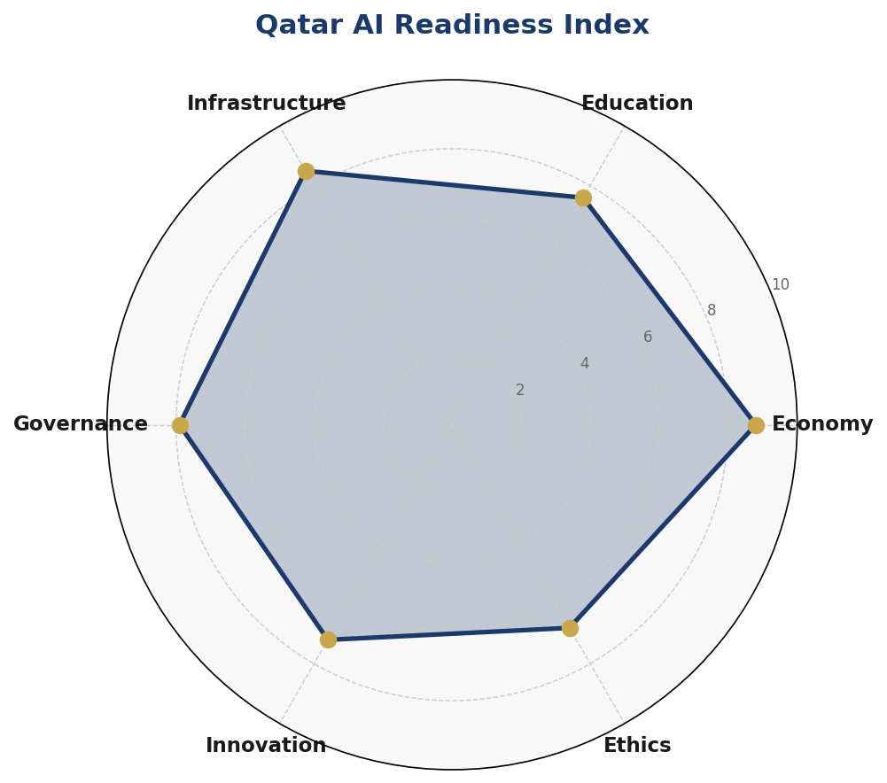
Figure 1.1: Qatar AI Readiness Index — Six-Dimension Assessment (Scores out of 10)

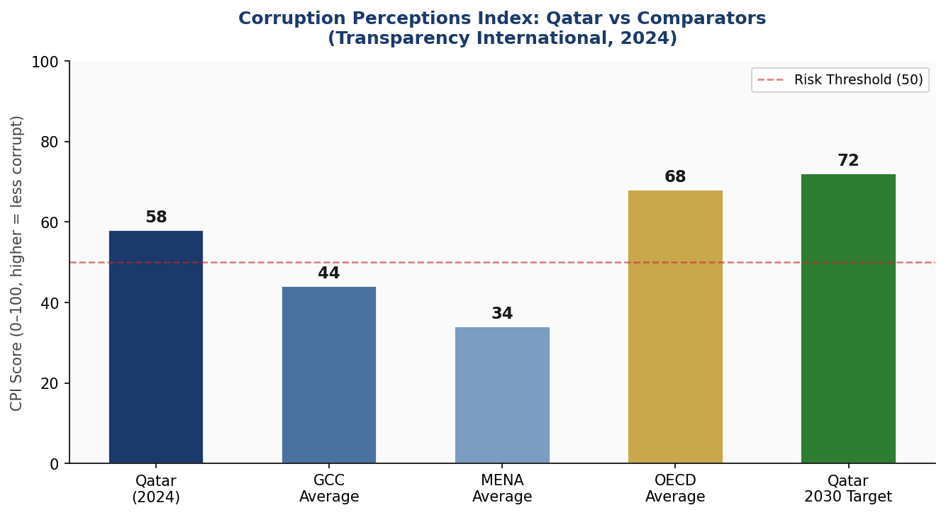
Figure 1.2: Corruption Perceptions Index — Qatar vs Regional and Global Comparators

Section 2: Policy Vision and Strategic Pillars

2.1 Vision Statement
"Qatar aspires to be a global leader in ethical, human-centred Artificial Intelligence — deploying AI as a force for economic prosperity, social equity, environmental sustainability, and the well-being of all people within our borders and beyond."
This vision is rooted in the values of Qatar National Vision 2030 — human development, social development, economic development, and environmental development — and aligns with the universal aspirations expressed in UNESCO's Recommendation on the Ethics of AI (2021). Qatar's AI vision explicitly acknowledges the rights of migrant workers, who comprise over 85% of the national population, as a critical dimension of inclusive AI governance.

2.2 Strategic Pillar 1: Ethical AI and Human Rights Protection
Qatar commits to placing human dignity, privacy, non-discrimination, and accountability at the centre of all AI development and deployment. This pillar establishes a National AI Ethics Board, a mandatory AI impact assessment regime, and enforceable prohibitions on AI systems that violate fundamental rights. Particular attention is paid to AI systems affecting migrant labour — including recruitment algorithms, wage management systems, and border control AI — which must meet heightened scrutiny standards.
- Establish National AI Ethics Board with independent mandate
- Enact mandatory AI Impact Assessment for high-risk public sector systems
- Prohibit AI-enabled social scoring, predictive policing without judicial oversight, and mass biometric surveillance in public spaces
- Ensure algorithmic transparency in government benefits, visa, and employment systems
- Protect migrant workers from exploitative AI-enabled labour management

2.3 Strategic Pillar 2: Economic Growth and Industrial AI Adoption
Qatar's AI economic strategy prioritises three high-value sectors: energy and resource management (AI-optimised LNG production and sustainability), financial services (AI in fintech, fraud detection, and Islamic finance), and smart infrastructure (AI-managed transportation, water, and urban systems). A national AI investment fund of QAR 5 billion over five years will support both domestic startups and international AI investment attraction.
- Launch QAR 5 billion National AI Investment Fund
- Establish AI adoption incentive programme for SMEs (tax credits, technical assistance)
- Target LNG sector AI efficiency improvements of 15% by 2027
- Create Qatar AI Business Registry to catalogue AI deployments and ensure accountability

2.4 Strategic Pillar 3: Education, Upskilling, and AI Workforce Development
Qatar will transform its education system to produce AI-literate citizens and globally competitive AI professionals. This includes embedding AI literacy into the national K–12 curriculum by 2026, establishing three AI Centres of Excellence at Qatari universities, and launching a National AI Scholarship Programme to send 500 Qataris annually to top global AI programmes through 2030.
- National AI Literacy Programme: 95% awareness coverage by 2030
- K–12 AI curriculum integration (coding, data literacy, ethics) by 2026
- Three AI Centres of Excellence at Qatar University, HBKU, and QF institutions
- 500 annual National AI Scholarships for Qataris at global AI programmes
- AI Reskilling Initiative for 10,000 government employees by 2027

2.5 Strategic Pillar 4: Public Sector AI and e-Governance
Qatar's government is committed to being a responsible and exemplary early adopter of AI. Priority use cases include predictive healthcare (disease surveillance, hospital resource optimisation), smart transportation (traffic management, autonomous vehicle corridors), judicial support tools (case analysis, legal research — never decision-making), and social services delivery. All public AI systems will operate under the Government AI Procurement Standard mandated by this policy.
- Implement AI in healthcare triage and disease surveillance at Hamad Medical Corporation
- Deploy AI traffic management across Doha metropolitan area
- AI-powered e-services for visa, residency, and civil registration by 2026
- Government AI Procurement Standard: all vendors must meet Qatar AI Certification

2.6 Strategic Pillar 5: AI Research, Innovation, and Startup Ecosystem
Qatar's research ecosystem, anchored in Qatar Foundation and the Qatar National Research Fund (QNRF), provides a strong basis for AI research investment. This pillar targets tripling Qatar's annual AI research publications by 2027, establishing an AI Regulatory Sandbox for innovation, and creating a Qatar AI Startup Accelerator in partnership with QSTP (Qatar Science and Technology Park).
- Triple Qatar's annual AI research output by 2027 (baseline: 2024 Web of Science data)
- Establish AI Regulatory Sandbox for controlled innovation in fintech, health, and logistics
- Launch Qatar AI Startup Accelerator: 50 companies annually, equity-free grants of QAR 500,000
- International Research Collaboration: formal AI partnerships with 10 nations by 2028

Section 3: International Framework Alignment

3.1 UNESCO AI Ethics Recommendation (2021)
The UNESCO Recommendation on the Ethics of AI, adopted by all 193 member states, provides the broadest and most inclusive normative framework for AI governance. It identifies 11 core values: proportionality, safety and security, fairness and non-discrimination, sustainability, privacy, human oversight and determination, transparency and explainability, responsibility and accountability, awareness and literacy, multi-stakeholder and adaptive governance, and international cooperation.
This policy maps all 11 UNESCO values to specific sections and obligations. Qatar's obligations under UNESCO are particularly salient in the context of its large migrant worker population, where AI systems in recruitment, labour management, and social services carry heightened risks of discrimination and harm.

3.2 OECD AI Principles (2019, Updated 2024)
The OECD AI Principles, adopted by Qatar as a non-member through the OECD Global Forum on AI (GPAI), provide the foundational framework for trustworthy AI. The updated 2024 principles strengthen provisions on transparency, accountability, and the specific risks posed by generative AI systems. Qatar's policy incorporates OECD-aligned AI risk assessment methodologies and adopts the OECD Framework for the Classification of AI Systems as the basis for its domestic risk classification regime.

3.3 EU AI Act (2024)
The European Union AI Act, which entered into force in August 2024, represents the world's most comprehensive binding AI regulatory framework. While Qatar is not subject to the EU AI Act, the Act functions as de facto global standard-setting given the European Single Market's scale. Qatar's AI risk classification system — Unacceptable Risk (prohibited), High Risk (regulated), Limited Risk (transparency obligations), and Minimal Risk (voluntary code) — is directly modelled on the EU Act's four-tier approach, adapted to Qatar's legal and institutional context.

3.4 World Bank, G20, and ITU Alignment
The World Bank's AI Strategy for Development Economies emphasises AI's potential to accelerate progress on the Sustainable Development Goals (SDGs), particularly in health, education, and financial inclusion. Qatar, as a high-income developing economy with unique labour market characteristics, draws on the World Bank framework to ensure AI investments benefit all residents. The G20 AI Principles, originally adopted under Japan's presidency in 2019, emphasise trustworthiness, human-centredness, and international cooperation — themes this policy advances through Qatar's G20 engagement and bilateral cooperation commitments. The ITU AI for Good framework provides the SDG linkage methodology used in Qatar's public sector AI deployment prioritisation.

3.5 Comprehensive Framework Alignment Matrix
The table below summarises alignment between this policy's six strategic pillars and the key principles of each international framework. S1 = Ethics, S2 = Economy, S3 = Education, S4 = Public Sector, S5 = R&D, S6 = Legal/Regulatory.

Framework Principle | S1 Ethics | S2 Econ | S3 Edu | S4 Gov | S5 R&D | S6 Legal
UNESCO: Human Dignity & Non-Discrimination | ✅ | ✅ | ✅ | ⚠️ | 🔲 | ✅
UNESCO: Privacy & Data Protection | ✅ | ⚠️ | 🔲 | ✅ | 🔲 | ✅
UNESCO: Transparency & Explainability | ✅ | ✅ | ⚠️ | ✅ | ✅ | ✅
UNESCO: Multi-Stakeholder Governance | ✅ | ⚠️ | ⚠️ | ⚠️ | ✅ | ✅
OECD: Inclusive Growth & Sustainability | ✅ | ✅ | ✅ | ⚠️ | ✅ | ⚠️
OECD: Human-Centred Values & Fairness | ✅ | ✅ | ✅ | ✅ | 🔲 | ✅
EU AI Act: Risk-Based Classification | ✅ | ✅ | 🔲 | ✅ | ⚠️ | ✅
EU AI Act: Prohibited AI Systems | ✅ | 🔲 | 🔲 | ✅ | 🔲 | ✅
World Bank: AI for Development | ⚠️ | ✅ | ✅ | ⚠️ | ✅ | ⚠️
G20: Trustworthy AI Principles | ✅ | ✅ | ✅ | ✅ | ✅ | ✅
ITU AI for Good: SDG Linkage | ✅ | ✅ | ✅ | ⚠️ | ✅ | ⚠️
GPAI: International AI Cooperation | ⚠️ | ✅ | ⚠️ | ⚠️ | ✅ | ⚠️
Legend: ✅ Full Alignment ⚠️ Partial Alignment 🔲 Under Development

Section 4: Economic Impact and Investment Roadmap

4.1 AI's Projected Economic Contribution
Consistent with McKinsey Global Institute, PwC, and World Economic Forum analyses of AI's economic impact in high-income Gulf economies, Qatar's AI adoption is projected to contribute up to 8.5% of GDP by 2030 under a full-implementation scenario. This translates to approximately USD 15–18 billion in annual economic value by 2030, encompassing productivity gains across existing industries, new AI-enabled sectors, and the broader innovation ecosystem effects.
The energy sector represents Qatar's highest-potential AI deployment context, where machine learning applied to LNG plant operations, predictive maintenance, and reservoir optimisation can yield efficiency gains equivalent to 2–3% of sector output. Financial services AI — including algorithmic trading, fraud detection, credit scoring, and Islamic finance product optimisation — represents the second-largest value pool. Smart infrastructure AI, spanning transportation, utilities, and urban management, provides the third major economic stream.

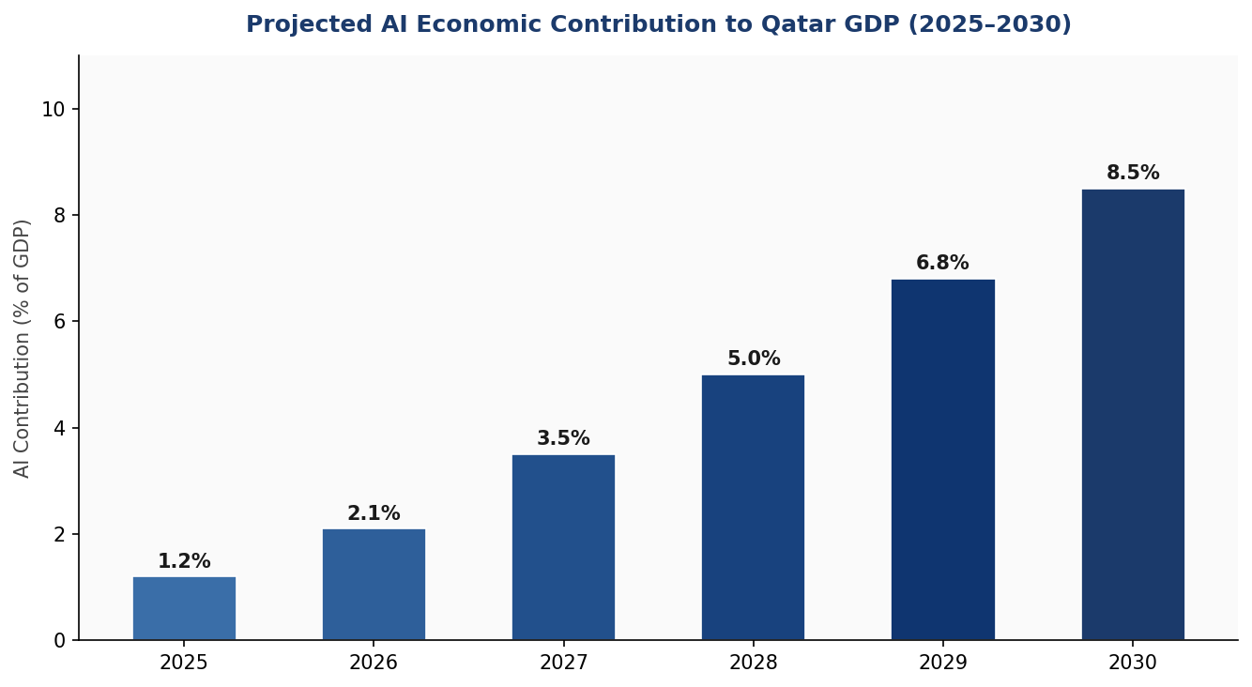
Figure 4.1: Projected AI Contribution to Qatar GDP, 2025–2030 (% of GDP)

4.2 National AI Investment Framework
Qatar's five-year AI investment framework recommends a total public investment of QAR 10 billion (approximately USD 2.75 billion) over the 2025–2030 period, to be supplemented by private sector co-investment estimated at three times the public investment. The allocation framework below reflects international best practice in balancing foundational infrastructure investment with human capital development, regulatory capacity, and ethical governance — recognising that infrastructure alone is insufficient for sustainable AI leadership.

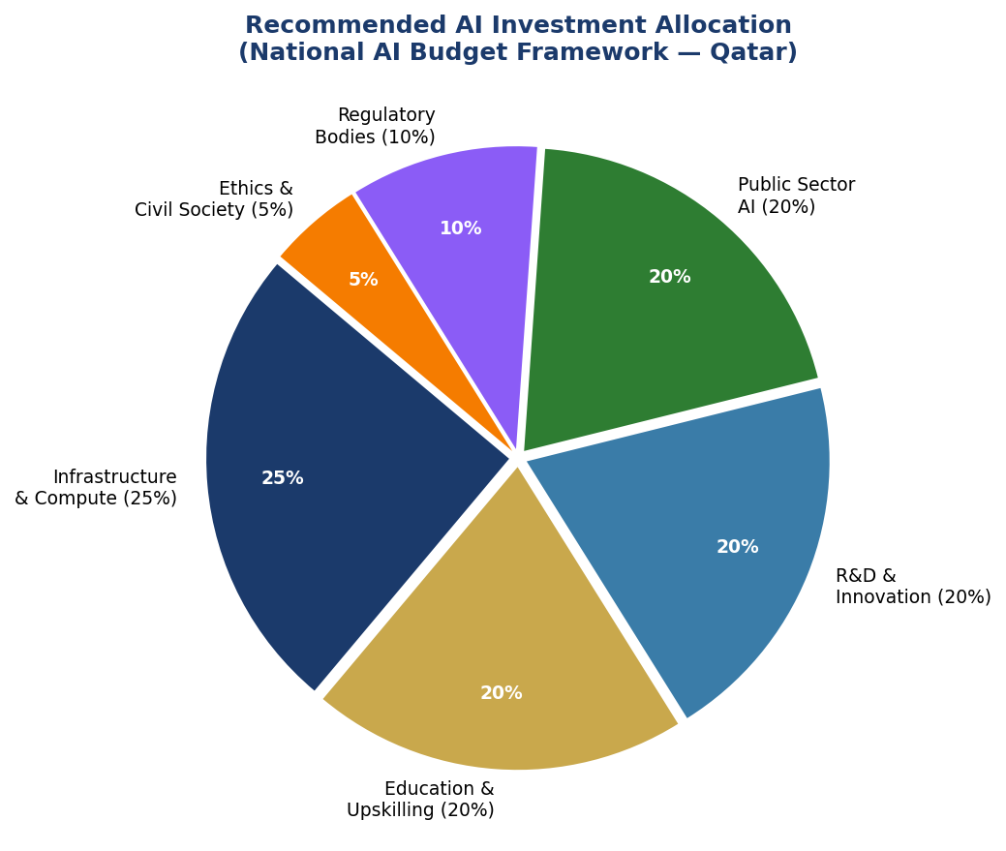
Figure 4.2: Recommended National AI Budget Allocation (QAR 10 billion, 2025–2030)

4.3 Priority Sectors for AI Adoption
Qatar's unique economic structure — dominated by hydrocarbon wealth, a large expatriate workforce, and world-class sports and tourism infrastructure — shapes the priority sectors for AI investment:
- Energy and LNG: AI-optimised production, predictive maintenance, carbon monitoring
- Financial Services: AI in Islamic finance, wealth management, fintech, fraud prevention
- Healthcare: Precision medicine, AI diagnostics, hospital resource management, epidemic surveillance
- Smart City Infrastructure: Traffic optimisation, water management, energy grid AI, waste reduction
- Education: Personalised learning platforms, AI tutoring systems, skills assessment
- Logistics and Trade: Port AI, supply chain optimisation, customs AI (key for Hamad Port)
- Tourism and Events: AI visitor experience, predictive crowd management, Arabic NLP services

4.4 Public-Private Partnership Framework
Qatar's AI investment strategy relies on structured public-private partnerships (PPPs) to leverage private sector innovation capacity alongside public sector scale. The Qatar AI PPP Framework establishes three partnership tiers: Strategic Partnerships (national AI platform agreements with global technology leaders), Co-Investment Partnerships (50/50 funding for AI research and infrastructure), and Procurement Partnerships (government as anchor customer for Qatari AI startups). The Qatar Investment Authority (QIA) will lead international AI investment attraction, targeting sovereign wealth partnerships with AI ecosystems in Singapore, Canada, the UK, and South Korea.

Section 5: Education and Human Capital Development

5.1 Current Skills Gap Analysis
Qatar's AI skills landscape reflects both its strengths and structural vulnerabilities. Education City hosts some of the world's finest university campuses, producing high-quality graduates in engineering, computer science, and business. However, Qatari nationals comprise a small fraction of technology graduates, with most AI-relevant roles filled by expatriate professionals from India, the United States, Europe, and East Asia.
A 2024 Qatar Foundation skills gap assessment identified that fewer than 3% of Qatari nationals in the private sector hold technology-related roles, and that AI-specific competencies are absent from over 90% of public sector employee profiles. Addressing this gap is both an economic and national security imperative.

5.2 National AI Curriculum Framework
Qatar will adopt a four-level AI competency framework spanning from awareness to expertise, implemented across all education stages:
- Level 1 — AI Awareness (General Public): Understanding what AI is, how it affects daily life, and basic digital literacy. Target: 95% of adults by 2030.
- Level 2 — AI Literacy (K–12): Computational thinking, basic coding (Python), data literacy, and AI ethics. Integrated into national curriculum by 2026.
- Level 3 — AI Practitioner (Tertiary and Vocational): Professional AI skills — machine learning, data science, AI product development, applied ethics. Target: 25,000 practitioners by 2030.
- Level 4 — AI Expert (Research and Advanced Practice): PhD-level AI research, frontier model development, AI governance expertise. Target: 3,000 experts by 2030.

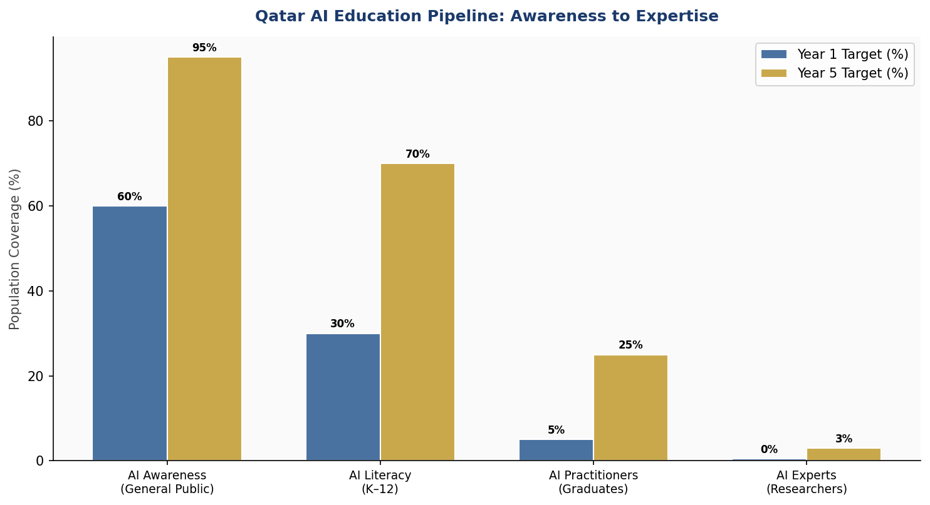
Figure 5.1: Qatar AI Education Pipeline — Population Coverage Targets, Year 1 vs Year 5

5.3 International Scholarship and Exchange Programmes
The National AI Scholarship Programme will fund 500 Qataris per year to attend top-ranked AI programmes globally — including MIT, Stanford, ETH Zurich, Oxford, the National University of Singapore, and KAIST — with a bond requirement of five years of service to Qatar's public or private sector upon return. A complementary AI Faculty Attraction Programme will recruit 200 international AI academics to Qatari universities on five-year appointments, with research funding and housing support.

5.4 Women and Underrepresented Groups in AI
Qatar's policy sets explicit gender equity targets for AI education and workforce participation. By 2030, Qatar commits that at least 40% of AI scholarship recipients are women, 40% of AI researchers at QF institutions are women, and 30% of senior technology roles in government are held by women. Targeted outreach programmes will engage Qatari women in STEM from secondary school, building on the strong foundation of Qatar University's female-majority student body.

Section 6: Ethical AI Governance and Regulatory Framework

6.1 National AI Ethics Board
Qatar will establish a National AI Ethics Board (NAEB) as a permanent, independent statutory body mandated to provide ethical guidance, conduct investigations, and enforce compliance with Qatar's AI regulatory framework. The NAEB will comprise fifteen members: five government representatives (MCIT, Ministry of Justice, Ministry of Health, Ministry of Interior, Qatar Central Bank), five independent experts (AI technology, law, ethics, civil society, Islamic jurisprudence), and five sector representatives (energy, healthcare, finance, education, technology industry).
The NAEB will operate with a guaranteed budget independent of any single ministry, publish an annual Qatar AI Ethics Report, and maintain a public registry of high-risk AI systems deployed in Qatar. Its enforcement powers will include the authority to suspend AI system operations pending investigation, impose administrative penalties, and refer criminal matters to the Attorney General.

6.2 AI Risk Classification System
Qatar adopts a four-tier AI risk classification system modelled on the EU AI Act and adapted to Qatar's legal context, Islamic values, and specific national risk profile:

Risk Category | Definition | Qatar Examples
Unacceptable Risk  (BANNED) | AI systems that pose clear threats to fundamental rights, safety, or human dignity. Deployment prohibited. | Social scoring by government; predictive policing without judicial oversight; subliminal manipulation; exploitation of vulnerable groups
High Risk  (REGULATED) | AI in critical sectors with significant impact on rights or safety. Mandatory conformity assessment, registration, and annual audit. | AI in labour recruitment, visa/residency decisions, healthcare diagnostics, infrastructure management, judicial analytics
Limited Risk  (TRANSPARENCY) | AI with specific deception risks. Transparency obligations: users must know they are interacting with AI. | Chatbots, AI-generated content, deepfakes, emotion recognition in marketing
Minimal Risk  (VOLUNTARY) | All other AI applications. No mandatory obligations; voluntary adherence to Qatar AI Code of Conduct encouraged. | AI-powered search, spam filters, recommendation engines, AI-assisted creative tools

6.3 Data Protection and Privacy Framework
Qatar's existing Personal Data Privacy Protection Law (Law No. 13 of 2016) provides a foundational framework for data protection. This policy recommends its amendment to incorporate AI-specific provisions: the right to explanation of automated decisions, restrictions on AI-based profiling, mandatory data breach notification within 72 hours, and enhanced protections for biometric and health data. Qatar will align its data protection framework with the OECD Privacy Guidelines and, over time, pursue adequacy recognition from the EU to facilitate data-driven trade and investment.

6.4 Algorithmic Accountability Standards
All High-Risk AI systems deployed by or for government must meet Qatar's Algorithmic Accountability Standard (AAS), which requires: documentation of training data sources and methodology; bias audits prior to deployment and annually thereafter; explainability reports for automated decisions affecting individuals; public disclosure summaries; and independent third-party audits every two years. The AAS will be maintained and updated by the NAEB in consultation with international standards bodies including ISO/IEC JTC 1/SC 42.

6.5 Migrant Worker AI Protections
Given that over 85% of Qatar's population are migrant workers — including 2 million low-income construction and domestic workers — this policy includes specific protections against AI-enabled labour exploitation. All AI systems used in migrant worker recruitment, wage management, performance monitoring, accommodation assignment, and deportation processes are automatically classified as High Risk and subject to the full AAS regime. Qatar will establish a dedicated AI and Labour Rights Unit within the National Human Rights Committee to receive complaints and conduct investigations.

Section 7: Public Sector AI and e-Governance

7.1 Priority Government AI Use Cases
Qatar's government will lead by example in responsible AI adoption. Priority use cases have been selected on the basis of public benefit, technical feasibility, and alignment with Qatar National Vision 2030 goals:
Healthcare AI
Hamad Medical Corporation (HMC), Qatar's primary public healthcare provider, will implement AI diagnostic support tools in radiology, pathology, and emergency triage. A National Disease Surveillance AI, integrated with WHO global health networks, will provide real-time epidemic monitoring capabilities — a lesson drawn directly from the COVID-19 pandemic. AI scheduling and resource optimisation is projected to reduce emergency department wait times by 30% by 2027.
Smart Transportation
The Mowasalat (Karwa) public transport network and the recently expanded Doha Metro system will integrate AI-driven demand forecasting, dynamic routing, and maintenance prediction. AI traffic management systems — already partially deployed for the FIFA 2022 World Cup — will be expanded citywide, targeting a 20% reduction in average urban journey times by 2028.
Civil Registration and e-Services
The Ministry of Interior will deploy AI-powered document processing, identity verification, and service routing across visa, residency, and civil registration systems. Natural language processing in Arabic will enable voice-based access to government services, significantly improving accessibility for low-literacy users.
Education Personalisation
The Ministry of Education will pilot AI personalised learning platforms in 50 public schools by 2026, adapting curriculum delivery to individual student learning profiles. All AI education platforms will comply with COPPA-equivalent data protection standards for minors.

7.2 Government AI Procurement Standard
All government entities procuring AI systems must comply with the Qatar Government AI Procurement Standard (QGAPS), which requires: evidence of AI system testing for bias and accuracy prior to submission; vendor disclosure of training data sources; contractual guarantees of explainability for decisions affecting citizens; security certification under Qatar's National Cybersecurity Framework; and mandatory data localisation for sensitive government data. Foreign AI vendors must demonstrate compliance with Qatar data sovereignty requirements.

7.3 Interoperability and Data Sharing
Qatar's government AI infrastructure will be built on the Qatar Government Cloud (G-Cloud), providing a secure, interoperable platform for data sharing between ministries. A National AI Data Exchange will allow authorised entities to access anonymised government datasets for research and development, governed by the NAEB's data ethics framework. International data sharing agreements will be subject to individual case-by-case assessment against Qatar's data sovereignty policy.

Section 8: Implementation Roadmap

8.1 Five-Year Implementation Timeline
Qatar's AI policy implementation is organised into three phases, each building on the preceding phase's achievements and responding to evolving global AI developments:

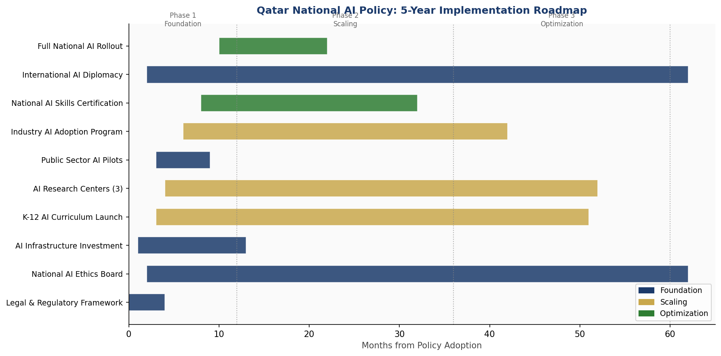
Figure 8.1: Qatar National AI Policy — 5-Year Implementation Gantt Chart (Months from Adoption)

8.2 Phase 1 — Foundation (Year 1: 2025)
Phase 1 focuses on establishing the legal, institutional, and infrastructure foundations without which AI adoption cannot be safe or sustainable. Key deliverables include:
- Enact Qatar AI Governance Law (amending existing digital commerce and privacy legislation)
- Establish National AI Ethics Board with full statutory mandate and budget
- Publish Qatar AI Risk Classification Register and Algorithmic Accountability Standard
- Launch Government AI Procurement Standard (QGAPS) — mandatory for all new procurement
- Commission three AI pilot programmes: healthcare triage, traffic management, civil registration
- Announce National AI Scholarship Programme and begin Year 1 cohort selection
- Complete Qatar Government Cloud infrastructure upgrades for AI workloads

8.3 Phase 2 — Scaling (Years 2–3: 2026–2027)
Phase 2 expands successful pilots to national deployment, accelerates education reform, and drives private sector AI adoption:
- Roll out K–12 AI curriculum to 100% of public schools
- Open first Qatar AI Centre of Excellence at Qatar University
- Launch National AI Investment Fund and begin first investment cycle
- Deploy AI systems across all ministries under QGAPS
- Establish Qatar AI Startup Accelerator — first cohort of 50 companies
- Complete National Disease Surveillance AI integration with HMC
- Publish first Annual Qatar AI State Report (via National AI Observatory)

8.4 Phase 3 — Optimisation (Years 4–5: 2028–2030)
Phase 3 focuses on optimising AI systems based on performance data, integrating Qatar into global AI governance, and positioning Qatar as an AI exporter:
- Comprehensive review of Qatar AI Governance Law (first five-year review)
- Achieve full 8.5% GDP AI contribution target
- Establish Qatar as permanent host of annual MENA AI Governance Forum
- Launch Qatar AI Export Programme — supporting Qatari AI companies in regional markets
- Submit Qatar AI Progress Report to UNESCO, OECD, and G20 AI governance processes
- Achieve 40% Qatari representation in AI sector workforce

8.5 KPI Dashboard

KPI Metric | Baseline (2024) | Year 1 Target | Year 3 Target
AI contribution to GDP (%) | 0.8% | 1.2% | 3.5%
Qatari nationals in AI roles (#) | ~200 | 500 | 2,500
AI ethics cases reviewed by NAEB | 0 | 50 | 200
Government AI systems certified (AAS) | 0 | 20 | 80
AI research publications (annual) | ~180 | 300 | 600
Women in AI scholarship programme (%) | N/A | 35% | 40%
Public awareness of AI (% population) | ~40% | 60% | 85%
AI startups in Qatar (cumulative) | ~30 | 80 | 250
K-12 schools with AI curriculum (%) | 5% | 25% | 80%
Migrant worker AI complaints resolved | N/A | 100% | 100%

Section 9: Monitoring, Evaluation, and Accountability

9.1 National AI Observatory
Qatar will establish a National AI Observatory (QAIO) as a permanent research and monitoring unit housed within the Ministry of Communications and Information Technology, operating with independent reporting lines to the Council of Ministers. The QAIO mandate includes: continuous monitoring of AI deployment across public and private sectors, benchmarking Qatar's AI progress against international indices (Oxford AI Readiness, WEF Global AI Index, OECD AI Policy Observatory), conducting social impact assessments of AI on vulnerable groups, and providing an early warning function for emerging AI risks.
The QAIO will maintain a publicly accessible National AI Registry — a database of all registered AI systems operating in Qatar, with summary information on purpose, risk classification, deploying organisation, and compliance status. This registry will be updated quarterly and searchable by citizens.

9.2 Annual AI State Report
Each year, the QAIO will publish the Qatar Annual AI State Report — a comprehensive assessment of progress against the KPIs in Section 8, emerging risks, international developments relevant to Qatar's AI ecosystem, and recommendations for policy adjustment. The report will be tabled before the Advisory Council (Majlis Al-Shura) and published in full on the MCIT website in Arabic and English.

9.3 Parliamentary and Civil Society Oversight
The Advisory Council will establish a standing Committee on Digital Affairs and Artificial Intelligence with a mandate to scrutinise the Annual AI State Report, hold public hearings on AI-related concerns, and propose legislative amendments to the AI Governance Law. Qatar will also establish a Civil Society AI Advisory Panel — comprising representatives of academic institutions, professional associations, the legal profession, and international civil society organisations — to provide independent stakeholder input to the NAEB.

9.4 Independent Audit Function
All High-Risk AI systems in government use will be subject to independent third-party audits conducted by accredited audit firms, assessed under Qatar's AI Audit Accreditation Programme. Audit reports will be submitted to the NAEB and summary findings published publicly. The NAEB may commission extraordinary audits in response to complaints, incidents, or emerging risk signals.

Section 10: International Cooperation and AI Diplomacy

10.1 Bilateral AI Cooperation Priorities
Qatar will pursue formal bilateral AI cooperation agreements with 10 strategic partners by 2028, prioritising countries with leading AI ecosystems and complementary strategic interests:
- United States: AI research collaboration through Carnegie Mellon Qatar and Texas A&M Qatar; defence AI ethics dialogue
- United Kingdom: AI governance framework sharing; Turing Institute–HBKU research partnership
- France: AI regulation cooperation; Arabic NLP and cultural AI research
- South Korea: AI manufacturing and smart city deployment; KT and Samsung partnership frameworks
- Singapore: AI financial services regulation; FinTech and Islamic finance AI
- Canada: AI ethics research collaboration; Vector Institute–QF partnership
- China: AI infrastructure and smart city technology; balanced engagement with governance guardrails
- India: AI talent development; Tata Consultancy Services and Infosys Qatar partnerships
- Germany: Industry 4.0 AI; energy sector AI cooperation
- Japan: AI for ageing society and healthcare; robotics and autonomous systems

10.2 Regional AI Governance — Gulf and MENA
Qatar is committed to advancing AI governance coordination across the GCC and the broader MENA region. Qatar will propose a GCC AI Governance Framework to standardise risk classification, data sharing protocols, and AI ethics standards across the six GCC member states. This framework would reduce regulatory fragmentation and enable a more competitive regional AI market. Qatar will also support the Arab League's Digital Arab Economy initiative, contributing AI governance expertise to the Arab Digital Economy Strategy 2022–2031.

10.3 Global AI Governance Participation
Qatar will seek full membership of the Global Partnership on AI (GPAI) and will actively contribute to UN processes on AI governance, including the Secretary-General's AI Advisory Body. Qatar will engage in the ITU's AI for Good programme and submit national AI progress reports to the OECD AI Policy Observatory. Qatar's representation at major AI governance forums — the OECD Global Forum on AI, the AI Safety Summit process, UNESCO's expert groups — will be elevated to ministerial level to reflect the strategic priority of this policy.

10.4 South-South Knowledge Transfer
Qatar's AI policy experience is particularly relevant to other Arab and Muslim-majority nations navigating AI governance. Qatar will establish an Arab AI Policy Exchange programme — facilitating knowledge transfer to OIC (Organisation of Islamic Cooperation) member states, with particular focus on AI ethics from an Islamic jurisprudence perspective, AI governance for labour-intensive economies, and AI deployment in Arabic language contexts. Qatar University and Hamad Bin Khalifa University will host annual Arab AI Governance workshops open to policymakers from OIC members.

Conclusion

Artificial Intelligence is not a distant possibility — it is a present and accelerating force reshaping economies, governance systems, and human relationships across the world. Qatar, with its extraordinary resource wealth, strategic vision, and demonstrated capacity for transformational investment, is uniquely positioned to lead this moment responsibly.
This National AI Policy 2025–2030 is Qatar's commitment to ensuring that AI serves human dignity, promotes economic prosperity for all residents, strengthens public institutions, and advances Qatar's standing as a responsible international actor. It is a policy built on the conviction that being an AI leader and being an ethical actor are not in tension — they are, in fact, mutually reinforcing.
The path ahead requires courage and coordination. It requires government institutions to modernise rapidly while maintaining accountability. It requires the private sector to invest ambitiously while operating responsibly. It requires educators to reimagine their mission for an AI-integrated world. And it requires Qatar's citizens and residents — Qatari nationals and the migrant workers who share this nation — to be treated as active participants in an AI future that belongs to all of them.
Qatar's Islamic tradition provides a profound foundation for AI ethics: the concepts of Maslaha (public benefit), Adl (justice), Amanah (stewardship and trustworthiness), and Shura (consultation) are not historical artefacts — they are living principles that should govern how powerful technologies are designed and deployed. This policy is an expression of those values in the language of modern governance.
Qatar in 2030, guided by this policy, will be a nation where AI powers the hospitals, manages the infrastructure, educates the children, and protects the rights of every person within its borders — while contributing its experience and expertise to the global effort to govern AI for the benefit of humanity.

References and Bibliography

International Frameworks and Primary Sources
- UNESCO (2021). Recommendation on the Ethics of Artificial Intelligence. Paris: UNESCO.
- OECD (2024). OECD AI Principles (Updated). Paris: OECD Publishing.
- European Union (2024). Regulation (EU) 2024/1689 of the European Parliament and of the Council laying down harmonised rules on artificial intelligence (EU AI Act). Official Journal of the European Union.
- World Bank (2021). World Development Report 2021: Data for Better Lives. Washington: World Bank.
- G20 (2019). G20 AI Principles. Osaka: G20 Summit.
- ITU (2020). AI for Good: Artificial Intelligence in Service of the UN Sustainable Development Goals. Geneva: ITU.
- GPAI (2022). Global Partnership on AI Responsible AI Working Group Reports. Montreal: GPAI.

Qatar-Specific Sources
- Qatar National Vision 2030 (2008). General Secretariat for Development Planning, Doha.
- Ministry of Communications and Information Technology (2020). Smart Qatar (TASMU) Digital Transformation Programme Overview. Doha: MCIT.
- Qatar National Research Fund (2024). Qatar AI Research Landscape Report 2024. Doha: QNRF.
- Qatar Foundation (2023). Education City: A Decade of Impact. Doha: Qatar Foundation.
- Qatar Central Bank (2024). FinTech and Digital Financial Services Strategy 2024–2027. Doha: QCB.

Academic and Research Sources
- Oxford Insights (2024). Government AI Readiness Index 2024. Oxford: Oxford Insights.
- Transparency International (2024). Corruption Perceptions Index 2024. Berlin: TI.
- World Economic Forum (2023). The Future of Jobs Report 2023. Geneva: WEF.
- PwC (2023). Global Artificial Intelligence Study: Sizing the Prize — What's the Real Value of AI for Your Business? London: PwC.
- McKinsey Global Institute (2023). The Economic Potential of Generative AI: The Next Productivity Frontier. New York: McKinsey & Company.
- World Bank (2023). Worldwide Governance Indicators 2023. Washington: World Bank Group.

About the Author

Nafiul Ahmad Rafi
Policy & Good Governance Researcher | BD Civic Tech Architect
Nafiul Ahmad Rafi is a civic technologist, policy researcher, author, photographer, and musician based in Dhaka, Bangladesh. He is the Founder and Director of Insights Bangladesh, a data-driven governance and policy impact analysis institution, and the Founder & Lead Architect of NagorikBD.org — a transparency-first civic platform scaled across Mymensingh Division, connecting citizens with government services across 45 Upazilas.
His work exists at the intersection of institutional reform and artificial intelligence, transforming theoretical governance into scalable, data-driven reality. Without a conventional computer science degree, he self-taught the tools of modern AI and web development to build the infrastructure that enforces the policies he once only researched.

Key Platforms and Projects
- NagorikBD.org — Civic transparency platform, Mymensingh Division
- Insights Bangladesh — Policy impact analysis institution
- FactCheck BD (factcheckbd.org) — Bangladesh's AI-powered fact-checking platform
- Political Insights BD / PIBD (pibbd.org) — Political intelligence and civic tech hub
- PeaceShield BD / National Peace Tracker — AI-powered hate speech and conflict monitoring
- PolicyLens AI (aigovbd.org) — 9-dimensional AI policy audit tool

He has published four books and maintains a personal site at ahmad-rafi.com.

Research Interests
AI Governance · Policy Research · Future of Bangladesh · Climate Policy

Contact
- Web: ahmad-rafi.com
- LinkedIn: linkedin.com/in/nafiul-ahmad-rafi
- Email: contact@ahmad-rafi.com

"I build code to ensure transparency, and I write lyrics to inspire the courage to use it."

